Research article submission **British Journal of Social Work**

Person-centred process?:

Procedural fairness in Care Act 2014 needs assessments

This paper examines the process of seeking social care needs assessments under the Care Act 2014 in England through the lens of procedural fairness theory. Drawing on interviews with 21 individuals with experiences of needs assessments, we identify the ‘process qualities’ - the factors rooted in the literature on procedural fairness - that matter most to people navigating this critical front-line component of the social care system. Our analysis reveals two themes: the importance of ‘dignified treatment’ and system ‘proactivity’, each underpinned by a set of process qualities. These qualities for the former – personalisation, empathy, and voice – are well explored in the literature on person-centred care. However, the latter – responsibility taking, dependability, transparency, assistance, and availability – are neglected in current research on experiences of the Care Act 2014. Drawing on these process qualities, we set out the potential for future research grounded in procedural fairness theory in social care.

**Keywords:** Care Act 2014, needs assessments, person-centred care, procedural fairness, gatekeeping.

|  |
| --- |
| **‘Teaser text’**  **(as required in the British Journal of Social Work submission portal)**  This study explores how people experience the process of seeking social care support under the Care Act 2014 in England using an approach normally adopted in studies evaluating ‘procedural fairness’. By interviewing 21 individuals who have gone through needs assessments, either for themselves or as carers, the research uncovers what qualities matter most to people navigating this complex system. The findings highlight two key themes: the importance of a proactive system that takes responsibility and provides clear, dependable assistance, and the need for dignified treatment that emphasises empathy and personalisation. While current research focuses on dignified treatment, this study highlights that system proactivity is equally crucial but often overlooked. These insights can help local authorities design more responsive and effective social care processes, ultimately leading to better outcomes for those in need of care and support. |

**Introduction**

No one in England can receive state support for social care without first navigating a Care Act 2014 ‘needs assessment’. With over 2 million requests for support each year and nearly 250,000 on waiting lists, the design and delivery of this process is a ‘critical’ front-line component of the social care system (Symonds et al, 2020; ADASS, 2022). In its fundamental reform of social care processes – including identifying needs, assessing eligibility and care planning – the Care Act 2014 sought to standardise a prior patchwork of approaches and place the promotion of ‘wellbeing’ at the heart of people’s engagement with the social care system (Burn et al, 2024). As a key site of front-line decision-making in the welfare state, Local Authorities have wide-ranging discretion in how they discharge their duties and design needs assessment processes, leading to substantial variation across the country.

To date, analyses of this Care Act 2014 needs assessment pathway have generally interrogated the format of needs assessments themselves and the conduct of staff delivering them. As outlined in a 2022 NICE review of existing evidence, research has explored a number of issues in the design and delivery of needs assessments, from the ‘perceived appropriateness of the conduct of assessments’ (such as the role of the social worker or the use of self-assessment tools) through to ‘positive and negative aspects of the process of assessment and review’ (such as the perceived ability to express preferences or the timeliness of the assessment) (National Institute for Health and Care Excellence, 2022). These studies tend to draw on perspectives rooted in the influential literature on person-centred approaches to care in order to interrogate the design and delivery of needs assessment processes (see Symonds et al, 2020).

This paper draws on procedural fairness theory to explore the experiences of people seeking support under the Care Act 2014. Although theories of procedural fairness have been influential in other contexts, the insights of this literature are yet to be adopted in the social care context. An exhaustive account of this literature is not possible in a paper of this length, but the approach can be characterised as tackling two questions which we go on to explore(Adler, 2006, 618). First, what does ‘treating people fairly’ mean to those seeking support under the Care Act 2014? The central concern of the foundational work examining this question, *Bureaucratic Justice* by Mashaw (1983), is to identify ‘those qualities of a decision process that provide arguments for the acceptability of its decisions’ (Mashaw, 1983, 24; Adler, 2006, 619). Here, Mashaw draws on empirical data on the operation of the American Disability Insurance programme to identify three different models of administrative justice: bureaucratic rationality, professional treatment, and moral judgement. Each competes for priority and is underpinned by its own set of legitimating values, primary goals, and organisational structures. In subsequent scholarship, these models have been developed and applied across a range of other front-line decision-making contexts (Mashaw, 2022).

In this paper, drawing on interviews with 21 people with experience of needs assessments, we identify the process qualities that matter most to people seeking support under the Care Act 2014. We take as our starting point the same exercise undertaken by Halliday et al (2024) for Universal Credit claimants in England. In the context of the Universal Credit programme – the UK’s most widely claimed means-tested social security support – Halliday et al identify 22 relevant process qualities, from ‘accessibility’ to ‘voice’ (Halliday et al, 2024). They argue that recipients of Universal Credit prioritise process qualities that deal with ‘interactions with’ officials (*empathy*, *voice*, and *respectful communication*), those that deal with the ‘virtues’ of officials (*dependability*, *consistency* and *responsibility taking*) and those that deal with ‘access to’ officials (*availability*, *assistance* and *speed*). They summarise these process qualities as ‘Universal Credit as a relationship’, as opposed to the Universal Credit as an ‘entitlement’ or a ‘service’ that dominates the views of welfare benefits advisors and civil servants respectively (Halliday et al, 2024).

In taking this approach to our analysis of seeking support under the Care Act 2014, we identify two overarching themes in the data, each underpinned by a series of process qualities: the importance of system ‘proactivity’ and ‘dignified treatment’. Our data suggests that perceptions of ‘proactivity’ were informed through the process qualities of *responsibility taking, dependability, transparency, assistance*, and *availability.* Perceptions of ‘dignified treatment’ were underpinned by process qualities already familiar to social care researchers: *personalisation*, *empathy*, and *voice*. As opposed to a characterisation of our participants’ interaction with the social care system as a ‘relationship’ (as in Halliday et al’s work (2024)), the set of process qualities emphasised by our participants reflected the perception of ‘social care as a maze’. We are by no means the first to describe social care as a complex maze. Peel and Harding (2014) found that some carers for people with dementia find navigating the systemic issues of social care more challenging than other aspects of providing care

The second question in this literature explores whether these process qualities differ for social care, when compared to other contexts. As Adler puts it, drawing on Mashaw, ‘is there an invariant set of principles which should guide the way in which governments deal with people, or does a different set of principles apply to different sets of activities?’ (Adler, 2006, 618). For example, do people care about the same process qualities in an immigration decision as they do a social security appeal; or is there a distinction between process qualities for a disability support process (as in Mashaw’s work) versus seeking social care support under the Care Act 2014? In comparing our findings to Halliday et al’s similar exercise for Universal Credit claimants, we suggest that social care processes do appear to carry some key differences – particularly the emphasis participants placed on *transparency*, *responsibility-taking, dependability, availability* and *assistance* under the ‘proactivity’ umbrella.

This study addresses these two questions in the context of people seeking support under the Care Act 2014. We begin by setting out existing research tackling the Care Act 2014 needs assessment process, before turning to our approach rooted in procedural fairness theory and research. We then set out our method and identify the key process qualities that emerged in the data. Our broader agenda is to argue that theories of procedural fairness provide an under-utilised conceptual framework for evaluating Local Authority approaches to the design and administration of needs assessments and, by extension, other elements of social care decision-making processes.

**The procedural turn under the Care Act 2014**

The Care Act 2014 could be characterised as the most significant and wide-ranging shake-up of the process of seeking social care support since the National Assistance Act 1948 (Barnes et al, 2017, 176). Broadly speaking, the legislation had two key aims. First, to replace a ‘patchwork’ of legislation, guidance and policy that had developed over the course of 60 years (Symonds et al, 2020). Local variations in eligibility assessments under the prior ‘Fair Access to Care Services’ framework had led to a ‘postcode lottery’, and the assessment of needs was governed by a smörgåsbord of statutes and accompanying guidance that bore little overall coherence (Humphries, Forder, & Fernández, 2010). The legislation was, therefore, partly an exercise in standardisation and simplification: it aims to clarify and expand the right to have social care needs assessed and streamline processes to determine eligibility for financial support to address them.

However, its second aim was a broader one. As laid out in legislation and accompanying guidance, the Care Act 2014 was intended to shift social care processes towards a more personalised ‘person-centred approach’ (Symonds et al, 2020). With the promotion of well-being at its core as enshrined in the broad-ranging duty in section 1 of the Act (Burn et al, 2024). The key processes laid out in the legislation – identifying needs, assessing eligibility and care planning – are treated as central to an individual’s overall experience of the social care system, with consequences for people’s independence and well-being, and the extent of control they have over their care and support (Hunter et al, 2020, 197; Barnes et al, 2017). The Care Act 2014 therefore also aims to fundamentally reform not just the processes themselves, but also how they are *experienced* by those accessing them, creating a more ‘holistic and empowering’ engagement with the social care system (Barnes et al, 2017).

This second aim has spurred a seam of research examining person-centred approaches to ‘needs assessment’ processes under the Care Act 2014. Most of this work focuses on the format and conduct of the needs assessment itself. As outlined in a 2022 NICE evidence review of existing evidence, research has interrogated a number of issues in the design and delivery of needs assessments, from the ‘perceived appropriateness of the conduct of assessments’ (such as the role of the social worker or the use of self-assessment tools) through to ‘positive and negative aspects of the process of assessment and review’ (such as the perceived ability to express preferences or the timeliness of the assessment) (National Institute for Health and Care Excellence, 2022). For instance, O’Rouke et al’s work on carer’s assessments demonstrates the variation in approaches between Local Authorities in terms of format, from telephone-based processes to face-to-face visits, and provision, such as whether needs assessments are contracted out to a voluntary sector organisations (O’Rouke et al, 2021). These decisions, in turn, shape the experience of carers having their needs assessed (ibid).

However, studies of needs assessment processes – and person-centred approaches under the Care Act 2014 more generally – have begun to turn towards examining broader components of an individual’s ‘journey’ or ‘pathway’ to support outside of the needs assessment itself. These fall into three key streams of work. First, studies that examine people’s understanding and expectations of the ‘processes and procedures around needs assessments’ (Mayrhofer et al, 2021). Here, research identifies a lack of clarity in and understanding of social care processes. For instance, in Mayrhofer et al’s work with families with young onset dementia, participants often struggled to distinguish between social care assessments and those undertaken for Personal Independence Payments (PIP) via the Department for Work and Pensions – as one put it, the system is ‘too complicated to understand’ (ibid, 668). Indeed, in a study by Healthwatch York with 11 participants who had a recent needs assessment with City of York Council, only 2 were aware that they had been through such a process: the ‘terminology was not meaningful to other respondents who took part in the interviews’ (Healthwatch York, 2023). This echoes work examining people’s expectations of entry into social care support, which ‘suggests a degree of naivety about the social care system and the complexity of making care and funding decisions’ (Baxter, Gridley, & Birks, 2023).

Second, research increasingly points to the importance of a ‘whole system approach’ to addressing the Care Act 2014 (Mahesh, Bharatan & Miller, 2024). Here, the argument goes that the focus of both research and implementation of ‘person-based’ or ‘strengths-based’ approaches in the Care Act 2014 should not limit themselves to narrow aspects of individual processes (such as the design and delivery of needs and eligibility assessments) but look holistically at the support and services an individual engages with across their social care journey. This is likely to include other stakeholders outside of the Local Authority (such as community and voluntary organisations or telecare providers), and staff outside of social work practice alone (such as occupational therapists) (ibid).

Finally, a stream of existing research explores ‘gatekeeping’ practices for those seeking support under the Care Act 2014. In the context of acute resource pressures facing both Local Authorities and other voluntary and community services, the poor design of screening, triage, sign-posting and first-tier assessments can serve to increase ‘the likelihood of risks being borne privately’ by gatekeeping access to support (O’Rourke et al, 2020, 381). One such example (which we return to below) is the conflation between eligibility and needs assessments under the Care Act 2014. Notwithstanding that the separation of these two processes was designed to ensure that ‘the assessment of financial means should follow the needs assessment’ and should ‘not affect the local authority’s decision to carry out an assessment’, in practice, the picture is more mixed (Henwood et al, 2018, 31). These gatekeeping arguments are not solely a creature of the Care Act 2014; as Needham and Glasby underscore, concerns about the changing role of social workers towards ‘care managers and gatekeepers’ have abounded since at least the 1990s, especially shifts to a reduced ‘scope for holistic and preventative types of support’ (Needham & Glasby, 2023, 206).

Given this increasing turn towards examining attitudes to process more holistically in social care, it is perhaps surprising that the broad-ranging literature on procedural fairness is yet to inform analyses of the Care Act 2014 needs assessment pathway. By situating our analysis within the framework of procedural fairness, we extend the conceptual vocabulary available for understanding the design and delivery of social care processes. Unlike traditional person-centred care frameworks, which often focus on outcomes or individual experiences, procedural fairness emphasises the structural and relational qualities of interactions that influence perceptions of justice and legitimacy. This perspective broadens the scope of analysis to include systemic factors such as transparency, proactivity, and accountability, offering a more comprehensive lens through which to evaluate needs assessment pathways.

Our focus also bridges a gap in the existing literature on procedural fairness itself, which has primarily focused on other areas of public administration outside of social care, such as social security, immigration, and homelessness decision-making. This cross-contextual comparison enables us to explore whether core process qualities, such as those identified by Halliday et al. (2024) in Universal Credit, hold consistent across different welfare domains or whether unique features of social care necessitate distinct procedural considerations. In doing so, we advance an understanding of how procedural principles can be tailored to address the specific challenges and priorities of individuals navigating complex and resource-constrained systems like social care.

**Method**

The analysis below draws on interviews with 21 people who have either had a needs assessment themselves (4), were involved in the assessment of one or more family members (13) or had experience of the process both personally and as a carer (4). In this section, we deal first with the recruitment of participants before turning to the composition of the sample and analysis of the data.

All participants were recruited for online interviews via Prolific - a widely utilised panel provider. The process used for recruiting participants is outlined in Figure One below. In order to recruit participants with direct experiences of social care needs assessments processes, a screening survey was first issued to a sample of 504 English respondents who had indicated in their Prolific panel data that: (i) they have a long term health condition or disability, and/or (ii) have informal/unpaid caring responsibilities, and (iii) were at least 18 years old. Respondents to the screening survey were asked about their experiences of social care needs assessment processes; of these, 99 had their own needs assessed within the last two years, and 226 cared for someone who had their needs assessed within the last two years. The rest of the sample were ineligible for participation. Of those eligible for participation, interview slots were released for all of the former (99 in total) and a random selection of the latter (165 out of 226, with a view to ensuring that demand was proportionate to researcher availability). Interview slots were then allocated on a first-come-first-served basis over the course of two weeks, with a total of 45 participants booking a slot. The booking process asked participants to confirm their eligibility for the study - at this point, a further 16 were screened out due to being ineligible and 8 did not attend an interview slot they had booked, leaving a final sample of 21. The main driver of exclusions were participants confusing social care assessments with assessments in support of a PIP application (a phenomenon also noted by Mayrhofer et al (2021), as discussed above). This process is outlined in Figure One below.

**Figure One: Summary of the participant recruitment process on Prolific**

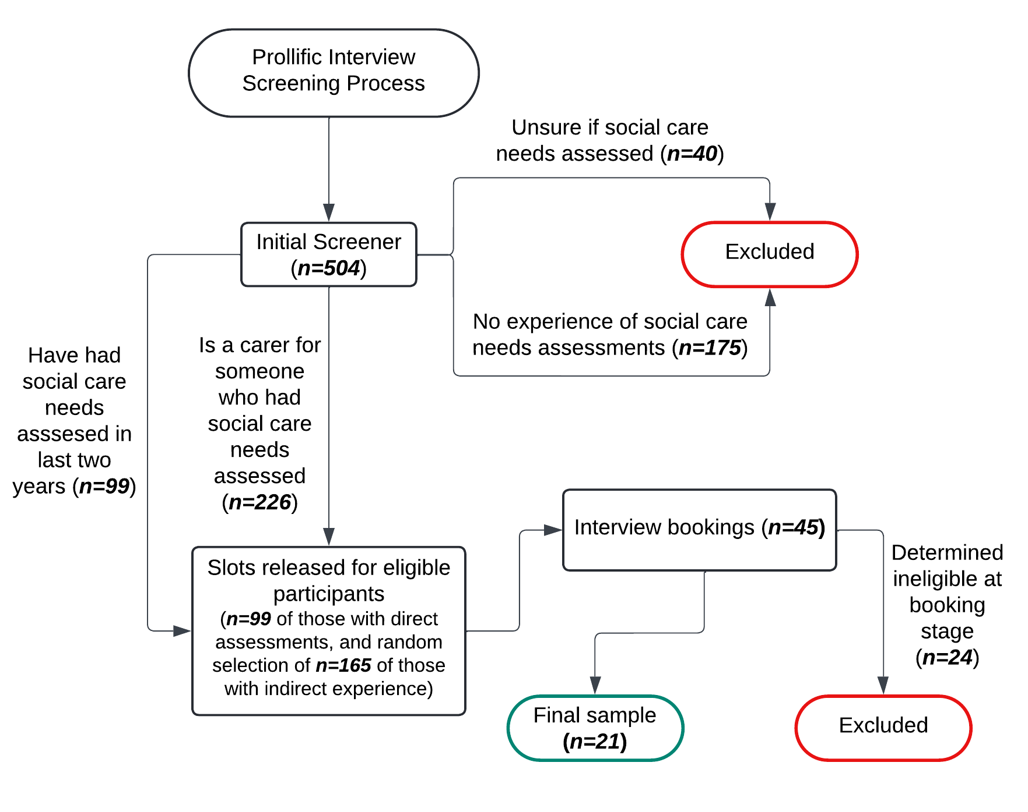

Participants were interviewed over Zoom; audio recordings were made and transcribed for analysis. Participants were paid in line with Prolific incentive rates for completion of the screening survey and at a total of £30 for attendance at the interview. The interview itself followed a semi-structured format, asking about their experiences and reflections on these experiences of seeking support under the Care Act 2014, either for themselves or the person they have caring responsibilities for. The final sample socio-demographics are provided in Table One below.

**Table One: Breakdown of the sample socio-demographics**

|  |  |
| --- | --- |
| SOCIO-DEMOGRAPHICS | N |
| **Age** |  |
| 25-34 | 4 |
| 35-44 | 5 |
| 45-54 | 6 |
| 55-64 | 2 |
| 65+ | 2 |
| Did not provide | 2 |
| **Gender** |  |
| Female | 14 |
| Male | 7 |
| **Needs assessment** |  |
| For themselves | 8 |
| For their parent/in-law | 12 |
| For their child (18+) | 3 |
| For their partner/spouse | 4 |
| For their grandparent | 1 |
| **Multiple needs assessments** |  |
| Multiple assessments for the same person | 2 |
| Assessments for more than one person | 5 |
| **Ethnicity** |  |
| White | 15 |
| Mixed | 2 |
| Black | 1 |
| Mixed Asian | 1 |
| British Pakistani | 1 |
| Did not provide | 1 |
| **Employment status** |  |
| Full-time | 9 |
| Not in paid work (e.g. homemaker', 'retired or disabled) | 7 |
| Full-time carer | 1 |
| Part-time | 1 |
| Did not provide | 3 |

Before turning to analysis of the data, it is important to note three key limitations of the study’s methodology. First, the qualitative sample is not a representative reflection of those seeking support under the Care Act 2014 or supporting others to do so. For instance, the final sample was majority female (n=14) versus male (n=7) and was skewed towards carers (n=13) over those who were being assessed themselves (n=8). Although this limits the generalisability of the findings we set out below, our analysis does not claim such generalisability. Second, the recruitment process through Prolific may have introduced selection bias. Participants who are registered on Prolific may differ systematically from the broader population seeking social care support, potentially being more tech-savvy or having different socioeconomic characteristics. This could affect the range of experiences and perspectives captured in our study, particularly regarding comfort with accessing online systems or other processes at the Local Authority. Likewise, the reliance on online interviews may have excluded individuals who lack internet access or are less comfortable with digital communication. Third, the retrospective nature of the interviews means that participants' recollections of their experiences may be subject to recall bias. The time elapsed between their needs assessment and the interview could have affected the accuracy and completeness of their accounts, although - for all participants - their experiences of needs assessments were all within the last two years.

Having set out the collection of the data, we now turn to its analysis. The interview data were transcribed and then analysed deductively in line with the process qualities set out in Halliday et al’s 2024 study, reproduced in Table Two below. Across the interview transcripts, references to these process qualities were compiled by one researcher on the team, before being reviewed by a second researcher to ensure consistency in how quotations were coded. This led to a document with references to each of the process qualities in Table Two, broken down by participant. These excerpts were then analysed thematically to identify common themes.

**Table Two: The process qualities identified by Halliday et al (2024) in their study of Universal Credit claimants**

|  |  |
| --- | --- |
| PROCESS QUALITY | DEFINITION |
| **Accessibility** | The system makes it easy for making or updating applications |
| **Assistance** | Officials offer help to applicants who are struggling with a claim |
| **Availability** | It is easy to get hold of relevant officials |
| **Consistency** | Officers or offices give consistent advice and information |
| **Correctability** | It is easy for errors to be corrected |
| **Decision discretion** | Rules are applied flexibly to meet the circumstances of the claimant |
| **Dependability** | Officials follow through on any promises made |
| **Dignifying treatment** | Interactions and processes are dignifying for claimants |
| **Efficiency** | The system works effectively whilst minimising operational costs |
| **Empathy** | Officials have empathy for clients |
| **Factual accuracy** | Claimants’ situations are fully understood |
| **Intelligibility** | Official communications are clear and easy to understand |
| **Legality** | Officials know their own rules and apply them competently |
| **Margin of error** | The system is forgiving of mistakes and gives the benefit of doubt |
| **Neutrality** | Officials and processes exhibit a lack of bias and discrimination |
| **Personalisation** | Communications are specific to claimant’s circumstances |
| **Respectful communication** | Claimants are communicated with respectfully |
| **Responsibility-taking** | The burden of putting official errors right is taken by officials |
| **Speed** | Relevant actions are taken promptly |
| **Transparency** | It is easy to find out and/or show the basis for decisions |
| **Trustworthiness** | Officials act in a way that exhibits trustworthiness |
| **Voice** | Claimants can express themselves and feel listened to/understood |

The study as a whole - including recruitment and the approach to analysis detailed above - received ethical approval from [REDACTED FOR ANONYMITY].

**Findings: ‘Social care as a maze’**

Our analysis of the data revealed two overarching themes; each underpinned by a series of process qualities identified by Halliday et al (2024). First, the importance of ‘proactivity’ of the system and the staff working within it: as Participant [469] put it, ‘we always have to chase…they never proactively tell us whatever’. We argue that this ‘proactivity’ is comprised of a combination of process qualities outlined in Table Two above: *responsibility-taking, dependability, transparency, assistance,* and *availability.* Second, in common with the experiences of Universal Credit recipients, the importance of ‘dignified treatment’; this sat alongside the process qualities of *personalisation*, *voice* and *empathy*. The significance of the latter is perhaps unsurprising: they are all associated with the principles of ‘person-centred care’ that is at the heart of the Care Act 2014 and accompanying research in this area (see Symonds, J. et al, 2020, as discussed above). Taken together, these two qualities reflect an overall view of social care not as a ‘relationship’ - as in the study of Universal Credit recipients - but as a ‘maze’. The importance of complex processes lacking transparency echoes Peel and Harding’s findings on dementia care services, where ‘prevalence of the metaphor of a maze’ was widespread across their participants (Peel and Harding, 2014). Across the sample, most participants had negative experiences of ‘proactivity’, but positive experiences of ‘dignified treatment’ - this was true for both those who had been assessed themselves and carers in attendance at assessments. We deal with each of these two themes in turn.

**Figure Two: A summary of process qualities detailed in the sample**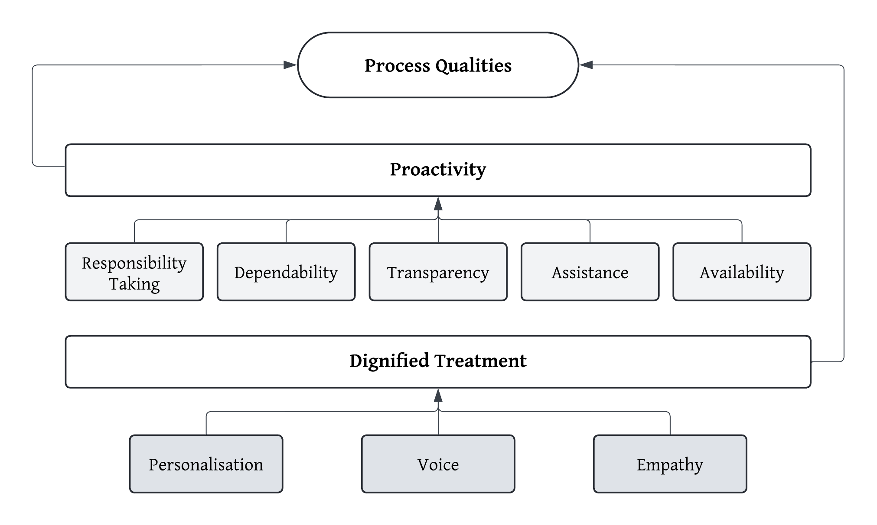

*The importance of ‘proactivity’*

In a departure from Halliday et al’s (2024) work on Universal Credit recipients, participants repeatedly underscored the importance of process qualities associated with ‘proactivity’ – both of staff within the social care needs assessment process, or the system itself (such as the triggering of communications). Part of this appeared to be tied to a broader conception of ‘responsibility-taking’. Instead of being focused on the burden to ‘put official errors right’ being ‘taken by officials’ (Halliday et al, 2024, 69, as in Table Two above), participants highlighted the importance of officials taking the initiative to communicate with them, or provide support. For instance, as Participant [94d4] explained:

*You just want to know what’s going on. You want to be checking them all the time? I mean a little email just to say maybe just…or a letter to say don’t worry, things are still progressing... But when you don’t hear anything, it’s just like, what? What’s going on? Like you don’t know where you are.* (Participant [94d4]).

This was particularly acute for participants given they had very limited familiarity with the social care process prior to seeking to access the system. This reflects the experience of self-funders explored by Baxter, Gridley, & Birks (2023). For our participants, this extended to Local Authorities being proactive in providing *assistance*. Participant [9f22] described how they longed for a ‘hand out to say…we will help you’.

*You want somebody to tell you what you should be doing, not the other way around… if we felt that we could make the decisions on our own, we would, you know, we wouldn’t have contacted the local authority in the first place. The idea is that you’re meant to have somebody effectively put a hand-out to say, no, we will help you.* (Participant [9f22]).

For carers in the sample, this *assistance* quality was reflected in concerns about how the assessment process would have happened if they were unavailable to help the person they care for. This was in respect of specific practical concerns - for instance, Participant [2411] noted the absence of an interpreter - or more general sentiments that, given the lack of help otherwise available, they would have ‘no idea’ how the person they care for would have gone through the Care Act processes.

*…even though she didn’t speak English, they didn’t have the, they didn’t offer an interpreter. So it was more about me communicating with them on behalf of my aunt. So I didn’t know whether that facility was available. And I can’t remember asking about it. But because it wasn’t offered, I assumed that they didn’t have that* (Participant [2411]).

*…if we weren’t involved, I have no idea how it would have all got set up* (Participant [c1ab]).

The importance of these broader conceptions of *responsibility-taking* and *assistance* sat alongside concerns about the *transparency* of the process – as Participant [5c88] put it, ‘we didn’t know really what was going to happen, when it was going to happen’. Although the Care Act 2014 process envisages a separation between the assessments of ‘need’ for social care support, and ‘eligibility’ for meeting the costs that arise (see Barnes et al, 2017), in reality, the blurring of these processes in the operationalisation of needs assessments led to increased confusion and concerns about ‘random’, rather than transparent, processes. For instance, Participant [a937] outlined their concerns about their experiences of confusing needs and eligibility assessment processes.

*Basically, it would be good to know if, if it’s worth doing. Like, if you qualify or not. Because it all seems a bit random… Like there’s people we know who, you know, get carers and things and then there’s people we know who don’t. And, it kind of seems a bit random really* (Participant [a937]).

This lack of *responsibility-taking*, *assistance* and *transparency* was exacerbated given problems participants had in contacting Local Authority staff for updates about assessments. *Availability* was therefore an important consideration across the sample.

*With adult social scare, it’s kind of like, right we’ll get back to you, and then it’s just beeeeeeeeep* [answerphone sound]. (Participant [e469]).

*…the response to my telephone call or my email was not responded* [to]*. I mean, if I got maybe one out of three returned telephone calls, I was doing quite, quite good.* (Participant [0176]).

Such was the difficulty of the *availability* of staff that a minority of participants even suggested this was a feature of the process; a kind of gatekeeping designed to keep demands on the system at a minimum.

*You get fed up. And I think that’s what they want. I think they want you to give up on the system and be like, well, I’m sick of chasing them. I’m not going anywhere. I think that’s actually what they want to try and save money.* (Participant [94d4]).

*It just seems to be more that the system is –* *and you could be cynical in saying – it’s set up almost to deter you from going through the process sometimes to save the money.* (Participant [c1ab]).

‘Proactivity’ also depends on officials following through on communications that are provided to those seeking social care support. *Dependability* was therefore an important virtue of staff in contact with individuals that cuts across these other ‘proactivity’ process qualities. For participants in the sample, key examples were ‘call backs’ – when a staff member says they will phone them at a particular time – and for needs assessments appointments themselves. For those with negative experiences, this was particularly frustrating.

*If you say you’re coming at one, either turn up or don’t rock up at five… But most of the time it’s just not…that’s the thing as well, it was arranged three times and then got rearranged, and then got rearranged, and rearranged, and rearranged.* (Participant [e469]).

*…you know like rough times or when they’re coming back, it’s always like ‘oh it’s, it’s all gonna get done later. It never gets done. So in the end we have kind of given up. We’ve given up with it, we’re that used to now doing things on our own. That is, that’s what it is. I don’t know where else to go from here.* (Participant [94d4]).

Our data therefore suggest that ‘proactivity' – combining the process qualities of *responsibility-taking, dependability, transparency, assistance,* and *availability* – is a crucial yet often overlooked aspect of the social care needs assessment process. Participants consistently emphasised the importance of proactive communication, initiative-taking by officials, and transparent processes. These findings extend beyond Halliday et al's (2024) focus on error correction, highlighting a broader conception of *responsibility-taking* within the system. A perceived lack of proactivity, coupled with poor availability and dependability of staff, not only frustrates users but also erodes trust in the system, with some participants perceiving these shortcomings as intentional gatekeeping mechanisms. We return to implications of these findings after turning to ‘dignified treatment’.

*The importance of ‘dignified treatment’*

The second key theme in the data is the importance of ‘dignified treatment’. As outlined above, this is in common with the Universal Credit recipients in Halliday et al’s study (2024, 76). However, in their case, this theme appeared to be associated with a wide range of other process qualities dealing with the tone and content of interactions with staff (*empathy, voice* and *respectful communication*), virtues of staff (*dependability, consistency* and *responsibility-taking*) and those that deal with access to staff (*availability, assistance* and *speed*). For our participants, a smaller range of factors emerged: *empathy, personalisation* and *voice*. Their significance is perhaps unsurprising: they align with principles of ‘person-centred care’ (see Symonds, J. et al, 2020, as discussed above).

Almost all participants highlighted at least some positive experiences of *empathy* with staff they interacted with across the Care Act 2014 processes and within individual needs assessments themselves. Participant [3e82] reflects sentiments across the sample, especially for staff undertaking needs assessments themselves:

*Very pleasant, very approachable. And most of all, they were very good with dad. They appreciated his needs…And you know, they took time to look at the surroundings as well and pick up on things. For instance, a lifetime choir award that he’s got and you know, things like that, and then engaging him in the conversation that interests him… They were very lovely people* (Participant [3e82]).

Participants identified instances of being ‘centred’ in the assessment process, and staff being sensitive to the health needs of those being assessed. For instance, Participant [2411] recounted a needs assessment where the assessor took care to centre her aunt in difficult circumstances:

*I remember in my aunt’s assessment that she said she was not feeling too well. So she was lying down on the sofa when the, the social worker came, but she didn’t sit…on the other side of the room. She actually asked, have you got a chair so I can sit beside her?* (Participant [2411]).

Although positive experiences of *empathetic* staff were common, perceptions of *personalisation* and *voice* were comparatively more negative across the sample. As Participant [91ac] put it, ‘*in an ideal world they* [the interactions with the Local Authority] w*ould be much more personalised… But then again, you can’t get a personalised system* (Participant [91ac]). Notwithstanding generally very positive reflections on their interactions with staff, participants described this as feeling like being ‘*numbers in a system*’ or ‘*social care by numbers*’:

*We kind of are at the moment just numbers in a system. And it’s sad and it’s, you know and I guess we need to get away from that before it’s, I think we are being just chucked into a machine at the minute* (Participant [f509]).

This importance of *personalisation* was particularly acute for participants from ethnic minorities, who spoke about the importance of addressing ‘cultural aspects’ and ‘cultural needs’ as part of the needs assessment process – issues they felt had been neglected in their own experiences. This was particularly true in situations where the lack of professional interpretation placed additional stresses on family carers who had to navigate unfamiliar terminology and cultural appropriateness during assessments.

*So it just felt like, certain things that we talked about, personal dignity, and I didn’t know whether they understood the cultural aspect of it* (Participant [2411]).

*There are issues about dignity of care. There are issues about cultural needs, which yeah, no one considered* (Participant [0176]).

Finally, participants underscored the importance of feeling listened to in the needs assessment process; the process quality of having a *voice*. This accompanied reflections on the length of assessments or other interactions (such a phone call), with a feeling that the staff member was trying to leave ‘as fast as they can’ or ‘rush’ the process:

*Are you actually listening or are you just wanting to get in and out as fast as you can? You’ve dotted all the Is and ticked all the Ts and it’s all done. And then you can class it as you’ve done it. You’re not actually listening to the problem* (Participant [94d4]).

These sentiments were closely tied to *personalisation,* with participants equating being listened to with the opportunity to ‘understand their concerns’ and ‘getting to know the person and an individual’:

*It was a little bit, maybe rushed…And sometimes you can feel a little bit like they’re doing it by the books, you know… it’s sort of social care by numbers…sometimes to a certain degree, you’re becoming like a number… But you need to put more focus on getting to know the person as an individual and maybe understanding their concerns and maybe taking the time to listen to their concerns a bit more.* (Participant [9f22]).

What emerges, therefore, is a set of process qualities tied to ‘dignified treatment’ - *empathy,* *personalisation* and *voice* - that align with existing research evaluating social care needs assessment processes. Although not drawing directly on the procedural fairness literature, similar qualities are echoed in studies of ‘person-centred approaches’ and the implementation of the wellbeing principle in the Care Act 2014, such as ‘dignity’, ‘respect’, ‘involvement’ and ‘empowerment’ (see for instance Braye and Preston-Shoot, 2019, 116).

**Conclusion**

This study's application of procedural fairness theory to experiences of seeking support under the Care Act 2014 yields several significant insights that both reinforce findings in the existing literature and open new avenues for research and practice. Firstly, our analysis reveals a crucial yet often overlooked aspect of the social care needs assessment process: the importance of 'proactivity'. While existing literature and policy have rightly focused on 'dignified treatment' process qualities - which align closely with person-centred care principles - our findings suggest that process qualities tied to 'proactivity' are equally important to the experiences of those navigating the system. Participants consistently emphasised the importance of system ‘proactivity’, encompassing process qualities of *responsibility-taking, dependability, transparency, assistance,* and *availability*.

This emphasis on proactivity aligns with recent calls for a 'whole system approach' to addressing the Care Act 2014 (Mahesh, Bharatan & Miller, 2024). Our findings suggest that improving experiences of seeking social care support requires attention not just to the conduct of assessments themselves, but to the broader administrative ecosystem in which they occur. This includes proactive communication, clear pathways for assistance, and dependable follow-through on commitments made to those seeking support.

Secondly, our study reinforces the importance of 'dignified treatment', echoing findings from both the procedural fairness literature (Halliday et al., 2024) and existing social care research (Symonds et al., 2020). The process qualities of *empathy, personalization, and voice* emerged as crucial components of positive experiences with the Care Act 2014 assessment process. However, our findings suggest that these qualities need to be considered not just within the confines of individual assessments, but throughout the entire engagement with the social care system. This aligns with the Care Act 2014's broader aim of promoting wellbeing and person-centred approaches (Burn et al., 2024).

Importantly, our findings on personalization and voice highlight persistent challenges in implementing truly person-centred approaches, particularly for individuals from diverse cultural backgrounds. This echoes concerns raised in the literature about the gap between the Care Act 2014's aspirations and its practical implementation (Hunter et al., 2020). Future research and practice should focus on developing more culturally sensitive and responsive assessment processes.

Thirdly, our study demonstrates the value of applying procedural fairness theory to social care processes. This approach provides a nuanced framework for understanding what matters to individuals navigating complex bureaucratic systems. By considering the full range of process qualities that matter to individuals, policymakers and practitioners can design more responsive and effective social care systems. This aligns with calls in the literature for more holistic evaluations of Care Act 2014 implementation (Burn et al., 2024).

The application of procedural fairness theory also reveals important distinctions between experiences of social care and other welfare systems. While our findings share commonalities with similar approaches taken with Universal Credit recipients (Halliday et al., 2024), the emphasis on proactivity and the specific challenges of navigating such an unfamiliar system are a key differentiator for people’s engagement with social care processes. This suggests that perceptions of procedural fairness are likely contingent: there is a need for tailored approaches to improving procedural fairness in different welfare contexts. For instance, Universal Credit requires regular – sometimes almost daily – interactions with digital systems, whereas social care needs assessments are more likely to be tied to significant changes in an individual’s circumstances and require less routine engagement. This may in turn explain why some qualities – such as ‘respectful communication’ – were emphasised in this context but not in the current study.

Looking forward, our findings suggest that Local Authorities should consider how to embed ‘proactivity’ throughout their social care processes, from initial contact through to post-assessment support. This may involve, for instance, ensuring that systems encourage the tracking of commitments made to individuals and resulting follow-ups, developing clear communication protocols in advance of and during needs assessments processes (such as accessible ‘what is going to happen’ materials), the use of digital tools (such as user-facing platforms for tracking places on waiting lists) to aid transparency, and enhancing staff training on providing ‘proactive assistance’ alongside person-centred approaches.

Finally, our study opens up new avenues for research. Future studies could explore how procedural fairness theory might be applied to other aspects of the Care Act 2014 pathway, such as eligibility assessments, care planning, and reviews. More fundamentally, our findings here address a key area of critique in the procedural fairness literature: if we are concerned with what ‘treating people fairly’ look like, whose perspective matters, and what happens if there are differences between those designing a system and its users (for an extended discussion of this issue, see Arvind et al, 2024)? Our focus in this paper has been on the perspectives of those accessing the social care system themselves, but the views of other stakeholders – including front-line staff – could reveal differences in priorities and approaches. There is also scope for quantitative research to examine the relative importance of different process qualities across larger populations, and to investigate how experiences of procedural fairness impact outcomes for those receiving social care support. In this paper, we have sought to provide a starting point for applying approaches rooted in procedural fairness theory more widely in social care research.

**References**

ADASS (2022) 'Waiting for care: ADASS report May 2022' <https://www.adass.org.uk/waiting-for-care-adass-report-may-2022> accessed 17 June 2024.

Adler, M. (2006) 'Fairness in Context', *Journal of Law and Society*, 33: 615-38.

Arvind, TT., Halliday, S., and Stirton, L. (2024) ‘Thought styles on administrative justice systems’ in S. Cowan and S. Halliday (eds), *Socio-Legal Generation Essays in Honour of Michael Adler* (Palgrave MacMillian) pg. 99-118.

Barnes, D. et al. (2017) 'Personalisation and social care assessment – the Care Act 2014', *BJPsych Bulletin*, 41/3: 176-80.

Baxter, K., Gridley, K., and Birks, Y. (2023) 'The role of uncertainty in planning for self-funded social care for older people with a diagnosis of dementia', *Ageing and Society*, 1-21.

Burn, E., Redgate, S., Needham, C., and Peckham, S., 'Implementing England's Care Act 2014: was the Act a success and when will we know?', *International Journal of Care and Caring*, 8/1 (2024), 47–63.

Halliday, S., Meers, J., and Tomlinson, J. (2024). ‘Procedural Legitimacy Logics within the Digital Welfare State’, *Journal of Social Security Law*, 31:1, 64-81.

Healthwatch York (2023) *Care Assessment – Independent Voice Report 2023*. York: Healthwatch.

Henwood, M. et al. (2018) 'From Bystanders to Core Participants? A Literature and Data Review of Self Funders in Social Care Markets', University of Birmingham: Health Services Management Centre. <https://www.birmingham.ac.uk/Documents/college-social-sciences/social-policy/HSMC/publications/2018/UoB-PRP-Self-funders-review-of-data-and-literature-FINAL.pdf> accessed 26th July 2024.

Humphries, R., Forder, J., & Fernández, J.L. (2010). Securing good care for more people: Options for reform. London: The King's Fund.

Hunter, D. J., Redgate, S., Hudson, B., and Peckham, S. (2020) 'Do Policy Implementation Support Programmes Work? The Case of the Care Act 2014', Journal of Long Term Care, 196–207.

Mahesh, S., Bharatan, I., and Miller, R. (2024) 'Strengths-based practice in adult social care: Understanding implementation', *NIHR Open Res*, 4: 19.

Mashaw, J. L. (1985) *Managing Social Security Disability Claims*. Yale University Press.

Mayrhofer, A. M. et al. (2021) 'Understanding the financial impact of a diagnosis of young onset dementia on individuals and families in the United Kingdom: Results of an online survey', *Health Soc Care Community*, 29: 664-71.

National Institute for Health and Care Excellence (2022) *Social work with adults experiencing complex needs.* London: NICE.

Needham, C. and Glasby, J. (2023) 'Forgotten, neglected and a poor relation? Reflecting on the 75th anniversary of adult social care'. In: Exworthy, M., Mannion, R., and Powell, M. (eds) *The NHS at 75: The State of UK*, Policy Press.

O'Rourke, G. et al. (2021) 'Supporting Older Co-Resident Carers of Older People – The Impact of Care Act Implementation in Four Local Authorities in England', *Social Policy and Society*, 20/3: 371-84.

Peel E, Harding R. (2014). ‘It’s a huge maze, the system, it’s a terrible maze’: Dementia carers’ constructions of navigating health and social care services. *Dementia*. 13/5:642-661.

Symonds, J. et al. (2020) 'Making person-centred assessments', *Journal of Social Work*, 20/4: 431-47.