**The Rise of the Chaotic State: Decline, Decadence and Failure in UK Government**

**Martin Smith**

**Department of Politics**

**University of York**

**Introduction**

The United Kingdom seems to be at a point of acute political and economic crisis. Following a long period of low economic growth, the 2008 financial crisis resulted in falling living standards, a consistent pattern of poor economic performance and worsening services in the public sector. At the same time there is substantial distrust in politicians and disillusionment with public institutions. There is now a growing body of literature by academics, journalists, politicians, and even celebrities, discussing and analysing the current malaise. This sense of doom has spread beyond the commentariat. According to the Guardian journalist Rafael Behr:

In a recent survey by More in Common…voters were asked to describe the UK in a word. The top choices were ‘broken’, ‘mess’, ‘struggling’, ‘divided’, ‘expensive’, ’poor’ and ‘chaotic’. (Behr 2024)

The explanation of the crisis, or perhaps set of interlocking crises, is many fold but often focuses on Brexit, austerity policies, neo-liberalism or from different perspectives an inflexible and unproductive labour market, and an entrepreneurial class limited by over regulation. However, the idea of Britain in crisis or decline is not new. Indeed, going back to the 1960s there has been a significant body of literature focusing on the crisis of the British state. During the 1980s this sense of crisis developed into a ‘Britain in decline’ industry producing myriad accounts of why the UK seemed to be performing so badly. However, from the 1990s the combination of cheap credit, a liberalised labour market, low energy prices and China’s economic expansion drove a period of sustained economic growth (the period from 1992-2008 was the longest period of continuous growth in the postwar period). The economic growth allowed the 1997-2010 Labour Government to undertake a significant investment in public services (Smith 2014), which was allied with a renewal of public spaces. Consequently, the issue of decline slipped off the agenda. For many it seemed that Britain had broken out of its spiral of decline and it was back as a leading world economy.

The belief that boom/bust economic cycles had been consigned to history was hubris. The financial crisis of 2008/9 demonstrated the fragility of credit led growth. The crash, which of course affected many countries around the world, led to a long period of austerity in the UK with significant cuts in spending for public services. In addition, the decision to leave the European Union in 2016 further destabilized the economy. The subsequence economic shocks have reignited the debate about the problematic nature of the British economy and polity, and led to a renewed debate about the British crisis. The argument of this paper is that much of the problem in the UK has been a failure, despite recurrent crisis, for the state to modernise. The result has been a long process of ad hoc reforms which have failed to tackle the underlying problem: the failure of an overcentralised state lacking the capacity to deliver policy through a fragmented policy delivery landscape.

**The nature of the crisis**

There is a growing sense that Britain is suffering a deep crisis largely as a consequence of austerity, Brexit and growing spatial and economic inequality. Whilst Brexit was seen by some as a response to the impact of austerity it has paradoxically exacerbated some of the factors that it was meant to resolve. For Mcleavy and Jones (2021: 449):

the aftermath of the referendum has seen the forces acting in and through the state working to resolve the ‘Brexit crisis’ through the strategic use of the ‘left behind’ as a policy and political category…state elites have sought to (re) structure assemblages of power and so enable the continued governance of contemporary capitalism. Instances of failure (such as the implementation of neoliberal policies that ignore uneven development…) have been used as a basis for EU withdrawal that looks set to further compound the problems….’ (Mcleavy and Jones 2021: 449)

Brexit was in some ways a post-austerity political economy strategy that was unable to accept the logic of its position. This was illustrated by the rapid demise of the short-lived Prime Minister, Liz Truss. What Truss (2024) identified was a need for a post-Brexit economic shock. What she missed was that the strategy lacked the necessary political superstructure and hence it was rejected by the economic institutions, the markets and the public. Nevertheless, Truss recognised the scale of the problems and the need for something more than leaving the EU to break out of the UK’s low growth cycle. She saw, like many commentators of all persuasions, that UK governance is in a state of crisis with a growing view that things in the UK are just not functioning as they should. The period since 2010 has seen a significant decline in the scale and performance of the public sector. The IFG’s 2023 public services performance tracker highlights the way in which the public sector has been underfunded since 2010 and as a result:

Public services that have for years been creaking are now crumbling. The public is experiencing first-hand the consequences of successive governments’ short-term policy making – perhaps most starkly in the forced closure of more than 100 schools just days before the start of the new academic year in September 2023, for fear they may collapse. In the NHS, the elective waiting list reaches a new record high every time figures are published, industrial action by doctors is now into its eighth month and patients find it increasingly difficult to get an appointment with an ever shrinking number of GPs (IFG 2023).

According to the report nearly every service in the public sector is struggling: NHS spending has continued to be well below the OECD average with the UK, for example, having half the number of CT scanners as the OECD average and waiting lists up to 7.8 million in 2023. An increasing number of local authorities are declaring themselves effectively bankrupt. There is a growing loss of experienced staff and capital underinvestment is leading to decaying working environments. As the report points out (reflecting the siloisation and short-termism of Treasury funding Richards et al 2024), these problems are systemic and moreover there is considerable spillover from policy failure in one area to policy area in another which ultimately increases costs to government.

The scale of governmental failure is extensive: there are failures in transport with trains, with or without strike actions, being seen as unreliable and expensive, the abandonment of the northern section of HS2, a crisis of potholes on Britain’s road and crumbling concrete damaging many public sector buildings. The 2024 Darzi review concluded that the NHS ‘is in serious trouble’ and identified significant failures in primary care, accident and emergency and cancer care (Darzi 2024). In addition, labour shortages are damaging productivity, and an aging sewage system is leading to continual discharges into rivers and seas. The United Kingdom appears subject to what some authors call polycrisis (Tooze 2021). Indeed, the Labour government elected in 2024 views the situation as worse than anyone realised and so proposing a further period of austerity in order to rectify the situation. The question is whether this crisis is particular to the post austerity period or a consequence of a long-term and deep structural problems with the British economy and governance arrangements.

**Explaining Fragmentation and Failure**

For several authors the UK crisis is of a particular kind and intensity as a result of the way in which austerity has been built into the fabric of public policy and exacerbated the tendencies of neo-liberalism and new public management. For Kirk and others, the crisis started with austerity and in his view (Kirk 2024: 3):

The present crisis in the UK certain qualifies as another example of a combined or systemic crisis for UK capitalism. It is indeed probably the most serious in living memory. This is because of its deep, extensive, interlocking long-lasting and continuing memory.

The combination of austerity, economic uncertainty, declining real incomes, rising house prices and more recently inflation has resulted in a turn to populist politics. For Clarke (2023: 164)

the current crisis of the state has three distinctive…aspects. First, there is a crisis of capacity involving the state’s ability to manage social, political, environmental and economic disorders. Second, there is a crisis of legitimacy that condenses varieties of anti-state scepticism alongside a deepening mistrust of politics… Third,…a crisis of authority in which the dominant bloc has found it harder to command popular support for its projects, policies and promises.

For Clarke the severity of the crisis in the UK is the consequence of a particular conjuncture, ‘a distinctive configuration of time and space’, (Clarke 2023:2) in which both international and domestic factors around the economy, neoliberalism, the UK’s colonialism, Brexit, environmental, state failure and the rise of populism have condensed to create a unique and intense crisis for Britain.

Innes (2023) continues this theme arguing that the integration of New Public Management and neo-liberalism into the state has created a system where an apparently market led approach has been driven by a target culture that results in the UK becoming a soviet like planning system which has undermined the functioning of public services. Similar arguments are made by Bevan (2023) who sees the crisis very much a consequence of the marketisation of governance but like Dorling (2023) adds the impact of embedded geographical inequalities. According to Innes (2023: 379):

The sorry punchline, however, is that Britain’s neoliberal revolution has produced a state far closer to the hyper-centralised, arbitrarily intervening , bureaucratically rigid and captured mercenary behemoth of the original public choice fever dream than its post-war state, however imperfect, ever was.

Whilst Innes my overstretch her analogy with the idea of late Soviet Britain, there is no doubt that privatisation and contracting out has seen resources sucked from the public to the private sector with situations like Thames Water being close to bankruptcy, whilst borrowing billions and paying billions to shareholders. Moreover, UK governments’ commitment to the free market has been continually compromised by an inability to accept the logical outcomes of markets and so producing a complex structure of regulations, accountability and performance targets. The focus on reducing public spending, cutting taxation and using public funding to purchase private services has seen growing inequality.

There is considerable consensus in the literature in terms of how neo-liberalism has undermined living standards and increased inequality leading to a wider political disillusion prompting increased support for populism and indeed Brexit. However, there is a tendency to exaggerate the scale and impact of neo-liberalism in the UK. Whilst there has clearly be an expansion of markets and private organisation in the supply of public goods, it is still the case that the state plays a major role in the provision of welfare, health, education and infrastructure. Indeed, neo-liberalism has always been partial and complex in its implementation (Marsh and Rhodes 1992) and to see the period from the 1980s simply as a rise of hegemonic neo-liberalism is an oversimplification (Sutcliffe-Braithwaite, Davies and Jackson 2024). Austerity has seen public spending reduced from around 41 per cent of GDP to 35 and the impact on public services has been significant. Yet what the crisis literature going back to the 1960s demonstrates is that this is part of a deeper malaise in the British system and one where the framework of the state sees market solutions as the predominant tools when face with problems. Indeed, Hindmoor (2024), picking up on some of the themes Foster highlights, sees the apparent reoccurrence of British crisis (or crises) being a consequence of political processes. Perhaps unknowingly he repeats some of Samuel Finer’s conclusions (1980) and suggests that ‘one underlying – and increasingly acute – problem is the dominant role accorded to adversarial politics’ (Hindmoor 2024: 495). The inability of a consensual approach to politics means the rapid change of policy and an inability to develop any long-term strategy (see also Diamond et al 2024).

There is no doubt that neo-liberalism has resulted in an increased fragmentation of UK. From the late 1970s, its focus was on characterising the British state as increasingly hollowed out; the growing confluence of processes of privatisation, agencification, contracting out, Europeanisation and more broadly globalisation saw power shifting power downwards, sideways and upwards from the core of the British state (Rhodes 1994). At a conceptual level, these accounts, notably including Rhodes ‘differentiated polity model’ (1994, 1997) [DPM] argued hierarchical government was increasingly being replaced by fragmented governance and a loss of capacity at the centre with the central state being something that steered rather than rowed (Osborne and Gaebler 1992). Rhodes posited (1994: 149):

The combination of fragmentation and accountability points to another meaning for the phrase ‘hollowing out’ of the state: it…refers to a decline in central capability. Fragmentation constrains the centre’s administrative ability to coordinate and plan. Diminished accountability constrains the centre’s ability to exercise pollical control. In sum current trends erode the centre’s capacity to steer the system – its capacity for governance.

The hollowing-out narrative formed part of a wider ‘society-centric’ governance literature emphasising the loss of nation-state sovereignty, state capacity and fragmentation. Governing was increasingly characterised by: ‘…institutional differentiation and pluralization’ (Rhodes 1997:217) and a shift to ‘governing without government’ (Rosenau 1992). However, in terms of explaining the fragmentation of the British state and the growing tension between centralisation and fragementation, the literature tends to underplay the extent to which this incoherent state has a long pedigree and cannot be limited to an account that focuses solely on the impact of neo-liberalislm and new public management.

*Imperialism, Constitution, Sovereignty and Accountability*

This sense of Britain is in crisis is not new. Since the 1960s (or perhaps the since the 1956 Suez crisis) there has been a widespread view of deep-seated problems in the British economy with periods of stop/go economic policy and relative decline in relation to the UK’s competitors (Tomlinson 1996 sees this debate going back to the 1950s; Diamond et al 2024). As Figure 1 demonstrates, despite the post war boom the UK under performed every OECD economy in the 1960s and 1970s.

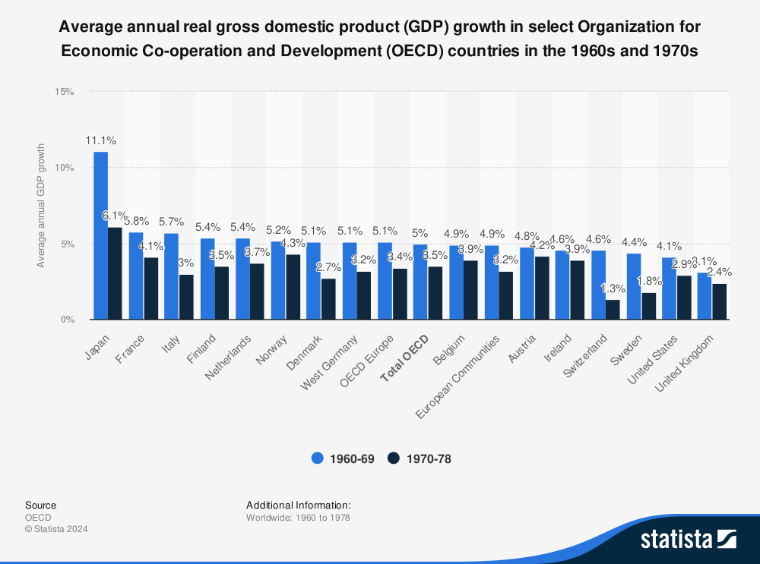

Perry Anderson wrote in 1964 (1964: 260), in words that could be used today:

British society is in the throes of a profound, pervasive but cryptic crisis, undramatic in its appearance but ubiquitous in its reverberations. As a result a Labour Government seems imminent. So much everyone agrees. But what do these phenomena mean? What kind of crisis is it?

Anderson suggests that the foundations of the crisis lay in the failure of the bourgeoisie to establish a modern state leading to a situation where a powerful economic powers confront a weak state, with the UK never establishing the sort of bureaucratic governance that developed in other European powers. For Anderson (1964: 261):

Today, Britain stands revealed as a sclerosed, archaic society, trapped and burdened by its past successes, now for the first time aware of its lassitude, but as yet unable to overcome it. The symptoms of the decline have been catalogued too frequently and copiously to need repetition here: a torpid economy, a pinched and regressive education, a listless urban environment, a demoralized governing class, a wretched cultural provincialism..

Much of the basis of the continuing crisis of the British state is in a sense ideational and historical in that it derives from the conception of the state that is reproduced by the political elite. Historically at the core of this conception is the way Empire has continued to shape government. Empire has had very significant impact on how the British state is both perceived and operates. First, is a continuing sense of hubris; a genuine belief amongst parts of the ruling elite both that the UK is a world leader and that it has some of the best services in the world: the best police, army, BBC, education, Universities, health system etc – even when these services are often failing. And, of course, it is this hubris that played a large part in the debate over Brexit and the belief that despite long periods of weak economic growth, the UK could operate effectively outside of the world’s largest trading bloc.

Empire also institutionalised a particular form of state. It reduced the need to develop strong central capacity as the functioning of the economy depended, not on developing the domestic economy, but on extraction, exploitation and trade (Cain and Hopkins 2016). The initial expansion of the Empire was effectively a private enterprise with for instance the East India Company being the key organisation behind the colonisation of India (Dalrymple 2019; Braddick). Hence the role of the military was largely to protect trade routes so that exploitation could continue. The UK’s position as a world power led to a focus on free trade rather than economic intervention as the key element in economic expansion resulting in a state that rarely developed a economic policy based on any form of direct state activity (Hall 1986)

The legitimacy of the nineteenth century political system to a large degree was dependent on the largesse of the Empire system. Empire revenues allowed the state to expand the professional, middle and upper classes without a high burden of taxation. Moreover, the Empire provided an endless stream of comfortable positions in military service and the colonial services throughout the Empire. This complex structure of posts, according to Kirk Green (2000: 22) ‘was a clear example of the homogenizing public school code and culture duly translated into the ethos and the esprit de corps of Britain's imperial administrative elite’. Thus the colonial civil service perception of itself as a professional cadre floating above the chaotic everyday world of empire was a construction that embedded itself in the domestic civil service creating the sense that ‘the man in Whitehall knows best’- an essentially centralising conception of policy making which continues to shape the British state today.

Perhaps more determining in terms of the impact of the Empire state is the conception of sovereignty within British political discourse and constitution. In the mid-19th century – a point when the modern constitution was crystallising, Britain controlled large parts of the world and was able to strongly assert its sovereignty. Its sovereignty derived from its dominant position in the world combined with a monarchical view that state power is concentrated in a single body (physical or metaphorical). Consequently, as power shifted from the monarchy to Parliament it was Parliament that became the sovereign body.

Fundamental to the British constitution was, and continues to be, Parliamentary Sovereignty. This conception of sovereignty was clarified by Dicey (1885), whose text shaped how sovereignty has been understood over the last 100 or more years:

The sovereignty of Parliament is the dominant characteristic of our political institutions. Parliament means…the King, the House of Lords and the House of Commons; these three bodies acting together may aptly be described as the ‘King in Parliament’…Parliament thus defined has, under the English constitution, the right to make or unmake any law whatever; and, further, that no person or body is recognised by the law of England as having a right to override or set aside the legislation of Parliament.

The absolutist nature of this conception of sovereignty is striking. And was reinforced in 2005 by the pronouncement of Lord Bingham in Jackson v Attorney General:

The bedrock of the British constitution is, and in 1911 was, the supremacy of the Crown in Parliament . . . Then, as now, the Crown in Parliament was unconstrained by any entrenched or codified constitution. It could make or unmake any law it wished. Statutes, formally enacted as Acts of Parliament, properly interpreted, enjoyed the highest legal authority(House of Lords 2005).

By establishing the Crown-in-Parliament, the absolute power of the monarch is transferred to Parliament. The United Kingdom Government could act without external, or internal, limit. Parliament effectively became the embodiment of absolute monarchical power. As the power of the monarch declined, power did not shift to the people but to Parliament. This absolutist sense of sovereignty was of course mythical, because all states and political actors face restraint, but it was developed at a time when the UK as an Empire state faced little limit on its power(Krasner 2009). This conception of sovereignty reinforces the highly centralising nature of the British state. As no authority is higher than Parliament cementing the centralising tendencies of the British state. Whatever the organisation of the state, Westminister/Whitehall remains the dominant authority.

However, one of the key contradictions of the Empire state – and one that is reproduced today is that whilst the state was based on a centralising principle, the governing of the Empire was often ad hoc and incoherent, with little direction from the centre. Whilst the 19th Century was a period of almost continual colonial expansion, the preferred way of expansion was informal ‘resulting from economic and cultural forces’. Formal empire was seen as a last resort (Robinson and Gallaher p.41) Imperialism’s ‘official mind’ was guided by its own traditions, memories and values, and set apart from the rest of society by birth, education and lifestyle. It developed a strong concept of the ‘national interest’ centred on the maintenance of British supremacy in India, the unique political, economic and strategic value of which meant that Victorian statesman were prepared not only to intervene much more directly int its affairs than in those of other colonies, but to contemplate the acquisition of territories in other parts of the world to ensure it future safety and stability. For the real British Empire was not just bloc of territories to rule. It was a colossal jigsaw of dependencies and protectorates, settlement colonies and ‘spheres of influence’, trucial states and treaty-ports, enclaves and entrepots…..(Darwin quoted in Kumar 2017: 318).

This elite, centralised and ad hoc form of governance was embodied in the codification of a ‘constitution’ that was essentially self-governing. The underlying principle of the British constitution has always been elite rule. As Bagehot stated: ‘Once you permit the ignorant class to begin to rule you may bid farewell to deference for ever’. Power was, and still is (at least in England), concentrated in Westminster and the Executive. A common theme in liberal thought from JS Mill’s view of democracy to Douglas Jay’s ‘ the man in Whitehall knows best’ is that only the ‘educated’ can really be involved in government(Mill 1861; Jennings 1966. From this perspective representatives have to us their own judgement rather than, to coin Joseph Chamberlains phrase ‘truckle with the multitude’. Nevertheless, class pressure did lead to the extension of the franchise in 1868, to full male suffrage in 1918, and to universal suffrage in 1928. However, in the British case suffrage did not lead to participation. Voters remained subjects and sovereignty was embedded in the Crown-in-Parliament. Essentially the British constitution was an internally constituted system, where governors set the rules, reproduced the rules and determined when the rules were broken (as the Cabinet Secretary Simon Case said in 2022 to the Public Accounts Committee, only the Prime Minister can determine whether the Prime Minister should be investigated for rule breaking. (Public Accounts Committee 2022). The only role for the public was to elect the government. As a report by the Institution of Government illustrated:

the UK system is in theory self-regulating. It relies on those within being willing to exercise restraint, adhering to largely unwritten rules of behaviour, and, when they fail to do so, facing political consequences. In recent years , various political actors have shown an increased willingness to test constitutional boundaries….Debates over constitutional principles have increasingly been considered secondary to other political goals (Sargeant, J, et al 2023).

The early twentieth century saw the settlement of the modern constitution. The Monarch was consigned to a ceremonial position, the Lords’ veto was removed, and party discipline secured executive dominance. With executive dominance, a Diceyian conception of absolute sovereignty became embedded in the constitutional imagination of the elite. The post-war constitution was made up of an interlocking set of relationships including First Past the Post electoral system (FPP), parliamentary sovereignty, cabinet and ministerial responsibility and secrecy. At least until the 1970s, FPP produced single-party government. The electoral system reinforced the idea that the election was a winner-take-all process that resulted in strong government, creating clear lines of responsibility in terms of decision making. With the cementing of party discipline, sovereignty was firmly located in the executive as the post-war years saw the nationalisation of politics, as both public and private sectors were drawn into the remit of central government. Government at the centre took control of health, education, social services and welfare as well as key industries. At the same time, the principle underpinning the executive was one of collective responsibility, whereby (much like democratic centralism) debate within government could occur up to the point where decisions are made and then all are bound to defend them. The Labour politician, Douglas Jay (1907-1996) embodied the combination of a whiggish, nineteenth century elite liberalism and Fabian social democracy with the statement that ‘in the case of nutrition and health, just as in the case of education, the gentleman in Whitehall really does know what is good for the people better than the people know themselves.’( Jay 1937) Whilst Richard Toye suggests that this quote has been used to misrepresent Jay and has become apocryphal, it does represent a culture of British governance underpinned by the constitution which allowed the development of a form of elite modernism that dominated post-war British politics (Toye 2002).

The combination of sovereignty and elite self-government led to a form of accountability which facilitated the reproduction of the core pathologies of the British state. Accountability is a fundamental feature of the British political system. Constitutionally It underpins the whole functioning of British democracy. The argument is the Parliament is sovereign and governments are elected to make decisions. If they make poor decisions voters can choose can vote for a new government. The first past the post system provides simple choices and enables voters to punish poor performance. However, the electoral system is capricious, and voters vote for a range of reasons, making elections a weak accountability mechanism. So the BPT maintains that Ministers are accountable to Parliament, through oral and written questions, parliamentary debates, votes on legislation and select committees, Ministers have to answer for what they do. Moreover, as the British politics textbooks point out, accountability has two dimensions: individual and collective. Through individual responsibility Ministers are responsible for their actions within their departments and Collective, Cabinet Responsibility that they are also responsible for the actions of the government agreed in Cabinet and consequently Ministers cannot speak out, or act against, the collectively agreed actions of the Government.

What is of interest how the functioning of accountability in terms of how the Treasury operates and how it is held to account and to what extent the fragmentation of governance has affected the operation of accountability. In order to understand the role of accountability, there are two important points that need to be considered. First accountability is political and not constitutional. The British constitution is in many ways a fiction. Rather than existing as a written document, the rules of the constitution are determined by practice and that practice is in effect a political decision (see Smith 2025). Consequently processes of accountability usually operate to political criteria. Who is accountable, who they are accountability to and the consequences of accountability are highly contingent and dependent of political circumstances. Whether a Minister is held responsible for a poor decision depends on the political strength of the minister, the political circumstances at the time, the relationship between the Minister and the Prime Minister.

Second, as Judge (1993) makes clear, the nature of Ministerial accountability reinforces the hierarchical and centralized nature of British government. The fact that it is Minister who are accountable to Parliament means that power is hierarchical and situated at the apex of Government in departments and ultimately the Minister. As Ministers are accountable to Parliament, all activities within the sphere of a Department are ultimately the responsibility of the Minister. As a result, accountability is drawn upwards. It is rational for Minister to be risk averse and to want to have strong oversight of activities within the Department because accountability is at the apex of government. Those making and delivering public policy are accountable to the centre of government and not downwards to recipients of policy. This notion of accountability is reinforced by the strong view that the policy making process should remain secret and therefore the process of accountability is always post hoc. The options and advice Ministers receive is not open to challenge.

As Denham and Morphet (2024: 6) emphasise:

The centralisation of England has taken place within a UK state wedded to the Anglo-centric Westminster model of sovereignty whereby the UK government is held to be accountable solely to Parliament through its departmental ministers. This formal political accountability was underpinned and rein-forced by the accountability of permanent secretaries in their AO roles to Parliament and HM Treasury, while Anglocentric constitutionalism fostered a political culture whereby ministers are responsible for English domestic policy and are held accountable by the media, as well as Parliament, for even the most local of service failures. The culture provides a powerful incentive to ministers to reduce the scope of local government and increase their own power and responsibility in the often vain hope of raising the quality of provision and the effectiveness of the state. Doing so has not succeeded and the evidence of the accelerating failure of the central state has surely prompted Labour’s commitment to devolution and mission-led government. It is less clear whether Labour has appreciated the constitutional radicalism that this implies.’ (Denham and Morphet 2024: 6)

Hence there is an interesting contradiction in the tensions between Ministerial accountability and fragmented governance. The complexity of governance processes makes it increasingly the case that Ministers are able to ‘blame shift’ (Hood and Rothstein 2001) arguing that they cannot be held responsible for decisions or outcomes over which they did not have direct control. Yet the principles of Ministerial Accountability continually pull responsibility back to the centre. Moreover, as an National Audit Office report highlights, this produces suboptimal outcomes in terms of policy:

Each department’s accounting officer is responsible and accountable to Parliament for that department’s funds. This means that without additional accountabilities being set up, there is little incentive for departments to spend money delivering benefits or savings for other parts of government. (National Audit Office 2024: 23)

Different modes of governance have not led to the development of different modes of accountability and, again, the consequence is local agencies and central government work to different logics and there is little sense of the importance of outputs in relation to citizens.

The fundamental issue in terms of both democracy and effective policy is that like the rest of the constitution, accountability is political. Frequently, the role of accountability is not about holding Ministers to account for poor policy outcomes to legitimize a secretive and majoritarian form of decision making. Accountability is effectively a game where Parliament, and to some degree the media, aim to hold Minister to account for their decisions and actions whilst Ministers continually protest their effectiveness and/or shift blame.

The argument is that a combination of a ‘Empire state of mind’, parliamentary sovereignty and accountability have continued to shape the operation of the state. Moreover, this 19th Century conception of state has failed to adapt to the very different circumstances. Ad hocery has developed in state of reform leading to a state without the capacity to manage the myriad of bodies that have developed.

**The Failure to Reform Britain’s Premodern State**

To invoke Tom Nairn (1977b), the British state remains ‘premodern’. Britain has muddled through by relying on a set of premodern traditions and practices – largely a monarchical and aristocratic form of government – which have endured through a capacity to incorporate first the bourgeoisie (nineteenth century) and then the working class (twentieth century) into its existing structures. Anderson (1964) suggests that the foundations of the post-war crisis lay in the failure of the bourgeoisie to establish a modern state, leading to a situation where powerful economic forces confront a weak state, with the UK never establishing the sort of modern, bureaucratic governance that developed in other European powers:

Britain stands revealed as a sclerosed, archaic society, trapped and burdened by its past successes, now for the first time aware of its lassitude, but as yet unable to overcome it. The symptoms of the decline have been catalogued too frequently and copiously to need repetition here: a torpid economy, a pinched and regressive education, a listless urban environment, a demoralized governing class, a wretched cultural provincialism. All these burdens of the present have their origins in blessings of the past. This past is not merely that of the imperialist era, as so many socialist—and capitalist—critics now repeat. It extends both backwards and forwards far beyond the late 19th century, which, as has been indicated, in the main saw only a final consolidation of the superstructure of modern British society (Anderson 1964: 26).

To some degree the Anderson critique was widely accepted. Then, the Profumo scandal and the emergence of an aristocrat as Prime Minister (Alec Douglas Home) shone a light on the increasingly anachronistic aristocratic, elite rule. In this context, there were attempts at reform throughout the next three decades.

Harold Wilson’s 1964-70 Government committed to modernising the British state and economy, harnessing the ‘white heat of technology’. The reality was somewhat more mundane, rooted in the Whiggish tradition of incremental adaptation, rather than the more radical, Continental rationalist tradition – a pattern set to repeat itself over the ensuing decades.

The hallmark of Wilson’s reform was more akin to institutional tinkering. The Fulton Committee (1968) was established to propose a new type of civil service and a new Department of Economic Affairs. The latter with its National Economic Plan was intended to drive economic productivity and break the UK out of its boom/bust economic cycle. Both, however, ran into the sand.

The subsequent Heath Government (1970-74) again promised a modernization of Britain’s economy and reform to Whitehall, but his approach contained commitments both to tradition and to modernisation. A number of measures sought to strengthen the centre of government, including a commitment to proper policy analysis and long-term planning. A newly created Central Policy Review Staff was tasked to focus on strategy and horizon scanning. In a precursor of managerialism, Heath introduced new management systems for controlling public spending and ‘super ministries’ intended to resolve the problems of departmental silos. However, the Conservative administration of 1970-74 was short-lived, weakened by a series of policy U-turns, escalating economic problems and widespread industrial unrest (Warner 2023).

The growing contradictions of the British state were further illustrated by the 1974-79 Labour government which, constrained by continuing economic and industrial relations problems, found itself cornered into obtaining a loan from the IMF. The imposition of ‘Cash Limits’ on spending undermined many of the principles of the Keynesian Welfare State. A powerful critique took hold - spurred on by newly emerging centre-right think tanks like the Centre for Policy Studies and the Institute for Economic Affairs - on the themes of government overload and ungovernability. It was advanced in both the academic literature (King 1975, Brittan 1975, Jay 1977) and by a small but increasingly prominent set of Conservative politicians – Enoch Powell, Keith Joseph and Nicholas Ridley. In the midst of this ‘first wave crisis’ (Richards et al. 2019), Britain’s pre-modern state limped on with its Constitution, alongside the WM’s and BPT’s governing framework remaining almost wholly unreformed. However, further challenges lay afoot, with closer integration into the European Union, questions about the sustainability of the ‘elective dictatorship’ (Hailsham 1978) and growing tensions with the Union, particularly in Scotland and Northern Ireland (Mackintosh 1977).

**Muddling Through: Thatcherism’s New Public Management and New Labour’s Constitutional Tinkering**

The Thatcher/Major Governments (1979-97) and then New Labour (1997-2010) adopted contrasting (and to some degree contradictory) approaches to the question of reforming Britain’s pre-modern state. Thatcherism what was presented as a neo-liberal ‘revolution’ concerned with reducing the role of the state, cutting public expenditure and unleashing the market as the mechanism to modernise the UK economy, offload costly nationalised monopolies and discipline the public sector. This neo-liberal inspired project has been characterised, somewhat inaccurately, as a ‘hollowing out’ of the state (Rhodes 1997).

Throughout this period, various waves of New Public Management (NPM) informed reforms were rolled out, but quickly appeared less viable in complex policy areas such as health or education, where quasi-markets did not drive a performance transformation (Hood and Dixon 2015). NPM notably saw the development of arms-length agencies to deliver public services from the late 1980s. Subsequently, in the 1990s the creation of separate entities (such as trusts) in health and education followed to further promote competition between schools and hospitals and to increase the power of citizens as consumers.

Two points are crucial. First, despite their claims to be radical reforming administrations, Conservative Governments throughout this period left the Constitution largely untouched, committed as they were to the BPT and the mythology surrounding the WM’s system of government, much to the regret of some on the New Right (Hoskyns 2000). The Thatcherite ideology might emphasise the need for less state intervention in the economy, but at the same time, the polity still needed strong, rather than a responsive, government. The outmoded and unreformed political tradition remained in place.

Second, although Britain’s pre-modern state remained largely intact, despite the advancement of neo-liberalism throughout this period, the imposition of managerialist informed reforms created a major problem; the NPM proved increasingly incompatible with the value system of Westminster and Whitehall (Smith 2009). If Parliament is sovereign and accountability and responsibility reside with ministers who answer to the House of Commons, how can decisions be made in agencies or by private organisations? If one school performs better than another, who is responsible the Headteacher or the Secretary of State for Education? As such, as Marsh et al. (2024), Powers (1999) and Innes (2023), among others, have observed, NPM did not lead to the emergence of a differentiated polity (Rhodes 1997), but rather to the development of new mechanisms of control. The incompatibility of the traditional notion of ministerial responsibility and centralised control with increasingly complex and fragmented governance systems, meant that managers were not left to manage. Ministers operating in an adversarial polity based on a ‘winner-takes-all’ electoral system were primarily focussed on *political* outcomes not *policy* outcomes.

The key point here is that the value system of the WM and the BPT embeds central control, but NPM points to decentralisation and marketisation, weakening that control. The paradox is less effective control, paranoia at poor outcomes and attempts to reassert control, further undermining decentralisation. It’s an archaic and linear approach to ministerial accountability that does not take account of how governance has changed. In relation to the market (commercial confidentiality etc), the levers of control are even fewer and more opaque, but service delivery is ostensibly cheaper, at least in the short term. From this perspective, there is an obvious incompatibility between the WM and BPT and the consequences of NPM. The unforeseen consequence, as we see below, is that the route map of reform pursued by the UK, guided by a pre-modern state navigator but tracking to a set of a market-informed reforms, was a mess, its end destination an increasingly incoherent system of government.

Blair’s New Labour initially offered hope that it had understood the inherent contradictions between the WM/BPT and NPM, by staking out a very different approach to resolving the problems of Britian’s pre-modern state. The Government also came to power with significant popular support and with a stronger economy. This seemed an opportunity to significantly weaken the grip of the BPT.

Like Harold Wilson, Blair focussed on modernising Britain by promising a range of constitutional reforms and, indeed, Labour’s period in office saw the only sustained and conscious era of constitutional adaptation in British history; it was committed, among other things, to electoral reform, devolution, introducing freedom of information legislation and reform of the House of Lords. Marsh and Hall (2007) chart and explain the fate of this constitutional reform agenda. In each case the reforms were either not introduced or they were deradicalized (see also Gamble 2010).

Overall, this was a missed opportunity for major constitutional change. New Labour largely opted for the status quo and working within the established traditions of the Party and the core tenets of the WM and BPT (Diamond 2021). It fell into the trap of adopting an incremental and limited approach to reform, falling well-short when it came to fundamentally addressing the inadequacies of Britain’s pre-modern state.

To compound these shortcomings, throughout its time in office New Labour continued to build on, rather than replace, the top-down, managerialist approach to reforming public services (Richards and Smith 2006). A new wave of NPM continued in the form of an extensive use of targets, league tables and public-private partnerships. Again, the tensions between NPM and the WM were clear to see as Blair was concerned to strengthen the centre of government and increase capacity round the Prime Minister. The creation of a Delivery Unit saw the Prime Minister intervene very directly in the detail of policy delivery (Smith et al 2011). This might have produced some much-needed improvements in standards, but the top-down model neglected to empower local actors or embed long-term systemic resilience.

**From a Pre-Modern to an Incoherent State: Austerity, Complexity and De-constitutionalisation**

The combination of the 2008-09 financial crash and the 2010 election of a Conservative-Liberal Democratic Coalition Government committed to austerity, led to an unprecedented squeeze on the public sector (Crawford and Johnson 2015). The impact of cuts at both central and local levels further reduced the capacity, but intensified the complexity, within the governance processes. The Coalition increasingly relied on third sector organizations and short-term funding for the delivery services. This created a complex pattern of overlapping services functioning often through personal connections and with increasingly confused lines of accountability (Solar and Smith 2022) (see figure 1). It also launched a new wave of devolution deals, at first under the tagline of the Northern Powerhouse, but which latter focused on city-regions. Most commentators initially supported the agenda, while eliding over the extent to which devolution was strictly controlled from Whitehall, or more precisely the Treasury. English devolution was a top-down process, rolled-out in an ad hoc and inconsistent fashion, rather than being informed by the principle of subsidiarity. Different regions were subjected to a range of variegated requirements based on the offer of a complex and changeable set of powers (Richards and Smith 2015).

The evolution of the metro-mayor model in the form of combined authorities creates a further contradiction to the Westminster system. The problem is that the metro mayors have no formal place in the constitution and their powers are contingent on the whims of the executive (see figure 2). Whilst few people think this process can now be reversed, it still leaves incomplete sub-national governance arrangements vulnerable. Consequently, their significance to some degree depends on their effectiveness with soft power. We have already seen metro mayors carving out their roles with unanticipated consequences for central-local relations (Giovannini, 2021). As Newman (2024) illustrates, the government has: ‘…this new unknown beast, which is a load of Labour mayors that have quite a powerful voice and speak quite clearly for parts of the country that have become politically important’. This creates further uncertainty in the system because much of the power of the region will be about politically negotiated settlements with local leaders, not the establishment of a clearly defined framework of powers for each layer of government. It further amplifies the British state’s incoherence, with powers varying across region and no clear procedures for establishing appropriate governance mechanisms (Newman et al. 2024).

Figure 1

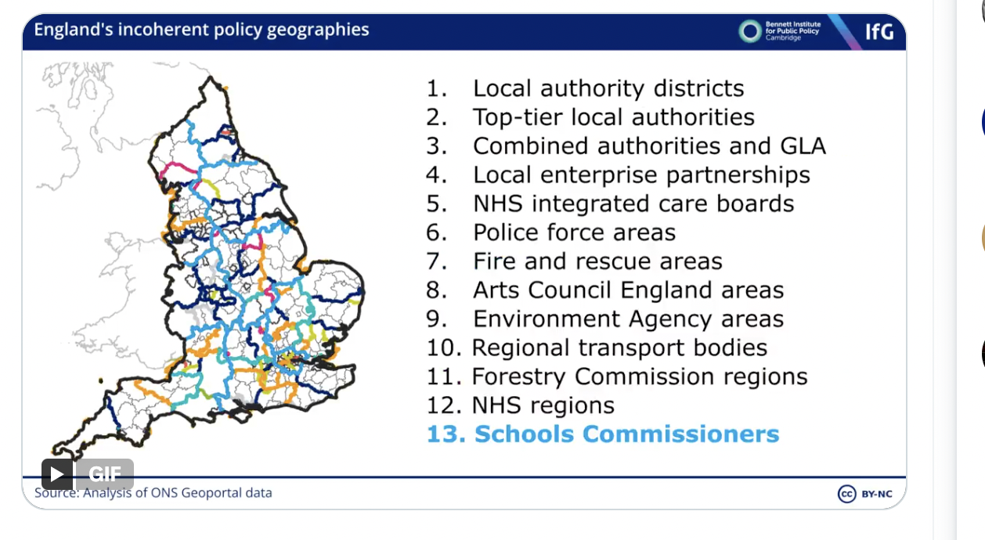

Newman and Kenny 2023.

Figure 2

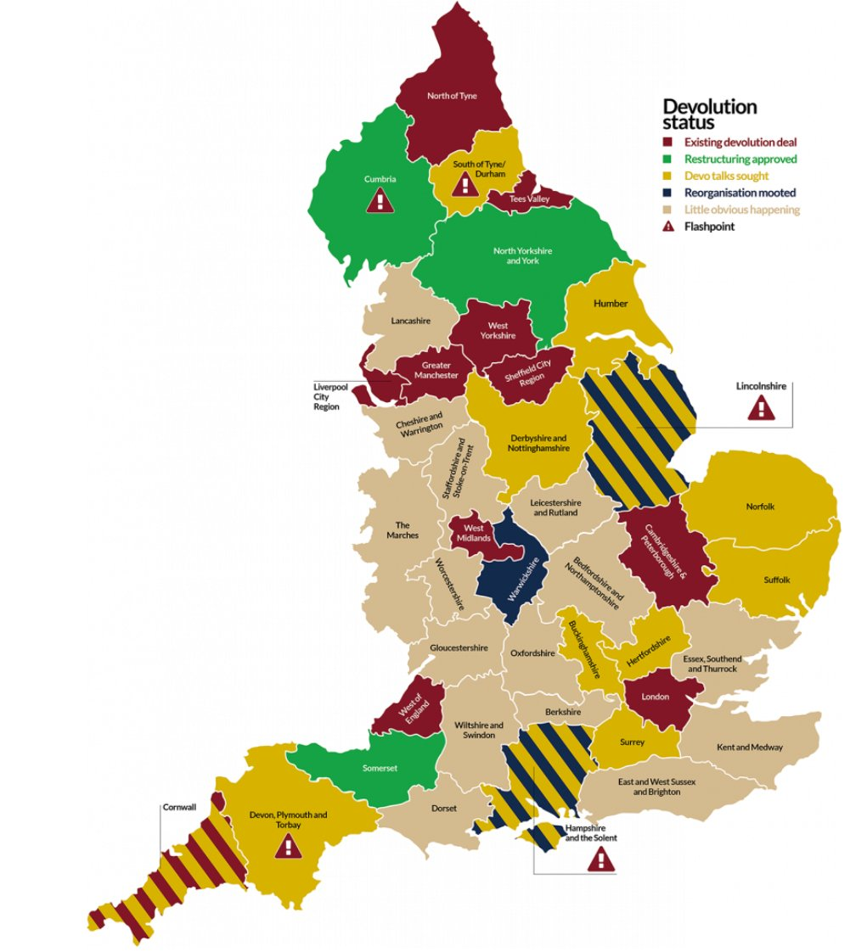

The potential dislocation wrought by the 2016 decision for the UK to leave the European Union has led to the most de-stabilising period of Conservative Government with five Prime Ministers coming and going. Of most note was the 80-seat majority commanded by the Johnson Government in 2019, delivered on the back of appeals to ‘Get Brexit Done’ and a Labour Party itself plagued by infighting under the leadership of Jeremy Corbyn. Brexit presented a window of opportunity to once and for all see much needed wholesale reforms to Britian’s pre-modern state. Instead, what was served up was a backward-looking Eton-mess, informed by what Weale (2016) labels ‘democratic nostalgia’, an approach predicated on an ephemeral desire to fortify the primacy of the Westminster model through the reassertion of a strong notion of sovereignty. Whilst the slogan – ‘Take Back Control’ – had electorally proved to be a highly effective rhetorical device for the Johnson Government, it masked what was absent below the surface - a coherent blueprint for post-Brexit Britian, both domestically and internationally. This void predictably led the Government down a well-trodden path of muddling through, ad hocery and centralisation (Ward 2021). Incremental adaptation once again was the only game going on in the Westminster town.

What is revealing is that, despite appeals to reassert Parliamentary Sovereignty, the Johnson administration did not seek to deliver on this through a constitutional process of renewal and reinvigoration. Instead, it opted for the very opposite. The very flexibility of Britain’s uncodified constitution created the opportunity for one of its own to traduce the very value-set they would have been expected to uphold.

The argument here is that the asymmetries in the political system have been reinforced by an explicit process of what we label de-constitutionalisation that occurred largely during the Johnson administration. This version of ‘democratic backsliding’ (James 2023) saw the flexibility of the constitution over-stretched purely for political ends. As Sanders (2023) notes, Johnson persistently violated ‘the constitution’. He illegally prorogued Parliament, frequently lied in the Chamber, ignored the advice of his ethics advisor and the Committee on Standards in Public Life, violated the rules on appointments to the House of Lords and undermined the independence of the Electoral Commission. In addition, there have been an increasing number of occasions through the recent period when Ministers have ignored or overruled Civil Service advice, not just in terms of policy which is legitimate, but in cases where the government threatened to break international law in relation to the EU withdrawal agreement (Rutter 2022). However, the key point is that these decisions were not just personal but a consequence of the asymmetric structures of the British political system. The very flexibility of Britain’s uncodified constitution, reliant as it was on the ‘good chaps [sic] theory of government’ (see Priestly 1986, cf. Blick and Hennessy 2019) - itself an elite construct based on the notion that those drawn from a particular social strata would understand and respect the informal rules of the game – ironically created the opportunity for one of its own to traduce the very value-set they would have been expected to uphold.

What we see in the post-Johnson Conservative Governments is a further attempt to use Parliamentary Sovereignty’s mythological status to reassert the dominance of the executive. The idea of a functioning, yet uncodified constitution having the capacity to constrain politicians, has not withstood the highly political approach within the governing Conservative Party. Executive control of the Parliamentary agenda is regularly used as a tool to stifle debate, drive legislation through and limit the scrutiny function of committees (Dunt 2023). The recent period has seen repeated attempts to reshape established rules beyond acceptable bounds, justified by appeals to the reassertion of indivisible and uncontested sovereignty.

In many ways, frustration with the difficulties of governing has led to calls for power to be pulled back to the centre, to ‘take back control’ paradoxically by undermining – not preserving – the myth of Parliamentary Sovereignty and associated constraints on Executive power. The European Union and the growing opposition to other international organisations such the European Court of Human Rights are manifestations of this tendency to blame checks and balances for the bureaucratic inertia of the UK state. Hence, the Conservative project, which does not contradict the BPT, is a continuation of the Thatcherite project of politicising policy decisions and concentrating power in the executive (Smith 2015). This on-going process of politicisation (illustrated most clearly by Brexit) means that decision making cannot be consensual but is increasingly majoritarian and integrated almost universally into all areas of the policy process. This *political* project draws legitimacy from constitutional conventions and traditions associated with the WM, despite being highly selective regarding – and even dismissive of – any constraints on executive power. Instability is now a product of the contradictions of Britain’s pre-modern state.

The consequences of this are most pronounced when reflecting on the process of governance and the evolving topography of public service delivery. What binds the period from the 1980s to the present is the scale of fragmentation driven by NPM, but without central government developing an effective system of metagovernance (Matthews 2013; Flinders and Huggins, 2021). As research on the Treasury reveals, the centre of government’s capacity to act with strategic authority has been at best sub-optimal (Warner et al. 2021; Richards et al. 2023). Much of the political and economic problems of UK governance flow from the UK’s pre-modern state arrangements that are now widely associated with a lack of strategic capacity, short termism, departmental silos and overly politicised decision making. An overly dominant Treasury has too much influence over policy resulting in decision-making being driven by input cost considerations, rather than longer-term policy outcomes. This short-termist, ‘penny wise pound foolish’ approach to management of the public finances would appear remarkably familiar to critics of the past (Pollard 1982).

The scale and variety of change has created a landscape of complexity that is challenging to map. NPM has been augmented in unanticipated ways as a result of ministerial centralisation (Diamond 2019) and, more latterly, the development of decentralised and collaborative forms of sub-national governance, broadly characterised by New Public Governance, as actors *beyond* Whitehall independently adapt to an increasingly incoherent state. The problem is that new funding models have not emerged, and governance processes are now increasingly fragmented and improvised. Alongside the rapidly changing map of English devolution, this has shifted the contours of the state and changed its architecture. The net result has been that of instability and persistent policy shortcomings which has eviscerated the capacity of the Westminster Government to ‘steer’ in a rational and strategic manner despite the governing class clinging to the mythology surrounding their own power. The complexity and fragmentation of the UK system is highlighted by the response to the Covid 19 pandemic (see Richards et al 2023). The process that was set up was highly centralised but at the same time contained a myriad of bodies often attempting to adapt local responses to central direction (see figure 3).

Figure 3 The Covid Policy Chain.

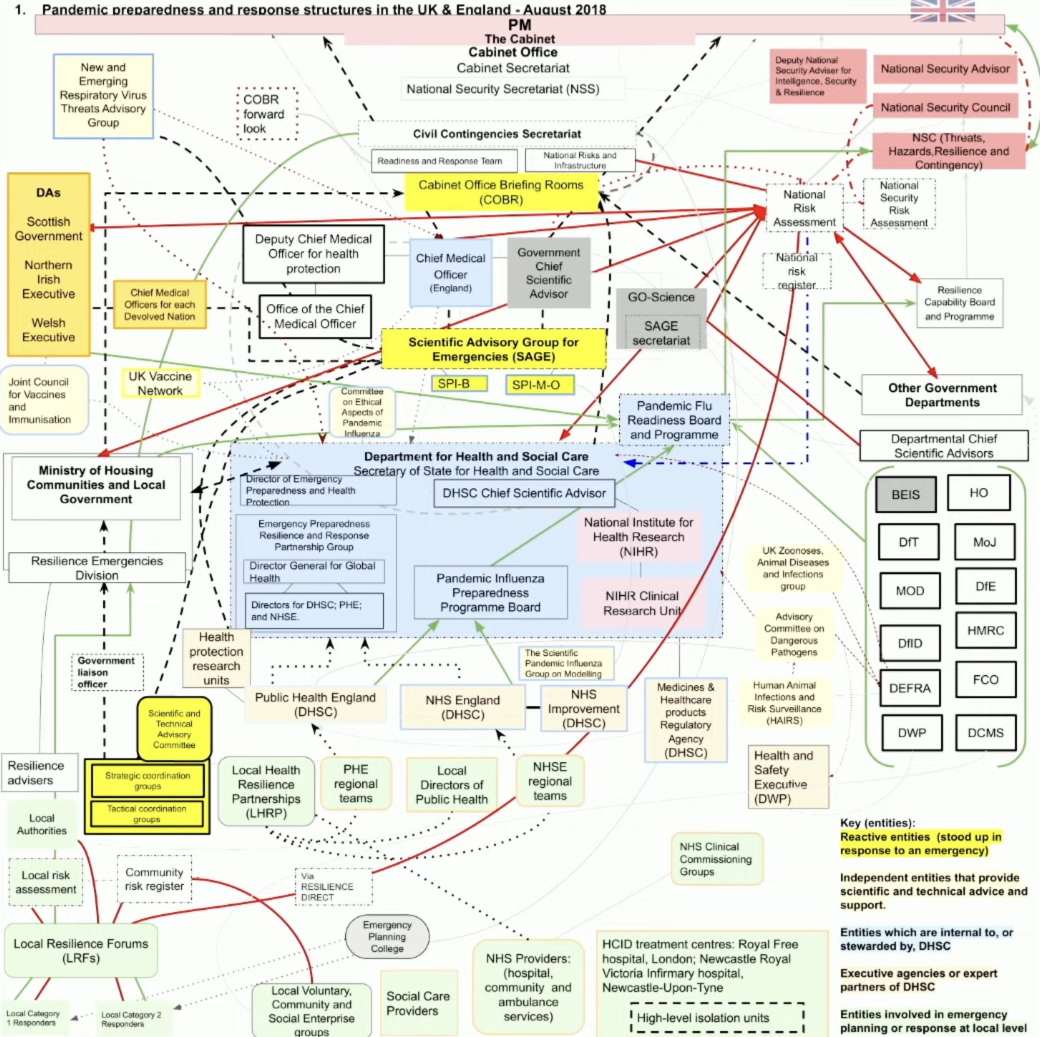

Across these various measures, the UK in general, and England in particular, are notably more centralised than other OECD and European countries. England is governed in more centralised ways than the UK as a whole because the devolved administrations are themselves counted here as decentralised institutions. There are, of course, separate debates about the nature of centralisation within Scotland, Wales and Northern Ireland. But in England it is clear that the UK government plays an abnormally expansive and determining role, while subnational institutions are limited in their scope and comparatively weak. These measures become particularly stark when we consider England’s population. Most larger countries have significant forms of decentralised government, while England sits alongside countries that are, in some cases, one tenth of its size. Few other developed countries try to manage the affairs of this many people from a single administrative centre. Across Europe and the OECD, Turkey is the only other large country (in population terms) that is more centralised than the UK. (Kenny and Shaw page 32)

**Conclusion**

The fundamental problem with the British system is the contradiction between highly centralised policy making and highly fragmented and uncoordinated policy delivery. Financial and legal resources are concentrated within Whitehall and this is reinforced by adversarial politics and upward accountability with make government at the same time opposed to consensus and risk averse. There is a widespread distrust of local organisations and a lack of understanding of the problems faced on the ground. This fragmentation and incoherence has been exacerbated by new public management and privatisations but actually reflect long term problems in the British state which are ad hocery, short termism, the inability to build capacity either at the centre or in the locality. Consequently, the UK has a policy system where central policy makers attempt to direct a incoherent, inchoate and under-resourced street level bureaucrats who are often focused on targets and objectives rather than the direct needs of citizens. This situation is made worse by the fact they are accountable upwards to politicians in Whitehall rather the people they are delivering services for. The classic problems of parliamentary sovereignty and accountability systems focus attention on the centre the performance of ministers and governments not services. Moreover, the fragmentary nature of neo-liberalism and NPM has created further tensions with the Westminster model. The need to retain political control contradicts the market incentives of NPM. This ad hoc and contradictory system of government makes it increasingly difficult to deliver policy effectively.

**Bibliography**

Anderson, P. (1964) ‘Origins of the present crisis’, *New left review*, *23*(1), pp.26-53.

Braddick, M.J., 1998. The English Government, War, Trade, and Settlement, 1625-1688. *The Origins of Empire*, *1*, pp.286-308.

Bevan, G. (2023) *How did Britain come to this?* London: LSE Press.

Cain, P.J. and Hopkins, A.G., 2016. *British Imperialism: 1688-2015*. Routledge.

Clarke, J. (2023) *The battle for Britain: Class, conflicts and* conjectures, Bristol: Bristol University PressCrawford, R. and Johnson, P. (2015) *The UK Coalition Government’s Record, and Challenges for the Future*, Institute for Fiscal Studies, 15 September; <https://ifs.org.uk/articles/uk-coalition-governments-record-and-challenges-future>

Dalrymple, W., 2019. *The anarchy: The relentless rise of the East India Company*. Bloomsbury Publishing.

Darzi, Lord (2024) *Independent investigation of the National Health Service in England,* <https://assets.publishing.service.gov.uk/media/66e1b49e3b0c9e88544a0049/Lord-Darzi-Independent-Investigation-of-the-National-Health-Service-in-England.pdf>

Denham, J. and Morphet, J. (2024), Centralised by Design: Anglocentric Constitutionalism, Accountability and the Failure of English Devolution. The Political Quarterly.

Diamond, P. (2019) The End of Whitehall? Government by Permanent Campaign. London: Routledge.

Diamond, P., Newman, J., Richards, D., Sanders, A. and Westwood, A. (2024) ‘Hyper-active incrementalism and the Westminster system of governance: Why spatial policy has failed over time. *The British Journal of Politics and International Relations*,

Dicey, A.V., 1885. *Lectures Introductory to the Study of the Law of the Constitution* (No. 43445-43449). London: Macmillan.

Dorling, D. (2023) *Shattered nation: Inequality and the geography of a failing state,* London: Verso

Dunt, I. (2023) *How Westminster Works and Why it Doesn’t.* London: Weidenfeld & Nicolson.

Finer, S.E. (1980) *The changing British party system, 1945-1980*, Washington D.C.: American Enterprise Institute.

Flinders, M. and Huggins, C. (2021) Modes of State Governance, Populist Pressures and Public Sector Reform in J. Connolly and A. van der Zwet (eds) *Public Value Management, Governance and Reform in Britain.* Basingstoke: Palgrave, pp.87-114.

Gamble, A. (2010) New Labour and Political Change.*Parliamentary Affairs*, 63(4), pp.639–652.

Giovannini, A. (2021) The 2021 Metro Mayors Elections: Localism Rebooted? *The Political Quarterly,* 92(3), pp.474-485.

Hall, P.A. (1986) *Governing the economy: The politics of state intervention in Britain and*

*France*, Oxford: Oxford University Press.

Hindmoor, A. (2024) *Haywire: a political history of Britain since 2000*, Harmondsworth: Penguin.

House of Lords (2005). Opinions of the Lords of Appeal for Judgment in the Cause: Jackson and others (Appellants) v. Her Majesty’s Attorney General (Respondent), UKHL 56.

Innes, A., 2023. *Late Soviet Britain: Why materialist utopias fail*, Cambridge: Cambridge

Institute for Government (2023) *Performance Tracker 2023,* <https://www.instituteforgovernment.org.uk/publication/performance-tracker-2023>

Jessop, R.D. (1971) ‘Civility and traditionalism in English political culture’, *British Journal of Political Science*, *1*(1), pp.1-24.

Jay, D., (1937). *The Socialist case*. Harmondsworth: Penguin.

James, T.S. (2023) *UK Democracy Under Strain: Democratic Backsliding and Strengthening 2019 – 2023.* London: Unlock Democracy.

Jennings, I. (1966) *The British constitution,* Cambridge: Cambridge University Press

Judge (1993) *The Parliamentary State,* London: Sage.

Kirk, N. (2024) *A nation in crisis: Division, conflict and capitalism in the United Kingdom*, London: Bloomsbury.

Kirk-Greene, A., 2000. *Britain's imperial administrators, 1858-1966*. Springer.

Krasner SD. (2009). *Sovereignty: an institutional perspective*. Routledge: London.

Kumar, K., 2017. *Visions of empire: How five imperial regimes shaped the world*. Princeton University Press.

MacLeavy, J. and Jones, M., 2021. Brexit as Britain in decline and its crises (revisited). *The Political Quarterly*, *92*(3), pp.444-452.

Marsh, D. and Hall, M. (2007) The British Political Tradition: Explaining the Fate of New Labour’s Constitutional Reform Agenda. *British Politics,* 2, pp.215-238.

Marsh D. and Rhodes, R. (1992) *Implementing Thatcherite policies: audit of an era*. Milton Keynes: Open University Press.

Marsh, D., Richards, D. and Smith, M.J., 2024. The asymmetric power model 20 years on. *Parliamentary Affairs*, *77*(4), pp.658-685.

Mill JS(1861) *Considerations on Representative Government,* Parker, Son and Bourn: London; Jay, D.

Nairn, T. (1977a) The twilight of the British state. *New Left Review*, 101(2), pp.3-61.

Nairn, T. (1977b) *The Break-up of Britain: Crisis and Neo-nationalism.* London: Verso.

National Audit Office (2024) *Lessons learnt a planning and spending framwork,* https://www.nao.org.uk/wp-content/uploads/2024/10/lessons-learned-a-planning-and-spending-framework.pdf

Newman, J. (2024) The State of UK Devolution, *UK in a Changing Europe Lunch Hour*, 19 March; <https://www.youtube.com/watch?v=Bfh3w7Cyvrg>

Newman, J., & Kenny, M. (2023). Devolving English Government. London: Institute for Government; <https://www.instituteforgovernment.org.uk/sites/default/files/2023-04/devolving-english-government.pdf>

Pollard, S. (1982) *The Wasting of the British Economy.* London: Croom Helm.

Priestley, C. (1986) ‘Promoting the efficiency of central government’, in Arthur Shenfield et al., *Managing the Bureaucracy* London: Adam Smith Institute.

Rhodes, R. (1994) ‘The hollowing out of the state’, *Political Quarterly* 65, 138-151.

Rhodes, R. (1997) *Understanding Governance: Policy Networks, Governance, Reflexivity and Accountability*. Milton Keynes: The Open University Press.

Richards, D. and Smith, M.J. (2015) Devolution in England, the British political tradition and the absence of consultation, consensus and consideration. *Representation*, 51(4), pp.385-401.

Richards, D., Warner, S., Smith, M. and Coyle, D. (2023) Crisis and state transformation: Covid-19, levelling up and the UK’s incoherent state. *Cambridge Journal of Regions, Economy and Society*, 16(1), pp.31–48.

Rosenau, J.N., 1992. *Governance without Government: Order and Change in World Politics*. Cambridge UniversityPress.

Rutter, J. (2022) *Relationship Breakdown: Civil Service – Ministerial Relations: Time for a Reset*. London: Institute for Government.

Sanders, D. (2023) One Man’s Damage: The Consequence of Boris Johnson’s Assault on the British Political System. *The* *Political Quarterly*, 94(2), pp.166-174.

Sargeant, J., Coulter, S. Pannell, J and Mckee, R. (2023) *Review of the UK constitution*, London: Institute of Government

Smith, M.J. (2025) ‘The British Constitution’ in Beers, L. (ed.) *The Cambridge History of Britain, vol. IV.* Cambridge: Cambridge University Press. [forthcoming].

Smith, M.J. (2015) From Consensus to Conflict: Thatcher and the Transformation of Politics. *British Politics,* 10, pp.64-78.

Smith, M.J., Richards, D., Geddes, A. and Mathers, H. (2011) Analysing Policy Delivery in the United Kingdom: The Case of Street Crime and Anti‐Social Behaviour. *Public Administration*, 89(3), pp.975-1000.

Solar, C. and Smith, M. (2022) Austerity and Governance: Coordinating Policing and Mental Health Policy in the UK. *Policy Studies*, 43(2), pp.352-369.

Sutcliffe-Braithwaite, F., Davies, A and Jackson, B. (2021) ‘Introduction: a neo-liberal age?’ in Sutcliffe-Braithwaite, F., Davies, A and Jackson, B (eds) *The Neoliberal Age? Britain since the 1970s,* London: UCL Press.

Tomlinson, J., (1996) ‘Inventing ‘decline': the falling behind of the British economy in the postwar years’, *Economic History Review*, pp.731-757.

Tomlinson, J. (2014) *The Politics of Decline: Understanding Postwar Britain* London: Routledge.

Tomlinson, J., (2016) ‘De-industrialization not decline: a new meta-narrative for post-war British history’ *Twentieth Century British History*, *27*(1), pp.76-99.

Tooze, A. (2021) *Shutdown: How Covid Shook the World’s Economy,* New York: Viking.:

Toye, R., (2002). ‘The Gentleman in Whitehall’ Reconsidered: The Evolution of Douglas Jay's Views on Economic Planning and Consumer Choice, 1937-47. *Labour History Review*, *67*(2), pp.187-205.

Truss, L. (2024) *Ten years to save the west: Lessons from the only conservative in the room,* London: Biteback.

Ward, J.W. (2021) Reasserting the Centre: The Brexit Doctrine and the Impetrative Mandate in British Politics. *Parliamentary Affairs,* 74(4), pp.890-910.

Ward, J. and Ward, B. (2023) ‘From Brexit to COVID-19: The Johnson government, executive centralisation and authoritarian populism’, *Political Studies*, *71*(4), pp.1171-1189.

Ward, J., Ward, B. and Kerr, P. (2024) ‘Whither the Centre? Tracing Centralisation and Fragmentation in UK Politics’, *Political Studies Review*, p.14789299241258629.

Warner, S., Richards, D., Coyle, D. and Smith, M.J. (2021) English Devolution and the Covid-19 Pandemic: Governing Dilemmas in the Shadow of the Treasury. *The Political Quarterly*, 92(2), pp.321-329.

Weale, A. (2016) Nostalgic Democracy Triumphs over Democratic Internationalism. *The Political Quarterly*, 87, pp.352-354.