Highlights
- PLA MPs adsorbed significantly more Cd than PE MPs
- Weathering led to the appearance of oxygen-containing functional groups in PE MPs
- Weathering increased abundance of oxygen-containing functional groups in PLA MPs
- Biofilms developed on MPs during weathering
- Increased adsorption of Cd after weathering was due to biofilms

Abstract: Biodegradable polylactic acid (PLA) mulch has been developed to replace conventional polyethylene (PE) mulch in agriculture to reduce plastic pollution and the accumulation of microplastics (MPs) in soil. Cadmium (Cd) is a significant soil contaminant, and can be adsorbed by MPs. It is increasingly recognised that in the natural environment biofilms can develop on MPs and that this can affect their adsorption properties. We exposed PLA and PE mulches outdoors for 16 months. MPs were then generated from pristine and weathered mulches. Biofilms developed on the weathered plastics. Oxygen-containing functional groups were detected on the weathered, but not the pristine PE, abundance of these groups increased for the weathered PLA. After removal of the biofilm the observed increases in oxygen-containing functional groups relative to the pristine plastics remained. In adsorption experiments pristine PLA MPs had a greater maximum adsorption capacity than pristine PE MPs (106 - 126 vs 23.2 mg / kg) despite having a lower specific surface area (0.325 m² / g vs 1.82 m² / g) suggesting that the greater levels of adsorption were due to MP chemistry. The weathered plastics adsorbed more Cd than the pristine plastics (e.g. maximum adsorption capacities of 153 - 185 and 152 mg / kg for the weathered PLA and PE respectively). However, after removal of the biofilm, adsorption of Cd to the weathered MPs was no greater than for the pristine plastics. This suggests that the increased adsorption of Cd due to weathering was caused primarily by adsorption onto the biofilm.

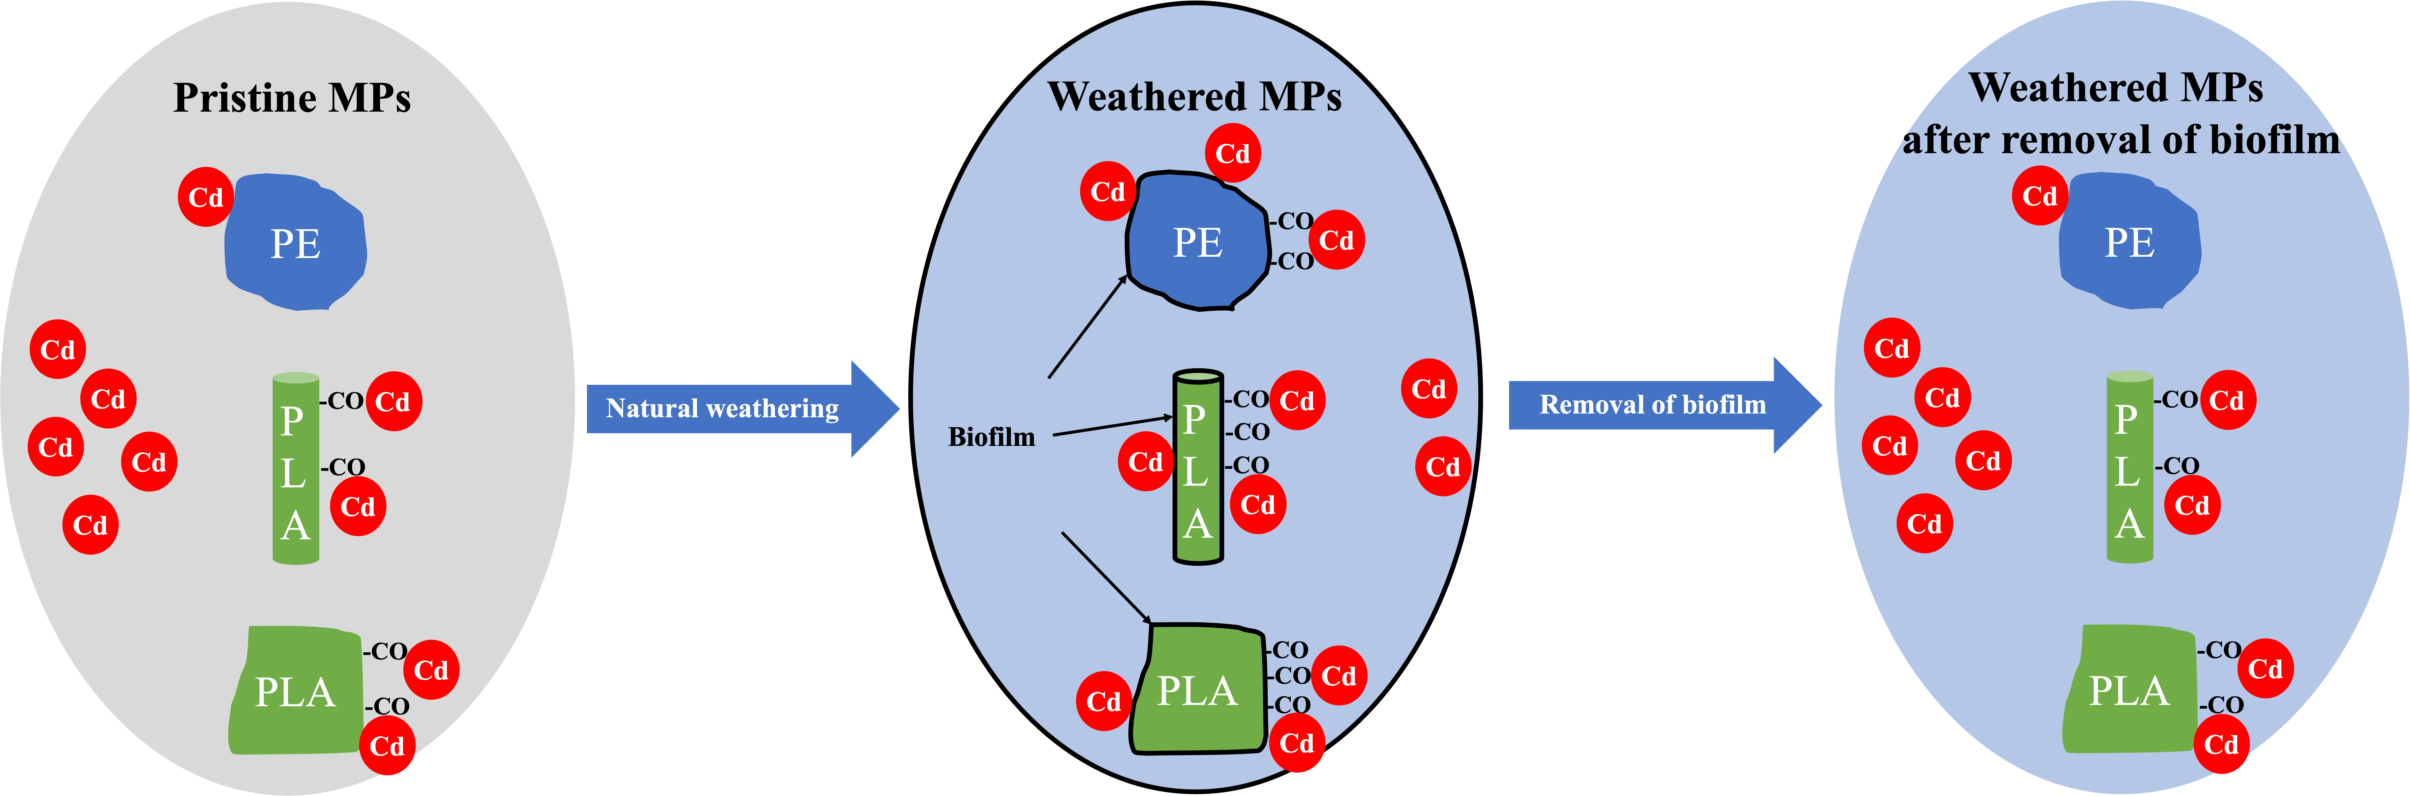
Graphical abstract

Key words: pristine MPs, natural weathering, biofilm, oxygen-containing functional groups, shape

Introduction
Agricultural plastic mulches have been developed to increase yields and improve crop quality (Deng et al., 2006, Kasirajan et al., 2012). The most commonly used type is polyethylene (PE) (Khalid et al., 2023, Qiang et al., 2023). It is estimated that over 8300 million tonnes of plastics have been produced globally, with PE accounting for 36.3 % of that figure, in addition, by 2023 annual plastic production rates were over 400 million tonnes (Singh et al., 2024, Plastics Europe, 2023). Biodegradable plastic mulches have been developed to replace conventional PE mulch as a response to growing concerns about plastic pollution (Sintim and Flury, 2017). In 2028, global bioplastics production capacity is set to increase significantly to approximately 7.43 million tonnes (Plastics Europe, 2023). Polylactic acid (PLA) accounts for the largest share (24 %) of total global biodegradable plastics manufacturing (Haider et al., 2019) and it has wider application potential in the future (European Bioplastics, 2022).

Under some management practices, plastic mulches are ploughed into the soil at the end of their use which could generate plastic debris with a range of sizes including microplastics (MPs), i.e. plastic material less than 5 mm in size (Thompson et al., 2004). Microplastic mulch residues could also form when mulch degrades during exposure to ultraviolet (UV) radiation and weather (Huang et al., 2020, Luo et al., 2022). Once MPs enter the environment, they can interact with contaminants, such as metals (Alimi et al., 2018, Gao et al., 2021a; Ricardo et al., 2021, Liu et al., 2022a, Luo et al., 2022, Li and Wang, 2023), potentially reducing the availability of metals to soil organisms (Cao et al., 2021, Hodson et al., 2017, Khalid et al., 2021, Xiao et al., 2024). Cadmium (Cd) contamination of agricultural soils is an ongoing challenge around the world (Burau, 1981, Quezada-Hinojosa et al., 2009, Park et al., 2010, Zhao et al., 2015, Niño-Savala et al., 2019, Gray and Cavanagh, 2023) often due to the use of Cd-bearing phosphate fertilisers (Niño-Savala et al., 2019) with Cd concentrations in soils being reported up to 47.7 mg / kg (Huang et al., 2024a). It is already known that MPs can adsorb Cd (Alimi et al., 2018, Wen et al., 2018, Zhou et al., 2020). Fei et al., (2023) and Jiang et al., (2024) found that pristine biodegradable PLA MPs adsorbed more Cd than conventional polyvinyl chloride (PVC) and polypropylene (PP) MPs. Most (> 99 %) conventional MPs found in arable land are PE MPs (Liu et al., 2022b) and PE MPs have been found to adsorb Cd (Wang et al., 2019, Zhang et al., 2020). However, it is not known how adsorption of Cd compares between PE MPs and biodegradable PLA MPs.

Weathering of plastic mulches may impact their adsorption of contaminants due to changes in their physical and chemical properties (Zhang et al., 2018, Duan et al., 2021; Ventura et al., 2024). The mechanisms of plastic ageing are complex and diverse and can be affected by environmental factors (Ding et al., 2020, Ge et al., 2023). The mechanisms include physical ageing (abrasion), chemical ageing (advanced oxidation and photo-oxidation) and biological ageing (microbial attachment and colonization) (He et al., 2023, Wang et al., 2023a). However, the majority of studies on ageing of MPs consider UV ageing and biological ageing has been neglected (Ge et al., 2023, Wang et al., 2023a). When exposed to the natural environment plastic mulches are readily colonised by microorganisms (Bhagwat et al., 2021). Microorganisms attach to the surface of plastics, reproduce and secrete polysaccharide substrates that encapsulate the bacterial colonies and lead to the formation of biofilms (Luo et al., 2022, Tu et al., 2020a, Wang et al., 2021, Moyal et al., 2023). These biofilms can increase the size, density and surface hydrophobicity of MPs, which may promote the transport and sedimentation of MPs in the environment (Ding et al., 2015, Chen et al., 2019). Furthermore, these biofilms can act as reservoirs for pathogenic microorganisms which can spread through the food chain (Keswani et al., 2016, Imran et al., 2019, Hirt and Body-Malapel, 2020). The biofilms may also modify the sorption behavior of the MPs. The adsorption capacity of conventional MPs (including PE, PS, PET, PA, PVC and PP) for divalent metals generally increases with artificial ageing (Chen et al., 2021, Gao et al., 2021b, Wang et al., 2023b) due to the roughening of the MPs surface, creating additional surface area, and the appearance of oxygen-containing groups on the surface of the MPs (Mao et al., 2020, Liu et al., 2022c). Huang et al., (2023, 2024b) found that biodegradable PLA had a greater adsorption capacity for divalent metal ions after artificial ageing, mainly due to an increase in oxygen-containing functional groups. However, the above studies (Chen et al., 2021, Gao et al., 2021b, Huang et al., 2023, Wang et al., 2023b, Huang et al., 2024b) only compared pristine with artificially aged (UV-aged and H₂O₂-aged) conventional and biodegradable MPs which may not be good representatives of naturally weathered MPs, particularly in terms of the development of biofilms (Hanun et al., 2021, Alimi et al., 2022, Lozano et al., 2023).

Therefore, the aim of this study was to compare the adsorption of Cd on MPs of the most commonly used conventional and biodegradable mulching plastics, PE and PLA respectively, and also to investigate their adsorption capacity before and after natural weathering. Previous studies mainly focused on MPs after artificial weathering which may not fairly represent naturally weathered MPs. As far as the authors are aware, this is the first study to directly compare adsorption of Cd on pristine and naturally weathered PE and PLA MPs generated from plastic mulches. This study will provide a better understanding of the mobility and distribution of Cd in agricultural environments where plastic mulches are used.

Materials and methods
Plastic mulch selection
Two types of plastic mulches, non-biodegradable PE (sold as “YYOBK Mo garden PE weeding film vegetable mulch film, 5 hole mulch film for plant cultivation greenhouse agriculture”) and biodegradable PLA (sold as “GBNHGYP Mo agricultural ground cloth orchard grass cover cloth durable degradable breathable moisturizing mulch, biodegradable ecological PLA mulch”), were purchased from the BEIJUANDEOZXIAODIAN storefront on Amazon. Details of their characterisation are given in the Supplementary Information (Text S1-3, Figs. S1-S3, Tables S1-S5). They were confirmed to be PE and PLA using Fourier transform infrared (FTIR) spectroscopy (Text S1, Fig. S1, Table S1).

Mulch weathering and MP generation
Large metre scale sheets of PE and PLA mulches were cut from the purchased mulching materials and hung outside to naturally age from 3rd April 2022 to 2nd August 2023 (Fig. S4); local mean monthly weather data for this period are shown in Fig. S4. Over this period the plastics will have been exposed to natural UV weathering, as well as changes in temperature and moisture level; also biofilms would be expected to form on the sheets. At the end of the exposure period, the weathered mulching sheets were rinsed with deionised water to clean dust from them, and air-dried. This cleaning process was necessary to prevent the presence of dust confounding our adsorption studies but may have impacted the biofilm. However, repeated exposure to rain during the weathering period did not result in removal of the biofilm and biofilm was still present after the cleaning process (see below) so we assume that the biofilm was robust and not substantially impacted by the cleaning process. Afterwards, both pristine and weathered mulches were cut into small pieces (2 cm²) using scissors, shredded using a Ninja blender and sieved to less than 2 mm. The PE formed planar particles whilst the PLA formed fibres. This generated the following sample types: pristine PE pieces (PPE), weathered PE pieces (WPE), pristine PLA fibre (PPLAF), and weathered PLA fibre (WPLAF). Because of the difference in the shapes of the PE and PLA, and in order to account for the possible impact of this on adsorption characteristics, pristine and weathered PLA mulches were also cut to produce similar shaped particles to the PE using scissors (generating pristine PLA pieces, PPLAP, and weathered PLA pieces, WPLAP). Finally subsamples of the weathered PE and PLA MPs were washed in absolute ethanol (vwrc20821.330) in an ultrasonic bath (Grant XUBA 3) for 15 mins to remove possible adhering biofilm (Tu et al., 2020b, Tarafdar et al., 2021) to generate: ethanol-washed weathered PE pieces (WWPE), ethanol-washed weathered PLA fibre (WWPLAF) and ethanol-washed weathered PLA pieces (WWPLAP).

Images of the particles (Figs. 1-3) were taken using an Axio Zoom V16 Microscope equipped with an Axiocam 105 colour camera and Zen 2 (blue version) software and a scanning electron microscopy (SEM, HITACHI TM4000Plus Tabletop Microscope) operated at an electron accelerating voltage of 5 kV. Additionally, the size and shape of the particles (n = 50 for each particle type) were analysed using ImageJ 2.3.0 / 151 1.53r (Fig. S3 and Tables S2-S4).

Ideally SSA would be measured using gas adsorption and application of the Brunauer-Emmett-Teller (BET) isotherm (Brunauer et al, 1938). We attempted to measure the BET surface area of our samples using a Micromeritics Porosimeters ASAP 2020 & Tristar with N₂ as the adsorbate following over-night degassing at 60 °C under a constant flow of N₂ using a VacPrep 061 (the temperature was chosen to avoid any melting of the plastic). However, the BET measurement needs sufficient materials to make an accurate measurement. We were only able to add up to 0.0182 g for PE, 0.0760 g for PLAF and 0.0182 g for PLAP of materials to the sample holders before they were full and unfortunately this mass of material was insufficient for measuring the surface area to a meaningful level of accuracy or precision. Therefore, we calculated geometric SSAs, i.e. we assumed that the particles had regular geometries. Such calculations will be approximations as they assume smooth surfaced particles and do not account for the surface roughness which is visible on our MPs (Figs. 1-3), a fact that we return to in the discussion of our results. For the PE and PLAP a cuboidal geometry was assumed using average areas obtained from imageJ (Tables S2, S4). We measured the thickness of the sheets using calipers as 0.0012 and 0.005 mm for PE and PLA respectively and therefore assumed that the surface area of faces perpendicular to the sheeting was negligible (Text S3). In contrast, to calculate the SSA of the fibrous PLAF MPs a cylindrical particle shape was assumed and the mean particle length and diameter as determined using ImageJ was used in calculations (Table S3). Densities used in our calculations were determined using pycnometers (see Text S2). PE density was measured as 0.917 ± 0.0003 g cm⁻³ and PLA as 0.924 ± 0.0002 g cm⁻³, which were in the range for these plastic types reported previously (Li et al., 2018a, Borges-Ramírez et al., 2020, Meng et al., 2023). The calculated SSAs were 1.82, 0.217 and 0.433 m² / g for the PE, PLAP and fibrous PLA respectively. The presence of biofilms on the weathered material and the increased surface roughness of the weathered and the weathered and washed particles should result in higher SSA than for the pristine materials but our geometric assumptions can not take this into account.

Triplicate samples of the different MPs were characterised by FTIR to determine whether weathering and ethanol washing resulted in changes in the presence or relative intensity of functional groups (Text S1, see Results section). The peak areas of the FTIR spectra in the ranges 1300 to 800 cm⁻¹ and 3200 to 2600 cm⁻¹ were calculated using OriginPro 2023b 10.0.5.157 (Table S5). These ranges covered the main oxygen containing functional group and the highest intensity peaks for non-polar groups (C-H) in the spectra.

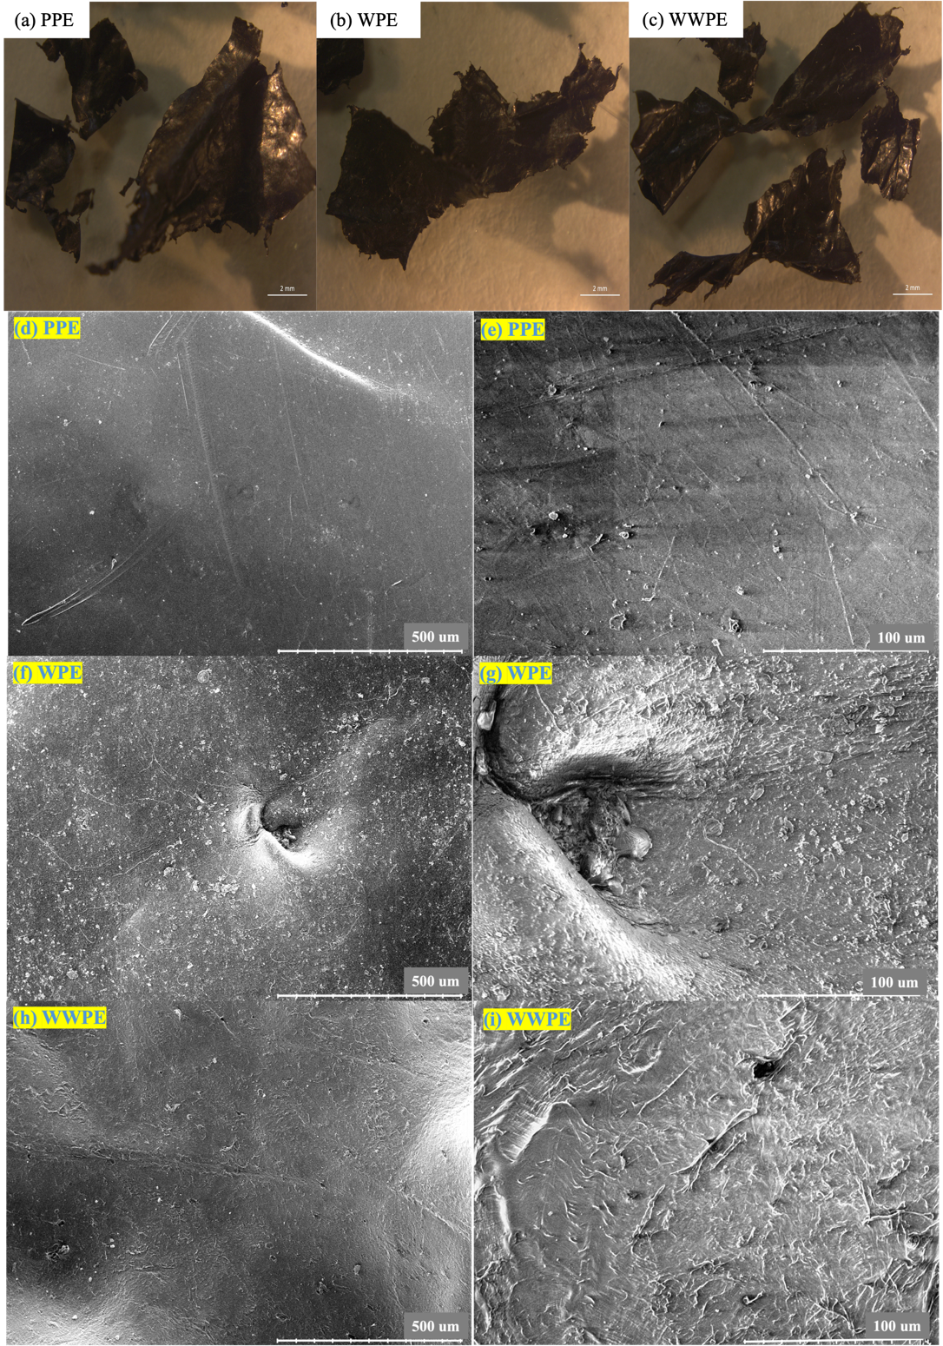
Fig. 1. Optical microscope images of the plastic mulch-derived MP particles used in the experiments: (a) pristine polyethylene (PPE), (b) weathered polyethylene (WPE) and (c) ethanol-washed weathered polyethylene (WWPE) particles. In the cases of a, b, c the scale bar represents 2 mm. Typical SEM images of the polyethylene (PE) pieces MPs used in the experiments: (d), (f) and (h) are the pristine, weathered and weathered and washed PE pieces at low magnificent (scale bar equal to 500 µm) whilst (e), (g) and (i) are the pristine, weathered and weathered and washed PE pieces at higher magnification (scale bar equal to 100 µm). The PPE samples show a smooth topography; particles interpreted to be biofilm are present on the WPE samples; these particles are not present on the WWPE samples which show a rougher topography than the PPE samples.

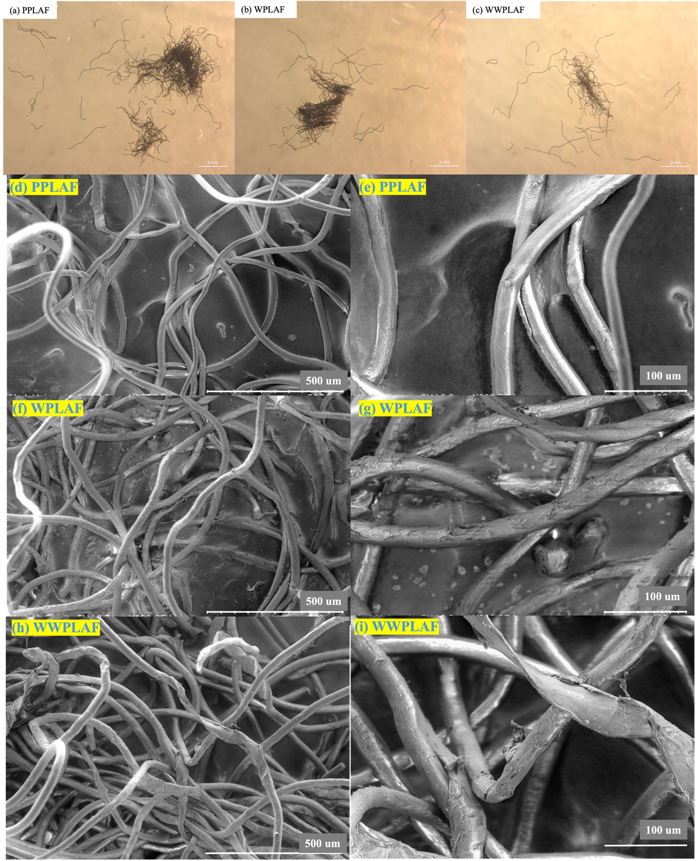
Fig. 2. Optical microscope images of the plastic mulch-derived MP particles used in the experiments: (a) pristine polylactic acid fibres (PPLAF), (b) weathered polylactic acid fibres (WPLAF) and (c) ethanol-washed weathered polylactic acid fibres (WWPLAF). In the cases of a, b, c the scale bar represents 2 mm. Typical SEM images of the polylactic acid fibres (PLAF) MPs used in the experiments: (d), (f) and (h) are the pristine, weathered and weathered and washed PLAF at low magnificent (scale bar equal to 500 µm) whilst(e), (g) and (i) are the pristine, weathered and weathered and washed PLAF at higher magnification (scale bar equal to 100 µm). The PPLAF samples show a smooth topography; particles interpreted to be biofilm are present on the WPLAF samples; these particles are not present on the WWPLAF samples which show a rougher topography than the PPLAF samples.

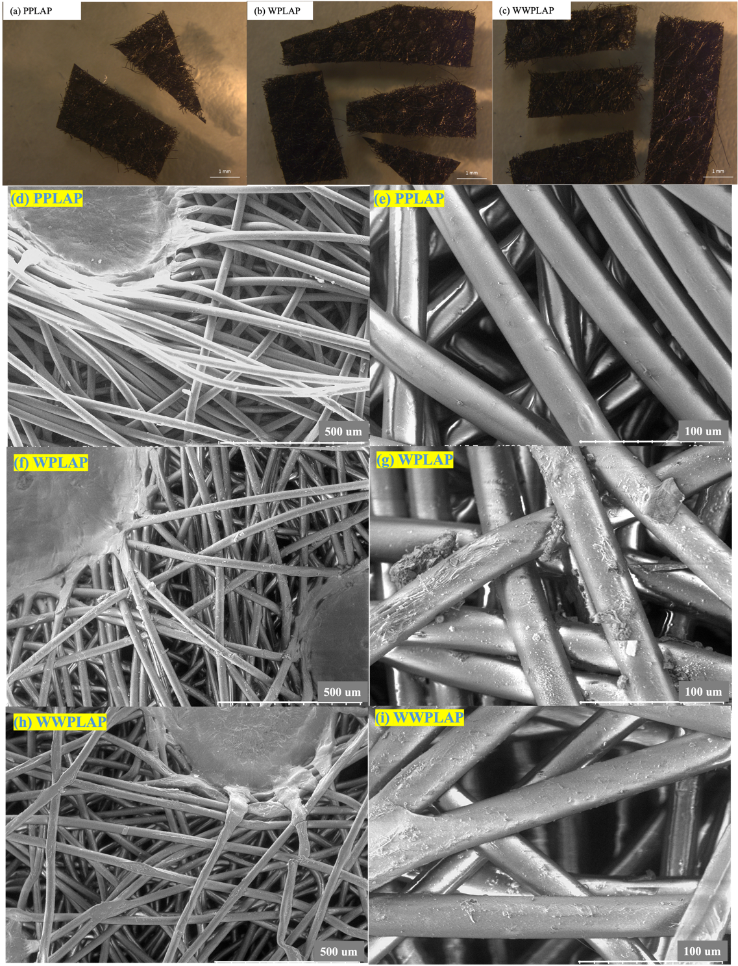
Fig. 3. Optical microscope images of the plastic mulch-derived MP particles used in the experiments: (a) pristine polylactic acid pieces (PPLAP), (b) weathered polylactic acid pieces (WPLAP) and (c) ethanol-washed weathered polylactic acid pieces (WWPLAP). In the cases of a, b, c the scale bar represents 1 mm. Typical SEM images of the polylactic acid pieces (PLAP) MPs used in the experiments: (d), (f) and (h) are the pristine, weathered and weathered and washed PLAP at low magnificent (scale bar equal to 500 µm) whilst (e), (g) and (i) are the pristine, weathered and weathered and washed PLAP at higher magnification (scale bar equal to 100 µm). The PPLAP samples show a smooth topography; particles interpreted to be biofilm are present on the WPLAP samples; these particles are not present on the WWPLAP samples which show a rougher topography than the PPLAP samples.

Adsorption experiments
A series of batch adsorption experiments were conducted to investigate the potential for the different types of MPs to adsorb Cd. Approximately 0.2 g of MPs were accurately weighed and added to 30 mL of a Cd solution obtained by dissolving Cd(NO₃)₂·4H₂O in a background electrolyte of 0.01 mol / L NaNO₃ at a pH of 6.0 to give a constant ionic strength (Hodson et al., 2017). Initial Cd target concentrations were 0.1, 0.5, 1, 5, 10, 50 and 100 mg / L with triplicate control and MP treatments at each concentration. These concentrations were chosen due to the high levels of Cd found in contaminated soils (e.g. Huang et al., 2024a) and to provide a range in concentrations of several orders of magnitude to generate adsorption isotherms (Kettum et al., 2018, Shahrokhi-Shahraki et al., 2021, Qu et al., 2022). Samples were shaken in 50 mL centrifuge tubes at 220 rpm on a flatbed shaker in a 12 °C temperature controlled room for 24 h. A number of previous studies indicate that 24 h should be sufficient for adsorption to reach equilibrium (Hodson et al., 2017, Li et al., 2022, Khan and Hodson, 2024). After 24 h, suspensions were centrifuged at 4000 RPM for 15 minutes and filtered through Whatman no. 540 12.5 cm diameter filter paper. All filtered solutions were analysed for Cd using a Thermo Scientific iCAP 7000 inductively coupled plasma-optical emission spectrometer (ICP-OES). Accuracy, assessed via analysis of an in house 0.5 ppm standard was 100 %, precision, assessed by measurement of paired samples and expressed as the coefficient of variation (Gill and Ramsey, 1997) was 1.90 % and the detection limit, calculated from repeat measurements of the blank standard (Walsh, 1997) was 0.006 mg / L. Controls were used to measure actual concentrations of initial Cd solution. Cd adsorption by MPs was calculated by difference between the average Cd concentrations in the controls and MP treatments at the end of the adsorption period. Linear, Langmuir and Freundlich isotherms were used to fit the adsorption data. For fitting the linear isotherm the regression line was constrained to pass through the origin.

Determination of biofilm content adhered on MPs
The crystal violet staining method was used to determine the amount of biofilm present on the surface of the weathered MPs via a modification of the method of Bhagwat et al. (2021). Four pieces of microplastic were placed into a sterile Petri dish and carefully rinsed three times with 2 mL of deionised water. The particles were allowed to dry at room temperature for 45 min, and then 0.5 mL of 1 % (w / v) crystal violet solution was added to the Petri dish. After a further 45 min at room temperature the excess dye solution was carefully discarded. The microplastic samples were washed 3 times with 5 mL of deionised water, allowed to dry for 45 min at room temperature and then placed in a 2 mL centrifuge tube to which 1 mL of 95 % ethanol solution was added and left to stand for 10 min. The solution was transferred to a cuvette, and the absorbance was measured at 595 nm using a Shimadzu UV - 1800 UV / Visible Scanning Spectrophotometer to give a measure of the amount of biofilm present (OD₅₉₅). MP-free treatments of the 95% ethanol solution served as a blank control to zero the spectrophotometer. The pristine microplastic pieces also served as a control group. All extractions were carried out on triplicate subsamples of MPs. After the extractions the MPs were thoroughly rinsed with deionised water to remove any residual chemicals, air-dried, and weighed with a 5 decimal place balance (Kern, ABT 100-5M, WB14G0048). The SSA of the particles were determined as described above (Table S6). The amount of biofilm detected was normalized to the mass of MP (g) and the MP surface area (m²).

Data analysis
Statistical analysis was carried out using SigmaPlot version 15.0 software, SPSS version 28.0.1.1 (15) and Excel version 16.72. The variation of adsorption data (the Cd concentration adsorbed to MPs at equilibrium C_{MPs}, mg / kg) was analysed using a non-parametric 3 way Scheirer Ray Hare test (Holmes et al., 2017) as it proved not possible to transform the adsorption data to obtain a normal distribution and equal variance. Initial target Cd concentration (0.1, 0.5, 1, 5, 10, 50, 100 mg / L), plastic type (PE, PLAF, PLAP) and plastic treatment (pristine, weathered, weathered-washed) were used as factors, Games-Howell post hoc tests were then carried out (Field, 2013). Variation in relative intensity of FTIR peaks and amount of biofilm (OD₅₉₅, OD₅₉₅ / mass and OD₅₉₅ / surface area) was analysed with plastic type (PE, PLAF, PLAP) and plastic treatment (pristine, weathered, weathered-washed) as factors. Normality and equal variance were assessed using the Shapiro-Wilks and Brown-Forsythe tests respectively. The relative intensity of FTIR peaks data set did not have equal variance (P ≤ 0.05) and the OD₅₉₅ / mass data set was not normally distributed (P ≤ 0.05). It was not possible to transform the relative intensity of FTIR peaks data set to both a normal distribution and equal variance so this data was analysed using the non-parametric 2 way Scheirer Ray Hare test (Holmes et al., 2017) followed by Games-Howell post hoc tests (Field, 2013). A log10 transformation was used to convert the OD₅₉₅ / mass data set to obtain normal distributions and equal variance. Data sets were then analysed using a two way ANOVA analysis followed by Holm-sidak post doc tests (Underwood, 1997).

Results
Adsorption of Cd on different types of MP
Cadmium adsorption isotherms of pristine MPs, weathered MPs and weathered then washed MPs are shown in Fig. 4 with the fitting parameters listed in Table 1. In our adsorption experiments, the amount of Cd adsorbed on MPs ranged from 1.742 to 993.1 mg / kg (Fig. 4a). The adsorption data obtained at an initial Cd concentration of 100 mg / L appeared to deviate slightly from the trend of the other data. However, based on 95 % confidence intervals from fitted parameters of the isotherms, there were no significant differences between when the 100 mg / L data were included and excluded (Table 1 and S7). Thus, the Cd data at 100 mg / L were included in our analysis.

The results of the 3 way Scheirer Ray Hare Test showed that initial Cd concentration, plastic type and plastic treatment had a significant impact on adsorption (P ≤ 0.05); there were no significant interactions. Adsorption increased with initial Cd concentrations (from below detection to almost 1000 mg / kg; Fig. 4a). PLA adsorbed more Cd than PE (106 - 126 vs 23.2 mg / kg; Table 1). Adsorption onto the weathered MPs (maximum adsorption capacities of 153 - 185 and 152 mg / kg for the weathered PLA and PE respectively; Table 1) was significantly greater (P ≤ 0.05) than that onto either the pristine (maximum adsorption capacities of 106 - 126 and 23.2 mg / kg for the pristine PLA and PE respectively; Table 1) or weathered then washed MPs (maximum adsorption capacities of 108 - 153 and 108 mg / kg for the weathered then washed PLA and PE respectively; Table 1) but there were no significant differences (P ≥ 0.05) between adsorption to the pristine and weathered then washed MPs (3 way Scheirer Ray Hare Test followed by Games - Howell post hoc test).

The linear, Freundlich and Langmuir isotherms all described the data well though fits to the Langmuir and Freundlich isotherms were better than those to the linear isotherm (Table 1). Pristine PLA adsorbed more Cd than pristine PE, regardless of its shape (Fig. 4a). The maximum adsorption capacity (C_{m}) of the pristine PLA MPs was significantly greater than that of the pristine PE MPs when 95 % confidence intervals were considered (Table 1). Isotherm fit parameters (K_{d}, K_{F}, and C_{m}) indicated no significant difference of adsorption capacity between the PLA fibres and PLA pieces given the over lapping 95 % confidence intervals (Table 1). Consistent with the results of the 3 way Scheirer Ray Hare Test both the weathered and the weathered then washed PE showed significantly greater adsorption of Cd relative to the pristine PE (Fig. 4a) but this was not the case for the pristine and weathered or weathered then washed PLA (Table 1).

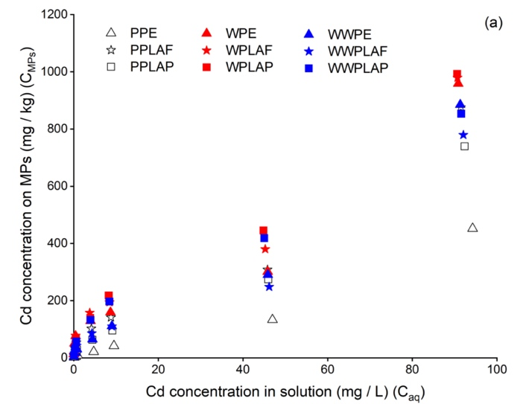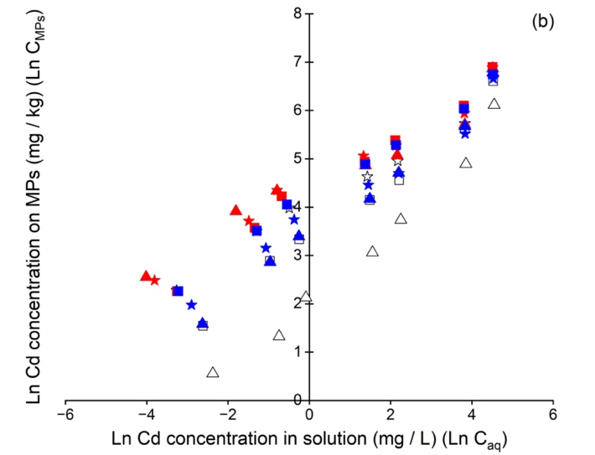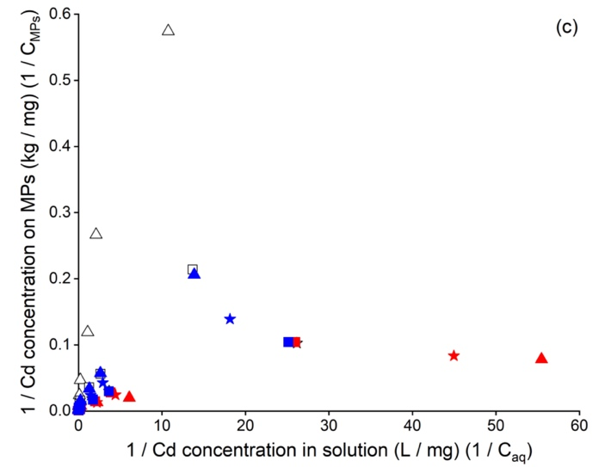
Fig. 4. (a) Adsorption data for different types of MPs expressed per unit mass. (b) Freundlich isotherms for different types of MPs (per unit mass). (c) Langmuir isotherms for different types of MPs (per unit mass). White symbols are pristine MPs, red are weathered MPs and blue are weathered and washed MPs. Triangles are PE, stars are PLAF and squares are PLAP. Individual plots are presented in the SI (Figs. S6-S8).

Table 1. Linear, Freundlich and Langmuir isotherm parameters for Cd adsorption to different types of MPs with concentrations adsorbed expressed on a per unit mass basis, 95 % confidence intervals are given in brackets. Initial Cd concentrations range from 0.1 to 100 mg / L. C_{MPs} is concentration adsorbed to MPs at equilibrium, mg / kg, C_{aq} is concentration in solution at equilibrium, mg / L. The linear adsorption model is expressed as C_{MPs} = K_{d}C_{aq} where K_{d} is the adsorption coefficient, L / kg. The Freundlich model is expressed as C_{MPs} = K_{F}C_{aq}^{1/n} where K_{F} is the distribution coefficient, (L / mg)^{1/n}. The Langmuir model is expressed as C_{MPs} = C_{m}K_{L}C_{aq} / (1+K_{L}C_{aq}) where K_{L} is the binding constant, mg / L and C_{m} is the maximum concentration adsorbed to MPs, mg / kg.
 | Linear |  |  | Freundlich |  |  |  | Langmuir
MPs type | K_{d} | R² | P | LnK_{F} | 1/n | R² | P | K_{L} | C_{m} | R² | P
pristine PE / PPE | 4.405 | 0.82 | < 0.001 | 2.115 | 0.7785 | 0.98 | < 0.001 | 0.8357 | 23.2 | 0.92 | < 0.001
 | (3.625-5.184) |  |  | (1.771-2.460) | (0.6485-0.9085) |  |  | (0.6567-1.622) | (9.115-42.72)
pristine PLA fibre / PPLAF | 9.082 | 0.81 | < 0.001 | 4.041 | 0.5172 | 0.97 | < 0.001 | 2.158 | 126 | 0.97 | < 0.001
 | (7.550-10.62) |  |  | (3.758-4.324) | (0.4156-0.6187) |  |  | (0.4991-3.324) | (69.66-660.1)
pristine PLA piece / PPLAP | 7.634 | 0.8 | < 0.001 | 3.332 | 0.6507 | 0.98 | < 0.001 | 0.6238 | 106.2 | 0.99 | < 0.001
 | (6.711-8.557) |  |  | (3.074-3.591) | (0.5541-0.7474) |  |  | (0.1552-1.014) | (59.87-469.7)
weathered PE / WPE | 9.841 | 0.79 | < 0.001 | 4.435 | 0.4284 | 0.93 | < 0.001 | 5.032 | 152.4 | 0.98 | < 0.001
 | (7.703-11.98) |  |  | (4.075-4.796) | (0.3068-0.5500) |  |  | (1.912-7.279) | (90.62-479.0)
weathered PLA fibre / WPLAF | 10.45 | 0.8 | < 0.001 | 4.425 | 0.4791 | 0.97 | < 0.001 | 3.767 | 153.2 | 0.96 | < 0.001
 | (8.449-12.46) |  |  | (4.166-4.683) | (0.3898-0.5684) |  |  | (0.2845-6.055) | (78.98-2560)
weathered PLA pieces / WPLAP | 10.9 | 0.81 | < 0.001 | 4.258 | 0.5497 | 0.98 | < 0.001 | 1.399 | 185.2 | 0.99 | < 0.001
 | (9.123-12.68) |  |  | (4.024-4.492) | (0.4656-0.6338) |  |  | (0.1617-2.359) | (97.52-1834)
washed, weathered PE / WWPE | 9.045 | 0.81 | < 0.001 | 3.386 | 0.6684 | 0.98 | < 0.001 | 0.646 | 107.7 | 0.99 | < 0.001
 | (7.627-10.46) |  |  | (3.107-3.666) | (0.5637-0.7731) |  |  | (0.09841-1.090) | (57.81-789.4)
washed, weathered PLA fibre / WWPLAF | 7.902 | 0.8 | < 0.001 | 3.695 | 0.5647 | 0.96 | < 0.001 | 1.278 | 107.6 | 0.98 | < 0.001
 | (6.460-9.344) |  |  | (3.386-4.005) | (0.4509-0.6785) |  |  | (0.2034-2.059) | (57.67-804.2)
washed, weathered PLA pieces / WWPLAP | 9.449 | 0.81 | < 0.001 | 4.156 | 0.5452 | 0.99 | < 0.001 | 1.643 | 153.9 | 0.98 | < 0.001
 | (7.854-11.04) |  |  | (3.997-4.316) | (0.4877-0.6028) |  |  | (0.1599-2.725) | (80.26-1876)

MP characteristics
The 16 months of weathering outside had no obvious optically-visible changes in the appearance of the plastic mulch-derived MPs before and after weathering or washing in ethanol (Figs. 1-3). However, SEM images and FTIR spectra suggested that biofilms had formed on the surfaces of the weathered MPs and that the biofilms were removed by the ethanol-wash (Fig. 1-3). The surfaces of the weathered and the weathered then washed MPs were rougher and had creases (PE) or were more uneven (PLA) compared with those of the pristine MPs (Figs. 1-3). Furthermore, the FTIR spectra of both the weathered PE (WPE) and weathered PE after ethanol washing (WWPE) showed a new peak at around 1100 cm⁻¹ compared to the pristine PE (PPE). This peak corresponds to the oxygen-containing hydroxyl functional group C-O-H (Fig. 5a). The intensity of this peak, relative to that of the C-H peak (around wave numbers 3200 - 2600 cm⁻¹) decreased significantly after the WPE was washed with ethanol (Table S5; 2 way Scheirer Ray Hare Test followed by Games - Howell post hoc test). There was no obvious change in the peaks present in the FTIR spectra of the PLA across different treatments (Fig. 5b). However, the relative peak intensity of the C-O peak (1300 - 800 cm⁻¹) to the C-H peak (3200 - 2600 cm⁻¹) increased significantly in the order pristine PLA (PPLAF and PPLAP) < weathered then washed PLA (WWPLAF and WWPLAP) < weathered PLA (WPLAF and WPLAP) (P ≤ 0.001, 2 way Scheirer Ray Hare Test followed by Games - Howell post hoc test) (Table S5).

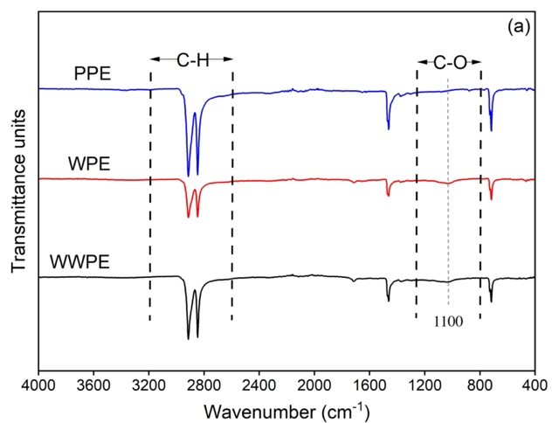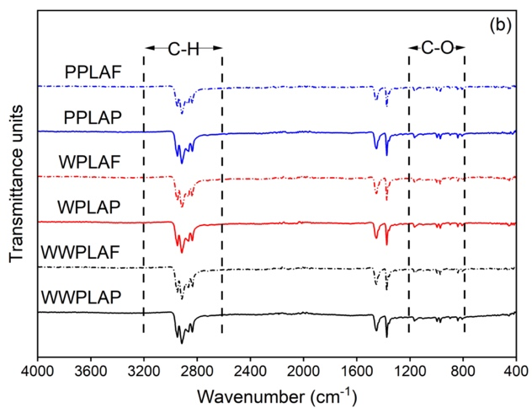
Fig. 5. FTIR spectra of different types of MPs: (a) pristine (PPE), weathered (WPE) and ethanol-washed weathered PE (WWPE) and (b) pristine (PPLAF, PPLAP), weathered (WPLAF, WPLAP) and ethanol-washed weathered PLA fibres and pieces (WWPLAF, WWPLAP). The grey vertical dotted line in (a) indicates the position of the new peak at 1100 cm⁻¹ in the WPE and WWPE samples.

The amount of biofilm on the MPs was determined using crystal violet staining and absorption at 595 nm (OD₅₉₅, Fig. 6). There was no significant difference in the OD₅₉₅ values between the different pristine MPs (P ≥ 0.05, two way ANOVA followed by Holm-Sidak post hoc test). After being weathered or weathered and then washed, PE and PLA showed significant differences in the amount of biofilm present; significantly less biofilm was associated with the PE (P ≤ 0.001, two way ANOVA followed by Holm-Sidak post hoc test and 2 way Scheirer Ray Hare Test followed by Games - Howell post hoc test) (Fig. 6). Biomass per unit mass was greater for the PE than the PLA (P ≤ 0.001, 2 way Scheirer Ray Hare Test followed by Games - Howell post hoc test) (Fig. 6b), whereas biomass per unit area was greater for the PLA (P ≤ 0.001, two way ANOVA followed by Holm-Sidak post hoc test) (Fig. 6c). Regardless of the normalisation of biofilm biomass (biomass: Fig. 6a; biomass per unit mass: Fig. 6b; biomass per surface area: Fig. 6c), the amount of biofilm decreased significantly in the order weathered MPs > weathered then washed MPs > pristine MPs for both PE and PLA (P ≤ 0.001, two way ANOVA followed by Holm-Sidak post hoc test and 2 way Scheirer Ray Hare Test followed by Games - Howell post hoc test) (Fig. 6). The pristine PLA fibres and particles did not have significantly different amounts of biofilm associated with them regardless of normalization to mass or surface area (P ≥ 0.05, two way ANOVA followed by Holm-Sidak post hoc test and 2 way Scheirer Ray Hare Test followed by Games - Howell post hoc test) (Fig. 6b, 6c). However, the weathered and weathered then washed mass normalised biofilm concentrations were greater for the PLAP than the PLAF (Fig. 6b), whereas the weathered and weathered then washed surface area normalised biofilm concentrations were greater for the PLAF than the PLAP (Fig. 6c) (P ≤ 0.001, two way ANOVA followed by Holm-Sidak post hoc test and 2 way Scheirer Ray Hare Test followed by Games - Howell post hoc test).

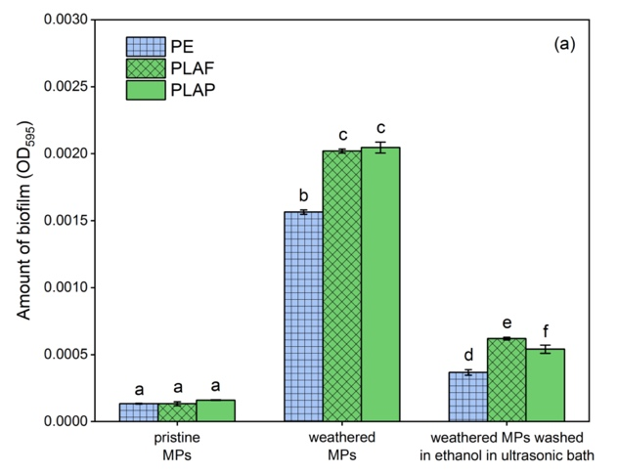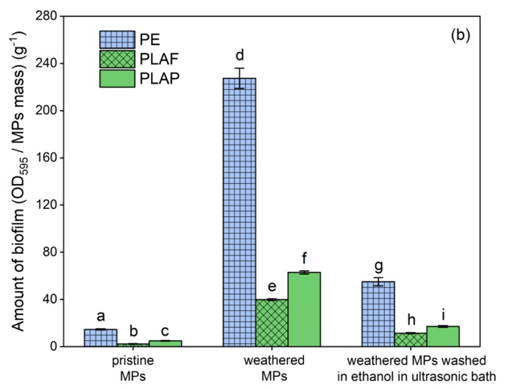
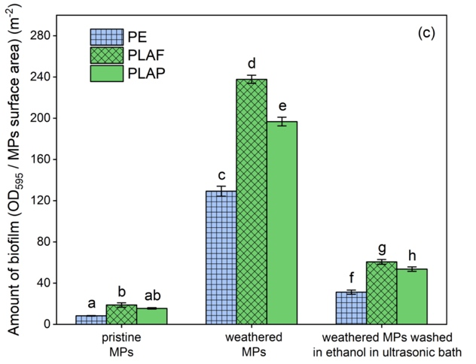
Fig. 6. Amount of biofilm on the PE, PLAF and PLAP samples expressed as (a) OD₅₉₅, (b) OD₅₉₅ / MP mass, and (c) OD₅₉₅ / MPs surface area. Values are averages ± standard deviations (n = 3). For (a) and (c) different letters above the bars indicate a significant difference at P ≤ 0.001 (2 way ANOVA followed by Holm-Sidak post hoc test). For (b) different letters above the bars indicate a significant difference at P ≤ 0.001 (2 way Scheirer Ray Hare Test followed by Games - Howell post hoc test).

Discussion
Cd adsorbed to all the MPs tested and was better described by Freundlich and Langmuir than by linear isotherms (Table 1). Adsorption was greater for the biodegradable PLA than the conventional PE MPs and significantly greater for the weathered than either the weathered then washed or pristine MPs (Fig. 4, Table 1). The amount of biofilm extracted from the MPs decreased in the order weathered > weathered then washed > pristine (Fig. 6) as did the relative intensity of the oxygen-bearing functional groups present in the FTIR spectra.

Impacts of MPs shape and chemistry on adsorption of Cd
Adsorption is a surface phenomenon; as SSA increases more surface is available for sorption per mass of material (Wang et al., 2019, Zhang et al., 2020, Zhou et al., 2020, Li et al., 2022, Chang et al., 2024). The PE MPs used in our study were platy particles, while PLA MPs were either platy or fibrous particles (Figs. 1-3). Our calculations suggest that the mean SSAs of the platy PE MPs, platy PLA MPs and fibrous PLA MPs were 1.82, 0.217 and 0.433 m² / g respectively. Although our SSA calculations do not take into account surface roughness and are therefore approximations, visual analysis of the MP surfaces by SEM suggests that the pristine PE and PLA show no significant difference in terms of their roughness (Figs. 1-3). Surface roughness is a scaling factor between BET and geometric SSA (Brantley and Mellott, 2000) and thus whilst the absolute values of SSA may vary from our calculations, our calculations do indicate that there was substantially more surface area present in the pristine PE adsorption experiments than in those that used the pristine PLA, whilst the platy and fibrous PLA had very similar SSA. Therefore, the lack of a significant difference in adsorption between the platy and the fibrous PLA (Table 1) was not unexpected; for a given mass of each shape of particle a similar amount of surface should have been available for adsorption. However, there would have been more PE than PLA surface area for a given mass of particles in our adsorption experiments. Despite this, the PLA MPs showed greater adsorption of Cd than the PE MPs (Fig. 4, Fig. S5, Table 1) suggesting that this was due to differences in the chemistry of the MPs rather than available surface area for adsorption (Gao et al., 2021a, Khalid et al., 2021). Similarly, previous studies also found that biodegradable MPs were able to adsorb more metal ions than conventional MPs (Li et al., 2018b, Huang et al., 2023, Shi et al., 2023, Huang et al., 2024b, Jiang et al., 2024), however, they did not take surface area into account. Therefore, they were unable to unambiguously attribute this to compositional differences between the plastics rather than their size and shape. The PLA contained polar, oxygen-containing ether functional groups whereas PE contained no polar functional groups (Fig. S1, Table S1 and S5). Adsorption between non-polar PE and metal ions is likely to be a non-specific interaction such as by weak van der waal forces (Gao et al., 2021a, Xu et al., 2021). In contrast, metal ions can adsorb by surface complexation with the polar functional groups of PLA (Fan et al., 2018, Wu et al., 2019) leading to an increase in adsorption (Brennecke et al., 2016).

Impacts of natural weathering on adsorption of Cd on MPs
The adsorption of Cd on the weathered MPs was significantly higher than that on the pristine or weathered then washed MPs (Fig. 4 and Table 1). A biofilm was associated with the weathered MPs and was significantly reduced by the ethanol washing (Fig. 6). Previous studies have demonstrated an increase in adsorption by artificially aged MPs (Bhagat et al., 2022, Huang et al., 2023, Huang et al., 2024b) and the adsorption of metals by biofilms (Qi et al., 2021, Qiongjie et al., 2022). Ageing can alter the surface morphology (Liu et al., 2019, Mao et al., 2020, Gao et al., 2024) and physicochemical properties of MPs (Guo and Wang, 2019, Wei et al., 2021, Deng et al., 2023). We were not able to quantify the additional surface area generated by weathering of the MPs (either from the biofilm or changes in the roughness of the MP itself) but SEM observation suggests that the biofilm associated with the weathered MPs will have increased particle surface roughness and thus SSA to a greater extent than the physical affects of weathering but that the physical weathering of the MPs also increased the roughness of the particles, and thus SSA, relative to the pristine MPs (Figs. 1-3). Furthermore, the FTIR spectra of the weathered PE included a new peak at around 1100 cm⁻¹ which corresponds to polar, oxygen-containing hydroxyl functional groups. Although their relative intensity decreased, the peaks remained present after the MPs were washed to remove the biofilm. In contrast to the PE, no new peaks were found in the PLA spectra after weathering. However, there was a significant increase in the relative intensity of peaks representing oxygen-containing ether and hydroxyl functional group (Fig. 5b, Table S5) on weathering of the PLA and a subsequent decrease after washing in ethanol. The relative intensities after washing were still greater than those for the pristine material. This suggests that some of the oxygen-containing functional groups were associated with the biofilm but that some were associated with alteration of the MP chemical structure. The new functional groups would provide new adsorption sites (Li et al. 2019a, Li et al. 2019b, Guan et al. 2020). However, once the biofilm was removed by washing in ethanol there was no significant difference in the adsorption of Cd between the weathered then washed compared to the pristine MPs. This suggests that the increased adsorption of Cd after weathering of the MPs was mainly due to adsorption by the biofilm rather than increased adsorption directly onto the surface of the MPs. However, we are unable to determine how much of the additional adsorption on the weathered MPs was due to the chemical groups in the biofilm as opposed to the additional surface area associated with the biofilm. In slight contrast to the statistical analysis of the adsorption data, the differences in modelled K_{d} and C_{m} perhaps suggest some increased adsorption due to chemical changes in response to weathering, at least for the PE where the introduction of new functional groups might be considered a more significant chemical change than a slight increase in their abundance as was the case for the PLA. The majority of studies that have demonstrated an increase in adsorption to MPs after ageing have used artificial ageing methods such as UV light (Han et al., 2021, Bhagat et al., 2022, Qiongjie et al., 2022, Huang et al., 2023, Huang et al., 2024b), the photo-Fenton reaction (Lang et al., 2020, Liu et al., 2020, Jiang et al., 2022), or heat activated potassium persulfate oxidation (Wu et al., 2020) or reducing agents NaBH₄ (Xiao et al., 2023) which alter the physical (increased surface roughness, cracks and holes formation, decreased particle size) (Bhagat et al., 2022, Qiongjie et al., 2022, Huang et al., 2023) and chemical (changed functional groups on MPs and chain scission) (Han et al., 2021, Xiao et al., 2023, Huang et al., 2024b) properties of MPs rather than leading to the development of biofilms which potentially raises questions about the relevance of those studies to naturally weathering processes and environmental MPs. Our results confirm that natural weathering leads to the incorporation of oxygen-bearing functional groups into the weathered plastics, which could ultimately lead to increased adsorption of Cd. However, the above mentioned studies and this study also suggest that whilst natural and artificial ageing can both result in increased adsorption, at least in the short (16 month of natural weathering) term this is likely due to different mechanisms with the changes in adsorption by the naturally weathered MPs being more closely linked to biofilm formation than structural / compositional changes.

Differences in biofilm formation between biodegradable PLA and conventional PE
The PE particles had a higher SSA than that of the PLA and would therefore have a higher surface area for a given mass of particles. As biofilms form on surfaces, this is consistent with the amount of biofilm being greater in the PE than PLA particles when normalized to mass as that mass of material represents a greater amount of surface. However, when normalized to surface area the opposite is seen (Fig. 6). PLA is, by design, biodegradable (Kasirajan et al., 2012, Haider et al., 2019) and our results suggests that it is perhaps easier for biofilm to colonise PLA surfaces, most likely because the biodegradable PLA could act as a food source resulting in more biofilm being present on the particles per unit area.

Conclusions
The ecological hazards of Cd depend on its mobility, which can be influenced by adsorption. We showed that polymer type, weathering and biofilms had a significant impact on adsorption of Cd by the MPs (P ≤ 0.05). Pristine PLA was significantly more sorptive to Cd than pristine PE (e.g. maximum adsorption capacities of 106 - 126 vs 23.2 mg / kg). Thus, initially, reductions in Cd bioavailability in Cd-bearing soils may occur if PE mulches are replaced by PLA mulches which could lead to increased accumulation of Cd in soils but a reduced risk of this Cd entering the food chain by biomagnification. Weathering of the plastics resulted in the appearance (PE) or increased abundance (PLA) of oxygen-containing functional groups in their chemical structure, together with the development of biofilms leading to an increase in adsorption of Cd (e.g. increases in maximum adsorption capacity to 153 - 185 and 152 mg / kg for the PLA and PE respectively) which could decrease Cd mobility further. Artificial weathering of MPs which does not result in biofilm formation may lead to differing results between studies of naturally and artificially weathered MPs or mean that conclusions drawn from artificial weathering studies are not applicable to short term (months long duration) natural weathering. Although PLA is designed to biodegrade it showed little signs of degradation after 16 months exposure to natural conditions. In the short term use of PLA could therefore lead to increased retention of Cd in soil but reduced Cd bioavailability. If Cd has been retained in soil by adsorption to biodegradable MPs this might ultimately lead to a larger pool of bioavailable Cd on degradation of the MPs.

Limitations and future research recommendations
Our study produced naturally weathered MPs by hanging up plastic mulch sheets to expose them to ambient weather conditions. However, when mulches are used in practice they are laid on the soil surface. Therefore only one side of the mulch would be exposed to sunlight, the other would be in contact with the soil which could result in different weathering mechanisms and / or different rates of weathering which could in turn result in different adsorption properties. Thus whilst we believe that using naturally weathered MPs is an advance on using artificially weathered MPs in terms of environmental realism, further consideration to the exposure scenarios of pristine plastics is warranted when generating weathered MPs.

Whilst we quantified the amount of biofilm present on our MPs, further research on how biofilms form on MPs and adsorb metals (and other contaminants) at a molecular level is warranted to better understand the potential risk that this poses in the environment. Furthermore, genetic characterization of the biofilms would support understanding of their origins and properties. The use of isotopically labelled MPs in experiments could be investigated to determine whether the micro-organisms present in biofilms are using the MPs as a carbon source and actively metabolizing them.

Acknowledgements
This study was supported by the University of York - China Scholarship Council joint research scholarship (No: 202008220157). The authors thank the editors and anonymous reviewers for their helpful comments.

Reference
Alimi, O.S., Farner Budarz, J., Hernandez, L.M. and Tufenkji, N., 2018. Microplastics and nanoplastics in aquatic environments: aggregation, deposition, and enhanced contaminant transport. Environ. Sci. Technol. 52, 1704-1724.
Alimi, O.S., Claveau-Mallet, D., Kurusu, R.S., Lapointe, M., Bayen, S. and Tufenkji, N., 2022. Weathering pathways and protocols for environmentally relevant microplastics and nanoplastics: What are we missing? J. Hazard. Mater. 423, 126955.
Brantley, S.L. and Mellott, N.P., 2000. Surface area and porosity of primary silicate minerals. Am. Mineral. 85, 1767-1783.
Brunauer, S., Emmett, P.H. and Teller, E., 1938. Adsorption of gases in multimolecular layers. J. Am. Chem. Soc. 60, 309-319.
Burau, R.G., 1981. National and local dietary impact of cadmium in south coastal California soils. Ecotoxicol. Environ. Saf. 7, 53-57.
Bhagat, K., Barrios, A.C., Rajwade, K., Kumar, A., Oswald, J., Apul, O. and Perreault, F., 2022. Aging of microplastics increases their adsorption affinity towards organic contaminants. Chemosphere 298, 134238.
Bhagwat, G., Tran, T.K.A., Lamb, D., Senathirajah, K., Grainge, I., O’Connor, W., Juhasz, A. and Palanisami, T., 2021. Biofilms enhance the adsorption of toxic contaminants on plastic microfibers under environmentally relevant conditions. Environ. Sci. Technol. 55, 8877-8887.
Borges-Ramírez, M.M., Mendoza-Franco, E.F., Escalona-Segura, G. and Rendón-von Osten, J., 2020. Plastic density as a key factor in the presence of microplastic in the gastrointestinal tract of commercial fishes from Campeche Bay, Mexico. Environ. Pollut. 267, 115659.
Brennecke, D., Duarte, B., Paiva, F., Caçador, I. and Canning-Clode, J., 2016. Microplastics as vector for heavy metal contamination from the marine environment. Estuar. Coast. Shelf S. 178, 189-195.
Brunauer, S., Deming, L.S., Deming, W.E. and Teller, E., 1940. On a theory of the van der Waals adsorption of gases. J. Am. Chem. Soc. 62, 1723-1732.
Cao, Y., Zhao, M., Ma, X., Song, Y., Zuo, S., Li, H. and Deng, W., 2021. A critical review on the interactions of microplastics with heavy metals: mechanism and their combined effect on organisms and humans. Sci. Total Environ. 788, 147620.
Chang, B., Huang, Z., Yang, X., Yang, T., Fang, X., Zhong, X., Ding, W., Cao, G., Yang, Y., Hu, F. and Xu, C., 2024. Adsorption of Pb (II) by UV-aged microplastics and cotransport in homogeneous and heterogeneous porous media. J. Hazard. Mater. 465, 133413.
Chen, X., Xiong, X., Jiang, X., Shi, H. and Wu, C., 2019. Sinking of floating plastic debris caused by biofilm development in a freshwater lake. Chemosphere, 222, 856-864.
Chen, C.C., Zhu, X., Xu, H., Chen, F., Ma, J. and Pan, K., 2021. Copper adsorption to microplastics and natural particles in seawater: a comparison of kinetics, isotherms, and bioavailability. Environ. Sci. Technol. 55, 13923-13931.
Deng, X. P., Shan, L., Zhang, H., and Turner, N. C., 2006. Improving agricultural water use efficiency in arid and semiarid areas of China. Agr. Water Manage. 80, 23-40.
Deng, H., Zhang, Y., Li, D., Fu, Q., He, J., Zhao, Y., Feng, D., Yu, H. and Ge, C., 2023. Mangrove degradation retarded microplastics weathering and affected metabolic activities of microplastics-associated microbes. J. Hazard. Mater. 445, 130535.
Ding, H., Li, Y., Hou, J., Wang, Q. and Wu, Y., 2015. Sorption behavior and modeling of endocrine-disrupting chemicals on natural sediments: role of biofilm covered on surface. Environ. Sci. Pollut. Res. 22, 1380-1388.
Ding, L., Mao, R., Ma, S., Guo, X. and Zhu, L., 2020. High temperature depended on the ageing mechanism of microplastics under different environmental conditions and its effect on the distribution of organic pollutants. Water Res. 174, 115634.
Duan, J., Bolan, N., Li, Y., Ding, S., Atugoda, T., Vithanage, M., Sarkar, B., Tsang, D.C. and Kirkham, M.B., 2021. Weathering of microplastics and interaction with other coexisting constituents in terrestrial and aquatic environments. Water Res. 196, 117011.
European Bioplastics, 2023. Bioplastics Market Data. https://www.european-bioplastics.org/market/ (accessed 23 December 2024).
Fan, Q., Sun, J., Chu, L., Cui, L., Quan, G., Yan, J., Hussain, Q. and Iqbal, M., 2018. Effects of chemical oxidation on surface oxygen-containing functional groups and adsorption behavior of biochar. Chemosphere 207, 33-40.
Fei, J., Cui, J., Wang, B., Xie, H., Wang, C., Zhao, Y., Sun, H. and Yin, X., 2023. Co-transport of degradable microplastics with Cd (Ⅱ) in saturated porous media: Synergistic effects of strong adsorption affinity and high mobility. Environ. Pollut. 330, 121804.
Field, A., 2013. Discovering statistics using IBM SPSS statistics third edition. Sage 374.
Gao, X., Hassan, I., Peng, Y., Huo, S. and Ling, L., 2021a. Behaviors and influencing factors of the heavy metals adsorption onto microplastics: A review. J. Clean Prod. 319, 128777.
Gao, L., Fu, D., Zhao, J., Wu, W., Wang, Z., Su, Y. and Peng, L., 2021b. Microplastics aged in various environmental media exhibited strong sorption to heavy metals in seawater. Mar. Pollut. Bul. 169, 112480.
Gao, J., Wang, L., Wu, W.M., Luo, J. and Hou, D., 2024. Microplastic generation from field-collected plastic gauze: Unveiling the aging processes. J. Hazard. Mater. 467, 133615.
Ge, J., Wang, M., Liu, P., Zhang, Z., Peng, J. and Guo, X., 2023. A systematic review on the aging of microplastics and the effects of typical factors in various environmental media. TrAC Trend. Anal. Chem. 162, 117025.
Gill, R. and Ramsey, M.H., 1997. What a geochemical analysis means. In: Gill, R. (ed.) Modern Analytical Geochemistry: An Introduction to Quantitative Chemical Analysis Techniques for Earth, Environment and Materials Scientists (Longman Geochemistry Series) 1-11.
Gray, C.W. and Cavanagh, J.A.E., 2023. The state of knowledge of cadmium in New Zealand agricultural systems: 2021. New Zeal. J. Agr. Res. 66, 285-335.
Guan, J., Qi, K., Wang, J., Wang, W., Wang, Z., Lu, N. and Qu, J., 2020. Microplastics as an emerging anthropogenic vector of trace metals in freshwater: Significance of biofilms and comparison with natural substrates. Water Res. 184, 116205.
Guo, X. and Wang, J., 2019. The chemical behaviors of microplastics in marine environment: A review. Mar. Pollut. Bul. 142, 1-14.
Haider, T.P., Völker, C., Kramm, J., Landfester, K. and Wurm, F.R., 2019. Plastics of the future? The impact of biodegradable polymers on the environment and on society. Angew. Chem. Int. Ed. 58, 50-62.
Han, X., Vogt, R.D., Zhou, J., Zheng, B., Yu, X., Feng, J. and Lu, X., 2021. Increased Cu (II) adsorption onto UV-aged polyethylene, polypropylene, and polyethylene terephthalate microplastic particles in seawater. Front. Mar. Sci. 8, 770606.
Hanun, J.N., Hassan, F. and Jiang, J.J., 2021. Occurrence, fate, and sorption behavior of contaminants of emerging concern to microplastics: Influence of the weathering/aging process. J. Environ. Chem. Eng. 9, 106290.
He, W., Liu, S., Zhang, W., Yi, K., Zhang, C., Pang, H., Huang, D., Huang, J. and Li, X., 2023. Recent advances on microplastic aging: Identification, mechanism, influence factors, and additives release. Sci. Total Environ. 889, 164035.
Hirt, N. and Body-Malapel, M., 2020. Immunotoxicity and intestinal effects of nano-and microplastics: a review of the literature. Part. Fibre Toxicol. 17, pp.1-22.
Hodson, M.E., Duffus-Hodson, C.A., Clark, A., Prendergast-Miller, M.T. and Thorpe, K.L., 2017. Plastic bag derived-microplastics as a vector for metal exposure in terrestrial invertebrates. Environ. Sci. Technol. 51, 4714-4721.
Holmes, D., Moody, P., Dine, D., and Trueman, L., 2017. Research methods for the biosciences. Oxford university press.
Huang, Y., Liu, Q., Jia, W., Yan, C. and Wang, J., 2020. Agricultural plastic mulching as a source of microplastics in the terrestrial environment. Environ. Pollut. 260, 114096.
Huang, W., Deng, J., Liang, J. and Xia, X., 2023. Comparison of lead adsorption on the aged conventional microplastics, biodegradable microplastics and environmentally-relevant tire wear particles. Chem. Eng. J. 460, 141838.
Huang, X., Li, X., Zheng, L., Zhang, Y., Sun, L., Feng, Y., Du, J., Lu, X. and Wang, G., 2024a. Comprehensive assessment of health and ecological risk of cadmium in agricultural soils across China: a tiered framework. J. Hazard. Mater. 465, 133111.
Huang, W., Zhang, J., Zhang, Z., Gao, H., Xu, W. and Xia, X., 2024b. Insights into adsorption behavior and mechanism of Cu (II) onto biodegradable and conventional microplastics: Effect of aging process and environmental factors. Environ. Pollut. 342, 123061.
Imran, M., Das, K.R. and Naik, M.M., 2019. Co-selection of multi-antibiotic resistance in bacterial pathogens in metal and microplastic contaminated environments: An emerging health threat. Chemosphere, 215, 846-857.
Jiang, Z., Huang, L., Fan, Y., Zhou, S. and Zou, X., 2022. Contrasting effects of microplastic aging upon the adsorption of sulfonamides and its mechanism. Chem. Eng. J. 430, 132939.
Jiang, T., Wu, X., Yuan, S., Lai, C., Bian, S., Yu, W., Liang, S., Hu, J., Huang, L., Duan, H. and Shi, Y., 2024. A potential threat from biodegradable microplastics: mechanism of cadmium adsorption and desorption in the simulated gastrointestinal environment. Front. Env. Sci. Eng. 18, 19.
Kasirajan, S., and Ngouajio, M., 2012. Polyethylene and biodegradable mulches for agricultural applications: a review. Agron. Sustain, Dev. 32, 501-529.
Kettum, W., Tran, T.T.V., Kongparakul, S., Reubroycharoen, P., Guan, G., Chanlek, N. and Samart, C., 2018. Heavy metal sequestration with a boronic acid-functionalized carbon-based adsorbent. J. Environ. Chem. Eng. 6, 1147-1154.
Keswani, A., Oliver, D.M., Gutierrez, T. and Quilliam, R.S., 2016. Microbial hitchhikers on marine plastic debris: human exposure risks at bathing waters and beach environments. Mar. Environ. Res. 118, 10-19.
Khalid, N., Aqeel, M., Noman, A., Khan, S.M. and Akhter, N., 2021. Interactions and effects of microplastics with heavy metals in aquatic and terrestrial environments. Environ. Pollut. 290, 118104.
Khalid, N., Aqeel, M., Noman, A. and Rizvi, Z.F., 2023. Impact of plastic mulching as a major source of microplastics in agroecosystems. J. Hazard. Mater. 445, 130455.
Khan T.F. and Hodson, M.E., 2024. Polyethylene microplastic can adsorb phosphate but is unlikely to limit its availability in soil. Heliyon 10, e23179.
Lang, M., Yu, X., Liu, J., Xia, T., Wang, T., Jia, H. and Guo, X., 2020. Fenton aging significantly affects the heavy metal adsorption capacity of polystyrene microplastics. Sci. Total Environ. 722, 137762.
Li, K. and Wang, F. Global hotspots and trends in interactions of microplastics and heavy metals: a bibliometric analysis and literature review. Environ. Sci. Pollut. Res. 2023, 30, 93309-93322.
Li, L., Li, M., Deng, H., Cai, L., Cai, H., Yan, B., Hu, J. and Shi, H., 2018a. A straightforward method for measuring the range of apparent density of microplastics. Sci. Total Environ. 639, 367-373.
Li, J., Zhang, K., and Zhang, H., 2018b. Adsorption of antibiotics on microplastics. Environ. Pollut. 237, 460-467.
Li, W., Zhang, Y., Wu, N., Zhao, Z., Xu, W.A., Ma, Y. and Niu, Z., 2019a. Colonization characteristics of bacterial communities on plastic debris influenced by environmental factors and polymer types in the Haihe Estuary of Bohai Bay, China. Environ. Sci. Technol. 53, 10763-10773.
Li, X., Mei, Q., Chen, L., Zhang, H., Dong, B., Dai, X., He, C. and Zhou, J., 2019b. Enhancement in adsorption potential of microplastics in sewage sludge for metal pollutants after the wastewater treatment process. Water Res. 157, 228-237.
Li, W., Zu, B., Yang, Q., Huang, Y. and Li, J., 2022. Adsorption of lead and cadmium by microplastics and their desorption behavior as vectors in the gastrointestinal environment. J. Environ. Chem. Eng. 10, 107379.
Liu, P., Qian, L., Wang, H., Zhan, X., Lu, K., Gu, C. and Gao, S., 2019. New insights into the aging behavior of microplastics accelerated by advanced oxidation processes. Environ. Sci. Technol. 53, 3579-3588.
Liu, P., Lu, K., Li, J., Wu, X., Qian, L., Wang, M. and Gao, S., 2020. Effect of aging on adsorption behavior of polystyrene microplastics for pharmaceuticals: Adsorption mechanism and role of aging intermediates. J. Hazard. Mater. 384, 121193.
Liu, S., Huang, J., Zhang, W., Shi, L., Yi, K., Yu, H., Zhang, C., Li, S. and Li, J., 2022a. Microplastics as a vehicle of heavy metals in aquatic environments: A review of adsorption factors, mechanisms, and biological effects. J. Environ. Manage. 302, 113995.
Liu, H., Wang, X., Shi, Q., Liu, Y., Lei, H. and Chen, Y., 2022b. Microplastics in arid soils: Impact of different cropping systems (Altay, Xinjiang). Environ. Pollut. 303, 119162.
Liu, S., Huang, J., Zhang, W., Shi, L., Yi, K., Zhang, C., Pang, H., Li, J. and Li, S., 2022c. Investigation of the adsorption behavior of Pb (II) onto natural-aged microplastics as affected by salt ions. J. Hazard. Mater. 431, 128643.
Lozano, Y.M., Gordillo-Rocha, H., Waldman, W.R. and Rillig, M.C., 2023. Photodegradation modifies microplastic effects on soil properties and plant performance. J. Appl. Ecol. 61, 13-24.
Luo, H., Liu, C., He, D., Xu, J., Sun, J., Li, J. and Pan, X., 2022. Environmental behaviors of microplastics in aquatic systems: A systematic review on degradation, adsorption, toxicity and biofilm under aging conditions. J. Hazard. Mater. 423, 126915.
Mao, R., Lang, M., Yu, X., Wu, R., Yang, X. and Guo, X., 2020. Aging mechanism of microplastics with UV irradiation and its effects on the adsorption of heavy metals. J. Hazard. Mater. 393, 122515.
Meng, K., Lwanga, E.H., van der Zee, M., Munhoz, D.R. and Geissen, V., 2023. Fragmentation and depolymerization of microplastics in the earthworm gut: a potential for microplastic bioremediation? J. Hazard. Mater. 447, 130765.
More, T.T., Yadav, J.S.S., Yan, S., Tyagi, R.D. and Surampalli, R.Y., 2014. Extracellular polymeric substances of bacteria and their potential environmental applications. J. Environ. Manage. 144, 1-25.
Moyal, J., Dave, P.H., Wu, M., Karimpour, S., Brar, S.K., Zhong, H. and Kwong, R.W., 2023. Impacts of biofilm formation on the physicochemical properties and toxicity of microplastics: a concise review. Rev. Environ. Contam. T. 261, 8.
Niño-Savala, A.G., Zhuang, Z., Ma, X., Fangmeier, A., Li, H., Tang, A. and Liu, X., 2019. Cadmium pollution from phosphate fertilizers in arable soils and crops: An overview. Front. Agr. Sci. Eng. 6, 419-430.
Park, M., Chon, H.T. and Marton, L., 2010. Mobility and accumulation of selenium and its relationship with other heavy metals in the system rocks/soils–crops in areas covered by black shale in Korea. J. Geochem. Explor. 107, 161-168.
Plastics Europe. Plastics - the facts 2022., 2024. https://plasticseurope.org/knowledge-hub/plastics-the-facts-2022/.
Qi, K., Lu, N., Zhang, S., Wang, W., Wang, Z. and Guan, J., 2021. Uptake of Pb (II) onto microplastic-associated biofilms in freshwater: adsorption and combined toxicity in comparison to natural solid substrates. J. Hazard. Mater. 411, 125115.
Qiang, L., Hu, H., Li, G., Xu, J., Cheng, J., Wang, J. and Zhang, R., 2023. Plastic mulching, and occurrence, incorporation, degradation, and impacts of polyethylene microplastics in agroecosystems. Ecotoxicol. Environ. Saf. 263, 115274.
Qiongjie, W., Yong, Z., Yangyang, Z., Zhouqi, L., Jinxiaoxue, W. and Huijuan, C., 2022. Effects of biofilm on metal adsorption behavior and microbial community of microplastics. J. Hazard. Mater. 424, 127340.
Qu, J., Lin, X., Liu, Z., Liu, Y., Wang, Z., Liu, S., Meng, Q., Tao, Y., Hu, Q. and Zhang, Y., 2022. One-pot synthesis of Ca-based magnetic hydrochar derived from consecutive hydrothermal and pyrolysis processing of bamboo for high-performance scavenging of Pb (II) and tetracycline from water. Bioresource Technol. 343, 126046.
Quezada-Hinojosa, R.P., Matera, V., Adatte, T., Rambeau, C. and Föllmi, K.B., 2009. Cadmium distribution in soils covering Jurassic oolitic limestone with high Cd contents in the Swiss Jura. Geoderma 150, 287-301.
Ricardo, I.A., Alberto, E.A., Júnior, A.H.S., Macuvele, D.L.P., Padoin, N., Soares, C., Riella, H.G., Starling, M.C.V. and Trovo, A.G., 2021. A critical review on microplastics, interaction with organic and inorganic pollutants, impacts and effectiveness of advanced oxidation processes applied for their removal from aqueous matrices. Chem. Eng. J. 424, 130282.
Shahrokhi-Shahraki, R., Benally, C., El-Din, M.G. and Park, J., 2021. High efficiency removal of heavy metals using tire-derived activated carbon vs commercial activated carbon: Insights into the adsorption mechanisms. Chemosphere 264, 128455.
Shi, M., Xie, Q., Li, Z.L., Pan, Y.F., Yuan, Z., Lin, L., Xu, X.R. and Li, H.X., 2023. Adsorption of heavy metals on biodegradable and conventional microplastics in the Pearl River Estuary, China. Environ. Pollut. 322, 121158.
Singh, R.S., Gilcrease, E.B., Goel, R., Free, M.L. and Sarswat, P.K., 2024. The rising tide of plastic pollution: Exploring bacillus sp. for sustainable microbial degradation of polyethylene. J. Polym. Environ. 32, 2748-2761.
Sintim, H.Y. and Flury, M., 2017. Is biodegradable plastic mulch the solution to agriculture’s plastic problem? Environ. Sci. Technol. 51, 1068-1069.
Tarafdar, A., Lee, J.U., Jeong, J.E., Lee, H., Jung, Y., Oh, H.B., Woo, H.Y. and Kwon, J.H., 2021. Biofilm development of Bacillus siamensis ATKU1 on pristine short chain low-density polyethylene: A case study on microbe-microplastics interaction. J. Hazard. Mater. 409, 124516.
Thompson, R.C., Olsen, Y., Mitchell, R.P., Davis, A., Rowland, S.J., John, A.W., McGonigle, D. and Russell, A.E., 2004. Lost at sea: where is all the plastic? Science 304, 838.
Tu, C., Zhou, Q., Zhang, C., Liu, Y. and Luo, Y., 2020a. Biofilms of microplastics. In: He, D. F, Luo, Y. M. (eds) Microplastics in terrestrial environments: emerging contaminants and major challenges. Springer Nature, Switzerland, 299-317.
Tu, C., Chen, T., Zhou, Q., Liu, Y., Wei, J., Waniek, J.J. and Luo, Y., 2020b. Biofilm formation and its influences on the properties of microplastics as affected by exposure time and depth in the seawater. Sci. Total Environ. 734, 139237.
Underwood, A.J., 1997. Experiments in ecology: their logical design and interpretation using analysis of variance. Cambridge university press.
Ventura, E., Marín, A., Gámez-Pérez, J. and Cabedo, L., 2024. Recent advances in the relationships between biofilms and microplastics in natural environments. World J. Microb. Biot. 40, 220.
Walsh, J.N., 1997. Inductively coupled plasma-atomic emission spectrometry (ICP-AES). Modern Analytical Geochemistry 41-86.
Wang, F., Yang, W., Cheng, P., Zhang, S., Zhang, S., Jiao, W., and Sun, Y., 2019. Adsorption characteristics of cadmium onto microplastics from aqueous solutions. Chemosphere 235, 1073-1080.
Wang, J., Guo, X. and Xue, J., 2021. Biofilm-developed microplastics as vectors of pollutants in aquatic environments. Environ. Sci. Technol. 5, 12780-12790.
Wang, L., Zhang, J., Huang, W. and He, Y., 2023a. Laboratory simulated aging methods, mechanisms and characteristic changes of microplastics: A review. Chemosphere 315, 137744.
Wang, L., Guo, C., Qian, Q., Lang, D., Wu, R., Abliz, S., Wang, W. and Wang, J., 2023b. Adsorption behavior of UV aged microplastics on the heavy metals Pb (II) and Cu (II) in aqueous solutions. Chemosphere 313, 137439.
Wei, X.F., Bohlén, M., Lindblad, C., Hedenqvist, M. and Hakonen, A., 2021. Microplastics generated from a biodegradable plastic in freshwater and seawater. Water Res. 198, 117123.
Wen, B., Jin, S.R., Chen, Z.Z., Gao, J.Z., Liu, Y.N., Liu, J.H. and Feng, X.S., 2018. Single and combined effects of microplastics and cadmium on the cadmium accumulation, antioxidant defence and innate immunity of the discus fish (Symphysodon aequifasciatus). Environ. Pollut. 243, 462-471.
Wu, J., Wang, T., Zhang, Y. and Pan, W.P., 2019. The distribution of Pb (II) / Cd (II) adsorption mechanisms on biochars from aqueous solution: Considering the increased oxygen functional groups by HCl treatment. Bioresource Technol. 291, 121859.
Wu, X., Liu, P., Huang, H. and Gao, S., 2020. Adsorption of triclosan onto different aged polypropylene microplastics: critical effect of cations. Sci. Total Environ. 717, 137033.
Xiao, C., Zhang, M., Ding, L., Qiu, X. and Guo, X., 2023. New sight of microplastics aging: Reducing agents promote rapid aging of microplastics under anoxic conditions. J. Hazard. Mater. 451, 131123.
Xiao, X., Sallach, B. and Hodson, M.E., 2024. Microplastics and metals: microplastics generated from biodegradable polylactic acid mulch reduce bioaccumulation of cadmium in earthworms compared to those generated from polyethylene. Ecotoxicol. Environ. Saf. 282, 116746.
Xu, J., Wang, L. and Sun, H., 2021. Adsorption of neutral organic compounds on polar and nonpolar microplastics: Prediction and insight into mechanisms based on pp-LFERs. J. Hazard. Mater. 408, 124857.
Zhang, H., Wang, J., Zhou, B., Zhou, Y., Dai, Z., Zhou, Q., Chriestie, P. and Luo, Y., 2018. Enhanced adsorption of oxytetracycline to weathered microplastic polystyrene: Kinetics, isotherms and influencing factors. Environ. Pollut. 243, 1550-1557.
Zhang, S., Han, B., Sun, Y., and Wang, F., 2020. Microplastics influence the adsorption and desorption characteristics of Cd in an agricultural soil. J. Hazard. Mater. 388, 121775.
Zhao, F.J., Ma, Y., Zhu, Y.G., Tang, Z. and McGrath, S.P., 2015. Soil contamination in China: current status and mitigation strategies. Environ. Sci. Technol. 49, 750-759.
Zhou, Y., Yang, Y., Liu, G., He, G. and Liu, W., 2020. Adsorption mechanism of cadmium on microplastics and their desorption behavior in sediment and gut environments: The roles of water pH, lead ions, natural organic matter and phenanthrene. Water Res. 184, 116209.

