**Interfacial modulation of spin-orbit torques induced by two-dimensional van der Waals material ZrSe3**

Lulu Cao1, Qian Chen1, Yonghui Zhu1, Kaiyu Tong2, Wenjia Li2, Jun Ma2, Milad Jalali1, Zhaocong Huang1,*, Jing Wu2,*, Ya Zhai1,*

1. Key Laboratory of Quantum Materials and Devices of Ministry of Education, School of Physics, Southeast University, Nanjing, 211189, China

2. Department of Physics, Engineering and Technology, University of York, York, YO10 5DD, UK

**Abstract**

Two-dimensional van der Waals (2D vdW) materials are widely used in spin-orbit torque (SOT)devices. Recent studies have demonstrated the low crystal symmetry and large spin Hall conductivity of 2D vdW ZrSe3, indicating its potential applications in low-power SOT devices. Here, we study the interfacial contribution of SOTs and current-induced magnetization switching in ZrSe3/Py (Ni80Fe20) and ZrSe3/Cu/Py heterostructures. SOT efficiencies of samples are detected by the spin-torque ferromagnetic resonance (ST-FMR) and out-of-plane damping-like torque ($τ_{B}$) is observed. The ratio between $τ_{B}$ and the field-like torque ($τ_{A}$) decreases from 0.175 to 0.138 when inserting 1 nm Cu at the interface and then drops to 0.001 when the thickness of Cu intercalation is 2 nm, indicating that Cu intercalation inhibits the $τ_{B}$ component of SOT. Moreover, the SOT efficiency is increased from 3.05 to 5.21, which may be attributed to the Cu intercalation being beneficial to improve the interface between Py and ZrSe3. Theoretical caculation has shown that Cu spacer can change the conductivity of ZrSe3 from semiconductor to conductor, thereby decreasing the Schottky barrier and increase the transmission efficiency of spin current. Furthermore, MOKE microscopy is employed to verify the current-driven magnetization switching in these structures. Compared with ZrSe3/Py bilayer, the critical current density of ZrSe3/Cu/Py is reduced when inserting 1nm Cu, demonstrating the higher SOT efficiency and lower power consumption in ZrSe3/Cu/ Py structures.

**Introduction**

In recent years, spin-orbit torque (SOT) has emerged as a significant technology for achieving spin manipulation on potential application of SOT-magnetic random-access memory (SOT-MRAM), SOT spin logic devices, and spin Hall nano-oscillators [1-7]. The electron spin polarization in heavy metal/ferromagnetic material (HM/FM) heterostructures arises from the underlying physical mechanisms of either the bulk spin Hall effect, the interfacial Rashba-Edelstein effect, or a combination of both [8-10]. The physical origins of SOT determine the inherent three-terminal advantages of SOT devices. This advantage allows for the disentanglement of information read and write operations, thereby surpassing the dual-terminal constraints of traditional spin transfer torque devices. The performance evaluation of SOT devices typically revolves around two key factors: the charge-to-spin conversion efficiency and the dependence on external magnetic field assistance during the magnetization switching [11,12]. Achieving a high charge-to-spin conversion efficiency requires a substantial spin-orbit coupling (SOC) either within the spin source layer or at the interface. While field-free magnetization switching indicates the utilization of materials or devices with broken symmetry characteristics. Heavy metal materials with significant spin-orbit coupling, such as Pt, W, and Ta [13-15], are employed as non-magnetic layers. Unfortunately, the SOT efficiency of these heavy metal materials is typically within 30%, and they possess high spatial symmetry, making it challenging to achieve all-electrical efficient magnetization switching [16-18].

In order to achieve groundbreaking advancements in the performance of SOT devices, various novel material systems are being employed in SOT research. Among these, considerable attention has been directed towards topological insulators and two-dimensional van der Waals (2D vdW) materials. The pioneering 2D material in SOT investigations was WTe2, wherein researchers discovered its distinct low-symmetry crystal structure that induces an out-of-plane damping-like torque, thereby facilitating field-free reversal of materials exhibiting perpendicular magnetic anisotropy (PMA). Consequently, an expanding array of 2D low-symmetry materials have emerged as focal points of SOT research, including 2D MoTe2, NbSe2, black phosphorus, and ZrSe3[19-23]. These findings highlight the potential applications of this material in low-power SOT devices. However, further studies are necessary to elucidate the sources of SOT and the modulation effect of the interface, as well as to realize the SOT-driven magnetization switching in ZrSe3-based SOT devices.

In this work, we study the interfacial contribution of SOTs by comparing ZrSe3/Py (Ni80Fe20) with ZrSe3/Cu/Py heterostructures by means of spin-torque ferromagnetic resonance. In addition, current-induced magnetization switching is investigated by the magneto-optical Kerr effect (MOKE). We find that both the SOT efficiency and the critical switching current density are significantly reduced after inserting a 1 nm Cu layer. Theoretical calculations indicate that the enhancement in magnetization switching efficiency is associated with the increased state density of ZrSe3 interfaced with Cu.

**Experiment**

ZrSe3 nano flacks with a thickness of about 10 nm are obtained by mechanical exfoliation. First of all, Al2O3 thin film with a thickness of 6 nm is synthesized on a Si/SiO2 substrate using an atomic layer deposition technique. A freshly cleaved ZrSe3 crystal is then adhered to a tape in contact with an Al2O3 thin film. Utilizing the adhesion between Al2O3 and ZrSe3, a few-layered ZrSe3 are obtained successfully on the Al2O3 thin film and then the sample SiO2/Si/Al2O3/ZrSe3 is transferred to the sample holder, all in a nitrogen-protected glove box. Subsequently, the Al2O3/ZrSe3 samples are transferred into an ultra-high vacuum chamber immediately for further deposition of Cu and Ni80Fe20 (Py) by DC magnetron sputtering. The base pressure and the Ar gas pressure are 1.2×10-5 Pa and 0.5 Pa, respectively. Specifically, the sputtering power for Py deposition is set at 10 W, while the sputtering speed is maintained at 0.03 nm/s. Under these conditions, the energy released by Ni and Fe atoms bombarding the surface of ZrSe3 is relatively low, effectively safeguarding the ZrSe3 flake interface. A magnetic field of 50 Oe is applied on the substrate to induce a small in-plane uniaxial anisotropy of Py. Finally, the sample of ZrSe3 (10 nm)/Py (10 nm) is obtained, as shown in Fig. 1(a). Besides, ZrSe3 (10 nm)/Cu (t=1, 2 nm)/Py (10 nm) is also prepared at the same sputtering condition for comparison [24].

The crystal structure properties of the bulk ZrSe3 are characterized by X-ray diffraction (XRD) and atomic force microscope (AFM). The films are patterned into micro-strips (45 μm length, 8 μm width) by lithography and Ar+ ion beam milling, and then sputtering electrode in shape of a coplanar waveguide by Ti (10 nm)/Au (110 nm). SOT efficiency is detected by spin-torque ferromagnetic resonance (ST-FMR), and magnetic switching is achieved by pulse current and captured by magneto-optical Kerr effect (MOKE) at room temperature. Density function theory (DFT) is used to explain the electronic structure of ZrSe3 in pure ZrSe3 monolayer and Cu/ ZrSe3 heterostructure.

**Results and discussion**

The structure of all samples in this study are successfully prepared and modeled, as shown in Fig.1(a). Figure 1(b) shows the XRD pattern of the ZrSe3 crystal, and the diffraction peaks are belonged to $\left(00l\right)$. It indicates that the crystal surface of the bulk is parallel to the ab plane. The crystal structure of ZrSe3 is characterized by Raman spectroscopy with a 532 nm excitation laser. As is shown in the inset in Fig. 1(b), three characteristic Raman peaks, Ag1(178 cm-1), Ag2 (230 cm−1) and Ag2 (300 cm−1), are clearly observed, consistent with previous studies [24,25]. The polar plot of the angular dependent intensities of these modes are presented in Fig. 1(c). All vibration modes have the same twofold symmetry, and the maximum relative intensity of these vibration modes appears when the excitation laser direction is parallel with the b-axis of the exfoliated ZrSe3 flake. Optical image of the device is shown in Figure 1(d), and the thickness of the exfoliated ZrSe3 flake is measured by AFM, as shown in the inset Fig. 1(e) presents the cross-sectional transmission electron microscope (TEM) image of ZrSe3/Py heterostructure, from which a layered structure of ZrSe3 and the shape interface between ZrSe3 and Pyare observed clearly, demonstrating the high-quality interface of the heterostructure. The Fourier diffraction pattern of the crystal structure of ZrSe3 is illustrated in the inset of Figure 1(e), which consists well with the XRD results. Magnetic hysteresis loops of ZrSe3/Py are measured by MOKE, as shown in Fig. 1(f). The black hysteresis loop represents the response when the external magnetic field is applied in the direction parallel to the length of the sample strip, whereas the red hysteresis loop corresponds to the response when the magnetic field is applied along the width of the strip. This observation confirms the existence of uniaxial magnetic anisotropy in the device, with the easy axis aligned along the length direction.

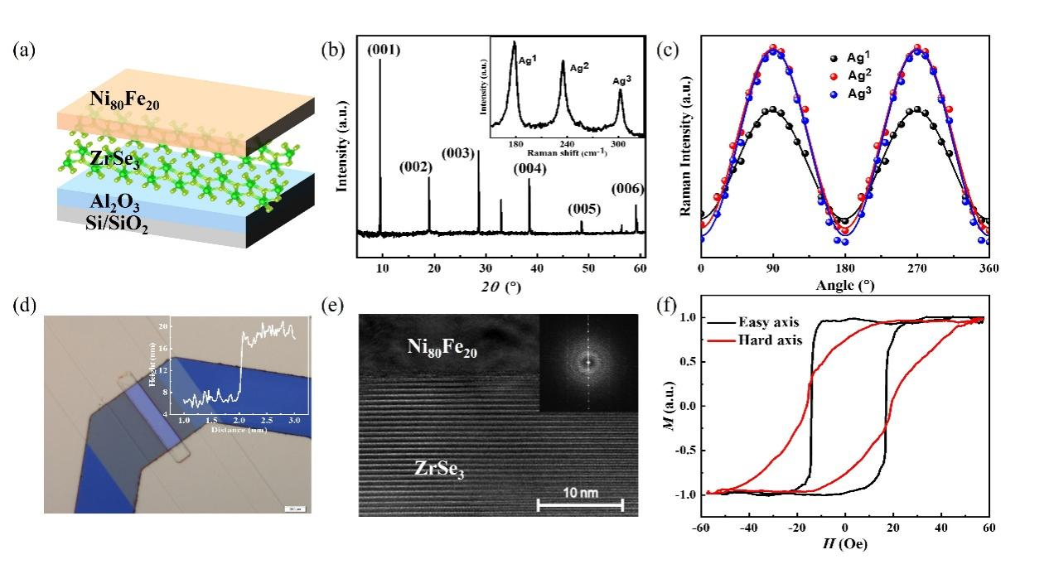

Fig. 1. (a) Schematic diagram of Si/SiO2/Al2O3/ZrSe3/Py heterostructure. (b) XRD pattern of the ZrSe3 crystal. (c) Angle-dependent Raman modes (at 178 cm-1,230 cm-1,300 cm-1) of exfoliated few-layered ZrSe3. Inset shows the Raman spectrum. (d) Optical image of the ZrSe3/Py device. Inset is the AFM height-profile of the ZrSe3 flake. (e) Cross-sectional TEM images of ZrSe3/Py structure. Inset is the Fourier diffraction pattern of the crystal structure of ZrSe3 obtained from TEM results. The scale bar is 10 nm. (f) Magnetic hysteresis loops (M/Ms) of ZrSe3/Py sample along the length (easy axis) and width direction (hard axis) of the strip, respectively.

Then, we use the spin-torque ferromagnetic resonance equipment to study the SOT efficiency in ZrSe3/Cu (t=0, 1, 2 nm)/Py samples. Figure 2(a) shows the typical ST-FMR spectra for ZrSe3/Py heterostructure, and the ST-FMR measurement in samples at an incident microwave power of 14 dB and external magnetic field at *ϕ*=45° with respect to microwave current (*Irf*). The frequency is from 3 to 9 GHz. Using the Lorentzian equation to fit mixing voltage (*Vmix*) consisting of symmetric ($V_{S}$) and antisymmetric ($V_{A}$) components as follows [24, 26]:

$V_{mix}=V_{S}\frac{{∆H}^{2}}{{\left(H-H_{res}\right)}^{2}+{∆H}^{2}}+V_{A}\frac{∆H\left(H-H_{res}\right)}{{\left(H-H_{res}\right)}^{2}+{∆H}^{2}}$ (1)

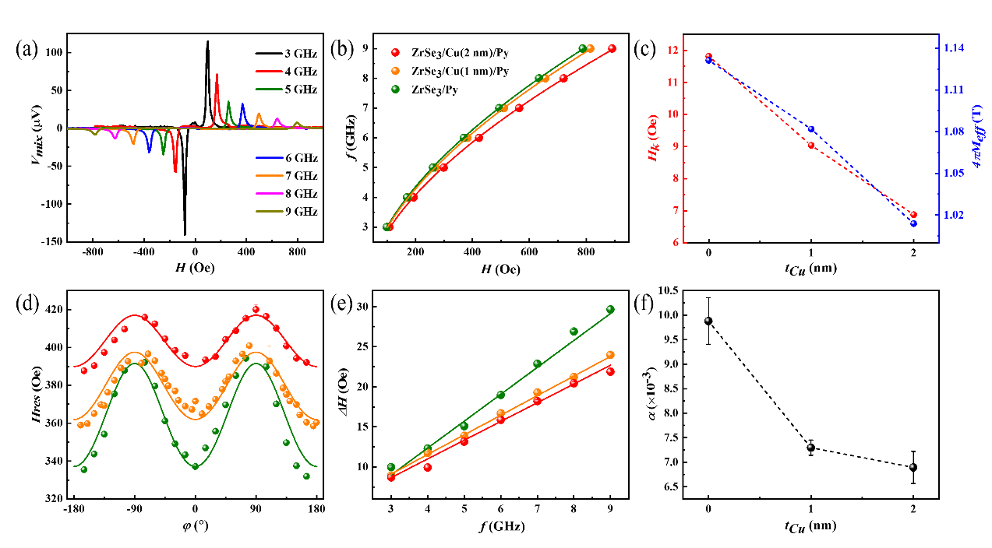

Fig. 2. (a) The ST-FMR spectra for the ZrSe3/Py heterostructure with the external magnetic field at an angle *ϕ*=45° with respect to *Irf*. (b) The relationship between the ST-FMR resonance frequency with the resonance field for ZrSe3/Cu (t=0, 1, 2 nm)/Py heterostructures. Solid lines are fitted by the Kittel formula. (c) The relationship between anisotropy field and effective magnetization with the thickness of Cu intercalation. (d) The angle-dependence between the resonant field and the applied magnetic field at 6 GHz. The solid lines are the fitting lines. (e) The relationship between the ST-FMR resonance frequency with the resonance linewidth for ZrSe3/Cu (t=0, 1, 2 nm)/Py heterostructures. Solid lines are fitting lines. (f) The relationship between anisotropy field and effective magnetic damping with the thickness of Cu intercalation. The dot lines are a guide to the eye.

We can obtain the ST-FMR resonance field (*Hres*) and linewidth ($∆H$). Fig. 2(b) shows the ST-FMR resonance field with different frequencies of ZrSe3/Cu (t=0, 1, 2 nm)/Py samples obtained at *ϕ*=45°. The relationship between *Hres* and *f* can be presented by using the following Kittel equation.

$f=\left(\frac{γμ_{0}}{2π}\right){\left[\left(H_{res}+H_{k}\right)\left(H_{res}+H_{k}+4πM_{eff}\right)\right]}^{1/2}$ (2)

where $γ$ is the gyromagnetic ratio and $μ_{0}$ is the vacuum permeability. $H_{k}$ is the in-plane magnetic anisotropy field, and $4πM_{eff}$ is the effective magnetization. From equation (2), we can obtain the effective magnetization and $H_{k}$ of Py in ZrSe3/Py and ZrSe3/Cu /Py, as illustrated in Fig. 2(c). With the increase of Cu thickness, $H_{k}$ decrease monotonically, suggesting that ZrSe3 can enhance the magnetic anisotropy of Py, while the Cu layer can disrupt this interfacial effect. We further quantitatively characterize the magnetic anisotropy of the device by fitting the angular dependence of the resonance field, as illustrated in Fig. 2(d). Details of the fitting process are provided in supplementary information S1. The results closely align with those obtained from fitting using the Kittel equation, affirming the reliability of our experimental analysis. We attribute this phenomenon to the structural asymmetry of ZrSe3, which facilitates an enhancement of in-plane anisotropy in the adjacent Py layer, while the introduction of a Cu spacer attenuates this proximity effect. Meanwhile, as shown in Fig. 2(e), the linear relationship between $∆H$ and *f* can be fitted by the following equation:

$∆H=∆H_{0}+\left(\frac{2πα}{γ}\right)f$ (3)

where $∆H_{0}$ is the ST-FMR resonance linewidth that comes from the inhomogeneity of Py layer, α is the Gilbert damping. The value of $∆H_{0}$ obtained from equation (3) with 1.3 Oe for ZrSe3/Py, 1.5 Oe for ZrSe3/Cu (1 nm)/Py, 1.3 Oe for ZrSe3/Cu (2 nm)/Py, which is too small and could to be neglected, indicating the high quality of Py films [27,28]. Extracted values of the Gilbert damping for ZrSe3/Py is 0.0099, for ZrSe3/Cu (1 nm)/Py is 0.0073, and for ZrSe3/Cu (2 nm)/Py is 0.0069, as shown in Fig. 2(f). The declined Gilbert damping indicates that the separation of Cu also weakens the interface induced damping enhancement of Py. These results prove that the Cu intercalation can effectively prevent the interface effect from the bulk effect in ZrSe3/Py structures.

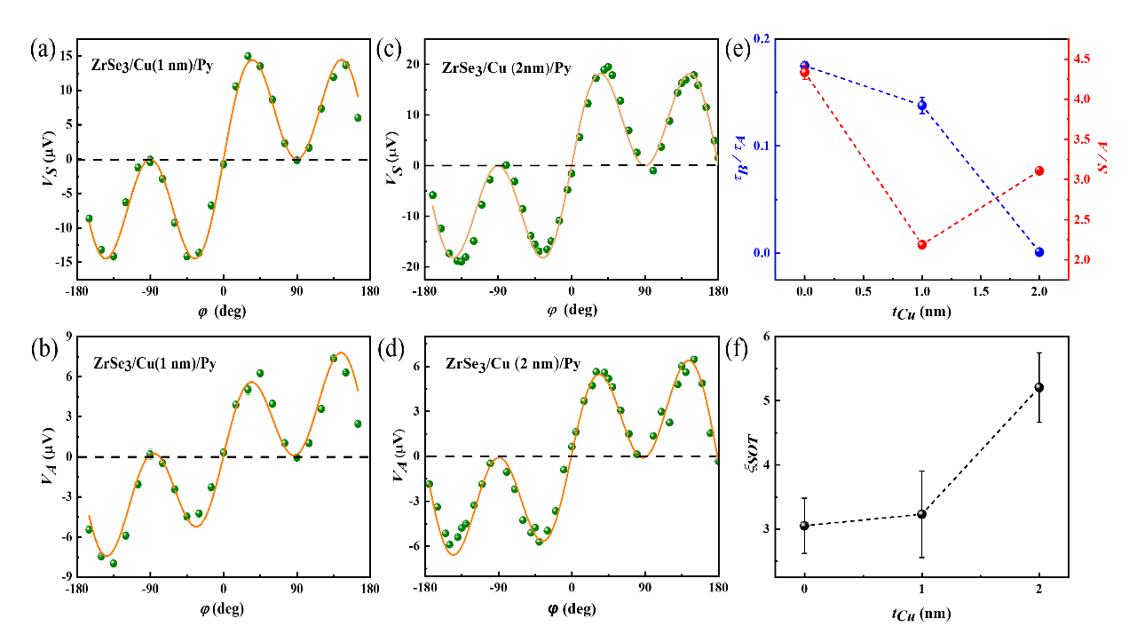

Fig. 3. (a)(b) and (c)(d) are the symmetric and antisymmetric ST-FMR resonance components for the ZrSe3/Cu (1, 2 nm)/Py samples as a function of in-plane magnetic field angle *ϕ*, respectively. The orange solid lines are the fitting lines. (e) The relationship between $τ_{B}/τ_{A}$ (the ratio between the out-of-plane field-like torque and out-of-plane damping-like torque) and *S/A* (the ratio between the symmetric and antisymmetric ST-FMR resonance coefficient) with Cu intercalation thickness, respectively. (f) The relationship between the spin-torque efficiency ($ξ_{SOT}$) with Cu intercalation thickness. All samples are measured at the applied microwave power of 14 dB and 6 GHz. The dot lines are a guide to the eyes.

Then, we focus on the interfacial contribution of ZrSe3/Py to SOT efficiency. The angular dependence of the *Vmix*signal at 6 GHz is exhibited as shown in Fig.3(a)-(d). The $φ$ represents the angle between the applied magnetic field and microwave-frequency current (*Irf*). Fig. 3(a)-(d) presents the symmetric and antisymmetric components of the ST-FMR signal for ZrSe3/Cu (t=1, 2 nm)/Py samples. In general, the symmetric and antisymmetric components of the ST-FMR signal follow the same angular dependence on $\cos\left(φ\right)\sin\left(2φ\right)$. Hence, we can fit the symmetric component of the ST-FMR signal according to the below equation,

$V_{S}=S\cos\left(φ\right)\sin\left(2φ\right)$ (4)

Where *S* is the coefficient associated with the strength of the in-plane damping-like torque and independent of the angle of the applied magnetic field. However, the case for an antisymmetric component of the ST-FMR signal is different. The abnormal angular dependence for an antisymmetric component of the ST-FMR signal can be fitted by adding $\sin\left(2φ\right)$ term as follows,

$V_{A}=A\cos\left(φ\right)\sin\left(2φ\right)+B\sin\left(2φ\right)$ (5)

Where *A* and *B* are coefficients associated with the strength of the out-of-plane field-like torque and out-of-plane damping-like torque, respectively. This phenomenon may be attributed to the symmetry breaking of the structure of ZrSe3. It is known that the symmetric and antisymmetric components are proportional to the in-plane torque ($τ_{∕∕}$) and out-of-plane torque ($τ_{⊥}$), respectively. So, the in-plane torque and out-of-plane torque can be described as the following formula:

$τ_{∕∕}=τ_{S}\cos\left(φ\right)$ (6)

$τ_{⊥}=τ_{A}\cos\left(φ\right)+τ_{B}$ (7)

$τ_{B}$ represents the out-of-plane damping-like torque, and $τ_{A}$ denotes to the out-of-plane field-like torque. Therefore, the ratio $τ_{B}$/ $τ_{A}$ can reflect the contribution of out-of-plane damping-like torque. $τ_{B}/τ_{A}$ can be derived from the obtained B/A, resulting in a value of 0.175 ± 0.004 for ZrSe3/Py. Upon introducing a 1 nm Cu spacer, $τ_{B}/τ_{A}$ is decreased to 0.138±0.008 for the ZrSe3/Cu/Py. Subsequently, with an increased Cu thickness of 2 nm, $τ_{B}/τ_{A}$ approaches near insignificance, reaching a value close to 0.001. This means that the out-of-plane damping-like torque component decreases when inserting a 1 nm Cu layer and then almost vanishes when Cu intercalation thickness is 2 nm, as shown in Fig.3 (e). This result indicates that the ZrSe3/Py interface takes a vital role in the out-of-plane damping-like torque. Then, further studies on the spin-torque efficiency $ξ_{SOT}$ are performed by the standard line-shape analysis. However, the calculation of SOT efficiency should take into account the current distribution in the Cu intercalation. So, the modified SOT efficiency formula can be expressed as below:

$ξ_{SOT}=t_{Py}\frac{S}{A}\frac{eμ_{0}M_{s}}{ℏ}\left(\frac{ρ_{{ZrSe}_{3}}}{ρ_{Cu}}t_{Cu}+t_{{ZrSe}_{3}}\right)\sqrt{1+\left({4πM_{eff}}/{H_{res}}\right)}$ (8)

where $M_{s}$ is the saturation magnetization of Py. $t_{Py}$ and $t_{{ZrSe}_{3}}$ are the thickness of Py and ZrSe3, respectively. From the equation (8), the spin-orbit efficiency ($ξ_{SOT}$) of ZrSe3/Py device is 3.05±0.43, the spin-orbit efficiency ($ξ_{SOT}$) of ZrSe3/Cu (1 nm)/Py device is 3.22±0.67 and the spin-orbit efficiency ($ξ_{SOT}$) of ZrSe3/Cu (2 nm)/Py device is 5.21±0.54, as shown in Fig.3(f). We can see that $ξ_{SOT}$ increases when inserting Cu intercalation. Spin pumping in ZrSe3/Cu/Py is negligible since its Gilbert damping is very close to the intrinsic damping of Py. We speculate that the observed changes in SOT efficiency may be attributed to alterations in current distribution at the interface induced by the introduction of Cu spacers.

To find out the mechanism for the increased SOT efficiency, a theoretical analysis is performed. The electronic structure of pure monolayer ZrSe3 and Cu/ZrSe3 heterostructure are carried out using DFT. We adopt a projected augmented wave (PAW) pseudopotential [29] to describe the interaction between ions-valence electrons of atoms, and the general gradient approximation (GGA) describes the exchange correlation function in the scheme of Perdew, Burke, and Ernzerhof (PBE) [30], as implemented in the Vienna Ab-initio Simulation Package (VASP) [31]. The Monkhorst-Pack method [32] for geometry optimizations of the Brillouin zone is sampled by a 5×7×1 k-point grid, and the kinetic energy cutoff is 500 eV. For Cu/ZrSe3 heterostructure, a finer 5×14×1 k-point grid is chosen and used for calculation. ZrSe3 andCu/ZrSe3 crystal structures are fully relaxed without any symmetry constraint until both the Hellmann-Feynman forces acting on each ion and total energy change are less than 0.01 eV/Å and 1×10-5 eV, respectively. Then, we study the electronic structure of pure monolayer ZrSe3 and Cu/ZrSe3 heterostructure by using the relaxed structure. Fig. 4 represents a density of state (DOS) calculated by PBE-GGA+U for pure monolayer ZrSe3 and Cu/ZrSe3 heterostructure. From Fig.4(a), we see that the DOS for the pure monolayer ZrSe3 shows a semiconductor character, and the bandgap is 0.62 eV. This result is consistent with previous reports [33,34]. Meanwhile, for the Cu/ZrSe3 heterostructure, the DOS behaves as a conductor, as shown in Figure 4(b). Then, the DOS of the ZrSe3 layer is extracted from the Cu/ZrSe3 heterostructure, which shows a conductor character as presented in Fig.4(c). From Figure 4(c), we see that the DOS of Zr and Se are increased at Fermi level when ZrSe3 comes into contact with Cu layer. Therefore, we believe that Cu intercalation changes the conductivity of ZrSe3, thereby reducing the Schottky barrier of ZrSe3/Py heterostructure and increasing the transport efficiency of the spin current. Hence, the resistivity at the interface of ZrSe3 flake connect with Cu insertion will changes, while the overall resistivity of the ZrSe3 flake does not change significantly.

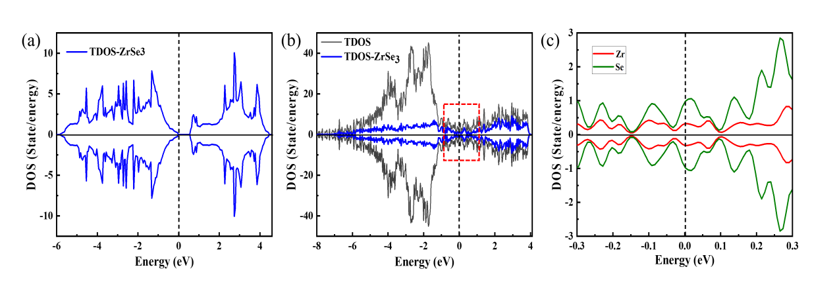

Fig. 4 (a) Total density of state (TDOS) of pure ZrSe3 monolayer. (b) The dark grey line represents the TDOS of Cu/ZrSe3 heterostructure, and the blue line represents the TDOS of ZrSe3. (c) comes from the red dot box in Figure 4(b).

Finally, we study the magnetization switching with the pulse dc current (*I*) at room temperature [18, 19, 22]. And the SOT-driven magnetic moment switching process is captured by MOKE images in Fig. 5(a)-(f) in ZrSe3/Cu (1 nm)/Py structure, where the length and width of the device are 45 μm and 8 μm, respectively. From figure 5(a)-(c), the magnetic moment is switched by pulsed charge current with 200 μs pulse width applied between the two electrodes connected with sample stripes, as shown in a red rectangular frame. Before switching, the magnetization of Py has saturated along the +y (-y) axis with an external magnetic field, and then the field is removed. Figure 5(a) shows the MOKE image of the initial saturated magnetization after removing the external magnetic field (+y axis). This pre-magnetization process can capture the initial MOKE image and make the injected spin polarization antiparallel with the remanence magnetic moment direction. Figures 5(b) and (c) show the magnetization direction reversal from +y(white) to -y(gray) with the increasing pulse current when the pulse charge current is applied in the +x direction. During this process, an anti-damping torque resulting from spin accumulation in spin polarization acts in opposition to the initial magnetization direction of Py along the +y axis, thereby causing a reversal of the Py magnetic moments along the -y axis. The total charge current density can be described as the following formula [18]:

$J_{tot}=\frac{I}{w×d}$ (11)

where *I* is the current, $w$ is the width of the sample stripe, while *d* is the total thickness of the sample structure. So, in Figure 5(b), the total current density at which the magnetization begins to reverse is 2.32×106 A/cm2 (the charge current density at ZrSe3 layer is 0.70×106 A/cm2). While the total current density at the completion of the magnetization reversal is 4.94×106 A/cm2 (the charge current density at ZrSe3 layer is 1.62×106 A/cm2) as shown in figure 5(c). Conversely, figure 5(d)-(e) shows an opposite magnetization switching process, and the charge current is applied along the -x direction, while the Py magnetization direction reverses from -y (gray) to +y (white). Compare to the ZrSe3/Py sample, as shown in the supplementary information S2, the critical charge current density for Py magnetization reversal is smaller in the ZrSe3/Cu (1 nm)/Py sample, which is consistent with that of the ST-FMR.

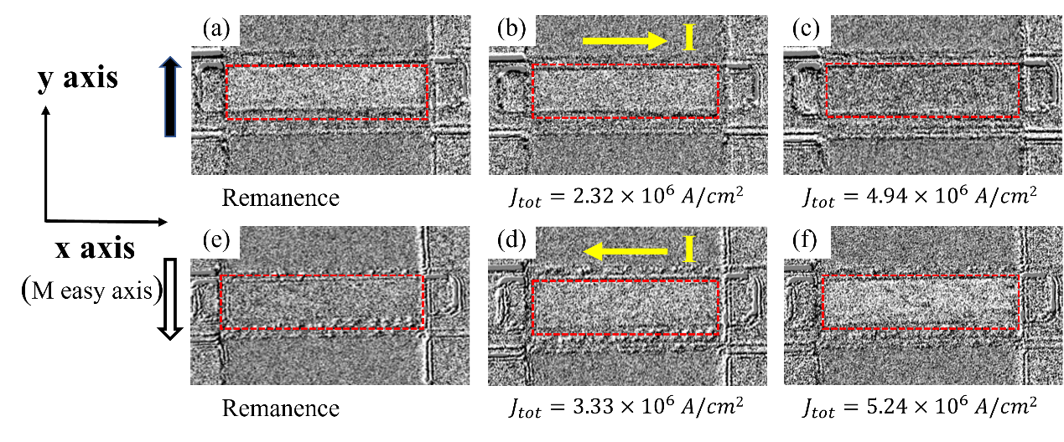

Fig. 5. MOKE images of SOT-driven magnetization switching in ZrSe3 (10 nm)/Cu (1 nm)/Py (10 nm) structure. (a)-(c) MOKE images of magnetization switching (at zero magnetic field) by applying a pulsed dc current ***I*** (yellow arrow point to the pulsed current direction) along the +x axis (M easy axis) with the increasing charge density $J_{tot}$ from the structure and the estimated charge current $J_{{ZrSe}_{3}}$ in the underneath ZrSe3 layer. (d)-(f) MOKE images of magnetization switching by applying a pulsed dc current ***I*** (yellow arrow points to the pulsed current direction) along the -x axis with the increasing charge density $J_{tot}$ from the structure and the estimated charge current $J_{{ZrSe}_{3}}$ in the underneath ZrSe3 layer. The red dashed rectangle in the figures represents the 8 $μm$ wide ZrSe3 (10 nm)/Cu (1 nm)/Py (10 nm) channel connected with two electrodes. The dark (light) arrow represents the initial magnetization direction along +y (-y). All measurements are performed at room temperature.

In summary, by SOTs of ZrSe3 and ZrSe3 /Cu, the magnetization of the Py layer is switched with current. SOT efficiencies of samples are detected by ST-FMR and an out-of-plane damping-like torque ($τ_{B}$) is observed. $τ_{B}/τ_{A}$ decreases from 0.175 to 0.001 when inserting 2 nm Cu at the interface, indicating that the ZrSe3/Py interface plays a decisive role in the out-of-plane damping-like torque. In addition, the SOT efficiency is increased from 3.05 to 5.21. Combining theoretical calculations, we have found that the enhancement in SOT efficiency primarily stems from the alteration of the density of states at the ZrSe3 interface caused by the introduction of Cu spacers, leading to a conductivity transition from semiconductor to conductor. Furthermore, MOKE microscopy is employed to verify the current-driven magnetization switching in these structures. The critical current density of ZrSe3/Cu/Py is 2.32×106 A/cm2, which is smaller than that of the ZrSe3/Py bilayer (4.63×106 A/cm2), consistent well with the ST-FMR results and the theoretical calculations.

**Author Contributions**

Lulu Cao and Qian Chen are contributed equally to this work.

**Funding**

This work is support by National Natural Science Foundation of China (Nos. 52071079, 12274071,12104484), Jiangsu Funding Program for Excellent Postdoctoral Talent (No. 2023ZB491).

**Conflict of Interest**

The author have no conflicts to disclose.

**Data availability.**

Data underlying the results presented in this paper are not publicly available at this time but may be obtained from the authors upon reasonable request.

**Reference**

[1] G. Prenat, K. Jabeur, P. Vanhauwaert, G. D. Pendina, F. Oboril, R. Bishnoi, M. Ebrahimi, N. Lamard, O. Boulle, K. Garello, J. Langer, B. Ocker, M. -C. Cyrille, P. Gambardella, M. Tahoori, G. Gaudin. Ultra-Fast and High-Reliability SOT-MRAM: From Cache Replacement to Normally-off Computing. IEEE Transactions on Multi-Scale Computing, Vol. 2, 1, 49-60 (2015).

[2] X. N. Zhao, Y. N. Dong, W. B. Chen, X. J. Xie, L. H. Bai, Y. X. Chen, S. S. Kang, S. S. Yan, Y. F. Tian. Advanced Functional Material **15**, Vol.31, 2105359 (2021).

[3] Y. C. Li, N. Zhang, K. Y. Wang. Spin logic operations based on magnetization switching by asymmetric spin current. Science China Information Sciences **65**, 122404 (2022).

[4] M. Haidar, A. A. Awad, M. Dvornik, R. Khymyn, A. Houshang, J. Åkerman. A single layer spin-orbit torque nano-oscillator. Nature Communications **10**, 2362 (2019).

[5] I. M. Miron, K. Garello, G. Gaudin, P.-J. Zermatten, M. V. Costache, S. Auffret, S. Bandiera, B. Rodmacq, A. Schuhl, P. Gambardella. Perpendicular switching of a single ferromagnetic layer induced by in-plane current injection. Nature **476**, 189–193 (2011).

[6] A. Brataas, A. D. Kent, K. Ohno. Current-induced torques in magnetic materials. Nature Materials **11**, 372-381 (2012).

[7] W. J. Kong, C. H. Wan, X. Wang, B. S. Tao, L. Huang, C. Fang, C. Y. Guo, Y. Guang, M. Irfan, X. F. Han. Spin-orbit torque switching in a T-type magnetic configuration with current orthogonal to easy axes. Nature Communications **10**, 233 (2019).

[8] J. E. Hirsch. Spin Hall Effect. Phys Rev Lett, **83**, 1834 (1999).

[9] U. H. Pi, K. W. Kim, J. Y. Bae, S. C. Lee, Y. J. Cho, K. S. Kim, S. Seo. Tilting of the spin orientation induced by Rashba effect in ferromagnetic metal layer, Appl. Phys. Lett. **97**,162507 (2010).

[10] Q. M. Shao, G. Q. Yu, Y. -W. Lan, Y. M. Shi, M. Y. Li, C. Zheng, X. D. Zhu, L. -J. Li, P. K. Amiri, K. L. Wang. Strong Rashba-Edelstein Effect-Induced Spin-Orbit Torques in Monolayer Transition Metal Dichalcogenide/Ferromagnet Bilayers. Nano Lett. **16**, 7514-7520 (2016).

[11] D. Sander, S. O. Valenzuela, D. Makarov, C. H. Marrows, E. E. Fullerton, P. Fischer, J. McCord, P. Vavassori, S. Mangin, P. Pirro, B. Hillebrands, A. D. Kent, T. Jungwirth, O. Gutfleisch, C. G. Kim, A. Berger. The 2017 Magnetism Roadmap. J. Phys. D: Appl. Phys. **50**, 363001 (2017).

[12] S. Ikeda, K. Miura, H. Yamamoto, K. Mizunuma, H. D. Gan, M. Endo, S. Kanai, J. Hayakawa, F. Matsukura, H. Ohno. A perpendicular-anisotropy CoFeB-MgO magnetic tunnel junction. Nat. Mater. **9**, 721 (2010).

[13] O. Mosendz, J. E. Pearson, F. Y. Fradin, G. E. W. Bauer, S. D. Bader, A. Hoffmann. Quantifying Spin Hall Angles from Spin Pumping: Experiments and Theory. Phys. Rev. Lett. **104,** 046601 (2010).

[14] C. F. Pai, L. Q. Liu, Y. Li, H. W. Tseng, D. C. Ralph, R. A. Buhrman. Spin transfer torque devices utilizing the giant spin Hall effect of tungsten. Appl. Phys. Lett. **101**, 122404 (2012).

[15] L. Q. Liu, C. Pai, Y. Li, H. W. Tseng, D. C. Ralph, and R. A. Buhrman. Spin-torque switching with the giant spin hall effect of tantalum. Science **336**, 555–558 (2012).

[16] L. Q. Liu, T. Moriyama, D. C. Ralph, and R. A. Buhrman. Spin-Torque Ferromagnetic Resonance Induced by the Spin Hall Effect. Phys. Rev. Lett. **106**, 036601 (2011).

[17] L. Q. Liu, O. J. Lee, T. J. Gudmundsen, D. C. Ralph, R. A. Buhrman, Current-Induced Switching of Perpendicularly Magnetized Magnetic Layers Using Spin Torque from the Spin Hall Effect. Phys. Rev. Lett. **109**, 096602 (2012).

[18] S. H. Liang, S. Y. Shi, C. H. Hsu, K. M. Cai, Y. Wang, P. He, Y. Wu, Vitor M. Pereira, H. Yang. Spin-Orbit Torque Magnetization Switching in MoTe2/ Permalloy Heterostructures. Adv. Mater **32**, 2002779 (2020).

[19] Y. Wang, D. P. Zhu, Y. Wu, Y. M. Yang, J. W. Yu, R. Ramaswamy, R. Mishra, S. Y. Shi, M. Elyasi, K. L. Teo, Y. H. Wu, H. Yang. Room temperature magnetization switching in topological insulator-ferromagnet heterostructures by spin-orbit torques. Nature Communications **8**, 1364 (2017).

[20] Y. T. Liu, Q. M. Shao. Two-Dimensional Materials for Energy-Efficient Spin-Orbit Torque Devices. ACS Nano **14**, 9389-407 (2020).

[21] C. K. Safeer, N. Ontoso, J. Ingla-Aynés, F. Herling, V. T. Pham, A. Kurzmann, K. Ensslin, A. Chuvilin, I. Robredo, M. G. Vergniory, F. de Juan, L. E. Hueso, M. R. Calvo, F. Casanova, Large Multidirectional Spin-to-Charge Conversion in Low-Symmetry Semimetal MoTe2 at Room Temperature. Nano Lett. **19**, 8758 (2019).

[22] S. Y Shi, S. H. Liang, Z. F. Zhu 1, K. C. Cai 1, S. D. Pollard, Y. Wang, J. Y. Wang, Q. S. Wang, P. He, J. W. Yu, G. Eda, G. C. Liang, H. Yang. All-electric magnetization switching and Dzyaloshinskii–Moriya interaction in WTe2/ferromagnet heterostructures. Nature Nanotechnology **14**, 945-949 (2019).

[23] M. H. D. Guimaraes, G. M. Stiehl, D. MacNeill, N. D. Reynolds, D. C. Ralph, Spin–Orbit Torques in NbSe2/Permalloy Bilayers. Nano Lett. **18,** 1311 (2018).

[24] Y. H. Zhu, Q. Chen, H. J. Wu, J. Liang, Mi. M. Tian, W. Jiang, J. C. Wang, R. X. Li, S. K. Li, Z. C. Huang, Z. X. Kou, W. M. Lv, B. S. Zhang, Z. M. Zeng, Y. Zhai. Large spin hall conductivity in low-symmetry semiconductor ZrSe3. Journal of Alloys and Compounds, Vol. 918**,** 165579 (2022).

[25] K. Osada, S. Bae, M. Tanaka, H. Raebiger, K. Shudo, T. Suzuki, Phonon properties of few-layer crystals of quasi-one-dimensional ZrS3 and ZrSe3, J. Phys. Chem. C. **120**, 4653–4659 (2016).

[26] A. Ganguly, K. Kondou, H. Sukegawa, S. Mitani, S. Kasai, Y. Niimi, Y. Otani, A. Barman. Thickness dependence of spin torque ferromagnetic resonance in Co75Fe25/Pt bilayer films. Appl. Phys. Lett. **104**, 072405 (2014).

[27] Y. Liu, Z. Yuan, R. J. H. Wesselink, A. A. Starikov, P. J. Kelly. Interface Enhancement of Gilbert Damping from First Principles. Phys. Rev. Lett. **113**, 207202 (2014).

[28] S. Mizukami, Y. Ando, T. Miyazaki. The Study on Ferromagnetic Resonance Linewidth for NM/80NiFe/NM (NM=Cu, Ta, Pd and Pt) Films. Jpn. J. Appl. Phys. **40**, 580-585 (2001).

[29] P. E. Blöchl. Projector augmented-wave method. Phys. Rev. B. **50**, 17953-17979 (1994).

[30] J. P. Perdew, K. Burke, M. Ernzerhof. Generalized Gradient Approximation Made Simple. Phys. Rev. Lett. **77**, 3865-3868(1996).

[31] G. Kresse, J. Hafner. Ab-initio Molecular Dynamics for Liquid Metals. Phys. Rev. B. **47**, 558-561(1993).

[32] H. J. Monkhorst, J. D. Pack, Special points for Brillouin-zone integrations. Phys. Rev. B. **13**, 5188-5192(1976).

[33] M. Li, J. Dai, X. C. Zeng. Tuning the electronic properties of transition-metal trichalcogenides via tensile strain. Nanoscale **7**, 15385-15391(2015).

[34] H. Li, G. S. -Santolino, S. Puebla, R. Frisendo, A. M. A. -Enizi, A. Nafady, R. D’Agosta, A. C. -Gomez. Strongly Anisotropic Strain-Tunability of Excitons in Exfoliated ZrSe3. Advanced Material **34**, 2103571 (2022).

[35] W. Zhang, W. Han, X. Jiang, S. H. Yang, S. S. P. Parkin. Role of transparency of platinum–ferromagnet interfaces in determining the intrinsic magnitude of the spin Hall effect. Nat. Phys. **11**, 496-502 (2015).

[36] P. Debashis, T. Y. T. Hung, Z. Chen. Monolayer WSe2 induced giant enhancement in the spin Hall efficiency of Tantalum [J]. npj 2D Materials and Applications **4**, 18 (2020).

[37] Q. D. Xie, W. N. Lin, B. S. Yang, X. Y. Shu, S. H. Chen, L. Liu, X. J. Yu, M. B. H. Breese, T. J. Zhou, M. Yang, Z. Zhang, S. J. Wang, H. X. Yang, J. W. Chai, X. F. Han, J. S. Chen. Giant Enhancements of Perpendicular Magnetic Anisotropy and Spin-Orbit Torque by a MoS2 Layer. Adv. Mater. **48**, 1900776 (2019).

[38] Y. Luo, Q. Chen, R. X. Li, Y. P. Wang, W. M. Lv, B. S. Zhang, Y. M. Fan, H. Wu, Z. M. Zeng.Enhanced spin–orbit torque and field-free switching in Au/TMDs/Ni hybrid structures. Nanoscale **15**, 3142 (2023).