Effect of defects on the characteristics of CoFeB-MgO based MRAM structure

Bosen Zhang1,2, Jieyao Chen1, Junlin Wang1,2,a, Wenjia Li1,2，Kaiyu Tong1,2,Guanqi Li1,2, Jun Ma1,2, Jing Wu1,3, Yongbing Xu1,2,b

*1)School of Integrated Circuits, Guangdong University of Technology, Guangzhou 510006, China*

*2)Spintronics and Nanodevice laboratory, Department of Electronic Engineering, University of York, York YO10 5DD, United Kingdom*

*3)Department of Physics, University of York, York, YO10 5BP, UK*

*a) junlin.wang@gdut.edu.cn*

*b) yongbing.xu@york.ac.uk*

Received 03 06 2023

Abstract— Magnetic random-access memory (MRAM) is one of the most promising next-generation purpose memory devices for nonvolatile storage and in-memory computing. However, material defects can affect the performance of the MRAM device. Here, the relationship between the material detects and the properties of CoFeB-MgO-based MRAM have been studied with micromagnetic simulations. The results show that the coercivity and the switching speed are strongly influenced by the material defects. This work provides a useful guideline for the fabrication of the MARM devices.

Keywords:STT-MRAM, Defect, Magnetization switching.

1.Introduction

Nowadays, the magnetoresistive (MR) effect in ferromagnetic (FM) materials is being widely studied, and the MR effect mainly includes anisotropic magnetoresistance (AMR)[1], giant magnetoresistance (GMR) [2, 3] and tunnel magnetoresistance (TMR) [4-6]. The development of high-performance spintronics storage devices is made possible by the presence of these MR effects. Both spin transfer moment MRAM (STT-MRAM) and spin-orbital torque RAM (SOT-MRAM) are currently being developed for memory applications. MRAM is a non-volatile memory technology with great promise being used as a general-purpose memory. With the development of the information industry, the demand for large storage density and high-performance devices is increasing. At present, STT-MRAM, as a novel non-volatile memory, has the characteristics of fast write speed, low power consumption and large capacity. Magnetic tunnelling junctions (MTJ) with nanoscale dimensions are the basic building blocks of STT-MRAM. MTJ has a sandwich structure, usually consisting of two ferromagnetic layers on both sides (free layer and fixed layer) and an insulating layer in the middle (also known as a barrier layer) [7-9]. When the magnetizations in the two ferromagnetic layers are in parallel, MTJ will have the lowest tunnel magnetoresistance. When the magnetizations in the two ferromagnetic layers are in anti-parallel parallel, MTJ will have the highest tunnel magnetoresistance [10]. It can therefore be used to store binary information '0' and '1'. The free layer of the MTJ structure can be switched by injecting spin polarization current, thus having different magnetoresistive states [11].

**2.Micromagnetic simulation**

The MTJ based on CoFeB/MgO is one of the most promising vertical STT-MRAM components with high thermal stability, low critical switching current density, and high TMR. The vertical magnetic anisotropy (PMA) of MTJ comes from the interface between MgO and CoFeB. To be precise, it is the Fe-O bond formed by hybridization between Fe-3d and O-2p orbits at the MgO interface [12, 13]. Many factors affect the interface of CoFeB-based MTJs [14-17]. Defect change is one of the more important influencing factors. In the production and manufacturing process of MTJ, defects will be unavoidably created. Many processes in the manufacturing process can cause a variety of lattice defects. Some of these steps inevitably create defects, while others deliberately create defects for certain purposes [18-20]. Defects affect the characteristics of MTJ, for example, the saturation magnetization strength and coercivity. There are also dynamic characteristics such as switching speed and current required for switching [19, 21, 22]. Fig. 1 shows the basic structure of the MTJ used in this micromagnetic simulation. The bottom layer is the fixed layer, the upper layer is the CoFeB free layer, and the middle is the MgO insulation layer [10]. Spin transfer torque is injected from the fixed layer through the insulating layer to the free layer. In this model, we only studied the free layer with material defects. The coercivity and STT characteristics of the device have been studied in detail.

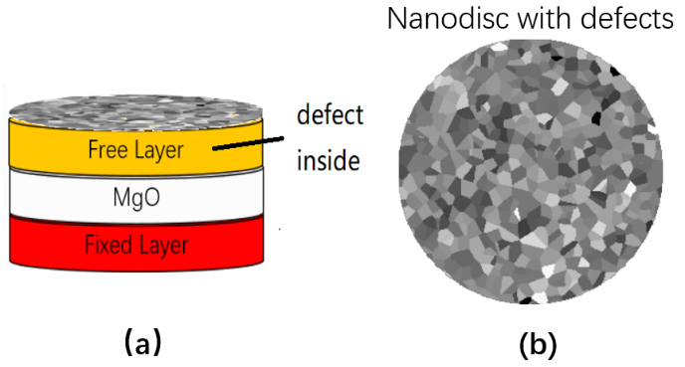

Fig. 1 The schematic diagram of the MTJ with material defect. (a) Schematic diagram of MTJ hierarchy. (b)Internal defect structure of free layer.

The micromagnetic simulation is provided by the micromagnetic simulation software *MUMAX3* [23]. Unless otherwise specified, the nanodisk diameter of the CoFeB free layer is 40 nm and the thickness is 1.2 nm. The simulation parameters in the micromagnetic simulation are given as magnetic anisotropy *Ku*=1.0883 MJ/m3, the saturation magnetization *Ms* = 140 kA m-1, and the exchange constant *Aex* = 19 pJ m-1. The cell size for the micromagnetic simulation is set as 0.4 nm $×$ 0.4 nm $×$ 0.4 nm. In this simulation, we specify that the difference between a defect and a non-defect is the anisotropy energy at the defect *Kud*< *Ku*.

The magnetization follows the Landau–Lifshitz–Gilbert (LLG) equation :

$\frac{dm}{dt}= -γm× αm×\frac{dm}{dt}+ \frac{u}{t_{F}}m×\left(m_{p}×m\right)-ξ\frac{u}{t_{F}}(m×m_{p})$ (1)

Equation 1 is the LLG equation containing STT, where *tF* is the free layer thickness and *mp* is the direction of polarization of the current. *ξ* is the strength of the vertical spin moment, *u* is the speed of the spin electron.

$u= \frac{γħP}{2μ_{0}eM_{s}}J$ (2)

*u* is defined as Equation (2), where *ħ* is Planck's constant, P is the spin polarization rate, *J* is the current density, and *u0* is the vacuum permeability. Unless otherwise specified, all the simulations in this work were performed without thermal effects, and the results were based on the results of 10 simulations of different random seeds. We considered that the uniaxial anisotropy energy at the defect area is lower than the uniaxial anisotropy energy at the defect-free region. The uniaxial anisotropy energy *Ku* at non-defects area is 1.0883 MJ/m3. The coercivity for the nanodisk in this work is calculated from the static hysteresis loop simulation. The magnetization switching time induce by the STT, is calculate by applying a spin polarized current into the free layer.

**3.Results and Discussion**

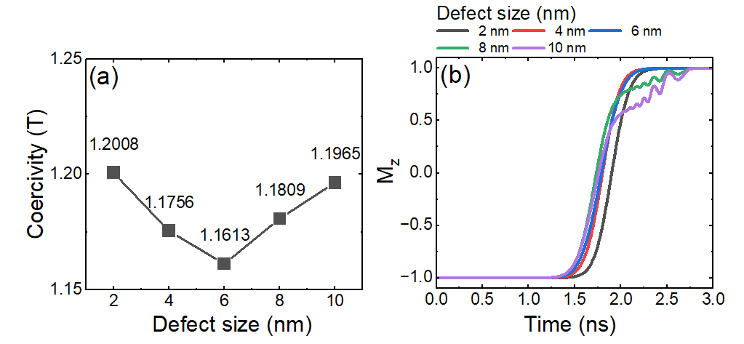

Fig. 2 Coercivity and magnetization switching of CoFeB-MgO structures at different defect sizes. The device has a diameter of 40 nm and a thickness of 1.2 nm, regardless of temperature effects. The result is statistical results from 10 simulations using different random seeds. (a) The relationship between defect size and coercivity (b) Time dependent current induced magnetization switching with different defect sizes, the current density is 51011A/m2.

Fig. 2 shows how the size of the defect affects the coercivity and the magnetization switching time. The device in Fig. 2 has a diameter of 40 nm and a thickness of 1.2 nm, defect density of 10 %. The results in Fig. 2(a) shows that the coercivity can be influenced by different defect sizes. In Fig. 2(a), the coercivity of the system is first decrease when the defect size is below 6 nm. Then the value of the coercivity reach a minimum value when the defect size is 6 nm. If the defect size is larger than 6 nm, the coercivity of the system will increase. The simulation results show that, there is a minimum value of the system coercivity with the various defect size. This phenomenon may induce by the different defect size will influence the domain wall nucleation in the system. Fig. 2(b) shows the magnetization switching curve of MTJ with different defect sizes. The current density in Fig. 2(b) is 51011A/m2, when the defect size increase, the magnetization switching speed will be faster. But as the defect size increases, the gain on switching speed decreases gradually. The increase of switching speed at 2 nm, 4 nm and 6 nm are more obvious, then the curve at 8 nm similar to the curve at 10 nm which show a magnetization oscillation. The curve with defect size as 8 nm and 10 nm are similar to the 6 nm curve before magnetization oscillation happened. Nonetheless, when the defect size exceeds certain thresholds(e.g. 8 nm, 10 nm), it induces oscillations during the switching process, consequently leading to significantly prolonged switching times. When the size of the defect is in the range of 4 nm to 6 nm, the effect of the size of the defect on the switching rate is relatively small. When the defect size is greater than or equal to 8 nm, it will cause jitter at the end of the switch curve. This will increase the switching speed from less than 2 ns to more than 2.5 ns, an increase of more than 30%.

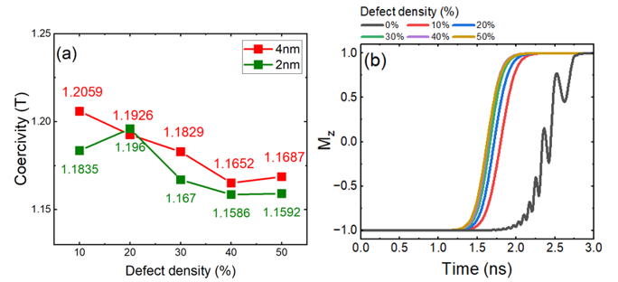

Fig. 3 Coercivity and magnetization switching of CoFeB-MgO structures at different defect densities. The device has a diameter of 40 nm and a thickness of 1.2 nm, regardless of temperature effects. The result is statistical results from 10 simulations using different random seeds. (a) The relationship between defect density and coercivity, the defect size is from 2 nm to 4nm. (b) The current induce magnetization switching curve under different defect densities, the current density is 5 × 1011A/m2.

Fig. 3 shows how the density of the defect affects the size of the coercivity and the time required for magnetization switching. The device in Fig. 3 has a diameter of 40 nm, a thickness of 1.2 nm, and a defect size change from 2 nm to 4 nm. Defect density means what percentage of the area with a lower uniaxial anisotropy which is induced by the material defects. Fig. 3(a) shows the change in coercivity at different defect densities. It can be seen that the initial size of the coercivity decreases with the size of the material defects. When the defect size is 2 nm, the coercivity increases with the increase of defect density when the defect density is in the range of 10 % to 20 %. When the defect density is 20 % - 40 %, the coercivity decreases with the increase of defect density and reaches the lowest point at 40 %. After the defect density is greater than 40 %, with the increase of defect density, the magnitude of the increase in coercivity becomes very low, and can even be said to be almost unchanged. When the defect size is 4 nm, the coercivity decreases at a substantially uniform rate with the increase of defect density when the defect density is in the range of 10 % to 40 %. When the defect density is 40 %, the coercivity has a minimum value. After that, the size of the coercivity will increase again to a higher value as the defect density increases. But after the defect density is greater than 40 %, with the increase of defect density, the magnitude of the increase of coercivity becomes very low. Fig. 3(b) illustrates the magnetization switching curve of the MTJ at various defect densities, all with a consistent defect size of 4 nm. The current density in Fig. 3(b) is 5 1011A/m2 and defect density equal to 0 can be considered as defect-free. According to the results, the greater the defect density, the earlier the switching starts and completes. When the system is free of defects, not only will the switching speed be slower, but the critical switching current density will increase, which will cause magnetization oscillations during switching. The presence of defects has a significant effect on the switching speed. But when the defect density is between 30 % to 40 %, the switching curves almost overlap. This indicates that the time required for switching within this interval is less affected by the defect density. Moreover, compared with the curve without defects, it can be seen that the existence of defects can greatly reduce the shock generated during the switching process. When the defect density is at 30%-50%, the switching speed is almost unchanged. When the defect density is 10%, the switching speed is about 15% slower.

It should be noted that, under the premise of the same defect density, the larger defect size will lead to a larger area of a single defect. If the defect density maintains at 10%, the defect area of the system will keep at 10%.

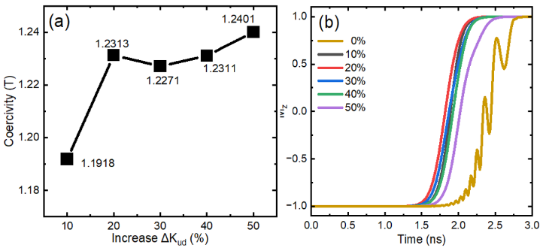

Fig. 4 Coercivity and magnetization switching curves of the system with defect harder than other area at different defect densities. The device has a diameter as 40 nm, a thickness as 1.2 nm and a defect size as 4 nm, regardless of temperature effects. The result is statistical results from 10 simulations using different random seeds. (a) The relationship between defect density and coercivity. (b) The current induce magnetization switching curve under different defect densities, the current density is 5 × 1011A/m2.

Fig. 4 shows how the density of the defect affects the coercivity and the speed of magnetization switching. The device in Fig. 4 has a diameter of 40 nm, a thickness of 1.2 nm, defect density means what percentage of the area with a higher uniaxial anisotropy. It can be seen that the initial magnitude of the coercive force generally increases with the lager densities. Although the coercivity decreases slightly when the defect density is 20%-30%. Fig. 4(b) shows the magnetization switching curve of MTJ at different defect densities. In Fig. 4(b), the current density is maintained at 5 x 1011 A/m2, and it's important to note that a defect density of 0 can be regarded as representing a defect-free scenario. The results show that the higher the defect density, the faster the switching speed. The defect-free system has a slowest switching speed. When the defect density ranges from 10% to 40%, the effect of defect density on the flipping speed is not obvious. The results demonstrate that although the defect has a higher magnetic anisotropy than other area, the existence of the defect will significantly increase the switching speed of the system.

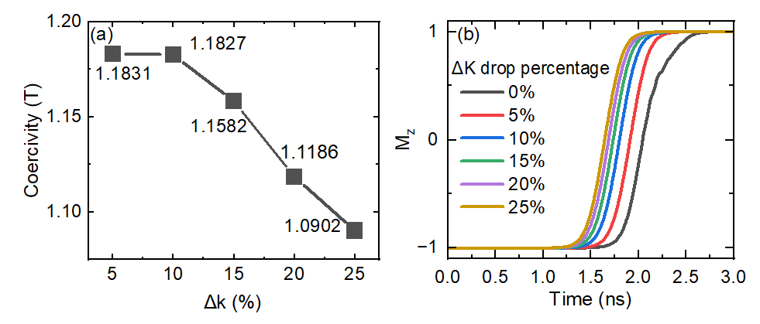

Fig. 5 Coercivity images and magnetized switching images of the system under different amplitudes of effective stochastic performance variations. The device has a diameter as 40 nm and a thickness as 1.2 nm, regardless of temperature effects. The result is statistical results from 10 simulations using different random seeds. (a) The relationship between different effective stochastic properties changes and coercivitys (b) Magnetization switching curves under changes in *Keffect* of different stochastic anisotropic properties.

Fig. 5 shows that changes in anisotropy of the nanodisk affects the magnitude of the coercive force and the time required for switching. The diameter of the nanodisk is 40 nm, the thickness is 1.2 nm, and the defect size is 4 nm. This part simulates the effect of the variation of the effective heterogeneity *Kud* at different defects on the system. *Kud* drops range from 5% to 25% Fig. 5(a) shows the change in coercivity under different amplitudes of stochastic anisotropic properties. The coercivity varies with the variation of random anisotropic properties. The size of the coercivity within the range of change decreases with the increase of the range of change. In the range of 5% to 10% of the effective heterogeneity *Kud*, the decrease in coercivity is small, but in the 10% to 25% of the effective heterogeneity *Kud*, the coercivity starts to decrease with a clearly visible The velocity decreases uniformly as the effective heterogeneity *Kud* increases. Fig. 5(b) shows the magnetization switching curve of the system with different amplitudes of anisotropy variations and the current density in Fig. 4 is 5 1011A/m2. The speed of the switching decreases with the increase of the effective random anisotropic performance range. However, as the effective heterogeneity *Kud* increases, the gain on switching speed decreases gradually. As shown in Fig. 4, the improvement of 5% compared with 0% is very obvious, and the improvement of 10% compared with 5% is also more obvious. However, beyond that point, the curves tend to converge or overlap.

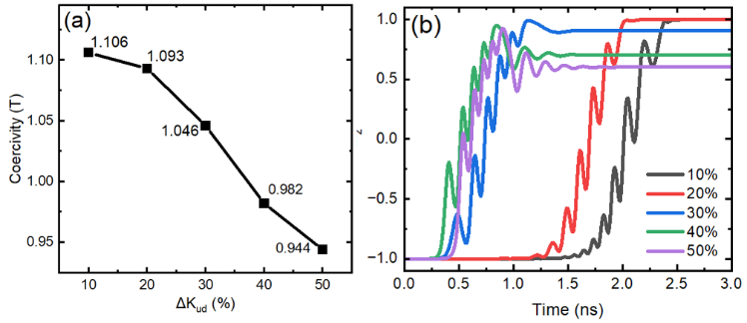

Fig. 6 Coercivity and magnetization switching curves of system with a ring shape edge defect. The width of the ring shape edge defect is set as 4 nm. The device has a diameter as 40 nm and a thickness as 1.2 nm, regardless of temperature effects. (a) The coercivity of the system with different defect ring. The *Ku* of the defect ring area is decrease from 0 % to 50 %. (b) The magnetization switching of the system with different defect ring. The *Ku* of the defect ring area is decrease from 0 % to 50 %. The current density is 5 × 1011A/m2.

In addition, we study the edge defect effect of the system. A core-shell structure is considered, the outer ring of the system is defined as ring shape defect area with a width as 4 nm. Fig. 6(a) gives the relationship between the coercivities and the edge defect. When the *Ku* of the edge defect area, the coercivity will also decrease. This is because the edge defect induces the reduce of system anisotropy energy. For the current induce magnetization switching of the system which is given in Fig. 6(b), the result is similar to the result in Fig. 5(b). But when the *Ku* decrease to 30%, the magnetization after switching will have a tilt angle away from the perpendicular direction, because of the decease of the system perpendicular anisotropy energy.

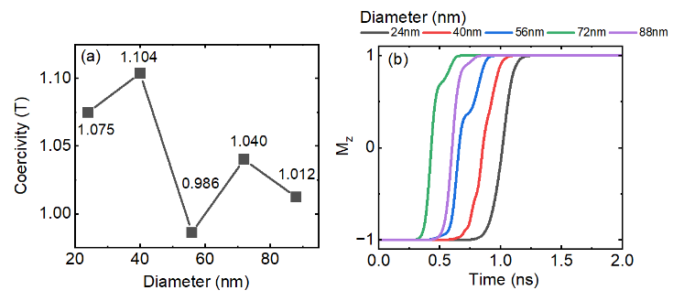

Fig. 7 Coercivity and magnetization switching image of CoFeB-MgO structure under the diameter of different defective nanodisks. The thickness of the device is 1.2 nm and temperature effects are not considered. The result is statistical results from 10 simulations using different random seeds. (a) The relationship between the diameter of the nanodisk and the coercivity. (b) the magnetization switching curve of the nanodisk of different diameters.

Fig. 7 demonstrates that the size of the nanodisk can affect the size of the coercivity and the time required for switching. Fig. 5 has a thickness of 1.2 nm and a defect size of 4 nm. Fig. 7(a) shows the change in coercivity at different nanodisk sizes. The averaged simulation results show that the size of the system will influence the system coercivity. When the diameter of the nanodisk increase from 24 nm to 88 nm, the coercivity first increase and reach the maximum value at 40 nm. Then if the system diameter larger than 40 nm, the coercivity reduce a smaller value. The general trend of the coercivity is to decrease first and then rise with the increase of diameter, reaching the lowest point at 56 nm in diameter. However, this trend is not very obvious, and the size of the coercive force fluctuates continuously with the increase of the size of the nanodisk. Fig. 7(b) shows the magnetization switching curve of MTJ at different nanodisk sizes. The magnitude of the current density in Fig. 7 is 11012A/m2 and the diameter of the system is changing from 24 nm to 88 nm. The speed of switching increases with the size of the nanodisk diameter until it reaches a critical size at 72 nm. Subsequently, as the diameter increases, the switching speed diminishes.

We have further found that the changes in defect properties or changes in nanodisk size could potentially affect the switching behavior of the system.

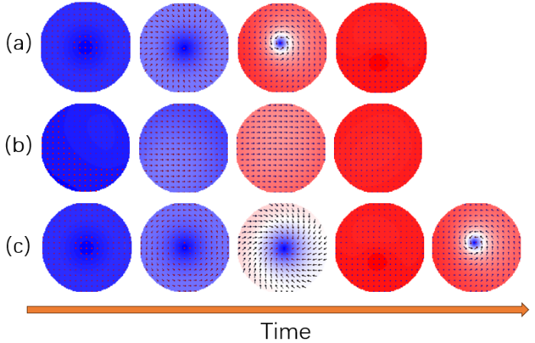

Fig. 8 Effect of defects on MTJ switching patterns. (a) is the switching mode when the defect density is 0. (b) is the switching mode when the defect density is not zero and defect size smaller than 10 nm. (c) is the switching mode when the defect density is not zero and defect size is larger than 20 nm. The color palette is determined

by the Mz (red for +1, white for 0, and blue for −1).

Fig. 8 shows how the defects affect the switching mode of the nanodisk. Fig. 8(a) shows the switching mode when the defect density is 0, which can be regarded as no defects. The switching mode at this time is spiral switching. During the switching process, the direction of the magnetic chips is spiral. Fig. 8(b) shows that the defect density is not zero, that is, the switching mode when the defect is present. The switching mode at this time is parallel switching, and the directions of the magnetic chips are parallel to each other during the switching process. In the simulation process, the defect density range is from 10 % to 50 %, and the switching mode is shown in Fig. 8(b). Whether the defect density is 0 leads to two different switching modes, which is also likely to be the reason for the oscillation of the switching curve without defects in Fig. 3(b). But if the size of the defect is very large, such as the 20nm size in (c), at this time, the switching mode becomes spiral switching again. Throughout the switching process, the orientation of the magnetic sheet adopts a helical pattern, with the direction of the spiral continuously shifting.

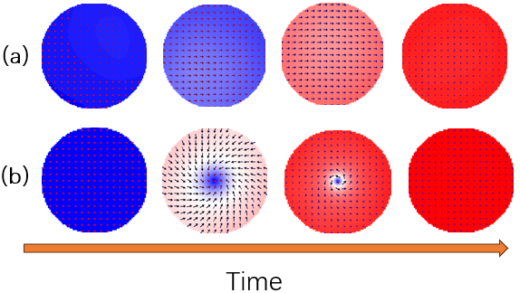

Fig. 9 Effects of changes in MTJ diameter on switching patterns. (a) switching mode with a diameter of 88 nm. (b) switching mode when the diameter is less than 72 nm. The color palette is determined

by the Mz (red for +1, white for 0, and blue for −1).

As shown in Fig. 9, the diameter of the MTJ affects the switching mode. Fig. 9(a) shows the switching mode when the diameter is 88 nm, and the switching mode at this time is helical switching. During the switching process, the direction of the magnetic chips is spiral. Fig. 9(b) shows the switching mode when the nanodisk diameter is less than 72 nm. The switching mode at this time is parallel switching, and the directions of the magnetic chips are parallel to each other during the switching process.

The presence of defects can significantly reduce the effective magnetic anisotropy of the device which will influence the switching barrier of the free layer [24-27]. As a result, both the coercivity and the time for magnetization switching are reduced. When the defect size increases, the coercivity decreases and so does the time required to switching. But when the defect size reaches a criticality level, the switching may deteriorate. As the defect density increases, the coercivity decreases, as does the magnetization switching time. When the uniaxial anisotropy at the defect decreases, the coercivity and the time required for magnetization switching will also decrease. For the application of magnetic recording device, if the defect density between each bits is different, it will increase the error rate of the writing and reading process due to the different switching time and critical switching current density.

**4.Conlusion**

Through simulation, we have found that the magnitude of the coercivity of CoFeB/MgO based MTJ and the switching rate under the premise of constant current density are affected by defects. The Defect size, density and the varying amplitudes of effective random anisotropy all affect the coercivity of free layer as well as the current switching speed. At the same time, different MTJ diameter sizes will also affect the coercivity and switching speed of the device. According to our simulation, the switching time can be reduced by more than 20% while keeping a large coercivity with suitable defects. The results are expected to provide some insight into the effect of defects on the performance of MRAM, which will help the control of the fabrication process.

Acknowledgment

This work is supported by Key-Area Research & Development Program of Guangdong Province under Grant 2021B0101300003, Guangdong Basic and Applied Basic Research Foundation 2022A1515110863, 2023A1515010837, National Key Research and Development Program of China (Grant No. 2016YFA0300803), the National Natural Science Foundation of China (Grant No. 61427812, 11774160 and 12304136), the Natural Science Foundation of Jiangsu. Province of China (No. BK20192006), the Fundamental Research Funds for the Central Universities (Grant No. 021014380113) the Natural Science Foundation of Jiangsu Province of China (No. BK20200307).

References

1. McGuire, T. and R. Potter, *Anisotropic magnetoresistance in ferromagnetic 3d alloys.* IEEE Transactions on Magnetics, 1975. **11**(4): p. 1018-1038.

2. Baibich, M.N., et al., *Giant Magnetoresistance of (001)Fe/(001)Cr Magnetic Superlattices.* Physical Review Letters, 1988. **61**(21): p. 2472-2475.

3. Binasch, G., et al., *Enhanced magnetoresistance in layered magnetic structures with antiferromagnetic interlayer exchange.* Physical Review B, 1989. **39**(7): p. 4828-4830.

4. Nishimura, N., et al., *Magnetic tunnel junction device with perpendicular magnetization films for high-density magnetic random access memory.* Journal of Applied Physics, 2002. **91**(8): p. 5246-5249.

5. Sharma, M., S.X. Wang, and J.H. Nickel, *Inversion of Spin Polarization and Tunneling Magnetoresistance in Spin-Dependent Tunneling Junctions.* Physical Review Letters, 1999. **82**(3): p. 616-619.

6. Rizzo, N.D., et al., *Thermally activated magnetization reversal in submicron magnetic tunnel junctions for magnetoresistive random access memory.* Applied Physics Letters, 2002. **80**(13): p. 2335-2337.

7. Miyazaki, T. and N. Tezuka, *Giant magnetic tunneling effect in Fe/Al2O3/Fe junction.* Journal of Magnetism and Magnetic Materials, 1995. **139**(3): p. L231-L234.

8. Weisheng, Z., et al., *High Speed, High Stability and Low Power Sensing Amplifier for MTJ/CMOS Hybrid Logic Circuits.* IEEE Transactions on Magnetics, 2009. **45**(10): p. 3784-3787.

9. Zhao, W., et al., *New non-volatile logic based on spin-MTJ.* physica status solidi (a), 2008. **205**(6): p. 1373-1377.

10. Zhu, J.-G. and C. Park, *Magnetic tunnel junctions.* Materials Today, 2006. **9**(11): p. 36-45.

11. Kurebayashi, *Spin-Orbit torques: going in the right direction.* 2016.

12. Yang, H.X., et al., *First-principles investigation of the very large perpendicular magnetic anisotropy at Fe$|$MgO and Co$|$MgO interfaces.* Physical Review B, 2011. **84**(5): p. 054401.

13. Kudrnovský, J., et al., *Exchange Interactions and Magnetic Percolation in Diluted Magnetic Semiconductors*, in *Local-Moment Ferromagnets: Unique Properties for Modern Applications*, M. Donath and W. Nolting, Editors. 2005, Springer Berlin Heidelberg: Berlin, Heidelberg. p. 131-145.

14. Lequeux, S., et al., *Thermal robustness of magnetic tunnel junctions with perpendicular shape anisotropy.* Nanoscale, 2020. **12**(11): p. 6378-6384.

15. Iwata-Harms, J.M., et al., *Ultrathin perpendicular magnetic anisotropy CoFeB free layers for highly efficient, high speed writing in spin-transfer-torque magnetic random access memory.* Scientific Reports, 2019. **9**(1).

16. Wang, M., et al., *Current-induced magnetization switching in atom-thick tungsten engineered perpendicular magnetic tunnel junctions with large tunnel magnetoresistance.* Nature Communications, 2018. **9**(1).

17. Pandey, C.A., et al., *Enhancing perpendicular magnetic anisotropy through dead layer reduction utilizing precise control of Mg insertions.* Journal of Magnetism and Magnetic Materials, 2020. **511**: p. 166956.

18. Xu, Z. and L. Qin, *Effects of sputtering parameters and annealing temperatures on magnetic properties of CoFeB films.* Journal of Magnetism and Magnetic Materials, 2021. **538**.

19. Yoshida, C., et al., *Micromagnetic Study of Edge-Damage Effects in Perpendicular CoFeB/MgO Magnetic Tunnel Junction.* IEEE Transactions on Magnetics, 2019. **55**(7): p. 1-5.

20. Sinha, J., et al., *Enhanced interface perpendicular magnetic anisotropy in Ta|CoFeB|MgO using nitrogen doped Ta underlayers.* Applied Physics Letters, 2013. **102**(24): p. 242405.

21. Yuan, F.-T., et al., *Effect of thickness of MgO, Co-Fe-B, and Ta layers on perpendicular magnetic anisotropy of [Ta/Co60Fe20B20/MgO]5 multilayered films.* Journal of Applied Physics, 2012. **111**(7): p. 07C111.

22. Hayakawa, J., et al., *Dependence of Giant Tunnel Magnetoresistance of Sputtered CoFeB/MgO/CoFeB Magnetic Tunnel Junctions on MgO Barrier Thickness and Annealing Temperature.* Japanese Journal of Applied Physics, 2005. **44**(No. 19): p. L587-L589.

23. Vansteenkiste, A., et al., *The design and verification of MuMax3.* AIP Advances, 2014. **4**(10): p. 107133.

24. Lee, D.-Y., H.-T. Seo, and J.-G. Park, *Effects of the radio-frequency sputtering power of an MgO tunneling barrier on the tunneling magneto-resistance ratio for Co2Fe6B2/MgO-based perpendicular-magnetic tunnel junctions.* Journal of Materials Chemistry C, 2016. **4**(1): p. 135-141.

25. Zhang, L., et al., *Shape Defect Effect in Perpendicular Shape Anisotropy Nanodots.* IEEE Magnetics Letters, 2021. **12**: p. 1-5.

26. Singh, S., S. Munjal, and N. Khare, *Strain/defect induced enhanced coercivity in single domain CoFe2O4 nanoparticles.* JOURNAL OF MAGNETISM AND MAGNETIC MATERIALS, 2015. **386**: p. 69-73.

27. Wesselinowa, J.M. and I. Apostolova, *Size, anisotropy and doping effects on the coercive field of ferromagnetic nanoparticles.* JOURNAL OF PHYSICS-CONDENSED MATTER, 2007. **19**(40).