Field-Free Spin-Orbit Torque Switching in Perpendicularly Magnetized Ta/CoFeB/MgO/NiO/Ta with a Canted Antiferromagnetic Insulator NiO Interlayer

Zhe Zhang, 1, 2, 3, † Zhuoyi Li, 1, 2, 3, † Yuzhe Chen, 1, 2, 3 Fangyuan Zhu,4 Yu Yan, 2 Yao Li, 1, 2, 3 Liang He, 1, 2, 3 Jun Du,1,5 Rong Zhang,2 Jing Wu, 6, 7 Yongbing Xu1, 2, 3, 7, * Xianyang Lu, 1, 2, 3, *

1National Key Laboratory of Spintronics, Nanjing University, Suzhou 215163, China.

2Jiangsu Provincial Key Laboratory of Advanced Photonic and Electronic Materials, School of Electronic Science and Engineering, Nanjing University, Nanjing 210093, China.

3School of Integrated Circuits, Nanjing University, Suzhou 215163, China.

4Shanghai Synchrotron Radiation Facility, Shanghai Advanced Research Institute, Chinese Academy of Sciences, Shanghai 201204, China

5National Laboratory of Solid State Microstructures, Nanjing University, Nanjing 210093, China.

6School of Integrated Circuits, Guangdong University of Technology, Guangzhou 510006, China.

7York-Nanjing International Center for Spintronics (YNICS), School of Physics, Engineering and Technology, University of York, York YO10 5DD, UK.

*Authors to whom correspondence should be addressed: [ybxu@nju.edu.cn](mailto:ybxu@nju.edu.cn) and [xylu@nju.edu.cn](mailto:xylu@nju.edu.cn).

†Z. Zhang and Z. Li contributed equally to this work.

Keywords: NiO, canted magnetization, out-of-plane spin polarization, field-free, spin-orbit torque, CoFeB multilayers.

**Abstract**

In this study, we achieve deterministic current-induced spin-orbit torque (SOT) magnetization switching, particularly in systems with perpendicular magnetic anisotropy (PMA), without the need for a collinear in-plane field, a traditionally challenging requirement. In a Ta/CoFeB/MgO/NiO/Ta structure, spin reflection at the MgO/NiO interface generates a spin current with an out-of-plane spin polarization component σz. Notably, the sample featuring 0.8 nm MgO and 2 nm NiO demonstrates an impressive optimal switching ratio approaching 100% without any in-plane field. A systematic investigation of the effects of the MgO and NiO thickness demonstrates that the formation of noncollinear spin structures and canted magnetization in the ultrathin NiO interlayer plays a pivotal role to the field-free SOT switching. The integration of NiO as an antiferromagnetic insulator effectively mitigates current shunting effects and enhances the thermal stability of the device. This advancement in the CoFeB/MgO system holds promise for significant applications in spintronics, marking a crucial step towards realizing innovative technologies.

1. Introduction

In conventional electronics, the underutilization of electron spin has confined devices to the charge degree of freedom. Spintronics offers a transformative approach by harnessing electron spin, thereby introducing additional degrees of freedom and enabling diverse device architectures[1, 2, 3]. Among the various techniques, spin-orbit torque (SOT) stands out for its efficiency, surpassing traditional spin-transfer torque (STT) through reduced power consumption and faster operation. This method induces a transverse spin current at the bilayer interface, facilitating manipulation of the ferromagnetic layer's magnetization[4]. Notably, SOT is particularly promising for SOT-MRAM cells, delivering enhanced design margins and stability compared to STT-MRAM configurations[5].

However, achieving deterministic current-induced SOT magnetization switching in systems with perpendicular magnetic anisotropy (PMA) poses significant challenges, often necessitating a collinear in-plane field, which restricts device integration and scalability. These limitations are counterproductive to the design principles of high-density and thermally stable SOT devices. Recent advancements have focused on field-free SOT switching in PMA systems, employing techniques such as exchange bias from adjacent antiferromagnets[6, 7] and stray fields from neighboring ferromagnetic layers[8]. Despite their potential, these methods may be susceptible to current-induced Joule heating and face material constraints that require larger write currents, complicating large-scale fabrication processes.

In contrast, utilizing out-of-plane spin polarization (σz) offers a more efficient and universally applicable strategy[9, 10, 11]. σz is often observed in two-dimensional van der Waals semimetals with lower crystal symmetry, such as WTe2 and MoTe2[12, 13], and has recently been reported in certain nonlinear antiferromagnetic materials like Mn3Sn and Mn3GaN[14, 15]. Nonetheless, controlling crystal symmetry and the resulting σz remains a formidable challenge, particularly regarding compatibility with semiconductor-based complementary metal-oxide-semiconductor (CMOS) technologies. Recent investigations have explored σz generation through spin reflection to achieve field-free magnetization switching[10, 16], though the underlying physical mechanisms require further elucidation.

In this study, we propose a novel Ta/CoFeB/MgO/NiO/Ta structure, where a sample with 0.8 nm MgO and 2 nm NiO demonstrates an optimal field-free SOT switching ratio of up to 93%. Our findings reveal a unique mechanism that leverages spin reflection at the MgO/NiO interface to generate σz. As depicted in Fig. 1(a), the z-polarized spin induces an out-of-plane anti-damping torque $M×z×M$ (τz), enabling deterministic switching of the CoFeB layer without an external magnetic field. As the thickness of the MgO and NiO layers increases, the canting of the spin direction in the interfacial NiO layer diminishes, resulting in a reduction of σz generated by the reflected spin current. Consequently, as depicted in Fig. 1(b), achieving deterministic SOT switching in a perpendicular anisotropic magnetic layer necessitates an additional in-plane auxiliary magnetic field, underscoring the importance of noncollinear spin structures and canted magnetization at the NiO interface.

Moreover, utilizing NiO as an antiferromagnetic insulator mitigates current shunting effects and enhances thermal stability due to its Néel temperature of 520 K[17]. Additionally, it introduces minimal stray fields, ensuring that device integration and stability are not compromised. This configuration not only facilitates σz generation but also allows for systematic tuning of the MgO and NiO thicknesses, optimizing the reflected spin current and nearing 100% switching efficiency. The generation of σz in CoFeB/MgO heterostructures is pivotal for practical spintronic applications, particularly given CoFeB's widespread use as a free layer in high-performance magnetic tunnel junctions[18]. This advancement in the CoFeB/MgO system holds significant promise for applications in spintronics, including spin-orbit torque-logic devices, neuromorphic computing, and deep neural networks[1].

2. Results and discussion

All the samples were grown on Si substrates with SiO2 insulation layers using a magnetron sputtering system. The layer sequence Ta (5)/Co40Fe40B20 (1)/MgO (n)/NiO (t)/Ta (2) was deposited from bottom to top. The numbers in parentheses denote thickness in nanometers. In subsequent discussions, these samples are referred to as MgO (n)/NiO (t) samples with different film thicknesses. The NiO layers were grown by sputtering a pure Ni metal target in a magnetron sputtering system with a mixture of argon and oxygen gases[19]. During the film growth process, a 50 sccm Ar gas flow was introduced, while the flow rate of O2 was 3 sccm. X-ray diffraction (XRD) pattern in Fig. 1(c) reveals a distinct NiO (111) peak for the MgO (0.8)/NiO (30) sample. Simultaneously, the Reflection High-Energy Electron Diffraction (RHEED) patterns indicate a polycrystalline nature of the NiO layer grown on the MgO, as shown in Fig. S1. The cross-sectional transmission electron microscope (TEM) images of the device structure, shown in Fig. 1(d) and Fig. S6, reveal a high-quality multilayer configuration. The growth quality of the MgO layer is further validated by element-resolved TEM imaging, which confirms its uniformity and continuity, ensuring the integrity of the MgO layer within the multilayer structure. The stack was then post-growth annealed at 300 $℃$ for 0.5 h in vacuum. The static magnetic hysteresis loops of the MgO (0.8)/NiO (2) sample, measured at room temperature using vibrating sample magnetometer (VSM) and Magneto-optical Kerr effect (MOKE) measurements, reveal a stable perpendicular magnetic anisotropy (PMA), as illustrated in Fig. S2. Hall bar devices with a width of 10 μm were fabricated for these stacks through optical lithography and etching process. Fig. S3 presents an optical image of the Hall bar device and schematic illustration of the electric measurements. The direction perpendicular to the plane is defined as the z-axis, with pulse current applied along the x-axis, and lateral Hall voltage measured along the y-axis.

The Anomalous Hall effect (AHE) loops, measured with an out-of-plane external magnetic field (*Hz*), are shown in Fig. 2(a) for MgO (2)/NiO (2), MgO (1)/NiO (2), MgO (0.8)/NiO (2) and MgO (0.8)/NiO (0) samples. It is evident that, even with a reduced MgO layer thickness of 0.8 nm, clear PMA is maintained[9, 10, 16, 20]. Additionally, it is observed that the sample without the NiO layer exhibit a relatively larger coercive force. Subsequently, we applied pulsed direct current (*Ipluse*) and measured the change in Hall resistance for Hall bars while the in-plane auxiliary field (*Hx*) varying from + 20 Oe to - 20 Oe. The current pulse width was maintained at 100 μs. Following each pulse, the Hall voltage was measured by applying a small reading current of 200 μA. The switching curves of Hall resistance (*RH*) are shown in Fig. 2(b, c, e and f) under varying *Hx* from + 20 Oe to - 20 Oe. It is evident that the MgO (2)/NiO (2) and MgO (1)/NiO (2) samples exhibit significant SOT switching only when the *Hx* exceeds approximately ± 8 Oe. Nevertheless, an almost complete SOT switching loop was observed at *Hx* = 0 Oe when the MgO layer thickness was reduced to 0.8 nm, as illustrated for the MgO (0.8)/NiO (2) sample in Fig. 2(e). The critical current density of the field-free switching is about $J_{c}=7.03×{10}^{6} A/{cm}^{2}$, emphasizing the efficiency of our design and its potential for low-power applications. Additionally, almost no switching signal was detected in this sample when *Hx* = - 5 Oe. These findings suggest the existence of an effective internal field in this structure, contributing to the deterministic field-free SOT switching process[3, 10]. Furthermore, we conducted MOKE image measurements after each pulse current at *Hx* = 0 Oe. The current-induced domain evolution with *Ipulse*, transitioning from negative to positive and vice versa, is illustrated in Fig. 2(d). This provides strong evidence supporting field-free switching in the MgO (0.8)/NiO (2) sample[21]. Based on the aforementioned results, field-free switching is exclusively observed when the MgO layer thickness is reduced to 0.8 nm in samples with a 2 nm NiO layer. As the MgO thickness further decreases, the multilayer film structure fails to establish stable PMA, as shown in Fig. S4. To investigate the impact of the NiO layer on magnetization switching, we prepared a comparative sample, MgO (0.8)/NiO (0). Remarkably, no indication of field-free switching was observed in the sample without a NiO layer, as shown in Fig. 2(f). These findings strongly support the crucial role of the NiO layer in enabling field-free switching.

Next, we explore the mechanism underlying the field-free switching in MgO (0.8)/NiO (2) sample. As reported in previous studies, the antiferromagnetic insulator NiO may introduce exchange bias, obtaining an out-of-plane SOT effective field for field-free switching[6, 7]. In our sample, we introduced a MgO layer between the CoFeB and NiO layers to mitigate the exchange bias effect, thereby avoiding direct contact between the ferromagnetic and antiferromagnetic layers. Furthermore, we did not grow our samples under an applied magnetic field. The hysteresis loops for both the in-plane and out-of-plane directions, as illustrated in Fig. S2, clearly demonstrate the absence of exchange bias in the MgO (0.8)/NiO (2) sample. Another plausible mechanism for field-free switching involves the realignment of part of the spin current with a spin polarization σy, facilitated by the insertion of the NiO layer. This realignment induces spin polarization with an out-of-plane component σz[15, 22, 23, 24, 25, 26]. To validate the presence and contribution of the out-of-plane component σz to the field-free SOT switching in our samples, we conducted measurements of the shift effect in the out-of-plane hysteresis loops under different currents[9, 10, 12, 16, 27]. Fig. 3(a, b) illustrate the AHE loops under ± 1 mA and ± 6 mA at an in-plane field *Hx* = 0 Oe for the MgO (0.8)/NiO (2) sample, respectively. The distinct right and left shift of the AHE loop was observed when the current is ± 6 mA at *Hx* = 0 Oe. The calculation of the shift field |∆*H*| is determined in the inset of Fig. 3(b). The shift field |∆*H*| at *Hx* = 0 Oe with current for MgO (0.8)/NiO (2) and MgO (0.8)/NiO (0) samples is summarized in Fig. 3(e). For the MgO (0.8)/NiO (2) sample, with the current smaller than ± 1 mA, no obvious shift was detected. However, upon increasing the current to ± 2 mA, an abrupt shift was observed, and the value of |∆*H*| continued to increases linearly with the escalating current, resembling findings previously reported with the presence of the spin current with an out-of-plane component σz[9, 10, 23]. For the MgO (0.8)/NiO (0) sample, it was observed that the shift field |∆*H*| remained nearly zero at *Hx* = 0 Oe, regardless of the magnitude of the current. Compared with the sample without NiO layer, the pronounced shift effect in the AHE loops at *Hx* = 0 Oe for the MgO (0.8)/NiO (2) sample clearly confirms the existence of the out-of-plane component σz.

Fig. 3(f) presents the comparable results of |∆*H*| for the MgO (0.8)/NiO (2) and MgO (0.8)/NiO (0) samples with *Hx* = 500 Oe. The linear slope between |∆*H*| and current can quantitatively manifest the SOT efficiency[28]. From the results, the MgO (0.8)/NiO (2) sample exhibits a higher SOT efficiency, with a slope of $11.28 ±0.26$ Oe/mA, whereas for the MgO (0.8)/NiO (0) sample, the slope is $7.84 ± 0.08$ Oe/mA. Additionally, we conducted harmonic Hall voltage measurements by sweeping the in-plane magnetic field to further investigate the SOT efficiency[29, 30, 31]. Fig. 3(c, d) illustrate the typical first (*Vω*) and second (*V2ω*) harmonic voltage signals for the MgO (0.8)/NiO (2) sample under 1 mA (AC) with longitudinal field *Hx* (H∥I) and transverse field *Hy* (H⊥I), respectively. The insets in Fig. 3(c, d) illustrate the fitting process of the data. Based on the Hall voltage results, longitudinal effective field ∆*HL* and transverse effective field ∆*HT* generated by the damping-like and field-like SOTs are extracted shown in Fig. 3(g, h). The values of ∆*HL* and ∆*HT* can be extracted by fitting the harmonic voltage curves under a small magnetic field range using the following equation[31, 32, 33]:

(1)

Both the SOT effective fields ∆*HL* and ∆*HT* are enhanced in the sample with a NiO interlayer. Specifically, the MgO (0.8)/NiO (2) sample exhibited a SOT effective fields of ∆*HL* = and ∆*HT* = Oe/mA, while the MgO (0.8)/NiO (0) sample showed ∆*HL* = and ∆*HT* = Oe/mA. The additional contribution from *HFL* due to σz significantly increases the overall effective field, as illustrated in Fig. S9f, thereby facilitating domain wall motion and enhancing deterministic magnetization switching.

Above discussions demonstrate that the insertion of the NiO layer and the reduction in the thickness of the MgO layer in the multilayer structure lead to the generation of σz in the system, thereby achieving field-free SOT switching. To delve deeper into the mechanism of σz generation, we prepared a series of additional samples. Firstly, we can rule out the generation of spin currents by the Ta capping layer and its interaction with the NiO layer to produce σz. The 2 nm thick Ta layer, acting as the capping layer, will undergo complete oxidation to Ta2O5[34, 35], acquiring insulating properties and rendering it no longer viable as a spin source. To provide further evidence, we replaced the capping layer material with Ru. The spin Hall angle of Ru has an opposite sign compared to Ta and is significantly smaller[36, 37, 38]. As shown in Fig. S5, the MgO (0.8)/NiO (2) sample with Ru capping also achieved field-free switching with a ratio approaching complete switching. The above results rule out the possibility that the spin polarization of the spin current has an out-of-plane component σz originating from the capping layer Ta.

Subsequently, we investigated the influences of reflected spin on SOT switching, as depicted in Fig. 4(d). When electrons traverse the Ta layer in the x-direction, a spin current in the z-direction with polarization along the y-direction is induced. Due to the low intrinsic Gilbert damping parameter and the high effective spin-mixing conductance with moderately high transparency of the Ta/CoFeB bilayer system[39], this spin current is injected into the adjacent magnetic CoFeB layer, exerting torques on the magnetization of the CoFeB layer[1, 40]. However, at this point, the spin current only exhibits σy, lacking the essential spin polarization component in the out-of-plane direction, σz, thus rendering it incapable of achieving field-free switching.

Spin electrons polarized along the y-direction undergo spin reflection at the interface of NiO, thereby generating σz. The significant spin reflection can be attributed to the difference in work function between the two materials, resulting in the generation of an internal electric field pointing from NiO to CoFeB[10, 16, 41, 42, 43]. The spin current carrying an out-of-plane spin polarization component σz is subsequently reflected back to the CoFeB layer, facilitating the field-free switching. Notably, literature indicates that the spin diffusion length in magnetic materials like CoFe can exceed 6 nm[44, 45], allowing the spin current from Ta to traverse the 1 nm CoFeB layer and enter the MgO barrier. Moreover, prior studies have shown that MgO thicknesses around 3 nm can yield favorable tunneling magnetoresistance[46, 47], reinforcing the feasibility of our tunneling mechanism through MgO. This is particularly supported by our observation of field-free SOT switching at a MgO thickness of 0.8 nm, which necessitates a sufficiently thin insulating barrier to achieve a stronger tunneling current while maintaining the integrity of the internal electric field.

Additionally, we note that the interfacial magnetic and electronic structure at the NiO/MgO interface is critical and should be thoroughly considered. This is because spin reflection at typical interfaces may not induce sufficient deflection in the spin polarization direction to generate a strong enough out-of-plane component[48].

It is noteworthy that the existence of antiferromagnetic Néel vector in NiO at the interface is crucial. In our sample, the crystal orientation of NiO is (111). Under normal circumstances, the Néel vector of NiO aligns along the in-plane direction since the easy plane is along the (111) orientation. The interfacial magnetic structures were probed using X-ray Magnetic Circular Dichroism (XMCD) in Fig. S7(a, b). Intriguingly, the Ni *L*3,2 edges exhibit XMCD signals in the MgO (0.8)/ NiO (2) sample, indicating a net magnetic moment arising from the Ni atoms. The values of spin moment *ms* = 0.390 *μ*B/atom and orbital moment *ml* = 0.067 *μ*B/atom were calculated by applying sum rules on the integrated XMCD and total XAS spectra. The spin moment is approximately 20% of that for bulk NiO crystals, as determined from magnetic x-ray scattering measurements[49, 50]. However, no Ni *L*3,2 edge XMCD signal was observed in the MgO (2)/NiO (2) sample. This demonstrates the clear role of ferromagnetism in inducing a ferromagnetic ordering of interfacial Ni spins, which coincides with the conditions necessary for the generation of σz. Fig. S8 shows The Ni *L*2,3-edge x-ray absorption (XAS) spectra of the NiO in the MgO (0.8)/NiO (10), MgO (0.8)/NiO (2) and MgO (0.8)/Ni (2) samples. For a NiO thickness of 10 nm, the XAS characteristic spectra observed are consistent with those reported in the literature[51, 52]. However, for the 2 nm NiO sample, the *L*2 and *L*3 peaks exhibit larger full widths at half maximum (FWHM) compared to the Ni thin film sample, and distinct peaks are not evident. This observation is consistent with report on thin NiO in the literature[50]. This suggests that thin NiO films may have certain defects, which in turn weaken their intrinsic antiferromagnetic exchange interactions. When the MgO layer is sufficiently thin, the NiO layer is influenced by interactions with adjacent ferromagnetic layers[51, 52, 53, 54]. This results in a slight canting of the spin direction of the interfacial NiO layer moments away from the AFM in-plane easy axis[50]. In other words, the Ni moments at the interface tilt towards the Co moments due to the Co-Ni exchange interaction, leading to the formation of noncollinear spin structures at the interface of the NiO layer. The canted magnetization and the presence of an internal electric field at the NiO interface interact with the reflected spin, causing spin flip, rotation, and precession. This interaction ultimately reorients the spin polarization to include an out-of-plane component.

In addition to the MgO (0.8)/ NiO (2) sample, we also prepared samples with NiO thicknesses of 3, 5, and 10 nm to further validate our explanation. As shown in Fig. 4(a), in the current-induced magnetization switching experiments, the ratio of field-free SOT switching gradually decreases with the increasing thickness of the NiO layer, and no field-free switching is observed when the NiO layer thickness reaches 10 nm. This is due to the fact that the strength of this coupling depends on the competition between the exchange interaction of the interfacial magnetic moments in the antiferromagnetic and ferromagnetic layers, as well as the antiferromagnetic super-exchange interaction within the NiO layer[50]. Moreover, with increasing thickness of the NiO layer, enhanced effective AFM exchange coupling results in a reduction of the canting angle[55]. Consequently, this weakens the return of the spin current carrying an out-of-plane spin polarization component σz through reflection. We experimentally confirmed this phenomenon by investigating the shift threshold effect of the AHE loops for MgO (0.8)/NiO (2, 3, 5 and 10) samples under the in-plane field *Hx* = 0 Oe, as depicted in Fig. 4(b, c). As the NiO thickness increases, the threshold current value gradually increases. At the same time, the shift field |∆*H*| decreases accordingly. These results qualitatively indicate a reduction in the generation of spin current with an out-of-plane component σz, which is correlated with the ratio of field-free switching in these samples.

**3. Conclusion**

In summary, we have successfully achieved field-free SOT switching within a Ta/CoFeB/MgO/NiO/Ta structure. Notably, the MgO (0.8)/NiO (2) sample exhibited an impressive switching ratio approaching 100% without the need for an in-plane field. Spin-polarized electrons, aligned along the y-direction, undergo spin reflection at the NiO interface, characterized by noncollinear spin structures with canted magnetization, thereby generating an out-of-plane spin polarization component σz. Our thorough validation of the σz’s contribution, supported by measurements of the shift effect in out-of-plane hysteresis loops, underscores the pivotal role of this mechanism in achieving field-free SOT switching. Simultaneously, we observed that the ratio of field-free SOT switching gradually decreases with the increasing thickness of the NiO layer. This highlights the importance of forming noncollinear spin structures and canted magnetization at the NiO layer interface in the spin reflection process for generating σz. Utilizing NiO as an antiferromagnetic insulator mitigates current shunting and enhances thermal stability while introducing minimal stray fields, thus preserving device integration and stability. The generation of σz in CoFeB/MgO heterostructures is crucial for spintronic applications. Beyond advancing our fundamental understanding of spintronics, this breakthrough paves the way for promising practical applications, marking a significant step toward innovative technologies in the field.

**Data Availability**

The data that support the findings of this work are available within the paper and its Supporting Information. Additional data are available from the corresponding authors upon reasonable request.

**Associated Content**

Refer to the supporting information for additional information.

**Acknowledgements**

This work is supported by the National Key Research and Development Program of China (Grant Nos. 2021YFB3601600, 2023YFA1406603, 2022YFA1403602) and the National Natural Science Foundation of China (Grant Nos. 12104216, 12241403, 61427812, 12374112, T2394473, T2394470, 12234017, 62322408 and 62204113).

**Author contributions**

X.L., Y.X. and Z.Z.conceived the project and designed the experiments. Z.Z. and Z.L. prepared the samples with the help from Y.Y., Y.L. and L.H.. Z.Z. and Z.L. performed the SOT measurements with the help from Y.C.. Z.Z. and F.Z. performed the XMCD measurements. J.D. performed the VSM measurements. Z.Z., Z.L., Y.X., J.W., R.Z. and X.L. performed the data analysis and wrote the paper with contributions from all authors. All authors discussed the results, interpretation and conclusion.

**Competing interests**

The authors declare no competing interests.

**Figures and captions**

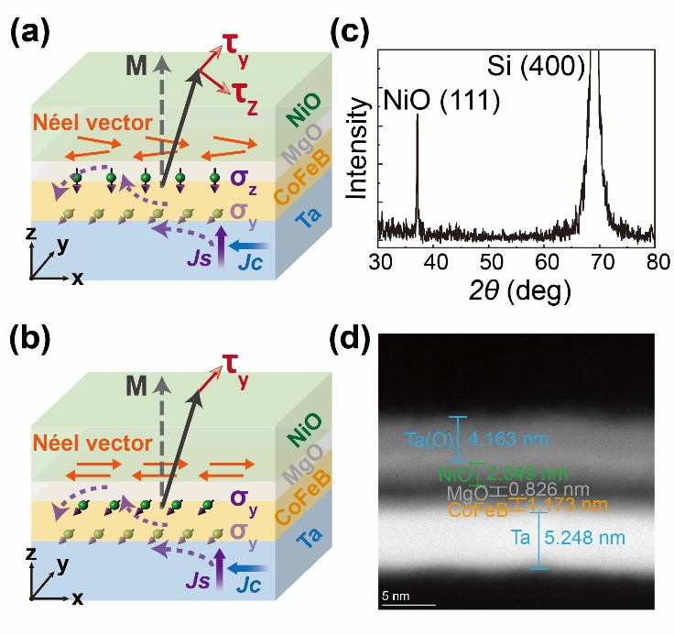

**Fig. 1.** (a, b) Schematic of our SOT device. The z-polarized spins (σz) induce an out-of-plane anti-damping torque $M×z×M$ (τz), facilitating deterministic switching of the CoFeB layer without the need for an external magnetic field. *Jc* represents the charge current, and *Js* represents the spin current. (c) X-ray diffraction patterns of the MgO (0.8)/NiO (30) sample. (d) The high-resolution cross section transmission electron microscope (TEM) image of the multilayers.

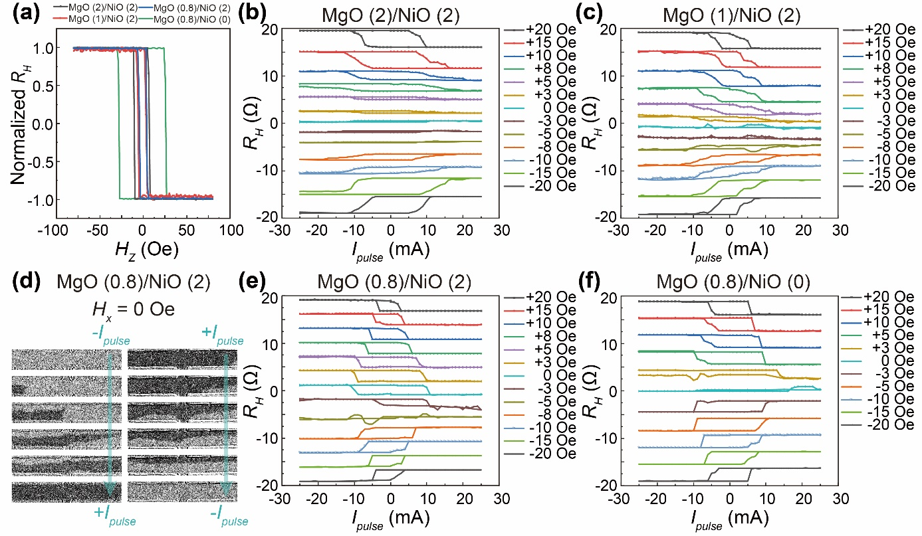

**Fig. 2.** (a) Anomalous Hall effect loops for MgO (2)/NiO (2), MgO (1)/NiO (2), MgO (0.8)/NiO (2) and MgO (0.8)/NiO (0) samples. Current-induced magnetization switching under different magnetic field (*HX*)for (b) MgO (2)/NiO (2), (c) MgO (1)/NiO (2), (e) MgO (0.8)/NiO (2) and (f) MgO (0.8)/NiO (0) samples. (d) MOKE images of zero-field magnetization switching for the MgO (0.8)/NiO (2) sample.

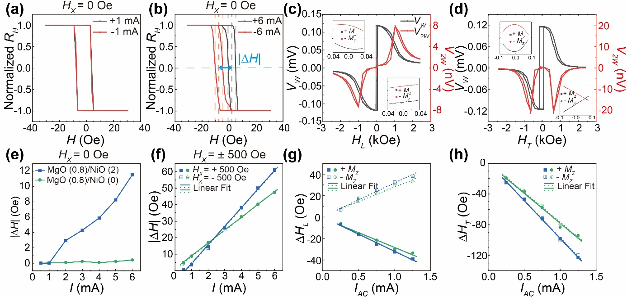

**Fig. 3.** (a, b) Shift effect of the out-of-plane hysteresis loops under ± 1 mA and ± 6 mA at an in-plane field *Hx* = 0 Oe for MgO (0.8)/NiO (2) sample. The calculation of the shift field |*∆H*| is determined in the inset of (b). (c, d) First and second harmonic Hall signals as a function of the in-plane magnetic field *Hx* (H $∥$ I) and *Hy* (H $⊥$ I)under 1 mA. (e, f) Summarized |*∆H*| with current at *Hx* = 0 and ± 500 Oe. (g, h)The current-induced effective fields versus *IAC* value for longitudinal effective field ∆*HL* and transverse effective field ∆*HT*.

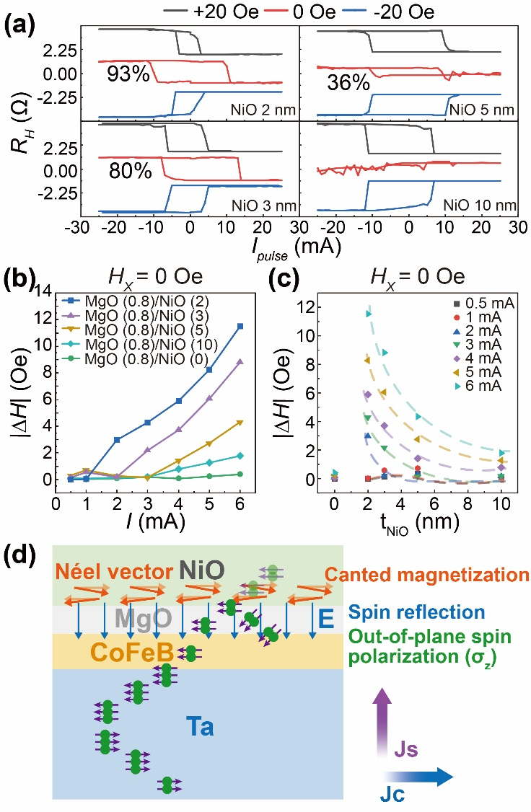

**Fig. 4.** (a) Current-induced magnetization switching under different magnetic field (*HX*) for the MgO (0.8)/NiO (t) samples (t = 2, 3, 5 and 10 nm). (b, c) Summarized shift field |∆*H*| with current at *Hx* = 0 Oe for the MgO (0.8)/NiO (t) samples (t = 0, 2, 3, 5 and 10 nm). The dashed lines are guidelines for the eye. (d) Schematic representation of spin tunneling and spin reflection in the multilayer film structure.

**References**

[1] C. Song, R. Zhang, L. Liao, Y. Zhou, X. Zhou, R. Chen, Y. You, X. Chen, F. Pan, *Prog. Mater. Sci.* **2021**, 118.

[2] Q. Shao, P. Li, L. Liu, H. Yang, S. Fukami, A. Razavi, H. Wu, K. Wang, F. Freimuth, Y. Mokrousov, M. D. Stiles, S. Emori, A. Hoffmann, J. Akerman, K. Roy, J.-P. Wang, S.-H. Yang, K. Garello, W. Zhang, *IEEE T. Magn.* **2021**, 57, 1.

[3] J. Ryu, S. Lee, K. J. Lee, B. G. Park, *Adv. Mater.* **2020**, 32, e1907148.

[4] X. Han, X. Wang, C. Wan, G. Yu, X. Lv, *Appl. Phys. Lett.* **2021**, 118.

[5] R. Ramaswamy, J. M. Lee, K. Cai, H. Yang, *Appl. Phys. Rev.* **2018**, 5.

[6] Y. W. Oh, S. H. Chris Baek, Y. M. Kim, H. Y. Lee, K. D. Lee, C. G. Yang, E. S. Park, K. S. Lee, K. W. Kim, G. Go, J. R. Jeong, B. C. Min, H. W. Lee, K. J. Lee, B. G. Park, *Nat. Nanotechnol.* **2016**, 11, 878.

[7] S. Fukami, C. Zhang, S. DuttaGupta, A. Kurenkov, H. Ohno, *Nat. Mater.* **2016**, 15, 535.

[8] Y. C. Lau, D. Betto, K. Rode, J. M. Coey, P. Stamenov, *Nat. Nanotechnol.* **2016**, 11, 758.

[9] L. Liu, C. Zhou, X. Shu, C. Li, T. Zhao, W. Lin, J. Deng, Q. Xie, S. Chen, J. Zhou, R. Guo, H. Wang, J. Yu, S. Shi, P. Yang, S. Pennycook, A. Manchon, J. Chen, *Nat. Nanotechnol.* **2021**, 16, 277.

[10] T. Jin, G. J. Lim, H. Y. Poh, S. Wu, F. Tan, W. S. Lew, *ACS Appl. Mater. Interfaces* **2022**, 14, 9781.

[11] Z. Li, Z. Zhang, M. Wei, X. Lu, T. Li, J. Zhou, Y. Yan, J. Du, X. Wang, Y. Li, L. He, J. Wu, Y. Gao, R. Zhang, Y. Xu, *Adv. Sci.* **2024**, e2406924.

[12] Q. Xie, W. Lin, S. Sarkar, X. Shu, S. Chen, L. Liu, T. Zhao, C. Zhou, H. Wang, J. Zhou, S. Gradečak, J. Chen, *APL Mater.* **2021**, 9.

[13] S. Liang, S. Shi, C. H. Hsu, K. Cai, Y. Wang, P. He, Y. Wu, V. M. Pereira, H. Yang, *Adv. Mater.* **2020**, 32, e2002799.

[14] H. Xie, X. Chen, Q. Zhang, Z. Mu, X. Zhang, B. Yan, Y. Wu, *Nat. Commun.* **2022**, 13, 5744.

[15] T. Nan, C. X. Quintela, J. Irwin, G. Gurung, D. F. Shao, J. Gibbons, N. Campbell, K. Song, S. Choi, L. Guo, R. D. Johnson, P. Manuel, R. V. Chopdekar, I. Hallsteinsen, T. Tybell, P. J. Ryan, J. Kim, Y. Choi, P. G. Radaelli, D. C. Ralph, E. Y. Tsymbal, M. S. Rzchowski, C. B. Eom, *Nat. Commun.* **2020**, 11, 4671.

[16] M. Wang, J. Zhou, X. Xu, T. Zhang, Z. Zhu, Z. Guo, Y. Deng, M. Yang, K. Meng, B. He, J. Li, G. Yu, T. Zhu, A. Li, X. Han, Y. Jiang, *Nat. Commun.* **2023**, 14, 2871.

[17] V. Baltz, A. Manchon, M. Tsoi, T. Moriyama, T. Ono, Y. Tserkovnyak, *Rev. Mod. Phys.* **2018**, 90.

[18] S. Ikeda, K. Miura, H. Yamamoto, K. Mizunuma, H. D. Gan, M. Endo, S. Kanai, J. Hayakawa, F. Matsukura, H. Ohno, *Nat. Mater.* **2010**, 9, 721.

[19] Z. Zhang, X. Lu, Y. Yan, J. Lu, Z. Li, Q. Liu, F. Zhu, J. Cao, Y. Wang, Z. Huang, Y. Zhai, Y. Li, X. Ruan, L. He, J. Wu, J. Du, R. Zhang, Y. Xu, *Appl. Phys. Lett.* **2022**, 120.

[20] H. H. Huy, Z. Ruixian, T. Shirokura, S. Takahashi, Y. Hirayama, P. N. Hai, *IEEE T. Magn.* **2023**, 59, 1.

[21] K. Jhuria, J. Hohlfeld, A. Pattabi, E. Martin, A. Y. Arriola Córdova, X. Shi, R. Lo Conte, S. Petit-Watelot, J. C. Rojas-Sanchez, G. Malinowski, S. Mangin, A. Lemaître, M. Hehn, J. Bokor, R. B. Wilson, J. Gorchon, *Nat. Electron.* **2020**, 3, 680.

[22] A. M. Humphries, T. Wang, E. R. J. Edwards, S. R. Allen, J. M. Shaw, H. T. Nembach, J. Q. Xiao, T. J. Silva, X. Fan, *Nat. Commun.* **2017**, 8, 911.

[23] S. C. Baek, V. P. Amin, Y. W. Oh, G. Go, S. J. Lee, G. H. Lee, K. J. Kim, M. D. Stiles, B. G. Park, K. J. Lee, *Nat. Mater.* **2018**, 17, 509.

[24] S. Hu, D. F. Shao, H. Yang, C. Pan, Z. Fu, M. Tang, Y. Yang, W. Fan, S. Zhou, E. Y. Tsymbal, X. Qiu, *Nat. Commun.* **2022**, 13, 4447.

[25] D. MacNeill, G. M. Stiehl, M. H. D. Guimaraes, R. A. Buhrman, J. Park, D. C. Ralph, *Nat. Phys.* **2016**, 13, 300.

[26] X. Chen, S. Shi, G. Shi, X. Fan, C. Song, X. Zhou, H. Bai, L. Liao, Y. Zhou, H. Zhang, A. Li, Y. Chen, X. Han, S. Jiang, Z. Zhu, H. Wu, X. Wang, D. Xue, H. Yang, F. Pan, *Nat. Mater.* **2021**, 20, 800.

[27] K. J. Lee, Y. Liu, A. Deac, M. Li, J. W. Chang, S. Liao, K. Ju, O. Redon, J. P. Nozières, B. Dieny, *J. Appl. Phys.* **2004**, 95, 7423.

[28] Y. Chen, Q. Zhang, J. Jia, Y. Zheng, Y. Wang, X. Fan, J. Cao, *Appl. Phys. Lett.* **2018**, 112.

[29] J. Kim, J. Sinha, M. Hayashi, M. Yamanouchi, S. Fukami, T. Suzuki, S. Mitani, H. Ohno, *Nat. Mater.* **2013**, 12, 240.

[30] K. Garello, I. M. Miron, C. O. Avci, F. Freimuth, Y. Mokrousov, S. Blugel, S. Auffret, O. Boulle, G. Gaudin, P. Gambardella, *Nat. Nanotechnol.* **2013**, 8, 587.

[31] Z. Li, X. Lu, Z. Zhang, W. Li, T. Li, J. Zhou, Y. Yan, R. Liu, J. Du, R. Liu, X. Wang, Y. Li, L. He, J. Wu, R. Zhang, Y. Xu, *Appl. Phys. Lett.* **2023**, 123.

[32] J. Zhang, Z. Jiang, Z. Li, Y. Song, J. Zhang, Q. Jin, Y. Liu, Z. Zhang, *ACS Appl. Electron. Mater.* **2024**, 6, 3908.

[33] H. Xue, M. Tang, Y. Zhang, Z. Ji, X. Qiu, Z. Zhang, *Adv. Electron. Mater.* **2021**, 8.

[34] M. Khanuja, H. Sharma, B. R. Mehta, S. M. Shivaprasad, *J. Electron Spectrosc.* **2009**, 169, 41.

[35] S. Lecuyer, A. Quemerais, G. Jezequel, *Surf. Interface Anal.* **1992**, 18, 257.

[36] A. Hoffmann, *IEEE T. Magn.* **2013**, 49, 5172.

[37] G. Feng, X. Chen, D. Fu, J. Liu, X. Yang, G. Yu, *J. Appl. Phys.* **2021**, 130.

[38] Z. Wen, J. Kim, H. Sukegawa, M. Hayashi, S. Mitani, *AIP Adv.* **2016**, 6.

[39] S. N. Panda, S. Mondal, J. Sinha, S. Choudhury, A. Barman, *Sci. Adv.* **2019**, 5, eaav7200.

[40] J. Sinova, S. O. Valenzuela, J. Wunderlich, C. H. Back, T. Jungwirth, *Rev. Mod. Phys.* **2015**, 87, 1213.

[41] M. Imran, H. Coskun, N. A. Khan, J. Ouyang, *Appl. Phys. A* **2021**, 127.

[42] M. Akyol, J. G. Alzate, G. Yu, P. Upadhyaya, K. L. Wong, A. Ekicibil, P. Khalili Amiri, K. L. Wang, *Appl. Phys. Lett.* **2015**, 106.

[43] B. Cui, H. Wu, D. Li, S. A. Razavi, D. Wu, K. L. Wong, M. Chang, M. Gao, Y. Zuo, L. Xi, K. L. Wang, *ACS Appl. Mater. Interfaces* **2019**, 11, 39369.

[44] G. Zahnd, L. Vila, V. T. Pham, M. Cosset-Cheneau, W. Lim, A. Brenac, P. Laczkowski, A. Marty, J. P. Attané, *Phys. Rev. B* **2018**, 98.

[45] K.-H. Ko, G.-M. Choi, *J. Magn. Magn. Mater.* **2020**, 510.

[46] S. S. Parkin, C. Kaiser, A. Panchula, P. M. Rice, B. Hughes, M. Samant, S. H. Yang, *Nat. Mater.* **2004**, 3, 862.

[47] H. Yang, S. H. Yang, S. Takahashi, S. Maekawa, S. S. Parkin, *Nat. Mater.* **2010**, 9, 586.

[48] X. Qiu, W. Legrand, P. He, Y. Wu, J. Yu, R. Ramaswamy, A. Manchon, H. Yang, *Phys. Rev. Lett.* **2016**, 117, 217206.

[49] W. Neubeck, C. Vettier, V. Fernandez, F. de Bergevin, C. Giles, *J. Appl. Phys.* **1999**, 85, 4847.

[50] H. Yang, S. H. Yang, D. C. Qi, A. Rusydi, H. Kawai, M. Saeys, T. Leo, D. J. Smith, S. S. Parkin, *Phys. Rev. Lett.* **2011**, 106, 167201.

[51] A. Kozioł-Rachwał, M. Ślęzak, M. Zając, P. Dróżdż, W. Janus, M. Szpytma, H. Nayyef, T. Ślęzak, *APL Mater.* **2020**, 8.

[52] E. Arenholz, G. van der Laan, F. Nolting, *Appl. Phys. Lett.* **2008**, 93.

[53] N. C. Koon, *Phys. Rev. Lett.* **1997**, 78, 4865.

[54] T. C. Schulthess, W. H. Butler, *Phys. Rev. Lett.* **1998**, 81, 4516.

[55] M. D. Stiles, R. D. McMichael, *Phys. Rev. B* **1999**, 59, 3722.