Towards open and shareable acoustic channel tools & models for acoustic communication (ACOMMS) waveform-receiver performance assessment

Jonathan Davies   
Dr, Chief Scientist  
Acousonix LtdDorchester, Dorset, UK   
[jonathan.davies@acousonix.co.uk](mailto:jonathan.davies@acousonix.co.uk)

Henry Dol  
Dr, Principal Scientist  
TNO,   
 The Hague, Netherlands  
Henry.dol@tno.nl

Justin Dinale  
DL MAR RAS COMMS*,DSTG*   
*Department of Defence   
Sydney, NSW, Australia*[Justin.Dinale@defence.gov.au](mailto:Justin.Dinale@defence.gov.au)

Paul Van Walree

Dr, Principal Scientist

Norwegian Defence Est. (FFI),Horten, Norway  
[paul.vanwalree@ffi.no](mailto:paul.vanwalree@ffi.no)

Paul Mitchell  
Professor, Head of Underwater Information Systems Research Group University of York,York,UK[paul.mitchell@york.ac.uk](mailto:paul.mitchell@york.ac.uk)

Ivor Nissen

Dr, Bundeswehr Technical Center for Ships and Naval Weapons, Maritime Technology and Research, Eckernförde,Germany IvorNissen@bundeswehr.org

*Abstract*— The development and adoption of underwater acoustic communication standards has long been hampered by the lack of agreed, standardized, acoustic channel models to facilitate comparative waveform testing in a controlled, fair and physically realistic manner. The shortfall has been recognized at NATO level, and a research task group (RTG) initiative is presently underway (IST216) to develop standardized means to performance assess emerging, open (and closed) acoustic waveform designs. This paper reviews the objectives of IST216, the challenges posed by the task, and opportunities presented, by time-varying-impulse response (TVIR) based acoustic channel models, capable of capturing macroscale (multipath) and microscale (forward scatter) channel effects in conjunction with flexible means for noise addition in sound pressure level terms. Keywords—Channel modelling, propagation, standardization

# Introduction

The emergence of multiple acoustic communication (ACOMMS) waveform specifications in recent years, has placed increased emphasis on how emerging waveforms, and the equipment hosting these waveforms, can be meaningfully tested and evaluated in line with defence end user needs. Standardized channel model based testing is an established and widely accepted practice underpinning terrestrial radio frequency (RF) waveform technology development, and standards adoption. The lack of an equivalent, standards based approach to ACOMMS technology and standards development is consequently both curious, and inconsistent with well-established practice in other technology domains.

Recognizing this shortfall and future need, several NATO nations and industry partners from GBR, DEU, NLD, NOR, ESP, TUR, CAN, ITA and AUS have come together under a new research task group (RTG) IST216 to address this shortfall - *Channel Modelling and Application for Secure Underwater Acoustic Communications Waveform Assessment and Standardization* [1]

This paper introduces the acoustic channel modelling problem (Section II), overviews IST216 objectives (Section III), and reviews early stage work towards meeting the RTG objectives.

# ACOMMS Performance assessment frameworks

Acoustic communications (ACOMMS) presents a multi-tiered modelling challenge spanning high level operational modelling aspects, low level acoustic propagation modelling aspects, and ACOMMS waveform physical layer performance modelling aspects. These various modelling aspects are represented in Figure 1**.** The figure seeks to differentiate between three levels of ACOMMS modelling. At the highest level (1) is the need to provide end users tactical planning tools to enable them to understand ACOMMS technology capabilities and limitations, set against acoustic noise and ocean propagation effects as embodied in choice of acoustic propagation model.

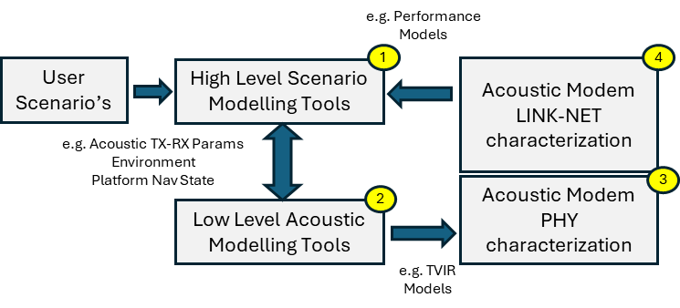

Figure 1- ACOMMS modelling levels (1) Tactical/Operational (2) Acoustic propagation and channel modelling (3) Waveform-receiver (PHY) performance modelling (4) Link-NET performance modelling

At the lowest level (2), is the challenge of modelling acoustic channel macro and micro scale effects. Macroscale effects (i.e. channel multipath or macro-path) are typically modelled using ray-trace tools to characterise how sound propagates and interacts with boundaries between transmitter and receiver (eigenpaths). This parameterization of ‘macro’ acoustic channel structure provides a template against which finer-temporal resolution channel dispersion mechanisms can be introduced, most notably forward scattering processes due to sound interaction with the sea-surface and sea-floor. The representation of macro-path and micro-path channel effects as separable time-varying-impulse-response (TVIR) models, and their combination (via convolution), as a means to understand and more realistically model acoustic channel behaviour is an area of study within IST216. The application and use of acoustic channel models to performance characterize and assess different ACOMMS waveform receiver implementations represents the third modelling level (3). In this third level, ACOMMS waveform receiver implementations can be performance characterized using standardized channel models traceable to environments of interest. The abstraction and use of ACOMMS point-to-point (P2P) performance metrics in this way, provides means to apply P2P metrics and use them in higher layer performance modelling (i.e. link and network) (4) to support protocol development relevant to tactical and operational planning needs.

# acomms modelling challenges

It is widely acknowledged that the undersea acoustic environment presents unique challenges in relation to formulating representative acoustic channel models (ACMs) [2,3]. These challenges extend to synthetic modelling methods [2] (i.e. methods seeking to simulate the effects of ocean processes on ACOMMS signals) and non-synthetic modelling methods [3](i.e. methods seeking to observe and reproduce the effects of ocean processes on ACOMMS signals), and interplay between channel and acoustic networks [4].

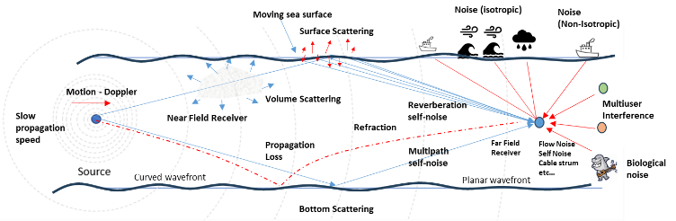**Figure 2** sets out a simplified overview of the ACOMMS channel modelling problem, identifying several of the modelling challenges, including acoustic Doppler, bounded-reflecting-refracting propagation (multipath), complex forward-scattering effects at medium interfaces (micro-path) including moving sea-surface, disparate isotropic and non-isotropic noise effects, and multi-user interference.

Figure 2- ACOMMS channel modelling challenges

Modelling challenges stem principally from the slow propagation speed (1500m/s) of acoustic signals relative to RF counterparts (3x108) resulting in ACOMMS information symbols occupying a spatial scale some 200,000 times smaller than RF information symbols for an equivalent symbolling rate. The physical manifestation of this is that in a bounded propagation medium, at typical ACOMMS symbolling rates (say 100’s-10000’s sym/s), symbol signal spatial scales are typically in the range of a few meters to few tens of centimeters. Moreover, variabilities within the medium, its boundaries and the motion of communicating platforms themselves, may occur at comparable spatial scales, such that the acoustic channel can be concurrently highly frequency selective (in-band frequency fading) due to multipath/macro-path time variability effects, and highly time-selective (within-symbol and intra-symbol time fading) due to forward scatter/micro-path effects affecting each macro-path arrival. Micro-path effects relate to a finer temporal scale of path arrival components arising for example from forward scatter at sea-surface, sea-bed and even within the water column itself (i.e. water column micro-structure) Where micro-path components arrive within a time-span less than the reciprocal of the signal bandwidth, these components are not resolvable in the receiver detection and demodulation algorithms. Where unresolved micro-path components span carrier wavelength scales, then fast fading effects can arise depending on the signal fractional bandwidth of the signal and the relative magnitude-delay of micro-path components. Such macro and micro level acoustic channel structure and its time-variability, represents significant challenges to ACOMMS waveform, detection, synchronization and equalization design.

For mobile platforms, the acoustic Doppler effect i.e. time-dilation of signals arising from motion of transmit-receive transducers through outgoing/incoming sound field, is also a direct consequence of the slow propagation speed of sound. Acoustic Doppler as a time dilation effect, leads not only to a carrier frequency translation term (as in RF), but also to a bandwidth compression/expansion term. Modelling of acoustic Doppler effect at complex baseband therefore requires separate treatment of the carrier frequency translation term (i.e. Doppler frequency shift correction) and bandwidth correction term (i.e. symbol timing correction). Modelling of acoustic Doppler effect at passband however, manages both. The two aforementioned considerations, namely the need to model both macro and micro-path behavior at appropriately fine time-scale and the benefit of simulating Doppler as a passband effect, provides motivation to model acoustic channels at passband rather than complex baseband as per normal RF convention.

Noise addition represents a separate modelling challenge. Sources include ‘ambient’ environmental noise mechanisms (e.g. wind wave and rain noise), self-noise and mutual-noise mechanisms attributable to macro/micro path effects as previously discussed and multi-user noise effects. Ambient noise may be isotropic in nature (e.g. wind, rain) or non-isotropic in nature (e.g. local shipping, biologics). Both noise mechanisms must be modelled in conjunction with knowledge and understanding of noise source anisotropy and platform sensor directional and aspect.

A standardized approach to acoustic channel and noise model formulation and application, is a key step towards the wider adoption of emerging interoperable ACOMMS standards to meet defence end user needs. NATO’s IST216 RTG initiative seeks to establish the foundations for this.

# IST216 RTG - Aims and objectives

## Agree Standardized Approach to TVIR formats and Non-Networked CM Convolution Tool (CT) Implementations

## Agree Standardized Acoustic Noise Modelling and Implementation Approach

## Agree Standardized Acoustic Modem Receiver Performance Metrics

## Agree Standardized Approach to Network Enabled Acoustic Modelling

## Establish NATO-only acoustic waveform assessment framework to enable NATO nations to undertake discussions and testing of classified modem equipment and/or waveforms up to NATO secret level.

The current lack of formal, standardized, acoustic waveform and acoustic network performance assessment tools, left unchecked, will present an ongoing barrier to NATO nations ability to develop, test and ultimately procure, secure, interoperable, tactical, network enabled, ACOMMS modem solutions to meet future NATO needs. IST216 objectives (A-E) have been set to address this shortfall. The approach is considering the formulation of acoustic channels as Time-Varying Impulse Response (TVIR) models applicable using standardised convolution tools (A), and standardised means for noise addition (B), and standardized ACOMMS waveform-receiver performance metrics (C). Whilst (A-C) are physical layer focussed, (D) is to consider standardization of acoustic network modelling approach, and (E) is considering aspects of waveform security, and means to facilitate testing of open and closed waveform types.

# IST216 Work Package Structure

IST216 technical approach involves parallel studies into high level scenario definition and capture, ACM synthetic and non-synthetic methods, noise modelling and PHY-LINK and LINK-NET performance modelling, as indicated below.

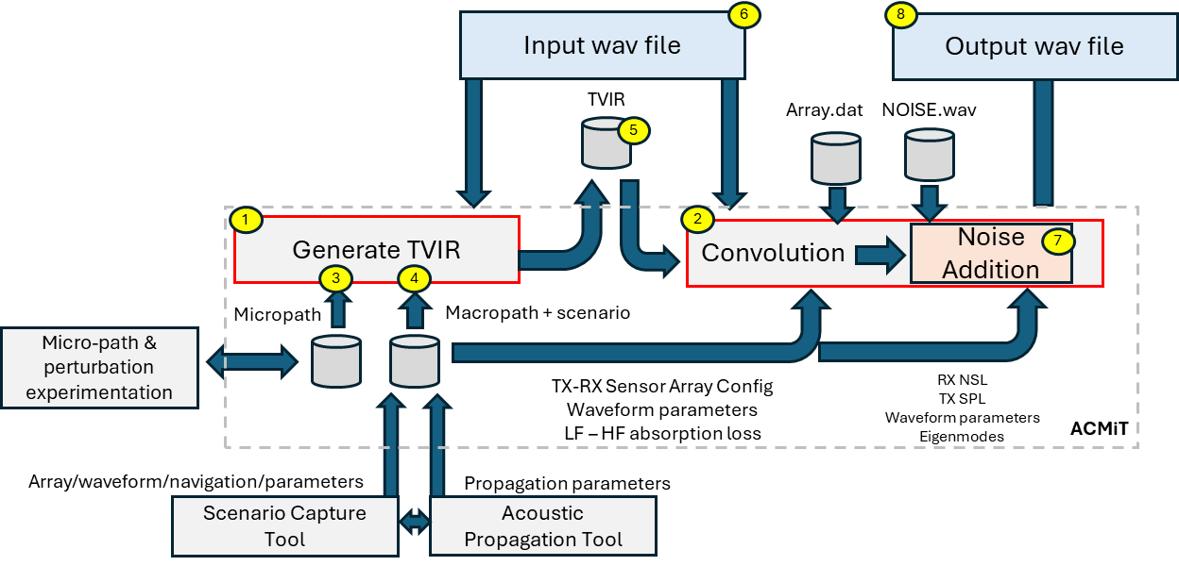WP1 – High Level Scenario Definition

WP1.1 – High Level Scenario Definition

WP1.1.1 Scenario Capture and formats

WP1.1.2 Network Topologies

WP1.2 Standards Oversight

WP1.3 IST216 Formal Outputs

WP2 – TVIR Derivation Methods and Test Channels

WP2.1 Non-Synthetic TVIR Methods and Test Channels

WP2.2 Synthetic TVIR Methods and Test Channels

WP2.3 Synthetic/Non-Synthetic Model Cross Validation

WP2.4 Noise Modelling

WP2.5 PHY-LINK Layer Modelling /Specification

WP3 – Acoustic Network Modelling

WP3.1 LINK-NET Interface specification

WP3.2 NET Modelling / Simulation Methods

WP3.3 NET Verification / Validation Methods

# IST216 shared model approach

IST216 represents an opportunity for the ACOMMS community to come together to share knowledge and tools to support the aims of the RTG and to jointly work towards a NATO STANREC (standards recommendation) on future ACOMMS waveform testing processes, tools and models. This includes existing, non-synthetic, channel modelling tools e.g. Watermark (Norway - FFI), and synthetic channel modelling tools e.g. Acoustic Performance assessment Facility (APAF)/Waymark (UK QinetiQ/University of York) tools. A third, NATO shareable development tool (Acoustic Channel Modelling Tool (ACMiT)), has been developed under DSTG(AUS) funding to help stimulate technical debate regarding model convergence and cross validation, set against the challenges as outlined in section III. The ACMiT tool is intended to be shared under free EULA terms to IST216 participating nations (UK, DEU, NLD, NOR, SPN, TUR, CAN, SWE).

The tool generalised workflow is illustrated in Figure 3 below. It comprises two executable files, a TVIR generation executable (1) and an acoustic signal convolution executable (2). The TVIR executable (1) reads an input acoustic parameter file (4), comprising platform navigation state information, sensor information and simulated channel propagation path information, in conjunction with associated perturbation file (3).

The input acoustic parameter file (4) represents a ‘first-cut’ at a ‘fused’ scenario-acoustics data structure, to inform standardised TVIR generation and application. The input parameter fields (4) include, TX-RX link addresses, TX-RX navigation states, TX-RX sensor array types (single/multielement) and TX-RX sensor acoustic parameters. The file also includes propagation eigenpath parameters specific to the scenario of interest. These eigenpath fields (macro-paths) are assumed to be derived from separate acoustic propagation tools, and are intended to be optionally edited, to allow the addition of additional micro-paths for TVIR experimentation purposes. Eigenpath parameters include propagation time (s), propagation loss (dB), spread loss (dB), absorption loss (LF and HF band edges), estimated scattering loss (dB), total prop loss (dB), propagation vector (NED(m)), path Doppler (m/s), path field divergence (dz/dq), path inflection history (e.g. SBRSR)

Figure 3- The ACMiT TVIR Tool Workflow

The configured macro-micropath file (4) with associated path perturbations (3), is used to generate a TVIR model (5). Convolution of supplied signal (6) and TVIR (5) is performed in a second executable (2). The convolution is performed for single element receiver, although options for multielement/beam receivers will be supported in future. The convolution tool may optionally apply band differential absorption loss as determined by the acoustic propagation tool. The convolution process is followed by noise addition (7) with options for noise-free, additive noise at SNR specific to scenario, or additive noise at a prescribed SNR. The resulting channel perturbed, noisy (or noise-free signal) is then written to a wav. The ACMiT tool is provided with some basic analysis tools to test and visualise generated TVIR’s based on linear frequency modulation ‘chirp’ probes and/or dirac-delta pulses train probes for analysis purposes. Once the TVIR model is analysed it may be applied to ACOMMS signals of interest for testing purposes.

To summarise, the ACMiT tool purpose is to provide a means to synthesize, manipulate and apply TVIR acoustic channel models, based on supplied macro and micro path terms in a flexible and controllable manner, to facilitate ACOMMS waveform performance testing and assessment. Some examples of its use are now provided.

# synthetic channel simulation examples

## 2-path channel lfm probe simulation example

This first simulation example involves the synthesis of a 2-path time-varying channel to illustrate Rayleigh fast fading on a 4kHz LFM pulse train. Such signals are widely employed in field measurements of acoustic channel behaviour. The simulation seeks to highlight narrowband fading of LFM matched filter envelope introduced by non-resolved acoustic micro-path (i.e. path arrivals << 1/SignalBWHz). In this example the channel model comprises two multipath arrivals with time separation varying from +1ms to -1ms due to application of acoustic Doppler on the time varying path. Additive noise is set to one of several acoustic noise reference 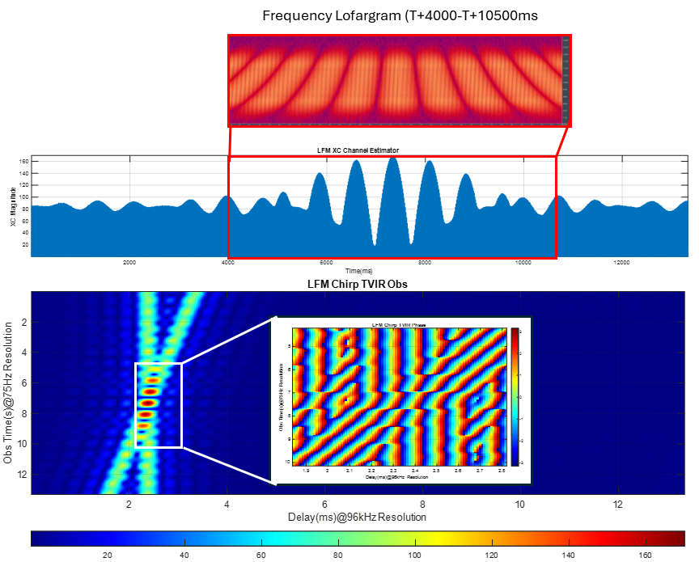wav files. The simulation is shown in **Figure 4**.

Figure 4- Synthetic 2-path TVIR model applied to LFM chirp probe train. B=8-12kHz,T=10ms,PRF=75Hz (Top) Lofargram, (Mid) matched filter envelope time series, (Bottom) TVIR estimate showing magnitude and phase in fast fading region

The upper figure shows time-frequency lofargram plot of the simulated LFM pulse train, demonstrating frequency selective fading consistent with time-varying path time-difference of arrival. The middle figure shows the time-history variation in the MF envelope to highlight the fast fading regime. The lower figure depicts the MF derived channel impulse observations re-ordered at 75Hz PRF, again showing fast fading regime, including phase behaviour, as the paths coalesce to within 1/4000Hz~250us. Such behaviour presents challenges when inferring channel behaviour form channel probing and this is an area of study within IST216.

## Synthetic Reverberation Example

In this example (**Figure 5)** we consider the same two-path channel, where, instead of applying +20cm/s Doppler to the second path, the path is augmented by twelve decaying, time-varying, micro-paths to represent surface reverberation with mildly varying magnitude-time structure as to generate a non-coherent, reverberation-decay profile on the second path. This is illustrated in the LFM probe MF output in the lower figure.

## ACOMMS Performance Characterisation Example

The final example (**Figure 6**) aligns more directly with IST216 objectives. The figure shows waveform performance curves derived from synthetic TVIR acoustic channel models representing ‘easy’ and ‘challenging’ cases as applied to two ACOMMS waveform specifications, A and B. The upper performance curves depict initial detection, link control (i.e. mode selection), and data payload delivery success rate metrics. The lower curves depict symbol error rate (SER). All curves are shown for AWGN and test channel conditions. Key observations from the figure include the increase in SNR (=energy) requirement associated with operation in more challenging environment, and the observable difference in performance of the two waveforms in the baseline receiver comparison case. The formal specification of comparison metrics in terms of ACOMMS waveform power and/or energy (i.e. Eb/No, Epacket/No) is an important forward consideration within IST216, given ACOMMS requirements related to persistence (battery life) and tactical applications (counter detection risk).

## 

Figure 5 - Synthetic reverberation example (Upper plot) Dirac-delta channel probe output (Lower plot) LFM MF chirp (low resolution) channel probe output.

Figure 6 – Synthetic TVIR application and performance characterisation of two ACOMMS waveforms under (left) Benign channel conditions (right) Challenging channel conditions

# conclusion

This paper has introduced the objectives and some early work from IST216 RTG to meet NATO level requirement for standardized ACOMMS waveform-receiver performance assessment testing. It is concluded that IST216 presents opportunities for the ACOMMS community to converge and align on accepted channel modelling methods, tools and practice. This paper has briefly introduced standardized TVIR formulation and application, as a potential means to achieve this, and some early examples provides illustrating application method.

##### Acknowledgements

DSTG funding support in relation to the ACMiT tool development in support of the IST216 task initiative is gratefully acknowledged.

##### References

1. Davies J., “Channel Modelling and Application for Secure Underwater Acoustic Communication Waveform Assessement and Standardization”, IST216 Technical Activity Proposal (TAP), Jan 2024
2. N. Morozs, W. Gorma, B. T. Henson, L. Shen, P. D. Mitchell and Y. V. Zakharov, "Channel Modeling for Underwater Acoustic Network Simulation," in IEEE Access, vol. 8, pp. 136151-136175, 2020, doi: 10.1109/ACCESS.2020.3011620
3. P. A. van Walree, F. -X. Socheleau, R. Otnes and T. Jenserud, "The Watermark Benchmark for Underwater Acoustic Modulation Schemes," in IEEE Journal of Oceanic Engineering, vol. 42, no. 4, pp. 1007-1018, Oct. 2017, doi: 10.1109/JOE.2017.2699078
4. H. Dol et al., "EDA-SALSA: Development of a self-reconfigurable protocol stack for robust underwater acoustic networking," OCEANS 2023 - Limerick, Limerick, Ireland, 2023, pp. 1-10, doi: 10.1109/OCEANSLimerick52467.2023.10244330.