Gender and social inequality

Penny Bickle
Marta Cintas-Peña

Abstract
This chapter provides a critical overview of archaeological approaches to gender and social inequality to date, and suggests future perspectives and approaches. We argue that considering gender as a central framework through which to analyze past social inequality is long overdue in the archaeological discipline. It is surprising given the space dedicated to debating the origins and development of social inequality under the processual frameworks of the 1970s and 1980s, that issues of gender inequality were rarely raised. Yet, feminist and gender perspectives have repeatedly demonstrated the significance of gender for the construction of social differences and identities in the past, and at times having a distinct role in driving forward historical change. Despite this, we identify a continuation of earlier approaches today, with gender a topic of study often treated in isolation. For example, while the advent and spread of farming brought new tasks and social practices, the co-current changes around gender are rarely married together with the grand narratives of Neolithisation. Likewise, the origin and development of metal craft during the Copper and Bronze Ages is often explained as linked to the emergence of male warriors, without considering at all the role played by women or by people who did not fit into such binary gender expressions. Much work thus remains to be done by Archaeologists, not only to address gender, but to place gender within the social context of change in different prehistoric and historic periods. We identify positive steps in this direction that are taking place within the discipline, and propose that multi-proxy approaches, which bridge both the biological processes of bodies and social questions of gender, are a promising way to address these complex questions and bring social inequality into focus.
Keywords

Gender; inequality; archaeology; ethnography; diversity.

- Introduction

When the French philosopher Simone de Beauvoir published The Second Sex in 1949, there were many who celebrated. The author was also described as a lesbian, frigid or nymphomaniac, and the book was accused of "disgracing the French man" by Nobel Prize for Literature winner, Albert Camus. As with de Beauvoir's work, publications that have aimed to analyze gender inequality have often been ridiculed, criticized as unnecessary, or characterized as politicized (Cruz Berrocal, 2009: 26 and ff.). In academia, the attitude of opposition and resistance towards feminist work, alongside the broader umbrella of gender studies, led to only a very slow incorporation of these issues in some fields (ref other papers this volume?). In Archeology, gender as a category of analysis made its appearance relatively late compared to other disciplines (Arnold and Wicker, 2001: vii), which led some researchers to wonder, at the height of 1991, 42 years after the publication of The Second Sex, 'why is there no archeology of gender?' (Wylie, 1991).
No one could deny today the existence of an ‘Archeology of Gender’. Hundreds of articles, books or book chapters, as well as communications and conference sessions attest not only the incorporation, but the consolidation, of gender as a category of analysis in archeology (cf. Alberti & Back Danielsson, 2014, Montón Subías, 2014, De Leiuen, 2014, Dommasnes, 2014). However, despite the undeniable advances and growing interest in gender approaches that exist today in comparison with previous decades, gender continues to be treated in isolation from some of the “big issues” of Archaeology. Since both elements are undoubtedly social, the relationship between them should be automatic. Nothing further from the truth: despite growing interest in studies of inequality within Archaeology (cf. Kohler & Smith, 2018), gender inequalities are treated as an isolated topic separate to the large narratives of history. The explanations of neolithization, for example, usually focus on the new social worlds that formed after the domestication of animals and plants, and the processes of sedentarization, without barely mentioning the word gender. Did the Neolithic mean the same for men as for women (Figure 1)? Furthermore, can we speak for that period of the universal existence of two binary groups - men and women - which are clearly differentiated? We contend here that this situation arises in androcentrism, in which research about gender is considered to be about women, and therefore regulated to be a subset of research, quite apart from the “important” work of explaining what happened in (pre)history. Clearly this is not a satisfactory state of affairs.
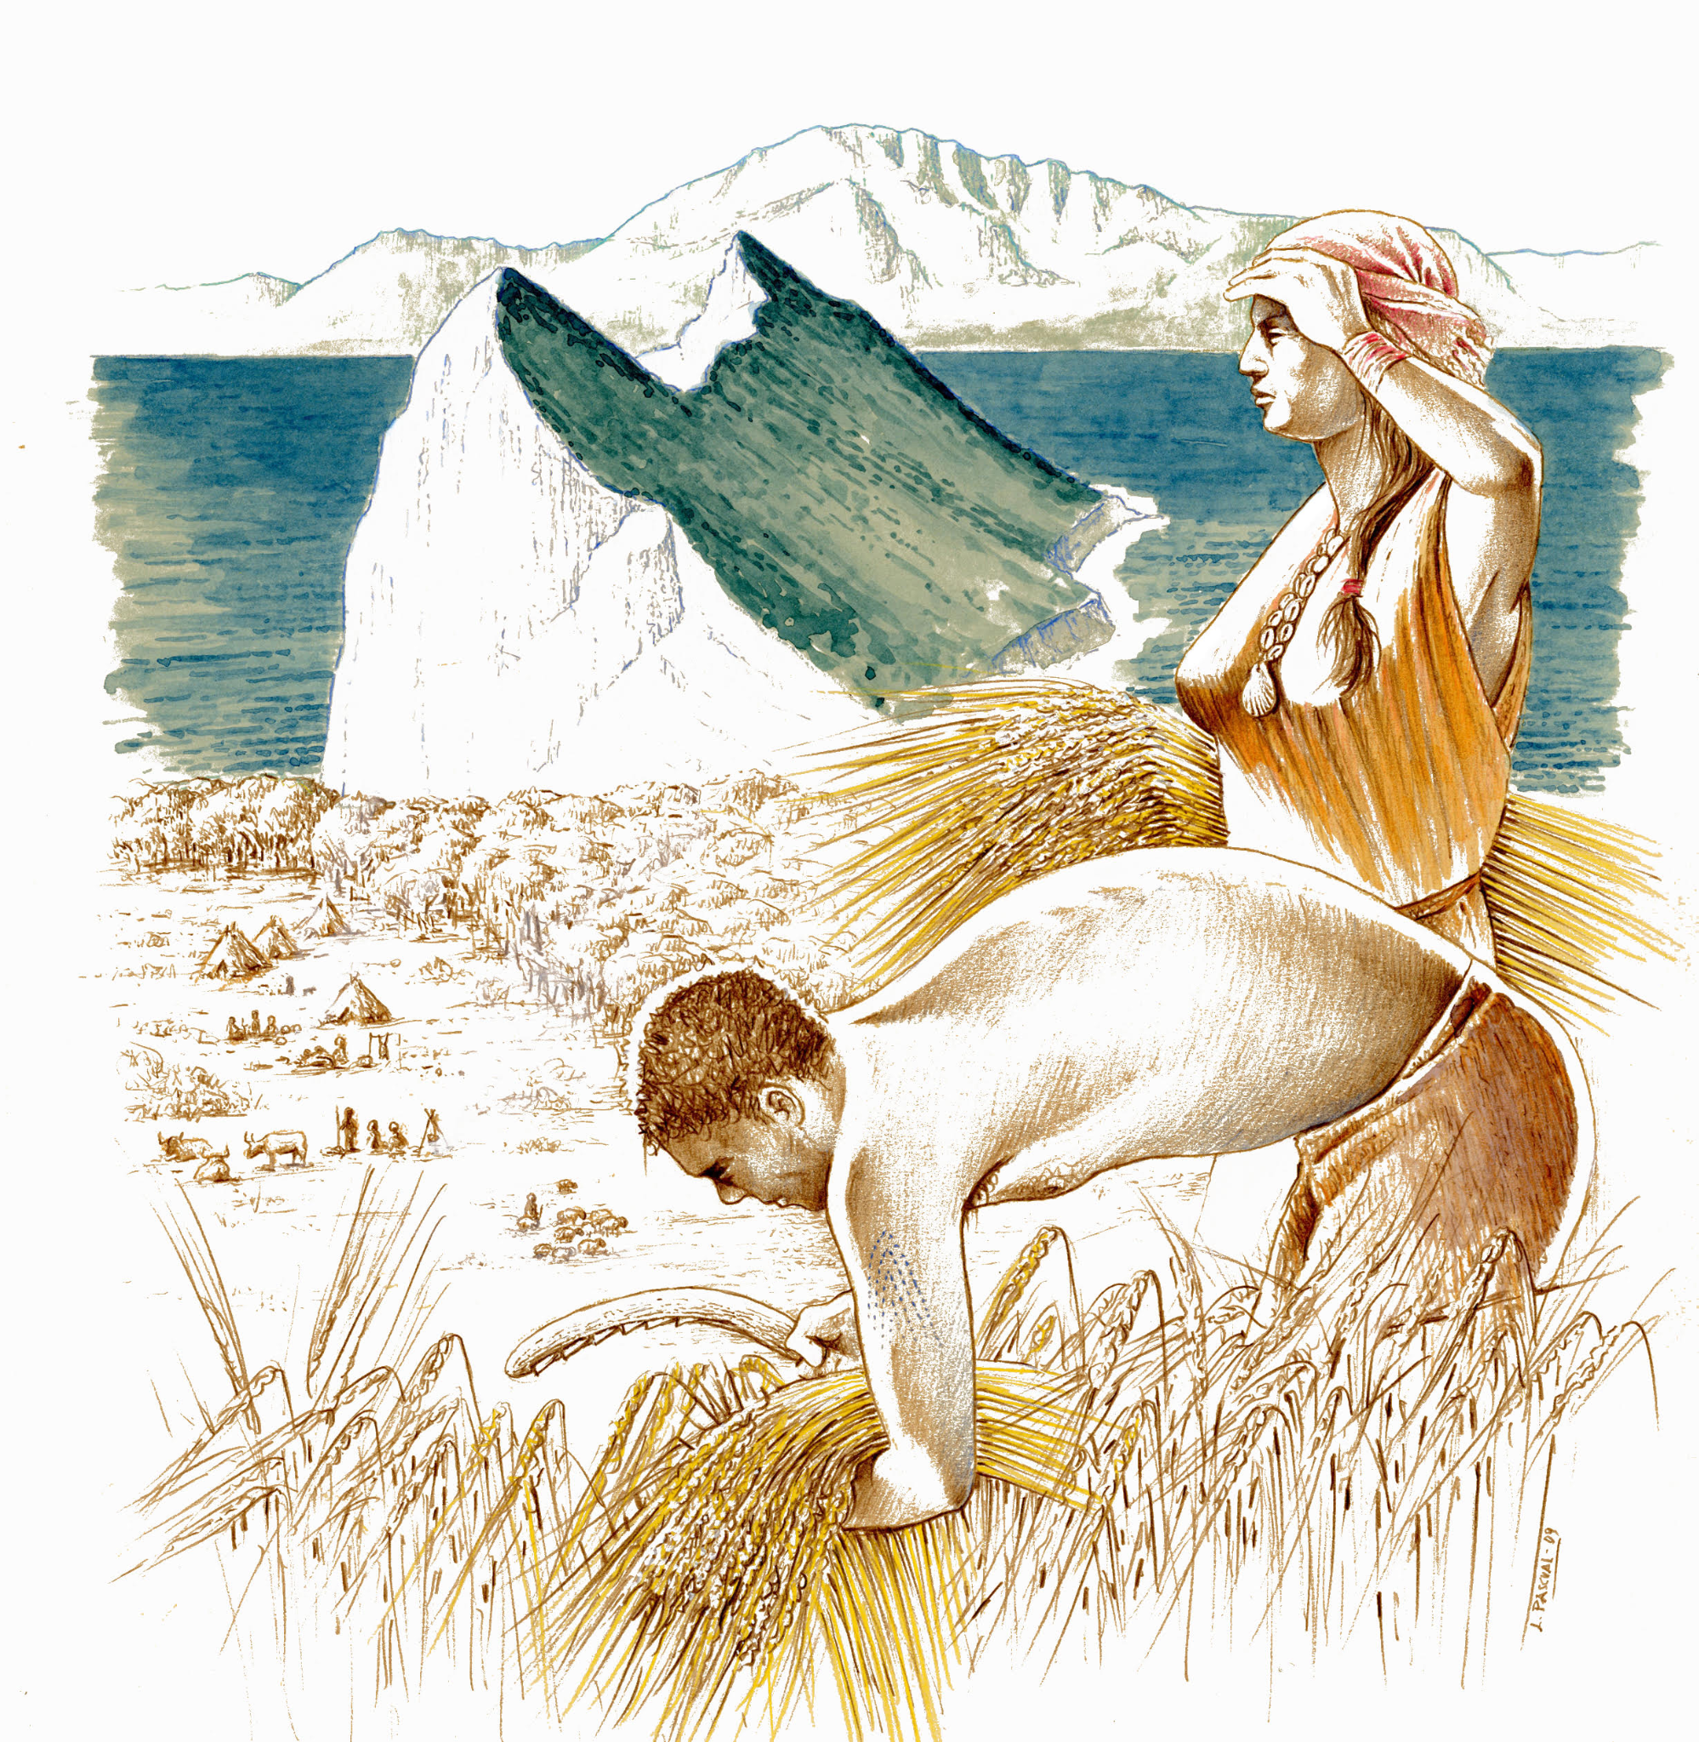
Figure 1: Recreation of a woman and a man carrying out harvesting tasks, in what must have been an everyday scene during the Neolithic. Illustrator: Luis Pascual Repiso.
Considering gender as a central framework through which to analyse past social inequality is long overdue in the archaeological discipline and becomes even more urgent now as social inequality becomes highlighted not only by archaeologists, but also funding schemes, as an urgent topic for studies of the past to address. Gender is inherent within the social differentiation processes and it should be considered when addressing any transformation in the social organization of a given human community. In the light of above, in this chapter our first aim is to offer a critical overview of the work carried out regarding gender and social inequality to date; secondly, to suggest future perspectives and approaches that will contribute to the increasing research carried out to document the rise and development of social complexity and stratification through time.
- Theorising gender inequality

Before exploring archaeological approaches in more detail, it is worth briefly debating the theoretical issues that fall under the banner of gender inequality. Our aim here is not to rehearse the theoretical history of gender research in Archaeology, as this is covered in depth elsewhere in this volume (see ‘Introduction: Was ‘she’ right and about what exactly? From Gimbutas to current debates in archaeology’, in this volume), but rather to consider what it means to examine the archaeology of gender inequality by defining some key terms. At first glance, this is a simple concept capturing the uneven valuing of one or more genders in a society, but we contend here that there is more at stake. The first question to ask is what do we mean by gender inequality? Although this term was born linked to medicine (Money and Ehrhardt, 1982: 5), when first used in the social sciences, gender was considered distinctly different to sex, with gender representing the socially constructed elements of being male or female. Falling into use in the 1950s, the rise of the term gender followed second wave feminism. This approach is captured in The Second Sex by Simone de Beauvoir (2010[1949], 330) and her insistence that “one is not born, but rather becomes a woman”. Gender was thus the cultural elaboration of biological differences, performed through relationships, clothing, material culture, social ritual and labour. Sex was considered the binary opposite, the biological classification of bodies into male or female. If sex was a matter for biology, gender was the subject for the social sciences, and crucially accesible from the material evidence. This distinction - the notion of gender as culture and sex as nature, following the nature/culture dichotomy of modernism (Robb and Harris 2018) - will be familiar to many. However, what we emphasise here is that the term gender also became decoupled from the term's original aim to capture the inequalities of men and women. De Beauvoir (2010[1949], 816), afterall, aimed to show that the social rules for men and women were different, that “rejecting feminine attributes does not mean acquiring virile ones”; that the social norms that shaped women's lives, were particular and cross-cut by issues of age, class, race and other factors of identity. Inequalities thus lie at the heart of the original definition of gender, which second wave feminists largely attributed to a pervasive and universal concept of the patriarchy (Gilchrist 1999, 2; discussed further below).

Third-wave feminism turned greater attention to the concept of sex and the work it was doing in supporting inequality of access to power. Butler (1993) argued that sex was as performative as gender, with those performances framed by normative heterosexuality. Regulatory ideals or norms, materialised by linguistic structures and reinforced by reiteration, teach people to regard sex as pre-linguistic; to take it for granted (Butler 1993, 5). From this perspective, the gender inequalities are no longer a power system which are applied onto men and women; the inequalities present arise in a social system which at the same time produces particular forms and experiences of gender. In the modern, western world, we can characterise this as people living with and through notions of masculinity or feminity, that are seen to arise from human bodies, and viewed as mutually exclusive concepts. The genders and sexes are then conflated by naturalising the differences between the two genders by locating their origin within the most obvious visual sex differences. Butler (1993) was also working from a queer prespective, which together with the broader recognition of the intersectionality of identity, worked to help social scientists recognise that the elements of sex, gender, age, race, and social status, were variable in ways that are historically contingent. Biology was reaching a similar conclusion about the plasticity of sex at the same time, having shown that biological sex is far more complicated than simply being classified by either XX and XY chromosomes (Fausto-Sterling, 1993). Some estimations find that as many 1 in 100 people have some form of intersex DSD (differences of sex development) influencing body growth, anatomy, and hormone levels which can cross-cut each other, rather than forming two absolute categories (Ainsworth 2015). For many disciplines, this opened the door for greater acknowledgement that both sex and gender could be found in non-binary forms, performed and fluid.

Following this line of reasoning, if notions of sex and gender are produced in tandem with the political systems which enforces them, this leaves us with the question of from where does gender inequality then arise if not from biological sex? One of the first suggested sources was institutionalised labour differences, heavily influenced by Marxist approaches to the onset of private property, particularly represented by Engels’ (1981 [1884]) Origin of the Family, Private Property and the State. The story is now familiar. Men and women largely had different but equal spheres of complementary labour, with men hunting, making tools and fighting, women gathering, staying close to home, and raising children. The advent of farming led to ownership of land, resources and animals, the concept of property, followed shortly afterwards by a concern with inheritance and thus the need of men to control women's sexuality to ensure the offspring were their own (Lerner 1986, 22). That the development of concepts of ownership was assumed to directly lead to the control of women’s sexuality, rather than a shared interest in the success (however defined) of offspring is telling that male dominance and the importance of the nuclear family is already presupposed in these models.

Within such marxist approaches, the control of economic factors are linked to political power, with a uni-linear transformation of the tasks carried out by men and women at the transition to farming sometimes presumed to be the point at which male dominance was established. Thus the domestic sphere, the purview of women, loses its power as societies are thought to become more socially complex and the domestic (and by association women) is distanced from the public political sphere (e.g. Friedl 1967). Such a simplistic narrative seems highly unlikely, and even though many archaeologists agree that economy does not explain everything, and that kinship and household organisation are also important to the development of farming, alternative proposals have been limited in number (Peterson 2002, 3).

Another well-known and apparently alternative explanation is that of Marija Gimbutas (1982). Although she argued that such masculine control arrived later with the Indo-Europeans, the narrative is effectively the same: female power is ultimately rooted in the ways the economic value of women is symbolised and valued (by men), largely associated with their reproductive capacity, which is conflated inexorably with the domestic sphere and the tasks thus associated. In these accounts, therefore, the division of labour ultimately emerges from the restrictions of mobility placed on women by their ability to be pregnant, and hence the need to stay close to home to care for children. Like falling dominoes, first the economy and then male dominance complete the picture. Why males should become dominant or seek to hold onto power by suppressing women is not questioned, nor fully explained. This chain of logic is thus the founding mythology for modern gender inequalities, such as those classed as the oppression of the “patriarchy”, and is quite rightly criticized as such by many feminist philosophers (Braidotti 2016). Studies of more recent groups settling down suggest sedentism does not inevitably lead to gender inequality and, conversely, nomadism and hunter-gatherer subsistence is not necessarily linked to egalitarianism (see discussion below). In this vein, Kent’s (1995) study of the various hunter-gatherer groups in the Kalahari, who have turned to different settlement and economic patterns across the late 20th century, shows that they adopted gender hierarchies under the influence of neighbouring groups’ economies and technologies, rather than inequality naturally arising through decreased movement. Here, gender inequality appears to have arisen as an integral part of the westernised institutions (economy, health care, education) such groups were forced to participate in, rather than as a separate value system (Amadiume 2015).

Anthropological accounts of gender show that other ways of understanding sex and gender can be found within the relationships which structure social forms, demonstrating strong diversity in both equality and inequality, at times within a single community. Carsten (2004, 72) gives a nice example of this diversity from among the Malay, Langkawi, in which gender only comes into focus for differentiating people at particular ages, particularly before marriage and at major rituals in the life cycle. The gender hierarchy too varies over time, with men’s authority at its highest in young and middle adulthood, while for women it increases across the whole lifecourse (Carsten 2004, 72). This illustrates a very different form of gender inequality, in which differences within rather than between the genders takes precedence. Within such accounts, another view of gender inequality emerges, in which it is relational to context rather than given by biology or economic capacity. In such relational experiences of gender, people come into the world already multiple and composed of exchanges, in ways not always restricted to humans (such as in animism, Insoll, 2011), for example without a clear division between humans and animals (Conneller, 2004). This has been broadly accepted in many archaeological accounts of gender, yet there has also been a tendency to adopt notions of relational personhood without considering gender inequality or gender at all (e.g. Fowler 2004). It is thus worth remembering that the source for most of these archaeological accounts is drawn from the influential analysis of Marilyn Strathern (1988) of the “problems with women” in Melanesian society. Her aim is to show that the classic marxist interpretation of hierarchical differences between men and women fail to account for Melanesian understandings of gender, and hence inequalities between genders. In Melanesian society, in which gift exchange forms the primary fabric of social life rather than a commodity value system, regarding women as a lesser class than males exploited for their labour misses the inalienable properties of labour (Strathern 1988). Thus, while women may appear to be the extension of male social prestige, they are full participants in the action and their status, while excluded from male prestige, is far more contextual and ambiguous than the kinds of structural inequalities captured by marxism (Biersack 1991). From this perspective, the sexual division of labour and its significance to sexual hierarchies, arise not from a pre-given capacity to reproduce embedded in the body, nor as the ability of one gender to exploit the labour of the other. Rather, inequalities are contingent on the exchanges which make up society. From this we can take that how each society values and enables the formation of sex and gender will provide archaeologists with an important window onto the whole operation of society. The ethnographic record thus teaches us that marxism’s patriarchy is not the only option for gender inequality.

Finally, it is worth briefly reflecting on the term patriarchy, as it is often uncritically used to refer to gender inequality irrespective of context. Patriarchy, while meaning literally “rule of the father” (with religious overtones), appears to be first used specifically as a sociological term in the second half of the 1800s, but took its current meaning when it was reintroduced in 1970 (as largely an ahistorical term), capturing as much the feminist struggle against inequality as categorising particular forms of male dominanted social actions (Waters 1989). Two principles define the patriarchal government: ‘male shall dominate female, elder male shall dominate younger’ (Millet, 2000 [1970], 26). But pinning down exactly what “patriarchy” means beyond the dominance of men and oppression of women is extremely challenging, with many different definitions in circulation (Waters 1989). This short analysis of feminist and anthropological debates shows we cannot presume the forms of sex/gender which will underpin gendered inequalities, nor limit our models of inequality to (for want of a better term) “the patriarchy”. This means moving from what was the relative position of men and women in the past, to asking how was gender and sex produced in social action and exchange; and considering whether such exchanges were structured to advantage or oppress some forms of gender over others? More broadly, it challenges us to think beyond patriarchy when we do see evidence of inequality and difference, as ultimately the patriarchy is a narrative which seeks to explain the present, rather than a social structure separate to the context in which it was first named. Difference, either between the sexes or between two or more genders, does not always arise in structural and social inequalities, and we must be careful not to carry our own expectations about the relative prestige of domestic versus public life back onto the past (Arnold 1995). Thus while anthropologies encourage us to recognize that specific forms of inequalities and equalities will be inherent within the production of different forms of gender, rather than, for example, regarding men and women as created equal and the patriarchy founded afterwards, Archaeology has been slow on the uptake to explore the full ramifications of this proposal.

- Archaeological approaches to gender inequality

In considering archaeological approaches to gender inequality, it is worth noting that in comparison to studies of inequality more broadly, explicit archaeologies of “gender inequality” remain relatively few in number (e.g. Scott 1994, Peterson 2002, Voss 2008, Cintas-Peña and Garcia Sanjuan 2019, see also discussion below). Given that in Archaeology we agree we should not ignore gender diversity in the past, what are we to learn from this discrepancy? Is, then, gender inequality of substantial different form to other inequalities in social power? While determining gender in the past from archaeological evidence is challenging, different methodologies have long been in reach for discussion of rank, prestige and social differentiation (Wason 1994). Rather it seems such reluctance to engage with the topic, arises elsewhere. Dempsey (2019) convincingly connects dominance of white men in the research and publication of archaeology to a lack of diversity in archaeological narratives of the past; the middle ground, mainstream research is mostly carried out by white, highly educated, males in western countries, and thus white and male narratives are frequently treated as a neutral space, from which others differ (see also Back Danielsson and Thedéen, 2012). Thus from the outset, it appears that to study gender inequality in archaeology is to have already chosen to focus on a subsidiary stream of inequality: social inequality as the norm, gender inequality as the alterity. There is often a contradiction between the centrality of gender differences to the creation of society and how marginal it is considered in providing meaning to history (Lerner 1986, 5). While noting that there is, particularly in prehistory, a limited engagement with gender inequality in comparison to gender studies more broadly, this topic has been broached from a number of different ways and perspectives. In looking back at past, and exploring current, approaches in the discipline, we identify here four broad traditions of studying gender inequality within Archaeology: implicit, generalised, exceptionalist, and positivist (Figure 2). These are not strictly successive, nor do they belong to particular intellectual traditions in Archaeology, but cross-cut both temporal and theoretical research traditions.

Implicit: Perhaps, unfortunately, the approach most frequently found is that both gender and sex, and difference and inequality, have been conflated and implicitly regarded as categories which do not vary across time and space. The result of this is that the prehistoric past almost becomes a caricature of modern gender biases, with “man the hunter, women the gatherer'' based on assumed natural biological differences. In such approaches, while social inequality is conceived and explained as a product of the historical process and the development of communities over time, gender inequality seems to require no explanation. It is thus not uncommon for gender as an analytical category, and by extension gender inequality, to be conspicuous by its absence. Thus the idea that men are the active individuals and main actors of social change, while women remain passive observers, has dominated prehistoric interpretations: “History happens to her, while men made it happen” (Sorensen, 2000: 17). Bell Beaker people “roamed abroad on their own, but always taking with them their wives to make their pots and brew their beer” (Childe, 1950: 76), in Central Europe during the 4th millennium, women are equated to pairs of cattle as accompanying grave goods to elite burials: “goods and chattels formed an ideological unit is shown by the ultimate fourth-millennium status symbol” (Sherratt, 1998: 187). The Egtved girl was a Southern German girl who was given in marriage to a man in Jutland so as to forge an alliance between two powerful families’ (University of Copenhagen 2015)[1]. Following such interpretations, the reader can easily conclude that in each of the three situations there were differences in power between men and women, that is, gender inequality was present, even if it is not explicitly mentioned.
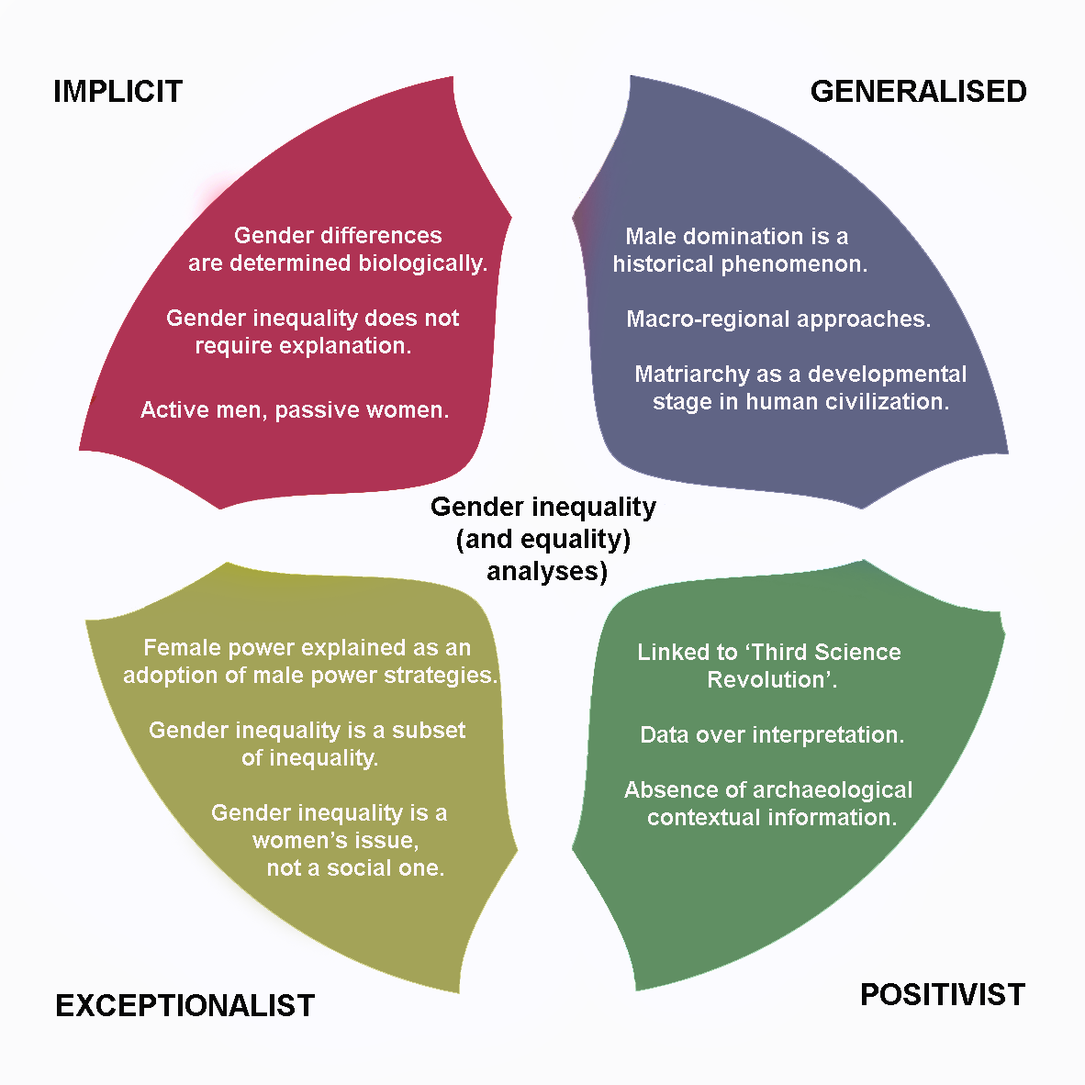
Figure 2: Schematic representation of the main archaeological approaches to gender inequality.
Generalised: For some researchers, male domination is natural to the extent that it is not raised as a matter for discussion; others, however, recognise that male domination is a historical phenomenon, and thus has a distinct origin in time. These historical roots have been approached, fundamentally, from the irruption of second-wave feminism in Archeology, with researchers interested in problematizing the situation of women in the past. Was there a universal male domination? Has patriarchy been the most frequent form of social organization? Is prehistory the moment in which not only social but also gender inequality is forged and consolidated? With these and other questions in mind, researchers such as Lerner (1986), Eisler (1987), Hawkes (1968) and Gimbutas (1974) carried out studies that we could classify as generalist. Their approach was broadly macro-regional and different types of evidence were gathered with the aim of producing a story that does not simply assume, but tries to explain the rise of the “patriarchy”. Despite the obvious differences in the work of the four authors, for all of them there was a period prior to the consolidation of patriarchy in which the social organization of the communities had a more egalitarian character. Pre-patriarchal cultures, gylany (Eisler 1987), or even matriarchy (Gimbutas 1974) are terms used by them to refer to a bygone moment in which women would have enjoyed of an status comparable to that of men or, at least, they would have lived in a world less unequal than it was to become later. Extreme examples from the 19th and early 20th centuries argued matriarchy was even a developmental stage in the evolution of human civilization, such as Arthur Evans who proposed that Knossos represented a matriarchy based on Goddess worship (Foxhall 2013, 8).
However, such works of a generalist or macro-regional nature, especially those carried out by Marija Gimbutas, have been dismissed for not being rigorous, criticized for offering insufficiently contrasted conclusions more typical of literature than science, as well as for reverse sexism (Meskell, 1995). Such criticisms are well founded, not least that the naturalisation of gender underpins many of these works, but we cannot overlook the significant contribution they have made to modern feminism. They generated an alternative explanation to the mainstream, placing women at the centre of social analysis and did not assume universal and timeless male domination. In fact, proposals suggested by these authors, such as the possibility of considering the existence of matrilineal or avuncular societies (Gimbutas 1988), instead of patrilineal, are only now being discussed again (Hrnčíř et al. 2020). This is not to attempt to uncritically rescue such generalist approaches, however. In the case of searching for the origins of the patriarchy, these works remain problematic because ultimately, men and women remain naturalised and binary categories of analysis within them. As discussed above, we contend that gender is not produced prior to, or separately from, the political systems in which it forms.
Exceptionalist: In other contexts, gender inequality is raised, but its significance is implicitly or explicitly downplayed, or it is treated as an exception to a non-gendered norm. Such an approach has been identified in Viking Age studies by Moen (2019), who notes that women’s actions and things are often handled as something separate to the norm of society, with often no such treatment for areas classified as maleculine, which are treated as the mainstream. Thus women’s inequality is women’s business, rather than embedded into the society. A closer look at Price and Feinman’s (1995) volume on the Foundations of Inequality is instructive here. While women holding positions of power are acknowledged within the ethnographic and other case studies drawn on to explain the archaeological record (most notably in the paper by Ames 1995), two distinct approaches to gender and women arise. First, gender, often coupled with age, is classed as a subset of inequality, if not dismissed. Indeed, Arnold (1995, 92) claims to “focus on inequality over and above what exists based on age and gender”. This works to devalue gender inequality by relegating it as a subset of the main structures of inequality (the implications of this from a feminist standpoint hardly need spelling out here). Second, while “Big women” are acknowledged (e.g. Hayden 1995, 55), this does not appear to largely influence the broader value system in which women’s roles find their status in economic productive power. In other words, the presence of “Big Women'' does not change the models of gender nor inequality, but rather these women are explained away as adopting male power strategies. In such approaches, therefore, gender inequality is a sub-form of other inequalities; it is the male form of dominance or leadership that represents all power, which can, at times, trickle down to others in society. Thus, gender inequality is considered a matter of concern for women in the past, rather than the whole of society.
Positivist: The fourth approach we identify here arises in part from the incorporation in recent years of a large number of techniques from disciplines such as physics, chemistry or biology into archaeology (see ‘Gender and Third Science Revolution’, in this volume). While these analytical techniques, such as strontium, carbon and nitrogen isotopes, or aDNA, provide fascinating insights into past societies, some of these works have been criticized for being too biologically deterministic or for not giving enough consideration to the archaeological context. This is especially clear in the case of information obtained through strontium isotopes and aDNA and their interpretation in terms of female exogamy and migration. Some of the more recent and relevant publications on this issue (Kristiansen et al., 2017), leading on genetics and strontium data, have developed a narrative where women are passive individuals exchanged in marriage to active and violent males. It is not our intention to deny the data, which suggest that in different regions women were more mobile than men, but to ask why a higher female mobility is seen so frequently as passive (‘perhaps marriage by abduction’ Kristiansen et al., 2017: 338), while a higher male mobility is interpreted as active or the motor for the migration of people? Other interpretations are equally possible (Frieman et al., 2019, Brück, 2021) (Figure 3).
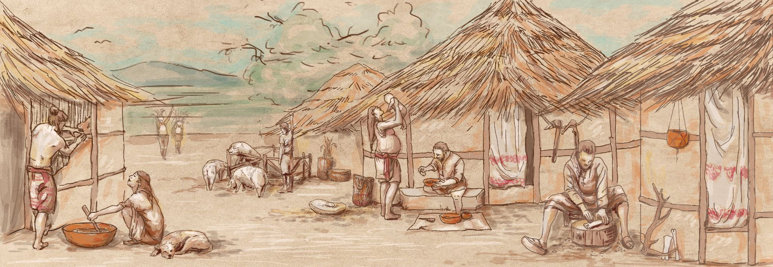
Figure 3. Recreation of the arrival of two people to a prehistoric village. In research of European Late Prehistory, female mobility is frequently interpreted as a consequence of exogamy practices linked to marriage, however, male mobility is rarely explained as motivated by residential patterns. Illustrator: Miriam Luciañez Triviño.
Regardless of the tradition, implicit, generalised, exceptionalist and positivist, the research carried out so far has two common characteristics: i) it mostly assumes the existence of a binary sex/gender system, focusing especifically on gender and putting other variables such as age or class aside and considering gender as an isolated element to address; and, ii) its conclusions are mostly reached through the analysis of one single variable, either grave goods, diet, art, mobility, stress markers, etc. In line with the first feature, the analysis of gender as an independent variable is a double-edged sword; although it has been and continues to be necessary to speak about gender independently as this research strategy has contributed enormously to making women of the past visible, it is also necessary to incorporate the category of analysis when elaborating broader narratives. Even today those who make general approximations often do not take gender into account, and those who take gender into account do not usually connect gender to the large narratives of social change. In contrast, we want to argue here that it is not possible to explain any social organization, past or present, without knowing the sex/gender system in force in it, which is, in turn, hard to address through a single variable. The challenge set to adequately account for the full diversity of gendered inequalities through time requires us to go further, at theoretical, methodological and interpretative level.
- Future perspectives
To move forward studies of gender inequality, new approaches to archaeological evidence are therefore required. Here we suggest alternative approaches, which consider gender inequality as inherent within the social differentiation processes with broader relevance for thinking about social change (Cintas-Peña and Garcia Sanjuán 2019). Also, we identify positive steps to critically assessing the existence of a binary sex/gender system (i.e. Soriano et al., 2021), combining different elements of one individual’s identity (Rey et al., 2021), as well as addressing the issue of gendered relationship at the core of social organisation and through multiple variables (Lull et al., 2021).
These positive steps are especially relevant insofar as they demonstrate a real attempt to treat the category of gender as central to social analysis. Hence an explanation based on several elements is more complete, more complex, as well as internally more consistent than one based on a single element. Several recent publications attest to this (Masclans Latorre et al., 2021a, 2021b; Sjögren et al., 2020.). Here we advocate for multi-proxy approaches in the study of gender inequality. Drawing together the new possibilities arising from archaeological science datasets and a wide range of evidence strands from the historical context, such as houses, burials, ritual practice and so on, offers a way to investigate particular intersections between gender and inequality in different times and places. Nevertheless, we now have rapidly developing and rich datasets arising variously from bioarchaeology, material culture studies and excavation, theoretical frameworks to interpret the data have not kept up the same pace. In this section, we discuss first different theoretical approaches that may aid in structuring discussions of gender inequality in the past, before moving on to propose a number of different methodologies that can be used to apply the multi-proxy method to the evidence.
4.1. Broadening models of gender inequality

One of the approaches we would like to propose here, is to return to the anthropological and ethnographic literature in order to widen the models of relationships between genders in use in archaeological scholarship. As discussed above, there is a tendency in Archaeology to lump all inequalities together under umbrella terms such as “the patriarchy”, or conversely see all forms of equality as identical. While this research is just as likely to be impacted by biases based on modern gender expectations as Archaeology has been, where anthropologists have challenged these expectations, it can help us to capture something of the complexity of the gendered inequalities recorded globally. What many of the examples we explored have in common is that forms of gendered inequality and equality are rarely stable through time, and although the majority of examples chart the increasing move to economic disparities between the sexes as the impacts of colonialism and globalization took hold (e.g. Cliggett 2005), some chart the reverse taking place (Gemignani 2002). In this sense, Amadiume (2015) argues that gender inequalities for the Igbo became a place of conflict for understanding and negotiating social change, both from the impacts of colonialism and attempts to resist it. Elsewhere, communities who were described as practising matrilineal descent, only had male names recorded by colonial powers in accounts of land ownership and in land sales (Becker 1986). Overall, it remains clear that what can be classified as a broadly western gender inequality seen in many places arose through enforcement from colonial powers who expected to transact only with men; it is not universal.

We also propose that greater awareness of anthropological literature can help to build on cross-cultural analysis, which has in the past found weak correlations between different aspects of women’s status (Whyte 1978a; 1978b). In Whyte’s study (1978a, 214), it became clear that there is not a pattern of universal male dominance nor a homogeneity between inequalities, with little overlap between the categories chosen for analysis in this study (the sex of gods, sex of leaders, subsistence contributions, inheritance rights, ease of divorce and machismo) across 93 different cultures. Whyte’s (1978a; 1978b) research suggests that it is more productive to consider how gender intersects with other areas of concern for a culture. It is also worth noting that at times, informants appear to frustrate anthropologists with their agnostic responses to discussing the relationship between the genders (Kent 1995), hinting that not all sex/gender concerns are shaped by those expected in the Western world. Gender experiences can often vary depending on your position within a society. For example, Clark (1994) wryly notes a male informant stating women did not have the strength to carry heavy items, while all around him women were busy moving heavy boxes about the market space. For the Sala’ilua (Samoa), sisters and brothers are considered equivalent positions, whereas other family relationships may be considered more hierarchical (Shore 1982). Thus inequality or equality can be situational and depend on context.

With the aim of offering a general view on the variability and diversity of situations, we have carried out a brief qualitative survey of anthropological texts on differential status attribution between the genders, drawing on a limited search of Human Relations Area Files world cultures database (HRAF, n.d.), and recurrent areas of concern arose. These can be summarised (for want of space here) as kinship relationships, ritual activity or religious practice, economic activity, health and diet, and educational possibilities. The status of a gender permeated each of these aspects of social life in different ways, ranging from how access could be permitted or restricted, freedom of choice, ability to influence the decisions of others, inheritance rights (to both the material and immaterial, such as titles), and the possibility of accumulation (again here we refer to both alienable and inalienable property; in some cultures this would thus be the ability to share or gift). Crucially, these different characteristics do not also intersect in obvious ways, with inter-relationships or autonomy between genders often shaping whether shared or different value systems structure each gender (Strathern 1987, 18). As an example, we can point to two situations where women’s exclusion from ritual life leads to two different understandings of gender hierarchy. Peletz (1996) argues that among the Negeri Sembilan (Malay), the secondary status of women arises not in kinship structures, but rather in a cosmological schema in which men are more spiritually powerful, a reasoning which permeates other aspects of social life. Amongst the Delaware (mostly practising hunter-gathering, Oklahoma, United States), in contrast, women had to be accompanied by men when speaking in a “Big House” ceremony, but matrilineal relations were important in determining the roles and activities of different people, giving women strong control of important kinship networks (Miller 1991). Miller (1991, 26) argues that “women gave and sustained life; men protected and empowered it”, both aspects seen as relational and equally valued. Ritual spheres can thus create social spaces of inequality that are not carried through to other areas of life. In other cases, religious schema forms the basis for significant oppression of women.

While areas of status need not overlap, gender can act together with other aspects of social differentiation (such as class) to create very different experiences of inequality for people of the same gender. In South Korea, Kim (1993) expresses the complexity of how this can work; lower class women need to work to support the family economically, providing certain other limited freedoms, whereas not working was a significant status symbol for middle class women, keeping them away from economic independence, whilst also having more the benefits of belonging to a higher class. This is not to say that everything was rosy for working class women, but to highlight what black feminists have long stressed, that different forms of oppression can work together, while regarding all inequalities as applicable for all women irregardless of, for example, race or disability, can negate the spaces of resistence or equality that other groups have carved out (Crenshaw 1989). While this will be different in each society, we contend here that complexity and intersectionality should thus be the starting point for an archaeology of gender inequality.

While it would be a mistake to categorise pre-colonial era as the antidote to modern inequalities (Hanretta 1998), it is important to be alert to where gender ideals thus become tied to binaries based on biological sex, as this is just one of the possibilities for finding differences between men and women. Amadiume’s (2015) carefully documented ethnography of pre-colonial Igbo (Nigeria), illustrates how women could become both husbands and wives, with political roles taken on by people of any sex. Marriage in this context was not limited to a sexual or romantic relationship (heterosexual or otherwise), but could also take place when relationships were formed that centred on sharing or commanding labour. Thus women in many ways stayed as women, although called husbands, and similarly some men became wives (Amadiume 2015). This is importantly different from other examples, such as the Burrnesha in Northern Albania, where women live as men. In this case, women become men, including taking on aspects of masculinity, thus preserving the male dominance of leadership roles (Robertson Martinez 2020). Gender differentiation can also arise through kinship, in which inequalities are relative to people’s position within kinship systems, and thus frequently change across someone’s lifetime, rather than inherent within their biological body. In some contexts men can exert power over women as husbands and fathers, but not in other relationships such as brother-sister. For the Nuba (Sudan), men cannot exert influence or status over women other than their wives (Faris 1989), whereas among the KwaZulu (South Africa), as a woman ages and changes her relationship status to those around her, her influence and prestige increases (Webster 1991). Some specific forms of kinship are linked to a lower status of women, for example patrilineal societies with transferral of women’s membership can be associated with extreme gender inequality (Ensor, 2021, 21), but this is by no means the case for all patrilineal societies (Bickle and Hofmann In press).

Beyond demonstrating the global complexity of gender relations, there are two further points we would like to draw out from the anthropological literature as particularly relevant to an archaeology of gender inequality. One of the major insights is that, although trends can be identified, we cannot assume gender relationships from subsistence activities alone. Equality between the sexes/genders is most frequently attributed to hunter-gatherers and horticulturalists, but can also be found in other subsistence practices (e.g. pastoralists such as Gwembe Tonga, Zambia, Cliggett 2005, and agriculturalists in the Andes, Hamilton 1998). In contrast, hunter-gatherers can also display forms of gendered inequality as well, like the case of selknam (Tierra del Fuego, Argentina), with a male domination well illustrated by the Hain or Klóketen ceremony of male initiation, specifically oriented against the female section of the community (Gusinde, 1982, 805). Equality can be found as an important value amongst farmers. The Chanchaló, horticulturalists, say that their households have “two heads”, referring to the way resources and decisions are pooled between married couples and women are often recognised as political leaders at a regional level, in stark contrast to neighbouring groups (Hamilton 1998). Somewhat ironically, some of the most unequal societies are found in modern commercial economies, where the equality of women is often legally recognised. Many texts noted that women living in cultures classed as other subsistence types (e.g. pastoralism, horticulture, agriculture) can use commercial activity to alleviate other inequalities (e.g. of status, or access to the prestige economy; Clark 1994), emphasising ultimately that gender systems are almost always flexible to some degree. Most importantly, we need to be alert to where our own value systems and assumptions about the rankings of activity impact on how we interpret tasks identified in the archaeological record. Kent (1995) argues that for many hunter-gatherers, hunting is not considered a superior activity. In the cases where women tend not to hunt, it is that they do not have the knowledge, rather than the knowledge or activity being restricted to men, with the tendency to see hunting as a prestige activity arising from the anthropologist focus on hunting, not from the cultures themselves (Kent 1995). In this respect, difference does not always mean inequality, and demonstrates that further evidence beyond division of labour is required to determine how the different genders are valued and status thus ascribed.

The second area of discussion on gendered relationships we would like to highlight in this short section is that gendered relationships are fundamentally dynamic and can thus play a large role in social change. This is because, as Strathern (1976, 49) states, “in many cultures notions about differences and similarities between the sexes (gender constructs) are put to use, not just to order actual relations between men and women, but as a kind of language for talking about other things as well”. In Mongolia, Bulag (1998, 271) argues that how the difference between the genders is shaped (women as doers, men as lazy) creates “domains of difference”, which in turn shape collective experiences of other differences, and importantly preferred nationality for marriage partners by women. Tapper and Tapper (1982) argue that the view that women are naturally inferior to men among the Durrani Pashtans (Turkestan) arises in a conception that social hierarchies are understood in terms of domination (power over, rather than power to) and ultimately resulting in the idea that it is right for women to be controlled by their husbands, with significant implications for the freedom (economic and otherwise) of wives. Thus, it is not just what gender forms are present that is significant, but also how the “difference” between them is itself conceived of, that matters in understanding the structuring of social worlds (Wilk 2004, Bickle 2021). Therefore, we can suggest that if “difference” is conceived of as well-defined and closely policed, gender hierarchies are likely to also be similarly restrictive, whereas where difference is formed in other ways, for example, as relational, gender is likely to be similarly relational and thus varied by situation. This means that how the difference between the genders is conceived of, is likely to intersect with major changes in social practice and historical events in non-passive ways.

In summary, what our brief survey of the literature taught us, that we believe is most significant to the archaeology of gender inequality is two-fold. First, archaeologists need to be alert to how different categories of status can exist alongside each other, not necessarily overlapping or caught in a binary opposition. This means that, for example, differences in ritual need not translate into the rest of social life, especially if these differences do not affect the whole population and/but exceptions to the norm are relatively frequent. Value systems for difference need to be assessed, beyond charting variation in the archaeological data. Second, that the categorisation of gender and the relationships formed between the genders are dynamic over time and subject to frequent changes, meaning that gender cannot be handled as a separate topic, isolated from wider social changes; and wider social changes can be treated as isolated from gender value systems. Overall, cross-cultural research has shown that no one characteristic defines the form of gender inequality found within a society. There are no elements that necessarily work as foundations of gender inequality, but rather a variety of situations that, in combination, can lead to women having a lower status than men. However, from the discussion above we would like to propose a hypothesis for further analysis; an area where archaeology may be able to further contribute to the broader discussion of gender inequality in the social sciences. The examples discussed above suggest that the more rigid the sex/gender system is within a society (i.e. the more closely certain characteristics for men and women are policed by a society and enforced through norms), the more likely gender inequality is found within a given community, and viceversa. To date, there are no systematic surveys of the prevalence of different gender systems (with two, three, or more categories) (Ember et al., 2019: 20), nor of the prevalence of flexible versus rigid sex/gender systems. Assessing such forms of difference found within societies may open fresh lines of enquiry both for anthropologists and archaeologists in the future.

4.2. Archeological implications: methodology and interpretation

Archaeologically, our survey suggests that to identify gender equality or inequality close examination of task differentiation may be informative, cross-checking how it corresponds with other areas of potential difference such as diet, use and access to ritual, and any evidence for leadership, political or otherwise. The ethnographic studies of cultures analysed above allow us to construct a theoretical framework in which the diversity of modes in which societies understand gender, as well as the relationship between gender and equality and/or inequality, are powerful elements for defining a society's approach to gender. A second step requires asking what methodology we can draw on to address gender equality or inequality in the past, to efficiently establish a bridge between the anthropological models and the archaeological record. In this sense, the qualitative previous approach to different cultures indicates clearly that social or gender inequality is not a matter or presence versus absence, but a matter of grade: how equal are men, women and in some cases other genders in a given society in relation to one or another element? How unequal are men and women in a given community in relation to another one? Since anthropology shows us that dealing with equality or inequality involves analysing a diversity of elements and the relationships among them within and outside a human group, it seems necessary to focus not on one specific archaeological item, but on a variety of them.

In the last years the so-called multi-proxy or multi-model analysis have been argued to offer more complex and better explanations of archaeological contexts, such as kinship (Fowler et al., 2021), chronology (García Sanjuán et al., forthcoming), demography (French, 2015), sexual division of labour (Masclans Latorre et al., 2021a), etc. Although not all data types contribute equally to revealing gender inequality, the more robust and diverse set of data we have, the more accurate our reconstruction of past social lives will be. We propose that fuller research approaches should include i) chronological information, ii) contextual information, iii) bioarchaeological data on sex, age, pathologies, iv) diet (carbon and nitrogen isotopes) and mobility (strontium and/or aDNA) analyses, alongside evidence for v) settlement, vi) task differentiation, vii) ritual practice and belief, including burial practices, and viii) connectivity with other sites/regions (as a non-exhaustive list). Putting together all this data would provide us with a ‘biographical package’ that allows archaeologists to both build a biography at the scale of the individual (cf. Frei et al., 2015), and through comparison reveal the diversity in the community in order to establish differences or inequalities.
Beyond the production of data from a diversity of spheres, an accurate multi-proxy analysis requires applying statistics to evaluate the information properly. Chi squared, the Student’s t test, Welch’s test, guttman scale, cluster analysis, entropy-measures and Theil index, or Z-transformation, among others, are some of the tools applied successfully in recent publications that focus on gender differences (Masclans Latorre et al., 2021b). One further possibility is use of the gini-coefficient, which has been growing in popularity in archaeological approaches to social inequality. Borrowed from economics, the Gini number is a measure of statistical difference, or variability, effectively assessing the distance between the richest and poorest (Gini 1936). Archaeologists have used this approach to compare inequalities both synchronously and diachronically, though often with single variables such as variability in house size, which could potentially be misleading when comparing across different cultural contexts (cf. Kohler et al., 2017 and Peterson et al., 2018). The development of something like a Gini coefficient for the analysis of gender inequality that can be successfully applied archaeologically is still to be achieved.
However, a Gini coefficient on its own might map the differences found, but will not explain them. Any measure of difference needs to be carefully interpreted with reference to the variability we see in the anthropological record and by being alert to our own gender value systems. Thus preceded by theoretical framework and methodology, the third step in any scientific approach is interpretation. Following the line of reasoning we have carried out through this paper, sex and gender system (whatever form it adopts: binary or not) should be placed in the centre of analyses. Was neolithization affected at some extent by a sex/gender system? Did the Bell-beaker phenomenon lay its origins in gender role differentiation? Was the origin of the state during the Bronze and Iron Ages based on patrilineality and/or patrilocality? Although there are some publications that address these general problems focusing on gender (e.g. Treherne, 1995), these questions have not seen consistent archaeological debate from a variety of perspectives. As archaeologists we know that archaeological context is a key issue, but just as relevant is the interpretative framework in which we value the data obtained. Despite the fact that, as shown in the previous section, type of subsistence or division of labour are not necessarily related to higher levels of social and/or gender inequality, it is often assumed implicitly as a backdrop to debating the “big questions” of change in archaeology. For example, despite no factor being demonstrated to cause or to be necessarily linked to a lower status of women, gender inequality is very frequently assumed to have existed in patrilocal or patrilineal societies (cf. Brück, 2021; Bickle and Hofman, in press). This kinship model has become the passive backdrop to major changes in Prehistory. We conclude here that to interpret any kind of archaeological data in terms of gender inequality implies, as a first step, the analysis of the sex/gender system that functions in a given community, as a fundamental part of its history and transformation through time.
Conclusion
In this paper, we have aimed to contribute to the foundation of an archeology of gender inequality. Decades of research and hundreds of publications show that the gender perspective and the inclusion of this category in social analysis is not something optional, but mandatory, in any worthwhile study of a human community, past, present, or future. Nevertheless, the incorporation of gender as a central element in Archaeology is far from being consolidated. We have identified and evaluated four approaches (implicit, generalised, positivist and exceptionalist) based on the way in which researchers address the relationship between women and men (and other possible genders). Our aim is that this synthesis can be used to help structure and to think about the way in which gender inequality has been analyzed to date in archaeology, particularly where modern sex/gender value systems have been allowed to persist unexamined in our explanations of the past.

Our second point, beyond the offered synthesis, is to go further in the building of an archaeology of gender inequality. It is necessary to construct a theoretical framework that, based both on intersectionality emphasised by anthropological studies, cross-cultural analysis and on the recognition of the diversity of human behaviour, allows archaeologists to identify possible trends and correlations, and to warn researchers about alternative forms of social organization and developments. While societal norms are important, they are also often challenged and undermined. In this sense, we hypothesize that the degree of rigidity and flexibility found within a sex/gender system is linked to the extent of inequality between men and women (and other possible genders) - in other words, the forms of difference found; an issue worth further exploration through a cross-cultural study. In methodological terms, we point out that multi-proxy and high-resolution approaches, together with the application of statistical methods, are the most appropriate tools currently available to identify such norms and exceptions within different sex and gender value systems, patterns which can then form the basis for further interpretation. The quality of the research that may be carried out and the validity of the conclusions reached will be closely related not only to the quantity and quality of the data analyzed, but also to the theoretical framework within which they are interpreted.
[1] Cited in Frieman et al., 2019.
- Acknowledgements and funding

We would like to thank the editors of this volume for inviting us to write this chapter and further support offered during the writing process. To add: thanks to peer reviewers and those who gave permission for figures.
Marta Cintas-Peña contract is linked to the WOMAM project (GA 891776) funded by the European Commission through Marie Sklodowska Curie Actions.

- References
Ainsworth C (2015) Sex redefined, Nature 518: 288-291
Alberti B, Back Danielsson I-M (2014) Gender, Feminist, and Queer Archaeologies: USA Perspective. In Smith C (ed) Encyclopedia of Global Archaeology. Springer, New York, p 2988–2997
Amaduime I (2015) Male daughters, female husbands: Gender and sex in an African society [First published 1987]. Zed Books, London
Ames KM (1995) Chiefly Power and Household Production on the Northwest Coast. In Price TD, Feinman GM (eds) Foundations of Social Inequality. Fundamental Issues in Archaeology. Springer, Boston MA, p 155–187
Arnold JE (1995) Social inequality, marginalization, and economic process. In Price TD, Feinman GM (eds) Foundations of social inequality. Springer, Boston MA, p 87–103
Arnold B, Wicker NL (eds) (2001) Gender and the Archaeology of Death. Altamira, Walnut Creek, CA
Back Danielsson IM, Thedéen S (2012) Much ado about nothing? Gender research in journals during the last 30 years within Archaeology. In Back Danielsson IM, Thedéen S (eds) To Tender Gender: the pasts and futures of gender research in archaeology, University of Stockholm, Stockholm, p 17–32
Becker MJ (1986) Cultural diversity in the lower Delaware River valley, 1550–1750. In Custer JF (ed) Late Woodland cultures of the Middle Atlantic region. University of Delaware, London, p 90–101
Bickle P (2021) Thinking gender differently: new approaches to identity difference in the central European Neolithic. Cambridge Archaeological Journal 30(2):201–218.

Bickle P, Hofmann D (In press) Female mobility patterns in Prehistory: patrilocality, descent and kinship of the Linearbandkeramik (LBK). In Denaire A, Grando-Válecková S, Lefranc P, Mauvilly M, van Willigen S (eds) D’Oberlard à Wesaluri, itinéraire d’un préhistorien. mélanges offerts à Christian Jeunesse. AVAGE, Strasbourg.
Biersack A (1991) Thinking difference: a review of Marilyn Strathern’s The gender of the gift. Oceania 62(2): 147–154
Braidotti R (2016) Posthuman feminist theory. In Disch L, Hawkesworth, M (eds) The Oxford Handbook of Feminist Theory. Oxford University, Oxford, p 673–698
Brück J (2021) Ancient DNA, kinship and relational identities in Bronze Age Britain. Antiquity 95(379):228–237
Bulag UE (1998) Nationalism and hybridity in Mongolia. Clarendon, Oxford and New York
Butler J (1993) Bodies that matter: on the discursive limits of sex. Routledge, London.
Carsten J (2004) After Kinship. Cambridge University, Cambridge.
Cintas-Peña M, García Sanjuán LG (2019) Gender inequalities in Neolithic Iberia: A multi-proxy approach. European Journal of Archaeology 22(4):499–522
Childe VG (1950) Prehistoric Migrations in Europe. Institutet for Sammenlignende Kulturforskning, Oslo
Clark, G. (1994) Onions are my husband: survival and accumulation by West African Market Women. University of Chicago, Chicago
Cliggett L (2005) Grains from grass: ageing, gender and famine in rural Africa. Cornell Unviersity, New York
Conneller C (2004) Becoming deer. Corporeal transformations at Star Carr. Archaeological dialogues 11(1): 37–56
Crenshaw K (1989) Demarginalizing the Intersection of Race and Sex: A Black Feminist Critique of Antidiscrimination Doctrine, Feminist Theory and Antiracist Politics. University of Chicago Legal Forum 1:8
Cruz Berrocal M (2009) Feminismo, teoría y práctica de una arqueología científica. Trabajos de Prehistoria 66(2): 25–43
De Beauvoir S (2010) The Second Sex [First published 1949]. Alfred A. Knopf, New York.
De Leiuen Ch (2014) Gender, Feminist, and Queer Archaeologies: Australian Perspective. In Smith C (ed) Encyclopedia of Global Archaeology. Springer, New York, p 2961–2968
Dempsey K (2019) Gender and medieval archaeology: storming the castle. Antiquity 93(369): 771–788
Dommasnes LH (2014) Gender, Feminist, and Queer Archaeologies: European Perspective. In Smith C (ed) Encyclopedia of Global Archaeology. Springer, New York, p 2968–2980
Eisler R (1987) The Chalice and the Blade: Our History, Our Future. Harper and Row, San Francisco, CA
Ember CR, Escobar M, Rossen N, McCarter A (2019) Gender. In Ember CR (ed) Explaining Human Culture. Human Relations Area Files.
Engels F (1981) Origin of the Family, Private Property and the State in the light of the researches of Lewis H. Morgan [First published 1884]. Lawrence and Wishart, London.
Ensor BE (2021) The Not Very Patrilocal European Neolithic: Strontium, aDNA and Archaeological Kinship Analyses. Archaeopress, Oxford
Faris JC (1989) Southeast Nuba social relations. Alano, Aachen
Fausto-Sterling A (1993) The Five Sexes: Why Male and Female are not Enough. The Sciences (March/April): 20–24 [First published in the New York Times.]
Fowler C (2004) The archaeology of personhood. An anthropological approach. Routledge, London and New York
Fowler C, Olalde I, Cummings V, Armit I, Büster L, Cuthbert S, Rohland N, Cheronet O, Pinhasi R, Reich D (2021) A high-resolution picture of kinship practices in an Early Neolithic tomb. Nature 601:584–587.
Foxhall L (2013) Studying gender in Classical Antiquity. Cambridge University, Cambridge
Frei KM, Mannering U, Kristiansen K, Allentoft ME, Wilson AS, Skals I, ... & Frei R (2015) Tracing the dynamic life story of a Bronze Age Female. Scientific reports 5(1):1–7
French JC (2015) The demography of the Upper Palaeolithic hunter–gatherers of Southwestern France: A multi-proxy approach using archaeological data. Journal of Archaeological Science 39:193–209.
Friedl, E (1967) The position of women: appearance and reality. Anthropological Quarterly 40(3): 97–108.
Frieman CJ, Teather A, Morgan Ch (2019) Bodies in Motion: Narratives and Counter Narratives of Gendered Mobility in European Later Prehistory, Norwegian Archaeological Review 52(2):148–169
García Sanjuán L, Medialdea Utande A, Balsera Nieto V, Athanassas C, Pike A, Standish C, Dias I, Rodrigues AL, Clavero Toledo JL, Wheatley D, Cintas-Peña M (forthcoming) Birth of a Giant. A Multi-Method Approach to the Genesis of Menga, a World Heritage Megalith. Quaternary Research.
Gemignani R (2002) Gender, reason and agriculture: a hundred years of negotiated development in the Uluguru Mountains, Tanzania. ProQuest Information and Learning Company, Ann Arbor
Gilchrist R (1999) Gender and Archaeology: Contesting the Past. Routledge, London.
Gimbutas M (1974) The gods and goddesses of old Europe: 7000 to 3500 BC myths, legends and cult images (Vol. 4). University of California, Berkeley
Gimbutas M (1982) Old Europe in the Fifth Millennium B.C.: The European Situation on the Arrival of Indo-Europeans. In Polomé EC (ed) The Indo-Europeans in the Fourth and Third Millennia BC. Karoma, Ann Arbor, p 1–60
Gimbutas M (1988) Implications of the chalice and the blade for the relation of archaeology to social science. World Futures, 25(3–4):289–295
Gini C (1936) On the Measure of Concentration with Special Reference to Income and Statistics. Colorado College Publication, General Series 208:73–79
Gusinde M (1982) Los indios de Tierra del Fuego. Los Selknam. Centro Argentino de Etnología Americana, Buenos Aires.
Hamilton S (1998) The Two-headed household: gender and rural development in the Ecuadorean Andes. University of Pittsburgh, Pittsburgh
Hanretta S (1998) Women, marginality and the Zulu state: women's institutions and power in the early nineteenth century. Journal of African History 39(3):389–415
Hayden B (1995) Pathways to power: principles for creating socioeconomic inequalities. In Price TD, Feinman GM (eds) Foundations of Social Inequality. Fundamental Issues in Archaeology. Springer, Boston MA, p 15–86
Hawkes J (1968) Dawn of the Gods. Chatto and Windus, London
Hrnčíř V, Vondrovský V, Květina P (2020) Post-marital residence patterns in LBK: Comparison of different models. Journal of Anthropological Archaeology 59:101190.
HRAF. n.d. eHRAF World Cultures. Human Relations Area Files. Retrieved from https://ehrafworldcultures.yale.edu/.
Insoll T (2011) Animism and totemism. Oxford Handbook of the Archaeology of Ritual and Religion. Oxford University, Oxford, p 1004–1016
Kent S (1995) Does Sedentarization Promote Gender Inequality? A Case Study from the Kalahari. Journal of the Royal Anthropological Institute 1(3):513–536
Kim MH (1993) Transformation of family ideology in upper middle class families in urban South Korea. Ethnology 32(1):69–85
Kohler, T. A., Smith, M. E., Bogaard, A., Feinman, G. M., Peterson, C. E., Betzenhauser, A., ... & Bowles, S. (2017). Greater post-Neolithic wealth disparities in Eurasia than in North America and Mesoamerica. Nature, 551(7682), 619-622.
Kohler, T.A. & Smith, M.E. 2018. Ten Thousand Years of Inequality: The Archaeology of Wealth Differences. Tucson, University of Arizona Press.
Kristiansen K, Allentoft ME, Frei KM, Iversen R, Johannsen NN, Pospieszny Ł, Price TD, Rasmussen S, Sjögren K-G, Sikora M, Willerslev E (2017) Re-thorising mobility and the formation of culture and language among the Corded Ware culture in Europe. Antiquity 91(356):334–347
Lerner G (1986) The Creation of Patriarchy. Oxford University, Oxford and New York.
Lull V, Rihuete-Herrada C, Risch R, Bonora B, Celdrán-Beltrán E, Fregeiro MI, ... Micó R (2021) Emblems and spaces of power during the Argaric Bronze Age at La Almoloya, Murcia. Antiquity 95(380):329–348
Masclans Latorre A, Tvrdý Z, Pavúk J, Cheben M, Bickle P (2021a) Exploring sexual division of labour at “Nitra Horné Krškany” cemetery using stone tool use-wear analysis, physical activity markers, diet, and mobility as proxies. Archaeological and Anthropological Sciences 13: 109, s12520-021-01318-z
Masclans Latorre A, Bickle P, Hamon C (2021b) Sexual Inequalities in the Early Neolithic? Exploring Relationships Between Sexes/Genders at the Cemetery of Vedrovice Using Use-Wear Analysis, Diet and Mobility. Journal of Archaeological Method and Theory 28: 232–273
Meskell L (1995) Goddesses, Gimbutas and new age archaeology. Antiquity 69(262):74–86
Miller J (1991) Delaware Personhood. Man in the Northeast 42(fall):17–27
Millet K (2000) Sexual Politics [First published 1970]. University of Illinois, Urbana
Moen M (2019) Challenging gender: a reconsideration of gender in the Viking Age using the mortuary landscape. Unpublished Doctoral thesis, University of Oslo.
Money J, Ehrhardt A (1982) Desarrollo de la sexualidad humana (Diferenciación y dimorfismo de la identidad de género). Ediciones Morata, Madrid.
Montón Subías S (2014) Gender, Feminist, and Queer Archaeologies: Spanish Perspective. In Smith C (ed) Encyclopedia of Global Archaeology. Springer, New York, p 2980–2988
Peletz MG (1996) Reason and passion: representations of gender in a Malay society. University of California, Berkeley
Peterson J (2002) Sexual revolutions: gender and labor at the dawn of agriculture. Altamira, Walnut Creek CA
Peterson CE, Drennan RD, Kohler TA, Smith ME (2018) Letting the Gini out of the bottle: measuring inequality archaeologically. In Kohler TA, Smith ME (eds) Ten thousand years of inequality: the archaeology of wealth differences. University of Arizona, Tucson, p 39–66
Price TD, Feinman GM (eds) (1995) Foundations of Social Inequality. Plenum, New York.
Rey L, Rottier S, Santos F, Goude G (2021) Sex and age-related social organization in the Neolithic: A promising survey from the Paris Basin. Journal of Archaeological Science: Reports 38:103092.
Robb J, Harris OJ (2018) Becoming gendered in European prehistory: was Neolithic gender fundamentally different? American Antiquity 83(1):128–147
Robertson Martinez E (2020) Social representations and women who live as men in Northern Albania. Unpublished Doctoral thesis, University of Cambridge
Scott EM (ed) (1994) Those of little note: Gender, Race, and Class in Historical Archaeology. University of Arizona, Tucson
Sherratt A (1998) The Transformation of Early Agrarian Europe: The Latter Neolithic and Copper Ages, 4500–2500 BC. In Cunliffe B (ed.) The Oxford Illustrated History of Prehistoric Europe. Oxford University, Oxford, p 167–201
Shore B (1982) Sala’ilua, a Somoan mystery. Columbia University, New York
Sjögren KG, Olalde I, Carver S, Allentoft ME, Knowles T, Kroonen G, ... Heyd V (2020) Kinship and social organization in Copper Age Europe. A cross-disciplinary analysis of archaeology, DNA, isotopes, and anthropology from two Bell Beaker cemeteries. Plos one, 15(11):e0241278
Sorensen MLS (2000) Gender Archaeology. Blackwell, Cambridge
Soriano I, Herrero-Corral AM, Garrido-Pena R, Majó T (2021) Sex/gender system and social hierarchization in Bell Beaker burials from Iberia. Journal of Anthropological Archaeology 64:101335
Strathern M (1976) An anthropological perspective. In Lloyd BB, Archer J (eds) Exploring sex differences. Academic, New York, p 49–70
Strathern M (1987) Introduction. In Strathern M (ed) Dealing with inequality: analysing gender relations in Melanesia and beyond. Cambridge University, Cambridge, p 1–32
Strathern M (1988) The Gender of the gift: problems with women and problems with society in Melanesia. University of California, Berkeley, Los Angeles and London
Tapper N, Tapper R (1982) Marriage preferences and ethnic relations among Durrani Pashtuns of Afghan Turkeston. Folk 24:157–177.
Treherne P (1995) The warrior's beauty: the masculine body and self-identity in Bronze-Age Europe. Journal of European archaeology 3(1):105–144
Voss BL (2008) Gender, race, and labor in the archaeology of the Spanish colonial Americas. Current Anthropology 49(5):861–897.
Wason P (1994) The Archaeology of Rank. Cambridge University, Cambridge.
Waters M (1989) Patriarchy and hierarchy: an exploration and reconstruction of concepts of masculine domination. Sociology 23:193–211
Webster D (1991) Abafazi Bathonga Bafihlakala: ethnicity and gender in a KwaZulu border community. In Spiegel AD, McAllister PA (eds) Tradition and transition in Southern Africa: festschrift for Philip and Iona Mayer. Witwatersrand University, Johannesburg, p 243–271
Wilk R (2004). Miss Universe, the Olmec and the valley of Oaxaca. Journal of Social Archaeology 4:81–89
Whyte, MK (1978a) Cross-cultural codes dealing with the relative status of women. Ethnology 17(2):211–237
Whyte, MK (1978b) The Status of Women in Preindustrial Societies. Princeton University, Princeton
Wylie A (1991) Gender theory and the archaeological record: Why is there no archaeology of gender? In Gero JM, Conkey W (eds) Engendering archaeology: Women and prehistory. Basil Blackwell, Oxford, p 31–54

