Familiarity enhances functional connectivity between visual and non-visual regions of the brain during natural viewing

Kira N. Noad, David M. Watson and Timothy J. Andrews

Department of Psychology, University of York, UK.

* Corresponding authors: kira.noad@york.ac.uk & timothy.andrews@york.ac.uk

Kira Noad: https://orcid.org/0000-0001-8790-2522
David Watson: https://orcid.org/0000-0002-5479-3822
Tim Andrews: https://orcid.org/0000-0001-8255-9120

Keywords: Recognition, Face, Place, Identity, Prosopagnosia

Interests: Authors have no competing interests

ABSTRACT
We explored the neural correlates of familiarity with people and places using a naturalistic viewing paradigm. Neural responses were measured using fMRI while participants viewed a movie taken from Game of Thrones. We compared inter-subject correlations (ISC) and functional connectivity in participants who were either familiar or unfamiliar with the TV series. Higher ISC were found between familiar participants in regions, beyond the visual brain, that are typically associated with the processing of semantic, episodic and affective information. However, familiarity also increased functional connectivity between face and scene regions in the visual brain and the non-visual regions of the familiarity network. To determine whether these regions play an important role in face recognition, we measured responses in participants with developmental prosopagnosia (DP). Consistent with a deficit in face recognition, the effect of familiarity was significantly attenuated across the familiarity network. There was also a reduced effect of familiarity on functional connectivity between face regions and the familiarity network. These results show that the neural response to familiarity involves an extended network of brain regions, and that functional connectivity between visual and non-visual regions of the brain plays an important role in the recognition of people and places during natural viewing.

INTRODUCTION
The ability to recognise familiar people and places is important for our ability to navigate and interact in the real world. A key challenge is that, during natural viewing, substantial changes can occur to the image of a person’s face or a scene. Nevertheless, it is possible to recognise familiar people and places across these dynamic changes. Cognitive models propose that faces are initially encoded in an image-dependent code, which is then transformed into a structural or image-invariant representation that can be used to support recognition of familiar faces (Bruce & Young, 1986; Burton et al., 1999; Hancock et al., 2000; Young & Burton, 2017). Activation of these image-invariant representations are thought to lead to the sensation that a face is familiar. This is then followed by access to relevant semantic, episodic and affective information about a person (Bruce & Young, 1986; Burton, 1994).

Neural models propose an analogous pathway in the brain for processing familiar faces (Duchaine & Yovel, 2015; Haxby et al., 2000; Ishai, 2008). A core network in the visual brain represents the visual properties of faces. Within this core network, an initial view-dependent representation of faces emerges in the occipital face area (OFA), which then projects to a view-invariant representation in the fusiform face area (FFA) for the recognition of identity. The ability to access appropriate person knowledge following the recognition of a face is thought to occur through the activation of the extended face network. The extended network contains regions that do not exclusively process faces, but are important for processing non-visual information associated with the face. This links the visual representation of the face with semantic, episodic and affective knowledge about the person (Gobbini & Haxby, 2007; Haxby et al., 2000; Ishai, 2008; Kovács, 2020).

Despite the efforts of many studies, evidence for an effect of familiarity in core face regions, such as the FFA, has been mixed. Some studies report stronger FFA activity for familiar compared to unfamiliar faces (Sergent et al., 1992; Weibert & Andrews, 2015), while others find no difference in response (Gobbini et al., 2004; Gorno-Tempini & Price, 2001; Leveroni et al., 2000). Other studies, using adaptation or multivoxel pattern analysis to probe image-invariant responses to familiar faces also show inconsistent effects within the core face regions, with some studies showing an effect of familiarity (Andrews et al., 2010; Axelrod & Yovel, 2015; Ewbank & Andrews, 2008; Rotshtein et al., 2005), whereas other studies show no difference between familiar and unfamiliar faces (Davies-Thompson et al., 2009; Davies-Thompson et al., 2013; Pourtois et al., 2005; Weibert et al., 2016). In contrast, regions of the extended face network are typically defined by their response to familiar faces. For example, a higher response to familiar compared to unfamiliar faces is evident across a range of regions involved in semantic and episodic memory, personality traits and affective responses (Gobbini et al., 2004; Gorno-Tempini & Price, 2001; Leveroni et al., 2000; Visconti di Oleggio Castello et al., 2017; Visconti di Oleggio Castello et al., 2021).

An alternative approach to understanding familiar face processing is to measure neural responses in people with a deficit in recognition, such as developmental prosopagnosia (DP) (B. C. Duchaine & K. Nakayama, 2006). Again, there is conflicting evidence for the role of the core face regions in recognition (Manippa et al., 2023). Some reports find neural responses to faces in DP are similar to neurotypical controls (Avidan et al., 2005; Hasson et al., 2003; Rivolta et al., 2014), whereas other studies report reduced activity in the core face-selective areas of DPs (Furl et al., 2011; Hadjikhani & de Gelder, 2002; Jiahui et al., 2018). In contrast, other studies have shown attenuated responses in the extended face network of DPs (Avidan & Behrmann, 2009), which could result from a disruption in the connectivity with the core face regions (Avidan et al., 2014; Rosenthal et al., 2017; Thomas et al., 2009).

The neural basis of familiar places, relative to faces, is less well understood. Neuroimaging studies have shown a number of regions in the visual brain that show selective responses to scenes compared to faces and other objects (Aguirre et al., 1998; Epstein & Kanwisher, 1998; Epstein & Baker, 2019). These regions can be divided into a posterior network that connects more strongly with early visual regions and is involved in processing visual properties and a more anterior network that is involved in higher-level aspects of scene processing such as navigation, recognition, and memory recall (Baldassano et al., 2016; Watson & Andrews, 2023). Some studies have found an effect of familiarity in posterior scene regions (Epstein, Higgins, et al., 2007), whereas other studies do not (Epstein et al., 1999; Epstein, Parker, et al., 2007). The effect of familiarity is more consistent in anterior scene regions (Epstein et al., 1999; Epstein, Parker, et al., 2007) and in regions of the medial and lateral parietal lobe that are beyond the core scene network (Epstein, Parker, et al., 2007; Silson et al., 2019; Steel et al., 2021; Sugiura et al., 2005).

A potential limitation of previous neuroimaging studies is that faces and places are often presented separately and in controlled experimental settings, which do not reflect our experience in real life (Hasson et al., 2010; Redcay & Moraczewski, 2020). Recent studies of social cognition have attempted to overcome this limitation by using natural viewing approaches to capture the complexity and context in which we typically view faces (Hasson et al., 2004; Jääskeläinen et al., 2021). Key to the success of this approach is the development of model-free methods such as inter-subject correlation (ISC) and functional connectivity. These approaches differ from standard univariate analyses in which the experimenter provides a model of the expected neural activity with which to compare the observed neural activity. In contrast, model free methods make no assumption about the expected response. This is necessary as it allows the analysis of complex natural stimuli for which it would be difficult to provide an adequate a priori model. Model free methods simply compare the time courses of response in the same brain region between participants (ISC) or the time courses in different regions within the same participant (functional connectivity). Recent studies have used ISC to explore the neural basis of group differences during natural viewing, by revealing regions that are more similar in individuals from the same group, compared to individuals from a different group (Andrews et al., 2019; Leong et al., 2020; van Baar et al., 2021).

Here, we develop these natural viewing paradigms to explore the neural basis of familiarity (Fig. 1). Natural viewing conditions were simulated by showing a movie of excerpts from the TV series Game of Thrones (GoT). Our first objective was to determine which brain regions showed an effect of familiarity. We compared neural responses between groups of participants who were either familiar or unfamiliar with GoT. We predicted that regions involved in familiarity should show a higher ISC between familiar participants when compared to unfamiliar participants. Our second objective was to explore how regions in the visual brain interact with non-visual regions involved in familiarity. We predicted that functional connectivity with regions involved in familiarity should be higher in familiar compared to unfamiliar participants. Our third objective was to determine the extent to which regions involved in familiarity are specific to faces. To address this, we measured the responses in participants with a deficit in face recognition (DP). Our prediction is that activity and connectivity in regions of the brain that are directly linked to familiar face recognition will be attenuated in DP.

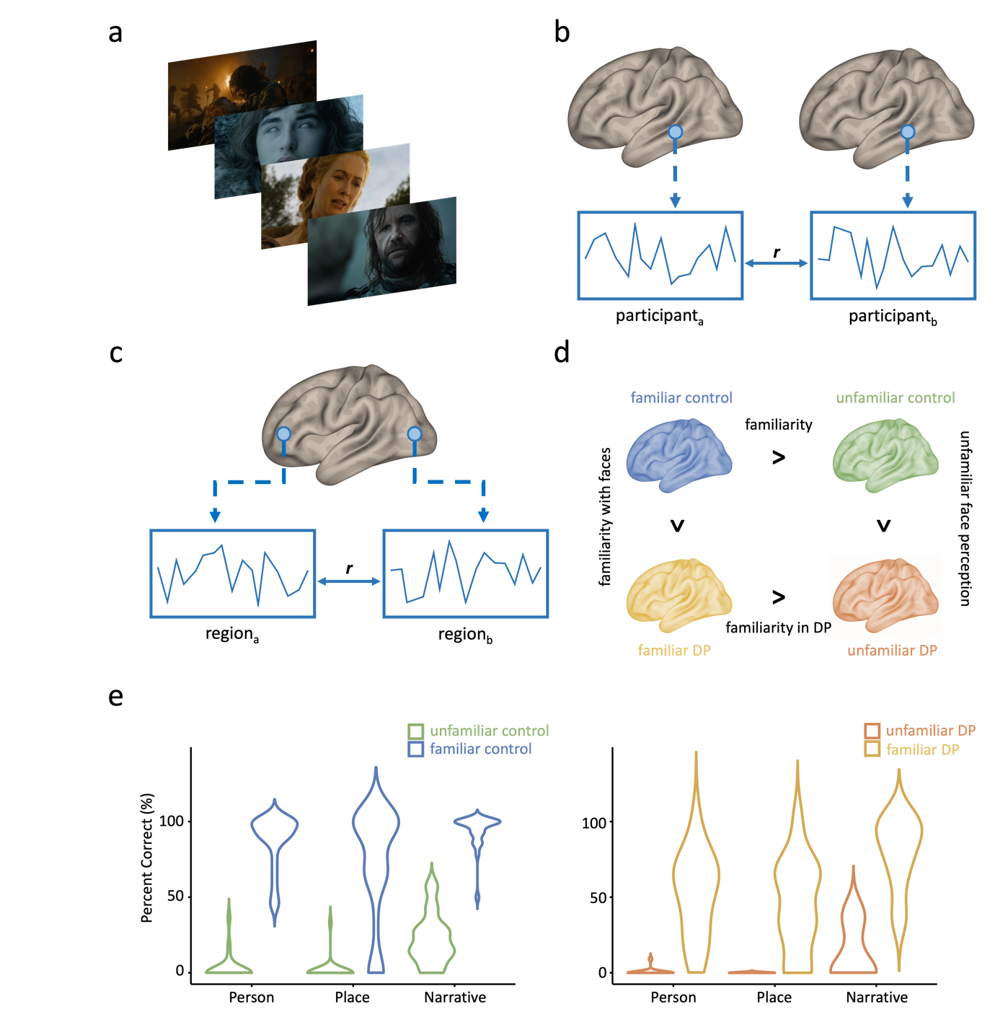

Figure 1. Natural viewing paradigm and experimental design. a) Participants watched a movie that was taken from Game of Thrones while brain activity was measured using fMRI. b) Neural responses were compared across individuals using inter-subject correlation (ISC, top) in which the time-course of response in corresponding voxels was correlated (r) between participants or c) using functional connectivity (bottom) in which the time-course of response between two different regions was correlated (r) within a participant. d) Neural responses were measured in control participants and participants with developmental prosopagnosia (DP), who were either familiar or unfamiliar with Game of Thrones. Differences in ISC or functional connectivity were compared across different groups to determine neural correlates of (i) familiarity (familiar control > unfamiliar control), (ii) familiarity with faces (familiar control > familiar DP), (iii) familiarity in DP (familiar DP > unfamiliar DP) and (iv) unfamiliar face perception (unfamiliar control > unfamiliar DP). e) Participants completed a behavioural test to determine their familiarity with Game of Thrones. Plots show percent correct on tests of narrative understanding and person and place recognition for familiar and unfamiliar controls and for familiar and unfamiliar DPs. Familiar controls and familiar DPs performed significantly better on face, place and narrative understanding compared to their unfamiliar counterparts.

METHODS

Participants
We recruited participants from 4 groups: (1) control participants who were familiar with the TV series Game of Thrones, (2) control participants who were not familiar with Game of Thrones, (3) DP participants who were familiar with Game of Thrones, (4) DP participants who were not familiar with Game of Thrones.

45 control participants (median age: 19 years, age range: 18-32, 15 male) took part in this study. All control participants were neurologically healthy, right-handed and had normal or corrected-to-normal vision. 22 of the control participants had watched Game of Thrones. The remaining 23 control participants had not watched Game of Thrones. 28 participants with developmental prosopagnosia also took part in the study (median age: 47 years, age range: 23-69, 12 male). The sample size was determined a priori based on prior fMRI studies using naturalistic stimuli and employing analysis techniques similar to those in the current study (Andrews et al., 2019; Chen et al., 2017; Hasson et al., 2009; Hasson et al., 2008). All developmental prosopagnosic participants were neurologically healthy, had normal or corrected-to-normal vision and 2 were left-handed. 15 developmental prosopagnosic participants were unfamiliar with Game of Thrones and 13 were familiar. DP participants were recruited through www.troublewithfaces.org and other online sources. To determine diagnostic evidence for the presence of DP, all DP participants completed the PI20 (20-item prosopagnosia index to measure self-reported face recognition abilities (Shah et al., 2015)) and the Cambridge Face Memory Test (B. Duchaine & K. Nakayama, 2006) (CFMT). To be classified with DP, a participant had to score above 65 on the PI20 (M= 80, SE= 1.51) and below 65% on the CFMT (M= 52.5%, SE= 1.54%) (Supplementary Table 1). Written informed consent was obtained for all participants and the study was approved by the York Neuroimaging Centre Ethics Committee.

fMRI Data Acquisition
All scanning was completed at the York Neuroimaging Centre using a 3T Siemens Magnetom Prisma MRI scanner and a 64-channel phased array head coil. A gradient-echo echo-planner imaging (EPI) sequence was used to collect data from 60 axial slices, EPI (TR = 2s, TE = 30ms, FOV = 240 x 240 mm, matrix size = 80 x 80, voxel dimensions = 3 x 3 x 3mm, slice thickness = 3mm, flip angle = 80°, phase encoding direction = anterior to posterior, multiband acceleration factor = 2). T1-weighted structural images were acquired from 176 sagittal slices (TR = 2300ms, TE = 2.26ms, matrix size = 256 x 256, voxel dimensions = 1 x 1 x 1mm, slice thickness = 1mm, flip angle = 8°). Field maps were collected from 60 slices (TR = 554ms, short TE = 4.90ms, long TE = 7.38ms, matrix size = 80 x 80, voxel dimensions = 3 x 3 x 3mm, slice thickness = 3mm, flip angle = 60°).

The fMRI data were analysed using FSL’s FEAT v6.0 (http://www.fmrib.ox.ac.uk/fsl (Jenkinson et al., 2012)). Motion correction (MCFLIRT) (Jenkinson et al., 2002), temporal high-pass filtering (Gaussian-weighted least squares straight line fittings, sigma = 50 s) and slice timing correction were applied. Spatial smoothing (Gaussian) was applied at 6mm FWHM. Removal of non-brain material was performed with BET (Smith, 2002). Functional data were first registered to a high-resolution T1-anatomical image via boundary-based registration (Greve & Fischl, 2009), and then onto the standard MRI brain (MNI152) via a non-linear registration computed via FNIRT. Field maps were used to apply correction to distortion of functional images as part of the registration step.

Game of Thrones Scan
Participants viewed and listened to a movie that was constructed with audio-visual segments from Seasons 3 and 4 of Game of Thrones. The movie was projected onto an in-bore screen at a distance of 57 cm from the participant with the image subtending approximately 38.7 × 22.3 degrees of visual angle. Accompanying audio (that included some speech) was also played to participants in the scanner. There were a total of 10 distinct scenes that ranged in length from 50-117 seconds, for a total movie length of 12 minutes 58 seconds (778s). The movie was presented using PsychoPy (Peirce et al., 2019).

First, we measured inter-subject correlations (ISC) within participants from the different groups during the Game of Thrones scan. To do this, the time series from each voxel in each participant was converted to % signal change, and 6 head motion parameters were regressed out of the data. These time series were then correlated (Pearson’s r) with corresponding voxels from participants from the same group. This was done for all combinations of participants within each group. To compare ISC across groups, a Fisher’s z transform was applied to the correlations. Then, for each voxel, a one-tailed Welch’s independent-samples t-test was performed to determine differences in ISC between groups. When applied to all voxels, this produced whole-brain p-statistic maps for each contrast, which we represented in negative log units. A cluster correction for multiple comparisons was then applied to these maps using an initial cluster forming threshold of -log₁₀(p) > 4 (p < .0001) and a cluster significance threshold of p < .05.

To determine whether ISC could be influenced by the age of participants, we ran an additional regression analysis. For each voxel in the brain, the ages of each pair of participants plus the interaction of those ages were use as predictors for the ISC. Significance was determined by a permutation test (5000 permutations) based on randomising the order of participants’ ages. Across the whole brain, only a few voxels had ISCs that were significantly predicted by participant age (Supplementary Fig. 1), and these did not survive cluster correction for multiple comparisons (using an initial cluster forming threshold of -log₁₀(p) > 3 (p < .001) and a cluster significance threshold of p < .05).

Next, we measured functional connectivity within participants between the face and scene regions defined in the localiser scan and the familiarity network defined using ISC. The time course of response of all voxels within a region was averaged in each participant to create an average time course of response. To measure connectivity, pairwise correlations (Pearson’s r) of timeseries were computed between regions for each participant. The correlations between each face or scene region and every other region (i.e., averaging within rows of the connectivity matrix) was calculated for each participant. A Fisher’s z transform was applied to all correlations prior to any statistics.

To determine if there were differences between groups, the resulting average correlation values from each face or scene region were compared across groups using Welch’s independent-samples t-test. A Bonferroni-Holm correction (Holm, 1979) was applied to correct for familywise errors over regions. To determine whether functional connectivity could be influenced by the age of participants, we correlated age of participant with each functional connection for the main regions of interest. Significance was determined by a permutation test (10000 permutations) based on randomising the order of participants’ ages. No functional connections were significantly correlated with age after correction for multiple comparisons (all p > .05 after Bonferroni-Holm correction).

In a further analysis, we explored the effect of age on variance in the signal to determine whether this could influence the ISC or functional connectivity. We calculated the average temporal standard deviation across all voxels. We then correlated this value with the mean age of the participants. However, we did not find a significant correlation between the mean temporal standard deviation and age (r(71)=-.18, p=.122).

All participants performed a behavioural test after the scan to determine their familiarity with Game of Thrones. First, we measured understanding of the narrative using a set of 14, 4-alternative, multiple-choice questions. Next, we tested the ability to recognize the faces of key people in the video. Participants viewed faces and were asked to name the person or provide information about them that was relevant to Game of Thrones. Finally, we tested the ability to recognize key places or landmarks. Participants viewed scenes and were asked to provide the name or key information about the scene that was relevant to Game of Thrones. When participants provided key information rather than the name of the face or scene, two independent observers who were familiar with Game of Thrones had to both agree that the information provided was sufficient to show familiarity. All tests were self-paced.

Localizer Scan
A localizer scan was used to define face-selective and scene-selective regions. There were 3 stimulus conditions: faces, scenes, and phase scrambled faces. Face stimuli had three viewpoints (-45°,0°,45°) and were taken from the Radbound database of face stimuli (Langner et al., 2010). Faces were presented on a greyscale 1/f amplitude-mask background. Scrambled faces were created by randomising the phase spectra while maintaining the amplitude spectra of the face images including the amplitude mask background. Scenes were indoor, outdoor man-made and outdoor natural stimuli from the SUN database (Xiao et al., 2010). Images subtended 8.4 x 8.4 degrees of visual angle. 4 images from each condition were presented in each block for 600ms with a 200ms ISI for a total of 9 seconds per block. 9 blocks were presented for each condition in a pseudorandomized order, for a total scan time of 244s. To maintain attention, participants performed an orthogonal task detecting periodic colour changes in the fixation cross, responding via a button press.

Data from the localiser scan were used to both define face- and scene-selective regions of interest (ROIs) from control participants. Boxcar models of each stimulus block were convolved with a single-gamma haemodynamic response function to generate regressors for each condition. These were then entered into a first-level GLM analysis (Woolrich et al., 2001) alongside their temporal derivatives plus confound regressors for 6 head motion parameters. Individual participant data from the controls were entered into a higher-level group analysis using a mixed-effects GLM using FLAME (Woolrich et al., 2004). Face-selective and scene-selective regions were then defined using the contrast of the response to either faces or scenes compared to both other conditions (faces > scenes + scrambled face; scene > faces + scrambled faces). To define ROIs, we used a clustering algorithm that iteratively adjusted the statistical threshold to grow clusters of 250 spatially contiguous voxels (2000 mm³) around seed voxels within each region. Figure 2 shows face-selective ROIs in the Fusiform Face Area (FFA), Occipital Face Area (OFA), Superior Temporal Sulcus (STS), Amygdala (AMG) and Inferior Frontal Gyrus (IFG), and scene-selective ROIs in the Occipital Place Area (OPA), Parahippocampal Place Area (PPA) and Retrosplenial cortex (RSC). A summary of the locations of these ROIs is provided in Supplementary Table 2. Finally, we did a whole-brain group contrasts between the control and DP groups. Individual participant data were entered into a higher-level group analysis using a mixed-effects GLM using FLAME (Woolrich et al., 2004). We defined group-level contrasts of controls > DPs to compare univariate category selectivity between the groups for the first-level face- and scene-selective contrasts.
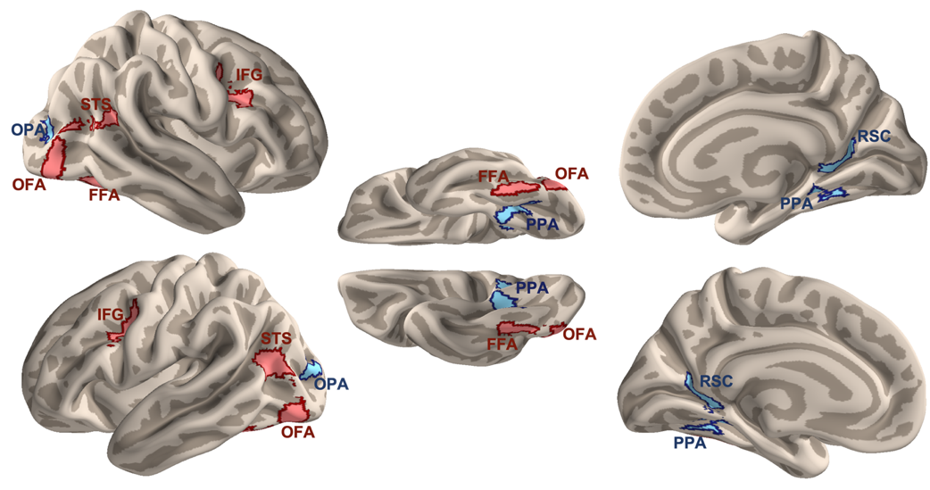

Figure 2. Face- and scene-selective ROIs defined from the localizer scan in the control participants. Red regions are face-selective and blue regions are scene-selective. (OFA: occipital face area, FFA: fusiform face area, STS: superior temporal sulcus, IFG: inferior frontal gyrus, OPA: occipital place area, PPA: parahippocampal place area, RSC: retrosplenial cortex).

RESULTS

Behavioural effects of familiarity
First, we measured person, place and narrative knowledge in participants who were familiar and unfamiliar with the TV series Game of Thrones. Figure 1e shows the scores of the behavioural test in the Control and DP groups. As expected, there was significantly higher recollection in the familiar controls compared to unfamiliar controls on the narrative test (t(37.1) = 16.8, p < .001, d = 5.04), the person recognition test (t(31.9) = 20.2, p < .001, d = 5.93) and the place recognition test (t(23.6) = 8.61, p < .001, d = 2.51). We compared performance between the familiar control and familiar DP group. No significant differences were found for the narrative test (t(15.3) = 2.1, p = .052 , d = 0.87). There was a small but significant difference between familiar controls and familiar DPs for the place recognition test (t(29.1) = 2.3, p = .027, d = 0.76). However, a larger difference between familiar controls and familiar DPs was evident in the person recognition test (t(17.5) = 4.1, p < .001, d = 1.62). In the comparison between familiar DPs and unfamiliar DPs, there was a significant difference on the narrative test (t(22.1) = 8.1, p < .001, d = 3.14), the person recognition test (t(12.1) = 6.4, p < .001, d = 2.60) and the place recognition test (t(12) = 5.0, p < .001, d = 2.03). Finally, there was no difference in the behavioural scores between the unfamiliar controls and unfamiliar DPs on the narrative test (t(28.9) = 1.35, p = .188 , d = 0.46), the person recognition test (t(25.4) = 1.18, p = .247 , d = 0.34) or the scene recognition test (t(21) = 1.00, p = .329 , d = 0.28).

Network of regions involved in familiarity
Next, we compared differences in the neural response of control participants who were familiar or unfamiliar with Game of Thrones. We measured ISC across all voxels in the brain for all combinations of control participants in either the familiar or unfamiliar groups. We then directly compared the correlations between the familiar and unfamiliar groups at each voxel to create a whole brain statistical map with a cluster correction for multiple comparisons. Figure 3a shows regions with higher ISCs in the familiar than unfamiliar group (red/yellow) voxels and vice versa (blue). A clear distinction is evident between regions in the temporal, parietal and frontal lobes that show higher ISC values in the familiar group and regions in the occipital and posterior temporal lobes that show higher ISC values in the unfamiliar group.
Figure 3. A network of regions across the brain involved in familiarity. a) ISC differences between familiar controls and unfamiliar controls. Voxels across temporal, parietal and frontal cortex showed higher ISC between familiar controls compared to the unfamiliar controls (red-yellow). In contrast, regions in occipital and posterior temporal cortex showed higher ISC in the unfamiliar controls compared to the familiar controls (blue-light blue). P-values are represented in negative log units (-log₁₀(p)). b) Functional connectivity differences between familiar controls and unfamiliar controls. There was enhanced connectivity between regions within the face and scene network in the familiar control group compared to the unfamiliar control group. There was also enhanced connectivity between the face and scene regions and the familiarity network in the familiar controls compared to the unfamiliar controls.

A cluster analysis was used to reveal different regions that showed higher ISCs between familiar participants. This revealed 23 regions, many of which appeared bilaterally. The statistical values and coordinates of the peak voxel in each cluster are shown in Table 1 and Supplementary Table 3. Next, we asked if the regions in the familiarity network overlapped with the face and scene regions found in the localizer scan, we determined the overlap with the familiarity network revealed by the cluster analysis. There was limited overlap with the core face and scene regions (Table 2) and the effect of familiarity was generally lower or even reversed compared to the familiarity network (see Table 1 for comparison). Finally, we analysed the location of the clusters that showed higher ISC for the unfamiliar group compared to the familiar group. These regions overlapped with early visual areas (V1-V3; Supplementary Table 4). In summary, the ISC analysis revealed a network of regions beyond the core face and scene areas that show significantly higher ISCs in the familiar group. In contrast, posterior regions in the occipital lobe show higher ISCs in the unfamiliar group.

Table 1. Regions showing higher ISC in familiar controls compared to unfamiliar controls during movie watching. Maximum t-value and percentage overlap with the familiarity network for each ISC contrast. The familiar control > familiar DP contrast shows large overlap with the familiarity network defined by the familiar control > unfamiliar control contrast. The familiar DP > unfamiliar DP contrast does not demonstrate an overlap with the familiarity network.

 |  |  | Familiar Control > Unfamiliar Control |  | Familiar Control > Familiar DP |  | Familiar DP > Unfamiliar DP
Region |  | Hemisphere | t | % overlap | t | % overlap | t | % overlap
Superior Frontal Gyrus |  | R | 7.67 | 100 | 7.66 | 87 | -7.00 | 0
 |  | L | 7.97 | 100 | 9.39 | 99 | -3.84 | 0
Superior Parietal Lobule |  | R | 10.02 | 100 | 10.54 | 93 | -6.41 | 0
 |  | L | 10.87 | 100 | 9.60 | 100 | 1.87 | 0
Medial Frontal Gyrus |  | R | 5.34 | 100 | 6.13 | 40.3 | 2.67 | 0
Postcentral Gyrus 1 |  | R | 6.27 | 100 | 5.77 | 17 | -1.89 | 0
 |  | L | 10.55 | 100 | 8.97 | 85 | -3.97 | 0
Precuneus 1 |  | R | 9.74 | 100 | 10.45 | 97 | -7.11 | 0
Intraparietal Lobule |  | R | 9.31 | 100 | 9.51 | 100 | -5.80 | 0
 |  | L | 7.39 | 100 | 10.10 | 100 | 3.28 | 0
Postcentral Gyrus 2 |  | R | 8.91 | 100 | 8.96 | 96 | -4.34 | 0
 |  | L | 10.89 | 100 | 10.56 | 100 | -6.01 | 0
Precuneus 2 |  | R | 10.70 | 100 | 8.63 | 72 | -2.66 | 0
 |  | L | 10.13 | 100 | 7.73 | 47 | -2.40 | 0
Posterior Cingulate 1 |  | R | 6.24 | 100 | 4.68 | 6.4 | 2.21 | 0
 |  | L | 8.68 | 100 | 7.29 | 57 | 3.63 | 0
Supramarginal Gyrus |  | R | 7.76 | 100 | 8.83 | 83 | -5.35 | 0
 |  | L | 9.37 | 100 | 11.76 | 100 | -6.72 | 0
Precentral Gyrus |  | R | 5.55 | 100 | 6.75 | 73 | -3.73 | 0
 |  | L | 8.68 | 100 | 9.88 | 97.8 | -3.11 | 0
Temporoparietal junction |  | L | 11.01 | 100 | 13.15 | 100 | -7.34 | 0
Superior Temporal Gyrus |  | R | 10.25 | 100 | 8.71 | 84 | -7.11 | 0
 |  | L | 7.21 | 100 | 7.99 | 90 | -4.58 | 0
Occipital Pole |  | L | 9.36 | 100 | 8.51 | 21.6 | -4.51 | 0
Inferior Frontal Gyrus |  | R | 8.85 | 100 | 6.46 | 54 | -4.23 | 0
 |  | L | 9.70 | 100 | 8.58 | 93 | -2.97 | 0
Posterior Cingulate 2 |  | R | 6.39 | 100 | 5.49 | 82.9 | -4.35 | 0
Frontal Pole |  | R | 6.93 | 100 | 6.35 | 56 | 2.17 | 0
Retrosplenial Cortex |  | R | 6.87 | 100 | 5.48 | 0 | 3.63 | 0
 |  | L | 6.81 | 100 | 7.27 | 33.8 | 3.74 | 0
Middle Temporal Gyrus 2 |  | R | 9.12 | 100 | 13.03 | 96 | 4.80 | 12
Middle Temporal Gyrus 1 |  | R | 11.93 | 100 | 12.06 | 97 | 4.52 | 3
 |  | L | 7.25 | 100 | 8.70 | 59.6 | -3.60 | 0
Superior Temporal Sulcus 1 |  | R | 8.87 | 100 | 12.71 | 89 | -2.87 | 0
 |  | L | 8.43 | 100 | 8.89 | 99 | 3.58 | 0
Superior Temporal Sulcus 2 |  | R | 8.76 | 100 | 9.51 | 100 | -2.33 | 0
 |  | L | 13.91 | 100 | 8.23 | 91 | 3.69 | 0
Medial Prefrontal Cortex |  | R | 8.01 | 100 | 4.71 | 0 | 4.82 | 0
 |  | L | 7.13 | 100 | 4.36 | 0 | 2.01 | 0
Hippocampus |  | R | 5.65 | 100 | 7.02 | 17.9 | 1.58 | 0
 |  | L | 5.44 | 100 | 3.83 | 0 | 3.22 | 0
Inferior Temporal Gyrus |  | L | 10.04 | 100 | 12.21 | 100 | -6.23 | 0
Fusiform Gyrus |  | R | 8.38 | 100 | 4.25 | 1.1 | 1.89 | 0
 |  | L | 6.56 | 100 | 7.06 | 35 | -3.18 | 0
Temporal Pole 1 |  | R | 8.04 | 100 | 9.65 | 88 | 3.19 | 0
 |  | L | 7.91 | 100 | 8.34 | 100 | 4.23 | 2
Temporal Pole 2 |  | R | 5.29 | 100 | 5.78 | 58.9 | 2.01 | 0

Table 2. Percentage overlap and maximum t-value of ISC group contrasts in face- and scene-selective regions. For each whole-brain ISC contrast, the overlap with core face- and scene-selective regions was calculated. The familiar control > unfamiliar control contrast and the familiar DP > unfamiliar DP contrast show limited overlap with the face- and scene-selective regions. The familiar control > familiar DP likewise show relatively limited overlap.

Region |  | Hemisphere | Familiar Control > Unfamiliar Control |  |  | Familiar Control > Familiar DP |  | Familiar DP > Unfamiliar DP
 |  |  | t | % overlap |  | t | % overlap | t | % overlap
Occipital face area |  | R | -4.76 | 2.0 |  | 5.71 | 8.8 | 5.91 | 10
 |  | L | -6.32 | 5.2 |  | 8.37 | 11 | -4.79 | 0
Fusiform face area |  | R | -7.73 | 0.4 |  | -4.14 | 0.4 | 5.27 | 3.6
 |  | L | 6.86 | 31 |  | 9.76 | 65 | -6.88 | 0.0
Superior temporal sulcus |  | R | 6.53 | 14 |  | 13.64 | 52 | -12.86 | 0.0
 |  | L | 8.58 | 52 |  | 19.68 | 99 | -9.15 | 0.0
Inferior frontal gyrus |  | R | 8.25 | 51 |  | 6.34 | 35 | -3.96 | 0.0
 |  | L | 6.47 | 18 |  | 7.44 | 27 | -2.83 | 0.0
Amygdala |  | R | 3.95 | 0.0 |  | 3.42 | 0.0 | -2.34 | 0.0
 |  | L | 4.25 | 2.8 |  | 5.44 | 0.0 | -2.57 | 0.0
Occipital place area |  | R | -8.96 | 0.0 |  | 7.53 | 59 | -6.18 | 0.0
 |  | L | -6.80 | 0.0 |  | 6.89 | 4.8 | -5.03 | 9.6
Parahippocampal place area |  | R | -4.95 | 0.0 |  | 9.83 | 70 | -4.71 | 1.6
 |  | L | -7.38 | 0.0 |  | 7.26 | 28 | -4.73 | 0.0
Retrosplenial Cortex |  | R | 6.87 | 18 |  | 5.59 | 0.4 | 5.28 | 8.4
 |  | L | 6.81 | 21 |  | 7.27 | 17 | 5.89 | 12

Table 3. Percentage overlap and maximum t-value of early visual regions with ISC group contrast for unfamiliar control > familiar control. In contrast to the unfamiliar control, this contrast overlaps with early visual areas.

Region | Hemisphere | t | % overlap
V1 | R | 9.45 | 48.9
 | L | 8.60 | 47.9
V2 | R | 9.27 | 38.5
 | L | 8.47 | 28.0
V3 | R | 9.02 | 46.7
 | L | 11.43 | 39.3

We next asked how functional connectivity across the brain was influenced by familiarity. We first measured functional connectivity between face-selective or scene-selective regions. The average correlation matrices for the participants in the familiar and unfamiliar groups are shown in Suppl. Fig. 2 and 3. A correlation between the familiar and unfamiliar matrices shows that there was a similar pattern of connectivity within the face (r(43) =.99, p < .001) and scene (r(13) =.97, p < .001) regions in the two groups. We then asked how the magnitude of connectivity differed across the familiar and unfamiliar groups (Fig. 3b, left). We first averaged the Fisher’s z correlations over all connections and contrasted these values between conditions. There was overall higher connectivity between the face (t(42.2)=3.18, p=.003, d=0.96) and scene (t(42.7)=2.69, p=.010, d=0.82) regions in the familiar participants. We further compared the effect of familiarity for each region by comparing the average correlations for each region. In the face regions (Fig. 3b, top left), the effect of familiarity was due to increased connectivity with the lFFA (t(42.4)=3.02, p=.038, d=0.92) and lIFG (t(42.4)=3.22, p=.025, d=0.98). In the scene regions (Fig 2b, bottom left), the effect of familiarity was due to increased connectivity with the rRSC (t(42.7)=3.25, p=.011, d=0.99) and lRSC (t(42.9)=3.48, p=.007, d=1.06). No other face or scene regions showed a significant difference after correction (all p > .05).

Next, we measured functional connectivity between the core face and place regions in the visual brain and familiarity network defined from the ISC analysis. The average correlation matrices for the participants in the familiar and unfamiliar groups are shown in Suppl. Fig. 2 and 3. A correlation between the familiar and unfamiliar matrices shows that there was a similar pattern of connectivity between the familiarity network and the face (r(468) =.92, p < .001) and scene (r(280) =.95, p < .001) regions in the two groups. However, a comparison of the magnitude of the connectivity showed enhanced connectivity between the familiarity network and both the face (t(42.8)=4.30, p<.001, d=1.31) and scene (t(41.5)=3.38, p=.002, d=1.02) regions (see Fig. 3b, right). The effect of increased connectivity with familiarity was evident in all the face regions (rFFA: t(42.9)=3.95, p=.002, d=1.20; lFFA: t(42.9)=4.27, p<.001, d=1.30; rOFA: t(42.7)=4.62, p<.001, d=1.41; lOFA: t(41.7)=4.13, p=.001, d=1.25; rSTS: t(41.9)=4.57, p<.001, d=1.39; lSTS: t(42.9)=3.62, p=.003, d=1.10; rIFG: t(41.9)=3.15, p=.008, d=0.96; lIFG: t(42.7)=3.04, p=.008, d=0.93; rAMG: t(34.9)=3.86, p=.002, d=1.16; lAMG: t(37.6)=3.24, p=.008, d=0.98). Similarly, the effect of increased connectivity with familiarity was evident in all the scene regions (rPPA: t(36.0)=3.14, p=.011, d=0.95; lPPA: t(40.2)=3.28, p=.011, d=0.99; rRSC: t(41.4)=2.96, p=.011, d=0.90; lRSC: t(42.3)=3.22, p=.011, d=0.98; rOPA: t(42.8)=3.64, p=.004, d=1.11; lOPA: t(43.0)=3.19, p=.011, d=0.97).

To determine if the core face and scene regions interacted with the familiarity network in a similar way, we averaged the correlation values within each row of the functional connectivity matrices (see Fig. 3b, right). This gave an average correlation (over face or scene regions) for each region in the familiarity network. There was a significant correlation between the two vectors (r(45)=.62, p<.001). This shows that the effect of familiarity on functional connectivity with the familiarity network is similar for face and scene regions. We also found a significantly higher effect of familiarity on the connectivity between the face regions with the familiarity network compared to the scene regions with the familiarity network (t(46)=4.55, p<.001, d=0.60).

Network of regions involved in familiarity for faces
Next, we asked which brain regions were specifically involved in processing familiar faces. To do this, we compared familiar controls and familiar DPs. Both groups of participants were familiar with the stimuli, but participants with developmental prosopagnosia have a lifelong deficit in face recognition and showed lower face recognition in the GoT behavioural test. Our hypothesis was that voxels that are important for processing familiar faces would show significantly higher ISC among familiar controls compared to familiar DPs.
Fig. 4a shows regions in which there were significantly higher ISCs comparing familiar controls to familiar DPs. There was a clear distinction between regions in the temporal, parietal and frontal lobe that show higher values in the familiar control group and regions in the occipital lobe that show higher values in the familiar DP group. The pattern was similar to the contrast of familiar control vs unfamiliar control (see Fig. 3a). To determine the similarity between these contrasts, we measured the statistical difference between the familiar controls and familiar DPs in each cluster from the familiarity network (Table 1). The similarity between the cluster analyses shows that the majority of the clusters from the familiarity network also show a greater difference between familiar controls and familiar DPs. In contrast, there was limited overlap between the face and scene regions and the cluster analysis for familiar controls > familiar DPs (Table 2). This again suggests that the difference between familiar controls and familiar DPs is primarily evident in regions beyond the visual brain.
Figure 4. Network of regions involved in familiarity for faces. a) ISC differences between familiar controls and familiar DPs. Voxels in temporal, parietal and frontal cortex showed higher ISC in the familiar control compared to the familiar DPs (red-yellow). In contrast, regions in occipital and posterior temporal cortex showed higher ISC in the familiar DPs compared to the familiar controls (blue-light blue). b) Functional connectivity differences between familiar controls and familiar DPs. There was enhanced connectivity between regions in the core face and scene network in the familiar control group compared to the familiar DP group. There was also enhanced connectivity between the familiarity network and the face regions in the familiar controls compared to the familiar DPs.

Next, we measured the difference in functional connectivity between familiar controls and familiar DPs (Fig. 4b). The average correlation matrices for the participants in these groups are shown in Suppl. Fig. 2 and 3. A correlation between the familiar control and familiar DP matrices shows that there was a similar pattern of connectivity within the face (r(43) =.95, p < .001) and scene (r(13) =.98, p < .001) regions. There was, however, an overall increase in the magnitude of functional connectivity between the face regions in the familiar controls compared to the familiar DPs (t(23.2) = 2.59, p = .016, d = 0.95). In the face regions (Fig. 4b, top left), the effect of familiarity was due to increased connectivity with the rOFA (t(29.2) = 3.1, p = .045, d = 1.04) and lSTS (t(19.0) = 3.2, p = .045, d = 1.26). There was also an overall increase in connectivity between the scene-selective regions (t(23.3) = 2.1, p = .046, d = 0.77), although no single ROI was significant after corrections.

We next measured the functional connectivity between the face and scene regions and the familiarity network. A correlation between the familiar control and familiar DP matrices shows that there was a similar pattern of connectivity between the familiarity network and the face regions (r(468) =.90, p < .001) and between the familiarity network and the scene (r(280) =.94, p < .001) regions. However, the magnitude of connectivity between the face regions and the familiarity network was greater for familiar controls compared to familiar DPs (t(22.4) = 2.32, p = .030, d = 0.86). The effect of increased connectivity with familiarity was evident in the rOFA (t(26.9) = 3.2, p = .034, d = 1.12). Interestingly, no significant differences were found in the overall connectivity in scene-selective regions and the familiarity network for familiar controls compared to familiar DPs (t(21.8) = 1.71, p = .102, d = 0.64). Moreover, a direct comparison of the connectivity in the face and scene regions with the familiarity network showed a significant difference (t(46)=4.09, p<.001). This shows that the enhanced connectivity in familiar controls compared to familiar DPs was face specific.

A reduced response to familiarity in DP
To explore the neural basis of familiarity in DP, we compared familiar DPs with unfamiliar DPs. Both groups of participants had a deficit in face recognition, but only one group was familiar with GoT. Given the deficit in face recognition, we did not predict that this would reveal the network of regions involved in familiarity. Indeed, a cluster analysis of the ISC found very limited overlap with the network of regions involved in familiarity (Fig. 5a; Table 1). The pattern was also different in the face and scene regions compared to the previous contrasts (See Table 2).

Next, we compared the difference in connectivity between familiar and unfamiliar DPs (Fig. 5b). The average correlation matrices for the participants in these groups are shown in Suppl. Fig. 2 and 3. A correlation between the familiar DP and unfamiliar DP matrices shows that there was a similar pattern of connectivity within the face (r(43) =.94, p < .001) and scene (r(13) =.97, p < .001) regions. There was also no significant difference in connectivity in either the face-selective (t(25.1) = 1.22, p = .234, d = 0.48) or scene-selective (t(24.9) =-0.69, p = .496, d = 0.27) regions, or in any individual ROI (all p > .05).

We compared the functional connectivity between the face and scene regions and the familiarity network. A correlation between the familiar DP and unfamiliar DP matrices shows that there was a similar pattern of connectivity between the familiarity network and the face regions (r(468) =.81, p < .001) and between the familiarity network and the scene regions (r(280) =.92, p < .001). There was no significant difference in overall functional connectivity between the face-selective regions and familiarity network for familiar DPs compared to unfamiliar DPs (t(23.5) = 1.51, p = .145, d = 0.60). Finally, no significant differences were found in the overall connectivity in scene-selective regions for familiar DPs compared to unfamiliar DPs (t(22.8) = 1.47, p = .154, d = 0.59).

Figure 5. No familiarity network in DP. a) ISC differences between familiar DPs and unfamiliar DPs. The extended network for familiarity across temporal, parietal and frontal cortex was not evident for the contrast of familiar DPs compared to unfamiliar DPs (red-yellow). b) Functional connectivity differences between familiar DPs and unfamiliar DPs. Familiarity did not increase functional connectivity in familiar DPs compared to unfamiliar DPs.

Network of regions involved in the perception of unfamiliar faces
While comparisons of familiar controls and familiar DPs highlight regions involved in processing of familiar faces, comparisons of unfamiliar controls with unfamiliar DPs should reveal regions that are important for general face perception.

First, we compared the ISC of the unfamiliar controls and the unfamiliar DPs while watching Game of Thrones. A cluster analysis showed a higher ISC in unfamiliar controls compared to unfamiliar DP participants in regions of the temporal and occipital lobe (Fig. 6a). Supplementary Table 4 shows how this pattern of difference overlapped with the core face and scene regions. This showed some overlap in the OFA, FFA and PPA. In summary, this analysis reveals a network of regions in the occipital and temporal lobe, which overlaps with the core face and scene areas, that show significantly higher ISCs in the control unfamiliar compared to the DP unfamiliar group.

Figure 6. Network of regions involved in the perception of unfamiliar faces. a) ISC differences between unfamiliar controls and unfamiliar DPs. Regions across the occipital and temporal lobe showed higher ISC in the control compared to the DP group (red-yellow). Fewer clusters show significantly greater inter-subject correlations in unfamiliar DPs compared to unfamiliar controls (blue-light blue). Maps were created using one-sided Welch’s t-tests and cluster corrected using an initial cluster forming threshold of -log₁₀(p) > 4 (p < .0001) and a cluster significance of p < .05. b) Functional connectivity differences between unfamiliar controls and unfamiliar DPs. There was no increase in connectivity between regions in the unfamiliar control group compared to the unfamiliar DP group.

Next, we analysed connectivity within the core face and scene regions (Figure 6b). There was no significant difference in connectivity between the unfamiliar control and DP groups within the face (t(25.5) = 1.28, p = .211, d = 0.46) or scene (t(27.1) = 0.80, p = .431, d = 0.28) regions, and no individual ROIs were significant. There was, however, reduced connectivity with the familiarity network in both face (t(25.5) = 2.92, p = .007, d = 1.05) and scene (t(26.7) = 2.86, p = .008, d = 1.02) regions for the control compared to the DP group. This connectivity was significant in the right (t(27.0) = 3.18, p = .037, d = 1.13) and left FFA (t(28.0) = 3.13, p = .037, d = 1.10) with the familiarity network, and all scene regions with the familiarity network (rPPA: t(21.5)=2.12, p=.046, d=0.80; lPPA: t(25.6)=2.83, p=.044, d=1.02; rOPA: t(28.2)=2.61, p=.044, d=0.91; lOPA: t(30.5)=2.56, p=.044, d=0.88; rRSC: t(28.3)=2.81, p=.044, d=0.99; lRSC: t(25.5)=3.26, p=.019, d=1.18).

Finally, we compared face-selectivity and scene-selectivity in the localizer scan. Figure 7 shows a whole-brain group analysis of the difference in face-selectivity and scene-selectivity between controls and DPs. This shows a cluster of voxels in the left fusiform gyrus that showed greater face-selectivity in controls compared to DPs. There were also more medial clusters in the right and left parahippocampal gyrus that showed greater scene-selectivity in controls compared to DPs in response to scenes (see Supplementary Table 5 for peak coordinates). We also compared the difference in response between controls and DPs to faces, scrambled faces and scenes within the face-selective and scene-selective ROIs (Supplementary Figures 4 and 5 & Supplementary Table 6). There were significant differences in the response to faces between the control and DP groups in both the left and right OFA, the left and right FFA and the left STS. However, there were no significant differences in the response to faces between the control and DP groups for any of the scene regions. We also found significant differences in the response to scrambled faces between the control and DP group in the left OFA, the left and right FFA and the left STS. There were no significant differences in the response to scrambled images between the control and DP group in any of the scene regions. Finally, we found that there was a significant difference in the response to scenes between the control and DP group in the right PPA. No other regions showed a significant group difference in the response to scenes.

Finally, Supplementary Figures 6 and 7 show the main effects of familiarity (control familiar + DP familiar vs control unfamiliar + DP unfamiliar) and group (control familiar + control unfamiliar vs DP familiar + DP unfamiliar).

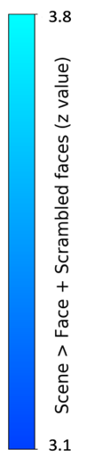
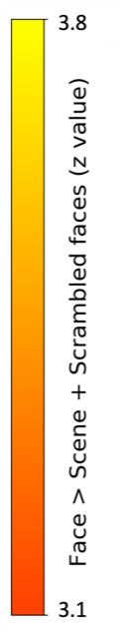
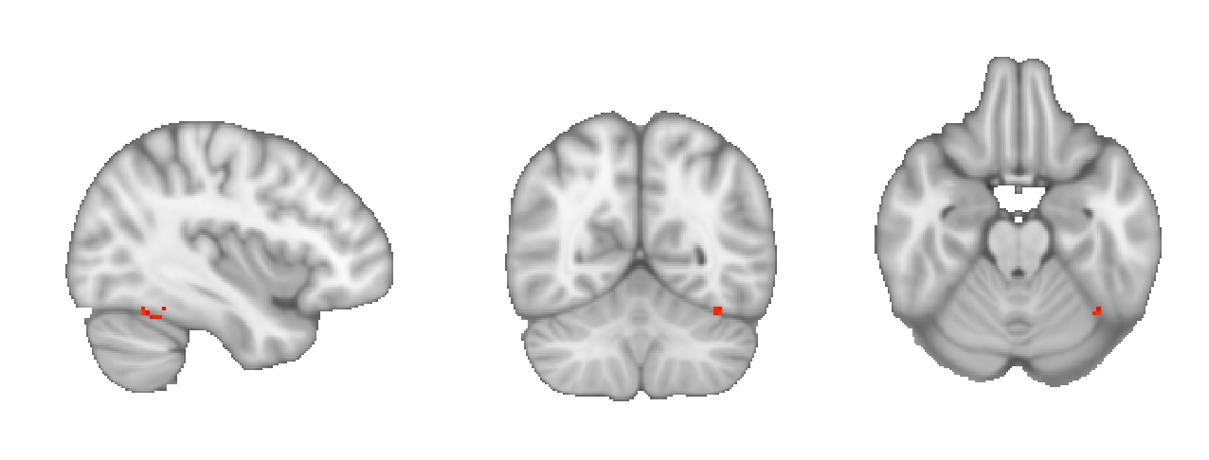
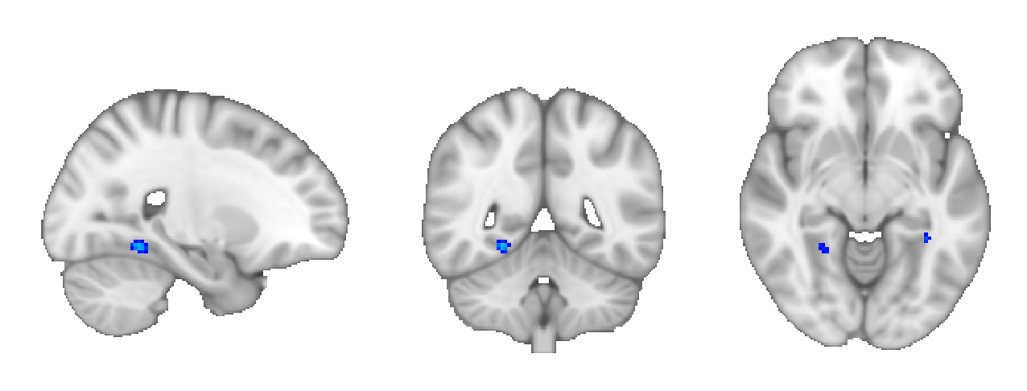
x = 64
y = 34
z = 25
x = 33
y = 39
z = 32

Figure 7. Greater face selectivity for controls compared to DPs. In the localiser scan, greater face selectivity was found in the left hemisphere (red-yellow) and greater scene selectivity was found for controls compared to DPs (blue-light blue) in the localiser scan. Statistical maps are thresholded at Z > 3.1 (one-tailed p < .001) uncorrected.

DISCUSSION
A natural viewing paradigm was used to explore the neural correlates of familiarity. Our results show: (1) The neural response to familiarity in natural viewing is dependent on a distributed network of regions that extend beyond the visual brain; (2) Familiarity enhanced the functional connectivity between this familiarity network and face and scene regions in the visual brain; (3) The response of the familiarity network and its functional connectivity with the core face regions were significantly attenuated in participants who have a deficit in the ability to recognize faces. These findings reveal the importance of extensive interactions between visual and non-visual regions of the brain during natural viewing of familiar people and places.

The naturalistic approach (movie watching) used in this study allowed us to capture the richness and complexity associated with real-world familiarity (Hasson et al., 2010; Redcay & Moraczewski, 2020). A key feature of our paradigm was that the stimulus was the same for all participants. By comparing the neural response in participants who were either familiar or unfamiliar with the TV series Game of Thrones (GoT), it was possible to reveal regions of the brain that are involved in familiarity. We found a network of regions across the brain that showed a strong and robust effect of familiarity. The cognitive processes underlying the effect of familiarity are likely to reflect our memory of particular episodes and our understanding of the narrative and context in which they occur (Jääskeläinen et al., 2021). The ability to understand and interpret events is known to be enhanced by our prior schematic knowledge of the world (Bartlett, 1932; Baldassano et al., 2018). This schematic knowledge has been shown to influence neural processing of familiar events and stimuli in regions such as the medial prefrontal cortex - mPFC (Baldassano et al., 2018, Reagh & Ranganath, 2023; van Kesteren et al., 2013, Raykov et al., 2021; Yeshurun et al., 2017). For example, the recall of events in a movie activates a network of regions across the brain that are associated with autobiographical memory and are similar to those found in this study (Chen et al., 2017). The higher ISC in regions such as the mPFC that we find is likely to reflect a greater schematic understanding of the movie in the familiar participants. Previous studies have shown that the coherence of the narrative can have a large effect on the similarity of the neural response across participants when watching movies (Hasson et al., 2008). For example, a movie showing an unstructured real-life event without any editing shows ISC only in sensory regions of the brain. In contrast, there is a much more widespread pattern of ISC across a larger area of the cortical surface during viewing of movies with an engaging and coherent storyline.

Our understanding of real-world social interactions relies on the ability to recognise people and to access knowledge about them. We typically recognise people through their face. The neural processing of faces involves a core network of regions that process the visual properties of the image and an extended network of regions that process non-visual image about the person (Gobbini & Haxby, 2007; Haxby et al., 2000; Ishai, 2008; Kovács, 2020). We found limited overlap between regions that have been associated with face recognition, such as the right FFA and regions that showed an effect of familiarity in the ISC analysis. In contrast, we found more overlap between regions showing an effect of familiarity and other face regions, such as the left STS and right IFG. Models of face recognition propose that the activation of an image-invariant visual representation of familiar faces occurs prior to accessing person knowledge (Bruce & Young, 1986; Burton et al., 1999; Haxby et al., 2000). However, neuroimaging studies have failed to find convincing empirical evidence for an image-invariant representation of familiar faces in core face regions, such as the right FFA (Davies-Thompson et al., 2009; Davies-Thompson et al., 2013; Pourtois et al., 2005; Weibert et al., 2018; Weibert et al., 2016). This suggests that the neural responses in the FFA may not be sufficient for familiar face recognition (Collins & Olson, 2014).

We found the strongest responses to familiarity in regions within the extended face network that are associated with person knowledge. For example, regions selective for familiarity were found in the temporo-parietal junction, inferior parietal lobule and medial prefrontal cortex, which have been associated with theory of mind (Frith & Frith, 1999) and the perception of personality traits (Gobbini et al., 2004; Visconti di Oleggio Castello et al., 2017). We also found familiarity effects in other regions that are associated with episodic memory, such as the hippocampus and the precuneus/posterior cingulate (Dickerson & Eichenbaum, 2010; Rugg et al., 2002; Silson et al., 2019). This fits with studies showing neural responses in the medial temporal lobe to different images of the same person, but also to related images such as the name of the person (Quiroga et al., 2009; Quiroga et al., 2005; Weibert et al., 2016). The response to familiarity in the anterior temporal lobe that we show is likely to reflect semantic information about a person (Lambon Ralph, 2014; Rice et al., 2018). Finally, the effect of familiarity in the superior temporal sulcus and amygdala may underpin the affective response to familiar faces (Harris et al., 2012; Ramon & Gobbini, 2018). These findings showing the important role of non-sensory processing in familiarity are consistent with EEG studies showing that the difference between familiar and unfamiliar faces is most evident at later time periods (Andrews et al., 2017; Wiese et al., 2019). Together, this suggests that the representation of familiar faces is evident in a distributed neural response that extends beyond the visual brain and involves regions involved in person knowledge.

The effect of familiarity was also evident in the enhanced functional connectivity between different regions in the core face network, and also between the core face regions and the extended network in the visual brain. The increased functional connectivity in familiar participants during moving watching shows the importance of interactions with the core face network during natural viewing. Previous studies have explored the relationship between face recognition ability and functional connectivity of the core face network with resting state fMRI. These studies have shown mixed results with some studies showing that the magnitude of functional connectivity between core face regions predicts behavioural ability in face recognition (Zhu, Zhan et al., 2011; Wang, Zhen et al., 2016), whereas others show no relationship (Ramot et al., 2019). A key difference between these studies is the presence of a stimulus. It is possible that movie watching elicits more structured and reliable patterns of response that better reflect cognitive differences in face processing (Finn, 2021; van der Meer, Breakspear et al., 2024).

To explore how the familiarity network that is evident in our analysis is critical for familiar face recognition, we measured responses in participants who have developmental prosopagnosia (DP). Familiar DPs showed reduced performance on the face recognition test of actors from GoT, consistent with their performance on other tasks of face recognition. When we compared the ISC of familiar controls with familiar DPs, we again found a network of regions that was very similar to when we compared familiar controls with unfamiliar controls. This suggests that the neural response to familiar faces in DPs is less coherent across these regions and perhaps more like unfamiliar controls. Because of the selective deficit in face recognition in DP, the contrast between familiar controls and familiar DPs provides a more direct link between regions in the familiarity network and face recognition. Our findings are consistent with previous studies that have shown an attenuated response to familiar faces across some regions of the extended face network in DP (Avidan & Behrmann, 2009). Interestingly, we found a difference in functional connectivity between face regions (but not scene regions) in familiar controls compared to familiar DPs. Similarly, there was greater connectivity between the core face regions (but not scene regions) and familiarity network in familiar controls compared to familiar DPs. This again suggests a selective attenuation in connectivity between core and extended face regions in DP (see also, (Avidan et al., 2014; Rosenthal et al., 2017; Thomas et al., 2009).

We also compared familiar DPs with unfamiliar DPs. This contrast did not reveal a difference in ISC across familiarity network, nor was there any difference in functional connectivity. This was somewhat surprising given that familiar DPs were able to recognise some of the faces on the behavioural GoT task. One possible explanation could be that the familiar DPs used a range of non-face cues to help with recognition that were not consistent across the group. Consistent with this explanation, the variance across the DP group in the behavioural study was larger than for the control participants. This would be consistent with DPs being a more heterogenous group. The greater heterogeneity in the DP group could also explain the contrast between the familiar controls and familiar DPs. Nonetheless, our results show a selective attenuation of the effect of familiarity on ISC and functional connectivity in the core and extended face regions.

The deficit in face recognition in DP is typically shown by significantly below average performance on tests of unfamiliar face perception (Duchaine & Nakayama, 2006). To determine the neural correlates of the deficit in unfamiliar face perception, we compared unfamiliar controls with unfamiliar DPs during movie watching. We found higher ISC in the unfamiliar controls compared to the unfamiliar DPs across the occipital and temporal lobes. Interestingly, the regions showing differences overlapped with the core face and scene regions. These findings suggest that the deficit in DP involves the visual encoding of the face. Next, we compared the selectivity of the response to unfamiliar faces relative to unfamiliar scenes and scrambled faces from the localiser scan. Some previous studies have reported reduced activity in the core face-selective areas when viewing faces in DP (Furl et al., 2011; Hadjikhani & de Gelder, 2002; Jiahui et al., 2018), whereas other studies have reported activity that is comparable to that found in control participants (Avidan et al., 2005; Hasson et al., 2003; Rivolta et al., 2014). One possible reason for the inconsistency across previous studies has been variation in the number of participants used in each study (Jiahui et al., 2018). In this analysis, we compared the responses of 45 controls with 28 DPs, which is significantly higher than most previous studies. Our results show that there was reduced selectivity to faces in DPs in the FFA. This suggests that the deficit in DPs may involve an inability to encode information about face images. A finer grained analysis revealed that there was a reduced response in the FFA of DPs for both intact and scrambled faces compared to scenes. This fits with a recent behavioural study showing a reduced sensitivity in DPs to pareidolic objects with similar image properties to faces, but not to pareidolic objects with dissimilar properties to faces (Epihova et al., 2022) and suggests that the deficit in DP may also reflect the ability to encode image properties that are typically found in faces. We also found lower selectivity for scenes in the PPA (Jiahui et al., 2018). This fits with the lower ISC in DPs during movie watching. It is not clear why DPs show this deficit in scene processing, but it may shed light on a wider debate about the underlying mechanisms of DP (Bate et al., 2019; Garrido et al., 2018; Geskin & Behrmann, 2020).

Our ability to recognise familiar places is important for understanding the context of real-world situations. Neuroimaging studies have shown that there are number of regions in the visual brain that respond selectively to scenes (Aguirre et al., 1998; Epstein & Kanwisher, 1998; Epstein & Baker, 2019). Studies using conventional neuroimaging designs have found mixed evidence for an effect of familiarity in these regions (Epstein et al., 1999; Epstein, Higgins, et al., 2007; Epstein, Parker, et al., 2007). We found limited overlap between the familiarity network in the ISC analysis and the scene regions. However, we did find that connectivity between regions in the scene network was enhanced by the familiarity of the participants. Differences between familiar and unfamiliar scenes have been more consistently reported outside the core scene network in regions of the medial and lateral parietal lobe (Epstein, Parker, et al., 2007; Silson et al., 2019; Steel et al., 2021; Sugiura et al., 2005). We also found higher ISC in familiar participants in these regions. We also show that familiarity enhanced the functional connectivity between scene regions and the familiarity network. This suggests that our ability to recognize familiar places may also depend on interactions within the visual brain and between visual and non-visual regions of the brain.

Previous neuroimaging studies have found conflicting evidence for whether knowledge about people or places involves distinct or overlapping representations in memory (Gorno-Tempini & Price, 2001; Morton et al., 2021; Simmons et al., 2010). To address this question, we compared connectivity between the familiarity network and either the face or scene regions. Despite the fact that distinct regions are involved in processing faces and scenes within the visual brain, we found a similar effect of familiarity on the pattern of connectivity between face or scene regions and the familiarity network. This suggests that there is an overlapping representation of familiar people and places in non-visual regions of the brain.

An alternative explanation of our data is that differences in attention to the stimulus could explain the effects of familiarity that we report in the neural response. However, an interesting finding from our analyses was that early visual regions showed higher ISC in unfamiliar compared to familiar control participants. This shows that the higher ISC in the familiar control group is not an inherited response from early stages of processing. One possibility for the higher ISC in the unfamiliar group is that top-down expectations may have influenced the response in early visual regions (Bar, 2003; Friston, 2005). A growing body of evidence suggests that higher order cortical regions can influence responses in early visual regions if they are predictable (Murray et al., 2002; Summerfield & De Lange, 2014). It is possible, therefore, that the knowledge and understanding of the stimulus in the familiar control group led to top-down influences on the neural processing in early visual regions.

In conclusion, natural viewing reveals a network of regions, beyond sensory cortex, that are involved in our familiarity with people and places. The role of this familiarity network in face recognition is evident by its attenuation in participants with developmental prosopagnosia. We found that familiarity enhanced the functional connectivity within core face and scene regions, but also between these core regions and non-visual regions in the brain. These findings suggest that the representation of familiar people and places arises from widespread functional connectivity between visual and non-visual regions of the brain.

REFERENCES
Aguirre, G. K., Zarahn, E., & D’Esposito, M. (1998). Neural components of topographical representation. Proceedings of the National Academy of Sciences, 95(3), 839-846.
Andrews, S., Burton, A. M., Schweinberger, S. R., & Wiese, H. (2017). Event-related potentials reveal the development of stable face representations from natural variability. Quarterly Journal of Experimental Psychology, 70(8), 1620-1632.
Andrews, T. J., Davies-Thompson, J., Kingstone, A., & Young, A. W. (2010). Internal and external features of the face are represented holistically in face-selective regions of visual cortex. Journal of neuroscience, 30(9), 3544-3552.
Andrews, T. J., Smith, R. K., Hoggart, R. L., Ulrich, P. I., & Gouws, A. D. (2019). Neural correlates of group bias during natural viewing. Cerebral Cortex, 29(8), 3380-3389.
Avidan, G., & Behrmann, M. (2009). Functional MRI reveals compromised neural integrity of the face processing network in congenital prosopagnosia. Current Biology, 19(13), 1146-1150.
Avidan, G., Hasson, U., Malach, R., & Behrmann, M. (2005). Detailed exploration of face-related processing in congenital prosopagnosia: 2. Functional neuroimaging findings. Journal of cognitive neuroscience, 17(7), 1150-1167.
Avidan, G., Tanzer, M., Hadj-Bouziane, F., Liu, N., Ungerleider, L. G., & Behrmann, M. (2014). Selective dissociation between core and extended regions of the face processing network in congenital prosopagnosia. Cerebral Cortex, 24(6), 1565-1578.
Axelrod, V., & Yovel, G. (2015). Successful decoding of famous faces in the fusiform face area. PloS one, 10(2), e0117126.
Baldassano, C., Esteva, A., Fei-Fei, L., & Beck, D. M. (2016). Two distinct scene-processing networks connecting vision and memory. Eneuro, 3(5).
Baldassano, C., Hasson, U., & Norman, K. A. (2018). Representation of real-world event schemas during narrative perception. Journal of Neuroscience, 38(45), 9689-9699.
Bar, M. (2003). A cortical mechanism for triggering top-down facilitation in visual object recognition. Journal of cognitive neuroscience, 15(4), 600-609.
Bartlett, F. C. (1995). Remembering: A study in experimental and social psychology. Cambridge university press.
Bate, S., Bennetts, R. J., Tree, J. J., Adams, A., & Murray, E. (2019). The domain-specificity of face matching impairments in 40 cases of developmental prosopagnosia. Cognition, 192, 104031.
Bruce, V., & Young, A. (1986). Understanding face recognition. British journal of psychology, 77(3), 305-327.
Burton, A. M. (1994). Learning new faces in an interactive activation and competition model. Visual Cognition, 1(2-3), 313-348.
Burton, A. M., Bruce, V., & Hancock, P. J. (1999). From pixels to people: A model of familiar face recognition. Cognitive science, 23(1), 1-31.
Chen, J., Leong, Y. C., Honey, C. J., Yong, C. H., Norman, K. A., & Hasson, U. (2017). Shared memories reveal shared structure in neural activity across individuals. Nature neuroscience, 20(1), 115-125.
Collins, J. A., & Olson, I. R. (2014). Beyond the FFA: the role of the ventral anterior temporal lobes in face processing. Neuropsychologia, 61, 65-79.
Davies-Thompson, J., Gouws, A., & Andrews, T. J. (2009). An image-dependent representation of familiar and unfamiliar faces in the human ventral stream. Neuropsychologia, 47(6), 1627-1635.
Davies-Thompson, J., Newling, K., & Andrews, T. J. (2013). Image-invariant responses in face-selective regions do not explain the perceptual advantage for familiar face recognition. Cerebral Cortex, 23(2), 370-377.
Dickerson, B. C., & Eichenbaum, H. (2010). The episodic memory system: neurocircuitry and disorders. Neuropsychopharmacology, 35(1), 86-104.
Duchaine, B., & Nakayama, K. (2006). The Cambridge Face Memory Test: Results for neurologically intact individuals and an investigation of its validity using inverted face stimuli and prosopagnosic participants. Neuropsychologia, 44(4), 576-585.
Duchaine, B., & Yovel, G. (2015). A revised neural framework for face processing. Annual Review of Vision Science, 1, 393-416.
Duchaine, B. C., & Nakayama, K. (2006). Developmental prosopagnosia: a window to content-specific face processing. Current opinion in neurobiology, 16(2), 166-173.
Epihova, G., Cook, R., & Andrews, T. J. (2022). Recognition of pareidolic objects in developmental prosopagnosic and neurotypical individuals. Cortex, 153, 21-31.
Epstein, R., Harris, A., Stanley, D., & Kanwisher, N. (1999). The parahippocampal place area: recognition, navigation, or encoding? Neuron, 23(1), 115-125.
Epstein, R., & Kanwisher, N. (1998). A cortical representation of the local visual environment. Nature, 392(6676), 598-601.
Epstein, R. A., & Baker, C. I. (2019). Scene perception in the human brain. Annual Review of Vision Science, 5, 373-397.
Epstein, R. A., Higgins, J. S., Jablonski, K., & Feiler, A. M. (2007). Visual scene processing in familiar and unfamiliar environments. Journal of neurophysiology, 97(5), 3670-3683.
Epstein, R. A., Parker, W. E., & Feiler, A. M. (2007). Where am I now? Distinct roles for parahippocampal and retrosplenial cortices in place recognition. Journal of neuroscience, 27(23), 6141-6149.
Ewbank, M. P., & Andrews, T. J. (2008). Differential sensitivity for viewpoint between familiar and unfamiliar faces in human visual cortex. Neuroimage, 40(4), 1857-1870.
Friston, K. (2005). A theory of cortical responses. Philosophical Transactions of the Royal Society B: Biological Sciences, 360(1456), 815-836.
Frith, C. D., & Frith, U. (1999). Interacting minds--a biological basis. science, 286(5445), 1692-1695.
Furl, N., Garrido, L., Dolan, R. J., Driver, J., & Duchaine, B. (2011). Fusiform gyrus face selectivity relates to individual differences in facial recognition ability. Journal of cognitive neuroscience, 23(7), 1723-1740.
Garrido, L., Duchaine, B., & DeGutis, J. (2018). Association vs dissociation and setting appropriate criteria for object agnosia. Cognitive neuropsychology, 35(1-2), 55-58.
Geskin, J., & Behrmann, M. (2020). Congenital prosopagnosia without object agnosia? A literature review. The Face Specificity of Lifelong Prosopagnosia, 4-54.
Gobbini, M. I., & Haxby, J. V. (2007). Neural systems for recognition of familiar faces. Neuropsychologia, 45(1), 32-41.
Gobbini, M. I., Leibenluft, E., Santiago, N., & Haxby, J. V. (2004). Social and emotional attachment in the neural representation of faces. Neuroimage, 22(4), 1628-1635.
Gorno-Tempini, M. L., & Price, C. (2001). Identification of famous faces and buildings: a functional neuroimaging study of semantically unique items. Brain, 124(10), 2087-2097.
Greve, D. N., & Fischl, B. (2009). Accurate and robust brain image alignment using boundary-based registration. Neuroimage, 48(1), 63-72.
Hadjikhani, N., & de Gelder, B. (2002). Neural basis of prosopagnosia: an fMRI study. Human brain mapping, 16(3), 176-182.
Hancock, P. J., Bruce, V., & Burton, A. M. (2000). Recognition of unfamiliar faces. Trends in cognitive sciences, 4(9), 330-337.
Harris, R. J., Young, A. W., & Andrews, T. J. (2012). Morphing between expressions dissociates continuous from categorical representations of facial expression in the human brain. Proceedings of the National Academy of Sciences, 109(51), 21164-21169.
Hasson, U., Avidan, G., Deouell, L. Y., Bentin, S., & Malach, R. (2003). Face-selective activation in a congenital prosopagnosic subject. Journal of cognitive neuroscience, 15(3), 419-431.
Hasson, U., Avidan, G., Gelbard, H., Vallines, I., Harel, M., Minshew, N., & Behrmann, M. (2009). Shared and idiosyncratic cortical activation patterns in autism revealed under continuous real‐life viewing conditions. Autism Research, 2(4), 220-231.
Hasson, U., Malach, R., & Heeger, D. J. (2010). Reliability of cortical activity during natural stimulation. Trends in cognitive sciences, 14(1), 40-48.
Hasson, U., Nir, Y., Levy, I., Fuhrmann, G., & Malach, R. (2004). Intersubject synchronization of cortical activity during natural vision. science, 303(5664), 1634-1640.
Hasson, U., Yang, E., Vallines, I., Heeger, D. J., & Rubin, N. (2008). A hierarchy of temporal receptive windows in human cortex. Journal of neuroscience, 28(10), 2539-2550.
Haxby, J. V., Hoffman, E. A., & Gobbini, M. I. (2000). The distributed human neural system for face perception. Trends in cognitive sciences, 4(6), 223-233.
Holm, S. (1979). A simple sequentially rejective multiple test procedure. Scandinavian journal of statistics, 65-70.
Ishai, A. (2008). Let’s face it: it’sa cortical network. Neuroimage, 40(2), 415-419.
Jääskeläinen, I. P., Sams, M., Glerean, E., & Ahveninen, J. (2021). Movies and narratives as naturalistic stimuli in neuroimaging. Neuroimage, 224, 117445.
Jenkinson, M., Bannister, P., Brady, M., & Smith, S. (2002). Improved optimization for the robust and accurate linear registration and motion correction of brain images. Neuroimage, 17(2), 825-841.
Jenkinson, M., Beckmann, C. F., Behrens, T. E., Woolrich, M. W., & Smith, S. M. (2012). Fsl. Neuroimage, 62(2), 782-790.
Jiahui, G., Yang, H., & Duchaine, B. (2018). Developmental prosopagnosics have widespread selectivity reductions across category-selective visual cortex. Proceedings of the National Academy of Sciences, 115(28), E6418-E6427.
Kovács, G. (2020). Getting to know someone: Familiarity, person recognition, and identification in the human brain. Journal of cognitive neuroscience, 32(12), 2205-2225.
Lambon Ralph, M. A. (2014). Neurocognitive insights on conceptual knowledge and its breakdown. Philosophical Transactions of the Royal Society B: Biological Sciences, 369(1634), 20120392.
Langner, O., Dotsch, R., Bijlstra, G., Wigboldus, D. H., Hawk, S. T., & Van Knippenberg, A. (2010). Presentation and validation of the Radboud Faces Database. Cognition and emotion, 24(8), 1377-1388.
Leong, Y. C., Chen, J., Willer, R., & Zaki, J. (2020). Conservative and liberal attitudes drive polarized neural responses to political content. Proceedings of the National Academy of Sciences, 117(44), 27731-27739.
Leveroni, C. L., Seidenberg, M., Mayer, A. R., Mead, L. A., Binder, J. R., & Rao, S. M. (2000). Neural systems underlying the recognition of familiar and newly learned faces. Journal of neuroscience, 20(2), 878-886.
Manippa, V., Palmisano, A., Ventura, M., & Rivolta, D. (2023). The Neural Correlates of Developmental Prosopagnosia: Twenty-Five Years on. Brain Sciences, 13(10), 1399.
Morton, N. W., Zippi, E. L., Noh, S. M., & Preston, A. R. (2021). Semantic knowledge of famous people and places is represented in hippocampus and distinct cortical networks. Journal of neuroscience, 41(12), 2762-2779.
Murray, S. O., Kersten, D., Olshausen, B. A., Schrater, P., & Woods, D. L. (2002). Shape perception reduces activity in human primary visual cortex. Proceedings of the National Academy of Sciences, 99(23), 15164-15169.
Peirce, J., Gray, J. R., Simpson, S., MacAskill, M., Höchenberger, R., Sogo, H., Kastman, E., & Lindeløv, J. K. (2019). PsychoPy2: Experiments in behavior made easy. Behavior research methods, 51, 195-203.
Pourtois, G., Schwartz, S., Seghier, M. L., Lazeyras, F., & Vuilleumier, P. (2005). View-independent coding of face identity in frontal and temporal cortices is modulated by familiarity: an event-related fMRI study. Neuroimage, 24(4), 1214-1224.
Quiroga, R. Q., Kraskov, A., Koch, C., & Fried, I. (2009). Explicit encoding of multimodal percepts by single neurons in the human brain. Current Biology, 19(15), 1308-1313.
Quiroga, R. Q., Reddy, L., Kreiman, G., Koch, C., & Fried, I. (2005). Invariant visual representation by single neurons in the human brain. Nature, 435(7045), 1102-1107.
Ramon, M., & Gobbini, M. I. (2018). Familiarity matters: A review on prioritized processing of personally familiar faces. Visual Cognition, 26(3), 179-195.
Ramot, M., Walsh, C., & Martin, A. (2019). Multifaceted integration: memory for faces is subserved by widespread connections between visual, memory, auditory, and social networks. Journal of neuroscience, 39(25), 4976-4985.
Raykov, P. P., Keidel, J. L., Oakhill, J., & Bird, C. M. (2021). Activation of person knowledge in medial prefrontal cortex during the encoding of new lifelike events. Cerebral Cortex, 31(7), 3494-3505.
Reagh, Z. M., & Ranganath, C. (2023). Flexible reuse of cortico-hippocampal representations during encoding and recall of naturalistic events. Nature Communications, 14(1), 1279.
Redcay, E., & Moraczewski, D. (2020). Social cognition in context: A naturalistic imaging approach. Neuroimage, 216, 116392.
Rice, G. E., Caswell, H., Moore, P., Hoffman, P., & Lambon Ralph, M. A. (2018). The roles of left versus right anterior temporal lobes in semantic memory: a neuropsychological comparison of postsurgical temporal lobe epilepsy patients. Cerebral Cortex, 28(4), 1487-1501.
Rivolta, D., Woolgar, A., Palermo, R., Butko, M., Schmalzl, L., & Williams, M. A. (2014). Multi-voxel pattern analysis (MVPA) reveals abnormal fMRI activity in both the “core” and “extended” face network in congenital prosopagnosia. Frontiers in human neuroscience, 8, 925.
Rosenthal, G., Tanzer, M., Simony, E., Hasson, U., Behrmann, M., & Avidan, G. (2017). Altered topology of neural circuits in congenital prosopagnosia. elife, 6, e25069.
Rotshtein, P., Henson, R. N., Treves, A., Driver, J., & Dolan, R. J. (2005). Morphing Marilyn into Maggie dissociates physical and identity face representations in the brain. Nature neuroscience, 8(1), 107-113.
Rugg, M. D., Otten, L. J., & Henson, R. N. (2002). The neural basis of episodic memory: evidence from functional neuroimaging. Philosophical Transactions of the Royal Society of London. Series B: Biological Sciences, 357(1424), 1097-1110.
Sergent, J., Ohta, S., & Macdonald, B. (1992). Functional neuroanatomy of face and object processing: a positron emission tomography study. Brain, 115(1), 15-36.
Shah, P., Gaule, A., Sowden, S., Bird, G., & Cook, R. (2015). The 20-item prosopagnosia index (PI20): a self-report instrument for identifying developmental prosopagnosia. Royal Society open science, 2(6), 140343.
Silson, E. H., Steel, A., Kidder, A., Gilmore, A. W., & Baker, C. I. (2019). Distinct subdivisions of human medial parietal cortex support recollection of people and places. elife, 8, e47391.
Simmons, W. K., Reddish, M., Bellgowan, P. S., & Martin, A. (2010). The selectivity and functional connectivity of the anterior temporal lobes. Cerebral Cortex, 20(4), 813-825.
Smith, S. M. (2002). Fast robust automated brain extraction. Human brain mapping, 17(3), 143-155.
Steel, A., Billings, M. M., Silson, E. H., & Robertson, C. E. (2021). A network linking scene perception and spatial memory systems in posterior cerebral cortex. Nature communications, 12(1), 2632.
Sugiura, M., Shah, N. J., Zilles, K., & Fink, G. R. (2005). Cortical representations of personally familiar objects and places: functional organization of the human posterior cingulate cortex. Journal of cognitive neuroscience, 17(2), 183-198.
Summerfield, C., & De Lange, F. P. (2014). Expectation in perceptual decision making: neural and computational mechanisms. Nature Reviews Neuroscience, 15(11), 745-756.
Thomas, C., Avidan, G., Humphreys, K., Jung, K.-j., Gao, F., & Behrmann, M. (2009). Reduced structural connectivity in ventral visual cortex in congenital prosopagnosia. Nature neuroscience, 12(1), 29-31.
van Baar, J. M., Halpern, D. J., & FeldmanHall, O. (2021). Intolerance of uncertainty modulates brain-to-brain synchrony during politically polarized perception. Proceedings of the National Academy of Sciences, 118(20), e2022491118.
Van Kesteren, M. T., Beul, S. F., Takashima, A., Henson, R. N., Ruiter, D. J., & Fernández, G. (2013). Differential roles for medial prefrontal and medial temporal cortices in schema-dependent encoding: from congruent to incongruent. Neuropsychologia, 51(12), 2352-2359.
Visconti di Oleggio Castello, M., Halchenko, Y. O., Guntupalli, J. S., Gors, J. D., & Gobbini, M. I. (2017). The neural representation of personally familiar and unfamiliar faces in the distributed system for face perception. Scientific reports, 7(1), 12237.
Visconti di Oleggio Castello, M., Haxby, J. V., & Gobbini, M. I. (2021). Shared neural codes for visual and semantic information about familiar faces in a common representational space. Proceedings of the National Academy of Sciences, 118(45), e2110474118.
Watson, D., & Andrews, T. (2023). Mapping the functional and structural connectivity of the scene network. Human brain mapping, (in press).
Weibert, K., & Andrews, T. J. (2015). Activity in the right fusiform face area predicts the behavioural advantage for the perception of familiar faces. Neuropsychologia, 75, 588-596.
Weibert, K., Flack, T. R., Young, A. W., & Andrews, T. J. (2018). Patterns of neural response in face regions are predicted by low-level image properties. Cortex, 103, 199-210.
Weibert, K., Harris, R. J., Mitchell, A., Byrne, H., Young, A. W., & Andrews, T. J. (2016). An image-invariant neural response to familiar faces in the human medial temporal lobe. Cortex, 84, 34-42.
Wiese, H., Tüttenberg, S. C., Ingram, B. T., Chan, C. Y., Gurbuz, Z., Burton, A. M., & Young, A. W. (2019). A robust neural index of high face familiarity. Psychological science, 30(2), 261-272.
Woolrich, M. W., Behrens, T. E., Beckmann, C. F., Jenkinson, M., & Smith, S. M. (2004). Multilevel linear modelling for FMRI group analysis using Bayesian inference. Neuroimage, 21(4), 1732-1747.
Woolrich, M. W., Ripley, B. D., Brady, M., & Smith, S. M. (2001). Temporal autocorrelation in univariate linear modeling of FMRI data. Neuroimage, 14(6), 1370-1386.
Xiao, J., Hays, J., Ehinger, K. A., Oliva, A., & Torralba, A. (2010). Sun database: Large-scale scene recognition from abbey to zoo. 2010 IEEE computer society conference on computer vision and pattern recognition.
Yeshurun, Y., Swanson, S., Simony, E., Chen, J., Lazaridi, C., Honey, C. J., & Hasson, U. (2017). Same story, different story: the neural representation of interpretive frameworks. Psychological science, 28(3), 307-319.
Young, A. W., & Burton, A. M. (2017). Recognizing faces. Current Directions in Psychological Science, 26(3), 212-217.

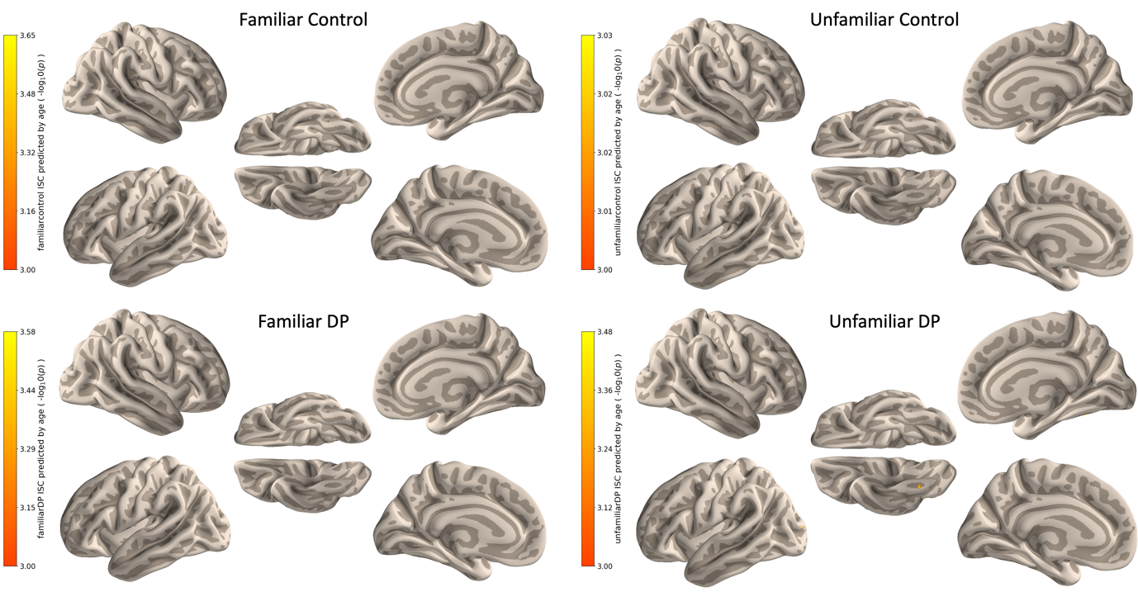
Supplementary Information

Supplementary Fig. 1. Age did not predict inter-subject correlations (ISC). Prediction of intersubject correlations by age are shown for each group of participants, uncorrected and thresholded at p < .001 (-log₁₀(p) > 3) .

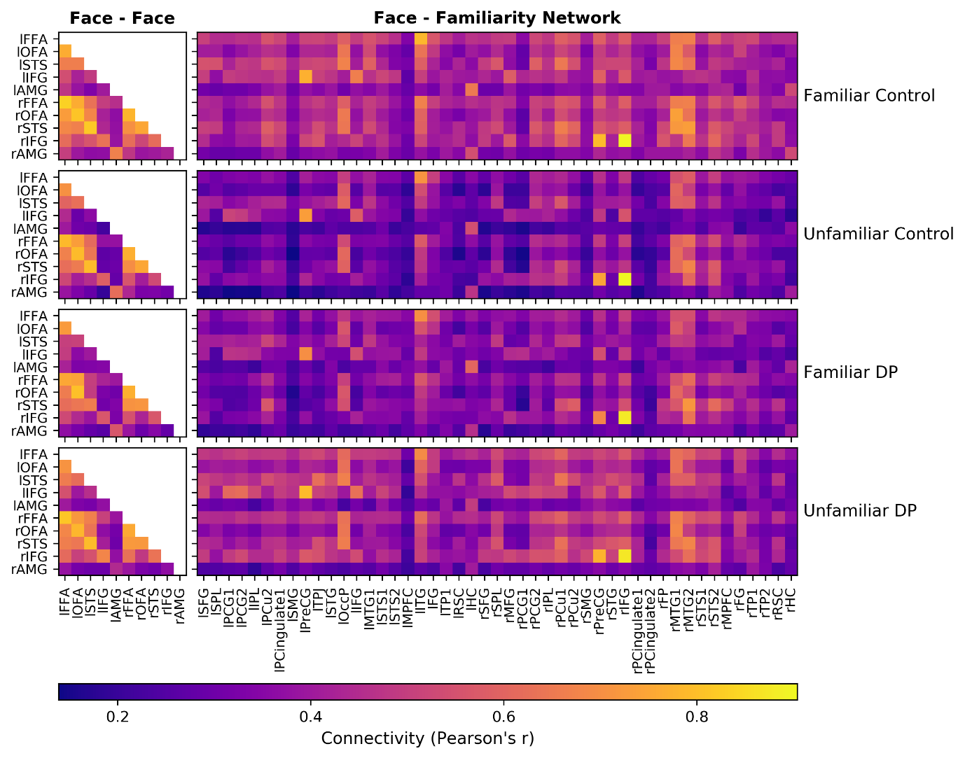
Supplementary Fig. 2. Functional connectivity for familiar and unfamiliar controls and DPs in (left) face-selective regions and (right) between face-selective regions and the familiarity network. Patterns of connectivity are similar across groups.

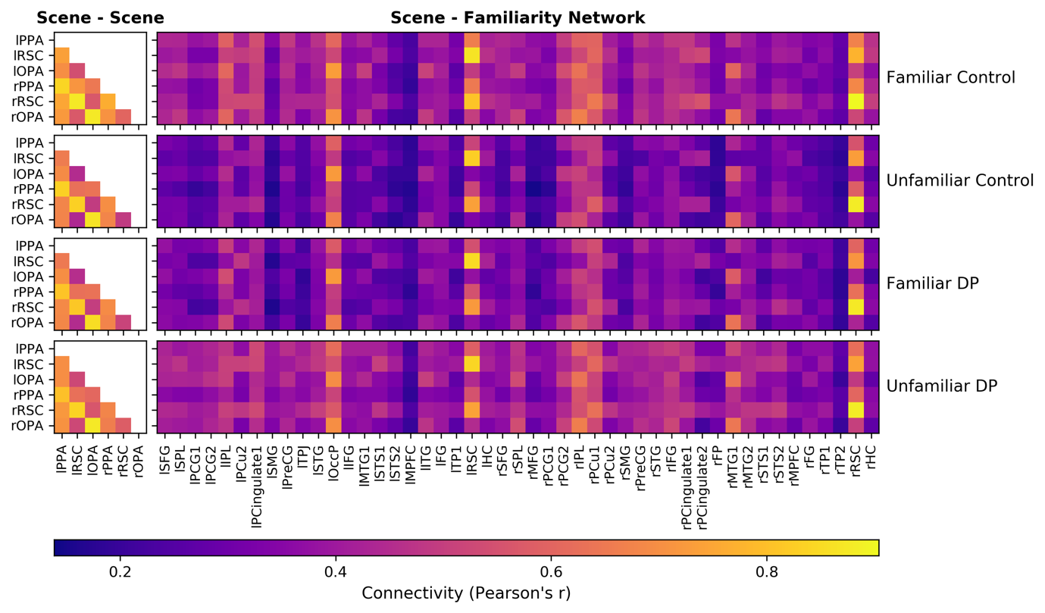
Supplementary Fig. 3. Functional connectivity for familiar and unfamiliar controls and DPs in (left) scene-selective regions and (right) between scene-selective regions and the familiarity network. Patterns of connectivity are similar across groups.

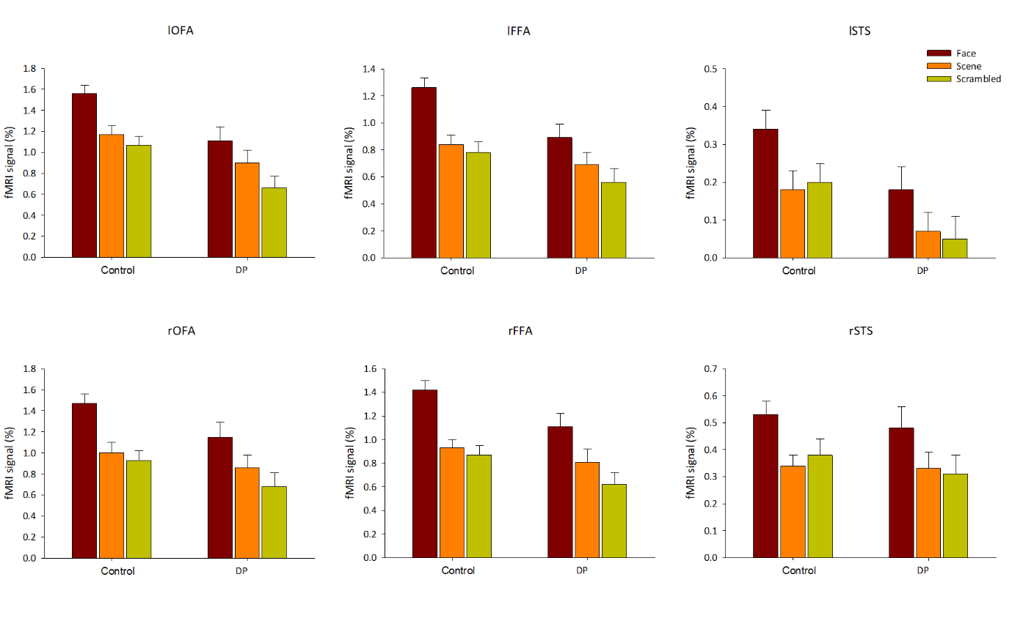
Supplementary Fig. 4. Response to faces, scenes and scrambled faces in face regions in the control and DP groups.

Supplementary Fig. 5. Response to faces, scenes and scrambled faces in scene regions in the control and DP groups.

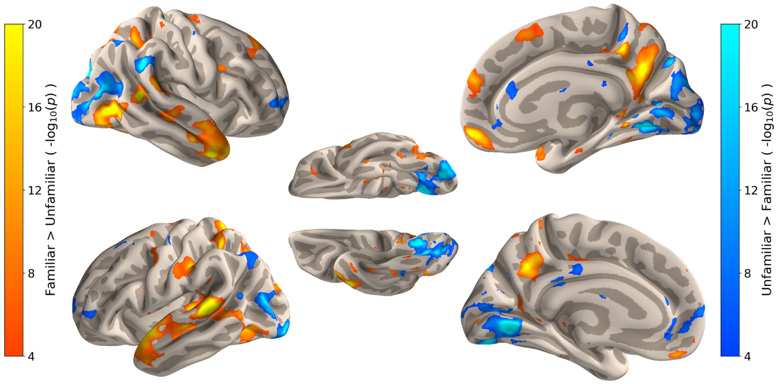

Supplementary Fig. 6. Regions showing a main effect of familiarity (control familiar + DP familiar > control unfamiliar + DP unfamiliar).

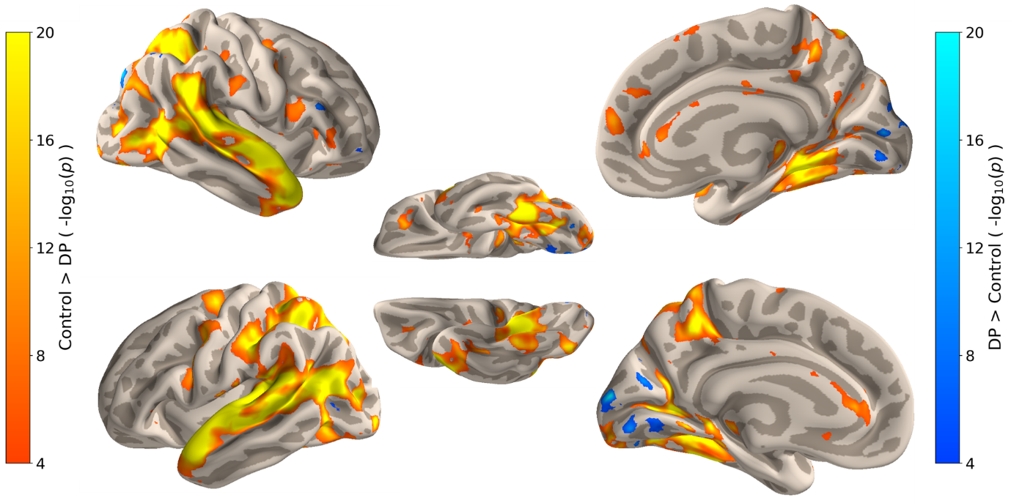

Supplementary Fig. 7. Regions showing a main effect of group (control familiar + control unfamiliar > DP familiar + DP unfamiliar).

Supplementary Table 1. Individual scores on the PI20 questionnaire and Cambridge Face Memory Test (CMFT) used to validate developmental prosopagnosia. High scores on the PI20 indicate more prosopagnosic traits. Low scores on the CFMT show worse face memory performance. Control comparison data (N = 54) for the PI20 and CFMT were taken from Biotti et al., (2019).

Participant | Age | Gender | Familiarity | Handedness | PI20 Score | CFMT score (%) |  | zPI20 | zCFMT
1 | 56 | F | N | R | 74 |  | 58.33 | 3.96 | -3.00
2 | 40 | M | N | R | 76 |  | 62.5 | 4.18 | -2.53
3 | 49 | F | N | R | 87 |  | 44.44 | 5.38 | -4.56
4 | 27 | F | N | R | 83 |  | 59.72 | 4.95 | -2.84
5 | 53 | F | N | R | 84 |  | 54.17 | 5.05 | -3.46
6 | 69 | M | N | L | 65 |  | 48.6 | 2.97 | -4.09
7 | 55 | M | N | R | 84 |  | 51.39 | 5.05 | -3.78
8 | 50 | F | N | R | 86 |  | 62.5 | 5.27 | -2.53
9 | 48 | M | N | R | 77 |  | 56.94 | 4.29 | -3.15
10 | 48 | M | N | R | 88 |  | 48.61 | 5.49 | -4.09
11 | 53 | M | N | R | 87 |  | 58.3 | 5.38 | -3.00
12 | 54 | M | N | R | 80 |  | 43.1 | 4.62 | -4.71
13 | 55 | F | N | R | 83 |  | 51.4 | 4.95 | -3.78
14 | 39 | F | N | R | 75 |  | 45.8 | 4.07 | -4.40
15 | 33 | M | N | R | 75 |  | 48.6 | 4.07 | -4.09
16 | 50 | F | Y | R | 81 |  | 63.89 | 4.73 | -2.37
17 | 42 | F | Y | R | 80 |  | 56.9 | 4.62 | -3.16
18 | 60 | F | Y | R | 90 |  | 44.4 | 5.71 | -4.56
19 | 32 | F | Y | L | 89 |  | 47.22 | 5.60 | -4.24
20 | 55 | F | Y | R | 92 |  | 54.1 | 5.93 | -3.47
21 | 23 | M | Y | R | 85 |  | 27.8 | 5.16 | -6.43
22 | 46 | M | Y | R | 79 |  | 59.7 | 4.51 | -2.84
23 | 38 | F | Y | R | 83 |  | 43.1 | 4.95 | -4.71
24 | 29 | F | Y | R | 74 |  | 61.1 | 3.96 | -2.69
25 | 28 | F | Y | R | 78 |  | 52.8 | 4.40 | -3.62
26 | 23 | M | Y | R | 72 |  | 44.5 | 3.74 | -4.55
27 | 43 | F | Y | R | 54 |  | 51.4 | 1.76 | -3.78
28 | 25 | M | Y | R | 78 |  | 61.1 | 4.40 | -2.69
DPs Mean |  |  |  |  | 79.96 |  | 52.23
DPs SD |  |  |  |  | 8.00 |  | 8.15
Comparison Mean |  |  |  |  | 38.0 |  | 85.0
Comparison SD |  |  |  |  | 9.1 |  | 8.9

Supplementary Table 2. MNI coordinates of the centre of face- and scene-selective region masks from the face > scrambled face + scene, and scene > face + scrambled face contrasts from the localiser for control participants.
 |  | Coordinates
Region | Hemisphere | x | y | z | Mask size (voxels) | Threshold  (z)
Occipital face area | R | 47 | -77 | -4 | 250 | 6.47
 | L | -44 | -79 | -8 | 250 | 5.82
Fusiform face area | R | 42 | -50 | -18 | 250 | 6.25
 | L | -39 | -51 | -20 | 249 | 5.99
Superior temporal sulcus | R | 50 | -61 | 14 | 249 | 4.88
 | L | -44 | -68 | 16 | 250 | 4.38
Inferior frontal gyrus | R | 40 | 11 | 30 | 250 | 3.85
 | L | -41 | 6 | 35 | 250 | 3.26
Amygdala | R | 21 | -4 | -14 | 227 | 3.11
 | L | -20 | -3 | -15 | 250 | 3.17
Occipital place area | R | 34 | -83 | 17 | 250 | 7.95
 | L | -29 | -90 | 16 | 250 | 7.54
Parahippocampal place area | R | 26 | -44 | -9 | 250 | 8.91
 | L | -24 | -52 | -10 | 250 | 8.19
Retrosplenial Cortex | R | 18 | -52 | 10 | 250 | 5.98
 | L | -18 | -55 | 8 | 250 | 5.05

Supplementary Table 3. MNI coordinates of maximally responding voxel of cluster regions revealed in the familiar control > unfamiliar control whole brain contrast

 |  |  | Coordinates
Region |  | Hemisphere | x | y | z | Mask size (voxels) | Threshold  (-log₁₀(p))
Superior Frontal Gyrus |  | R | 18 | -4 | 62 | 100 | 9.65
 |  | L | -28 | -6 | 68 | 100 | 7.98
Superior Parietal Lobule |  | R | 26 | -44 | 54 | 100 | 14.3
 |  | L | -20 | -50 | 60 | 100 | 17.8
Medial Frontal Gyrus |  | R | 6 | 16 | 62 | 67 | 4.02
Postcentral Gyrus 1 |  | R | 52 | -32 | 52 | 100 | 6.61
 |  | L | -44 | -42 | 52 | 100 | 8.18
Precuneus 1 |  | R | 4 | -46 | 50 | 100 | 11.1
Intraparietal Lobule |  | R | 22 | -70 | 48 | 100 | 8.12
 |  | L | -18 | -68 | 44 | 100 | 7.92
Postcentral Gyrus 2 |  | R | 26 | -40 | 48 | 100 | 8.16
 |  | L | -42 | -42 | 50 | 100 | 15.3
Precuneus 2 |  | R | 2 | -58 | 34 | 100 | 14.5
 |  | L | -2 | -56 | 42 | 100 | 11.1
Posterior Cingulate 1 |  | R | 16 | -34 | 42 | 94 | 4.01
 |  | L | -12 | -20 | 40 | 100 | 6.41
Supramarginal Gyrus |  | R | 60 | -28 | 26 | 100 | 6.83
 |  | L | -54 | -24 | 32 | 100 | 11.2
Precentral Gyrus |  | R | 44 | 4 | 28 | 100 | 4.20
 |  | L | -50 | 2 | 34 | 92 | 5.43
Temporoparietal junction |  | L | -60 | -50 | 22 | 100 | 10.1
Superior Temporal Gyrus |  | R | 50 | -32 | 22 | 100 | 11.1
 |  | L | -48 | -36 | 30 | 100 | 5.85
Occipital Pole |  | L | -18 | -84 | 18 | 102 | 5.33
Inferior Frontal Gyrus |  | R | 34 | 12 | 24 | 100 | 8.75
 |  | L | -44 | 6 | 20 | 100 | 8.22
Posterior Cingulate 2 |  | R | 2 | -36 | 18 | 70 | 4.03
Frontal Pole |  | R | 4 | 58 | 30 | 100 | 5.21
Retrosplenial Cortex |  | R | 18 | -52 | 14 | 63 | 4.14
 |  | L | -20 | -58 | 14 | 77 | 4.00
Middle Temporal Gyrus 2 |  | R | 54 | -46 | 6 | 100 | 9.14
Middle Temporal Gyrus 1 |  | R | 48 | -62 | 0 | 100 | 14.2
 |  | L | -58 | -62 | 2 | 99 | 6.03
Superior Temporal Sulcus 1 |  | R | 54 | -10 | -2 | 100 | 7.76
 |  | L | -44 | -26 | 2 | 100 | 6.56
Superior Temporal Sulcus 2 |  | R | 54 | -2 | -10 | 100 | 5.61
 |  | L | -68 | -36 | 8 | 100 | 14.6
Medial Prefrontal Cortex |  | R | 6 | 54 | -12 | 100 | 5.75
 |  | L | -2 | 48 | -20 | 90 | 4.03
Hippocampus |  | R | 18 | -26 | -10 | 39 | 4.03
 |  | L | -26 | -22 | -8 | 83 | 4.01
Inferior Temporal Gyrus |  | L | -44 | -42 | -14 | 100 | 8.34
Fusiform Gyrus |  | R | 44 | -34 | -20 | 94 | 4.01
 |  | L | -32 | -28 | -24 | 100 | 4.44
Temporal Pole 1 |  | R | 54 | 16 | -16 | 75 | 6.20
 |  | L | -58 | 10 | -10 | 100 | 7.68
Temporal Pole 2 |  | R | 38 | 8 | -44 | 90 | 4.01

Supplementary Table 4. Percentage overlap and maximum t-value of face- and scene-selective regions with the unfamiliar control > unfamiliar DP contrast. There is an overlap with the core face regions and regions that showed greater ISCs in unfamiliar controls than unfamiliar DPs.

Region | Hemisphere | % overlap | t
Occipital face area | R | 30.4 | 7.93
 | L | 20 | 7.17
Fusiform face area | R | 28.8 | 8.10
 | L | 32 | 10.2
Superior temporal sulcus | R | 1.6 | -9.64
 | L | 0 | 3.70
Inferior frontal gyrus | R | 0 | -3.73
 | L | 0 | 2.95
Amygdala | R | 0 | 4.04
 | L | 0 | 4.01
Occipital place area | R | 10 | 5.05
 | L | 30 | 6.40
Parahippocampal place area | R | 83.6 | 10.4
 | L | 20.8 | 6.09
Retrosplenial Cortex | R | 12.4 | 6.52
 | L | 29.6 | 7.68

Supplementary Table 5. MNI coordinates of the maximum responding voxels of the regions from the control > developmental prosopagnosia face > scene and scene > face contrast from the localiser

 |  | Coordinates
Contrast | Hemisphere | x | y | z | Z value
Face > Scene + Scrambled Faces | L | -38 | -58 | -22 | 3.25
Scene > Face + Scrambled Faces | R | 16 | -38 | -14 | 3.77
 | L | -34 | -42 | -9 | 3.77

Supplementary Table 6. One-tailed Welch’s t-tests (assuming unequal variances) to show the difference in signal for controls vs DPs from the localiser scan for faces, scene and scrambled faces

Region |  | Hemisphere | Face |  | Scene |  | Scrambled faces
 |  |  | t | p | t | p | t | p
Occipital face area |  | R | 1.86 | .034 | 0.87 | .194 | 1.57 | .061
 |  | L | 2.87 | .003 | 1.91 | .030 | 2.85 | .006
Fusiform face area |  | R | 2.14 | .018 | 0.97 | .169 | 1.94 | .029
 |  | L | 3.02 | .002 | 1.33 | .094 | 1.78 | .040
Superior temporal sulcus |  | R | 0.49 | .313 | 0.14 | .444 | 0.77 | .221
 |  | L | 1.94 | .028 | 1.71 | .046 | 2.00 | .025
Occipital place area |  | R | -0.00 | .498 | 0.62 | .270 | 0.24 | .404
 |  | L | 0.66 | .257 | 0.77 | .223 | 0.42 | .338
Parahippocampal place area |  | R | 1.17 | .122 | 1.86 | .033 | 1.23 | .112
 |  | L | 0.72 | .237 | 1.33 | .094 | 0.37 | .355
Retrosplenial Cortex |  | R | -0.92 | .180 | -0.38 | .352 | -0.57 | .284
 |  | L | -0.87 | .194 | -0.69 | .246 | -1.07 | .144

