Phoebe Martin and Harriet Gray

You are Not Alone:
Feminist memorialisation and the present tense of gender-based violence in the Monument Quilt

Key words: Time, temporality, present tense, memorialisation, artivism, craftivism, gender-based violence, Monument Quilt.
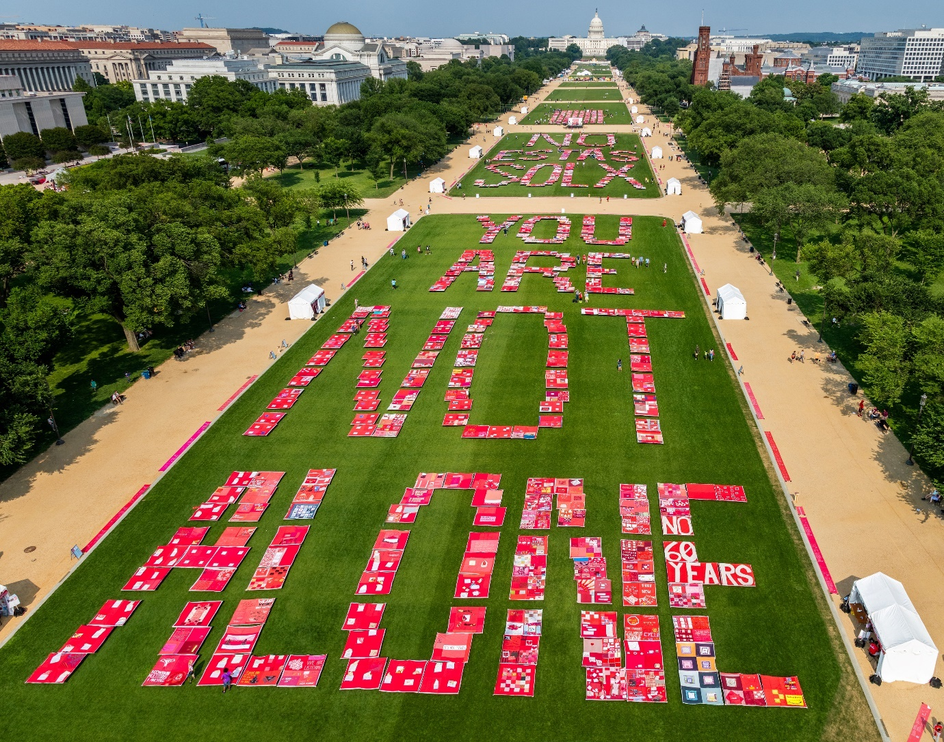
The Quilt on the National Mall. Photograph by Nate Gregorio, courtesy of FORCE.

Introduction
From the 31st of May to the 2nd of June 2019, a giant quilt covered the National Mall in Washington D.C. with messages of support for victim-survivors of gender-based violence (GBV); its panels laid out to spell the message, in English and Spanish, ‘YOU ARE NOT ALONE’ / ‘NO ESTÁS SOLX.’ This was the fiftieth and final display of The Monument Quilt (hereafter: the Quilt): a collection of around 3,000 squares of red fabric created by victim-survivors and their allies over a six-year period. The Quilt - described by its creators as “the first memorial to survivors of sexual and intimate partner violence” in the USA – sought to challenge rape culture by constructing a “culture of consent” and creating “space to heal” (FORCE no date a).

As we discuss below, the Quilt is part of a growing contemporary wave of memorials commemorating GBV in the US and beyond. The overwhelming majority of these GBV memorials remember wartime histories; like most mainstream memorials, that is, most GBV memorials are built primarily to commemorate historical events. There are also, in addition, a small but growing number of memorials that commemorate peacetime GBV. Among these peacetime memorials, we focus our attention in this article on the Monument Quilt: both because it has received only limited scholarly attention (c.f. Held 2022) and, more significantly, because its unique form – a deliberately temporary project with multiple creators – generates, we suggest, the clearest example of an approach to GBV memorialisation that might enable community building, narrative complexity, and an approach to temporality that emphasises the “chronicity” (Arthur 2021) of GBV in politically productive ways. Our analysis of the Quilt as a memorialisation project, therefore, provides space for rethinking certain elements of the ongoing creation of a feminist memoryscape around GBV.

The article proceeds as follows. We start by mapping the current surge in GBV memorial creation as well as briefly discussing the history of activist quilting. We then turn to the conceptual literature on the politics of temporality in memorialisation. After a brief outline of our methods, we then sketch the history of the Quilt before analysing its contribution to the contemporary GBV memoryscape across three sections, focused on building community, creating space for multiplicity, and storying GBV through a temporality of chronicity and prefiguration.

Feminist Activism through Memorials and Quilting
Feminist scholars and activists have long bemoaned the silencing of GBV in public space, including among memorials (e.g. Fox 2019; Nyugen 2016: 227-228). The last few decades, however, have seen a burgeoning, global GBV memorialisation movement, of which the Monument Quilt is a part. While memorials are far from the only artform that shapes public debate on GBV – we might think, for example, about installations such as Jaime Black’s REDress Project (Black no date), or protest actions in Latin America that draw on visual and/or performance art (Serafini 2020; Martin 2024) – there is something particular about memorials. Collective memory is the basis for the construction of collective identity (see Bellentani and Panico 2016: 30); memorials provide an “anchor” for collective memory (Hutton, cited in Zucker and Simon 2020: 3). Memorials claim to “represent the values of society and the accepted versions of history” (Mirkinson 2020: 150) and, as such, play an important role in “tell[ing] us who we are and how we should behave” (Abousnnouga and Machin 2013: 71-72; see also Boesten and Scanlon 2021: 1). That is, it is not just the public location of these artworks but also their status as memorials that lends them a certain authority.

Early public GBV memorials include several sites in Canada commemorating femicide - particularly the 1989 Montreal massacre - most of them parks, memorial stones, and plaques (Bold et al. 2003, 2006) and a memorial stone, erected in Japan in the early 1980s, dedicated to the so-called “comfort women” of the Asia-Pacific War (Soh 2008: 197-201). Notwithstanding these few examples, GBV memorials remained rare until a dramatic rise began in the 2010s. The majority of the new memorials are dedicated to the comfort women: these include likely uncountable numbers in South Korea, at least ten in the United States, and additional examples in at least nine other countries worldwide (Gray no date), mostly plaques and/or bronze figurative sculptures, plus some commemorative gardens. A handful of additional memorials – again, mostly plaques or figurative statues – now commemorate GBV in historical conflicts in Vietnam, Hungary, Bangladesh and Kosovo (Pető 2021; Gray and Martin forthcoming). Turning to peacetime memorials, in the US, a Contemplative Garden now stands at the site where Brock Turner assaulted Chanel Miller on Stanford University Campus (Bae 2020); the Survivors Memorial in Minnesota features circular benches and large mosaics (Sardina and Fox 2022); and the Sexual Assault Survivors Monument in Wisconsin consists of benches between stone pillars supporting a teal, metal frame (Zimmerman 2023). In Mexico, femicide is commemorated by metal sculptures of the Venus symbol with a raised fist known as antimonumentas and by the Glorieta de las mujeres que luchan (The Roundabout of Women Who Fight): a wooden silhouette of a girl with raised fist on a high plinth in Mexico City (Stengel Peña 2023). In the UK, a mosaic bench remembers “women who died from male violence” (Lloyd 2022). In other settings, ephemeral materials have been used to create temporary memorials: small wooden crosses in Mexico (Stengel Peña 2023: 97-98); ribbons in South Africa (Hayes-Roberts 2023).

Mirroring the growth in memorials themselves, recent years have also seen a significant increase in academic literature analysing GBV memorials. Not all of this literature is necessarily feminist: some of that on comfort women memorialisation, for example, reproduces ongoing masculinist-nationalist struggles in focusing primarily on its impact upon state-level relations between Japan, South Korea and, in some cases, also the USA (e.g. Ward and Lay 2019). In the feminist literature, in contrast, GBV memorials that “break the silence” on GBV – given that this silence has been identified as one of the mechanisms through which GBV is normalized and allowed to continue – have been celebrated as a powerful activist tool (e.g. Boesten and Scanlon 2021: 5-6; Bold at al. 2002; Break the Silence, no date; Hayes-Roberts 2023; Held 2022; Kim 2020; Lines 2024; Mirkinson 2020; Sardina and Fox 2022; Stengel Peña 2023).

Several scholars caveat this celebration of silence breaking by insisting that GBV memorials must not only provide space to remember past violences but also, more importantly, must work to transform gender norms and reduce the occurrence of future violence (Altinay et al. 2019; Arentes Ferreira Bastos and Soares 2021: 150; Bold et al. 2002; Boesten and Scanlon 2021: 3; Stengel Peña 2023). Bold et al, for example, call for memorials to resist “active forgetting,” defined as “the apparatus through which the systemic nature of gendered violence is denied while each violent event is treated in isolation as the pathological behaviour of a deranged individual rather than as behaviour into which individuals have been socialised” (2002: 127). For Bold et al, to play this role memorials must resist “[claiming] unique status and significance for the individuals and groups that are commemorated” (ibid.: 127-128), because such claims risk silencing the experiences of multiply-marginalised victim-survivors (ibid.: 143-144) and, additionally, may imply the possibility of closure in relation to a particular episode of GBV, preventing it “from existing as a part of the collective and active memory of systemic violence” (ibid.: 131). Scholarship on post-conflict transitional justice, similarly, warns against exceptionalising wartime violence without narrating its connection to peacetime GBV (Arentes Ferreira Bastos and Soares 2021: 141; Boesten 2021: 33-35). Several scholars of comfort women memorialisation, as well as many of the comfort women memorials themselves, are likewise at pains to connect the history of the comfort system to a broader transnational continuum of GBV, most commonly conflict-related GBV in other warzones and/or sex trafficking (e.g. Li 2022; Kim 2020; Mirkinson 2000; Noh 2024; Yoon 2018); at the same time, as Gluck notes, the comfort system has become “a transnational and global referent for the violation of the human rights of women,” standing in as ‘the’ example of conflict-related GBV as the Holocaust does for genocide (Gluck 2021: 100).

Also notable for our discussions here, the literature describes potential benefits of collaborative processes of memorial creation for building community. Hayes-Roberts, discussing ribbon memorials in South Africa, describes how they must be continually remade (using low-cost, ephemeral materials) if they are to survive; they thus become a “social practice that actively promotes participation” (Hayes-Roberts 2023: 27). Lines (2024), similarly, describes the painting of public murals in Mexico commemorating victims of femicide as a collective process that develops strong bonds between groups of artists; and Stengel Peña describes the Glorieta de las mujeres que luchan in Mexico City as rooted in ongoing collective action: the “manifestation of the collective protests of a community” (2023: 115). Here, the scholarship goes beyond an analysis of the object of a memorial, also exploring the politics of the process by which that object comes into being.

While we approach the Quilt as a memorial, it also builds on the long history of political quilt-making within the US and beyond. “Quiltmaking,” Butler suggests, “has been employed as a tool for social action and political awareness for hundreds of years” (2019: 597); activist quilts and textiles are “found across the globe, and their making crosses lines of age, race and class (although less often of gender)” (Robertson 2015: 197; see also Newmeyer 2008). Political quilts can take many forms; a piece of art need not explicitly promote an overtly political message to do political work (Bleiker 2009: 8-10). Indeed, some of the most well-recognised quilts – the Gee’s Bend Quilts being the most obvious example – are deeply political and politicised objects despite carrying no overt messages in their visual design (Chave 2015; Butler 2019). In this article, however, we focus on quilts whose visual design explicitly stories violence and harm. Textiles have been used to tell stories of violence in places including South Africa (Becker 2014), Canada (Robertson 2009), and Chile (Adams 2002; Bryan-Wilson 2017: 143-178); in the US, the Black Lives Matter Witness Quilt honours Black victims of domestic femicide (Butler 2019: 590), and the Lynch Quilts Project tells of the country’s history of racist violence (Robertson 2015). Perhaps most famously among activist quilts, the panels of the NAMES project Memorial AIDS Quilt bear the names of people who have died from AIDS (Bryan-Wilson 2017: 181-250).

Activists quilts such as the examples cited above do their political work in multiple ways. First, paralleling mainstream memorial forms such as statues and plaques, they ‘break the silence’ through storytelling: publicly naming those who have died of AIDS, for example, or through domestic violence, making it difficult to ignore the reality of human lives lost (Butler 2019; Bryan-Wilson 2018: 181-250); or they raise awareness internationally of crimes hidden through the censorship of a repressive regime (Adams 2002; Bryan-Wilson 2017: 143-178). Quilting can, moreover, open other spaces for political work that elude mainstream memorials. The association of quilting with femininity, domesticity and tradition, for example, enables activist quilts to “erupt as potential sites of resistance to that very traditionalism” (Bryan-Wilson 2017: 1); there is a transgression inherent in their claiming of space in the public sphere that can generate political resources (Held 2022: 179; see also Black 2017: 701). In the case of the AIDS Quilt, scholars have suggested that the warmth and comfort with which quilts are associated provided a powerful metaphor in the face of the grief, fear, and trauma of the height of the AIDS crisis (Hillard 1994; see also Newmeyer 2008: 448-450). The creation of a quilt, moreover, often entails community building in a way that the creation of more traditional memorial forms may not. Historically, quilts were made communally rather than individually, both because of an economic need to pool resources (Robertson and Vinebaum 2016: 8) and because it is more efficient to conduct the physically demanding work with several people (Roach 1985: 62). In multiple contexts, quilting has provided a respectable space for women to gather and form community and collective consciousness without raising eyebrows (Robertson 2015); itself a powerful political resource.

Our analysis in this paper, while recognising the diverse entanglements between politics and the fibre arts, focuses specifically on the Monument Quilt as a memorial – part of the ongoing wave of GBV memorialisation that we identified above – albeit one that draws much of its political power from the traditions of activist quilting. We do not suggest that the Quilt is unique in all of its elements: other memorials may also build community, for example, or communicate an alternative approach to temporality. We have chosen to focus on the Quilt not because it is necessarily all alone in its politics but because, we suggest, it provides the clearest recent example through which all of these characteristics, and the political potentialities that they open up, can be examined at once. It is, then, to the burgeoning literature on feminist memorialisation that we most directly contribute. We do this in four main ways. First, we provide insight on an important and under-researched memorialisation project; one that contrasts with the existing literature’s focus on wartime memorials in both form and focus. Second, learning from the literature on activist quilting and building on scholarship that explores community building as part of memorial creation in other sites, we highlight how the Quilt project built a trauma informed community through its workshops and its displays. Third, we explore how the Quilt’s form and method of creation provided space for multiplicity in a way not often seen in more mainstream memorials, thereby avoiding the pitfalls of claiming exceptionality for a particular individual or group, as described by Bold et al (2002) and discussed above. It is worth noting here that while Bold et al call for memorialising forms that make space for multiplicity, they highlight the ways that the example on which they focus – Marianne’s Park in Ontario, Canada – fails to achieve this; the Quilt, then, provides an alternative form that might to a certain extent better achieve these ideals. Finally, we examine how temporality emerges in the Quilt and note the productive political avenues that this can open. This, to our knowledge, has not yet been done in the literature on GBV memorialisation – while the work of Bold et al. (2002) and of Hayes-Roberts (2023) have particularly clear implications for the articulation of time in memorial forms, neither explicitly theorises temporality. We argue that the Quilt stories GBV through a framework of “chronicity” (Arthur 2021: 28) that resists closure and, additionally, that this gives the Quilt a different approach to the future than we might see in mainstream memorials, creating space for it to take a prefigurative approach to the political task of resisting GBV. Drawing these threads together, our analysis of the Quilt opens space for thinking through the politics and potentials of the contemporary wave of GBV memorialisation that goes beyond that already recognised in the literature.

About time: Pasts, presents, and futures in memory politics
In the West, the dominant ontology of time frames it as linear and progressive: in Edkins’ words, “[i]t is axiomatic that time is linear, a succession of past, present and future” (2003: 34). In contrast, scholars generally understand time as “socially produced and reproduced in everyday life;” that is, “we construct the time we live in” (Viebach 2019: 279). While all time is constructed, traumatic events can particularly disrupt the way that it is experienced. Mass violence can make survivors experience time itself as “broken,” as the expected lifecycle of birth, life, and death is upended (ibid.: 279-280). Traumatic events, similarly, may be so shocking that they cannot be integrated into narrative memory and are therefore “in a sense timeless” (Van der Kolk and van der Hart, cited in Edkins 2003: 40). They are often re-experienced again and again, creating a kind of “trauma time” which, for Edkins, “destabilises any production of linearity” (2003: 16).

Following this understanding of time as socially produced, scholars argue that processes of collective memory do not “represent” the past but “perform” it (Mandolessi 2023: 1514); they bring into being ideas of past and future that have meaning for the politics of the present. Hegemonic, state-led approaches to commemorating trauma and violence usually tell a story about an event – most often war – that reproduces linear time: the event took place firmly in the past, which is separate from the present, and holds lessons for the future. Such an approach draws a firm distinction between the memorialised time and the present: it creates an identifiable “before” and “after” to violent events (Viebach 2019: 280).

There is, of course, a politics to embedding linear time into collective memories of violence. For Edkins, linear narratives mask how the very systems through which we seek security – the state, the patriarchal family – are “productive of and produced by force and violence” (2003: 6). The linear framework obscures the ongoing nature of violence and oppression, creating a clear distinction between “’now’ and ‘then’” which, in turn, make possible “[n]otions of ‘breaking with the past’ and ‘never again’” (Nagy 2008: 280). This temporal framing thus enables stories of national trauma to become stories of national overcoming and glory: the trauma is papered over, and the status quo of power relations is reinforced (Edkins 2023: 94-95; see also Zucker and Simon 2020: 4). Following Young, in addition, we note that memorials that place violence neatly in the past reduce the public to “passive spectators” with no responsibility to remember the traumas they represent: “once we assign monumental form to memory, we have to some degree divested ourselves of the obligation to remember” (Young 1992: 273).

As we explore below, the Monument Quilt functions on a different temporality, in that the traumatic events with which it engages are emphatically present tense. Here, we find Arthur’s concept of “chronicity” helpful, as a framework that “renders crisis into an undecidable event as it relates to past and present” (2021: 28). We also suggest that this different approach to the past/present in comparison to traditional memorials also gives the Quilt a different orientation towards the future. Here, we turn to scholarship on pre-figurative politics: political movements which seek to “build the world anew” through “the creation of alternatives in the here and now” (Maeckelbergh 2011: 2). If traditional social movement politics assumes a linear theory of social change – that progressive groups must “march forward toward an end in the future,” first seizing power within existing frameworks and then making the changes they desire – “[p]ractising prefigurative politics means removing the temporal distinction between the struggle in the present and a goal in the future; instead, the struggle and the goal, the real and the ideal, become one in the present” (ibid 2011: 15, 4; see also Domańska 2021: 151). Prefiguration is an approach commonly used by contemporary social movements (e.g. Rossdale 2016; Serafini 2018), including those explicitly concerned with GBV (Downes 2019; Serafini 2020).

Methods
Our analysis draws on individual and group interview data, textual data in the form of documents obtained via the Quilt website, and visual analysis of the Quilt itself. In 2022 and 2023, Harriet Gray carried out in-depth, qualitative interviews with three key informants involved in the Quilt’s creation, display and archiving. In addition, both authors ran focus groups with memorial activists, including Quilt organisers, in 2023. Given the small number of participants whose narratives we draw on in this paper, to preserve their anonymity we do not use pseudonyms but instead cite all interview extracts as ‘Interview Participant.’ For our visual analysis, both authors viewed the Quilt using the online digital archive. In addition, Gray viewed pieces of the Quilt in the archives at the Maryland Institute College of Art, Towson University, and the University of Maryland Baltimore County, as well as on display at the Baltimore Museum of Art. The data collection for this project began in 2022, and we were therefore unable to attend displays; instead we viewed photographs available via the FORCE website (FORCE no date c) and Facebook page (FORCE no date d). The Quilt was not experienced by visitors and contributors as purely a visual object, but also haptic, emotional, and interpersonal. Our combination of interview, textual, and visual data gives us access to some of this range of engagements.

The History of the Monument Quilt
The Monument Quilt was conceived and created by Hannah Brancato and Rebecca Nagle, co-founders of FORCE: Upsetting Rape Culture, a Baltimore-based art and activist collective. FORCE had planned to create a series of temporary GBV memorials, hoping to build momentum towards a permanent site (Interview Participant). The first temporary memorial took the form of large red Styrofoam words – ‘I can’t forget what happened, but no one else remembers’ – floated in the Reflecting Pool between the Washington and Lincoln Memorials in Washington DC (Chemaly 2013). The Monument Quilt, the second temporary memorial, ran from 2013 to 2019; from 2014 onwards it was organised in collaboration with La Casa Mandarina (LCM), a Mexico-City based non-profit founded by Mora Fernández that works to end sexual violence “through advocacy and ARTivism” (La Casa Mandarina no date). Initially, the Quilt project was expected to run for two or three years, but it “took on a life of its own” (Interview Participant), becoming such a big project that, in the end, the organisers decided not to continue working towards a permanent memorial.

The 3,000 red fabric squares of the Quilt each measure four by four feet. They are stitched together into blocks of four, 750 in total, backed with polyethylene tarp. The vast majority of the squares were created at Quilt-making workshops. Some workshops were facilitated by FORCE, others by LCM, and others still by members of the public using resources downloadable from the FORCE website (FORCE no date e). Most Quilt-making workshops took place across the USA, in locations including “college campuses, tribal sexual assault programmes, rape crisis centres, domestic violence shelters, [and] community-based organisations” (Interview Participant); smaller numbers were held in Mexico and elsewhere.

Over six years, the Quilt was displayed 50 times in 33 cities across the US and Mexico, at locations including universities, military bases, sports fields, and public parks. At smaller displays it was often arranged in a grid formation, sometimes spelling the words ‘NOT ALONE.’ At a 2017 display on the US-Mexico border, panels spelled out ‘NO ESTÁS SOLX’ in El Paso, Texas, and ‘YOU ARE NOT ALONE’ in Ciudad Juárez, Mexico (McCabe 2019). During displays specifically associated with the Dollar General case (see below), the panels were displayed alongside the words ‘STILL HERE,’ a slogan associated with Native American activism and resistance (FORCE no date c). The fiftieth and final display, on the National Mall, was the only occasion that the Quilt was displayed in its entirety (McCabe 2019). FORCE estimates that over 50,000 people saw the Monument Quilt in person over the three days, and that hundreds of thousands more engaged with it online (FORCE no date a).

When the active phase of the project ended in 2019, FORCE and LCM began the ongoing work of archiving the Quilt. At the time that this research was carried out, around 150 of the 750 blocks of the Quilt had found permanent homes at institutions including the Baltimore Museum of Art, the National Museum of the American Indian, the Reginald F. Lewis Museum of Maryland African American History and Culture, Womankind NYC, and eight universities. Members of the public can now encounter the Quilt in three ways. First, by appointment, it is possible to view the Quilt in the archives of the various universities that house it. Here, the visitor must carefully lift each block from its box, unfold and fold it up again; feeling the weight and the many hours of work – and of care, love, hurt, and anger – that went into its creation. In some of the archives (e.g. at MICA), Quilt pieces are clearly positioned as activist objects by their contextualisation alongside ephemera such as leaflets, banners, self-care zines, and handbooks for National Mall display volunteers. Second, it may be possible to view the Quilt on display at the museums or galleries that have pieces in their collections. The acquisition of Quilt blocks by these institutions is an important statement of their worth as objects of art (Robertson and Vinebaum 2016: 2-3). In a museum setting, however - such as the Baltimore Museum of Art where Gray viewed the Quilt in 2023 - the blocks no longer feel primarily like community objects, fuelled with hope, despair, anger, and care, created to be used to create a new culture. At the BMA, Gray was unable to touch the blocks, prevented from doing so by the norms that govern the space of the art museum as well as by signage to that effect. Here, the Quilt blocks are transformed from living, breathing activist tools into prestigious art objects to be viewed with a detached and critical eye.

Finally, reflecting the growing role of the digital in memorialisation (see Zucker and Simon 2020; Mandolessi 2023), every square has been photographed and uploaded to a publicly accessible digital archive. This reconfigures the spatiality and temporality of the art itself, greatly expanding the opportunities for members of the public to engage with it (Zebracki 2017; see also Hayes-Roberts 2023). Upon opening the digital archive the viewer is confronted with 24 randomly chosen, uniformly presented red squares and, at the bottom, the option to ‘Show more squares,’ which adds another 24, and so on. The viewer can keep adding squares and scrolling down, seemingly forever. Users can filter by tags including ‘solidarity,’ ‘survivor,’ ‘healing,’ and ‘love,’ as well as ‘marital rape,’ ‘lgbtq,’ and ‘child sex abuse.’

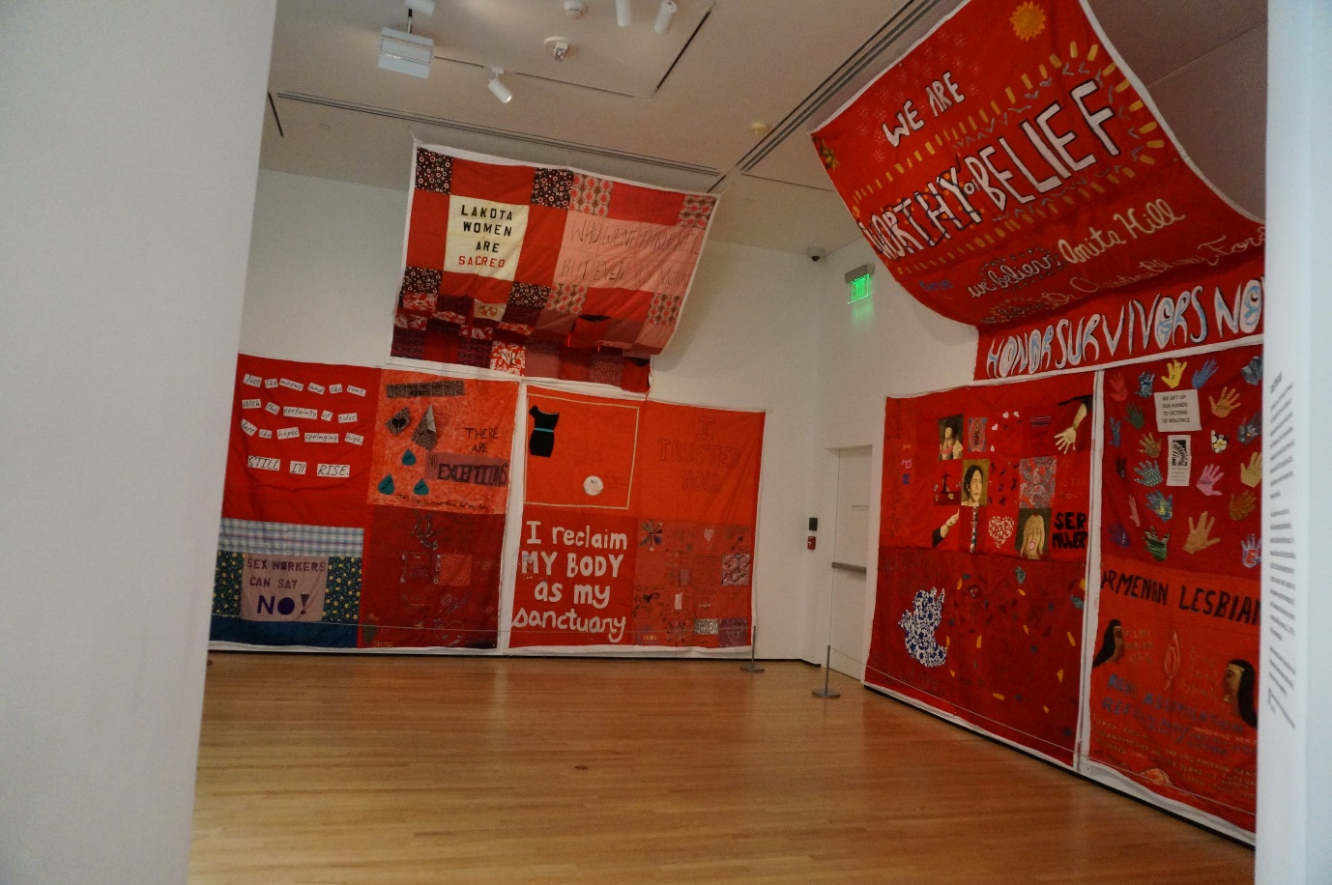
The Quilt on display at the BMA. Photograph by Harriet Gray.

Building a trauma-informed community
Most existing GBV memorials have been created by small groups of committed activists, often (although not always) including survivors themselves (Bold et al. 2002; Hasunuma and McCarthy 2019; Lee and Hahm 2000; Li 2022; Lines 2024; Mirkinson 2020; Sardina and Fox 2022; Stengel Peña 2023). In most cases (c.f. Hayes-Roberts 2023), opportunities for members of the public to participate in the creation of these memorials are limited, assuming they do not want to become highly committed volunteers themselves, to raising or donating money (Sardina and Fox 2022) or, in some cases, supporting the initiative at (sometimes highly politicised) public meetings (Mirkinson 2020). Once these memorials are constructed, members of the public can interact with them when they are the sites for protests or vigils (Bold et al 2002; Crozier-de Rosa and Mackie 2019) or, in some cases, by using them to perform symbolic acts of care for victim-survivors (Crozier-de Rosa and Mackie 2019: 175). Others, such as at the Survivors Memorial in Minneapolis, are designed to be gathering spaces where victim-survivors might come to reflect and to heal (Sardina and Fox 2022). In some cases, such as the South African ribbon memorials, members of the public can participate in a memorial’s continuous recreation (Hayes-Roberts 2023). Opportunities for participation and community building, then, do arise at many existing GBV memorials. The form of the Quilt, however, enabled – indeed relied upon – greater levels of collaboration and community creation than most of the above examples.

As the activist quilting scholarship reminds us, working together to create the physical product of a quilt can also create community (Roach 1985; Robertson 2015; Black 2017; see also Lines 2024; Stengel Peña 2023). Importantly, the Quilt organisers put significant work into ensuring that the community being created – both at the workshops and at the displays – was a particular kind of community: one that was trauma informed and organised around supporting survivors. FORCE provided specific guidance for workshop organisers on how to ensure that the events were trauma informed, which included information on how to talk to survivors about their experiences and support resources that could be shared (this guidance is, at the time of writing, still available for download at FORCE no date e). At the displays, similarly, all modes of engagement were explicitly optional: “you’re never required to… share details of your story if you don’t want to… You don’t have to read the stories at the displays… as a survivor you get to choose how you engage and interact with it” (Interview Participant). In addition, the Quilt team provided therapists at displays who could support visitors, identifiable by colour-coded t-shirts, and offered information on support resources for visitors to take away. FORCE and LCM would partner with a local organisations to organise workshops, support sessions, and performances around a display. This was most clearly in evidence at the National Mall display, where a main stage and multiple tents hosted events including a youth-led conversation on rape culture, a workshop on racial bias in support services, a meet up for a sex workers’ outreach project, yoga, reiki, and acupuncture sessions, art activities, and the collection of oral histories (FORCE no date b). While this is more difficult for the original organisers to control, efforts are also made to ensure that trauma informed working persists into the archiving phase of the project. To this end, FORCE signs a memorandum of understanding with archiving organisations that require trigger warnings to be displayed wherever Quilt panels are exhibited, and recommends that such exhibitions also provide information on support resources (Interview Participant).

Media reporting reveals that some victim-survivors of GBV found the community building elements of the Quilt to be particularly impactful. A male survivor who had participated in a quilt-making workshop, for example, told a journalist at the Washington Mall display that “Since I was 9 years-old, I was sexually assaulted. But these women here at the Monument FORCE, they created such a safe space for me to share my story” (Elmasry 2019). Another survivor told a reporter that until she made a square for the Quilt “I never really processed or acknowledged what happened… I consider that my first real recognition” (Flagg 2019). In video forage of a Baltimore display, an attendee said “This is a great healing process for me. It took me a long time to come to grips with it… thinking that I was no good, that this was normal, for him to beat me… and it’s just a beautiful feeling to know that I’m just not the only one. It makes me feel free” (Refinery29 no date). Another visitor, at a different display in Baltimore, stated that “[there was] some crying involved. And, you know, supporting each other and letting it go. A lot of us had stories that we didn’t know how to say… But now we’re telling it and we’re not alone” (FORCE no date f). Our interview participants relayed similar sentiments: they told us that: “for me it was a life changing thing, because I was there in the display and… for the first time, I felt not alone”; “it kind of feels like you’re… letting yourself be, like, held by a community… Like, it’s a little lighter if we’re carrying it together” (Interview Participants). The organising message of the displays - Not Alone / No Estás Solx - foregrounds this sense of community.

Creating space for multiplicities
As Bold et al. caution, GBV memorials that claim unique statue for an individual or group run the risk of creating exclusions, often by silencing the stories of the most marginalised victim-survivors (2002: 129). Reflecting this concern, the Quilt organisers wanted to “[resist] a singular narrative of sexual violence” (Interview Participant); to communicate the idea that “all of the stories are here, there’s no one story that’s more important" (Interview Participant). Because the Quilt is, as one interview participant put it, a “crowdsourced” memorial made up of thousands of unique squares, it reflects multiplicities that would be difficult to imagine in more conventional memorials. Its creation process, that is, enabled the Quilt to communicate some of how intersecting oppressions shape experiences of GBV and its aftermath: how “our identities… shape the way that our assaults are reacted to… how they’re treated, whether there is accountability or not” (Interview Participant).

Several quiltmakers chose to directly engage with intersectional oppression in their calls for justice: “Black Women Have The Right To Defend Themselves’” in appliqued letters surrounded by hands and flowers (Quilt square #2788); ‘soy gay, soy humano y meresco respeto’ (I’m gay, I’m human and I deserve respect) painted onto the red fabric next to appliqued rainbow hearts and painted birds (Quilt square #2029). While much of this focus on intersectionality was organic, some of it was also deliberately curated through the organisation of workshops focused on topical cases:

Sometimes we would highlight particular stories, that’s a way of… levelling the playing field … if white women are, like, the picture of what sexual violence is, then let’s highlight a Black woman who defended herself, or a male survivor.... We would highlight stories as a way of creating a multiplicity of understanding.
(Interview Participant)

Some workshops, for example, focused on the Dollar General Corp. v. Mississippi Band of Choctaw Indians case at the US Supreme Court, which involved the sexual abuse of a tribal youth by a non-Indian manager at a Dollar General store on tribal land and raised the issue of tribal sovereignty and its impact on victim-survivors of GBV (see Deer and Nagle 2018). Quilts produced at these workshops – ‘HOLLER NO DOLLER’ written in pen around a drawing of a medicine wheel with two feathers, a sacred symbol used by several native American tribes (Quilt square #1899) – work to “name indigenous identity and issues of tribal sovereignty as part of what rape culture looks like in the US” (Interview Participant). Other workshops focused on the experiences of Black women – specifically Marissa Alexander and Tondalao Hall, both victims of domestic violence who were unfairly incarcerated – in order to highlight how rape culture is shaped by “the legacy of slavery in America [and] anti-Blackness” (Interview Participant).

In addition, the Quilt’s “crowdsourced” creation process enabled a diversity of emotional expression not seen in more conventional memorials. This is not to say that all the squares are controversial. Indeed, the dominant theme remains one of solidarity – ‘TRUST KNOW AND LOVE YOURSELF’ in multicoloured typewriter style lettering against a background of small flowers (Quilt square #2652). As Doss (2008: 29) notes, it is “generally taboo” to explicitly represent trauma, pain, or death in memorials. War memorials, for example, tend to depict soldiers as strong, healthy, and calm; portrayals of frightened, malnourished, injured, or dead soldiers are significantly harder to come by (Abousnnouga and Machin 2013: 101-129). Even in protest memorials, images of suffering are rare. Murals of murdered women in Mexico that seek to draw attention to femicide, for example, celebrate the women’s lives – depicting “their favourite flowers, their hobbies or interests, or their pets” – they do not visually represent their suffering or their deaths (Lines 2024: 3345; the same is true of the AIDS Quilt, see Bryan-Wilson 2017: 200-201). While there are a few exceptions, including among GBV memorials, public memorials tend to eschew representations of trauma, violence, or pain.

This is not the case in the Monument Quilt. First, anger is communicated by several of the squares: ‘FUCK YOU’ painted in black capitals with ‘I [heart shape] my anger’ in smaller lettering along the side (Quilt square #3095); ‘YOU KNOW WHAT YOU DID KRIS’ and ‘Gaslighter coercive Liar Abuser Faux Feminist’ painted in white directly onto the red background (Quilt square #2860). In some of these angry squares - for example, one on which the words ‘fuck you I won’t do what you tell me, motherfucker’ are painted in a neat yellow cursive script on shiny purple fabric, with pink floral and green paisley lines appliqued around like the sun’s rays (Quilt square #2450) - the combination of artful, colourful, feminine design with the anger of the words speaks to us of joy. That is, there is as pleasure to this safe expression of a rage that so often is held inside for fear of judgement, or for fear of inciting further violence.
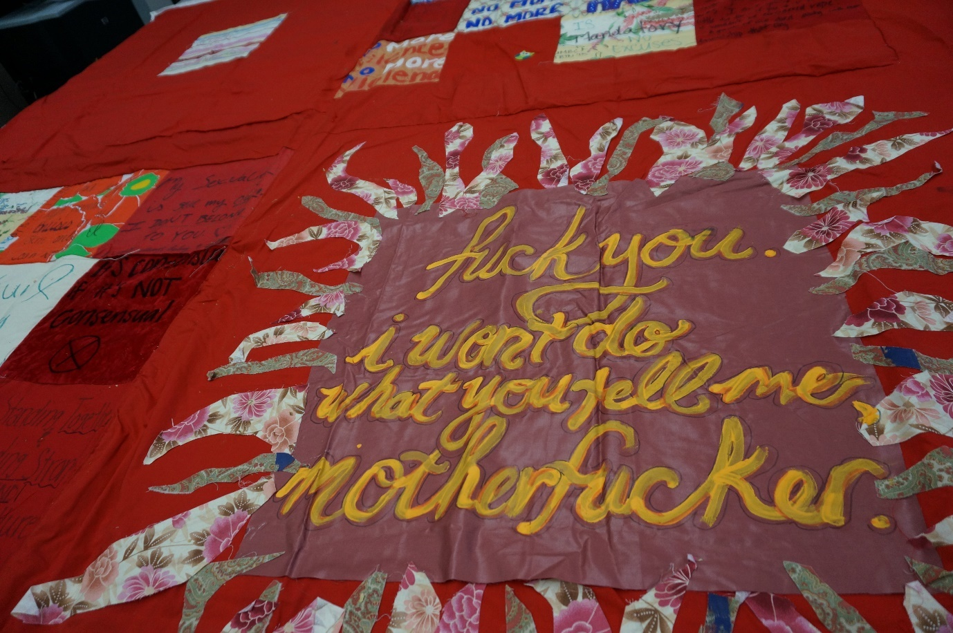Quilt square #2450 in the archives at UMBC. Photograph by Harriet Gray.

In addition to these cathartic expressions of rage, we also encountered squares that communicate other often deeply uncomfortable emotions or sentiments: ‘STOP DAD DON’T BE MEAN’ in floral appliqué with ‘Sophie 4 years old’ stitched in below (Quilt square #289); ‘I HAVE NOT HAD THE COURAGE TO PROSECUTE MY RAPIST, BECAUSE HE WAS MY FRIEND’ written in black pen on red and white floral fabric (Quilt square #214); ‘WHEN I KNOW A MAN IS VISITING I OFTEN HIDE MY KNIVES’ (Quilt square #2700).

That emotions and sentiments such as these are unlikely to find expression in more permanent forms of memorialisation is partly a matter of logistics: to get permission from relevant local authorities, permanent memorials built on public land must generally convey messaging unlikely to trigger or to offend. While the general design of the Quilt would have been considered by the authorities whose permission was required for its many displays, the individual squares would not have been. As a result, while most GBV memorials reproduce publicly palatable stories – as we argue elsewhere, most often inspiring stories of solidarity and recovery, albeit, in the wartime examples, sometimes intermeshed with righteous nationalism (see Gray and Martin forthcoming) – the Monument Quilt approach creates space for multiple kinds of survivorship, including those that are messy, complicated, and unresolved.

This multiplicity of emotional expression continued through the Quilt displays, at which organisers aimed to create a space in which visitors had “permission to… feel lots of different ways” (Interview Participants). Banners positioned around the Quilt blocks reassured visitors that “It’s okay to cry, to talk, to leave, to be still”; and “It’s okay to feel sad, angry, overwhelmed, speechless, numb.” Public expressions of difficult emotions such as grief are usually performed according to socially accepted rituals and codes of behaviour (Doss 2008: 25-27). Public GBV victim-survivor identities, moreover, are often constrained by the stock character of the idealised heroic survivor (Ross 2022; see also Gray and Martin forthcoming). In addition, while the open expression of anger by women, particularly Black women, has long been subject to cultural condemnation, feminists and anti-racist activists increasingly recognise the potential of political anger as a powerful tool: “Anger at injustice and inequality is in many ways exactly like fuel. A necessary accelerant, it can drive… noble and difficult crusades” (Traister 2018: xxvii; see also Lorde 1981). Encountering these distressing, combative messages through the feminised medium of textiles, moreover, likely enhanced their shock value and, therefore, their impact (Bryan-Wilson 2017: 1; Held 2022: 179; Black 2017). The Quilt thus pushed the boundaries of narrow scripts for acceptable public emotions, expanding the scope for permissible public survivorship.

Temporalities of chronicity and pre-figuration
Unlike bronze statues, quilts are not permanent objects: “fabric that’s being displayed outdoors is going to fade and change over time, and that’s on purpose” (Interview Participant). Many of the Quilt blocks that Gray viewed in the archives bear the scars of past displays – there are grass stains, the colour is faded by the sun, and some of the grommets used to anchor them to the ground for displays have fallen off. Even in the BMA, where the blocks on display had been carefully cleaned as part of their transformation into art objects, signs of wear were still visible: some of the appliqued materials were peeling off, and some squares were visibly more sun-bleached than others. It is worth noting that when viewed in the digital archive, these signs of wear and tear are much harder to decipher. As Bryan-Wilson notes in her discussion of the digital archive of the AIDS Quilt, this is “not how the Quilt was meant to be viewed,” because the photographic archive cannot “capture the Quilt’s full dimensionality of textures and materials that are so vital to its many meanings” (2017: 238, 239). While this is similarly true of the Monument Quilt – because the photographs zoom in on the design of each square, cutting out additional red space; because it is not possible to properly experience the materials and techniques used to create each square – we also noticed that the signs of wear and tear cannot really be apprehended. The stains, the sun-fading, and the bits of loose thread cannot really be seen and thus it becomes more difficult to understand the squares as activist objects with a past; something of the love and grief and hope is lost when they are reduced to pixels on a screen.

That aside, when the aging and the histories of use are apparent in an encounter with the Quilt, this visible impermanence has utility in sidestepping the lure of closure (see Bold et al. 2003). The Quilt’s signs of wear, as well as its creation from low cost, familiar materials such as fabric, marker pens, paint, glue and thread – even whimsical materials: some fabrics with a shiny or faux fur texture; others printed with colourful dinosaur patterns or rabbits popping up out of little top hats – brings it firmly into the sphere of the quotidian. That is, while some materials, such as bronze or stone, might represent timelessness and grandeur (Abousnnouga and Machin 2013: 48), the DIY aesthetic of the Quilt evokes homeliness and lived experience; everyday life, rather than a history to be revered from afar. This everyday aesthetic refuses the closure or transcendence promised by a bronze enshrinement of ‘the past,’ contributing to a different kind of politics of memorialisation more centred on the “chronicity” of GBV. We return here to Young’s concern that: “under the illusion that our memorial edifices will always be there to remind us, we take leave of them and return only at our convenience” (1992: 273). The Quilt’s temporary nature cannot maintain that illusion, and for the organisers this was “part of the point, because it’s, like, the idea is to motivate people to act in, like, OK, like, we know we need this so let’s keep creating it”; “it’s not over and it will never be over… Because the Monument Quilt, it’s a living thing” (Interview Participants).

Moving from the materiality of the Quilt to its messaging, we return to the unusual presence, when compared to other memorials, of explicit representations of pain and suffering. The discomfort that this generates, we suggest, is not due only to the public sharing of intense emotional experiences but also by the fact that, in the narratives of the Quilt squares, suffering is aired without being resolved. While, as we discuss above, mainstream memorials generally reproduce a framework of linear time that draws a distinction between “past” violences and the present (see Viebach 2019), many of the squares that share trauma or anger leave that suffering unfinished. The Quilt thus reflects “trauma time:” it encircles the trauma of GBV, marking it without attempting to discipline it into a linear narrative which ends in resolution (Edkins 2003); it centres the “chronicity” of GBV (Arthur 2021).

In addition, and moving again from the Quilt’s messaging to its community function, in seeking to create trauma-informed spaces in which community was built and survivors were free to experience a whole range of emotions, we suggest, the workshops and the displays sought to prefigure a survivor-centred community. Organisers spoke of building a “culture of consent” (Interview Participant) and sought to create new cultures and spaces in which survivors would be supported:

The Monument Quilt was a, kind of, imagining of what could be, like, what could a culture of support for survivors look like? And we tried to create this microcosm of it through the project, and the events that we had around the project.
(Interview Participant)

Creating healing spaces in the open air of football fields, public parks, and train stations, the Monument Quilt temporarily integrates healing from rape and abuse into everyday public life. In doing so, the quilt displays envision a different reality in which it is the public’s responsibility to make space for survivors rather than the survivor’s responsibility to re-assimilate into a “normal” public.
(Rogers-Fett 2016)

To use Domańska’s phrasing, we might think of the workshops and displays as the creation of a series of “micro-utopias that [were] realized on temporally and spatially limited local scales” (2021: 152); that is, the creation of small pockets of time and space in which the culture around sexual violence was different. Circling back to the community building that we discussed above, then, we suggest this building of an alternative, survivor-centred community should be understood as an attempt to prefigure an alternative political structure “in the here and now” (Maeckelbergh 2011: 2).

Conclusion
The Monument Quilt is part of the ongoing work of creating a new public memoryscape around gender-based violence. While the recent steep increase in the numbers of memorials dedicated to GBV is something to be celebrated, given the longstanding silencing of (feminist narratives of) GBV in public space, as we argue in this article, we also need to pay careful attention to the shape and the politics of this emerging memoryscape. In particular when viewed alongside the statues, plaques, and commemorative gardens that constitute the majority of public GBV memorial sites, the Quilt provides scholars and activists alike with space to imagine memorialisation otherwise. In our analysis, we have built upon existing scholarship highlighting how the creation of GBV memorials can create community (e.g. Lines 2024) by highlighting how, in centring the creation of trauma informed spaces, memorials can also prefigure survivor-centred “micro-utopias” (Domańska 2021: 152). By foregrounding multiple voices and emotions, moreover, we have suggested that the Quilt highlights the complex, ongoing, unresolvable work that feminist coalition building requires, providing to the literature an example of how this can effectively be done. In addition, we have suggested that in framing GBV as chronic and unresolved, the Quilt pushes towards discomfort and activation (Bold et al 2002); here, we open avenues for scholars and activists alike to think critically and creatively about how memorial projects engage with temporality.

It is not the purpose of this article to proscribe the forms that GBV memorials should take, or to idealise the work of the Quilt. Indeed while we suggest above that the form of the Quilt generates significant potential for powerful political storytelling in response to GBV, it is not without its drawbacks; as one of our interview participants cautioned, given the “ebbs and flows of people’s willingness to talk about [GBV],” permanent sites may be more generative than ephemeral memorials in weathering the storm of any future backlash. Whether permanent or not, creating a GBV memorial can be a difficult and emotionally exhausting process (see Brancato et al. no date) and, as feminists, it is not our intention to undermine the hard work of committed activists and victim-survivors.

As scholars, however, it is our role not only to celebrate the breaking of mnemonic silences but to push further with an analysis of the myriad political negotiations and contributions that memorials can generate on multiple levels. The Quilt, we suggest, has much to teach us, broadly, about the role of collective memory in progressive political projects, specifically in feminist, anti-racist politics. That is, where the politics of collective memory have traditionally done much to shore up the status quo – not least through “the memorialising tendency to carve history in stone” (Bold et al 2002: 145) – mnemonic engagement the multiplicity as well as with the chronicity of violence and oppression can be a powerful tool for feminist scholars and activists trying to build a better world in the now.

References

Abousnnouga, Gill and David Machin (2013) The Language of War Monuments. London: Bloomsbury.
Adams, Jacqueline. 2002. “Art in Social Movements: Shantytown Women’s Protest in Pinochet’s Chile.” Sociological Forum 17(1): 21–56.
Altinay, Ayşe Gül, María José Contreras, Marianne Hirsch, Jean Howard, Banu Karaca, and Alisa Solomon (eds.) 2019. Women Mobilising Memory. New York: Columbia University Press.
Arentes Ferreira Bastos, Lucia Elena, and Inês Virgínia Prado Soares. 2021. “The Challenges of Symbolic Reparations for Gender Justice in Brasil.” In Boesten, Jelke, and Helen Scanlon (eds.) Gender and the Arts of Transition: Global Perspectives on Commemoration and Mobilisation. Oxon: Routledge.
Arthur, Marc. 2021. “Nostalgia and Chronicity: Two Temporalities in the Restaging of AIDS.’ Theatre Journal 73(1): 19-36.
Bae, Gina. 2020. “Chanel Miller Plaque Installed at Stanford after 4 Year Delay.” The Campanile, April 15 2020.
Becker, Carol. 2004. “Amazwi Abesifazane (Voices of Women).” Art Journal 63(4): 116-134.
Bellentani, Federico, and Mario Panico. 2016. 'The Meanings of Mouments and Memorials: Toward a semiotic approach.' Punctum 2: 28-46.
Black, Jaime. No date. “The Redress Project.” available at https://www.jaimeblackartist.com/exhibitions/. Accessed March 18 2024.
Black, Shannon. 2017. “‘KNIT + RESIST: Placing the Pussyhat Project in the Context of Craft Activism”
Bleiker, Roland. 2009. Aesthetics and World Politics. Basingstoke: Palgrave Macmillan.
Boesten, Jelke, and Helen Scanlon. 2021. Gender and the Arts of Transition: Global Perspectives on Commemoration and Mobilisation. Oxon: Routledge.
Bold, Christine, Ric Knowles and Belinda Leach. 2002. “Feminist Memorializing and Cultural Countermemory: The Case of Marianne’s Park.” Signs: Journal of Women in Culture in Society 28(1): 125-148.
Bold, Christine, Sly Castaldi, Ric Knowles, Jodie McConnell, and Lisa Schincariol. 2006. Remembering Women Murdered by Men: Memorials Across Canada. Toronto: Sumach Press.
Brancato, Hannah, Hyunsook Elizabeth Cho, Sarah Colford, Mora Fernández, Harriet Gray, Lori Greene, SoYeong Jeong, Phyllis Kim, Phoebe Martin, Judith Mirkinson, Lillian Sing, Sarah Super, Julie Tang. No date. “A Toolkit for Planning and Designing Memorials to Sexual Violence.” Available at https://gbv-memorials.org.uk/resource/a-toolkit-for-planning-and-designing-memorials-to-sexual-violence/. (Accessed September 16th 2024).
Break the Silence. No date. “The Memorial: Honoring Survivors of Sexual Violence.” Available at https://www.breakthesilence.org/memorial. Accessed September 3 2024.
Bryan-Wilson, Julia. 2017. Fray: Art and Textile Politics. Chicago: University of Chicago Press.
Butler, Alana. 2019. “Quiltmaking among African-American Women as a Pedagogy of Care, Empowerment, and Sisterhood.” Gender and Education 31(5): 590-603.
Chave, Anna. 2008. “Dis/Cover/ing the Quilts of Gee’s Bend, Alabama.” The Journal of Modern Craft, 1(2): 221–253.
Chemaly, Soraya. 2013. “I Can’t Forget What Happens, But No One Else Remembers.” HuffPost December 6.
Crozier-De Rosa, Sharon, and Vera Mackie. 2019. Remembering Women’s Activism. London: Routledge.
Deer, Sarah, and Mary Kathryn Nagle. 2018. “Return to Worcester: Dollar General and the Restoration of Tribal Jurisdiction to Protect Native Women and Children.’” Harvard Journal of Law and Gender 41: 179-238
Domańska, Ewa. 2021. “Prefigurative Humanities.” History and Theory: Studies in the Philosophy of History 60(4): 141-158.
Doss, Erika. 2008. The Emotional Life of Contemporary Public Memorials: Towards a Theory of Temporary Memorials. Amsterdam: Amsterdam University Press.
Downes, Julia. 2019. “Re-imagining an End to Gendered Violence: Prefiguring the Worlds we Want.” In Resist the Punitive State: Grassroots Struggles Across Welfare, Housing, Education and Prisons, ed. Emily Hart, Joe Greener, and Rich Moths. London: Pluto Press.
Edkins, Jenny. 2003. Trauma and the Memory of Politics. Cambridge: Cambridge University Press.
Flagg, Anna. 2019. “A Monument to Survivors.” The Marshall Project. 30th May. Available at www.themarshallproject.org/2019/05/30/a-monument-to-survivors. (Accessed 16 September 2025).
FORCE. no date a. “About.” Available at: https://upsettingrapeculture.com/whoweare/about. Accessed September 27 2023.
FORCE. no date b. “The Quilt on the National Mall.” Available at: https://themonumentquilt.org/nationalmall/ (Accessed March 18 2024).
FORCE. no date c. “Monument Quilt Displays.” Available at https://themonumentquilt.org/about/monument-quilt-displays/. (Accessed March 15 2024).
FORCE. no date d. “Photos.” Available at https://www.facebook.com/upsettingrapeculture/photos_albums. (Accessed March 15 2024)
FORCE. no date e. “Monument Quilt Workshop Tools.” Available at https://upsettingrapeculture.com/resources/monument-quilt-workshop-tools. (Accessed March 18 2024).
FORCE, no date f. “The Monument Quilt in Baltimore.” Available at https://vimeo.com/170612941 (Accessed 11 September 2024).
Fox, Nicole. 2019. “Memory in Interaction: Gender-Based Violence, Genocide, and Commemoration.” Signs 45(1): 123-148.
Gluck, Carol. 2021. “What the World Owes the Comfort Women.” In Mnemonic Solidarity, eds Jie-Hyun Lim and Eve Rosenhaft. Cham: Palgrave Macmillan.
Gray, Harriet. no date. “Memorials.” Available at www.gbv-memorials.org.uk/memorials. (Accessed March 18 2024).
Gray, Harriet, and Phoebe Martin. Forthcoming. ‘Victim, Survivor, Perpetrator: Tracing Tropes in the Memorialisation of Sexual Violence.’
Hasunuma, Linda, and Mary McCarthy. 2019. “Creating a Collective Memory of the Comfort Women in the USA.” International Journal of Politics Culture and Society 32: 145–162.
Hayes-Roberts, Hayley. 2023. “Ribbon Remembrances at the Tokai Forest Gender Based Violence Roadside Memorial: Mapping Materiality, Artivism and Multimodal Afterlives in Cape Town.” Critical Arts 37(1), 17–38.
Held, Sarah. 2022. “Textile Healing: Feminist Resistance Against Sexualized Violence and Femicides Through Activist Art’.” Journal of Textile Design Research and Practice 10(2): 175–194.
Hillard, Van E. “Census, Consensus, and the Commodification of Form: The NAMES Project Quilt.”
In Quilt Culture: Tracing the Pattern, eds. Cheryl Torsney and Judy Elsley, 112-124. Columbia: University of Missouri Press.
Kim, Joohee. 2020. “Going Transnational? A Feminist View of “Comfort Women” Memorials.” Asian Journal of Women’s Studies 26(3): 397–409.
La Casa Mandarina. No date. “About Us.” Available at https://www.lacasamandarina.org/about-us. (Accessed March 15 2024).
Lee, Jungsil, and Dongwoo Lee Hahm. 2021. “Tracing 28 years of the Redress Movement Led by the Washington Coalition for Comfort Women Issues,” in Thomas R. Chung and Sejung Sage Yim, and Pyong Gap Min (eds.), The Transnational Redress Movement for the Victims of Japanese Military Sexual Slavery. Berlin: De Gruyter Oldenbourg. Pp. 117-147.
Li, Lin. 2022. "“Comfort Women” Memorials at the Crossroads of Ultranationalist, Feminist, and Decolonial Critiques: Triangulating Japan, South Korea, and the United States." Frontiers: A Journal of Women Studies 43(3): 89-116.
Lines, Tallulah. 2024. “Portraits of Feminicide: Mural Painting as Protection among Migrant Women in Quintana Roo, Mexico.” Journal of Ethnic and Migration Studies 50(13): 3338-3358.
Lloyd, Nina. 2022. “Call for Action on Male Violence as Bench Unveiled for Sarah Everard Anniversary.” Independent, March 5 2022.
Lorde, Audre. 1981. “The Uses of Anger.” Women’s Studies Quarterly 25(1/2): 278-285.
Maeckelbergh, Marianne. 2011. “Doing is Believing: Prefiguration as Strategic Practice in the Alterglobalization Movement.” Social Movement Studies 10(1): 1-20.
Mandolessi, Silvana. 2023. “The Digital Turn in Memory Studies.” Memory Studies 16(6): 1513-1528.
Martin, Phoebe. 2024. "‘Somos las indígenas que no pudiste esterilizar’: visual and embodied activism in the contemporary Peruvian feminist movement." Decolonising Andean Identities: Andinxs, activism and social change. UCL Press. 111-130.
McCabe, Bret (2019) “FORCE: Upsetting Rape Culture takes the Monument Quilt to the National Mall.” Baltimore Fishbowl 31 May. Available at https://baltimorefishbowl.com/stories/force-upsetting-rape-culture-takes-the-monument-quilt-to-the-national-mall/ (Accessed September 16 2024).
Mirkinson, Judith. 2020. 'Building the San Francisco Memorial: Why the Issue of the ‘Comfort Women’ is Still Relevant Today?' in Thomas R. Chung and Sejung Sage Yim, and Pyong Gap Min (eds.), The Transnational Redress Movement for the Victims of Japanese Military Sexual Slavery. Berlin: De Gruyter Oldenbourg. Pp. 19-177.
Nagy, Rosemary. 2008. “Transitional Justice as Global Project: Critical reflections.” Third World Quarterly 29(2): 275-289.
Newmeyer, Trent. 2008. “Knit One, Stitch Two, Protest Three! Examining the Historical and Contemporary Politics of Crafting.” Leisure/Loisir 32(2): 437-460.
Nguyen, Viet Thanh. 2017. Nothing Ever Dies: Vietnam and the Memory of War. Cambridge MA: Harvard University Press.
Noh, Jae-Eun. 2024. “Coloniality and Decoloniality in ‘Comfort Women’ Memory Activism: Transnational and Transgenerational Truth-Telling Practices in Australia.” Journal of Sociology.
Pető, Andrea. 2021. “The New Monument to Victims of Military Sexual Violence in Budapest.” Hungarian Studies Review 48(2): 209-215.
Quilt square #214. No date. Available at https://app.themonumentquilt.org/squares/214.html. (Accessed March 22 2024).
Quilt square #289. No date. Available at https://app.themonumentquilt.org/squares/289.html. (Accessed March 22 2024).
Quilt square #810. No date. Available at https://app.themonumentquilt.org/squares/810.html. (Accessed March 19 2024).
Quilt square #1899. No date. Available at https://app.themonumentquilt.org/squares/1899.html. (Accessed March 19 2024).
Quilt square #2029. No date. Available at https://app.themonumentquilt.org/squares/2029.html. (Accessed March 19 2024).
Quilt square #2450. No date. Available at https://app.themonumentquilt.org/squares/2450.html. (Accessed March 19 2024).
Quilt square #2652. No date. Available at https://app.themonumentquilt.org/squares/2652.html. (Accessed March 19 2024).
Quilt square #2700. No date. Available at https://app.themonumentquilt.org/squares/2700.html. (Accessed March 22 2024).
Quilt square #2788. No date. Available at https://app.themonumentquilt.org/squares/2788.html. (Accessed March 19 2024).
Quilt square #2860. No date. Available at https://app.themonumentquilt.org/squares/2860.html. (Accessed March 19 2024).
Quilt square #3095. No date. Available at https://app.themonumentquilt.org/squares/3095.html. (Accessed March 19 2024).
Quilt square #3207. No date. Available at https://app.themonumentquilt.org/squares/3207.html. (Accessed March 22 2024).
Refinery29. No date. “The Monument Quilt is a Powerful Statement against Rape and Abuse” (video). Available at https://fb.watch/uxwVyTuUnD/ [accessed 11 September 2024).
Roach, Susan (1985) “The Kinship Quilt: An Ethnographic Semiotic Analysis of a Quilting Bee.’ In Women’s Folklore, Women’s Culture, eds. Rosan A Jordan and Susan J Kalcik. Philadelphia: University of Pennsylvania Press.
Robertson, Kirsty. 2015. “Quilts for the Twenty-First Century: Activism in the Expanded Field of Quilting.’ In Handbook of Textile Culture, ed. Janice Jeffries, Hazel Clark and Diana Wood Conroy, 197-210. London: Bloomsbury Press.
Robertson, Kirsty, and Lisa Vinebaum. 2016. “Crafting Community.” Textile 14(1): 2-13.
Ross, Lily Kay. 2022. “The Survivor Imperative: Sexual Violence, Victimhood, and Neoliberalism.” Signs 48(1): 51-75.
Rossdale, Chris. 2019. Resisting Militarism: Direct Action and the Politics of Subversion. Edinburgh: Edinburgh University Press.
Sardina, Alexa and Nicole Fox. 2022. “America’s First Memorial Honoring Survivors of Sexual Violence.” Journal of Interpersonal Violence 37(17–18): pp. NP14914–NP14937.
Serafini, Paula. 2018. Performance Action: The Politics of Art Activism. Abindgon: Routledge.
Serafini, Paula. 2020. “A Rapist in your Path’: Transnational Feminist Protest and Why (and How) Performance Matters.” European Journal of Cultural Studies 23(2): 290-295.
Soh, C. Sarah. 2008. The Comfort Women: Sexual violence and postcolonial memory in Korea and Japan. Chicago: University of Chicago Press.
Stengel Peña Natalia. 2023. “The Feminist Anti-Monumentas, Renaming of Those Hidden by the State: The Consolidation of Mexico City’s La Glorieta de las Mujeres que Luchan.” Alternautas 10(2): 93-118.
Traister, Rebecca. 2018. Good and Mad: The revolutionary power of women’s anger. New York: Simon and Schuster.
Viebach, Julia. 2019. “Of Other Times: Temporality, Memory and Trauma in Post-Genocide Rwanda.” International Review of Victimology 25(3): 277-301.
Ward, Thomas, and William Lay (2019) Park Statue Politics: World War II Comfort Women Memorials in the United States. Bristol: E-International Relations Publishing.
Yoon, Rangsook. 2018. “Erecting the ‘Comfort Women’ Memorials: From Seoul to San Francisco. De Arte 53(2-3): 70-85.
Young, James E. 1992. “The Counter-Monument: Memory against Itself in Germany Today.” Critical Inquiry 18(2): 267–296.
Zebracki, Martin. 2017. “A Cybergeography of Public Art Encounter: The Case of Rubber Duck.” International Journal of Cultural Studies 20(5): 526-544.
Zimmerman, Jason. 2023. “Sexual Assault Survivors Monument Constructed in Appleton.” WBAY 24 October 2023.
Zucker, Eve Monique and David J. Simon, eds. 2020. Mass Violence and Memory in the Digital Age: Memorialisation Unmoored. London: Palgrave Macmillan.

This work is supported by the Economics and Social Research Council [grant number ES/V003321/1].
While the Monument Quilt was the first US memorial of which we are aware commemorating peacetime GBV, there have been memorials commemorating the comfort women since at least 2010.
Adjacent to this literature is scholarship interested more broadly in gender and memory politics (e.g. Altinay et al. 2019) including in post-conflict transitional justice settings (e.g. Boesten and Scanlon 2021). We cite this literature here where it reflects the key points that we draw from the literature specifically focused on GBV memorials literature; our engagement with it beyond this, however, is limited by scope.
Because they lack an insulating layer, neither the AIDS Quilt nor the Monument Quilt are technically quilts (Bryan-Wilson 2017: 190); however the symbolic associations with warmth persist even in the absence, for practical reasons, of insulation.
For a discussion of other (non-GBV) memorials that enact “trauma time,” see Edkins (2003: 57-110), Viebach (2019), and Young (1992: 277).
Some squares – “a few hundred,” by one interview participant’s estimation - were made by individuals in their own time and posted to FORCE.
As far as we are aware, there are three wartime GBV memorials that clearly depict the lead up to violence, as well as two that depict emotional suffering in the aftermath of conflict rape. We discuss these elsewhere (see Gray and Martin forthcoming).

