## **“The moral madness of the modern Herakles”: collage and fragments in Tony Harrison’s *The Labourers of Herakles* and the Harrison Archive**

## **Owen Hodkinson**

**1 Introduction**

In his 1995 play *The Labourers of Herakles* (henceforth *Labourers*),[1] Tony Harrison uses the figure of Herakles and the few extant fragments of the early Greek tragedian Phrynichus to explore war, violence, and masculinity—recurring themes of his dramatic oeuvre. The cast are all at times labourers working on the construction site for the new theatre at Delphi (see further below, n. ##), but one Labourer also assumes the club and lion-skin of Herakles, while the others become Persian soldiers or Women of Miletus. Miletus, an Athenian colony in Asia Minor, was sacked by the Persians suppressing the Ionian revolt (499-493 BCE) by Greek cities of Asia Minor. They slaughtered almost the entire male population, and enslaved the women and children. Phrynichus wrote *The Sack of Miletus* shortly afterwards. If Herodotus is to be believed, the play was too distressing for the Athenian audience, moving them to tears, and causing them to fine him ‘for reminding them of familiar misfortunes’, and to ban future performances. There is also a tradition, reported in the Byzantine encyclopaedia the Suda, that Phrynichus was the first tragedian to introduce female characters onto the Athenian stage (played by male actors, as with all classical drama). Harrison uses these traditions to great effect in *Labourers*, having the all-male cast don female masks and adopt ‘feminine’ voices to become Women of Miletus. The play contains, in the original Greek, all the remaining fragments of Phyrnichus’ tragedies.[2] Intended as a one-off,[3] it has now been performed three times (the Delphi production and two recent staged readings in the UK). It was written for the Eighth International Meeting on Ancient Greek Drama at Delphi, Greece, staged on 23rd August 1995, as a co-production of the European Cultural Centre of Delphi (henceforth ECCD) and the National Theatre Studio, and sponsored by the Herakles General Cement Corporation. The play was performed on the construction site of the ECCD’s long anticipated Phrynichus Theatre, the building of which had finally begun in 1995.[4] Its stage directions include gestures pointing in the direction of the former Yugoslavia, where the Bosnian war was then taking place, and it made deliberate use of an only partially completed ‘ancient’ theatre reconstruction as its set, with cement mixers and a cement silo on and behind the stage respectively; its cast at times played labourers of the Herakles cement company, working as if to complete the theatre for the upcoming festival.[5] Because of its temporally and chronologically anchored quality, it was not performed again until two staged readings I was fortunate enough to be able to organise, directed by George Rodosthenous, at the University of Leeds in 2017 as part of a conference to celebrate Harrison’s 80th year and his association with Classics and English at the university, reprised in 2018 at Oxford University’s Archive for the Performance of Greek and Roman Drama.[6]

*Labourers* follows the pattern established in several of Harrison’s classical reception texts, most notably *The Trackers of Oxyrhynchus* (1990), in casting his net very wide in terms of chronological and geographical scope and the range of registers and cultural levels. His sources include classical texts (in the original language), the contemporary reception of those works and the intervening reception history of his subject, and the full breadth of popular receptions of Herakles’ name and symbolism to accompany the more ‘literary’ or ‘high art’ receptions of the hero. The use of the modern Greek Herakles General Cement Corporation’s silo with its Herakles-figure logo on the set of *Labourers*, and the doubling of the cast as both classical characters and eponymous employees of that company, is only the most prominent example of this breadth. Tony Harrison’s archives, held in Special Collections at the University of Leeds’ Brotherton Library, contains the notebooks in which he collected research material and wrote drafts of all his writing projects.[7] From this collection, including his *Labourers* notebooks (containing nearly 1000 A5 pages of material between them)[8] and other materials relating to its composition and performance, even more clearly than in the published text of the play, emerges Harrison’s magpie gleaning of any and every cultural product constituting a reception of Herakles and his other themes, all to become components of the hero that Harrison found and perpetuated. Harrison is equally at home engaging intertextually with the few surviving fragments of the ancient Greek tragedian Phrynichus, with newspaper reports and coverage about the Bosnian war (1992-1995) contemporary with the composition of *Labourers* (1995),[9] with brands and advertising slogans exploiting the association of Herakles with strength, and all in between.

*Labourers* is a composite of fragmentary texts and conflicting images of the hero and of the qualities and themes he embodies: Harrison transposes the story of Herakles into the alien political environment of the late twentieth century, in a play partly based on the tragic fragments of Phrynichus but which treats modern genocide and ethnic cleansing in the Bosnian war in a powerful statement about the universality of human suffering. Herakles in this play serves on the one hand as a figure for death and war in general – ‘the moral madness of the modern Herakles’ (*Labourers* p. 143) refers to the Bosnian conflict – but on the other hand, through the myths of Herakles wrestling with death and as civilising culture-hero, as a figure of protest against humanity’s repetition of its destructive errors.[10] The composite nature of the play, and Harrison’s inspiration from the suggestive power of fragments – textual, architectural, conceptual – and their juxtaposition, emerges particularly vividly when one uses the papers held in the Brotherton Archive as a window on to the various stages of his creative process.[11] It is a process that seems to have begun from the idea of fragments, and developed into construction from destruction and deconstruction: the collage-like technique with which Harrison assembles images and texts about everything to do with Herakles, Phrynichus, the Bosnian war and much more besides in his notebooks while working on the draft of the play is familiar from his notebooks for other projects.[12] But for this playin particular, Harrison’s way of working seems to inform the project from its inception and is inseparable from the nature of the finished product, so that archival research (always extremely rewarding in the case of Harrison’s work) is even more critical to an understanding of these aspects of *Labourers*. Harrison’s net caught all kinds of material that made its way into the collage of the notebooks, in the manner of the *objets trouvés* (‘found objects’) art movement, and thence in some form into the play;[13] in very limited cases, the finished product is also comparable to the literary equivalent of *objets trouvés* art, ‘found poetry’. In addition, because of the time-and space-specific nature of *Labourers* and the consequentscarcity of performances, the lack of footage, and unlikelihood of many future performances (almost impossible, at least in anything like the envisaged unique performance at Delphi), archival research into the poet’s creative processes and the period surrounding the play’s original production remains far the best way to gain an insight into *Labourers*.

The importance of the concept of fragments to the creative processes involved in *Labourers* is made very clear both by the presence of the first image below and by how early in the notebooks and thus the creative process it occurs. Harrison himself wrote of ‘The power of the fragment’ in an early page of his *Labourers* Notebook 1 (Figure 4.1). The text of his marginal annotation reads: ‘The power of the fragment when properly “placed”. The whole horse fills the spaces.’[14] As Harrison observed, ancient fragments of statues can be, and frequently are, displayed in this way, so that the original outline of the whole is suggested and automatically filled in by the viewer. But his own way of using ancient fragments is a creative reception process, not simply reconstructing an approximation of the original form, but creating a new work of art of entirely different shape, which incorporates these disparate fragments. Taking my cue from Harrison’s observation of ‘the power of the fragment’ and the obvious importance of fragments in the play, I investigate four kinds and uses of ‘fragments’ in the creative reception processes involved in creating *Labourers*, which emerge even more clearly from the archival material: §2 fragments of Phrynichus, §3 fragments of visual art, §4 collage in the notebooks assembled from modern cultural and consumer products, and §5 ‘linguistic collage’ in the notebooks (juxtapositions based on word associations in clippings from newspaper and other media assembled in the notebooks). In each of the four sections below, I examine this material through a two-stage process: first the collection of a kind of fragment and its incorporation into the notebooks; second, the aspects of the play that are created from both those fragments and, equally crucially, from their new-found associations and contexts in the notebooks.

**2 Fragments of Phrynichus**

One of the first ingredients Harrison turned to in beginning to create *Labourers* is the vanishingly small extant corpus of fragments of the ancient tragedian Phrynichus.[15] He pasted into the notebooks twice over (Notebook 1 pp. 9-18; Notebook 2 pp. 248-280) the whole surviving corpus, in modern editions of Greek tragic fragments, annotating them each time.[16] Elsewhere (pasted into Notebook 1 p. 195) we find the following typescript notes, including the alternative title for *Labourers* (which is retained inside the printed edition on the play’s title page, Harrison 1996a p. 115, but nowhere else in the volume, and not includeed in the alternative publication, Harrison 1996b):

THE LABOURERS OF HERAKLES or η αυτοψία του Φρυνιχου

[‘the eyewitness testimony of Phrynichus’]

σωμα δ αθαμβες γυιοδονητον

τειρει

[Phrynichus fr. 2: ‘He [Thanatos?] wears out his [Herakles’?] fearless, limb-shaking body.’[17]]

PHRYNICHOS

The one surviving line from his tetralogy on the subject of HERAKLES

The fragment is usually taken to refer to the wrestling match between

Herakles and Death.

Death has already consumed the entire tetralogy but for these four

surviving words.

From the notebooks it is evident that Phrynichus was central to the conception of *Labourers* from the beginning and throughout, despite the tragedian’s surviving fragments having little to tell us about Herakles. The alternative title can easily be connected with the idea that emerges throughout the play and the notebooks’ materials that Phrynichus had made a new contribution to poetry’s observation of human suffering, death and war, through his account of the sack of Miletus by the Persians and the shocking effect it had on the Athenian audience, and through the tradition that Phrynichus was the first to put female characters (played by male actors) on the tragic stage, the better to portray women’s and children’s suffering and the full consequences of male violence; Harrison identifies his and Phrynichus’ roles as poets by ventriloquising the tragedian in one of *Labourers*’ conceptually central speeches.[18] This thought is combined on the notebook page with the figure of Herakles wrestling with Death in Phrynichus’ fragment 2, paradoxically by this juxtaposition emphasising the hero as one who stands *against* death and the consequences of violence,[19] rather than a protagonist in multiple violent episodes: this in turn leads to the comments on war in the closing dialogue between Labourer 1/Herakles and the other Labourers.[20] The chance survival of this particular line of Phrynichus about Herakles, rather than, say, a line about his completion of one of the twelve labours or a line about his murder of his family, contributes from the inception of the project to the tension between the war themes of the *Sack of Miletus* – which, when broadened out into the larger themes of warfare and murder in general, encompass Herakles’ acts of killing and allow Herakles himself to be a symbol of death and violence – and the theme of Herakles standing *against* death and for all humankind, a creative tension for the depiction of Herakles throughout *Labourers*. Finally, Harrison’s note on the line (i.e. ‘Death has already consumed the entire tetralogy’) also combines those ideas with death as metaphor for destruction of text, leaving the fragments from which the poet begins his project.[21]

The centrality of Phrynichus to the final play is also clear: it begins with a repeated recitation (in the original Greek) of the one extant fragment concerning Herakles, from his *Alcestis*, contains at its heart a recitation of all his fragments(again in the original), then features Harrison speaking onstage as ‘The Spirit of Phrynichus’, and concludes with repeated invocations of the title of his play on the sack of Miletus, *Halosis Miletou*. Behind the published text, the underlying process of absorbing Phrynichus’ extant fragments and other information about him via the notebooks is fascinating, and helps explain how they are used in the final product. In contrast to the fully extant Greek text available as basis for Harrison’s *Oresteia*, and the fragmentary but far more substantial remains of Sophocles’ *Trackers* as basis for Harrison’s *Trackers of Oxyrhynchus*,[22] of Phrynichus we only have a few lines and scattered phrases, each from a different play (whose identity is not always certain), plus the known titles of some other plays from which we have no certain surviving fragments. Aside from the papyrologists and editors privileged to handle the ancient papyri themselves and whose task is to assemble and try to attribute such fragments and other testimonia, everyone else at *Labourers*’ time of composition could only access the extant work of Phrynichus in the products of their labours, works like *TrGF*, which contained all (at the time of publication) known and hypothesised fragments of all Greek tragedians, including where relevant the surrounding context of a passage of a later author who quoted the fragment thus preserving it for us, and also the editors’ explications and hypotheses about the attribution of the fragment to a particular tragedian or play, where made, and reconstructions of possible contexts within the play that the fragment might originally have been found in. The pages from this work pertaining to Phrynichus are all photocopied and pasted into the notebooks, there to be annotated further by Harrison. The modern playwright might have instead worked only with the known title and ancient and modern discussions of one of the ancient playwright’s works, the *Halosis Miletou*, and/or only with the fragment concerning Herakles and any information or speculation to be gleaned about that play. But in this case he takes what is already an annotated assemblage of fragments from diverse sources to incorporate into his mixture of ingredients. That is, taking the analogy of Harrison’s observations on ‘the power of the fragment’ written next to the horse sculpture, the reconstruction work has already been done by the editors of *TrGF* and the minute body of extant fragments as properly placed as the scanty evidence will allow, and Harrison is pasting the reconstructed whole, not gleaned fragments, into his notebooks and thence to his *Labourers*.

But of course, this is in some ways quite a disanalogy: the horse sculpture fragments are clearly part of an original whole, one work of art, while the Phrynichus fragments were certainly never part of a single whole – excepting the ‘whole of the dramas of Phrynichus’, ολα τα δραματα του ΦΡΥΝΙΧΟΥ (*Labourers* p. 134),[23] which the Voice from the Silo instructs the Labourers to recite. By *not* re-dissecting the scholarly reconstruction of the whole of Phrynichus in order to reconstruct only the Miletus-related or Herakles-related fragments and testimonia, but instead pasting the entire scholarly construct with its apparatus into his notebooks and his play, Harrison allows this new whole to bring creative and suggestive juxtapositions to bear. Most obviously, Phrynichus’ fragments about Herakles and about Miletus have nothing (that we can know of) in common save their authorship: and it was perhaps the simple fact that so little of Phrynichus’ oeuvre survived, leading to their close proximity in any edition of Greek tragic fragments, which led to their both taking on a crucial role in *Labourers*, instead of only one of them. For had even a few dozen fragments of Phrynichus’ output survived including several from either *Halosis Miletou*, the tetralogy on Herakles, or even other works whose fragments might have been printed in editions of fragmentsbetween the fragments of those two, thus creating more space between them, it might have been another juxtaposition or association that Harrison had moulded into *Labourers*. Besides the fragments of the different plays themselves, the scholarly construct pasted into the notebooks includes other material which finds its way into *Labourers*: *TrGF* prefaces the fragment from *Alcestis* (quoted above) with a tentative phrase to suggest its possible context: Ἡρακλῆς Θάνατον παλαίων νικᾷ?, that is ‘Herakles wrestling with death defeats him?’ This leads to this mise en scène of Herakles at the beginning of *Labourers*, as described in the stage directions: ‘Labourer 1 *assumes the stance of the Herakles who wrestles with death*’ (pp.120-122). Indeed, Harrison’s stage directions include a description of this scholarly insert as ‘stage directions’:

(*Labourer 1 assumes the stance of the ‘wrestling* Herakles*’ and adds the stage directions*:)

Labourer 1

Ηρακλης Θανατον παλαιων νικα. (*Labourers* p.120)[24]

The only part of this scholarly attempt to reconstruct original context that Harrison omits is the question mark.

Another kind of ‘fragment’ that goes into the scholarly reconstruction of ancient tragedians undertaken in works such as *TrGF* is ancient testimonia: pieces of external ancient evidence that support attributions of fragments to particular plays or playwrights, or add weight to reconstructions of the context of a fragment. One such item is printed in *Musa Tragica* concerning the same fragment about Herakles, and this again makes it into *Labourers*: it is Phrynichus Testimonium 3, from an ancient commentary on the text of Virgil’s *Aeneid* by Servius:

Notebook 1 p. 13 (pasted photocopy from *Musa Tragica*) (Figure 4.2)

[Testimonium] 3

*alii dicunt Euripidem Orcum in scenam inducere, gladium ferentem quo crinem Alcesti abscidat, et Euripidem hoc a Phrynicho, antico tragico, mutuatum.*

That is, ‘Some say that Euripides put Hades/Death on the stage, carrying a sword to cut off Alcestis’ hair, and that Euripides borrowed this from Phrynichus, the ancient tragedian’ (translation mine).[25]

*Labourers* p.135

All

*Orcum…*!

(*The Labourers have a vision of* Death/Thanatos *coming towards them*.)

… *gladium ferentem… quo crinem Alcesti abscidat…*

(“Death… carrying a sword… to cut off Alcestis’ hair”)

Harrison adopts only excerpts from the scholarly reconstruction into the final text of the play (Figure 4.2 illustrates the amount and other kinds of content included around the fragments that is not transferred into *Labourers*’ text); he keeps to the same order of fragments and testimonia, translating part but leaving others in the original Latin of the testimonia as with the Greek text of the fragments. Thus Harrison’s process relating to the Phrynichus fragments is almost, but not quite, one of wholesale transposition of the scholarly reconstructions, which he had pasted into his notebooks, to the playtext of *Labourers* . This is both like and unlike many translators’ or adaptors’ ‘faithful’ approach to adapting ancient texts into modern versions: like, because it takes all the ancient evidence and the best available scholarly reconstructions at the time and absorbs it, in that reconstructed order and context, into the modern play (Harrison’s own integration of what survives of Sophocles’ *Ichneutai* into *Trackers* in his own version is a good example); but of course in this case it is an approach that deliberately works counter to the reconstructive logic of *TrGF*, keeping together fragments belonging to different ancient texts which were grouped together only because of their attribution to Phrynichus, but which are not part of the same original play. The whole Phrynichus fragments section of *Labourers* (pp. 134-142) *–* but only this section – is a kind of ‘found poetry’ (the literary analogue of visual art using *objets trouvés*): it appropriates an ‘overheard (scholarly) conversation’, as it were, about the Phrynichus fragments, a conversation in English and Latin, quoting fragments in Greek and commenting on them; then it makes all of this multilingual conversation, poetry and prose alike, part of a new poem – the text of Harrison’s play.

Another aspect of the scholarly fragment collection adopted and creatively adapted by Harrison is its appearance as a sequence of snippets of Greek and some Latin surrounded by comments in the language of the edition: visually comparing the pages of *Labourers* that reproduce the fragments of Phrynichus with the equivalent pages in editions of tragic fragmentsgives the best idea of this similarity. The scholarly apparatus of numbering for the fragments is lightly adapted, with Labourer 1 counting them out in modern Greek before all the labourers recite each fragment. Then when it comes to a fragment of a play by the homonymous late fifth-century BCE comic playwright Phrynichus that had been erroneously attributed to the tragedian, the Labourers all ‘burst out laughing’, and Labourer 1 says ‘I’m sorry if we’re laughing, but it’s just because fragment fifteen’s from the *comic* Phrynichus’ (*Labourers* p.140). *TrGF* does not include the Greek text, but preserves its number for the sake of consistency of reference for scholarship, thus it prints under this number only ‘[15 = Phryn. com. fr. 70 K.]’ (p.77): that is, what had previously been attributed to the tragedian Phrynichus and numbered as fragment 15 of his extant work is actually fragment 70 of the comic playwright Phrynichus, in the numbering of K[ock] 1880-1888. So in *Labourers*, the Greek text of that comic fragment is heard by the Labourers as if a noise offstage, but unlike the other Phrynichus fragments it is not recited aloud by the Labourers to the audience, nor is it heard by the audience. On the second set of pages from tragic fragment editions pasted in to the notebooks (Notebook 2 p.276), Harrison has written (ms) ‘LAUGHS. no [1 word illegible] the comic Phrynichus’, clearly developing the stage directions and dialogue then found in the final play. Comment by the characters, in the form of laughter and words, replaces scholarly comment on the fragments.

But Harrison’s research on the fragments of Phrynichus, especially his *Halosis Miletou*, went further than the ‘display-case’ of their collected edition: he also accumulated materials from wider sources for his equivalent of contextual narrative display board to introduce the case containing the fragments. In the case of the sack of Miletus, that includes pages from Herodotus and from modern historians of ancient Greece narrating and analysing the historical event, and ancient sources for and scholarship on the history of Greek drama concerning Phrynichus and his dramatisation of the sack of Miletus, and the impact it had on its contemporary audience. This research fed in to the comparison of Miletus with modern wars, discussed below §4.

**3 Fragments of iconography**

A different kind of ‘fragment’ that went into the mix to produce *Labourers* is fragments of ancient iconography and statuary.[26] This applies to two things: 1) to images, especially of Herakles, depicted in one or multiple ancient artworks in a particular way, whose surrounding context (e.g. the building or architectural space in which they were originally erected) has been wholly or partly destroyed and which themselves might have been partly destroyed, so that they have become an iconographic equivalent of fragments of a larger text; 2) to physical fragments of ancient statuary and buildings, reduced to dust and reused as raw material for new structures, literally and figuratively.

**3.1 Fragmentary images**

Many images of Herakles as represented in ancient art, either extant or preserved by intermediaries, caught Harrison’s eye and were pasted into the *Labourers* notebooks.

One such example from early in the writing process is an ancient statue of the Farnese Herakles type as sketched and reproduced in a modern (nineteenth-century?) publication, which Harrison photocopied and pasted into pages Notebook 1 (Figure 4.3).[27] The statue depicts the nude Herakles leaning on his club with left hand, the lionskin draped over the club, his right hand behind his back, holding the apples of the Hesperides. Over the top of half of this image, but pasted only on one edge so that it forms a flap allowing access to the ancient statue, is a modern colour photograph of a man from behind, bending over (slightly more than Herakles), shovelling, and in the foreground a sack of cement bearing the logo – a head of Herakles wearing the lionskin, itself also adapted from other ancient artistic portrayals – and brand name of the Herakles cement company. So in the notebook here three different images of ‘Herakles’ (or of the figure who will eventually be Labourer 1/Herakles in the play) are juxtaposed and superimposed, on their way to the eventual imagery and action of the play. Below the image of the Herakles statue (p.26) is Harrison’s handwritten note:

The labourers of Herakles

Cement worker leans on shovel in this pose.

Concrete sets round his feet/mafiosi

This is an early (perhaps the earliest?) jotting of the idea for several aspects of *Labourers*:[28] the title of the project; the Labourers constructing the Delphi theatre becoming stuck in cement (*Labourers* p. 132); and the repurposing of ancient iconography of the heavily muscled Herakles in the play, both in the form of a reproduction Herakles statue (Figure 4.4) and in the form of actor Barrie Rutter doubling as a (nearly nude) muscular Labourer and Herakles, adopting exactly the same pose as in the statue (Figure 4.5).

The stage directions give instructions that make the analogies with the pieces of ancient iconography very clear: see especially (p.122) ‘*Labourer 1 is frozen into the position of the statue of Herakles, with his shirt and shovel positioned like the lionskin and club of the statue.*’ The juxtapositions of ancient fragments and modern imagery in the notebooks, in the case of Herakles’ physical form, are melded into one new whole: Herakles-Labourer 1 in Herakles’ pose but with a modern labourer’s clothes and equipment.

**3.2 Recycled fragments**

Some pages in Harrison’s Notebook 1 (pp. 41-2) also attest to his early research into the site of ancient Delphi: they contain pasted in photocopies of Frazer 1898, an annotated edition of Pausanias’ *Description of Greece*, specifically an excerpt on the ancient Delphic Stadium.[29] This was a site of sporting contests, not of theatre, but the exact site was used as the main performance site for ECCD productions (including Harrison’s 1990 *The Trackers of Oxyrhynchus*) until they built the new theatre, in part because of archaeologists’ objections to the continued use of the ancient stadium.[30] One of the pages features a sentence Harrison has picked out using both a highlighter pen and a marginal line and an X: ‘They [marble seats in the stadium, which the book reports to have survived at least in part into the seventeenth century] have probably gone the way of so many other ancient marbles of Greece, into the lime-kiln.’[31] The destruction of ancient marble artefacts, both functional and ornamental, is a recurring theme in the notebooks and the finished *Labourers*, but rather than simply becoming the subject of lamentation for their loss, both the theme of such destruction and the marble itself have been used creatively. Lime, extractable from marble, is a necessary ingredient for the manufacture of cement, so that later building projects have reincorporated ancient stones throughout the succeeding centuries, just as *Labourers* reincorporates ancient fragments and the ancient site of Delphi. Harrison’s extensive research into the manufacturing process is documented in the notebooks, as well; characteristically, his intellectual curiosity is wide-ranging and not confined to literature. This might have been the first seed of the idea for employing the Herakles cement company and labourers with concrete mixers in the play.

Harrison’s notebooks contain this scholarly documentation of the process of reducing ancient art and architecture to fragments, which are then utterly destroyed to become just raw materials for new constructions again; that process is replicated yet again in the final text of *Labourers* p. 122 (stage directions):

*Labourer 1 suddenly squares up to the statue and then demolishes it with*

*violent blows from his shovel. He throws bits of the shattered statue into the*

*turning cement mixers, thereby increasing their thunderous volume.*

Thus the fragments of ‘ancient’ marble become raw materials for the Labourers to build the new theatre at Delphi, the task they are undertaking throughout *Labourers*. In this case, unlike some re-uses of fragments in Harrison’s work, the ancient fragments lose all vestige of their ancient form. Another essential ingredient of cement, water, is then added to the mix, but in the specific form of ‘Kastalian water’ (*Labourers* p.130), i.e. water from the Castalian springs at Delphi: these were both appropriate to the location of the performance and thus a likely ultimate source for water in the vicinity, and at the same time apt for cement to build a Greek theatre, because of their historic and mythical associations with poetic inspiration and with Apollo as god of Greek theatre.[32]

**4 Clippings as ‘fragments’: the notebooks as collage**

Not all ‘fragments’ are ancient and found: some are created anew. Those familiar with Harrison’s notebooks and other archive items he collected during the development of each project will have experienced the pleasure of finding items of all kinds and from widely disparate sources often as unlikely companions pasted onto the same opening in a notebook. For projects such as *Labourers* or *Trackers* before it, many of these are ancient fragments of one kind or another, but in all cases there are also newspaper and magazine clippings (of whole articles or sometimes small excerpts or images), postcards and photographs, labels from consumer products whose brand name or logo might (or might not) be related to the themes of the project, tickets to theatre performances Harrison attended and so on: new fragments that Harrison himself created by excising them from their original contexts. Their original wholes are occasionally as irrecoverable by a researcher as the original wholes of ancient fragments; most of them could be reconstructed, but again like ancient fragments, with difficulty, and only by bringing to bear extremely eclectic sets of information, from the food and drink products available in Greece or the UK while Harrison was living and working there[33] via archived programmes of theatrical performances in the world’s theatres to the entire set of back issues of many national and local newspapers including their supplements and inserts. All these materials, and their associations in collage-like assemblages of *objets trouvés* in the notebooks, create fascinating work for the researcher in trying to see whether, and how, each fragment or association fed into some aspect of the final work. (Sometimes they seem simply to be labels e.g. from wine that Harrison was drinking at the time, which may well have fed the creative process, but establishing a connection between the particular vineyard, vintage, grape variety, etc. and the poetry produced might prove rather difficult![34]) Some of these notebook pages or openings containing multiple different kinds of visual and textual matter, juxtaposed and at times commenting on one another, are almost works of art in their own right:[35] collages that are very revealing about the creative collection of ideas and permutations of juxtaposed elements relating to the project’s themes, not all of which made the final cut of a play’s published scripts and first productions but may have informed them, and thus worthy of study as intermediate steps, but also simply as their own products of the same creative mind (Figures 4.6 and 4.7).

While this feature of the notebooks and other collected items in the Archives is just as true of projects whose ancient underpinnings (where present) and published form have nothing to do with fragments, and while the items found therein may still be illuminating for researchers into the creatives processes of those projects, with *Labourers* in particular Harrison’s observations on ‘the power of the fragment’ and thematising of fragments of various sorts in the finished play mean that it is especially worth paying attention to these notebooks’ collection and assemblage of all kinds of fragments as stages in the creation process. We have already seen this in the case of ancient fragments, textual and sculptural, which make it into the text of the play in various reconstructions and new constructions. But the modern ‘fragments’, both clippings from newspapers and elsewhere about the Bosnian war (see below §4), and items like labels cut from consumer or ‘lower-brow’ cultural products, all have an important place too in *Labourers.*

Harrison’s eye was drawn no less to what might be termed ‘thin’ or trivial receptions of classical culture: anything bearing the name or image of Herakles and other relevant ancient themes, be it only in a brand name or logo, which in the case of Herakles might trade on consumers’ basic recognition that he is a great and strong hero and thus give a simply good (e.g. for Herakles wine) or a strong (e.g. Herakles cement) association with a product so branded. No further detailed knowledge of the ancient figure is expected of the viewer to understand the message of this kind of branding, so that a rich ancient ‘cultural product’ is stripped of almost (if not quite) all of its meaning in order to construct this new consumer product. We might compare here not the treatment of the fragments of Phrynichus in scholarly and literary reconstructions, but rather the treatment of those ancient marbles which Harrison remarked on being smashed and turned into raw materials for new buildings utterly different (and in some cases no doubt more mundane in purpose) than their monumental or artistic ancient form; like the statue of Herakles smashed and thrown into cement mixers during *Labourers*, the complex mythical, artistic, and literary traditions of Herakles are *almost* entirely destroyed when a stylised version of his image together with his name are repurposed to sell cement. But it is typical of Harrison’s concerns with breaking down barriers of ‘high’ and ‘low’, his commitment to inclusivity, and his magpie eye for anything and everything related to antiquity and his current chosen themes, that his notebooks do not overlook any product or text (in the broadest sense of both terms) that mentions Herakles or the other themes of *Labourers*. In many cases the resulting *objets trouvés* have no further bearing on the finished play; but the accumulation of so many instances of Herakles’ name or image cropping up as a figure of speech, brand name or logo for strength or simply for superiority of any kind at least contributes to the idea of Herakles as a kind of everyman figure in *Labourers*, his struggles as humanity’s champion, fighting or suffering on behalf of humankind.

But more specifically, of course, one instance of the notebooks’ collocation of ‘high’ and ‘low’ cultural and consumer products about or bearing the name and image of Herakles, the case of the Herakles cement company, is both creatively and financially productive for *Labourers*. There are multiple levels of ‘feedback loop’ and metaliterature at work here, which can already be seen in the notebooks. As described above (§2.1), very early in Notebook 1 we find layered an image of an early modern engraving of an ancient sculpture of Herakles with an image of a modern labourer shovelling from a sack of Herakles cement, which features a stylised image of the hero’s head with lion-skin as its logo. The Herakles General Cement Company is (within the fiction[36]) involved in the construction of a new theatre, its logo visible on the genuine silo behind the set, so that a large head of Herakles is positioned above the action throughout, like a god on top of the *skene* building.[37] The Herakles General Cement Company also made the production possible through its sponsorship.[38] Within the action of *Labourers*, the actors are on the real construction site of the anticipated theatre and play Labourers on the construction site of that theatre; they are in a play reviving and adapting ancient plays and discuss the future revivals of ancient plays that will take place on this stage once they have constructed it (*Labourers* p.131):

Labourer 1

Before it gets monopolized by the cultural élite,

let’s mark these foundations with the imprint of our feet.

Then when the first Agamemnon walks towards the axe,[39]

little will he know it, but he’ll be walking in our tracks.

As with the silo, real construction site material is incorporated into the performance, for set, costume, and props: sandbags as bodies, cement mixers the Labourers drum upon as the play’s ‘chorus’, shovels, traffic cones and orange plasting mesh, etc. And the image of Herakles’ ancient statue being smashed into pieces by Labourer 1/Herakles, then put into the Herakles General Cement Company’s cement mixers to become the foundations for a theatre in which the *Labourers of Herakles* is currently being performed, is a multilayered metatheatrical moment, with potential for extra humour arising from the audience’s awareness of the production’s sponsorship, and thus of the Herakles General Cement Company straddling the frame between the internal fiction of the play and the external location in which the audience was sitting.

This playful, frame-breaking interplay between several types of real and literary artefacts and circumstances emerges from ideas and images already beginning to be cut together and layered by Harrison in the notebooks. In a broader sense, it emerges from his tendency, well established by this time, to collect and assemble disparate items into project notebooks, and to build on the associations newly found there in creating the literature that emerged. In the case of *Labourers*, collecting brands and logos containing ‘thin’ receptions of ancient concepts was not in all instances merely a game or a reflection of happenstance. Instead, by bringing ‘thin’ and ‘thick’ receptions of Herakles into contact with one another, he brings depth back even to some of the shallower receptions of the hero that only borrowed his name for his strength; he employs the ‘cement’ of an ancient signifier almost destroyed by being repurposed to sell cement, in order to construct a new cultural product that both thematises this kind of destruction-to-construction process and at the same time enacts it by combining fragments of Herakles that tell us more, or sometimes just tell us different things about him, with fragments like the Herakles-head image employed as logo.

This process then facilitates *Labourers*’ furtherexploration of one of Harrison’s favourite themes, ‘high’ and ‘low’ culture and the boundaries between them, in a manner that is equally metatheatrical and referential to these same layers and loops: the Labourers talk about how they prefer football and the theatre is not for the likes of them (‘Labourer 3:No, there’s nothing in the theater for me. I’d sooner watch the fucking football on TV’, p. 131) and immediately afterwards (quoted above) revel in the idea that despite this separation or exclusion, it is they who will have trodden the stage here before Agamemnon and co. Then, stuck in the wet cement, they are instructed by the Voice from the Silo to perform the fragments of Phrynichus in order to free themselves, then inspired by the Spirit of Phrynichus to sing the *Sack of Miletus* song that ends the play, in lieu of a surviving text of that tragedy; in doing so they thus overturn this boundary between them, the ‘Labourers of the Herakles cement company’, and the theatre, and teach the audience the lesson of that play. Labourer 1 closes the play directly after this song in a metatheatrical direct address to the audience, like ancient comedies[40] (*Labourers* p.150):

Now the power to free us is entirely yours.

Fine us and ban us. Or give us your applause.

The ending collapses the barrier between the labourers and the ancient theatre too, anticipating that the performers might be fined and banned as Phrynichus supposedly was for his *Sack of Miletus*.

**5 Linguistic collage: Word-association in clippings**

The final kind of productive use of ‘fragments’ from elsewhere is the textual aspect of clippings from (or photocopies of) newspapers and magazines, scholarly books and articles, which when brought into contact with one another emphasise coincidences of expression or concept in articles about completely unrelated subjects. The textual materials pasted into the notebooks, besides ancient primary texts in their modern editions and translations, includes scholarship on ancient sites and sculpture, literature, and history, but also much scholarship or non-fiction educational material of various levels on the history and manufacture (including in scientific detail about the chemistry) of cement and concrete. Also in frequent evidence are newspaper and magazine reports, analysis, and editorials about the contemporary Bosnian conflict and genocide, from tabloid newspapers to broadsheets’ weekend magazine inserts and current affairs periodicals. Besides this, he added various texts from any source relating, however tangentially, to concrete, Herakles, or anything else in *Labourers*.[41] Once pasted in, sometimes these items are annotated by Harrison: commenting on or highlighting a word or phrase in various ways, which sometimes serves to emphasise connections between items, sometimes on unrelated themes, collocated in the notebooks. These clippings sometimes also contain images, of course, but here I want to concentrate on the textual process. While there are many instances that were evidently fed into the final mix of *Labourers* where the source texts were broadly about the same subject, it is especially interesting when they were initially unrelated, so that we can see a connection being formed, often seemingly from simple word association, which is then developed in the play. This makes some notebook openings a kind of linguistic collage, akin to ‘found poetry’, a textual equivalent of what was discussed above: a verbal artist makes thought-provoking connections between ancient literature or art or history and current affairs on the blank canvas of the notebook pages, deliberately taking individual words, phrases, and larger portions of text out of their contexts and placing them into a new, composite text.[42] Word association can be key here: the connections drawn might not be at the level of an essential feature (argued, demonstrated, or thought to be) common to the two subjects of disparate articles, but instead, Harrison seems to have noticed a particular word being used in one among many articles read about topic A, and that same word quite coincidentally being used in one among many articles read about topic B; this leads to the selection and highlighting of those two treatments, and to creative juxtaposition and comparison in the notebooks.

One suggestive set of juxtapositions that underpins *Labourers* can be seen in Figures 4.8-10. It evidently arose from Harrison’s noticing that the word ‘appeasement’ and its cognates, most famously used of the policy of WWII Allies-to-be towards Hitler’s Germany in the 1930s, were being used again in contemporary discourse about the disastrous consequences for local populations of the West’s policy in the Bosnian conflict; and that the same words were used by at least one scholar, Lazenby,[43] about the ancient Athenians and the capture of Miletus, theme of Phrynichus’ *Capture of Miletus*.[44] On the notebook page, the word ‘appeasement’ is underlined in red and highlighted with yellow marker (Figure 4.8), and appears prominently in the centre of the top half of the page. From the modern context, there is a clipped newspaper headline ‘Chirac [then French President] blames the appeasers’, (Figures 4.9-10).[45] Also on the same notebook page are two further very small newspaper clippings. One, on the left (from a different, unidentified newspaper article) reads ‘French President Jacques Chirac angered Britain and other allies by accusing them of acting like Hitler’s appeasers’. The other, on the right, says ‘The worst performance since the appeasement of Hitler – US Speaker Newt Gingrich on the Western response to the fall of Srebrenica’. Harrison thus fills the page with the language of appeasement used both about the fall of Miletus and the fall of Srebrenica, and in the modern cases, about the WWII Allies’ appeasement of Hitler for comparison.[46] It is of course possible that Harrison might independently have come to compare the sack of Miletus in particular, among other ancient wars, with the war going on in Bosnia at the time, or that he might independently have come to describe both as resulting from ‘appeasement’; but more likely, the particular combination of comparison plus linguistic connection thus hit upon were instrumental in the process of creating *Labourers*.

This comparison between wars, and this use of the language of appeasement found in analysis of both, made their way into the text of *Labourers*: indeed the comparison is there throughout the whole play, including the casts’ physical gestures and looking towards the contemporary ‘theatre of war’ (p.143).[47] The language is prominent in Labourer 1/Herakles’ first speech (*Labourers* pp.125-6):

When Greece squared up to Persia…

…

Even Delphi’s oracle advised the Greeks to flee –

not the advice that you’d ever get from me.

Appeasement of aggressors has been the fatal cause

not just of the Persian but your more recent wars.

…

Medizing appeasers banned *The Fall of Miletos*

and fined, for his politics, the poet *Phrynichos.*

Harrison thus takes his cue from Lazenby’s analysis of the historical context of the fall of Miletus in using the same language of Greek (Western) ‘appeasers’ of the (Eastern) Persians as he does. And with ‘your more recent wars’, he refers to both the Bosnian conflict and to WWII and others for which the comparison had been made in articles included in the notebooks.[48] Harrison exploits the creative associations ‘found’ in fragments and put together in his ‘collages’ to explore artistically universal and recurring themes of inhumanity, murder, suffering in war, in order to make Miletus and Bosnia stand for one another, and both of them to stand at various points in *Labourers* for the universal nature of these themes.

**6 Conclusions**

The two project notebooks for *Labourers* in the Harrison Archive shed unparalleled light on the processes and thought behind the creation of the play from its first conception – even more than for Harrison’s other works, for all of which his practice of keeping very full and detailed research materials, notes, drafts and more offers very rich material for researchers.[49] But *Labourers* turns out to be a special case, initially because of its inaccessibility relative to others of Harrison’s published works, so that the Harrison archives at the Brotherton Library are by far the best way to engage with this particular play. But conducting this research has revealed a second, more important way in which *Labourers* is best understood through the archives, one that is significant rather than only practical: the notebooks far more than the published play reveal fascinating creation and reception processes engaged with the concept of the fragment, of all kinds, from the beginning and through all stages to the finished product. The ways in which Harrison had come habitually to use his project notebooks, well established by the time of writing *Labourers* – his saving, pasting, and annotating of diverse sorts of material, the collage-like effect using *objets trouvés* – has become by this stage of his writing career and for this play especially a decisive factor in what sort of text would emerge: a composite text, one that bears fruitful comparison to the visual equivalent, the collage, which many of his notebook openings resemble. Analysis of the notebooks’ then the published play’s incorporation of different sorts of ‘fragment’ in two sequential stages each time demonstrates that the notebooks are not simply a tool any more for Harrison, a repository of reference material: instead, the fact that, and the ways in which, he uses them, is instrumental in shaping *Labourers* as a work of art and as a reception of classical and other art forms and cultural products.

The Herakles of *Labourers* is also a composite,an embodiment of the hero’s manifold and multi-layered reception history:[50] he came to the 1995 Delphi stage directly from quoted ancient literary sources and ancient visual representations adapted by Harrison himself (like the Farnese statue), but equally from countless intervening layers of his reception from high-art to popular and consumer cultural products, receptions by Harrison of receptions (of receptions, and so on; like the play’s use of the cement company’s logo, a stylised reception of ancient art depicting Herakles, in a way that has functional value for the play’s plot and setting). The ‘watered down’ significance of Herakles as simply a brand-name evoking strength or even more generally a good quality (cement company or wine label) is re-converted from a rather thin reception to something deeper by being incorporated into a new work of art, like consumer products employed in a collage or *objets trouvés* repurposed as art pieces. The minimal extant reference to Herakles by Phrynichus, of the hero wrestling with Death, is adopted, but applied to a wider context of comment on humanity’s sufferings in war and death rather than original context, wrestling with Death to release Alcestis back to life. Accidents of survival led to this piece of context from Phrynichus’ *Alcestis* being written out of the portrayal of Herakles in *Labourers*. Elsewhere in the play, Herakles is just as much a symbol of masculinity and of specifically male violence as he often is in his reception.[51] The iconography of heroic Herakles from statues like the Farnese Herakles is adopted in combination with modern images of cement company workers, weapons replaced by construction tools and protective gear; at the same time, *Labourers* thematises the *idea* of such ancient statues being repurposed in various ways, in whole or in part, sometimes via and after their complete destruction and reconstitution: one of the play’s many self-conscious reflections on the stages and processes of reception which, usually tacitly, underlie all receptions of antiquity. At its conclusion (pp.147-50), *Labourers* employs Herakles as a figure for humankind’s inhumanity throughout all eras (‘the moral madness of the modern Herakles’); again through the accident of one *Alcestis* fragment surviving alongside the title and ancient descriptions of Phrynichus’ innovation and the contemporary reaction to his *Halosis Miletou*, the hero is employed particularly in the service of an explicit ‘message’ given to *Labourers* by the latter Phrynichan play: ‘a title with no play | but the text’s in front of you | in Bosnia today.’

**Images and captions**

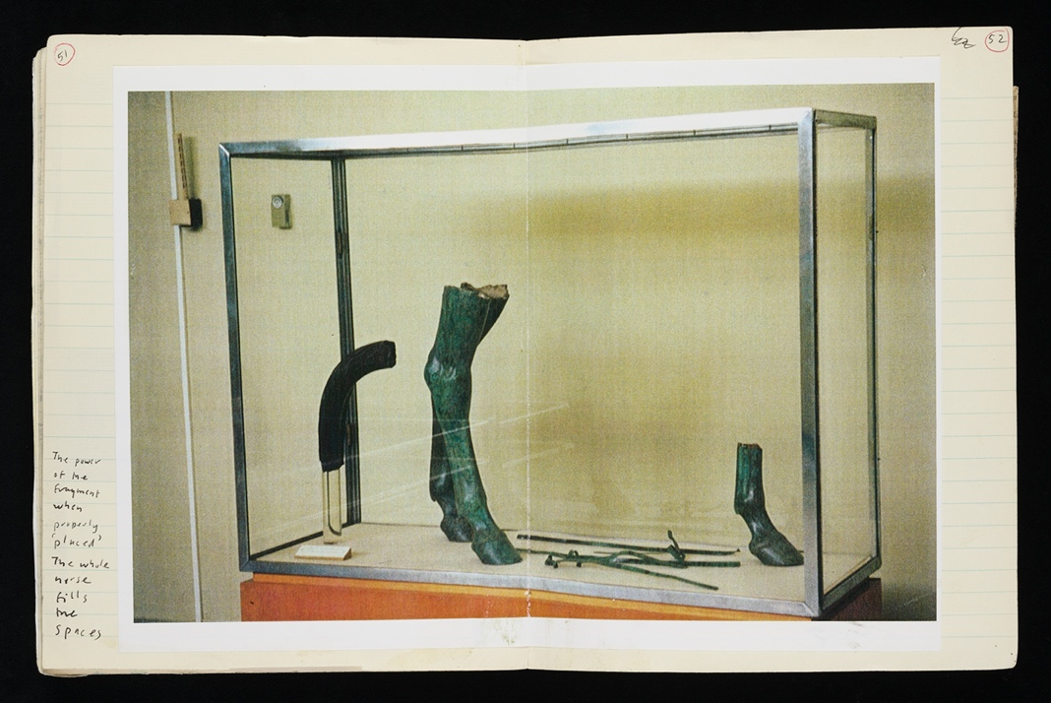

**Figure 4.1** *Labourers* Notebook 1 pp. 51-52: Photo of the fragmentary bronze statue of a horse from Delphi Museum, with annotation.

Reproduced by kind permission of Tony Harrison and the Brotherton Archives and Special Collections.

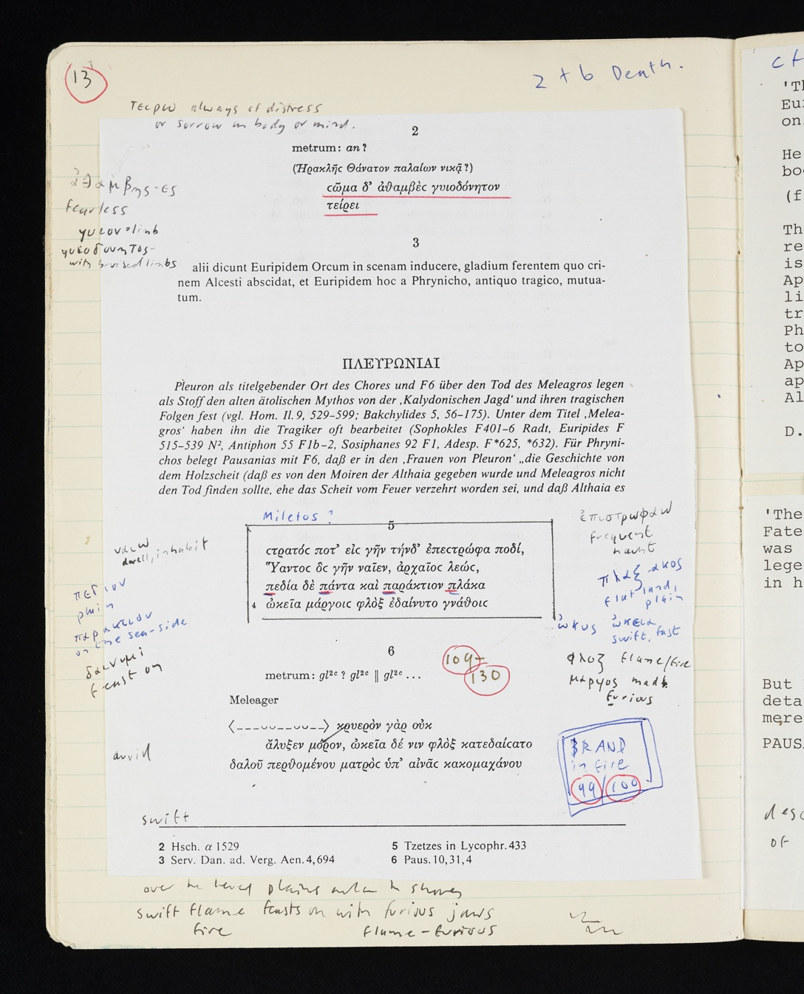

**Figure 4.2** Notebook 1 p. 13, showing p. 44 of *Musa Tragica* with Harrison’s annotations.

Reproduced by kind permission of Tony Harrison and the Brotherton Archives and Special Collections.

**Figure 4.3** Notebook 1, pp. 25-26, an engraving of the Farnese Hercules by L. P. Boitard, photocopied from Spence 1747, pl. XVI.

Reproduced by kind permission of Tony Harrison and the Brotherton Archives and Special Collections.

**Figure 4.4** Statue of Herakles similar to the one depicted in the notebook, as used in the Delphi production.

Photo: Vicki Hallam. Reproduced by kind permission of Vicki Hallam and the Brotherton Archives and Special Collections.

**Figure 4.5** Photograph of Delphi production of *Labourers*: Barrie Rutter (l.) as Labourer 1, doubling as Herakles, leaning on his shovel in similar pose to the statue.

Photo: Vicki Hallam. Reproduced by kind permission of Vicki Hallam and the Brotherton Archives and Special Collections.

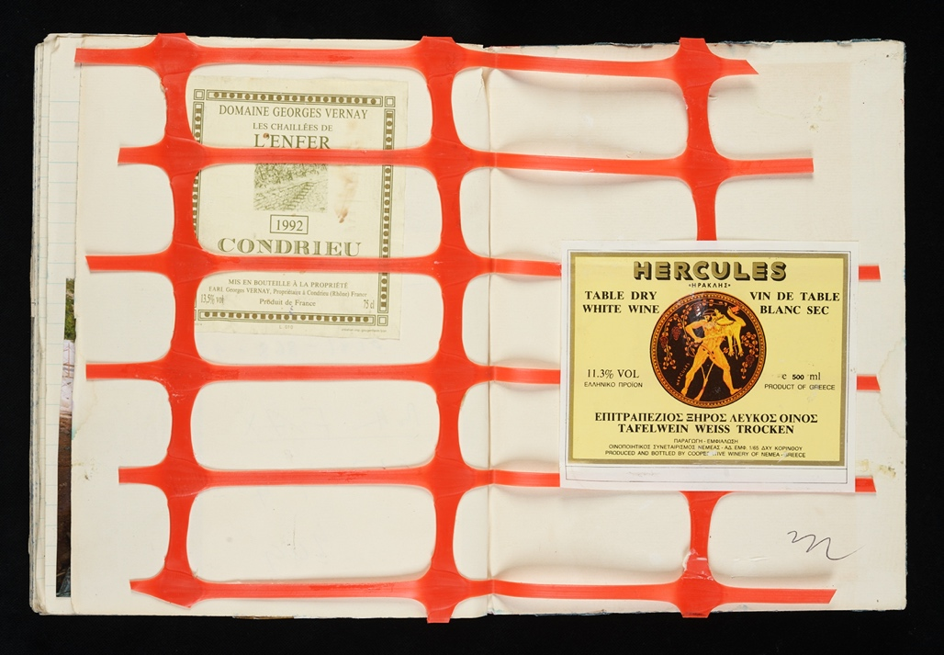

**Figure 4.6** Notebook 2, inside back cover [n.p.], containing two wine bottle labels, and a segment of the plastic construction mesh worn by the Labourers (along with traffic cones as helmets) when adopting ‘Persian’ garb.

Reproduced by kind permission of Tony Harrison and the Brotherton Archives and Special Collections.

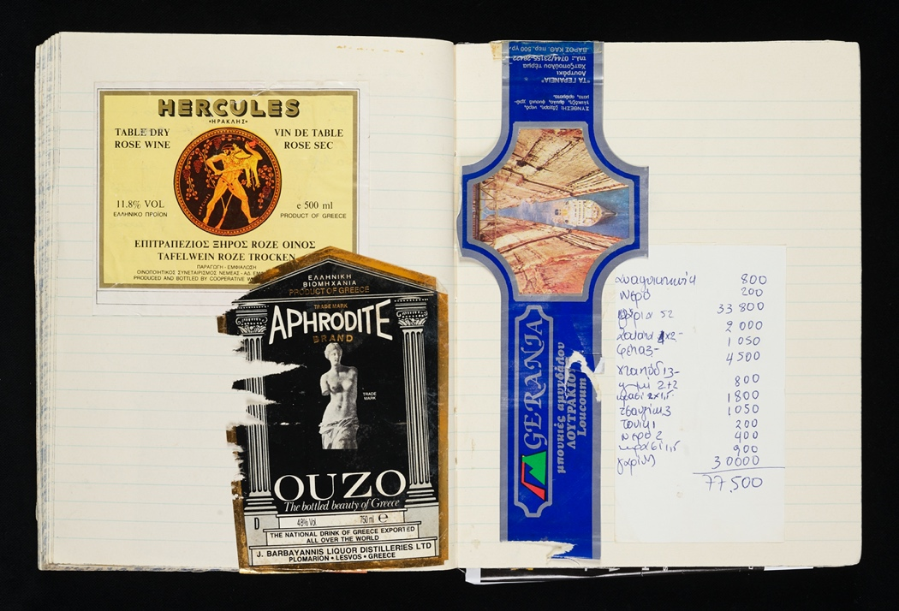

**Figure 4.7** Notebook 2 pp. 450-451, featuring various labels for comestibles and a Greek restaurant bill.

Reproduced by kind permission of Tony Harrison and the Brotherton Archives and Special Collections.

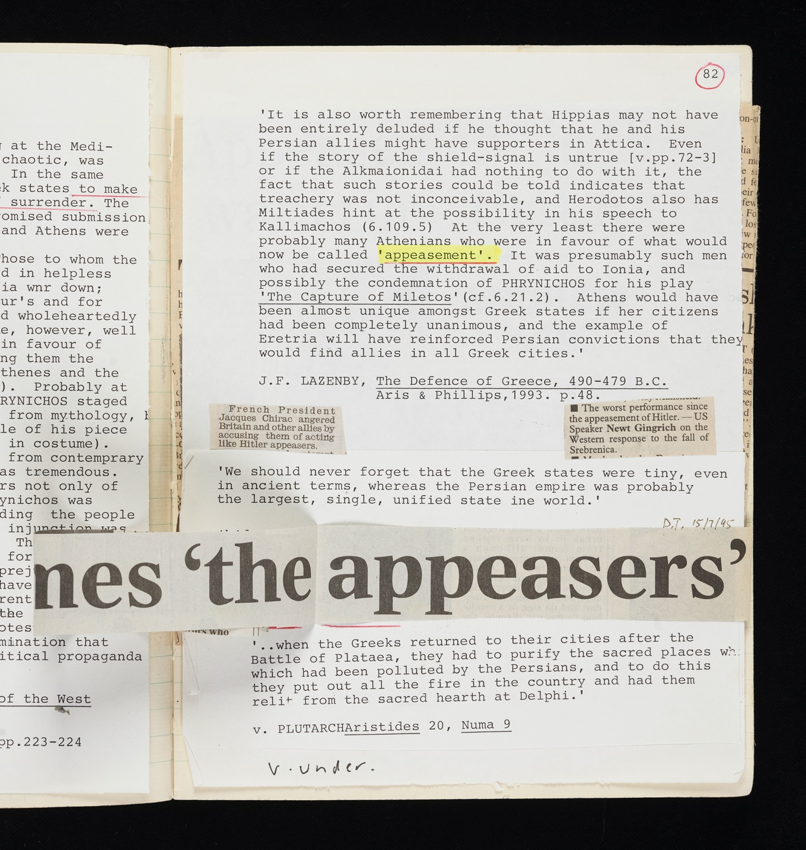

**Figure 4.8** Detail from Notebook 1 p.82.

Reproduced by kind permission of Tony Harrison and the Brotherton Archives and Special Collections.

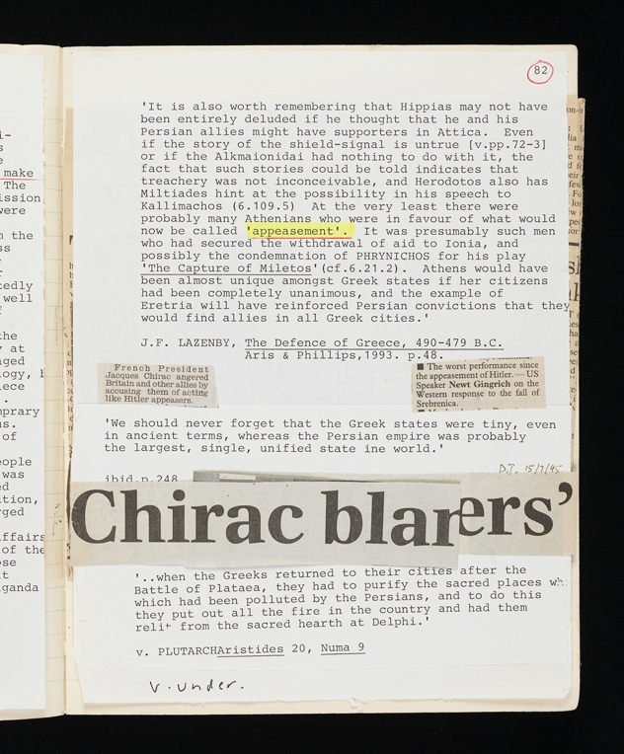

**Figure 4.9** Notebook 1 p.82

Reproduced by kind permission of Tony Harrison and the Brotherton Archives and Special Collections.

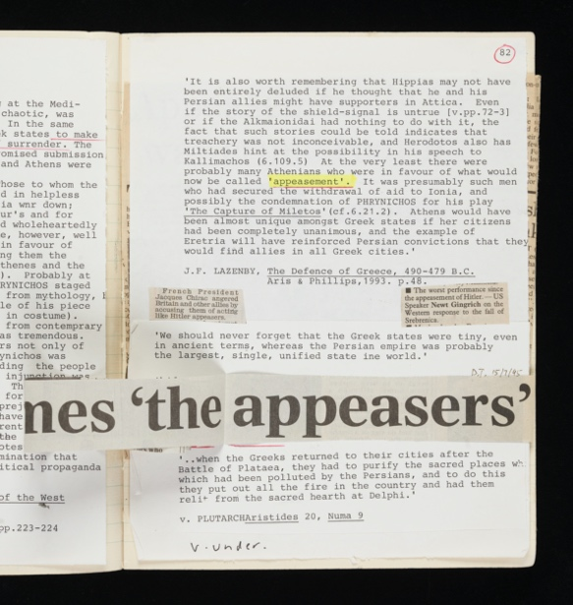

**Figure 4.10** Notebook 1 p.81-82

Reproduced by kind permission of Tony Harrison and the Brotherton Archives and Special Collections.

**Bibliography**

Archive materials

Harrison, Tony (c.1995-1998), Notebooks in the University of Leeds Brotherton

Library Special Collections:

*Labourers* Notebook 1 = BC MS 20c Harrison/03/HER/01 (1995-1998)

*Labourers* Notebook 2 = BC MS 20c Harrison/03/HER/02 (1995-1998)

Published materials

Blakesley, Jacob (2018), ‘Tony Harrison the Translator: “Life’s a Performance. Either Join in

/ Lightheartedly, or Thole the Pain”’, *English Studies* 99.1 (special issue, = R. Bower

and J. Blakesley (eds.), *Tony Harrison: International Man of Letters*): 51-66.

Bower, Rachel (2018), ‘Tony Harrison in Nigeria: Teacher, Translator and Dramatist’,

*English Studies* 99.1 (special issue, = R. Bower and J. Blakesley (eds.),

*Tony Harrison: International Man of Letters*): 34-50.

Bower, Rachel (2019), ‘Tony Harrison: Nigeria, Masque and Masks’, in Edith Hall, ed., *New Light on Tony Harrison*, Oxford: Oxford: Oxford University Press for the British Academy, 81-90.

Armitstead, Claire (2019), ‘Tony Harrison and the *Guardian*’ in Edith Hall, ed., *New*

*Light on Tony Harrison*, Oxford: Oxford: Oxford University Press for the British

Academy, 41-52.

Copley, Hannah (2018), ‘From Baghdad to Sarajevo to Beeston: The War Poetry of Tony

Harrison’, *English Studies* 99.1 (special issue, = R. Bower and J. Blakesley (eds.),

*Tony Harrison: International Man of Letters*): 19-33.

Daverio Rocchi, Giovanna, 2006, ‘Castalia’, in *Brill’s New Pauly*, edited by Hubert Cancik

and Helmuth Schneider, English Edition by Christine F. Salazar, online at: <http://dx.doi.org/10.1163/1574-9347_bnp_e610240> <04 August 2020>

ECCD 2016 Website of the European Cultural Centre of Delphi: Webpage ‘VIII International

Meeting on Ancient Drama - 1st Theatre Olympics CROSSING MILLENNIUM (8)’,

online at <https://www.eccd.gr/en/events/videos/viii-international-meeting-on-ancient-drama-1st-theatre-olympics-crossing-millennium-8/> , accessed August 4 2020.

Eyre, R. (1991), ‘Such men are dangerous’, in N. Astley (ed.), *Bloodaxe Critical*

*Anthology 1: Tony Harrison* (Newcastle upon Tyne, Bloodaxe Books), 362–6.

Fink, Dennis L. 2014 *The Battle of Marathon in Scholarship: Research, Theories and*

*Controversies since 1850.* Jefferson, NC: McFarland and Company.

Frazer, J.G. 1898. *Pausanias's Description of Greece. Volume 5: Commentary on Books IX,*

*X. Addenda*. Cambridge: CUP

Hall, E., (2018) ‘Statuary and Classicism in Harrison’s *The Loiners* and Beyond’, *English*

*Studies* 99: 77-91.

Hampton, C., D. Hare, T. Harrison, F. McGuiness, and T. Stoppard (2005), *Faber Playwrights at the National Theatre*. London: Faber and Faber

Harrison, Tony (1996a), *Plays 3: Poetry or Bust. The Kaisers of Carnuntum. The Labourers of Herakles.* London: Faber and Faber.

Harrison, Tony (1996b), ‘The Labourers of Herakles’, *Arion* 4.1, pp. 115-154.

Harrison, Tony (2001), ‘The Tears and The Trumpets’, *Arion* 9.2, 1-22.

Harrison, Tony (2002a), *Plays 4: The Oresteia. The Common Chorus (Parts I and II).*  London: Faber and Faber.

Harrison, Tony (2002b), ‘The Grilling’, *LRB* 24.11 6 June 2002.

Harrison, Tony (2004), *Plays 5: The Trackers of Oxyrhynchus. Square Rounds.*  London: Faber and Faber.

Harrison, Tony (2007), *Collected Film Poetry*. London: Faber and Faber.

Harrison, Tony (2015), ‘Polygons’, *LRB* 37.4, 19 Feb. 2015.

Harrison, Tony (2016), *Collected Poems*, London: Penguin.

Harrison, Tony (2017), *The Inky Digit of Defiance: Selected Prose 1966-2016*, ed Edith Hall. London: Faber and Faber.

Hodkinson, O. (2022) ‘Insights from the Tony Harrison Archive’, in Sandie Byrne (ed.) *Tony*

*Harrison and the Classics* (*Classical Presences*), Oxford: Oxford University Press, pp. 284-301.

Ioannidou, Eleftheria (2017), *Greek Fragments in Postmodern Frames: Rewriting Tragedy 1970-2005*. Oxford: Oxford University Press*.*

Johnston, Philip, Patrick Bishop and Suzanne Lowry, 1995, ‘Chirac blames “the appeasers”’,

*The Daily Telegraph,* Saturday July 15, 1995.

Kock, Theodor (1880-1888), *Comicorum atticorum fragmenta* (3 vols.), Leipzig: B. G.

Teubner.

Lazenby, J. F. 1993 *The Defence of Greece, 490 - 479 B. C*. Warminster: Aris and Phillips.

Lloyd-Jones, Hugh 1990 *Greek Epic, Lyric, and Tragedy*, Oxford: Oxford University Press.

Macintosh, Fiona (2019), ‘Harrison as Scholar-Poet of the Theatre’, in Edith Hall, ed.,

*New Light on Tony Harrison*. Oxford: Oxford University Press for the British

Academy, 101-109.

Mainz, V. and Stafford, E.J. (eds) (2020) *The Exemplary Hercules From the Renaissance to the Enlightenment and Beyond* (Metaforms vol. ##), Leiden: Brill

Marshall, C.W. 2001. ‘The Next Time Agamemnon Died’, *CW* 95, 59-63.

Marshall, Hallie R. (2010), ‘Banging the Lyre: The Classical Plays of Tony Harrison’. PhD thesis. Vancouver: University of British Columbia.

———, 2008. ‘Remembrance is Not Enough": The Political Function of Tony Harrison’s

Poetry’, *Syllecta Classica* 19: 221-236

*Musa Tragica* **=** Kannicht, Richard and Gauly, B.M. (1991), *Musa Tragica: die griechische*

*Tragödie von Thespis bis Ezekiel. Ausgewählte Zeugnisse und Fragmente, griechisch*

*und deutsch*. Göttingen: Vandenhoeck and Ruprecht.

*OCD* = Cary, Max (ed.) 1949 *The Oxford Classical Dictionary* (1st ed.).Oxford: Clarendon

Press.

Padley, Steve (2008), ‘“Hijacking culture”: Tony Harrison and the Greeks’, *Cycnos* 18.1 (18th

September 2008) [n.p.], online at: <http://revel.unice.fr/cycnos/index.html?id=1681>.

Riley, Kathleen. (2008) *The Reception and Performance of Euripides’ Herakles. Reasoning*

*Madness*. Oxford: Oxford University Press.

Rosenbloom, David (1993), ‘Shouting “fire” in a crowded theater: Phrynichos’s *Capture of*

*Miletos* and the politics of fear in early Attic tragedy’, *Philologus* 137.2 (December

1993): 159-96.

Rowland, Antony 2019. ‘Modernism and the 'Double Consciousness' of Myth in Tony Harrison's Poems and Metamorpheus’, in Edith Hall, ed., *New Light on Tony Harrison*, Oxford: Oxford: Oxford University Press for the British Academy, 185-204.

Rutter, Carol C. (1997), ‘Harrison, Herakles, and Wailing Women: “Labourers” at Delphi’,

*New Theatre Quarterly* 13 (50) (15th January 2009): 133-43.

Rusbridger, A. (1997), ‘Tony Harrison and the Guardian’, in S. Byrne (ed.), *Tony Harrison:*

*Loiner* (Oxford, Oxford University Press), 133–6.

de Selincourt, A. (trans.) 1955. *Herodotus: The Histories*. Harmondsworth: Penguin.

Spence, Joseph 1747. *Polymetis, or, An enquiry concerning the agreement between the works of the Roman poets, and of the ancient artists*. London: R. Dodsley.

Stead, Henry 2019 ‘The Only Tone for Terror: Tony Harrison and the Gorgon’s Gaze, in Edith Hall, ed., *New Light on Tony Harrison*, Oxford: Oxford: Oxford University Press for the British Academy, 205-219.

---- (forthcoming) ‘Fire, fennel and the future of socialism: Tony Harrison’s *Prometheus*’, in Byrne (ed.) *Tony Harrison and the Classics,* Oxford: Oxford University Press.

Symes, Peter 2019, ‘A Poet behind the Camera’, in Edith Hall, ed., *New Light on Tony Harrison*, Oxford: Oxford: Oxford University Press for the British Academy, 177-183.

Taplin, Oliver (1997), ‘The Chorus of Mams’ in Sandie Byrne, ed., *Tony Harrison: Loiner*. Oxford: Clarendon Press, 171-84.

Taplin, Oliver (2005), ‘The Harrison version: “so long ago that it's become a song?”’, in *Agamemnon in Performance, 458 BC to AD 2004* eds Fiona Macintosh, Pantelis Michelakis, Edith Hall and Oliver Taplin. Oxford: Oxford University Press, 235-51.

*TrGF* = *Tragicorum Graecorum fragmenta*. The only volume referred to in this chapter is

Snell, B. 1971. *Tragicorum Graecorum fragmenta . Vol.1, Didascaliae tragicae*

*catalogi tragicorum et tragoediarum, testimonia et fragmenta tragicorum minorum*.

Göttingen: Vandenhoeck & Ruprecht

Whale, John (2018), ‘Tony Harrison: The Making of a Post-War English Poet’, *English*

*Studies* 99.1 (special issue, = R. Bower and J. Blakesley (eds.), *Tony Harrison:*

*International Man of Letters*): 6-18.

1. I am very grateful to Tony Harrison for permission to quote and reproduce materials from his archive (Figs. 4.1-4.3 and 4.6-4.10, all taken from the two project Notebooks for the play, Harrison (c.1995-1998) in my bibliography), as well as generously giving his time to answer questions about the play and his activities around the time of its composition; to Vicki Hallam for permission to reproduce two photographs from the Delphi production (Figs. 4.4 and 4.5) held in the Tony Harrison archive in the Brotherton Library; to Sarah Prescott, literary archivist in the Brotherton Library’s Special Collections, for facilitating the meeting with Harrison that led to our 2017 re-staging of *Labourers* and the necessary permissions, and for all her help with access to the Harrison archives for research and teaching; to the Brotherton Library’s Special Collections for permission to reproduce the items from the Tony Harrison archive, and its digitisation services for the reproductions of all images used in the chapter; and to Hallie Marshall and the editor for many helpful suggestions and comments on a draft.
2. The play can currently be watched online: ECCD 2016. There is little by way of conventional plot in *Labourers*; long speeches by Herakles and Phrynichus (the latter played by Harrison himself in the Delphi performance), meditations on war and people’s inhumanity to one another both in antiquity and since, form the bulk of the dialogue, while an extended opening action sequence features Labourer 1/Herakles miming the violence of Herakles in his madness and drumming on a ‘chorus’ of concrete mixers. As such the play would not be easy to follow for a regular theatre audience: it includes untranslated ancient Greek, and is otherwise mostly in English with a small amount of modern Greek, reflecting the languages of the ECCD conference attached to the performances, with the expectation of varying degrees of comprehension by audience members. See Taplin 1997, who was at the Delphi performance, for a summary and assessment (p. 182, a ‘“mixed” reception from its predominantly Greek audience’); Rutter 1997, who was also there, also summarises and analyses the gender aspects of the play in the context of Harrison’s other drama. For a longer overview and assessment of the play, see Marshall 2010, 151-69, esp. on Harrison’s engagement with Phrynichus and the ancient reports about his lost plays; on his composition process p.151-3; *ead.* 130-150 on Harrison’s *The Kaisers of Carnuntum* (also 1995), another play concerned with the reception of Herakles that was initially conceived of as part of a trilogy alongside *Labourers* (Marshall 2010, 145-6; like *Labourers*, this had Barrie Rutter as the lead, the emperor Commodus styled as Herakles with lion-skin and club): for brief discussion of this play in the context of the reception of Euripides’ *Herakles*, see Riley (2008) 340-342; see also briefly Ioannou 2017, 142-143. Hodkinson (2022) also focuses on using the archive to study Harrison’s drama, with *Labourers* and *Oresteia* as the main examples.
3. ‘Inspired by the single performance nature of… classical Greek drama’, Padley 2008 [n.p.].
4. As Rutter 1997, 134 notes, the scene was ‘something of a joke upon Harrison’s hosts, since the E.C.C.D. has long aspired to building a new theatre at Delphi’. *Labourers* is one of three productions that Harrison staged in co-operation with the ECCD: *Trackers*, which had a single performance in the ancient stadium, before opening in a revised version at the National Theatre in London, *Labourers*, and then Hecuba, which was performed in the new ECCD theatre, for which the first concrete for its foundation was poured as part of the *Labourers* performance.
5. A very Aristophanic metatheatrical touch. On Harrison’s plays and Greek Old Comedy, see Marshall 2010, 170-213; and see 198 and 201-2 on metatheatrical touches in *Labourers* (the ‘Spirit of Phrynichus’ speech by Harrison compared with the parabasis of Old Comedy).
6. I am very grateful to Tony Harrison for giving us permission to bring *Labourers* back to the stage and to use archive materials in its staging; to Vicki Hallam, the photographer whose images of the Delphi production were projected behind the stage to help the audience of the staged readings have a better sense of Harrison’s intentions; and to Fiona Macintosh, who arranged the Oxford performance, and Oliver Taplin, who introduced that performance with the insight of one who was present at the original Delphi performance.
7. Harrison studied Classics at Leeds and thereafter had a lifelong association with the University, and is still in the process of gradually donating all of his personal archive to the Brotherton.
8. There are two project notebooks for *Labourers*, classmarks BC MS 20c Harrison/03/HER/01 and BC MS 20c Harrison/03/HER/02. Henceforth I shall refer to these simply as ‘the notebooks’, or Notebook 1 or 2.
9. Shortly after *Labourers*, Harrison went to Bosnia to write front-line reports in poetic form for *The* *Guardian*: see his ‘Three poems from Bosnia’, Harrison (2007a) 337-341. Rusbridger 1997, Copley 2018, Armitstead 2019. But he did not know this at the time of writing the play (*pace* e.g. Riley 2008, 340), as he told me (in a meeting in the Brotherton Special Collections Leeds, 2017, to discuss the performance that year).
10. The culture-hero aspect of Herakles is alluded to e.g. *Labourers* p.125 ‘the one who masters monsters’.
11. Cf. Ioannidou 2017, 137-8: ‘The fragments of the past, both ancient and modern, have a significant place in Tony Harrison’s work; the quotation of lines from the ancient texts (*The Labourers of Herakles, The Trackers of Oxyrhynchus*) and their adaptations across time (p.138) (*Medea: A Sex-War Opera*) in Harrison provides a relentless interrogation of the process of appropriation’; 142-5 for this feature of several of Harrison’s classical plays.
12. For studies of Harrison’s other works employing the archives, see Taplin 1997 and 2005; Bower 2018; Copley 2018; Whale 2018; Hodkinson (2022) on the nature and uses of his archives for teaching and research.
13. I do not suggest a random method: *where* the nets were often cast (reading material about the production and history of cement, Phrynichus, or the Bosnian conflict) is mostly deliberate choice, naturally; but materials happened upon in everyday reading and life, bearing even the most tangential connection to any theme or aspect of the play, are also incorporated and repurposed.
14. Cf. also early in the process some sketchy handwritten notes for a structure of the play, including (Notebook 1 p. 31): ‘The fertility of spaces [these four words highlighted by enclosure in a box] gaps… 1. Perform the fragments. 2. Perform the gaps. 3. Epilogue on the fertility in the space around the fragments. [From here onwards ms shifts from blue to black ink, so probably later addition] 4. Theatre space for 21 century.’
15. Fifth century BCE; known plays include an *Alcestis*, featuring Herakles, of which we have a single fragment; and *The Sack [or Capture] of Miletus*, often referred to by Harrison by the transliterated Greek title, *Halosis Miletou*, of which only the title survives; instead of the commoner mythical themes of Greek tragedy, the latter treated the capture of Miletus by the Persians in 494 BCE, during the Ionian revolt against Persian rule. Notebook 1 p. 1 / inside front cover features a xerox of the entry on Phrynicus in the *OCD*;pp. 5-6 contains xeroxes of Herodotus in De Selincourt’s (1954) translation, pp.364-7, an excerpt including 6.21 on Phrynichus and the *Sack of Miletus*. On Phrynichus’ play, its historical context and the reaction to the performance see Rosenbloom 1993 with exhaustive bibliography; Lloyd-Jones (1990) 230-237.
16. The first is *Musa Tragica*, the second *TrGF*. The extant fragments (some consisting only of the play’s title) number 24, though one of these was falsely attributed to the tragedian Phrynichus: see below.
17. Taplin 1997, 224 n.33 proposes this translation of the fragment. For a discussion of the fragment see Dale (1954) xiii-xiv, and Parker (2007) xv-xvi.
18. ‘*Enter* Tony Harrison*to speak as* The Spirit of Phrynichus: … To honour Phrynichus, who gave theatre a start | in redeeming destruction through the power of art, | and, witnessing male warfare, gave the task | of mourning and redemption to the female mask… to… get their spirits freed | from Europe’s impasse, where art cannot redeem | the cry from Krajina or the Srbrenica scream, | all modern poet and actors need to do, | to perform the sadly missing *Halosis Miletou*, | is to incline their heads north-west a few degrees, | to see the moral madness of the modern Herakles,’ p.143; ‘Cast aside mythology and turn your fearful gaze | to blazing Miletos, yesterday’s, today’s. (*The Labourers turn again towards former Yugoslavia, then turn back towards the audience.*) Once more the mourning women trudge the roads | of murderous Europe,’ p.145. ‘Labourers 2 and 3: When the former Yugoslavs started slaughtering each other, | who was left to mourn them but the daughter, sister, mother? | When all the men are massacred in Miletos, or elsewhere, | who is left but women to keen in their despair? | This was the truth that Phrynichos first knew | when female masks first mourned *Halosis Miletou*,’ p.147. On the story about the Athenians’ reception of the play, see pp.126-7. In the notebooks, the items in n.6 above among several others show research into these aspects of Phrynichus’ apparent innovation and his reception. See Rutter 1997, 138-141 on this aspect of the play.
19. Cf. the role of Herakles in Euripides’ *Alcestis*, which Harrison had also considered composing a version of (again provisionally with Barrie Rutter as Herakles, before Rutter played that part in Ted Hughes’ *Alcestis*): see Marshall 2010, 151.
20. pp. 147-50: see quote from p.147, previous n.; then as Herakles is burned by the shirt of Nessus: ‘Labourer 1/Herakles: If you pull this garment from me, you’ll pull away my skin. | This is Europe’s conscience I’m cremated in. … And officials with the suits and ties of Nessus on | walk the corridors of power in Washington and Bonn, | In London and in Paris, in New York at the UN, | the shirt of fire’s the fashion for flame-tormented men,’ p.148; ‘Labourer 3:*Halosis Miletou*, | a play once banned, now lost, | but its message still shines through | in times of Holocaust. | *Halosis Miletou*, a title with no play | but the text’s in front of you | in Bosnia today,’ p. 150.
21. Herakles, ignorant of the fate of Phrynichus’ tragedies, is ironically made to say ‘Though this poet wrote me four plays for myself | (which I trust, are on everybody’s library shelf!), | showing my adventures for many years to come, | even, dare I say it, to the next millennium…’
22. On Harrison’s work with those Greek sources as seen in the archive, involving copious annotations on the Greek texts of multiple kinds (trying out several different translations for many Greek words; ideas for staging, costume, set; historical and mythical contextual explanations from scholarship, etc.), see Taplin 2005 (on *Oresteia*). For *Labourers*, Harrison’s annotations are similar, including various translations of some of the Greek words in the fragments, and it is very possible that he initially considered translating the fragments in his new play, rather than leaving them in the original as he finally did.
23. *sic*: I print Greek text when quoted from *Labourers* without accents and breathings, as it appears in the more definitive published edition (1996a, published by Faber); Harrison 1996b (in the classical periodical *Arion*) prints breathings and accents as appropriate on both ancient and modern Greek passages. (The lack of accents and breathings in the playtexts as published by Faber is a decision by the press and not the poet: where the publisher is familiar with the use of accents and breathings, as with *Arion*, the plays are printed as per Harrison’s text. But when it is printed by a publisher for who those markings are not normative, they are dropped.)
24. Hallie Marshall draws my attention to the different punctuation in the *Arion* publication of the play: there too the scholarly question mark, indicating the fact that the suggestion for the fragment’s context is tentative, is omitted, but instead of full stop here, the line ends with an ellipsis (Harrison 1996 *Arion* p. 117), which as she suggests ‘but adds a new sense of the fragmentedness of the text but pointing to the beginning of a stage action which cannot be completed because there is no more text for the action to follow’ (in correspondence).
25. This refers to Euripides’ extant *Alcestis* of 438 BCE? On Herakles’ encounters with Death, Sleep and Old Age, in Phrynichus, Euripides, and vase paintings, see Stafford 2012, 118-20.
26. See Hall (2018) on Harrison’s use of statuary, especially classical sculpture, as a source of artistic inspiration from his earliest poetry onward.
27. On the extraordinary influence of the Farnese Herakles, a colossal third-century AD copy of a fourth-century BCE original, from its discovery in 1546 in the Baths of Caracalla at Rome, see Mainz and Stafford (eds) 2020 *passim*. Harrison will have been familiar with it from his classical studies, and no doubt from seeing it in the Naples Archaeological Museum: he does not mention it specifically, but Harrison’s fondness for Naples is clear from Harrison 2001, 1-2 (thanks to Hallie Marshall for this reference).
28. Harrison says that one of the first things that he did with any production was to think about ‘the look of the thing’, most often in collaboration with Jocelyn Herbert: Hampton, Hare, Harrison *et al.* 2005, 70.
29. Frazer 1898, 394-5.
30. Thus *Labourers* marks a shift from the ancient site being used as a space for modern performances to the building of a new theatre modelled on ancient Greek theatres; the labourers are literally pouring the foundation of a new orchestra. On the falling rocks being an issue in the stadium, see Harrison’s poem ‘Polygons’ (Harrison 2015).
31. From Notebook 1 p. 42, featuring Frazer 1891, 395.
32. See Daverio Rocchi 2006: ‘C. is often used synonymously with Delphi’; for spring as inspiring poets, e.g. Pindar, *Paean* 6, Virgil, *Georgics* 3.293. On Harrison’s love of the Castalian springs, see ‘Polygons’ (Harrison 2015).
33. Harrison had a regular apartment in Delphi that he returned to for many successive summers to write.
34. Though not always difficult. The drafts for his poem “The Grilling” (Harrison 2002b) have wine labels affixed that can be mapped directly onto the resulting poem.
35. Harrison’s sensibilities as visual as well as verbal artist emerge elsewhere in his innovative film-poems: see Harrison 2007; Stead 2019, Stead (forthcoming), Symes 2019, Rowland 2019.
36. Thanks to Maro Nicolopoulou, Head, Conferences & Artistic Programmes at the ECCD, for answering my queries about the history of the theatre: he confirms that the Herakles company was not involved in the construction of the real theatre anticipated in *Labourers* (i.e. what would become the Frynihos Open-Air Theatre).
37. Notebook 1 p.27 features a photograph of such a silo; the one in the play can be seen Harrison 1996a p. 128, Harrison 1996b p. 144. Thanks to Hallie Marshall for the suggestion of Herakles on the silo serving as the equivalent to the god on top of the skene in an ancient theatre.
38. *Labourers* p.117; ECCD 2016.
39. I.e. in anticipated future stagings of Aeschylus, *Agamemnon* (notwithstanding the debate over whether the weapon used was an axe or in fact a sword: see Marshall 2001 with references to previous contributors to the debate).
40. Cf. e.g. Menander *Dyskolos* 966-7.
41. E.g. Notebook 1 pp. 73-4 features a story cut from *The Sun*, front cover 8.6.95, with the headline ‘Bonkrete Mixer’, about a couple who put a concrete mixer in their bedroom to ‘put the throb back in their sex life’: subhead ‘Throb of bedside machine reminds us of sex at Spain hols site’.
42. Note that I am applying this comparison with ‘found poetry’ primarily to the notebooks, not to the text of *Labourers*, with the one exception noted above, p. ### [7]
43. The page pasted into the notebook there is Lazenby 1993: 48.
44. Note that I do not in any way wish to suggest that this kind of artistic process based on what might be called coincidences of language shows a simplistic or superficial research into or engagement with analysis of events ancient or modern by Harrison; not only would this be entirely out of character for him (see discussions of his political engagement such as Marshall 2008; cf. Hall 2017; and of the depth of the research he undertakes for his writing: e.g. Marshall 2010, 151-3 for *Labourers,* Macintosh 2019 for *Medea: A Sex-War Opera*, Taplin 2005 for *Oresteia*, Hodkinson 2022), it is also belied by a quantity of contemporary articles reporting on and analysing the contemporary war from a variety of sources in the notebooks, most of which is not highlighted nor seemingly chosen on the basis of particular linguistic similarities. For just one example see Notebook 2 p.431, from *The Guardian* August 17th 1995, an article comparing genocides in the same region: 1690, WWII, and 1995. The role of the Turks in 1690 might have suggested further links with the Persians in ancient Miletus.
45. The source is Johnston, Bishop and Lowry 1995.
46. See also Notebook 2 p. 250: a photocopy of the page of *TrGF* (p.74)containing the title of Phrynichus’ *Halosis Miletou* fills most of the page; to the left, aligned at right angles, is pasted in from a newspaper headline in large type the name ‘Srebrenica’. Also in Notebook 1 p. 82 (*sic*: the material on Chirac above is pasted as a flap over the top of this), we find a full article by Andrew Neil about the same conflict, also comparing 1930s appeasement.
47. Other places where the comparison is made include p.144, where Miletos is implied to be ‘today’s Yugoslavia’; p.147; p.149, where the sack of Miletos is made to stand for all wars.
48. It is beyond the scope of this chapter to examine these parallels and their aptness; my concern here is only to document and to examine the creative processes of Harrison’s reception of ancient figures and narratives in notebooks and published play. For more recent discussion of the sack of Miletus including discussion of Lazenby’s position, see e.g. Fink 2014 p.125. Some comment on the aptness of the modern parallels in Rutter 1997, 142 nn.5-6.
49. This chapter can only hope to scratch the surface of the wealth of material in the Harrison Archive: there is far more to be got from the two notebooks on *Labourers*, and much other material beyond the notebooks that would need to be incorporated in a more extensive treatment.
50. On reception of Herakles in the play touching on gender, violence, and combination of diverse ancient sources see Marshall 2010, 163-7.
51. See further Rutter 1997, 138-140 on the ambivalent and gendered Herakles in *Labourers* and elsewhere in Harrison’s oeuvre, incl. 138 quoting Harrison’s programme notes for the Delphi performance: ‘In his programme notes to The Labourers of Herakles, Harrison makes Herakles signify the massively aggressive male urge toward destruction which, in the play, is specifically formulated as “racist rage”. But he also signifies the heroic male resistance that defeats such destruction. So, “paradoxically”, writes Harrison, “the most destructive forces Herakles must wrestle with are himself and his own destructive impulses which led him to the unspeakable murder of his own children.”’