Title: Pain Reduction with Oral Methotrexate in Knee Osteoarthritis; a Randomized Placebo-Controlled Clinical Trial

Authors: Sarah R. Kingsbury PhD¹, Puvan Tharmanathan PhD², Ada Keding MSc², Fiona E Watt MD^{3,7}, David L Scott PhD⁴, Edward Roddy DM⁵, Fraser Birrell PhD⁶, Nigel K Arden PhD⁷, Mike Bowes PhD⁸, Catherine Arundel MSc², Michelle Watson MSc², Sarah J Ronaldson MSc², Catherine Hewitt PhD², Michael Doherty MD⁹, Robert J. Moots PhD¹⁰, Terence W O’Neill MD¹¹, Michael Green MB ChB^{12,13}, Gulam Patel MA¹⁴, Toby Garrood PhD¹⁵, Christopher J Edwards MD¹⁶, Phil J Walmsley MD¹⁷, Tom Sheeran MD¹⁸, David J Torgerson PhD², Philip G Conaghan PhD¹

Affiliations:
1 Leeds Institute of Rheumatic and Musculoskeletal Medicine, University of Leeds and National Institute for Health Research (NIHR) Leeds Biomedical Research Centre, Leeds, United Kingdom

2 York Trials Unit, Department of Health Sciences, Faculty of Science, Seebohm Rowntree Building, University of York, Heslington, York, United Kingdom

3 Centre for Inflammatory Disease, Department of Immunology and Inflammation, Hammersmith Campus, Imperial College London, and Centre for Osteoarthritis Pathogenesis Versus Arthritis, Kennedy Institute of Rheumatology, Roosevelt Drive, Nuffield Department of Orthopaedics, Rheumatology and Musculoskeletal Sciences, University of Oxford, United Kingdom and Department of Rheumatology, Oxford University Hospitals NHS Foundation Trust

4 King's College London, London, United Kingdom

5 Primary Care Centre Versus Arthritis, Keele University, Keele, United Kingdom and Haywood Academic Rheumatology Centre, Midlands Partnership NHS Foundation Trust

6 Medical Research Council-Versus Arthritis Centre for Integrated Research into Musculoskeletal Ageing, Newcastle University and Northumbria Healthcare NHS Foundation Trust, Newcastle upon Tyne, United Kingdom

7 Nuffield Department of Orthopaedics, Rheumatology and Musculoskeletal Sciences, and Centre for Sport, Exercise and Osteoarthritis Research Versus Arthritis, University of Oxford, Oxford, United Kingdom.

8 Imorphics, Manchester, United Kingdom

9 Academic Rheumatology and Pain Centre Versus Arthritis, University of Nottingham, Nottingham, United Kingdom.

10 Faculty of Heath Social Care and Medicine, Edge Hill University, Ormskirk, L39 4QP and Department of Rheumatology, Aintree University Hospital, Longmoor Lane, Liverpool L9 7AL.

11 Centre for Epidemiology Versus Arthritis, Division of Musculoskeletal and Dermatological Sciences, Manchester Academic Health Science Centre, University of Manchester, and NIHR Manchester Biomedical Research Centre, Manchester University NHS Foundation Trust, Manchester, United Kingdom.

12 Harrogate and District NHS Foundation Trust, Harrogate, United Kingdom

13 York Teaching Hospital NHS Foundation Trust, York, United Kingdom
14 Rheumatology Department, Ashford and St Peters Hospital NHS Trust, Chertsey, United Kingdom.

15 Department of Rheumatology, Guy's and St Thomas' NHS Trust, London, United Kingdom

16 NIHR Southampton Clinical Research Facility, University Hospital Southampton NHS Foundation Trust, Southampton, United Kingdom. United Kingdom

17 Department of Orthopaedics, Victoria Hospital Kirkcaldy and School of Medicine, St Andrews University, Fife and Fife NHS Trust, Kirkcaldy, United Kingdom

18 Department of Rheumatology, Royal Wolverhampton Hospitals NHS Trust, Wolverhampton, United Kingdom

Corresponding author:
Professor Philip G Conaghan,
Leeds Institute of Rheumatic and Musculoskeletal Medicine,
2nd Floor Chapel Allerton Hospital,
Chapeltown Road,
Leeds LS7 4SA,
United Kingdom.
Email: p.conaghan@leeds.ac.uk;
Telephone : +44 (0)11339 24883; Fax: +44 (0) 1133924991

Manuscript Word Count: 3500
ABSTRACT

Background: Treatments for osteoarthritis are limited. Previous small studies suggest the anti-rheumatic drug methotrexate may be a potential treatment for osteoarthritis pain.

Objective: To assess symptomatic benefits of methotrexate in knee osteoarthritis.

Design: A multi-center, randomized, double-blind, placebo-controlled trial conducted between 13 June 2014 and 8 September 2017.

Setting: Fifteen United Kingdom secondary-care musculoskeletal clinics.

Participants: 207 participants with symptomatic, radiographic knee osteoarthritis, knee pain (severity ≥4/10) on most days in the last 3-months, with inadequate response to current medication were approached for inclusion.

Interventions: Participants were randomized 1:1 to once-weekly oral methotrexate (6-week escalation 10mg-25mg) or matched placebo over 12-months and continued usual analgesia.

Measurements: The primary endpoint was average knee pain (numerical rating scale (NRS) 0-10) at 6-months, with 12-month follow-up to assess longer-term response. Secondary endpoints included knee stiffness and function outcomes, and adverse events.

Results: 155 participants (64% women, mean age 60.9 years, 50% Kellgren-Lawrence Grade 3-4) were randomized to methotrexate (n=77) or placebo (n=78). Follow-up was 86% (n=134; MTX 66, Placebo 68) at 6-months. Mean(SD) knee pain reduced from 6.4(1.80) at baseline to 5.1(2.32) at 6-months in the MTX group, and from 6.8(1.62) to 6.2(2.30) in the placebo group. The primary intention-to-treat analysis revealed a statistically significant pain reduction of 0.79 NRS points in favour of MTX (95%CI[0.08-1.51];p=0.030). There were also statistically significant treatment-group differences in favour of MTX at 6-months for WOMAC stiffness (0.60 points, 95%CI[0.01-1.18];p=0.045) and function (5.01 points, 95%CI[1.29-8.74],p=0.008). Treatment-compliance analysis supported a dose-response effect. Four unrelated serious adverse events were reported (methotrexate:2, placebo:2).

Limitations: Not permitting oral methotrexate to be changed to subcutaneous delivery for intolerance.

Conclusions: Oral methotrexate added to usual medications demonstrated statistically significant reduction in knee osteoarthritis pain, stiffness and function at 6-months.

Funding Source: Versus Arthritis 20186.
Trial registration number: ISRCTN77854383 (https://doi.org/10.1186/ISRCTN77854383); EudraCT: 2013-001689-41 (https://www.clinicaltrialsregister.eu/ctr-search/search?query=eudract_number%3A2013-001689-41)

Keywords: double-blind, knee osteoarthritis, methotrexate, placebo-controlled, randomized

BACKGROUND
Symptomatic knee osteoarthritis (KOA) affects approximately 364 million adults globally,(1) with increasing prevalence over the last two decades. KOA can result in chronic pain and functional impairment, reducing quality-of-life (QoL).(1) Current pharmacological treatments for OA are limited by lack of efficacy. Even nonsteroidal anti-inflammatory drugs (NSAIDs), the most commonly recommended pharmacological KOA therapy internationally, are inappropriate for many patients because of toxicity or contraindications.(2) The disease-modifying anti-rheumatic drug methotrexate (MTX) is the standard-of-care treatment for inflammatory arthritis. Small clinical and experimental studies suggest MTX could be a potential treatment for people with KOA symptoms.(3-5)

The Pain Reduction with Oral Methotrexate in knee Osteoarthritis, a pragmatic phase III trial of Treatment Effectiveness (PROMOTE) aimed to assess whether MTX, added to usual care, improves knee pain compared to placebo.

METHODS
Trial Design
PROMOTE was an investigator-led, pragmatic, multi-center, superiority, randomized, 1:1 placebo-controlled trial assessing MTX efficacy compared to placebo in reducing knee pain associated with symptomatic, radiographic KOA. Contrast-enhanced magnetic resonance imaging (MRI) and soluble immunological and inflammatory biomarker sub-studies explored potential mechanisms of symptom change.

The research protocol (Supplement S1) was approved by Leeds West Research Ethics Committee (13/YH/0279) and the UK Medicines and Healthcare Products Regulatory Agency (16767/0269/001-0001; EudraCT: 2013-001689-41). All protocol amendments (Supplement S3) and adverse events were reported in accordance with UK law.

Participants were recruited from 13 June 2014 until 8 September 2016 and followed-up for 12-months post-randomisation, with last follow-up on 13 October 2017.

Setting and Participants
There were 15 UK secondary care hospitals as recruiting sites. Referral of potential participants came through musculoskeletal clinics in both primary care (first point of contact care, e.g., general practitioner) and secondary care (specialist provision, e.g., rheumatology, orthopaedics) to ensure a representative sample of adult patients with painful knee symptoms, radiographic knee OA and inadequate response to current medication. Eligible participants were: age ≥18 years with a diagnosis of primary KOA fulfilling American College of Rheumatology Clinical criteria;(6) changes consistent with tibiofemoral OA on radiographs (read locally reflecting standard clinical practice) taken within 24-months; knee pain on most days in last 3 months; average knee pain severity score during last 3-months ≥40mm on 100mm visual analogue scale; inadequate response to current medication (e.g., paracetamol, NSAIDs, opioid) or previous intolerance/contraindications; stable analgesic regimen (including nutraceuticals) for 4-weeks prior to consent; ability to comply with the protocol and give informed consent. Participants identified a ‘signal knee’ if both knees were equally painful. Exclusion criteria included: presence of any inflammatory arthritis (e.g., gout, reactive arthritis, rheumatoid arthritis, psoriatic arthritis, seronegative spondylarthropathy, previous diagnosis of pseudogout) or fibromyalgia; use of intra-articular hyaluronic acid within previous 4-months; use of intra-articular, intra-muscular or oral corticosteroids in previous 3-months; use of other anti-synovial agents (e.g., hydroxychloroquine) in previous 2-months; non-OA causes of pain in signal knee e.g., referred hip pain; uncontrolled disease states (e.g., moderate/severe asthma, inflammatory bowel disease), where flares are commonly treated with oral/parenteral corticosteroids, or recurrent infections. Participants were screened for Rheumatoid Factor, anti-cyclic citrullinated protein and C-reactive protein. For full eligibility criteria see Supplement S1. All participants gave written informed consent before screening.

Trial Procedures
Participants were randomly assigned to weekly oral MTX or placebo, added to usual care. Using existing inflammatory arthritis (IA) dosing guidelines for MTX, participants were prescribed 10mg MTX/placebo for 2-weeks, then 15mg for 2-weeks, 20mg for 2-weeks, up to 25mg for the remainder of the study. All participants were prescribed oral folic acid 5mg tablets for the six consecutive days after the weekly MTX/placebo dose (a commonly used folate replacement practice in the UK). Slower dose escalation was permitted at clinical discretion to bring participants as close to the maximum tolerated dose. If participants showed MTX toxicity upon dose escalation, the dose was dropped to the maximum tolerated dose and maintained for the study duration. Participants unable to tolerate 7.5mg/week were withdrawn from treatment.

Randomisation (1:1) was computer-generated (PRISYM ClinTrial [PRISYM ID]) using random-permuted blocks of 10 without stratification. The contract manufacturer ((Sharp Clinical Services (UK) Ltd, Crickhowell, Wales) prepared over-encapsulated MTX 2.5mg tablets (packed with microcrystalline cellulose) or placebo (matching capsules packed with microcrystalline cellulose) to create identical intervention and placebo-control products and assigned intervention and control packs in sequence to recruiting sites. All parties remained blinded to treatment allocation throughout the trial. Adverse events (AEs), vital signs, and blood monitoring were assessed on an ongoing basis during the 12-month follow-up, with study visits at 1-,2-,3-,6-,9- and 12-months, additional blood monitoring at 2-,6-,10-,16-,20-,28-,32-,40-,44- weeks (in line with British Society for Rheumatology Guidelines for MTX)(7) and a final telephone follow-up visit at 13-months. All elements of participant care were at the discretion of the site research team, reflecting the pragmatic nature of the trial, except that steroids (oral, intravenous, intra-articular or intra-muscular) were not permitted in the 12-weeks prior to the primary endpoint. Participants were offered the option of a rescue intra-articular steroid injection after the 6-month visit, if knee symptoms were intolerable despite current medication. For full details see Supplement S1(8).

Trial Outcomes
The primary endpoint was ‘average overall knee pain severity over the previous week’ (0-10 numerical rating scale (NRS)) at six-months (24-weeks) in line with OARSI recommendations for pain outcomes for OA patients.(9, 10) Secondary outcomes, measured at 3-,6-,9- and 12-months, included Western Ontario and McMaster Universities Osteoarthritis Index (WOMAC) pain, function and stiffness,(11) Intermittent and Constant Osteoarthritis Pain (ICOAP),(12) OARSI-OMERACT Responder Index,(12) Osteoarthritis QoL (OAQoL),(13) SF-12,(14) worst knee pain (NRS), pain in other joints (NRS), EQ-5D-5L,(15) healthcare resource use and adverse events (for full list see Supplement S1).(8) Sub-study imaging outcomes were change in total synovial volume (mm³), medial/lateral femur, tibia and patella 3D bone area (mm²) and bone marrow lesion volume (mm³) between baseline and 6-months. These were quantitatively assessed using previously reported MRI statistical shape modelling (Imorphics Ltd).(16-23) Biological sample analysis will be reported separately.

Statistical Analysis
For sample size calculation using the NRS, to detect a 2-point between-group difference with an assumed standard deviation (SD) of 4, 80% power and 5% significance level, 64 participants per arm were required.(24, 25) Allowing for 20% dropout, the total recruitment target was 160 participants.

The primary analysis was conducted on an intention-to-treat basis, including all randomised participants, analysed in the group they were randomised to. (This analysis was updated following peer review, for original planned modified-ITT analysis see Statistical Analysis Plan, Supplement S2, and Results, Supplement S6). A covariance pattern linear mixed-effects model was used including all time points with fixed effects of allocation, time, allocation by time-interaction, age, gender, BMI and baseline analgesic use, and random-effect of site, including the outcome at baseline in the modelled outcome. Treatment-effect estimates were reported at all time points, with the primary endpoint at 6-months.

A sensitivity analysis repeated the mixed model using multiply imputed data for any missing pain NRS and WOMAC outcomes. Complier-average causal effect (CACE) analysis at 6-months, using an instrumental variable approach where treatment randomisation was the instrument, explored the impact of drug non-compliance on treatment-effect estimates (≥4 missed weekly doses within 3-months). The safety population included all participants who received ≥1 dose of study medication.

Continuous secondary outcomes were analysed by linear mixed models adjusting for baseline outcome. Group differences in OARSI-OMERACT criteria were analysed by chi-squared test. Treatment-interaction terms were assessed for sub-groups of low/high synovitis levels and Kellgren-Lawrence (K-L) grades (Grade 1/2 vs Grade 3/4). Based on recent data suggesting that selection for elevated hsCRP markedly reduced joint replacement in a large cardiovascular trial of the IL-1β inhibitor Canakinumab,(26, 27) we included a post-hoc analysis to assess treatment-interaction terms for sub-groups of low/high hsCRP levels. The effect-size (ES) of response for the primary outcome was also determined. ES helps understand the potential clinical meaningfulness of a therapy (ES of 0.2 to <0.5 as "small", 0.5 to <0.8 as "moderate", and >0.8 as "large”) and also provides context with respect to established analgesic therapies.

All analyses were carried out in Stata version 15.(28) An external Data Monitoring and Ethics Committee met 6-monthly to review accumulating recruitment, baseline and safety data (by treatment groups A vs B).

Role of the Funding Source
PROMOTE was funded by Versus Arthritis(reference 20186). Versus Arthritis was not involved in study design, conduct, analysis, data interpretation, manuscript preparation, or decision to submit for publication.

RESULTS
In total, 207 patients were screened, with 155 randomized to MTX (n=77) or placebo (n=78). Reasons for exclusion (n=52) were mostly consent withdrawal prior to randomisation or clinically important haematological or biochemical abnormalities at screening (Figure 1). Follow-up was 88% (n=136) at 3-months (mean dose of participants included in primary analysis, MTX 22.0mg, placebo 22.4mg), 86% (n=134) at 6-months (mean dose MTX 20.2mg, placebo 21.1mg), 79% (n=122) at 9-months (mean dose MTX 18.4mg, placebo 19.9mg) and 78% (n=121) at 12-months (mean dose MTX 16.9mg, placebo 17.9mg) (Figure 1, Supplement S5). Loss-to-follow-up was mostly due to withdrawal of consent or adverse events, and missing data were distributed similarly between arms (Figure 1).

The 155 randomized participants were 64% (99/155) women, mean age 60.9 years, 50% (78/155) K-L Grade 3-4 in the signal knee, 61.9% bilateral knee symptoms (Table 1). Baseline characteristics of randomized participants did not suggest systematic differences between groups (Table 1, Supplement S4). An analysis of predictors of missingness did not reveal any influential variables.

Mean(SD) knee pain at baseline was 6.4(1.80) in the MTX group and 6.8(1.62) in the placebo group, reducing at 6-months to 5.1(2.32) in the MTX group and 6.2(2.30) in the placebo group. The primary analysis revealed a statistically significant pain reduction of 0.79 NRS points in favour of MTX (95%CI 0.08-1.51; p=0.030; equivalent to a standard-effect size of 0.34 (Tables 2 and 3, Figure 2). Results were robust to multiple imputation (treatment-effect: 0.86 NRS points, 95%CI 0.17-1.54, p=0.014) and treatment compliance in the CACE analysis (0.95, 95%CI 0.18-1.72, p=0.019), and also remained consistent when data from all follow-up was included in a separate adjusted-covariance pattern linear mixed model (0.86, 95%CI 0.15-1.57, p=0.018) (Supplement S6.6). The magnitude of the difference between treatments reduced over time: 9-months (0.70, 95%CI -0.08-1.47, p=0.078); 12-months (0.14, 95%CI -0.69-0.98, p=0.74) (Tables 2 and 3, Figure 2).

Secondary and Safety Outcomes
Statistically significant treatment-group differences in favour of MTX were found at 6-months for WOMAC stiffness (0.60 points) and physical function (5.01 points), ICOAP intermittent pain (12.84 points), ICOAP total pain (9.50 points), worst knee pain NRS in the last 7 days (0.81 points) and the OMERACT-OARSI responder index (Risk Ratio: 1.72), but not for WOMAC pain, ICOAP constant pain, pain in all other joints, OAQoL or SF-12 physical and mental functioning (Tables 2 and 3, Figure 2). Treatment-group differences were also found to be statistically significant for WOMAC physical function at 3-months (3.59 points), WOMAC stiffness at 9-months (0.73 points) and worst knee pain NRS in the last 7 days at 9-months (0.94 points). Participants in the MTX arm had more favourable pain and function scores at baseline, and baseline values were adjusted for in all analyses. Repeat analyses of NRS pain and WOMAC outcomes using imputed data supported the trial findings (Supplement S7). Baseline background analgesic use was similar and remained stable to 6-months in both arms (Supplement S10, Tables S17,S18). At 12-months, there was a trend towards a reduction in analgesic medication in the MTX arm and an increase in analgesic medication in the placebo arm (Supplement S10, Table S19). No participants received a rescue intra-articular steroid injection to their signal knee in the 3-months prior to the primary endpoint. Intra-articular steroid injections administered after the primary endpoint are summarised in Table S20. For complete results from all secondary outcomes, including economic outcomes, see Supplements S6-11, S13.

Four serious AEs were reported (MTX: 2 [codeine overdose; transient global amnesia, both classed as unrelated to IMP], placebo: 2 [urethral stricture; suspected labyrinthitis]). No deaths were reported. A total of 359 non-serious AEs were reported (172 MTX arm, 187 Placebo arm, Supplement S8). One (0.6%) non-emergency, post-withdrawal request for unblinding was made, to confirm ongoing treatment decisions for a participant with a new IA diagnosis. Only one participant required a total knee replacement (0 MTX arm, 1 Placebo arm, Supplement S8.10)

Imaging Endpoint Analyses
MRI was available at 11 sites, with data available for 96 participants at baseline and 80 at 6-months (Supplement S11). There were no differences in synovial volume, bone area or bone marrow lesion volume at 6-months between treatment groups, controlling for baseline MRI-imaging biomarker, age, gender and BMI (p=0.37), and no differential treatment-effects based on degree of baseline synovitis (low vs high levels, p=0.57) or K-L grades (1-2 vs 3-4, p=0.58).

The post-hoc analysis indicated that there was a statistically significant treatment effect based on baseline hsCRP level (p=0.006; Supplement S12).

DISCUSSION
Methotrexate added to usual analgesia demonstrated statistically significant reduction in KOA pain at 6-months, with improvements also noted in some secondary outcomes including WOMAC stiffness and function and the OMERACT-OARSI responder index. No differential treatment-effects based on MRI synovitis level (from sub-study) or K-L grade, as recorded prior to study entry, were detected. Groups had comparable outcomes by 12-months, though loss-to-follow-up was higher and mean MTX dose lower by 12-months in the MTX arm.

Whilst our primary outcome showed a statistically significant benefit in favour of MTX, the WOMAC pain subscale failed to reach statistical significance. However, the WOMAC stiffness and function subscales, ICOAP intermittent pain, ICOAP total pain, worst knee pain NRS in the last 7 days and the OMERACT-OARSI responder index all demonstrated benefits in favour of the MTX arm. Differential responses using similar NRS and WOMAC have been reported before in KOA (using intra-articular corticosteroid, a known effective therapy) and it is possible given the different anchor questions that these tools measure slightly different constructs of OA pain.(29)

The benefits of MTX at 6-months were not sustained to 12-months. This may reflect a drop in mean MTX dose in the intention-to-treat primary analysis population at 12-months, whilst participant withdrawals from 6-12 months and less intensive follow-up in this period may have also impacted long-term outcomes. The importance of adequate dosing is supported by the benefit observed in a recent 24-week trial of MTX in hand OA which utilised a 20mg MTX dose,(30) whilst a trial of 10mg MTX for symptomatic erosive hand OA failed to showed a treatment benefit.(31) In the current study, an improvement in the treatment-difference was observed in the treatment compliance analysis following adjustment based on our a priori definition of adherence (<4 missed weekly doses in 3-months). Also, an exploratory CACE analysis, adjusting for most recent dose ≥17mg, further increased the treatment-effect at 6-months (1.01 NRS points, 95% CI 0.19 to 1.82; p=0.019), supporting the concept of a dose-response effect. Intolerance to oral MTX is well-known, however unlike usual IA care, treatment was not changed to sub-cutaneous for participants unable to tolerate oral MTX. Despite MTX having long-term benefits in IA, its mechanisms-of-action in terms of analgesic response are still not well defined and the pathological drivers of pain may well differ between OA and IA.

The treatment-effect should also be considered in the context of the PROMOTE trial design, which differed from most previous OA analgesia trials, in that participants were able to remain on their current analgesic regimen in addition to trial medication. It is possible that background medication use confounded the MTX effect. Whilst background medication use remained stable at 6-months, at the 12-month follow-up there was a trend towards a decrease in medication use in the MTX arm and an increase in medication use in the placebo arm, which may account in part for the observed reduction in benefit of MTX vs placebo at 12-months.

We did not observe a relationship between change in MRI synovial volume and treatment response, despite a positive effect on symptoms.(32) However, it is important to note that MRI-imaging synovitis was only assessed in a subset of patients. As well, the lack of an association between morphologic synovial volume reduction and treatment response does not exclude an anti-inflammatory effect of MTX, for example through local changes in inflammatory mediators or via modulation of neuroinflammation, as evidenced in phase 1 results of a chemokine antagonist.(33)

Systemic inflammation has been linked previously to OA pain.(34) The results of the PROMOTE trial are of particular interest in light of the secondary analysis of the CANTOS (Canakinumab Anti-inflammatory Thrombosis Outcomes Study) trial which found a reduction with IL-1β inhibition of up to 40% in incident total hip or knee replacement as well as OA-related AEs during a follow-up of 3.7 years.(26) The CANTOS trial required elevated hsCRP level, a marker of systemic inflammation(35), for inclusion and the investigators hypothesised that systemic inflammation may be related to joint pain, as suggested in metabolic-syndrome associated OA (MetS-OA).(36) Laboratory studies have demonstrated the inhibitory effect of MTX on TNF-induced NF-κB activation and IL-1β-induced proliferation of fibroblast-like synoviocytes in vitro.(37, 38) Based on CANTOS, we conducted a post-hoc analysis which identified a statistically significant treatment-effect associated with elevated baseline hsCRP levels. hsCRP is elevated in metabolic diseases, including obesity, diabetes, dyslipidaemia and hypertension, which have been linked to MetS-OA.(34) These findings indicate that the symptom benefit associated with MTX treatment in this study may relate to an effect on systemic inflammation.

The clinical importance of these findings requires interpretation in the context of a number of different indicators.(39) The magnitude of between-group change was 0.79 (increasing to 0.95 in a treatment compliance-adjusted analysis that excluded patients who had missed ≥4 doses in 3-months), which is similar to the between-group difference reported by Wang et al in their recent RCT of MTX for hand OA.(30) A statistically significant difference in OMERACT-OARSI responder index was also found in favour of MTX, with almost half of MTX treated patients classified as responders compared with a quarter in the placebo arm. The between-group mean difference equates to an effect-size of 0.34, a treatment-effect similar to that of NSAIDs (ES=0.19-0.55) in similar populations.(40-42)

There were limitations to this study. As discussed above, the drop in mean MTX dose from 6 to 12 months may have impacted long-term benefit. Given the known side-effect profile of MTX, participants may have guessed their allocation if they experienced typical side-effects; however, there was no substantive difference in the non-serious AE profile across the two arms. The high number of AEs relates to an all–inclusive nature of our pharmacovigilance reporting. The more MTX-specific effects of nausea and diarrhoea were not obviously different between arms, although it should be noted that the placebo capsules were packed with microcrystalline cellulose which may not be inert. In addition, participants were given frequent folate supplementation, above that currently recommended for treating IA in clinical practice, which may have reduced AEs in the MTX arm, and most participants in both arms were using other non-study medications (e.g., NSAIDs) that may have also contributed to AE reporting. We did not include a participant exit questionnaire to assess the robustness of blinding in this study.

To reduce radiation exposure and given that OA structural progression is slow and moves in one direction only, we allowed radiographic evidence of OA to be determined from clinical radiographs taken within the 2-years prior to screening. As such, some participants may have had more advanced disease than recorded in this study. Radiographic K-L grade was read locally at recruiting sites, reflecting the pragmatic nature of the trial. As stated, the hsCRP analysis was post-hoc given recent findings. For inclusion, we screened for pain using a visual analogue scale, while using a NRS as our primary outcome measure, in order to mitigate possible score inflation.(43) However we found only 2 patients whose NRS baseline pain scores were not ≥4 and removing these did not change the study findings.

In summary, oral MTX added to usual care demonstrated statistically significant reduction in KOA pain, WOMAC stiffness and function and a composite patient responder index. Further work is required to understand adequate MTX dosing, whether benefits are greater in those with elevated systemic inflammation levels, and to consider cost-effectiveness before introducing this therapy for a potentially large population.

Acknowledgements
Conflicts of Interest
PGC declares speakers bureaus or consultancies from AbbVie, AstraZeneca, Eli Lilly and Company, Eupraxia, Galapagos, Genascence, GlaxoSmithKline, Grunenthal, Janssen, Levicept, Moebius Medical, Novartis, Stryker, Takeda, TrialSpark and UCB.

Data Access, Responsibility and Analysis
AK had full access to all the data in the study and takes responsibility for the integrity of the data and the accuracy of the data analysis. AK and CH (York Trials Unit, University of York) conducted and were responsible for the data analysis with support from I Sbizzera (York Trials Unit, University of York) as part of statistical training.

Data Sharing Statement
The data that support the findings of this study are available from the corresponding author, PGC, upon reasonable request.

Acknowledgements
The authors thank the participants who volunteered their time and participated in the trial.
The support of clinicians, research nurses, radiographers, ultrasonographers, pharmacists and administrators at the following trial sites is also gratefully acknowledged:
Aintree University Hospital NHS Trust; Ashford and St Peter’s Hospitals NHS Foundation Trust; NHS Fife; Guy’s and St Thomas’ NHS Foundation Trust; Harrogate and District NHS Foundation Trust; King’s College Hospital NHS Foundation Trust; Leeds Teaching Hospitals NHS Trust; Northumbria Healthcare NHS Foundation Trust; Oxford University Hospitals NHS Trust; Salford Royal NHS Foundation Trust; Staffordshire and Stoke on Trent Partnership NHS Trust – Haywood Hospital; University Hospital Southampton NHS Foundation Trust; West Suffolk NHS Foundation Trust; The Royal Wolverhampton NHS Trust (Cannock Chase and New Cross Hospitals); York Teaching Hospitals NHS Foundation Trust.
PGC and SRK are funded in part by the National Institute for Health and Care Research (NIHR) through the Leeds Biomedical Research Centre (NIHR203331). The views expressed are those of the authors and not necessarily those of the NHS, the NIHR or the Department of Health and Social Care. FEW is supported by a UKRI Future Leaders Fellowship (MR/S016538; MR/S016538/2; MR/Y003470/1) the Centre for OA Pathogenesis Versus Arthritis (Grants 20205 and 21621) and Centre for Sport, Exercise and Osteoarthritis Research Versus Arthritis, University of Oxford (Grant 21595).
The authors also thank Lema Vernon, Belen Corbacho and Illary Sbizzera for their work on this study; Dr Joy Adamson and Dr Jack Bowden for their support in initial protocol development, the York Trials Unit and the NIHR, through the Comprehensive Clinical Research Network, for their support of this study.

References
1. Yang G., Wang J., Liu Y., Lu H., He L., Ma C., Zhao Z. Burden of Knee Osteoarthritis in 204 Countries and Territories, 1990-2019: Results From the Global Burden of Disease Study 2019. Arthritis Care & Research. 2023;75(12):2489-500.
2. Katz N., Arant KR., Loeser RF. Diagnosis and Treatment of Hip and Knee Osteoarthritis: A Review. JAMA. 2021;325(6):568-78.
3. Wenham CY, Grainger AJ, Hensor EM, Caperon AR, Ash ZR, Conaghan PG. Methotrexate for pain relief in knee osteoarthritis: an open-label study. Rheumatology (Oxford). 2013;52(5):888-92.
4. de Holanda HT, Pollak DF, Pucinelli ML. Low-dose methotrexate compared to placebo in the treatment of knee osteoarthritis. Rev Bras Reumatol. 2007;47(5):334–40.
5. Pavelka K, Olejarova M, Pavelkova A. Methotrexate in the treatment of erosive OA of the hands. Ann Rheum Dis. 2006;65(Suppl II):402.
6. Altman R, Asch E, Bloch D, Bole G, Borenstein D, Brandt K, et al. Development of criteria for the classification and reporting of osteoarthritis. Classification of osteoarthritis of the knee. Diagnostic and Therapeutic Criteria Committee of the American Rheumatism Association. Arthritis Rheum. 1986;29(8):1039-49.
7. Ledingham J., Gullick N., Irving K., Gorodkin R., Aris M., Burke J., al. e. BSR and BHPR guideline for the prescription and monitoring of non-biologic disease-modifying anti-rheumatic drugs,. Rheumatology (Oxford). 2017;56(6):865-8.
8. Kingsbury SR, Tharmanathan P, Arden NK, Batley M, Birrell F, Cocks K, et al. Pain reduction with oral methotrexate in knee osteoarthritis, a pragmatic phase iii trial of treatment effectiveness (PROMOTE): study protocol for a randomized controlled trial. Trials. 2015;16:77.
9. Altman R., Brandt K., Hochberg M., Moskowitz R., Bellamy N., Bloch DA. Design and conduct of clinical trials in patients with osteoarthritis: recommendations from a task force of the Osteoarthritis Research Society. Results from a workshop. . Osteoarthritis Cartilage. 1996;4(4):217-43.
10. McAlindon T.E, Driban JB., Henrotin Y., Hunter DJ., Jiang GL., Skou ST., et al. OARSI Clinical Trials Recommendations: Design, conduct, and reporting of clinical trials for knee osteoarthritis. Osteoarthritis Cartilage. 2015;23(5):747-60.
11. Bellamy N, Buchanan WW, Goldsmith CH, Campbell J, Stitt LW. Validation study of WOMAC: a health status instrument for measuring clinically important patient relevant outcomes to antirheumatic drug therapy in patients with osteoarthritis of the hip or knee. The Journal of rheumatology. 1988;15(12):1833-40.
12. Hawker GA, Davis AM, French MR, Cibere J, Jordan JM, March L, et al. Development and preliminary psychometric testing of a new OA pain measure--an OARSI/OMERACT initiative. Osteoarthritis Cartilage. 2008;16(4):409-14.
13. Keenan A, Mckenna S, Doward L, Conaghan P, Emery P, Tennant A. Development and validation of a needs-based quality of life instrument for osteoarthritis Arthritis Care & Research. 2008;59(6):841-8.
14. Ware J, Jr., Kosinski M, Keller SD. A 12-Item Short-Form Health Survey: construction of scales and preliminary tests of reliability and validity. Med Care. 1996;34(3):220-33.
15. Herdman M, Gudex C, Lloyd A, Janssen M, Kind P, Parkin D, et al. Development and preliminary testing of the new five-level version of EQ-5D (EQ-5D-5L). Qual Life Res. 2011;20(10):1727-36.
16. Bowes MA, Vincent GR, Wolstenholme CB, Conaghan PG. A novel method for bone area measurement provides new insights into osteoarthritis and its progression. Ann Rheum Dis. 2015;74(3):519-25.
17. Heimann T, Meinzer HP. Statistical shape models for 3D medical image segmentation: a review. Med Image Anal. 2009;13(4):543-63.
18. Davies RH, Twining CJ, Cootes TF, Taylor CJ. Building 3-D Statistical Shape Models by Direct Optimization. IEEE Transactions on Medical Imaging. 2010;29(4):961-81.
19. Williams TG, Holmes AP, Waterton JC, Maciewicz RA, Hutchinson CE, Moots RJ, et al. Anatomically corresponded regional analysis of cartilage in asymptomatic and osteoarthritic knees by statistical shape modelling of the bone. IEEE Trans Med Imaging. 2010;29(8):1541-59.
20. Bowes MA, Maciewicz RA, Waterton JC, Hunter DJ, Conaghan PG. Bone Area Provides a Responsive Outcome Measure for Bone Changes in Short-term Knee Osteoarthritis Studies. J Rheumatol. 2016;43(12):2179-82.
21. Conaghan PG., Bowes MA., Kingsbury SR., Brett A., Guillard G., Rizoska B., al. e. Disease-Modifying Effects of a Novel Cathepsin K Inhibitor in Osteoarthritis: A Randomized Controlled Trial. Ann Intern Med. 2020;172(2):86-95.
22. O'Neill TW., Parkes MJ., Maricar N., Marjanovic EJ., Hodgson R., Gait AD., al. e. Synovial tissue volume: a treatment target in knee osteoarthritis (OA). Ann Rheum Dis. 2016;75(1):84-90.
23. Bowes MA., McLure SW., Wolstenholme CB., Vincent GR, Williams S., Grainger A., al. e. Osteoarthritic bone marrow lesions almost exclusively colocate with denuded cartilage: a 3D study using data from the Osteoarthritis Initiative. . Ann Rheum Dis. 2016;75(10):1852-7.
24. Farrar JT, Young JP, Jr., LaMoreaux L, Werth JL, Poole MR. Clinical importance of changes in chronic pain intensity measured on an 11-point numerical pain rating scale. Pain. 2001;94(2):149-58.
25. Salaffi F, Stancati A, Silvestri CA, Ciapetti A, Grassi W. Minimal clinically important changes in chronic musculoskeletal pain intensity measured on a numerical rating scale. Eur J Pain. 2004;8(4):283-91.
26. Schieker M, Conaghan PG, Mindeholm L, Praestgaard J, Solomon DH, Scotti C, et al. Effects of Interleukin-1beta Inhibition on Incident Hip and Knee Replacement : Exploratory Analyses From a Randomized, Double-Blind, Placebo-Controlled Trial. Ann Intern Med. 2020;173(7):509-15.
27. Ridker PM, Everett BM, Thuren T, MacFadyen JG, Chang WH, Ballantyne C, et al. Antiinflammatory Therapy with Canakinumab for Atherosclerotic Disease. N Engl J Med. 2017;377(12):1119-31.
28. StataCorp. 2017. Stata Statistical Software: Release 15. College Station, TX: StataCorp LLC.
29. Conaghan PG, Hunter DJ, Cohen SB, Kraus VB, Berenbaum F, Lieberman JR, et al. Effects of a Single Intra-Articular Injection of a Microsphere Formulation of Triamcinolone Acetonide on Knee Osteoarthritis Pain: A Double-Blinded, Randomized, Placebo-Controlled, Multinational Study. J Bone Joint Surg Am. 2018;100(8):666-77.
30. Wang Y., Jones G., Keen HI., Hill CL., Wluka AE., Kasza J., et al. Methotrexate to treat hand osteoarthritis with synovitis (METHODS): an Australian, multisite, parallel-group, double-blind, randomised, placebo-controlled trial. The Lancet. 2023;402(10414):1764-72.
31. Ferrero S, Wittoek R, Allado E, Cruzel C, Fontas E, Breuil V, et al. Methotrexate treatment in hand osteoarthritis refractory to usual treatments: A randomised, double-blind, placebo-controlled trial. . Semin Arthritis Rheum. . 2021;51(4):831-8.
32. Smolen JS, Aletaha D. Rheumatoid arthritis therapy reappraisal: strategies, opportunities and challenges. Nat Rev Rheumatol. 2015;11(5):276-89.
33. Singh Nijjar J., Abbott-Banner K., Ray R., Munoz Vicente S., Bentley JH., Muya C., et al. OP0075 EFFICACY, SAFETY, PHARMACOKINETICS AND IMMUNOGENICITY OF REPEATED DOSING OF GSK3858279 IN PATIENTS WITH KNEE OSTEOARTHRITIS: A PHASE I, RANDOMIZED, DOUBLE-BLIND, PLACEBO-CONTROLLED STUDY. Ann Rheum Dis. 2023;82(Suppl 1):51-2.
34. Courties A, Sellam J, Berenbaum F. Metabolic syndrome-associated osteoarthritis. Curr Opin Rheumatol. 2017;29(2):214-22.
35. Visser M, Bouter LM, McQuillan GM, Wener MH, Harris TB. Elevated C-reactive protein levels in overweight and obese adults. JAMA. 1999;282(22):2131-5.
36. Zheng L, Zhang Z, Sheng P, Mobasheri A. The role of metabolism in chondrocyte dysfunction and the progression of osteoarthritis. Ageing Res Rev. 2021;66:101249.
37. Bergstrom B, Carlsten H, Ekwall AH. Methotrexate inhibits effects of platelet-derived growth factor and interleukin-1beta on rheumatoid arthritis fibroblast-like synoviocytes. Arthritis Res Ther. 2018;20(1):49.
38. Spurlock CF, 3rd, Gass HMt, Bryant CJ, Wells BC, Olsen NJ, Aune TM. Methotrexate-mediated inhibition of nuclear factor kappaB activation by distinct pathways in T cells and fibroblast-like synoviocytes. Rheumatology (Oxford). 2015;54(1):178-87.
39. Dworkin R, Turk D, McDermott M, Peirce-Sandner S, Burke L, Cowan P, et al. Interpreting the clinical importance of group differences in chronic pain clinical trials: IMMPACT recommendations. Pain. 2009;146(3):238-44.
40. Zhang W, Nuki G, Moskowitz RW, Abramson S, Altman RD, Arden NK, et al. OARSI recommendations for the management of hip and knee osteoarthritis: part III: Changes in evidence following systematic cumulative update of research published through January 2009. Osteoarthritis Cartilage. 2010;18(4):476-99.
41. da Costa BR, Reichenbach S, Keller N, Nartey L, Wandel S, Juni P, Trelle S. Effectiveness of non-steroidal anti-inflammatory drugs for the treatment of pain in knee and hip osteoarthritis: a network meta-analysis. Lancet. 2017;390(10090):e21-e33.
42. Berenbaum F, Blanco FJ, Guermazi A, Miki K, Yamabe T, Viktrup L, et al. Subcutaneous tanezumab for osteoarthritis of the hip or knee: efficacy and safety results from a 24-week randomised phase III study with a 24-week follow-up period. Ann Rheum Dis. 2020;79(6):800-10.
43. Katz N. Design and conduct of confirmatory chronic pain clinical trials. Pain Rep. 2020;6(1):e845.

Tables and Figures
Table 1: Characteristics of Participants at Baseline
 | Randomized participants
 | MTX  (n=77) | Placebo  (n=78)
Characteristic
Age
Mean (SD) | 61.5 (9.79) | 60.4 (9.59)
Gender
Male | 27 (35.1%) | 29 (37.2%)
Female | 50 (64.9%) | 49 (62.8%)
BMI
Mean (SD) | 31.9 (6.25) | 33.7 (6.48)
Median (min, max) | 31 (23, 56) | 33 (21, 61)
Missing | 1 | 0
Ethnicity
Caucasian | 73 (94.8%) | 74 (94.9%)
South Asian | 0 (0.0%) | 1 (1.3%)
East Asian | 0 (0.0%) | 1 (1.3%)
Afro-Caribbean | 2 (2.6%) | 2 (2.6%)
Other | 2 (2.6%) | 0 (0.0%)
Smoking
Never | 33 (42.9%) | 39 (50.0%)
Current | 7 (9.1%) | 8 (10.3%)
Previous | 37 (48.0%) | 31 (39.7%)
Alcohol
Mean units per week (SD) | 6.6 (7.01) | 4.9 (6.08)
Missing | 0 | 1
Employment
Employed | 36 (46.8%) | 29 (37.2%)
Self-employed | 7 (9.1%) | 8 (10.3%)
Unemployed | 2 (2.6%) | 4 (5.1%)
Retired | 29 (37.7%) | 33 (42.3%)
Other | 3 (3.9%) | 4 (5.1%)
Knee pain duration in years
Mean (SD) | 9.3 (8.03) | 9.3 (8.33)
Knee pain severity over the last 3 months (VAS scale)
Mean (SD) | 65.1 (14.96) | 68.8 (13.59)
Overall Knee Pain Severity NRS (last week) [0 none - 10 worst]
Mean (SD) | 6.4 (1.80) | 6.8 (1.62)
Missing | 1 | 0
Worst Knee Pain Severity NRS (last week) [0 none - 10 worst]
Mean (SD) | 7.7 (1.58) | 7.8 (1.56)
Missing | 1 | 0
WOMAC Pain [0 none - 20 extreme]
Mean (SD) | 10.5 (3.49) | 11.7 (3.77)
WOMAC Stiffness [0 none - 8 extreme]
Mean (SD) | 4.6 (1.57) | 4.9 (1.97)
WOMAC Physical Function [0 none - 68 extreme]
Mean (SD) | 35.4 (10.98) | 37.0 (13.54)
Missing | 1 | 0
WOMAC Index [0-96, higher scores = worse condition]
Mean (SD) | 50.5 (15.13) | 53.6 (18.12)
Missing | 1 | 0
ICOAP Constant Pain [0 no pain - 100 extreme]
Mean (SD) | 45.1 (25.49) | 53.3 (27.03)
Missing | 0 | 1 (x%)
ICOAP Intermittent Pain [0 no pain - 100 extreme]
Mean (SD) | 54.9 (20.18) | 57.8 (24.30)
Missing | 0 | 1
ICOAP Total Pain [0 no pain - 100 extreme]
Mean (SD) | 50.4 (20.23) | 55.8 (23.66)
Missing | 0 | 1
Bilateral Knee Pain
Pain in single knee | 29 (37.7%) | 30 (38.5%)
Pain in both knees | 48 (62.3%) | 48 (61.5%)
Pain in all other joints NRS (last week) [0 none - 10 worst]
Mean (SD) | 3.8 (2.78) | 4.9 (2.69)
Missing | 2 | 1
Currently taking medication for knee OA | 70 (90.9%) | 71 (91.0%)
Oral NSAIDs | 38 (49.4%) | 39 (50.0%)
Topical NSAIDs | 11 (14.3%) | 15 (19.2%)
Paracetamol | 34 (44.2%) | 43 (55.1%)
Opioids | 11 (14.3%) | 11 (14.1%)
Co-codamol | 21 (27.3%) | 24 (30.8%)
Other | 13 (16.9%) | 8 (10.3%)
K-L Grade (based on medial tibial femoral X-ray)
Grade 1 | 10 (13.0%) | 8 (10.3%)
Grade 2 | 32 (41.6%) | 27 (34.6%)
Grade 3 | 22 (28.6%) | 27 (34.6%)
Grade 4 | 13 (16.9%) | 16 (20.5%)

Abbreviations: Methotrexate (MTX); Standard Deviation (SD); Visual Analogue Scale (VAS); Numerical Rating Scale (NRS); Western Ontario and McMaster Universities Arthritis Index (WOMAC); Intermittent and Constant Osteoarthritis Pain Score (ICOAP); Osteoarthritis (OA); Non-steroidal anti-inflammatory drugs (NSAIDs); Kellgren-Lawrence (K-L)

Table 2: Primary and secondary outcomes descriptives
Outcome | Baseline |  | 3 Months |  | 6 Months |  | 9 Months |  | 12 Months
 | MTX  N=77 | Placebo  N=78 | MTX  N=67 * | Placebo  N=69 † | MTX  N=66 ‡ | Placebo  N=68 § | MTX  N=59 || | Placebo  N=64 ¶ | MTX  N=60 ** | Placebo  N=61 ††
 | Mean (SD) | Mean (SD) | Mean (SD) | Mean (SD) | Mean (SD) | Mean (SD) | Mean (SD) | Mean (SD) | Mean (SD) | Mean (SD)
Average Knee Pain NRS (0-10) | 6.4 (1.78) | 6.8 (1.62) | 5.2 (2.04) | 6.0 (2.01) | 5.1 (2.32) | 6.2 (2.30) | 5.1 (2.34) | 6.1 (2.41) | 5.3 (2.54) | 5.8 (2.62)
WOMAC Pain | 10.5 (3.49) | 11.7 (3.77) | 8.4 (4.01) | 9.6 (3.94) | 8.1 (4.46) | 9.9 (4.38) | 8.0 (4.56) | 9.7 (4.36) | 8.1 (4.65) | 9.7 (4.46)
WOMAC Stiffness | 4.6 (1.57) | 4.9 (1.97) | 3.9 (1.81) | 4.3 (1.92) | 3.6 (1.80) | 4.4 (2.05) | 3.5 (2.02) | 4.3 (2.11) | 3.6 (1.96) | 4.3 (2.13)
WOMAC Physical Function | 35.4 (10.98) | 37.0 (13.54) | 27.5 (14.19) | 32.4 (14.82) | 26.4 (14.73) | 32.5 (15.32) | 25.9 (15.50) | 31.2 (15.14) | 26.4 (15.78) | 30.9 (16.74)
WOMAC Total | 50.5 (15.13) | 53.6 (18.12) | 39.9 (19.0) | 46.4 (19.9) | 38.1 (20.1) | 46.8 (20.9) | 37.4 (21.5) | 45.2 (21.0) | 38.8 (21.8) | 44.9 (22.7)
ICOAP Constant Pain | 45.1 (25.49) | 53.3 (27.03) | 34.7 (28.3) | 42.0 (27.6) | 31.0 (28.3) | 42.3 (29.8) | 30.2 (29.3) | 41.4 (28.1) | 30.5 (28.9) | 38.7 (29.7)
ICOAP Intermittent Pain | 54.9 (20.18) | 57.8 (24.30) | 44.2 (23.8) | 44.4 (26.6) | 37.2 (24.6) | 51.7 (24.6) | 39.5 (24.3) | 48.2 (25.9) | 41.2 (24.8) | 46.5 (28.3)
ICOAP Total Pain | 50.4 (20.23) | 55.8 (23.66) | 39.9 (24.9) | 43.3 (24.1) | 34.4 (23.8) | 47.4 (25.5) | 35.2 (24.9) | 45.1 (25.9) | 36.3 (25.5) | 43.0 (27.3)
Worst Knee Pain in past 7 days (NRS) | 7.7 (1.58) | 7.8 (1.56) | 6.5 (1.97) | 7.0 (2.08) | 6.1 (2.37) | 6.9 (2.27) | 5.9 (2.58) | 7.0 (2.61) | 6.2 (2.60) | 6.6 (2.68)
Pain in all other joints in the past 7 days (NRS) | 3.8 (2.78) | 4.9 (2.69) | 4.0 (2.69) | 4.6 (2.85) | 3.9 (2.70) | 5.0 (2.86) | 4.0 (2.80) | 4.8 (2.94) | 4.4 (2.80) | 4.9 (2.81)
OAQoL | 8.1 (5.64) | 9.6 (6.04) | - | - | 6.7 (6.44) | 9.0 (6.64) | - | - | 6.3 (6.27) | 8.0 (5.76)
SF-12 Physical Component Score | 34.2 (8.81) | 30.8 (8.99) | - | - | 37.6 (10.00) | 33.7 (10.66) | - | - | 36.8 (10.12) | 33.3 (10.14)
SF-12 Mental Component Score | 52.8 (9.83) | 53.0 (11.26) | - | - | 52.9 (9.45) | 50.4 (12.54) | - | - | 52.6 (9.89) | 52.7 (12.21)
 |  |  |  |  | N (%)‡‡ | N (%)§§
OARSI-OMERACT | - | - | - | - | 34 (45.3%) | 20 (26.3%) | - | - | - | -
Abbreviations: Methotrexate (MTX); Standard Deviation (SD); Confidence Interval (CI); Standard Effect Size (Std. ES); Numerical Rating Scale (NRS); Western Ontario and McMaster Universities Arthritis Index (WOMAC); Intermittent and Constant Osteoarthritis Pain Score (ICOAP); Osteoarthritis Quality of Life Scale (OAQoL); 12-Item Short Form Health Survey (SF-12); Osteoarthritis Research Society International - Outcome Measures in Rheumatology Committee (OARSI-OMERACT)
* N=67 Average Knee Pain NRS (0-10); N=65 WOMAC Pain; N=66 WOMAC Stiffness; N=64 WOMAC Physical Function; N=64 WOMAC Total; N=65 ICOAP Constant Pain; N=65 ICOAP Intermittent Pain; N=65 ICOAP Total Pain; N=67 Worst Knee Pain NRS; N=66 Pain in all other joints NRS
† N=69 Average Knee Pain NRS (0-10); N=69 WOMAC Pain; N=69 WOMAC Stiffness; N=68 WOMAC Physical Function; N=68 WOMAC Total; N=69 ICOAP Constant Pain; N=69 ICOAP Intermittent Pain; N=69 ICOAP Total Pain; N=69 Worst Knee Pain NRS; N=69 Pain in all other joints NRS
‡ N=66 Average Knee Pain NRS (0-10); N=66 WOMAC Pain; N=66 WOMAC Stiffness; N=66 WOMAC Physical Function; N=66 WOMAC Total; N=66 ICOAP Constant Pain; N=66 ICOAP Intermittent Pain; N=66 ICOAP Total Pain; N=66 Worst Knee Pain NRS; N=66 Pain in all other joints NRS; N=66 OAQoL; N=65 SF-12 Physical Component; N=65 Mental Component
§ N=68 Average Knee Pain NRS (0-10); N=68 WOMAC Pain; N=68 WOMAC Stiffness; N=68 WOMAC Physical Function; N=68 WOMAC Total; N=68 ICOAP Constant Pain; N=68 ICOAP Intermittent Pain; N=68 ICOAP Total Pain; N=68 Worst Knee Pain NRS; N=68 Pain in all other joints NRS; N=68 OAQoL; N=67 SF-12 Physical Component; N=67 Mental Component

|| N=59 Average Knee Pain NRS (0-10); N=59 WOMAC Pain; N=59 WOMAC Stiffness; N=59 WOMAC Physical Function; N=59 WOMAC Total; N=59 ICOAP Constant Pain; N=59 ICOAP Intermittent Pain; N=59 ICOAP Total Pain; N=59 Worst Knee Pain NRS; N=58 Pain in all other joints NRS
¶ N=63 Average Knee Pain NRS (0-10); N=64 WOMAC Pain; N=64 WOMAC Stiffness; N=64 WOMAC Physical Function; N=64 WOMAC Total; N=63 ICOAP Constant Pain; N=63 ICOAP Intermittent Pain; N=63 ICOAP Total Pain; N=64 Worst Knee Pain NRS; N=64 Pain in all other joints NRS
** N=60 Average Knee Pain NRS (0-10); N=58 WOMAC Pain; N=59 WOMAC Stiffness; N=60 WOMAC Physical Function; N=58 WOMAC Total; N=60 ICOAP Constant Pain; N=60 ICOAP Intermittent Pain; N=60 ICOAP Total Pain; N=60 Worst Knee Pain NRS; N=59 Pain in all other joints NRS; N=60 OAQoL; N=59 SF-12 Physical Component; N=59 Mental Component
†† N=61 Average Knee Pain NRS (0-10); N=61 WOMAC Pain; N=61 WOMAC Stiffness; N=61 WOMAC Physical Function; N=61 WOMAC Total; N=60 ICOAP Constant Pain; N=60 ICOAP Intermittent Pain; N=60 ICOAP Total Pain; N=61 Worst Knee Pain NRS; N=61 Pain in all other joints NRS; N=61 OAQoL; N=61 SF-12 Physical Component; N=61 Mental Component
‡‡ N=75 with responder outcome, missing data at 6 months assumed to be non-responders
§§ N=76 with responder outcome, missing data at 6 months assumed to be non-responders

Table 3: Estimates of average treatment differences for primary and secondary outcomes
Outcome |  | 3 Months |  |  | 6 Months |  |  | 9 Months |  |  | 12 Months
 | Model | Mean Difference Estimate (95% CI) | Std. ES | p-value | Mean Difference Estimate (95% CI) | Std. ES | p-value | Mean Difference Estimate (95% CI) | Std. ES | p-value | Mean Difference Estimate (95% CI) | Std. ES | p-value
Average Knee Pain NRS (0-10) | * | 0.38 (-0.22, 0.98) | 0.19 | 0.22 | 0.79 (0.08, 1.51) † | 0.34 | 0.030 | 0.70 (-0.08, 1.47) | 0.29 | 0.078 | 0.14 (-0.69, 0.98) | 0.06 | 0.74
WOMAC Pain | ‡ | 0.29 (-0.80, 1.38) | 0.07 | 0.60 | 0.95 (-0.27, 2.17) | 0.21 | 0.126 | 0.71 (-0.61, 2.03) | 0.16 | 0.29 | 0.59 (-0.78, 1.97) | 0.13 | 0.40
WOMAC Stiffness | ‡ | 0.32 (-0.17, 0.82) | 0.17 | 0.195 | 0.60 (0.01, 1.18) | 0.31 | 0.045 | 0.73 (0.14, 1.32) | 0.35 | 0.016 | 0.49 (-0.15, 1.14) | 0.24 | 0.131
WOMAC Physical Function | ‡ | 3.59 (0.34, 6.85) | 0.25 | 0.031 | 5.01 (1.29, 8.74) | 0.33 | 0.008 | 3.67 (-0.32, 7.65) | 0.24 | 0.071 | 3.51 (-0.79, 7.81) | 0.22 | 0.110
WOMAC Total | ‡ | 3.94 (-0.66, 8.55) | 0.20 | 0.093 | 6.38 (1.19, 11.57) | 0.31 | 0.016 | 4.82 (-0.83, 10.47) | 0.23 | 0.095 | 3.93 (-2.16, 10.01) | 0.18 | 0.21
ICOAP Constant Pain | ‡ | 2.49 (-4.47, 9.44) | 0.09 | 0.48 | 5.84 (-2.15, 13.82) | 0.20 | 0.152 | 5.52 (-2.75, 13.78) | 0.19 | 0.191 | 2.78 (-5.63, 11.18) | 0.09 | 0.52
ICOAP Intermittent Pain | ‡ | -0.15 (-7.64, 7.35) | -0.01 | 0.97 | 12.84 (5.07, 20.61) | 0.52 | 0.001 | 5.81 (-2.12, 13.75) | 0.23 | 0.151 | 4.58 (-4.05, 13.22) | 0.17 | 0.30
ICOAP Total Pain | ‡ | 0.92 (-5.53, 7.38) | 0.04 | 0.78 | 9.50 (2.21, 16.78) | 0.39 | 0.011 | 5.47 (-2.08, 13.03) | 0.22 | 0.156 | 3.62 (-4.22, 11.47) | 0.14 | 0.37
Worst Knee Pain in past 7 days (NRS) | ‡ | 0.35 (-0.30, 1.00) | 0.17 | 0.29 | 0.82 (0.05, 1.58) | 0.35 | 0.036 | 0.94 (0.08, 1.81) | 0.36 | 0.033 | 0.32 (-0.56, 1.20) | 0.12 | 0.47
Pain in all other joints in the past 7 days (NRS) | ‡ | -0.25 (-1.00, 0.51) | -0.09 | 0.52 | 0.37 (-0.41, 1.15) | 0.13 | 0.36 | 0.13 (-0.87, 0.90) | 0.05 | 0.98 | -0.23 (-1.08, 0.62) | -0.08 | 0.59
OAQoL | ‡ | - | - | - | 1.22 (-0.22, 2.66) | 0.19 | 0.096 | - | - | - | 0.67 (-0.80, 2.13) | 0.11 | 0.37
SF-12 Physical Component Score | ‡ | - | - | - | -1.19 (-3.88, 1.49) | -0.12 | 0.39 | - | - | - | -1.14 (-4.04, 1.76) | -0.11 | 0.44
SF-12 Mental Component Score | ‡ | - | - | - | -2.69 (-5.46, 0.08) | -0.24 | 0.057 | - | - | - | -0.45 (-3.48, 2.59) | -0.04 | 0.77
 |  |  |  |  | Risk Ratio  (95% CI) |  | p-value
OARSI-OMERACT | § | - | - | - | 1.72 (1.10, 2.70) | - | 0.015 | - | - | - | - | - | -
Abbreviations: Confidence Interval (CI); Standard Effect Size (Std. ES); Numerical Rating Scale (NRS); Western Ontario and McMaster Universities Arthritis Index (WOMAC); Intermittent and Constant Osteoarthritis Pain Score (ICOAP); Osteoarthritis Quality of Life Scale (OAQoL); 12-Item Short Form Health Survey (SF-12); Osteoarthritis Research Society International - Outcome Measures in Rheumatology Committee (OARSI-OMERACT)
* Covariance pattern linear mixed effects model including all time points with fixed effects of allocation, time, allocation by time interaction, age, gender, BMI and baseline analgesic use, and random effect of site, including the outcome at baseline in the modelled outcome
† Primary Endpoint

‡ Covariance pattern linear mixed effects model including all time points with fixed effects of allocation, time, allocation by time interaction, outcome at baseline, and random effect of site
§ Chi squared test of responders, missing data at 6 months assumed to be non-responders

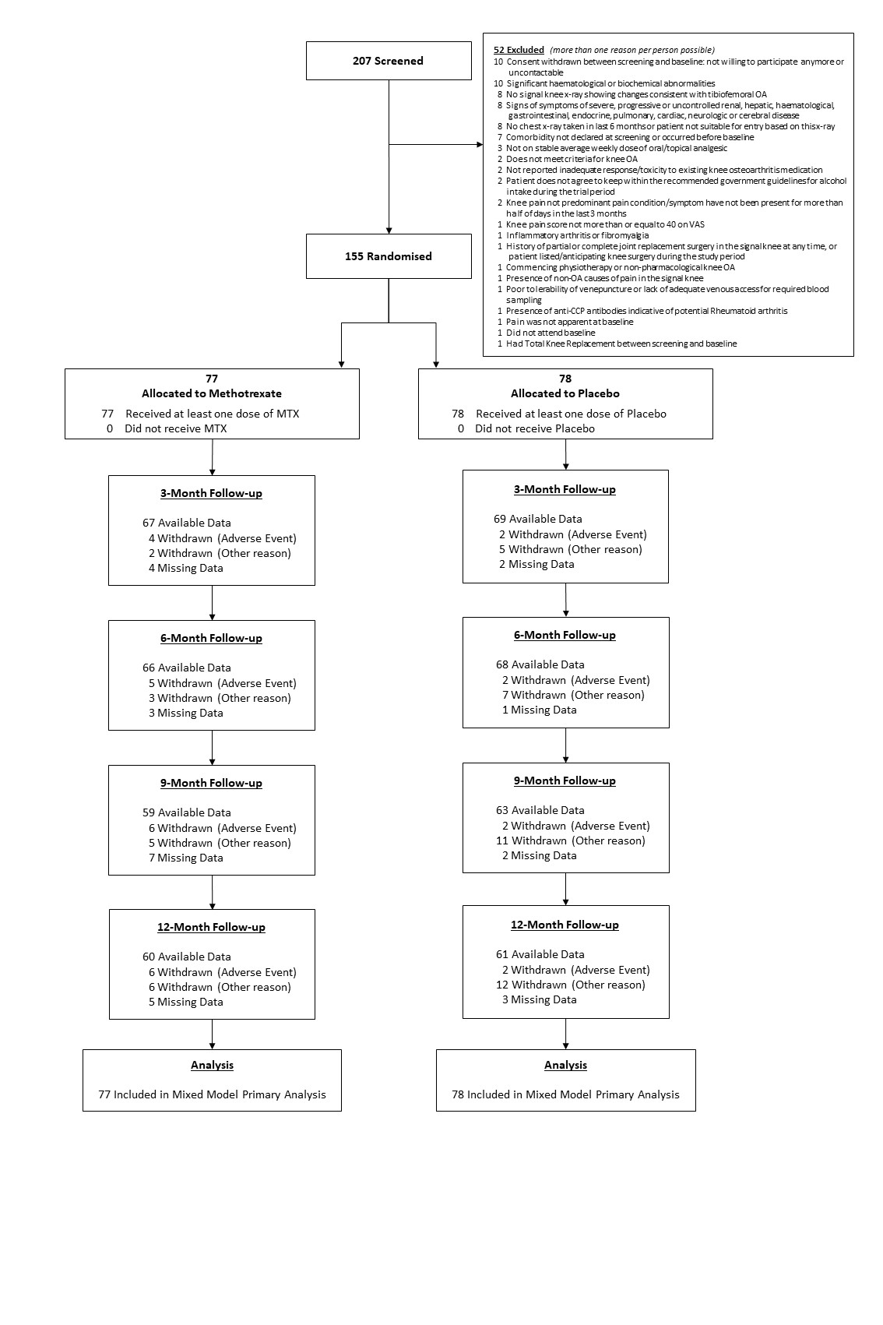
Figure 1. CONSORT Flow Diagram
Figure 2. Primary Outcome and Pain and Function Secondary Outcomes over Time (unadjusted means and 95% Confidence Intervals)
Overall Knee Pain (NRS) over the last week | WOMAC Pain
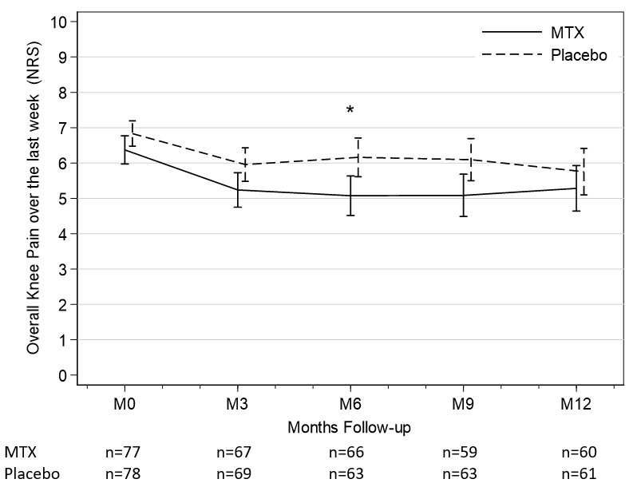 | 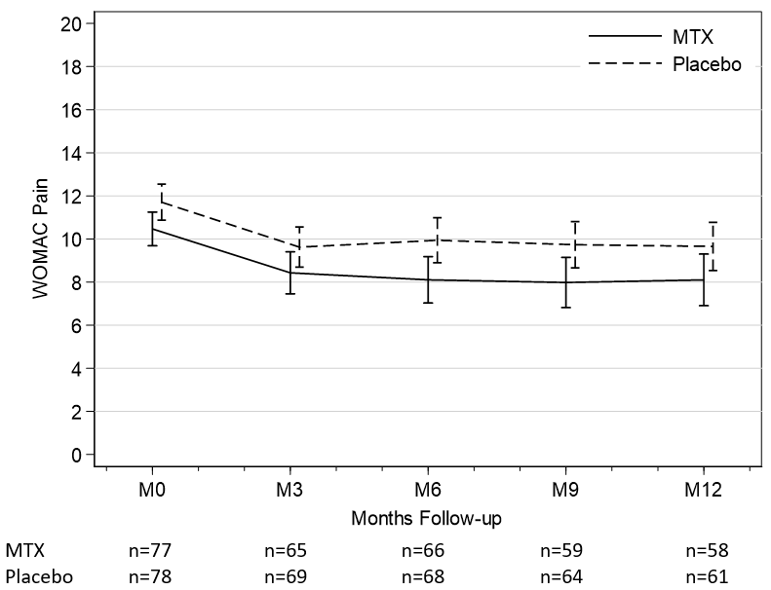
WOMAC Physical Function | WOMAC Stiffness
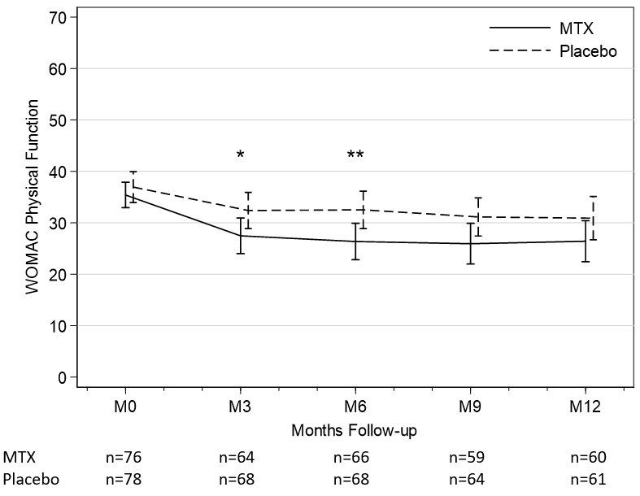 | 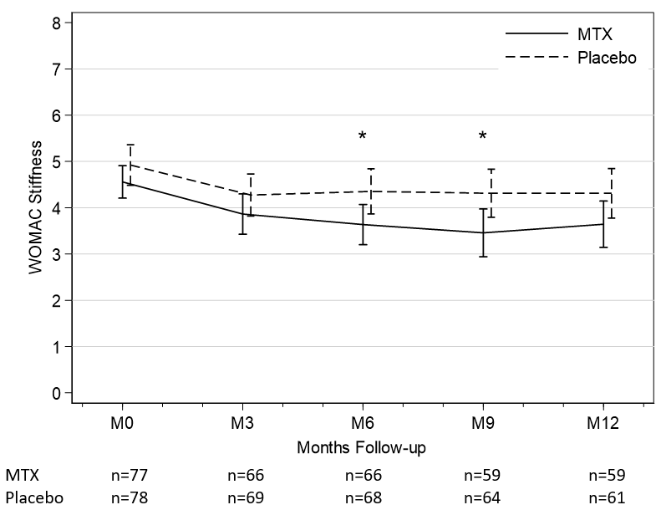
Abbreviations: Methotrexate (MTX); Numerical Rating Scale (NRS); Western Ontario and McMaster Universities Arthritis Index (WOMAC)
Statistical significance of group difference based on analysis models: * p<0.05, ** p<0.01

