**Lignin-based Conductive Hydrogels with Plasticity, Recyclability and Self-adhesion as Flexible Strain Sensors for Human Motion Monitoring**

Kunyun Rena, Yongdong Shia, Chaoyao Wena, Xinchang Kanga, Yu Tiana, Youjun Guana, Chengyun Ningb, Lei Zhouc,*, Rumin Fub,*, and Guoxin Tana,*

a*School of Chemical Engineering and Light Industry, Guangdong University of Technology, Guangzhou 510006, P. R. China.*

b *School of Materials Science and Engineering & National Engineering Research Center for Tissue Restoration and Reconstruction, South China University of Technology, Guangzhou 510006, P. R. China.*

c *Guangzhou Key Laboratory of Spine Disease Prevention and Treatment, Department of Spine Surgery, The Third Affiliated Hospital of Guangzhou Medical University, Guangzhou 510150, P. R. China.*

*d* *School of Dentistry, University of Leeds, Level 7, WTBB, St. James’s University Hospital, Leeds LS9 7TF, United Kingdom*

* Corresponding authors:

**E-mail**: zhoul@gzhmu.edu.cn (Lei Zhou); furumin@126.com (Rumin Fu); tanguoxin@126.com (Guoxin Tan)

**Abstract:** Conductive hydrogels possessing conductivity, flexibility and biocompatibility have garnered considerable attention in recent years for their applications in flexible wearable devices. However, most reported conductive hydrogels are mainly elastic hydrogel substrates with chemically cross-linked networks, poor shape adaptability and irreversible electromechanical properties after molding, thereby limiting their prospective utility in flexible electronics. In this study, we fabricate multifunctional lignin-gelatin-polypyrrole (LGP) hydrogels with plasticity, recyclability, strong adhesion, and biocompatibility via a straightforward methodology employing gelatin, polypyrrole, and sodium lignosulfonate. The resultant LGP hydrogel is interlinked by dynamic non-covalent bonds, yielding remarkable plasticity and recyclability, and could be manipulated by hand to fashion diverse shapes. Additionally, the LGP hydrogel displays substantial adhesion (23.88 kPa to pig skin) and maintains strong adhesion to wide substrates. The LGP hydrogel strain sensor demonstrates high sensitivity (GF = 6.08) and rapid response (107 ms), providing a stable resistive signal output for both large (25-200%) and small (1-5%) strains across diverse operating conditions. Moreover, the LGP hydrogel can be seamlessly integrated as a flexible wearable strain sensor to facilitate real-time monitoring of human physiological activities.

**KEYWORDS:** plasticity, recyclability, lignin, conductive hydrogel, [flexible sensor](https://pubs.acs.org/action/doSearch?action=search&AllField=Flexible+Sensor&qsSearchArea=AllField)

**1. Introduction**

In recent years, smart wearable devices have garnered significant attention from researchers due to their extensive applications in areas such as human health monitoring, electronic skin, human-machine interfaces, soft robotics, and sensing technology.1-5 Flexible strain sensors, which are soft and lightweight, excel in measuring extensive strains.6 Their adeptness at converting mechanical deformations into quantifiable electrical signals renders them ideally suited for incorporation into smart wearable technologies.7 Conductive hydrogel constitutes a three-dimensional polymer network constituted by hydrophilic polymer chains, by utilizing select polymers and polymer networks imparts the hydrogel with attributes such as enhanced flexibility, superior electrical conductivity, and robust adhesion.8-11 These qualities render conductive hydrogel an exemplary material for fabricating flexible strain sensors. The incorporation of conducting polymers, which possess intrinsic electronic conductivity such as polyaniline (PANi), polypyrrole (PPy), and poly(3,4-ethylenedioxythiophene)-poly(styrenesulfonic acid) (PEDOT:PSS) into hydrogel matrices, is a prevalent method for fabricating conductive hydrogels.12-14 Among these polymers, PPy stands out as a conductive polymer with excellent electrical conductivity, admirable biocompatibility, remarkable redox properties, and significant environmental stability, rendering it particularly suitable for integration with hydrogel matrices.15-18 Much of the previous research on conductive hydrogels has focused on elastic substrates with chemically cross-linked networks.8 These materials demonstrate characteristic elastic behavior yet suffer from limited shape adaptability, immutable electromechanical properties upon solidification, and in certain cases, potential toxicity manifested by some synthetic polymers, limiting their deployment in medical applications.11, 19-22 Moreover, the non-recyclability of synthetic polymers is a major environmental challenge.23 With the rapid development of wearable devices, this could lead to an increase in electronic waste, posing a significant risk to the ecological environment.24, 25

Lignin represents the second most abundant biomass in nature and is distinguished as the sole aromatic biopolymer present in plants.26, 27 Moreover, lignin possesses distinct advantages when utilized as a raw material for hydrogel fabrication. Primarily, the structural rigidity of lignin chains contributes positively to the enhancement of the mechanical properties of hydrogels.28 And the copious hydroxyl groups and benzene rings inherent in lignin encourage the formation of hydrogen bonds.29, 30 However, the limited water solubility of lignin hinders its potential to supplant water-soluble polyphenols in hydrogel applications.31, 32 Consequently, water-soluble sulfonated lignin has been employed as an alternative additive in conductive hydrogels to ensure uniform dispersion.33, 34 The sulfonic acid groups within lignosulfonates ionize readily within hydrogel matrices, leading to the deduction that an increased quantity of lignosulfonates results in enhanced ionization and by extension, higher electrical conductivity.35-37 Lignosulfonates are rich in reduced phenolic hydroxyl, methoxy, and sulfonic acid groups, which leads to adhesion to different substrates through hydrogen bonding, electrostatic interactions, and hydrophobic interactions.38-41 The low cost, wide availability, high conductivity, and good biocompatibility of lignin-based hydrogels make them good candidates for flexible wearable strain sensors in recent years.

In this study, we propose a straightforward method to prepare multifunctional conductive lignin-gelatin-polypyrrole (LGP) hydrogels exhibiting high electrical conductivity, plasticity, recyclability, strong adhesion, and biocompatibility. Pyrrole (Py) was blended into gelatin (Gel), and ammonium persulfate was subsequently added to induce the polymerization of Py into polypyrrole (PPy) directly within the Gel solution. Following the completion of the reaction, sodium lignosulfonate (LS) was then added, yielding the LGP hydrogel through gelation mediated by physical forces such as hydrogen bonding and electrostatic interactions. Gelatin endows LGP hydrogels with outstanding flexibility and biocompatibility. The hydrogen bonding between LGP hydrogels and water imparts significant self-healing viscoelasticity to the hydrogels. Notably, the LGP hydrogels demonstrate excellent plasticity and recyclability, allowing for hand kneading to achieve various shapes. Moreover, these hydrogels can be promptly restored to their original forms or reshaped after disruption by simply reassembling the pieces. The inclusion of phenolic hydroxyl, methoxy, and sulfonic acid groups from LS contributes to strong adhesion (23.88 kPa to pig skin). Further observations indicated that the LGP hydrogel sensor possessed high sensitivity (GF = 6.08), rapid responsiveness (107 ms), and a brief recovery time (99 ms), displaying excellent stability and durability across 600 cyclic load tests. Leveraging these superior attributes, the application of LGP hydrogel as a strain sensor was explored to monitor an array of human motions, encompassing both large joint activities (finger, wrist, elbow, walk, and neck) and subtle movements (swallow, pulse, smile, and frow), highlighting its significant potential in the realm of wearable flexible electronics.

**2. Experimental Section**

**2.1. Materials**

Sodium Lignosulfonate (LS), ammonium persulphate (APS), and Gelatin (with a gel strength of approximately 100g Bloom) were acquired from Shanghai Aladdin Biochemical Technology Co., Ltd. Pyrrole (Py, ≥98% purity) was sourced from Sigma-Aldrich. All reagents were utilized as received, without additional purification.

**2.2. Preparation of LGP Hydrogels**

Initially, dissolve the Gel in deionized water at 55℃ to prepare a 30 w/v% Gel solution. Subsequently, combine 100μL of Py with 2mL of the prepared Gel solution. Dissolve 0.49mg of APS in 1mL of deionized water and gradually introduce it to the Py-Gel mixture. Incubate the mixture at 4℃ for 12 hours to yield Solution A. Prepare LS Solution B to attain concentrations of 30w/v%, 40w/v%, and 50w/v%, each with a volume of 2mL. Vigorous shaking was employed to homogenize Solution A and Solution B, resulting in the formation of hydrogels. The resultant hydrogels were designated as LGP-1, LGP-2, and LGP-3, respectively.

**2.3. Characterization**

Fourier transform infrared spectroscopy (FTIR) was employed to confirm the synthesis of the LGP hydrogels, and the surface morphology was examined with field-emission scanning electron microscopy (FE-SEM, ZEISS Ultra 55, Germany). The LGP hydrogel samples were prepared in a cylindrical form with a diameter of 0.5 cm and a height of 1 cm. Prior to testing, the LGP hydrogel sample underwent lyophilization for seventy-two hours. After this, the sample was rendered brittle using liquid nitrogen, affixed to the sample stage with the cross section upward, and subjected to gold sputtering using coating equipment (SC7620, Quorum Technologies, UK) for 90 seconds to improve its electrical conductivity. Fourier transform infrared spectroscopy (FTIR, Nicolet 6700, Thermo Fisher Scientific) was conducted to ascertain the chemical composition of the samples. Before analysis, potassium bromide powder and the various sample materials were combined and pulverized to achieve a 1:100 mass ratio. Absorbance values for the samples were subsequently recorded in transmission mode over a wavelength range of 400–4000 cm−1.

**2.4. Swelling Measurement**

This study investigated the swelling behavior of dried LGP hydrogels using standard gravimetric methods. The LGP hydrogels were immersed in deionized water at 37℃ and subsequently retrieved at predetermined time points, blotted with absorbent paper, and measured for their mass. The swelling ratio (SR) was calculated using eq (1):

$SR=\frac{W_{t}-W_{0}}{W_{0}}×100\%$ (1)

where *Wt* denotes the mass of the hydrogel at a given time point after swelling, and *W0* denotes the initial mass of the hydrogel.

**2.5. Rheology Analysis**

The mechanical properties of LGP hydrogels were assessed using a rotational rheometer (Physica MCR301, Anton Paar). Frequency sweeps were conducted over a range of 0.1 to 10 Hz, maintaining a strain amplitude of 0.1% and a consistent temperature of 37℃. The hydrogel's self-healing capacity was gauged through an alternating step-strain scanning test at 37℃, utilizing a constant frequency of 1 Hz. The oscillatory strain alternated between a small amplitude (*γ*=0.1%) and a large amplitude (*γ*=100%), each maintained for a duration of 100 seconds. Conducting an oscillatory time sweep lasting 130 seconds at a controlled strain of 0.1% and a frequency of 1 Hz allowed for the measurement of the gelation kinetics. Changes in the storage modulus (*Gʹ*) and loss modulus (*Gʺ*) over time were monitored throughout the oscillatory time sweep. To ascertain the hydrogel's injection potential, a shear rate scanning test was conducted (shear rates ranging from 0.1 to 100 s-1) at a constant strain of 1%. This assessment is indicative of the hydrogel's injectability.

**2.6. Adhesion Tests**

The aim of this study was to quantify the adhesion strength of LGP hydrogels to various substrates employing a lap shear assay. The hydrogel was uniformly distributed between pairs of identical substrates including pig skin, wood, glass, polytetrafluoroethylene and iron, each featuring a contact area of 1 cm × 1 cm. Following incubation at 37℃ for 10 minutes followed by a 20 minute period at room temperature, a lap shear test was conducted with a dynamic mechanical analyzer (CMT-2503, Sansi Taijie, China) operating at a crosshead speed of 5 mm/min.

**2.7. Electrical Tests**

The hydrogel's electrical properties were determined using cyclic voltammetry (CV), electrochemical impedance spectroscopy (EIS), and Baud spectrum tests with an electrochemical workstation (Shanghai Chenhua, 660E). Indium tin oxide (ITO) conductive glass was coated with a thin layer of LGP hydrogel of different components and LS-Gel mixture and then immersed in phosphate-buffered saline (PBS: 0.1 M, pH= 7.3) parallel to the platinum electrode. ITO was used as a control. The conductivity of LGP hydrogels and LS-Gel mixture at room temperature was measured using a four-point Probe (RTS-8, 4 Probe Tech, China).

**2.8. Biocompatibility Study**

The cytocompatibility of hydrogels with L929 fibroblasts was evaluated through live/dead assays and CCK-8 tests. Before seeding, the hydrogels were sterilized with 75% ethanol for 12 hours and subsequently rinsed with PBS four times to eliminate residual ethanol. The hydrogel samples were positioned in a 48-well plate and incubated in 500 μL dulbecco's modified eagle medium (DMEM) supplemented with 10% fetal bovine serum for 12 hours. Cell density was adjusted to 1 × 104 cells/mL, and the resultant cell suspension was inoculated onto the hydrogel extract. Following 1, 3, and 5 days of co-cultivation, the cells were labeled with Acetyl methoxymethyl ester (AM, for viable cells) and Propidium iodide （PI, for non-viable cells). Observations of the sample were conducted with an Olympus IX73 inverted microscope, outfitted with an Olympus U-HGLGPS fluorescent light source and an Olympus XM10 camera.

L929 cell proliferation within the hydrogel was monitored via the Cell Counting Kit-8 (CCK-8) assay. The initial seeding density stood at 1 × 104 cells/mL. The CCK-8 assay was executed on days 1, 3, and 5 post-incubation, utilizing fresh medium containing 10% CCK-8 solution. Subsequently, the medium was incubated at 37°C for 2 hours, and the optical density (OD) at 450 nm was recorded by a microplate reader (MK3, Thermo Fisher Scientific, USA).

**2.9. Mechanical - Electrical Response Tests**

The mechanical and electrical behavior of the LGP hydrogel were characterized with a signal measurement system, comprised of a dynamic mechanical analyzer, a data acquisition unit, and a force sensor. For the LGP strain sensor fabrication, the LGP hydrogel was manually molded and subsequently sandwiched between two Very High Bond（VHB）tapes (length: 40 mm, width: 15 mm, thickness: 2 mm), with copper sheets securing both ends of the hydrogel. The gauge factor (GF) to tensile strain was determined employing eq (2):

$GF=\frac{\frac{R-R_{0}}{R_{0}}}{ε}$（2）

where *ε* represents the strain, *R0* and *R* represent the resistance without strain and with strain, respectively.

**2.10. Sensing Applications**

For the fabrication of the LGP strain sensor, the LGP hydrogel was manually manipulated and subsequently enveloped between two VHB tapes (length: 40 mm, width: 15 mm, thickness: 2 mm). The extremities of the hydrogel were affixed with a copper sheet. Resistance measurements are conducted using a multimeter (Keithley DMM7510, USA) with an AC voltage of 1 V applied. These measurements serve to monitor human physiological responses, including joint movements, swallowing, pulse, and the dynamics of smiling and frowning.

**3. Results and Discussion**

**3.1. Design and Preparation of the LGP Hydrogels**

The schematic representation of the LGP hydrogel preparation process is depicted in Figure 1a. Initially, Py was introduced into the Gel solution and subsequently oxidized to PPy via per-APS, resulting in a black mixed solution (Figure. S1). Thereafter, LS solution was incorporated to yield the LGP hydrogel. Gelation then occurred due to dynamic non-covalent bonding among Gel, PPy, and LS. Cross-linking is established through intermolecular interactions between the phenolic hydroxyl and methoxy groups of LS, the amino groups of the Gel side chain, and the protonated nitrogen groups of PPy. Owing to the multitude of dynamic non-covalent bonds among the LGP hydrogel's components, it boasts excellent plasticity, allowing for highly flexible and controlled customization into a variety of desired shapes, including whimsical forms like cartoon rabbits, houses, stars, and butterflies, via manual shaping (Figure 1b). In contrast to preformed hydrogels, LGP hydrogels offer the added benefit of recyclability. As depicted in Figure 1c, after the LGP hydrogel is manually shaped and subsequently disrupted, it can seamlessly return to its original shape and be reshaped. The LGP hydrogel can conform to irregular interfaces and be affixed to human joints, thus facilitating the detection of motion signals by strain sensors (Figure 1d).

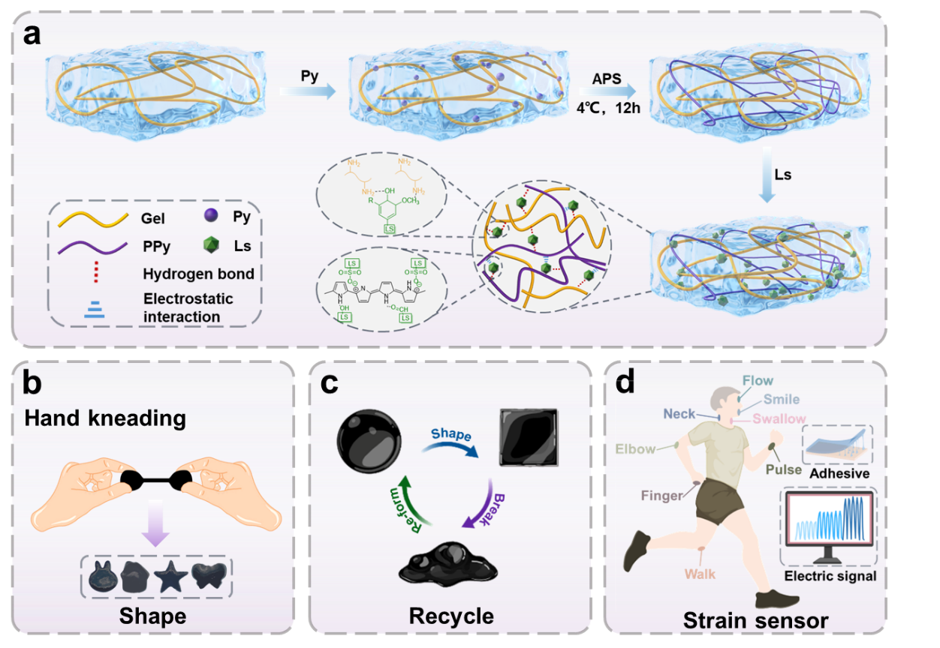

**Figure 1.** LGP hydrogel preparation process and applications. **a** Schematic diagram of LGP hydrogel preparation. **b** Shaping of LGP hydrogel by kneading. **c** Properties of LGP hydrogel recycling. **d** LGP hydrogel as strain sensor for motion signal detection.

**3.2. Physicochemical and Characterization of the LGP Hydrogels**

Figure S2 presents the FTIR spectra of Gel, LS, PPy, and LGP hydrogels. The peak at 1658 cm-1 corresponds to the amido I peak of gelatin, while the peak at 1038 cm-1 is attributed to the stretching vibration of the S=O bond in LS. The peak at 1438 cm-1 corresponds to the asymmetric stretching vibration peak of the pyrrole ring in PPy.42 The FTIR spectrum of the LGP hydrogel exhibits characteristic peaks of Gel, LS, and PPy, suggesting a successful integration of the three components. The microscopic morphology of LGP hydrogels post-lyophilization was characterized by scanning electron microscopy (SEM) (Figure S3). The hydrogels demonstrated a porous network structure. The swelling rates of LGP-1, LGP-2, and LGP-3 hydrogels are reported as 52.24%, 45.54%, and 43.45%, respectively, as depicted in Figure S4. The swelling rates of LGP hydrogels exhibited a slight decrease with an incremental addition of LS content. Additionally, LGP hydrogels demonstrate plasticine-like properties and can be readily molded into various shapes, such as cartoon rabbits, houses, stars, and butterflies (Figure 2a). As depicted in Figure 2b, the LGP hydrogels possess a unique ability for repeated recycling due to their dynamic non-covalent bonds. When subjected to external forces, the damaged hydrogels have the capacity to immediately reform their original shape and undergo reshaping. Furthermore, the LGP hydrogel was incorporated into a light-emitting diode (LED) bulb circuit as depicted in Figure 2c. Disconnection of the LGP hydrogel led to a subsequent interruption of the circuit and the cessation of light emission from the LED bulb. The LGP hydrogel underwent cutting and subsequent reassembly. Once the hydrogel self-healed, the circuit was reestablished, and the LED bulb resumed emitting light. Rheological analyses were performed to assess the viscoelastic properties of the hydrogels. The self-healing properties of LGP hydrogels were quantified utilizing continuous high-low strain cyclic scanning measurements (Figure 2d). At a strain of 0.1%, the storage modulus (*G'*) of the LGP hydrogel surpasses the loss modulus (*G''*). However, at a strain of 100%, the *G''* of the LGP hydrogel surpasses the *G'*, suggestive of structural damage to the gel. Upon the strain reverting to 0.1%, the *G''* of the LGP hydrogel is found to be less than the *G'*. This reversibility is evidenced by the finding that upon returning to a strain of 0.1%, the *G''* is once again less than the *G'*, evidencing the hydrogel network's capacity for reversible and repeatable sol-gel transformation during the alternating strain cycle test. As determined by rheological time scanning, the *G'* and *G"* of the hydrogel exhibit minimal variation within 260 seconds (Figure 2e), indicating that the hydrogel maintains considerable stability. As indicated in Figure 2f, under a 0.1% strain condition, the *G'* and *G''* demonstrate a gradual increase with frequency. Initially, the *G'* is less than the *G''*, yet it subsequently exceeds the latter. Throughout the scanning frequency range, the *G'* is comparable to the *G''*, which signifies that the LGP hydrogel displays exceptional viscoelasticity and is indicative of its plasticity. At a frequency of 1 Hz, the *G'* demonstrates a consistent ascent in conjunction with an increased LS content (Figure 2g). This suggests that elevating the LS content can augment the mechanical properties of hydrogels. The steady-state shear rheological analysis presented in Figure 2h demonstrates that the viscosity of the LGP hydrogel decreases sharply as the shear rate progressively increases, which signifies that the LGP hydrogel possesses typical shear thinning characteristics. The shear-thinning behavior of the LGP hydrogels can be ascribed to the disintegration of the hydrogel network under progressively increasing strain, arising from their cross-linking through dynamic non-covalent bonds. Furthermore, the plasticity and shape retention of the hydrogel could stem from the swift disruption and reformation of reversible non-covalent bonds within the hydrogel network.43

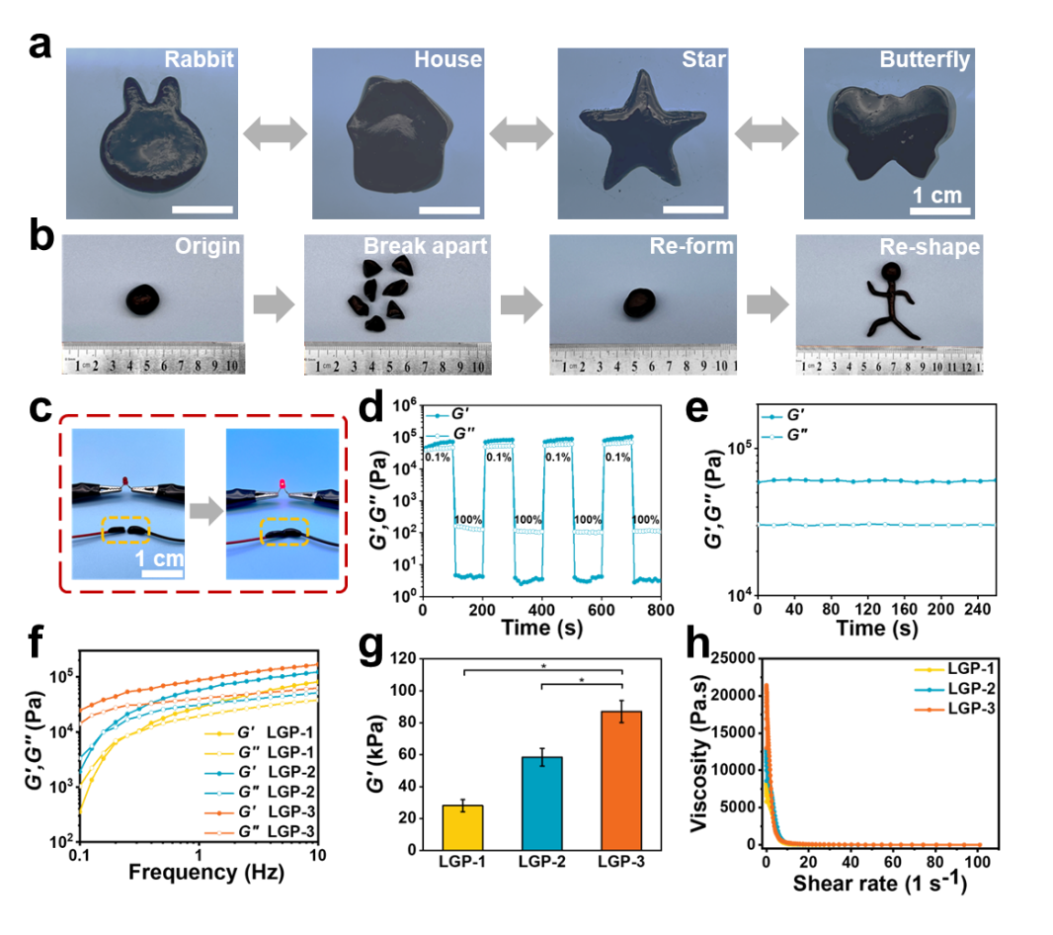

**Figure 2.** Mechanical properties of LGP hydrogel. **a** LGP hydrogel can be processed into various shapes. **b** LGP hydrogel has recycling ability. **c** Self-repairing circuits constructed with LGP hydrogel. **d** Sequential step strain test of LGP hydrogel from small strain (0.1%) to large strain (100%) at 1 Hz frequency at 37°C. **e** Time-scan rheological test of LGP hydrogel. **f** Rheological analysis of LGP hydrogels in the frequency sweep mode at 37°C. **g** Energy storage modulus of LGP hydrogels at 1 Hz. **h** Shear thinning rheology test of LGP hydrogels at 37°C. All statistical data are represented as mean ± SD. (\**P*< 0.05, \*\**P*< 0.01, \*\*\**P*< 0.001, *n*= 3)

**3.3. Self-adhesion of LGP Hydrogels**

LGP hydrogels offer the advantage of adhesion, enhancing the integrity of the interfacial bond. Figure 3a illustrates that LGP hydrogels maintain robust adhesion to diverse substrates, such as polytetrafluoroethylene (PTFE), aluminum, glass, rubber, iron, polypropylene (PP), wood, and biaxially oriented polypropylene film (BOPP). Furthermore, LGP hydrogels demonstrate superior tissue adhesion, advantageous for the monitoring of human joint motion. To quantitatively evaluate the adhesion strength of LGP hydrogels, lap shear testing was performed on various LGP hydrogels as well as pig skin (Figure 3b). The shear stress-displacement curve presented in Figure 3c indicates that with increasing tensile displacement, the shear stress of the LGP hydrogel rapidly escalates to a peak before undergoing a decline. Figures 3d reveal that the adhesion strength of the LGP hydrogel to pig skin initially surges from 19.05 kPa to 23.88 kPa with increasing sodium lignosulfonate concentration. However, this strength subsequently declines to 16.68 kPa, a trend that might be attributed to the enhanced cohesive property of the LGP hydrogel. The adhesive properties of the LGP hydrogel are influenced by variations in the LS content. Moreover, the hydrogels demonstrated repeatable bonding behavior on pigskin across ten cycles of adhesion and detachment. Although the adhesion strength of the elastomers exhibited a slight decrease after repeated cycles, they maintained stable adhesion (Figure S5). Even after an hour of adherence to human skin, the LGP hydrogel can be easily removed without leaving any residue (Figure S6). The robust adhesion between the LGP hydrogel and pig skin can be ascribed to the electrostatic interactions and hydrogen bonds formed at the interface present on both the LGP hydrogel and pig skin. Figure 3e delineates the adhesion mechanism of LGP hydrogels, incorporating active functional groups including hydroxyl, carboxyl, and sulfonic groups. These functional groups enable LGP hydrogels to adhere to a range of substrates through mechanisms such as electrostatic interactions, hydrophobic interactions, and hydrogen bonding. Additionally, the adhesion strength of LGP hydrogels to various common substrates has been quantitatively ascertained. Figures 3f and g illustrate that the adhesion strength of the LGP hydrogel on wood is the highest at 126.61 kPa, followed by glass at 48.26 kPa, iron at 34.42 kPa, PTFE at 24.45 kPa, and pig skin at 23.88 kPa. The adhesive forces of LGP hydrogels are contingent on the properties of the substrates. For instance, LGP hydrogels exhibit the greatest adhesion to wood, which may be attributed to the porous structure of the wood surface, permitting the LGP hydrogels to penetrate into internal gaps, thereby forming physical interlocks and enhancing adhesive strength. Conversely, LGP hydrogels demonstrate reduced adhesive forces on substrates such as glass, iron, and PTFE, owing to the materials' smooth surface, which impedes the penetration of the LGP hydrogel. Moreover, the physicochemical attributes of LGP hydrogels play a pivotal role in dictating their adhesive strength. The cohesive and adhesive strengths of LGP hydrogels escalate with increased LS content. However, an overabundance of LS leads to enhanced crosslinking density within LGP hydrogels, which corresponds to diminished adhesive strength.44, 45 An overabundance of LS may induce phase separation within the LGP hydrogel, compromising the interfacial interactions with the substrate.46 Consequently, the adhesive strength of the LGP hydrogel initially surges but subsequently wanes as the LS content increases. Optimal adhesion promotes intimate contact between the hydrogel and sensor packaging material, enhancing the collection of motion signals during the utilization of the hydrogel strain sensor.

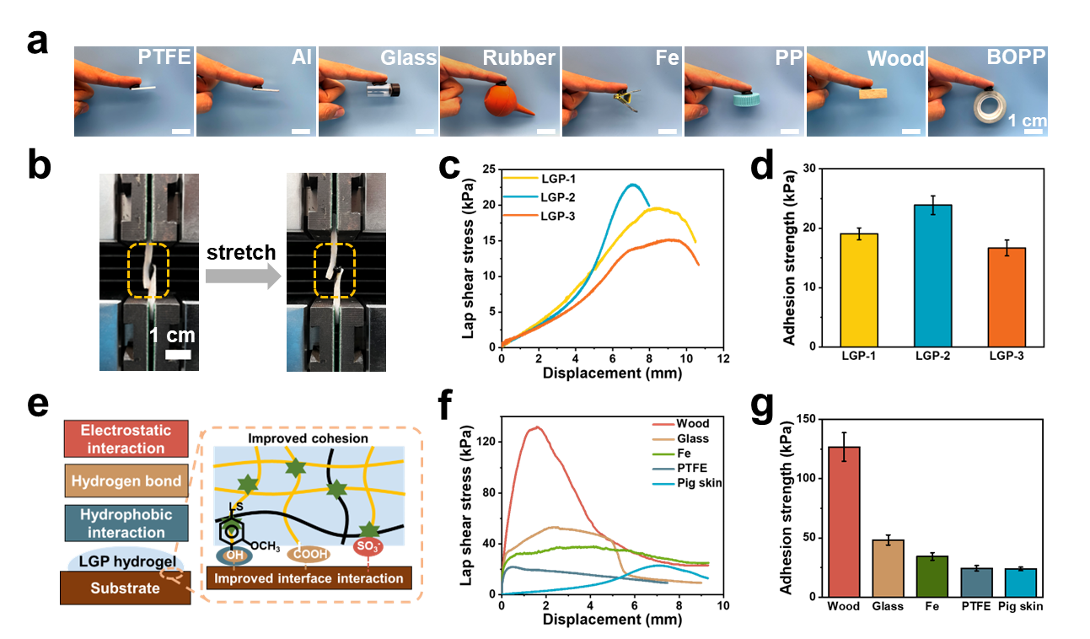

**Figure 3.** Self**-**adhesive properties of LGP hydrogels. **a** LGP hydrogel adhesion to various material surfaces and tissues. **b** Physical diagram of LGP hydrogels lap shear test. **c** Lap shear test on pig skin with LGP hydrogels. **d** Adhesion strength of LGP hydrogels to pig skin. **e** Adhesion strength of LGP hydrogels to substrate. **f** Lap shear test of LGP hydrogels on various substrates. **g** Adhesion strength of LGP hydrogels to various substrates.

**3.4. Electrical Study of LGP Hydrogels**

The electrical characteristics of LGP hydrogels were assessed with cyclic voltammetry (CV). A LS-Gel mixture and different LGP hydrogels were cast onto indium tin oxide (ITO) conductive glass substrates and submerged in phosphate-buffered saline (PBS: 0.1 M, pH 7.3). Figure 4a demonstrates that all LGP hydrogels display expansive hysteresis loops, in contrast to the LS-Gel complex which features more contained hysteresis loops. In comparison, the hysteresis loop generated by the standalone ITO conductive glass is negligible (Figure S7). The CV profile reveals that the LGP-2 hydrogel group possesses the broadest hysteresis loop area, with a current response exceeding that of the other hydrogels, which suggests enhanced electrical properties for the LGP-2 group. To further probe the electrical properties of LGP hydrogels, electrochemical impedance spectroscopy (EIS) measurements were carried out. Figure 4b illustrates that, within the high-frequency domain of the Nyquist plot, all LGP hydrogels and LS-Gel mixtures present a discernible semicircle diameter. The LGP-2 hydrogel exhibits the smallest semicircle diameter, in contrast to the LS-Gel mixture, which displays the largest. This indicates that LGP-2 hydrogels possess a relatively lower charge transfer resistance compared to the remaining LGP hydrogels and LS-Gel mixture. The results of the conductivity tests performed on the LS-Gel mixture and various LGP hydrogels were similar, as depicted in Figure 4c. Conductivity values for the LS-Gel mixture and various LGP hydrogels are recorded as: LS-Gel (0.24 mS cm-1), LGP-1 (1.66 mS cm-1), LGP-2 (2.30 mS cm-1), and LGP-3 (2.23 mS cm-1). The LGP-2 hydrogel's conductivity registered at a value 9.5 times greater than that of the LS-Gel. The LGP hydrogels' electrical properties are markedly superior to those of the LS-Gel mixture, owing to the embedded PPy network within the LGP hydrogels that enhances electrical conductivity. Figure 4d displays the Bode plot of the LGP hydrogel. The figure demonstrates that the LGP hydrogel exhibits an elevated impedance at low frequencies and a diminished impedance at high frequencies, indicative of stable electrical characteristics. The electrical properties of LGP hydrogels are likely associated with their crosslinking density and LS content. Given that the PPy content remains constant, an increased LS content leads to a heightened crosslink density and augments the conductivity.47 The diminished conductivity attributable to the enhanced crosslink density is lower than the elevated conductivity arising from increased LS content.48 Consequently, the LGP-2 hydrogel exhibits greater conductivity than its LGP-1 counterpart. However, should the amplification in crosslink density lead to a more pronounced reduction in conductivity than the rise in LS content, the conductivity of the LGP hydrogel would diminish. This scenario is exemplified by LGP-3, which exhibits lower conductivity than LGP-2. The results from CV, EIS, and conductivity measurements corroborate that LGP-2 possesses superior electrical properties and charge transfer capabilities when compared to LGP-1 and LGP-3.

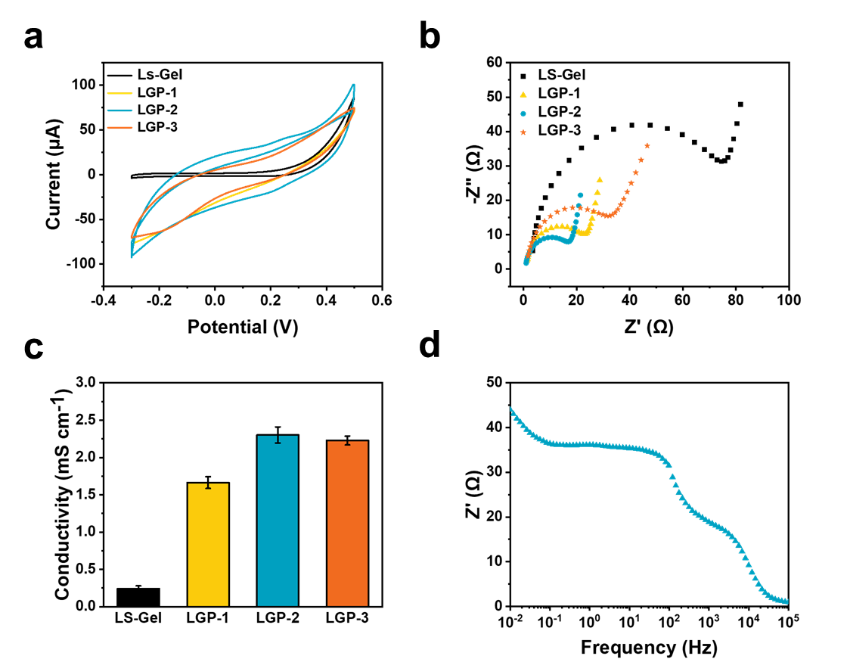

**Figure 4.** Electrical properties of LGP hydrogels. **a** Cyclic voltammetry curves of LGP hydrogels and LS-Gel mixture. **b** Nyquist plot of LGP hydrogels and LS-Gel mixture. **c** Conductivity of LGP hydrogels and LS-Gel mixture. **d** Bode plot of LGP hydrogel.

**3.5. Mechanical - Electrical Responsiveness of LGP Hydrogels**

To evaluate the suitability of LGP hydrogels for wearable flexible strain sensors, a systematic investigation into their mechano-electrical responsiveness was undertaken. LGP hydrogel was encapsulated within elastic VHB tape for deployment as a strain sensor, leveraging its considerable viscoelastic and electrically conductive properties. For the electromechanical response trial preparation (Figure 5a), the LGP hydrogel was ensconced between two layers of VHB tape. Sensing signal evaluation is predicated on strain sensitivity, ascertained by the computation of the gauge factor (GF), defined as the relative resistance change *ΔR*/*R0* (where *ΔR* = *R* - *R0*), in relation to the strain curve's gradient.49 In this context, *R* denotes the resistance post-stretching, and *R0* indicates the baseline resistance. As shown in Figure 5b, the resistance variation within the LGP hydrogel under strains ranging from 0-300% has been documented, and the corresponding graph demonstrates a proportional increase in relative resistance correlating with the increment in tensile strain. The LGP hydrogel exhibits a GF value of 6.08, exhibiting exceptional strain sensitivity, rapid response time (107 ms), and quick recovery time (99 ms) (Figure 5c), evidencing its superior mechanical and electrical properties. Figure 5d reveals that the LGP hydrogel's resistance signal was maintained with relative uniformity throughout diverse stretching rates (25-200 mm min-1), underscoring its stability. Extended testing on the resistance response under a spectrum of strain intensities (Figures 5e, f) confirmed the hydrogel's consistent performance through a range of strain magnitudes, from minimal to extensive (1-5% and 25-200%). This excerpt highlights the LGP hydrogel sensor's elevated sensitivity and broad operational range. It is imperative to underscore that enduring stability is pivotal for the sustained durability of flexible strain sensors. Literature suggests that in-situ self-healing capabilities considerably enhance long-term durability in flexible strain sensors. While the LGP hydrogel encapsulated in VHB tape may fracture under significant tensile strain, its self-healing ability assures the re-establishment of a continuous conductive pathway. We performed 600 consecutive load tests on the LGP hydrogel tensile sample at 100% elongation to gauge its durability and long-term performance. Figure 5g illustrates that the LGP hydrogel sensor maintains robust amplitude and waveform integrity, evidencing outstanding stability and endurance. This further confirms the LGP hydrogel's viability as a strain sensor. Additionally, the self-healing characteristics of the circuit formed with the LGP hydrogel have been investigated through real-time electrical current measurements. The circuit's electrical current was reinstated to its pre-severance level once the cut LGP hydrogels had been re-joined. The findings demonstrate that the hydrogel's self-healing properties facilitate consistent electrical conductance and prolong the operational lifespan of the LGP hydrogel in strain-sensing applications. To provide a comprehensive perspective, the LGP hydrogel sensor underwent comparative analysis with other conductive hydrogel sensors documented in the literature (Table S1). This comparative analysis underscored the sensor's sensitivity, conductivity, and adhesiveness, thereby affirming its efficacy as a flexible wearable electronic device for detecting human motion.

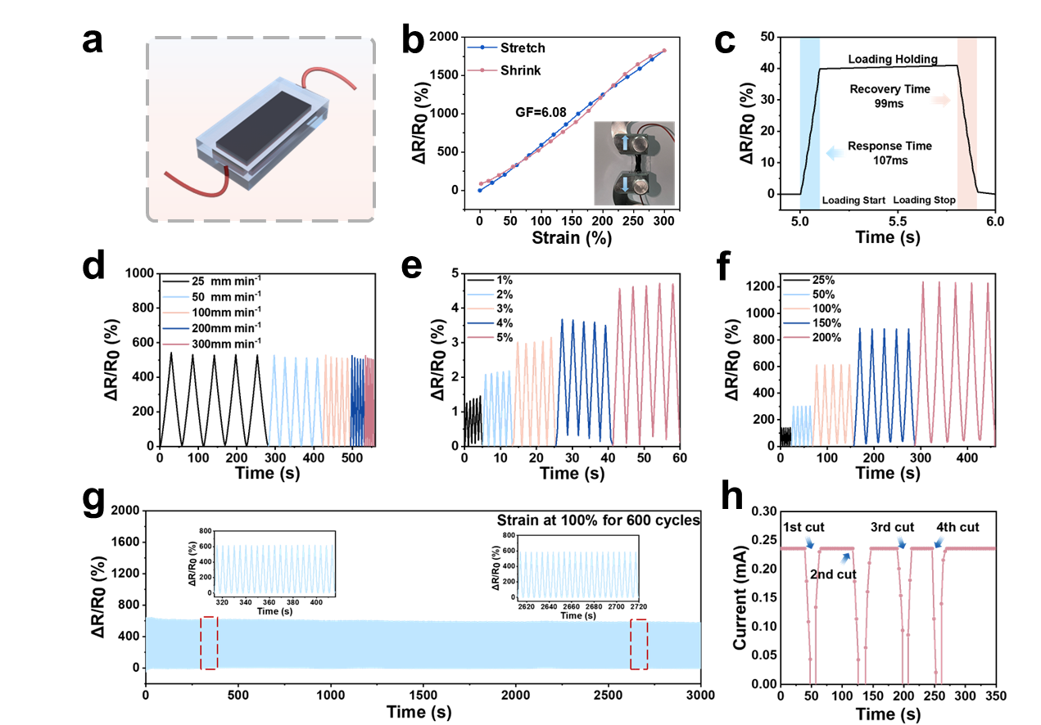

**Figure 5.** Mechanical - Electrical properties of LGP hydrogel. **a** Schematic diagram of LGP hydrogel encapsulation. **b** Response of relative resistance of LGP hydrogel with strain. **c** Response time to relative resistance change during a single tensile release. **d** Response time of relative resistance change at different drawing rates. **e** Response time of relative resistance change at different small strains. **f** Response time of relative resistance change at different large strains. **g** Response of relative resistance of LGP hydrogel under 600 cyclic loading and unloading tests with a maximum strain of 100%. **h** Current change of LGP hydrogel during cutting healing.

**3.6. Sensing Application of LGP Hydrogels**

The LGP hydrogel demonstrates exceptional plasticity, remarkable sensing capabilities, and high electrical conductivity, rendering it ideal for employment as a wearable sensor to detect a diverse array of human physiological movements. Figure 6 illustrates how the LGP hydrogel sensor facilitates swift and precise monitoring of extensive joint movements, including those of the fingers, wrists, elbows, walks, and neck (Figures 6a-e). The sensor is capable of consistently and accurately discerning finger joint movements across a spectrum of angles (30-90°), in real-time (Figure 6a). With the incremental angulation of finger bending from 30° to 90°, the relative resistance signal escalates commensurately. Upon straightening the finger, the relative resistance signal rapidly reverts to its baseline state. Additionally, the LGP hydrogel sensor can precisely track variations in the velocity of wrist movements (Figure 6b). The study observed that the relative resistance signal is less frequent when the wrist articulates slowly and more frequently during rapid movements. Consequently, these findings indicate that sensors based on LGP hydrogel possess exceptional sensitivity and hold promise for use in the surveillance of joint kinetics and the diagnosis of pathological conditions. Furthermore, the LGP hydrogel sensor is adept at discerning not only the movement of large joints but also minute human actions like swallowing, pulse detection, and facial expressions such as smiling and frowning, with remarkable precision (Figures 6f-i). When the hydrogel was secured to the throats of test subjects, the resultant electrical signals fluctuated promptly, distinctly identifying the mechanical changes associated with swallowing (Figure 6f). As depicted in Figure 6g, the LGP hydrogel sensor successfully captures minimal pulse oscillations with relative resistance variations not exceeding 1.5%, attributable to the subtle amplitude of the pulse. Signals recorded from the radial artery typically exhibited three characteristic peaks, named the percussion wave (P1), tidal wave (P2), and diastolic wave (P3). Moreover, the LGP hydrogel sensor showcases stability and precision when monitoring smile dynamics as illustrated in Figure 6h. It is noteworthy that the LGP hydrogel sensor precisely distinguishes between various forms of frowning, exhibiting a diminished relative resistance output for inward frowns relative to that of raised eyebrows. This capability facilitates the discrimination of distinct frowning patterns (Figure 6i). In conclusion, the LGP hydrogel sensor is capable of differentiating body movements by analyzing the configuration of the response curve and the signal intensity. It can ascertain the specific nature, scale, and velocity of the motion by evaluating the contour, peak, and breadth of the signal waveform. Furthermore, the hydrogel sensor exhibits subtle variations in response to identical motions attributable to discrepancies in signal amplitude. The LGP hydrogel demonstrates considerable promise as a flexible strain sensor for observing human motion and facilitating healthcare analysis within the realm of soft wearable electronics. This is predicated on its inherent sensing attributes suitable for tracking both extensive and subtle human body movements.

Assessing cytocompatibility is imperative for conductive hydrogels intended for human motion detection applications. For the cytocompatibility evaluation of LGP hydrogels, L929 fibroblasts were incubated alongside the hydrogel extracts in 48-well plates over a period of several days. Cells cultured in standard tissue culture plates served as controls. In assays involving live/dead cell staining, both the LGP hydrogel and the blank control groups exhibited robust cell proliferation over 1, 3, and 5 days of culture, demonstrating the LGP hydrogel's exceptional cytocompatibility (Figure S8a). Cell viability assessments were performed via Cell Counting Kit-8 (CCK-8) assays, revealing no statistically significant disparities between the two groups (Figure S8b). Moreover, an increase in optical density values corresponding with prolonged incubation was observed, indicative of cell proliferation. These results confirm that LGP hydrogels possess favorable biocompatibility, encourage cell proliferation, and are suitable for use in human movement monitoring.

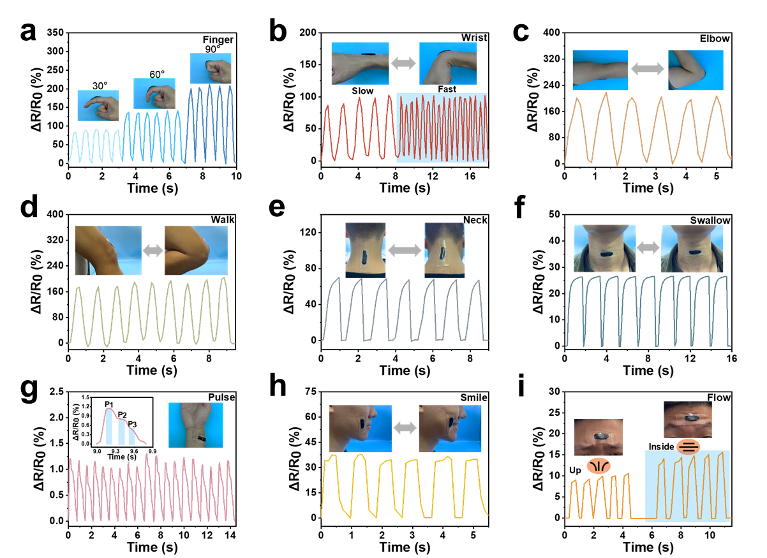

**Figure 6.** LGP hydrogel as a strain sensor to detect human motion signals. **a** finger with different bending angles, **b** wrist movements at different speeds of motion, **c** elbow movement, **d** walking movement, **e** neck movement, **f** swallowing, **g** pulse beating, **h** facial smile change, **i** frowning relative resistance change.

**4. Conclusion**

In summary, we have developed a multifunctional LGP hydrogel strain sensor exhibiting plasticity, recyclability, self-healing, strong adhesion, high conductivity, and excellent biocompatibility using a straightforward technique. Given that the hydrogel is characterized by cross-linking through various dynamic non-covalent bonds, it possesses exceptional plasticity, enabling it to be shaped into any desired form, including whimsical shapes such as cartoon rabbits, houses, stars, butterflies, and more. Additionally, the LGP hydrogels can reassume their original form and undergo additional molding following destruction and recombination. Furthermore, attributable to the abundance of phenolic hydroxyl, methoxy, and sulfonic acid groups contributed by LS, the LGP hydrogel demonstrates excellent adhesion (23.88 kPa to pig skin) to various substrates. Notably, the LGP hydrogel strain sensor exhibits high strain sensitivity (GF = 6.08) and a rapid response (107 ms), providing stable resistive signal output for both minimal (1-5%) and significant (25-200%) strains across a broad operating range. Moreover, it demonstrates exceptional durability and stability throughout 600 cyclic load tests. These properties render the hydrogel particularly suitable for integration into wearable flexible strain sensors, enabling the real-time monitoring of human physiological activities, ranging from major joint motions to subtle movements like swallowing, pulse detection, smiling, and frowning. We propose that our study represents a viable approach to fabricating a wearable flexible strain sensing device endowed with plasticity, recyclability, self-healing capability, strong adhesion, high conductivity, and excellent biocompatibility, optimized for human motion monitoring that can contribute to human health management and sports training.

**ASSOCIATED CONTENT**

**Supporting Information**

The Supporting Information is available free of charge

Optical pictures of Gel, Gel-PPy mixture and LGP hydrogel; FTIR spectra of Gel, LS, PPy and LGP hydrogel; SEM images of LGP hydrogel; Swelling ratios of LGP hydrogels; Cyclic voltammograms of ITO and LGP hydrogel; Biocompatibility assessment of LGP hydrogel.

**AUTHOR INFORMATION**

**Corresponding Authors**

**Lei Zhou −** *Guangzhou Key Laboratory of Spine Disease Prevention and Treatment, Department of Spine Surgery, The Third Affiliated Hospital of Guangzhou Medical University, Guangzhou, 510150, P. R. China*;E-mail: zhoul@gzhmu.edu.cn

**Rumin Fu −** *School of Materials Science and Engineering & National Engineering Research Center for Tissue Restoration and Reconstruction, South China University of Technology, Guangzhou 510006, P. R. China*; E-mail: furumin@126.com

**Guoxin Tan −** *School of Chemical Engineering and Light Industry, Guangdong University of Technology, Guangzhou 510006, P. R. China*; E-mail: tanguoxin@126.com

**Authors**

**Kunyu Ren****−** *School of Chemical Engineering and Light Industry, Guangdong University of Technology, Guangzhou 510006, P. R. China.*

**Yongdong Shi****−** *School of Chemical Engineering and Light Industry, Guangdong University of Technology, Guangzhou 510006, P. R. China.*

**Chaoyao Wen****−** *School of Chemical Engineering and Light Industry, Guangdong University of Technology, Guangzhou 510006, P. R. China.*

**Xinchang Kang****−** *School of Chemical Engineering and Light Industry, Guangdong University of Technology, Guangzhou 510006, P. R. China.*

**Yu Tian****−** *School of Chemical Engineering and Light Industry, Guangdong University of Technology, Guangzhou 510006, P. R. China.*

**Youjun Guan****−** *School of Chemical Engineering and Light Industry, Guangdong University of Technology, Guangzhou 510006, P. R. China.*

**Chengyun Ning −** *School of Materials Science and Engineering & National Engineering Research Center for Tissue Restoration and Reconstruction, South China University of Technology, Guangzhou 510006, P. R. China.*

**Author Contributions**

K.Y.R and Y.D.S. contributed equally to this work.

**Notes**

The authors declare no competing financial interest.

**Acknowledgments**

This work was supported by the National Natural Science Foundation of China (No. 51932002), the Regional Innovation Joint Development Fund of China (No. U22A20160), the Natural Science Foundation of Guangdong Province (No. 2023A1515011039), and the Science and Technology Plan Project of Guangzhou City (Nos. 202102010008 and 2023A03J0383).

**References**

(1) Khoshmanesh, F.; Thurgood, P.; Pirogova, E.; Nahavandi, S.; Baratchi, S. Wearable sensors: At the frontier of personalised health monitoring, smart prosthetics and assistive technologies. *Biosensors & Bioelectronics* **2021**, *176*. DOI: 10.1016/j.bios.2020.112946.

(2) Li, J.; Yang, P. H.; Li, X. Y.; Jiang, C.; Yun, J. H.; Yan, W. Q.; Liu, K.; Fan, H. J.; Lee, S. W. Ultrathin Smart Energy-Storage Devices for Skin-Interfaced Wearable Electronics. *Acs Energy Letters* **2022**, 1-8. DOI: 10.1021/acsenergylett.2c02029.

(3) Xiong, J. Q.; Chen, J.; Lee, P. S. Functional Fibers and Fabrics for Soft Robotics, Wearables, and Human-Robot Interface. *Advanced Materials* **2021**, *33* (19). DOI: 10.1002/adma.202002640.

(4) Yuan, M.; Luo, F.; Wang, Z. P.; Yu, J. B.; Li, H.; Chen, X. P. Smart wearable band-aid integrated with high-performance micro-supercapacitor, humidity and pressure sensor for multifunctional monitoring. *Chemical Engineering Journal* **2023**, *453*. DOI: 10.1016/j.cej.2022.139898.

(5) Zhu, Y. Z.; Li, J. H.; Kim, J.; Li, S. P.; Zhao, Y. C.; Bahari, J.; Eliahoo, P.; Li, G. H.; Kawakita, S.; Haghniaz, R.; Gao, X. X.; Falcone, N.; Ermis, M.; Kang, H.; Liu, H.; Kim, H. J.; Tabish, T.; Yu, H. D.; Li, B. B.; Akbari, M.; Emaminejad, S.; Khademhosseini, A. Skin-interfaced electronics: A promising and intelligent paradigm for personalized healthcare. *Biomaterials* **2023**, *296*. DOI: 10.1016/j.biomaterials.2023.122075.

(6) Gao, Z. Y.; Xiao, X.; Carlo, A. D.; Yin, J. Y.; Wang, Y. X.; Huang, L. J.; Tang, J. G.; Chen, J. Advances in Wearable Strain Sensors Based on Electrospun Fibers. *Advanced Functional Materials* **2023**, *33* (18). DOI: 10.1002/adfm.202214265.

(7) Lin, R. X.; Lei, M.; Ding, S.; Cheng, Q. S.; Ma, Z. C.; Wang, L. P.; Tang, Z. K.; Zhou, B. P.; Zhou, Y. N. Applications of flexible electronics related to cardiocerebral vascular system. *Materials Today Bio* **2023**, *23*. DOI: 10.1016/j.mtbio.2023.100787.

(8) Cheng, T.; Zhang, Y. Z.; Wang, S.; Chen, Y. L.; Gao, S. Y.; Wang, F.; Lai, W. Y.; Huang, W. Conductive Hydrogel-Based Electrodes and Electrolytes for Stretchable and Self-Healable Supercapacitors. *Advanced Functional Materials* **2021**, *31* (24). DOI: 10.1002/adfm.202101303.

(9) Zhao, Y.; Liu, B. R.; Pan, L. J.; Yu, G. H. 3D nanostructured conductive polymer hydrogels for high-performance electrochemical devices. *Energy & Environmental Science* **2013**, *6* (10), 2856-2870. DOI: 10.1039/c3ee40997j.

(10) Zheng, H. Y.; Chen, M.; Sun, Y. S.; Zuo, B. Q. Self-Healing, Wet-Adhesion silk fibroin conductive hydrogel as a wearable strain sensor for underwater applications. *Chemical Engineering Journal* **2022**, *446*. DOI: 10.1016/j.cej.2022.136931.

(11) Zhu, T. X.; Ni, Y. M.; Biesold, G. M.; Cheng, Y.; Ge, M. Z.; Li, H. Q.; Huang, J. Y.; Lin, Z. Q.; Lai, Y. K. Recent advances in conductive hydrogels: classifications, properties, and applications. *Chemical Society Reviews* **2023**, *52* (2), 473-509. DOI: 10.1039/d2cs00173j.

(12) Qian, C. H.; Li, Y. Q.; Chen, C.; Han, L.; Han, Q. S.; Liu, L. K.; Lu, Z. C. A stretchable and conductive design based on multi-responsive hydrogel for self-sensing actuators. *Chemical Engineering Journal* **2023**, *454*: 140263. DOI: 10.1016/j.cej.2022.140263.

(13) He, H. M.; Li, H.; Pu, A. Y.; Li, W. X.; Ban, K. W.; Xu, L. Z. Hybrid assembly of polymeric nanofiber network for robust and electronically conductive hydrogels. *Nature Communications* **2023**, *14*(1): 759. DOI: 10.1038/s41467-023-36438-8.

(14) Feig, V. R.; Tran, H.; Lee, M.; Liu, K.; Huang, Z. J.; Beker, L.; Mackanic, D. G.; Bao, Z. N. An electrochemical gelation method for patterning conductive PEDOT: PSS hydrogels. *Advanced Materials* **2019**, *31*(39): 1902869. DOI: 10.1002/adma.201902869.

(15) Migahed, M. D.; Fahmy, T.; Ishra, M.; Barakat, A. Preparation, characterization, and electrical conductivity of polypyrrole composite films. *Polymer testing* **2004**, *23*(3), 361-365. DOI: 10.1016/S0142-9418(03)00101-6.

(16) Wang, X. D.; Gu, X. S.; Yuan, C. W.; Chen, S. J.; Zhang, P. Y.; Zhang, T. Y.; Yao, J.; Chen, F.; Chen, G. Evaluation of biocompatibility of polypyrrole in vitro and in vivo. *Journal of Biomedical Materials Research Part A: An Official Journal of The Society for Biomaterials, The Japanese Society for Biomaterials, and The Australian Society for Biomaterials and the Korean Society for Biomaterials* **2004**, *68*(3), 411-422. DOI: 10.1002/jbm.a.20065.

(17) Hao, L.; Dong, C. Y.; Zhang, L. F.; Zhu, K. M.; Yu, D. Polypyrrole nanomaterials: Structure, preparation and application. *Polymers* **2022**, *14*(23), 5139. DOI: 10.3390/polym14235139.

(18) Kudoh, Y.; Akami, K.; Matsuya, Y. Solid electrolytic capacitor with highly stable conducting polymer as a counter electrode. *Synthetic metals* **1999**, *102*(1-3), 973-974. DOI: 10.1016/S0379-6779(98)01012-1.

(19) Chen, Z.; Chen, Y. J.; Hedenqvist, M. S.; Chen, C.; Cai, C.; Li, H.; Liu, H. Z.; Fu, J. Multifunctional conductive hydrogels and their applications as smart wearable devices. *Journal of Materials Chemistry B* **2021**, *9* (11), 2561-2583. DOI: 10.1039/d0tb02929g.

(20) Liu, H. Y.; Wang, X.; Cao, Y. X.; Yang, Y. Y.; Yang, Y. T.; Gao, Y. F.; Ma, Z. S.; Wang, J. F.; Wang, W. J.; Wu, D. C. Freezing-Tolerant, Highly Sensitive Strain and Pressure Sensors Assembled from Ionic Conductive Hydrogels with Dynamic Cross-Links. *Acs Applied Materials & Interfaces* **2020**, *12* (22), 25334-25344. DOI: 10.1021/acsami.0c06067.

(21) Wang, Y. B.; Li, G. C.; Yang, L.; Luo, R. F.; Guo, G. Y. Development of Innovative Biomaterials and Devices for the Treatment of Cardiovascular Diseases. *Advanced Materials* **2022**, *34* (46). DOI: 10.1002/adma.202201971.

(22) Zhang, H. M.; Xue, K.; Shao, C. Y.; Hao, S. W.; Yang, J. Recent Progress in Bioinspired Design Strategies for Freeze Resistant Hydrogel Platforms toward Flexible Electronics. *Chemistry of Materials* **2023**, *35* (24), 10316-10347. DOI: 10.1021/acs.chemmater.3c02234.

(23) Raza, S.; Zhang, J. Y.; Ali, I.; Li, X. L.; Liu, C. K. Recent trends in the development of biomass-based polymers from renewable resources and their environmental applications. *Journal of the Taiwan Institute of Chemical Engineers* **2020**, *115*, 293-303. DOI: 10.1016/j.jtice.2020.10.013.

(24) Ankit; Saha, L.; Kumar, V.; Tiwari, J.; Sweta; Rawat, S.; Singh, J.; Bauddh, K. Electronic waste and their leachates impact on human health and environment: Global ecological threat and management. *Environmental Technology & Innovation* **2021**, *24*. DOI: 10.1016/j.eti.2021.102049.

(25) Liman, M. L. R.; Islam, M. T. Emerging washable textronics for imminent e-waste mitigation: strategies, reliability, and perspectives. *Journal of Materials Chemistry A* **2022**, *10* (6), 2697-2735. DOI: 10.1039/d1ta09384c.

(26) Li, C. Z.; Zhao, X. C.; Wang, A. Q.; Huber, G. W.; Zhang, T. Catalytic Transformation of Lignin for the Production of Chemicals and Fuels. *Chemical Reviews* **2015**, *115* (21), 11559-11624. DOI: 10.1021/acs.chemrev.5b00155.

(27) Sethupathy, S.; Morales, G. M.; Gao, L.; Wang, H. L.; Yang, B.; Jiang, J. X.; Sun, J. Z.; Zhu, D. C. Lignin valorization: Status, challenges and opportunities. *Bioresource Technology* **2022**, *347*. DOI: 10.1016/j.biortech.2022.126696.

(28) Cao, J. F.; Zhao, Y. N.; Jin, S. C.; Li, J. Z.; Wu, P.; Luo, Z. Q. Flexible Lignin-based hydrogels with Self-healing and adhesive ability driven by noncovalent interactions. *Chemical Engineering Journal* **2022**, *429*. DOI: 10.1016/j.cej.2021.132252.

(29) Banu, J. R.; Kavitha, S.; Kannah, R. Y.; Devi, T. P.; Gunasekaran, M.; Kim, S. H.; Kumar, G. A review on biopolymer production via lignin valorization. *Bioresource Technology* **2019**, *290*. DOI: 10.1016/j.biortech.2019.121790.

(30) Gan, J.; Chen, L. Z.; Chen, Z. J.; Zhang, J. L.; Yu, W. J.; Huang, C. X.; Wu, Y.; Zhang, K. Lignocellulosic Biomass-Based Carbon Dots: Synthesis Processes, Properties, and Applications. *Small* **2023**. DOI: 10.1002/smll.202304066.

(31) Sugiarto, S.; Leow, Y.; Tan, C. L.; Wang, G.; Kai, D. How far is Lignin from being a biomedical material? *Bioactive Materials* **2022**, *8*, 71-94. DOI: 10.1016/j.bioactmat.2021.06.023.

(32) Zhao, H. N.; Hao, S. W.; Fu, Q. J.; Zhang, X. R.; Meng, L.; Xu, F.; Yang, J. Ultrafast Fabrication of Lignin-Encapsulated Silica Nanoparticles Reinforced Conductive Hydrogels with High Elasticity and Self-Adhesion for Strain Sensors. *Chemistry of Materials* **2022**, *34* (11), 5258-5272. DOI: 10.1021/acs.chemmater.2c00934.

(33) Gan, M. J.; Niu, Y. Q.; Qu, X. J.; Zhou, C. H. Lignin to value-added chemicals and advanced materials: extraction, degradation, and functionalization. *Green Chemistry* **2022**, *24* (20), 7705-7750. DOI: 10.1039/d2gc00092j.

(34) Shah, S. W. A.; Xu, Q.; Ullah, M. W.; Sethupathy, S.; Morales, G. M.; Sun, J. Z.; Zhu, D. C. Lignin-based additive materials: A review of current status, challenges, and future perspectives. *Additive Manufacturing* **2023**, *74*. DOI: 10.1016/j.addma.2023.103711.

(35) Li, J.; Yu, P. F.; Zhang, S. T.; Wen, Z. L.; Wen, Y. H.; Zhou, W. Y.; Dong, X. M.; Liu, Y. L.; Liang, Y. R. Mild synthesis of superadhesive hydrogel electrolyte with low interfacial resistance and enhanced ionic conductivity for flexible zinc ion battery. *Journal of Colloid and Interface Science* **2021**, *600*, 586-593. DOI: 10.1016/j.jcis.2021.05.023.

(36) Wang, Q. H.; Pan, X. F.; Lin, C. M.; Ma, X. J.; Cao, S. L.; Ni, Y. H. Ultrafast gelling using sulfonated lignin-Fe3+ chelates to produce dynamic crosslinked hydrogel/coating with charming stretchable, conductive, self-healing, and ultraviolet-blocking properties. *Chemical Engineering Journal* **2020**, *396*. DOI: 10.1016/j.cej.2020.125341.

(37) Wang, S. R.; Feng, T.; Chen, Y. A.; Liu, G. Lignosulfonate functionalized nanomaterials for enhancement of the electrochemical performance of polyaniline. *Applied Surface Science* **2022**, *593*. DOI: 10.1016/j.apsusc.2022.153457.

(38) Aro, T.; Fatehi, P. Production and Application of Lignosulfonates and Sulfonated Lignin. *Chemsuschem* **2017**, *10* (9), 1861-1877. DOI: 10.1002/cssc.201700082.

(39) Gao, S. S.; Cheng, Z. H.; Zhou, X.; Liu, Y. P.; Chen, R. Q.; Wang, J. F.; Wang, C. P.; Chu, F. X.; Xu, F.; Zhang, D. H. Unexpected role of amphiphilic lignosulfonate to improve the storage stability of urea formaldehyde resin and its application as adhesives. *International Journal of Biological Macromolecules* **2020**, *161*, 755-762. DOI: 10.1016/j.ijbiomac.2020.06.135.

(40) Wang, T. Y.; Li, H. Y.; Diao, X. Y.; Lu, X. B.; Ma, D. G.; Ji, N. Lignin to dispersants, adsorbents, flocculants and adhesives: A critical review on industrial applications of lignin. *Industrial Crops and Products* **2023**, *199*. DOI: 10.1016/j.indcrop.2023.116715.

(41) Zhang, A. C.; Wu, X. W.; Ouyang, X. P.; Lou, H. M.; Yang, D. J.; Qian, Y.; Qiu, X. Q. Preparation of Light-Colored Lignosulfonate Sunscreen Microcapsules with Strengthened UV-Blocking and Adhesion Performance. *Acs Sustainable Chemistry & Engineering* **2022**, *10* (29), 9381-9388. DOI: 10.1021/acssuschemeng.2c01487.

(42) Zhou, L.; Fan, L.; Yi, X.; Zhou, Z. N.; Liu, C.; Fu, R. M.; Dai, C.; Wang, Z. G.; Chen, X. X.; Yu, P.; Chen, D. F.; Tan, G. X.; Wang, Q. Y.; Ning, C. Y. Soft Conducting Polymer Hydrogels Cross-Linked and Doped by Tannic Acid for Spinal Cord Injury Repair. *ACS Nano* **2018**, *12* (11), 10957-10967. DOI: 10.1021/acsnano.8b04609.

(43) Heidarian, P.; Kouzani, A. Z.; Kaynak, A.; Paulino, M.; Nasri-Nasrabadi, B.; Zolfagharian, A.; Varley, R. Dynamic plant-derived polysaccharide-based hydrogels. *Carbohydrate Polymers* **2020**, *231*. DOI: 10.1016/j.carbpol.2019.115743.

(44) Liang, M.; Ge, X.; Dai, J. D.; Ren, P. F.; Wei, D. D.; Xu, L.; Zhang, Q. L.; He, C. P.; Lu, Z. H.; Zhang, T. Z. High-Strength Hydrogel Adhesive Formed via Multiple Interactions for Persistent Adhesion under Saline. *Acs Applied Bio Materials* **2021**, *4* (6), 5016-5025. DOI: 10.1021/acsabm.1c00293.

(45) Ni, X.; Yang, Z.; Li, J. Y. Scaling Behavior of Fracture Properties of Tough Adhesive Hydrogels. *Acs Macro Letters* **2021**, *10* (2), 180-185. DOI: 10.1021/acsmacrolett.0c00854.

(46) Borisova, A. S.; Virkkala, T.; Pylkkänen, R.; Kellock, M.; Mohammadi, P. Toughening brittle kraft lignin coating on mismatched substrate with spider Silk-Inspired protein as an interfacial modulator. *Journal of Colloid and Interface Science* **2024**, *655*, 789-799. DOI: 10.1016/j.jcis.2023.11.057.

(47) Mondal, A. K.; Xu, D. Z.; Wu, S.; Zou, Q. X.; Lin, W. J.; Huang, F.; Ni, Y. H. High lignin containing hydrogels with excellent conducting, self-healing, antibacterial, dye adsorbing, sensing, moist-induced power generating and supercapacitance properties. *International Journal of Biological Macromolecules* **2022**, *207*, 48-61. DOI: 10.1016/j.ijbiomac.2022.02.144.

(48) Garland, M. J.; Singh, T. R. R.; Woolfson, A. D.; Donnelly, R. F. Electrically enhanced solute permeation across poly(ethylene glycol)-crosslinked poly(methyl vinyl ether-co-maleic acid) hydrogels: Effect of hydrogel crosslink density and ionic conductivity. *International Journal of Pharmaceutics* **2011**, *406* (1-2), 91-98. DOI: 10.1016/j.ijpharm.2011.01.002.

(49) Huang, H. L.; Han, L.; Li, J. F.; Fu, X. B.; Wang, Y. L.; Yang, Z. L.; Xu, X. T.; Pan, L. K.; Xu, M. Super-stretchable, elastic and recoverable ionic conductive hydrogel for wireless wearable, stretchable sensor. *Journal of Materials Chemistry A* **2020**, *8* (20), 10291-10300. DOI: 10.1039/d0ta02902e.

For Table of Contents Use Only

**Lignin-based Conductive Hydrogels with Plasticity, Recyclability and Self-adhesion as Flexible Strain Sensors for Human Motion Monitoring**

Kunyun Rena, Yongdong Shia, Chaoyao Wena, Xinchang Kanga, Yu Tiana, Youjun Guana, Chengyun Ningb, Lei Zhouc,*, Rumin Fub,*, and Guoxin Tana,*

