Effects of vegetation restoration on soil properties and vegetation attributes in the arid and semi-arid regions of China

Wenxin Zhou1,2, Changjia Li1,2*, Shuai Wang1,2, Zhuobing Ren1,2, Lindsay C. Stringer3,4

1. State Key Laboratory of Earth Surface Processes and Resource Ecology, Faculty of Geographical Science, Beijing Normal University, Beijing, China

2. Institute of Land Surface System and Sustainable Development, Faculty of Geographical Science, Beijing Normal University, Beijing, China.

3. Department of Environment and Geography, University of York, York, UK

4. York Environmental Sustainability Institute, University of York, York, UK.

*Correspondence: changjia.li@bnu.edu.cn

# Abstract

Driven by the goal of reversing desertification and recovering degraded lands, a wide range of vegetation restoration practices (such as planting and fencing) have been implemented in China’s drylands. It is essential to examine the effects of vegetation restoration and environmental factors on soil fertilities to optimize restoration approaches. However, quantitative evaluation on this topic is insufficient due to a lack of long-term field monitoring data. This study evaluated the effects of sandy steppe restoration and sand dune fixation in the semi-arid desert, and natural/artificial vegetation restoration in the arid desert on soil and plant characteristics using long-term (2005-2015) data from the Naiman Research Station located in the semi-arid region and Shapotou Research Station in the arid region of China’s drylands. Results showed the sandy steppe had higher soil nutrient contents, vegetation biomass and rate of accumulating soil organic matter (OM) than the fixed dune and moving dune. Soil nutrient contents and vegetation biomass of the natural vegetation of *Artemisia ordosica* were higher than those of the artificial restoration of *Artemisia ordosica* since 1956. Artificial restoration had a higher rate of accumulating soil OM, total nitrogen (TN) and grass litter biomass than natural restoration. Soil water indirectly affected soil OM by affecting vegetation. Grass diversity was the main influencing factor on soil OM variance in the semi-arid Naiman desert while shrub diversity was the main factor in the arid Shapotou desert. These findings indicate that sand fixation in semi-arid deserts and vegetation restoration in arid deserts bring benefits for soil nutrient accumulation and vegetation improvement, and natural restoration is preferable to artificial restoration. Results can be used to formulate sustainable vegetation restoration strategies, such as encouraging natural restoration, considering local resource constraints, and giving priority to restoring shrubs in arid areas with limited water.

**Keywords:** Soil physicochemical property, vegetation characteristic, ecological recovery, sand fixation, semi-arid desert, arid desert

# 1. Introduction

Drylands are defined as regions with the aridity index (AI), i.e., the ratio of mean annual precipitation to mean annual evapotranspiration, less than 0.65, covering hyper-arid, arid, semi-arid to dry sub-humid regions (Reynolds et al., 2007b). Drylands constitute approximately 41% of the land surface worldwide (Cherlet et al., 2018), and are inhabited by more than 38% of the total population (Reynolds et al., 2007b). Drylands, characterized by a combination of low and highly variable precipitation, high evaporation, nutrient-poor soils, sparse vegetation, and fragile ecological environments, are highly vulnerable to desertification (Maestre et al., 2021). Desertification is a serious land degradation problem in arid and semi-arid regions (Dregne, 2002), mainly caused by overgrazing, clear-cutting and extensive cultivation of the natural grasslands (Reynolds et al., 2007a). A wide range of vegetation restoration has been developed and implemented to combat desertification (Bestelmeyer et al., 2015; Li et al., 2021; Al-Obaidi et al., 2022), among which, planting and fencing are common and effective forms (Fry et al., 2017; Hu et al., 2022b). However, large-scale monoculture plantations may result in a reduction in biodiversity and productivity and a risk of degradation of ecosystem functions, and fail to meet the requirements of sustainable development in the long run (Zhang et al., 2021). It is imperative to conduct research aiming at refining and optimizing the approach of vegetation restoration, and to improve public understanding of the long-term sustainability of vegetation restoration in arid and semi-arid regions.

The drylands of Northern China have undergone severe desertification since the late 20th century, characterized by the conversion of large areas of sandy steppes to sand dunes, and fixed sand dunes to mobile sand dunes (Zhang et al., 2004). To reduce losses caused by wind erosion and sand dune movement, sand fixation measures have been developed and implemented to prevent grassland degradation (Li et al., 2009; Zuo et al., 2009). For example, the straw checkerboard is a low-cost and easy-to-use measure, which places the straw from wheat, rice, and other plants in the shape of a checkerboard with sides of 1.0 - 3.0 m, with one half buried in the sand and the other half exposed (about 20 cm high) (Zhang et al., 2018). The straw checkerboard construction and shrub planting establish a physical barrier that helps to reduce wind speed and prevent sand movement (Zhang et al., 2004). Grazing exclusion on light and moderately degraded grasslands is also an effective measure to prevent vegetation degradation (Fry et al., 2017). These measures improved the physical and chemical properties of soil and facilitated the establishment and spread of plants (Zhang et al., 2018). In the process of the restoration from moving dune to fixed dune to sandy grassland, the vegetation communities experience a complex succession, which in turn divers the habitat changes (Li et al., 2007). However, the relative long-term effects of sand fixation and vegetation restoration measures on soil and vegetation restoration remain unclear.

Since the 1980s, large-scale ecological conservation and restoration projects have been implemented in China's drylands, including the Grain-to-Green Program (GGP), the Three North Shelterbelt Project (TNSP), and the Natural Forest Protection Program (NFPP) (Chang et al., 2011; Li et al., 2021). These vegetation restorations plant trees, shrubs and grass, and enclose mountains and grasslands for natural restoration (Huang et al., 2020). These measures had been proven to have a positive effect on the improvement of soil quality, the increase of vegetation cover, and the reversal of ecosystem degradation in previous studies (Jones et al., 2018; Huang et al., 2020), but the choice between natural and artificial restoration methods remains controversial. Xu and Zhang (2021) found that in the short term of fewer than 10 years, vegetation coverage in the planted areas increased faster than that in the natural restoration areas, but in the long term of more than 20 years, the growth rate in the planted areas decreased and almost remained unchanged in areas under natural restoration. Natural restoration is more stable and more effective to enhance biodiversity, while artificial restoration can provide rapid and visible results (Li et al., 2018). On the other hand, artificial cultivation may lead to a series of risks including exotic species invasion (Wang et al., 2013) and excessive consumption of groundwater (Zucca et al., 2021). Therefore, it is essential to assess the dynamics of soil nutrients and vegetation characteristics of natural restoration and artificial restoration, for further identifying and preventing the risk of artificial restoration.

Soil organic matter (OM) plays an important role in maintaining soil quality, regulating biogeochemistry cycles (Finzi et al., 2011), enhancing crop production (Dessalegn et al., 2014), controlling net primary productivity, assembling plant species distributions (John et al., 2007), and mitigating global warming through soil C sequestration (Lal, 2019). Land degradation results in a net loss of soil carbon to the atmosphere, thereby increasing greenhouse gas emissions (Lal, 2004), while the process of soil OM loss can be reversed by vegetation restoration (Wang et al., 2011; Hu et al., 2018). However, the effects of vegetation restoration types and environmental factors on soil OM may vary along the aridity gradient (Huang et al., 2020). In this case, in order to make more accurate predictions about soil nutrient accumulation for sustainable land management, it is crucial to have a better understanding of the influence of different methods of vegetation restoration and environmental factors as well as their interactions on the sequestration of soil OM in different degrees of aridity.

The hypotheses of this study are as follows: i) sand fixation and vegetation restoration bring benefits for soil nutrient accumulation and vegetation improvement; ii) natural vegetation restoration is preferable to artificial restoration for soil fertility and vegetation biomass improvements; and iii) the effects of vegetation restoration types and environmental factors on soil OM varies in semi-arid deserts and arid deserts. These hypotheses were hereby tested through the analysis of 10 years of field monitoring of soil properties and vegetation attributes. The specific objectives of this study were: i) to assess the effects of the restoration of sandy steppe and fixation of moving dunes on soil physicochemical properties and vegetation attributes in semi-arid deserts; ii) to investigate the effects of natural/artificial vegetation restoration on soil physicochemical properties and vegetation attributes in arid deserts; and iii) to identify the environmental factors affecting soil OM accumulation for different vegetation restoration types in arid and semi-arid deserts. Overall, the findings of this study provide valuable new insights into optimizing vegetation restoration strategies to ensure the effectiveness and sustainability of degraded land recovery.

# 2. Material and methods

## 2.1 Study site

This study was conducted across the arid and semi-arid regions of China’s drylands, which cover approximately 2.5 million and 2.0 million km2, accounting for 26% and 21% of China’s terrestrial surface, respectively (Fig. 1), where the precipitation is low, with a mean annual rainfall of 406.0 mm (standard deviation: 34.1 mm) and 128.73 mm (standard deviation: 13.6 mm) reported between 1980 and 2015, respectively (Li et al., 2021). Meanwhile, deserts cover approximately 0.8 million km2, accounting for 17% of the arid and semi-arid regions of China’s drylands. Desert ecosystems have an annual average precipitation of less than 200 mm and evapotranspiration of more than 700 mm (Jin et al., 2007; Chang et al., 2015). There are 4 deserts (Horqin Desert, Hulunbeier Desert, Otindag Desert and Mu Us Desert) in the semi-arid region and 5 deserts (Kubuqi Desert, Ulan Buh Desert, Tenger Desert, Badainjaran Desert and Gurbantunggut Desert) in the arid region from east to west (Fig. 1a). The deserts have low-level surface vegetation (generally < 40%), and Arenosols, with high vulnerability to wind erosion, are the main soil types as reported by the FAO/UNESCO taxonomy (Pan et al., 2008; Li et al., 2013). *Setaria viridis* steppes are common in semi-arid desert steppe areas, *Agriophyllum squarrosumand* is the dominant species in semi-arid desert dunes, and *Caragana microphylla* and *Artemisia halodendron* are the main shrubs in the semi-arid desert shrubland (Li et al., 2013). Besides, the main shrub is *Artemisia ordosica* in the arid desert shrubland (Pan et al., 2008).

The Chinese Ecosystem Research Network (CERN) is a national network of 40 ecosystem research stations, which facilitates long-term and extensive monitoring of typical ecosystems across China (Fu et al., 2010; Zhao et al., 2021). The CERN network has two desert ecosystem research stations for studying the impact of vegetation restoration across the drylands of China, i.e., the Naiman Desertification Research Station (NMD) and Shapotou Desert Ecological Research Station (SPD). These two sites cross from semi-arid desert (NMD) to arid desert (SPD) (latitudinal range from 37°27′N to 43°38′N, longitudinal range from 104°57′E to 37°27′E) (Fig. 1b). The region has a mean annual temperature ranging from 3.0 to 9.6 °C (from the 1970s to 2010s), and mean annual precipitation ranging from 186 to 500 mm (from 1970s to 2010s) (Table S1). Control-impact paired experiments are set between the sandy steppe, fixed dune and moving dune restoration ecosystem in NMD (Fig. 1c-e), and natural vegetation and artificial vegetation restoration ecosystem in SPD (Fig. 1f and g). All vegetation restoration sample sites are managed by enclosure using fences to avoid disturbance from grazing and human logging.

Table S1 summarizes the key characteristics in the region of each research station. NMD is characterized by sandy steppe, fixed dune and moving dune. The dominant species in the region are *Setaria viridis* of the sandy steppe, *Caragana microphyll*, *Artemisia halodendron* and *Setaria viridis* of the fixed dune, and *Agriophyllum squarrosumand* of the moving dune. The sandy steppe sites comprise a square plot covering an area of 10,000 m2, and enclosure restoration has been conducted since 1979 to prevent grazing and human disturbance. The fixed dune sites comprise a square plot with an area of 2,500 m2, and enclosure sand fixation has been conducted by paving straw checkerboard barriers and planting shrubs (i.e. *Artemisia halodendron*) since 1985. The moving dune sites comprise a square plot covering an area of 2,500 m2, and have been fenced off since 1985 (Li et al., 2013). SPD is characterized by natural vegetation ecosystems and artificial vegetation ecosystems, which share similar soil types, vegetation types and landscape positions. The dominant specie in the region is *Artemisia ordosica.* The natural vegetation sites comprise a square plot covering an area of 10,000 m2, and have been fenced off since 2005 to prevent grazing and human disturbance. In the artificial vegetation sites, the original desert landscape dominated by mobile sand dunes has changed to a complex artificial-natural ecosystem (with an area of 222,750 m2) through artificial vegetation restoration since 1956 (Pan et al., 2008).

## 2.2 Soil sampling and vegetation survey

Long-term sampling sites were set up for the sandy steppe, fixed dune and moving dune ecosystems in NMD, as well as natural vegetation and artificial natural vegetation ecosystems in SPD. The sampling area was 100 m◊100 m in the northwest of each site. The sampling sites were set up approximately 20-30 m away from the fence border to avoid the edge effect. Identical sampling was applied to the selected paired sites with similar soil types, vegetation types and landscape positions. Soil sampling and vegetation surveys were carried out in the annual growing season (from April to October) from 2005 to 2015. The sampling area was divided into 100 small sampling plots (with an area of 10 m◊10 m). Soil and vegetation samples were collected from each of the randomly selected 6 plots each year. The first-year soil samples were collected from plots marked A, and vegetation samples were collected from plots marked B. The order was changed annually (Fig. S1). At least 6 soil samples were collected in an S shape from each sample plot. Vegetation samples were collected 1m × 1m in quadrats randomly selected on each sample line set at 2.5 m intervals on the sample plot. Soil samples were then fully mixed to obtain a single sample for subsequent analysis, and the vegetation statistics of each quadrat were averaged for each sample plot.

In line with the sampling protocols set by the CERN, soil samples were collected from each site at five different depths (0-10 cm, 10-20 cm, 20-40 cm, 40-60 cm, 60-100 cm) using a 4.0 cm-diameter soil sampler, and then were analyzed for various physicochemical properties, including bulk density (g/cm3), the ratio of silt + clay (SC) (%), pH, organic matter (OM) content (g/kg), total nitrogen (TN) content (g/kg), total phosphorus (TP) content (g/kg) and total potassium (TK) content (g/kg). The samples were collected from a 1.0-m long, 0.7-m wide, and 1.0-m deep pit, dug in each sampling plot. The bulk density was measured using a stainless-steel cutting ring with a 5.0 cm diameter, 5.0 cm height, and 100 cm3 volume. Before the analysis, the samples were manually mixed, and any major live plant material or gravel (such as visible root residues) was removed in advance. The samples were air-dried, crushed and sieved through a 2 mm mesh. The samples were also portioned into subsamples, and 50 g subsamples were ground using a mortar and sieved through a 0.25 mm mesh to determine the content of OM, TN, TP and TK. The ratio of silt + clay was determined using the pipette method (Miller and Miller, 1987). Soil pH was evaluated using the potentiometric method with a 1:2.5 soil-to-water suspension (Pansu and Gautheyrou, 2006). The OM content was determined using the potassium dichromate oxidation method, wherein a digestion mixture of potassium dichromate and sulfuric acid was added to soil samples and externally heated using an electric plate under reflux for 30 minutes at 100 ºC (Kalembasa and Jenkinson, 1973). The Kjeldahl method was used to determine the TN content (Bremner, 1960). The antimony anti-colorimetric method was employed to measure the TP content after treating the samples with sulfuric acid, perchloric acid and molybdenum. The reaction of phosphorus minerals and organic phosphorus compounds with sulfuric acid and perchloric acid at high-temperature conditions produced orthophosphate salt, which was then dissolved in the solution, followed by the use of anti-colorimetry to determine the TP content (Sommers and Nelson, 1972). The TK content was determined using the sodium carbonate melting method, with sodium carbonate (Na2CO3) taken as an alkali solvent that melted with soil samples at a high temperature (920°C) to dissolve the potassium in the solution (Knudsen et al., 1983). Soil physicochemical properties were analyzed in the laboratory for each research station.

Vegetation attributes were measured and sampled in a 1 m×1 m quadrat. The diversity, density and coverage were measured by visual observation. The dominant species’ height was measured from the ground up to the highest leaves belonging to the vegetative part of the plant using a ruler. The aboveground biomass was estimated via a destructive sampling which removed all biomass for grass and harvested leaves and young twigs for shrubs (Maestre et al., 2022). The underground biomass was estimated using the soil coring method (Neill, 1992) in a 0.4 m depth soil layer for grass and a 1.0 m depth soil layer for shrubs.

## 2.3 Data analysis

Monthly data on annual mean precipitation and potential evapotranspiration data between 2005-2015 were obtained from the TerraClimate dataset, a source of information on the monthly climate and climatic water balance at a 4 km spatial resolution for terrestrial surfaces worldwide (Abatzoglou et al., 2018). Data on soil properties and vegetation attributes for different vegetation restoration ecosystems (sandy steppe vs. fixed dune vs. moving dune in NMD, natural vegetation vs. artificial vegetation in SPD) at each soil depth were tested using the Shapiro–Wilk test for normality. One-way analysis of variance (*ANOVA*) with Fisher's least significant difference (*LSD*) test with Bonferroni correction was conducted to determine the statistically significant difference at the *p*=0.05 level for the means of the variables.

For the time series of soil properties and vegetation attributes in different vegetation restoration ecosystems from 2005 to 2015, the variation of soil properties along the aridity index gradient was evaluated using linear regression analysis. Ordinary least-squares regression analysis was performed to estimate the linear trends, and the slope coefficient of the fitted regression line was computed. The significance of the linear regression equation was tested using F-test, and the statistical significance was determined at *p*=0.05.

The mechanism of environmental factors (such as precipitation and vegetation variables) affecting soil properties was explored using the structural equation model (SEM) (Grace, 2006). The net effect of one variable on another was calculated by summing all the direct and indirect paths between the two variables, with a ratio of chi-square to freedom (χ2/Df) is less than 5 indicating the well fit of the model (Schumacker and Lomax, 2004). A general linear model (GLM) was performed to determine variation in soil OM content that was explained by the influencing variables (Zhang et al., 2019), with a smaller Akaike information criterion (AIC) and Bayesian Information Criterion (BIC) representing a better model fit. Data analysis was conducted using SPSS 26.0 software.

# 3. Results

## 3.1 Effects of sand fixation and vegetation restoration on soil properties and vegetation attributes

Table 1 showed that soil BD of the sandy steppe was the lowest, which was significantly lower (p<0.05) than that of the fixed dune and moving dune in the 0-100 cm soil profile in the semi-arid desert of Horqin Desert (NMD). The sandy steppe exhibited significantly higher contents of soil nutrients such as OM and TN (6.59±1.90 g/kg, 0.46±0.15 g/kg, respectively) compared with the fixed dune (2.12±1.39 g/kg, 0.15±0.07 g/kg, respectively), while the fixed dune exhibited significantly higher contents than the moving dune (0.62±0.45 g/kg, 0.08±0.06 g/kg, respectively) on the surface 0-10 cm soil layer. Soil TP content of the sandy steppe was 0.29±0.07 g/kg, which was significantly higher (p<0.05) than that of the moving dune (0.17±0.10 g/kg). The OM, TN, TP and TK contents and the SC ratio for the sandy steppe were the highest, significantly higher (p<0.05) than those of the fixed dune and moving dune in the 20-100 cm soil layer. The significantly increased slope (p<0.05) of OM content on the surface 0-20 cm soil layer of the sandy steppe (0.004) was higher than that of the fixed dune (0.003), which was higher than that of the moving dune (0.001) from 2005 to 2015 (Fig. 2a). The absolute value of the significantly decreased slope (p<0.05) of TK content of the sandy steppe was 0.005, which was lower compared with the value of 0.006 of the fixed dune and moving dune (Fig. 2b).

Table 2 showed that the diversity of grass for the fixed dune was 8.49±3.36 species/m2, which was significantly higher (p<0.05) than 5.51±2.19 species/m2 of the sandy steppe and 5.03±1.77 species/m2 of the moving dune. Compared with the sandy steppe (199.38±188.70/m2) and fixed dune (214.76±206.30/m2), the density of grass was significantly lower (p<0.05) of the moving dune (53.3±68.47/m2). The sandy steppe had the highest height of dominant species, coverage, litter mass, AGB and UGB of grass, all of which were significantly higher (p<0.05) than those of the fixed dune and moving dune. The absolute value of the significantly decreased (p<0.05) slope of grass diversity was 0.070 for the fixed dune, which was higher compared with 0.034 for the sandy steppe and 0.028 for the moving dune from 2005 to 2015 (Fig. 2c). The AGB of grass for the sandy steppe and moving dune decreased, but slightly increased (p>0.05) for the fixed dune (Fig. 2d). The litter mass and AGB of shrubs for the fixed dune increased significantly (p<0.05), and the increased slope was 0.637 and 3.991, respectively (Fig. 2e and f).

## 3.2 Effects of natural and artificial vegetation restoration on soil properties and vegetation attributes

Soil BD for the natural vegetation was 1.44±0.09 g/cm3, which was significantly lower (p<0.05) than that of the artificial vegetation (1.60±0.01 g/cm3) in the 60-100 cm soil layer in the arid desert of Tenger Desert (SPD) (Table 1). The contents of soil nutrients such as OM and TN in the 10-20 cm soil layer, the TP content in the 0-100 cm soil profile, and the SC ratio in the 40-100 cm soil layer of the natural vegetation were significantly higher than those of the artificial vegetation (Table 1). The contents of soil OM and TN on the surface 0-20 cm layer increased significantly (p<0.05) during 2005-2015, and the increased slope of the natural vegetation was higher than that of the artificial vegetation (Fig. 3a and b).

Vegetation attributes such as the diversity, density, dominant species height, coverage and UGB of grass, and diversity and coverage of shrubs for the natural vegetation were significantly higher than those for the artificial vegetation (Table 2). The density and AGB of grass, and AGB of shrubs decreased from 2005 to 2015 (Fig. 3c, e and f). The decrease trends for the artificial vegetation were significant (p<0.05), whereas the decrease trends for the natural vegetation were moderate (p>0.05). The density of shrubs for the natural vegetation decreased significantly (p<0.05) with a slope of -0.003, but increased significantly (p<0.05) with a slope of 0.007 for the artificial vegetation (Fig. 3e).

## 3.3 Effects of environmental factors on soil properties

Precipitation indirectly affected vegetation attributes and soil properties by significantly influencing soil water (p<0.05) in the semi-arid desert of Horqin Desert (NMD) and the arid desert of Tenger Desert (SPD) (Fig. 4). Soil water had a significantly positive effect on the coverage and AGB of grass (p<0.05) in the semi-arid desert and arid desert (Fig. 4). The AGB of grass had a significantly negative effect on soil bulk density (p<0.05) with a path coefficient of 0.70, and a significantly positive effect on soil TN (p<0.05) with a path coefficient of 0.31 for the sandy steppe (Fig. 4a). The coverage of grass had a significantly positive effect on soil TN (p<0.05) with a path coefficient of 0.37 for the fixed dune (Fig. 4b). Moreover, soil water had more significant effects on the vegetation attributes of grass (p<0.05) than on the vegetation attributes of shrubs (Fig. 4). Soil OM was significantly positively affected by soil water, silt+clay, and diversity, density, litter, UGB and AGB of grass (p<0.05), but significantly negatively affected by soil bulk density (p<0.05), and also significantly affected other soil properties such as the TN and pH (p<0.05) (Fig. 4).

The GLM model explained more than 95% and 75% of the total variation in soil OM in the semi-arid desert of Horqin Desert (NMD) (Fig. 5a) and the arid desert of Tenger Desert (SPD) (Fig. 5b), respectively. The primary driver of soil OM variation in the sandy steppe and fixed dune was soil bulk density (occupying 42.06% and 27.76%, respectively), and in the moving dune was grass diversity (accounting for 40.99%) (Fig. 5a). The main driver of soil OM variation in the natural vegetation was soil bulk density and shrub diversity (taking up 20.89% and 19.86%, respectively), and in the artificial vegetation was shrub diversity (occupying 27.17%) (Fig. 5b).

# 4. Discussion

## 4.1 Effects of sand fixation and vegetation restoration on soil properties and vegetation attributes

Sandy steppe had the highest level of soil OM, TN, TP and TK contents and SC ratio, as well as grass density, coverage, dominant species height, litter, AGB and UGB, followed by the fixed dune, and finally the moving dune, while soil BD was opposite (following the order of sandy grassland < fixed dune < moving dune) (Table 1 and 2). This result indicated that the restoration of sandy steppe and fixation of moving dunes in the semi-arid desert could bring about substantial benefits for soil nutrient accumulation, soil texture modification, and vegetation improvement. During the process of fixation and vegetation restoration of the mobile dune in Horqin Desert, *Agriophyllum squarrosum* became the pioneer plant species in moving dunes due to its strong adaptability to wind erosion and barren dune environments (Zhang et al., 2005; Zuo et al., 2009). With the decrease in dune mobility, *Agriophyllum squarrosum* was replaced by the shrub *Artemisia halodendron*, which created nutrient-rich areas by virtue of its “fertile island effect” (Garner and Steinberger, 1989; Zuo et al., 2009). With the fixation of dunes and the improvement of soil fertility, the herbaceous plant community expands (Zhang et al., 2005), which produced more biomass and root systems (Wan et al., 2019). The growth of plant roots contributed to fragmenting soils and forming aggregates, which increased the silt and clay content of soil (Angers and Caron, 1998; Zhao et al., 2014). The nutrient up-taken by plant roots and the litter decomposition processes increased soil nutrients (Bardgett and Wardle, 2003; Freschet et al., 2013). Moreover, vegetation cover played a crucial role in preventing soil resources from being washed away by water or wind (Zuazo and Pleguezuelo, 2009). Improved soil fertility in turn could provide the necessary nutrients for vegetation growth, and ultimately bring about increased productivity (Hu et al., 2022a). Some studies also reported that vegetation restoration and sand-fixing could impose a range of positive effects on ecosystem functioning in drylands, including the prevention of further desertification and the reduction of wind erosion (Li et al., 2009; Zhang et al., 2018).

From 2005 to 2015, soil OM content increased, but the TK content decreased (Fig. 2), which was probably attributed to the fact that the contents of soil carbon matter were mainly controlled by biological processes, such as photosynthesis, atmospheric N fixation, and soil enzyme and microbe activity (Jiao et al., 2016), while soil potassium content was primarily derived from physical processes, such as mechanical weathering, and was regulated by biological and geochemical processes (Delgado-Baquerizo et al., 2013). The root exudates and litter input of plants could increase soil OM (Bardgett and Wardle, 2003). On the other hand, the absorption of the plant root systems could result in a reduction of soil TK (Finzi et al., 2011). Furthermore, it was found that the sandy steppe exhibited the highest increase rate of OM content, followed by the fixed dune, and finally the moving dune. The absolute value of the decreased slope of TK content for the sandy steppe was lower than that for the fixed dune and moving dune (Fig. 2). These results indicated that vegetation restoration could improve the increase rate of soil OM, and slow down the reduction rate of soil TK. Compared with the moving dune, better vegetation cover and stronger root networks in the sandy steppe and fixed dune increased soil OM input and reduced soil TK loss due to erosion (Su et al., 2005; Zhang et al., 2018). For vegetation, the grass diversity and AGB for the sandy steppe decreased (Fig. 2), which might indicate potential risks of planting fast-growing plants at high densities. For example, using exotic species during ecological restoration could lead to the unintended spread of invasive species and decrease biodiversity (Wang et al., 2013). Another risk could be that the poor water availability and soil fertility in drylands are might fail to support the sustainable growth of restored vegetation (Zucca et al., 2021). The AGB of grass, and litter mass and AGB of shrubs for the fixed dune increased (Fig. 2), suggesting the overall healthy conditions of the plant community structure and function of sand-fixing vegetation. Restoration via succession had the potential for vegetation recovery and desertification control (Zhang et al., 2005; Yirdaw et al., 2017). However, the strong dominance of shrubs (i.e. *Artemisia halodendron*) contributed to a decline in the richness of grass species (Zhang et al., 2005).

## 4.2 Effects of natural and artificial vegetation restoration on soil properties and vegetation attributes

Compared with the artificial restoration vegetation, natural restoration vegetation had higher soil OM, TN and TP contents and SC ratio, as well as diversity, density, coverage, dominant species height and UGB of grass, and diversity and coverage of shrubs, while soil BD was opposite (following the order of natural vegetation < artificial vegetation) (Table 1 and 2). This result indicated that natural restoration was preferable to artificial restoration if soil fertility and vegetation biomass improvements were desired, which was consistent with previous studies (Wang et al., 2015; Hu et al., 2018; Li et al., 2018). Natural vegetation communities had a richer species diversity, more complete stand structures, and less human disturbance than artificial vegetation communities, which provided higher soil nutrient input from roots and litter (Wang et al., 2015). The abundant species in natural vegetation communities resulted in a greater degree of resilience and adaptability to changing environmental conditions, as well as a lower risk of ecosystem destabilization (Bautista et al., 2009; Mayor et al., 2013).

The increased rates of soil OM and TN contents, and shrub density increased from 2005 (restored for 49 years) to 2015 (restored for 59 years) for the artificial vegetation were higher than those of the natural vegetation (Fig. 3), indicating that the artificial vegetation restoration still had a high ecological recovery potential even after more than 50 years of natural succession, while the trend of ecological development of natural restoration was more stable (Xu and Zhang, 2021). However, the significant decrease trend of the diversity of grass, and AGB of grass and shrub (Fig. 3) presented potential risks of artificial restoration. An inappropriate selection of exotic species that outcompeted and excluded local plants might decrease the biodiversity in establishing a new vegetation community (Wang et al., 2013). Given that the loss of biodiversity reduced the resilience of ecosystems to changing environments, the restored vegetation failing to resist environmental stressors might give rise to the occurrence of the degradation of the restored ecosystem (Török et al., 2020). Natural restoration allowed for the establishment of a diverse and self-sustaining ecosystem that could improve soil health, nutrient cycling, and biodiversity (Loidi and Fernández-González, 2012). Additionally, natural restoration was often more compatible with local environmental conditions and had a lower risk of introducing invasive species or disrupting existing ecological processes (Tölgyesi et al., 2022).

## 4.3 Effects of environmental factors on soil properties

Water is the main factor controlling plant growth in drylands. Drought stress limits vegetation growth characterized by low soil moisture (Liu et al., 2020). It was found that precipitation affected vegetation and soil properties indirectly, mainly through its effects on soil water (Fig. 4). Vegetation attributes of shrubs appeared to be less sensitive to soil water availability than those of grass (Fig. 4), which might indicate that shrublands were more resistant to drought than grasslands because shrubs could access deeper soil water (Winkler et al., 2019). Therefore, in areas with higher levels of aridity, shrubs were endowed with a competitive advantage over herbaceous plants in terms of growth (Winkler et al., 2019), which could explain the present finding that grass diversity was the main influencing factor of soil OM variance in semi-arid deserts while the shrub diversity was the main factor in arid deserts (Fig. 5). Soil water was the main driving force that indirectly affected soil OM, TN, BD and pH by affecting vegetation attributes (Fig. 4). Soil water has a positive effect on soil OM through facilitating the growth and activity of microorganisms, which in turn increases the decomposition of organic materials and the formation of stable OM (Sierra et al., 2015). On the other hand, a sufficient supply of soil water could promote the growth of vegetation. Good vegetation conditions with high coverage and abundant litter cover and strong root systems could improve soil structure (Zhao et al., 2014), soil nutrient accumulation (Bardgett and Wardle, 2003; Martí-Roura et al., 2011) and soil pH reduction (Mofidi et al., 2013) through a series of mechanisms, such as litter decomposition and root system actions. In drylands, vegetation cover could reduce soil erosion by wind and water through the cover of plants, leaves and litter on the ground surface and the fixation of roots (Zhou et al., 2006; Hu et al., 2022b), which is also beneficial for the structure and nutrient accumulation of soil.

Soil OM sensitivity to soil water was particularly relevant in arid deserts (Fig. 5b). This was because soil water was a limiting factor on the source of soil OM (litter and root exudates from plants) in an arid environment (D'Odorico et al., 2007). In addition, microbial decomposition activity was inhibited when soil moisture was insufficient (Sierra et al., 2015), which could also limit the content of soil OM. It was also found that soil OM was significantly positively affected by soil silt+clay, but significantly negatively affected by BD (Fig. 4), the main factor controlling the OM variance (Fig. 5). This indicated that soil OM was closely related to soil structure, aeration, permeability, adsorption and buffering (Esmaeilzadeh and Ahangar, 2014). The small size of silt and clay particles provided a high surface area for soil OM to bind to, increasing the potential for OM accumulation in soil (Six et al., 2000). In addition, the silt and clay particles in the soil were responsible for binding together soil particles, creating stable soil aggregates, and improving soil structures, which reduced the loss of soil OM (Six et al., 2000). Soil with more silt and clay had more pore space, resulting in lower soil compactness. Therefore, soil with a lower bulk density content had a higher organic matter (Bauer, 1974; Indoria et al., 2020). These factors worked jointly to affect the water conductivity and water capacity of soils, affecting physical and chemical properties by affecting the water transport (Esmaeilzadeh and Ahangar, 2014). Soil OM was the source of various nutrients, including a significant portion of organic nitrogen, as the release of mineralized nitrogen and other nutrients can occur during the decomposition process (Booth et al., 2005). In addition, soil OM could also help promote nitrogen immobilization, as the microbes in the soil used up available nitrogen to break down the high-carbon organic matter, leading to a temporary immobilization of nitrogen that could reduce the availability of this nutrient for plants (Barrett and Burke, 2000). The decomposition of OM released ions such as hydrogen (H+) and hydroxide (OH-), thereby affecting soil pH (Fig 4). Soil OM could also help to stabilize pH by absorbing excess H+ (Yan et al., 1996; Zhou et al., 2019).

## 4.4 Implications

The positive effect of sand fixation and vegetation restoration on soil nutrient accumulation and vegetation growth was hereby proved. Sand fixation and vegetation restoration should be encouraged to combat desertification. In areas where sand dunes are mobile, sand fixation such as planting straw checkerboard helps stabilize the soil, reduce erosion, and increase soil moisture retention, which in turn promotes vegetation growth (Zhang et al., 2018). The establishment of vegetation especially shrubs leads to an increase in soil nutrient accumulation, as the roots help break up compacted soil and their exudates increase organic matter content, and litters provide organic matter inputs (Zuo et al., 2009). After the dunes are fixed and soil fertility improves, the restoration of herbaceous plants should be emphasized to provide higher root biomass for the soil (Zhang et al., 2005).

The higher increase rates of soil OM and TN for the artificial vegetation indicated the higher recovery potential of artificial restoration, while the steady trends of the diversity and AGB of grass, dominant species height of grass and shrub indicated the better stability of natural vegetation. While artificial restoration could produce rapid results, it may not be as stable in the long term, as there were potential risks of artificial restoration. Therefore, the short-term and long-term effects should be considered while choosing vegetation restoration strategies and determining the intensity of planting (Xu and Zhang, 2021). Artificial intervention could be carried out in the early stage of restoration, and then the restoration ecosystem should follow a long-term natural succession process while monitoring the vegetation growth status, species composition and soil quality within protected and fenced measures.

The selection of vegetation restoration methods must take into account local vegetation conditions, climate, and water resources. For example, in order to avoid exotic species invasion and biodiversity decline, priority should be given to the use of native species. The restoration of shrubs should be emphasized in arid deserts, because of their higher-level resistance to drought than grass. Climate change should be projected during the recovery period, informing the selection of species with climatic niche requirements appropriate to current and future climatic conditions (Havrilla et al., 2020). The optimal state of vegetation restoration ultimately depended on the long-term resource endowment and carrying capacity (Xu et al., 2020), to ensure that restoration efforts do not exceed the available resources. For the long-term success of revegetation in drylands, vegetation species and planting density should be matched to sustainable water resources, i.e. the vegetation water use threshold should be less than the difference between precipitation and human economic and social water demand (Feng et al., 2016). The optimal vegetation cover hypothesis by the tradeoff of water supply and water demand (Mo et al., 2016) could be used as a theoretical model for restoration in drylands. Overall, the aim of sustainable restoration should be to improve soil health and structure, increase biodiversity, and enhance local livelihoods.

# 5. Conclusions

In semi-arid deserts, sandy steppe had the highest level of soil nutrients and vegetation biomass, followed by fixed dune, and finally the moving dune. The sandy steppe had a higher increase rate of OM content (slope of 0.004), followed by the fixed dune slope of 0.003, and finally the moving dune (slope of 0.001). The decrease rate of the TK content for the sandy steppe (absolute slope of 0.005) was lower than that for the fixed dune and the moving dune (absolute slope of 0.006). The grass diversity and AGB for the sandy steppe decreased while the AGB of grass, litter mass and AGB of shrubs for the fixed dune increased. In arid deserts, natural restoration vegetation had higher soil nutrients and vegetation biomass. The increased rates of soil OM and TN contents, and shrub density for the artificial vegetation were higher than those for the natural vegetation. The diversity of grass, and AGB of grass and shrub for the artificial vegetation decreased.

Precipitation affected vegetation and soil properties indirectly, mainly through its effects on soil water. The vegetation attributes of shrubs appeared to be less sensitive to soil water availability than those of grass. Soil water indirectly affected soil physical and chemical properties (such as OM, TN, BD and pH) by affecting vegetation attributes. Grass diversity was the main influencing factor (accounting for 29.97%) of soil OM variance in semi-arid deserts while shrub diversity was the main factor (accounting for 23.52%) in arid deserts. Soil OM was significantly positively affected by soil water with a slope > 0.80. The direct effect of soil water on OM was greater than the indirect effect by affecting vegetation which in turn affected the OM, and the OM sensitivity to soil water was particularly relevant in arid deserts. Soil OM was significantly positively affected by soil silt+clay, but significantly negatively affected by BD, and also affected other soil properties such as TN and pH. Findings provided information on the effect of sand fixation and vegetation restoration on soil nutrient accumulation and vegetation biomass increase, and suggested that the natural restoration should be encouraged with considering local resource constraints, and the shrub restoring should be given priority in arid areas.

# Acknowledgments

This research is jointly funded by the National Natural Science Foundation of China Project (grants 41991235, 42007052), and the Fundamental Research Funds for the Central Universities.

# Reference

Abatzoglou, J.T., Dobrowski, S.Z.P., Sean A. , Hegewisch, K.C., 2018. TerraClimate, a high-resolution global dataset of monthly climate and climatic water balance from 1958–2015. Scientific Data. 5(1), 170191. https://doi.org/10.1038/sdata.2017.191.

Al-Obaidi, J.R., Yahya Allawi, M., Salim Al-Taie, B., Alobaidi, K.H., Al-Khayri, J.M., Abdullah, S., Ahmad-Kamil, E.I., 2022. The environmental, economic, and social development impact of desertification in Iraq: a review on desertification control measures and mitigation strategies. Environmental Monitoring and Assessment. 194(6), 440. https://doi.org/10.1007/s10661-022-10102-y.

Angers, D.A., Caron, J., 1998. Plant-induced changes in soil structure: Processes and feedbacks. In: N. Van Breemen (Ed.), Plant-induced soil changes: Processes and feedbacks. Springer Netherlands, Dordrecht, pp. 55-72. https://doi.org/10.1007/978-94-017-2691-7_3.

Bardgett, R.D., Wardle, D.A., 2003. Herbivore‐mediated linkages between aboveground and belowground communities. Ecology. 84(9), 2258-2268. https://doi.org/10.1890/02-0274.

Barrett, J.E., Burke, I.C., 2000. Potential nitrogen immobilization in grassland soils across a soil organic matter gradient. Soil Biology and Biochemistry. 32(11), 1707-1716. https://doi.org/10.1016/S0038-0717(00)00089-4.

Bauer, A., 1974. Influence of soil organic matter on bulk density and available water capacity of soils. Farm Research. 31(5). http://hdl.handle.net/10365/24299.

Bautista, S., Aronson, J., Vallejo, V.R., 2009. Land restoration to combat desertification. Innovative Approaches, Quality Control and Project Evaluation.

Bestelmeyer, B.T., Okin, G.S., Duniway, M.C., Archer, S.R., Sayre, N.F., Williamson, J.C., Herrick, J.E., 2015. Desertification, land use, and the transformation of global drylands. Frontiers in Ecology and the Environment. 13(1), 28-36. https://doi.org/10.1890/140162.

Booth, M.S., Stark, J.M., Rastetter, E., 2005. Controls on Nitrogen Cycling in Terrestrial Ecosystems: A Synthetic Analysis of Literature Data. Ecological Monographs. 75(2), 139-157. https://doi.org/10.1890/04-0988.

Bremner, J.M., 1960. Determination of nitrogen in soil by the Kjeldahl method. The Journal of Agricultural Science. 55(1), 11-33. https://doi.org/10.1017/S0021859600021572.

Chang, R., Fu, B., Liu, G., Liu, S., 2011. Soil Carbon Sequestration Potential for “Grain for Green” Project in Loess Plateau, China. Environmental Management. 48(6), 1158-1172. https://doi.org/10.1007/s00267-011-9682-8.

Chang, X., Zhao, W., Zeng, F., 2015. Crop evapotranspiration-based irrigation management during the growing season in the arid region of northwestern China. Environmental Monitoring and Assessment. 187(11), 699. https://doi.org/10.1007/s10661-015-4920-9.

Cherlet, M., Hill, J., Sommer, S., Reynolds, J., Von Maltitz, G., Hutchinson, C., 2018. World atlas of desertification : rethinking land degradation and sustainable land management. European Commission Joint Research Centre. https://doi.org/doi/10.2760/06292.

D'Odorico, P., Caylor, K., Okin, G.S., Scanlon, T.M., 2007. On soil moisture–vegetation feedbacks and their possible effects on the dynamics of dryland ecosystems. 112(G4). https://doi.org/10.1029/2006JG000379.

Delgado-Baquerizo, M., Maestre, F.T., Gallardo, A., Bowker, M.A., Wallenstein, M.D., Quero, J.L., Ochoa, V., Gozalo, B., García-Gómez, M., Soliveres, S., García-Palacios, P., Berdugo, M., Valencia, E., Escolar, C., Arredondo, T., Barraza-Zepeda, C., Bran, D., Carreira, J.A., Chaieb, M., Conceição, A.A., Derak, M., Eldridge, D.J., Escudero, A., Espinosa, C.I., Gaitán, J., Gatica, M.G., Gómez-González, S., Guzman, E., Gutiérrez, J.R., Florentino, A., Hepper, E., Hernández, R.M., Huber-Sannwald, E., Jankju, M., Liu, J., Mau, R.L., Miriti, M., Monerris, J., Naseri, K., Noumi, Z., Polo, V., Prina, A., Pucheta, E., Ramírez, E., Ramírez-Collantes, D.A., Romão, R., Tighe, M., Torres, D., Torres-Díaz, C., Ungar, E.D., Val, J., Wamiti, W., Wang, D., Zaady, E., 2013. Decoupling of soil nutrient cycles as a function of aridity in global drylands. Nature. 502(7473), 672-676. https://doi.org/10.1038/nature12670.

Dessalegn, D., Beyene, S., Ram, N., Walley, F., Gala, T.S., 2014. Effects of topography and land use on soil characteristics along the toposequence of Ele watershed in southern Ethiopia. CATENA. 115, 47-54. https://doi.org/10.1016/j.catena.2013.11.007.

Dregne, H.E., 2002. Land Degradation in the Drylands. Arid Land Research and Management. 16(2), 99-132. https://doi.org/10.1080/153249802317304422.

Esmaeilzadeh, J., Ahangar, A.G., 2014. Influence of soil organic matter content on soil physical, chemical and biological properties. The International Journal of Plant, Animal Environmental Sciences. 4(4).

Feng, X., Fu, B., Piao, S., Wang, S., Ciais, P., Zeng, Z., Lü, Y., Zeng, Y., Li, Y., Jiang, X., Wu, B., 2016. Revegetation in China’s Loess Plateau is approaching sustainable water resource limits. Nature Climate Change. 6(11), 1019-1022. https://doi.org/10.1038/nclimate3092.

Finzi, A.C., Austin, A.T., Cleland, E.E., Frey, S.D., Houlton, B.Z., Wallenstein, M.D., 2011. Responses and feedbacks of coupled biogeochemical cycles to climate change: examples from terrestrial ecosystems. Frontiers in Ecology and the Environment. 9(1), 61-67. https://doi.org/10.1890/100001.

Freschet, G.T., Cornwell, W.K., Wardle, D.A., Elumeeva, T.G., Liu, W., Jackson, B.G., Onipchenko, V.G., Soudzilovskaia, N.A., Tao, J., Cornelissen, J.H.C., 2013. Linking litter decomposition of above- and below-ground organs to plant–soil feedbacks worldwide. Journal of Ecology. 101(4), 943-952. https://doi.org/10.1111/1365-2745.12092.

Fry, E.L., Pilgrim, E.S., Tallowin, J.R.B., Smith, R.S., Mortimer, S.R., Beaumont, D.A., Simkin, J., Harris, S.J., Shiel, R.S., Quirk, H., Harrison, K.A., Lawson, C.S., Hobbs, P.J., Bardgett, R.D., 2017. Plant, soil and microbial controls on grassland diversity restoration: a long-term, multi-site mesocosm experiment. Journal of Applied Ecology. 54(5), 1320-1330. https://doi.org/10.1111/1365-2664.12869.

Fu, B., Li, S., Yu, X., Yang, P., Yu, G., Feng, R., Zhuang, X., 2010. Chinese ecosystem research network: Progress and perspectives. Ecological Complexity. 7(2), 225-233. https://doi.org/10.1016/j.ecocom.2010.02.007.

Garner, W., Steinberger, Y., 1989. A proposed mechanism for the formation of ‘Fertile Islands’ in the desert ecosystem. Journal of Arid Environments. 16(3), 257-262. https://doi.org/10.1016/S0140-1963(18)30941-8.

Grace, J.B., 2006. Structural Equation Modeling and Natural Systems. Cambridge University Press. https://doi.org/10.1017/cbo9780511617799

Havrilla, C.A., Munson, S.M., McCormick, M.L., Laushman, K.M., Balazs, K.R., Butterfield, B.J., 2020. RestoreNet: An emerging restoration network reveals controls on seeding success across dryland ecosystems. Journal of Applied Ecology. 57(11), 2191-2202. https://doi.org/10.1111/1365-2664.13715.

Hu, J., Zhou, Q., Cao, Q., Hu, J., 2022a. Effects of ecological restoration measures on vegetation and soil properties in semi-humid sandy land on the southeast Qinghai-Tibetan Plateau, China. Global Ecology and Conservation. 33, e02000. https://doi.org/10.1016/j.gecco.2022.e02000.

Hu, P.-L., Liu, S.-J., Ye, Y.-Y., Zhang, W., Wang, K.-L., Su, Y.-R., 2018. Effects of environmental factors on soil organic carbon under natural or managed vegetation restoration. Land Degradation & Development. 29(3), 387-397. https://doi.org/10.1002/ldr.2876.

Hu, Z., Song, X., Wang, M., Ma, J., Zhang, Y., Xu, H.-J., Hu, Z., Zhu, X., Liu, H., Ma, J., Yu, Q., Ostle, N.J., Li, Y., Yue, C., 2022b. Aridity influences root versus shoot contributions to steppe grassland soil carbon stock and its stability. Geoderma. 413, 115744. https://doi.org/10.1016/j.geoderma.2022.115744.

Huang, C., Zeng, Y., Wang, L., Wang, S., 2020. Responses of soil nutrients to vegetation restoration in China. Regional Environmental Change. 20(3), 82. https://doi.org/10.1007/s10113-020-01679-6.

Indoria, A.K., Sharma, K.L., Reddy, K.S., 2020. Chapter 18 - Hydraulic properties of soil under warming climate. In: M.N.V. Prasad, M. Pietrzykowski (Eds.), Climate Change and Soil Interactions. Elsevier, pp. 473-508. https://doi.org/10.1016/B978-0-12-818032-7.00018-7.

Jiao, F., Shi, X.-R., Han, F.-P., Yuan, Z.-Y., 2016. Increasing aridity, temperature and soil pH induce soil C-N-P imbalance in grasslands. Scientific Reports. 6(1), 19601. https://doi.org/10.1038/srep19601.

Jin, Z., Qi, Y.-c., Dong, Y.-s., 2007. Storage of biomass and net primary productivity in desert shrubland of Artemisia ordosica on Ordos Plateau of Inner Mongolia, China. Journal of Forestry Research. 18(4), 298-300. https://doi.org/10.1007/s11676-007-0059-z.

John, R., Dalling, J.W., Harms, K.E., Yavitt, J.B., Stallard, R.F., Mirabello, M., Hubbell, S.P., Valencia, R., Navarrete, H., Vallejo, M., 2007. Soil nutrients influence spatial distributions of tropical tree species. Proceedings of the National Academy of Sciences. 104(3), 864-869. https://doi.org/10.1073/pnas.0604666104.

Jones, H.P., Jones, P.C., Barbier, E.B., Blackburn, R.C., Rey Benayas, J.M., Holl, K.D., McCrackin, M., Meli, P., Montoya, D., Mateos, D.M., 2018. Restoration and repair of Earth's damaged ecosystems. 285(1873), 20172577. https://royalsocietypublishing.org/doi/abs/10.1098/rspb.2017.2577.

Kalembasa, S.J., Jenkinson, D.S., 1973. A comparative study of titrimetric and gravimetric methods for the determination of organic carbon in soil. Journal of the Science of Food and Agriculture. 24(9), 1085-1090. https://doi.org/10.1002/jsfa.2740240910.

Knudsen, D., Peterson, G.A., Pratt, P.F., 1983. Lithium, Sodium, and Potassium. In Methods of Soil Analysis. https://doi.org/10.2134/agronmonogr9.2.2ed.c13.

Lal, R., 2019. Accelerated soil erosion as a source of atmospheric CO2. Soil Tillage Research. 188, 35-40. https://doi.org/10.1016/j.still.2018.02.001.

Lal, R., 2004. Carbon Sequestration in Dryland Ecosystems. Environmental Management. 33(4), 528-544. https://doi.org/10.1007/s00267-003-9110-9.

Li, C., Fu, B., Wang, S., Stringer, L.C., Wang, Y., Li, Z., Liu, Y., Zhou, W., 2021. Drivers and impacts of changes in China’s drylands. Nature Reviews Earth & Environment. 2(12), 858-873. https://doi.org/10.1038/s43017-021-00226-z.

Li, J., Li, Z., Guo, M., Li, P., Cheng, S., Yuan, B., 2018. Effects of vegetation restoration on soil physical properties of abandoned farmland on the Loess Plateau, China. Environmental Earth Sciences. 77(5), 205. https://doi.org/10.1007/s12665-018-7385-7.

Li, Y., Cui, J., Zhang, T., Okuro, T., Drake, S., 2009. Effectiveness of sand-fixing measures on desert land restoration in Kerqin Sandy Land, northern China. Ecological Engineering. 35(1), 118-127. https://doi.org/10.1016/j.ecoleng.2008.09.013.

Li, Y., Han, J., Wang, S., Brandle, J., Lian, J., Luo, Y., Zhang, F., 2013. Soil organic carbon and total nitrogen storage under different land uses in the Naiman Banner, a semiarid degraded region of northern China. Canadian Journal of Soil Science. 94(1), 9-20. https://doi.org/10.4141/cjss2013-074.

Li, Y., Zhang, Q.W., Reicosky, D.C., Lindstrom, M.J., Bai, L.Y., Li, L., 2007. Changes in soil organic carbon induced by tillage and water erosion on a steep cultivated hillslope in the Chinese Loess Plateau from 1898–1954 and 1954–1998. Journal of Geophysical Research: Biogeosciences. 112(G1). https://doi.org/10.1029/2005JG000107.

Liu, L., Gudmundsson, L., Hauser, M., Qin, D., Li, S., Seneviratne, S.I., 2020. Soil moisture dominates dryness stress on ecosystem production globally. Nature Communications. 11(1), 4892. https://doi.org/10.1038/s41467-020-18631-1.

Loidi, J., Fernández-González, F., 2012. Potential natural vegetation: reburying or reboring? Journal of Vegetation Science. 23(3), 596-604. https://doi.org/10.1111/j.1654-1103.2012.01387.x.

Maestre, F.T., Benito, B.M., Berdugo, M., Concostrina-Zubiri, L., Delgado-Baquerizo, M., Eldridge, D.J., Guirado, E., Gross, N., Kéfi, S., Le Bagousse-Pinguet, Y., Ochoa-Hueso, R., Soliveres, S., 2021. Biogeography of global drylands. New Phytologist. 231(2), 540-558. https://doi.org/10.1111/nph.17395.

Maestre, F.T., Eldridge, D.J., Gross, N., Le Bagousse-Pinguet, Y., Saiz, H., Gozalo, B., Ochoa, V., Gaitán, J.J., 2022. The BIODESERT survey: assessing the impacts of grazing on the structure and functioning of global drylands. Web Ecol. 22(2), 75-96. https://doi.org/10.5194/we-22-75-2022.

Martí-Roura, M., Casals, P., Romanyà, J., 2011. Temporal changes in soil organic C under Mediterranean shrublands and grasslands: impact of fire and drought. Plant and Soil. 338(1), 289-300. https://doi.org/10.1007/s11104-010-0485-0.

Mayor, Á.G., Kéfi, S., Bautista, S., Rodríguez, F., Cartení, F., Rietkerk, M., 2013. Feedbacks between vegetation pattern and resource loss dramatically decrease ecosystem resilience and restoration potential in a simple dryland model. Landscape Ecology. 28(5), 931-942. https://doi.org/10.1007/s10980-013-9870-4.

Miller, W.P., Miller, D.M., 1987. A micro‐pipette method for soil mechanical analysis. Communications in Soil Science and Plant Analysis. 18(1), 1-15. https://doi.org/10.1080/00103628709367799.

Mo, K., Cong, Z., Lei, H., 2016. Optimal vegetation cover in the Horqin Sands, China. Ecohydrology. 9(4), 700-711. https://doi.org/10.1002/eco.1668.

Mofidi, M., Jafari, M., Tavili, A., Rashtbari, M., Alijanpour, A., 2013. Grazing Exclusion Effect on Soil and Vegetation Properties in Imam Kandi Rangelands, Iran. Arid Land Research and Management. 27(1), 32-40. https://doi.org/10.1080/15324982.2012.719575.

Neill, C., 1992. Comparison of Soil Coring and Ingrowth Methods for Measuring Belowground Production. Ecology. 73(5), 1918-1921. https://doi.org/10.2307/1940044.

Pan, Y.X., Wang, X.P., Jia, R.L., Chen, Y.W., He, M.Z., 2008. Spatial variability of surface soil moisture content in a re-vegetated desert area in Shapotou, Northern China. Journal of Arid Environments. 72(9), 1675-1683. https://doi.org/10.1016/j.jaridenv.2008.03.010.

Pansu, M., Gautheyrou, J., 2006. pH measurement. Springer. https://doi.org/10.1007/978-3-540-31211-6_15.

Reynolds, J.F., Maestre, F.T., Kemp, P.R., Stafford-Smith, D.M., Lambin, E., 2007a. Natural and Human Dimensions of Land Degradation in Drylands: Causes and Consequences. In: J.G. Canadell, D.E. Pataki, L.F. Pitelka (Eds.), Terrestrial Ecosystems in a Changing World. Springer Berlin Heidelberg, Berlin, Heidelberg, pp. 247-257. https://doi.org/10.1007/978-3-540-32730-1_20.

Reynolds, J.F., Smith, D.M.S., Lambin, E.F., Turner, B.L., Mortimore, M., Batterbury, S.P.J., Downing, T.E., Dowlatabadi, H., Fernández, R.J., Herrick, J.E., Huber-Sannwald, E., Jiang, H., Leemans, R., Lynam, T., Maestre, F.T., Ayarza, M., Walker, B., 2007b. Global Desertification: Building a Science for Dryland Development. Science. 316(5826), 847-851. https://doi.org/10.1126/science.1131634.

Schumacker, R.E., Lomax, R.G., 2004. A beginner's guide to structural equation modeling. psychology press. https://doi.org/10.4324/9780203851319

Sierra, C.A., Trumbore, S.E., Davidson, E.A., Vicca, S., Janssens, I., 2015. Sensitivity of decomposition rates of soil organic matter with respect to simultaneous changes in temperature and moisture. Journal of Advances in Modeling Earth Systems. 7(1), 335-356. https://doi.org/10.1002/2014MS000358.

Six, J., Paustian, K., Elliott, E.T., Combrink, C., 2000. Soil Structure and Organic Matter I. Distribution of Aggregate-Size Classes and Aggregate-Associated Carbon. 64(2), 681-689. https://doi.org/10.2136/sssaj2000.642681x.

Sommers, L.E., Nelson, D.W., 1972. Determination of Total Phosphorus in Soils: A Rapid Perchloric Acid Digestion Procedure. Soil Science Society of America Journal. 36(6), 902-904. https://doi.org/10.2136/sssaj1972.03615995003600060020x.

Su, Y.Z., Zhang, T.H., Li, Y.L., Wang, F., 2005. Changes in Soil Properties After Establishment of Artemisia halodendron and Caragana microphylla on Shifting Sand Dunes in Semiarid Horqin Sandy Land, Northern China. Environmental Management. 36(2), 272-281. https://doi.org/10.1007/s00267-004-4083-x.

Tölgyesi, C., Buisson, E., Helm, A., Temperton, V.M., Török, P., 2022. Urgent need for updating the slogan of global climate actions from “tree planting” to “restore native vegetation”. Restoration Ecology. 30(3), e13594. https://doi.org/10.1111/rec.13594.

Török, P., Bullock, J.M., Jiménez-Alfaro, B., Sonkoly, J., 2020. The importance of dispersal and species establishment in vegetation dynamics and resilience. Journal of Vegetation Science. 31(6), 935-942. https://doi.org/10.1111/jvs.12958.

Wan, Q., Zhu, G., Guo, H., Zhang, Y., Pan, H., Yong, L., Ma, H., 2019. Influence of Vegetation Coverage and Climate Environment on Soil Organic Carbon in the Qilian Mountains. Scientific Reports. 9(1), 17623. https://doi.org/10.1038/s41598-019-53837-4.

Wang, S., Wilkes, A., Zhang, Z., Chang, X., Lang, R., Wang, Y., Niu, H., 2011. Management and land use change effects on soil carbon in northern China's grasslands: a synthesis. Agriculture, Ecosystems & Environment. 142(3), 329-340. https://doi.org/10.1016/j.agee.2011.06.002.

Wang, X., Wang, Y., Wang, Y., 2013. Use of exotic species during ecological restoration can produce effects that resemble vegetation invasions and other unintended consequences. Ecological Engineering. 52, 247-251. https://doi.org/10.1016/j.ecoleng.2012.11.007.

Wang, Z., Guo, S., Sun, Q., Li, N., Jiang, J., Wang, R., Zhang, Y., Liu, Q., Wu, D., Li, R., Du, L., Zhao, M., 2015. Soil organic carbon sequestration potential of artificial and natural vegetation in the hilly regions of Loess Plateau. Ecological Engineering. 82, 547-554. https://doi.org/10.1016/j.ecoleng.2015.05.031.

Winkler, D.E., Belnap, J., Hoover, D., Reed, S.C., Duniway, M.C., 2019. Shrub persistence and increased grass mortality in response to drought in dryland systems. Global Change Biology. 25(9), 3121-3135. https://doi.org/10.1111/gcb.14667.

Xu, X., Zhang, D., 2021. Comparing the long-term effects of artificial and natural vegetation restoration strategies: A case-study of Wuqi and its adjacent counties in northern China. Land Degradation & Development. 32(14), 3930-3945. https://doi.org/10.1002/ldr.4018.

Xu, X., Zhang, D., Zhang, Y., Yao, S., Zhang, J., 2020. Evaluating the vegetation restoration potential achievement of ecological projects: A case study of Yan’an, China. Land Use Policy. 90, 104293. https://doi.org/10.1016/j.landusepol.2019.104293.

Yan, F., Schubert, S., Mengel, K., 1996. Soil pH increase due to biological decarboxylation of organic anions. Soil Biology and Biochemistry. 28(4), 617-624. https://doi.org/10.1016/0038-0717(95)00180-8.

Yirdaw, E., Tigabu, M., Monge Monge, A.A., 2017. Rehabilitation of degraded dryland ecosystems–review. Silva Fennica. 51(1B). https://doi.org/10.14214/sf.1673.

Zhang, J., Fu, B., Stafford-Smith, M., Wang, S., Zhao, W., 2021. Improve forest restoration initiatives to meet Sustainable Development Goal 15. Nature Ecology & Evolution. 5(1), 10-13. https://doi.org/10.1038/s41559-020-01332-9.

Zhang, J., Zhao, H., Zhang, T., Zhao, X., Drake, S., 2005. Community succession along a chronosequence of vegetation restoration on sand dunes in Horqin Sandy Land. Journal of Arid Environments. 62(4), 555-566. https://doi.org/10.1016/j.jaridenv.2005.01.016.

Zhang, S., Ding, G.D., Yu, M.H., Gao, G.L., Zhao, Y.Y., Wu, G.H., Wang, L., 2018. Effect of Straw Checkerboards on Wind Proofing, Sand Fixation, and Ecological Restoration in Shifting Sandy Land. International journal of environmental research and public health. 15(10). https://doi.org/10.3390/ijerph15102184.

Zhang, T.-H., Zhao, H.-L., Li, S.-G., Li, F.-R., Shirato, Y., Ohkuro, T., Taniyama, I., 2004. A comparison of different measures for stabilizing moving sand dunes in the Horqin Sandy Land of Inner Mongolia, China. Journal of Arid Environments. 58(2), 203-214. https://doi.org/10.1016/j.jaridenv.2003.08.003.

Zhang, Y., Xu, X., Li, Z., Liu, M., Xu, C., Zhang, R., Luo, W., 2019. Effects of vegetation restoration on soil quality in degraded karst landscapes of southwest China. Science of The Total Environment. 650, 2657-2665. https://doi.org/10.1016/j.scitotenv.2018.09.372.

Zhao, N.-N., Guggenberger, G., Shibistova, O., Thao, D.T., Shi, W.J., Li, X.G., 2014. Aspect-vegetation complex effects on biochemical characteristics and decomposability of soil organic carbon on the eastern Qinghai-Tibetan Plateau. Plant and Soil. 384(1), 289-301. https://doi.org/10.1007/s11104-014-2210-x.

Zhao, W., Yu, X., Xu, C., 2021. Social-ecological system management in drylands: experiences from Chinese Ecosystem Research Network. Current Opinion in Environmental Sustainability. 48, 93-102. https://doi.org/10.1016/j.cosust.2020.11.006.

Zhou, W., Han, G., Liu, M., Li, X., 2019. Effects of soil pH and texture on soil carbon and nitrogen in soil profiles under different land uses in Mun River Basin, Northeast Thailand. PeerJ. 7, e7880. https://doi.org/10.7717/peerj.7880.

Zhou, Z.C., Shangguan, Z.P., Zhao, D., 2006. Modeling vegetation coverage and soil erosion in the Loess Plateau Area of China. Ecological Modelling. 198(1), 263-268. https://doi.org/10.1016/j.ecolmodel.2006.04.019.

Zuazo, V.c.H.D., Pleguezuelo, C.R.o.R., 2009. Soil-Erosion and Runoff Prevention by Plant Covers: A Review. In: E. Lichtfouse, M. Navarrete, P. Debaeke, S. Véronique, C. Alberola (Eds.), Sustainable Agriculture. Springer Netherlands, Dordrecht, pp. 785-811. https://doi.org/10.1007/978-90-481-2666-8_48.

Zucca, C., Middleton, N., Kang, U., Liniger, H., 2021. Shrinking water bodies as hotspots of sand and dust storms: The role of land degradation and sustainable soil and water management. CATENA. 207, 105669. https://doi.org/10.1016/j.catena.2021.105669.

Zuo, X., Zhao, X., Zhao, H., Zhang, T., Guo, Y., Li, Y., Huang, Y., 2009. Spatial heterogeneity of soil properties and vegetation–soil relationships following vegetation restoration of mobile dunes in Horqin Sandy Land, Northern China. Plant and Soil. 318(1), 153-167. https://doi.org/10.1007/s11104-008-9826-7.

# Figures

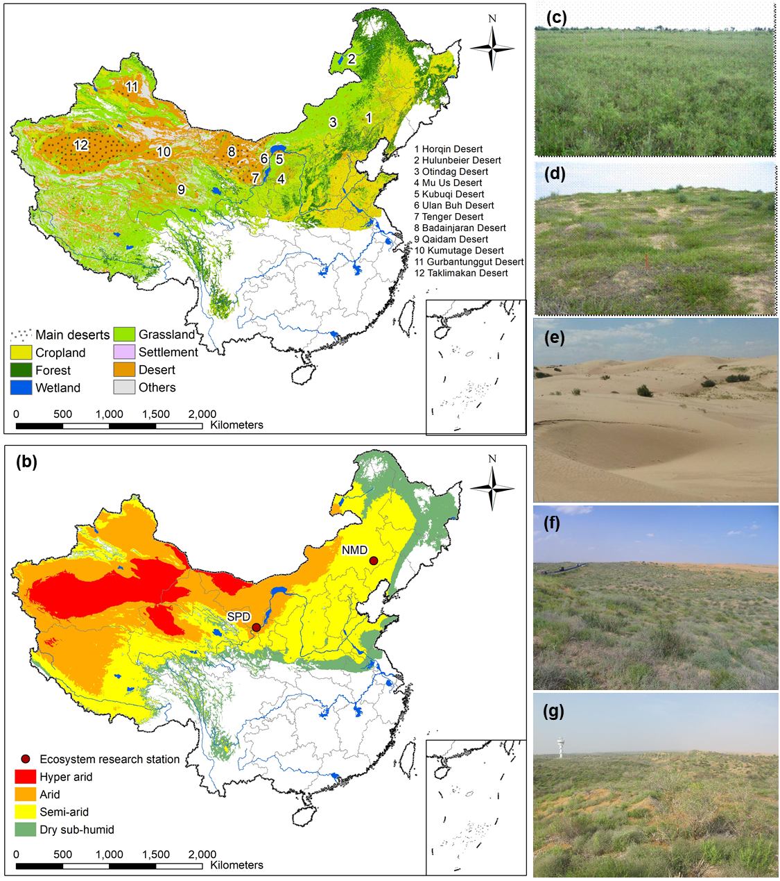

**Fig. 1.** (a) Distributions of major ecosystems and main deserts in China’s drylands; (b) Spatial distributions of Naiman Desertification Research Station (NMD) and Shapotou Desert Ecological Research Station (SPD) of the Chinese Ecosystem Research Network (CERN) in China’s drylands; Sandy steppe (c), fixed dune (d) and moving dune (e) in NMD, and natural vegetation (f) and artificial vegetation (g) in SPD. (Figures adapted from http://www.cern.ac.cn)

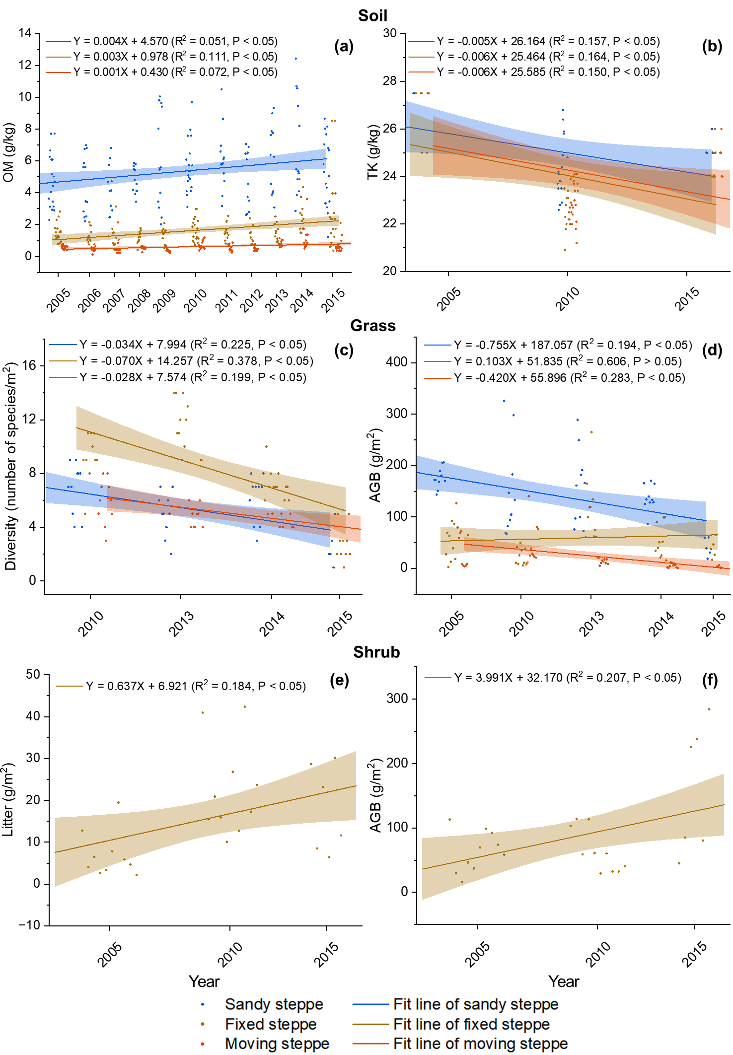

**Fig. 2.** Variation of soil properties and vegetation attributes for the sandy steppe, fixed dune and moving dune in the semi-arid desert of Horqin Desert (NMD) over time (year) as determined by linear fit: (a) pH; (ab) organic matter (OM) content, ; (c) organic matter (OM) content; and (bd) total potassium (TK) content, (c) diversity of grass, (d) aboveground biomass (AGB) of grass, (e) litter mass of shrubs; and (f) aboveground biomass (AGB) of shrubs. Slope>0 indicates that the value increases over time, while slope<0 indicates that the value decreases over time.

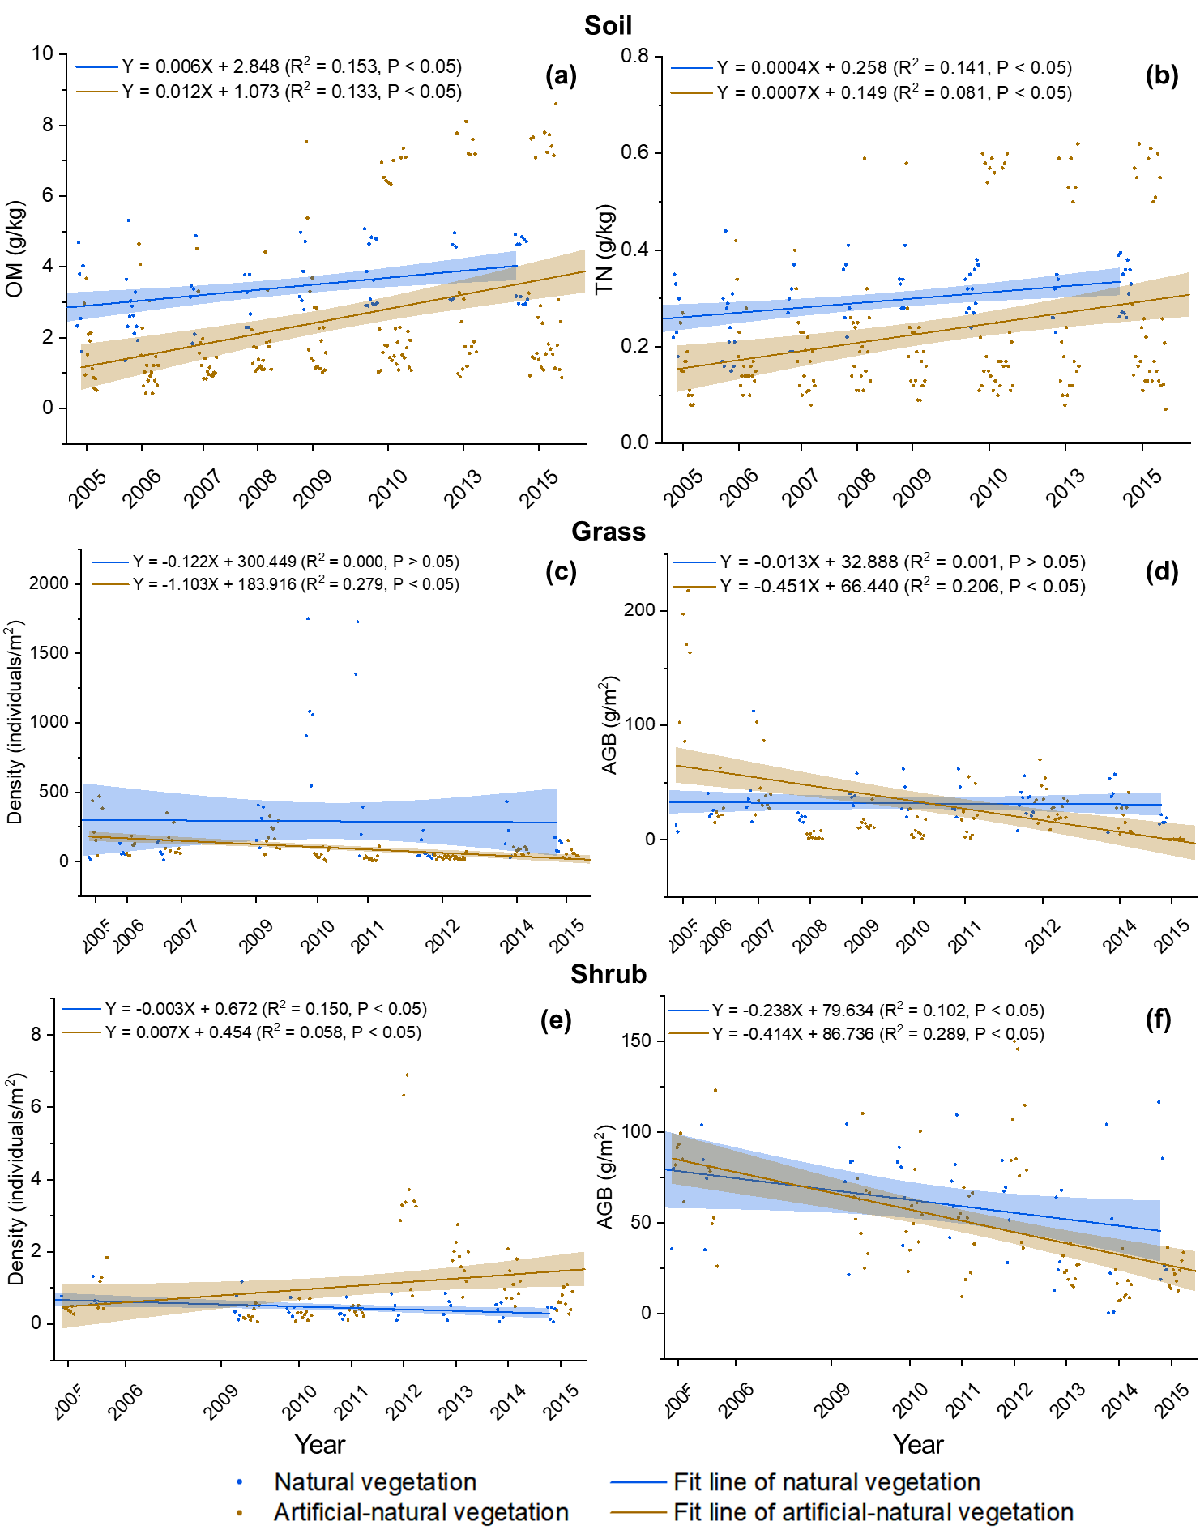

**Fig. 3.** Variation of soil properties and vegetation attributes for the natural vegetation and artificial vegetation in the arid desert of Tenger Desert (SPD) over time (year) as determined by linear fit: (a) organic matter (OM) content, (b) total nitrogen (TN) content, (c) density of grass, (d) aboveground biomass (AGB) of grass, (e) density of shrubs, and (f) aboveground biomass (AGB) of shrubs. Slope>0 indicates that the soil property increases over time, while slope<0 indicates that the soil property decreases over time.

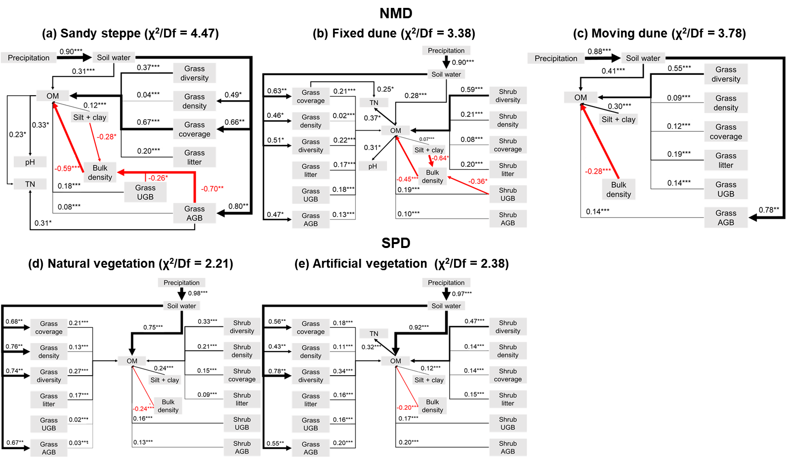

**Fig. 4.** The hypothesized causal relationships among climate factors (precipitation), vegetation attributes (diversity, density, coverage, litter, aboveground biomass (AGB), and underground biomass (UGB) of grass and shrub) and soil properties (soil water, silt+clay, bulk density, organic matter (OM), total nitrogen (TN), and pH) determined by structural equation model (SEM) for the sandy steppe (a), fixed dune (b) and moving dune (c) in the semi-arid desert of Horqin Desert (NMD) and for the natural vegetation (d) and artificial vegetation (e) in the arid desert of Tenger Desert (SPD). Each arrow represents a hypothesized direct causal relationship in the direction of the arrow. An indirect causal relationship occurs when a variable is connected to another through an intermediate variable. Numbers on arrows are standardized coefficients. The black arrow indicates a positive relationship, while the red arrow indicates a negative relationship. The thickness of the arrows indicates the size of the causal relationship. *, ** and *** indicate that the relationship is significant at the p=0.05, 0.01 and 0.001 levels, respectively.

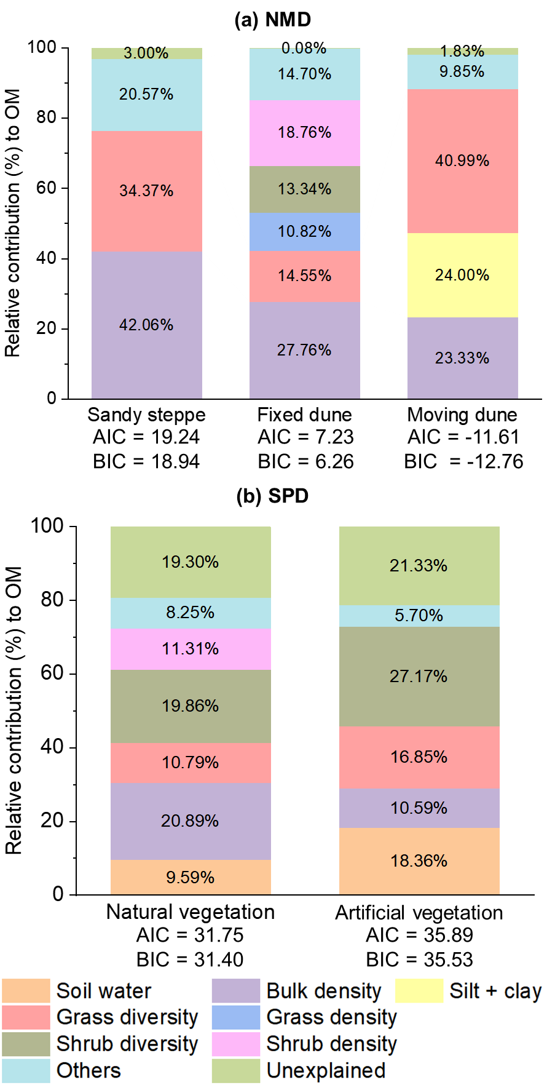

**Fig. 5.** The relative contribution of environmental factors to OM determined by the general linear model (GLM) for the sandy steppe, fixed dune and moving dune in the semi-arid desert of Horqin Desert (NMD) (a); and for the natural vegetation and artificial vegetation in the arid desert of Tenger Desert (SPD) (b).

# Tables

**Table 1.** Comparisons of soil properties (mean±standard error) across different soil depths for the sandy steppe, fixed dune and moving dune in the semi-arid desert of Horqin Desert (NMD), and for the natural vegetation and artificial vegetation in the arid desert of Tenger Desert (SPD)

|  |  |  |  |  |  |  |  |  |  |  |  |
| --- | --- | --- | --- | --- | --- | --- | --- | --- | --- | --- | --- |
| Soil property | Depth (cm) | NMD | | | | | | SPD | | | |
| Sandy steppe | | Fixed dune | | Moving dune | | Natural vegetation | | Artificial vegetation | |
| N | Mean±standard error | N | Mean±standard error | N | Mean±standard error | N | Mean±standard error | N | Mean±standard error |
| BD (g/cm3) | 0-10 | 18 | 1.43±0.10 b | 18 | 1.57±0.07 a | 18 | 1.61±0.09 a | 9 | 1.43±0.10 a | 19 | 1.44±0.03 a |
| 10-20 | 18 | 1.45±0.11 b | 18 | 1.59±0.07 a | 18 | 1.62±0.06 a | 9 | 1.52±0.06 a | 19 | 1.50±0.02 a |
| 20-40 | 6 | 1.31±0.15 b | 6 | 1.50±0.11 a | 6 | 1.57±0.07 a | 6 | 1.50±0.05 a | 10 | 1.54±0.02 a |
| 40-60 | 6 | 1.29±0.08 b | 6 | 1.52±0.07 a | 6 | 1.56±0.10 a | 6 | 1.49±0.04 a | 10 | 1.56±0.02 a |
| 60-100 | 6 | 1.28±0.06 b | 6 | 1.51±0.11 a | 6 | 1.56±0.09 a | 6 | 1.44±0.09 b | 10 | 1.60±0.01 a |
| OM (g/kg) | 0-10 | 75 | 6.59±1.90 a | 75 | 2.12±1.39 b | 75 | 0.62±0.45 c | 33 | 4.15±0.85 a | 81 | 3.88±2.47 a |
| 10-20 | 75 | 4.14±1.66 a | 75 | 1.15±0.46 b | 75 | 0.63±0.34 b | 33 | 2.73±0.52 a | 81 | 1.24±0.36 b |
| 20-40 | 9 | 4.47±1.54 a | 9 | 0.89±0.33 b | 9 | 0.58±0.23 b | 9 | 1.94±0.75 a | 18 | 0.81±0.29 a |
| 40-60 | 9 | 3.80±1.13 a | 9 | 0.72±0.22 b | 9 | 0.53±0.12 b | 9 | 1.54±0.72 a | 18 | 0.59±0.25 a |
| 60-100 | 9 | 3.60±1.17 a | 9 | 0.66±0.18 b | 9 | 0.53±0.16 b | 9 | 1.46±1.06 a | 18 | 0.51±0.16 a |
| TN (g/kg) | 0-10 | 75 | 0.46±0.15 a | 75 | 0.15±0.07 b | 75 | 0.08±0.06 c | 33 | 0.34±0.05 a | 81 | 0.34±0.17 a |
| 10-20 | 75 | 0.30±0.09 a | 75 | 0.10±0.04 b | 75 | 0.06±0.03 b | 33 | 0.25±0.05 a | 81 | 0.13±0.03 b |
| 20-40 | 9 | 0.31±0.05 a | 9 | 0.10±0.01 b | 9 | 0.08±0.02 b | 9 | 0.19±0.06 a | 18 | 0.11±0.03 a |
| 40-60 | 9 | 0.27±0.05 a | 9 | 0.09±0.01 b | 9 | 0.07±0.02 b | 9 | 0.17±0.06 a | 18 | 0.09±0.02 a |
| 60-100 | 9 | 0.24±0.08 a | 9 | 0.08±0.02 b | 9 | 0.07±0.02 b | 9 | 0.14±0.10 a | 18 | 0.08±0.02 a |
| TP (g/kg) | 0-10 | 15 | 0.29±0.07 a | 15 | 0.20±0.08 ab | 15 | 0.17±0.10 b | 9 | 0.24±0.03 a | 18 | 0.18±0.04 b |
| 10-20 | 15 | 0.27±0.11 a | 15 | 0.18±0.10 a | 15 | 0.16±0.10 a | 9 | 0.21±0.06 a | 18 | 0.13±0.02 b |
| 20-40 | 9 | 0.34±0.10 a | 9 | 0.09±0.03 b | 9 | 0.09±0.02 b | 9 | 0.21±0.05 a | 18 | 0.11±0.02 b |
| 40-60 | 9 | 0.35±0.11 a | 9 | 0.09±0.03 b | 9 | 0.09±0.02 b | 9 | 0.20±0.04 a | 18 | 0.10±0.01 b |
| 60-100 | 9 | 0.35±0.14 a | 9 | 0.08±0.01 b | 9 | 0.09±0.01 b | 9 | 0.21±0.04 a | 18 | 0.10±0.01 b |
| TK (g/kg) | 0-10 | 15 | 20.99±14.25 a | 15 | 6.80±2.64 a | 15 | 3.47±1.71 a | 9 | 1.40±0.17 a | 18 | 1.73±0.67 a |
| 10-20 | 15 | 28.08±22.90 a | 15 | 5.01±2.46 b | 15 | 2.71±1.68 b | 9 | 1.37±0.24 a | 18 | 1.11±0.27 a |
| 20-40 | 9 | 26.90±23.73 a | 9 | 4.09±3.07 b | 9 | 2.75±1.03 b | 9 | 0.94±0.19 a | 18 | 0.96±0.27 a |
| 40-60 | 9 | 29.30±22.60 a | 9 | 3.35±2.26 b | 9 | 2.44±1.95 b | 9 | 0.84±0.26 a | 18 | 0.86±0.18 a |
| 60-100 | 9 | 27.43±13.59 a | 9 | 3.15±1.77 b | 9 | 1.88±0.93 b | 9 | 0.66±0.35 a | 18 | 0.77±0.19 a |
| SC (g/kg) | 0-10 | 9 | 1.59±0.53 a | 9 | 0.80±0.45 b | 9 | 0.60±0.43 b | 9 | 10.76±2.45 a | 16 | 14.02±5.52 a |
| 10-20 | 9 | 1.25±0.45 a | 9 | 0.99±0.64 ab | 9 | 0.62±0.47 b | 9 | 5.18±1.34 a | 16 | 4.86±3.18 a |
| 20-40 | 9 | 0.98±0.37 a | 9 | 1.13±0.30 a | 9 | 0.92±0.39 a | 9 | 5.85±1.85 a | 16 | 2.70±2.66 a |
| 40-60 | 9 | 0.84±0.31 a | 9 | 0.98±0.28 a | 9 | 0.88±0.42 a | 9 | 7.75±2.34 a | 16 | 1.80±2.02 b |
| 60-100 | 9 | 0.75±0.30 a | 9 | 0.99±0.23 a | 9 | 0.81±0.33 a | 9 | 13.55±5.25 a | 16 | 1.30±1.69 b |

Notes: Soil properties include soil pH, bulk density (BD), organic matter (OM), total nitrogen (TN), total phosphorus (TP), and total potassium (TK) contents, and the ratio of silt+clay (SC). Means (± standard error) followed by the same letters indicate insignificant differences among the sandy steppe, fixed dune and moving dune, and among the natural vegetation and artificial vegetation at p>0.05. N is the replication.

**Table 2.** Comparisons of vegetation attributes (mean±standard error) for the sandy steppe, fixed dune and moving dune in the semi-arid desert of Horqin Desert (NMD), and for the natural vegetation and artificial vegetation in the arid desert of Tenger Desert (SPD)

|  |  |  |  |  |  |  |  |  |  |  |  |
| --- | --- | --- | --- | --- | --- | --- | --- | --- | --- | --- | --- |
| Vegetation type | Attribute | NMD | | | | | | SPD | | | |
| Sandy steppe | | Fixed dune | | Moving dune | | Natural vegetation | | Artificial vegetation | |
| N | Mean±standard error | N | Mean±standard error | N | Mean±standard error | N | Mean±standard error | N | Mean±standard error |
| Grass | Diversity (number of species/m2) | 35 | 5.51±2.19 b | 35 | 8.49±3.36 a | 35 | 5.03±1.77 b | 49 | 4.65±1.61 a | 96 | 3.28±1.1 b |
| Density (individual/m2) | 45 | 199.38±188.70 a | 45 | 214.76±206.30 a | 45 | 53.33±68.47 b | 46 | 291.13±435.64 a | 93 | 91.38±96.1 b |
| Height (cm) | 45 | 52.38±18.84 a | 45 | 24.94±13.40 b | 45 | 23.31±21.42 b | 46 | 9.98±6.35 a | 93 | 7.73±5.17 b |
| Coverage (%) | 45 | 55.78±10.05 a | 45 | 47.31±15.45 b | 45 | 19.44±11.28 c | 51 | 22.56±14.34 a | 103 | 15.66±14.44 b |
| AGB (g/m2) | 45 | 142.85±67.70 a | 45 | 58.86±50.45 b | 45 | 23.40±29.80 c | 51 | 31.92±18.51 a | 103 | 30.33±44.96 a |
| Litter (g/m2) | 25 | 127.02±113.80 a | 23 | 41.79±42.88 b | 22 | 6.10±6.91 b | 49 | 8.30±5.90 a | 96 | 8.81±9.40 a |
| UGB (g/m2) | 25 | 86.05±101.95 a | 25 | 35.63±44.38 b | 25 | 8.03±11.76 b | 51 | 377.63±189.02 a | 103 | 269.38±159.48 b |
| Shrub | Diversity (number of species/m2) |  |  | 26 | 1.54±0.51 |  |  | 51 | 0.78±0.26 a | 102 | 0.55±0.20 b |
| Density (individual/m2) |  |  | 26 | 0.29±0.24 |  |  | 41 | 7.84±25.07 a | 82 | 8.09±28.76 a |
| Height (m) |  |  | 26 | 0.69±0.47 |  |  | 51 | 0.74±0.21 a | 102 | 0.73±0.29 a |
| Coverage (%) |  |  | 26 | 17.62±6.25 |  |  | 51 | 22.65±10.69 a | 102 | 15.70±9.54 b |
| AGB (g/m2) |  |  | 26 | 86.05±67.07 |  |  | 41 | 59.86±31.59 a | 82 | 49.55±33.38 a |
| Litter (g/m2) |  |  | 26 | 15.52±11.36 |  |  | 49 | 5.44±1.70 a | 96 | 5.73±1.79 a |
| UGB (g/m2) |  |  | 26 | 33.59±21.50 |  |  | 41 | 62.48±55.28 a | 82 | 50.05±22.76 a |

Notes: Vegetation attributes include diversity, density, dominant species height (Height), coverage, aboveground biomass (AGB), litter mass (Litter), and underground biomass (UGB) of grass and shrub. Means (± standard error) followed by the same letters indicate insignificant differences among the sandy steppe, fixed dune and moving dune, and among the natural vegetation and artificial vegetation at p>0.05. N is the replication.

# Supplementary information

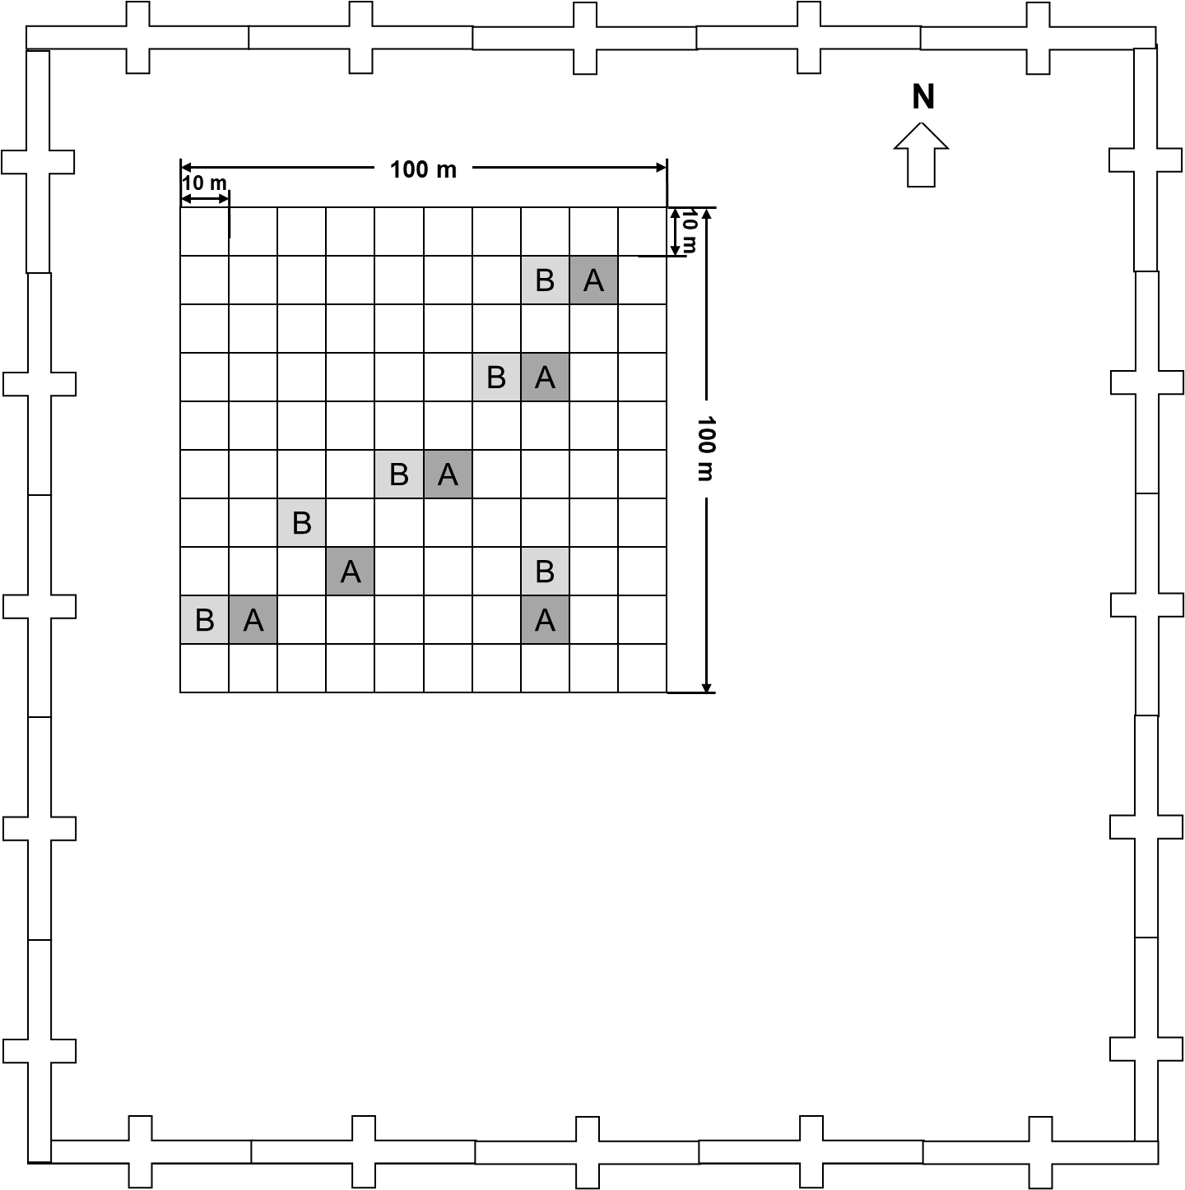

**Fig. S1.** The sub-plot layout strategy was used in soil and vegetation sampling, with enclosure lands not drawn to scale.

**Table S1.** Site information of the two CERN desert research stations (NMD and SPD) in China’s drylands.

| Abbreviation | NMD | SPD |
| --- | --- | --- |
| Ecosystem Research Station | Naiman Desertification Research Station | Shapotou Desert Ecological Research Station |
| Location | Horqin Desert | Tenger Desert |
| Latitude and longitude | 120°42′E, 43°55′N | 104°57′E, 37°27′N |
| Elevation (m) | 358 | 1250 |
| Topography | Plain, and sand dune | Plain |
| Dryland subtypes | Semi-arid | Arid |
| AI | 0.29 | 0.13 |
| Climate type | Subhumid and semiarid continental monsoon climate | Arid temperate continental climate |
| Annual mean temperature (℃) | 3-7 | 9.6 |
| Annual precipitation (mm) | 350-500 | 186 |
| Ecosystem | Desert | Desert |
| Vegetation type | Sandy steppe, fixed sand dune steppe, and moving sand dune steppe | Natural vegetation, and artificial natural vegetation |
| Dominant species | Sandy steppe: Setaria viridis; Fixed dune: Caragana microphyll, Artemisia halodendron and Setaria viridis; Moving dune: Agriophyllum squarrosumand. | Artemisia ordosica |
| Soil type | Arenosols | Arenosols |
| Soil properties and sampling years | BD, SC, TP, TK: 2005, 2010, 2015; pH: 2005-2006, 2008-2013; OM, TN: 2005-2015 | BD, SC, TP, TK: 2005, 2010, 2015; pH: 2005, 2007-2010, 2013-2015; OM, TN: 2005-2010, 2013, 2015 |
| Vegetation attributes and sampling years | Grass diversity: 2010, 2013- 2015; Grass density, height, coverage, AGB: 2005, 2010, 2013-2015; Grass litter, UGB, shrub diversity, density, height coverage, AGB, litter, UGB: 2005, 2010, 2015. | Grass diversity, litter: 2006-2012, 2014-2015; Grass density: 2005-2007, 2009-2012, 2014-2015; Grass height: 2005-2009, 2011-2012, 2014-2015; Grass coverage, AGB, UGB: 2005-2012, 2014-2015; Shrub diversity, height, density: 2005-2015; Shrub density, AGB, UGB: 2005-2006, 2009-2015; Shrub litter: 2006-2015. |
| Management | Enclosure | Enclosure |
| Starting year of enclosure and restoration | Sandy steppe: 1997; Fixed dune and moving dune: 1985. | Natural vegetation: 2005; Artificial restoration: 1956. |

Note: Detailed descriptions are available in Li et al. (2013) for NMD and Pan et al. (2008) for SPD. Soil properties: soil pH, organic matter (OM), total nitrogen (TN), total phosphorus (TP), total potassium (TK) contents, bulk density (BD), and the ratio of silt+clay (SC). Vegetation attributes: diversity, density, the height of dominant species (height), coverage, aboveground biomass (AGB), the mass of litter (litter) and underground biomass (UGB) of grass and shrub.