Title

Rapid assessment of the need for evidence: applying the principles of value of information to research prioritisation

Authors

David Glynn*, PhD. Centre for Health Economics, University of York, York, UK. david.glynn@york.ac.uk. <https://orcid.org/0000-0002-0989-1984>

Vijay S. Gc, PhD. School of Human and Health Sciences, University of Huddersfield, Huddersfield, UK. <https://orcid.org/0000-0003-0365-2605>

Karl Claxton, PhD. Centre for Health Economics, University of York, York, UK.

Chris Littlewood, PhD. Allied Health, Social Work & Wellbeing, Edgehill University, Ormskirk, UK. <https://orcid.org/0000-0002-7703-727X>

Claire Rothery, PhD. Centre for Health Economics, University of York, York, UK.

*corresponding author

Declarations

Funding was provided to DG, CR and KC by UK National Institute for Health Research (NIHR) Health Technology Assessment (HTA) Programme as project number 16/29/01

The authors report no conflicts of interest.

DG, CR and KC developed the method, with CR leading the work. DG drafted the paper, VG implemented the method, CL supported the case study. All authors provided comments on drafts of the paper.

Abstract

We propose a short-cut heuristic approach to rapidly estimate value of information (VOI) using information commonly reported in a research funding application to make a case for the need for further evaluative research. We develop a “Rapid VOI” approach which focuses on uncertainty in the primary outcome of clinical effectiveness and uses this to explore the health consequences of decision uncertainty. We develop a freely accessible online tool, RANE (Rapid Assessment of the Need for Evidence), to allow for the efficient computation of the value of research. As a case study, the method was applied to a proposal for research on shoulder pain rehabilitation. The analysis was included as part of a successful application for research funding to the UK National Institute for Health and Care Research.Our approach enables research funders and applicants to rapidly estimate the value proposed research. Rapid VOI relies on information which is readily available and reported in research funding applications. Rapid VOI supports research prioritisation and commissioning decisions where there is insufficient time and resources available to develop and validate complex decision-analytic models. The method provides practical means for implementing VOI in practice, thus providing a starting point for deliberation and contributing to the transparency and accountability of research prioritisation decisions.

# Key words

Value of information, research prioritization, decision support tools, minimal modelling

# Running heading

Rapid VOI

# Key points

* We propose an approach to rapidly estimate the value of research funding applications. This method was developed so that it would be practical for those without extensive time and resources such as those submitting research funding applications and research funding bodies.
* The case study in the paper describes a proposal which was submitted to NIHR in the UK. This successful funding application utilised our method to support the case for new research.
* To aid its implementation in practice this paper links to an online tool which implements our method <https://shiny.york.ac.uk/rane/>

1. Introduction

Empirical research provides the scientific foundation for modern medicine. Research can take many forms, such as randomised controlled trials (RCTs), observational studies, and feasibility studies, which provide additional evidence to support the use of health technologies. Regardless of its form, budgets to fund research and the resources required to carry it out are limited. Research prioritisation is the practice of choosing to fund certain research proposals at the expense of not funding others. This task is carried out by a range of national and international agencies.

When making funding decisions across research proposals, the aim is to fund research that is efficient, effective and offers an improvement in population health outcomes. This complex task requires careful scrutiny by working closely with stakeholders across the health system to respond to research needs, improve health outcomes, and ensure that the research represents good value for money. Quantitative methods, which estimate the health impact of research projects, can improve the transparency and accountability of the research prioritisation process. Value of information (VOI) methods provide an analytic framework to quantify the expected benefits of research. VOI quantifies the extent to which further research resolves decision uncertainty, i.e. the probability weighted consequences of making an incorrect decision given current evidence (1-5).

VOI methods were developed originally by Raiffa and Schlaifer in the context of business decision making with the aim of maximizing profit (6). They have since been adapted for use within healthcare decisionmaking with the aim of maximizing health (2, 7, 8). VOI has traditionally been applied within the context of probabilistic decision-analytic models used to inform health care decisions. Decision analytic models are mathematical structures used to inform decision making by comparing the costs and health effects associated with the relevant treatment options, with health benefits typically expressed in quality-adjusted life years (QALYs) (1). These models can range in complexity from relatively simple decision trees to more sophisticated patient level simulation models (9).

Recent advances in “efficient computation” for VOI have substantially reduced the computation time required to calculate VOI metrics (10, 11). However, the large amount of time required to construct and validate decision models remains a barrier to uptake. Research funders often operate within rigid timelines, and so cannot easily delay decisions until a full decision model has been constructed (12, 13). Further, the standard information provided in research funding applications is not sufficient to construct full decision models. “Minimal modelling” approaches have been developed to overcome these barriers. Meltzer et al (2011) proposed a method based on individual patient data (14). Bennette et al (2016) developed an approach based on simple Markov models commonly seen in oncology (12, 13). An alternative approach was proposed by Claxton et al (2015), which places the focus on a primary outcome of relevance to the decision and uses it to understand the consequences of decision uncertainty, expressed in terms of the primary outcome (3, 15). This “Rapid VOI” approach assumes that the primary outcome reported in studies or a proposed new research study, typically captures the most important aspect of outcome for the decision.

The different approaches to VOI may be viewed as a “spectrum of complexity” (see Table 1). At one end of the spectrum is a narrative approach in which decision makers use the principles of VOI to compare research proposals without quantitative estimates. The principles of VOI are the insights which come from formal VOI literature, namely insights into the drivers of research value. Rapid VOI and minimal modelling approaches represent an increase in complexity relative to the narrative approach, requiring additional time, assumptions and resources but potentially providing additional insight. VOI calculated using full decision analytic models represents a further increase in complexity (16-18). It is important to note that additional complexity comes with potential benefits (better representation of reality) as well as costs (more resource intensive, less transparency to non-specialists). The appropriate level of complexity for a given context will depend on the needs of the decision maker.

The aim of this paper is twofold. First, we aim to support narrative assessments of research value by showing how the principles of VOI can be used to interpret the standard information provided in research funding applications. Second, we build upon the Rapid VOI approach of Claxton et al to show how a minimal information set can be used to produce quantitative VOI estimates of research value (3). We have developed a freely available online tool, RANE (Rapid Assessment of the Need for Evidence), to calculate the value of research proposals to inform research funding and prioritisation decisions in a timely manner: <https://shiny.york.ac.uk/rane/> (version 1.0). We illustrate the method using a research proposal which was successfully funded by the National Institute for Health and Care Research (NIHR) and included a Rapid VOI analysis.

[INSERT TABLE 1]

1. Methods

In this section, we describe the minimum requirements to conduct a rapid assessment of the value of research using the principles of VOI. Informed by these principles, we describe how each piece of information relates to the health consequences of uncertainty. If a narrative approach to research prioritisation is taken, then these principles can improve deliberation by clarifying the drivers of research value. In the case study section, we illustrate how to go beyond a narrative understanding by combining the information to create a quantitative estimate of research value.

2.1 Information required for research prioritisation

***2.1.1.Primary outcome measure***

RCTs are commonly designed around a primary outcome measure or endpoint. If a primary outcome can be chosen which captures the most important aspects of health outcome, this can be used to express the value of research in terms of this outcome, e.g., as ‘benefits gained’ or ‘harms avoided’ depending on whether the outcome is a benefit or harmful outcome. Typically, primary outcomes can be classified as binary, continuous or survival outcomes.

***2.1.2.Expected health outcomes with current standard of care (baseline outcome)***

The value of research comes from potential changes to current practice, therefore an estimate of the baseline event rate under the current standard of care, is required for binary and survival outcomes. For binary outcomes, this is the probability of the outcome with current standard of care, while for survival outcomes this is the baseline event rate under current standard of care. This should be expressed in terms of the primary outcome measure. This is required to understand the consequences of current uncertainty as, all else equal, uncertainty about more common events will have larger absolute health consequences. The baseline probability/rate of an outcome may be informed by the control arm of clinical trials, external evidence, or expert opinion or judgements relevant to the target population, and is likely to be subject to uncertainty.

***2.1.3.Uncertainty about relative effectiveness of the experimental treatment***

To understand the value of research, an estimate of the relative effectiveness of the experimental treatment compared to the current standard of care is required for the primary outcome measure, along with an estimate of its uncertainty. Depending on the nature of the primary outcome this may be expressed as an odds ratio, relative risk, risk difference, mean difference, or hazard ratio. Importantly, some judgement about uncertainty in the estimate of the relative effectiveness of the new treatment compared with the standard of care must be made in order to determine whether additional evidence is required. This judgement may come from a single study or systematic review and meta-analysis of existing evidence (3). In cases where there is no existing evidence upon which to form a judgement, methods such as expert elicitation and meta-epidemiological studies are available (19, 20). If a single estimate is unavailable or considered inadequate, alternative values can be used to represent different judgements about the uncertain estimate of relative effect.

***2.1.4.Incidence per annum***

Information generated by research is used to inform decisions for the population of individuals who could potentially benefit from the information. In order to translate clinical uncertainty into an estimate of the health consequences of uncertainty, some assessment of the number of patients affected by the clinical decision each year is required (1).

***2.1.5.Minimum clinical difference (MCD) in primary outcome***

In some situations, the primary outcome will not be sufficient to capture some important aspects of outcome that are relevant for choosing between the alternative treatments. The new treatment may be more or less expensive and/or have increased or decreased side effects relative to current standard of care. In these cases a minimum clinical difference (MCD) in effectiveness in the primary outcome may be specified in order to capture these additional considerations i.e. secondary outcomes (3). A positive MCD represents the required improvement in the primary outcome to compensate for some undesirable secondary outcomes (e.g., additional cost). See appendix A1 for further details.

***2.1.6.Costs of the proposed new study***

Some assessment of the likely costs of the proposed new study to the research funder is required in order to establish whether the expected benefits of the study are sufficient to justify the expected costs (2, 21).

***2.1.7.Duration of the proposed new study***

A judgement about the duration of time it will take for the proposed research to be conducted and for the results to report is required since the information produced by a study is only available at the end of that study. This means that the health benefits of research decline the longer it takes for research to report (1, 21). This might be informed by an assessment of study sample size, expected recruitment rates, or historical experience from conducting similar types of studies.

***2.1.8.Length of time for which new evidence is expected to be valuable***

The information generated by new research will not be valuable indefinitely because other changes occur over time (22). For example, over time new and more effective treatments become available, which will eventually make those currently available obsolete. This means that clinical evidence is only relevant for a specific amount of time. A judgement about the length of time that the evidence from the proposed new study might be valuable is required in order to estimate the expected benefits over an appropriate time horizon. This judgement could be informed by historical evidence or experience about whether a particular research area is likely to see future innovations and/or other evaluative research reporting. As this judgement represents an important source of structural uncertainty, one-way sensitivity analysis is usually recommended in which different values are used to explore the impact on results (1, 23).

***2.1.9.Discount rate***

When a time horizon greater than one year is considered, discounting should be used to reflect the fact that resources committed today could be invested at a real rate of return to provide more resources in the future.

1. Case study

This case study represents a proposal which was submitted to NIHR in the UK (24). This successful funding application included Rapid VOI to support the case for new research. Details of the application are summarised in Table 2.

[INSERT TABLE 2]

3.1. Why is the trial needed?

The primary aim of the RCT is to determine the effects of early patient-directed rehabilitation (EPDR) compared with standard rehabilitation on Shoulder Pain and Disability Index (SPADI) score at 12 weeks in adults who have undergone surgery for tears of tendons of the shoulder (rotator cuff). The SPADI score is a patient reported questionnaire with 13 items assessing pain level and extent of difficulty using the involved shoulder. It is a continuous outcome which ranges from 0 (best) to 100 (worst) (25).

[INSERT BOX 1]

3.2. Primary outcome measure

The primary outcome for the proposed trial is the difference in total SPADI score between treatments at 12 weeks as estimated by ANCOVA. The incremental health benefits of EPDR are estimated by the average change in the SPADI score relative to the comparator. If EPDR is better than standard rehabilitation, then the change in SPADI score will be negative in the EPDR group.

3.3. Relative effectiveness of treatment based on existing evidence

A UK based pilot study was used as the source of data on relative effectiveness as it is representative of the population and treatments of interest (26). Littlewood et al (2021) reported a mean between-group difference in the SPADI score at 12-weeks of -5.5 favouring EPDR relative to standard rehabilitation. The 95% confidence interval[1] ranged from -19.8 to 8.7. The link between current uncertainty and health consequences at the individual level is illustrated in Figure 1. To calculate the magnitude of health consequences associated with current uncertainty, we fit a normal distribution to the 95% uncertainty interval. A normal distribution was chosen because the study had over 35 observations per arm which means the sampling distribution of the mean should be approximately normal under the central limit theorem. This distribution has a mean at -5.5 and has 22% of its density above zero. Assuming that any improvement in the outcome is considered beneficial, this means that with current information we expect the new treatment to improve outcomes but there is still a 22% chance that the new treatment will make the primary outcome worse.

[INSERT FIG1]

[INSERT BOX 2]

3.4. Incidence per annum

The expected health benefits of additional evidence depend on the size of the population whose treatment choice is to be informed by the evidence i.e., the number of individuals facing the uncertain choice between the alternative treatments. The research proposal states that 9,000 individuals each year undergo surgery for tears of the tendons of the shoulder (rotator cuff) and so may benefit from the EPDR approach (27).

3.5. Rapid estimation of the expected health benefits of research per year

On the balance of the pilot RCT data, EPDR is judged to be the most effective option (based on a mean difference of -5.5 in SPADI score at 12 weeks post-surgery compared with standard rehabilitation). However, due to uncertainty in the evidence base, there is a 22% chance that EPDR is not more effective than standard rehabilitation. The uncertainty translates into health consequences at a population level, i.e. number of additional SPADI units experienced each year due to uncertainty about the optimal rehabilitation option (Figure 2).

[INSERT FIG2]

There is a 78% chance of no health consequences because EPDR is expected to be the optimal treatment choice. However, there is a 22% chance that EPDR is worse than standard rehabilitation. The consequences of getting the decision wrong are not uniform: there is a greater chance of more limited consequences (e.g. an 8% chance of 10,000 additional SPADI units per year) and a smaller chance of larger consequences (e.g., a <1% chance of 210,000 additional SPADI units per year). The average over this distribution of consequences provides an estimate of the expected consequences of uncertainty, which is 8,584 additional SPADI units per year.

The expected consequences of uncertainty can be interpreted as an estimate of the expected health benefits that could be gained each year if the uncertainty surrounding the decision about optimal rehabilitation for those recovering from rotator cuff repair were resolved, i.e., it indicates an expected upper bound on the benefits of further research that would confirm whether standard rehabilitation or EPDR, is more effective[2].

3.6. Length of time for which new evidence is expected to be valuable

The expected benefits of research increase with the size of the patient population whose treatment choice can be informed by the additional evidence and the time over which evidence about the effectiveness of the treatments is expected to be useful.

There is currently no empirical evidence about the rate at which standard practice in shoulder rehabilitation progresses, but it is anticipated that effective rehabilitation approaches might be valuable for a long time period. A time span of 20 years is assumed (alternative scenarios may be considered to assess the impact of shorter durations). This means that the health consequences of uncertainty surrounding the decision increase greatly by the fact that, in the absence of better evidence, the health system runs the risk of utilising the suboptimal option every year for the next 20 years.

Taking the time horizon into account means that the expected consequences of uncertainty are 123,467 additional SPADI units over a 20-year period (after discounting at 3.5% per annum). However, the proposed trial will not report immediately, and the value of additional evidence will decline the longer it takes to report. The proposed trial is expected to take 4.5 years to report. Therefore, the expected upper bound on the benefits of further research is reduced to 87,727 additional SPADI units avoided over the 20-year period. This is illustrated in Figure 3.

[INSERT FIG3]

3.7. The value of new evidence

The value of new evidence is summarised by comparing the maximum expected benefits of research to the costs of research (Table 3). The trial is expected to cost the NIHR budget approximately £1.8 million.  The maximum expected value of the proposed trial is therefore £1.8 million / 87,727 = £21 per SPADI unit avoided[3].

[INSERT TABLE3]

[INSERT BOX 3]

1. Discussion

Using the principles of VOI we described how nine pieces of information may be used to establish the value of research. This represents the minimum information requirements to conduct the Rapid VOI analysis using the RANE tool. Because the budget for funding research is limited, it is reasonable to expect that these nine pieces of information should form a minimum requirement for research funding decisions. Going beyond a narrative assessment of the need for further research, we have shown how the minimum information set can be used to obtain a quantitative estimate of the value of research. We provide a free online tool (RANE) which can be used to quickly carry out the analysis. See appendix A2 for details on the validity and generalisability of RANE. The method and tool were illustrated through a case study which estimated the value of research comparing options for rehabilitation after shoulder surgery.

Moving from a narrative approach to a quantitative approach represents a step up in the spectrum of complexity, providing additional insight for additional time and resource use. Applying our Rapid VOI method estimated the value of research in terms of cost per SPADI unit avoided. In order to make decisions, the value of research proposals will need to be compared either to each other or to some other standard of value. For example, the value of the research in the case study is estimated as £21 per SPADI points avoided; this may be competing for funding against another proposal which is estimated to have a value of £40,000 per death avoided. Notwithstanding the benefits of Rapid VOI, decision makers in this scenario are required to implicity make trade-offs regarding the importance of the primary outcomes.

Linking primary outcomes to costs, length of life and quality of life using QALYs provides one approach to making these trade-off explicit and accountable. This link to QALYs represents an increase in complexity, providing additional insight at the cost of additional time and resources. In appendix A3 we provide a rapid estimation that one SPADI point avoided results in 0.00471 additional QALYs for the patient population. As the value of the research is £21 per SPADI point avoided, this is equivalent to approximately (£21/0.00471 =) £4,500 per QALY gained.

It is possible to increase complexity further by carrying out VOI based on a “full modelling” approach. Traditionally, this has been a pre-requisite for undertaking a VOI analysis. A full modelling approach can overcome some of the simplifications of the Rapid VOI approach. Most importantly, the Rapid VOI approach requires a primary outcome which captures the main sources of value of the treatment of interest. Other outcomes are considered as secondary outcomes and can only be implicitly accounted for using the MCD. The advantage of full modelling is that a complex decision model can explicitly model a number of outcomes. The joint uncertainty in all inputs can be used to estimate downstream QALYs and costs. Because the Rapid VOI approach only takes account of uncertainty in the primary outcome, this means that the value of reducing uncertainty in other aspects of the clinical decision (e.g. probability of side effects, or other outcomes of interest) will not be estimated. Rapid VOI provides a short-cut heuristic which may be considered in the absence of a full decision model, where a full decision model would provide an exhaustive assessment of research value.

It should be noted that a full decision model linking all relevant evidence to costs and QALYs does not represent the maximum point on the spectrum of complexity. Within the class of full decision models there is a great range of complexity (e.g. cohort vs microsimulation), and there are many outcomes which are relevant to decision making which are not captured in the QALY but can be modelled quantitatively (e.g. effects on education, inequalities etc.) (28, 29). The appropriate analysis is not always the most complex, rather it will depend on the constraints faced.

The case study application formed part of a successful research funding bid, demonstrating that it is feasible for research applicants to include this analysis in their funding bids to support the value of further research. Those who fund research, and the patients they serve, may benefit from this analysis insofar as it can improve the transparency and accountability of research funding decisions. The method can also be applied to interpret the results of a meta-analysis, to help understand the value of additional research. This is demonstrated in Claxton et al and McKenna et al (3, 15).

In this paper we have discussed the use of Rapid VOI to estimate the value of an RCT within a defined population. In principle, the method can be applied to estimate the value of an observational study designed to answer a specific research question (30). However, observational studies may include biases which will reduce the value of research. Additionally, the methods here do not take account of the value of transporting evidence from one population to another (31). These are limitations in the VOI literature more broadly and further research is required to address them.

An important extension to the Rapid VOI approach is to extend the methods to take account of sample size. The method described in this paper provide an estimate of the expected upper bound for the value of research as it assumes that the proposed research will resolve all uncertainty in the primary outcome (3). VOI methods to adjust the value of research for the number of patients enrolled are well established (10, 32)[4]. In addition to providing a more accurate estimate of the value of research this extended method could be used to help determine the sample size of proposed research. The advantage of this approach over the traditional power calculation is that sample size would be based on the principles set out in this paper, explicitly considering resource constraints, the size of the incident population, the time for research to report and the current levels of uncertainty. In principle, the Rapid VOI approach can also be extended to incorporate other dimensions of the “research design space” such as trial duration, unbalanced allocation, sequential designs and portfolio design (33-35)

1. Conclusion

This paper describes the principles of research prioritisation and provides a pragmatic method to approximate the value of research proposals to give a broad indication of the value for money of a research project. These methods may be useful to both research funders, charged with making research prioritisation decisions, and those applying for research funding.

References

1. Briggs A, Sculpher M, Claxton K. Decision modelling for health economic evaluation: Oup Oxford; 2006.

2. Willan AR, Pinto EM. The value of information and optimal clinical trial design. Statistics in medicine. 2005;24(12):1791-806.

3. Claxton K, Griffin S, Koffijberg H, McKenna C. How to estimate the health benefits of additional research and changing clinical practice. Bmj. 2015;351.

4. Fenwick E, Steuten L, Knies S, Ghabri S, Basu A, Murray JF, et al. Value of information analysis for research decisions—an introduction: report 1 of the ISPOR Value of Information Analysis Emerging Good Practices Task Force. Value in Health. 2020;23(2):139-50.

5. Rothery C, Strong M, Koffijberg HE, Basu A, Ghabri S, Knies S, et al. Value of Information Analytical Methods: Report 2 of the ISPOR Value of Information Analysis Emerging Good Practices Task Force. Value Health. 2020;23(3):277-86.

6. Raiffa H, Schlaifer R. Applied statistical decision theory: John Wiley & Sons; 2000.

7. Thompson MS. Decision-analytic determination of study size: the case of electronic fetal monitoring. Medical Decision Making. 1981;1(2):165-79.

8. Claxton K. The irrelevance of inference: a decision-making approach to the stochastic evaluation of health care technologies. Journal of health economics. 1999;18(3):341-64.

9. Brennan A, Chick SE, Davies R. A taxonomy of model structures for economic evaluation of health technologies. Health economics. 2006;15(12):1295-310.

10. Kunst N, Wilson EC, Glynn D, Alarid-Escudero F, Baio G, Brennan A, et al. Computing the expected value of sample information efficiently: practical guidance and recommendations for four model-based methods. Value in Health. 2020;23(6):734-42.

11. Strong M, Oakley JE, Brennan A, Breeze P. Estimating the Expected Value of Sample Information Using the Probabilistic Sensitivity Analysis Sample: A Fast, Nonparametric Regression-Based Method. Med Decis Making. 2015;35(5):570-83.

12. Bennette CS, Veenstra DL, Basu A, Baker LH, Ramsey SD, Carlson JJ. Development and evaluation of an approach to using value of information analyses for real-time prioritization decisions within SWOG, a large cancer clinical trials cooperative group. Medical Decision Making. 2016;36(5):641-51.

13. Carlson JJ, Kim DD, Guzauskas GF, Bennette CS, Veenstra DL, Basu A, et al. Integrating value of research into NCI Clinical Trials Cooperative Group research review and prioritization: a pilot study. Cancer Medicine. 2018;7(9):4251-60.

14. Meltzer DO, Hoomans T, Chung JW, Basu A. Minimal modeling approaches to value of information analysis for health research. Medical decision making. 2011;31(6):E1-E22.

15. McKenna C, Griffin S, Koffijberg H, Claxton K. Methods to place a value on additional evidence are illustrated using a case study of corticosteroids after traumatic brain injury. Journal of clinical epidemiology. 2016;70:183-90.

16. Kunst NR, Alarid-Escudero F, Paltiel AD, Wang SY. A Value of Information Analysis of Research on the 21-Gene Assay for Breast Cancer Management. Value Health. 2019;22(10):1102-10.

17. Jackson C, Presanis A, Conti S, De Angelis D. Value of information: Sensitivity analysis and research design in Bayesian evidence synthesis. Journal of the American Statistical Association. 2019.

18. Tuffaha HW, Gordon LG, Scuffham PA. Value of Information Analysis Informing Adoption and Research Decisions in a Portfolio of Health Care Interventions. MDM Policy & Practice. 2016;1(1):2381468316642238.

19. O'Hagan A, Buck CE, Daneshkhah A, Eiser JR, Garthwaite PH, Jenkinson DJ, et al. Uncertain judgements: eliciting experts' probabilities. 2006.

20. Glynn D, Nikolaidis G, Jankovic D, Welton NJ. Constructing Relative Effect Priors for Research Prioritization and Trial Design: A Meta-epidemiological Analysis. Med Decis Making. 2023:272989x231165985.

21. McKenna C, Soares M, Claxton K, Bojke L, Griffin S, Palmer S, Spackman E. Unifying Research and Reimbursement Decisions: Case Studies Demonstrating the Sequence of Assessment and Judgments Required. Value Health. 2015;18(6):865-75.

22. Philips Z, Claxton K, Palmer S. The Half-Life of Truth: What Are Appropriate Time Horizons for Research Decisions? Medical Decision Making. 2008;28(3):287-99.

23. Bojke L, Claxton K, Sculpher M, Palmer S. Characterizing structural uncertainty in decision analytic models: a review and application of methods. Value in Health. 2009;12(5):739-49.

24. NIHR. Funding award. Clinical and cost-effectiveness of early patient-directed rehabilitation versus standard rehabilitation after surgical repair of the rotator cuff of the shoulder: a multi-centre, randomised controlled trial with integrated Quintet Recruitment Intervention (RaCeR 2): National Institute for Health and Care Research (NIHR); 2022 [Available from: <https://fundingawards.nihr.ac.uk/award/NIHR133874>.

25. Roach KE, Budiman‐Mak E, Songsiridej N, Lertratanakul Y. Development of a shoulder pain and disability index. Arthritis & Rheumatism: Official Journal of the American College of Rheumatology. 1991;4(4):143-9.

26. Littlewood C, Bateman M, Butler-Walley S, Bathers S, Bromley K, Lewis M, et al. Rehabilitation following rotator cuff repair: A multi-centre pilot & feasibility randomised controlled trial (RaCeR). Clinical Rehabilitation. 2021;35(6):829-39.

27. NHS Digital. Hospital Admitted Patient Care Activity 2018-19. In: statistics N, editor. 2019.

28. Ramponi F, Walker S, Griffin S, Parrott S, Drummond C, Deluca P, et al. Cost-effectiveness analysis of public health interventions with impacts on health and criminal justice: An applied cross-sectoral analysis of an alcohol misuse intervention. Health Economics. 2021;30(5):972-88.

29. Walker S, Griffin S, Asaria M, Tsuchiya A, Sculpher M. Striving for a Societal Perspective: A Framework for Economic Evaluations When Costs and Effects Fall on Multiple Sectors and Decision Makers. Applied Health Economics and Health Policy. 2019;17(5):577-90.

30. Hernán MA, Wang W, Leaf DE. Target Trial Emulation: A Framework for Causal Inference From Observational Data. JAMA. 2022;328(24):2446-7.

31. Westreich D, Edwards JK, Lesko CR, Stuart E, Cole SR. Transportability of trial results using inverse odds of sampling weights. American journal of epidemiology. 2017;186(8):1010-4.

32. Heath A, Strong M, Glynn D, Kunst N, Welton NJ, Goldhaber-Fiebert JD. Simulating Study Data to Support Expected Value of Sample Information Calculations: A Tutorial. Med Decis Making. 2022;42(2):143-55.

33. Conti S, Claxton K. Dimensions of design space: a decision-theoretic approach to optimal research design. Med Decis Making. 2009;29(6):643-60.

34. Flight L, Julious S, Brennan A, Todd S. Expected Value of Sample Information to Guide the Design of Group Sequential Clinical Trials. Medical Decision Making. 2021;42(4):461-73.

35. Fairley M, Cipriano LE, Goldhaber-Fiebert JD. Optimal Allocation of Research Funds under a Budget Constraint. Medical Decision Making. 2020;40(6):797-814.

Figures

## Figure 1

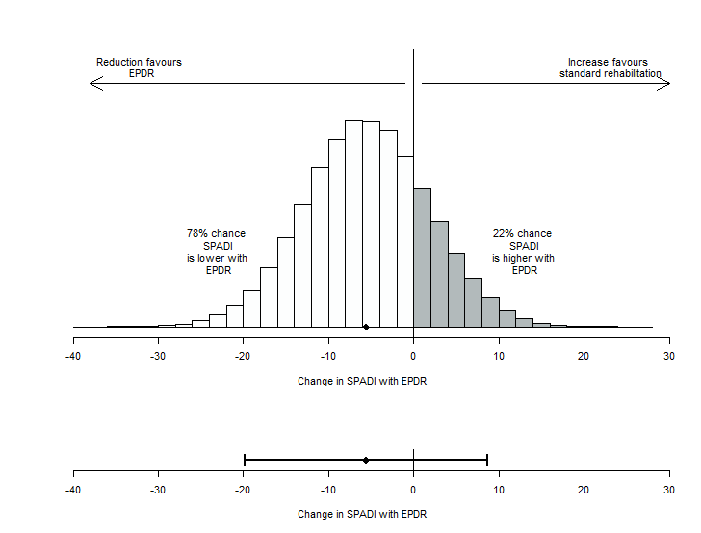

Figure 1: Estimate of uncertainty in the relative effectiveness of EPDR before the trial was commissioned. This plot illustrates the mean between-group difference in SPADI score for EPDR (solid black diamond). The lower image shows the 95% interval from the pilot study, the upper image translates this into a histogram of uncertain health consequences. The SPADI score is a continuous measure of effectiveness where lower values indicate improvement. EPDR has a higher probability of improving outcomes relative to standard rehabilitation. This is shown by the larger proportion of white columns relative to grey in the histogram.

EPDR = early patient-directed rehabilitation; SPADI = shoulder pain and disability index

## Figure 2

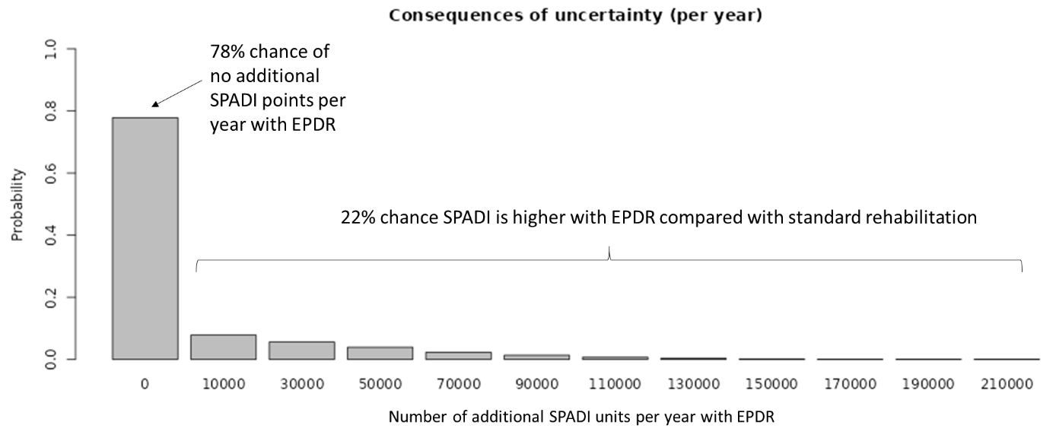

Figure 2: Number of additional SPADI units experienced each year due to uncertainty about the optimal rehabilitation option following shoulder surgery. The tall white column indicates the probability that EPDR is optimal, resulting in no adverse consequences of uncertainty. The lower grey columns illustrate the magnitude and probability of adverse health consequences if EPDR is worse than standard rehabilitation. EPDR = early patient-directed rehabilitation; SPADI = shoulder pain and disability index

## Figure 3

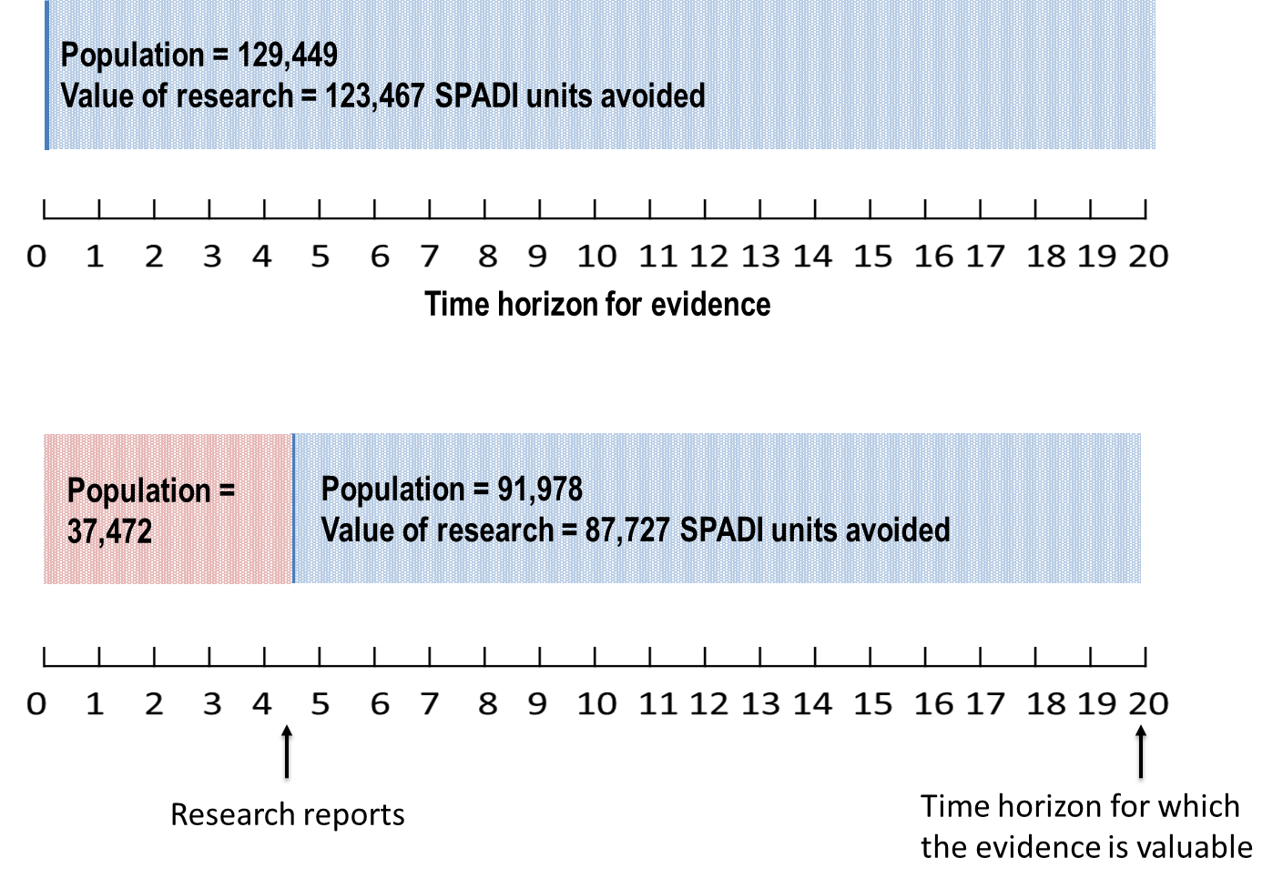

Figure 3: Taking account of the size of the population expected to benefit from the results of the research. The upper bar shows the total population and the value of research over the full 20-year time horizon. The lower bar shows how the size of the population which can benefit and the value of the research decrease as the duration of the research is considered. Because the proposed research is expected to take 4.5 years to report, logically, only the incident population after this time can benefit from the results. All results are discounted at a rate of 3.5%. SPADI = shoulder pain and disability index

# Tables

## Table 1

|  |  |  |
| --- | --- | --- |
| **Name of approach** | **Summary** | **Examples** |
| Narrative | Qualitatively consider the drivers of research value. The drivers considered may or may not be informed by the principles of VOI. | Typical approach utilised by research prioritisation bodies |
| Rapid VOI | Apply VOI methodology to uncertainty in the trial primary outcome. Results may be expressed in terms of the primary outcome or linked to quality adjusted life years (QALYs). | Claxton et al 2015 (3)  McKenna et al 2016 (15)  RANE online tool |
| Minimal modelling 1 | Use the individual patient-level data from an existing clinical study to calculate VOI metrics. | Meltzer et al 2011 (14) |
| Minimal modelling 2 | Construct simple Markov models to model disease progression over time then apply standard VOI methodology. | Bennette et al 2016 (12) Carlson et al 2018 (13) |
| Full decision modelling | Construct a full decision model which captures the progression of disease over time with an varying degree of complexity, then apply standard VOI methodology. | Kunst et al 2019 (16)  Jackson et al 2019 (17)  Tuffaha et al 2016 (18) |

Table 1: Description of approaches to estimating the value of a proposed research study. In general, the degree of complexity and resources required increases from bottom to top. VOI = value of information, RANE = rapid assessment of need for evidence.

## Table 2

|  |  |
| --- | --- |
| **Research question** | Does individualised (early) patient-directed rehabilitation (EPDR) improve shoulder pain and disability compared to current standard (delayed) rehabilitation for patients following surgery to repair the rotator cuff of the shoulder? |
| **Experimental treatment** | Early patient-directed rehabilitation (EPDR) enables patients to remove their shoulder sling following surgery as they feel able and to begin to move their arm, as they feel able. |
| **Comparator** | Standard rehabilitation where patients keep shoulder sling on after surgery for four weeks and remove it only when washing, eating, dressing, or when undertaking specific exercises. |
| **Primary outcome** | Shoulder Pain and Disability Index (SPADI) score at 12 weeks post-surgery. |
| **Secondary outcomes** | SPADI score at 6 and 12-months post-surgery; EQ-5D-5L at 12-weeks, 6 and 12-months; healthcare resource use over 12 months; time out of sling; time to return to usual activities, including driving and work; adverse events; rotator cuff integrity at 12 months. |
| **Proposed study** | Pragmatic multi-centre, open label, RCT with internal pilot phase using a parallel group design with 1:1 allocation ratio. The pilot will run for 6 months to assess recruitment rates and the number of sites opened. The RCT will recruit 638 adults (319 per treatment group). |
| **Duration of proposed study** | 4.5 years to findings reported. |
| **Costs of proposed study** | £1,800,000 |

Table 2: Summary of proposal information for the trial of early patient-directed rehabilitation compared to standard rehabilitation. EPDR = early patient-directed rehabilitation; SPADI = shoulder pain and disability index; RCT = randomised controlled trial.

## Table 3

|  |  |
| --- | --- |
| **Cost of research** | |
| £1,800,000 | |
| **Maximum expected value of additional evidence** | |
| **Primary outcome** | SPADI units avoided |
| **per annum**  (based on population size of 9,000 per year) | 8,584 additional SPADI units avoided per annum. |
| **per 20-year period**  (based on population size of 129,449 and 4.5 years for research to report) | 87,727 additional SPADI units avoided.  £21 per SPADI unit avoided. |

Table 3: Summary of the maximum expected value of proposed new research study based on SPADI score as the primary outcome. Individuals are expected to receive standard rehabilitation until new research reports. Outcomes discounted at a rate of 3.5% per year. SPADI = shoulder pain and disability index

## Table A1

|  |  |  |
| --- | --- | --- |
| **MCD**  **(units on the SPADI scale)** | **Total SPADI units avoided by research** | **Value of research, cost per SPADI unit avoided** |
| 0 (base case) | 87,727 | £21 |
| 1 | 110,121 | £16 |
| 2 | 136,680 | £13 |
| 3 | 167,601 | £11 |
| 4 | 203,203 | £9 |
| 5 | 243,598 | £7 |
| 6 | 249,555 | £7 |
| 7 | 208,051 | £9 |
| 8 | 171,395 | £11 |
| 9 | 139,539 | £13 |
| 10 | 112,250 | £16 |

Table 2: Summary of the maximum expected value of proposed new research study for a range of positive MCD values. The health impact and the value of research reach a peak when MCD is between 5 and 6. Individuals are expected to receive standard rehabilitation until new research reports. Outcomes discounted at a rate of 3.5% per year. SPADI = shoulder pain and disability index; MCD = minimal clinical difference.

# Boxes

## Box 1

|  |
| --- |
| **RANE step 1**  Go to <https://shiny.york.ac.uk/rane/>, navigate to the "Inputs” tab, then “Step 1: Primary outcome”. Choose “Continuous” endpoint. For this analysis we keep the results in “Natural outcomes” which is the default. A higher SPADI score is worse so this outcome is classified as a “Harm”. Type “SPADI points” as the name of the outcome. |

## Box 2

|  |
| --- |
| **RANE step 2**  Navigate to the tab “Step 2: Interventions”. Keep the number of interventions at two (the default). Type “Standard rehabilitation” as the name of the baseline treatment. Keep the baseline treatment utilisation at 100% (note this will not impact the value of research, only the potential value of implementing EPDR).  Type “EPDR” as the name of intervention 1. Keep the intervention treatment utilisation at 0%. Use the sliders to set the 95% range for the mean difference to -19.8 and 8.7. In the base case analysis, EPDR is not expected to be associated with additional costs or side effects and, therefore, keep MCD at zero. |

## Box 3

|  |
| --- |
| **RANE step 3**  Navigate to the tab “Step 3: Proposed research”. The proposed research is an RCT which is the default type of research. Move the slider for expected duration of research to 4.5 years. Input 1800000 as the cost of research (£ is the default currency). Adjust the slider for “Time over which evidence would be valuable” to 20 years. Keep the discount rate at its default (3.5% per year). Input 9000 as the incidence per annum.  Click the “Run analysis” button and navigate to the “Results” tab. |

1. Note that this uncertainty interval was estimated using a frequentist procedure and so is a confidence interval. However, in this analysis we are technically interpreting it as a Bayesian 95% credible interval. Throughout the text we will refer to this simply as an 95% interval.
2. In the VOI literature this is the expected value of perfect information (EVPI), the value of resolving all uncertainty in all uncertain parameters in a decision model. The expected value of partial perfect information (EVPPI) is the expected value of resolving all uncertainty in a subset of model parameters. The expected value of sample information (EVSI) is the expected value of partially resolving uncertainty in a set of model parameters. In the case study the relative effectiveness of EPDR is the only uncertain parameter. EVPI is an expected upper bound for the value of research as it implicitly assumes a trial with infinite sample size which collects information on all uncertain parameters.
3. In technical VOI terminology this ratio represents the expected net gain of sampling (ENGS). In the case study the benefits of research are measured by EVPI. Typically ENGS is expressed as the benefits of research minus the costs of research, where both are expressed on a common scale (health or money). In the case study the benefits and costs are left in different units and so ENGS is expressed as a ratio.
4. In VOI terminology, the expected value of sample information (EVSI) takes account of the sample size when calculating the value of research. The methods described in the case study and implemented in the RANE tool only estimate the expected value of perfect information (EVPI), which assumes an infinite sample size. By definition, EVPI ≥ EVSI.