**Supplementary information for**

**Full title:** Alkylresorcinol detection and identification in archaeological pottery by ultra high performance liquid chromatography-quadrupole/Orbitrap mass spectrometry

**Short title:**  Alkylresorcinol detection and identification in pottery by UHPLC-Q/Orbitrap MS

**Authors:** Jonica Ella Doliente1,2,3, Swen Langer4,5, Marc R. Dickinson1, Miriam Cubas6, André C. Colonese3, Kirsty Penkman1, Oliver E. Craig2

**Affiliations:** 1Department of Chemistry, University of York, York, United Kingdom; 2BioArCh, Department of Archaeology, University of York, York, United Kingdom; 3Department of Prehistory, Institute of Environmental Science and Technology (ICTA), Universitat Autònoma de Barcelona, Barcelona, Spain; 4Department of Biology, Bioscience Technology Facility, University of York, York, United Kingdom; 5Centre of Excellence in Mass Spectrometry, University of York, York, United Kingdom; 6Department of History and Philosophy, University of Alcalá, Madrid, Spain

**Correspondence:** Jonica Ella Doliente, Department of Chemistry, University of York, York YO10 5DD, United Kingdom; Email: [jonica.doliente@york.ac.uk](mailto:jonica.doliente@york.ac.uk); Telephone: +44 7443981282

**This pdf contains:**

**Supplementary Discussion**

**Supplementary Tables:**

**Supplementary Table 1.** Modern cereal samples analysed in this study.

**Supplementary Table 2.** Archaeological samples from the site of Must Farm.

**Supplementary Table 3.** Comparison of the three instruments – GC/MS vs UHPLC-Q/TOFMS vs UHPLC-Q/Orbitrap MS. The sample analysed was common wheat extract at 1:100 dilution.

**Supplementary Table 4.** Distribution of AR homologues in purified Must Farm archaeological pot samples.

**Supplementary Figures:**

**Supplementary Figure 1.** Bar charts showing the relative abundance of saturated AR homologues in modern common wheat extracts diluted at different concentrations. The ARs were detected using GC/MS, UHPLC-Q/TOFMS, and UHPLC-Q/Orbitrap MS.

**Supplementary Figure 2.** Calibration curve and regression equation of AR 22:0 standard solutions analysed by the UHPLC-Q/Orbitrap MS method.

**Supplementary Figure 3.** Structures of some AR homologues detected in modern cereal species using UHPLC-Q/Orbitrap MS. Saturated (A) and unsaturated (B) ARs.

**Supplementary Figure 4.** Relative distribution of AR homologues in different cereal species using GC/[1–5](https://paperpile.com/c/YjTOZI/cLWt+yAhj+bL2Z+iDh7+NkLM) (A) and LC/MS-based[6,7](https://paperpile.com/c/YjTOZI/gc8C+fuKG) protocols (B). The distribution patterns of AR homologues in the five different cereal species remain unchanged whether LC/ or GC/MS-based methods were used.

**Supplementary Discussion**

**Comparison of the three instruments**

Overall, UHPLC-Q/Orbitrap MS was the most sensitive instrument among the three techniques, able to detect the major AR homologues (AR 19:0, AR 21:0, and AR 23:0) at a 1:10,000 dilution of common wheat extracts using the developed method. UHPLC-Q/TOFMS and GC/MS detected the same ARs of the same cereal extracts at 1:1000 and 1:100 dilutions, respectively (Supplementary Figure 1). Further comparison among the three techniques is presented in Supplementary Table 3.

UHPLC-Q/Orbitrap MS instrument detected more types and numbers of AR homologues (five saturated ARs, two unsaturated ARs, and four 5-(2-oxo)ARs) in a common wheat extract at 1:100 dilution than the other two instruments. UHPLC-Q/TOFMS detected five saturated ARs, and three 5-(2-oxo)ARs, while the conventional GC/MS in SIM mode didn’t detect any other type of AR homologues other than the four saturated ones (Supplementary Table 3).

**Supplementary Tables**

**Supplementary Table 1.** Modern cereal samples analysed in this study.

|  |  |
| --- | --- |
| Species | Ploidy level* |
| Common wheat (*Triticum aestivum* spp. *aestivum*) | hexaploid (6x) |
| Khorasan wheat (*Triticum turgidum* spp. *turanicum*) | tetraploid (4x) |
| Emmer (*Triticum turgidum* spp. *dicoccum*) |
| Einkorn (*Triticum monococcum* spp. *monococcum*) | diploid (2x) |
| Barley (*Hordeum vulgare* L.) | - |

*Ploidy level = number of sets of chromosomes.

**Supplementary Table 2.** Archaeological samples from the site of Must Farm[8](https://paperpile.com/c/YjTOZI/tSmN).

|  |  |  |  |
| --- | --- | --- | --- |
| Sample ID | Structure | Typological classification | Location of the sample |
| MUS 76 | M1 | - | - |
| MUS 1192 | 1 | Fineware bowl | Body under the rim |
| MUS 1281 | MI | Coarseware jar | Bottom |
| MUS 1379A | - | Coarseware jar | Rim |
| MUS 1924 | 1 | Coarseware bowl | Under the rim |
| MUS 2828 | 1 | Coarseware bowl | Rim and under the rim |
| MUS 2830 | 1 | Fineware bowl | Body under the rim |
| MUS 2835 | 1 | Fineware bowl | Rim and under the rim |

*M: midden

**Supplementary Table 3.** Comparison of the three instruments – GC/MS vs UHPLC-Q/TOFMS vs UHPLC-Q/Orbitrap MS. The sample analysed was common wheat extract at 1:100 dilution.

|  |  |  |  |
| --- | --- | --- | --- |
| Parameters | GC/MS | UHPLC-Q/TOFMS | UHPLC-Q/Orbitrap MS |
| detected saturated AR at 1:100 dilution | AR 17:0, AR 19:0, AR 21:0, AR 23:0 | AR 17:0, AR 19:0, AR 21:0, AR 23:0, AR 25:0 | AR 17:0, AR 19:0, AR 21:0, AR 23:0, AR 25:0 |
| detected unsaturated AR at 1:100 dilution | nd | nd | AR 19:1 and AR 21:1 |
| detected 5-(2-oxo)ARs at 1:100 dilution | nd | AR 21:0 oxo, AR 23:0 oxo, AR 25:0 oxo | AR 21:0 oxo, AR 23:1 oxo, AR 23:0 oxo, AR 25:0 oxo |
| dilution in which major ARs* are detectable | 1:100 | 1:1000 | 1:10,000 |
| derivatisation step | required | not required | not required |
| analysis time (min/sample) | 98 | 17 | 17 |
| cost (£ per sample)** | 7 | 22 | 22 |

*major ARs include AR 19:0, AR 21:0, and AR 23:0

**cost depends on the laboratory/university

**Supplementary Table 4.** Distribution of AR homologues in purified Must Farm archaeological pot samples.

|  |  |  |  |  |  |
| --- | --- | --- | --- | --- | --- |
| Sample ID | AR homologue content (%) | | | | |
| 17:0 | 19:0 | 21:0 | 23:0 | 25:0 |
| MUS 76 | nd* | nd* | 100 | nd* | nd* |
| MUS 1192 | nd* | nd* | 81 | 19 | nd* |
| MUS 1281 | nd* | nd* | 85 | 15 | nd* |
| MUS 1379A | nd* | nd* | 100 | nd* | nd* |
| MUS 1924 | nd* | nd* | 100 | <LOD | nd* |
| MUS 2828 | nd* | nd* | 100 | nd* | nd* |
| MUS 2830 | nd* | nd* | nd* | nd* | nd* |
| MUS 2835 | nd* | <LOD | 59 | 30 | 11 |

*nd: not detected

**Supplementary Figures**

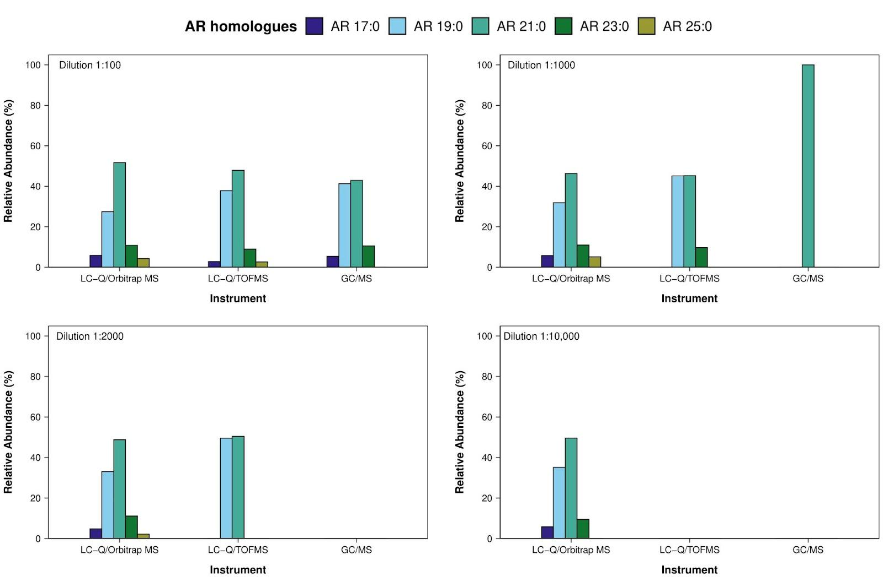

**Supplementary Figure 1.** Bar charts showing the relative abundance of saturated AR homologues in modern common wheat extracts diluted at different concentrations. The ARs were detected using GC/MS, UHPLC-Q/TOFMS, and UHPLC-Q/Orbitrap MS.

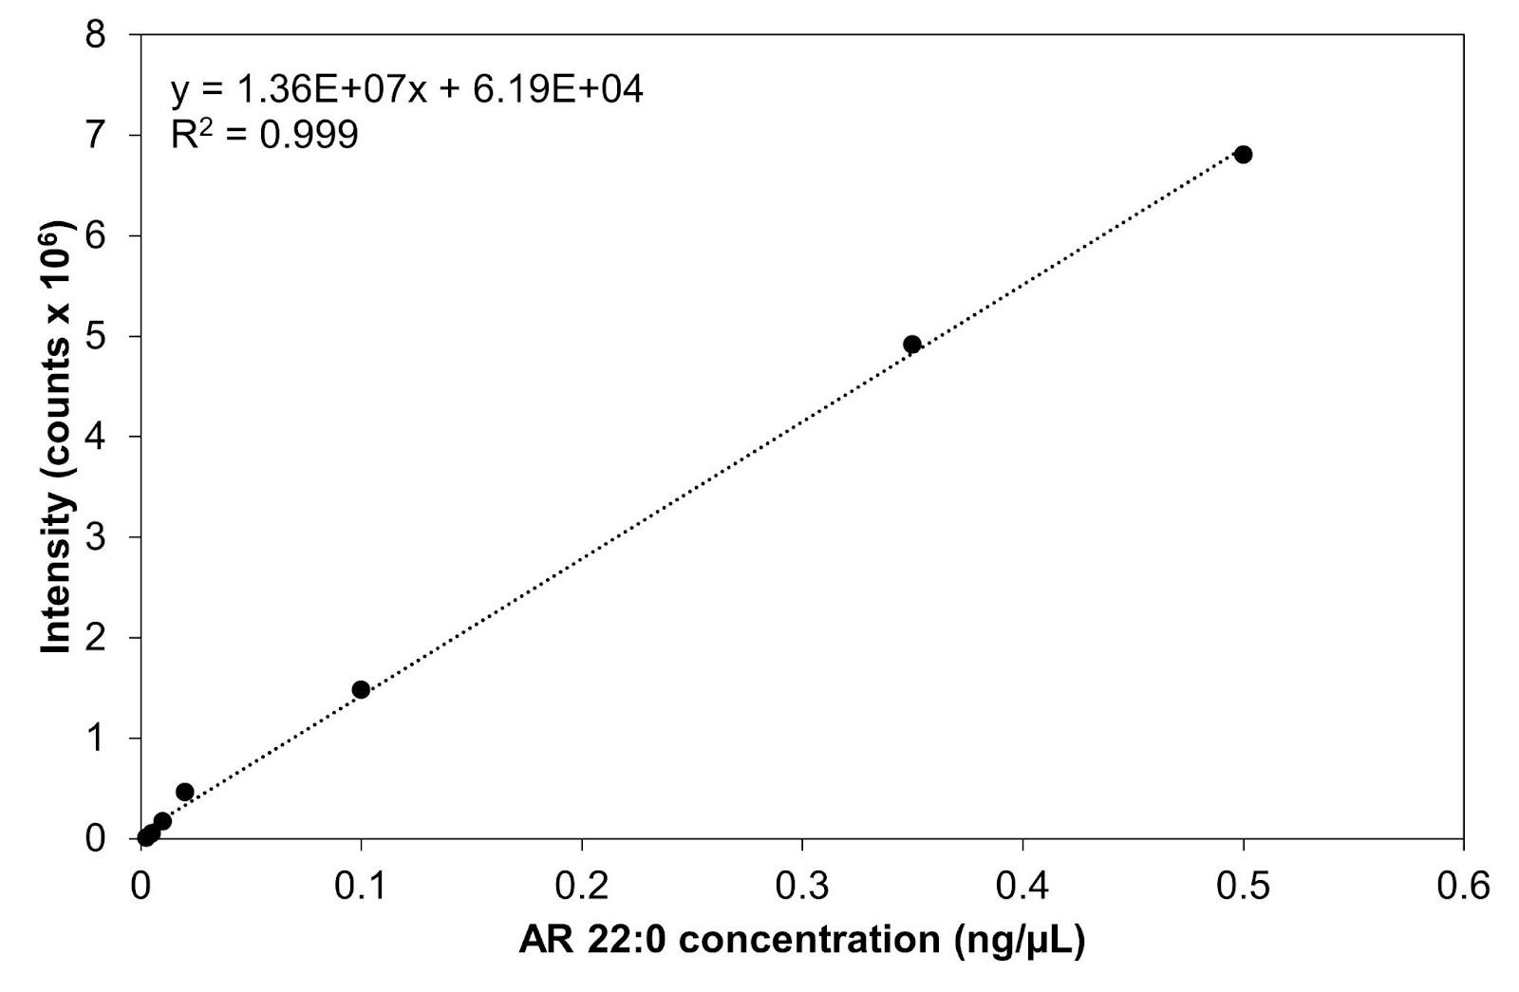

**Supplementary Figure 2.** Calibration curve and regression equation of AR 22:0 standard solutions analysed by the UHPLC-Q/Orbitrap MS method.

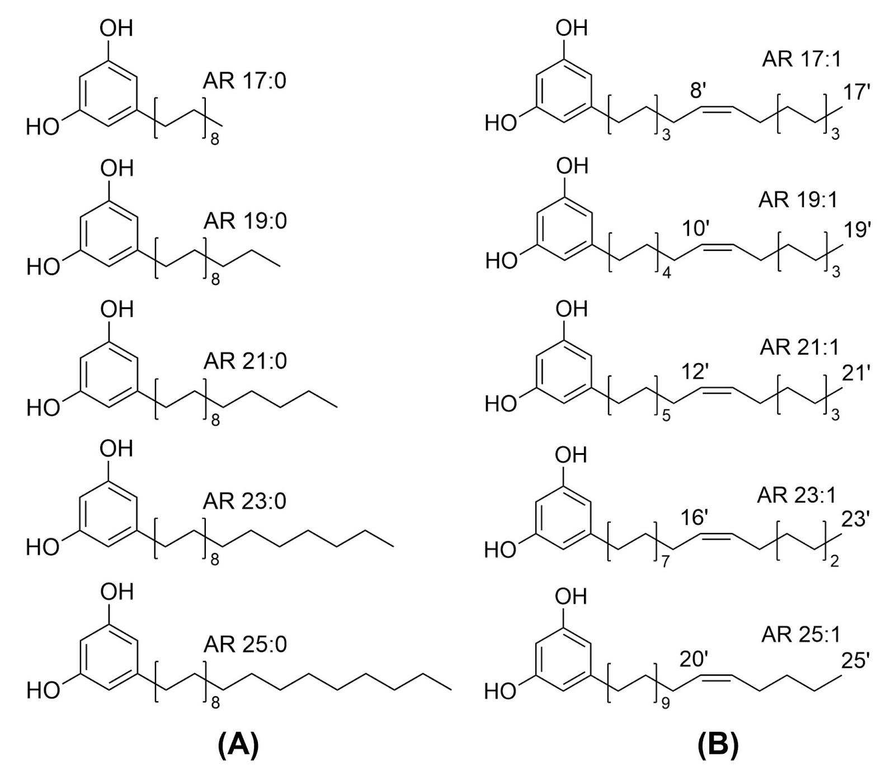

**Supplementary Figure 3.** Structures of some AR homologues detected in modern cereal species using UHPLC-Q/Orbitrap MS. Saturated (A) and unsaturated (B) ARs.

**Supplementary Figure 4.** Relative distribution of AR homologues in different cereal species using GC/[1–5](https://paperpile.com/c/YjTOZI/cLWt+yAhj+bL2Z+iDh7+NkLM) (A) and LC/MS-based[6,7](https://paperpile.com/c/YjTOZI/gc8C+fuKG) protocols (B). The distribution patterns of AR homologues in the five different cereal species remain unchanged whether LC/ or GC/MS-based methods were used.

**Supplementary References**

1. [Ross AB, Kamal-Eldin A, Jung C, Shepherd MJ, Åman P. Gas chromatographic analysis of alkylresorcinols in rye (Secale cereale L) grains. *J Sci Food Agric*. 2001;81(14):1405-1411. doi:](http://paperpile.com/b/YjTOZI/cLWt)[10.1002/jsfa.956](http://dx.doi.org/10.1002/jsfa.956)

2. [Ross AB, Shepherd MJ, Schüpphaus M, et al. Alkylresorcinols in cereals and cereal products. *J Agric Food Chem*. 2003;51(14):4111-4118. doi:](http://paperpile.com/b/YjTOZI/yAhj)[10.1021/jf0340456](http://dx.doi.org/10.1021/jf0340456)

3. [Chen Y, Ross AB, Aman P, Kamal-Eldin A. Alkylresorcinols as markers of whole grain wheat and rye in cereal products. *J Agric Food Chem*. 2004;52(26):8242-8246. doi:](http://paperpile.com/b/YjTOZI/bL2Z)[10.1021/jf049726v](http://dx.doi.org/10.1021/jf049726v)

4. [Hammann S, Korf A, Bull ID, Hayen H, Cramp LJE. Lipid profiling and analytical discrimination of seven cereals using high temperature gas chromatography coupled to high resolution quadrupole time-of-flight mass spectrometry. *Food Chem*. 2019;282:27-35. doi:](http://paperpile.com/b/YjTOZI/iDh7)[10.1016/j.foodchem.2018.12.109](http://dx.doi.org/10.1016/j.foodchem.2018.12.109)

5. [Andersson AAM, Kamal-Eldin A, Aman P. Effects of environment and variety on alkylresorcinols in wheat in the HEALTHGRAIN diversity screen. *J Agric Food Chem*. 2010;58(17):9299-9305. doi:](http://paperpile.com/b/YjTOZI/NkLM)[10.1021/jf904526d](http://dx.doi.org/10.1021/jf904526d)

6. [Ziegler JU, Steingass CB, Longin CFH, Würschum T, Carle R, Schweiggert RM. Alkylresorcinol composition allows the differentiation of Triticum spp. having different degrees of ploidy. *J Cereal Sci*. 2015;65:244-251. doi:](http://paperpile.com/b/YjTOZI/gc8C)[10.1016/j.jcs.2015.07.013](http://dx.doi.org/10.1016/j.jcs.2015.07.013)

7. [Pedrazzani C, Vanara F, Bhandari DR, et al. 5-n-Alkylresorcinol Profiles in Different Cultivars of Einkorn, Emmer, Spelt, Common Wheat, and Tritordeum. *J Agric Food Chem*. 2021;69(47):14092-14102. doi:](http://paperpile.com/b/YjTOZI/fuKG)[10.1021/acs.jafc.1c05451](http://dx.doi.org/10.1021/acs.jafc.1c05451)

8. [Cubas M, Dickinson M, von Tersch M, Lucquin A, Craig OE. Chapter 28: Organic residues. In: Knight M, Ballantyne R, Cooper A, Gibson D, Zeki IR, eds. *Must Farm Pile Dwelling Settlement*. Vol 2. In Press; :1175-1187.](http://paperpile.com/b/YjTOZI/tSmN)