Effects of aridification on soil total carbon pools in China’s drylands

Zhuobing Ren1,2, Changjia Li1,2*, Bojie Fu1,2, Shuai Wang1,2, Lindsay C. Stringer3,4

1. State Key Laboratory of Earth Surface Processes and Resource Ecology, Faculty of Geographical Science, Beijing Normal University, Beijing, China

2. Institute of Land Surface System and Sustainable Development, Faculty of Geographical Science, Beijing Normal University, Beijing, China

3. Department of Environment and Geography, University of York, York, UK

4. York Environmental Sustainability Institute, University of York, York, UK

*Corresponding author: changjia.li@bnu.edu.cn

# Graphical Abstract

Aridification poses a threat to soil carbon pools in dryland ecosystems, yet the effect of increasing aridity on soil total carbon remains largely unknown. Based on a space-for-time-substitution approach and field survey across a ~4000 km transect in China’s drylands, we found that soil inorganic carbon positively compensated for soil organic carbon. The effect of aridity on soil total carbon changed from negative to positive at 0.71 aridity. In regions with lower aridity levels, aridification resulted in a decline in total carbon, primarily driven by the reduction in organic carbon. Conversely, in more arid regions, aridification favoured increasing inorganic carbon, consequently leading to an increase in total carbon.

# Abstract

Drylands are important carbon pools and are highly vulnerable to climate change, particularly in the context of increasing aridity. However, there has been limited research on the effects of aridification on soil total carbon including soil organic carbon and soil inorganic carbon, which hinders comprehensive understanding and projection of soil carbon dynamics in drylands. To determine the response of soil total carbon to aridification, and to understand how aridification drives soil total carbon variation along the aridity gradient through different ecosystem attributes, we measured soil organic carbon, inorganic carbon and total carbon across a 4000 km aridity gradient in the drylands of northern China. Distribution patterns of organic carbon, inorganic carbon and total carbon at different sites along the aridity gradient were analysed. Results showed that soil organic carbon and inorganic carbon had a complementary relationship, i.e., an increase in soil inorganic carbon positively compensated for the decrease in organic carbon in semi-arid to hyper-arid regions. Soil total carbon exhibited a nonlinear change with increasing aridity, and the effect of aridity on total carbon shifted from negative to positive at an aridity level of 0.71. In less arid regions, aridification leads to a decrease in total carbon, mainly through a decrease in organic carbon, whereas in more arid regions, aridification promotes an increase in inorganic carbon and thus an increase in total carbon. Our study highlights the importance of soil inorganic carbon to total carbon and the different effects of aridity on soil carbon pools in drylands. Soil total carbon needs to be considered when developing measures to conserve the terrestrial carbon sink.

**KEYWORDS:** increasing aridity, soil organic carbon, soil inorganic carbon, distribution pattern, nonlinear response, driving effects

# 1 INTRODUCTION

Soil is the largest terrestrial carbon store, holding approximately 2047 petagrams (Pg) of organic carbon and 1558 Pg of inorganic carbon (Plaza et al., 2018). The total soil carbon store is roughly four times the carbon content in the atmosphere (750 Pg) (Puetz et al., 2014) and six times that in vegetation (560 Pg) (Lal, 2018). Soil carbon in drylands accounts for approximately 52% of the global soil carbon pool (Lal, 2019; Plaza et al., 2018), including 32% of the global soil organic carbon pool and 80% of the global soil inorganic carbon pool. In the context of climate change, global aridity is increasing and drylands in many locations are expanding (Gu et al., 2018; Huang et al., 2016; C. Wang et al., 2014), contributing to land degradation and desertification (Fischlin et al., 2007). More regions are being influenced by dryland mechanisms such as the decoupling of soil biogeochemical cycles and biological soil crust formation (Grunzweig et al., 2022). Soil carbon in drylands is highly sensitive and vulnerable to such aridity-driven changes in environment and mechanism, and makes a considerable contribution to the overall loss of global soil carbon pools (Lal, 2004; Lal et al., 1999; Ojima et al., 1995). Studying the driving effect of aridity on soil carbon is therefore essential. Numerous studies have analyzed the impacts of aridity on soil organic carbon in drylands (Berdugo et al., 2020; W. G. Hu et al., 2021; Ren et al., 2023) as well as inorganic carbon (Raheb et al., 2017; Wu et al., 2009; Zamanian et al., 2016), but these studies have been conducted separately. As soil inorganic carbon plays a significant role in the soil total carbon stock (having more than twice the soil organic carbon amount) (C. Li et al., 2021; Song et al., 2022), it is important to consider soil inorganic carbon when studying soil carbon dynamics in drylands. However, research on the soil total carbon response to aridity is scarce, particularly across large-scale aridity gradients. Given that aridification is a key feature characterizing global drylands, enhanced understanding of its impacts on soil total carbon over a broad geographical range is necessary, yet largely missing in the literature.

Previous studies have demonstrated that increasing aridity levels lead to a reduction in soil organic carbon content (Berdugo et al., 2020; W. G. Hu et al., 2021; Z. Hu et al., 2022; C. Li et al., 2023). In contrast, an increase in aridity (or decrease in precipitation) is often accompanied by an increase in soil inorganic carbon content (Mi et al., 2008; Naorem et al., 2022; Tan et al., 2014). Although soil total carbon is composed of both soil organic carbon and soil inorganic carbon, the impact of increasing aridity on the total carbon pool in dryland soils remains unclear. The dynamics of soil total carbon are mostly determined by the formation and decomposition of soil organic carbon and soil inorganic carbon, so the possible impacts of aridity on soil total carbon can, in principle, be understood by examining pathways in regulating soil organic carbon and soil inorganic carbon. First, aridity can reduce the clay content of soil, causing it to be looser (Berdugo et al., 2022), which is a variable strongly associated with both organic carbon and inorganic carbon. Soil clay particles can promote soil aggregate formation, thereby facilitating organic carbon adsorption and preventing its decomposition (Vogel et al., 2014). Soils with a higher clay content have a greater total porosity and larger surface area, which promotes cation adsorption and reactions, thereby favoring inorganic carbon accumulation (Ferdush & Paul, 2021). Vegetation is an important source of soil organic carbon, and a decrease in vegetation leads to a reduction in soil organic carbon. Vegetation can also alter the amount and depth of water infiltration into the soil, thereby affecting soil inorganic carbon leaching (Basche & DeLonge, 2019; Yao et al., 2016). Soil nitrogen content is positively related to organic carbon (Puspok et al., 2023; Xu et al., 2022). While as nitrogen content increases, nitrate can cause the leaching of metal cations, reducing resistance to acidification (Tian & Niu, 2015). Moreover, ammonium ion absorption by plant roots releases H+ ions into the soil (Smith & Read, 2010). Therefore, an increase in soil nitrogen content can promote soil acidification with H+ input, resulting in a decrease in soil inorganic carbon (Song et al., 2022). Solid inorganic carbon (calcium carbonate) is transformed into Ca2+ loss and bicarbonate may be further reacted by hydrogen ions to carbon dioxide and water as shown in equations (Ferdush & Paul, 2021):

$$\begin{aligned}CaCO3\left(s\right)+ H^{+} ↔ {Ca}^{2+}\left(aq\right)+ {HCO}_{3}^{-}\left(aq\right)\#\left(1\right)\end{aligned}$$

$$\begin{aligned}{HCO}_{3}^{-}\left(aq\right)+ H^{+} ↔ H_{2}{CO}_{3}\left(aq\right)↔ H_{2}O + {CO}_{2}\left(g\right)\#\left(2\right)\end{aligned}$$

In addition to affecting inorganic carbon, low pH likely inhibits organic carbon decomposition (Shi et al., 2012). While all these processes may differentially influence how soil organic carbon and soil inorganic carbon respond to aridification, the overall impact of aridity on soil total carbon is still poorly understood and scarcely quantified.

Based on previous research, we hypothesize that: i) there is a complementary relationship between soil organic carbon and soil inorganic carbon along the aridity gradient. The response of soil total carbon to aridity is expected to be nonlinear, with the presence of an aridity threshold; And ii) this nonlinear change in soil total carbon is achieved by a negative to positive effect of aridity and an aridity-driven change in the role of key factors such as soil sand content, pH, and vegetation cover. In less arid regions, aridity mainly drives soil organic carbon reduction through direct or indirect pathways to reduce soil total carbon, whereas it drives soil inorganic carbon increases to escalate soil total carbon in more arid regions. To test these hypotheses, we conducted a large-scale transect survey along an approximately 4000 km aridity gradient in northern China. Soil and plant samples were collected to measure soil organic carbon, soil inorganic carbon and other soil and vegetation attributes. We aimed to: i) verify the relationship between soil organic carbon and soil inorganic carbon, ii) detect the nonlinear variation in soil total carbon along the aridity gradient and the shift in the effect of aridity, and iii) analyze how the driving effects of aridity on total carbon are generated and change through specific pathways.

# 2 MATERIALS AND METHODS

**2.1 Study areas**

This research was carried out along an approximately 4,000 km natural aridity gradient (longitude: 85°00′ - 121°32′E; latitude: 38°48′ - 50°10′N) in northern China’s drylands (Figure 1a). This region covers 6.6 million km2 and contains a substantial amount of soil organic carbon and inorganic carbon (C. Li et al., 2021). Field campaigns covered all dryland subtypes and spanned a wide range of environmental conditions (mean annual precipitation [MAP]: 34~431 mm; mean annual temperature [MAT]: -2~10 °C), vegetation types (e.g., meadow steppe, typical steppe, and desert steppe from eastern to western regions of the transect), and soil types (e.g., Aridisols including arid, sandy, brown loess for the drier parts, and Mollisols for the wetter parts of the transect). The aridity (1-aridity index) of this transect ranged from 0.39 to 0.97, providing wide range of conditions in which to investigate how aridification may impact soil organic carbon, inorganic carbon, and total carbon dynamics across a broad geographical and environmental range. Capturing this diversity is important given the overall expansion of global drylands, increasing aridity levels, and land degradation, in the context of accelerating global climate change.

**2.2 Field survey and sampling design**

A standardized field survey based on the BIODESERT global survey (Maestre et al., 2022) was conducted in 82 45ⅹ45 m plots between July and August in 2020 and 2021. Plot coordinates, including longitude, latitude, and altitude, were recorded using a high-precision GPS area measuring instrument (WS-009, JIEWEISEN, China). We measured the slope and aspect of each transect using a multifunctional slope measuring instrument, JZC-B2. At each site, four 45-m-long transects (using steel tape) interspaced 10 m from each other, were located from upslope to downslope. The line-point intercept method was used to survey the ground cover according to its category (e.g., bare soil, rock, vegetation, litter, biological soil crust) every 20 cm along the 45 m transects.

The soil survey was conducted by randomly selecting three sampling points in open areas without perennial vascular plants (covering < 5% of the total surface of the quadrat). Any two sampling points were at least 5 m apart. Stainless steel cutting rings (50.46 mm diameter by 50 mm height, 100 cm3 volume) were used to obtain soil cores at each sampling point at 0–10, 10–20, and 20–30 cm soil depths for bulk density measurements. A 38 mm diameter by 1.0 m long soil sampler was used to obtain soil samples (0–30 cm depth) in areas adjacent to where soil bulk density samples were collected to obtain samples for measurements of the soil’s physical and chemical properties.

**2.3 Laboratory method**

Soil samples were sealed in plastic bags, packed and sent by express to the Institute of Mountain Hazards and Environment (IMHE), Chinese Academy of Sciences, Chengdu, for lab analysis. The measured soil properties included bulk density, soil particle size, soil moisture, pH, soil organic carbon, total nitrogen, total phosphorus, and calcium carbonate. All soil samples were manually homogenized. Gravel and visible root residues and stones were removed prior to laboratory analysis. All samples were air-dried and crushed to pass through a 2 mm mesh, followed by grinding in a mortar and passing through a 0.25 mm mesh to determine the soil organic carbon, total nitrogen and total phosphorus contents. Soil bulk density (g cm-3) was determined through the oven-drying method (at 105 °C for 48 h). Soil particle size was determined using a laser particle sizer (Mastersizer 2000, Malvern, UK). Soil pH was quantified using a pH meter (HQ30d, HACH, USA). Soil organic carbon (g g-1) and total nitrogen (g g-1) were determined using an elemental analyzer (Vario MACRO Cube, PerkinElmer, USA). Soil total phosphorus (mg kg-1) was measured using the Mo-Sb colorimetric method (ICP‒OES Avio 200, PerkinElmer, USA). Soil calcium carbonate (g kg-1) was measured by the titrimetric method.

**2.4 Data collection of environmental variables**

We collected information on two categories of environmental factors: climatic and edaphic factors, to identify the major determinants of soil carbon in drylands. Climatic variables, including MAP and MAT, were obtained from the WordClim dataset (<http://www.worldclim.org/>), which has a spatial resolution of 1×1 km. Aridity index (AI) data were obtained from the Global Aridity Index and Potential Evapotranspiration Climate database (<https://cgiarcsi.community/>). Edaphic variables, including soil total K (STK), cation exchange capacity (CEC), and gravel content, were collected from the basic soil property dataset of high-resolution China Soil Information Grids (<http://doi.org/10.11666/00073.ver1.db>; ~1 km resolution). We extracted all plot-level environmental data from the datasets mentioned above, using the longitude and latitude coordinates of each plot.

**2.5 Data Analysis**

Equation (1) was used for calculating the amount of whole soil organic carbon in a sampling point with k horizons (Batjes, 1996; Y. Wang et al., 2010):

$$\begin{aligned}SOC=\sum_{i=1}^{k}{{SOC}_{i}}=\sum_{i=1}^{k}{ρ_{i}×P_{i}×D_{i}×\left(1-S_{i}\right)×10^{3}}\#\left(1\right)\end{aligned}$$

where i is the number of horizons, $ρ_{i}$ denotes the bulk density (Mg m−3), is the soil organic carbon density (kg m−2), represents the proportion of organic carbon (g C g−1) in horizon i, $D_{i}$ indicates the thickness of the horizon (m), and $S_{i}$ denotes the volume fraction of fragments >2 mm. Similarly, soil inorganic carbon density (kg m−2) in each sampling site was calculated using Equation (2):

$$\begin{aligned}SIC=\sum_{i=1}^{k}{{SIC}_{i}}=\sum_{i=1}^{k}{0.12×ρ_{i}×P_{i}×D_{i}×\left(1-S_{i}\right)×10^{3}}\#\left(2\right)\end{aligned}$$

where i is the number of horizons, $ρi$ is the bulk density (Mg m−3), is the soil inorganic carbon density (kg m−2), represents the proportion of inorganic carbon (g C g−1) in horizon i, $D_{i}$ indicates the thickness of the horizon (m), and $S_{i}$ denotes the volume fraction of fragments >2 mm. The coefficient of 0.12 corresponds to the molar fraction of C in CaCO3 used for converting the measured carbonates into SIC. Furthermore, soil total carbon density (kg m−2) at each soil depth was calculated by adding soil organic and inorganic carbon:

$$\begin{aligned}STC=SOC+SIC\#\left(3\right)\end{aligned}$$

In the subsequent test, we considered the data in the studied areas from the various aridity types as independent samples and tested them with the Mann‒Whitney U method. In contrast, the data from same aridity types (various depths) were considered paired samples and tested by the Wilcoxon rank test. Additionally, a boxplot was used to illustrate the variation in soil organic, inorganic, and total carbon at different soil depths and under different aridity levels.

To evaluate the responses of soil organic, inorganic and total carbon to aridity, the relationships between carbon and aridity were fitted using linear and nonlinear (quadratic and general additive models [GAM]) regressions. The linear and nonlinear models assumed that the carbon attribute changes gradually or nonlinearly with increasing aridity. The best fit in each case was determined by the Akaike information criterion (AIC), where the best model had the lowest AIC value. The thresholds were detected when nonlinear regressions better fit the data. We fitted threshold models, including segmented, step and stegmented models, to determine thresholds and used AIC to select the best model and the associated threshold (Berdugo et al., 2020). When the data did not exhibit a unimodal distribution (Table S1), the linear regressions were adjusted during fitting by replacing them with quantile regressions. The chngpt (Fong et al., 2017) and gam (Hastie & Tibshirani, 2017) packages in R were used to fit segmented/step/stegmented and GAM regressions, respectively. Bootstrap analysis was conducted on linear regressions to determine whether thresholds significantly affected intercepts and slopes (Canty & Ripley, 2021). Results were compared using the Mann−Whitney U test (Figure S3). Threshold values and segment parameters were calculated with a 95% confidence interval (Table S3). In addition, we calculated the posterior distribution of aridity thresholds and then determined the highest density intervals of the aridity thresholds to support their validity (Figure S4).

To further illustrate the directionality of shifts in different factors for soil total carbon in response to aridity, GradientBoost (GB) models were run for each factor individually with Shapley additive explanations (SHAP) dependence plots. The SHAP method, based on game theory, quantifies the contributions of model features toward either the increase or decrease in a specific output’s probability relative to the output’s average used for model training (i.e., soil total carbon in this study). A response curve corresponding to the effect of this predictor on the response variable was obtained by graphing the predictor value against the associated SHAP values (Egidi et al., 2023). A positive SHAP value suggests that a feature is expected to have a positive impact on the soil total carbon, while a negative SHAP value indicates the opposite impact. We built the models with the ‘xgboost’ package and extracted SHAP values with the ‘SHAPforxgboost’ package in R 4.1.3.

Piecewise structural equation models were used to assess the effects of aridity and potential pathways through which aridification may affect soil total carbon. Predictors were selected from the variables where significant changes in SHAP values occurred along with aridity. We used linear models to fit the component models of the piecewise SEM and reported the standardized coefficient of each path from each component model. We used the chi-squared test (X2/df) and AIC to test the overall fit of the SEM. We used the“piecewiseSEM” package to conduct piecewise SEM.

# 3 RESULTS

**3.1 Distribution patterns of soil organic and inorganic carbon across China’s drylands**

Over the entire study area, the average soil organic carbon was 2.78 kgC m−2 and the average soil inorganic carbon was 2.80 kgC m−2, with large variations (SD = 2.81 kgC m−2 and SD = 2.34 kgC m−2, respectively). Higher aridity corresponds to lower organic and higher inorganic carbon such as in the western interior, while lower aridity is associated with higher organic and lower inorganic carbon as shown in the eastern part of Inner Mongolia (Figure 1a). In dry sub-humid regions, the density of organic carbon is highest (9.28 kgC m-2) with the highest proportion of total carbon (90%), while the lowest density of inorganic carbon (1.04 kgC m-2) with the lowest proportion (10%). In hyper-arid areas, the density of organic carbon is lowest (0.62 kgC m-2) with the lowest proportion of total carbon (12%), while the density of inorganic carbon is highest (4.62 kgC m-2) with the highest proportion (88%). The composition of total carbon shifts between arid and semi-arid regions (Table 1), with the lowest total carbon density occurring in arid regions (5.08 kgC m-2). Soil organic carbon showed a gradual decreasing trend across the dry sub-humid, semi-arid, arid, and hyper-arid regions (p<0.05, Figure 1b). The soil inorganic carbon exhibited a gradual increasing trend along the semi-arid, arid and hyper-arid regions (p<0.05). The soil total carbon was significantly higher only in the dry sub-humid region compared to other aridity types (p<0.05). Total carbon was relatively stable in semi-arid, arid, and hyper-arid regions (p>0.05). As aridity decreased, the differences in soil organic carbon, soil inorganic carbon and soil total carbon between different soil depths became more pronounced (Figure S1). Moreover, with decreasing aridity, soil organic carbon tended to concentrate in shallow layers, while soil inorganic carbon tended to move to deeper layers, resulting in a separation of soil carbon pools. The differences in soil organic carbon, soil inorganic carbon and soil total carbon along the aridity gradient were almost consistent between different depths (Figure S2).

**3.2 Changes in soil organic, inorganic and total carbon with aridity**

Responses of soil organic carbon, soil inorganic carbon and soil total carbon to aridity were evaluated, and the aridity levels at which these responses showed abrupt changes were identified (Figure 2). Results showed that the linear model was more suitable for soil organic carbon (Table S2), indicating that soil organic carbon had no abrupt change and decreased with an increasing aridity gradient (*p* < 0.001). The nonlinear model was more suitable for soil inorganic carbon and soil total carbon in relation to aridity, which indicated that there were aridity thresholds where abrupt changes occurred (Table S2). A sharp rise in soil inorganic carbon was detected at an aridity level of 0.86, and soil total carbon decreased and then increased with a turning point at 0.86.

**3.3 Influence of different factors on soil total carbon along the aridity gradient**

We used XGBoost models and SHAP dependence plots to visualize the effects of different ecosystem attributes on soil total carbon along the aridity gradient. All of them exhibited varying degrees of nonlinear behavior, with changes in the effects of predictors signaling either nonsignificant (e.g., gravel, STK, and STP) or significant trends (e.g., aridity, soil organic carbon, soil inorganic carbon, CEC, VEGCOV, biocrust, sand and STN) along the aridity gradient (Figure 3). For instance, aridity’s influence on soil total carbon underwent a shift from negative to positive at an aridity level of 0.71 (Figure 4). This transition occurred below the aridity threshold of soil total carbon with aridity. The influence of soil organic carbon on soil total carbon was predicted to exhibit a positive-to-negative trend with increasing aridity, while soil total carbon was more positively associated with soil inorganic carbon in more arid regions (aridity > ~0.8). The impact of CEC on soil total carbon showed a noticeable transition from positive to negative, occurring at an approximate aridity level of 0.7. Soil total carbon was predicted to be more positively associated with VEGCOV along the aridity gradient (*p* < 0.001). Biocrust coverage had a higher probability of positively influencing soil total carbon in less arid regions and negatively influencing soil total carbon in more arid regions. The influence of soil sand content decreased with aridity (*p* < 0.001), and soil total carbon was predicted to be more related to the magnitude of sand content itself. Soil total carbon was quite likely to be positively associated with STN, but the influence decreased significantly with aridity (*p* < 0.001).

**3.4 Pathways of aridity effects on soil total carbon under less and more arid conditions**

As a complement to the analyses of the SHAP method (Figure 3), we further applied piecewise SEM to quantify both the direct and indirect effects of the factors on aridification-caused soil total carbon changes, and to assess whether different indirect pathways may drive aridity-soil total carbon relationships in less and more arid regions (Figure 5). Soil cation exchange capacity and biocrust coverage were included in the SEM considering the statistically significant change (*p* < 0.001) in the effects of these factors with aridity according to the SHAP dependence plots. Based on the changes in the positive and negative effects of aridity on soil total carbon, we divided the sampling area into less arid and more arid regions using an aridity threshold of 0.71. In less arid regions, aridity regulated soil organic carbon significantly through sand content (β = -0.23, standardized coefficient), soil total nitrogen (β = 0.22) and pH (β = -0.18), while inorganic carbon was regulated by soil organic carbon (β = -0.34), pH (β = 0.37) and sand content (β = -0.40). Soil organic carbon was strongly correlated with soil total carbon (β = 0.95) compared to inorganic carbon (β = 0.53). The standardized effect of aridity on soil total carbon through organic carbon was -0.33, while through inorganic carbon, it was only -0.03, resulting in an overall effect of -0.37 on soil total carbon. In more arid regions, aridity regulated soil organic carbon significantly through soil total nitrogen (β = 0.39) and vegetation coverage (β = 0.23), while soil inorganic carbon was regulated by cation exchange capacity (β = -0.40) and the aridity level itself (β = 0.25). Furthermore, sand content also directly influenced soil organic carbon (β = -0.21) and inorganic carbon (β = -0.34). Compared to organic carbon (β = 0.49), soil inorganic carbon showed a strong association with soil total carbon (β = 0.89). The standardized effect of aridity on total carbon through organic carbon was -0.15, while through inorganic carbon, it was 0.31, giving an overall effect of 0.15 on soil total carbon.

# 4 DISCUSSION

Soil carbon pools in drylands have been of great concern, as the large amount of carbon is highly vulnerable and sensitive to climate change (Lal, 2004; Lal et al., 1999; Ojima et al., 1995). Dryland soil carbon pools contain organic and inorganic carbon, and both are essential in determining the dynamics of total carbon, which undergoes significant changes in response to aridity: the primary driving force in drylands. However, the relationship between aridity and soil total carbon composed of organic and inorganic carbon has rarely been assessed, and it is virtually unknown how aridity drives relationships between ecosystem attributes (such as soil properties) and total carbon. Furthermore, we know little about the pathways through which aridity drives changes in soil total carbon, which limits our ability to protect and enhance soil carbon in drylands under climate change. Our study provides empirical evidence that organic and inorganic carbon have a complementary relationship along the aridity gradient, with a threshold observed at an aridity level of 0.86. Most factors’ effects on total carbon varied with aridity, and the shift in aridity’s effect on total carbon occurred at 0.71 aridity with associated changes in pathways. Our work highlights a more complex and changeable effect of aridification on dryland soil carbon than previous literature suggests. Here we discuss these findings in more detail.

Our study revealed a clear spatial pattern in soil total carbon, with larger amounts of soil inorganic carbon in more arid regions and larger soil organic carbon amounts in less arid regions (Figure 1a). In general, an increase in aridity leads to a reduction in soil organic carbon through decreased productivity, increased soil erosion, alteration of soil nutrients and texture, and impacts on microbial activity (Berdugo et al., 2020; Berdugo et al., 2022; W. G. Hu et al., 2021). Previous studies have indicated that as aridity increases, there is a decrease in leaching, an increase in evaporation, and an increase in pH, which leads to an increase in soil inorganic carbon (Ferdush & Paul, 2021; Naorem et al., 2022; Zamanian et al., 2016). Soil organic and inorganic carbon showed complementary relationships, resulting in relatively stable total carbon in semi-arid, arid, and hyper-arid regions (Figure 1b). Based on the threshold model’s detection, we found that soil inorganic carbon and total carbon exhibited nonlinear changes along the aridity gradient. Inorganic carbon showed an abrupt increase, and total carbon first decreased and then increased, consistent with our hypothesis. It has been found that soil inorganic carbon decreases abruptly with increasing precipitation (Pfeiffer et al., 2023). Although the nonlinear model did not show a better fit for soil organic carbon, as in some previous studies (Berdugo et al., 2020; W. G. Hu et al., 2021), the overall trend decreased significantly. This decrease contributed to the decline in soil total carbon below the aridity threshold. Soil inorganic carbon contributes a large proportion in the more arid regions, and given the consistent threshold of soil inorganic carbon and soil total carbon, the sharp increase in soil inorganic carbon could be the main cause of the abrupt change in soil total carbon.

Aridity’s effect on soil total carbon exhibited a significant transition from negative to positive (Figure 4), consistent with our hypothesis. The threshold where the transition in effect occurred was 0.71, which was different from the aridity threshold of 0.86 for soil total carbon. This was mainly because the segmented regression only considered the relationship between aridity and soil total carbon, whereas the XGBoost model included the combined influence of other factors, showing that the effect of aridity on total carbon changes at lower aridity levels. Our results showed a positive effect of cation exchange capacity on soil total carbon at low aridity levels. This could be attributed to the promotion of soil organic carbon accumulation by cation exchange capacity (Figure S5). Cation exchange capacity can maintain soil stability and enhance nutrient retention (Lyu et al., 2022), thereby enhancing productivity, increasing microbial activity, and promoting organic carbon accumulation. In more arid regions, an increase in cation exchange capacity can result in more calcium ions being adsorbed by soil colloids and accumulating in plant tissues (White, 2001). This may lead to a decrease in the accumulation of calcium carbonate. In more arid regions, vegetation cover can inhibit organic carbon erosion (Schlesinger et al., 1990) and facilitate fine particle deposition to increase inorganic carbon (Y. Li et al., 2013; Wasson & Nanninga, 1986). In less arid regions, however, vegetation cover’s effect on total carbon is negative. Increased vegetation cover may enhance organic carbon decomposition (Shahzad et al., 2015) and lower soil pH, resulting in a decrease in inorganic carbon (Hong & Chen, 2022). At low aridity levels, biocrusts prevent organic carbon from being eroded (Chamizo et al., 2017), whereas at high aridity levels, crusts can produce organic acids (Belnap, 2011) that can lead to inorganic carbon decomposition. In addition, higher levels of aridity promote a relatively higher proportion of biological crusts, which can increase soil respiration rates and lead to organic carbon loss (Diaz-Martinez et al., 2023).

Prior to the change in aridity’s effect, aridity’s negative effect on soil total carbon, as we hypothesized, was achieved mainly by affecting organic carbon (Figure 5a). Aridity significantly increased the sand content of soils, making them more vulnerable to erosion and reducing their adsorption capacity for soil organic carbon (Berdugo et al., 2022; O'Brien et al., 2015). Increasing sand content can reduce the total nitrogen content of the soil, resulting in a reduction in soil organic carbon. Aridity also led to an increase in soil pH (Figure 5a), causing a decrease in organic carbon stability (Tavakkoli et al., 2022). The overall effect of aridity on soil inorganic carbon is relatively small, mainly due to the counteracting positive effect of pH and the negative effect of sand content. Studies have shown that soils with higher pH tend to contain more inorganic carbon (Ferdush & Paul, 2021). The reduction in silt and clay content leads to reduced calcium ion adsorption (Cherian et al., 2018) and reduced water-holding capacity, which is unfavorable for inorganic carbon formation. Furthermore, organic carbon also negatively affects inorganic carbon in less arid regions (Figure 5a), which is consistent with previous studies (Song et al., 2022; Yang et al., 2018). It has been suggested that the accumulation of soil organic carbon increases soil respiration and CO2 concentration (Poeplau et al., 2011) and stimulates organic and carbonic acid production (K. Wang et al., 2016). This would lead to the dissolution of carbonates as the soil is not alkaline (mean pH < 7.5).

After the effect changed from negative to positive, the positive effect of aridity on soil total carbon was achieved through soil inorganic carbon (Figure 5b). Aridity directly increases inorganic carbon due to higher evaporation and reduced precipitation. It has been suggested that precipitation promotes the dissolution and leaching of calcium carbonate (Ferdush & Paul, 2021), while prolonged evaporation is conducive to calcium carbonate accumulation by supersaturating the soil solution (Zamanian et al., 2016). Aridity’s negative effect on cation exchange capacity is consistent with previous findings (Karray et al., 2020), and more calcium ions may contribute to calcium carbonate formation. Aridity still negatively affected soil organic carbon and significantly reduced vegetation cover, leading to a reduction in the input sources of soil organic carbon. Additionally, aridity lowers soil nitrogen content, which reduces organic carbon by decreasing productivity and microbial activity (Puspok et al., 2023). The lower effect of aridity on organic carbon in more arid regions is consistent with previous studies (Berdugo et al., 2020; W. G. Hu et al., 2021). Aridity had a greater positive effect on inorganic carbon than on organic carbon, resulting in a positive effect of aridity on soil total carbon.

Increasing aridity associated with global change is considered a key driving force on soil carbon pools in drylands through different pathways (Table S4). Aridity is known to reduce plant productivity, suppress microbial activity, increase soil erosion and consequently reduce soil organic carbon. The carbon stocks in dryland soils are highly vulnerable under accelerating aridification. However, the results of our study, considering both organic carbon and inorganic carbon, indicated a changing pattern in the effects of aridity on dryland soil carbon, with an initial negative effect followed by a positive effect. This finding challenges the conventional viewpoint that aridification always detrimentally impacts carbon sequestration in drylands (Huang et al., 2017; Huang et al., 2016; Zeng et al., 2023). The change from negative to positive effects of aridity provides some buffer for the urgent need for carbon peaking and carbon neutrality under climate change. Soil inorganic carbon plays an important and positive role in this process. Our study also showed that aridity reduces soil total carbon through different pathways, particularly that desertification leads to a simultaneous decrease in organic carbon and inorganic carbon. This finding emphasizes the importance of combating desertification in drylands. Attention should also be given to other factors that may affect soil organic and inorganic carbon in the process of minimizing mutual offsets and maximizing the benefits of dryland soil carbon sinks.

It is notable that the relationship between organic carbon and inorganic carbon varies across different soil types, climates, as well as temporal and spatial scales (Ferdush & Paul, 2021; Zheng et al., 2011). Some local-scale studies indicated that in saline-alkali soils (rich in calcium ions, high pH), the increase in organic carbon led to an elevation of carbon dioxide, thereby promoting an increase in inorganic carbon (X. Wang et al., 2015). However, from the perspective of long-term changes in the total carbon pool across the drylands globally, as aridification increases, plant productivity is constrained, soil organic carbon loss is accelerated, and carbon dioxide concentrations in the air increase (Sharma et al., 2012; Shukla et al., 2019; Trumper et al., 2008). More carbon dioxide reacts with primary carbonate and calcium silicate to produce calcium ions and bicarbonate ions (Wu et al., 2009). The increased bicarbonate and calcium ions form calcium bicarbonate in the soil which then breaks down and is fixed as inorganic carbon. Our study tentatively inferred the long-term dynamic conversion from organic into inorganic carbon in drylands from spatial changes in carbon density. In future, the complex relationship between organic and inorganic carbon needs to be further explored through long-term observations and model simulations across the globe.

# 5 CONCLUSION

In this research, we conducted a comprehensive assessment of how aridification influences soil total carbon along an aridity gradient, utilizing extensive field data from northern China, one of the world’s largest dryland areas. Our results demonstrated a complementary relationship between soil organic and inorganic carbon along the aridity gradient. Soil total carbon undergoes nonlinear changes with increasing aridity. The nonlinearity in soil total carbon is achieved through the transition of aridity effects from negative to positive at an aridity level of 0.71 and the modulation of other key environmental factors driven by aridity, such as vegetation cover, soil pH, nitrogen content and sand content. In less arid regions, aridity primarily causes a decrease in soil organic carbon, reducing soil total carbon. Conversely, in regions with higher aridity levels, aridity causes an increase in soil inorganic carbon, thus increasing soil total carbon. This knowledge is critical to our understanding of carbon’s stability in drylands and its role in global climate regulation. Our work also highlights the need to consider both organic and inorganic carbon when protecting global dryland carbon.

# AUTHOR CONTRIBUTIONS

Zhuobing Ren and Changjia Li conceived and designed the study. Zhuobing Ren carried out the calculations, drafted the figures and wrote the first draft of the manuscript. Changjia Li, Bojie Fu, Shuai Wang and Lindsay C. Stringer reviewed and edited the manuscript before submission. All authors made substantial contributions to the discussion of content.

# ACKNOWLEDGMENTS

This research is jointly funded by the National Natural Science Foundation of China Project (grant 41991235, 42007052, 42301108), and the Fundamental Research Funds for the Central Universities.

# CONFLICT OF INTEREST STATEMENT

The authors declare no competing interests.

# DATA AVAILABILITY STATEMENT

The field data is available upon request.

# REFERENCES

Basche, A. D., & DeLonge, M. S. (2019). Comparing infiltration rates in soils managed with conventional and alternative farming methods: A meta-analysis. *Plos One, 14*(9), e0215702. doi:10.1371/journal.pone.0215702

Batjes, N. H. (1996). Total carbon and nitrogen in the soils of the world. *European Journal of Soil Science, 47*(2), 151-163. doi:10.1111/j.1365-2389.1996.tb01386.x

Belnap, J. (2011). Biological Phosphorus Cycling in Dryland Regions. In E. Bünemann, A. Oberson, & E. Frossard (Eds.), *Phosphorus in Action: Biological Processes in Soil Phosphorus Cycling* (pp. 371-406). Berlin, Heidelberg: Springer Berlin Heidelberg.

Berdugo, M., Delgado-Baquerizo, M., Soliveres, S., Hernandez-Clemente, R., Zhao, Y. C., Gaitan, J. J., Gross, N., Saiz, H., Maire, V., Lehman, A., Rillig, M. C., Sole, R. V., & Maestre, F. T. (2020). Global ecosystem thresholds driven by aridity. *Science, 367*(6479), 787-790.

Berdugo, M., Vidiella, B., Sole, R. V., & Maestre, F. T. (2022). Ecological mechanisms underlying aridity thresholds in global drylands. *Functional Ecology, 36*(1), 4-23.

Canty, A., & Ripley, B. (2021). Package ‘boot’. *Reference manual available at R-CRAN:* [*https://cran.r-project.org/web/packages/boot/boot.pdf*](https://cran.r-project.org/web/packages/boot/boot.pdf).

Chamizo, S., Rodriguez-Caballero, E., Roman, J. R., & Canton, Y. (2017). Effects of biocrust on soil erosion and organic carbon losses under natural rainfall. *Catena, 148*, 117-125. doi:10.1016/j.catena.2016.06.017

Cherian, C., Kollannur, N. J., Bandipally, S., & Arnepalli, D. N. (2018). Calcium adsorption on clays: Effects of mineralogy, pore fluid chemistry and temperature. *Applied Clay Science, 160*, 282-289. doi:10.1016/j.clay.2018.02.034

Diaz-Martinez, P., Panettieri, M., Garcia-Palacios, P., Moreno, E., Plaza, C., & Maestre, F. T. (2023). Biocrusts Modulate Climate Change Effects on Soil Organic Carbon Pools: Insights From a 9-Year Experiment. *Ecosystems, 26*(3), 585-596. doi:10.1007/s10021-022-00779-0

Egidi, E., Delgado-Baquerizo, M., Berdugo, M., Guirado, E., Albanese, D., Singh, B. K., & Coleine, C. (2023). UV index and climate seasonality explain fungal community turnover in global drylands. *Global Ecology and Biogeography, 32*(1), 132-144. doi:10.1111/geb.13607

Ferdush, J., & Paul, V. (2021). A review on the possible factors influencing soil inorganic carbon under elevated CO2. *Catena, 204*, 105434. doi:10.1016/j.catena.2021.105434

Fischlin, A., Midgley, G. F., Price, J., Leemans, R., Gopal, B., Turley, C., Rounsevell, M., Dube, O., Tarazona, J., & Velichko, A. (2007). Ecosystems, their properties, goods and services.

Fong, Y., Huang, Y., Gilbert, P. B., & Permar, S. R. (2017). chngpt: threshold regression model estimation and inference. *Bmc Bioinformatics, 18*. doi:10.1186/s12859-017-1863-x

Grunzweig, J. M., De Boeck, H. J., Rey, A., Santos, M. J., Adam, O., Bahn, M., Belnap, J., Deckmyn, G., Dekker, S. C., Flores, O., Gliksman, D., Helman, D., Hultine, K. R., Liu, L. L., Meron, E., Michael, Y., Sheffer, E., Throop, H. L., Tzuk, O., & Yakir, D. (2022). Dryland mechanisms could widely control ecosystem functioning in a drier and warmer world. *Nature Ecology & Evolution, 6*(8), 1064-1076. doi:10.1038/s41559-022-01779-y

Gu, Q., Wei, J., Luo, S. C., Ma, M. G., & Tang, X. G. (2018). Potential and environmental control of carbon sequestration in major ecosystems across arid and semi-arid regions in China. *Science of the Total Environment, 645*, 796-805.

Hastie, T. J., & Tibshirani, R. J. (2017). *Generalized additive models*: Routledge.

Hong, S., & Chen, A. (2022). Contrasting Responses of Soil Inorganic Carbon to Afforestation in Acidic Versus Alkaline Soils. *Global Biogeochemical Cycles, 36*(1), e2021GB007038. doi:10.1029/2021gb007038

Hu, W. G., Ran, J. Z., Dong, L. W., Du, Q. J., Ji, M. F., Yao, S. R., Sun, Y., Gong, C. M., Hou, Q. Q., Gong, H. Y., Chen, R. F., Lu, J. L., Xie, S. B., Wang, Z. Q., Huang, H., Li, X. W., Xiong, J. L., Xia, R., Wei, M. H., Zhao, D. M., Zhang, Y. H., Li, J. H., Yang, H. X., Wang, X. T., Deng, Y., Sun, Y., Li, H. L., Zhang, L., Chu, Q. P., Li, X. W., Aqeel, M., Manan, A., Akram, M. A., Liu, X. H., Li, R., Li, F., Hou, C., Liu, J. Q., He, J. S., An, L. Z., Bardgett, R. D., Schmid, B., & Deng, J. M. (2021). Aridity-driven shift in biodiversity-soil multifunctionality relationships. *Nature Communications, 12*(1), 5350.

Hu, Z., Song, X., Wang, M., Ma, J., Zhang, Y., Xu, H., Hu, Z., Zhu, X., Liu, H., Ma, J., Yu, Q., Ostle, N. J., Li, Y., & Yue, C. (2022). Aridity influences root versus shoot contributions to steppe grassland soil carbon stock and its stability. *Geoderma, 413*, 115744. doi:10.1016/j.geoderma.2022.115744

Huang, J., Li, Y., Fu, C., Chen, F., Fu, Q., Dai, A., Shinoda, M., Ma, Z., Guo, W., Li, Z., Zhang, L., Liu, Y., Yu, H., He, Y., Xie, Y., Guan, X., Ji, M., Lin, L., Wang, S., Yan, H., & Wang, G. (2017). Dryland climate change: Recent progress and challenges. *Reviews of Geophysics, 55*(3), 719-778. doi:10.1002/2016rg000550

Huang, J., Yu, H., Guan, X., Wang, G., & Guo, R. (2016). Accelerated dryland expansion under climate change. *Nature Climate Change, 6*(2), 166-171. doi:10.1038/nclimate2837

Jia, X., Wang, X., Hou, L., Wei, X., Zhang, Y., Shao, M., & Zhao, X. (2019). Variable response of inorganic carbon and consistent increase of organic carbon as a consequence of afforestation in areas with semiarid soils. *Land Degradation & Development, 30*(11), 1345-1356. doi:10.1002/ldr.3320

Karray, F., Gargouri, M., Chebaane, A., Mhiri, N., Mliki, A., & Sayadi, S. (2020). Climatic Aridity Gradient Modulates the Diversity of the Rhizosphere and Endosphere Bacterial Microbiomes ofOpuntia ficus-indica. *Frontiers in Microbiology, 11*, 1622. doi:10.3389/fmicb.2020.01622

Lal, R. (2004). Carbon sequestration in dryland ecosystems. *Environmental Management, 33*(4), 528-544. doi:10.1007/s00267-003-9110-9

Lal, R. (2018). Digging deeper: A holistic perspective of factors affecting soil organic carbon sequestration in agroecosystems. *Global Change Biology, 24*(8), 3285-3301. doi:10.1111/gcb.14054

Lal, R. (2019). Carbon Cycling in Global Drylands. *Current Climate Change Reports, 5*(3), 221-232. doi:10.1007/s40641-019-00132-z

Lal, R., Hassan, H., & Dumanski, J. (1999). Desertification control to sequester C and mitigate the greenhouse effect. *Carbon sequestration in soils: science, monitoring, and beyond*, 83-107.

Li, C., Fu, B., Wang, S., Stringer, L., Wang, Y., Li, Z., Liu, Y., & Zhou, W. (2021). Drivers and impacts of changes in China's drylands. *Nature Reviews Earth & Environment, 2*(12), 858-873.

Li, C., Fu, B., Wang, S., Stringer, L., Zhou, W., Ren, Z., Hu, M., Zhang, Y., Rodriguez-Caballero, E., Weber, B., & Maestre, F. T. (2023). Climate-driven ecological thresholds in China’s drylands modulated by grazing. *Nature Sustainability*. doi:10.1038/s41893-023-01187-5

Li, Y., Brandle, J., Awada, T., Chen, Y., Han, J., Zhang, F., & Luo, Y. (2013). Accumulation of carbon and nitrogen in the plant-soil system after afforestation of active sand dunes in China's Horqin Sandy Land. *Agriculture Ecosystems & Environment, 177*, 75-84. doi:10.1016/j.agee.2013.06.007

Lyu, H., Xu, S., Liu, Y., Zhang, W., Duan, Q., Zhu, M., & Tang, J. (2022). Chapter 20 - Effect of biochar on the emission of greenhouse gas in farmland. In D. C. W. Tsang & Y. S. Ok (Eds.), *Biochar in Agriculture for Achieving Sustainable Development Goals* (pp. 251-262): Academic Press.

Maestre, F. T., Eldridge, D. J., Gross, N., Le Bagousse-Pinguet, Y., Saiz, H., Gozalo, B., Ochoa, V., & Gaitán, J. J. (2022). The BIODESERT survey: assessing the impacts of grazing on the structure and functioning of global drylands. *Web Ecol., 22*(2), 75-96. doi:10.5194/we-22-75-2022

Mi, N., Wang, S., Liu, J., Yu, G., Zhang, W., & JobbÁGy, E. (2008). Soil inorganic carbon storage pattern in China. *Global Change Biology, 14*(10), 2380-2387. doi:10.1111/j.1365-2486.2008.01642.x

Naorem, A., Jayaraman, S., Dalal, R. C., Patra, A., Rao, C. S., & Lal, R. (2022). Soil Inorganic Carbon as a Potential Sink in Carbon Storage in Dryland Soils-A Review. *Agriculture-Basel, 12*(8), 1256. doi:10.3390/agriculture12081256

O'Brien, S. L., Jastrow, J. D., Grimley, D. A., & Gonzalez-Meler, M. A. (2015). Edaphic controls on soil organic carbon stocks in restored grasslands. *Geoderma, 251*, 117-123. doi:10.1016/j.geoderma.2015.03.023

Ojima, D. S., Smith, M. S., & Beardsley, M. (1995). Factors affecting carbon storage in semiarid and arid ecosystems. In *Combating global climate change by combating land degradation* (pp. 93-115). Nairobi, Kenya: UNEP.

Pfeiffer, M., Padarian, J., & Vega, M. P. (2023). Soil inorganic carbon distribution, stocks and environmental thresholds along a major climatic gradient. *Geoderma, 433*, 116449. doi:10.1016/j.geoderma.2023.116449

Plaza, C., Zaccone, C., Sawicka, K., Mendez, A. M., Tarquis, A., Gasco, G., Heuvelink, G. B. M., Schuur, E. A. G., & Maestre, F. T. (2018). Soil resources and element stocks in drylands to face global issues. *Scientific Reports, 8*. doi:10.1038/s41598-018-32229-0

Poeplau, C., Don, A., Vesterdal, L., Leifeld, J., Van Wesemael, B., Schumacher, J., & Gensior, A. (2011). Temporal dynamics of soil organic carbon after land-use change in the temperate zone - carbon response functions as a model approach. *Global Change Biology, 17*(7), 2415-2427. doi:10.1111/j.1365-2486.2011.02408.x

Puetz, S., Groeneveld, J., Henle, K., Knogge, C., Martensen, A. C., Metz, M., Metzger, J. P., Ribeiro, M. C., de Paula, M. D., & Huth, A. (2014). Long-term carbon loss in fragmented Neotropical forests. *Nature Communications, 5*. doi:10.1038/ncomms6037

Puspok, J. F., Zhao, S., Calma, A. D., Vourlitis, G. L., Allison, S. D., Aronson, E. L., Schimel, J. P., Hanan, E. J., & Homyak, P. M. (2023). Effects of experimental nitrogen deposition on soil organic carbon storage in Southern California drylands. *Global Change Biology, 29*(6), 1660-1679. doi:10.1111/gcb.16563

Raheb, A., Heidari, A., & Mahmoodi, S. (2017). Organic and inorganic carbon storage in soils along an arid to dry sub-humid climosequence in northwest of Iran. *Catena, 153*, 66-74. doi:10.1016/j.catena.2017.01.035

Ren, Z., Li, C., Fu, B., Wang, S., Zhou, W., & Stringer, L. C. (2023). Belowground soil and vegetation components change across the aridity threshold in grasslands. *Environmental Research Letters, 18*(9). doi:10.1088/1748-9326/acec02

Schlesinger, W. H., Reynolds, J. F., Cunningham, G. L., Huenneke, L. F., Jarrell, W. M., Virginia, R. A., & Whitford, W. G. (1990). Biological Feedbacks in Global Desertification. *Science, 247*(4946), 1043-1048.

Shahzad, T., Chenu, C., Genet, P., Barot, S., Perveen, N., Mougin, C., & Fontaine, S. (2015). Contribution of exudates, arbuscular mycorrhizal fungi and litter depositions to the rhizosphere priming effect induced by grassland species. *Soil Biology & Biochemistry, 80*, 146-155.

Sharma, P., Abrol, V., Abrol, S., & Kumar, R. J. R. M. f. S. A. (2012). Climate change and carbon sequestration in dryland soils. *75*, 139-164.

Shi, Y., Baumann, F., Ma, Y., Song, C., Kuehn, P., Scholten, T., & He, J. S. (2012). Organic and inorganic carbon in the topsoil of the Mongolian and Tibetan grasslands: pattern, control and implications. *Biogeosciences, 9*(6), 2287-2299. doi:10.5194/bg-9-2287-2012

Shukla, P. R., Skea, J., Calvo Buendia, E., Masson-Delmotte, V., Pörtner, H. O., Roberts, D., Zhai, P., Slade, R., Connors, S., & Van Diemen, R. (2019). IPCC, 2019: Climate Change and Land: an IPCC special report on climate change, desertification, land degradation, sustainable land management, food security, and greenhouse gas fluxes in terrestrial ecosystems.

Smith, S. E., & Read, D. J. (2010). *Mycorrhizal symbiosis*: Academic press.

Song, X. D., Yang, F., Wu, H. Y., Zhang, J., Li, D. C., Liu, F., Zhao, Y. G., Yang, J. L., Ju, B., Cai, C. F., Huang, B. A., Long, H. Y., Lu, Y., Sui, Y. Y., Wang, Q. B., Wu, K. N., Zhang, F. R., Zhang, M. K., Shi, Z., Ma, W. Z., Xin, G., Qi, Z. P., Chang, Q. R., Ci, E., Yuan, D. G., Zhang, Y. Z., Bai, J. P., Chen, J. Y., Chen, J., Chen, Y. J., Dong, Y. Z., Han, C. L., Li, L., Liu, L. M., Pan, J. J., Song, F. P., Sun, F. J., Wang, D. F., Wang, T. W., Wei, X. H., Wu, H. Q., Zhao, X., Zhou, Q., & Zhang, G. L. (2022). Significant loss of soil inorganic carbon at the continental scale. *National Science Review, 9*(2), nwab120. doi:10.1093/nsr/nwab120

Tan, W., Zhang, R., Cao, H., Huang, C., Yang, Q., Wang, M., & Koopal, L. (2014). Soil inorganic carbon stock under different soil types and land uses on the Loess Plateau region of China. *Catena, 121*, 22-30. doi:10.1016/j.catena.2014.04.014

Tavakkoli, E., Uddin, S., Rengasamy, P., & McDonald, G. K. (2022). Field applications of gypsum reduce pH and improve soil C in highly alkaline soils in southern Australia's dryland cropping region. *Soil Use and Management, 38*(1), 466-477. doi:10.1111/sum.12756

Tian, D., & Niu, S. (2015). A global analysis of soil acidification caused by nitrogen addition. *Environmental Research Letters, 10*(2). doi:10.1088/1748-9326/10/2/024019

Trumper, K., Ravilious, C., & Dickson, B. (2008). Carbon in drylands: desertification, climate change and carbon finance.

Vogel, C., Mueller, C. W., Hoschen, C., Buegger, F., Heister, K., Schulz, S., Schloter, M., & Kogel-Knabner, I. (2014). Submicron structures provide preferential spots for carbon and nitrogen sequestration in soils. *Nature Communications, 5*, 2947. doi:10.1038/ncomms3947

Wang, C., Wang, X. B., Liu, D. W., Wu, H. H., Lu, X. T., Fang, Y. T., Cheng, W. X., Luo, W. T., Jiang, P., Shi, J. S., Yin, H. Q., Zhou, J. Z., Han, X. G., & Bai, E. (2014). Aridity threshold in controlling ecosystem nitrogen cycling in arid and semi-arid grasslands. *Nature Communications, 5*, 1-8.

Wang, K., Ren, Z., Deng, L., Zhou, Z., Shangguan, Z., Shi, W., & Chen, Y. (2016). Profile Distributions and Controls of Soil Inorganic Carbon along a 150-Year Natural Vegetation Restoration Chronosequence. *Soil Science Society of America Journal, 80*(1), 193-202. doi:10.2136/sssaj2015.08.0296

Wang, X., Wang, J., Xu, M., Zhang, W., Fan, T., & Zhang, J. (2015). Carbon accumulation in arid croplands of northwest China: pedogenic carbonate exceeding organic carbon. *Scientific Reports, 5*. doi:10.1038/srep11439

Wang, Y., Li, Y., Ye, X., Chu, Y., & Wang, X. (2010). Profile storage of organic/inorganic carbon in soil: From forest to desert. *Science of the Total Environment, 408*(8), 1925-1931. doi:10.1016/j.scitotenv.2010.01.015

Wasson, R. J., & Nanninga, P. M. (1986). Estimating wind transport of sand on vegetated surfaces. *11*(5), 505-514. doi:<https://doi.org/10.1002/esp.3290110505>

White, P. J. (2001). The pathways of calcium movement to the xylem. *Journal of Experimental Botany, 52*(358), 891-899. doi:10.1093/jexbot/52.358.891 %J Journal of Experimental Botany

Wu, H., Guo, Z., Gao, Q., & Peng, C. (2009). Distribution of soil inorganic carbon storage and its changes due to agricultural land use activity in China. *Agriculture, Ecosystems & Environment, 129*(4), 413-421. doi:10.1016/j.agee.2008.10.020

Xu, H., Zhang, Y., Shao, X., & Liu, N. (2022). Soil nitrogen and climate drive the positive effect of biological soil crusts on soil organic carbon sequestration in drylands: A Meta-analysis. *Science of the Total Environment, 803*, 150030. doi:10.1016/j.scitotenv.2021.150030

Yang, F., Huang, L., Yang, R., Yang, F., Li, D., Zhao, Y. C., Yang, J., Liu, F., & Zhang, G. (2018). Vertical distribution and storage of soil organic and inorganic carbon in a typical inland river basin, Northwest China. *Journal of Arid Land, 10*, 183-201.

Yao, Y., Wang, X., Zeng, Z., Liu, Y., Peng, S., Zhu, Z., & Piao, S. (2016). The Effect of Afforestation on Soil Moisture Content in Northeastern China. *Plos One, 11*(8), e0160776. doi:10.1371/journal.pone.0160776

Zamanian, K., Pustovoytov, K., & Kuzyakov, Y. (2016). Pedogenic carbonates: Forms and formation processes. *Earth-Science Reviews, 157*, 1-17. doi:10.1016/j.earscirev.2016.03.003

Zeng, Z., Wu, W., Li, Y., Huang, C., Zhang, X., Peñuelas, J., Zhang, Y., Gentine, P., Li, Z., & Wang, X. (2023). Increasing meteorological drought under climate change reduces terrestrial ecosystem productivity and carbon storage. *One Earth, 6*(10), 1326-1339.

Zhao, W., Zhang, R., Huang, C. Q., Wang, B. Q., Cao, H., Koopal, L. K., & Tan, W. F. (2016). Effect of different vegetation cover on the vertical distribution of soil organic and inorganic carbon in the Zhifanggou Watershed on the loess plateau. *Catena, 139*, 191-198. doi:10.1016/j.catena.2016.01.003

Zheng, J., Cheng, K., Pan, G., Pete, S., Li, L., Zhang, X., Zheng, J., Han, X., & Du, Y. (2011). Perspectives on studies on soil carbon stocks and the carbon sequestration potential of China. *Chinese Science Bulletin, 56*(35), 3748-3758. doi:10.1007/s11434-011-4693-7

# FIGURES

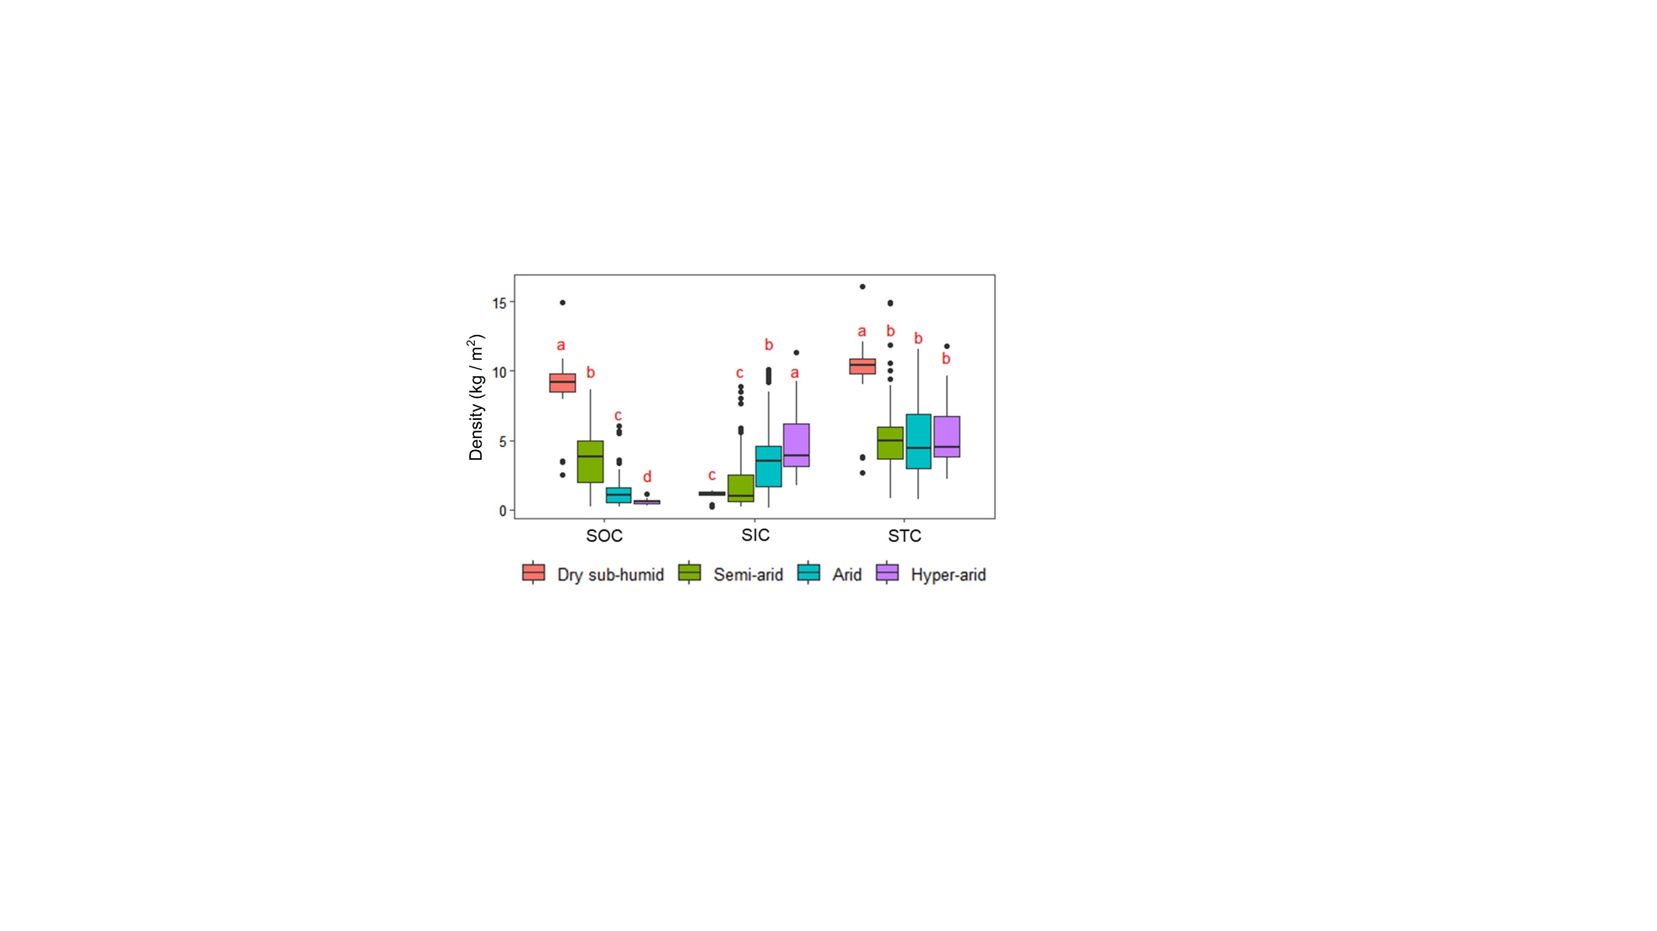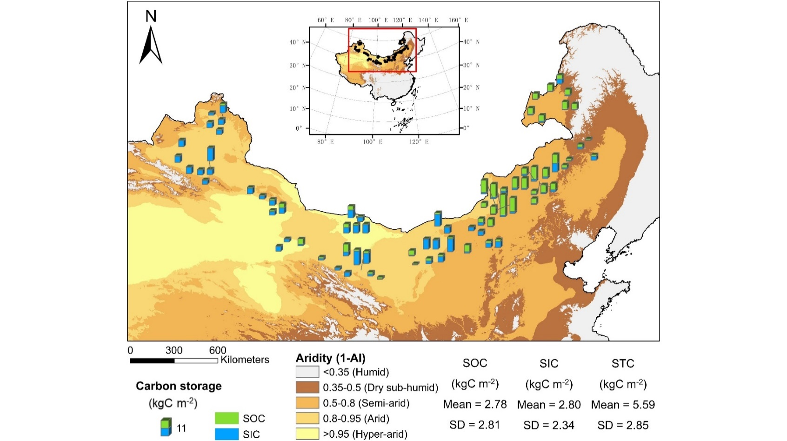

**(a)**

**(b)**

**FIGURE 1 Distribution pattern of soil total carbon across China’s drylands.** (a) Spatial distribution of soil total carbon composition across China’s drylands. (b) Soil organic carbon, inorganic carbon, and total carbon in different arid regions. Lowercase letters represent significant differences at p < 0.05 level between dryland subtypes. SOC, soil organic carbon; SIC, soil inorganic carbon; STC, soil total carbon.

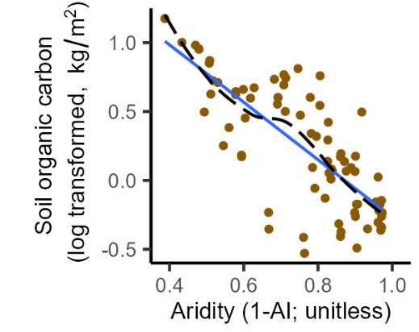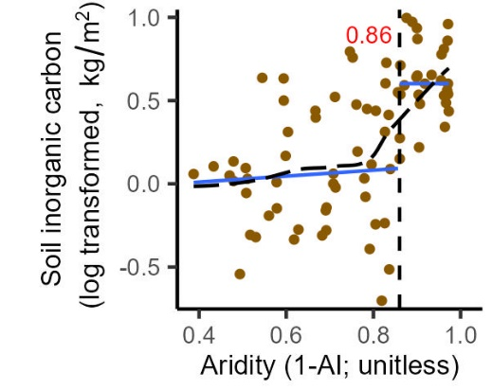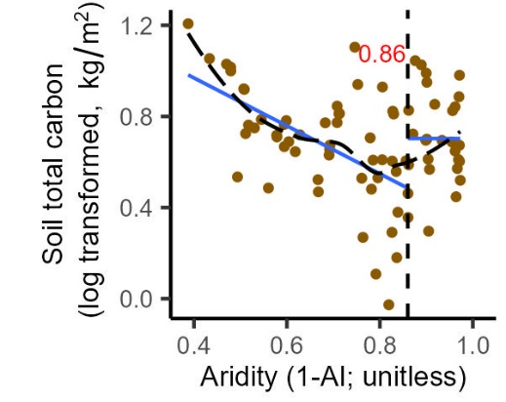

**(a)**

**(b)**

**(c)**

**FIGURE 2 Linear and nonlinear responses of soil carbon to increasing aridity.** (a) Linear response observed for soil organic carbon, (b) nonlinear response observed for soil inorganic carbon, (c) nonlinear response observed for soil total carbon. In (a)-(c), black dashed lines and blue solid lines represent the smoothed trend fitted by a generalized additive model (GAM) and the linear fits, respectively. Inset numbers in red and the vertical dashed lines describe the aridity threshold identified.

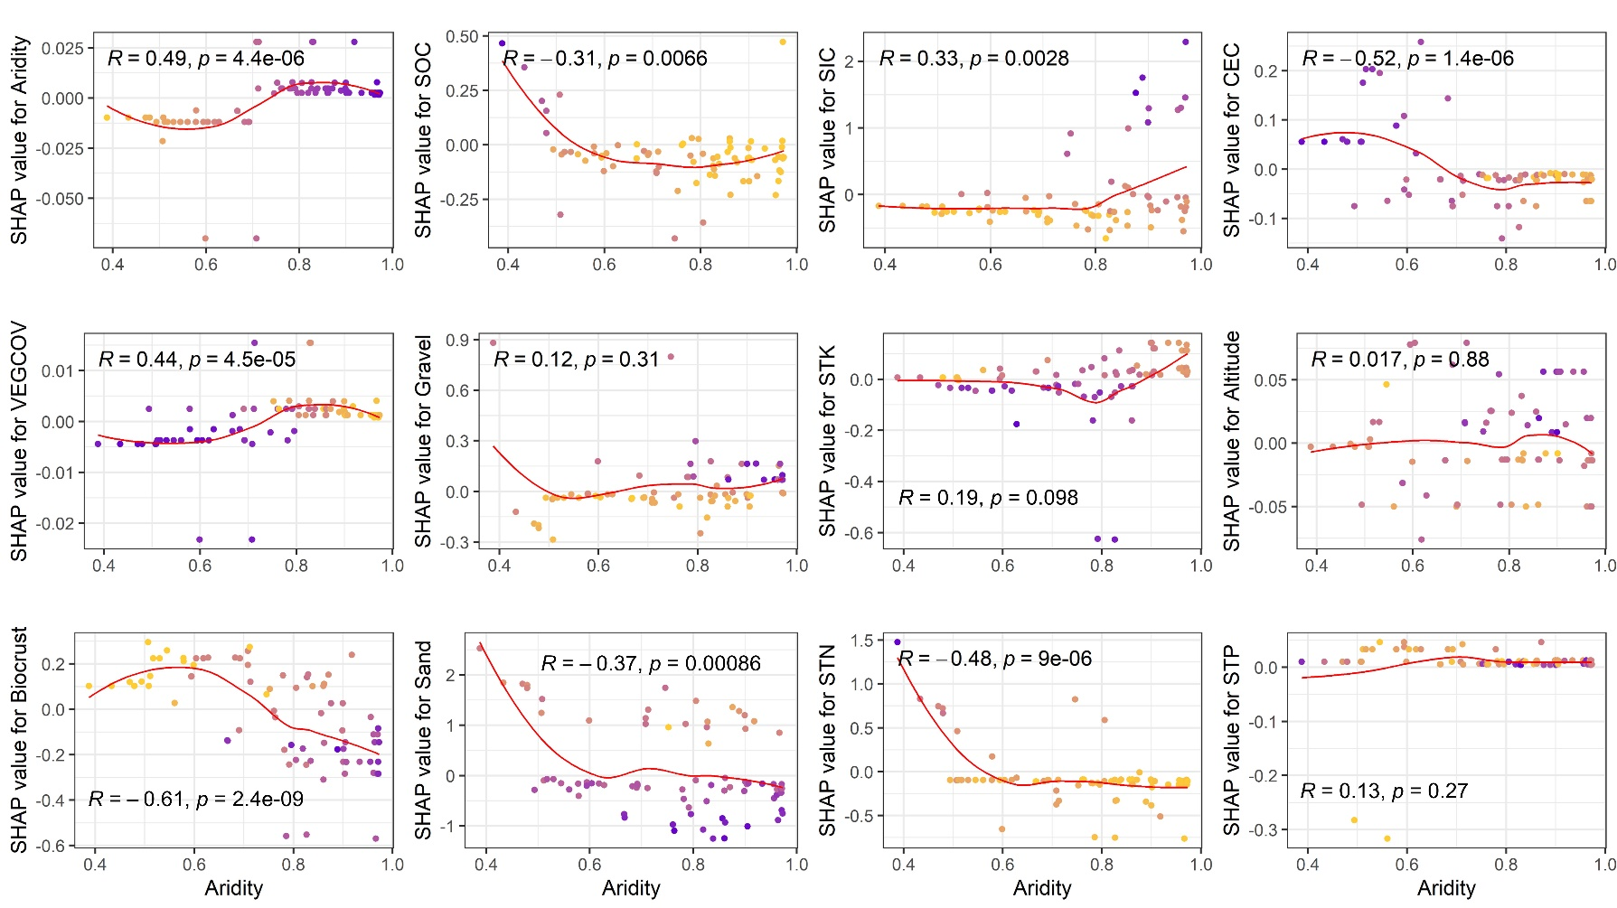**FIGURE 3 Shapley additive explanations (SHAP) dependence plots of vegetation and edaphic predictors of soil total carbon in China’s drylands.** The effects are expressed as SHAP values, which measure the influence of each predictor on the model output (soil total carbon). R and p are Spearman's rank correlation coefficient and p value, respectively. Yellow and purple dots indicate the maximum and minimum values of the corresponding factors. SOC, soil organic carbon; SIC, soil inorganic carbon; CEC, cation exchange capacity; VEGCOV, vegetation coverage; Gravel, gravel content; STK, soil total K; Sand, sand content; STN, soil total nitrogen; STP, soil total phosphorus.

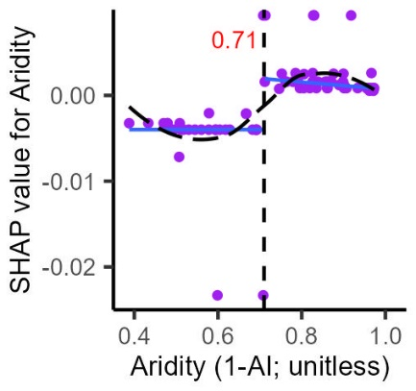 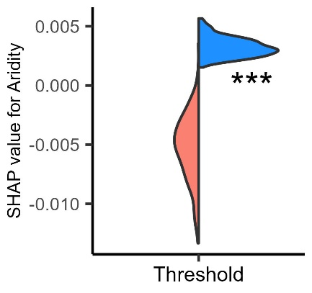

**(b)**

**(a)**

**Figure 4 Shift of SHAP value for Aridity of soil total carbon.** (a) The SHAP value for Aridity showed a nonlinear response and a threshold for aridity, (b) Violin diagrams show bootstrapped values of the predicted fitted trend at the threshold of the two regressions existing at each side of the threshold (red: below the threshold; blue, above the threshold). Asterisks indicate significant differences when conducting a Mann-Whitney U test between values below and above the threshold where: ***P < 0.01. The rest of the legend is as shown in Fig. 2.

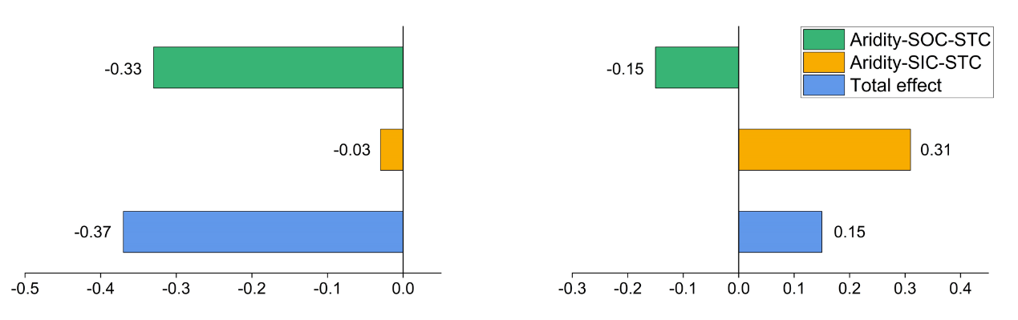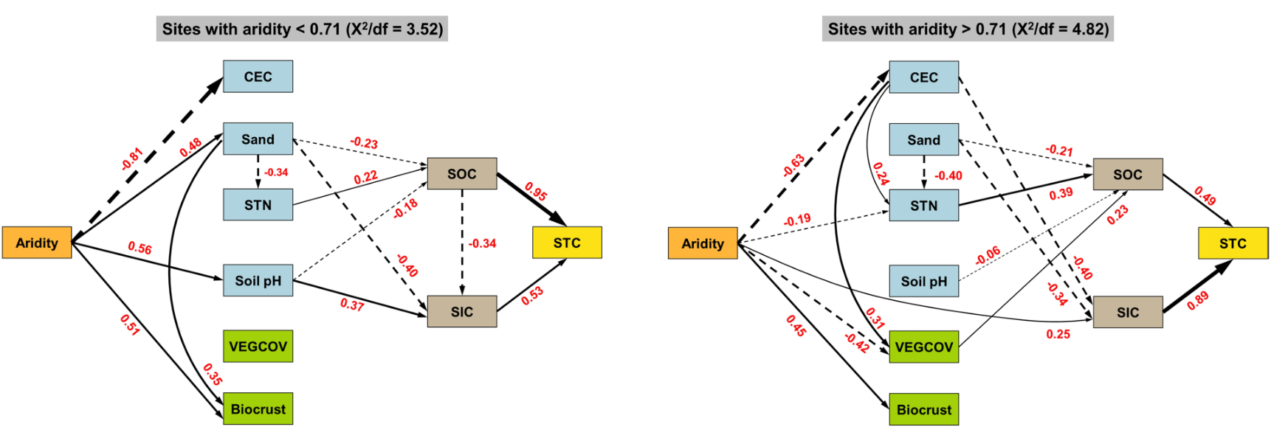

**(a)**

**(b)**

**FIGURE 5 Effects and driving pathways of aridity on soil total carbon.** Structural equation models are shown for sites with aridity < 0.71 (a) and >0.71 (b). We only present significant relationships (p < 0.05) and their coefficients (numbers adjacent to arrows) for graphical simplicity. Continuous and dashed arrows indicate positive and negative relationships, respectively. Widths of the arrows represent the magnitudes of the path coefficients. X2/df is given as a goodness-of-fit statistic. CEC, cation exchange capacity; Sand, sand content; STN, soil total nitrogen; VEGCOV, vegetation coverage; SOC, soil organic carbon; SIC, soil inorganic carbon; STC, soil total carbon.

**TABLE 1 Mean soil organic and inorganic carbon density and their proportions to total carbon across China’s drylands**

|  |  |  |  |  |  |
| --- | --- | --- | --- | --- | --- |
|  | Soil organic carbon (SOC, kgC m-2) | Soil inorganic carbon (SIC, kgC m-2) | Soil total carbon (STC, kgC m-2) | SOC Ratio | SIC Ratio |
| Hyper-arid | 0.62 | 4.62 | 5.24 | 12% | 88% |
| Arid | 1.39 | 3.69 | 5.08 | 27% | 73% |
| Semi-arid | 3.50 | 1.76 | 5.26 | 67% | 33% |
| Dry sub-humid | 9.28 | 1.04 | 10.32 | 90% | 10% |
| Total mean | 2.78 | 2.80 | 5.59 | 50% | 50% |