Land-based Transportation influences carbon emission in urbanized China: A regional spatial spillover perspective

Abstract: Global climate change is driving the need to reshape the relationship between urban land transportation and greenhouse gas mitigation and to improve the spatial coherence for regional development through an enhanced transportation network. In this study, we selected 135 cities in urbanized China to examine the spatial spillover effect of transportation on carbon emissions. The spatial Stochastic Impacts by Regression on Population, Affluence, Land, and Transportation (STIRPALT) model was used to consider regional linkages through passengers and freight flows on railways and highways, respectively. In addition, the regional strategy of formulating urban agglomeration was embedded in the spatial STIRPALT to investigate its potential effect. Results revealed that the spatial spillover effects through land transportation become apparent from 2015 to 2020 and have exhibited greater influence on highways through the passenger flows than freight flows in 2020. These spatial spillovers are also revealed to be sensitive to regional urban agglomeration strategies. The urbanization rate, the industrial added value, railway length, and built-up land area were also identified to contribute to carbon emissions. Deploying the threshold of the spatial spillover effect of passenger-induced road transport to guide the formulation of the regional development strategies offers great potential to help to address global climate change.

Keywords: railway, highway, greenhouse gas mitigation, urban agglomeration, regional development
1. Introduction
Global climate change provides an urgent warning of the need to reshape the relationship between transportation and carbon emissions, particularly in urban areas. As places with extensive transportation activities, cities with high urbanization rates generally have complex traffic systems, generating a multitude of energy types and ever-increasing carbon emission burdens (Wang et al., 2016). In China, accompanied by rapid urbanization to over 64% in 2021, transport carbon emissions reached 930 million tons, becoming one of the largest carbon emission sources, followed by its industrial sectors (Xu et al., 2022). The complex interactions between transportation development and carbon emissions in China's numerous fast-growing cities (Zhang & Hanaoka, 2022), as well as those in other developing countries, urgently demands an in-depth investigation of the underlying driving mechanisms and mitigation approaches. Empirical studies provide evidence on the nexus between transportation and carbon emissions worldwide, focusing on land transportation. The dynamics of transportation carbon emissions, including their reduction potential, have been diagnosed in European countries (Kazancoglu et al., 2021), across the Belt and Road Initiative countries (Du et al., 2021), and in China (Tan et al., 2021). We summarize the mainstream state of knowledge in exploring the influence of land transportation on carbon emissions, considering direct and indirect effects.
The first main category of studies directly probes the relationships between carbon emission, land use, and transportation in infrastructure planning, construction, and operation. Transportation infrastructure, such as roads, railways, tunnels, and others, release CO₂ at on-site construction and maintenance stages by inputting massive raw materials and energy (Noland & Hanson, 2015; Bilgili et al., 2019; Wei & Chen, 2020). According to the estimation of Noland & Hanson (2015), the carbon emissions of a highway reconstruction project in New Jersey account for approximately 20% of its carbon emissions in the whole life cycle of 50 years. Land related to transportation is also found to be at high levels of carbon emission intensity with an increasing trend (Xia & Chen, 2020; Simmonds et al., 2021; Feng et al., 2022). The urban landscape and the spatial pattern of transport facilities influences the energy consumption of transportation (Liu et al., 2022). The spatial “core-edge” transportation network pattern and the interprovincial spatial association of China’s provincial transportation carbon emissions have been identified (Bai et al., 2020). In recent years, land use planning combined with the construction of transportation infrastructure and the development of smart transportation is recommended to facilitate the mitigation of carbon emissions (Zhao et al., 2022).
The second main category of studies concerns the indirect influence on emissions, embodied in traffic flows, including the modal transport change. Generally, private car transportation shares the largest proportion of emissions among different transport modes (Su et al., 2022) with the highest carbon emissions per unit trip per person. In contrast, railway transportation, especially railway freight with much smaller carbon emissions (Cipek et al., 2019; Wen & Song, 2022), has been increasingly identified as a reasonable replacement for highway freight (Bilgili et al., 2019; Lin et al., 2021). Pragmatically, the transfer of road freight to railway transportation has been encouraged by emission taxes and other more stringent policy combinations (Liu et al., 2015; Hammond et al., 2020), including railway operations management, revenue management, and policy formulation. This has increased the market share of railway freight, thereby slowing the growth of transportation carbon emissions (Li et al., 2020). The dynamic association between flow-oriented transportation services and carbon emissions, has been investigated respectively in tourism and logistics sectors (Resat & Turkay, 2019; Mishra et al., 2020). In general, transportation scholars largely followed the land transport modes concerning road traffic, railways, and flow patterns. Combined with traffic flow, much greater attention has been paid to the spatial spillover effect of transportation infrastructure on carbon emission relating to the intertwined social and environmental context (Wang et al., 2020). Urban road density and highway mileage have increased CO₂ emissions along with emissions of other pollutants, whereas urban population density has a negative local influence and positive spatial spillover effect (Yang et al., 2019). Spatial- and time-lagged effects have been revealed: road and railway transportation have not only enriched the local transportation network but also produced spatial spillover effects in neighboring regions in terms of increasing CO₂ emissions (Wang et al., 2019). The high-speed railway network has been investigated to impel urban growth and land use change, in which the spatial spillover effect and its heterogeneity features have been discovered and measured (Zheng et al., 2019; Niu et al., 2021). In addition, the development of smart transportation has been found to have a spatial spillover effect on carbon mitigation in Chinese provinces (Zhao et al., 2022).
Although extant studies have already provided substantial evidence including on the intrinsic and extrinsic relationships between land transportation and CO₂ emission, the systematic exploration of the spatial spillover effect of transportation on regional CO₂ emission remains insufficient. Although consensus on substituting the highway with the railway has been reached worldwide given the lower railway emissions, work comparing the influences of railways and highways on carbon emissions, considering both their local and spatial spillover effects remain limited. At the same time, with the rapid development of transportation networks, various regional development patterns have emerged, including urban agglomerations (UA), urban supercities, and urban metropolitan areas, all of which are in an increasingly networked and urbanized world. Both increased transportation accessibility and the spatial compactness in the UA are prone to affect carbon emissions simultaneously. The actual influences of regional strategy on regional CO₂ emission through land transportation infrastructure are still unknown. We address both these gaps and consider two questions in our study:
RQ1: What is the difference in the spatial spillover effects between the railway and the highway in relation to regional carbon emission?
RQ2: Does the regional strategy strengthen the spatial interaction of carbon emission through transportation?
To answer these questions, we selected urbanized cities in China as case study areas. To the best of our knowledge, this study is the first to examine the systematic influence of transportation flows on carbon emissions, considering regional strategies.

2. Materials and Methods

2.1. Study area and data source
We selected prefectural-level Chinese cities with urbanization rates greater than or equal to 50% in 2020 as our study areas, which is in accordance with the large discrepancies in urban and rural areas regarding transportation infrastructure. The prominent urban features help to guarantee convergence in the models exploring the relationship between transport and carbon emission. We excluded cities with limitations stemming from data coverage and accessibility. The resulting dataset provided 135 prefectural-level cities distributed at 49.63%, 28.15%, 12.59%, and 9.63% in eastern, central, western, and northeastern China, respectively. Although ensuring spatial continuity in the selected cities is difficult, they concern the five mature UAs, namely, the Pearl River Delta (PRD), Yangtze River Delta (YRD), Chengdu–Chongqing UA (CCUA), Beijing–Tianjin–Hebei UA (BTHUA), and the UA in the middle reaches along the Yangtze River (UAMRYR) (Fig. 1). In China, regional strategies are proposed to solve the socio-ecological problems in megacities and enhance collaborative development. In the 14th Five-Year Plan (2021–2035), the integrated development of UAs has been reinforced to promote regional development. Considerable literature confirms that the formulation of UAs also addresses carbon mitigation and adaptation targets (Cui et al., 2020; Liu et al., 2022).
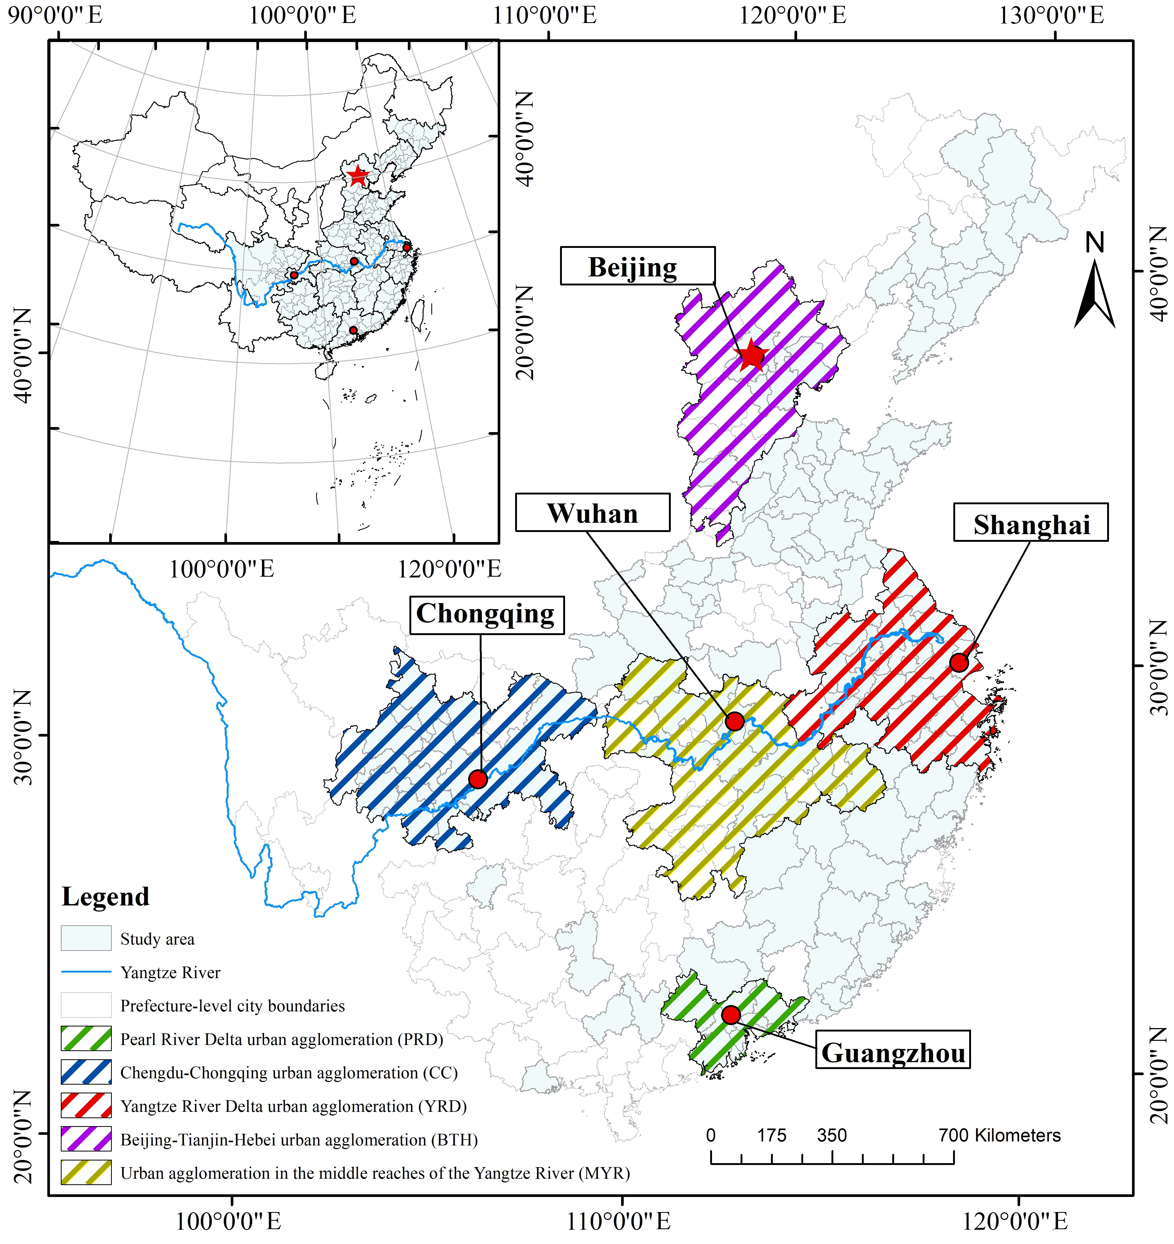
Fig. 1. Study area
The research dataset primarily includes socio-economic information and geo-referenced spatial data, including that on land use and transportation (Table 1). Land use data in 2015 and 2020 are interpreted from remotely sensed images with a spatial resolution of 30 m. Land use classification is based on the “Land Use Status Classification Standard” (GB/T21010-2017). The geospatial data of POI (Point of Interest) relating to railway stations (e.g., platform and ticket entrance, of which the number represents the scale of the station to some extent) and railway and road networks are extracted from the Geographical Information Monitoring Cloud Platform. The socio-economic dataset is primarily collected from the China City Statistical Yearbook plus the annual Government Work Reports at different municipality levels or the Provincial Statistical Yearbook from 2015 and 2020. Notably, railway passenger and freight volume data in 2015 and 2020 are calculated indirectly using the POI dataset because they were not officially available from the Statistical Yearbook. As such, we collected railway passenger and freight volume for each province and assigned them proportionally in accordance with the transportation POIs in each city. The results are compared with the actual railway data in some cities to examine the accuracy.
Table 1
Data description and their sources.
Data | Data type | Data source
Land use classification data  (Interpreted from Landsat TM/ETM images in 2015 and 2020) | Cropland, grassland, forest, urban and build-up land, water, and unclassified land | Geographical Information Monitoring Cloud Platform  (http://www.dsac.cn/DataProduct/Index/200804)
POI, road, and railway network data | Dataset of roads and railways | Geographical Information Monitoring Cloud Platform (http://www.dsac.cn/DataProduct/Detail/201843)
Administrative boundary dataset | Provincial, city, and county boundaries | Map World in National Platform for Common Geospatial Information Services (https://www.tianditu.gov.cn/)
Carbon emissions data | Carbon emissions | China City Greenhouse Gas Working Group (www.cityghg.com)
Socio-economic dataset | Population, GDP, sector structure, urbanization rate, passenger, and freight volume of highway and railway | The Provincial Statistical Yearbooks in 2015 and 2020, the China Urban Statistical Yearbook in 2015 and 2020

2.2. Methodology

We investigated the influences of transportation on carbon emission, incorporating both the local and spatial spillover effect through the passenger and freight flows. These influences were differentiated between railway and highway in the context of rapid urbanization and the promoting the urban agglomeration development in China. The general research framework was illustrated in Fig. 2.
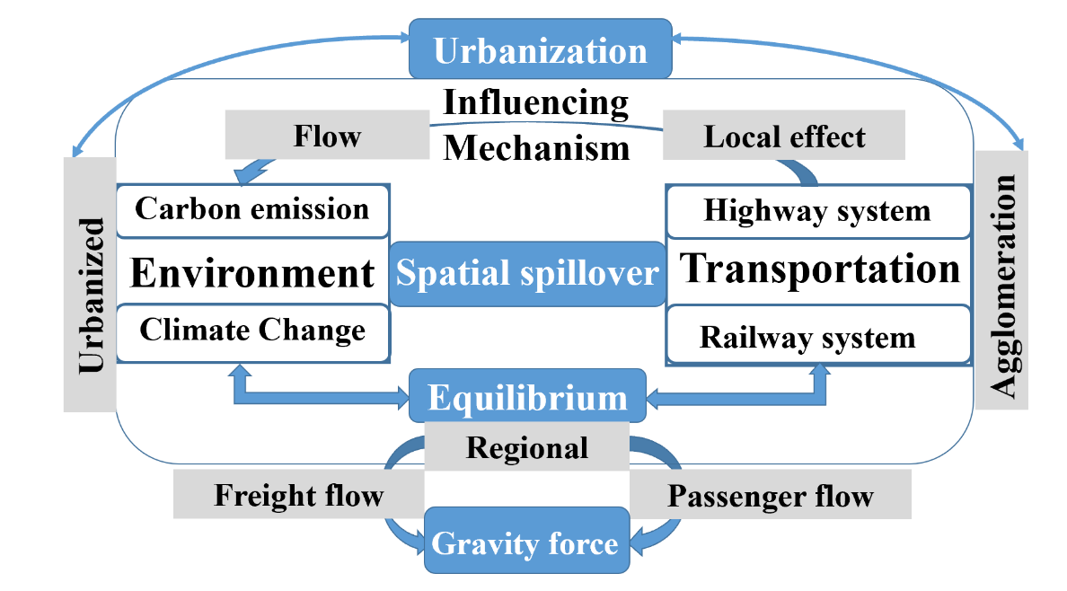
Fig. 2. Research framework.

2.2.1 STIRPALT model for exploring factors that influence carbon emission
We adjusted and extended the Stochastic Impacts by Regression on Population, Affluence, and Technology (STIRPAT) model to accommodate the exploration of factors that influence carbon emission, including the complex relationship with transportation. The original STIRPAT model holds that the non-proportional impact of population, affluence, and technology on the environment can be analyzed through regression (Xue et al., 2022). Although this model has been widely used in climate change science (Liu & Xiao, 2018), many scholars have noted that the influencing factors need to be added or disintegrated to deal with the complicated interactions between human activities and environment (Yang et al., 2018). Hence, to answer our research questions we first adjusted the model to include the factor of transportation, hereafter referred to as T in the model. The transportation we focus on is primarily the type of land transport, which in turn, informs land use. Evidence shows that global land use change contributes to 25% of total carbon emissions (Roe et al., 2019), with much built-up land supporting transportation infrastructure construction, such as railways, highways, and expressways.
We employ land use (hereafter referred to as L) to extend the model. In addition, we omit the original factor of technology (the original T in the model), even though it influences carbon emission and has potential to support the mitigation of and adaptation to climate change. This omission is made because technology is embodied in a variety of aspects in which transportation is also an indispensable part. Meanwhile, we have collected other proxies for technology, such as the number of patents or research and development institutions. However, preliminary analysis revealed an insignificant correlation between these proxies and carbon emissions. The original STIRPAT model was thus adjusted to the Stochastic Impacts by Regression on Population, Affluence, Land, and Transportation (STIRPALT) model as specified in Eq. (1).
$\ln{I_{i}}=β_{0i}+b\ln{P_{i}}+c\ln{A_{i}}+d\ln{L_{i}}+e\ln{T_{i}}+f_{i}$, (1)
where I refers to impact; P refers to population; A refers to affluence; L refers to land; T refers to transportation; β is the constant term; b, c, d, and e represent the correlation coefficients; f is the error term. Table 2 presents the potential indices in each factor considering the empirical studies and data accessibility.
Table 2
Dimensions and factors in the study.
Dimension | Factor
Impact (I) | Carbon emissions
Population (P) | Urbanization rate, population density
Affluence (A) | GDP, investment, revenue, technology
Land (L) | Cultivated land, forest, grassland, waters, construction land
Transportation (T) | Railway, highway

2.2.2 Spatial STIRPALT model in multiple schemes
We further extend the STIRPALT model to include the spatial terms given the empirically identified spatial spillover effect of carbon emissions. To accommodate this spatial interaction through land transportation, the spatial econometric model and the traffic flow served as the medium to link the cities. This established the spatial STIRPALT model, which can be represented by the following equation:
$\ln{I_{i}}=β_{0i}+αW{I_{i}}^{'}+b\ln{P_{i}}+c\ln{A_{i}}+d\ln{L_{i}}+e\ln{T_{i}}+f_{i}$, (2)
where $W$ represents the spatial weight matrix generated from transportation flow between cities which is determined by the gravity model, ${I_{i}}^{'}$ is the carbon emission from the neighboring observations, and $α$ is the spatial lag coefficient. Other terms are the same as in the STIRPALT model (Section 2.2.1).
The gravity models are established based on the decomposition of land transportation into four flow schemes: $S_{1}, S_{2}, S_{3}, { and S}_{4}$(Fig. 3). $S_{1}$ and $S_{2}$ depict the transportation flows on the highway for passengers and freight, respectively. $S_{3}$ and $S_{4}$ are where passengers and freight flow on the railway. The general form of the gravity model is presented in Eq. (3).
$W_{ij}=r_{ij}\frac{V_{i}V_{j}}{{d_{ij}}^{2}}$, (3)
where $W_{ij}$ is the traffic gravity between city $i$ and $j$; $r_{ij}$ is the gravity coefficient between city $i$ and $j$, which is usually equal to 1; $d_{ij}$ is the Euclidean distance between cities. The following four spatial interaction schemes are established with $V_{i}$ and $V_{j}$ referring to the corresponding indices.
$S_{1}$: when $V_{i}$ and $V_{j}$ are both highway passenger volume, $W_{ij}$ represents the gravity generated by the flow of highway passengers between cities.
$S_{2}$: when $V_{i}$ and $V_{j}$ are both highway freight volume, $W_{ij}$ represents the gravity generated by the flow of highway freight between cities.
$S_{3}$: when $V_{i}$ and $V_{j}$ are both railway passenger volume, $W_{ij}$ represents the gravity generated by the flow of railway passengers between cities.
$S_{4}$: when $V_{i}$ and $V_{j}$ are both railway freight volume, $W_{ij}$ represents the gravity generated by the flow of railway freight between cities.
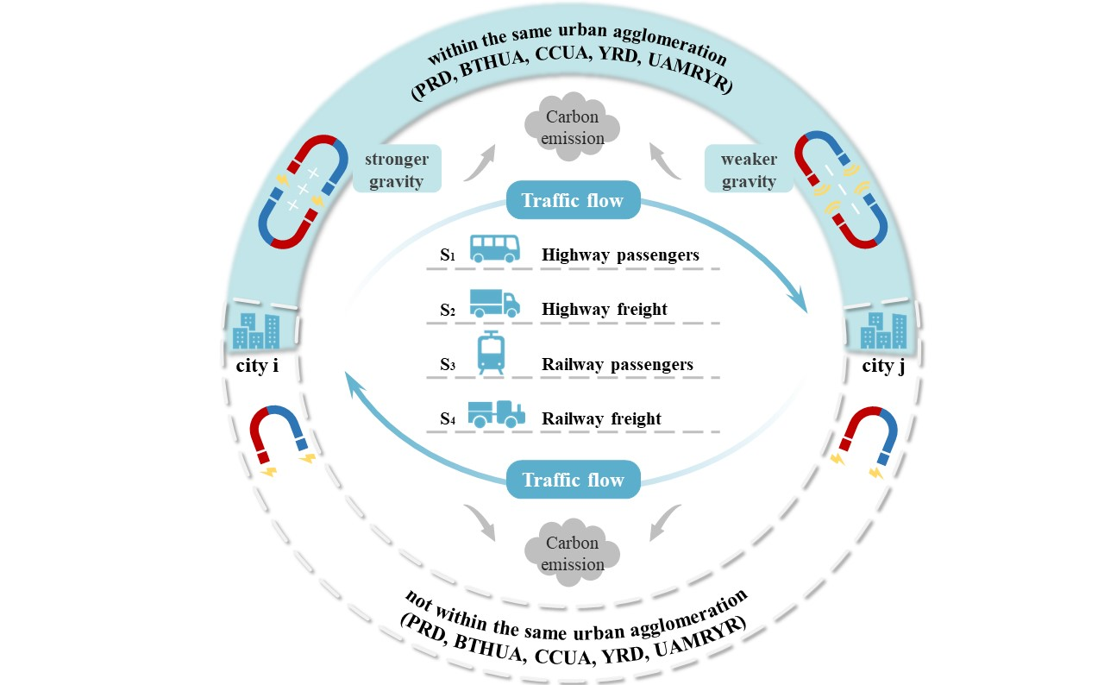
Fig. 3. Methodological framework for the quantification of the spatial weight matrix and regional strategy.
To examine the potential influence of regional strategy on carbon emissions, we introduce the spatial UA coefficient as $r_{ij}$ in the gravity model. $r_{ij}$ is assumed to differentiate the spatial interaction within or not within the UAs (PRD, BTHUA, CCUA, YRD, UAMRYR) in our study area. If $r_{ij}$ >1, the spatial interaction of the cities within the UA is stronger, and vice versa. When the cities are not within the same UA, $r_{ij}$ is assigned a value of 1 to turn into the general form of the gravity model.

3. Results

3.1. Spatio-temporal variation of carbon emissions and transportation
Fig. 4 illustrates the variations in carbon emissions for 135 cities in 2015 and 2020, with brief descriptive statistics. The general spatial emission patterns remain stable; nevertheless, BTHUA, YRD, and PRD show disproportionally high emissions. Carbon emission has increased by 285.63 million tons in total, with a growth rate of 4.46% during 2015–2020. In 2015, Shanghai in YRD in eastern China, Tangshan in BTHUA in northern China, and Chongqing in CCUA in western China were the cities with the highest carbon emissions, accounting for 4.32%, 3.22%, and 3.18% of the total emissions studied, respectively. In 2020, the top three cities became Tangshan in BTHUA in northern China, Shanghai, and Suzhou in YRD in eastern China, with contributions of 4.52%, 3.62%, and 2.84% of total carbon emissions, respectively. Conversely, most of the cities in PRD and UAMRYR, including in other provinces, contribute lower carbon emissions. As municipalities directly under the central government, Shanghai and Chongqing are highly developed cities, and rapid socio-economic development has incurred substantial environmental costs, including high carbon emissions. As the prefectural-level city in Hebei province, Tangshan has long been regarded as a typical heavy-industrial city and is confronted with an urgent need to transform towards low-carbon development (Cai et al., 2019).
Fig. 4. Carbon emissions in different prefecture-level cities in 2015 and 2020.
Fig. 5 depicts the length of newly built railways between 2015 and 2020: 13,697 km of railways, or 38.17% of the railway length in 2015. These newly built railways connect the UAs and cities within the UA. In 2020, the railway lengths of the CCUA and the PRD UA reached 5,418 and 1,351 km, showing an increase of 101.40% and 114.84%, respectively, compared with 2015. This confirms that the concentration of high-speed railway projects under rapid construction in recent years has exacerbated the imbalance between the UA and other areas.
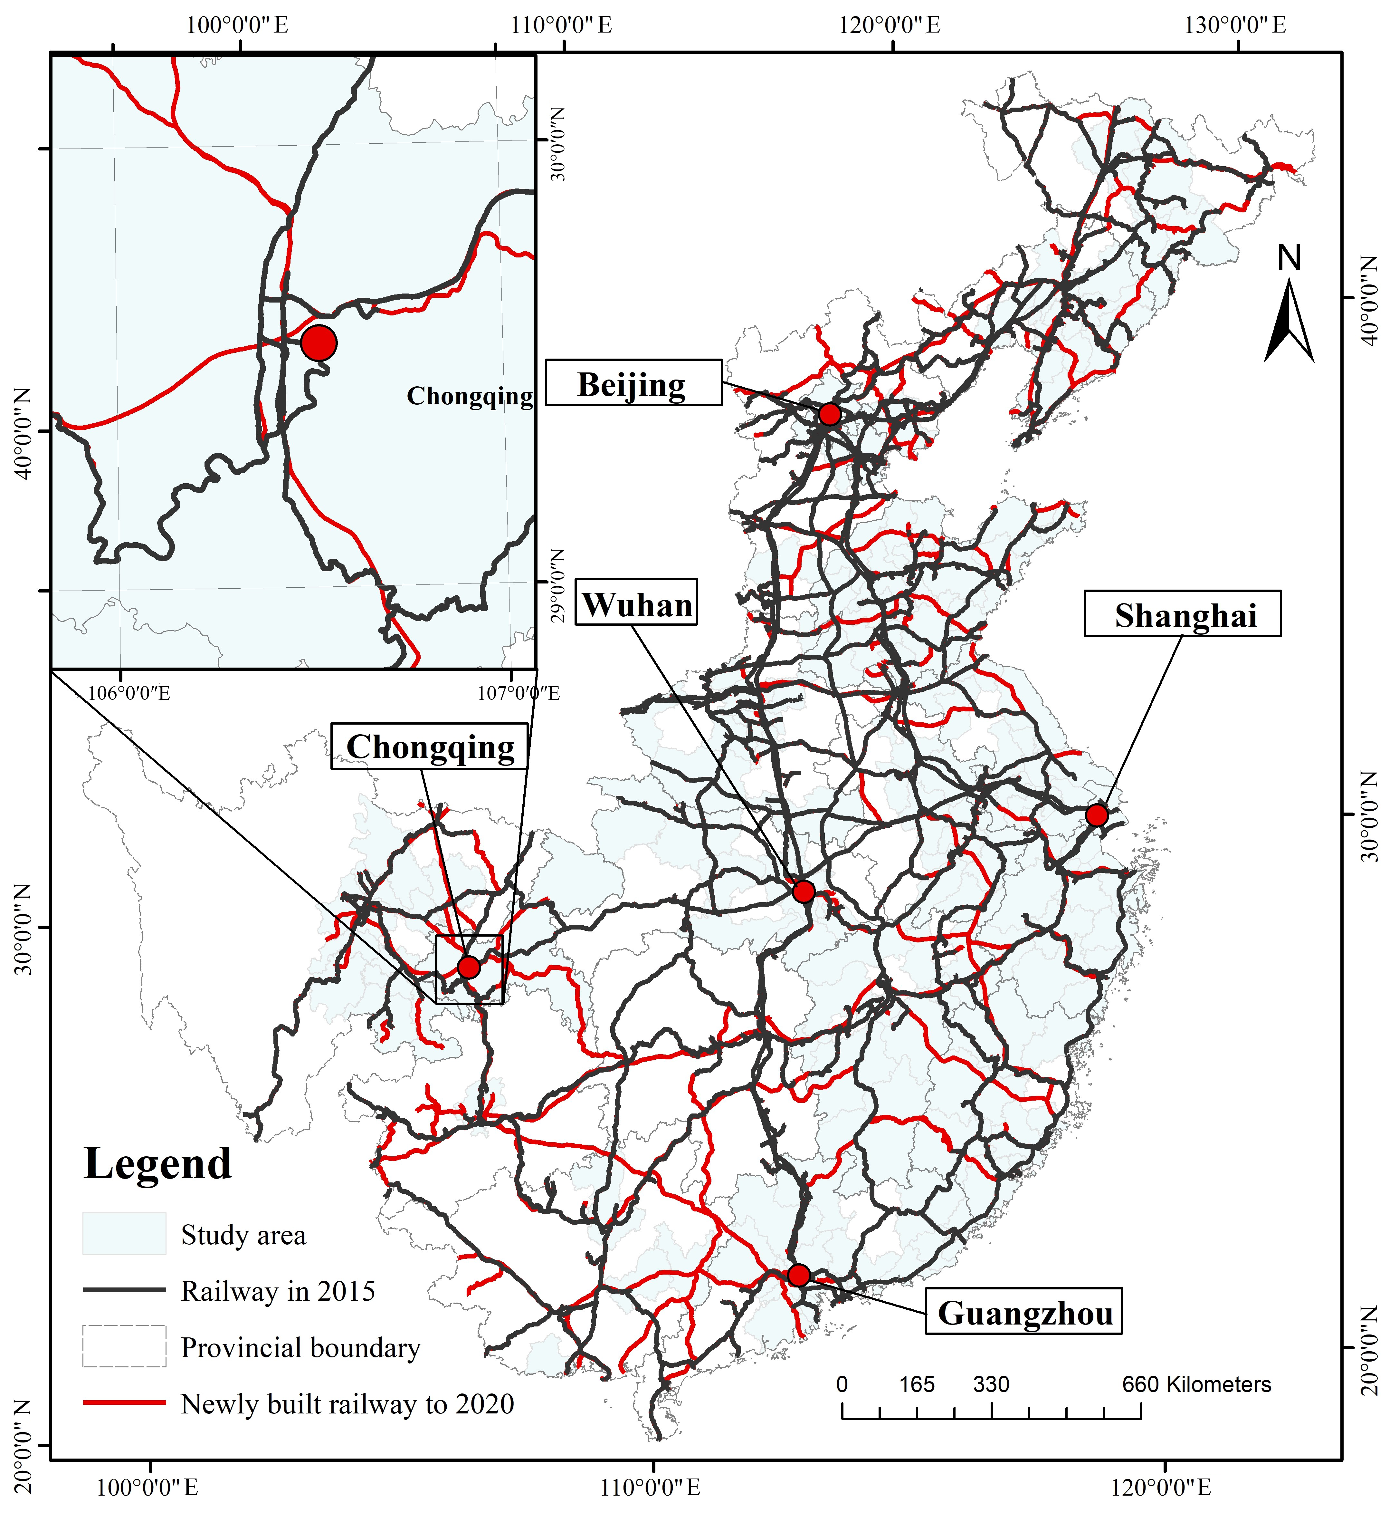
(a) Railway distribution
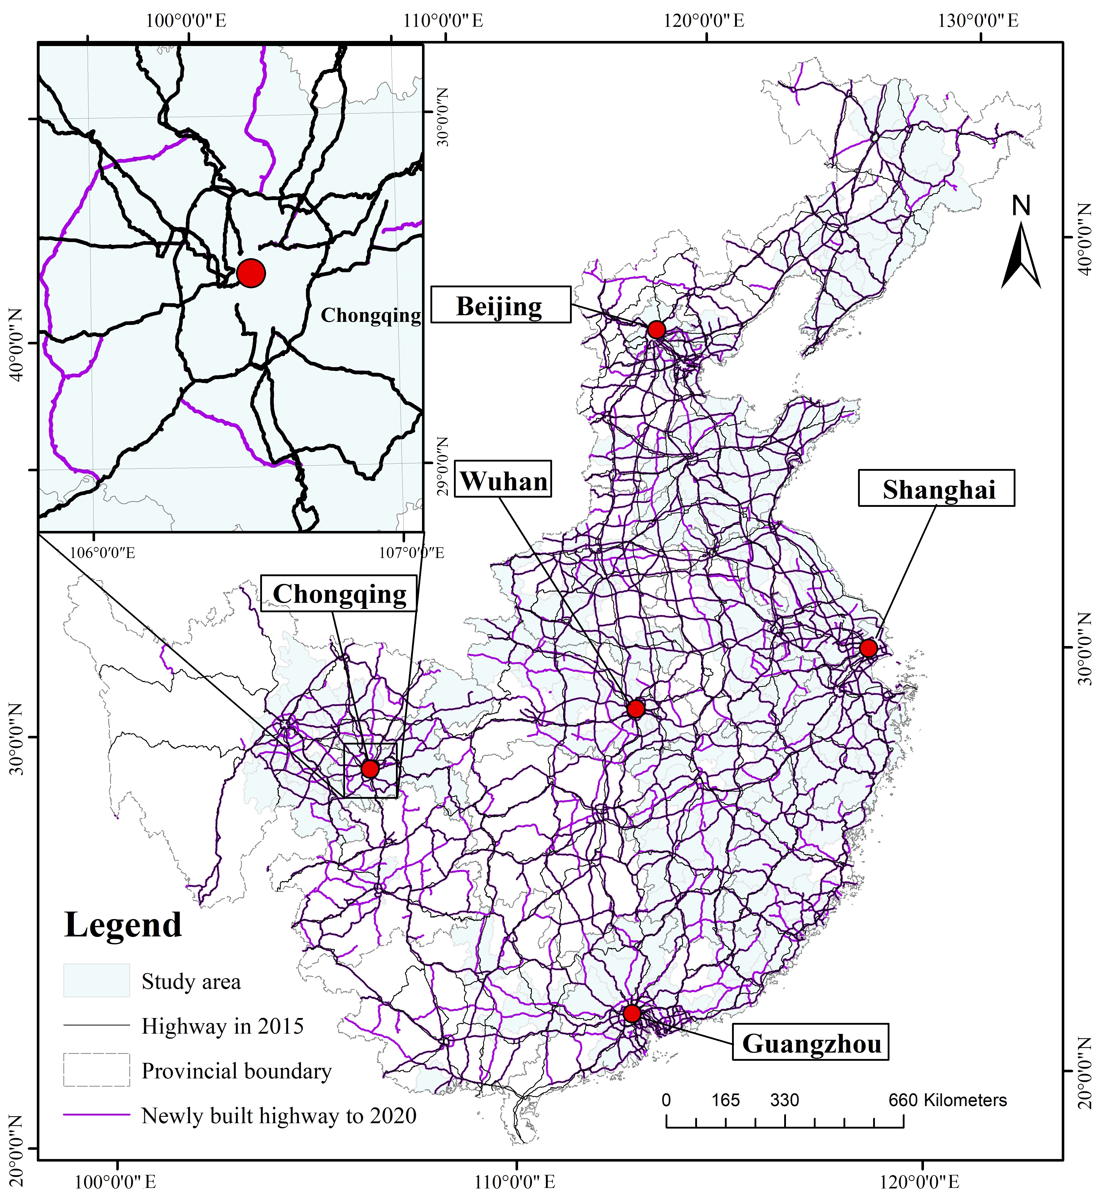
(b) Highway distribution
Fig. 5. The railway and highway transportation network from 2015 to 2020.
Compared with railways, the development of highways is more balanced across regions (Fig. 5). Highway length in 2015 and 2020 was 491.27 and 551.24 thousand km, respectively. In the past five years, highway length has increased by 59.98 thousand km, with a change rate of 12.21%. Moreover, the growth rate of the five UAs is between 9.11% and 19.59%, which is close to the national average. This shows that China’s highway construction has entered a stage of steady growth, and its impact on carbon emissions is more predictable.

3.2. Influences of transportation on carbon emission based on the spatial STIRPATL model

3.2.1. Identifying the influencing factors of carbon emissions
Based on the correlation analysis, five influencing factors were chosen with the consideration of multicollinearity problem in the STIRPALT model: i) urbanization rate (UrbanRt), ii) the industrial added value (Indvalue), iii) built-up land area (BltLand), iv) the total length of the highways (HighWy) and v) the total length of the railways (RailWy). Logarithm transformation is implemented to guarantee the normal distribution of these factors. Fig. 6 shows the results of the correlation analysis between these influencing factors and carbon emissions. A similar pattern is observed in 2015 and 2020. All five factors are positively correlated with carbon emissions. Indvalue and BltLand have the highest correlation coefficients with carbon emission, with Indvalue on a downward trend from 0.72 to 0.64 and BltLand rising from 0.64 to 0.70. To explore the influence of transportation on carbon emission, we ultimately chose HighWy and RailWy as the explanatory variables and UrbanRt, Indvalue, and BltLand as the control variables for multilinear regression.
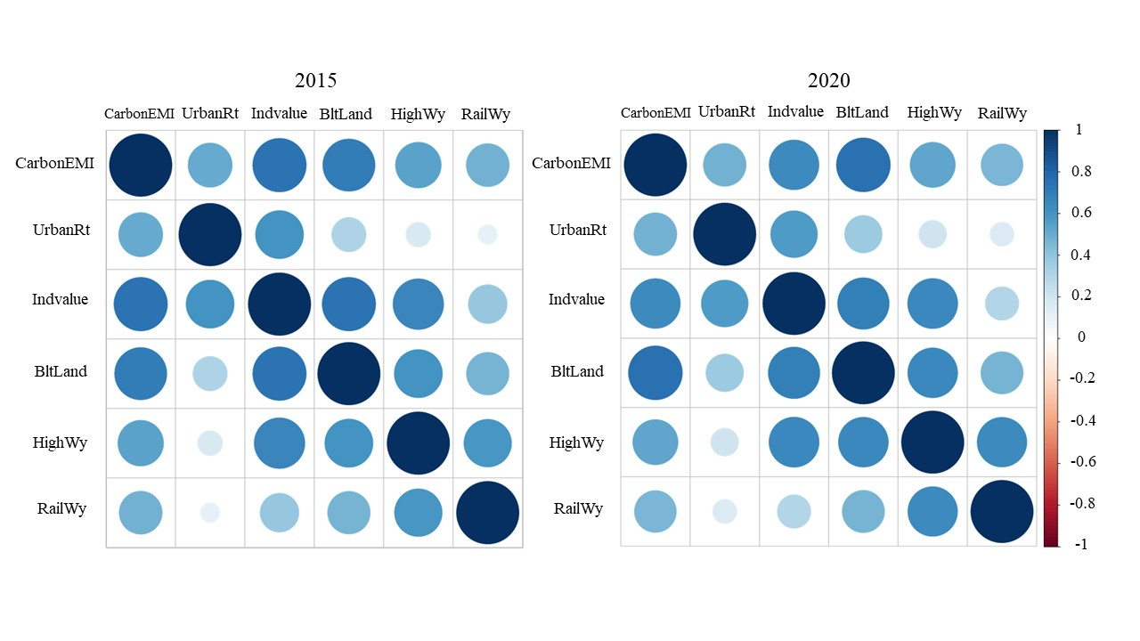
Fig. 6. Correlation diagram.
Fig. 6 shows all the explanatory variables and control variables are significant at the 0.1 level except HighWy. From 2015 to 2020, the correlation coefficients of RailWy remained significant at the 0.05 level and increased from 0.18 to 0.20, which coincides with the rapid development of the railway system. In terms of the control variables, urbanization contributes the largest share to CarbonEMI, with the correlation coefficient declining from 0.83 in 2015 to 0.76 in 2020. The contribution of BltLand has been reinforced, with the correlation coefficient rising from 0.31 in 2015 to 0.51 in 2020. The influence of Indvalue has weakened in accordance with the correlation coefficient and the significance level. Taken together, R² is over 0.63 both in 2015 and 2020, implying that the selected explanatory and control variables can explain more than a 60% variance in carbon emissions. Hence, we apply this STIRPALT model for further spatial regression analysis, with HighWy being omitted as the local explanatory variable.

3.2.2. Transportation flow-induced spatial interaction
Table 3 exhibits the estimated mean values (MVs) and standard deviations (SDs) of the gravity forces for the total study area (TA) and the UAs (PRD, BTHUA, CCUA, YRD, UAMRYR) in the four schemes proposed in Section 2.2.2. In general, regardless of highway or railway, MVs of the gravity forces in UAs are much larger than those of the whole research area, whereas greater discrepancies are also discovered in UAs. Comparison of values in 2015 and 2020 reveal the enormous impact of the COVID-19 pandemic, where the decline in passenger flow is much stronger than that in freight flow. The inter-city gravity force characterized by highway passenger volume shows the most conspicuous downward trend, with a change rate of −85.37%. Moreover, the declining rates of MVs in PRD, UAMRYR, and CCUA are larger than the average for the research area in 2015–2020. Average railway passenger-induced gravity forces also reduced at the rate of 22.22%, but MVs in PRD and CCUA maintained growth. Nonetheless, the gravity force engendered by road and railway freight has experienced an overall upward trend. MVs in YRD have the largest increase on the highways, whereas BTHUA has the largest growth on the railway in 2015–2020. To some extent, highways and railways have demonstrated complementary roles, with the SDs decreasing on the highways and rising on railways in both passenger and freight flows.
Table 3
Average gravity force of four schemes.
Schemes |  | S₁ |  | S₂ |  | S₃ |  | S₄
 |  | 2015 | 2020 | 2015 | 2020 | 2015 | 2020 | 2015 | 2020
MV | TA | 335 | 49 | 995 | 1280 | 9 | 7 | 3 | 5
 | PRD | 14333 | 839 | 46146 | 25312 | 340 | 400 | 49 | 48
 | BTHUA | 8729 | 1778 | 32827 | 28244 | 519 | 170 | 425 | 696
 | CCUA | 3408 | 447 | 3826 | 5289 | 17 | 27 | 6.95 | 7.02
 | YRD | 3079 | 565 | 4848 | 11345 | 101 | 99 | 12 | 14
 | UAMRYR | 1192 | 131 | 3185 | 3492 | 47 | 19 | 9 | 8
SD | TA | 2373 | 379 | 6293 | 6214 | 78 | 84 | 30 | 59
 | PRD | 29108 | 1376 | 75758 | 39588 | 740 | 1067 | 107 | 129
 | BTHUA | 13240 | 3534 | 40306 | 40307 | 930 | 303 | 659 | 1306
 | CCUA | 4771 | 555 | 6566 | 7974 | 42 | 65 | 18 | 17
 | YRD | 6075 | 1772 | 9623 | 20630 | 256 | 286 | 26 | 35
 | UAMRYR | 2089 | 219 | 4530 | 5522 | 146 | 56 | 28 | 24
We further illustrate the gravity forces generated by the passenger and freight volume of highways in 2020 to display the spatial variations of the highway-based inter-city links after the COVID-19 pandemic (Fig. 7). For each node city, the top three spatially interacted cities are marked, and the strength of the highway-based flows is reflected in the thickness of the lines. In general, passenger-based and freight-based flows show similar spatial patterns with intensified connections in UAs, with more densely networked patterns in the passenger-based scheme than that in the freight-based scheme. The strong inter-city attraction generated by highway freight volume mainly occurs within the UAs, whereas the spatial distribution of strong inter-city gravity formed by highway passenger volume is not restrained by UAs, and is prone to be affected by the locations and spatial distances.

Fig. 7. Flow of the highway network for each city in 2020. Note: GHPV is highway passenger volume gravity; GHFV is highway freight volume gravity.

3.2.3. Spatial spillover effect of transportation on carbon emissions
Table 4 presents the diagnoses of the multilinear regression model for the justification of the spatial econometric model, with the traditional inverse-distance spatial weight matrix, including the four schemes embedded in the gravity model. Moran’s I statistic for spatial autocorrelation of carbon emission is insignificant at the 0.05 level in the traditional model, as well as in the four schemes in 2015. However, it is significant at the 0.05 level in the traditional model and the schemes with highway-related flows ($S_{1}$, $S_{2}$) in 2020. Similar situations occur in the following LM tests and robust LM tests. The scheme based on highway passenger flow ($S_{1}$) is the only scheme with significant values at the 0.1 level in both LM-lag tests and robust LM-lag tests. As a result, we implement the spatial STIRPALT model with the scheme of embedding the highway passenger flow in exploring the spatial spillover effect of transportation on carbon emissions.
Table 4
Moran’s I and LM test.
Gravity model based on inverse distance (S) |  |  | Gravity model based on highway passenger volume (S₁) |  |  | Gravity model based on highway freight volume (S₂)
Moran’s I | LM-lag | RLM-lag | Moran’s I | LM-lag | RLM-lag | Moran’s I | LM-lag | RLM-lag
2.560** | 4.596** | 4.880** | 2.123** | 4.872** | 3.033* | 1.968** | 3.090* | 1.473
Note：*** is the significance level of 0.01, ** is the significance level of 0.05, * is the significance level of 0.1.
Table 5 presents the results of the spatial STIRPALT model based on the traditional inverse distance and the highway passenger-induced flow in 2020. The correlation coefficients of UrbanRt, Indvalue, and spatial lag declined in the highway passenger-based scheme compared with the traditional one. Conversely, the influences of built-up land, railway, and the fitting effect of R² rose, which has justified the effectiveness of the spatial STIRPALT model embedded with the transportation flow.
Table 5
Results of multilinear regression and spatial lag model.
 | Multilinear regression |  | Spatial lag model
 | 2015 | 2020 | Gravity model based on inverse distance (S) in 2020 | Gravity model based on highway passenger volume (S₁) in 2020
UrbanRt | 0.8303*** | 0.7625** | 0.6161** | 0.5977*
Indvalue | 0.2973*** | 0.1576* | 0.1938** | 0.1712**
BltLand | 0.3116*** | 0.5131*** | 0.3785*** | 0.3994***
HighWy | 0.0071 | −0.1058 | - | -
RailWy | 0.1842*** | 0.2038** | 0.1950*** | 0.1975***
α | - | - | 0.5863** | 0.2973**
R² | 0.6396 | 0.6302 | 0.642 | 0.644
Constant term | −4.6663*** | −6.8593*** | −9.3973*** | −7.3096***

3.3. Influences of the regional strategy on carbon emission
Table 6 presents the number of city pairs and the MVs of CarbonEMI in the five UAs in 2015 and 2020. There are 24 cities out of the total 135 cities in YRD, constituting the top 300 city pairs among the five UAs in the spatial weight matrix. Only five cities formulate 15 city pairs in BTHUA. However, the MVs of carbon emissions in these five cities in BTHUA were double those in YRD in both 2015 and 2020, with Tangshan in BTHUA contributing the most for its carbon emissions with an increase of 48.28% during this period. Although the number of cities in CCUA was slightly lower than that in UAMRYR, the MV of CarbonEMI in CCUA was higher than that from 2015 to 2020. Nevertheless, both CCUA and RD have realized carbon mitigation in the selected cities from 2015 to 2020.
Table 6
Average CarbonEMI in urban agglomerations.
 | The number of city pairs | The mean value of CarbonEMI / (t)
 |  | 2015 | 2020
PRD (8) | 28 | 4864 | 4635
BTHUA (5) | 15 | 12699 | 14444
CCUA (12) | 78 | 3921 | 3231
YRD (24) | 300 | 6331 | 6917
UAMRYR (14) | 105 | 2663 | 2997
Total | 526 | 6096 | 6445
Fig. 8 depicts the results of the influences of the regional strategy on carbon emission based on the established spatial STIRPALT model in the first scheme. The results were obtained by examining the variations of spatial coefficient ($α$) and R² coupled with the hypothesized change of the gravity coefficient ($r_{ij}$) in the spatial weight matrix within the same UA. When the gravity coefficient reaches 1.5, assuming that the spatial interaction within the UA is 1.5 times greater than the other situations, the R² of the spatial lag model reaches a maximum value of 0.645. There appears to be little variation in R² after that. Simultaneously, the spatial lag coefficient has also started to display a gradual downward trend after the coefficient of 1.5, indicating a steady status of spatial interaction.
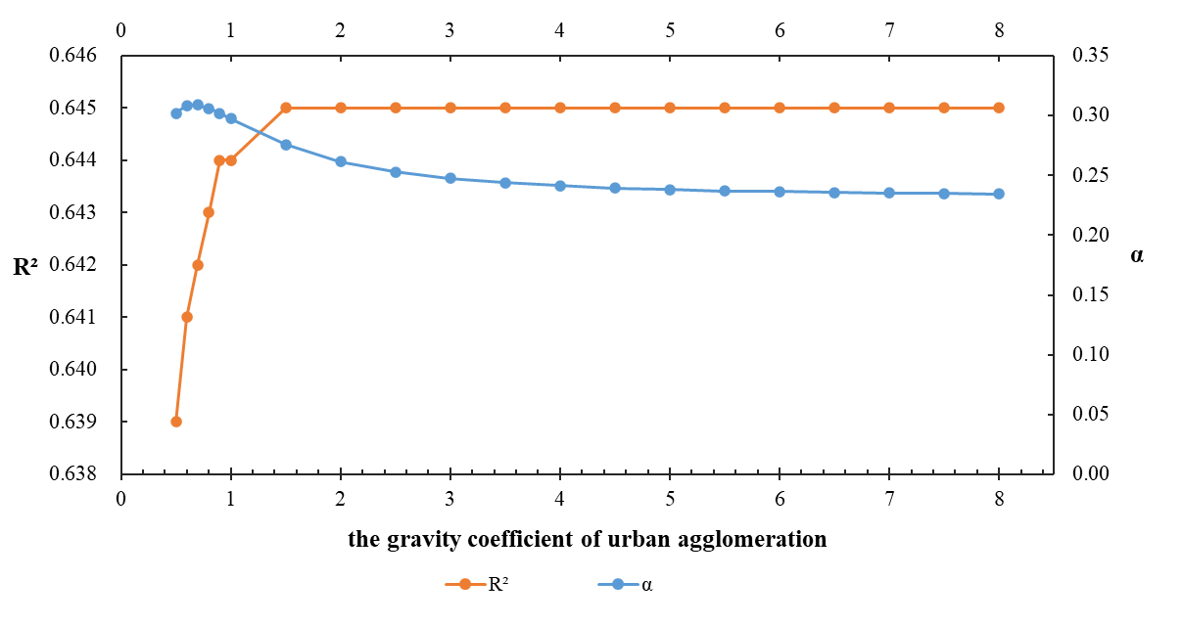
Fig. 8. Changes of $α$ and R² when the coefficient of urban agglomeration changes

4. Discussion
This study has extended previous studies by providing further insights into the impacts of land transportation on regional carbon emission in the form of both local and transboundary spatial spillover effects. Our results reflect the disproportionate increase of carbon emissions in urbanized China, with the most developed cities in the YRD being dominant. Simultaneously, the regional development strategy has markedly enlarged the scope of railway and highway networks. The advancement of the high-speed railway system has brought considerable growth in railway length in UAs in China. Although the estimated increase of highway length is not as much as that of the railway in 2015–2020, the perceived balanced spatial distribution implies rising passenger and freight flows through highways in the areas irrespective of whether they are eligible to be within any urban clusters or agglomerations. In this context, it is possible for railways and highways to play complementary roles in mitigating carbon emissions in cities or regions with the rapid development of land transportation.
Several prior studies focused on promoting railway rather than highway transportation to realize the decarbonization transition (Bilgili et al., 2019; Lin et al., 2021), so there has been relatively little research on integrating the spatial spillover effect into the comparison of highways and railways in influencing regional carbon emissions. Albeit for the significant positive bivariate correlation between railway and highway length with carbon emission, a serious multicollinearity problem exists between highway and industrial development since most industrial activities are provided by highway transportation (Egilmez & Tatari, 2012). This implies the potential outcomes of highway transport in relation to the industrial sector. In addition to the local influence, passenger and freight flows on roads or by rail have been pivotal to supporting carbon fluxes in urbanized China, as evidenced by the results of the spatial STIRPALT model with the four schemes that we used. The study found that the embedded passenger flow on the road has a greater spatial spillover effect on carbon emissions than that of freight flow on the road, although this effect was hampered by the COVID-19 epidemic in 2020. It is in line with the studies from Lin et al. (2021) and Liu et al. (2022), which identify the climate mitigation effect from the substitution of highway transport with railway, as well as the spatial spillover of carbon emission reduction caused by replacing highway passenger traffic with high-speed railway. Notably, the generated carbon emission through passenger flows on the road is in part caused by the lifestyle changes embodied in travel, commuting, car use, and others, including the massive rural out-migration accompanied by rapid urbanization, which is more intense in metropolitan areas (Kou et al., 2020; Leroutier & Philippe, 2022). The justification of spatial spillovers of carbon emissions in relation to human travel behaviors on the road shed light on controlling or optimizing human mobility on land transportation to realize the carbon mitigation.
In addition, the spatial heterogeneity in the spillover of carbon emission through land transportation due to the regional strategies for enhanced interactive socio-economic development in the preferential regions demand the exploration of the existence and magnitude of regional effects. Regional development in the megalopolis, UA, or urban metropolitan area accompanied by rapid urbanization has rigorously improved intra-regional transportation connectivity. Meanwhile, previous research has revealed that in the UA, transportation accessibility exerts a positive impact on carbon emissions, whereas the spatial compactness has a negative impact (Liu et al., 2020). It motivates the exploration on the threshold or the critical effect of the influence of transportation on carbon emission. In our study, the fitting effect has been improved with the hypothesized amplified gravity coefficient in the spatial STIRPALT model in the scheme of passenger flow on the road in the UAs in China. This conforms to the conclusions that there is an agglomeration effect caused by the transportation development, as well as the spatial spillover effects on the carbon emission in the studies in Shandong Peninsula (Yu et al., 2020) and BTH (Sun & Li, 2021) in China. Furthermore, we have observed there is a turning point of the spatial coefficient at 1.5, after which the fitting effect remains almost unaltered. This finding implies that although the spatial spillover effect of road transportation appears to be greater within UA, this increasing effect reaches a threshold, which is approximately 50% more than the effect not within UA. It echoes the initial assumption of the critical effect of transportation on regional carbon emission.

5. Conclusion
This study applied the spatial STIRPALT model to examine the influence of land transportation on carbon emissions in urbanized areas, underscoring the spatial spillover effects through various flow scenarios. High spatial correlations were observed among highway, railway, and carbon emissions in cities with an urbanization rate of over 50%. The urbanization rate, the industrial added value, railway length, and built-up land area have been identified to contribute to carbon emissions. The spatial spillover effects through land transportation become apparent from 2015 to 2020 and have exhibited greater influence through passenger flows on the highway than that of freight flows in 2020. These spatial spillovers are also revealed to be sensitive to regional strategies, such as the formulations of UAs in China. The increasing spatial interaction in explaining carbon emission through passenger flows on the highway and the threshold of this reinforced effect of the regional strategy have been demonstrated.
Our study extends existing research on the in-depth exploration of the influence of land transportation on carbon emissions through the comparison of railways and highways, including the local and spatial spillover effects, given the regional development strategy. It indicates the potential of carbon reduction in highway passenger transport both locally and regionally, shedding light on encouraging low-carbon passenger transport mode in the context of rapid urbanization in developing countries, such as China. Although the complementary roles of railways and highways have been acknowledged in climate mitigation, the adjustment, regulation, and optimization of the flows through land transport integrated with the spatial spillover effect have not been fully accomplished. Deploying the threshold of the spatial spillover effect of passenger-induced road transport is also of great potential to guide the formulation of a regional development strategy to address global climate change.
This paper focused on the impact of land transportation on carbon emissions, rather than air and water transportation, which also influence the traffic flow of people and freight but have a smaller market share. The scope of analyses presented here does not address the trip modes that influence carbon emissions, such as private cars, public transport, coach, or trains, and only compares the railway and highway in relation to spatial spillover effects of carbon emissions. The characteristics of transportation flows are constrained as passenger and freight, which remains also insufficient to manifest the features of mobile carbon sources. Additionally, it is assumed to apply the same regional spatial interaction in our study by donating the same spatial coefficient in different urban agglomerations. These limitations, in part, are due to data availability. Future work on the spatial influence of transportation on carbon emission should focus on the trade-offs and synergies among different transportation modes in relation to carbon emissions, including the heterogeneity of the spatial spillover effects.

Reference
- Bai, C., Zhou, L., Xia, M., & Feng, C. (2020). Analysis of the spatial association network structure of China's transportation carbon emissions and its driving factors. Journal of environmental management, 253, 109765.
- Bilgili, L., Kuzu, S. L., Çetinkaya, A. Y., & Kumar, P. (2019). Evaluation of railway versus highway emissions using LCA approach between the two cities of Middle Anatolia. Sustainable Cities and Society, 49, 101635.
- Cai, B., Lu, J., Wang, J., Dong, H., Liu, X., Chen, Y., ... & Zhang, J. (2019). A benchmark city-level carbon dioxide emission inventory for China in 2005. Applied Energy, 233, 659-673.
- Cipek, M., Pavković, D., Kljaić, Z., & Mlinarić, T. J. (2019). Assessment of battery-hybrid diesel-electric locomotive fuel savings and emission reduction potentials based on a realistic mountainous rail route. Energy, 173, 1154-1171.
- Cui, C., Cai, B., Bin, G., & Wang, Z. (2020). Decennary spatial pattern changes and scaling effects of CO2 emissions of urban agglomerations in China. Cities, 105, 102818.
- Du, Q., Lu, C., Zou, P. X., Li, Y., Li, J., & Cui, X. (2021). Estimating transportation carbon efficiency (TCE) across the belt and road initiative countries: An integrated approach of modified three-stage epsilon-based measurement model. Environmental Impact Assessment Review, 90, 106634.
- Egilmez, G., & Tatari, O. (2012). A dynamic modeling approach to highway sustainability: Strategies to reduce overall impact. Transportation Research Part A: Policy and Practice, 46(7), 1086-1096.
- Feng, M., Zhao, R., Huang, H., Xiao, L., Xie, Z., Zhang, L., ... & Chuai, X. (2022). Water–energy–carbon nexus of different land use types: The case of Zhengzhou, China. Ecological Indicators, 141, 109073.
- Hammond, W., Axsen, J., & Kjeang, E. (2020). How to slash greenhouse gas emissions in the freight sector: Policy insights from a technology-adoption model of Canada. Energy Policy, 137, 111093.
- Kazancoglu, Y., Ozbiltekin-Pala, M., & Ozkan-Ozen, Y. D. (2021). Prediction and evaluation of greenhouse gas emissions for sustainable road transport within Europe. Sustainable Cities and Society, 70, 102924.
- Kou, Z., Wang, X., Chiu, S. F. A., & Cai, H. (2020). Quantifying greenhouse gas emissions reduction from bike share systems: a model considering real-world trips and transportation mode choice patterns. Resources, Conservation and Recycling, 153, 104534.
- Leroutier, M., & Quirion, P. (2022). Air pollution and CO2 from daily mobility: Who emits and Why? Evidence from Paris. Energy Economics, 109, 105941.
- Li, L., & Zhang, X. (2020). Integrated optimization of railway freight operation planning and pricing based on carbon emission reduction policies. Journal of Cleaner Production, 263, 121316.
- Lin, Y., Qin, Y., Wu, J., & Xu, M. (2021). Impact of high-speed rail on road traffic and greenhouse gas emissions. Nature Climate Change, 11(11), 952-957.
- Liu, D., & Xiao, B. (2018). Can China achieve its carbon emission peaking? A scenario analysis based on STIRPAT and system dynamics model. Ecological indicators, 93, 647-657.
- Liu, H., Yan, F., & Tian, H. (2022). Towards low-carbon cities: Patch-based multi-objective optimization of land use allocation using an improved non-dominated sorting genetic algorithm-II. Ecological Indicators, 134, 108455.
- Liu, K., Xue, M., Peng, M., & Wang, C. (2020). Impact of spatial structure of urban agglomeration on carbon emissions: An analysis of the Shandong Peninsula, China. Technological Forecasting and Social Change, 161, 120313.
- Liu, L., Hwang, T., Lee, S., Ouyang, Y., Lee, B., Smith, S. J., ... & Bond, T. C. (2015). Emission projections for long-haul freight trucks and rail in the United States through 2050. Environmental Science & Technology, 49(19), 11569-11576.
- Liu, M., Niu, X., & Tian, Z. (2022). Revealing the transmission mechanism and spatial spillover of carbon emission reduction caused by high-speed rail opening. PloS one, 17(8), e0271585.
- Liu, X., Zhang, X., & Sun, W. (2022). Does the agglomeration of urban producer services promote carbon efficiency of manufacturing industry?. Land Use Policy, 120, 106264.
- Mishra, S., Sinha, A., Sharif, A., & Suki, N. M. (2020). Dynamic linkages between tourism, transportation, growth and carbon emission in the USA: evidence from partial and multiple wavelet coherence. Current Issues in Tourism, 23(21), 2733-2755.
- Niu, F., Xin, Z., & Sun, D. (2021). Urban land use effects of high-speed railway network in China: A spatial spillover perspective. Land Use Policy, 105, 105417.
- Noland, R. B., & Hanson, C. S. (2015). Life-cycle greenhouse gas emissions associated with a highway reconstruction: A New Jersey case study. Journal of Cleaner Production, 107, 731-740.
- Resat, H. G., & Turkay, M. (2019). A bi-objective model for design and analysis of sustainable intermodal transportation systems: a case study of Turkey. International Journal of Production Research, 57(19), 6146-6161.
- Roe, S., Streck, C., Obersteiner, M., Frank, S., Griscom, B., Drouet, L., ... & Lawrence, D. (2019). Contribution of the land sector to a 1.5 C world. Nature Climate Change, 9(11), 817-828.
- Simmonds, M. B., Di Vittorio, A. V., Jahns, C., Johnston, E., Jones, A., & Nico, P. S. (2021). Impacts of California’s climate-relevant land use policy scenarios on terrestrial carbon emissions (CO₂ and CH₄) and wildfire risk. Environmental Research Letters, 16(1), 014044.
- Su, Y., Wu, J., Ciais, P., Zheng, B., Wang, Y., Chen, X., ... & Lafortezza, R. (2022). Differential impacts of urbanization characteristics on city-level carbon emissions from passenger transport on road: Evidence from 360 cities in China. Building and Environment, 219, 109165.
- Sun, L., & Li, W. (2021). Has the opening of high-speed rail reduced urban carbon emissions? Empirical analysis based on panel data of cities in China. Journal of Cleaner Production, 321, 128958.
- Tan, X., Tu, T., Gu, B., & Zeng, Y. (2021). Scenario simulation of CO2 emissions from light-duty passenger vehicles under land use-transport planning: A case of Shenzhen International Low Carbon City. Sustainable Cities and Society, 75, 103266.
- Wang, L., Peng, C., Shi, W., & Zhu, M. (2020). Carbon dioxide emissions from port container distribution: Spatial characteristics and driving factors. Transportation Research Part D: Transport and Environment, 82, 102318.
- Wang, L., Zhao, Z., Xue, X., & Wang, Y. (2019). Spillover effects of railway and road on CO2 emission in China: a spatiotemporal analysis. Journal of Cleaner Production, 234, 797-809.
- Wang, Y., Li, L., Kubota, J., Han, R., Zhu, X., & Lu, G. (2016). Does urbanization lead to more carbon emission? Evidence from a panel of BRICS countries. Applied Energy, 168, 375-380.
- Wei, T., & Chen, S. (2020). Dynamic energy and carbon footprints of urban transportation infrastructures: Differentiating between existing and newly-built assets. Applied Energy, 277, 115554.
- Wen, L., & Song, Q. (2022). Simulation study on carbon emission of China's freight system under the target of carbon peaking. Science of The Total Environment, 812, 152600.
- Xia, C., & Chen, B. (2020). Urban land-carbon nexus based on ecological network analysis. Applied Energy, 276, 115465.
- Xu, H., Li, Y., Zheng, Y., & Xu, X. (2022). Analysis of spatial associations in the energy–carbon emission efficiency of the transportation industry and its influencing factors: Evidence from China. Environmental Impact Assessment Review, 97, 106905.
- Xue, L., Li, H., Xu, C., Zhao, X., Zheng, Z., Li, Y., & Liu, W. (2022). Impacts of industrial structure adjustment, upgrade and coordination on energy efficiency: Empirical research based on the extended STIRPAT model. Energy Strategy Reviews, 43, 100911.
- Yang, S., Cao, D., & Lo, K. (2018). Analyzing and optimizing the impact of economic restructuring on Shanghai’s carbon emissions using STIRPAT and NSGA-II. Sustainable cities and society, 40, 44-53.
- Yang, W., Wang, W., & Ouyang, S. (2019). The influencing factors and spatial spillover effects of CO2 emissions from transportation in China. Science of the Total Environment, 696, 133900.
- Yu, X., Wu, Z., Zheng, H., Li, M., & Tan, T. (2020). How urban agglomeration improve the emission efficiency? A spatial econometric analysis of the Yangtze River Delta urban agglomeration in China. Journal of environmental management, 260, 110061.
- Zhang, R., & Hanaoka, T. (2022). Cross-cutting scenarios and strategies for designing decarbonization pathways in the transport sector toward carbon neutrality. Nature communications, 13(1), 1-10.
- Zhao, C., Wang, K., Dong, X., & Dong, K. (2022). Is smart transportation associated with reduced carbon emissions? The case of China. Energy Economics, 105, 105715.
- Zheng, L., Long, F., Chang, Z., & Ye, J. (2019). Ghost town or city of hope? The spatial spillover effects of high-speed railway stations in China. Transport Policy, 81, 230-241.

