**Supplementary file**

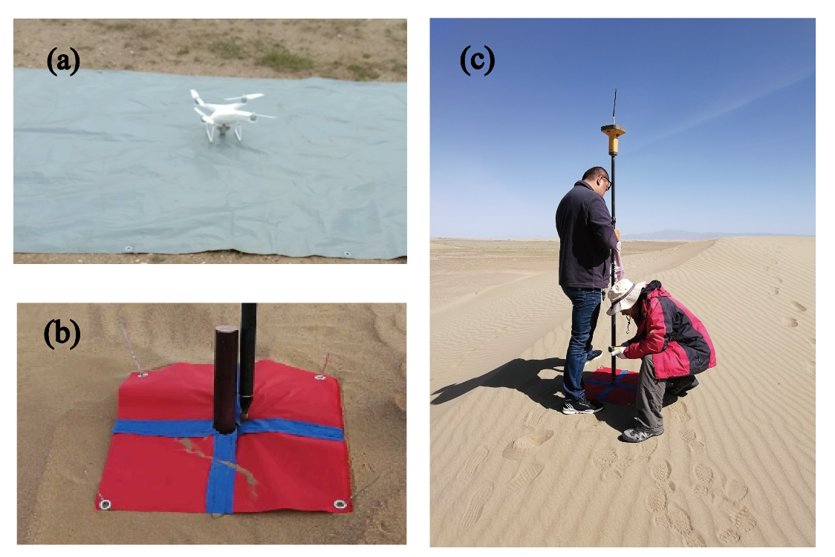

Figure S1. Field measurement of terrain and GCPS/CPS(a: the photos of UAV at work in the field; b: the marking of ground control points/check points; c: the coordinate position of the ground control points/check points is measured using RTK-GPS)



Figure S2. The locations of the ground control points and check points.



Figure S3. Experimental arrangement of surface air flow and sediment transport measurements



Figure S4. Variation of dune morphology parameters (a: variation of dune length; b: variation of dune height; c: variation of dune width; d: variation of dune basal area. The horizontal dotted line is the line with the variation of morphological parameters of 0, and the vertical dotted line is the boundary of the dune with a height of 5 meters).

Details in Photogrammetric Processing

Here we will give a detailed description of the parameters used in data processing. First of all, in the initial processing, we chose the Detected Template as 3D Maps, the Keypoints Images Scale was full, and the Images Scale was 1. The option of Matching Image Pairs was Aerial Grid or Corridor, and the Matching Strategy was not using Geometrically Verified Matching. The targeted Number of keypoints was automatic. As for the calibration, we used standard calibration method, both internal and external parameters optimization. Secondly, the processing options in point cloud densification details are as follows: the Image Scale was multiscale and half image size, the point density was optimal, minimum number of matches was 3. Thirdly, we give the DSM, Orthomosaic and Index details. DSM and DOM resolution was 1 GSD. We used the Noise Filtering in DSM Filters, and the surface smoothing type was sharp. Inverse Distance Weighting was the method of generating the Raster DSM.

Table S1. The parameters setting and shooting environment during the UAV images acquisition and processing

|  |  |  |  |  |  |  |
| --- | --- | --- | --- | --- | --- | --- |
| Time | Weather condition | Number of images | Keypoints | Calibrated images | Matches | Camera optimization |
| 2019.03 | sunny | 739 | 24051 | 100% | 11058.9 | 1.72% |
| 2019.07 | sunny | 2241 | 19577 | 100% | 12163.2 | 2.88% |
| 2020.01 | sunny | 1792 | 36435 | 100% | 20393.2 | 0.23% |
| 2020.08 | sunny | 1955 | 24055 | 100% | 8456.78 | 0.8% |

Table S2. The error of horizontal, vertical and RMSE of the control points and check points of 2019.03, 2019.07, 2020.01, 2020.08. The GCP** represents the control points and CP** represents the check points.

|  |  |  |  |  |  |  |  |  |  |  |  |
| --- | --- | --- | --- | --- | --- | --- | --- | --- | --- | --- | --- |
| GCPS/CPS code | 2019.03 | | GCPS/CPS code | 2019.07 | | GCPS/CPS code | 2020.01 | | GCPS/CPS code | 2020.08 | |
| Horizontal error | Vertical error | Horizontal error | Vertical error | Horizontal error | Vertical error | Horizontal error | Vertical error |
| GCP 1 | 0.012 | 0.025 | GPC 1 | 0.009 | 0.000 | GCP7 | 0.011 | 0.010 | PC1 | 0.011 | 0.005 |
| GCP 2 | 0.023 | 0.087 | GPC 2 | 0.007 | 0.020 | GCP8 | 0.021 | 0.011 | PC2 | 0.032 | 0.005 |
| GCP 6 | 0.009 | 0.003 | GPC 5 | 0.023 | 0.004 | GCP9 | 0.016 | 0.006 | PC3 | 0.015 | 0.027 |
| GCP 7 | 0.012 | 0.008 | GPC 6 | 0.024 | 0.000 | GCP10 | 0.031 | 0.049 | PC4 | 0.011 | 0.009 |
| GCP 9 | 0.011 | 0.029 | GPC 7 | 0.022 | 0.000 | GCP11 | 0.004 | 0.001 | PC5 | 0.016 | 0.004 |
| GCP 10 | 0.008 | 0.031 | GPC 8 | 0.007 | 0.003 | GCP14 | 0.014 | 0.012 | PC6 | 0.029 | 0.002 |
| GCP 11 | 0.016 | 0.049 | GPC 9 | 0.014 | 0.003 | GCP18 | 0.025 | 0.031 | PC8 | 0.022 | 0.006 |
| GCP 13 | 0.006 | 0.048 | GPC 10 | 0.005 | 0.006 | GCP21 | 0.006 | 0.027 | PC10 | 0.084 | 0.008 |
| GCP 14 | 0.006 | 0.039 | GPC 11 | 0.014 | 0.019 | GCP22 | 0.006 | 0.013 | PC11 | 0.042 | 0.049 |
| GCP 16 | 0.005 | 0.019 | GPC 14 | 0.013 | 0.023 | GCP26 | 0.028 | 0.023 | PC12 | 0.028 | 0.011 |
| GCP 17 | 0.009 | 0.016 | GPC 16 | 0.022 | 0.004 | GCP27 | 0.026 | 0.031 | PC13 | 0.038 | 0.010 |
| GCP 19 | 0.003 | 0.038 | GPC 17 | 0.012 | 0.028 | GCP28 | 0.022 | 0.082 | PC15 | 0.052 | 0.010 |
| GCP 20 | 0.007 | 0.004 | GPC 21 | 0.037 | 0.014 | GCP29 | 0.026 | 0.053 | PC16 | 0.039 | 0.016 |
| GCP 22 | 0.008 | 0.018 | GPC 22 | 0.021 | 0.009 | GCP45 | 0.012 | 0.016 | PC17 | 0.007 | 0.001 |
| GCP 25 | 0.027 | 0.044 | GPC 25 | 0.022 | 0.008 | GCP50 | 0.020 | 0.008 | PC18 | 0.051 | 0.010 |
| GCP 28 | 0.016 | 0.015 | GPC 26 | 0.009 | 0.015 | RMSE GCP | 0.019 | 0.032 | PC19 | 0.036 | 0.003 |
| GCP 29 | 0.017 | 0.012 | GPC 27 | 0.024 | 0.022 | CP43 | 0.023 | 0.151 | PC20 | 0.089 | 0.007 |
| GCP 43 | 0.008 | 0.041 | GPC 28 | 0.036 | 0.011 | CP44 | 0.004 | 0.085 | PC22 | 0.031 | 0.008 |
| GCP 44 | 0.016 | 0.057 | GPC 29 | 0.017 | 0.000 | CP47 | 0.026 | 0.064 | PC23 | 0.037 | 0.009 |
| GCP 46 | 0.030 | 0.033 | GPC 50 | 0.020 | 0.021 | CP48 | 0.005 | 0.028 | PC25 | 0.041 | 0.002 |
| GCP 47 | 0.024 | 0.015 | RMSE GCP | 0.020 | 0.014 | CP49 | 0.023 | 0.064 | PC26 | 0.035 | 0.018 |
| GCP 48 | 0.009 | 0.260 | CP 43 | 0.022 | 0.005 | RMSE CP | 0.019 | 0.088 | PC27 | 0.100 | 0.009 |
| GCP 50 | 0.014 | 0.003 | CP 44 | 0.010 | 0.013 |  |  |  | PC28 | 0.029 | 0.009 |
| GCP 51 | 0.023 | 0.032 | CP 45 | 0.012 | 0.019 |  |  |  | PC29 | 0.032 | 0.010 |
| RMSE GCP | 0.016 | 0.063 | CP 47 | 0.039 | 0.004 |  |  |  | PC31 | 0.025 | 0.001 |
| CP 5 | 0.013 | 0.029 | CP 48 | 0.017 | 0.013 |  |  |  | RMSE GCP | 0.043 | 0.014 |
| CP 8 | 0.012 | 0.031 | CP 49 | 0.005 | 0.048 |  |  |  | PC37 | 0.040 | 0.002 |
| CP 12 | 0.022 | 0.055 | RMSE CP | 0.020 | 0.023 |  |  |  | PC39 | 0.087 | 0.010 |
| CP 21 | 0.027 | 0.047 |  |  |  |  |  |  | PC40 | 0.061 | 0.065 |
| CP 23 | 0.008 | 0.060 |  |  |  |  |  |  | PC41 | 0.139 | 0.060 |
| CP 26 | 0.031 | 0.060 |  |  |  |  |  |  | RMSE CP | 0.090 | 0.046 |
| CP 27 | 0.033 | 0.050 |  |  |  |  |  |  |  |  |  |
| CP 45 | 0.026 | 0.05 |  |  |  |  |  |  |  |  |  |
| CP 49 | 0.006 | 0.054 |  |  |  |  |  |  |  |  |  |
| RMSE CP | 0.022 | 0.047 |  |  |  |  |  |  |  |  |  |

Table S3. The migration rate of the left and right horns of the barchan dunes(m/M)

|  |  |  |  |  |  |  |  |  |
| --- | --- | --- | --- | --- | --- | --- | --- | --- |
| Dune code | 2019.03-2019.07 | | 2019.07-2020.01 | | 2020.01-2020.08 | | 2019.03-2020.08 | |
| *DR* | *DL* | *DR* | *DL* | *DR* | *DL* | *DR* | *DL* |
| 1 | 0.69 | 2.24 | 0.58 | 3.26 | 0 | 1.26 | 0.03 | 0.57 |
| 2 | 1.50 | 1.67 | 3.21 | 1.71 | 0.39 | 0.96 | 0.77 | 1.13 |
| 3 | 1.44 | 1.86 | 4.13 | 1.61 | 1.20 | 2.79 | 0.51 | 1.40 |
| 4 | 1.63 | 1.77 | 0.23 | 0.39 | 0.72 | 0.42 | 0.56 | 0.37 |
| 5 | 0.22 | 0.18 | 1.41 | 0.04 | 0.57 | 0.04 | 0.69 | 0.08 |
| 6 | 1.69 | 2.47 | 0.95 | 1.05 | 0.78 | 2.77 | 0.97 | 0.94 |
| 8 | 8.86 | 1.56 | 1.81 | 1.16 | 0.63 | 1.58 | 1.24 | 1.46 |
| 10 | 1.91 | 1.54 | 3.14 | 0.33 | 1.49 | 0.90 | 2.07 | 1.05 |
| 12 | 0.88 | 1.29 | 1.35 | 0.79 | 0.38 | 1.94 | 0.44 | 1.57 |
| 14 | 0.66 | 1.92 | 1.04 | 1.46 | 0 | 0.72 | 0.42 | 1.16 |

Note: This paper only computed statistics on the 10 barchans which were independent, non-collisional or merging dunes (dunes No.1~6, 8,10,12,14). There were significant differences between the left and right side of the barchans according to our monitoring results.