**The forgotten bread oven: Local bakeries, forests and energy transition in Nigeria**

Abubakar Tanimu Salisu1,Aliyu Salisu Barau1*, Jamie A. Carr2,3,6, Banki T. Chunwate . 2, Eleanor KK Jew2,5, Joshua D. Kirshner2,6, Robert A. Marchant2,6, Julia Tomei4, Lindsay C. Stringer2,3,6

1 Department of Urban and Regional Planning, Faculty of Earth and Environmental Sciences, Bayero University Kano, Kano, Nigeria

2 Department of Environment and Geography, University of York, York, UK

3 Leverhulme Centre for Anthropocene Biodiversity, University of York, York, UK

4 UCL Institute for Sustainable Resources, University College London, London, UK

5 Interdisciplinary Global Development Centre, University of York, York, UK

6 York Environmental Sustainability Institute, University of York, York, UK

*Corresponding author: [asbarau.urp@buk.edu.ng](mailto:asbarau.urp@buk.edu.ng)

Lindsay Stringer ORCID [0000-0003-0017-1654](https://orcid.org/0000-0003-0017-1654)

Julia Tomei ORCID 0000-0002-2156-1603

Jamie Carr ORCID 0000-0003-2219-5374

Aliyu Barau ORCID 0000-0002-1259-3929

Joshua Kirshner ORCID 0000-0002-6860-4287

Eleanor Jew ORCID 0000-0003-0241-404X

Robert Marchant ORCID [0000-0001-5013-4056](https://orcid.org/0000-0001-5013-4056)

Banki Chunwate ORCID 0000-0002-4757-8657

Abubakar Salisu ORCID 0009-0007-4032-2572

**Statements and declarations:** Remote sensing data are available at: [EarthExplorer](https://earthexplorer.usgs.gov/). Questionnaire survey data are not publicly available in order to protect participant privacy, as promised during data collection and detailed in our ethical approval. Data from forest plots is detailed in Online Resource Table 4. The authors have no competing interests to declare.

**Author contributions: *Conceptualization***: Aliyu Barau, Lindsay C. Stringer; ***Writing- original draft preparation:*** Abubakar Salisu, Eleanor Jew, Lindsay C. Stringer, Joshua Kirshner, Aliyu Barau; ***Writing - review and editing:*** all authors; ***Funding acquisition:*** Lindsay C. Stringer, Aliyu Barau.

**Compliance with ethical standards:** Ethics approval for research involving human participants was granted by the Environment Department Ethical Review Committee, University of York, UK, with due consideration afforded to informed consent and data privacy.

**Funding acknowledgement:** This research was supported by the Royal Society International Collaboration Award ICA\R1\201148.

# Abstract

Despite three decades of policies discouraging biomass-based cooking in Africa, demand for fuelwood continues to rise. Several studies focus on household energy use, but few consider the role of commercial premises such as bakeries in deforestation, despite growing demand for bread. This study examines bread production by commercial bakeries in forest communities in Nigeria, investigating: a) the energy sources used, b) the changes to forests and c) the factors that could enable bakeries to transition toward clean energy. Mixed methods were used including questionnaire surveys, land use change mapping and assessments of forest plots. Questionnaires with 21 bakeries in two northern Nigerian states (Kaduna, Nasarawa) and Abuja Federal Capital Territory, suggest that they depend heavily on fuelwood, collected directly from the forest, or purchased from (largely female) suppliers, retailers or wholesalers. Bakeries most commonly use *Anogeissus leiocarpa* mainly due to its burning quality and availability. Remote sensing data show declines in forest cover from 71% (56,157 km2) in 2000 to 49% (38,756 km2) in 2020. While all bakeries were willing to transition to more sustainable energy sources, training on alternative fuels and more energy efficient ovens is required. Policies supporting energy transition must consider all value chain actors, not just fuelwood consumers, recognising that women play a key role in fuelwood sales at the community level. Transition efforts need to be underpinned by detailed analyses of trade-offs so that measures to reduce undesirable livelihood impacts can be established, and should consider more efficient ovens as well as stoves.

**Keywords:** energy transition, degradation, livelihoods, ovens, clean energy, SDGs, Africa

**Length of manuscript: 5830 + 2 tables and 4 figures = 7630**

# 1. Introduction

By 2050 the United Nations estimates that Nigeria will be the fourth most populous country in the world, with a population of 375 million, equal to that of the USA (UN DESA 2022), but with an area of 923,768 km2, only one third larger than the American state of Texas. This 73.6% increase in population, from an estimated 216 million in 2022, comes as Nigeria is expected to experience mounting climate change impacts, including increased rainfall variability, higher than average temperatures, extreme heat and coastal flooding, with strong regional variations (Haider 2019). The expected effects on Africa’s largest economy include decreases in GDP of 6-30% by 2050 (Pearce 2022; BNRCC 2011) with particularly severe impacts on the agriculture and energy sectors. Approximately 40% of the Nigerian population was living below the national poverty line in the latest (2018/19) national survey (NBS Nigeria 2022), with the COVID-19 pandemic adding a further ~2% to this (World Bank Group 2022). This is likely to increase further as GDP decreases and agricultural yields, which support 42% of all workers and 60% of the poorest workers (ibid.), become less reliable. In turn, human health will be affected, with increasing deaths from heat exhaustion, food and water insecurity, disease and displacement (World Bank Group 2021). This will make it even harder for Nigeria to advance towards the Sustainable Development Goals (SDGs) (SDG Report 2023).

Nigeria is Africa’s second largest greenhouse gas (GHG) emitter after South Africa, and its economy is heavily reliant on oil and gas exports, yet domestically, biomass is by far the largest energy type consumed (76%) (Carbon Brief 2023). Nigeria’s updated 2021 Nationally Determined Contributions to the Paris Agreement are to reduce emissions by 47% of Business as Usual (BAU) by 2030, conditional on international support (excluding Land Use, Land Use Change and Forestry), and an unconditional contribution of 20% below BAU by 2030 (Federal Government of Nigeria 2021). Besides improving electricity access for 86 million Nigerians (40% of the population) (IEA et al. 2023) one of the greatest challenges to achieving this target is to reduce the reliance on biomass for domestic energy needs through a transition to clean cooking fuels. Nigeria’s Energy Transition Plan, launched in the wake of COP26, notes that 40 MtCO2e comes from energy used in cooking. In addition, approximately 130,000 deaths annually are caused by poor indoor air quality resulting from cooking using biomass indoors, and this is expected to increase as air quality falls with increasing temperatures (World Bank Group 2021). The impacts of this will disproportionately affect women and children who are more exposed to open cooking fires (Roberman et al. 2021; Ezeh et al. 2014; Lee et al. 2020). Currently 78.1% of the population of Nigeria uses biomass to cook (firewood 69.9%; charcoal 5.8%; grasses etc. 2.4%), with a large difference between rural and urban populations, where ~88% of rural citizens use biomass compared to ~45% in urban areas (Adekoya et al. 2023).

This reliance on biomass and firewood is a driver of deforestation within Nigeria (UN 2022) contributing to a 12% loss in tree cover since 2000 (Global Forest Watch 2023). Other drivers include agriculture, land clearing for settlements and commercial projects such as mining and unsustainable timber extraction (Maijama’a et al. 2020), meaning that forest resources, biodiversity and ecosystem services are under increasing threat. Reasons for households to utilise biomass for cooking and lighting over alternative energy sources are well documented (Oyeniran and Isola 2023), and influencing socio-demographic factors include age, gender, household size, income and education levels (e.g. Ogwumike et al. 2014; Bisu et al. 2016; Shari et al. 2022). Other influential factors include accessibility to and availability of other fuels, in addition to fear of accidents with fuel such as Liquid Petroleum Gas (LPG) (e.g. Ozoh et al. 2018; Oyedepo 2012; Danlami et al. 2018; Barau et al. 2020). While there is a national programme (under the Sustainable Energy Action for All Action Agenda (SE4ALL-AA)) to encourage a transition to clean cooking fuels for households (Federal Government of Nigeria 2016) there is a growing sector that is largely overlooked and bridges the space between household cooking and commercial industries: small and medium enterprises (SMEs) in the form of small-scale bakeries, which supply the growing population with bread.

While some forms of traditional wheat have been cultivated within Nigeria for millennia (Zeven 1974), widespread consumption of leavened bread and similar products only began at the turn of the 20th century when they were introduced during British colonial rule (Haruna et al. 2017). Since then, wheat and its byproducts have had a turbulent time in Nigeria, with political decisions closely tied to the economic state of the country. Following Independence in 1960, wheat imports grew from 80,000 tons to 1.5 million tons per annum in the 1980s, with 95% coming from the USA (Watts 1987). This suppressed the development of domestic wheat production - called the ‘wheat trap’ (Andrae and Beckman 1985) - leading to a total ban of wheat imports in January 1987 (Kimmage 1991). However, domestic production was unable to meet demand, particularly as traditional varieties were unpopular, and imports were reinstated in 1990 (Togun et al. 2019). Bread had become a staple food for Nigerians and had rapidly penetrated rural markets (Watts 1987), where bread was baked in mud ovens fuelled by firewood.

The industry has seen continued growth since the 1990s. In 2021, Nigeria imported 6.3 million tons of wheat at a value of US$2 billion (FAOSTAT 2023). This meant that Nigeria was the second largest importer of wheat in the world, and it was the second most imported product in Nigeria (OEC 2023), representing significant expenditure of Nigeria’s limited foreign currency budget. For this reason, in 2021, public officials added wheat to a restricted foreign exchange list, preventing payment of imported wheat in a foreign currency. The aim of these restrictions was to reduce the burden on limited foreign currency, and to once again increase domestic wheat production (Central Bank of Nigeria 2021). As with the approach in the 1980s, this policy was short-lived. In June 2023, all restrictions on foreign currency payments were lifted, including wheat. Wheat imports continue to fluctuate both in terms of volume and cost due to market volatility in response to the Russia-Ukraine war (USDA 2022).

These policies illustrate how important wheat is to the national economy and food security within Nigeria where bread remains a staple food, with production increasing over time to feed the growing population. In 2015, bread represented 80% of the baked goods sector, with 72% of the market controlled by artisanal and small- to medium-sized bakeries (KPMG Nigeria 2016). Yet crucially, the process of baking bread by such bakeries has changed little over time. Bread is still baked in large masonry ovens (also known as black or Roman ovens) heated by burning wood, which is removed before the dough is put in to bake (see Online Resource Figure 1). Despite the size and growth of the bakery industry and its reliance on biomass for energy, little is known about the extent of biomass burning and the opportunities for energy transitions within the baking industry, yet the efforts of this sector will be critical to meet emissions goals. Using a case study approach in northern Nigeria, this paper addresses this research gap through: 1) understanding the current energy sources used by bakeries within the study areas; 2) assessing the changes to local forest resources over the period 2000-2020; and 3) identifying opportunities for bakeries to transition toward clean energy sources.

# 2. Methodology

**2.1 Study area context**

In this study, focus was placed on three locations where deforestation for cooking fuel use by bakeries is known to be high: Abuja Federal Capital Territory (FCT), Kaduna State and Nasarawa State (Figure 1). None of the study sites fall under the Abuja Federal Capital City, where such bakeries are scarce. Rather, the sites capture the broader FCT which has more rural parts. The study area covers a total land area of 79,094 km2.Our study sites are located mostly in the Southern Guinea Savanna zone, once an area with high vegetation cover. Even as far back as three decades ago, Hyman (1994) noted an overdependence on fuelwood in the region, but observed that households and SMEs relied on it because it was the least expensive and most readily available of the cooking energy options. Since then, ecological changes in the drier and more populous parts of the region further north have reduced the availability of fuelwood there, resulting in our study states supporting the energy demands of other parts of Nigeria (Nichol 1989), in addition to local cooking energy needs.

**Fig. 1** The study area with bakeries and forest reserves highlighted. Inset illustrates the location of the study states within Nigeria. Protected areas/forest are cross-shaded

**2.2 Methods**

An exploratory mixed methods research design was used (Nabukwangwa et al. 2023; Unwin 2009), combining analysis of data derived from remote sensing (satellite imagery depicting land cover, and changes therein), on-the-ground sampling of vegetation and questionnaires. A growing number of studies are employing mixed methods approaches to investigate the drivers and/or impacts of land cover change. Examples include those by Cvitanović et al. (2016), who combined remote sensing, statistical modelling and household questionnaires to compare rates of forest cover change and the influencing factors in Croatian forests under different governance systems; Kleemann et al. (2017), who combined interviews, questionnaires and remote sensing to assess the drivers and effects of land use change in northern Ghana; and Matsa et al. (2020), who combined key informant interviews, field observations and remote sensing to assess the socio-economic impacts of land use/cover changes on farmers at a specific locality in Zimbabwe.

Mixed methods approaches, such as those described above (and employed in this work), allow integration of qualitative and quantitative data types (e.g. interview data and remote sensing data) to provide more comprehensive insights into the topic of interest (Kinnebrew et al. 2021). A particular advantage in this regard is an ability to make inferences across scales. For example by examining qualitative data on the drivers of change at selected localities, one may infer that changes observed over a wider area are occurring as a result of similar drivers (e.g. see Malek et al. 2014). Conversely, information on the socio-economic impacts of change, if gathered from a representative sample of localities from a wider set of options, may be indicative of similar impacts at other locations undergoing similar changes (e.g. see Matsa et al. 2020). Such advantages underpin our choice of methods in this investigation, where we combine data from different scales to assess how energy resources used by bakeries may be affecting forests over a wide area. Nevertheless, it is important to keep in mind that some level of assumption is almost always required when drawing such inferences. No two localities are identical, and so caution must always be exercised when assuming similarities between sites that have and have not been directly observed.

Fieldwork was carried out between 2021 and 2022 across the study sites. Bakeries less than four hours’ walk away (~20 km) from forests were selected for the survey, considering also any security and safety issues within and around any selected site. Distance from forest was considered important because key informants noted that some bakeries sourced fuelwood directly from forests and we chose to use a four-hour walk cut-off as this was locally relatable. Also, if collecting wood took more than four hours, then people tended to purchase fuelwood rather than collect it directly from the forest. It was not possible to determine the total number of bakeries in the study area within 4 hours’ walk from a forest, so generalisations to the whole bakery population cannot be made.

2.2.1 Questionnaires

Questionnaires used open-ended questions and were undertaken with 21 people working in the bakeries. Respondents were identified using snowball sampling, with the help of the community heads and local contacts. The sample size in each state depended on the availability of bakeries and their willingness to participate (Figure 1; Online Resource Table 1). Questions were developed in English then translated into Hausa.COVID-19 protocols were observed as required as part of the national safety efforts set by the Nigerian Government at the time of data collection. All enumerators received training in order to minimise bias and ensure data was collected in a consistent manner.

Questionnaires took approximately 20 minutes to administer, considered the type of energy used, species preferences, amount of fuelwood used, and sought to capture bakeries’ perceptions of the barriers and opportunities associated with switching to clean energy. All participants were over 18 years old, informed verbal consent was obtained, and data was anonymized at the point of collection. The study methodology and instruments were approved by the Environment Department Ethical Review Committee at the University of York, UK. Answers were transcribed and categorised into themes relating to the research questions, enabling basic descriptive statistics to be compiled.

A key limitation was the small sample size, which as indicated above, means that the results of this study cannot be generalised to the wider population of bakeries. Other important limitations of questionnaires, such as differences in how people understand survey questions and the risk of respondents providing false or dishonest answers, were mitigated by carrying out the surveys in person. This enabled the enumerators to provide additional explanations where questions were unclear to respondents, as well as to observe behaviours and practices in situ which facilitated triangulation of the responses.

2.2.2 Remote sensing analysis

To determine land cover change across the three states satellite imagery data were analysed and compared between the years 2000 and 2020. This matches the period covered by the Millennium Development Goals (2000-2015) and SDGs while also connecting with the social memory of the respondents. Satellite images provided by the Landsat programme (an Earth-observation mission managed by NASA and the U.S. Geological Survey) for the two years (2000 and 2020) were filtered for clouds, mosaicked, and clipped using the JavaScript application interface on the Google Earth Engine platform (Gorelick et al. 2017). Due to the complex climate conditions and size of the study area, cloud-free images could only be generated by using multiple tile images from different years that were mosaicked and clipped to the study area boundaries. To obtain the best cloud-free images, we included all images in the mosaicking from April to October for two years around the target dates (2000–2001 and 2019–2020) to achieve the best classification effect (Hansen and Loveland 2012).

Normalized difference vegetation indices (NDVI), an established metric for quantifying the greenness and density of vegetation based on remotely-sensed data (Pettorelli et al. 2011), were calculated to improve the classification accuracy, as NDVI generally has a high correlation with the on-the-ground vegetation state. Finally, a high-quality multidimensional classification feature set for random forest (RF) classification was obtained (Breiman 2001) by directly calling the ee.smileRandomForest function in the Google Earth Engine Application Programming Interface, which only needs to identify two parameters: the number of classification trees and the number of feature variables entered at the time of node splitting (Liu et al. 2020). Compared with other machine learning methods, the RF classification algorithm has better robustness and can run effectively on large datasets (Belgiu and Drăguţ 2016). It was found experimentally that the classification results were more accurate when the number of trees was 500, so 500 trees were finally selected for RF classification, and the feature variables had the square root of the number of features involved in the classification calculated (Guo et al. 2011). The confusion matrix was used to verify the accuracy of the classification results of the features in the study area and describe the accuracy of the classification results by calculating the overall accuracy, Kappa coefficient, producer’s accuracy, and user’s accuracy (see Online Resource Figure 2 for a flowchart of the process and Online Resource Table 2 for the accuracy assessment results). Land use and land cover (LULC) types in the study area were classified into four categories: agriculture and other bare surfaces (e.g. rocky land), forest and scrublands, built-up land, and waterbodies. Training involved several sample points (see Online Resource Table 3). In all three locations, 70% of the sample points were used as training samples for training classifiers and 30% as verification samples for accuracy verification (Tassi et al. 2021). In each of the three study areas, two forest locations were then identified for ground-truthing of the LULC analysis, with GPS coordinates taken during field visits to pinpoint these areas. All maps were created in ArcGIS 10.8 (ESRI 2019).

2.2.3 Field observations

While remote sensing analyses can provide a broad overview of the spatio-temporal characteristics of forest change, the 30 m resolution of the imagery was too coarse to indicate details at species level. To address this, and to enable cross-checking with survey data on the abundance of species used for fuelwood, plant inventories were recorded in four 20 x 20 m plots in each state/territory. Plots were established in the following forests: Amba and Doma forests (both Nasarawa), Karshi and Paikon Kore (both in Abuja FCT), and Godogodo (in Kaduna) (Figure 1). In each forest, one degraded and one non-degraded plot were surveyed, based on assessment of the remote sensing outputs described above. Security issues in Angawan Mada Sanga, the second selected plot site in Kaduna, meant that we were unable to establish the plots there and fieldwork had to be aborted.

The plots were established along a randomly selected 1 km transect, making sure the forest edge as well as interior was surveyed. In each plot, species were recorded and observations were recorded (RAINFOR 2021: see Online Resource Table 4). Photographs, fieldnotes, and visual observations were utilized to corroborate the delineation of forested and non-forested areas and to record observable evidence of cooking energy-driven exploitation. Although it is difficult to isolate this from other deforestation drivers, stumps, as well as other signs of human use (such as charcoal production or widespread clearance for agriculture) were observed, alongside cut trees (Online Resource Figures 3a-3d). Tree height was estimated and species were identified in situ, taking voucher specimens where species identification was not immediately possible.

**3. Results**

Results are presented to address each research question in turn.

## 3.1 Energy sources used by bakeries in the study areas

All 21 commercial bakeries depended on fuelwood as their sole source of energy for bread production, obtaining it from eight different sources. One respondent noted: “*We use fuelwood, it is the only thing we can use*” (Respondent 1, Nasarawa State). Nevertheless, there were variations in the patterns of supply across the different states/FCT. All three surveyed bakeries in Abuja FCT obtained their fuelwood from major suppliers (2), wholesalers (1) or retailers (1), compared to the 11 bakeries in Kaduna, where male (7) and particularly female fuelwood sellers within the community (9) predominate. Also in Kaduna, some bakeries obtain fuel from farmers (1), from those directly engaged in deforestation (3) or from wholesalers (5). Obtaining fuelwood via the major suppliers facilitates access to fuel and preferred species in Abuja FCT, with little difficulty, as one respondent explained “[If I need firewood] *I just call my suppliers and they deliver it to me*” (Respondent 3, Abuja). However, in Kaduna and Nasarawa difficulties were experienced in obtaining firewood, leading to significant impacts: “*Sincerely speaking, it is very difficult to get it* [fuelwood]*. We may…. spend even two to three days sourcing it and we will not get it”* (Respondent 6, Kaduna)*.* All seven sampled commercial bakeries in Nasarawa sourced their fuelwood from bush or forest areas within the state. Respondents reported the use of both local and indigenous tree species (Table 1) and explained their species choices.

**Table 1** Tree species used by bakeries as fuelwood. Respondents were asked to list all species they used

|  |  |  |  |  |
| --- | --- | --- | --- | --- |
| **Species used by sampled bakeries** | **Number of bakeries using each species in Abuja** | **Number of bakeries using each species in Kaduna** | **Number of bakeries using each species in Nasarawa** | **Total number of sampled bakeries using each species** |
| *Terminalia* spp. | 2 | 0 | 0 | 2 |
| *Azadirachta indica* | 0 | 1 | 0 | 1 |
| *Ficus trichopoda* | 0 | 0 | 1 | 1 |
| *Pericopsis laxiflora* | 0 | 2 | 0 | 2 |
| *Ficus platyphylla* | 0 | 1 | 0 | 1 |
| *Erythrophleum africanum* | 0 | 0 | 1 | 1 |
| *Milicia excelsa* | 0 | 1 | 0 | 1 |
| *Vitellaria paradoxa* | 1 | 4 | 0 | 5 |
| *Piliostigma thonningii* | 1 | 0 | 1 | 2 |
| *Crossopteryx febrifuga* | 0 | 1 | 0 | 1 |
| *Amblygonocarpus andongensis* | 2 | 2 | 2 | 6 |
| *Khaya senegalensis* | 0 | 1 | 0 | 1 |
| *Pterocarpus erinaceus* | 0 | 1 | 0 | 1 |
| *Burkea africana* | 0 | 2 | 0 | 2 |
| *Anogeissus leiocarpa* | 3 | 10 | 3 | 16 |
| *Prosopis africana* | 2 | 2 | 2 | 6 |
| *Gmelina* sp. | 0 | 2 | 0 | 2 |
| *Tamarindus indica* | 0 | 1 | 0 | 1 |
| *Combretum molle* | 1 | 1 | 0 | 2 |
| **Total number of species used** | **7** | **15** | **6** | **19** |

Kaduna’s bakeries used 15 different species, whereas Abuja FCT bakeries used seven and Nasarawa State used six. Such diversity in Kaduna may nevertheless reflect the larger number of bakeries participating in the study at that site. Some of the species used by bakeries were also observed in the forest plots (Online Resource Table 4). *Anogeissus leiocarpa* is the most used species across the three study sites: by all three of the participating bakeries in Abuja, 10 of the 11 bakeries sampled in Kaduna and three of the seven bakeries in Nasarawa. In Abuja, bakeries justified their choices of species largely due to the length of time the wood can burn, preferring those that are more economical due to longer lasting heat. In Kaduna species were preferred because of their high burning quality, and because they produce good charcoal, more heat and less smoke, as one respondent described: “[These trees] *produce long lasting heat to bake bread”* (Respondent 9, Kaduna). Bakeries in Nasarawa tended to select tree species on the basis of availability, noting that the species they use are the only ones available, are easy to get from the forest and easy to use.

## 3.2 Spatio-temporal patterns of forest change and the nature of fuelwood related extraction impacts

Table 2 summarises the LULC categories in 2000 and 2020, while Figure 2a-c shows the spatio-temporal patterns of these changes.

**Table 2** Land Use and Land Cover categories in 2000 and 2020. All values shown are percentages of total land cover and have been rounded to the nearest whole number

|  |  |  |  |  |  |  |  |  |
| --- | --- | --- | --- | --- | --- | --- | --- | --- |
| **State:** | **Abuja** | | **Kaduna** | | **Nasarawa** | | **All** | |
|
| **Year  Land use** | **2000** | **2020** | **2000** | **2020** | **2000** | **2020** | **2000** | **2020** |
| Water body | 7 | 4 | 6 | 5 | 7 | 5 | 7 | 5 |
| Built-up areas | 5 | 13 | 5 | 6 | 4 | 7 | 5 | 8 |
| Forest and scrubland | 67 | 55 | 68 | 38 | 77 | 56 | 71 | 50 |
| Agriculture and others | 21 | 28 | 20 | 51 | 12 | 32 | 18 | 37 |

Within the study area the amount of land used for agriculture more than doubled (from 18% to 37%) between 2000 and 2020, particularly in Nasarawa and Kaduna (Table 3). Correspondingly, forest cover has reduced by 22% across the study sites, and in particular there has been a 30% decline in Kaduna. Field observations (Online Resource Table 4, Online Resource Figure 3) suggest evidence of fuelwood for cooking. It is possible that deforestation driven by demand for fuelwood led to clearance of areas of land into which agricultural land uses were then established. This possibility was corroborated anecdotally through informal conversations with people living near the forest.

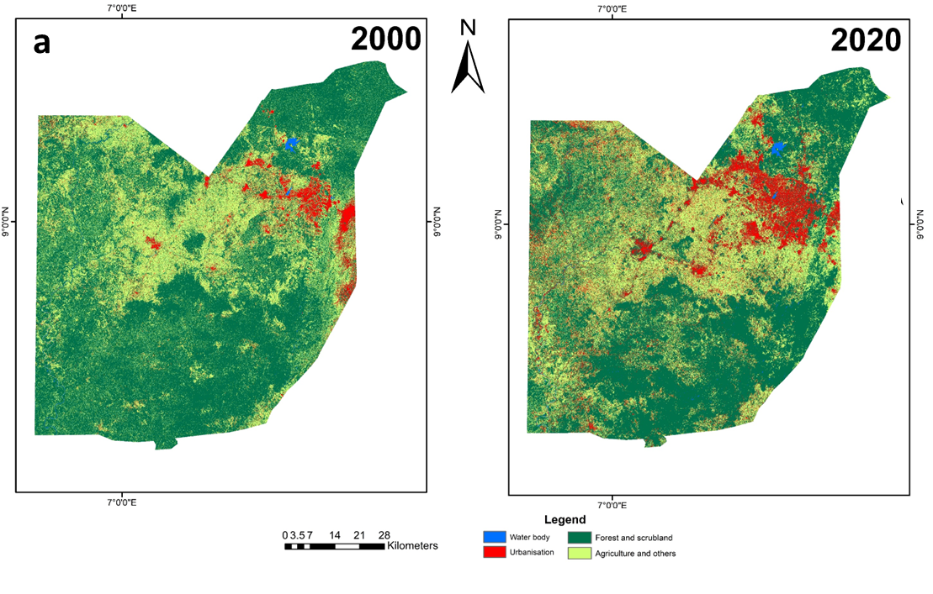

**Fig. 2a** Maps showing land use changes (2000-2020) in Abuja FCT. Total land area in Abuja is 7,633 km2

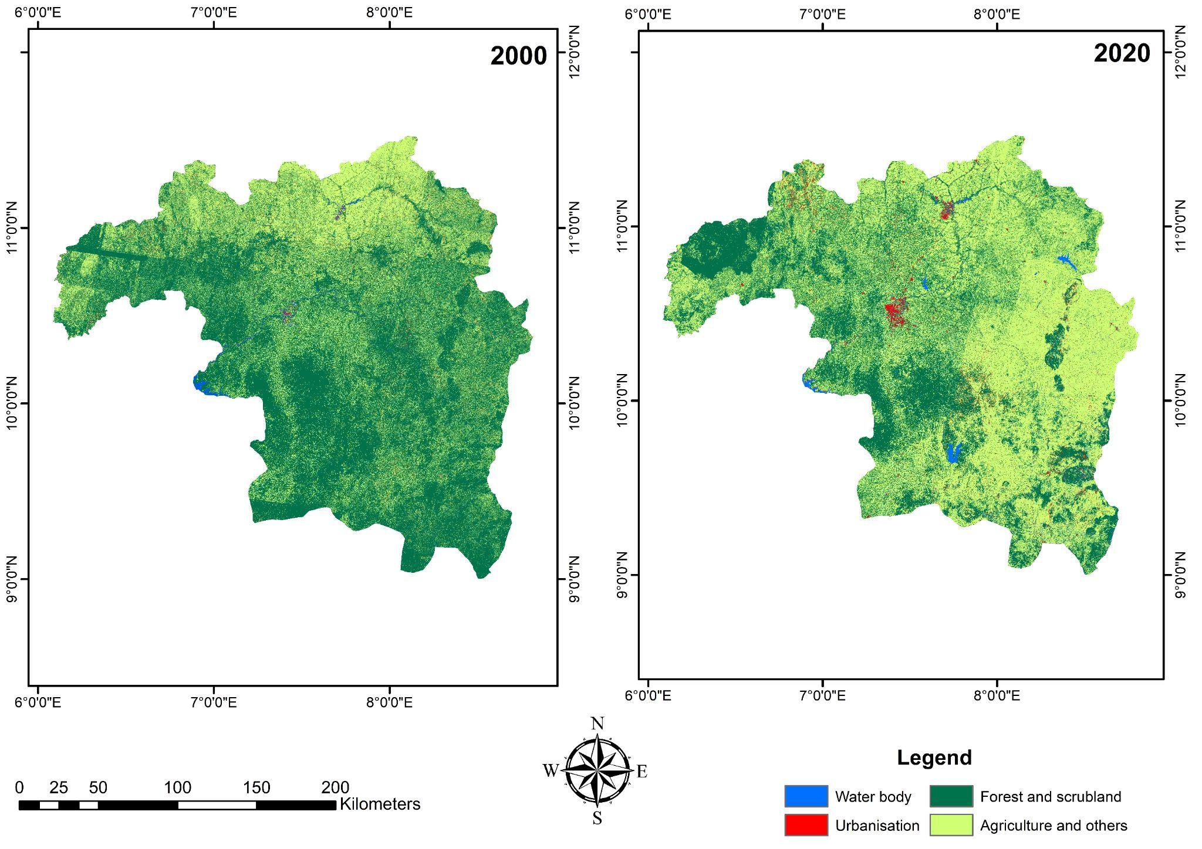

**Fig. 2b** Maps showing land use changes (2000-2020) in Kaduna State. Total land area in Kaduna is 45,205 km2

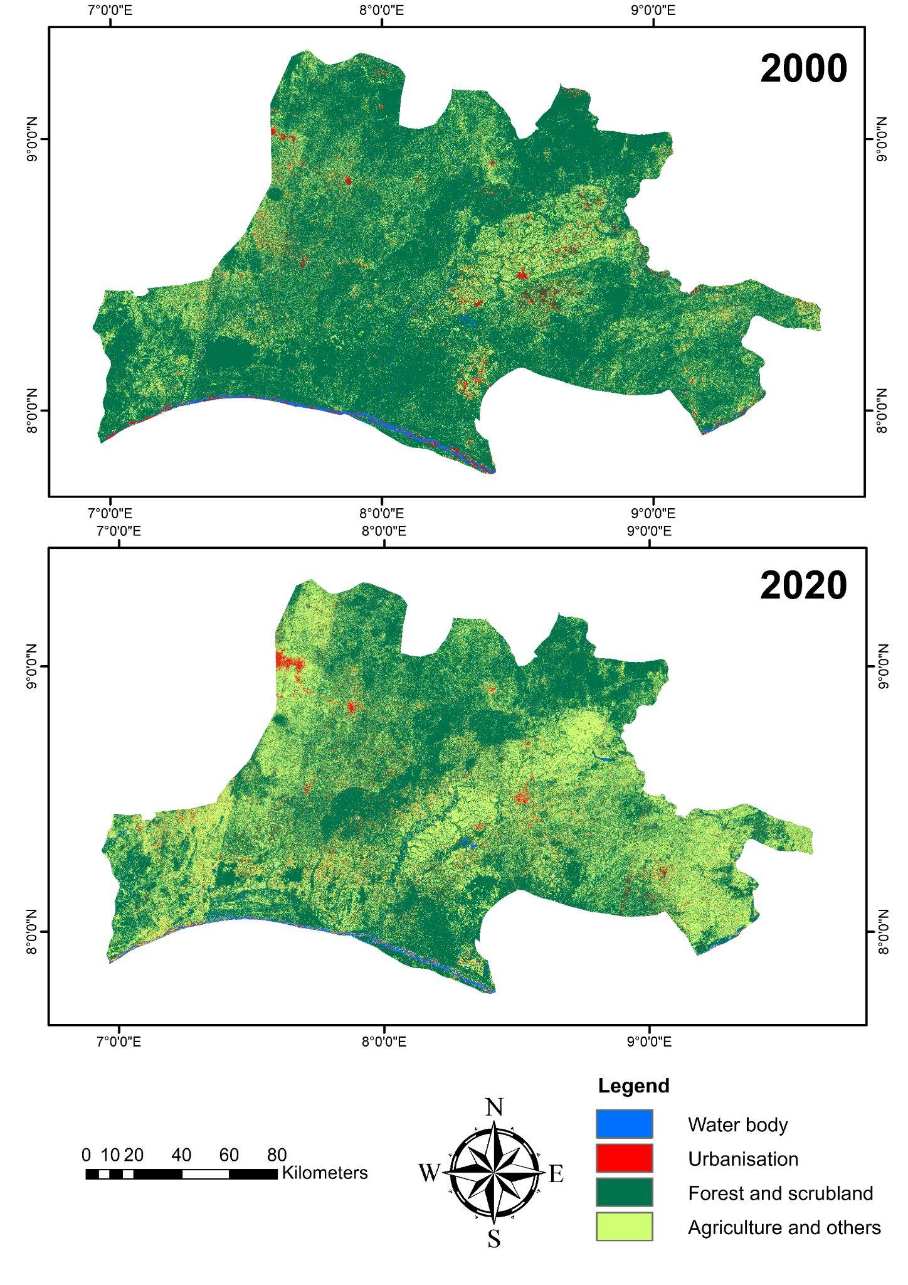

**Fig. 2c** Maps showing land use changes (2000-2020) in Nasarawa State. Total land area in Nasarawa is 26,255 km2

## 3.3. Considerations for transitioning to cleaner sources of energy

Many respondents from bakeries in the three states reported that smoke from fuelwood affects roofing materials and their eyes. One respondent in Kaduna said “*it affects our vision because of smoke”* (Respondent 6, Kaduna). Respondents also noted that they faced issues with heat, with some observing that the use of fuelwood impacts the environment through air pollution and can lead to desertification and global warming. These factors may help to explain bakeries’ willingness to use other fuels, even if they are not as easily accessible. Willingness to use other, less available, energy sources nevertheless varies across Abuja, Kaduna and Nasarawa. All of the sampled bakeries in Abuja expressed a willingness to use other energy sources that are currently less available. The majority (nine, or 82%) of those surveyed in Kaduna also agreed, as did six (or 86%) of surveyed bakeries in Nasarawa State, although this often depended on price. For example, one respondent said “*I would like it if it is cheaper”* (Respondent 6, Nasarawa State). All surveyed bakeries across the study locations, bar one bakery in Kaduna, would be willing to change to use cleaner energy sources. However, to make this transition, all sampled bakeries in Abuja and Kaduna said they would require training on the new energy source and any associated fuel technology - one respondent explained that “*Electricity requires training, that is why we will not go directly into electric sources”* (Respondent 1, Abuja), while three (67%) of surveyed bakeries in Nasarawa felt that they would require training. A possible driver for the willingness to switch to a different energy source could be fluctuations in the price of fuelwood - a concern throughout the study, with one respondent highlighting these issues: “*Before we were buying firewood at ₦ 8000* [US$8] *but now it is ₦ 15,000* [US$19]*, and not all the time you will get the correct ones* [species]*”* (Respondent 2, Abuja)*.* We did not speak to bakery customers, however, all except one respondent felt their customers were not concerned about the energy sources used in the bakeries.

# 4. Discussion

Bakeries sit among the under-explored consumers of fuelwood despite their growing importance in Nigeria and Africa. Previous research has shown that firewood and charcoal are major fuel sources in these local commercial premises across the country (Smah et al. 2021), suggesting fuel demands from bakeries contribute to ongoing deforestation. This was also the case in our research, in which all bakeries we surveyed used fuelwood for bread production. While amounts and species of fuelwood used varied across the study states and FCT, and we were unable to link this directly and quantitatively to the amounts of bread being produced and consumed, Table 2 and the maps in Figure 2a-c nevertheless indicate substantial forest losses since 2000, with survey data indicating that bakeries are contributing to this land cover change. At least four of the species used by the bakeries are threatened or near threatened according to the IUCN Red List of Threatened Species: *Milicia excelsa* (Near Threatened)*, Vitellaria paradoxa* (Vulnerable)*, Khaya senegalensis* (Vulnerable) *and Pterocarpus erinaceus* (Endangered) (IUCN 2022). Red List accounts of a further three species (*Amblygonocarpus andongensis*, *Burkea africana* and *Prosopis africana*) cite unsustainable harvesting as an ongoing threat, despite these species currently being listed as Least Concern. This is notable because *P. africana* was the second most used species (jointly with *Terminalia* spp.) reported across all states.

While forest monitoring plays a key role in conserving these ecosystems globally, literature suggests that in much of sub-Saharan Africa, including much of Nigeria, such monitoring is lacking, allowing informally driven deforestation to continue unabated (Mitchard and Flintrop 2013; Sedano et al. 2020). Combined with poor forest governance more widely, Nigeria faces a huge challenge in conserving its forests while continuing to attend to its cooking energy needs, not just in bakeries but also across its growing population, particularly given the livelihoods underpinned by the fuelwood trade. Jacob et al. (2017)’s analysis in Nigeria’s Ibom State included a survey that characterised 75 fuelwood sellers. They found that 92% were female, 88% started in their trade by using their own personal funds, 83% were over 30 years old, 63% belonged to an association and 53% of them had a household size of one to five people. These findings suggest that efforts to transition towards alternative energy sources need to also offer alternative options for those whose livelihoods depend on the fuelwood trade, particularly when the impacts of livelihood losses affect entire household incomes and wood sales are so female-dominated.

Despite these livelihood tradeoffs for other value chain actors, transition toward alternative fuels and improved ovens for baking bread is in the interests of both bakeries and the environment. Research has shown that a major challenge for bakeries and their energy use relates to the lack of temperature control in the oven and that the temperature of the oven increases accordingly with the hardness of the wood species and proximity to the heat source (Ajayi and Owolarafe 2007). Ovens are also often constructed without efficiency and ergonomic considerations, making it difficult to know when the optimum baking temperatures of 200-240°C are reached (Ekechukwu et al. 2011). These factors can result in more wood being used than perhaps is necessary, and thus more deforestation. Jekayinfa (2008) found that different fuels deliver very different average baking rates, with fuelwood, gas and electricity sources delivering 11.92 kg/h, 17.97 kg/h and 20.58 kg/h respectively, indicating that alternative (non-biomass) fuel sources could not only help to reduce deforestation rates, but also deliver efficiency benefits to bakeries.

A further benefit from a shift away from fuelwood relates to the health of bakery workers. Just under half of 504 bakery workers involved in research in Lebanon by (Habib et al. 2021) reported they had experienced heat stress, while other research has highlighted health challenges associated with respiratory illnesses, ergonomic hazards, burns and other occupational hazards (Bonsu et al. 2020). Compared to gas and electric baking and cooking, respiratory illnesses are much more common in settings where fuelwood and charcoal are used (particularly where ventilation is poor) due to exposure to smoke, while 1.6 million deaths per year can be attributed to indoor air pollution (Rehfuess and World Health Organization 2006). However, ventilation and improved ovens (e.g. through addition of a rocket pipe - a metal pipe connected to the chimney to aid the exit of smoke from the oven) could help to mitigate these challenges (Kosemani et al. 2021).

While our findings revealed a strong willingness for bakeries to transition towards alternative fuels, such shifts are not straightforward. For example, literature from other parts of Africa has demonstrated a customer preference for the taste of bread cooked with fuelwood (Gill-Wiehl et al. 2021; Misran et al. 2021), highlighting potential socio-cultural barriers to be overcome. Most of the respondents from bakeries in our study, however, did not think this would be an issue, but we did not have the opportunity to cross-check this with any customers. Respondents in our study underscored the importance of addressing training and capacity deficits in understanding the use of new technologies required for a shift to alternative fuels and ovens, while the literature also points towards infrastructure limitations, particularly a lack of grid-connected electricity systems that could supply bakeries (Ekechukwu et al. 2011). These findings are important given Nigeria’s Energy Transition Plan which currently seeks to achieve carbon neutrality by 2060. In the plan, emissions reductions are targeted in five major sectors: power, transport, oil and gas, cooking and industry. Addressing the needs of bakeries to shift towards cleaner energy could help to meet the 2060 goal, whereby replacement of firewood, kerosene and charcoal by LPG is the favoured pathway, with post-2030 transition to biogas (Balgah et al. 2023). However, policy focus tends to be on replacing stoves rather than ovens. This suggests an important policy gap that needs urgent attention, particularly as demand for bread grows.

# 5. Conclusion

Research and policymaking within Nigeria and internationally has largely focused on supporting transitions to clean cooking fuels and technologies in households and associated domestic activities, with an emphasis on cookstoves. Ovens have been sparsely considered. Energy use by small, medium and micro enterprises that span industry and cooking sectors has also received inadequate attention. Energy demand is growing from commercial bakeries in Nigeria. The country’s rising population and compounding challenges with climate change and human health impacts associated with fuelwood use, point to important sustainability challenges relating to bakeries and their need for accessible and affordable sources of cleaner fuel (Haider 2019).

We have demonstrated that bread has taken on growing importance as a staple food in recent decades in Nigeria, yet it is largely produced informally, using long-standing, inefficient cooking technologies, reliant on locally sourced fuelwood. Across the study sites, all the bakeries in our research used fuelwood, with growing concerns expressed about its availability and cost as trees deplete. Huge reductions of 22% in forest areas in our study areas over the period 2000-2020 indicate that deforestation remains an urgent challenge, particularly given that some of the species being used are noted to be under threat due to over-exploitation (IUCN 2022).

Together, these factors make a compelling case for supporting a transition towards cleaner fuels beyond households; it is also vital to consider the needs of commercial users, such as bakeries. Research participants in our study sites indicated a willingness for their bakeries to shift to alternative, cleaner energy sources and technologies. However, training in use of such fuels and technologies that can replace fuelwood and charcoal will be needed. Further research is also required to understand how transitions to cleaner cooking fuels and technologies can occur within SMEs, such as local bakeries, in Nigeria, particularly when Nigeria’s policies focus on stoves and not ovens. Attention also needs to be paid to those in the fuelwood value chain (particularly women wood sellers), whose livelihoods may be affected during the energy transition. Research could also usefully investigate the production levels of bakeries in terms of bread output, considering fuelwood inputs and other elements in the bread supply chain. Similarly, experimental engineering approaches regarding oven temperature and fuel types could potentially inform improved oven efficiencies, as would building on the existing research examining the heat produced by different fuelwood species (e.g. Ajayi and Owolarafe, 2007). Such research would need to engage bakeries and value chain actors as key stakeholders, ensuring co-development approaches reflect both local bakery and consumer needs. This would demand a transdisciplinary research design, bringing together local stakeholders and social scientists, anthropologists, engineers, ecologists, policy scientists, economists and other disciplines, as appropriate.

Overall, we argue for the importance of looking beyond household consumption to also consider how clean cooking transitions can be supported among SMEs. In the Nigerian context, we can expect bakeries to have an expanded presence in the near term while continuing to span industrial and consumption arenas. As such, their role in Nigeria’s Energy Transition Plan for achieving carbon neutrality by 2060 and its broader decarbonisation strategies should not be overlooked.

**Funding acknowledgement:** This research was supported by the Royal Society International Collaboration Award ICA\R1\201148.

**6. References**

Adekoya, A. E., Adenikinju, A. F., Olubusoye, O. E., Oyeranti, O. A., Otekunrin, O. A., et al. (2023). Household food insecurity and cooking energy access in Nigeria: A panel data approach. *Energy Nexus,* 12**,** 100242. <https://doi.org/10.1016/j.nexus.2023.100242>

Ajayi, O. A. & Owolarafe, O. K. (2007). Temperature variation in a sawdust oven using different wood species. *International Agrophysics,* 21**,** 311-316.

Andrae, G. & Beckman, B. 1985. *The Wheat Trap: bread and underdevelopment in Nigeria*, Zed Books Ltd.

Balgah, R. A., Ketuama, C. T., Ngwabie, M. N. & Roubík, H. (2023). Africa’s Energy Availability-Deficiency Paradox: Lessons from Small-scale Biogas Technology and Policy Implications. *Environment, Development and Sustainability*. <https://doi.org/10.1007/s10668-023-03810-z>

Barau, A. S., Abubakar, A. H. & Ibrahim Kiyawa, A.-H. (2020). Not There Yet: Mapping Inhibitions to Solar Energy Utilisation by Households in African Informal Urban Neighbourhoods. *Sustainability,* 12**,** 840. <https://doi.org/10.3390/su12030840>

Belgiu, M. & Drăguţ, L. (2016). Random forest in remote sensing: A review of applications and future directions. *ISPRS Journal of Photogrammetry and Remote Sensing,* 114**,** 24-31. <https://doi.org/10.1016/j.isprsjprs.2016.01.011>

Bisu, D. Y., Kuhe, A. & Iortyer, H. A. (2016). Urban household cooking energy choice: an example of Bauchi metropolis, Nigeria. *Energy, Sustainability and Society,* 6**,** 15. <https://doi.org/10.1186/s13705-016-0080-1>

BNRCC 2011. National adaptation strategy and plan of action on climate change for Nigeria (NASPA-CCN). Building Nigeria’s Response to Climate Change (BNRCC) Project.

Bonsu, W. S., Adei, D. & Agyemang-Duah, W. (2020). Exposure to occupational hazards among bakers and their coping mechanisms in Ghana. *Cogent Medicine,* 7**,** 1825172. <https://doi.org/10.1080/2331205X.2020.1825172>

Breiman, L. (2001). Random Forests. *Machine Learning,* 45**,** 5-32. <https://doi.org/10.1023/A:1010933404324>

Carbon Brief. 2023. *The Carbon Brief Profile: Nigeria* [Online]. Available: <https://www.carbonbrief.org/the-carbon-brief-profile-nigeria/> [Accessed 05/10/2023].

Central Bank of Nigeria. 2021. *Sugar and wheat to go into our FX restriction list* [Online]. Twitter: 16th April 2021. Available: <https://twitter.com/cenbank/status/1382991478486659081> [Accessed 17/10/2023].

Cvitanović, M., Blackburn, G. A. & Rudbeck Jepsen, M. (2016). Characteristics and drivers of forest cover change in the post-socialist era in Croatia: evidence from a mixed-methods approach. *Regional Environmental Change,* 16**,** 1751-1763. <https://doi.org/10.1007/s10113-016-0928-0>

Danlami, A. H., Applanaidu, S. D. & Islam, R. (2018). An analysis of household cooking fuel choice: a case of Bauchi State, Nigeria. *International Journal of Energy Sector Management,* 12**,** 265-283.

Ekechukwu, O. V., Madu, A. C., Nwanya, S. C. & Agunwamba, J. C. (2011). Optimization of energy and manpower requirements in Nigerian bakeries. *Energy Conversion and Management,* 52**,** 564-568. <https://doi.org/10.1016/j.enconman.2010.07.031>

ESRI 2019. *ArcGIS Desktop: Release 10.8*, Redlands, CA: Environmental Systems Research Institute.

Ezeh, O. K., Agho, K. E., Dibley, M. J., Hall, J. J. & Page, A. N. (2014). The effect of solid fuel use on childhood mortality in Nigeria: evidence from the 2013 cross-sectional household survey. *Environmental Health,* 13**,** 113. <https://doi.org/10.1186/1476-069X-13-113>

FAOSTAT. 2023. *Crop and livestock products data* [Online]. Available: <https://www.fao.org/faostat/en/#data/TCL> [Accessed 04/10/2023].

Federal Government of Nigeria 2016. Sustainable Energy For All Action Agenda (SE4ALL-AA). Federal Ministry of Power, Works & Housing, Abuja, Nigeria.

Federal Government of Nigeria 2021. Nigeria's First Nationally Determined Contribution -2021 Update. Federal Ministry of the Environment, Abuja.

Gill-Wiehl, A., Price, T. & Kammen, D. M. (2021). What’s in a stove? A review of the user preferences in improved stove designs. *Energy Research & Social Science,* 81**,** 102281. <https://doi.org/10.1016/j.erss.2021.102281>

Global Forest Watch. 2023. *Tree cover loss in Nigeria* [Online]. www.globalforestwatch.org. [Accessed 01/10/2023].

Gorelick, N., Hancher, M., Dixon, M., Ilyuschchenko, S., Thau, D., et al. (2017). Google Earth Engine: Planetary-scale geospatial analysis for everyone. *Remote Sensing of Environment,* 202**,** 18-27. <https://doi.org/10.1016/j.rse.2017.06.031>

Guo, L., Chehata, N., Mallet, C. & Boukir, S. (2011). Relevance of airborne lidar and multispectral image data for urban scene classification using Random Forests. *ISPRS Journal of Photogrammetry and Remote Sensing,* 66**,** 56-66. <https://doi.org/10.1016/j.isprsjprs.2010.08.007>

Habib, R. R., El-Haddad, N. W., Halwani, D. A., Elzein, K. & Hojeij, S. (2021). Heat Stress-Related Symptoms among Bakery Workers in Lebanon: A National Cross-Sectional Study. *Inquiry,* 58**,** 46958021990517. <https://doi.org/10.1177/0046958021990517>

Haider, H. 2019. Climate change in Nigeria: Impacts and responses. Brighton, UK: Institute of Development Studies.

Hansen, M. C. & Loveland, T. R. (2012). A review of large area monitoring of land cover change using Landsat data. *Remote Sensing of Environment,* 122**,** 66-74. <https://doi.org/10.1016/j.rse.2011.08.024>

Haruna, S., Adejumo, B., Chukwu, O. & Okolo, C. (2017). Getting out of the Nigeria “Wheat Trap”: A Multi-Disciplinary approach. *International Journal of Engineering Research and Technology,* 6**,** 672-681.

Hyman, E. L. (1994). Fuel substitution and efficient woodstoves: Are they the answers to the fuelwood supply problem in Northern Nigeria? *Environmental Management,* 18**,** 23-32. <https://doi.org/10.1007/BF02393747>

IEA, IRENA, UNSD, World Bank & WHO 2023. Tracking SDG 7: The Energy Progress Report. World Bank, Washington DC.

IUCN. 2022. *IUCN Red List of Threatened Species* [Online]. Version 2022-2. Available: <https://www.iucnredlist.org> [Accessed 02/10/2023].

Jacob, D. E., Nelson, İ. U. & Udo, E. S. (2017). Economic analysis of firewood marketing in Uyo capital city, Akwa, Ibom state, Nigeria. *Eurasian Journal of Forest Science,* 5**,** 26-43.

Jekayinfa, S. O. (2008). Ergonomic evaluation and energy requirements of bread‐baking operations in south western Nigeria. *Nutrition & Food Science,* 38**,** 239-248. <https://doi.org/10.1108/00346650810871920>

Kimmage, K. (1991). The Evolution of the 'Wheat Trap': The Nigerian Wheat Boom. *Africa: Journal of the International African Institute,* 61**,** 471-501. <https://doi.org/10.2307/1160533>

Kinnebrew, E., Shoffner, E., Farah-Pérez, A., Mills-Novoa, M. & Siegel, K. (2021). Approaches to interdisciplinary mixed methods research in land-change science and environmental management. *Conservation Biology,* 35**,** 130-141. <https://doi.org/10.1111/cobi.13642>

Kleemann, J., Baysal, G., Bulley, H. N. N. & Fürst, C. (2017). Assessing driving forces of land use and land cover change by a mixed-method approach in north-eastern Ghana, West Africa. *Journal of Environmental Management,* 196**,** 411-442. <https://doi.org/10.1016/j.jenvman.2017.01.053>

Kosemani, B. S., Ilori, A. T. & Atere, A. O. (2021). Modification and optimization of a baking oven for small scale bread production. *Agricultural Sciences,* 12**,** 630-644. <https://doi.org/10.4236/as.2021.126041>

KPMG Nigeria. 2016. *Wheat-based consumer foods in Nigeria* [Online]. KPMG Advisory Services. Available: <https://assets.kpmg.com/content/dam/kpmg/co/pdf/005-wheat-based-consumer-foods-in-nigeria.pdf> [Accessed 12/10/2023].

Lee, K. K., Bing, R., Kiang, J., Bashir, S., Spath, N., et al. (2020). Adverse health effects associated with household air pollution: a systematic review, meta-analysis, and burden estimation study. *The Lancet Global Health,* 8**,** e1427-e1434. <https://doi.org/10.1016/S2214-109X(20)30343-0>

Liu, X., Huang, Y., Xu, X., Li, X., Li, X., et al. (2020). High-spatiotemporal-resolution mapping of global urban change from 1985 to 2015. *Nature Sustainability,* 3**,** 564-570. <https://doi.org/10.1038/s41893-020-0521-x>

Maijama’a, R., Musa, K. S., Saleh, Z. M. & Garba, A. (2020). Assessing the drivers of deforestation in Nigeria: Evidence from fully modified ordinary least squares. *International Journal of Research and Innovation in Social Science,* 4**,** 466-473.

Malek, Ž., Scolobig, A. & Schröter, D. (2014). Understanding Land Cover Changes in the Italian Alps and Romanian Carpathians Combining Remote Sensing and Stakeholder Interviews. *Land,* 3**,** 52-73. <https://doi.org/10.3390/land3010052>

Matsa, M., Mupepi, O., Musasa, T. & Defe, R. (2020). A GIS and remote sensing aided assessment of land use/cover changes in resettlement areas; a case of ward 32 of Mazowe district, Zimbabwe. *Journal of Environmental Management,* 276**,** 111312. <https://doi.org/10.1016/j.jenvman.2020.111312>

Misran, N. N., Sharif, M. S. M., Saad, M., Ab Karim, S. & Ramly, A. S. (2021). Family Traditional Bakery Business Sustainability: An Analysis on its Contributing Success Factors. *Journal of Academic Research in Business and Social Sciences,* 11**,** 244-260. <http://dx.doi.org/10.6007/IJARBSS/v11-i16/11232>

Mitchard, E. T. & Flintrop, C. M. (2013). Woody encroachment and forest degradation in sub-Saharan Africa's woodlands and savannas 1982-2006. *Philos Trans R Soc Lond B Biol Sci,* 368**,** 20120406. <https://doi.org/10.1098/rstb.2012.0406>

Nabukwangwa, W., Clayton, S., Mwitari, J., Gohole, A., Muchiri, E., et al. (2023). Adoption of innovative energy efficiency pots to enhance sustained use of clean cooking with gas in resource-poor households in Kenya: Perceptions from participants of a randomized controlled trial. *Energy for Sustainable Development,* 72**,** 243-251. <https://doi.org/10.1016/j.esd.2022.12.010>

NBS Nigeria 2022. Nigeria Multidimensional Poverty Index (2022). National Bureau of Statistics of the Federal Republic of Nigeria, FCT Abuja.

Nichol, J. E. (1989). Ecology of fuelwood production in Kano Region, Northern Nigeria. *Journal of Arid Environments,* 16**,** 347-360. <https://doi.org/10.1016/S0140-1963(18)30951-0>

OEC. 2023. *The Obsevatory of Economic Complexity: Wheat in Nigeria* [Online]. Available: <https://oec.world/en/profile/bilateral-product/wheat/reporter/nga> [Accessed 15/10/2023].

Ogwumike, F. O., Ozughalu, U. M. & Abiona, G. A. (2014). Household energy use and determinants: Evidence from Nigeria. *International Journal of Energy Economics and Policy,* 4**,** 248-262.

Oyedepo, S. O. (2012). Energy and sustainable development in Nigeria: the way forward. *Energy, Sustainability and Society,* 2**,** 15. <https://doi.org/10.1186/2192-0567-2-15>

Oyeniran, I. W. & Isola, W. A. (2023). Patterns and determinants of household cooking fuel choice in Nigeria. *Energy,* 278**,** 127753. <https://doi.org/10.1016/j.energy.2023.127753>

Ozoh, O. B., Okwor, T. J., Adetona, O., Akinkugbe, A. O., Amadi, C. E., et al. (2018). Cooking Fuels in Lagos, Nigeria: Factors Associated with Household Choice of Kerosene or Liquefied Petroleum Gas (LPG). *International Journal of Environmental Research and Public Health,* 15**,** 641. <https://doi.org/10.3390/ijerph15040641>

Pearce, O. 2022. The cost to Africa: Drastic economic damage from climate change. Christian Aid

Pettorelli, N., Ryan, S., Mueller, T., Bunnefeld, N., Jędrzejewska, B., et al. (2011). The Normalized Difference Vegetation Index (NDVI) unforeseen successes in animal ecology. *Climate Research,* 46**,** 15-27. <https://doi.org/10.3354/cr00936>

RAINFOR. 2021. *RAINFOR - Tree Field Work Database Codes* [Online]. Available: <https://rainfor.org/wp-content/uploads/sites/129/2022/06/RAINFOR_data_codes_EN.pdf> [Accessed 11/12/2021].

Rehfuess, E. & World Health Organization 2006. Fuel for life : household energy and health. Geneva: World Health Organization.

Roberman, J., Emeto, T. I. & Adegboye, O. A. (2021). Adverse Birth Outcomes Due to Exposure to Household Air Pollution from Unclean Cooking Fuel among Women of Reproductive Age in Nigeria. *International Journal of Environmental Research and Public Health,* 18**,** 634. https//:doi.org/10.3390/ijerph18020634

SDG Report. 2023. *SDG overview - Nigeria* [Online]. Available: <https://dashboards.sdgindex.org/profiles/nigeria> [Accessed 11/10/2023].

Sedano, F., Lisboa, S. N., Duncanson, L., Ribeiro, N., Sitoe, A., et al. (2020). Monitoring forest degradation from charcoal production with historical Landsat imagery. A case study in southern Mozambique. *Environmental Research Letters,* 15**,** 015001. <https://doi.org/10.1088/1748-9326/ab3186>

Shari, B. E., Dioha, M. O., Abraham-Dukuma, M. C., Sobanke, V. O. & Emodi, N. V. (2022). Clean cooking energy transition in Nigeria: Policy implications for Developing countries. *Journal of Policy Modeling,* 44**,** 319-343. <https://doi.org/10.1016/j.jpolmod.2022.03.004>

Smah, A. C., Joshua, I. O. & Enyi, O. S. (2021). Survey on the Use of Energy in Ovens for Baking Bread in North Central Nigeria. *International Journal of Energy and Power Engineering,* 10**,** 50-56. <https://doi.org/10.11648/j.ijepe.20211003.11>

Tassi, A., Gigante, D., Modica, G., Di Martino, L. & Vizzari, M. (2021). Pixel- vs. Object-Based Landsat 8 Data Classification in Google Earth Engine Using Random Forest: The Case Study of Maiella National Park. *Remote Sensing,* 13**,** 2299. <https://doi.org/10.3390/rs13122299>

Togun, O., Oladejo, J., Binuomote, S. & Baba, A. (2019). Determinants of Wheat Price Fluctuation in Nigeria (1981-2013). *International Journal of Scientific Engineering Research,* 10**,** 173-179.

UN. 2022. *Nigeria Common Country Analysis* [Online]. Available: <https://nigeria.un.org/sites/default/files/2022-07/Common%20Country%20Analysis%202022_Nigeria.pdf> [Accessed 07/10/2023].

UN DESA 2022. World Population Prospects 2022: Summary of Results. UN DESA/POP/2022/TR/NO. 3.

Unwin, A. 2009. Exploratory Data Analysis. *In:* Peterson, P., Baker, E. & Mcgaw, B. (eds.) *International Encyclopedia of Education (Third Edition).* Elsevier Ltd.

USDA 2022. Grain and feed update. United States Department of Agriculture, Foreign Agricultural Service.

Watts, M. (1987). Survey 11: Powers of Production—Geographers among the Peasants. *Environment and Planning D: Society and Space,* 5**,** 215-230. <https://doi.org/10.1068/d050215>

World Bank Group 2021. Climate Risk Profile: Nigeria (2021). The World Bank Group.

World Bank Group 2022. Nigeria Poverty Assessment 2022. A Better Future for All Nigerians. Washington D.C.

Zeven, A. C. (1974). Indigenous bread wheat varieties from Northern Nigeria. *Acta Botanica Neerlandica,* 23**,** 137-144. <https://doi.org/10.1111/j.1438-8677.1974.tb00929.x>