**Cu-Zn Cation Disorder in Kesterite Cu2ZnSn(SxSe1-x)4 Solar Cells**

An-Yu Zhu1#, Rui-Xue Ding1#, Hao-Ting Xu1, Chuan-Jia Tong1,2*, Keith P. McKenna2

*1Institute of Quantum Physics, Hunan Key Laboratory of Nanophotonics and Devices, Hunan Key Laboratory of Super-Microstructure and Ultrafast Process, School of Physics, Central South University, Changsha 410083, China*

*2School of Physics, Engineering and Technology, University of York, Heslington, York YO10 5DD, United Kingdom*

#) An-Yu Zhu and Rui-Xue Ding contributed equally to this work.

*) Authors to whom correspondence should be addressed: chuanjia.tong@csu.edu.cn

**Abstract**

Cu-Zn cation disorder plays a vital and controversial role in kesterite CuZnSn(S1-xSex)4 solar cells. We demonstrate using density functional theory and non-adiabatic molecular dynamics simulations that the Cu-Zn disorder across different planes (i.e., Cu-Sn and Cu-Zn planes) is significantly more detrimental to device performance than the case when disorder is confined only to the Cu-Zn planes. The main reason is that different plane disorder induces a significant elongation of Sn-S/Se bond lengths, leading to a downshift of the conduction band minimum, decreasing the band gap and reducing the optical absorption. Moreover, Cu-Zn disorder across different planes accelerates nonradiative electron-hole recombination and decreases charge carrier lifetime due to the reduction of the band gap and enhanced electron-vibrational interaction. Our results provide a theoretical explanation for the influence of Cu-Zn disorder on material performance and offer valuable insight for the design of more efficient solar cells.

Cu2ZnSnS4 (CZTS) and Cu2ZnSnSe4 (CZTSe) have emerged as promising candidates for solar cell materials due to their nontoxic, earth-abundant elemental composition and high absorption coefficients.1-2 The systematic analysis of the semiconductor compound CZTS and its structural, chemical, and physical properties have been a focus of interest in recent years.3-5 CZTS and CZTSe have direct band gaps of 1.5 eV and 1.0 eV,6-7 respectively, while their mixtures, CZT(S1-xSex)4 (CZTS/Se), cover the optimal band gap range for photoelectric conversion as the ratio of S to Se is varied.8-10 However, the power conversion efficiency of CZTS/Se has currently reached only 13.8%,11 which is far lower than that of traditional CdTe12-13 and CIGS14-15 solar cells.

One critical limit to the efficiency is the severe open-circuit voltage (VOC) loss which has been mainly attributed to the widely observed Cu-Zn cation disorder.16-17 For example, Scragg *et al.* demonstrated that the Cu-Zn disorder is a critical contribution to the band gap fluctuations blamed for the large voltage deficit in CZTS/Se solar cells.18 Wallace *et al.* investigated the order-disorder transition mechanism at varying temperatures and observed a significant decrease in the band gap for the disordered samples causing open-circuit voltage reduction.19 However, theoretical studies have suggested that disorder has a minimal impact on band gap and open circuit voltage and would be insignificant in the efficiency of soler cells.20-21 This controversy between theory and experiment has hindered the improvement of CZTS/Se solar cell performance. Therefore, to gain clear atomistic insights into whether and how cation disorder deteriorates the performance of CZTS/Se solar cells, a detailed atomistic simulation of Cu-Zn disordered structures and its influence on electronic properties is required.

To address this issue, we employed systematic density functional theory (DFT) and non-adiabatic molecular dynamics (NAMD) simulations to investigate the effect of Cu-Zn disorder in CZT(S1-xSex)4. Our results revealed that Cu-Zn disorder in CZT(S1-xSex)4 can exist in two different forms: same plane disorder (SPD) where disorder is confined to the Cu-Zn planes and different plane disorder (DPD) where disorder is present across the Cu-Zn and Cu-Sn planes. SPD is found to have little influence on the performance of solar cells while DPD plays a particularly detrimental role when compared to pure CZT(S1-xSex)4, regardless of mixing parameter x. Further analysis shows that DPD induces serious structural distortion, particularly the extension of the Sn-S/Se bond, which is not the case for SPD. Such bond extension results in a downward shift of the CBM and greatly decreased band gap that dramatically reduces the optical absorption and hole mobility of CZTS/Se. NAMD simulations show that the distortion of Sn-S/Se bond in DPD structure strengthens high-frequency electron-vibrational interaction, which combined with the smaller band gap accelerates the non-radiative electron-hole recombination and shortens charge carrier lifetime. Our work reveals the microscopic mechanism of how Cu-Zn disorder deteriorates the performance of CZT(S1-xSex)4 and solves the long-time controversy between experiment and theory. The in-depth understanding of cation disorder provides theoretical guidance for future efficiency improvement of CZT(S1-xSex)4 solar cells.

All density functional theory (DFT) calculations and molecular dynamics (MD) simulations were performed using the projector augmented-wave method to describe the interaction between ions and electrons, as implemented in the Vienna Ab initio Stimulation Package (VASP).22-23 The conventional cell (16 atoms in total) of the mixed anion phase Cu2ZnSn(S1-xSex)4 was used to model a high concentration of Cu-Zn cation disorder which is widely observed experimentally.21, 24-25 The detailed configurations of mixed phases CZTS/Se were obtained from our previous work.26 The geometry optimization of all CZTS/Se structures were performed with the MS2 meta-GGA functional27-28 with constant volume and pressure, and the HSE06 hybrid functional was employed in electronic structure calculations.29-31 We used a 6 × 6 × 3 and 4 × 4 × 2 gamma-center *k*-point grid in geometry optimization and electronic structure calculations, respectively. The cutoff energy for the expansion of the plane wave basis set was set to 400 eV, the energy convergence criterion was 10−5 eV and the geometry optimization is performed until all forces are less than 1 × 10–2 eV/Å and. After geometry optimization at 0 K, the systems were heated to 300 K by repeated velocity rescaling. Next, 10 ps adiabatic MD trajectories were generated in the microcanonical ensemble with the time step set as 1 fs. NAMD simulations were performed with the decoherence-induced surface hopping (DISH)32 approach, as implemented in the PYXAID33-34 package. This method has been proven to be reliable in simulating excited-state dynamics in CZTS/Se35 and other materials.36-38 More theory details can be found in the Supporting Information (SI).

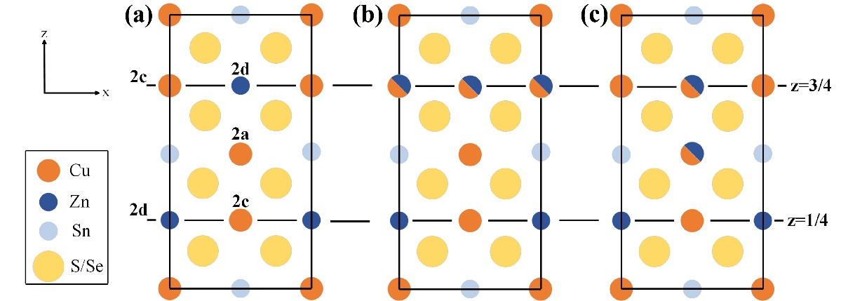

Figure 1. Different CZTS/Se structures represented by the Wyckoff position (z represents different atomic layers along the z axis): (a) pure kesterite structure. (b) Cu-Zn disorder in the Cu-Zn plane (z = 3/4) (c) Cu-Zn disorder across the Cu-Zn (z = 3/4) and Cu-Sn (z = 1/2) planes.

The primitive cell of CZTS/Se was used with the most stable kesterite structure, as shown in Figure 1a. The kesterite type structure is characterized by alternating cation planes of Cu-Sn, Cu-Zn, Cu-Sn, and Cu-Zn at z = 0, 1/4, 1/2, and 3/4, respectively. One copper occupies the 2a (0, 0, 0) position with zinc and the remaining copper ordered at 2c (0, 1/2, 1/4) and 2d (0, 1/2, 3/4) resulting in the space group ..39 The configuration of kesterite structure demonstrates that Cu-Zn disorder can be divided into two categories: 1) Cu-Zn disorder within the Cu-Zn planes (either z = 3/4 or z = 1/4 plane), defined as SPD as shown in Figure 1b; 2) Cu-Zn disorder across Cu-Zn and Cu-Sn planes, defined as DPD as shown in Figure 1c. The energy difference, ΔE, between SPD (DPD) and pure system for different x in CZT(S1-xSex)4 is calculated and shown in Figure 2a. The results show that the ΔE between SPD and pure is extremely tiny, less than 0.05 eV, which explains why previous theoretical works18, 21 only focus Cu-Zn disorder in the SPD case. However, the energy difference between DPD and pure is also found small, no more than 0.3 eV. In fact, with the development of high resolution neutron diffraction techniques, the DPD structure in CZTS has been observed experimentally.40 Such results clearly indicate that both SPD and DPD structures should exist at any value of mixing ratio x in CZT(S1-xSex)4.

To explore how Cu-Zn disorder affects the structure of CZTS/Se, the variation of different cation-S/Se bond lengths (ΔL) of SPD and DPD compared with pure CZT(S1-xSex)4 are summarized in Figure 2b. The SPD structure is very similar to the pure structure, with the variation of bond lengths (ΔL) being no more than 0.005 Å. However, the situation in DPD is different, although the change of Cu/Zn-S/Se bond length is also small, the Sn-S/Se bond length shows a considerable extension, with the largest ΔL reaching 0.045 Å, which is almost an order of magnitude larger than for SPD. Thus, it can be concluded that a more serious structural distortion occurs in DPD, mainly by extending the Sn-S/Se bond.

Previous works26, 41-42 has indicated that the band gap of CZTS/Se is strongly correlated with Sn-S/Se bond length, thus the band gap of pure, SPD and DPD structures with different x are presented in Figure 2c.An almost linear relationship between the band gap and mixing parameter x can be found in pure CZT(S1-xSex)4, which is in good agreement with previous reports.26, 43 The band gap behavior of SPD is close to that in pure CZT(S1-xSex)4, with the difference no more than 0.08 eV, which can be attributed to their similar structures as mentioned above. However, when it comes to DPD, the situation totally changes as the DPD experiences a serious structural distortion when compared with pure CZT(S1-xSex)4. As a result, the band gap of all DPD structures shows a considerable decrease (around 0.4 eV) at all x, with the largest decrease reaching 0.47 eV at x = 0.625. Such results demonstrate that Cu-Zn disorder would significantly reduce the band gap of CZTS/Se when it occurs across different planes, which clearly explains previous experimental reports18-19.

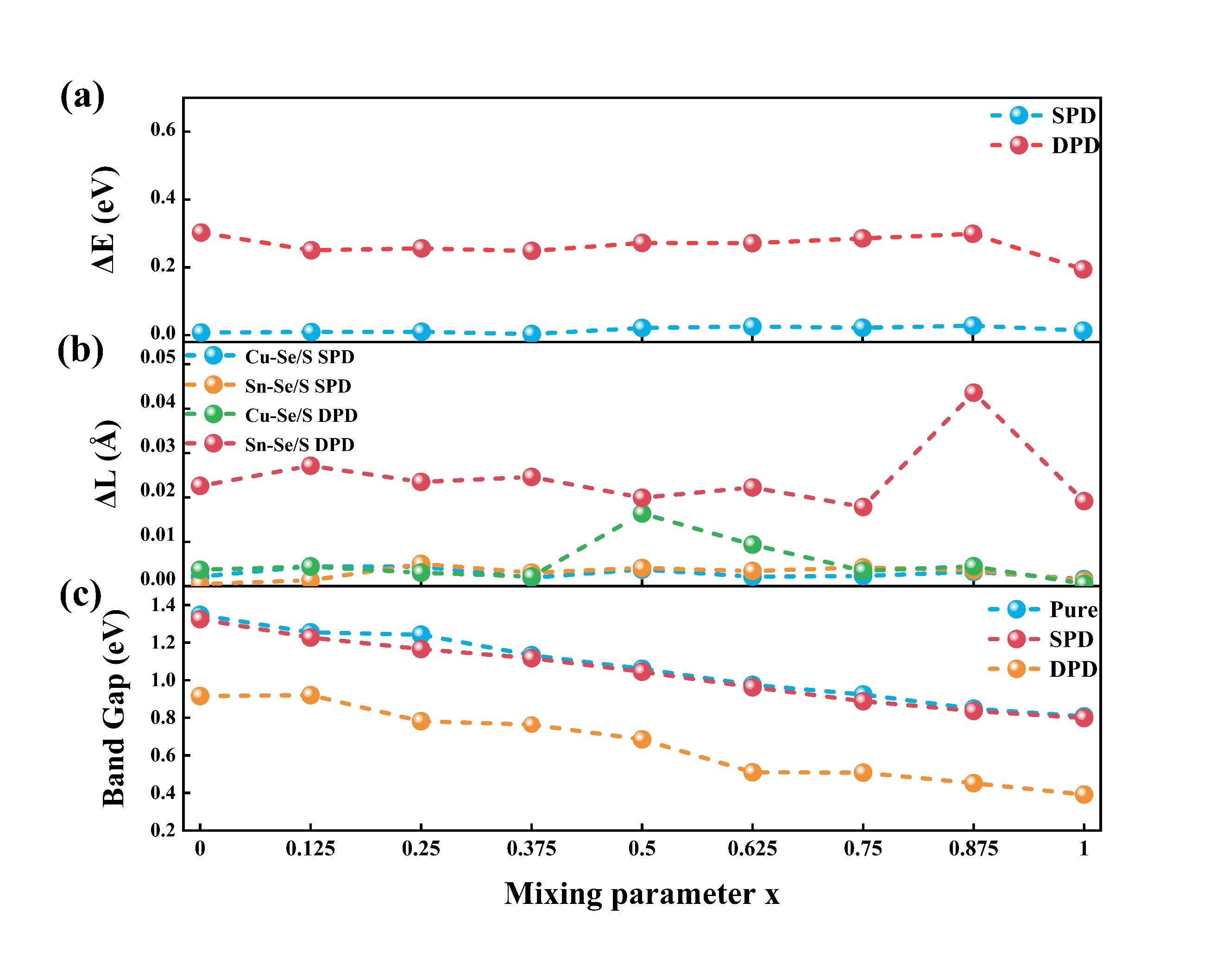

Figure 2. (a) Energy difference between SPD and DPD relative to pure structure, (b) the average bond length (ΔL) variation of Cu-Se/S and Sn-Se/S for SPD and DPD in CZT(S1-xSex)4, (c) the band gap for SPD and DPD compared to pure in CZT(S1-xSex)4.

To further understand the reason for the band gap reduction in DPD, a detailed analysis has been employed in CZT(S1-xSex)4 at x = 0.625 (see optimized structures in Figure 3a-c) as it shows the largest reduction. Moreover, CZT(S1-xSex)4 with x = 0.625 has been predicted to achieve optimal solar cell performance due to a slightly higher proportion of Se.44-45 The band structures of pure, SPD, and DPD systems are shown in Figure 3d-f. The band structures of the SPD and pure systems are very similar, while the band structure of DPD, especially the position of conduction band minimum (CBM), exhibits significant changes. The red dashed lines plotted in Figure 3b&c indicate the CBM of the pure structure, which highlights that the CBM in the case of SPD does not exhibit a significant change while the CBM for DPD stretches and moves downward in comparison with the pure system. Therefore, the reduction of band gap in DPD can be attributed to the downshift of the CBM. The density of states (DOS) in Figure 3d shows that in pure, SPD and DPD structures, the VBM is formed of antibonding states resulting from the hybridization between Cu-*3d* and S-*3p* (or Se-*4p*) orbitals, while the CBM is formed of antibonding states involving the hybridization between Sn-*5s* and S-*3p* (or Se-*4p*) orbitals, which agrees well with previous works.46-48 As explained above in Figure 2b, DPD exhibits a relatively longer Sn-S/Se bond length, thus the antibonding interaction between Sn-*5s* and S-*3p* (Se-*4p*) is weakened. Resultingly, the CBM antibonding orbitals are reduced in energy, as confirmed by the downward shift of the highlighted peak in Figure 3g. From the above analysis it can be concluded that the Cu-Zn disorder in DPD CZT(S1-xSex)4 enlarges the Sn-S/Se bond length, which leads to a downshift of the CBM and a reduction of the band gap. Similar conclusions can be also drawn for other mixing parameters x in CZT(S1-xSex)4, as shown in Figure S1-S2 in the SI.

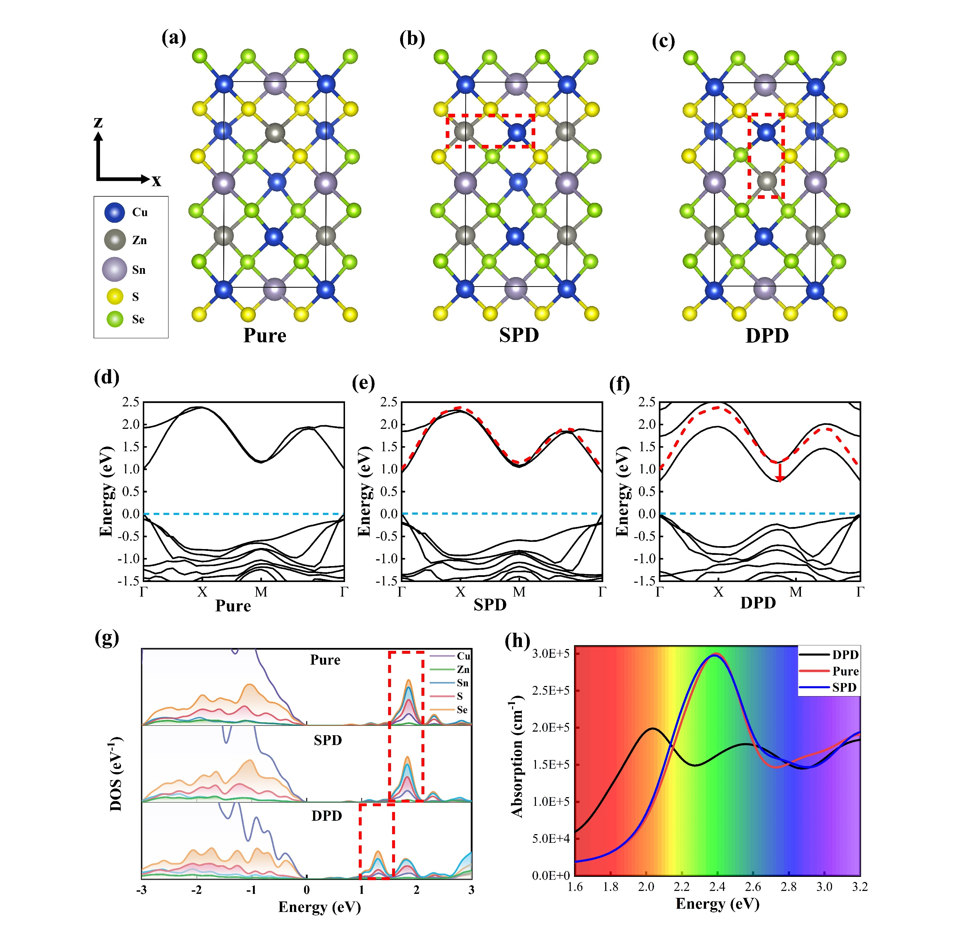

Figure 3. In CZT(S1-xSex)4 (x = 0.625), the structure of (a) pure, (b) SPD, (c) DPD; the band structures of (d) pure, (e) SPD, and (f) DPD (from left to right), where the curved red dashed line in SPD and DPD stand for the CBM in the pure system; (g) The density of state of pure, SPD, and DPD systems; (h) the optical absorption of pure, SPD, and DPD systems, where the colored area represents the visible light energy range.

It is well known that the optimal optical absorption of CZTS/Se mainly comes from its appropriate band gap, thus the variation of band gap should influence the optical absorption. Figure 3h shows the calculated optical absorption of DPD compared with that in pure and SPD CZT(S1-xSex)4 (x = 0.625). Once again, the optical absorption of SPD is similar to the pure system, and there is no obvious shift of the absorption peak within the visible light region. While the optical absorption peak in the visible light region of DPD is significantly red-shifted due to the reduction of the band gap. The same conclusion also applies to CZT(S1-xSex)4 with other mixing parameters x and the larger supercell, as demonstrated in Figure S3 in SI. The calculated band structures also indicate a significant increase of the effective mass of holes in all DPD structures (as shown in Table S1 in SI), indicating a considerable reduction in the hole mobility. Therefore, Cu-Zn disorder in *p*-type CZTS/Se should be also detrimental to its carrier transport, which is an important topic of further research.

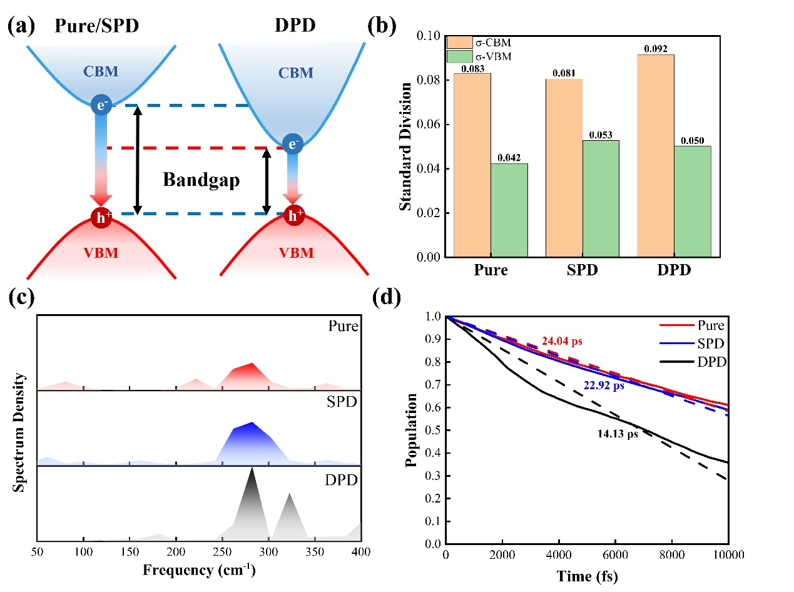

Figure 4. (a) Schematic diagram of the non-radiative recombination process of pure/SPD (left) and DPD (right) in CZT(S1-xSex)4 (x = 0.625). (b) Standard deviation of time-evolving VBM and CBM energy levels at 300 K, (c) the time evolution of the excited-state population (the dash lines are the fit of these data), (d) spectral densities of pure, SPD and DPD within 3000 fs in CZT(S1-xSex)4 (x=0.625).

The efficiencies of solar cells based on CZTS/Se are also limited by high rates of non-radiative electron-hole recombination which will contribute to a low open-circuit voltage.49 Generally speaking, the electron hopping is strongly determined by the energy gap of two states. Thus, the different band gap in DPD probably introduces a different non-radiative carrier recombination behavior when compared with pure and SPD CZT(S1-xSex)4 (x=0.625) (see in Figure 4a). Figure 4b presents the standard deviation of the time-evolving VBM and CBM energy levels at 300 K based on first-principles MD simulations. One can clearly see that the standard deviation of CBM is almost twice that of VBM in all structures, consistent with previous studies.35, 50 Moreover, in comparison to pure and SPD, DPD exhibits much larger energy fluctuation of the CBM, which should come from its more sensitive Sn-S/Se bond as clarified above. Therefore, apart from the downshift of the CBM, the Cu-Zn disorder in different plane also induces the larger fluctuation of the CBM, namely stronger thermal motion of the related Sn and S/Se atoms, which would finally influence the electron-phonon interaction.

Electron−phonon interaction plays a key role in the non-radiative charge carrier recombination process. The strength of the phonon modes that couple to the electron hopping between the VBM and CBM is presented in Figure 4c. It can be seen that SPD shows a slightly wider high-frequency peak (around 300 cm-1) than that of pure system. When it comes to DPD, a much wider peak appears (300~350 cm-1) with stronger intensity, indicating a stronger high-frequency electron-phonon interaction. Such results clearly explain previous Raman spectroscopy results51 that show Cu-Zn disorder can generate a widening of the peak at 331 cm-1. Previous works have also indicated that high-frequency modes in CZTS/Se are primarily associated with cation Sn and anion S/Se vibrations.52-54 Therefore, it is Cu-Zn disorder in DPD stretches the Sn-S/Se bond length and strengthens Sn-S/Se vibrations, which enhances the CBM fluctuation as mentioned above and strengthens high-frequency vibrations. High-frequency phonons are particularly important because they have higher velocities and create larger non-adiabatic coupling, which would promote the electron-hole recombination.

To better understand the non-radiative charge carrier recombination process between the CBM and VBM, NAMD simulations are then performed on pure, SPD and DPD CZT(S1-xSex)4 (x=0.625). Figure 4d presents the time evolution of the excited-state population for the three systems. To determine the carrier recombination time τ, the short-time linear approximation is used to expand the exponential decay, $f(t)= exp⁡(-t/τ) ≈1-t/τ$. The pure structure shows a long carrier lifetime of 24.04 ps, which is on the same order of magnitude as previous theoretical studies.35 For the SPD and DPD, the calculated charge carrier lifetime are 22.92 ps and 14.13 ps, respectively. The disorder can indeed accelerate the nonradiative electron-hole recombination and decrease the charge carrier lifetime, especially in DPD, where the lifetime is reduced by approximately 40%, which agrees with the degraded performance attributed to Cu-Zn cation disorder by experiments16-17. Thus, it can be concluded that Cu-Zn disorder across different planes can sharply shorten charge carrier lifetime, mainly owing to its smaller band gap and stronger high-frequency vibrations induced by the distortion of Sn-S/Se bond. It should be noted that current work only focuses on the Cu-Zn disorder in bulk CZTSSe. In real solar cells, interfaces between CZTSSe and electron/hole transport layer play a vital role in determining efficiency due to charge carrier transfer, bandgap engineering and so on. Thus, the cation disorder occurring at the interface is an important topic for further research.

In summary, this study conducts an in-depth investigation of different types of Cu-Zn disorder in mixed phases of kesterite CZTS and CZTSe through the employment of density functional theory and non-adiabatic molecular dynamics simulations. The cation disorder can exist in two cases: same plane disorder (SPD) and different plane disorder (DPD). We demonstrate that the DPD structure is particularly detrimental to the performance of this material while the traditional SPD structure almost shows no influence when compared to pure CZTS/Se. The results show that different plane disorder leads to serious structural distortion in the vicinity of S/Se, particularly the considerable extension of the Sn-S/Se bond length, which is not the case for SPD. Such bond extension results in the downward shift of the CBM and greatly decreases the band gap. In addition, the optical absorption in the visible light area and hole mobility in DPD are dramatically reduced. The distortion of Sn-S/Se bond in DPD structure can also induce the significant fluctuation of the CBM and strengthen high-frequency electron-vibrational interactions, which combined with the smaller band gap accelerates the non-radiative electron-hole recombination and shortens charge carrier lifetime, as confirmed by NAMD simulations. Our work reveals how Cu-Zn disorder in different planes deteriorate the performance of CuZnSn(S1-xSex)4 resolving the long-time controversy between experiment and theory, and providing theoretical guidance for improving the efficiency of CuZnSn(S1-xSex)4 solar cells.

**ASSOCIATED CONTENT**

**Supporting Information**

Band structure, density of states, optical absorption and effective electron/hole mass in CuZnSn(S1-xSex)4 for all x values.

**Notes**

The authors declare no competing financial interest.

**ACKNOWLEDGEMENTS**

This work was financially supported by the National Natural Science Foundation of China (No. 12104515). K.P.M. acknowledges support from EPSRC (EP/K003151/1, EP/P006051/1, and EP/P023843/1). This work made use of the facilities of Archer, the United Kingdom’s national high-performance computing service, via our membership in the UK HPC Materials Chemistry Consortium, which is funded by EPSRC (EP/L000202/1 and EP/R029431/1). This project also made use of the Viking Cluster, which is a high-performance computation facility provided by the University of York. We are grateful for resources from the High-Performance Computing Center of Central South University. We also acknowledge resources from the Hefei Advanced Computing Center.

**REFERENCES**

(1) Wu, L.; Wang, Q.; Zhuang, T.-T.; Zhang, G.-Z.; Li, Y.; Li, H.-H.; Fan, F.-J.; Yu, S.-H. A Library of Polytypic Copper-Based Quaternary Sulfide Nanocrystals Enables Efficient Solar-to-Hydrogen Conversion. *Nat. Commun.* **2022,** *13*, 5414.

(2) Wallace, S. K.; Mitzi, D. B.; Walsh, A. The Steady Rise of Kesterite Solar Cells. *ACS Energy Lett.* **2017,** *2*, 776-779.

(3) Hao, N.-J.; Ding, R.-X.; Tong, C.-J.; McKenna, K. P. Heterogeneity of Grain Boundary Properties in Cu2znsns4: A First-Principles Study. *J. Appl. Phys.* **2023,** *133*, 145002.

(4) Li, J.; Sun, K.; Yuan, X.; Huang, J.; Green, M. A.; Hao, X. Emergence of Flexible Kesterite Solar Cells: Progress and Perspectives. *npj Flexible Electronics* **2023,** *7*, 16.

(5) Kim, S.; Park, J.-S.; Walsh, A. Identification of Killer Defects in Kesterite Thin-Film Solar Cells. *ACS Energy Lett.* **2018,** *3*, 496-500.

(6) Chen, S.; Gong, X. G.; Walsh, A.; Wei, S.-H. Defect Physics of the Kesterite Thin-Film Solar Cell Absorber Cu2ZnSnS4. *Appl. Phys. Lett.* **2010,** *96*, 021902.

(7) Karade, V. C.; Suryawanshi, M. P.; Jang, J. S.; Gour, K. S.; Jang, S.; Park, J.; Kim, J. H.; Shin, S. W. Understanding Defects and Band Tailing Characteristics and Their Impact on the Device Performance of Cu2ZnSn(S,Se)4 Solar Cells. *J. Mater. Chem. A* **2022,** *10*, 8466-8478.

(8) Hadar, I.; Hu, X.; Luo, Z.-Z.; Dravid, V. P.; Kanatzidis, M. G. Nonlinear Band Gap Tunability in Selenium–Tellurium Alloys and Its Utilization in Solar Cells. *ACS Energy Lett.* **2019,** *4*, 2137-2143.

(9) Singh, A.; Singh, S.; Levcenko, S.; Unold, T.; Laffir, F.; Ryan, K. M. Compositionally Tunable Photoluminescence Emission in Cu2ZnSn(S1−xSex)4 Nanocrystals. *Angew. Chem. Int. Ed.* **2013,** *52*, 9120-9124.

(10) Chen, S.; Walsh, A.; Yang, J.-H.; Gong, X. G.; Sun, L.; Yang, P.-X.; Chu, J.-H.; Wei, S.-H. Compositional Dependence of Structural and Electronic Properties of Cu2ZnSn(S,Se)4 Alloys for Thin Film Solar Cells. *Phys. Rev. B* **2011,** *83*, 125201.

(11) Zhou, J.; Xu, X.; Wu, H.; Wang, J.; Lou, L.; Yin, K.; Gong, Y.; Shi, J.; Luo, Y.; Li, D. et al. Control of the Phase Evolution of Kesterite by Tuning of the Selenium Partial Pressure for Solar Cells with 13.8% Certified Efficiency. *Nature Energy* **2023,** *8*, 526-535.

(12) Kuddus, A.; Ismail, A. B. M.; Hossain, J. Design of a Highly Efficient CdTe-Based Dual-Heterojunction Solar Cell with 44% Predicted Efficiency. *Solar Energy* **2021,** *221*, 488-501.

(13) Ablekim, T.; Duenow, J. N.; Zheng, X.; Moutinho, H.; Moseley, J.; Perkins, C. L.; Johnston, S. W.; O’Keefe, P.; Colegrove, E.; Albin, D. S. et al. Thin-Film Solar Cells with 19% Efficiency by Thermal Evaporation of CdSe and CdTe. *ACS Energy Lett.* **2020,** *5*, 892-896.

(14) Jošt, M.; Köhnen, E.; Al-Ashouri, A.; Bertram, T.; Tomšič, Š.; Magomedov, A.; Kasparavicius, E.; Kodalle, T.; Lipovšek, B.; Getautis, V. et al. Perovskite/CIGS Tandem Solar Cells: From Certified 24.2% toward 30% and Beyond. *ACS Energy Lett.* **2022,** *7*, 1298-1307.

(15) Barman, B.; Kalita, P. K. Influence of Back Surface Field Layer on Enhancing the Efficiency of CIGS Solar Cell. *Solar Energy* **2021,** *216*, 329-337.

(16) Azzouzi, M.; Cabas-Vidani, A.; Haass, S. G.; Röhr, J. A.; Romanyuk, Y. E.; Tiwari, A. N.; Nelson, J. Analysis of the Voltage Losses in CZTSSe Solar Cells of Varying Sn Content. *J. Phys. Chem. Lett.* **2019,** *10*, 2829-2835.

(17) Larsen, J. K.; Scragg, J. J. S.; Ross, N.; Platzer-Björkman, C. Band Tails and Cu–Zn Disorder in Cu2ZnSnS4 Solar Cells. *ACS Applied Energy Materials* **2020,** *3*, 7520-7526.

(18) Scragg, J. J. S.; Larsen, J. K.; Kumar, M.; Persson, C.; Sendler, J.; Siebentritt, S.; Platzer Björkman, C. Cu–Zn Disorder and Band Gap Fluctuations in Cu2ZnSn(S,Se)4: Theoretical and Experimental Investigations. *physica status solidi (b)* **2016,** *253*, 247-254.

(19) Wallace, S. K.; Frost, J. M.; Walsh, A. Atomistic Insights into the Order–Disorder Transition in Cu2ZnSnS4 Solar Cells from Monte Carlo Simulations. *J. Mater. Chem. A* **2019,** *7*, 312-321.

(20) Bourdais, S.; Choné, C.; Delatouche, B.; Jacob, A.; Larramona, G.; Moisan, C.; Lafond, A.; Donatini, F.; Rey, G.; Siebentritt, S. et al. Is the Cu/Zn Disorder the Main Culprit for the Voltage Deficit in Kesterite Solar Cells? *Adv. Energy Mater.* **2016,** *6*, 1502276.

(21) Chen, W.; Dahliah, D.; Rignanese, G.-M.; Hautier, G. Origin of the Low Conversion Efficiency in Cu2ZnSnS4 Kesterite Solar Cells: The Actual Role of Cation Disorder. *Energy Environ. Sci.* **2021,** *14*, 3567-3578.

(22) Blöchl, P. E. Projector Augmented-Wave Method. *Phys. Rev. B* **1994,** *50*, 17953-17979.

(23) Kresse, G.; Joubert, D. From Ultrasoft Pseudopotentials to the Projector Augmented-Wave Method. *Phys. Rev. B* **1999,** *59*, 1758-1775.

(24) Choubrac, L.; Lafond, A.; Guillot-Deudon, C.; Moëlo, Y.; Jobic, S. Structure Flexibility of the Cu2ZnSnS4 Absorber in Low-Cost Photovoltaic Cells: From the Stoichiometric to the Copper-Poor Compounds. *Inorg. Chem.* **2012,** *51*, 3346-3348.

(25) Mendis, B. G.; Shannon, M. D.; Goodman, M. C. J.; Major, J. D.; Claridge, R.; Halliday, D. P.; Durose, K. Direct Observation of Cu, Zn Cation Disorder in Cu2ZnSnS4 Solar Cell Absorber Material Using Aberration Corrected Scanning Transmission Electron Microscopy. *Progress in Photovoltaics: Research and Applications* **2014,** *22*, 24-34.

(26) Tong, C.-J.; Edwards, H. J.; Hobson, T. D. C.; Durose, K.; Dhanak, V. R.; Major, J. D.; McKenna, K. P. Density Functional Theory and Experimental Determination of Band Gaps and Lattice Parameters in Kesterite Cu2ZnSn(SxSe1–x)4. *J. Phys. Chem. Lett.* **2020,** *11*, 10463-10468.

(27) Sun, J.; Haunschild, R.; Xiao, B.; Bulik, I. W.; Scuseria, G. E.; Perdew, J. P. Semilocal and Hybrid Meta-Generalized Gradient Approximations Based on the Understanding of the Kinetic-Energy-Density Dependence. *J. Chem. Phys.* **2013,** *138*, 044113.

(28) Sun, J.; Xiao, B.; Ruzsinszky, A. Communication: Effect of the Orbital-Overlap Dependence in the Meta Generalized Gradient Approximation. *J. Chem. Phys.* **2012,** *137*, 051101.

(29) Heyd, J.; Scuseria, G. E.; Ernzerhof, M. Hybrid Functionals Based on a Screened Coulomb Potential. *J. Chem. Phys.* **2003,** *118*, 8207.

(30) Krukau, A. V.; Vydrov, O. A.; Izmaylov, A. F.; Scuseria, G. E. Influence of the Exchange Screening Parameter on the Performance of Screened Hybrid Functionals. *J. Chem. Phys.* **2006,** *125*, 224106.

(31) Guidon, M.; Hutter, J.; VandeVondele, J. Robust Periodic Hartree−Fock Exchange for Large-Scale Simulations Using Gaussian Basis Sets. *J. Chem. Theory Comput.* **2009,** *5*, 3010-3021.

(32) Jaeger, H.; Fischer, S.; Prezhdo, O. Decoherence-Induced Surface Hopping. *J. Chem. Phys.* **2012,** *137*, 22A545.

(33) Akimov, A. V.; Prezhdo, O. V. The Pyxaid Program for Non-Adiabatic Molecular Dynamics in Condensed Matter Systems. *J. Chem. Theory Comput.* **2013,** *9*, 4959-4972.

(34) Akimov, A. V.; Prezhdo, O. V. Advanced Capabilities of the Pyxaid Program: Integration Schemes, Decoherence Effects, Multiexcitonic States, and Field-Matter Interaction. *J. Chem. Theory Comput.* **2014,** *10*, 789-804.

(35) Chen, Z.; Zhang, P.-Z.; Zhou, Y.; Zhang, X.; Liu, X.; Hou, Z.; Tang, J.; Li, W. Elucidating the Influence of Sulfur Vacancies on Nonradiative Recombination Dynamics in Cu2ZnSnS4 Solar Absorbers. *J. Phys. Chem. Lett.* **2020,** *11*, 10354-10361.

(36) Wei, Q.; Ren, H.; Liu, J.; Liu, Q.; Wang, C.; Lau, T. W.; Zhou, L.; Bian, T.; Zhou, Y.; Wang, P. et al. Long-Lived Hot Carriers in Two-Dimensional Perovskites: The Role of Alternating Cations in Interlayer Space. *ACS Energy Lett.* **2023,** *8*, 4315-4322.

(37) Shi, Y.; Prezhdo, O. V.; Zhao, J.; Saidi, W. A. Iodine and Sulfur Vacancy Cooperation Promotes Ultrafast Charge Extraction at MAPbI3/MoS2 Interface. *ACS Energy Lett.* **2020,** *5*, 1346-1354.

(38) Liu, L.; Fang, W.-H.; Long, R.; Prezhdo, O. V. Lewis Base Passivation of Hybrid Halide Perovskites Slows Electron–Hole Recombination: Time-Domain Ab Initio Analysis. *J. Phys. Chem. Lett.* **2018,** *9*, 1164-1171.

(39) Schorr, S. The Crystal Structure of Kesterite Type Compounds: A Neutron and X-Ray Diffraction Study. *Sol. Energy Mater. Sol. Cells* **2011,** *95*, 1482-1488.

(40) Ramkumar, S. P.; Miglio, A.; van Setten, M. J.; Waroquiers, D.; Hautier, G.; Rignanese, G. M. Insights into Cation Disorder and Phase Transitions in CZTS from a First-Principles Approach. *Physical Review Materials* **2018,** *2*, 085403.

(41) Hages, C. J.; Koeper, M. J.; Agrawal, R. Optoelectronic and Material Properties of Nanocrystal-Based CZTSe Absorbers with Ag-Alloying. *Sol. Energy Mater. Sol. Cells* **2016,** *145*, 342-348.

(42) Walsh, A.; Chen, S.; Wei, S.-H.; Gong, X.-G. Kesterite Thin-Film Solar Cells: Advances in Materials Modelling of Cu2ZnSnS4. *Adv. Energy Mater.* **2012,** *2*, 400-409.

(43) Mohammadnejad, S.; Baghban Parashkouh, A. CZTSSe Solar Cell Efficiency Improvement Using a New Band-Gap Grading Model in Absorber Layer. *Applied Physics A* **2017,** *123*, 758.

(44) Zhang, Z.; Zhang, Y.; Wang, J.; Xu, J.; Long, R. Doping-Induced Charge Localization Suppresses Electron–Hole Recombination in Copper Zinc Tin Sulfide: Quantum Dynamics Combined with Deep Neural Networks Analysis. *J. Phys. Chem. Lett.* **2021,** *12*, 835-842.

(45) Hakimi Raad, N.; Karimmirza, E.; Yousefizad, M.; Nouri, N.; Sharifpour, H.; Nadimi, E.; Ahmadi Zeidabadi, M.; Manavizadeh, N. Improving the Electronic and Optical Properties of Chalcogenide Cu2ZnSnS4 Compound with Transition Metal Dopants: A First-Principles Investigation. *Thin Solid Films* **2023,** *766*, 139653.

(46) Chen, S.; Walsh, A.; Gong, X.-G.; Wei, S.-H. Classification of Lattice Defects in the Kesterite Cu2znsns4 and Cu2ZnSnSe4 Earth-Abundant Solar Cell Absorbers. *Adv. Mater.* **2013,** *25*, 1522-1539.

(47) Paier, J.; Asahi, R.; Nagoya, A.; Kresse, G. Cu2ZnSnS4 as a Potential Photovoltaic Material: A Hybrid Hartree-Fock Density Functional Theory Study. *Phys. Rev. B* **2009,** *79*, 115126.

(48) Kheraj, V.; Patel, K. K.; Patel, S. J.; Shah, D. V. Synthesis and Characterisation of Copper Zinc Tin Sulphide (CZTS) Compound for Absorber Material in Solar-Cells. *J. Cryst. Growth* **2013,** *362*, 174-177.

(49) Monserrat, B.; Park, J.-S.; Kim, S.; Walsh, A. Role of Electron-Phonon Coupling and Thermal Expansion on Band Gaps, Carrier Mobility, and Interfacial Offsets in Kesterite Thin-Film Solar Cells. *Appl. Phys. Lett.* **2018,** *112*, 193903.

(50) Zhang, P.; Hou, Z.; Jiang, L.; Yang, J.; Saidi, W. A.; Prezhdo, O. V.; Li, W. Weak Anharmonicity Rationalizes the Temperature-Driven Acceleration of Nonradiative Dynamics in Cu2ZnSnS4 Photoabsorbers. *ACS Appl. Mater. Interfaces* **2021,** *13*, 61365-61373.

(51) Valakh, M. Y.; Kolomys, O. F.; Ponomaryov, S. S.; Yukhymchuk, V. O.; Babichuk, I. S.; Izquierdo-Roca, V.; Saucedo, E.; Perez-Rodriguez, A.; Morante, J. R.; Schorr, S. et al. Raman Scattering and Disorder Effect in Cu2ZnSnS4. *physica status solidi (RRL) – Rapid Research Letters* **2013,** *7*, 258-261.

(52) Dimitrievska, M.; Gurieva, G.; Xie, H.; Carrete, A.; Cabot, A.; Saucedo, E.; Pérez-Rodríguez, A.; Schorr, S.; Izquierdo-Roca, V. Raman Scattering Quantitative Analysis of the Anion Chemical Composition in Kesterite Cu2ZnSn(SxSe1−x)4 Solid Solutions. *J. Alloys Compd.* **2015,** *628*, 464-470.

(53) Skelton, J. M.; Jackson, A. J.; Dimitrievska, M.; Wallace, S. K.; Walsh, A. Vibrational Spectra and Lattice Thermal Conductivity of Kesterite-Structured Cu2ZnSnS4 and Cu2ZnSnSe4. *APL Mater.* **2015,** *3*, 041102.

(54) Dimitrievska, M.; Xie, H.; Fairbrother, A.; Fontané, X.; Gurieva, G.; Saucedo, E.; Pérez-Rodríguez, A.; Schorr, S.; Izquierdo-Roca, V. Multiwavelength Excitation Raman Scattering of Cu2ZnSn(SxSe1−x)4 (0 ≤ x ≤ 1) Polycrystalline Thin Films: Vibrational Properties of Sulfoselenide Solid Solutions. *Appl. Phys. Lett.* **2014,** *105*, 031913.

**Table of Contents**

