# Title Page

**Title: The Influence of Immunodeficiency, Disease Features and Patient**

**Characteristics on Survival in Plasmablastic Lymphoma**

Article Type: Regular Article, Lymphoid Neoplasia

Authors:

Pietro R. Di Ciaccio1,2, Mark N. Polizzotto3,1, Kate Cwynarski4, Alina S. Gerrie5, Catherine Burton6, Mark Bower7, John Kuruvilla8, Silvia Montoto9, Pam McKay10, Christopher P. Fox11,12, Samuel Milliken13, Awachana Jiamsakul14, Wendy Osborne15, Graham P Collins16,

Kate Manos17, Kim M. Linton18,19,20, Sunil Iyengar21, Shireen Kassam22, Michelle Poon Limei23, David Kliman24, Nicole Wong Doo25,26, Anne-Marie Watson27, Pasquale Fedele28,29, Costas K. Yannakou30, Stewart Hunt31, Matthew Ku32, Laurie H. Sehn5, Alexandra Smith33, Hanna Renshaw4, Alice Maxwell7, Qin Liu8, Rageshri Dhairyawan34, Graeme Ferguson10,

Keir Pickard15, Daniel Painter33, Nisha Thakrar4, Kevin W. Song35, Nada Hamad13,36,26.

1. Department of Haematology, The Canberra Hospital, Garran, ACT, Australia. 2. College of Health and Medicine, Australian National University, Canberra, ACT, Australia. 3. John Curtin School of Medical Research, Australian National University, Canberra ACT,

Australia. 4. Department of Haematology, University College Hospital, London, United

Kingdom. 5. Centre for Lymphoid Cancer and Division of Medical Oncology, BC Cancer,

University of British Columbia, Vancouver, BC, Canada. 6. Department of Haematology, St

James University Hospital, Leeds, United Kingdom. 7. National Centre for HIV Malignancy,

Chelsea & Westminster Hospital, London, United Kingdom. 8. Princess Margaret Cancer Centre, The Princess Margaret Hospital, Toronto, ON, Canada. 9. Department of Haematooncology, St Bartholomew's Hospital, Barts Health NHS Trust, London, United Kingdom. 10. Beatson West of Scotland Cancer Centre, Glasgow, United Kingdom. 11. University

Hospitals NHS Trust, Nottingham, United Kingdom. 12. School of Medicine, University of

Nottingham, Nottingham, United Kingdom. 13. Department of Haematology, St Vincent’s

Hospital, Sydney, NSW, Australia. 14. The Kirby Institute, University of New South Wales,

Sydney, NSW, Australia. 15. Newcastle upon Tyne NHS Foundation Trust, Newcastle-upon-

Tyne, United Kingdom. 16. Oxford University Hospitals NHS Foundation Trust, Oxford,

United Kingdom. 17. Department of Haematology, Flinders Medical Centre, Adelaide,

Australia. 18. The Christie Hospital NHS Foundation Trust, Manchester, United Kingdom.

19. University of Manchester, Manchester, United Kingdom. 20. Manchester Academic Health Science Centre, Manchester, United Kingdom. 21. The Royal Marsden NHS

Foundation Trust, London, United Kingdom. 22. King's College Hospital, London, United Kingdom. 23. Department of Haematology, National University Hospital, Singapore. 24. Department of Haematology, Royal North Shore Hospital, Sydney Australia. 25. Department of Haematology, Concord Repatriation General Hospital, Sydney, NSW, Australia. 26. Faculty of Medicine, University of Sydney, Sydney, NSW, Australia. 27. Department of Haematology, Liverpool Hospital, Sydney, NSW, Australia. 28. School of Clinical Sciences at Monash Health, Monash University, Clayton, VIC, Australia. 29. Haematology Department, Monash Health, Clayton, VIC, Australia. 30. Epworth HealthCare, Melbourne, VIC, Australia. 31. Royal Brisbane and Women’s Hospital, Brisbane, QLD, Australia. 32.

Department of Haematology, St Vincent’s Hospital, Melbourne, VIC, Australia. 33.

Epidemiology and Cancer Statistics Group, Department of Health Sciences, University of

York, York, United Kingdom. 34. Department of Infection and Immunity, Barts Health NHS Trust, London, United Kingdom. 35. Leukemia/Bone Marrow Transplant Program of British

Columbia and Division of Hematology, BC Cancer, University of British Columbia, Vancouver, BC, Canada. 36. School of Medicine, University of Notre Dame, Perth, WA, Australia.

Word Count (Abstract): 238

Word Count (Manuscript): 2878

Table Count: 2

Figure Count: 4

Running title: Plasmablastic lymphoma retrospective study

Corresponding Author:

Dr Pietro Di Ciaccio

Dept of Haematology, The Canberra Hospital

Garran, Australian Capital Territory, Australia

Ph +61 2 5124 8444

Fax +61 2 5124 5544

Email: pietro.diciaccio@act.gov.au

Data sharing statement: For original data, please contact pietro.diciaccio@act.gov.au. Deidentified data may be provided upon reasonable request.

Contributions:

PDC drafted the manuscript, collated the data, contributed to data analysis and interpretation, and reviewed and edited the manuscript. AJ performed statistical analysis, drafted the manuscript, and reviewed and edited the manuscript. KC, ASG, CB, MB, JK, SM, PM, CPF, SM, WO, GPC, KM, KL, SI, SK, MPL, DK, NWD, AMW, PF, CKY, SH, MK, LHS, AS,

HR, AM, QL, RD, GF, KP, DP, NT and KS provided the data, contributed to data analysis and interpretation, and reviewed and edited the manuscript. MNP conceived the study, contributed to the data analysis and interpretation, and reviewed and edited the manuscript. NH conceived and coordinated the study, provided data, contributed to the data analysis and interpretation, and reviewed and edited the manuscript.

Statement of prior presentation:

An earlier iteration of this study was presented as an oral abstract at the American Society of Hematology Annual Meeting in 2020. It was awarded an ASH Abstract Achievement Award (https://ash.confex.com/ash/2020/webprogram/Paper134972.html).

# Key Points

1. Plasmablastic lymphoma is a rare non-Hodgkin lymphoma with a poor prognosis and uncertainty regarding optimal treatment approaches.
2. Advanced stage, bone marrow involvement, ECOG>1 and EBV-negative lymphoma are associated with inferior overall survival.

# Abstract

Plasmablastic lymphoma (PBL) is a rare and aggressive non-Hodgkin lymphoma associated with immunodeficiency, characterized by uncertain treatment approaches and an unfavourable prognosis. We conducted a multicenter, international, retrospective cohort study, aiming to characterize the clinical features, risk factors, and outcomes of patients with PBL. Data were collected from 22 institutions across four countries regarding patients diagnosed with PBL between 1 January 1999 and 31 December 2020. Survival risk factors were analyzed using both univariate and multivariate regression models. Overall survival (OS) was calculated using Kaplan-Meier statistics. First-line treatment regimens were stratified into standard- and higher-intensity regimens, and by whether they incorporated a proteasome inhibitor (PI). A total of 281 patients (median age 55) were included. Immunodeficiency of any kind was identified in 144 patients (51%), and 99 patients (35%) were HIV-positive. The five-year OS for the entire cohort was 36% (95% CI 30-42%). In multivariate analysis, inferior OS was associated with EBV-negative lymphoma, poor performance status, advanced stage, and bone marrow involvement. In an independent univariate analysis, the IPI was associated with OS outcomes. Neither immunosuppression, nor HIV infection specifically, influenced OS. Among patients treated with curative intent (n=234), the overall response rate was 72%. Neither the intensity of the treatment regimen nor the inclusion of PIs in first-line therapy was associated with OS. In this large

1 retrospective study of PBL patients, we identified novel risk factors for survival. PBL 2 remains a challenging disease with poor long-term outcomes.

3

4

# Manuscript

## 1. Introduction

Plasmablastic lymphoma (PBL) is a rare aggressive subtype of B-cell non-Hodgkin lymphoma (NHL), frequently associated with human immunodeficiency virus (HIV) infection; however, it is also seen in patients with other forms of immunosuppression, as well

as apparently immunocompetent patients.1,2

PBL classically presents as an extra nodal disease involving the oral cavity, but it may also arise at various other nodal and extra nodal sites. Patients frequently present with aggressive disease and advanced stage.3 The cell of origin is the terminal plasmablast with downregulation of B-cell transcription factors such as *PAX5*. Expression of plasma cell markers CD38 and CD138 is common, and only a small minority will retain weak expression of B cell markers such as CD20.3–5 It is postulated that *MYC* dysregulation disrupts the physiological maturation of plasmablasts to terminally differentiated plasma cells.6 Infection of malignant cells with Epstein-Barr virus (EBV) has been reported, particularly in HIV-

associated cases, with a frequency of over 70% in that setting.1,7

Given the rarity of PBL, there is no standard therapeutic approach. The prognosis of PBL is generally poor, with a reported three to five-year overall survival (OS) of approximately 40%.8–10 Prospective evidence is lacking with the existing data mostly limited to case reports and modest retrospective studies. Risk factors for survival and how they may be used to inform treatment decisions are typically not well established in the literature, with conflicting

results.2,7,9,11

We aimed to perform an international, multicenter, retrospective analysis to evaluate the clinical features, treatment, and outcomes of patients with PBL, with a view to identifying prognostic factors that may be used to inform treatment decisions and improve patient outcomes.

## 2. Methods

We retrospectively identified PBL cases from 22 contributing sites in Australia, the United

Kingdom, Canada, and Singapore. Ethics approval for the study was granted by the Human Research Ethics Committee at St. Vincent’s Hospital, Sydney, Australia (2020/ETH00484) and the institutional review boards in contributing jurisdictions.

Patients were included if they had a tissue biopsy confirming the diagnosis of PBL between 1 January 1999 and 31 December 2020, and were aged at least 18 years. Although a centralized pathology review was not performed, all contributing sites were major academic centers with experienced hematopathologists and robust internal multidisciplinary review processes for lymphoproliferative disorders. Patients with HHV8-associated lymphoma, ALK-associated lymphoma, plasmacytoma, or high-grade B-cell lymphoma, not otherwise specified (NOS), were excluded according to the World Health Organization diagnostic criteria for PBL.4

Descriptive statistics were compared using the chi-squared test for categorical variables and Wilcoxon rank-sum test for continuous variables. OS was estimated using standard time-toevent analyses, including Kaplan-Meier statistics, from the date of diagnosis to death or the last follow-up. To account for loss to follow-up (LTFU) and heterogeneity across contributing centers, factors associated with OS were analyzed using Fine and Gray competing risk regression, adjusted for contributing centers. OS was determined from the date of diagnosis to the date of death. Patients known to be alive were censored on the date of their last follow-up. Patients with LTFU were analyzed as competing risks and censored on their date of LTFU. Patients with less than one day of follow up were excluded.

Risk factors included in the survival analysis were age, biological sex, HIV status, *MYC* rearrangement status, EBV status, immunophenotype (CD19, CD20, CD30; by flow cytometry or immunohistochemistry), lactate dehydrogenase (LDH), advanced stage (III-IV), Eastern Cooperative Oncology Group performance status (ECOG), central nervous system (CNS) involvement, bone marrow (BM) involvement, standard versus higher intensity firstline treatment, incorporation of rituximab, incorporation of a proteasome inhibitor (PI), autologous stem cell transplant (ASCT) in first-line, international prognostic index (IPI) score, and primary tumor location. Primary tumor location was categorized into two groups: oropharyngeal, nasopharyngeal, orbital, jaw, upper neck; and all other sites. All variables were analyzed as time-fixed covariates. A sensitivity analysis was performed to determine the effects of immunosuppression status on survival among patients with known HIV status.

The regression models were fitted using a backward stepwise selection process. Risk factors found to be significant in the univariate model at p<0.10 were included in the multivariate model. Risk factors with p<0.05 in the multivariate model were considered statistically significant.

EBV biopsy status was identified by either EBV-encoded small RNA (EBER), EBV nuclear antigen-2 (EBNA-2), or latency membrane protein-1 (LMP-1). *MYC* rearrangement was determined by fluorescence in situ hybridization, regardless of the partner gene. Immunosuppression-related PBL was defined as a case associated with either HIV, solid organ or allogeneic stem cell transplant (alloSCT), primary immunodeficiency, immunosuppressive medication (including ≥20 mg per day of prednisone or equivalent), or an underlying indolent lymphoproliferative disease. BM involvement was detected using either PET or direct bone marrow biopsy.

Stage and response were assessed based on the 2014 Lugano consensus criteria.12 Curative intent treatment was defined as a first-line treatment containing either an anthracycline and/or consolidated with high-dose chemotherapy and ASCT. Curative intent regimens were further classified as either standard-intensity (cyclophosphamide, doxorubicin, vincristine, prednisone {CHOP} or CHOP-like) or higher-intensity. A detailed classification of the treatment regimens is provided in the Supplementary Appendix (Supplementary Table 1). All patients were included in the survival analysis irrespective of the treatment received.

Data management and statistical analyses were performed using SAS (version 9.4; SAS Institute Inc., Cary, NC, USA), Stata software version 16.1 (Stata Corp., College Station, TX,

USA), and GraphPad Prism software version 9.2.0 (GraphPad Inc., San Diego, CA, USA).

## 3. Results

### 3.1 Patient Characteristics

A total of 281 patients from 22 sites were included in the analysis. The patient characteristics are described in Table 1. The median age at diagnosis was 55 years (interquartile range

{IQR} 44-69) and the majority of patients were male (199 patients, 71%). Seventy-nine (28%) patients had primary tumor sites classically associated with PBL in the head or neck, as defined in the Methods section. Most patients were diagnosed with advanced-stage disease, and 143 (51%) with stage IV specifically.

Regarding the staging modality, 134 were staged by positron emission tomography (PET) and 92 by computerized tomography (CT) (other/missing data, n=55). BM involvement was demonstrated in 51 of the 220 patients who underwent BM biopsy. CNS involvement was relatively uncommon (13 patients, 5%), with a mixture of cases involving the leptomeninges and the cortical parenchyma. CNS-IPI13 risk factors for patients with CNS involvement are described in Supplementary Table 2.

Analyzing the 259 patients with known HIV status, we compared patient characteristics according to their immunodeficiency status (Table 1). Immunodeficiency, including, but not limited to HIV, was a factor in 144 (56%) patients. Patients with immunodeficiency were younger (median 48 years vs. 65 years; p<0.001) and were more likely to have EBV-positive

PBL (72% vs. 43%, p<0.001) and *MYC* rearrangements (22% vs. 17%, p<0.001).

A minority of patients were HIV-positive (n=99) (35%). Of the HIV-positive patients, 63 (64%) were on antiretroviral therapy (ART) at the time of PBL diagnosis. A further 25 patients (25% of total HIV patients) commenced ART following PBL diagnosis. The median CD4 count and HIV viral load at PBL diagnosis were 208x106/L (IQR 65-334) and 252 copies/mL (IQR 40-68,500) respectively.

### 3.2 Survival

The median duration of follow-up was 1.15 years (IQR 0.41-3.67). There were 167 deaths

(59%) and 33 patients (12%) were lost to follow-up. The median OS was 1.72 years (95% CI (1.3-2.8) with an estimated five-year OS of 36% (95% CI 30-42%) (Figure 1). The relatively short follow-up period was predominantly due to early deaths rather than censoring events with a median time to mortality of 0.52 years (IQR 0.17-1.61) among the 167 patients who have died.

The most common cause of death was progressive PBL (117 patients, 70%), followed by infection (19 patients, 11%), subsequent primary malignancy (10 patients, 6%), and noninfectious treatment-related causes (five patients, 3%). Nine patients died from other miscellaneous causes, and eight did not have available cause-of-death data.

### 3.3 Risk Factors for Survival

The results of the risk factor analysis are presented in Table 2. In univariate analysis, factors associated with increased mortality risk were older age, female sex, negative EBV status, advanced stage, BM involvement, CNS involvement, primary tumor located outside the head/neck, and ECOG >1. On multivariate analysis, however, only negative EBV status

(SHR [Sub-hazard ratio]=1.57, 95% CI 1.03-2.39, p=0.037), advanced stage compared to

Stage I (Stage III SHR=4.11, 95% CI 2.04-8.28, p<0.001; Stage IV SHR=2.68, 95% CI 1.624.44, p<0.001, respectively), ECOG >1 (SHR=2.28, 95% CI 1.50-3.48, p<0.001) (Figures 2 and 3; Supplementary Figure 1), and other front line treatment compared to high intensity (SHR=6.52, 95% CI 3.68-11.55, p<0.001) were associated with higher mortality. Absence of BM involvement (SHR=0.52, 95% CI 0.32-0.83, p=0.006) was associated with superior OS. There was no interaction between BM and disease stage (p=0.163). The proportional hazards assumption was satisfied for all variables in the regression model.

The IPI was associated with survival in the univariate analysis (low-intermediate risk:

SHR=2.34, 95% CI 1.35-4.05, p=0.002; high-intermediate risk: SHR=3.90, 95% CI 2.286.69, p<0.001; and high risk: SHR=8.08, 95% CI 4.43-14.76, p<0.001, compared to low risk), but was not included in the multivariate analysis due to collinearity with other variables

(Supplementary Figure 2).

Immunodeficiency was not associated with OS in a sensitivity analysis (SHR=1.14, 95% CI

0.78-1.67, p=0.490).

### 3.4 Treatment Strategies for Patients Treated with Curative Intent

#### 3.4.1 First-line treatment

A total of 234 patients received therapy with curative intent, of whom 159 received standardintensity regimens and 75 received higher-intensity regimens (Figure 4). The most common standard-intensity regimen was CHOP (n=110). The most common high-intensity regimen was dose adjusted etoposide/prednisone/vincristine/cyclophosphamide/doxorubicin (EPOCH) (n=17), followed by EPOCH plus bortezomib (n=15) (Supplementary Table 1). Treatment intensity was not associated with age, IPI or stage; however, patients treated with a higher intensity were more likely to have ECOG performance status ≤1 (p=0.0012).

The overall and complete response rates were 72% (n=169) and 59% (n=137), respectively (assessment modality: PET, n=116; plain CT, n=60; other/data not available, n=58). Response data were missing for 9% of the patients (n=22). There was no effect on either the overall response rate (p=0.21) or OS (p=0.773) for patients who received higher-intensity regimens compared with standard-intensity regimens (Table 2).

Thirty-two patients (12%) received a chemotherapy regimen that incorporated PI (31 bortezomib and one carfilzomib). There was no difference in overall response rate (p=0.51) or OS (p=0.195) between patients exposed to a PI as a first-line treatment and those who did not (Table 2).

Twelve patients (5%) underwent consolidation ASCT as part of first-line therapy, 11 in complete response (CR) and one in partial response (PR); the latter case achieved CR after ASCT. Thirty-six patients treated with curative intent received consolidation radiotherapy following initial chemotherapy. Most of these patients had stage I disease (n =27) and primary oropharyngeal or orbital PBL (n=28).

#### 3.4.2 CNS Involvement and Prophylaxis

Among the patients treated with curative intent, nine (4%) had CNS involvement at the time of diagnosis. Only one of these patients was alive at the last follow-up, who had PBL confined to the CNS and was treated with high-dose methotrexate (HDMTX) and high-dose cytarabine.

A total of 27 patients received CNS-directed prophylaxis, comprising HDMTX alone in seven, intrathecal prophylaxis in 19, and both HDMTX and intrathecal in one patient.

Twenty-five of these patients had extra nodal disease sites, and 13 had elevated LDH. No CNS relapses were observed in this group; however, CNS relapses among the whole cohort were rare (n=3; 1%).

#### 3.4.3 Relapsed or Progressive Disease

Among 169 patients with an initial response to curative-intent treatment, 59 relapsed or progressed (35%). Analyzing only patients who achieved a CR in after first-line treatment, 38

(28%) relapsed. The median time to first relapse/progression from the date of diagnosis was 8.4 months (IQR 6.0-14.4). The latest relapse occurred approximately five years after diagnosis.

A wide variety of treatments were employed for relapsed/refractory PBL. The overall response rate to second-line treatment was 44% (n =19). The median OS after the first relapse or progression of patients initially treated with curative intent was 5.3 months (IQR 1.9-12.6) (Supplementary Figure 3). Eleven patients received ASCT as part of second-line treatment, with five achieving sustained CR.

A total of five patients received alloHCT for relapsed/refractory PBL. Four of these patients died: three due to transplant complications and one due to a second malignancy. One patient who underwent alloHCT after one prior line of treatment was alive at last follow-up, 26 months following alloHCT, with moderate chronic graft versus host disease.

### 3.5 Palliative treatment strategies

A total of 43 patients received palliative chemotherapy or best supportive care (Figure 4). Two patients were managed with a reduction in immunosuppression alone, both of whom achieved CR with this strategy. The first patient was a 37-year-old HIV-negative solid-organ transplant recipient with EBV-negative PBL of the skin who subsequently died from secondary acute myeloid leukemia. The second patient was a 54-year-old HIV-negative alloHCT recipient with Stage IE PBL who was alive at last follow-up.

## 4. Discussion

We conducted an international multicenter retrospective analysis to evaluate the clinical features of a large cohort of patients with PBL and to define important clinical risk factors for survival.

The key finding of our study was the identification of several independent risk factors for OS by multivariate analysis. Specifically, advanced stage at presentation, BM involvement, poor performance status, and EBV-negative lymphoma were independently associated with a worse OS. The adverse effects of both BM involvement and EBV-negative PBL as independent risk factors are novel findings.

Furthermore, we validated the IPI as a useful tool for predicting survival in PBL. A retrospective cohort study of 135 PBL patients found the IPI to be prognostic when stratified into low (IPI 0-2) and high (IPI 3-5) risk cohorts.9 Our study has importantly been able to develop this finding further by confirming the prognostic ability of the IPI in PBL in terms of the four original risk stratifications of the IPI as independent predictors of survival.14

Although PBL is classically associated with immunodeficient states, particularly HIV infection, 44% of patients in this study were immunocompetent at diagnosis. These patients were older, raising the prospect of contributory age-related immunosenescence; however, this requires further study.15 Immunocompetent patients in this study were less likely to have disease associated with EBV infection and *MYC* rearrangements.

The association between EBV negative PBL tumors and inferior survival supports the findings of a smaller recent Canadian study, which found a similar association, albeit only on

univariate analysis.16 As previously observed,9,11 immunosuppression-related PBL cases in our study were enriched for EBV involvement. There is evidence that EBV-negative PBL demonstrates a distinct molecular signature with greater molecular complexity and mutational load.17 The prognostic impact of various mutational signatures on prognosis is an area of potential future study.

The lack of impact of HIV on survival in this study contrasts with the findings of Tchernonog et al., who found that HIV was a predictor of favorable outcomes.9 However, another series,

as well as a large national registry study, found that HIV status was not associated with OS.7,8 We expanded this analysis to consider all immunosuppressed patients as a whole, not only those with HIV, and similarly, no association with OS was found.

Our study demonstrated a modest five-year OS of 36%, confirming the aggressive nature and relatively poor prognosis of PBL, although several patients had long-term remissions and a likely functional cure. Recent registry-level data from the National Cancer Database and the

Surveillance, Epidemiology and End Results (SEER) Program, describe three-year OS of 40% and 54% respectively,8,18 which is broadly consistent with the findings of our study.

Smaller studies have reported a median OS of six to 18 months, albeit often with very wide

confidence intervals.1,2,7,10,11

Due to the notable heterogeneity in baseline characteristics and treatment methods, conclusions about treatment efficacy from this study should be interpreted cautiously and viewed as hypothesis-generating only. Within the confines of this important limitation, either the use of higher-intensity regimens nor the inclusion of PIs in first-line treatment enhanced survival in this study.

The guidelines of the National Comprehensive Cancer Network suggest that CHOP is inadequate for the treatment of PBL, however, within the limitations of retrospective research, no study has yet shown a survival advantage with the use of more intense

regimens.7,9,11 The use of plasma cell-directed therapies, such as PIs, has a promising

biological basis but is yet to be confirmed in prospective studies.19,20

The potential for successful incorporation of more novel approaches in the treatment paradigm of PBL is emerging.21 A handful of case reports describe the activity of the antiCD38 monoclonal antibody daratumumab, the anti-CD30 antibody-drug conjugate

brentuximab vedotin, as well as immunomodulatory agents such as lenalidomide.22–25

Although there is a single case report of the successful use of B-cell maturation antigen

(BCMA)-directed chimeric-antigen receptor T-cells (CART) in a patient with refractory disease, there are no data regarding the use of CD19-directed CART in PBL.26 Further exploration into the role of these treatments in combating PBL is merited. Our study suggests that international, multicenter collaboration in PBL can potentially produce the necessary patient numbers for prospective research.

There are some limitations to our study, principally owing to its retrospective nature, and therefore the risk of ascertainment bias and missing data. Nevertheless, the data collected in this study are overall granular and comprehensive. Higher rates of missing data were noted for some characteristics, including *MYC* rearrangement and both CD19 and CD30 status. Regarding *MYC* status, in the vast majority were owing to this testing not being conducted, rather than incomplete data reporting.

Missing data were handled in our study by inclusion in the analysis as a separate category. To assess for bias, an additional complete case analysis was performed where only patients with complete data were analyzed (Supplementary Table 3). The effect sizes from the complete case analysis were similar to our reported findings suggesting that grouping missing data as a separate category was an appropriate method. Heterogeneity in baseline patient features also introduces confounding bias, which limits the generalizability of the findings, particularly those relating to the effectiveness of different treatment approaches.

Finally, we were unable to conduct a centralized pathology review, which is frequently the case in large, multicenter real-world studies. However, each contributing site was a major hematology tertiary referral center, with robust internal review processes and pathologists highly experienced in lymphoma diagnosis. Consistent and specific diagnostic criteria for PBL were applied, in keeping with the contemporary World Health Organization classification, to ensure consistent inclusion criteria across participating sites.4 Reassuringly, histological discordance rates between plasma cell neoplasms and lymphomas are in practise

likely low.27,28

This study has a number of key strengths. To our knowledge, this is the largest single cohort study of PBL, a rare disease described in the literature to date, pooling data from a large number of centers across four countries. The next largest single patient series reported outcomes of 135 patients from two European countries.9 The remainder of the published evidence draws from small to modest-sized series, registry data with limited patient

information, or literature reviews of previously published cases.7,8,11,29–33 The relatively large size of this study enabled more robust statistical analysis of survival risk factors. Furthermore, the inclusion of patients from multiple centers provided a more diverse population, which enhances the generalizability of the findings.

## 5. Conclusions

PBL remains a relatively rare and challenging entity with poor long-term outcomes and no standardized approach to treatment. Future research is warranted and may include prospective studies of different regimens, incorporation of novel therapies such as immunotherapies and targeted agents, and exploration of tailored approaches based on specific clinical, virological, or molecular features.

## 6. Acknowledgments

The authors wish to thank the healthcare professionals and staff at the participating centers for their contributions, as well as the patients from whom these data derive. This study was co-ordinated by investigators from the Australasian Lymphoma Alliance. The contribution from the University of York for this study was supported by Cancer Research UK, grant number 29685 and Blood Cancer UK, grant number 1503, which provides funding for the

Haematological Malignancy Research Network, UK. Forty-two patients contributed by BC Cancer, University of British Columbia, Vancouver, British Columbia, Canada, have been published separately and previously, following the primary data analysis of this study.16

## 7. Authorship

Contribution: PDC drafted the manuscript, collated the data, contributed to data analysis and interpretation, and reviewed and edited the manuscript. AJ performed statistical analysis, drafted the manuscript, and reviewed and edited the manuscript. KC, ASG, CB, MB, JK, SM, PM, CPF, SM, WO, GPC, KM, KL, SI, SK, MPL, DK, NWD, AMW, PF, CKY, SH, MK, LHS, AS, HR, AM, QL, RD, GF, KP, DP, NT and KS provided the data, contributed to data analysis and interpretation, and reviewed and edited the manuscript. MNP conceived the study, contributed to the data analysis and interpretation, and reviewed and edited the manuscript. NH conceived and coordinated the study, provided data, contributed to the data analysis and interpretation, and reviewed and edited the manuscript.

Conflict-of-interest disclosure: The authors declare no competing financial interests.

Correspondence: Dr Pietro Di Ciaccio, Dept of Haematology, The Canberra Hospital

Garran, Australian Capital Territory, Australia

Email: pietro.diciaccio@act.gov.au

## References

1. Morscio J, Dierickx D, Nijs J, et al. Clinicopathologic comparison of plasmablastic lymphoma in HIV-positive, immunocompetent, and posttransplant patients: single-center series of 25 cases and meta-analysis of 277 reported cases. *Am J Surg Pathol*.

2014;38(7):875–86.

1. Castillo JJ, Winer ES, Stachurski D, et al. HIV-negative plasmablastic lymphoma: not in the mouth. *Clin Lymphoma Myeloma Leuk*. 2011;11(2):185–9.
2. Castillo JJ, Bibas M, Miranda RN. The biology and treatment of plasmablastic lymphoma. *Blood*. 2015;125(15):2323–30.
3. Swerdlow S, Campo E, Harris N, et al. WHO Classification of Tumours of Haematopoietic and Lymphoid Tissues. Lyon: IARC; 2017.
4. Laurent C, Fabiani B, Do C, et al. Immune-checkpoint expression in Epstein-Barr virus positive and negative plasmablastic lymphoma: a clinical and pathological study in 82 patients. *Haematologica*. 2016;101(8):976–84.
5. Bailly J, Jenkins N, Chetty D, et al. Plasmablastic lymphoma: An update. *Int J Lab Hematology*. 2022;44(S1):54–63.
6. Loghavi S, Alayed K, Aladily TN, et al. Stage, age, and EBV status impact outcomes of plasmablastic lymphoma patients: a clinicopathologic analysis of 61 patients. *J Hematol Oncol*. 2015;8:65.
7. Qunaj L, Castillo JJ, Olszewski AJ. Survival of patients with CD20-negative variants of large B-cell lymphoma: an analysis of the National Cancer Data Base. *Leuk Lymphoma*.

2018;59(6):1375–1383.

1. Tchernonog E, Faurie P, Coppo P, et al. Clinical characteristics and prognostic factors of plasmablastic lymphoma patients: analysis of 135 patients from the LYSA group. *Ann Oncol*. 2017;28(4):843–848.
2. Castillo JJ, Winer ES, Stachurski D, et al. Prognostic factors in chemotherapy-treated patients with HIV-associated Plasmablastic lymphoma. *Oncologist*. 2010;15(3):293–9.
3. Castillo JJ, Furman M, Beltran BE, et al. Human immunodeficiency virus-associated plasmablastic lymphoma: poor prognosis in the era of highly active antiretroviral therapy. *Cancer*. 2012;118(21):5270–7.
4. Cheson BD, Fisher RI, Barrington SF, et al. Recommendations for initial evaluation, staging, and response assessment of Hodgkin and non-Hodgkin lymphoma: the Lugano classification. *J Clin Oncol*. 2014;32(27):3059–68.
5. Schmitz N, Zeynalova S, Nickelsen M, et al. CNS International Prognostic Index: A Risk Model for CNS Relapse in Patients With Diffuse Large B-Cell Lymphoma Treated With R-CHOP. *J Clin Oncol*. 2016;34(26):3150–6.
6. International Non-Hodgkin’s Lymphoma Prognostic Factors P. A predictive model for aggressive non-Hodgkin’s lymphoma. *N Engl J Med*. 1993;329(14):987–94. 15. Mancuso S, Carlisi M, Santoro M, et al. Immunosenescence and lymphomagenesis. *Immun Ageing*. 2018;15:22.
7. Jessa R, Chien N, Villa D, et al. Clinicopathological characteristics and long‐term outcomes of plasmablastic lymphoma in British Columbia. *Br J Haematol*. 2022;199(2):230– 238.
8. Garcia-Reyero J, Martinez Magunacelaya N, Gonzalez de Villambrosia S, et al. Genetic lesions in MYC and STAT3 drive oncogenic transcription factor overexpression in plasmablastic lymphoma. *Haematologica*. 2021;106(4):1120–1128.
9. Florindez JA, Alderuccio JP, Reis IM, Lossos IS. Survival analysis in treated plasmablastic lymphoma patients: a population-based study. *Am J Hematol*. 2020;
10. Liu Z, Filip I, Gomez K, et al. Genomic characterization of HIV-associated plasmablastic lymphoma identifies pervasive mutations in the JAK-STAT pathway. *Blood Cancer Discov*. 2020;1(1):112–125.
11. Ling SC, Lau EK, Al-Shabeeb A, et al. Response of myeloma to the proteasome inhibitor bortezomib is correlated with the unfolded protein response regulator XBP-1. *Haematologica*. 2012;97(1):64–72.
12. Pretscher D, Kalisch A, Wilhelm M, Birkmann J. Refractory plasmablastic lymphoma-a review of treatment options beyond standard therapy. *Ann Hematol*.

2017;96(6):967–970.

1. Bibas M, Grisetti S, Alba L, et al. Patient with HIV-associated plasmablastic lymphoma responding to bortezomib alone and in combination with dexamethasone, gemcitabine, oxaliplatin, cytarabine, and pegfilgrastim chemotherapy and lenalidomide alone. *J Clin Oncol*. 2010;28(34):e704-708.
2. Carras S, Regny C, Peoc’h M, et al. Dramatic efficacy of low dose lenalidomide as single agent in a patient with refractory gastric non-human immunodeficiency virusassociated plasmablastic lymphoma. *Leuk Lymphoma*. 2015;56(10):2986–8.
3. Dittus C, Miller JA, Wehbie R, Castillo JJ. Daratumumab with ifosfamide, carboplatin and etoposide for the treatment of relapsed plasmablastic lymphoma. *Br J Haematol*. 2022;bjh.18228.
4. Holderness BM, Malhotra S, Levy NB, Danilov AV. Brentuximab vedotin demonstrates activity in a patient with plasmablastic lymphoma arising from a background of chronic lymphocytic leukemia. *J Clin Oncol*. 2013;31(12):e197-9.
5. Raghunandan S, Pauly M, Blum WG, et al. BCMA CAR-T induces complete and durable remission in refractory plasmablastic lymphoma. *J Immunother Cancer*.

2023;11(5):e006684.

1. Delecluse HJ, Anagnostopoulos I, Dallenbach F, et al. Plasmablastic lymphomas of the oral cavity: a new entity associated with the human immunodeficiency virus infection. *Blood*. 1997;89(4):1413–20.
2. Schommers P, Hentrich M, Hoffmann C, et al. Survival of AIDS-related diffuse large

B-cell lymphoma, Burkitt lymphoma, and plasmablastic lymphoma in the German HIV Lymphoma Cohort. *Br J Haematol*. 2015;168(6):806–10.

1. Cattaneo C, Re A, Ungari M, et al. Plasmablastic lymphoma among human immunodeficiency virus-positive patients: results of a single center’s experience. *Leuk Lymphoma*. 2015;56(1):267–9.
2. Noy A, Lensing SY, Moore PC, et al. Plasmablastic lymphoma is treatable in the HAART era. A 10 year retrospective by the AIDS Malignancy Consortium. *Leuk Lymphoma*.

2016;57(7):1731–4.

1. Castillo JJ, Guerrero-Garcia T, Baldini F, et al. Bortezomib plus EPOCH is effective as frontline treatment in patients with plasmablastic lymphoma. *Br J Haematol*. 2019;184(4):679–682.

|  |  |  |  |
| --- | --- | --- | --- |
|  | **Total patients** | **Immunosuppression related** | **Not immunosupp** |
|  | n=281 (%) | n=144 (%) | n=115 (%) |
| **Age at diagnosis (years)** | Median =55 (IQR 44-69) | Median = 48, IQR (42-57) | Median = 64.9, IQ |
| ≤40 | (17) | (19) | (15) |
| 41-65 | (54) | (69) | (37) |
| >65 | (30) | (12) | (49) |
| **Sex**  Male | (71) | (72) | (70) |
| Female | (29) | (28) | (30) |
| **Year of diagnosis**  ≤2010 | (30) | (35) | (23) |
| 2011-2015 | (35) | (31) | (38) |
| 2016-2020 | (35) | (33) | (38) |
| **Stage**  I | (24) | (22) | (29) |
| II | (16) | (13) | (21) |
| III | (6) | (8) | (4) |
| IV | (51) | (57) | (41) |

## Tables

**r**

R

|  |  |  |  |
| --- | --- | --- | --- |
| Not reported | 8 (3) | 1 (1) | 6 (5) |
| **HIV Status**  Positive | 99 (35) | 99 (69) | 0 (0) |
| Negative | 160 (57) | 45 (31) | 115 (100) |
| Not tested/unknown | 22 (8) | 0 (0) | 0 (0) |
| ***MYC* rearrangement**  Yes | 52 (19) | 31 (22) | 19 (17) |
| No | 41 (15) | 9 (6) | 29 (25) |
| Not tested/unknown | 188 (67) | 104 (72) | 67 (58) |
| **EBV**  Positive | 160 (57) | 103 (72) | 50 (43) |
| Negative | 73 (26) | 26 (18) | 38 (33) |
| Not tested/unknown | 48 (17) | 15 (10) | 27 (23) |
| **CD20**  Positive | 26 (9) | 13 (9) | 11 (10) |
| Weak | 11 (4) | 5 (3) | 5 (4) |
| Negative | 217 (77) | 102 (71) | 98 (85) |
| Not tested/unknown | 27 (10) | 24 (17) | 1 (1) |
| **CD30**  Positive | 44 (16) | 21 (15) | 18 (16) |
| Negative | 116 (41) | 59 (41) | 50 (43) |

|  |  |  |  |
| --- | --- | --- | --- |
| Not tested/unknown | 121 (43) | 64 (44) | 47 (41) |
| **Bone marrow involvement**  Yes | 51 (18) | 29 (20) | 17 (15) |
| No | 169 (60) | 89 (62) | 73 (63) |
| Not tested/unknown | 61 (22) | 26 (18) | 25 (22) |
| **CNS involvement**  Yes | 13 (5) | 9 (6) | 3 (3) |
| No | 183 (65) | 105 (73) | 68 (59) |
| Not tested/unknown | 85 (30) | 30 (21) | 44 (38) |
| **Location of primary tumour**  Oropharynx/nasopharynx/orbit | 79 (28) | 38 (26) | 40 (35) |
| Other site | 181 (64) | 93 (65) | 71 (62) |
| Not reported/unknown | 21 (7) | 13 (9) | 4 (3) |
| **LDH**  Elevated | 155 (55) | 82 (57) | 62 (54) |
| Not elevated | 87 (31) | 42 (29) | 41 (36) |
| Not tested/unknown | 39 (14) | 20 (14) | 12 (10) |
| **ECOG**  ≤1 | 182 (65) | 89 (62) | 87 (76) |
| >1 | 84 (30) | 48 (33) | 26 (23) |
| Not reported | 15 (5) | 7 (5) | 2 (2) |

|  |  |  |  |
| --- | --- | --- | --- |
| **Front line treatment** |  |  |  |
| High intensity | 75 (27) | 38 (26) | 32 (28) |
| Standard intensity | 159 (57) | 86 (60) | 68 (59) |
| Other | 43 (15) | 19 (13) | 15 (13) |
| Not reported | 4 (1) | 1 (1) | 0 (0) |
| **Rituximab** |  |  |  |
| Yes | 45 (16) | 23 (16) | 22 (19) |
| No | 236 (84) | 121 (84) | 93 (81) |
| **Proteasome Inhibitor containing regimen** |  |  |  |
| Yes | 33 (12) | 14 (10) | 19 (17) |
| No | 205 (73) | 90 (63) | 76 (66) |
| Not reported | 43 (15) | 40 (28) | 20 (17) |
| **ASCT in first line** |  |  |  |
| Yes | 13 (5) | 3 (2) | 10 (9) |
| No | 268 (95) | 141 (98) | 105 (91) |
| **IPI** |  |  |  |
| Low risk | 76 (27) | 40 (28) | 34 (30) |
| Low-intermediate risk | 49 (17) | 21 (15) | 25 (22) |
| High-intermediate risk | 68 (24) | 36 (25) | 29 (25) |
| High risk | 36 (13) | 20 (14) | 10 (9) |
| Not reported | 52 (19) | 27 (19) | 17 (15) |

**Table 1: Patient characteristics, including comparison by immunosuppression status.**

|  |  |  |  |  |  |  |  |  |  |  |
| --- | --- | --- | --- | --- | --- | --- | --- | --- | --- | --- |
|  |  |  |  |  | **Univariate** | |  | **Multivariate** | |  |
|  | No  patients | Follow up  (years) | No of deaths | Mortality rate  (/100pys) | SHR 95% CI | | p-value | SHR 95% CI | | p-value |
| Total | 281 | 707.3 | 167 | 23.6 |  |  |  |  |  |  |
| Age at diagnosis (years) |  |  |  |  |  |  | 0.001 |  |  |  |
| ≤40 | 47 | 134.5 | 26 | 19.3 | 1 |  |  |  |  |  |
| 41-65 | 151 | 415.5 | 83 | 20.0 | 0.86 | (0.54, 1.38) | 0.537 |  |  |  |
| >65 | 83 | 157.3 | 58 | 36.9 | 1.78 | (1.07, 2.98) | 0.028 |  |  |  |
| Sex  Male | 199 | 548.1 | 109 | 19.9 | 1 |  |  |  |  |  |
| Female | 82 | 159.2 | 58 | 36.4 | 1.45 | (1.05, 2.01) | 0.024 |  |  |  |
| Year of diagnosis |  |  |  |  |  |  | 0.832 |  |  |  |
| ≤2010 | 83 | 334.1 | 59 | 17.7 | 1 |  |  |  |  |  |
| 2011-2015 | 99 | 261.7 | 60 | 22.9 | 1.04 | (0.71, 1.53) | 0.822 |  |  |  |
| 2016-2020 | 99 | 111.5 | 48 | 43.0 | 1.14 | (0.74, 1.76) | 0.547 |  |  |  |
| Stage |  |  |  |  |  |  | <0.001 |  |  | **<0.001** |
| I | 68 | 243.2 | 22 | 9.0 | 1 |  |  | 1 |  |  |
| II | 45 | 153.5 | 23 | 15.0 | 1.44 | (0.81, 2.55) | 0.217 | 1.45 | (0.79, 2.68) | 0.233 |
| III | 17 | 54.2 | 13 | 24.0 | 2.87 | (1.45, 5.69) | 0.003 | 4.11 | (2.04, 8.28) | **<0.001** |

|  |  |  |  |  |  |  |  |  |  |  |
| --- | --- | --- | --- | --- | --- | --- | --- | --- | --- | --- |
| IV | 143 | 242.3 | 102 | 42.1 | 3.17 | (1.97, 5.11) | <0.001 | 2.68 | (1.62, 4.44) | **<0.001** |
| Not reported | 8 | 14.2 | 7 | 49.4 |  |  |  |  |  |  |
| HIV status |  |  |  |  |  |  | 0.470 |  |  |  |
| Positive | 99 | 303.8 | 54 | 17.8 | 1 |  |  |  |  |  |
| Negative | 160 | 386.0 | 92 | 23.8 | 1.16 | (0.77, 1.75) | 0.470 |  |  |  |
| Not tested/unknown | 22 | 17.5 | 21 | 120.3 |  |  |  |  |  |  |
| *MYC* rearrangement |  |  |  |  |  |  | 0.869 |  |  |  |
| Yes | 52 | 119.7 | 28 | 23.4 | 1 |  |  |  |  |  |
| No | 41 | 109.6 | 23 | 21.0 | 0.95 | (0.51, 1.76) | 0.869 |  |  |  |
| Not tested/unknown | 188 | 478.0 | 116 | 24.3 |  |  |  |  |  |  |
| EBV |  |  |  |  |  |  | 0.033 |  |  |  |
| Positive | 160 | 428.0 | 80 | 18.7 | 1 |  |  | 1 |  |  |
| Negative | 73 | 174.7 | 50 | 28.6 | 1.52 | (1.03, 2.22) | 0.033 | 1.57 | (1.03, 2.39) | **0.037** |
| Not tested/unknown | 48 | 104.6 | 37 | 35.4 |  |  |  |  |  |  |
| CD20 Positive |  |  |  |  |  |  | 0.313 |  |  |  |
| Yes | 26 | 60.5 | 17 | 28.1 | 1 |  |  |  |  |  |
| Weak | 11 | 20.5 | 8 | 39.1 | 1.64 | (0.74, 3.60) | 0.220 |  |  |  |
| No | 217 | 544.2 | 124 | 22.8 | 0.97 | (0.60, 1.56) | 0.889 |  |  |  |
| Not tested/unknown | 27 | 82.1 | 18 | 21.9 |  |  |  |  |  |  |
| CD19 Positive |  |  |  |  |  |  | 0.214 |  |  |  |
| Yes | 10 | 20.3 | 4 | 19.7 | 1 |  |  |  |  |  |

|  |  |  |  |  |  |  |  |  |  |  |
| --- | --- | --- | --- | --- | --- | --- | --- | --- | --- | --- |
| No | 33 | 67.6 | 20 | 29.6 | 2.09 | (0.65, 6.70) | 0.214 |  |  |  |
| Not tested/unknown | 238 | 619.4 | 143 | 23.1 |  |  |  |  |  |  |
| CD30 positive |  |  |  |  |  |  | 0.601 |  |  |  |
| Yes | 44 | 103.4 | 29 | 28.0 | 1 |  |  |  |  |  |
| No | 116 | 318.0 | 61 | 19.2 | 0.88 | (0.54, 1.42) | 0.601 |  |  |  |
| Not tested/unknown | 121 | 285.9 | 77 | 26.9 |  |  |  |  |  |  |
| Bone marrow involvement |  |  |  |  |  |  | <0.001 |  |  |  |
| Yes | 51 | 71.7 | 39 | 54.4 | 1 |  |  | 1 |  |  |
| No | 169 | 553.7 | 83 | 15.0 | 0.42 | (0.28, 0.64) | <0.001 | 0.52 | (0.32, 0.83) | **0.006** |
| Not tested/unknown | 61 | 82.0 | 45 | 54.9 |  |  |  |  |  |  |
| CNS involvement |  |  |  |  |  |  | 0.009 |  |  |  |
| Yes | 13 | 13.4 | 11 | 82.3 | 1 |  |  |  |  |  |
| No | 183 | 504.9 | 97 | 19.2 | 0.37 | (0.18, 0.78) | 0.009 |  |  |  |
| Not tested/unknown | 85 | 189.0 | 59 | 31.2 |  |  |  |  |  |  |
| Location of primary tumour |  |  |  |  |  |  | <0.001 |  |  |  |
| Oropharynx/nasopharynx/orbit | 79 | 292.6 | 27 | 9.2 | 1 |  |  |  |  |  |
| Other site | 181 | 356.2 | 128 | 35.9 | 2.60 | (1.72, 3.94) | <0.001 |  |  |  |
| Not reported/unknown | 21 | 58.5 | 12 | 20.5 |  |  |  |  |  |  |
| LDH |  |  |  |  |  |  | <0.001 |  |  |  |
| Elevated | 155 | 365.2 | 102 | 27.9 | 1 |  |  |  |  |  |
| Not elevated | 87 | 250.9 | 34 | 13.6 | 0.49 | (0.33, 0.73) | <0.001 |  |  |  |

|  |  |  |  |  |  |  |  |  |  |  |
| --- | --- | --- | --- | --- | --- | --- | --- | --- | --- | --- |
| Not tested/unknown | 39 | 91.2 | 31 | 34.0 |  |  |  |  |  |  |
| ECOG |  |  |  |  |  |  | <0.001 |  |  |  |
| ≤1 | 182 | 583.8 | 80 | 13.7 | 1 |  |  | 1 |  |  |
| >1 | 84 | 101.4 | 74 | 73.0 | 3.79 | (2.58, 5.59) | <0.001 | 2.28 | (1.50, 3.48) | **<0.001** |
| Not reported | 15 | 22.1 | 13 | 58.9 |  |  |  |  |  |  |
| Front line treatment |  |  |  |  |  |  | <0.001 |  |  | **<0.001** |
| High intensity | 75 | 229.4 | 34 | 14.8 | 1 |  |  | 1 |  |  |
| Standard intensity | 159 | 433.5 | 90 | 20.8 | 1.06 | (0.71, 1.59) | 0.773 | 1.40 | (0.86, 2.28) | 0.173 |
| Other | 43 | 44.4 | 39 | 87.8 | 4.43 | (2.60, 7.56) | <0.001 | 6.52 | (3.68, 11.55) | **<0.001** |
| Not reported | 4 | 0.0 | 4 | 14610.0 |  |  |  |  |  |  |
| Rituximab  Yes | 45 | 111.4 | 27 | 24.2 | 1 |  |  |  |  |  |
| No | 236 | 595.9 | 140 | 23.5 | 1.1 | (0.72, 1.67) | 0.669 |  |  |  |
| Protease Inhibitor containing regimen |  |  |  |  |  |  | 0.195 |  |  |  |
| Yes | 33 | 62.9 | 12 | 19.1 | 1 |  |  |  |  |  |
| No | 205 | 600.5 | 116 | 19.3 | 1.52 | (0.81, 2.88) | 0.195 |  |  |  |
| Not reported | 43 | 44.0 | 39 | 88.7 |  |  |  |  |  |  |
| ASCT in first line  Yes | 13 | 59.0 | 5 | 8.5 | 1 |  |  |  |  |  |
| No | 268 | 648.3 | 162 | 25.0 | 2.02 | (0.97, 4.23) | 0.061 |  |  |  |
| IPI |  |  |  |  |  |  | <0.001 |  |  |  |
| Low risk | 76 | 272.7 | 19 | 7.0 | 1 |  | |  | | |
| Low-intermediate risk | 49 | 153.3 | 27 | 17.6 | 2.34 | (1.35, 4.05) 0.002 | |  | | |
| High-intermediate risk | 68 | 121.2 | 48 | 39.6 | 3.90 | (2.28, 6.69) <0.001 | |  | | |
| High risk | 36 | 40.9 | 32 | 78.1 | 8.08 | (4.43, 14.76) <0.001 | |  | | |
| Not reported | 52 | 119.2 | 41 | 34.4 |  |  | |  | | |

**Table 2: Risk factors associated with mortality from diagnosis of plasmablastic lymphoma.** Global p-values were test for heterogeneity, excluding not reported/unknown values. All analyses were adjusted for site. Values highlighted in bold represent significant covariates in the final multivariate model. Risk factors that were found to be significant in the univariate model at p<0.10 were included in the multivariate model. Results of those risk factors found to be significant in the multivariate model are shown.

## Figure Legends

**Figure 1: Overall survival from diagnosis**

**Figure 2: Survival time by EBV status**

### Figure 3: Survival time by bone marrow (BM) status

**Figure 4. Patient treatment disposition amongst the entire study cohort.**

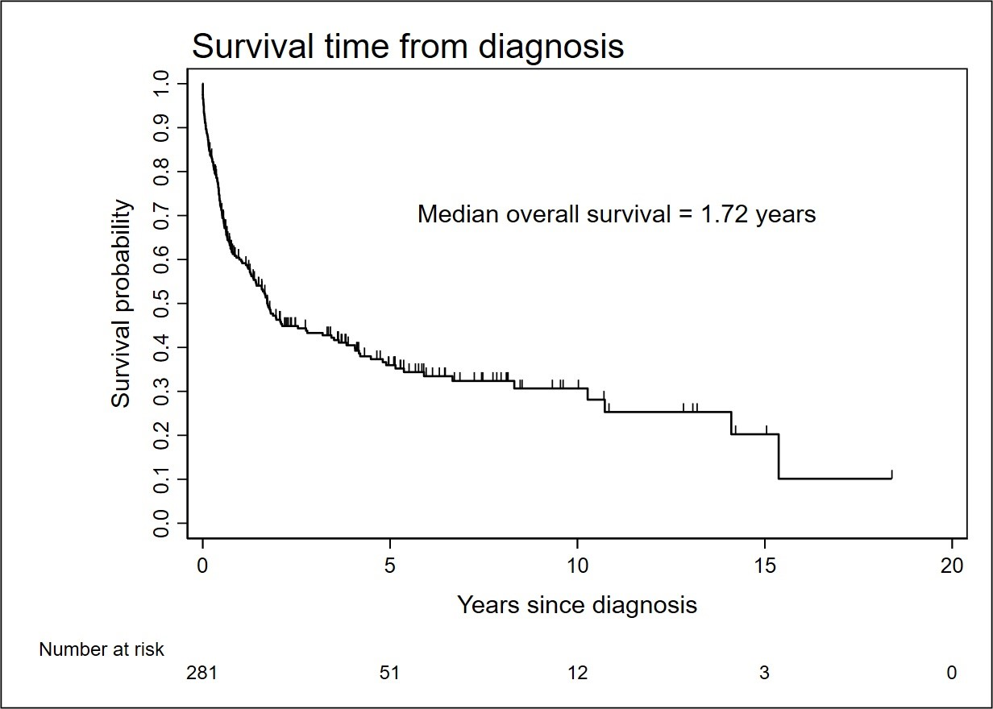

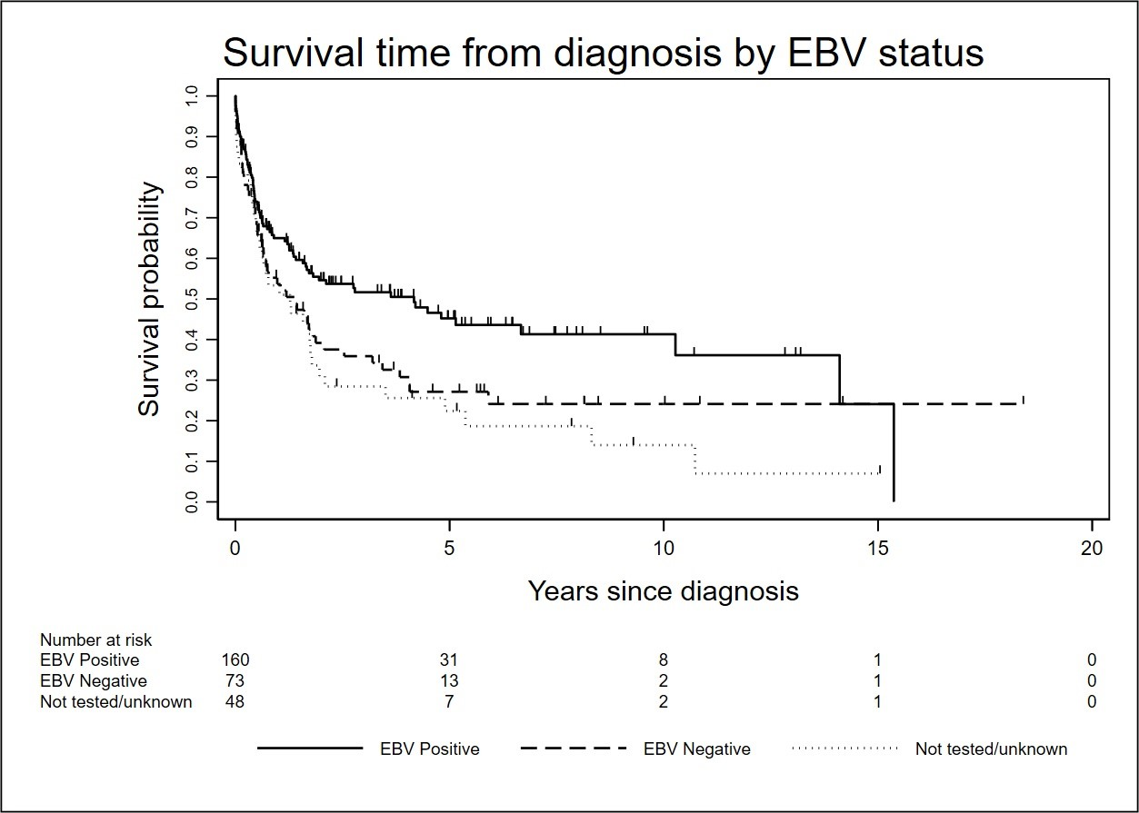

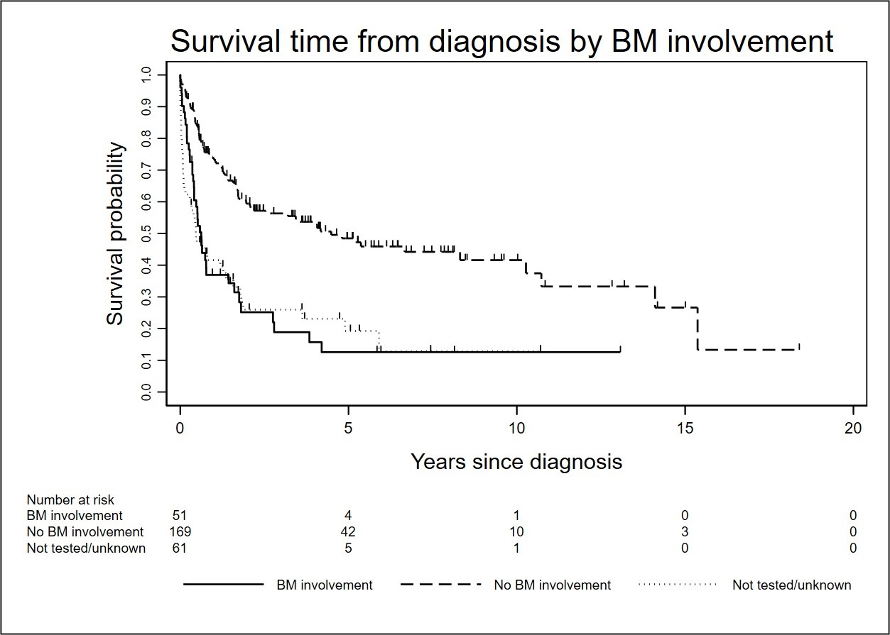

Total patients

n=281

Curative intent

n=234

Standard intensity

n=159

Proteasome

inhibitor-containing

n=8

No proteasome

inhibitor

n=151

Higher intensity

n=75

Proteasome

inhibitor-containing

n=24

No proteasome

inhibitor

n=51

Palliative intent or

best supportive care

n=43

No treatment data

available

n=4

Figure 4