**Title: Biochar from brown algae: production, activation, and characterisation**

**Authors:** Tannaz Pak1*, Kamal Elyasi Gomari1, Suranjana Bose2, Thierry Tonon3, David Hughes1, Mark Gronnow4, Duncan Macquarrie2

Affiliations: (1) School of Computing, Engineering & Digital Technologies, Teesside University, Middlesbrough TS1 3BX, UK; (2) Green Chemistry Centre of Excellence, Department of Chemistry, University of York, YO10 5DD, UK; (3) Centre for Novel Agricultural Products (CNAP), Department of Biology, University of York, York YO10 5DD, UK; (4) Biorenewables Development, 1 Hassacarr Close, Chessingham Park, Dunnington, York YO19 5SN, UK

*Corresponding author: Tannaz Pak, t.pak@tees.ac.uk

**Abstract**

Biochar has shown promise in combining water treatment and soil enhancement with long term carbon sequestration. Biochar performance depends on the feedstock and the pyrolysis process conditions. In this study, we conducted biochar production, activation, and characterisation from the brown algae *Laminaria digitata*, *Saccharina latissima*, *Saccorhiza polyschides*, *Himanthalia elongata*, and pelagic sargassum for several potential applications. Our results showed that these seaweeds, as harvested and without washing, contained significant amount of salt that needs to be removed to improve biochar quality for application in water treatment. However, presence of salts may confer advantages in certain catalytic processes. X-ray computed micro-tomography analysis shows the formation of porosity as a result of pyrolysis and biochar activation. Chemical activation successfully improved the biochar quality, in particular the available surface area for water and soil remediation. These results pave the way to extend applications of brown algae derived activated biochars.

**Keywords:** Algae, seaweeds, biochar, pyrolysis, activation, X-ray computed micro-tomography

**1. Introduction**

Biomass, as a renewable source of energy, presents a scalable solution for the energy and environmental challenges faced with the sustainable development of our planet. A major concern regarding large-scale utilisation of biomass is the impact on the environment and the food supply chain. Large-scale biomass to energy conversion is performed at power plants such as Drax in the UK that have adopted use of biomass (e.g. wood pellets) instead of fossil fuels (e.g. coal) as their feedstock. The food vs. fuel competition was recognised approximately fifteen years ago when the first generation biofuels (mainly bioethanol and biodiesel) were derived from food crops (Mitchell, 2008). Technological developments over the past decade have meant that non-edible plant biomass can now be used to produce biofuel. However, the challenges surrounding plant production, including the use of land and the need for irrigation, remain. One solution to overcome this situation lies in using biomass grown in the marine environment (e.g. macroalgae or seaweeds) as feedstock.

Algal biomass is abundant. It is estimated that 35.1 million tonnes of seaweeds were produced by aquaculture in 2022 (The State of World Fisheries and Aquaculture 2022, 2022). In addition, occurrence of seaweed blooms and invasions has increased during recent years in different parts of the world (Bermejo et al. 2023). For example, more than 20 million tons of pelagic sargassum were observed in the Tropical Atlantic in 2018 during the summer months (Wang et al., 2019). Seaweed biomass has the potential to be converted by pyrolysis into high-value products such as bio-oil and biochar that can offer a sustainable global solution to energy demand and environmental pollution challenges (Sekar et al., 2021). Pyrolysis corresponds to the thermal decomposition of biomass in absence of oxygen, and results into three main products: biochar (solid), bio-oil (liquid), and syn-gas (gaseous). The amount and composition of these products depend on the biomass used and on the pyrolysis conditions such as temperature, heating rate, and residence time (Amalina et al., 2022).

Seaweeds are commonly classified as green, red, and brown macroalgae that correspond to three distinct and relatively distant eukaryotic lineages. A wide diversity of green, red, and brown macroalgae have already been considered for the production of biochar and subsequent activation in the context of different applications (Anto et al., 2021; Chen et al., 2022; Farghali et al., 2023; Sun et al., 2022). As described in these reviews, several parameters important for the production and applications of biochar have been shown to depend on the algal species used. These include biochar yield, mineral content, electrical conductivity, cation-exchange capacity, pH, heating value, porosity, and surface area. In addition, it is well acknowledged that seaweed biochar is consistently different compared to lignocellulosic biomass derived biochar, including in its carbon and inorganic nutrient content (Roberts et al., 2015).

Here we focus on brown seaweeds. These macroalgae have applications in a wide range of industries, including food, pharmaceuticals, and cosmetics (Milledge et al., 2015). Some species of brown algae are used for direct food consumption, while others are processed to provide valuable products, including food additives, animal feed, fertilizers, and ingredients for cosmetics. Brown seaweeds also represent a sustainable photosynthetic feedstock for the bio-based production of energy and chemicals. Their advantages include high CO2 fixation efficiency, high yield, rapid growth, and no land requirement for cultivation (Ding and Liu, 2020; Rodrigues et al., 2015).

The five species considered in this study are *Laminaria digitata*, *Saccharina latissima*, *Saccorhiza polyschides*, *Himanthalia elongata*, and pelagic sargassum. *Saccharina latissima* and *Laminaria digitata* are currently farmed in Europe and in the UK, and are exploited for diverse industrial applications, including the production of alginates used as food additives, of animal feed, and for the manufacturing of biomaterials (Kostas et al., 2017; McElroy et al., 2023). *Saccorhiza polyschides* inhabits the European Atlantic shores, grow opportunistically on seaweed lines, and is also cultivated, including under integrated multi-trophic aquaculture conditions (Cardoso et al., 2023). *Himanthalia elongata* is commonly found from Scandinavia to Portugal and Ireland. It is not farmed but harvested from wild populations, and its nutritional and health benefits were reviewed recently (Ilyas et al., 2023). Pelagic sargassum biomass, formed by the species *S. natans* and *S. fluitans*, have been stranding massively on the coasts of the Caribbean and West Africa since 2011 (Fidai et al., 2020), causing highly negative socio-economic, health, and environmental impact. Several directions are currently explored to valorise this biomass (Oxenford et al., 2021). In terms of composition, carbohydrates dominate the brown algae biomass. Alginates and fucose containing sulfated polysaccharides encompass the main portion of the cell wall and represent up to 45% of algal dry weight. Cellulose only accounts for a small fraction (1–8% of algal dry weight) of the brown algae. Proteins and minerals are also found in brown algae while lignin is absent (Li et al., 2021).

Biochar is a porous, largely carbon-based material. Algal biochar has shown potential for water treatment, soil amendment, energy storage, and carbon sequestration (Singh et al., 2021). In water treatment, algal biochar is used as an adsorbent for removal of heavy metals and of other organic/inorganic pollutants from the aquatic ecosystem (Law et al., 2022; Michalak et al., 2019). For instance, algal biochar was shown to successfully remove ciprofloxacin (Nguyen et al., 2022), hydroxychloroquinine (Gumus et al., 2022), and tetracycline (Song et al., 2019) from aqueous solutions, similarly to biochar from terrestrial crop residues (Zheng et al., 2021). Algal biochar can also be used for soil amendment to achieve sustainability in agriculture. In the same vein, it has been shown to improve the water holding capacity of soil, to lower soil acidity, and to prevent nutrient leaching to groundwater (Liu and He, 2021). Algal biochar has also found applications in supercapacitor technologies and positively impacting the long-life cycle, high power density, fast charge-discharge rate, environmental friendliness, and production cost of these capacitors (Norouzi et al., 2021).

It has been shown that biochar produced from seaweed displays different properties compared with those produced from lignocellulosic biomass (Anto et al., 2021). In particular, seaweed biochar has shown to be high in nitrogen and ash content and low in carbon content compared with lignocellulosic biochar. Considering that most of the biochar literature is focused on synthesis, characterisation, activation, and application of lignocellulosic biochar, there is scope for further investigation to advance our knowledge on biochar produced from seaweeds given their renewable nature and abundance. Characterisation of biochar is key in defining its application (Singh et al., 2017). The chemical properties commonly studied include its functional groups, pH, and organic/inorganic components. Considering the porous nature of biochar, the main physical property investigated is its available surface area, which is of key importance for processes involving adsorption and removal of contaminants. However, biochar has a complex and multi-scale pore system with size of the pores ranging from the nano-meter to the micro-meter scale. It is inherently difficult to characterise material with multiple-scale porosity (Pak et al., 2016). The morphological structure of biochar (including pore shapes, sizes, and connectivity) can be studied through 2D or 3D imaging. While direct imaging techniques such as scanning electron microscopy (SEM) have been traditionally used to study the details of the biochar pore systems at sub-micron-scale, investigation at the nano-scale scale is more limited and more challenging.

Biochar porosity and its surface area play critical roles in its effectiveness for various applications. Enhancing these properties can be achieved through post-pyrolysis biochar activation. Activation can be through physical or chemical treatments (Cha et al., 2016). Physical activation involves exposing the biochar to gaseous agents such as carbon dioxide, steam, or both while requiring the biochar to be heated at high temperatures e.g. above 700°C (Molina-Sabio et al., 1996; Aworn et al., 2008, Zhang et al., 2014). This treatment results in an increase of the biochar surface area and its porosity. Additionally, this process eliminates highly reactive carbon atoms from the biochar surface. On the other hand, chemical activation incorporates the use of activators such as KOH, K2CO3, NaOH, H3PO4, ZnCl2 (Rodriguez-Reinoso and Molina Sabio, 1992; Ioannidou et al., 2007). In particular, chemical activation has proven to be a successful method for improving the quality of algal biochar. Among various chemical reagents, activation by KOH followed by washing with HCl stands out for developing intricate pore structures and to generate active functional groups on biochar surface (Abbaci et al., 2022; Elmouwahidi et al., 2012). The use of KOH for successful activation of algal biochar is reported by Kumar et al. (2020). These authors produced activated biochar with surface area of up to 850 m²/g and 960 m²/g when employing a 1:1 and 1:2 ratio of KOH respectively. Similar observations on the impact of KOH activation on algal biochar properties have been reported in the literature (Wu et al., 2021; Yaumi et al., 2017).

Here we present the findings of our study in which five brown seaweed species were used as feedstock for biochar production. The selected algae species are abundant and important globally but have particular importance within Europe and the UK. We also present outcome on the pelagic sargassum brown algae which is of particular importance in the Caribbean and Western Africa. The aim of this research was to test the effect of pyrolysis temperature in the range of 300-800°C as temperature is a key factor in the process of biochar production (Budarin et al., 2006; Chatterjee et al., 2020). We also tested subsequent chemical activation on properties of algal biochar obtained from the selected brown seaweeds. To fulfil this aim, approaches commonly used for analysis of biochar (e.g. BET, TGA, proximate and ultimate analysis, and FTIR) were combined with X-ray computed micro-tomography (X-ray µCT) imaging of the feedstock and of the derived pristine and activated biochar. This latter approach is a non-destructive technique that can produce images at micro-scale resolution to investigate the internal structure of a specimen under study and capture the micro-scale porosity caused by pyrolysis. While X-ray µCT has previously mostly been used to study other porous material, e.g. in manufacturing, food, geosciences applications (Hughes et al., 2019; Pak, 2015), it has been relatively less applied to study biochar and its morphological structure. Previous works focused on lignocellulosic biomass and hence wood-based biochar (Campos et al., 2020; Conte and Nestle, 2015; Hyväluoma et al., 2018; Jeffery et al., 2015; Rasa et al., 2018; Srocke et al., 2021). X-ray µCT images of seaweed biomass and biochar obtained in our study show the presence of high ash content within the internal structure of the biomass and the porosity development as a result of pyrolysis and biochar activation processes.

**2. Materials and Methods**

**2.1. Sample collection and preparation**

Five brown seaweeds, namely, *Laminaria digitata* (LD), *Saccharina latissima* (SL), *Saccorhiza polyschides* (SP), *Himanthalia elongata* (HE), and pelagic sargassum(PS), were studied. The LD, SL, SP, and HE samples were provided by the Cornish Seaweed Company based in Cornwall (UK). More specifically, LD was harvested in April 2021 in Coverack, SL and SP were collected in May 2021 in Porthallow, and HE in Lowland Point also in May 2021. After harvesting, samples were not washed with freshwater/tap water, and directly dried for approximately 30 hrs at 40°C using dehumidifying and heating. Samples of PS were collected at Hellshire Bay, Jamaica, in August 2020. This biomass consists of a mix of two species, *S. natans* and *S. fluitans,* and three morphotypes (*S. natans* I, *S. natans* VIII, and *S. fluitans* III). After removing non-sargassum debris (no wash with freshwater/tap water), samples were spread and dried for approximately 36 hrs at temperatures of 30–35°C (sun), 27.9°C (shade) and 25°C (night-time). After drying, all samples collected from the UK and Jamaica were milled to 1 mm diameter particle size using a Cyclone Mill Twister before further analysis.

Algae samples were not washed with freshwater/tap water in order to understand if biochar produced from brown algae without washing (which would involve extra energy and water use) can present reasonable quality. The only exception was the samples used for X-ray µCT imaging. An initial round of imaging demonstrated the presence of high amounts of salt within the algae samples. This adversely impacted the image quality by introducing imaging artefacts (streak artefacts due to high density nature of the salt phase). Therefore, to overcome this, we washed the samples used for imaging and air dried them before performing a second round of imaging. While washing did not remove all the salt content, it reduced it significantly and allowed successful imaging of the samples.

**2.2. Pyrolysis process**

Pyrolysis was carried out using a stainless-steel tube furnace under nitrogen environment (flow rate of 1.5 L/min). The biomass samples were placed on a boat and inserted in the tube furnace within the pyrolysis unit (Figure S1). The pyrolysis was performed at a heating rate of 16°C/min for time interval (residence time) of 15 minutes at temperatures of 300, 600, and 800°C. Subsequent to pyrolysis, the algal biochar samples were characterised both for chemical and physical properties.

**2.3. Algal biomass and biochar characterisation**

The moisture, volatile matter, ash, and fixed carbon content of the samples were determined according to ASTM D1762-84. In addition, ultimate analysis was conducted to measure the amount C, H, and N within the biomass and biochar samples using an elemental analyser (Exeter Analytical Inc. CE440).

The electrical conductivity (EC) and pH values of the samples were assessed. To achieve this, algal biomass and biochar were first added to deionised water (1:20 w/v) and mixed using a magnetic stirrer for 1 hr at room temperature. Subsequently, the pH and EC of these suspensions were determined after a period of 30 minutes. The functional groups of algal samples before and after pyrolysis process were identified using a Fourier Transform Infrared (FTIR) spectroscopy with wave numbers ranging between 4000 and 650 cm-1. FTIR spectra of the algal biomass and biochar were taken for analysis in 128 scans for each sample with a high spectral resolution of 0.5 cm-1. The obtained peaks were manipulated using baseline correction and the measurement noise was reduced through smoothing process. The crystalline structure of the algal biomass and biochar was determined using X-Ray diffraction (XRD) technique, scanning at scattering angle (2Ө) of 10° to 70° and scan rate of 1°/minute. The porous structure of the biomass and biochar samples was studied using X-ray µCT imaging. The surface area was measured using the Barrett-Joyner-Halenda (BJH) and Brunauer-Emmett-Teller (BET) methods (Micromeritics TriStar II Plus porosimeter) with 0.15 g sample. Thermogravimetric analysis (TGA) was conducted at heating rate of 10°C min−1 from 25 to 800°C. Nitrogen was used as the carrier gas at a flow rate of 20 mL/min (STA 6000 instrument).

**2.4. Algal biochar activation**

We applied chemical activation using KOH and HCl. To achieve this, 20 mL of deionised water was added to 2 g of KOH and then mixed with 1 g of pristine biochar. Afterwards, the excess water was evaporated using a hot plate stirrer (85-90°C). The sample was then dried overnight at 100°C in an oven. Subsequently, the resulting samples underwent a 2nd round of pyrolysis at the temperature of 600°C for an activation time of 15 minutes and heating rate of 100°C/min. Next, the samples were soaked in HCl (1 M) for one day, and then neutralised by washing with deionised water. Finally, the mixture was filtered and dried at 100°C for one day (Fig. 1).

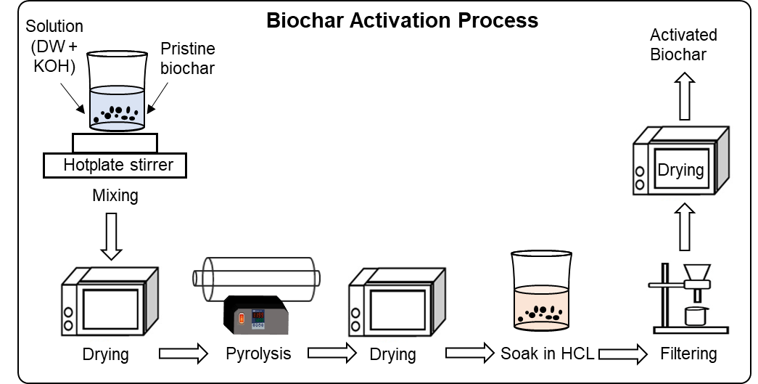

Fig. 1. The flow chart of chemical activation process used in this study.

**3. Results and Discussion**

**3.1. Biomass and biochar structure**

X-ray µCT imaging was used to investigate the internal structure of the biomass, biochar, and activated biochar samples. This is a non-destructive imaging technique. Fig. 2 shows examples of X-ray µCT slices (2D) for the LD, SP, HE, and PS samples. The pores as well as the empty space around particles are shown in black (darker phase) and the solid phase is shown in lighter shades of grey. In these images a significantly bright phase appears that correspond to a high-density material. Considering these samples are marine algae, the bright phase observed is likely due to the occurrence of salt crystals. The presence of salt was also identified by XRD measurements (Fig. S2).

As shown in Fig. 2 the biochar fragments (middle row) are all significantly more porous compared to their respective biomass samples (first row). These images clearly suggest that the pyrolysis process has resulted in significant opening of the pore spaces within the seaweed fragments. In addition, the activation process has increased the porosity of the fragments (bottom row). These images were obtained with a resolution of 1.4 µm, allowing the observation of the micro-scale structure of the materials, but not of the potential changes in porosity at the nano-scale. However, the formation of pores smaller than our image resolution was evidenced by steady increase of surface areas as measured by BET analysis (see Section 3.6).

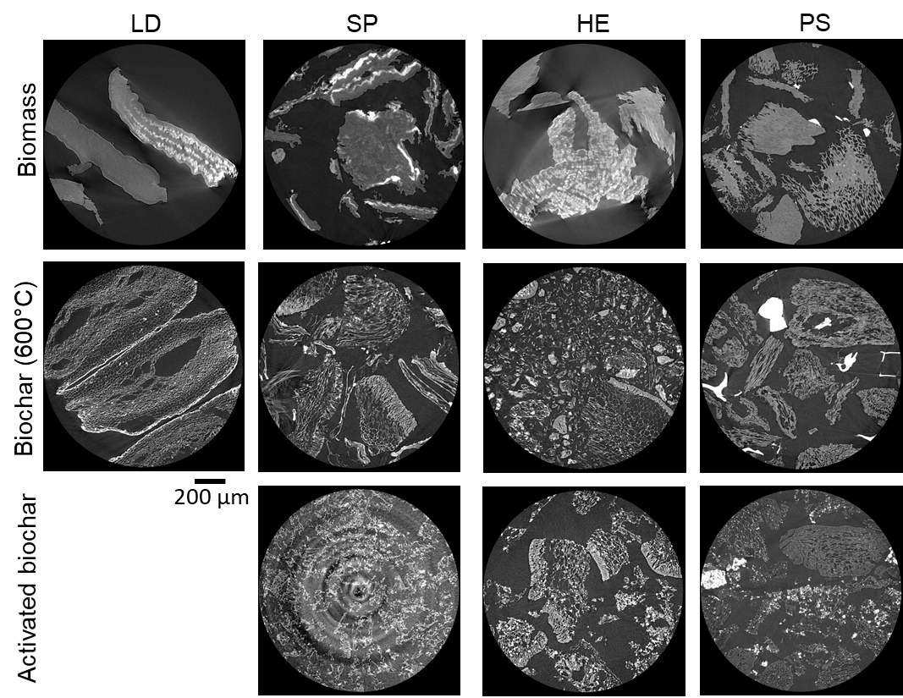

Fig. 2. Example X-ray µCT slices (2D) for *Laminaria digitata* (LD), *Saccorhiza polyschides* (SP), *Himanthalia elongata* (HE), and pelagic sargassum (PS) biomass (top row), biochar (middle row), and activated biochar (bottom row) samples.

**3.2. Biochar yield**

Fig. 3(a) illustrates the effect of pyrolysis temperature on algal biochar yield. Increasing the temperature from 300°C to 800°C results in reduction of yield in the range of 66.56% to 34.72%. This reduction is caused by the progressive decomposition of biomass as the temperature increases. The algal biochar samples have the highest yield at 300°C, with 66.56, 65.79, 62.09, 56.71 and 56.03% for SP, PS, SL, LD, and HE, respectively. In addition to the biomass type, biochar yield is affected by process factors including the type of pyrolysis unit, and the pyrolysis conditions (temperature, residence time, and heating rate). The measured yield for algal biochar in this study is higher than for lignocellulosic biomass such as wheat straw (40-45%; Zhang et al., 2020) and pine wood (55-60%; Jafri et al., 2018) when comparing biochar produced at 300°C for these different types of biomass. This is due to the difference in the main biomass components and their decomposition temperature range.

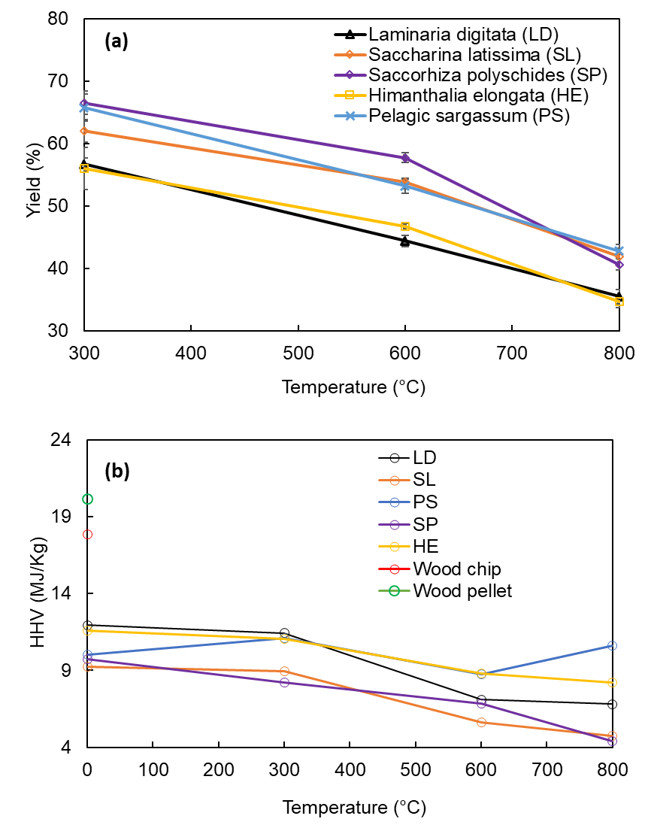

Fig. 3. Effect of pyrolysis temperature on biochar yield (a), and higher heating values (HHVs) determined for plant biomass, brown algae biomass, and brown algae derived biochar (b).

**3.3. Biochar heating value**

To investigate the potential use of the tested brown algae and of their respective biochar as renewable source of energy, their gross calorific values, also known as higher heating values (HHVs), was assessed (Fig. 3(b)). For reference we included the HHV of two wood-based biomass samples. HHVs are calculated based on the amount of carbon (C%) and hydrogen (H%) measured by ultimate analysis and using the following equation: HHV=0.2949C+0.8250H (Suárez et al., 2000). Yu (2011) showed this equation provides a close estimate of experimentally measured HHVs by examining 14 equations proposed in the literature (Yu et al., 2011). As shown in Fig. 3(b), the HHVs of the algae biomass and of their biochar were in the range of 5 to 12 MJ/Kg, significantly lower than wood-based material (17-20 MJ/Kg). Therefore, these untreated algal biochar samples are not a good source of energy.

**3.4. Proximate and ultimate analysis**

Based on the proximate analysis, the highest percentages of fixed carbon were found to be 34.70% and 33.16% in HE and LD respectively (Table 1). There is a negative correlation between the amount of fixed carbon and ash. LD and HE display the lowest ash contents with values of 10.72% and 13.33% respectively. The highest ash content was reported for PS at 23.44% with the lowest measured fixed carbon of 11.83%. The ultimate analysis also confirmed this finding. The highest carbon contents were measured in the LD and HE samples, 27.72% and 28.13% respectively.

One focus of our work was to characterise the untreated brown seaweeds and their derived biochar to explore whether there was a need for a pre-treatment step to produce high quality biochar from this feedstock. For water treatment application, high ash content in biochar is undesirable as it acts as an impurity and reduces the surface area of biochar. Pre-treatment of feedstock by chemical, physical, or biological methods improves its quality by removal of minerals and impurities that will otherwise lead to higher amounts of ash (Agbor et al., 2011).

Table 1. Proximate and ultimate analysis of algal biomass.

|  |  |  |  |  |  |  |  |  |
| --- | --- | --- | --- | --- | --- | --- | --- | --- |
|  | **Proximate analysis** | | | | **Ultimate analysis** | | | |
| Sample ID | Moisture (%)  T=110°C | Volatile (%)  T=925°C | Ash (%)  T=750°C | Fixed Carbon (%) | C% | H% | N% | Other (including S, O) % |
| LD | 3.78 | 52.33 | 10.72 | 33.16 | 27.72 | 4.58 | 2.28 | 65.42 |
| SL | 4.20 | 60.80 | 18.96 | 16.04 | 22.71 | 3.08 | 2.02 | 72.19 |
| SP | 4.61 | 57.35 | 22.49 | 15.56 | 21.91 | 3.98 | 1.98 | 72.13 |
| HE | 4.30 | 47.67 | 13.33 | 34.70 | 28.13 | 3.98 | 1.43 | 66.46 |
| PS | 8.50 | 56.22 | 23.44 | 11.83 | 22.92 | 3.98 | 0.81 | 73.29 |
| Wood chip | 6.21 | 79.85 | 2.37 | 11.57 | 44.34 | 5.78 | - | 49.87 |
| Wood pellet | 5.18 | 79.83 | 2.22 | 12.76 | 49.40 | 6.77 | 0.17 | 43.64 |

Proximate and ultimate analysis for two wood-based biomass and biochar samples are also presented in Table 1, as reference and to allow comparison. We observed that the wood chip and wood pellet samples display significantly lower ash content, and significantly higher carbon content compared with the algal biomass.

Table 2 presents the results of the ultimate analysis for the five algal biochar samples produced at different temperatures (300°C, 600°C, 800°C). For comparison, we also included the results for two wood-based samples (chips and pellets) produced at 480°C. The wood-based biochar showed very high levels of carbon, ranging between 78% and 81%. In contrast, significantly lower amounts of carbon were present in the algal biochar, ranging between 14% and 33%. For all five algae samples, the carbon content of the biochar (300°C) was higher than those measured for their respective biomass. It is known that pyrolysis at increasing temperatures leads to loss of volatiles such as water and small C-containing molecules. However, while carbon is lost form the original biomass, the biochar contained proportionately more carbon due to the more rapid loss of hydrogen and oxygen-rich species than carbon containing species at increasing temperatures. On the other hand, lower temperature biochars are obtained in higher yields and contain a more diverse set of chemical functionality.

Table 2. Ultimate analysis of non-activated algal biochar.

|  |  |  |  |  |  |
| --- | --- | --- | --- | --- | --- |
| Sample ID | Tem (°C) | C% | H% | N% | Other % |
| LD-B | 300 | 30.95 | 2.80 | 2.59 | 65.65 |
| 600 | 22.31 | 0.62 | 1.38 | 75.68 |
| 800 | 21.88 | 0.41 | 1.54 | 76.16 |
| SL-B | 300 | 24.56 | 2.08 | 2.03 | 71.32 |
| 600 | 17.55 | 0.54 | 1.11 | 80.79 |
| 800 | 15.46 | 0.21 | 0.55 | 83.77 |
| SP-B | 300 | 22.22 | 1.99 | 2.24 | 73.55 |
| 600 | 21.01 | 0.77 | 1.21 | 77.01 |
| 800 | 14.62 | 0.11 | 0.51 | 84.76 |
| HE-B | 300 | 30.36 | 2.55 | 1.74 | 65.32 |
| 600 | 27.33 | 0.87 | 1.01 | 70.79 |
| 800 | 26.10 | 0.64 | 1.00 | 72.56 |
| PS-B | 300 | 30.57 | 2.50 | 0.80 | 66.17 |
| 600 | 27.18 | 0.91 | 0.57 | 71.33 |
| 800 | 33.09 | 1.03 | 0.57 | 65.3 |
| Wood chip-B | 480 | 78.65 | 2.89 | - | 18.45 |
| Wood pellet-B | 480 | 80.96 | 2.70 | - | 16.39 |

The algal biochar produced at lower temperature (mainly 300°C), when mixed with water, resulted in the discoloration of water due to the release (leaching) of residual organic matter. This discolouration did not occur for higher temperature biochar, making the lower temperature biochar a less attractive choice as a water treatment solution due to the additional contamination they may introduce. The “other” column includes oxygen, sulfur and other inorganics, mainly halite and sylvite (see Section 3.8). As can be seen for all samples, this content increases with increasing pyrolysis temperature, as expected as the organic volatiles are left, leaving the involatile inorganics behind. The inorganic contents are highest for SL-B and SP-B, both at 800°C.

**3.5. pH and electrical conductivity (EC)**

Fig. 4(a) describes the effect of pyrolysis temperature on pH and on the EC for algal biomass and biochar. Both the pH and EC increased with the pyrolysis temperature. In particular, while the algal biomass showed pH values in the range of 5.5 to 7.5, algal biochar are alkaline with pH ranging from 11 to 13. Therefore, biochar produced from these five brown algal biomass could be used as a liming agent to reduce soil acidity and improve soil fertility. This is in line with results of other studies on macroalgal biochar (Kenneth et al., 2022). The lowest pH was measured for the HE biomass (5.49). This value almost doubled for derived biochar produced at 800°C (10.64). The highest pH was measured at 7.32 and 12.62 for biomass and biochar samples of PS, respectively. For all samples the pH increases sharply when comparing between the algal biomass and the respective biochar produced.

Similar trends were observed for EC. Fig. 4(b) shows that EC also increases with the pyrolysis temperature. The measured EC for the algal biomass and biochar ranges from 16.5 to 32 mS/cm and from 7.3 to 55.5 mS/cm, respectively. This makes the biochar produced from untreated macroalgae potential candidates for use in supercapacitor applications where a high EC is needed for better energy storage. However, in soil amendment application, biochar with high EC may be detrimental as it can have a negative impact on salt-sensitive plants (Kenneth et al., 2022).

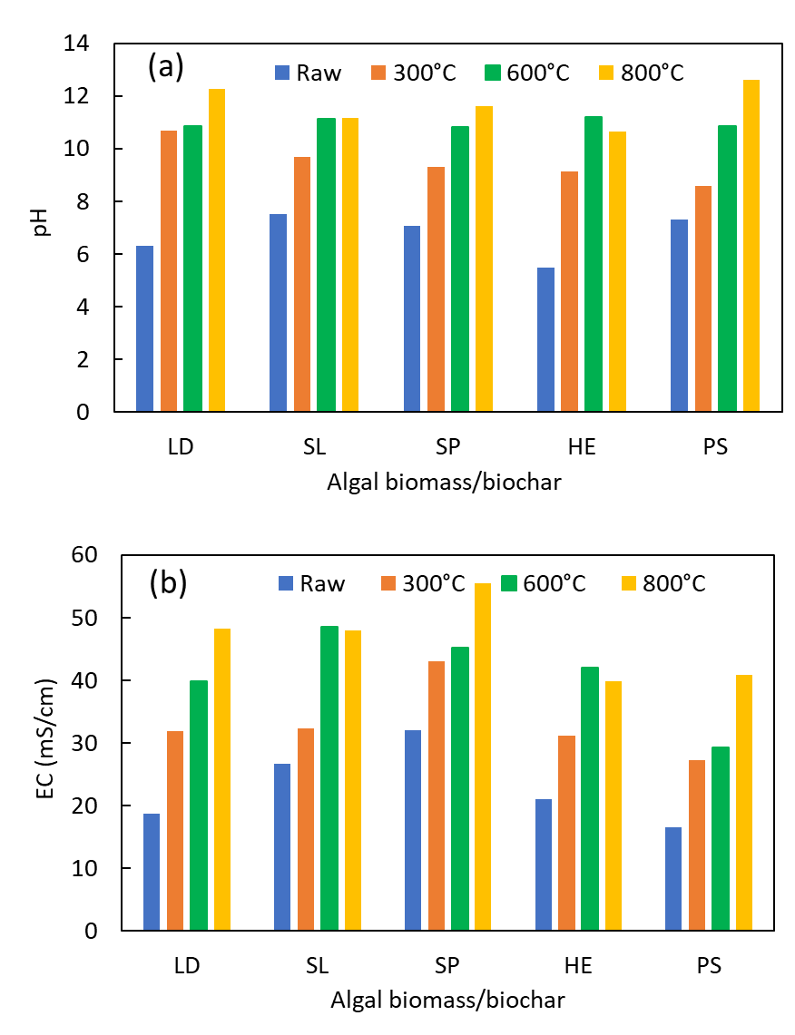

Fig. 4. Effect of pyrolysis temperature on pH (a), and electrical conductivity (EC, b) for *Laminaria digitata* (LD), *Saccharina latissima* (SL), *Saccorhiza polyschides* (SP), *Himanthalia elongata* (HE), and pelagic sargassum (PS).

**3.6. Biochar surface area measurement**

Table 3 shows the surface area per unit mass of the algal biomass and biochar samples using the Brunauer Emmet Teller (BET) method. The measured values lower than 2 m2/g are reported as “< 2 m2/g” due to expected error associated with measuring such small surface areas using this technique (Sing et al., 2001). The activated biochar displays a much larger surface area compared with the non-activated biochar and the biomass (Table 3). Larger surface area is key for application of biochar as adsorbent material for removal of contaminants from water, soil or air (Iwuozor et al., 2021). The highest surface area was measured for the activated HE biochar. Interestingly, and as discussed above, HE contains the highest amount of carbon and the lowest amount of ash among the biochar samples produced at 600°C. In addition, while the activated biochar samples obtained offer reasonable surface area, the non-activated biochar samples analysed showed relatively low surface area, making them less suitable for effective water treatment.

Table 3. BET measurements for raw and algal biochar (sample size 0.15 g).

|  |  |  |
| --- | --- | --- |
| Sample ID | Temperature (°C) | Surface area (m2/g) |
| LD | raw | <2 |
| 300 | - |
| 600 | <2 |
| 800 | 37 |
| Activated LD | 600 | 139 |
| SL | raw | - |
| 300 | <2 |
| 600 | 3 |
| 800 | 3 |
| Activated SL | 600 | 174 |
| SP | raw | - |
| 300 | - |
| 600 | 7 |
| 800 | 12 |
| Activated SP | 600 | 600 |
| HE | raw | <2 |
| 300 | 17 |
| 600 | 3 |
| 800 | 21 |
| Activated HE | 600 | 1042 |
| PS | raw | 3 |
| 300 | 3 |
| 600 | 3 |
| 800 | 11 |
| Activated PS | 600 | 320 |

Fig. 5 shows the SEM images of raw LD and activated LD biochars produced at 300, 600, and 800°C. As it can be seen in panel a, the raw LD biochar was smooth without any pores. However, after the pyrolysis and activation process (panels b-c-d), several pores were created due to the volatilization of organic compounds. It should be noted that the LD biochar had less pores with bigger sizes in the activated biochar obtained at 300°C (Figure 5b) compared to activated biochar produced at 600°C (Figure 5c). However, at a higher temperature (Figure 5d), more pores with smaller sizes were detected in the LD biochar.

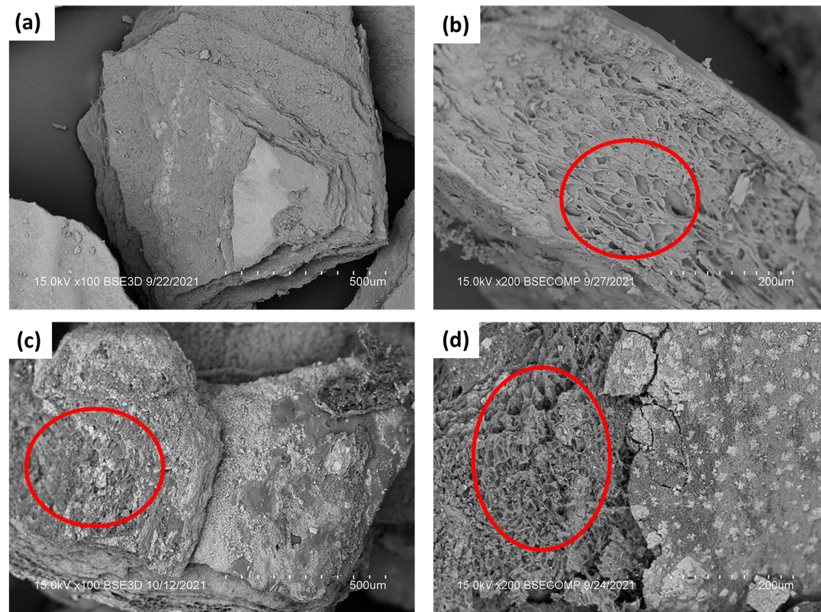

Fig. 5. SEM images of LD raw biochar (a), and LD activated biochars produced at 300°C (a), 600°C (c), and 800°C (d).

**3.7. Thermogravimetric (TGA) analysis**

For this, sample mass was measured as a function of temperature raised to 800°C at 10°C/min increment under nitrogen gas flow (250 mL/min). The degradation profile of the biomass is very different from the biochar produced from the five algae samples studied. This shows the produced algal biochar samples are significantly more stable compared to their respective biomass. As shown in Fig. 6, the biochar produced at 300°C, 600°C, and 800°C are 30%-70%, 60%-90%, 60%-130% more stable than their respective biomass. Among the studied algae, LD shows 10%-30% less remaining mass (for biochar produced at different temperatures) compared to the other four seaweed samples. This lower amount of remaining mass correlates with the lowest ash content for LD as reported in Table 1.

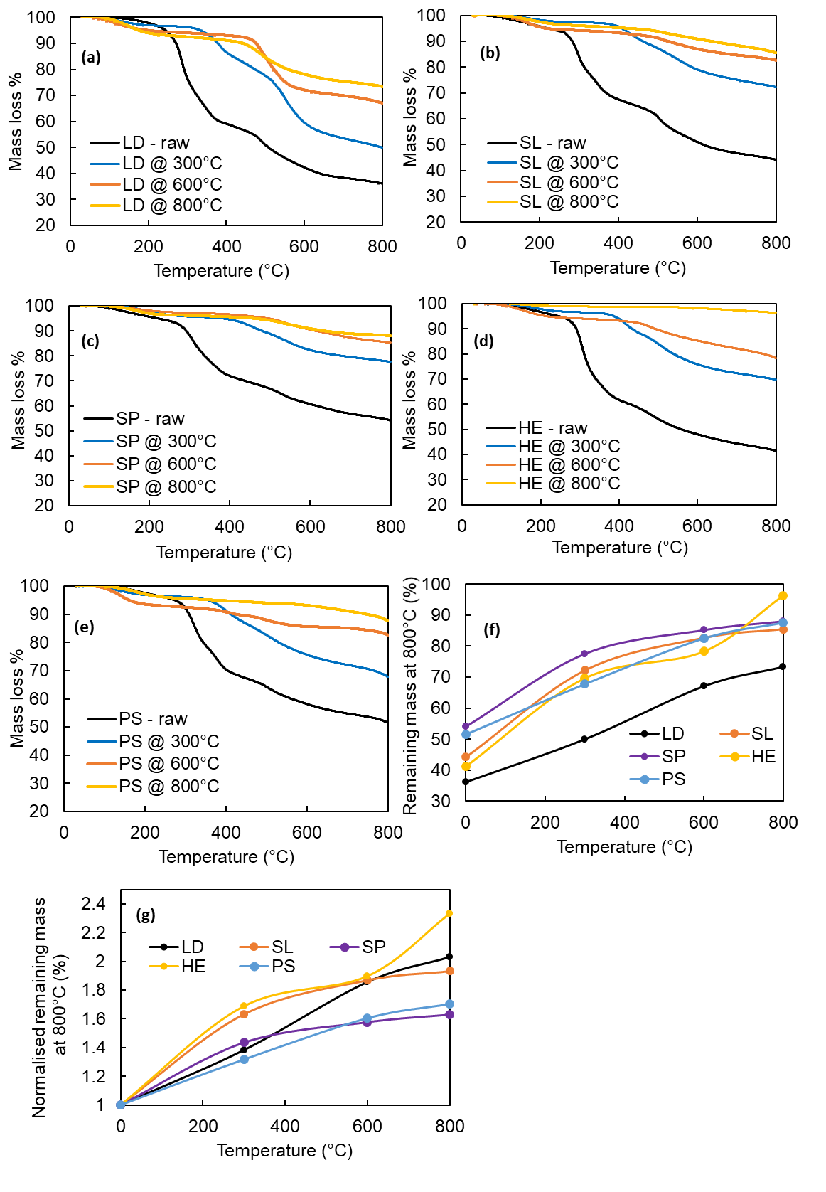

Fig. 6. TGA analysis results for *Laminaria digitata* (LD, a), *Saccharina latissima* (SL, b), *Saccorhiza polyschides* (SP, c), *Himanthalia elongata* (HE, d), and pelagic sargassum (PS, e); percentage of the remaining mass of the sample at 800 °C before (f) and after normalisation (g).

All the other samples show a similar trend of increasing remaining mass for biochar produced at increasing temperatures up to 800°C, suggesting that biochar produced at higher temperatures are more stable. For all samples, the high temperature biochars display some weight loss starting from temperatures lower than the pyrolysis temperature used to produce them. This indicates that a fraction of the thermally decomposable matter remains in the produced biochar, and that the thermal decomposition is not 100% efficient. This behaviour is dependent on the design and scale of the pyrolysis unit used, but clearly larger scale pyrolysis units face more challenge with establishing and maintaining stable temperatures.

The TGA fingerprint of the algal biochar samples under study show that the biochar produced at 600°C displays a high level of stability compared to the 300°C biochar, while not much stability is gained through increasing the temperature from 600°C to 800°C. This makes algal biochar produced at 600°C an optimum choice considering the balance between its synthesis cost and stability.

**3.8. X-Ray diffraction (XRD) analysis**

Patterns obtained for algal biomass and biochar at 300°C, 600°C and 800°C are shown in Fig. S2. All the samples analysed produced very similar XRD signals, and two types of crystalline structure, due to the presence of minerals in the samples, were identified: sylvite at 2Ө = 28-29º, 40-41º, 50-51º, 56-57º, 58-58º, and 66-67º; halite at 2Ө = 31-32º and 45-46º. Sylvite corresponds to crystals of KCl and halite to NaCl crystalline structure. The intensity of the peaks changed with increasing temperature pyrolysis due to destruction of the biomass structure. Sylvite ranged between 57% and 75% for algal biomass and biochar, while halite accounted for 25-43 % of the crystalline material present in the samples tested.

**3.9. FTIR analysis**

Fig. S3 presents the FTIR spectrum of algal biomass and biochar obtained at 300°C, 600°C, and 800°C. Overall, three major groups of components are expected in algal biomass, namely carbohydrates, proteins, and lipids. The strong band of hydroxyl (-OH) stretching was detected at 3200-3300 cm-1 for raw algae corresponding to water and also to the -OH groups derived from carbohydrates. The hydroxyl band reduced with increasing pyrolysis temperature, representing the loss of water and dehydration / degradation of the carbohydrates. A weak signal was detected at range of 2900-3000 cm-1, which is assigned to the aliphatic C-H stretching in raw algae and biochar at 300°C. However, the C-H stretching disappeared at 600 and 800°C, indicating a substantial loss of aliphatic C-H bonds. As these are primarily associated with polysaccharides, it can be concluded that the original structure of the polysaccharides has largely disappeared by 600°C. This is consistent with the significant mass losses seen between 200oC and 600°C in the TGA traces in Section 3.7. Bands at 1614 cm-1 was assigned to O-H bending mode, and it can be seen that the loss of this band correlates well with the loss in the O-H stretching band at 3200-3300 cm-1, consistent with the decomposition of the polysaccharide chains. The band at 1410 cm-1 can be assigned to C=C stretching and/or to C-H bending, respectively. There is some correlation in the weakening / broadening of this peak and the C-H stretch, but this is not as clear as with -OH, indicating that there is a significant amount of aromatic C=C bonds forming during pyrolysis, leaving a stable polyaromatic carbonaceous material. The IR activity of such sp2 C-H bonds in aromatic systems is much weaker than the aliphatics in the original material, and is rarely visible (occurring at 3000 cm-1 to ca. 3100 cm-1. Finally, the band at 1106 cm-1 confirmed the presence of C–O, which also weakens during pyrolysis as carbohydrate breakdown proceeds. Additional broad peaks in some of the 800°C spectra at ca.1080 cm-1 are potentially due to residual sulfate, and those at ca. 1500 cm-1 are potentially carbonate.

**4. Conclusions**

This work presents new findings on the use of untreated brown seaweed as feedstock for biochar production. We found that the optimum temperature for production of biochar from untreated dried and milled seaweed was 600°C, resulting in significant biochar yield (44% to 58%) with high stability (60%-90% above raw algae). The produced algal biochar contained significant amount of ash (mainly sylvite and halite salts), resulting in high pH values (ranging from 10.5 to 11.5) and high EC (ranging between 7.3 and 55.5 mS/cm). This makes these biochar samples likely suitable for application to acidic soil to regain soil neutrality.

Using X-ray µCT imaging, we show that the pyrolysis process results in the formation of new pore space in the studied seaweed samples. The untreated algal biochar showed very low surface area per unit of mass according to our BET measurements, in part because of the high percentage of salt within the unwashed and untreated seaweed. Washing the harvested seaweed could reduce the level of salt they contain, making them a better feedstock for producing biochar with improved properties. However, such a washing step will produce significant amount of concentrated brine that would need disposal and therefore increase the environmental impact and carbon footprint of the produced biochar.

The activation process used in this study was a chemical activation based on acid and base (HCl and KOH) treatment. All activated biochar samples displayed significant improvement in their surface area, making them a better product for water and soil remediation through adsorption of contaminants.

**5. Acknowledgements:**

This work was supported by the CharNival project through the UKRI Research England, Connecting Capability Fund through the Thyme project (project code ccf14-7167) a collaboration between the Universities of Teesside, Hull and York. We thank Pyrogenesys for their support. We acknowledge the contribution of Teesside University MSc students, Pavel Kazakovtsev, Anya Uchendu, and Humza Noor, and Mohammed Jani in measurements presented in this work. We thank the excellent support of Teesside University technician team in Engineering and in particular Jeff Lawrence for his contribution in production and characterisation of biochar. We thank Dr Tabitha Petchey, Leonardo Gomez, Mariana Silva, Carla Botelho Machado from the University of York, Tim Van Berkel from the Cornish Seaweed Company, and Mona Webber and Deanna Webber from the University of the West Indies in Jamaica for supplying the algae samples. These samples were obtained in the context of a grant from the Biomass Biorefinery Network (BBNet), a BBSRC/EPSRC funded Network in Industrial Biotechnology and Bioenergy (BBSRC NIBB) BB/S009779/1, and of the Economic and Social Research Council grant number ES/T002964/1.This work was supported by the National Research Facility for Lab X-ray CT (NXCT) through EPSRC grant EP/T02593X/1. We especially thank Dr Elizabeth Evans of University of Manchester for her help with the X-ray imaging.

**6. Data Availability:** All the data required to reproduce the work are reported in the manuscript.

**7.** Conflict of interest statement: The authors declare no conflict of interest.

**8. References**

Abbaci, F., Nait-Merzoug, A., Guellati, O., Harat, A., El Haskouri, J., Delhalle, J., Mekhalif, Z., Guerioune, M., 2022. Bio/KOH ratio effect on activated biochar and their dye based wastewater depollution. J. Anal. Appl Pyrolysis 162, 105452. <https://doi.org/10.1016/j.jaap.2022.105452>

Agbor, V.B., Cicek, N., Sparling, R., Berlin, A., Levin, D.B., 2011. Biomass pretreatment: Fundamentals toward application. Biotechnol Adv. 29, 675-685. <https://doi.org/10.1016/j.biotechadv.2011.05.005>

Amalina, F., Abd Razak, A.S., Krishnana, S., Sulaiman, H., Zularisam, A.W., Nasrullah, M., 2022. Biochar production techniques utilizing biomass waste-derived materials and environmental applications – A review. J. Haz. Mat. Adv. 7, 100134. <https://doi.org/10.1016/j.hazadv.2022.100134>

Anto, S., Sudhakar, M.P., Shan Ahamed, T., Samuel, M.S., Mathimani, T., Brindhadevi, K., Pugazhendhi, A., 2021. Activation strategies for biochar to use as an efficient catalyst in various applications. Fuel 285, 119205. <https://doi.org/10.1016/j.fuel.2020.119205>

Aworn, A., Thiravetyan, P., Nkbanpote, W., 2008. Preparation and characteristics of agricultural waste activated carbon by physical activation having micro and mesopores. J. Anal. Appl. Pyrolysis 82, 279-285. <https://doi.org/10.1016/j.jaap.2008.04.007>

Bermejo, R., Green-Gavrielidis, L., Gao G., 2023. Macroalgal blooms in a global change context. Front. Mar. Sci*.* 10, 1204117. <https://doi.org/10.3389/fmars.2023.1204117>

Budarin, Clark, J.H., Hardy, J.J.E., Luque, R., Milkowski, K., Tavener S.J., Wilson A.J., 2006. Starbons: New starch derived mesoporous carbonaceous materials with tuneable properties. Angew. Chem. Int. Ed. 45, 3782–3786. <https://doi.org/10.1002/anie.200600460>

Campos, P., Miller, A.Z., Knicker, H., Costa-Pereira, M.F., Merino, A., De la Rosa, J.M., 2020. Chemical, physical and morphological properties of biochars produced from agricultural residues: Implications for their use as soil amendment. Waste Manag. 105, 256-267. <https://doi.org/10.1016/j.wasman.2020.02.013>

Cardoso, C., Almeida, J., Coelho, I., Delgado, I., Gomes, R., Quintã, R., Bandarra, N.M., Afonso, C., 2023. Farming a wild seaweed and changes to its composition, bioactivity, and bioaccessibility: The *Saccorhiza polyschides* case study. Aquaculture 566, 739217. <https://doi.org/10.1016/j.aquaculture.2022.739217>

Cha, J.S., Park, S.H., Jung, S.C., Ryu, C., Jeon, J.K., Shin, M.C., Park, Y.K., 2016. Production and utilization of biochar: A review. J. Ind. Eng. Chem. 40, 1-16. <https://doi.org/10.1016/j.jiec.2016.06.002>

Chatterjee, R., Sajjadi, B., Chen, W.Y., Mattern, D.L., Hammer, N., Raman, V., Dorris, A, 2020. Effect of pyrolysis temperature on physicochemical properties and acoustic based amination of biochar for efficient CO2 absorption. Front. Energy Res. 8, 85. <https://doi.org/10.3389/fenrg.2020.00085>

Chen, B., Gu, Z., Wu, M., Ma, Z., Lim, H.R., Khoo, K.S., Show, P.L., 2022. Advancement pathway of biochar resources from macroalgae biomass: A review. Biomass Bioenergy 167, 106650. <https://doi.org/10.1016/j.biombioe.2022.106650>

Conte, P., Nestle, N., 2015. Water dynamics in different biochar fractions. Magn. Reson. Chem. 53, 726-734.<https://doi.org/10.1002/mrc.4204>

Ding, S., Liu, Y., 2020. Adsorption of CO2 from flue gas by novel seaweed-based KOH-activated porous biochars. Fuel 260, 116382. <https://doi.org/10.1016/j.fuel.2019.116382>

Elmouwahidi, A., Zapata-Benabithe, Z., Carrasco-Marín, F., Moreno-Castilla, C., 2012. Activated carbons from KOH-activation of argan (*Argania spinosa*) seed shells as supercapacitor electrodes. Bioresour. Technol. 111, 185-190. <https://doi.org/10.1016/j.biortech.2012.02.010>

Farghali, M., Mohamed, I.M.A., Osman, A.I., Rooney, D.W., 2023. Seaweed for climate mitigation, wastewater treatment, bioenergy, bioplastic, biochar, food, pharmaceuticals, and cosmetics: a review. Environ. Chem. Lett. 21, 97-152. <https://doi.org/10.1007/s10311-022-01520-y>

Fidai, Y.A., Dash, J., Tompkins, E.L., Tonon, T., 2020. A systematic review of floating and beach landing records of sargassum beyond the Sargasso Sea. Environ. Res. Commun. 2, 122001. <https://doi.org/10.1088/2515-7620/abd109>

Gümüş D., Gümüş F., 2022. Removal of Hydroxychloroquine Using Engineered Biochar from Algal Biodiesel Industry Waste: Characterization and Design of Experiment (DoE). Arab. J. Sci. Eng. 47, 7325-7334. <https://doi.org/10.1007/s13369-021-06235-w>

Hughes, D., Amalu, E.H., Pak, T., Kennedy, R., 2019. Effect of relative density on compressive load response of crumpled aluminium foil mesh. Materials 12, 4018. <https://doi.org/10.3390/ma12234018>

Hyväluoma, J., Kulju, S., Hannula, M., Wikberg, H., Källi, A., Rasa, K., 2018. Quantitative characterization of pore structure of several biochars with 3D imaging. Environ. Sci. Pollut. Res. 25, 25648-25658. <https://doi.org/10.1007/s11356-017-8823-x>

Ilyas, Z., Ali Redha, A., Wu, Y.S., Ozeer, F.Z., Aluko, R.E., 2023. Nutritional and Health Benefits of the Brown Seaweed *Himanthalia elongata*. Plant Foods Hum. Nutr. 78, 233-242. <https://doi.org/10.1007/s11130-023-01056-8>

Ioannidou, O., Zabaniotou, A., 2007. Agricultural residues as precursors for activated carbon production - a review. Renew. Sustain. Energy Rev. 11, 1966-2005. <https://doi.org/10.1016/j.rser.2006.03.013>

Iwuozor, K.O., Ighalo, J.O., Emenike, E.C., Igwegbe, C.A., Adeniyi, A.G., 2021. Do adsorbent pore size and specific surface area affect the kinetics of methyl orange aqueous phase adsorption? J. Chem. Lett. 2, 188-198. 10.22034/JCHEMLETT.2022.327407.1048

Jafri, N., Wong, W.Y., Doshi, V., Yoon, L.W., Cheah, 2018. A review on production and characterization of biochars for application in direct carbon fuel cells. Process. Saf. Environ. Prot. 118, 152-166. <https://doi.org/10.1016/j.psep.2018.06.036>

Jeffery, S., Meinders, M.B.J., Stoof, C.R., Bezemer, T.M., van de Voorde, T.F.J., Mommer, L., van Groenigen, J.W., 2015. Biochar application does not improve the soil hydrological function of a sandy soil. Geoderma 251–252. <https://doi.org/10.1016/j.geoderma.2015.03.022>

Kenneth, F., Joniver, C.F.H., Meredith, W., Adams, J.M.M., 2022. The productivity effects of macroalgal biochar from Ulva (Linnaeus) bloom species on *Arabidopsis thaliana* (Linnaeus) seedlings. Eur. J. Phycol. 58, 248-29. <https://doi.org/10.1080/09670262.2022.2103739>.

Kostas, E.T., White, D.A., Cook, D.J., 2017. Development of a bio-refinery process for the production of speciality chemical, biofuel and bioactive compounds from *Laminaria digitata*. Algal Res. 28, 211-219. <https://doi.org/10.1016/j.algal.2017.10.022>

Kumar, A., Kumar, J., Bhaskar, T., 2020. High surface area biochar from *Sargassum tenerrimum* as potential catalyst support for selective phenol hydrogenation. Environ. Res. 186. 109533. <https://doi.org/10.1016/j.envres.2020.109533>

Law, X.N., Cheah, W.Y., Chew, K.W., Ibrahim, M.F., Park, Y.K., Ho, S.H., Show, P.L., 2022. Microalgal-based biochar in wastewater remediation: Its synthesis, characterization and applications. Environ. Res. 204, 111966. <https://doi.org/10.1016/j.envres.2021.111966>

Li, Y., Zheng, Y., Zhang, Y., Yang, Y., Wang, P., Imre, B., Wong, A.C.Y., Hsieh, Y.S.Y., Wang, D., 2021. Brown Algae Carbohydrates: Structures, Pharmaceutical Properties, and Research Challenges. Mar. Drugs 19, 620. <https://doi.org/10.3390/MD19110620>

Liu, Y.N., He, L.Y., 2021. Effects of alkali-activated algae biochar on soil improvement after phosphorus absorption: Efficiency and mechanism. Sustainability 13, 11973. <https://doi.org/10.3390/su132111973>

McElroy, C.R., Kopanitsa, L., Helmes, R., Fan, J., Attard, T.M., Simister, R., van den Burg, S., Ladds, G., Bailey, D.S., Gomez, L.D., 2023. Integrated biorefinery approach to valorise *Saccharina latissima* biomass: Combined sustainable processing to produce biologically active fucoxanthin, mannitol, fucoidans and alginates. Environ. Technol. Innov. 29, 103014. <https://doi.org/10.1016/j.eti.2023.103014>

Michalak, I., Baśladyńska, S., Mokrzycki, J., Rutkowski, P., 2019. Biochar from A Freshwater Macroalga as A Potential Biosorbent for Wastewater Treatment. Water 11, 1390. <https://doi.org/10.3390/W11071390>

Milledge, J.J., Nielsen, B.V., Bailey, D., 2015. High-value products from macroalgae: the potential uses of the invasive brown seaweed, *Sargassum muticum*. Rev. Environ. Sci. Biotechnol. 15, 67–88. <https://doi.org/10.1007/S11157-015-9381-7>

Mitchell, D., 2008. A Note on Rising Food Prices. World Bank Development Prospects Group. <https://doi.org/10.1596/1813-9450-4682>

Molina-Sabio, M., González, M.T., Rodriguez-Reinoso, F., Sepúlveda-Escribano, A., 1996. Effect of steam and carbon dioxide activation in the micropore size distribution of activated carbo., Carbon 34, 505-509. <https://doi.org/10.1016/0008-6223(96)00006-1>

Nguyen, T.B., Truong Q.-M., Chen, C.-W., Doong, R.-A., Chen, W.-H., Dong, C.-D., 2022. Mesoporous and adsorption behaviour of algal biochar prepared by sequential hydrothermal carbonisation and Zncl2 activation. Bioresour. Technol. 346, 126351. <https://doi.org/10.1016/j.biortech.2021.126351>

Norouzi, O., Pourhosseini, S.E.M., Naderi, H.R., di Maria, F., Dutta, A., 2021. Integrated hybrid architecture of metal and biochar for high performance asymmetric supercapacitors. Sci. Rep. 11, 5387. <https://doi.org/10.1038/s41598-021-84979-z>

Oxenford, H.A., Cox, S.-A., van Tussenbroek, B.I., Desrochers, A., 2021. Challenges of Turning the Sargassum Crisis into Gold: Current Constraints and Implications for the Caribbean. Phycology 1, 27-48. <https://doi.org/10.3390/phycology1010003>

Pak, T., 2015. Saturation tracking and identification of residual oil saturation. University of Edinburgh. <http://hdl.handle.net/1842/17872>

Pak, T., Butler, I.B., Geiger, S., van Dijke, M.I.J., Jiang, Z., Surmas, R., 2016. Multiscale pore-network representation of heterogeneous carbonate rocks. Water Resour. Res. 52, 5433-5441. <https://doi.org/10.1002/2016WR018719>

Rasa, K., Heikkinen, J., Hannula, M., Arstila, K., Kulju, S., Hyväluoma, J., 2018. How and why does willow biochar increase a clay soil water retention capacity? Biomass Bioenergy 119, 346-353. <https://doi.org/10.1016/j.biombioe.2018.10.004>

Roberts, D.A., Paul, N.A., Dworjanyn, S.A., Bird, M.I., De Nys, R., 2015. Biochar from commercially cultivated seaweed for soil amelioration. Sci. Rep. 5, 9665. <https://doi.org/10.1038/srep09665>

Rodrigues, D., Freitas, A.C., Pereira, L., Rocha-Santos, T.A.P., Vasconcelos, M.W., Roriz, M., Rodríguez-Alcalá, L.M., Gomes, A.M.P., Duarte, A.C., 2015. Chemical composition of red, brown and green macroalgae from Buarcos bay in Central West Coast of Portugal. Food Chem. 183, 197-207. <https://doi.org/10.1016/j.foodchem.2015.03.057>

Rodríguez-Reinoso F., Molina Sabio, M., 1992. Activated carbons from lignocellulosic materials by chemical and/or physical activation: an overview. Carbon 30, 1111-1118. <https://doi.org/10.1016/0008-6223(92)90143-K>

Sekar, M., Mathimani, T., Alagumalai, A., Chi, N.T.L., Duc, P.A., Bhatia, S.K., Brindhadevi, K., Pugazhendhi, A., 2021. A review on the pyrolysis of algal biomass for biochar and bio-oil – Bottlenecks and scope. Fuel 283, 119190. <https://doi.org/10.1016/j.fuel.2020.119190>

Sing, K., 2001. Colloids and Surfaces A; Physicochemical and Engineering aspects 187-188, 3-9. <https://doi.org/10.1016/S0927-7757(01)00612-4>

Singh, A., Sharma, R., Pant, D., Malaviya, P., 2021. Engineered algal biochar for contaminant remediation and electrochemical applications. Sci. Total Environ. 774, 145676. <https://doi.org/10.1016/j.scitotenv.2021.145676>

Steiner, 2017. Biochar: A Guide to Analytical Methods. By Singh, B., Camps-Arbestain, M., Lehmann (eds). Published by CRC Press. <https://doi.org/10.1111/sum.12389>

Song, G., Guo, Y., Li, G., Zhao, W., Yu, Y., 2019. Comparison for adsorption of tetracycline and cefradine using biochar derived from seaweed Sargassum sp. Desalination Water Treat. 160, 316-324. <https://doi.org/10.5004/dwt.2019.24333>

Srocke, F., Han, L., Dutilleul, P., Xiao, X., Smith, D.L., Mašek, O., 2021. Synchrotron X-ray microtomography and multifractal analysis for the characterization of pore structure and distribution in softwood pellet biochar. Biochar 3, 671-686. <https://doi.org/10.1007/s42773-021-00104-3>

Suárez, J.A., Luengo, C.A., Felfli, F.F., Bezzon, G., Beatón, P.A., 2000. Thermochemical properties of cuban biomass. Energy Sources 22, 851-857. <https://doi.org/10.1080/00908310051128156>

Sun, J., Norouzi, O., Mašek, O., 2022. A state-of-the-art review on algae pyrolysis for bioenergy and biochar production. Bioresour. Technol. 346, 126258. <https://doi.org/10.1016/j.biortech.2021.126258>

The State of World Fisheries and Aquaculture 2022. FAO. <https://doi.org/10.4060/cc0461en>

Wang, M., Hu, C., Barnes, B.B., Mitchum, G., Lapointe, B., Montoya, J.P., 2019. The great Atlantic Sargassum belt. Science 364, 83–87. DOI: 10.1126/science.aaw7912

Wu, Y., Cheng, H., Pan, D., Zhang, L., Li, W., Song, Y., Bian, Y., Jiang, X., Han, J., 2021. Potassium hydroxide-modified algae-based biochar for the removal of sulfamethoxazole: Sorption performance and mechanisms. J. Environ. Manage. 293, 112912. <https://doi.org/10.1016/j.jenvman.2021.112912>

Yaumi, A.L., Bakar, M.Z.A., Hameed, B.H., 2017. Reusable nitrogen-doped mesoporous carbon adsorbent for carbon dioxide adsorption in fixed-bed. Energy 138, 776-784. <https://doi.org/10.1016/j.energy.2017.07.130>

Yu, Z.T., Xu, X., Hu, Y.C., Fan, L.W., Cen, K.F., 2011. Prediction of higher heating values of biomass from proximate and ultimate analyses. Fuel 90, 1128–1132. <https://doi.org/10.1016/J.FUEL.2010.11.031>

Zhang, Y.J., Xing, Z.J., Duan, Z.K., Li, M., Wang, Y., 2014. Effects of steam activation on the pore structure and surface chemistry of activated carbon derived from bamboo waste. Appl. Surf. Sci. 315, 279-286.

Zhang, X., Zhang, P., Yuan, X., Li, Y., Han, L., 2020. Effect of pyrolysis temperature and correlation analysis on the yield and physichochemical properties of crop residue biochar. Bioresour. Technol. 296, 122318. https://doi.org/10.1016/j.biortech.2019.122318.

Zheng, Z., Zhao, B., Guo, Yiping, Guo, Yujie, Pak, T., Li, G., 2021. Preparation of mesoporous batatas biochar via soft-template method for high efficiency removal of tetracycline. Sci. Total Environ. 787, 147397. <https://doi.org/10.1016/j.scitotenv.2021.147397>

**8. Figure Captions**

Fig. 1. The flow chart of chemical activation process used in this study.

Fig. 2. Example X-ray µCT slices (2D) for *Laminaria digitata* (LD), *Saccorhiza polyschides* (SP), *Himanthalia elongata* (HE), and pelagic sargassum (PS) biomass (top row), biochar (middle row), and activated biochar (bottom row) samples.

Fig. 3. Effect of pyrolysis temperature on biochar yield (a), and higher heating values (HHVs) determined for plant biomass, brown algae biomass, and brown algae derived biochar (b).

Fig. 4. Effect of pyrolysis temperature on pH (a), and electrical conductivity (EC, b) for *Laminaria digitata* (LD), *Saccharina latissima* (SL), *Saccorhiza polyschides* (SP), *Himanthalia elongata* (HE), and pelagic sargassum (PS).

Fig. 5. SEM images of LD raw biochar (a), and LD activated biochar produced at 300°C (a), 600°C (c), and 800°C (d).

Fig. 6. TGA analysis results for *Laminaria digitata* (LD, a), *Saccharina latissima* (SL, b), *Saccorhiza polyschides* (SP, c), *Himanthalia elongata* (HE, d), and pelagic sargassum (PS, e); percentage of the remaining mass of the sample at 800 °C before (f) and after normalisation (g).

**9. Table Captions**

Table 1. Proximate and ultimate analysis of algal biomass.

Table 2. Ultimate analysis of non-activated algal biochar.

Table 3. BET measurements for raw and algal biochar (sample size 0.15 g).