**Poverty in the UK and other countries**

Jonathan Bradshaw

[Standfirst] **The UK is wealthy, in terms of relative disposable incomes, median household incomes and the relative price of goods and serv ices. But child poverty rates here, and child deprivation, are comparatively higher than in most rich countries in the European Union and OECD.[1] Why is the UK’s initial child poverty rate before cash transfers in benefits and tax credits among the very highest in Europe? What role are these transfers playing to reduce child poverty? And what can we learn from other countries about reducing child poverty?**

There is a lot to be learned from comparing poverty rates between different countries. It is possible to see more clearly, for example, how different countries’ approaches to income redistribution have an impact on their rates of relative income poverty, which can inform policies and approaches governments take. That said, it can be difficult to compare standards of living because there are differences in what similar amounts of money can buy in different countries (although often figures are given on a ‘purchasing power parity’ basis to help account for this), exchange rates fluctuate , and official statistics don’t always capture the full picture. The data is also not as up to date as it could be and this problem has been exacerbated by Brexit.[2] Nevertheless, it is still useful to see how the UK fares against other comparable countries, and to examine why this might be the case.

**Overall incomes**

The overall income levels and the degrees of income inequality in each country are not, in themselves, measures of relative poverty. But these measures set the frame for measuring relative poverty levels and need to be compared first.

In terms of relative disposable incomes, which take into account both median household incomes and the relative price of goods and services in each country, the UK’s position as a wealthy country remains unchallenged (see Figure 1). This alone should inform the debate about how much the UK can ‘afford’ to assist low-income families with cash transfers. The International Monetary Fund, World Bank and United Nations all rank the UK as the world’s sixth largest economy.

The UK’s disposable household income, surprisingly perhaps, remains similar to that of Scandinavian and some other northern European countries, while below it are southern European countries such as Italy and Spain and then, further down, the former Soviet bloc nations.

**Figure 1: Adjusted annual household incomes (in US dollars) across 29 OECD countries, 2021**

Source: OECD.Stat, OECD Better Life Index 2021, data extracted 26 Jan 2022

**Income inequality**

The most commonly used measure to compare degrees of income inequality is the Gini coefficient (see Figure 2). In this analysis, the UK parts company with the Scandinavian countries, which have less inequality (and therefore a lower Gini coefficient) because they redistribute income to a greater extent through their tax and benefit regimes. Some of the former Soviet bloc countries (Slovenia, Slovak Republic and the Czech Republic) also retain greater income equality, though they have lower overall incomes too. Others (Bulgaria and the Baltic republics) show much greater inequality. Other northern European countries tend towards the lower range of inequality and the southern European nations towards the higher range. Among the larger countries, the UK and Italy exceed the EU average.

**Figure 2: Gini coefficient across Europe, 2018**

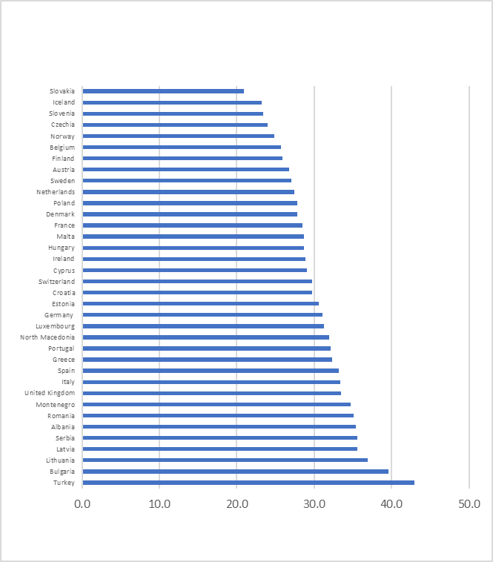

Source: Eurostat, Gini coefficient of equivalised disposable income – EU-SILC survey (online data code: TESSI190)

**Family spending**

States assist families with the costs of child rearing through interventions in the market economy to ensure adequate wages, gender equal pay and managing the economy to maximise employment. They also provide free or subsidised services: education, care, health, housing and sometimes commodities like water, energy or food subsidies. But by far the most important element of state intervention is direct transfers of cash and tax benefits that increase the incomes of families with children or reduce their tax liabilities.[3] The OECD provides analysis of the varying efforts that rich countries make.

Figure 3 shows that the highest spenders all tend to be European countries and they tend to make more use of cash benefits. The UK comes eighth in the league table, with most spending in the form of cash benefits and no spending on tax breaks. The UK reduced its overall spending on cash benefits from 4.27 per cent of GDP in 2010 to 3.23 per cent in 2017.

**Figure 3**: **Public expenditure on family benefits by type of expenditure (as % of GDP), 2017 and latest available**

Source: OECD, Family database Table PF1.1A

**Child poverty and deprivation in rich countries**

*Relative income poverty*

Table 1 presents OECD data on the ranking of countries by their child poverty rates using the 50 per cent of median threshold. Note that we typically consider the poverty line to be at 60 per cent of median income, but the OECD poverty line is lower. The proportion of children in poverty by this measure varies from 3.5 per cent in Finland to 35 per cent in South Africa. There are broadly three groupings of countries, starting with mainly Nordic countries with child poverty rates less than 10 per cent. The middle group includes the UK, with poverty rates between 10 per cent and 15 per cent. The remaining countries, including the USA, have child poverty rates in excess of 15 per cent. The UK along with Luxembourg and the USA have much higher child poverty rates than you would expect given their level of national household income.

**Table 1: Child poverty rates in the OECD: % of children aged >18 in households with equivalent income >50% of the median**

|  |  |  |
| --- | --- | --- |
| **Country** | **Year** | **Percentage** |
| Finland | 2018 | 3.5% |
| Denmark | 2018 | 4.9% |
| Iceland | 2017 | 5.4% |
| Slovenia | 2019 | 5.6% |
| Czech Republic | 2019 | 7.1% |
| Poland | 2018 | 7.4% |
| Norway | 2019 | 7.9% |
| Ireland | 2018 | 8.0% |
| Hungary | 2019 | 8.4% |
| Belgium | 2019 | 8.5% |
| Estonia | 2019 | 8.7% |
| Sweden | 2019 | 9.4% |
| Latvia | 2019 | 10.2% |
| Netherlands | 2019 | 10.4% |
| Switzerland | 2018 | 10.8% |
| Germany | 2018 | 11.1% |
| Canada | 2019 | 11.4% |
| France | 2019 | 11.7% |
| Korea | 2018 | 12.3% |
| Slovak Republic | 2019 | 12.4% |
| Austria | 2019 | 13.0% |
| Portugal | 2019 | 13.1% |
| Australia | 2018 | 13.3% |
| Japan | 2018 | 14.0% |
| United Kingdom | 2019 | 14.1% |
| Greece | 2019 | 14.4% |
| Lithuania | 2019 | 14.9% |
| Luxembourg | 2019 | 15.3% |
| Russia | 2017 | 17.9% |
| Italy | 2018 | 18.0% |
| Mexico | 2018 | 19.1% |
| Spain | 2019 | 20.9% |
| Bulgaria | 2019 | 20.9% |
| USA | 2019 | 21.0% |
| Romania | 2019 | 21.0% |
| Chile | 2017 | 21.5% |
| Israel | 2018 | 22.2% |
| Turkey | 2018 | 22.7% |
| Costa Rica | 2020 | 27.3% |
| South Africa | 2017 | 35.0% |

Source: OECD, Poverty rate, available at data.oecd.org/inequality/poverty-rate.htm#indicator-chart

The other main source of comparative data on child poverty is the Eurostat Survey of Income and Living Conditions (EU-SILC).[4] Table 2 presents four indicators derived from that source. Unfortunately, the latest data available for the UK is 2018 thanks to Brexit. Countries are ranked by the *at risk of poverty* rate, in this case using the 60 per cent median income threshold in contrast to the OECD’s 50 per cent median. The UK has a child poverty rate of 23.5 per cent before housing costs, which is more than double that of Iceland and is considerably higher than some much less wealthy European countries.

The UK has a slightly higher rank on the *material deprivation* indicator, with 16.8 per cent of children living in households lacking three or more socially perceived necessities. This is more than three times higher than Iceland and the worst performing of the richer countries of Europe.

The UK performs rather better on the *persistence* of child poverty: only 11.4 per cent of children had been at risk of poverty in two of the last three years. But this is still nearly double the rate of a much poorer country like Hungary, for example.

The UK also performs better on the *poverty gap* measure, with an average gap of 21.1 per cent between the household income of those below the poverty threshold and the poverty threshold itself. But this is still nearly double the size of the gap in Finland and Slovenia, which also have much lower poverty rates.

**Table 2: Eurostat child poverty indicators, 2018 (countries ranked by the *at risk of poverty* rate)**

|  |  |  |  |  |
| --- | --- | --- | --- | --- |
| **Country** | ***Material deprivation*** % of children >18 lacking three or more necessities | ***At risk of poverty***  % of children >18 in households with equivalent income less than 60% of median | ***Persistent poverty***  % of children >18 at risk of poverty in two of the last three years | ***Poverty gap***  Average gap between household income of those below the poverty threshold and the poverty threshold itself |
| Iceland | 4.6 | 10.7 | 1.7 | 15.0 |
| Czech Republic | 8.6 | 11.0 | 10.1 | 19.0 |
| Denmark | 8.5 | 11.0 | 0.8 | 16.4 |
| Finland | 8.8 | 11.1 | 3.5 | 12.0 |
| Slovenia | 7.5 | 11.7 | 3.1 | 13.3 |
| Poland | 9.0 | 13.0 | 11.1 | 20.1 |
| Netherlands | 5.8 | 13.1 | 7.6 | 20.9 |
| Norway | 5.0 | 13.2 | 4.8 | 18.6 |
| Hungary | 28.4 | 13.8 | 6.4 | 36.9 |
| Germany | 8.0 | 14.5 | 7.9 | 17.8 |
| Estonia | 11.1 | 15.2 | 11.8 | 23.5 |
| Ireland | 15.3 | 15.8 | 10.2 | 14.1 |
| Cyprus | 32.2 | 17.3 | 6.3 | 21.7 |
| Latvia | 19.7 | 17.5 | 7.6 | 30.7 |
| Portugal | 16.3 | 19.0 | 12.9 | 26.1 |
| Switzerland | 8.8 | 19.0 | 10.9 | 21.1 |
| Austria | 8.3 | 19.2 | 12.5 | 21.8 |
| Sweden | 6.8 | 19.3 | 6.5 | 21.7 |
| Croatia | 21.9 | 19.7 | 13.8 | 29.5 |
| France | 13.4 | 19.9 | 14.4 | 16.4 |
| Belgium | 14.3 | 20.1 | 14.2 | 20.4 |
| Slovak Republic | 18.9 | 20.5 |  | 26.1 |
| Malta | 10.7 | 21.4 | 15.6 | 21.9 |
| Luxembourg | 6.0 | 22.6 | 22.5 | 21.2 |
| Greece | 35.3 | 22.7 | 17.3 | 30.2 |
| United Kingdom | 16.8 | 23.5 | 11.4 | 21.1 |
| Lithuania | 21.2 | 23.9 | 15.2 | 32.3 |
| Italy | 16.3 | 26.2 | 19.6 | 32.0 |
| Bulgaria | 28.0 | 26.6 | 18.9 | 39.7 |
| Spain | 15.4 | 26.8 | 20.2 | 31.6 |
| Serbia | 28.9 | 28.8 | 23.4 | 42.4 |
| North Macedonia | 45.2 | 29.3 | 28.6 | 40.7 |
| Albania | 58.3 | 29.6 |  | 33.8 |
| Romania | 35.2 | 32.0 | 33.2 | 40.1 |
| Montenegro | 37.4 | 32.4 | 21.8 | 40.9 |
| Turkey | 45.1 | 33.8 | 23.1 | 26.8 |

Sources:

Material deprivation rate by age group: EU-SILC [TESSI082]

At risk of poverty rate by detailed age group: EU-SILC [TESSI120]

Persistent at risk of poverty rate by age group: EU-SILC [TESSI022]. The indicator shows the percentage of the population whose equivalised disposable income was below the ‘at risk of poverty threshold’ for the current year and at least two out of the preceding three years.

Relative median poverty risk gap by age group: EU-SILC [TESSI030]. The indicator is defined as the difference between the median equivalised total net income of persons below the at risk of poverty threshold and the at risk of poverty threshold.

**The effect of social transfers**

In each country, the rate of child poverty is reduced by social transfers: cash benefits or tax benefits or allowances paid to families to increase their incomes. The UK, for example, spent about 3.23 per cent of its GDP on transfers (cash benefits, services and tax breaks) to families with children in 2017, while the US spent about 1.08 per cent.[5]

How hard is the tax and benefits system made to work in each country to transfer income to poorer families, lifting those with low initial incomes (or none) up above the poverty line? Figure 4 answers this question for the EU countries, with some quite surprising results. There are a number of countries with a child poverty rate higher after transfers than before transfers. The reason for this is that the after-transfer income takes account of taxes payable, and they exceed any transfers that are received. Transfers in the UK and Ireland are among the highest in the EU. They have to be because the pre-transfer child poverty rates are so high because market incomes at the bottom of the distribution are so low.

**Figure 4: Child poverty rates (%) before and after transfers, 2018**

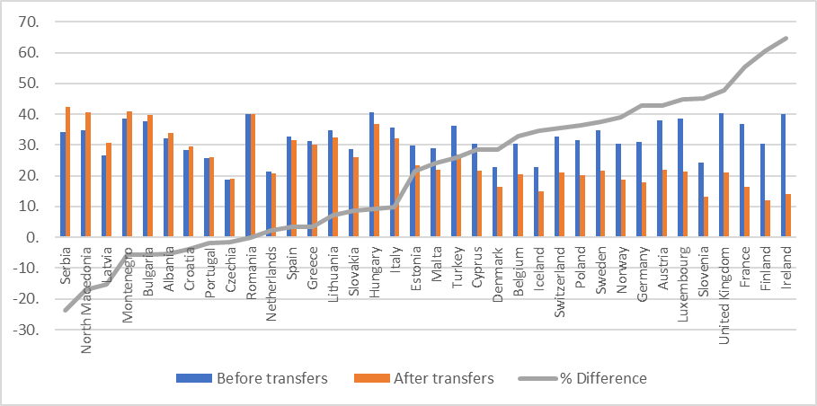

Source: Eurostat, Tables tesov252 and tessi126

An alternative method that can be used[6] for comparing the generosity of transfers for children is to use the OECD Tax-benefit web calculator.[7] Figure 5 gives the percentage difference in the net income a two-child family (with one earner on 60 per cent of the average wage and paying 20 per cent of the average wage in rent) would receive over a childless couple in the same circumstances. It is therefore effectively an indicator of state support in respect of children. There are large differences in the level of support for children in the OECD countries, with the UK providing comparatively quite generous support at this earnings level.

**Figure 5: Percentage difference between the net incomes of a couple with two children and a childless couple, 2020**

Source: Author’s calculations using OECD Tax-Benefit model

Figure 6 shows for the same family the composition of the family benefit package. In the case of the UK it is universal credit (UC) (classified as social assistance by OECD), housing benefit (the housing benefit element of UC) and child benefit. These amounts are expressed as a percentage of average earnings for the country as a method of standardising their value.

**Figure 6: Child benefit package as a % of average earnings for a couple with two children, one parent employed for 60% of the average wage and the other not working, 2020**

Source: Author’s calculations using OECD Tax-Benefit model

**Conclusions**

The UK remains one of the richest countries in the world. This alone should inform policy discussion about what the UK might or might not be able to ‘afford’ when setting the rates of benefits for those of its citizens with low incomes, or none. Such policy discussion is sharpened by evidence that the UK is one of the most unequal among rich countries.

What these comparative data show most clearly is that income poverty is policy responsive. For any nation to reduce poverty among its people, both the labour market and the system of social transfers and benefits should work well and in harmony. In the UK, a liberal market-led economy and government social policy do not combine well compared with many other developed countries. Social transfers in the UK must work extraordinarily hard to overcome large initial inequalities caused by wide disparities in wages, widened by a tax regime less progressive than in most other European countries. Relatively low productivity and an over-reliance on low-paid labour has left the UK a country where for too many workers, the minimum wage has become the maximum wage. Meanwhile, the rewards of educated labour have increased far faster. The real value of social transfers for families with children has fallen since 2010 and is falling further with the benefit cap and two-child limit. Unless these policies are reversed we can expect a further deterioration in the UK's position in the child poverty league table of rich countries.

*Jonathan Bradshaw is Emeritus Professor of Social Policy at the University of York.*

1. The Organisation for Economic Co-operation and Development (OECD) is made up of 38 mostly high-income member countries including much of Europe, the USA, Canada, Japan, South Korea, Australia and New Zealand, plus accession candidates, key partners and regional collaborators. See oecd.org/about/members-and-partners for the full list.
2. The UK data for EU SILC was supplied annually to Eurostat by the Office for National Statistics (ONS) until 2018. The ONS stopped supplying it after that.
3. N Van Mechelen and J Bradshaw, ‘Child benefit packages for working families, 1992–2009’, in I Marx and K Nelson (eds), *Minimum Income Protection in Flux*, Palgrave Macmillan, 2013, pp81-107 and N Finch and J Bradshaw, ‘Family Benefits and Services’, in D Béland, K J Morgan, H Obinger and C Pierson (eds), *Oxford Handbook of the Welfare State*, OUP, 2021
4. J Bradshaw and R Nieuwenhuis, ‘Poverty and the family in Europe’, in N F Schneider and M Kreyenfeld (eds), *Research Handbook on* *the sociology of the family – towards a European perspective*, Edward Elgar Publishing, 2021
5. OECD Family Database Table PF1.1
6. J Bradshaw, ‘Family benefit systems’, in G Bjork Eydal and T Rostgaard (eds), *Handbook of Family Policy*, Edward Elgar Publishing, 2018
7. oecd.org/els/soc/tax-benefit-web-calculator