The Scandinavian element in Leicestershire minor names: a study of East Goscote north of the Wreake

Abstract
In this article, I investigate the Scandinavian contribution to the medieval toponymic vocabulary of an area of northern Leicestershire, the part of East Goscote Hundred north of the River Wreake (Figure 1). Leicestershire – like other parts of the East Midlands – was conquered by Scandinavians during the ninth century and remained under Scandinavian control for about four decades. Many Scandinavian major place-names in the study-area, as in Leicestershire more widely, bear witness to substantial Scandinavian influence on naming in the wake of Scandinavian conquest. Here, I quantify the Scandinavian contribution to the vocabulary of medieval minor placenames from the study-area and compare the findings with those from similar studies. I find that the Scandinavian contribution to medieval microtoponymic vocabulary from the study-area was smaller than that identified in almost all other similar studies. This study thus adds to the growing body of evidence for discrepancies between levels of Scandinavian linguistic input in major and minor placenames. I argue that the discrepancy in the study-area cannot be entirely explained by the different chronological contexts of major and minor name-formation and tentatively suggest that limited non-elite migration may contribute to the low levels of Scandinavian vocabulary in the study-area’s medieval microtoponymy.

Introduction
Barrie Cox’s eight volumes of The Place-Names of Leicestershire, completed in 2019, present, discuss and analyse an enormous number of place-names from the county. Even excluding indices, introductions and element lists, the volumes have just shy of 2000 pages of material on Leicestershire’s place-names. Alongside revised etymologies and discussion of Leicestershire’s major place-names, river-names, road-names and group-names, these volumes make vast numbers of minor and field-names names from Leicestershire, many from unpublished sources, readily available to researchers for the first time. This article celebrates Barrie’s monumental achievement by demonstrating just one way in which this minor and field-name material can be used to investigate questions of interest to place-name researchers. Here, I make use of a method that was – appropriately enough -- first used at scale by Cox himself to investigate chronological and regional variation in the use of Scandinavian vocabulary in field-names from Rutland (Cox 1990). In his 1990 paper, Cox sought to investigate whether there was significant Scandinavian influence on Rutland’s minor place-names, despite the lack of much Scandinavian influence on the county’s major place-names. In this article, the same method is applied to an area of north-east Leicestershire where, in contrast to Rutland, Scandinavian major place-names are far from uncommon. This is the part of East Goscote Hundred north of the River Wreake in north Leicestershire (Figure 1).

Anglo-Scandinavian Leicestershire
Scandinavian influence on naming, language and identity in Leicestershire has its origins in the period of Scandinavian raiding, conquest and settlement in Britain during the late eighth and ninth centuries. In England, was to lead to the development of an area of northern and eastern England later known as the Danelaw where there was extensive Scandinavian influence on naming, language, material culture and legal customs. After an initial period characterised by raiding activities, the arrival of the so-called ‘great army’ (OE micel here) in England in the second half of the ninth century signalled a change in the scale and intent of Scandinavian activity in England. In this period, Scandinavian presence became both continuous – as marked first by overwintering in 851 – and following the arrival of great army in 865, of a much greater scale (Bately 1986: 44; Naismith 2021: 223). There is evidence for both winter camps and more temporary occupation not far beyond Leicestershire’s northern border. Repton, in Derbyshire but not far from the Leicestershire border, is now well known as the site of a great army camp and finds from other sites along the Trent also bear the hallmarks of the great army’s presence (Hadley and Richards 2018: 9–10). This great army had substantial military successes in England. Each of the major kingdoms of early medieval England was attacked between 866 and 871 and only Wessex managed to retain political independence.
English control of Mercia, the kingdom in which Leicestershire was situated, did not survive these events unscathed. The first historical reference to permanent Scandinavian settlement in Leicestershire is almost certainly contained within the Anglo-Saxon Chronicle’s entry for the year 877, which records the sharing out of parts of Mercia by the Scandinavian great army: ‘and then at harvest-time the army went into Mercia, and they divided some of it up, and some of it they gave to Cēolwulf’. Given the place-name, archaeological and later textual evidence for a Scandinavian presence in the East Midlands, the division referred to here is understood as that been between the East and West Midlands, with Leicestershire within the area of Scandinavian control. Eventually, after periods of contested and shifting political control over the area, Leicestershire was subsumed into the expanding Kingdom of the Anglo-Saxons, later the Kingdom of the English, by 942 as famously recorded in the poem known as the ‘Capture of the Five Boroughs’ in the Anglo-Saxon Chronicle (Bately 1986: 73; Cubbin 1996: 43; O'Brien O'Keefe 2001: 79–80; Taylor 1983: 53). Nevertheless, Scandinavian political dominance had lasted at least four decades.
In the context of this evidence for Scandinavian political control of Leicestershire in the late ninth and early tenth century, there are substantial numbers of Old Scandinavian and Anglo-Scandinavian place-names in Leicestershire (subsequently both referred to as ‘Scandinavian’). Figure 2 shows major place-names that either include Old Scandinavian place-name elements or that are English names whose pronunciation has been altered by Old Scandinavian speakers. The inset map gives contextual information about the distribution of early Domesday vills in Leicestershire for comparison. Shading on both maps shows where the different settlement-types cluster. As can be seen, Scandinavian place-names are widely distributed across the county. There are areas where a lack of Scandinavian place-names reflects the lack of settlements generally – as for instance around Charnwood Forest in north-west Leicestershire – and areas where Scandinavian place-names are markedly rare (e.g., along the south-west boundary of the county) despite there being many Domesday vills. Conversely, there are areas where there are noticeable clusters of Old Scandinavian names, especially in the Wreake Valley in north-east Leicestershire and in the north-west of the county towards the Derbyshire boundary. It is worth discussing the types of Scandinavian major place-names that are found. Figure 3 shows Scandinavian place-names categorised by name type. This map shows that indisputably Scandinavian major place-names are distributed widely. None of the clusters of Scandinavian place-names identified above consists only of names whose Scandinavian content is uncertain and none consists only of elements like OScand þorp ‘outlying farmstead,’ known to have been used in its Old Scandinavian derived/influenced form over a long period in English place-naming (Cullen, Jones et al 2011: 146 and 56).The map also shows that the major place-names already provide evidence of name formation in a mixed Anglo-Scandinavian milieu. The býr-names with English qualifiers which are frequent in the west of Leicestershire, but by no means rare in the east, are a good example of this. In summary, major place-names suggest Old Scandinavian was both widely spoken and spoken by communities in linguistic and cultural contact with Old English speakers.
In this context, it is intriguing that evidence for Scandinavian and Anglo-Scandinavian material culture is less impressive than elsewhere in England. Figure 2 (from Dale 2020) shows finds in the Portable Antiquities Scheme’s database classified as ‘Viking’ (in blue) or ‘Anglo-Scandinavian’ (in red). As can be seen, culturally Scandinavian or Anglo-Scandinavian finds are widely distributed in Leicestershire. However, finds of (Anglo-)Scandinavian metalwork from Leicestershire – and the East Midlands generally – appear to be much lower than in areas of Lincolnshire, Norfolk and Yorkshire (Kershaw and Røyrvik 2016: 1677 (Figure 3)). In Lincolnshire and Norfolk in particular, the scale and nature of culturally Scandinavian material culture has been interpreted as indicative of migration – female as well as male – on a scale that cannot be explained by settlement only by the military elite of the great army (Kershaw 2013: 245–47). Discrepancies in numbers of metalwork finds, mainly found by metal-detectorists, and the reporting of such finds vary greatly from county to county according to land-use and recording infrastructure. However, these factors alone do not explain the lack of recorded (Anglo-)Scandinavian artefacts from Leicestershire where there is no general dearth of artefacts recorded in the Portable Antiquities Scheme database (Kershaw 2013: 187 and 96–99). Kershaw’s study was based on data collected up to 2008 (Kershaw 2013: 5) and it is possible that finds recorded subsequently may modify this impression. However, as it stands, there are substantially fewer indications of non-elite and female metalwork from Leicestershire than from counties further east.
In this study, I am focussing on one small area of Leicestershire, the part of East Goscote Hundred north of the River Wreake. This area was selected principally as it was expected that this would be an area where there would be substantial use of Scandinavian-derived vocabulary in medieval microtoponyms. The Wreake valley has previously been identified as an area where numerous Scandinavian place-names, both major and minor, bear witness to particularly extensive Scandinavian linguistic influence on English names and dialect.

Investigating the Scandinavian element in microtoponymy
Several studies have previously investigated Scandinavian-derived vocabulary on English minor names, whether discussing the use of particular elements (e.g. Briggs 2019), highlighting the extent of Scandinavian influence on naming (e.g. Cameron 1978; Cameron 1996; Wainwright 1945–46: 87–101) or investigating differences between names in different geographical areas (e.g. Fellows Jensen 1974). There are, however, only six studies that have investigated the Scandinavian contribution to minor name vocabulary using quantitative approaches that allow findings from different corpora of names to be compared. These studies of minor and field-names are: Hald’s study of 80–90 names from Benniworth, Lincolnshire (Hald 1948: 24–28); Cameron’s (1973) study of 74 names from Dunholme, Lincolnshire; Cox’s (1990) county-wide study of Rutland field-names; Watts’ (2002) study of ‘250 or so’ field-names from Billingham and Wolviston, County Durham; Parsons’ (2006) study of two pairs of Norfolk hundreds, East and West Flegg (approximately 550 names), and Holt and North Erpingham (approximately 400 names); and Rye’s (2016) study of Wirral, Cheshire (more precisely, the Domesday hundred of Wilaveston; 549 names) and the West Ward of Westmorland Barony (henceforth ‘West Ward’; 538 names). The areas investigated in these studies are shown in Figure 5.
These studies are similar in approach: all take a defined corpus of names and determine the relative contributions of Old Scandinavian and Old English to the toponymic vocabulary being investigated. Most studies also present data in such a way that gross totals of elements occurring (a tokens-based count) either are or can be distinguished from the numbers of different elements occurring (a types-based count). The latter count-type is preferred in this article as it avoids results being skewed by the frequent occurrence of a handful of very frequently used elements (e.g. OE furlang ‘furlong’ or OScand holmr ‘island, water-meadow’). A summary of the findings of the existing studies of the Scandinavian component of medieval field-naming vocabulary is presented in Table 1 (results for Rutland are presented selectively). The results are shown graphically as Figure 6, the left-hand side of which presents published results from the different study areas ordered by the Scandinavian contribution to toponymic vocabulary (results for just two Rutland parishes are shown). As can be seen, the proportions of Scandinavian- to English-derived vocabulary found in the different study-areas vary greatly, from 7 : 93 in Lyddington (Rutland), to 69 : 31 in Benniworth (Lincolnshire). Minor names from Lincolnshire and the West Ward contain far higher proportions of Scandinavian-derived elements relative to English-derived elements than names from other areas, which accords well with areas where Scandinavian influence on non-toponymic languages is greatest (Samuels 1985). However, there is considerable variation in the scope and dates of material included, and there are also differences in the decisions made about element etymologies. Adjusted results which level out some of the differences in material investigated and differences in classification of elements, are shown as Table 2; adjusted results are presented (alongside non-adjusted results marked with an asterisk) as the right-hand side of Figure 6). The merits of the different approaches to selection of names – and the extent to which they affect comparison of the findings of these studies with each other – are assessed in the remainder of this section.
The first major difference between the studies concerns the date of the names investigated. Hald and Cameron’s Lincolnshire studies include the earliest material. Hald analyses names recorded from a single document, a cartulary copy of a diploma he dates to the late 12th or early 13th centuries (Hald 1948: 25). Cameron’s material is from more varied sources, but all names are first recorded between the late 12th century and 1272 CE (Cameron 1973: 39–41). Two studies cover material recorded later in the medieval period. Parsons’ Norfolk studies include material recorded between 1100 and 1400 CE (Parsons 2006: 166). Rye’s studies of names from Wirral and Westmorland analysed names recorded by 1500 CE, but also included analysis of names by the century of first attestation (Rye 2016: 183, 291, 192–93 and 298–99). Watts’ study of names from two Co. Durham’s parishes covers names recorded over the most extended period, between the early thirteenth century and the second half of the seventeenth century. Finally, Cox’s study of Rutland field-names covers names recorded by century cumulatively at century intervals between 1300 and 1600 CE, allowing diachronic change to be identified (Cox 1990: 7). There are merits to both narrow and broader chronological focusses. The chronologically narrow selections of names made by Hald and Cameron provide a snapshot of toponymic vocabulary for narrow time windows but cover smaller bodies of material. Conversely, the other studies’ chronologically broader selections of names mean that findings are less focussed on a narrow period of time, but more material can be included in the analysis.
These differences in dates of material mean that comparison of the findings will not be comparing like with like: Hald and Cameron’s studies cover names recorded in the early Middle English period, Parsons and Rye extend into the late Middle English period, and Watts and Cox cover material recorded in both the Middle and Early Modern English periods. These disparities in chronological focus mean that differences between the studies’ results may reflect diachronic as well as diatopic differences in toponymic vocabulary. This may affect the results: Rye (2016: 198) found indications that the relative proportions of toponymic vocabulary of Scandinavian origin decreased over time in both her Wirral and West Ward case-studies. However, some adjustments can be made to aid comparison between the studies. The studies including material dating from after 1500 both allow names recorded later than 1500 to be excluded; this was done silently in the presentation of Cox’s findings in Table 1 and is done as part of the adjustments made to Watt’s results for Billingham and Wolviston in Table 2. However, the chronological range of the other studies cannot be adjusted.
Another important difference between the studies concerns the elements included in the analysis. Several studies only analyse generic elements, namely the studies of Benniworth and Dunholme (Lincolnshire) and the studies of the Norfolk hundreds of (East and West) Flegg and Holt and North Erpingham, which analyse all generics but only present material for recurrent generics in full. Other studies analyse all elements in the names. Watts analyses and counts qualifiers and generic separately in the study of the County Durham parishes of Billingham and Wolviston. Cox and Rye both analyse all material and present results as combined figures for all element types. In addition, the authors of the studies that include qualifiers differ as to whether they include personal names in the element counts: they are included in the studies for Rutland, Wirral and the West Ward but not in the study of the County Durham parishes of Billingham and Wolviston.
There are advantages to both focussing on generics and including all elements in the names. There are practical advantages to analysing only generics as the more limited range of generics occurring (see Table 3 below) and, relatedly, their repetitive nature means they are easier to identify; the difficulties of distinguishing personal names from toponymic elements proper also do not occur (Parsons 2006: 167). The trade-off is, of course, that the material available for analysis is drastically reduced by considering only generics, not just in terms of absolute numbers but also in terms of the parts of speech represented since adjectives and numerals would not typically occur as generics. Conversely, including all element-types provides information that is somewhat more representative of wider language use (though of course still far from representative), but more time-consuming and prone to error. The wider range of information provided by including all elements is considered here to outweigh the additional difficulties the analysis of this material presents and so qualifiers have been included in the adjusted figures presented here where feasible. Personal names, however, have been excluded. Names are much more easily transferred between languages, probably in large part due to their lack of sense (Sandnes 2016: 540–41). Personal names may thus behave differently from toponymic vocabulary proper and, as this is the focus of this article, personal names have been excluded from the adjusted results where possible.
Again, adjustment to elements included in the analysis was possible for studies which present data in full. Lists of qualifiers and generics were combined and recounted for Watts’ study of the parishes of Billingham and Wolviston (Co. Durham). Qualifiers were also included for names from Dunholme (Lincolnshire), using the EPNS Survey volume for the area for etymological guidance (PNLi 7: 41–47). However, analysing qualifiers for Benniworth (Lincolnshire), in which the author neither analysed the material in the article, nor in a subsequent publication, was beyond the scope of this article. Similarly, it is beyond the scope of this article to adjust the results for the Norfolk studies by redoing the studies to include elements not presented in the article. The data analysed in Rye (2016) was also recounted with personal names removed from the counts.
Finally, the different studies differ in the source languages to which elements have been assigned. Distinguishing between vocabulary deriving from Old English and Old Scandinavian is difficult and often impossible because of a combination of the close genetic relationship between the two languages (e.g., OE hwīt and ON hvítr ‘white’) and the difficulty of distinguishing particular sounds in Middle English orthography (e.g., the use of <gg> for both /g(g)/ and /ʤ/). In some cases, a likely source in one language or the other can be narrowed down by considering toponymic usage in non-Scandinavian England and elsewhere in the Scandinavian Sprachraum. However, many elements remain indistinguishable in English- and Scandinavian-derived forms and all studies discussed here include this as one of the options for linguistic classification. The uncertainties involved in making these decisions -- similar to those termed ‘inherently probabilistic’ in a consideration of the same problem for lexical items (Dance 2018: 40) -- mean that no study classifies elements identically. To aid comparison of results, the linguistic classification of elements has been adjusted where possible in line with the classifications made in the Leicestershire analysis.
Most adjustments to results have resulted in proportions of Scandinavian-derived vocabulary being adjusted by only one or two percent. However, inclusion of qualifiers, or pooling of qualifiers and generics, has resulted in more substantial changes. The County Durham parishes had a lower proportion of Scandinavian-derived vocabulary amongst qualifiers than generics, and the inclusion of qualifiers has thus contributed to a lower proportion of Scandinavian vocabulary in the adjusted figures for the County Durham parishes in which counts for qualifier and generic elements are combined. Including qualifiers also explains the lower proportion of Scandinavian-derived elements in the adjusted results for Dunholme. This raises the question of whether there might be different proportions of Scandinavian- and English-derived elements in different positions in medieval minor names. However, as shown in Table 3, there does not seem to be such discrepancies between the proportions of Scandinavian-derived vocabulary used in qualifiers and generics in the larger-scale Wirral and West Ward studies. It is therefore unclear how widely vocabulary of different linguistic origins occurs in different proportions amongst qualifier and generic elements, particularly since one study showing such findings (Dunholme) was based on a small collection of names. This is a matter that is considered further in the analysis of Leicestershire names below. Overall though, and reassuringly in terms of the comparability of the different approaches to element choice and linguistic classifications, adjustments have not altered the overall pattern of results significantly: names from Lincolnshire and the West Ward still contain the highest proportions of Scandinavian-derived elements relative to English-derived elements despite revisions to the linguistic classification of elements and the inclusion of additional material (i.e., qualifiers).
This article applies the same methodology to field- and minor names from part of north-east Leicestershire. Analysing this body of material allows for the geographical range of this study-type into an area of Scandinavian activity and settlement in the East Midlands that is neither an area where Scandinavian influence is thought to be particularly low, as in Rutland (Cox 1989; Cox 1990), nor particularly high, as in Lincolnshire. With this in mind, the principal question this article will address is that of the size of the Scandinavian contribution to the late medieval toponymic vocabulary of the study-area. It is envisaged that the proportion of the vocabulary of Scandinavian origin will be higher than in areas with minimal evidence for Scandinavian activity and settlement (Rutland), but lower than that areas within Samuel’s ‘great Scandinavian belt’ (northern Lincolnshire and the West Ward). The study will also investigate diatopic variation within the study-area; it is anticipated that there will be variation, as in existing studies which have investigated this question (Cox 1990; Rye 2016).
This study has two subsidiary questions. Firstly, the study investigates whether there are diachronic differences in the proportions of Scandinavian vocabulary used in names first recorded at different points in the late medieval period. It is suspected, from comparison with the decline observed over time in Wirral and West Ward, that there will be some decline in the proportion of Scandinavian vocabulary used in forming later-recorded names. Secondly, this study investigate whether there are differences in the proportions of toponymic vocabulary of Scandinavian derivation in different structural elements (i.e., qualifiers, generics, affixes) within the names investigated. Existing field- and minor name studies paint a mixed picture in this respect, but the larger scale studies do not show a marked distinction between the make-up of qualifiers and generics, which is what would be expected from an a priori assumption that qualifiers and generics would have been selected for use in name-formation at the same point in time for many names (i.e. compound names). However, the same may not be true of elements added later to pre-existing names (cf. Fellows Jensen 1974: 51–52). (Note the differences between the proportions of affixes that are of Scandinavian origin compared with the proportions of qualifiers and generics of Scandinavian origin in Table 3 above.) Here, it is anticipated that there may be indications that affixes belong to a later layer of naming than the names they were added to

Data and methods
In making decisions about the data to analyse in this investigation of Leicestershire minor names, the approach followed here is to maximise the data included but to allow for investigation of factors like time and element-type that might be masked by analysis of the dataset as a whole. Thus, this study steers a middle course between the broad and narrow chronological approaches. All names recorded in what can (broadly) be considered the Middle English period (i.e. names recorded by 1500 CE) are included. Alongside this, information about the century of first attestation has been recorded to allow any diachronic differences in the composition of the minor name vocabulary to be discerned (following the approach used by Rye 2016). In terms of elements included in the analysis, qualifiers, generics and affixes have been included to maximise the range of elements and word-classes included, but information about where in a name an element is used has been recorded, to enable investigation of different patterns of usage in different element-types. Personal names (and other names, especially pre-existing major place-names) are excluded because of the likelihood of different behaviour from toponymic elements proper.
The data investigated in this study consists of minor place-names from the part of the Hundred of East Goscote north of the River Wreake recorded before 1500 CE. The categorisation of a place-names as a minor name follows the decisions made in PNLei 3: a name was considered to be a minor name if not presented as one of the ‘names of primary historical or etymological interest’ (PNLei 3: xvii); in effect, the overwhelming majority of the material comes from the field-name sections of the Survey volume. Any minor place-name or included in PNLei and recorded before 1500 was included in the study (with one exception). Names recorded only in Latin before 1500 were excluded from the analysis, because of the impossibility of determining the underlying vernacular forms, if any. Minor place-names that met these criteria were recorded in a database with information about: location at township level; date of first attestation; place-name elements in the names; medieval (pre-1500) attestations, their dates and the sources they were taken from. Existing names, both personal names and place-names, found as qualifiers in the minor names were not assigned to a language and so were excluded from the statistical analysis. In total, 522 distinct names were included.
At the point of recording names in the database, the languages of origins of place-name elements in the names were reassessed. The relatedness of Old English and Old Scandinavian means that reflexes of words from the two languages can very often not be distinguished. For instance, it cannot be decided whether ME smith ‘a smith’ derives from OE smið or ON smiðr, as both would yield ME smith. As in other studies investigating the relative Old English and Old Scandinavian contributions to minor name vocabulary, elements like ME smith were categorised as of ambiguous Old English or Old Scandinavian origin. In many cases, the decision to categorise elements as indistinguishable between Old English and Scandinavian derived forms is less self-evident than for ME smith as it involves some or all of: investigation of the evidence for possible etyma in Old English and Old Scandinavian; reconstruction of Viking Age Scandinavian forms where these would have differed from the forms of the earliest Old Scandinavian manuscripts; assessment of how Old English and Old Scandinavian forms would develop between the Viking Age and the late medieval period; and consideration of how elements borrowed from Old Scandinavian containing phones not found in Old English would have been adapted during the process of transfer into English. Decisions about elements’ linguistic origins were in many cases more cautious than those made in PNLei. For instance, the qualifier stac- in Stacfurlang’ (13th) in Cossington is interpreted as deriving from OE staca ‘a stake’ in PNLei (3: 68), but OScand stakkr ‘a stack, a rick’ (given as an element in other names in East Goscote Hundred; PNLei 3: 345) is also a plausible element so this element was classified as ambiguously derived from OE staca or OScand stakkr. Justification for classifications made cannot be set out in detail here. However, classifications largely follow arguments made in previous discussion of this topic (Coates 2006; Dance 2003: 68–103; Dance 2018; Rye 2016: 35–142) and are provided for transparency in the results section below.
Decisions also had to be made about how to classify elements deriving from multiple language. ME cross(-) demonstrates this kind of formation. In the survey volume, elements like cros(s) in Croslandes (post 1290) in Cossington are assigned to the Middle English adjective cross ‘athwart, lying across, crosswise’ (PNLei 3: 65 and 299). The root here, in phonetic form at least, is OScand kross (n.) ‘a cross’, but the adjectival use if not thought to be the development of an adjective from the noun alone (by zero-derivation). Instead, adjectival use of cross in this sense is usually derived (via the adverb ModE cross) from ME acrois (< ME a, reduced form of the preposition on + ME cros n. ‘a cross’), itself perhaps a loan-translation of Old French en croix (OED s.v. across, adv., prep., and adj.). The specifically Middle English context for the formation means that the element has been classified here as Middle English, despite the presence of some Scandinavian input.
Once names had been recorded in the database, and linguistic classifications of elements had been finalised, analysis of the dataset was carried out by querying the database to retrieve elements sorted by language of origin, date of first attestation and location. The following queries were performed. Firstly, a count was made of the total numbers of elements (including repeated elements) drawn from different languages (i.e., a token-based count) for all names in the study-area. Secondly, an assessment of the variety of vocabulary drawn from each language for all names in the study-area was made by running a query to determine the number of different elements (i.e., a type-based count). This type-based count was used for the third to fifth analyses, which assessed the variety of elements from different languages by the century of first attestation of the name, by civil parish, and by structural position within the names to assess diachronic, diatopic and structural variation in the composition of toponymic vocabulary.

Results
The area of Leicestershire selected for investigation includes, in the east, parts of the Wreake Valley where there are many Scandinavian major place-names, but also extends west to an area where there are not very many Scandinavian major names. It was suspected that the proportion of toponymic vocabulary derived from Old Scandinavian would be highest in the east of the study area – probably higher than in areas more peripheral in terms of Scandinavian settlement and influence on vocabulary like Wirral and County Durham -- but would drop off towards the west. It was also suspected that the proportion of toponymic vocabulary of Scandinavian derivation might decline over the Middle English period as this has been observed in previous studies of medieval minor name vocabulary. While the results support the hypotheses about a decline in the use of Scandinavian-derived vocabulary over time and greater use of Scandinavian-derived vocabulary in the east of the area, levels of Scandinavian-derived vocabulary were lower than expected.
Tables 4 and 5 show summaries of the linguistic origins of elements according to the century in which names were first recorded. Table 4 shows results for different elements (a types-based count) and Table 5 shows results for all elements (a tokens-type count). Elements in the names and the linguistic classifications made are given in the appendix. Beginning first with the results for all centuries, it is apparent that the proportion of different Scandinavian-derived vocabulary relative to English-derived vocabulary is lower than most similar studies when considering different elements (14 Scandinavian derived elements to every 86 English-derived elements). Considering all elements does not change the proportions much (13 Scandinavian derived elements to every 87 English-derived elements), presumably as there are only a few Scandinavian-derived elements that occur frequently (namely vangr with 17 occurrences, holmr with 15 occurrences and gata with 10 occurrences) while most other elements occur just once or twice. Comparison with results from similar studies (Figure 7) shows how low the proportion of Scandinavian-derived vocabulary is: it surpasses proportions of Scandinavian-derived vocabulary from Lyddington (Rutland) but not Wirral, the County Durham parishes of Billingham and Wolviston or Oakham (Rutland). This is surprising for an area where Scandinavian influence on major place-names is extensive.
There are indications that these results for the period up to 1500 CE mask some variation over time, Breaking the evidence down in century time-slices shows a decrease in the use of Scandinavian-derived elements relative to English-derived elements between the twelfth and fifteenth centuries. Numbers from the twelfth century are small and may not be representative of wider usage, but the decline in the proportion of Scandinavian derived vocabulary in the fifteenth century looks real enough. However, this fifteenth-century decline cannot explain why the proportion of Scandinavian-derived vocabulary is so low. Recounting elements after excluding names first recorded in the fifteenth century and names recorded at an uncertain date resulted in a rise in the ratio of Scandinavian-derived to English-derived vocabulary, but only to 16 : 84 (Table 6). The variety of Scandinavian-derived vocabulary in names recorded before the fifteenth century does not therefore appear much greater.
Looking at the vocabulary used by civil parish shows that there is geographical variation in the use of Scandinavian-derived vocabulary. Table 7 summarises the etymological origins of toponymic vocabulary by civil parish. Ratios of English- to Scandinavian-derived vocabulary were calculated for all parishes but those for parishes with fewer than twenty-five different elements in names recorded before 1500, shown in parentheses, are based on very little data. Results for parishes with twenty-five or more different elements recorded by 1500 are mapped in Figure 8. The proportions of Norse-derived elements relative to English-derived elements are higher in eastern parishes and drop considerably further west. However, even in the east of the area, the ratio of Scandinavian- to English-derived vocabulary is 18 : 82. Even in these parishes, results are more comparable with those from the County Durham and Wirral studies than with nearby Lincolnshire.
Looking at the languages of elements according to their structural position showed that there are differences in the composition of qualifiers, generics and other elements (i.e. affixes). Table 8 shows a summary of the linguistic origins of elements used in different positions in names. As can be seen, a higher proportion of generic elements are of Scandinavian origin than qualifier elements or affixes. For comparison with Parsons (2006), these figures were also calculated for names recorded by 1400 CE (Table 6) meaning the results for generics can be directly compared with the Norfolk hundreds. The ratio of Scandinavian- to English-derived generics of 20 : 80 remains lower than comparable findings for Flegg (28 : 72) and Holt and North Erpingham (24 : 76) (Parsons 2006: 170 (Table 1)). It seems therefore that there is greater use of Scandinavian-derived vocabulary in generic elements, but still not on the scale of the Norfolk study-areas. Larger scale studies would be needed to assess whether the linguistic origins of qualifiers and generics are significantly different. However, one factor that could explain the higher proportion of Scandinavian-derived generics observed in this study might be greater linguistic conservatism in generic elements, given the decline in the proportion of Scandinavian-derived vocabulary used over time in the study-area.

Concluding discussion
The most important finding from this study of part of Leicestershire is that the variety of Scandinavian-derived vocabulary relative to English-derived vocabulary is much lower than was expected. Analysing the data by century and by civil parish showed that that there was a more limited range of Scandinavian-derived vocabulary used in the west of the area and that there was a decline in the proportion of Scandinavian-derived vocabulary used over time. However, these trends alone do not explain why the proportions of Scandinavian-derived vocabulary are lower than in Lincolnshire, or the West Ward: looking at parishes in the east of the area in isolation, and excluding names first recorded in the fifteenth century did not result in differences from the overall findings of more than a few percent. Intriguingly, a greater proportion of generics were of Scandinavian origin than qualifiers or affixes. However, even accounting for methodological differences with a similar study for parts of Norfolk (Parsons 2006) by considering generics only in names recorded by 1400 CE, the proportion of Scandinavian-derived vocabulary remains lower than in the Norfolk hundreds of Flegg and Holt and North Erpingham.
This study provides another piece of evidence towards the ‘contoured medieval field-name map’ that Parsons (2006: 177–78) hoped might one day be available for the whole Danelaw. This study also adds to our understanding of how such a map might look overall and how colours on such a map might be calibrated. It appears from two small-scale studies of Lincolnshire field-names and a larger scale study of field-names from the West Ward (Westmorland) that proportions of Scandinavian-derived vocabulary of 50 % or higher will be the upper end of the scale; larger scale studies of Lincolnshire names would clarify what an upper limit might look like. This study’s findings suggest that we might have to rethink how the East Midlands (excluding Lincolnshire) might look on such a map. If this study’s findings are typical of other areas of the East Midlands (excluding Lincolnshire), then Norfolk might emerge as an area where Scandinavian-derived vocabulary constituted a relatively higher part of the medieval minor naming vocabulary than much of the East Midlands. Studies on a similar or larger scale of neighbouring parts of the East Midlands – especially Nottinghamshire and the parts of Framland Hundred between the Leicestershire study-area and Lincolnshire – would provide valuable points of comparison.
This study is also another example of a study of minor naming vocabulary where the findings differ substantially from what was expected from major name evidence. In the Wirral study, the Scandinavian contribution to vocabulary in minor names was lower than expected from the area’s major place-names (Rye 2020). Conversely, in the Norfolk Hundreds of Holt and North Erpingham, the Scandinavian contribution to vocabulary in minor names was higher than expected from the area’s major place-names (Parsons 2006: 172–73). The implication of this is that differences in levels of Scandinavian influence on the vocabulary of major and minor place-names may not be unusual.
On one level, this can be unproblematically explained by considering the contexts for the formation of major and minor place-names. In general, major names represent an earlier period of name-formation and one that, for Scandinavian major place-names, is much closer to the period of Scandinavian settlement. Minor place-names, known to fewer people and less frequently recorded in administrative records, are less stable and therefore generally of later date (for discussion of this issue, see Gregory 2018: xxiv–xxv; Parsons 2006: 166; Rye 2016: 26–30). We can account for discrepancies, then, by saying that the use of Scandinavian-derived vocabulary differed in (earlier) major place-names and (later) minor place-names. Indeed, results of studies like this one are now understood to be indicative of vocabulary usage in the Middle English period that reflects, but only indirectly, the vocabulary of populations some centuries earlier (Parsons 2006: 166).
Additionally, there may also be a social distinction to be drawn between groups responsible for the formation of major and minor place-names. It is usually – and reasonably – assumed that minor place-names were mainly given by those who worked the land, i.e. farming communities. The use of Scandinavian vocabulary by later medieval farming communities may therefore be an indicator of the presence of earlier Scandinavian-speaking farming communities – not just a small military elite – responsible for introducing Scandinavian vocabulary into the local naming vocabulary (Abrams and Parsons 2004: 402–03). Scandinavian major place-names do not require the presence of Scandinavian-speaking farming communities. So, whilst extensive Scandinavian influence on minor name vocabulary implies the presence of a Scandinavian-speaking farming community at an earlier date, the same is not necessarily implied by extensive Scandinavian influence on major names.
Where there is no discrepancy between Scandinavian influence on major and minor names, as in areas of Lincolnshire with high numbers of býr-names, the Scandinavian-speaking farming communities implied by highly Scandinavianised medieval field-names have been linked with Scandinavian-speaking communities implied by Scandinavian major names (Abrams and Parsons 2004: 402–03). However, explaining why there should be discrepancies in this respect between major and minor names is more difficult. Considering Norfolk may be particularly informative. In Norfolk, Scandinavian influence on major place-names is substantial in Flegg but less extensive elsewhere than in areas like Leicestershire (Abrams and Parsons 2004: 415; Smith 1956: map 10). However, the minor names tell a different story and, importantly, so does other evidence. The number and widespread distribution of typically Scandinavian female dress accessories from Norfolk has been plausibly interpreted by Kershaw as indicative of substantial levels of female migration well into the tenth-century (Kershaw 2013: 247). At these dates, whilst presumably initially related to Scandinavian control of East Anglia, these findings must be indicative of ongoing, non-military settlement. And presumably, migration may not have been restricted to women (though that is who the evidence considered in Kershaw’s study can tell us about). Thus, in Norfolk, there is evidence highly suggestive of large-scale, mixed immigration from Scandinavia which would not be suspected from the county’s major place-names. Such a migration might, however, have left more of a trace in the county’s medieval microtoponymy.
Returning to Leicestershire, the opposite seems to be the case. In Leicestershire, the major names show extensive Scandinavian input, though influence on medieval microtoponymy and, perhaps, female dress accessories and other indicators of Scandinavian cultural practices is not on the same scale as in Norfolk (though more up-to-date studies of the artefactual evidence are required). It would be possible to explain the low levels of Scandinavian vocabulary used in late medieval minor names from Leicestershire relative to the major names through extensive anglicisation of vocabulary between the late ninth or tenth centuries and the late medieval period. However, the levels of Scandinavian vocabulary observed in the earliest (twelfth-century) minor names from the study do not show levels of Scandinavian vocabulary usage that would indicate that this alone explains the discrepancy. Arguing from an absence of evidence is very speculative indeed. However, it may be worth considering a situation where Scandinavian land ownership in the wake of Scandinavian conquest is represented by the major place-names of Leicestershire, but that this was not accompanied by non-military migration on the same scale as in Norfolk. Such a situation could explain the lower levels of Scandinavian-derived vocabulary in medieval minor naming in Leicestershire than in Norfolk or Lincolnshire.
Returning to surer ground, what is clear is that close study of minor names from the Leicestershire study-area reveals that the vocabulary used in medieval minor names owed less to Old Scandinavian that we would suspect from the area’s major place-names. Collectively, this study and others like it highlight the extent of local variation in the effects of Scandinavian settlement on local naming vocabulary by the later medieval period.
This research only been possible thanks to the impressive body of names and analysis available in the Place-Names of Leicestershire and the author is to be congratulated on his momentous achievement in completing these volumes!

Appendix: elements in the study-area names
Other than the re-classification of elements as ambiguous in origin between Old English and Old Scandinavian etyma, the main changes to the linguistic classifications of elements concern those classed as Middle English in PNLei. Because the purpose of this study is to investigate the etymological origins of Middle English period vocabulary, elements classified as Middle English have been assigned instead to Old French where appropriate, or to an earlier stage of English if either attested in Old English, or if the morphemes within the elements are recorded in Old English even if the compound/derived form is not. However, elements whose etymologies require input from multiple languages and elements formed within English from elements that could derive from either Old English or Old Scandinavian have been classified as Middle English. Deviations from classifications made in PNLei (3: 284–58) are indicated in footnotes; numbers of occurrences for Old Scandinavian-derived elements are shown in parentheses after the elements.

Middle English (20 elements)
atte, bord-land, breche, brend, *bur-blade, butte, croked, *cros (adj.), dimming, flagge, gonele, goule, laie, levyngs, nōk, plot, stint, þe, tit, walke-milne and whinny.

Old English (151 elements)
abbod, abūfan, æppel-trēow, æsc, ān, ān-setl, bærlic, *bānig, bēan, beneoðan, bere-ærn, betwēonan, bī, botm, brād, *brēme, brēmel, brocc-hol, brocen, brōm, butere, byden, calc, clǣg, *coppede, *corf, croft, cwacian, cȳta, dāl, dead, (ge-)delf, derne, dora, draca, ēast, edisc, ellern, feld, fisc, (ge-)flit, ford, fore, fox, fox-hol, furðra, furh, furlang, gandra, gāra, geard, geoc glæppe, gold, grǣg, grāf, great, (ge-)hæg, haga, hald, hālig, *hāmere, hassuc, hēafod, hēafod-land, hēah, heard, henn, hlǣfdige, hōc, hrēod, hulfestre, hūne, hwǣte, hyll, in, *læcc, lǣs, lane, lēah, mǣd, (ge-)mǣne, māra, mere, mere-steall, mersc micel/mycel, middel, munuc, myl(e)n, mylen-weard, nearu, nest, nīwe, ofer³, on, orceard, peru, pirige, pise, *plæsc, port, prēost, *pyndere’, pull, read, risc/*rysc, rōd³, *ric, *ryde, ryding, ryge, saltere, sceard, scearp, sc(e)ort, scēp, scofl, secg, seofon, *set-copp, six, slæd, *sōg/*sōh, spearwa, stān, stānig, stede, stōd, strǣt, stream, *swæð, tǣsel, tēag, þrēo, twelf, (ge-)wæd, wæter, wæterig, wald, wall, weard, wer, wīd, *wiht, wilig, wiligen, *wisse and wudu.

Old English/Old Scandinavian (94 elements)
æcer/akr, æspe/ǫsp, balca/balkr, *ball/bǫllr, beorg/berg, bjarg, blæc, blāc/blakkr, boga/bogi, brant/brantr, OE/ODan *brince/*brinc(a) ‘brink, edge’, brōc/*brók, brycg/bryggja, *busc/*buskr, cāl/kál, catt/kǫttr, cald/kaldr, clif/klif, cnoll/knollr, cocc/kokkr, cot/kot, *crōc, crocc/krókr, cū/kýr, dæl/dalr, damm/dammr, dēop/djúpr, dīc/dík, dynge/dyngja, ende/endi, (ge-)fall/fall, fenn/fen, fōt/fótr, fūl/full, geat/gata, gōs/gás, grēne/grœnn (adj.), grēne/grœnn (n.), haga/hagi, hagu-þorn/hagþorn, hall/hǫll, hals/hals, hār/hár, hærg/hǫrgr, heort/hjǫrtr, hōh/haugr, hol/hol (n.), hol/holr (adj.), hors/hross, hungor/hungr, hwerfel/hvirfill, hyrne/hyrna, lamb/lamb, land/land, land-gemǣre/landa-mǽri, lang/langr, līm/lím, loc and loca/loka, lȳtel/lítill, (ge-)mǣre/-mæri, *malm/malmr,, mann/maðr, mearc/merki, mearð/mǫrðr, micel/mikill, mōr/mór, neoðera/neðri, norð/norðr, oxa/oxi, uxi, plōg/plógr, pōl/pollr, pott/*pott, pytt/pyttr, salt/salt, seox/sex, sīc/sík, smæl/*smalr, smið/smiðr, spang/spang- and spǫng, staca/stakkr, stīg/stígr, stocc/stokkr, strang/strangr, stubb/stubbi and stubbr, sūð/súðr, swīn/svín, þæc/þak, þicce/ þykkr, þing/þing, þorn/þorn, þyrne/þyrnir, tūn/tún, under/undir, ūterra/ytri, weg/vegr, wella/vella, west/vestr and wrang/*vrangr.

Old French (10 elements)
calenge, clos, espinei (> ME (*)spinney ‘a copse’), marle, mustard, parc, persone ‘a parson’, petit, AN standarde (> ME standard ‘the standing stump of a tree’) and tenement.

Old Scandinavian (25 elements)
austr (2), bekkr (2), bóndi (1), bónd-maðr (1) (> ME bond-man ‘husbandman, unfree villager’), deill (1), eng (4), gata (10), geiri (1), grein (1), hengjandi (2), hesli (1), hestr (1), holmr (15), kráka (1), lágr (1), lyng (1), mýrr (1), skegg (2), steinn (1), þrǽll (1), þverr, þvert (1), toft (1), vangr (17) and vrá (2).

Figures

Figure 1. Study: area: East Goscote Hundred north of the River Wreake
Map created using: Great Britain Historical GIS (2012a); Ordnance Survey (GB)
(2022); Pope (2017). Contains Ordnance Survey data
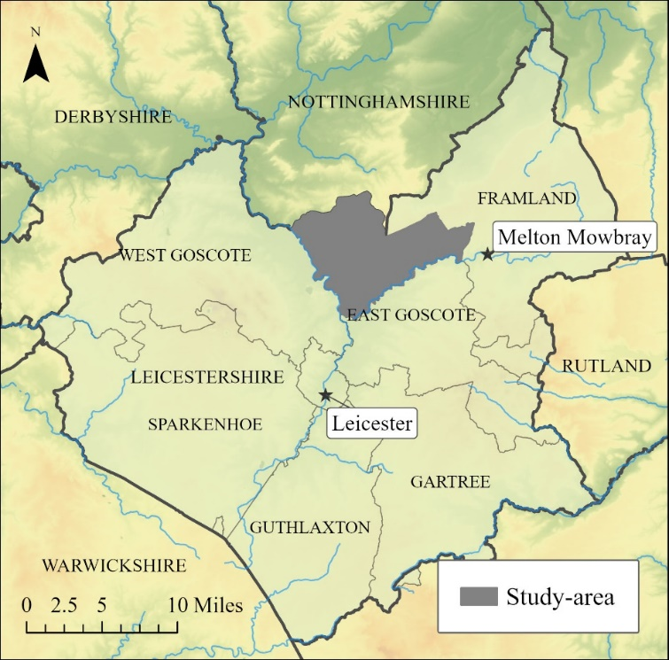

Figure 2. Scandinavian and Scandinavianised place-names in Leicestershire
Map created using: Great Britain Historical GIS (2012a); Palmer (2008); Pope (2017).
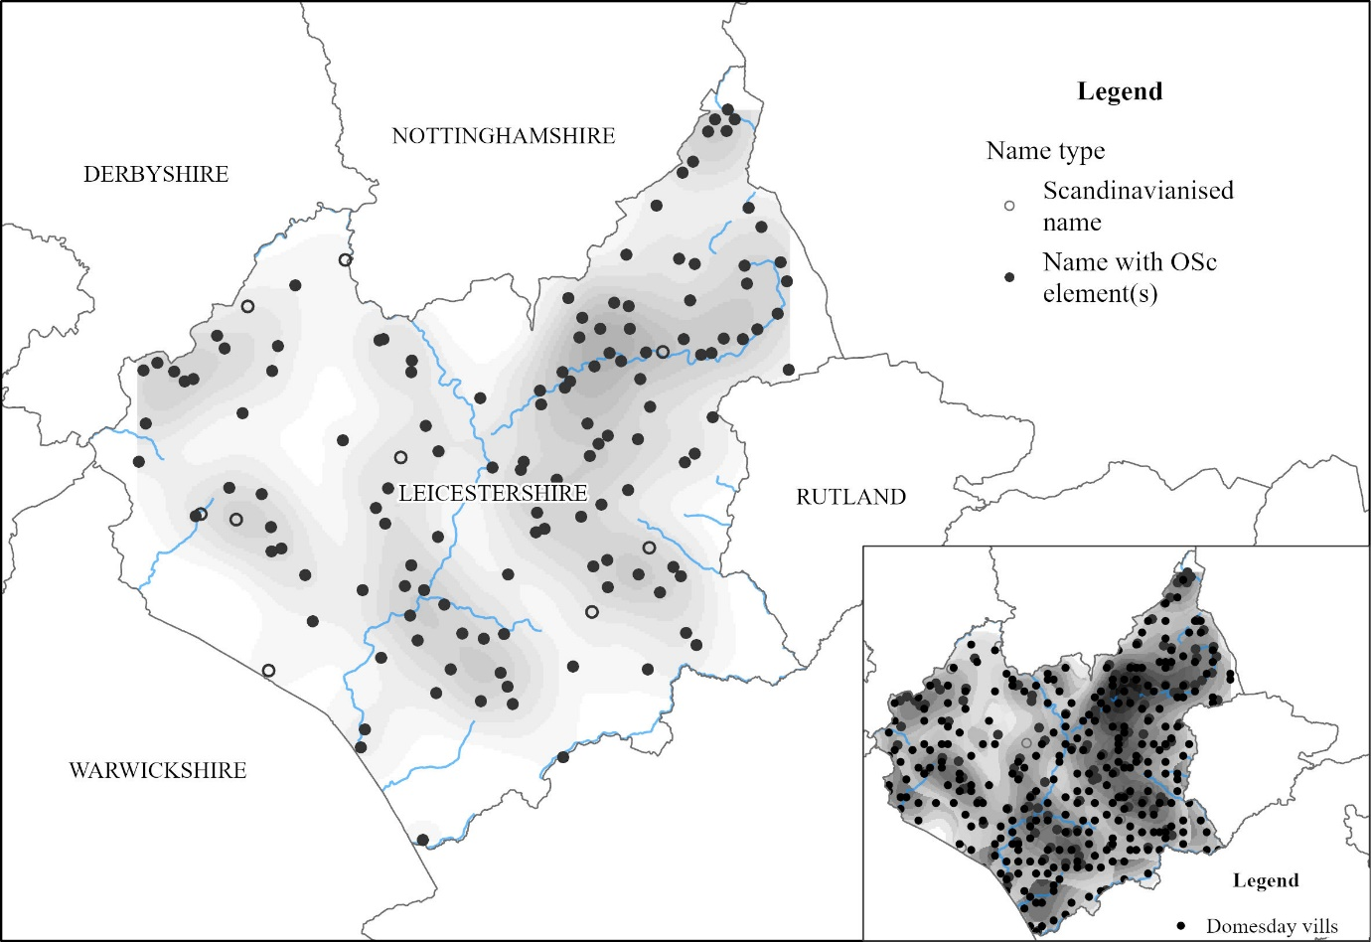

Figure 3. Types of Scandinavian place-names in Leicestershire.
Map created using: Great Britain Historical GIS (2012a); Ordnance Survey (GB) (2022); Pope (2017). Contains Ordnance Survey data © Crown copyright and database right 2022.
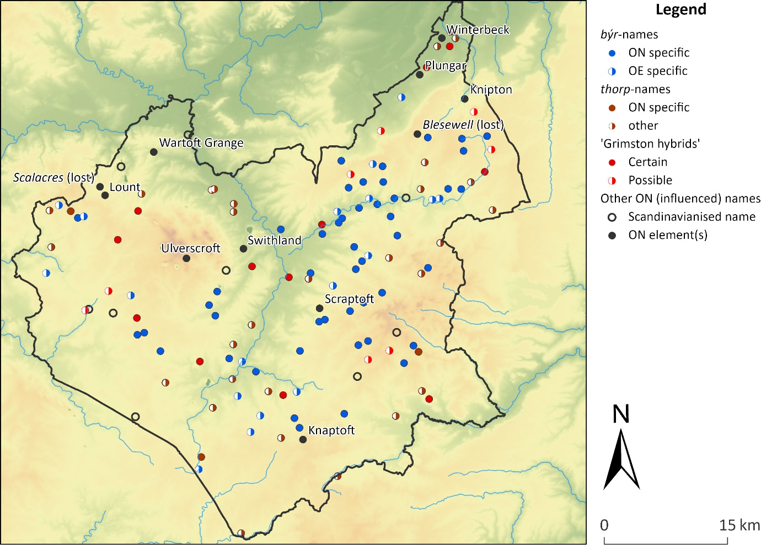

Figure 4. ‘Viking’ and ‘Anglo-Scandinavian’ finds from the Portable Antiquities Scheme database (Dale 2020).
Reproduced by permission of Five Leaves Publications and Roderick Dale.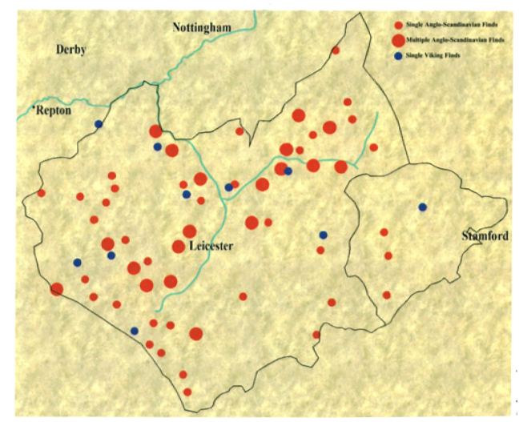

Figure 5. Studies of Scandinavian vocabulary in microtoponyms
Map created using: National Records of Scotland (1991); Office for National Statistics (1991). Contains data provided through EDINA UKBORDERS with the support of the ESRC and JISC and uses boundary material which is copyright of the Crown and the ED-LINE Consortium.
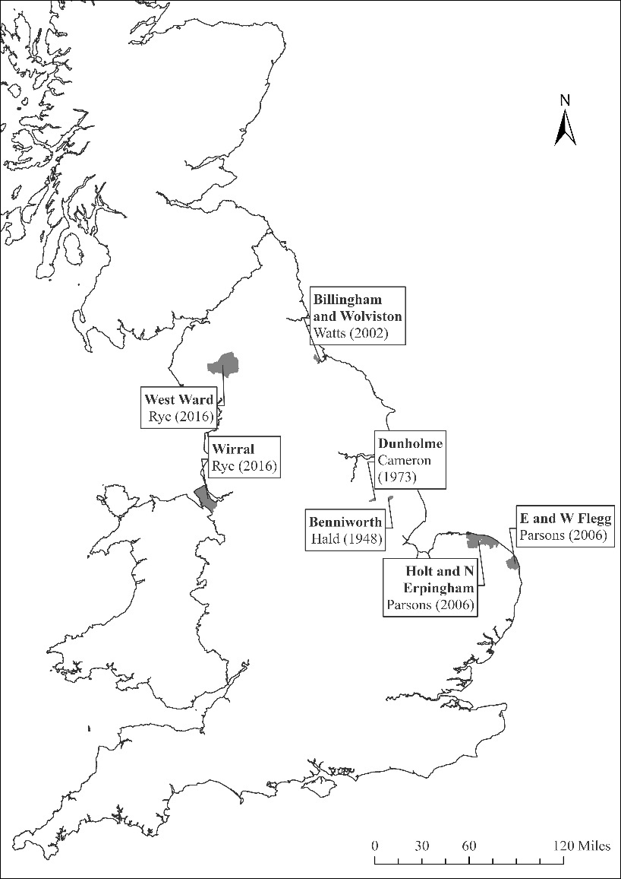

Figure 6. Studies of the Scandinavian contribution to the vocabulary of medieval microtoponyms.
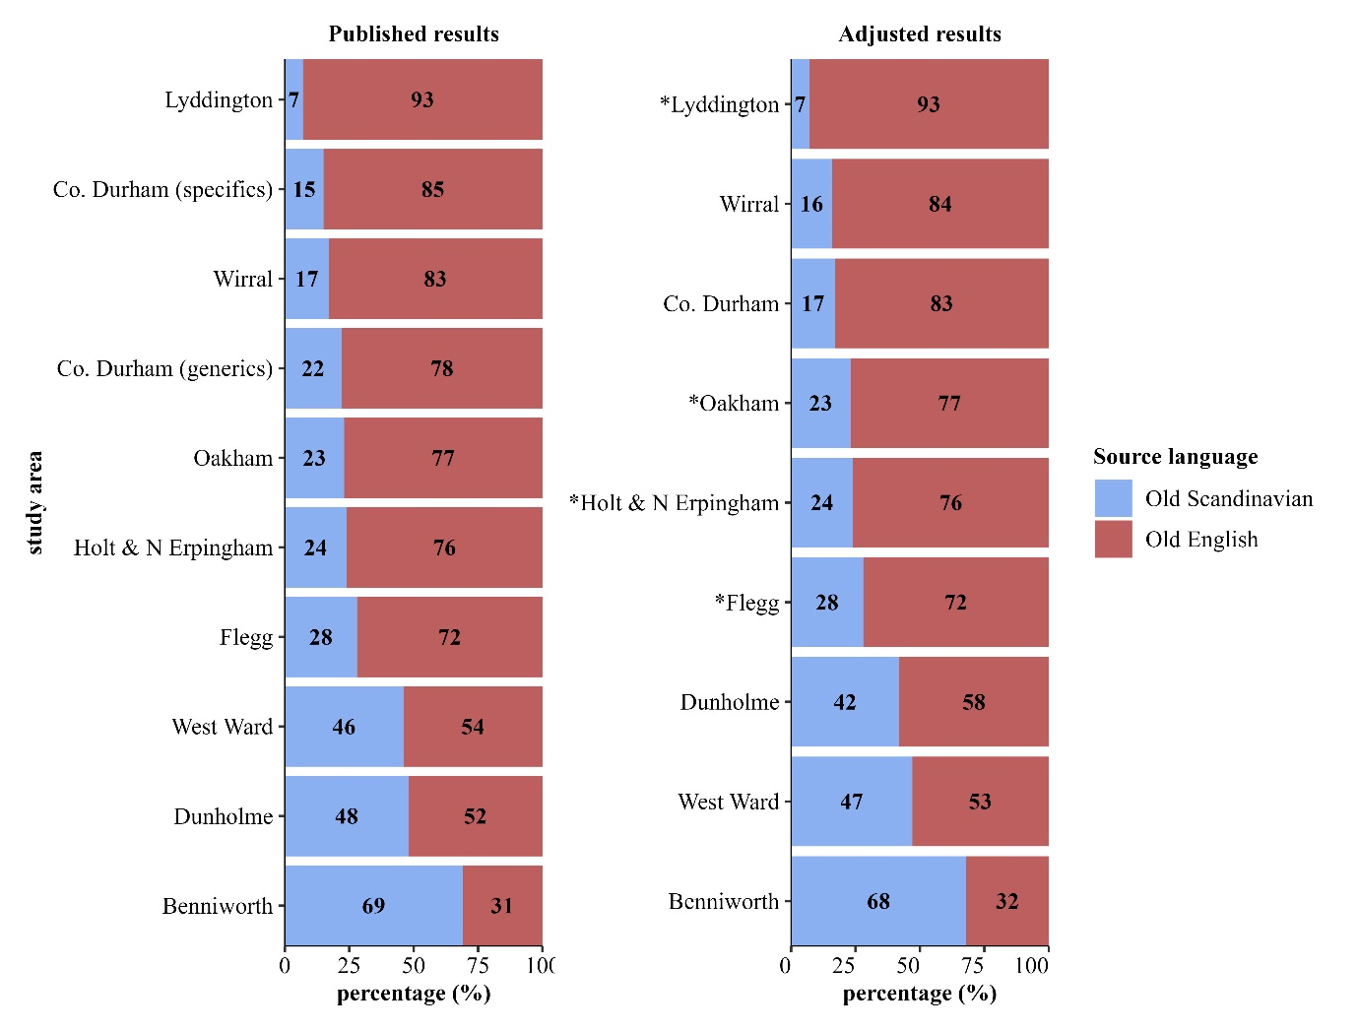

Figure 7. Results from the Leicestershire study-area and other studies
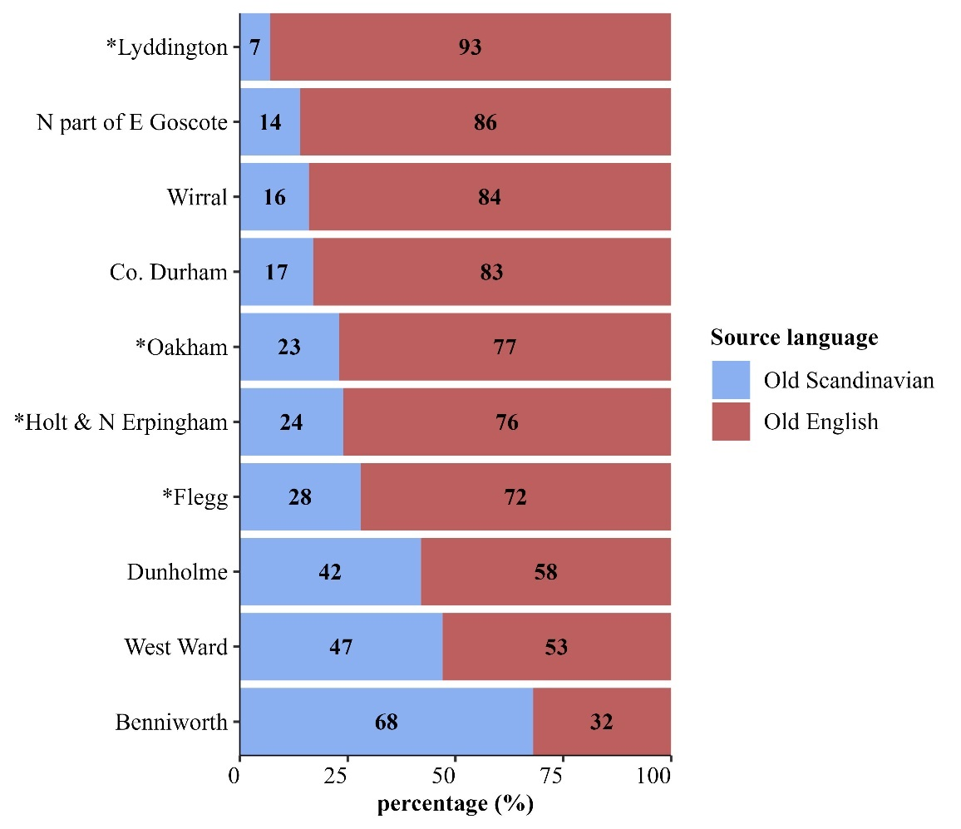

Figure 8. Different elements by civil parish.
Map created using Great Britain Historical GIS (2012a; 2012b).
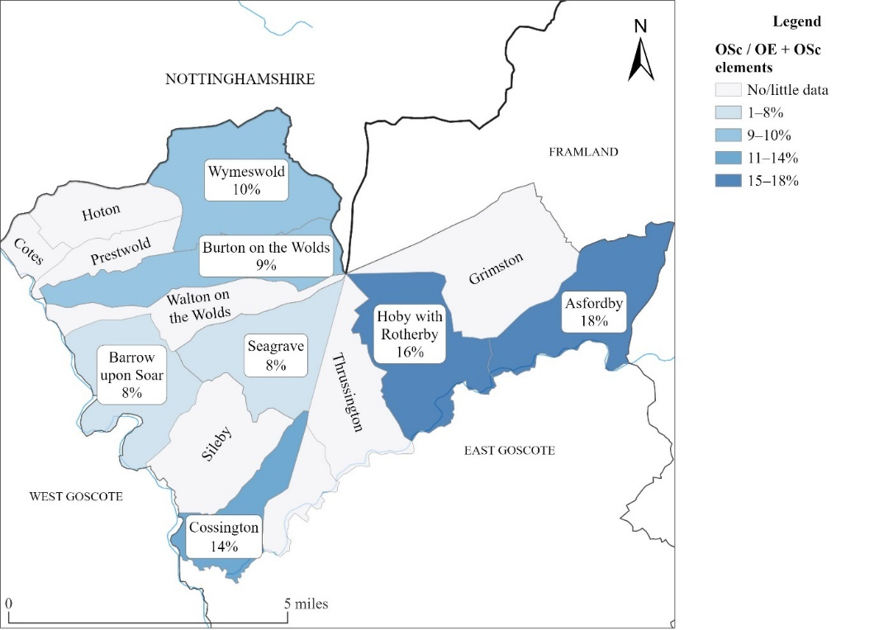

Tables

Table 1. Existing studies of Old Scandinavian vocabulary in minor and field-names
Study | Area | All elements |  |  | Different elements |  |  | Notes on data.
 |  | No. OE | No. OSc | Ratio  OE: OSc | No. OE | No. OSc | Ratio  OE: OSc
Cameron (1973) | Dunholme | 25 | 23 | 52 : 48 | 11 | 10 | 52 : 48 | Generics only; names to 1272 CE.
Cox (1990) | Alstoe Hundred (Market Overton) | 183 | 50 | 79 : 21 | (35) | (8) | (81 : 19) | All elements (including personal names); names to 1500 CE.
 | Oakham Soke Hundred (Oakham) | 92 | 25 | 79 : 21 | (37) | (11) | (77 : 23)
 | East Hundred (Little Casterton) | 105 | 40 | 72 : 28 | (36) | (9) | (80 : 20)
 | Martinsley Hundred (Uppingham) | 79 | 15 | 84 : 16 | (15) | (3) | (83 : 17)
 | Wrangdike Hundred (Lyddington) | 311 | 97 | 76 : 24 | (52) | (4) | (93 : 7)
Hald (1948) | Benniworth | 23 | 58 | 28 : 72 | 8 | 18 | 31 : 69 | Generics only; names l. 12th or e. 13th c.
Parsons (2006) | Flegg: all generics |  |  |  | 68 | 27 | 72 : 28 | Generics only; names to 1400 CE.
 | Holt & North Erpingham: all generics |  |  |  | 65 | 21 | 76 : 24
 | Flegg: recurrent generics |  |  |  | 27 | 12 | 69 : 31 | Recurrent generics only; names to 1400 CE.
 | Holt & North Erpingham: recurrent generics |  |  |  | 23 | 12 | 66 : 34
Rye (2016) | Wirral | 607 | 62 | 91 : 9 | 202 | 42 | 83 : 17 | All elements (including personal names); names to 1500 CE.
 | West Ward of Westmorland Barony | 219 | 330 | 40 : 60 | 112 | 95 | 54 : 46
Watts (2002) | Billingham & Wolviston, Co. Durham | 117 | 51 | 70 : 30 | 32 | 9 | 78 : 22 | Generics only; names to –1669 CE.
 |  | 62 | 10 | 86 : 14 | 45 | 8 | 85 : 15 | Qualifiers only; names to –1669 CE.

Table 2. Existing studies of OScand vocabulary in minor and field-names: adjusted results.
Study | Area | All elements |  |  | Different elements |  |  | Changes made.
 |  | No. OE | No. OSc | Ratio  OE: OSc | No. OE | No. OSc | Ratio  OE: OSc
Cameron (1973) | Dunholme | 46 | 27 | 63 : 37 | 26 | 19 | 58 : 42 | Qualifiers added (etymologies as in PNLi 7 41–47); elements reclassified.
Hald (1948) | Benniworth | 18 | 42 | 30 : 70 | 7 | 15 | 32 : 68 | Elements reclassified.
Rye (2016) | Wirral | 592 | 58 | 91 : 9 | 188 | 36 | 84 : 16 | Personal names removed; elements reclassified.
 | West Ward of Westmorland Barony | 215 | 332 | 39 : 61 | 108 | 94 | 53 : 47
Watts (2002) | Billingham & Wolviston, Co. Durham | 164 | 57 | 74 : 26 | 69 | 14 | 83 : 17 | Elements recorded after 1500 omitted; generics and qualifiers pooled; elements reclassified.

Table 3. Scandinavian- and English-derived vocabulary by structural position
Table 3 | Qualifiers |  |  | Generics |  |  | Affixes
Study area | No. OE | No. OSc | Ratio  OE: OSc | No. OE | No. OSc | Ratio  OE: OSc | No. OE | No. OSc | Ratio  OE: OSc
Wirral | 118 | 22 | 84 : 16 | 80 | 18 | 82 : 18 | 28 | 2 | 93 : 7
West Ward | 69 | 62 | 53 : 47 | 47 | 43 | 52 : 48 | 6 | 13 | 32 : 68

Table 4. Different elements by century
Century | OE | OSc | OE/OSc | OFr | ME | Ratio  OE : OSc
12th | 13 | 4 | 20 | 0 | 2 | 76 : 24
13th | 59 | 12 | 50 | 2 | 7 | 83 : 17
14th | 87 | 16 | 61 | 3 | 9 | 84 : 16
15th | 68 | 5 | 53 | 7 | 13 | 93 : 7
Unknown |  |  | 2
All centuries | 151 | 25 | 94 | 10 | 20 | 86 : 14

Table 5: All elements by century
Century | OE | OSc | OE/OSc | OFr | ME | Ratio  OE : OSc
12th | 17 | 4 | 33 | 0 | 2 | 81 : 19
13th | 110 | 17 | 138 | 2 | 11 | 87 : 13
14th | 182 | 33 | 164 | 5 | 15 | 85 : 15
15th | 160 | 18 | 109 | 7 | 16 | 90 : 10
Unknown |  |  | 2
All centuries | 469 | 72 | 446 | 14 | 44 | 87 : 13

Table 6. Different elements to 1400 CE
Century | OE | OSc | OE/OSc | OFr | ME | Ratio  OE : OSc
All elements | 151 | 25 | 94 | 10 | 20 | 86 : 14
Generic elements | 51 | 13 | 42 | 5 | 9 | 80 : 20
Qualifier elements | 99 | 14 | 65 | 5 | 10 | 88 : 12
Other elements | 34 | 4 | 27 | 1 | 6 | 89 : 11

Table 7. Different elements by civil parish
Parish | OE | OSc | OE/OSc | OFr | ME | Ratio  OE : OSc
Asfordby | 23 | 5 | 14 | 1 | 1 | 82 : 18
Barrow upon Soar | 56 | 5 | 46 | 4 | 7 | 92 : 8
Burton on the Wolds | 10 | 1 | 12 | 1 | 1 | 91 : 9
Cossington | 59 | 10 | 43 | 3 | 7 | 86 : 14
Cotes | 1 | 1 |  |  |  | (50 : 50)
Grimston | 5 |  | 7 |  | 3 | (100 : 0)
Hoby with Rotherby | 58 | 11 | 49 | 4 | 7 | 84 : 16
Hoton |  | 1 |  |  |  | (0 : 100)
Prestwold | 2 |  | 9 |  |  | (100 : 0)
Ratcliffe on the Wreake | 2 |  |  |  | 1 | (100 : 0)
Seagrave | 24 | 2 | 20 | 1 | 4 | 92 : 8
Sileby | 7 | 2 | 7 |  | 1 | (78 : 22)
Thrussington | 1 | 1 | 3 |  |  | (50 : 50)
Wymeswold | 28 | 3 | 30 |  | 1 | 90 : 10

Table 8. Different elements by structural position
Century | OE | OSc | OE/OSc | OFr | ME | Ratio  OE : OSc
All elements | 151 | 25 | 94 | 10 | 20 | 86 : 14
Generic elements | 51 | 13 | 42 | 5 | 9 | 80 : 20
Qualifier elements | 99 | 14 | 65 | 5 | 10 | 88 : 12
Other elements | 34 | 4 | 27 | 1 | 6 | 89 : 11

Bibliography
Abrams, Lesley and David N. Parsons (2004), ‘Place-names and the history of Scandinavian settlement in England’, in Land, Sea and Home. Settlement in the Viking Period, ed. John Hines et al. (Leeds: Maney), 379–431.
AND = Anglo-Norman Dictionary (2023). AND² online edition: <https://anglo-norman.net>.
Bately, Janet, ed. (1986), MS A, The Anglo-Saxon Chronicle. A Collaborative Edition (Cambridge: Brewer).
Blackburn, Mark (2006), ‘Currency under the Vikings. Part 2: the two Scandinavian kingdoms of the Danelaw, c. 895–954’, British Numismatic Journal 76, 204–26.
Briggs, Keith (2019), ‘Snavergate: a unique Old Danish term in medieval Suffolk’, Notes and Queries 66, 498–99.
Cameron, Angus et al. (1986–), Dictionary of Old English. (Toronto, University of Toronto),.
Cameron, Kenneth (1973), ‘Early field-names in an English-named Lincolnshire village’, in Otium et Negotium: studies in Onomatology and Library Science presented to Olof von Feilitzen, ed. Folke Sandgren (Stockholm: Norstedt), 38–43.
― (1978), ‘The minor names and field-names of the Holland division of Lincolnshire’, in The Vikings: proceedings of the Symposium of the Faculty of Arts of Uppsala University. June 6–9, 1977, ed. Thorsten Andersson and Karl Inge Sandred (Uppsala: Uppsala University Press), 81–88.
― (1996), ‘The Scandinavian element in minor names and field-names in north-east Lincolnshire’, Nomina 19, 5–27.
Coates, Richard (2006), ‘Behind the dictionary-forms of Scandinavian elements in England’, Journal of the English Place-Name Society 38, 43–61.
Cox, Barrie (1989), ‘Rutland and the Scandinavian settlements: the place-name evidence’, Anglo-Saxon England 18, 135–48.
― (1990), ‘Rutland in the Danelaw: a field-names perspective’, Journal of the English Place-Name Society 22, 7–22.
Cubbin, G. P., ed. (1996), MS D, The Anglo-Saxon Chronicle. A Collaborative Edition Cambridge: Brewer).
Cullen, Paul et al. (2011), Thorps in a changing landscape (Hatfield: University of Hertfordshire Press).
Dale, Roderick (2020), Viking Leicestershire (Nottingham: Five Leaves Publications).
Dance, Richard (2003), Words derived from Old Norse in early Middle English: studies in the vocabulary of the South-West Midland texts (Tempe, AZ: Arizona Center for Medieval and Renaissance Studies).
― (2018), Words derived from Old Norse in Sir Gawain and the Green Knight: an etymological survey (Chichester: Wiley Blackwell) [volume 2 available online only at https://onlinelibrary.wiley.com/toc/1467968x/2018/116/S2].
Fellows Jensen, Gillian (1974), ‘English field-names and the Danish settlement’, in Festskrift til Kristian Hald: navneforskning, dialektologi, sproghistorie, ed. Poul Anderson et al. (Copenhagen: Akademisk Forlag), 45–55.
Gobbitt, Thom (2010–2013), ‘Cambridge, Corpus Christi College, 383’, in The Production and Use of English Manuscripts 1060 to 1220, ed. Orietta Da Rold et al. (Leicester: University of Leicester). Retrieved 26 May 2023 from https://www.le.ac.uk/english/em1060to1220/mss/EM.CCCC.383.htm.
Great Britain Historical GIS (2012a), Counties of England and Wales 1911 [dataset] (Portsmouth: University of Portsmouth). Online at <https://www.visionofbritain.org.uk/data/index.jsp#>
Great Britain Historical GIS (2012b), Parishes of England and Wales 1911 [dataset] (Portsmouth: University of Portsmouth). Online at <https://www.visionofbritain.org.uk/data/index.jsp#>
Gregory, Rebecca (2018), ‘Introduction’, in A New Dictionary of English Field-Names, ed. (Nottingham: English Place-Name Society), v–xxxviii.
Hadley, Dawn M. and Julian D. Richards (2018), ‘In search of the Viking Great Arny: beyond the winter camps’, Medieval Settlement Research 33, 1–17.
Hald, Kristian (1948), ‘Vore marknavnes alder’, Namn och Bygd 36, 14–33.
Hoskins, W. G. (1934–35), ‘The Anglian and Scandinavian settlement of Leicestershire’, Leicestershire Archaeological and Historical Society Transactions 18.2, 109–47.
Hough, Carole (2010), Toponymicon and lexicon in north-west Europe: ‘'ever-changing connection’ (Cambridge: Department of Anglo-Saxon, Norse and Celtic, University of Cambridge).
Kershaw, Jane (2013), Viking identities: Scandinavian jewellery in England (Oxford: OUP).
Kershaw, Jane and Ellen C. Røyrvik (2016), ‘The “People of the British Isles” project and Viking settlement in England’, Antiquity 90, 1670–80.
Kristensson, Gillis (1987), A Survey of Middle English Dialects 1290–1350. The West Midland Counties (Lund: Lund University Press).
Naismith, Rory (2017), Medieval European Coinage: Volume 8: Britain and Ireland c.400–1066 (Cambridge: Cambridge University Press).
― (2021), Early Medieval Britain, c. 500–1000 (Cambridge: Cambridge University Press).
National Records of Scotland (1991), 1991 Census: boundary data (Scotland) [dataset] (Colchester: UK Data Service, University of Essex). Online at <http://census.ukdataservice.ac.uk/get-data/boundary-data.aspx>
O'Brien O'Keefe, Katherine, ed. (2001), MS C, The Anglo-Saxon Chronicle. A Collaborative Edition Cambridge: Brewer).
Office for National Statistics (1991), 1991 Census: boundary data (England and Wales) [dataset] (Colchester: UK Data Service, University of Essex). Online at <http://census.ukdataservice.ac.uk/get-data/boundary-data.aspx>
ONP = Ordbog over det Norrøne Prosasprog (1989–). <https://onp.ku.dk/onp/>.
Ordnance Survey (GB) (2022) (Edinburgh: EDINA Digimap Ordnance Survey Service). Online at <https://digimap.edina.ac.uk/>.
Palmer, John (2008), Domesday statistics database [dataset] (Hull: University of Hull). Online at <https://hydra.hull.ac.uk/resources/hull:465>.
Parsons, David N. (2006), ‘Field-name statistics, Norfolk and the Danelaw’, in Names through the Looking-Glass: Festschrift in honour of Gillian Fellows-Jensen, ed. Peder Gammeltoft and Bent Jørgensen (Copenhagen: Reitzel), 165–88.
Pope, Addy (2017), GB Rivers [dataset] (Edinburgh: University of Edinburgh). Online at <https://doi.org/10.7488/ds/1862>.
Rye, Eleanor (2016), Dialect in the Viking-age Scandinavian Diaspora: the Evidence of Medieval Minor Names. (Nottingham, University of Nottingham),PhD.
― (2020), ‘A fresh look at Scandinavian vocabulary in the minor place-names of Wirral’, in Viking Encounters. Proceedings of the Eighteenth Viking Congress, Denmark, August 6–12 2017, ed. Anne Pedersen and Søren M. Sindbæk (Aarhus: Aarhus University Press), 592–604.
Samuels, M. L. (1985), ‘The great Scandinavian belt’, in Papers from the 4th International Conference on English historical Linguistics, Amsterdam, April 10–13, 1985, ed. Roger Eaton et al. (Amsterdam: Benjamins), 269–81.
Sandnes, Berit (2016), ‘Names and language contact’, in The Oxford Handbook of Names and Naming, ed. Carole Hough (Oxford: Oxford University Press), 540–53.
Smith, A. H. (1956), English place-name elements (Cambridge: CUP).
Stenton, F. M. (1971), Anglo-Saxon England (Oxford: Oxford University Press).
Swanton, Michael James, ed. (2000), The Anglo-Saxon chronicles London: Phoenix).
Taylor, Simon, ed. (1983), MS B, The Anglo-Saxon Chronicle. A Collaborative Edition Cambridge: Brewer).
Wainwright, F. T. (1945–46), ‘The Scandinavians in Lancashire’, Transactions of the Lancashire and Cheshire Antiquarian Society 58, 71–116.
― (1962), Archaeology and place names and history: an essay on problems of co-ordination (London: Routledge & Paul).
Watts, Victor (2002), ‘Medieval field-names in two south Durham townships’, Nomina 25, 53–64.

For further detail about Leicestershire in particular, see Dale (2020).
‘7 þa on hærfeste gefor se here on Miercna lond 7 hit gedęldon sum 7 sum Ceolwulfe saldon’ (Bately 1986: 50).
Entries in the Anglo-Saxon Chronicle give an outline of events in this period; references to Leicester recorded in different manuscripts of the Chronicle can be compared in Swanton’s translations (Swanton 2000: 98–111). The first mention of Leicester come in 913 and 917, when Leicester and Northampton were named as bases for raiding armies. However, the following year, Æthelflǣd, Lady of The Mercians, took Leicester the following year, with control passing to her brother, Edward the Elder, on her death. The ‘capture’ of 942 requires loss of English control over the Five Boroughs, including Leicester, before 942 and it’s thought that Óláfr Guðrøðsson and Óláfr Sigtryggsson, successive Kings of York, briefly took control of the East Midlands as far as Watling Street following King Athelstan’s death in 939 (Stenton 1971: 356–58). Moreover, there are hints in the numismatic evidence of additional periods of Scandinavian control over parts of the East Midlands, especially Lincoln (Blackburn 2006: 209–15; Naismith 2017: 302–03).
Names were classified as major place-names following Cox’s classifications in PNLei.
Kernel density surfaces for the respective datasets created in ArcGIS Pro, using default parameters.
Wainwright argued that the number of names with OScand býr ‘settlement, village’ in the Wreake valley within five or six miles of Melton Mowbray meant ‘we must assume the English inhabitants to have been completely outnumbered and overwhelmed politically and socially as well as linguistically’ (Wainwright 1962: 82). He also discussed fourteenth-century field-names from Hoby, within the study-area, where widespread use of Scandinavian-derived elements showed that the inhabitants of Hoby were ‘still speaking a language that had much in common with the language of the Danes who had settled in the area four and a half centuries before’ Hoskins interpreted the Wreake’s Scandinavian name (< OScand ON (v)reithr “crooked, twisted” ; PNLei viii, 9) as an indication of the strength of the Scandinavian influence on the names of the area (Hoskins, 1934–35 (Hoskins 1934–35: 131; Wainwright 1962: 87–88).
Hald’s purpose was different from the other studies considered here, being part of an article arguing for the antiquity of field-naming in Denmark. However, Hald’s presentation of lists of elements from his comparative Lincolnshire material as derived from Old English, Old Scandinavian or indistinguishable in origin between these two languages is comparable to the approach of the other ‘quantitative’ studies and indeed seems to have inspired later similar studies (Cameron 1973: 38; Watts 2002: 53–54).
I count 74 names, though Cameron described the number as ‘over eighty’ (1973: 38).
Figures for Rye (2016) exclude names considered variants of other names.
Fellows Jensen (1974) also takes a quantitative approach but appears to count names containing Scandinavian elements (compare the numbers of names listed on p. 47 with the numbers and percentages on p., 50) rather than considering the Scandinavian contribution to all vocabulary in the names (as in the other studies discussed here).
For the ‘different element’ counts for Rutland, the parishes in each hundred which have the greatest number of different elements recorded by 1500 are shown.
Here, ‘different element’ counts were selected from those for parishes shown in Table 1. Of these parishes, only Lyddington and Oakham, the parishes with the smallest and greatest relative proportions of Scandinavian-derived elements respectively, are shown.
Adjustments to linguistic classifications of elements are listed in footnotes to Table 2.
Watts does not discuss dates, but the earliest and latest recorded names seem to be keueldale (1189 x 1212) or Lamim[er]e (early 13th c.), and Slackeside (1669) respectively (Watts 2002: 58–59).
Differences were most pronounced between the fourteenth and fifteenth centuries in Wirral and between the twelfth and thirteenth century in the West Ward.
Watts presents material in full, so the few elements recorded only after 1500 can be excluded. Cox presents material cumulatively by century, so material recorded by 1500 can be selected for comparison.
On the non-equivalence of toponymic and lexical vocabulary, see Hough (2010).
It is not necessary to know anything about the names Leicester or Barrie other than their phonetic form and referent(s) in order to use them in English, for instance, whereas one must know relevant senses of field in order to use this as an item of toponymic vocabulary.
For fuller discussion of the criteria used, see Coates (2006); Dance (2003: 68–103); Dance (2018: 25–63); Rye (2016: 35–142).
For instance, ME holm(e) ‘island, water-meadow’ is recorded lexically in both Old English and Old Scandinavian as cf. OE holm ‘sea, water, wave’ and OScand holmr, holmi ‘small island’ (1989–: s.vv. holmr & holmi; Cameron, Amos et al 1986–: s.v. holm). Here, the meaning is suggestive of a Scandinavian origin and comparison of English and Scandinavian toponymic usage confirms that a Scandinavian origin is far more likely than the existence of an Old English toponymic item with a different meaning from the recorded lexical item. In this case, the non-occurrence of the element before the fourteenth century in non-Scandinavian England and the element’s frequent early use in Scandinavian are reason to prefer a Scandinavian etymology for the English toponymic usage (Rye 2016: 132–34).
It was not possible to adjust element classifications for studies that did not present data in full, despite indications of discrepancies from the classifications made here. For example, some elements from Parsons (2006) would ideally be reclassified from Old English to ambiguous (OE hall → OE/OScand hall/hǫll, OE tūn → OE/OScand tūn/tún, OE wella → OE/OScand wella/vella); however, the non-presentation of non-recurrent elements means that this cannot be carried out for all non-recurrent elements.
Amongst generics, only one Scandinavian-derived element was reclassified as ambiguous between Old English and Old Scandinavian derivation in all instances, but three Old English-derived elements were reclassified as ambiguous. These changes would cause the proportion of Scandinavian-derived vocabulary relative to Old English-derived vocabulary to rise. Consequently, it must be inclusion of qualifier elements which is responsible for the fall in the proportion of Scandinavian-derived vocabulary in the adjusted results presented in table 2.
However, the proportions are very different amongst the vocabulary classed as affixes (Wirral: 44 different elements; West Ward: 34 different elements).
One descriptive phrase, Thoretheoxeneworeslaine ‘there (where) the oxen were slain’ (1322; Hoby) was excluded (PNLei 3: 120).
It is unclear, for instance, whether the pontium inter Loughteburg et Cotes (‘bridge between Loughborough and Cotes’) recorded in 1332 in Cotes and listed with Cotes Bridge in the Survey volume (PNLei 3: 70) reflects the existence of a (vernacular) name including an element meaning ‘bridge’ already in the fourteenth century, and the identity of any such element would be unclear.
Later spellings were not routinely collected but were recorded where they were used to disambiguate elements in names recorded before 1500. For instance, ME gate in Stongate (1467 x 84, Cossington) was interpreted as deriving from OScand gata ‘road’ (not OE geat ‘pass, gate, gap’) because of the explicit reference to a routeway in Stonegate way (1635) (PNLei 3: 68).
This decision was made for both theoretical and practical reasons. Theoretically, it was not thought desirable to include this material because of this study’s focus on toponymic vocabulary and because of the differences in the ways in which names and vocabulary are treated in language contact situations (As discussed above). Similarly, the language of origin of a place-name like Walton in Walton mere (1467 x 84; PNLei 3: 41) is not directly relevant to its use in forming a minor name in Old or Middle English. Practically, excluding all existing names meant (often impossible) decisions about whether names were (earlier) personal names or (later) family names derived from personal names could be avoided.
The preservation of the Old Scandinavian nominative masculine (and occasionally feminine) singular inflexional morpheme -r is vanishingly rare in borrowed material in Old and Middle English (Coates 2006: 45; Rye 2016: 55–60).
The form *cros might be preferred as cross (adj.) is not recorded until the sixteenth century (OED: s.v. cross, adj.).
Interpretation of all three names perhaps containing the element is complicated by the existence of Latin iuxta crucem in the same parish as the minor names, meaning this could be a direct reflex of OScand kross. However, due to the possibility of the derived adjectival sense occurring, this element was (cautiously) classified as ME *cros ‘across’ here.
Names and unidentified elements are excluded from the results presented here.
OE brēc also given in PNLei, but it is unclear whether final /ʧ/ (which is suggested by the early spellings, unlike in Wirral and the West Ward) can be derived from Old English alone (Rye 2016: 65–66).
Perhaps a form deriving from OE bærnan (past participle ge-bærned, ge-berned) and ON brenna (past participle brent), though although forms with initial <bren-> are dominant in southern England in late Middle English (VEPN s.v. brend).
Form *cros given in preference to cross in PNLei (see above).
Forms within English from the verb dim, for which see OE dimman, dimmian ‘to grow dim’ (used of vision and memory) and OScand dimma ‘to become dim’ (DOE s.v. dimman, dimming; OED s.vv. dimming, n. and dim, v.)
The form is that shown in several Lei field-names, mainly in connection with watercourses and/or mills; perhaps an earlier variant of ginnel, n. (recorded in OED from 1613 and of obscure origin). The form is reminiscent of AN gunele, gonele ‘tunic, coat’(AND s.v. gunele), but no intermediate sense is on record to support a metaphorical development from this word.
Cf. OE lagu, OScand lǫgr (dative singular legi) ‘water’ and OFr lai ‘lake, pool’ (OED s.v. lay, n.1).
Perhaps formed within Middle English from OE lǣfan and/or ON leifa ‘to leave behind’.
Recorded in Late Old English, but of uncertain origin (OED s.v. plot, n.): OED’s earliest attestations (S 1137 and Hit Becwæð) are in twelfth-century manuscripts (cf. Gobbitt 2010–2013).
< ME stinten ‘to cease’, which could formally derive from either ((or both) OE styntan ‘to blunt’ or ON stytta ‘to shorten’ (<earlier *stynta) (OED s.vv. stint, v. and stint n.1).
The first element, ME walk, could formally be derived from OE walcan and wealcian or OScand válka.
< OScand hvin ‘gorse’ + ME -i (adj. forming suffix < OE -ig).
Classed as OFr, ME by Cox (PNLei 3: 284), but well recorded in Old English (with forms with stem-final <t> as well as more common <d>) (VEPN s.v. abbod). OScand ábóti is thought to be a borrowing from Old English (OED s.v. abbot, n.).
Reclassified from Middle English aboven (cf. DOE s.v. a-būfan).
Reclassified from ME bony as both root and adjective-forming suffix are of OE origin.
Reclassified from Middle English benethe (cf. DOE be-neoþan).
Reclassified from Middle English copped² (cf. DOE s.v. coppede).
Reclassified from Middle English quake (cf. DOE s.v. cwacian).
I.e., hald¹..
Reclassified from ME hamer ‘nearer home, nearer the village’ as both root and comparative suffix are of OE origin (OED s.vv. home, n. and adj. and -er, suffix 3).
Reclassified from Middle English lavedi (cf. DOE s.v. hlǣfdige).
Reclassified from ME lache.
Reclassified from ME pinder as both root and agent-noun forming suffix are of OE origin (OED s.vv. pind, v. and -er, suffix 1).
Reclassified from Middle English swathe (cf. Bosworth-Toller s.v. swæþ).
See Rye (2016: 35–142) for explanation of why many of these forms are indistinguishable and explanations for this.
Classified as of ambiguous origin (despite the element being predominantly used in Anglo-Scandinavian England) as an Old English etymon is suggested for several major names from outside Anglo-Scandinavian England (VEPN s.v. brink) and as the word is widely attested in other West Germanic languages (OED s.v. brink, n.).
OE gōs would be indistinguishable from ON gás in this area where /ɑ:/ became ME /ɔ:/, written <o> (Kristensson 1987: 27–29).
Cf. OSwed, ODan hors (OED s.v. horse, n.).
For the OScand element, see ONP (s.v. landa-mǽri).
For ME <u> as a reflex of earlier /y(:)/ in Leicestershire, see Kristensson (1987: 81–99).
AND (2023) s.v. standard.
Classified as ME bond-man in PNLei. However, the compound is attested in Old Scandinavian (1989–: s.v. bónd-maðr) and while the Middle English usage probably reflects influence from the sense of ME bond ‘bond’, this too is derived from Old Scandinavian (OED s.vv. band, n.1 and bond, n.1).
Initial <heng-> in the two occurrences (le Hengondehul 1322, Hoby and le hengende 1270x90, Cossington) are better explained as deriving from OScand hengjandi than OE hangende.
Given as ME la(g)h in PNLei but borrowing from Old Scandinavian is uncontroversial (OED s.v. low, adj. and n.2).
See Rye (2016: 126 and 422) for discussion of possible Old English(-derived) examples of the element. Here, the element has been classed as Scandinavian-derived due to the element’s extremely frequent occurrence in Anglo-Scandinavian England and extreme rarity elsewhere (the one pre-Conquest place-name instance, from a saint’s life, is unidentified; two further examples are either uncertain or late enough to reflect diffusion of the borrowed Scandinavian form).
Only results (presented cumulatively) to 1500 CE are given here; Cox’s study continues to 1600 CE. The numbers presented for ‘all elements’ were made by adding up elements from Old English and Old Scandinavian for the parishes listed in Cox’s tables of results for each hundred. The same cannot be done for the different elements; instead, examples are given from the parishes with the highest number of different elements recorded by 1500 in each hundred.
Recalculated from 80 : 20 given by Cox (1990: 16).
Elements (supposedly) occurring in multiple variants of the same name were not counted multiple times. Thus, OScand áss ‘hill, mountain, ridge’ in Farusas, Farusassti, Netherfarusas and Vuerfarusas was counted as one instance of áss in a name Farusas (with the affixes OE/OScand stīg/stígr, OE/OScand neoðera/neðri and OE uferra).
Generic elements (and the same elements as qualifiers): Old English to ambiguous: OE brycg → OE/OScand brycg/bryggja, OE busc → OE/OScand *busc/*buskr, OE wella → OE/OScand wella/vella Old Scandinavian to ambiguous: OScand haugr → OE/ON hōh/haugr; OScand gata was considered ambiguous OE/OScand geat/gata in four cases, but OScand gata in one case where evidently a routeway (Netelham gate l. 12th; semitam de Netelham, viam de Netelham 1154–89; Cameron (1973: 41). Qualifier elements (differences from PNLi 7 41–7): Old English to ambiguous: OE grāfa → OE/OScand græf/grǫf or OE grāfa, OE lang → OE/OScand lang/langr, OE sand →OE/OScand sand/sandr, OE þistel →OE/OScand þistel/þistell, þistill, OE wīðig → OE/OScand wīðig/víðir Old Scandinavian to ambiguous: OScand hafri → OE/OScand *hæfera/hafri or OE/OScand hæfer/hafr. Other changes: OE hēafod-land was analysed as one compound element rather than two elements (OE hēafod + OE/OScand land), as was OScand *renn-stígr following PNLi (the second element was thus not counted as an instance of OE/OScand stīgr/stígr).
Old Danish to ambiguous (Old English or Old Scandinavian): ODan dam → OE/OScand *dammr/*damm (cf. Rye 2016: 78–79), ODan gata → OE/OScand geat/gata, ODan hø̄gh → OE/OScand hōh/haugr; the element ODan ās (OScand áss) ‘ridge, long hill’ was not amended, though this element is otherwise unknown in English place-names. Old English to ambiguous: OE mōr → OE/OScand mōr/mór, OE wella → OE/OScand wella/vella. Ambiguous to Old English: OE/ODan secg/*sæg(g) ‘sedge’. Hald lists the Old Danish element *sæg(g) as a possibility from the existence of Jutlandic dialect seg; however, this is not known elsewhere in Scandinavian, but the root is recorded elsewhere in West Germanic with similar meanings (OED s.v. sedge, n.1 ).
Wirral: Goid. cros → ME *cros ‘across’ in two instances as qualifier (twice in Wirral and five times in the West Ward) and to OScand kross (for comparability with other studies discussed here) in generic (four times in both the Wirral and the West Ward.
Namely, OScand báss OScand fit, one instance of OE hēafod (two remain), OE *scofl-brǣdu, one instance of OE side (eleven remain), OScand slakki.
Old English to ambiguous: OE brycg →OE/OScand brycg/bryggja, OE catt → OE/OScand catt/kǫttr, OE grēne (adj.) → OE/OScand grēne/grœnn, OE hall → OE/OScand hall/hǫll, OE heort → OE/OScand heort/hjǫrtr, OE lȳtel → OE/OScand lȳtel/lítill, Ambiguous to Old English: OE/OScand hwǣte/hveiti → OE hwǣte (no indication of diphthong in attestations), OE/OScand wer/verja → OE wer (the related noun in OScand was vǫr, var- (OED s.v. weir, n.). Ambiguous to Old Scandinavian: OE/ON cross/kross → OScand kross. Old Scandinavian to ambiguous: OScand reinn (sic) → *rǣn/rein. Other changes: OE stān(ig) was split into OE stān, OE stānig and OScand steinn according to the early spellings; OScand flak ‘turf’ was classified as ME flak as in PNDu 1 243.

