Food Hydrocolloids
Improving properties of Litsea cubeba oil Pickering emulsion-loaded gelatin-based bionanocomposite film via optimizing blending ratio: Application for mango preservation
--Manuscript Draft--
Highlights
Litsea cubeba oil Pickering emulsion (LCON) was stabilized by pectin/β-cyclodextrin

The gelatin/LCON/ZnO/red roselle extract nano-composite film was optimized using RSM

LCON/ZnO greatly improved the water barrier and mechanical properties of the film

The optimized RRE, ZnO & LCON were 1.10(wt%), 1.51(wt%) and 2.38(w/v%), respectively

The optimized film improved the postharvest quality and anthracnose in mango

Graphical Abstract
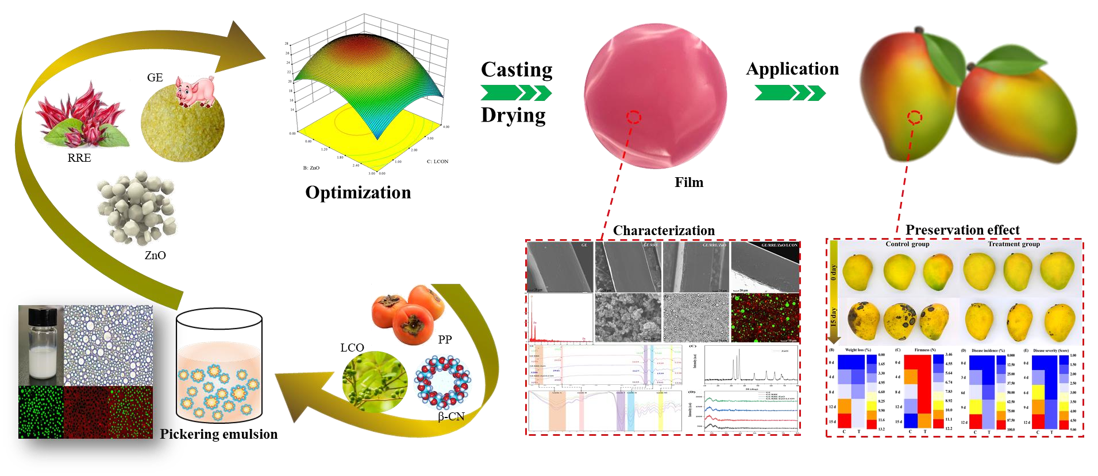

Manuscript File Click here to view linked References

1 Improving properties of Litsea cubeba oil Pickering emulsion-loaded gelatin2 based bio-nanocomposite film via optimizing blending ratio: Application for 3 mango preservation
- Zhikun Yang ^{a,b}, Mingrui Li ª, Yanxiao Li ª, Zhihua Li ^{a,*}, Xiaowei Huang ª, Xin Wang ª, Jiyong Shi ª, Xiaobo Zou ^{a,b *}, Xiaodong
- Zhai ª, Megan Povey ^{c}, Jianbo Xiao ^{d}
- ªAgricultural Product Processing and Storage Lab, School of Food and Biological Engineering, Jiangsu University, Zhenjiang,
- Jiangsu 212013, China
- ^{b}Institute of food and biotechnology, Yixing, China
- ^{c}School of Food Science and Nutrition, University of Leeds, Leeds LS2 9JT, United Kingdom
- ^{d}School of Food Science and Technology, Universidade de Vigo, Vigo, Spain 11 *Corresponding author. Email: zou_xiaobo@ujs.edu.cn (Xiaobo Zou)

12 Abstract
- The effect of red roselle extract (RRE), ZnO nanoparticles (ZnO) and Litsea cubeba oil Pickering
- emulsion (LCON) on the properties of the gelatin (GE) film were analyzed using response surface
- methodology (RSM). The RSM results reveal that these compounds greatly affect the properties of the
- film, especially the contribution of ZnO/LCON on mechanical and water barrier properties of the film.
- The optimal antifungal (80.15%), antibacterial (31.24 mm), antioxidant (73.00%), tensile strength (42.03
- MPa), elongation at break (25.50%), water vapor permeability (18.01 g·mm·m⁻²·Kpa⁻¹·h⁻¹), and water
- contact angle (110.2°) of the film were obtained at 1.10% RRE, 1.51% ZnO and 2.38% LCON. The X-
- ray diffraction pattern and FTIR spectra results indicated the change of molecular interactions and semi21 crystalline structure in the film. The scanning electron microscopy, fluorescence images, and energy 22 dispersive X-ray results revealed that the good dispersion of RRE, ZnO, and LCON in the GE matrix led
23 to an even and smooth structure in the film. This structure offers a positive effect on improving the 24 mechanical and barrier properties of the film. The colorful patterns were successfully printed on the film 25 to provide essential product information. Due to its excellent biological, mechanical and barrier
- properties, the optimized film was applied for mango preservation. The optimized GE/RRE/ZnO/LCON
- film significantly controlled the postharvest quality and anthracnose in mango. Thus, the 28 GE/RRE/ZnO/LCON film has great potential for mango preservation in active packaging applications.
29 Keywords: Gelatin; Red roselle extract; ZnO nanoparticles; Litsea cubeba oil Pickering emulsion;

Mango preservation;

Introduction
Mango (Mangifera indica L.) is one of the popular tropical fruit that is widely grown all over the world and has a high nutritional value. Mango has a short shelf-life due to rapid softening and anthracnose (Shah, et al., 2021).
Many researchers have pointed out that edible film based on natural polymer could prevent the exchange of oxygen and moisture movement so that prolonging the shelf life of mango (T. Wang, et al., 2022). However, the antimicrobial and antioxidant properties of the edible film were not adequate. Hence, their biological properties need to be improved by the incorporation of different additives such as antimicrobials, antioxidants, and anti-browning compounds (Y. Zhao, et al., 2022).
Red roselle extract (RRE), a natural anthocyanin-rich plant extract obtained from red roselle (Hibiscus sabdariffa L.), has been widely applied in food industry due to its safety, low cost and proven scavenging ability on free radicals (Yang, Zou, Li, Huang, & Tahir, 2019). Hence, the RRE could be considered to strengthen the antioxidant property of the edible film.
Metal oxide nanoparticles are popular in food packaging applications because it could be used as functional fillers to enhance the film properties (Nikolic, Vasiljevic, Auger, & Vidic, 2021). ZnO nanoparticles (ZnO) were a generally safe (GRAS) food additive with proven spectral antibacterial capacity (Nikolic, et al., 2021). ZnO can inhibit the growth of microbe by generating H₂O₂ to destroy cell membrane and release Zn²⁺ ions or ZnO nanoparticles into microbe cells (Shankar, Teng, Li, & Rhim, 2015). Recently, Sun, Li, and Le (2018) also reported the possible inhibition mechanism of ZnO on various fungi. Thus, it is desirable to incorporate ZnO to the edible film as an effective antibacterial and antifungal agent.
Although the bioactivity of edible films can be significantly improved by the addition of some antioxidant and antimicrobial agents. However, their high hydrophilicity and poor mechanical properties still greatly limit the application of edible packaging film in food (P. Zhao, et al., 2023). Fortunately, it has been proven to be effective in overcoming the above-mentioned disadvantages of films through forming multicomponent films by adding hydrophobic compounds in a hydrophilic matrix, particularly the emulsion films containing essential oils (P. Zhao, et al., 2023). Various essential oils have been added to edible films, including cinnamon essential oil (Fan, et al., 2023), anise essential oil (P. Zhao, et al., 2023), neem essential oil (Yang, Zhai, et al., 2022), and more. Among them, Litsea cubeba oil (LCO) is a lightyellow transparent liquid extracted from Litsea cubeba fruit, which is an essential natural plant resource widely distributed in southern China. It has received increasing attention due to its safety and proven antimicrobial and antioxidant activity (Li, et al., 2016). However, there are some challenges in the application of LCO, including its unstable, volatilized rapid and strong smell. In addition, adding essential oil directly into the film matrix could lead to uneven composite films due to the difference between the two phases (P. Zhao, et al., 2023). Pickering emulsion, a stable emulsion system only stabilized by solid particles instead of surfactants, has proved to be an effective green encapsulation technique to solve the above-mentioned disadvantage of essential oil (Xu, et al., 2023). Different solid particles have been explored to stabilize essential oil-loaded Pickering emulsion (Liu, et al., 2022). Persimmon Pectin (PP), a polysaccharide extracted from persimmon peel (Diospyros kaki Thunb.), has been explored recently as green stabilizer particles for the production of Pickering emulsion (Jia, Du, Li, & Li, 2022; Muñoz-Almagro, et al., 2021). Although PP has acceptable emulsifying properties, its emulsions stability needs to be further improved. Our previous research has reported that the double wettability of citrus pectin particles can be improved through β-cyclodextrin modification, thus greatly improving its emulsions stability (Cen, et al., 2023). β-cyclodextrin (β-CN) is a cheap oligosaccharide with suitable cavity size and solubility. Hence, the β-CN modified PP could be considered as potential stabilizer particles to fabricate Litsea cubeba oil Pickering emulsion (LCON).
The properties of the film could be enhanced owing to the synergistic effect of the mixture consisting of different functional agents. Our previous studies had proven that the biological and mechanical properties of the agar film could be greatly improved through the combination of various additives (Yang, Li, et al., 2022; Yang, Zhai, et al., 2022). However, the combination of different additive agents may have a negative influence on the properties of the film, because the properties of the film generally depend on the molecular interactions between different additive substances, the structural changes resulting from blending, and their concentrations (Azarifar, et al., 2019). Thus, it is critical to incorporate the RRE, ZnO, and LCON into GE film to enhance the film’s properties and assess the potential effect of different additives or their interactions on the properties of the film for obtaining optimized bio-nanocomposite formulation. Thus, the response surface methodology (RSM), an experimental modeling method measured to assess the effect of each variable parameter on the response of interest and their interactions in one or more response variables (Azarifar, et al., 2019), was selected in this work.
Furthermore, to provide important product information to consumers, packaging films are always linked with petroleum-based labels. However, these petroleum-based labels are harmful to human health and the environment. To reduce the food safety risk, the colored patterns or characters have been printed on the polysaccharide-based film containing anthocyanin as the “edible label” in our previous studies (Yang, Zhai, et al., 2022). These developed films with printed letters or patterns could be used as a promising alternative to petroleum-based labels. However, there are few works regarding the development of printing patterns on bio-nanocomposite films with electrochemical writing.
Despite these interests, to our best knowledge, there are only few work regarding the development of Pickering emulsion-loaded bio-nanocomposite film with edible labels, the use of RSM to assess the potential influences of individual factors on the properties of the film, and its application for fruit preservation. Thus, the present work aims to fabricate a novel active film based on gelatin/RRE/ZnO/LCON. Gelatin (GE) as an animal-derived protein has been widely studied as filmformation material. RSM was used to explore the influence of each component on the biological, mechanical, and barrier properties of the film, and to achieve the optimized formulation. The edible label made of colored written patterns was also printed on the optimized film. Finally, the optimized film was applied for mango preservation.

2. Materials and methods

2.1. Materials and reagents
Dried red roselle (Hibiscus sabdariffa L.) was obtained from Al-Fashir, Sudan. Persimmon (Diospyros kaki Thunb.) was brought from Cameron’s supermarket (Nanjing, China). Gelatin, ZnO nanoparticels (CAS: 1314-13-2, purity>99.8%, diameter = 50 ± 10 nm), litsea cubeba oil, β-Cyclodextrin, methanol and Nile red/blue were obtained from Aladdin Industrial Corporation (Shanghai, China). The C. gloeosporioides (ACCC 36161) and L. monocytogenes (ATCC 19114) was purchased from Shanghai
Ouyi Co., Ltd. (Shanghai, China).

2.2. Extraction of red roselle anthocyanin (RRE) and persimmon pectin (PP)
RRE was fabricated following Yang, Zhai, et al. (2022) with slight modification. The dried red roselle (10 g) was ground into powder and immersed in 100 mL ethanol water (75%). The mixture was centrifuged at 7000 rpm for 20 min to obtain supernatant. The supernatant was treated by rotary evaporation and then freeze-dried. The PP was obtained according to previous method (Cen, et al., 2023). The dried persimmon peel was ground into powder and mixed with acid solution at ratio of 1: 15. After that, the mixture liquid was centrifuged at 8000 rpm and then mixed with 100% ethanol. Finally, the supernatant was treated by rotary evaporation and then freeze-dried to obtain the PP powder.

2.3. Preparation and characterization of LCO Pickering emulsion (LCON)
The LCON was prepared according our previous method with slight modification (G. Zhao, Wang, Li, Yang, & Song, 2023). Firstly, the PP (1.5% w/v) solution was mixed with β-CN solution (0.5% w/v) at a ratio of 2:2. The composite solution was stirred for 2.0 h. After the synthesis, LCO was added dropwise into composite solution at ratio of 1:6 (v/v) and homogenized at 13000 rpm for 10 min (Fig. 1A). The particle size, Zeta potential, and polydispersity indexes (PDI) of the LCON were measured with a dynamic light scattering instrument at 25 °C. The fluorescence microscopy images of LCON was captured with a confocal laser scanning microscope. LCO were stained with Nile red (10 μg/mL), the
PP/β-CN solution were stained with Nile blue (100 μg/mL) for 1 h in the dark.

2.4. The fabrication of films using RSM
The RSM was used to optimize the three independent variables (RRE, ZnO, and LCON concentration) at three levels (-1, 0, and +1) (Table S1) to obtain the best properties of the film. Seventeen experimental data of three variables with seven center points are required to analysis the influence of three variables on the antifungal, antibacterial, antioxidant, tensile strength (TS), elongation percentage at break (EB), water vapor permeability (WVP) and water contact angle (WCA) of the tested film (Table S2). Casting method was used for the film fabrication (Fig .1B). The GE power (2.0% w/v) was dissolved in distilled water at 60 °C for 2 h to obtain GE solution. The different concentration of RRE was incorporated into the GE solution at 50 °C with magnetically stirring to obtain GE/RRE solution. The GE/RRE/ZnO solution was prepared by adding different concentration of ZnO powder into GE/RRE solution under 50 °C. Then, the mixture liquid was sonicated for 10 min at 50℃. The different concentration of LCON was added to the GE/RRE/ZnO solution under 50 °C to prepare GE/RRE/ZnO/LCON solution. All the film-forming solution (12 mL) was poured into polystyrene mold and dried at 35 °C for 12 h.

2.5. Antimicrobial and antioxidant properties
The antifungal (C. gloeosporioides) property of films was measured following previous method (Aloui, Licciardello, Khwaldia, Hamdi, & Restuccia, 2015). The C. gloeosporioides was cultured onto PDA plates. Spores suspensions of C. gloeosporioides were obtained by flooding the surfaces of six-day-old culture on the PDA plates with sterile normal saline, and then distributed in nutrient agar medium plates.
Thereafter, the different films were placed onto the inoculated surfaces. The inoculated surface without film served as the control. All inoculated medium plates were incubated at 25 °C and 75% relative humidity (RH). The inhibition percentage were presented based on the ratio of the decreased growth diameter over the growth diameter in the control plate.
The inhibition zone of the film against harmful microorganisms (L. monocytogenes) was measured in this work. The prepared L. monocytogenes cultures were diluted to 10⁵ CFU/mL with sterile saline and cultured onto TSA plates at 37 °C. The cut films (diameter = 6 mm) were placed on the center of the plate. The inhibition diameter of microorganism growth was measured with a Vernier caliper.
The DPPH free scavenging ability was measured to evaluate the antioxidant property of the tested film. Firstly, the tested film sample was placed in DPPH methanol solution (40 mg/L) and reacted in the dark for 45 minutes. The absorbance was noted at a wavenumber of 517 nm. The DPPH radical scavenging rate was calculated using Eq. (1)
𝐷𝑃𝑃𝐻 𝑠𝑐𝑎𝑣𝑒𝑛𝑔𝑖𝑛𝑔 𝑎𝑐𝑡𝑖𝑣𝑖𝑡𝑦 (%) = [(𝐴₀ − 𝐴₁)/𝐴₀] × 100 (1)
Where A₁ is the absorbance of the film extract solution, A₀ is the absorbance of DPPH methanol solution.

2.6. Mechanical and water barrier properties
TS and EB of the cut film samples were conducted according to previous method (Gasti, et al., 2022).
Briefly, the film samples were stretched at a speed of 1 mm/s with an initial clamp length of 40 mm. The
TS was calculated based on the ratio of the maximum load (F) over the initial cross-sectional area (S) in Eq. (2). The EB was obtained based on the ratio of the film extension (∆𝑙) over the initial length (𝑙₀) in Eq. (3).
𝑇𝑆 = 𝐹/𝑆 (2)
𝐸𝐵(%) = ∆𝑙/𝑙₀ (3) A video-based contact angle meter was used to test the WCA of films. Firstly, a droplet of distilled water (4 μL) was dispensed onto the surface of film sample. The contact angle was recorded and calculated based on digital images of the shape of the water drops on the film surfaces at 25 ℃.
The WVP was carried out referred to the our previous method (Yang, et al., 2023). The prepared film was sealed on vial with 100% RH and weighted. Then, the vial was conditioned in a controlled cabinet with 25 ℃, 50% RH. The test tube was weighted periodically for 36 h. The calculation of WVP according to Eq. (4).
𝑊𝑉𝑃 = (∆𝑚 × ∆𝑃)/(𝐴 × ∆𝑡 × 𝑥) (4)
Where, ∆m is the mass change of the sample during the time interval; ΔP is the difference air pressure inside and outside of the film (ΔP = 3.282 kPa at 25 ℃); A is the transfer area; ∆𝑡 is time interval; x is the film thickness.

2.7. Microstructure observation, FTIR spectrum, X-ray diffraction (XRD) and electrochemical writing property of the films
The cross-section and surface of the film morphology were obtained using scanning electron microscope
(JEOL, JSM-6360) with energy dispersive X-ray (EDX). The fluorescence microscopy of the
GE/RRE/ZnO/LCON solution was measured with a laser confocal microscope. LCON were stained with Nile red (10 μg/mL) for 6 h, the GE solution containing RRE and ZnO were stained with Nile blue (100 μg/mL) for 1 h in the dark. The FTIR spectra were collected as an average of 32 scans in the range 5254000 cm⁻¹ by an FTIR spectrometer (Boston, USA). Crystallinity of ZnO and the films was characterized with X-ray Powder diffractometer at a scan rate of 5°/min over the range of 10–80° (2 theta).The written patterns on the film was conducted by electrochemical writing. The electrochemical writing system consists of a computer, a robotic arm (DOBOT M1), an electrochemical workstation, a platinum (Pt) needle (0.2 mm) and a Pt plate. The Pt needle connected to the electrochemical workstation is controlled by the robotic arm to print different patterns according to the setting program (Yang, Zhai, et al., 2022).

2.8. Application for mango
Fresh mango (cultivar “Xiao Tai Mang”) fruits with the healthy peel and uniform size were selected for application experiment. All tested mangoes were soaked in distilled water for 2 min and then air-dried. Afterwards, the mangoes packaged with optimized films served as treatment group (T). Distilled water treated mango served as the control group (C). All mangoes were stored in a constant temperature and humidity tank with 25 ℃ and 75% RH for 15 d.

2.8.1. Determination of weight loss and firmness
The mango was weighed each 4 d and calculated by mass differences of mango weighted on the basic of 0 d. The firmness (N) of mango was measured using a texture analyzer (Shimazu, EZ Test, Japan). The compression speed was 0. 1 mm/s, and the compression depth was 10 mm.

2.8.2. The reduction of anthracnose
The reduction of anthracnose in mango was assessed based on the determination of anthracnose incidence and severity. The sodium hypochlorite (200 ppm) was used to remove the microbial on the fruit’s surface. All mangoes were immersed with C. gloeosporioides spores (1.0 x 10⁵ spore/mL) and air-dried. The infected mango packaged with the optimized films served as treatment group. No packaged mango served as the control group. All fruits were stored at 25 ± 1 °C, 75% RH for 12 days. The disease incidence percent and severity was evaluated based on previous method (Yang, Li, et al., 2022).

2.9. Statistical analysis
Design expert 8 software was used for the experimental design and data analysis. All the presented results were the average of three measurement.

3. Results and discussion

3.1. Characterization of RRE and LCON
The visual appearance and microstructure of LCON on day 0 were depicted in Fig. 2A. Fresh LCON presents an opalescent visual appearance, and most of LCO droplets were spherical and well distributed. As can be seen from the fluorescence images (Fig. 2B), the green droplets were surrounded by red regions, confirming the oil-in-water (O/W) nature of the LCON. The particle size, PDI and zeta-potential of the LCON were ~2.49 μm, 0.196, and −36.54 mV, respectively (Fig. 2C). After storage at 25 °C for 15 d, most oil droplets still have uniform size and good dispersion stability (Fig. 2D). The 15-d LCON still exhibited a stable O/W nature (Fig. 2E). The particle size of LCON changed from ~2.49 to ~2.61 μm
(less than 5%), the PDI changed to 0.215, indicating a good dispersion stability. The zeta-potential of the 15-d LCON was −31.10 mV (Fig. 2F), which was above 30 mV. This revealed that LCON could be considered as a stability system. This satisfactory storage stability of LCON could be due to the improved double wettability (WCA= 92.36 ± 0.13°) of PP thorough the crosslink of β-CN (Fig. S1). This result indicated the LCO Pickering emulsion with good storage stability was successfully developed in present work. The phytochemical compounds and biological capability of RRE reported in our previous study was depicted in Table 1. The RRE contains rich bioactive compounds, including Vitamin C (~11.0 mg/100g), flavonoid (~26.5 mg/100g), anthocyanin (~33.0 mg/100g), and polyphenol (~148.2 mg/100g). These rich bioactive substances contribute to the satisfactory antioxidant and antibacterial activities of
RRE (Table 1).

3.2. Statistical analysis and model fitting of RSM
RSM was used to optimize the three independent variables to obtain the best antifungal, antibacterial, antioxidant, mechanical (TS and EB), and water barrier (WVP and WCA) properties of the films. The regression equations for three independent variables were given below:
y₁ = 9.88 – 15.96x₁ + 26.00x₂ + 32.33x₃ + 10.72x₁x₂ – 0.30x₁x₃ – 3.70x₂x₃ + 10.07x₁² – 4.02x₂² – 4.19x₃²
y₂ = 2.27 + 3.62x₁ + 12.70x₂ + 9.38x₃ – 1.97x₁x₂ - 0.04x₁x₃ + 0.08x₂x₃ + 0.87x₁² – 2.40x₂² – 1.46x₃² y₃ = 3.46 + 55.82x₁ + 4.57x₂ + 22.37x₃ - 0.30x₁x₂ – 6.11x₁x₃ – 0.28x₂x₃ – 12.44x₁² – 1.52x₂² – 2.26x₃² y₄ = 31.88 + 3.29x₁ + 8.79x₂ + 1.36x₃ + 0.54x₁x₂ – 0.47x₁x₃ + 0.05x₂x₃ – 2.02x₁² – 2.62x₂² – 0.51x₃² y₅ = 21.10 – 1.75x₁ + 2.60x₂ + 4.21x₃ + 3.13x₁x₂ - 0.22x₁x₃ - 0.22x₂x₃ + 1.36x₁² - 1.86 x₂² - 0.86 x₃² y₆ = 20.70 + 0.09x₁ – 4.82x₂ – 1.19x₃ + 0.18x₁x₂ – 0.06x₁x₃ + 0.06x₂x₃ + 0.05x₁² + 2.22 x₂² + 0.36 x₃² y₇ = 68.97 + 3.97x₁ + 9.05x₂ + 21.31x₃ + 0.55x₁x₂ + 0.26x₁x₃ - 0.29x₂x₃ – 2.85x₁² – 3.19 x₂² – 3.14 x₃²
Where x₁, x_{2,} and x₃ are RRE, ZnO, and LCON concentrations, respectively.
The parameters obtained from the ANOVA analysis for experimental data of antifungal, antibacterial, antioxidant, mechanical and water barrier properties were presented in Table S3. The R² values of the ANOVA analysis for antifungal, antibacterial, antioxidant, TS, EB, WVP, and WCA were 0.99, 0.97, 0.97, 0.98, 0.99, 0.99 and 0.99, respectively. This result indicated high fitness between the experimental and the fitted values. The adequate precision was calculated to evaluate the desirability of the model. Generally, the adequate precision value > 4 represented the model is good. The adequate precision value of the models for different properties were above 4 (Table S3), indicating all the proposed model is good.
Thus, these results revealed that the fabricated model was an exact model for the properties of the film.

3.3. Interaction effects of RRE, ZnO, and LCON on antimicrobial property
Fig. 3A showed the 3D response surface plots based on the predictive quadratic models for the antifungal property of the films. The maximum antifungal property was obtained with the film containing 2.38% (w/w) ZnO, 0.71% (w/w) RRE, and 2.76% (w/v) of GE. Notably, the combination of ZnO and LCON significantly enhanced the antifungal property in GE-based nano-composite film. The interaction effects between ZnO and LCON were significant (Table S3), indicating their potential synergistic effect on film’s antifungal property. Roy, Priyadarshi, and Rhim (2022) also reported that the combination of copper-doped ZnO/clove essential oil Pickering emulsion significantly improved the antimicrobial properties of gelatin/agar films through synergistic effect. Fig. 3B showed the 3D response surface plots for the antibacterial property. The antibacterial activity of tested films was measured using the agar diffusion method against L. monocytogenes. The maximum inhibition zone was obtained with the film containing a high level of ZnO concentration (1.2%-3.0%), a high level of RRE concentration (2.0%), and a high level of LCON (2.1%-4.0%). The RRE, LCON, and ZnO concentrations could be served as sensitive parameters of the antibacterial property of the film. Further, compared with ZnO and LCON,
RRE induced a relatively lower effect on the antibacterial properties of the films (Table S3).
As predicted, the addition of ZnO and LCON greatly strengthened the antimicrobial property of the films. ZnO can inhibit the growth of microbes by generating H₂O₂ to destroy cell membrane and release Zn²⁺ ions or ZnO nanoparticles into cells (Shankar, et al., 2015). The suggested antimicrobial mechanism of essential oils includes: 1) reacting with respiratory enzymes in membrane, 2) inhibiting the synthesis of enzymes in mitochondria and 3) increasing the permeability of cellular membranes (H. Wang, et al., 2018). Based on the above-mentioned reason, the great contribution of ZnO/LCON on the film’s antimicrobial property may be ascribed to the fact that the synergistic effect between ZnO and LCON could strengthen the inhibition effect on microbes growth by modulating the metabolism of reactive oxygen species (Wu, et al., 2019). In addition, the destruction of microbial cell membrane caused by zinc oxide or essential oil is conducive to promoting the infiltration of zinc ions or active substances in essential oil into microbial cells, thus effectively damaging the structure of cells (Wu, et al., 2019).
The finding about the satisfactory contribution of ZnO/LCON combination on the film’s antimicrobial property in present work may be beneficial for the development of antimicrobial film.

3.4. Interaction effects of RRE, ZnO, and LCON on antioxidant property
The RRE and LCON concentration could be served as a sensitive parameters to the antioxidant property of the film (Fig. 3C), and the interaction effects between RRE and LCON were significant (P <0.05)
(Table S3). This contribution of RRE/LCON to the film’s antioxidant property ascribed to that abundant bioactive compounds (e.g., Vitamin C, anthocyanin, flavonoids) in RRE (Table 1) and LCON (e.g., βCitral, α-Citral, d-Limonene) (H. Wang, et al., 2018) could effectively scavenge the free radical. Even though the addition of the plant extract and essential oil greatly improve the antioxidant activity in GE film. However, the incorporation of ZnO exhibited a little effect on the antioxidant property of GE-based film. Notably, a high level concentration of ZnO caused a decrease in the antioxidant property of the film. Riahi, Priyadarshi, Rhim, and Bagheri (2021) also pointed out high concentration of nanoparticles in the film may absorb the plant extract so that prevent free interaction with the oxidizing free radicals. The maximum DPPH free radical scavenging percent was achieved with the film incorporating 1.53% RRE, 1.91% LCON, and 2.40% ZnO. The significant interaction between RRE and LCON (Table S3) may contribute to this satisfactory antioxidant property in GE-based film. Benamar-Aissa, et al. (2023) also pointed out that the phenolic extract/essential oil combination at a suitable ratio exhibited synergistic effect on the antioxidant activity. This result indicated that the combination and optimization of LCON and RRE is useful for the development of film with excellent antioxidant property.

3.5. Effect of independent variables on mechanical properties
The RRE, ZnO, and LCON significantly affect the TS value of GE-based film (Fig. 4A). The incorporation of ZnO has the largest effect on TS. The maximum TS value of the film was obtained when the concentration of RRE was 1.25%, the concentration of ZnO was 1.86%, and the concentration of LCON was 1.29%. As can be depicted in Fig. 4B, the EB of the tested film was sensitive to the ZnO concentration. The addition of RRE or LCON increased the EB of the film while the addition of ZnO decreased the EB. Yang, Zhai, et al. (2022) also pointed out that the incorporation of TiO₂ decease the EB in radish anthocyanin/neem essential oil loaded agar film. Notably, when the incorporated ZnO concentration was above 2.4%, the ZnO may massively aggregate in the matrix, in turn significantly reduced the EB value. Fortunately, the addition of LCO Pickering emulsion/anthocyanin extract can compensate for the adverse effects of the presence of nanoparticles on the EB in GE-based film. Generally, the mechanical property of the film are related to the polymer structure, chains' mobility, and the interaction between different substances. The incorporation of RRE and LCON could weaken the stronger polymer-polymer interactions, in turn increase chain’s mobility and finally increasing the EB of the film (Azarifar, et al., 2019). The maximum EB value of the film was obtained at 1.77% RRE, 0.74%
ZnO, and 2.07% LCON.

3.6. Effect of independent variables on water barrier properties
As can be seen from Fig. 5A, the ZnO and LCON concentration showed a significant effect on the WVP of the film. However, the interaction between three independent variables was not significant (Table S3). The lowest WVP value was obtained at 0.26% RRE, 0.81% ZnO, and 1.42% LCON. The lowest WVP value in the film containing middle level of LCON was due to the presence of hydrophobic substance in LCON could decrease the hydrophilicity in the GE-based films through the formation of noncovalent hydrophobic interactions. When the ZnO concentration above 1.8%, the further increase of ZnO concentration will lead to decrease of WVP value at any RRE and LOCN concentration. Because the high concentration of ZnO could aggregate in GE matrix so that break the uniformity and enlarge the crack of the matrix, resulting in an increased WVP of the film (Yang, Li, et al., 2022). The WCA was measured to evaluate the hydrophilic or hydrophobic nature of the film surface. Generally, the WCA of the material surface >65° are considered as hydrophobic (Vogler, 1998). The WCA of the film was sensitive to ZnO and LCON concentration (Fig. 5B), and the LCON induced the largest effect. The quadratic effect of three independent variables on WCA of the film was significant (P <0.05). The addition of a suitable concentration of ZnO and LCON increase the WCA of the film. When the ZnO concentration above 1.9%, the increased ZnO concentration decreased the WCA of the film. This ascribed to the presence of aggregated ZnO in the GE polymer change the roughness of the film surface (Fig. 6B). Notably, the WCA of the film increased with the increasing LCON concentration. When the LCON concentration was higher than 2.4%, the rise rate significantly decreased. Because the interaction of LCON and hydrophilic group in GE matrix could possibly reduce the surface polarity (Azarifar, et al., 2019). The maximum WCA (111.5°) was obtained for the films containing 1.01% RRE, 1.17%ZnO, and 2.74% LCON. The present result showed that the combination of ZnO and LCON
exhibited a positive influence on improving the water-resistance properties of the film. This was in accord with the fact that zinc oxide nanoparticles can be used to stabilize and adhere Pickering emulsion, in turn significantly improving the water-resistance property of the materials (Lee, et al., 2021; Roy, et al., 2022). Considering the application requirement of edible packaging system on fruits, the desired packaging materials generally requires good biological, barrier, and mechanical properties. Hence, the optimized bio-nanocomposite Pickering emulsion films based on 1.10% RRE, 1.51% ZnO, and 2.38% LCON was selected as the desirable packaging system for preservation application. The optimal value of antifungal property, antibacterial property, antioxidant property, TS, EB, WVP, and WCA in the optimized film was 80.62, 32.02, 76.20, 40.56, 26.45, 18.22, and 109, respectively. To check the viability of the model, the optimized film was developed following the optimized parameters. The antifungal property, antibacterial property, antioxidant property, TS, EB, WVP, and WCA of the optimized film were 80.15%, 31.24 mm,
73.00%, 42.03 MPa, 25.50%, 18.01 g·mm·m⁻²·Kpa⁻¹·h⁻¹, 110.2°, respectively.

3.7. Characterization of the films

3.7.1. SEM and fluorescence morphology and EDX analysis
The cross-section (Fig. 6A) and surface (Fig. 6B) microstructures of the prepared GE, GE/RRE, GE/RRE/ZnO, and GE/RRE/ZnO/LCON films were observed in this work. The GE film exhibited a smooth and flat cross-section and surface microstructures. The incorporation of RRE did not obviously alter the cross-section of GE film, showing good compatibility between RRE and GE matrix. Remarkably, the surface of the GE/RRE film greatly alters with the incorporation of ZnO. Some zinc oxide aggregates were obviously found on the surface of GE/RRE/ZnO film, and the cross-section morphology of the film presents some crystalline structure. The EDX analysis result (Fig. 6C) and ZnO morphology (Fig. 6D) also certified the existence of aggregated ZnO in the film. Notably, the surface and cross-section of the GE/RRE/ZnO/LCON film became smooth and even, and without phase separation. Similar result was also observed in zinc sulfide nanoparticles/tea tree essential oil Pickering emulsion loadedcarrageenan/agar film (Roy & Rhim, 2021). Roy, et al. (2022) also reported that the incorporation of clove essential oil Pickering emulsion makes the gelatin/agar film become smooth. The incorporation of LCON decreased the agglomeration of ZnO. This may be due to the enhanced H-bonding between the additives and GE matrix (Gasti, et al., 2022). The white light (Fig. 6E) and fluorescent images (Fig. 6F) of the GE/RRE/ZnO/LCON film also indicated that ZnO and LCON have good compatibility with the GE matrix. This result confirms that the addition of LCON promotes the uniform distribution of RRE and ZnO in the GE matrix, and the Pickering emulsion-loaded bio-nanocomposite film exhibited a smooth and compact structure.

3.7.2. FTIR spectrum and XRD analysis
To analyze the molecular interactions between different components, the FTIR spectrum of the film was checked in this work, and the result was presented in Fig. 7A. The characteristic band of pure GE film at 1625–1629, 1539–1541, 1236-1238, 3288–3291 and 2933-2941 cm⁻¹ were associated with amide I, amide II, and amide III, amide A and amide B, respectively (Etxabide, Maté, & Kilmartin, 2021). Compared with pure GE film, the intensity of the peak in GE film increased by the incorporation of RRE or ZnO (Fig. 7B). Etxabide, Maté and Kilmartin (Etxabide, et al., 2021) also observed similar peak shift in gelatin-black carrots extract film. The incorporation of LCON significantly enhanced the intensity of peak of amide A, amide I and amide II and broadened the peak of amide A. This result indicated the formation of more intermolecular hydrogen bonds or weak interactions in the bionanocomposite film.
Fig. 7C exhibits the XRD patterns of ZnO nanoparticles and different films. The characteristic peaks at 2θ of 31.6°, 34.6°, 36.6°, 47.5°, 56.5°, 62.9°, 66.3°, 68.2°, 69.1°, 72.4°, and 77° indicated the hexagonal morphology of ZnO nanoparticles (Chen, et al., 2010). Regarding GE films (Fig. 7D), it showed the characteristic diffraction peak at a 2θ of 19.1° and 22.5° (Arfat, Ahmed, Hiremath, Auras, & Joseph, 2017). Notably, the incorporation of RRE caused slightly decrease in the diffraction peak intensities of GE, indicating that the interactions between GE and RRE decreased the crystallinity of GE. Wei, Cheng, Ho, Tsai, and Mi (2017) also observed that the interactions between gellan gum and purple sweet potato extract decreased the crystallinity of gellan gum. The GE/RRE/ZnO film exhibited characteristic diffraction peaks at 2θ of 34.4°, 36.6° and 56.2°, which corresponds to (002), (101) and (110) planes of ZnO, respectively. These diffraction peaks confirmed the presence of crystal ZnO nanoparticles. The addition of LOCN decreased the peak intensity of the GE/RRE/ZnO film. This may ascribed to that the addition of Pickering emulsion reduced the agglomeration of nanoparticles and made the distribution of particles in the polymer matrix more uniform (Fig. 6).
Similar result was also reported by Sani, Pirsa, and Tağı (2019).

3.7.3. Electrochemical writing property
To provide essential manufacturing information to consumers, the different English letters ‘mango’ (Fig. 8A), ‘Film’ (Fig. 8B), Arabic numerals ’15 d’ (Fig. 8C) and colored triangle (Fig. 8D) were printed on the optimized films. The principle of the development of multicolor patterns on the anthocyanin-rich film by electrochemical writing was based on structure changes of anthocyanin molecular under different pH conditions (Fig. 8E). The principle of the fabrication of the red English letter ‘mango’ was related to the fact that the structure of anhydrobase converted to flavylium ion under the low pH condition generated by positive electrolyte water reaction (2H₂O – 4e⁻ = 4H⁺ + O²). The principle of the fabrication of the green English letter ‘Film’ or yellow Arabic numerals ’15 d’ was related to the fact that the structure of anhydrobase converted to anhydrobase anion under the high pH condition generated by negative electrolyte water reaction (4H₂O + 4e⁻ = 4OH⁻ + 2H₂). The red roselle anthocyanin turned to different colors due to the structure change of anhydrobase. This result indicated that the colorful patterns could be successfully printed on the GE/RRE/ZnO/LCON film by electrochemical writing, and these colorful printed patterns could be used as ‘edible label’ to broad the application range of the film

3.8. Application in mango

3.8.1. Appearance quality
As can be seen in Fig. 9A, the color of the healthy mango fruits are green-yellow at 0 d, and it changed to yellow during the storage process ascribed to chlorophyll degradation. After 4 days of storage, clearly visible black spots appeared in the peel of untreated mango while they appeared in the peel of 12-d treated mango. After storage for 15 d, obvious browning and mildew were observed in untreated mango due to the rapid ripening, enzymatic browning, and postharvest diseases. Notably, there are only a few black dots appeared in the peel of treated mango, indicating little decay and good quality. This may be ascribed to that the optimized film presented excellent antioxidant and antimicrobial properties that could effectively inhibit the browning and microbial infection (C. gloeosporioides) in mango so that maintain good appearance quality.

3.8.2. Weight loss and firmness
All mango exhibited a decreased weight through the ripening process (Fig. 9B). However, the weight loss in untreated mango was obviously higher over that in GE/RRE/ZnO/LCON treated mango. In 15 days, the weight loss rate in GE/RRE/ZnO/LCON packaged mango was ~6.18 % while that in untreated mango was ~13.20%. For the firmness of mango (Fig. 9C). After 15 days of storage, the firmness in untreated mango decreased to 3.46 N while that in treated mango were ~10.81 N. The deceased firmness during the storage was due to the degradation of pectin and cell material by hydrolytic enzymes (Romero, Albertos, Díez-Méndez, & Poveda, 2022). This improved firmness and water content in treated mango could be due to the fact that the improved antioxidant and water barrier properties in optimized film effectively reduce the moisture migration from mango, slow the metabolic ac tivity, and inhibit the activity of hydrolase and pectinase (Yang, Li, et al., 2022).
The influence of various edible films studied in previous literature on the firmness and weight loss of mango was also listed in the present work (Table 2). The different film materials exhibited positive effect on reducing weight loss and enhancing the hardness of the stored-mango. The weight loss of the mango treated by different edible films was in the range of ~4.8%-~17.18%, and that for firmness was in the range of ~0.68 N-14.52 N. Compared with the various prepared edible films in previous work, the prepared film in this work exhibited desirable effect on reducing the weight loss and maintaining firmness of mango.

3.8.3. The control of anthracnose
The control of the mango anthracnose during the postharvest process is beneficial for the reduction of economic losses in the mango industry. The severity and incidence of anthracnose in all infected mango increased during the storage period (Fig. 9D and 9E). After 12 days of storage, the untreated mango showed the highest disease incidence percent (100%) and severity (5 scores) while that in treated mango were only 26.5% and 1.89, respectively. This decreased anthracnose severity in treated mango was ascribed to the proven inhibition effect (80.15%) of optimized film on C. gloeosporioides. This result showed that the GE/RRE/ZnO/LCON film could effectively reduce the anthracnose in mango fruits. The influence of various films reported in previous literature on controlling anthracnose in mango was also listed in this work (Table 3). The anthracnose incidence of the mango treated with various packaging materials was in the range of ~19.73%-87.0%. Based on the comparison of the previously prepared film materials, the fabricated packaging film in the present study showed the satisfactory effect on reducing the anthracnose incidence in mango. These results indicated that the combination and optimization of different functional substances used in packaging materials are very advantageous for the development of packaging materials with excellent preservation effect.

4. Conclusion
RSM was employed to analyze the effect of RRE, ZnO and LCON on the properties of the film. The optimal antifungal, antioxidant, mechanical and barrier properties were obtained with films containing 1.10% of RRE, 1.51% of ZnO, and 2.38% of LCON. The RSM results reveal that these compounds greatly affect the properties of the bio-nanocomposite film, especially the combination of ZnO/LCON significantly strengthen the mechanical and water-resistance properties in the film. The fluorescence, SEM, XRD, and EDX results revealed that the good dispersion of RRE, ZnO, and LCON in the GE matrix led to an even and smooth structure in the optimized film. The colorful patterns were successfully printed on the film as the ‘edible label’. The optimized films improved the postharvest quality and reduced the anthracnose of mango during the storage period. According to these findings, this study demonstrated that the optimized GE/RRE/ZnO/LCON film with written patterns could be used as an active film for mango preservation packaging.

Acknowledgments
This study was supported by the National Natural Science Foundation of China (3210161415, 31801631,
31671844); Postgraduate Research & Practice Innovation Program of Jiangsu Province (KYCX21_3395);
Supplementary data to this article

Reference
Aloui, H., Licciardello, F., Khwaldia, K., Hamdi, M., & Restuccia, C. (2015). Physical properties and antifungal activity of bioactive films containing Wickerhamomyces anomalus killer yeast and their application for preservation of oranges and control of postharvest green mold caused by Penicillium digitatum. International Journal of Food Microbiology, 200, 22-30.
Arfat, Y. A., Ahmed, J., Hiremath, N., Auras, R., & Joseph, A. (2017). Thermo-mechanical, rheological, structural and antimicrobial properties of bionanocomposite films based on fish skin gelatin and silver-copper nanoparticles. Food Hydrocolloids, 62, 191-202.
Azarifar, M., Ghanbarzadeh, B., Sowti Khiabani, M., Akhondzadeh Basti, A., Abdulkhani, A., Noshirvani, N., & Hosseini, M. (2019). The optimization of gelatin-CMC based active films containing chitin nanofiber and Trachyspermum ammi essential oil by response surface methodology. Carbohydrate Polymers, 208, 457-468.
Benamar-Aissa, B., Gourine, N., Ouinten, M., Harrat, M., Benarfa, A., & Yousfi, M. (2023). Synergistic effects of essential oils and phenolic extracts on antioxidant activities responses using two Artemisia species (A. campestris and A. herba alba) combined with Citrus aurantium. Biocatalysis and Agricultural Biotechnology, 47, 102570.
Cen, S., Li, Z., Guo, Z., Shi, J., Huang, X., Zou, X., & Holmes, M. (2023). Fabrication of Pickering emulsions stabilized by citrus pectin modified with β-cyclodextrin and its application in 3D printing. Carbohydrate Polymers, 120833.
Chen, L., Zheng, K., Tian, X., Hu, K., Wang, R., Liu, C., Li, Y., & Cui, P. (2010). Double Glass Transitions and Interfacial Immobilized Layer in in-Situ-Synthesized Poly(vinyl alcohol)/Silica Nanocomposites. Macromolecules, 43(2), 1076-1082.
Etxabide, A., Maté, J. I., & Kilmartin, P. A. (2021). Effect of curcumin, betanin and anthocyanin containing colourants addition on gelatin films properties for intelligent films development. Food Hydrocolloids, 115, 106593.
Fan, S., Wang, D., Wen, X., Li, X., Fang, F., Richel, A., Xiao, N., Fauconnier, M.-L., Hou, C., & Zhang, D. (2023). Incorporation of cinnamon essential oil-loaded Pickering emulsion for improving antimicrobial properties and control release of chitosan/gelatin films. Food Hydrocolloids, 138, 108438.
Gasti, T., Dixit, S., Hiremani, V. D., Chougale, R. B., Masti, S. P., Vootla, S. K., & Mudigoudra, B. S. (2022). Chitosan/pullulan based films incorporated with clove essential oil loaded chitosan-ZnO hybrid nanoparticles for active food packaging. Carbohydrate Polymers, 277, 118866.
Jia, Y., Du, J., Li, K., & Li, C. (2022). Emulsification mechanism of persimmon pectin with promising emulsification capability and stability. Food Hydrocolloids, 131, 107727.
Lee, D., Park, D., Shin, K., Seo, H. M., Lee, H., Choi, Y., & Kim, J. W. (2021). ZnO nanoparticles-laden cellulose nanofibers-armored Pickering emulsions with improved UV protection and water resistance. Journal of Industrial and Engineering Chemistry, 96, 219-225.
Li, Y., Kong, W., Li, M., Liu, H., Zhao, X., Yang, S., & Yang, M. (2016). Litsea cubeba essential oil as the potential natural fumigant: Inhibition of Aspergillus flavus and AFB1 production in licorice. Industrial Crops and Products, 80, 186-193.
Liu, Y., Weng, P., Liu, Y., Wu, Z., Wang, L., & Liu, L. (2022). Citrus pectin research advances: Derived as a biomaterial in the construction and applications of micro/nano-delivery systems. Food Hydrocolloids, 133, 107910.
Muñoz-Almagro, N., Vendrell-Calatayud, M., Méndez-Albiñana, P., Moreno, R., Cano, M. P., & Villamiel, M. (2021). Extraction optimization and structural characterization of pectin from persimmon fruit (Diospyros kaki Thunb. var. Rojo brillante). Carbohydrate Polymers, 272, 118411.
Nikolic, M. V., Vasiljevic, Z. Z., Auger, S., & Vidic, J. (2021). Metal oxide nanoparticles for safe active and intelligent food packaging. Trends in Food Science & Technology, 116, 655-668.
Riahi, Z., Priyadarshi, R., Rhim, J.-W., & Bagheri, R. (2021). Gelatin-based functional films integrated with grapefruit seed extract and TiO2 for active food packaging applications. Food Hydrocolloids, 112, 106314.
Romero, J., Albertos, I., Díez-Méndez, A., & Poveda, J. (2022). Control of postharvest diseases in berries through edible coatings and bacterial probiotics. Scientia Horticulturae, 304, 111326.
Roy, S., Priyadarshi, R., & Rhim, J.-W. (2022). Gelatin/agar-based multifunctional film integrated with copper-doped zinc oxide nanoparticles and clove essential oil Pickering emulsion for enhancing
the shelf life of pork meat. Food Research International, 160, 111690.
Roy, S., & Rhim, J.-W. (2021). Carrageenan/agar-based functional film integrated with zinc sulfide nanoparticles and Pickering emulsion of tea tree essential oil for active packaging applications. International Journal of Biological Macromolecules, 193, 2038-2046.
Sani, I. K., Pirsa, S., & Tağı, Ş. (2019). Preparation of chitosan/zinc oxide/Melissa officinalis essential oil nano-composite film and evaluation of physical, mechanical and antimicrobial properties by response surface method. Polymer Testing, 79, 106004.
Shah, S., Hashmi, M. S., Qazi, I. M., Durrani, Y., Sarkhosh, A., Hussain, I., & Brecht, J. K. (2021). Prestorage chitosan-thyme oil coating control anthracnose in mango fruit. Scientia Horticulturae, 284, 110139.
Shankar, S., Teng, X., Li, G., & Rhim, J.-W. (2015). Preparation, characterization, and antimicrobial activity of gelatin/ZnO nanocomposite films. Food Hydrocolloids, 45, 264-271.
Sun, Q., Li, J., & Le, T. (2018). Zinc Oxide Nanoparticle as a Novel Class of Antifungal Agents: Current Advances and Future Perspectives. Journal of Agricultural and Food Chemistry, 66(43), 1120911220.
Vogler, E. A. (1998). Structure and reactivity of water at biomaterial surfaces. Advances in Colloid and Interface Science, 74(1), 69-117.
Wang, H., Yang, Z., Ying, G., Yang, M., Nian, Y., Wei, F., & Kong, W. (2018). Antifungal evaluation of plant essential oils and their major components against toxigenic fungi. Industrial Crops and Products, 120, 180-186.
Wang, T., Yang, Z., Zhang, C., Zhai, X., Zhang, X., Huang, X., Li, Z., Zhang, X., Zou, X., & Shi, J. (2022). Chitosan-cinnamon essential oil/sodium alginate-TiO2 bilayer films with enhanced bioactive retention property: Application for mango preservation. International Journal of Biological Macromolecules, 222, 2843-2854.
Wei, Y.-C., Cheng, C.-H., Ho, Y.-C., Tsai, M.-L., & Mi, F.-L. (2017). Active gellan gum/purple sweet potato composite films capable of monitoring pH variations. Food Hydrocolloids, 69, 491-502.
Wu, J., Sun, Q., Huang, H., Duan, Y., Xiao, G., & Le, T. (2019). Enhanced physico-mechanical, barrier and antifungal properties of soy protein isolate film by incorporating both plant-sourced cinnamaldehyde and facile synthesized zinc oxide nanosheets. Colloids and Surfaces B: Biointerfaces, 180, 31-38.
Xu, J., He, M., Wei, C., Duan, M., Yu, S., Li, D., Zhong, W., Tong, C., Pang, J., & Wu, C. (2023). Konjac glucomannan films with Pickering emulsion stabilized by TEMPO-oxidized chitin nanocrystal for active food packaging. Food Hydrocolloids, 139, 108539.
Yang, Z., Li, C., Wang, T., Li, Z., Zou, X., Huang, X., Zhai, X., Shi, J., Shen, T., Gong, Y., Holmes, M., & Povey, M. (2023). Novel gellan gum-based probiotic film with enhanced biological activity and probiotic viability: Application for fresh-cut apples and potatoes. International Journal of Biological Macromolecules, 239, 124128.
Yang, Z., Li, M., Zhai, X., Zhao, L., Tahir, H. E., Shi, J., Zou, X., Huang, X., Li, Z., & Xiao, J. (2022). Development and characterization of sodium alginate/tea tree essential oil nanoemulsion active film containing TiO2 nanoparticles for banana packaging. International Journal of Biological Macromolecules, 213, 145-154.
Yang, Z., Zhai, X., Zhang, C., Shi, J., Huang, X., Li, Z., Zou, X., Gong, Y., Holmes, M., Povey, M., & Xiao, J. (2022). Agar/TiO2/radish anthocyanin/neem essential oil bionanocomposite bilayer films with improved bioactive capability and electrochemical writing property for banana preservation. Food Hydrocolloids, 123, 107187.
Yang, Z., Zou, X., Li, Z., Huang, X., & Tahir, H. E. (2019). Improved Postharvest Quality of Cold Stored Blueberry by Edible Coating Based on Composite Gum Arabic/Roselle Extract. Food and Bioprocess Technology, 12(1).
Zhao, G., Wang, S., Li, Y., Yang, L., & Song, H. (2023). Properties and microstructure of pickering emulsion synergistically stabilized by silica particles and soy hull polysaccharides. Food Hydrocolloids, 134, 108084.
Zhao, P., Yan, X., Cheng, M., Wang, Y., Wang, Y., Wang, K., Wang, X., & Wang, J. (2023). Effect of Pickering emulsion on the physical properties, microstructure and bioactivity of corn starch/cassia gum composite films. Food Hydrocolloids, 141, 108713.
Zhao, Y., An, J., Su, H., Li, B., Liang, D., & Huang, C. (2022). Antimicrobial food packaging integrating polysaccharide-based substrates with green antimicrobial agents: A sustainable path. Food Research International, 155, 111096.

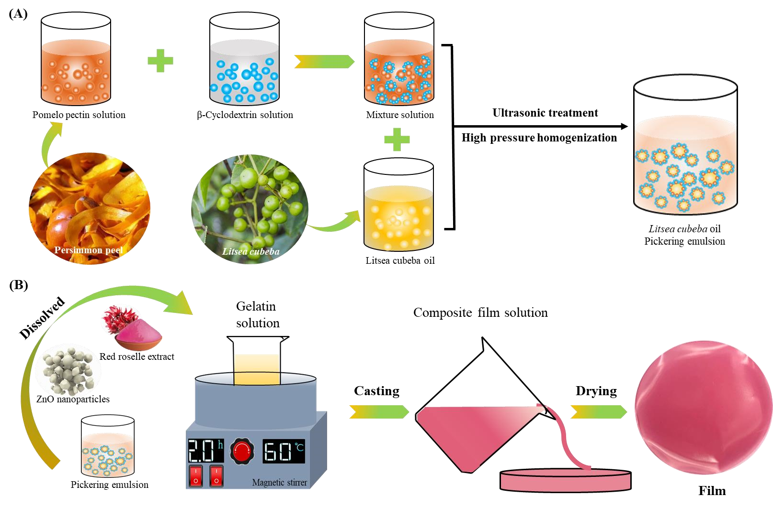

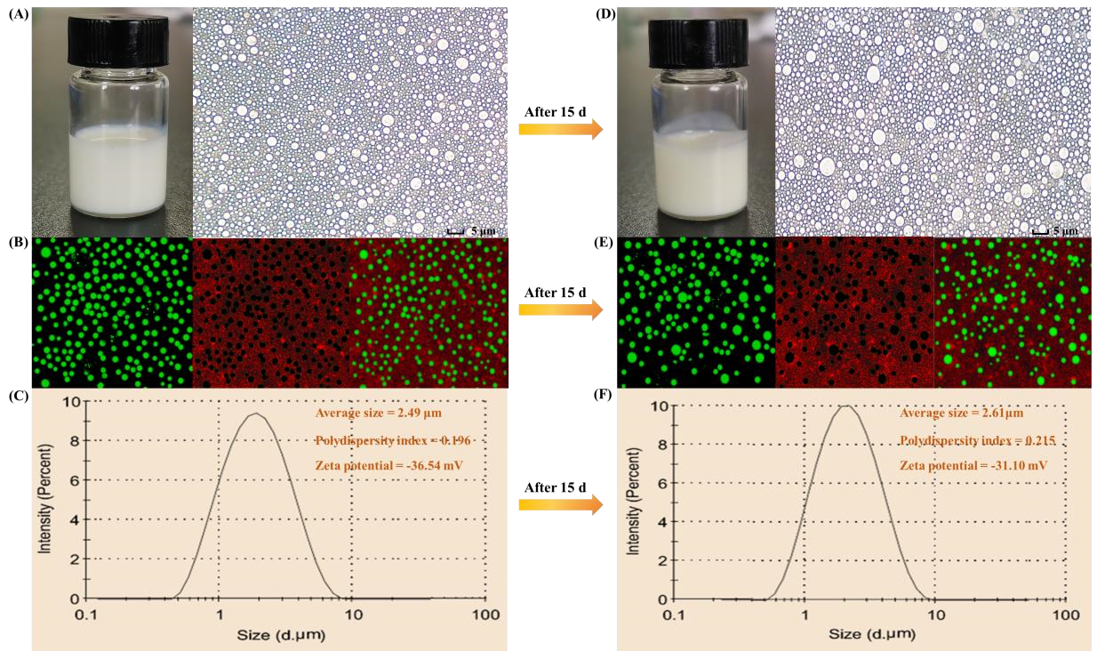

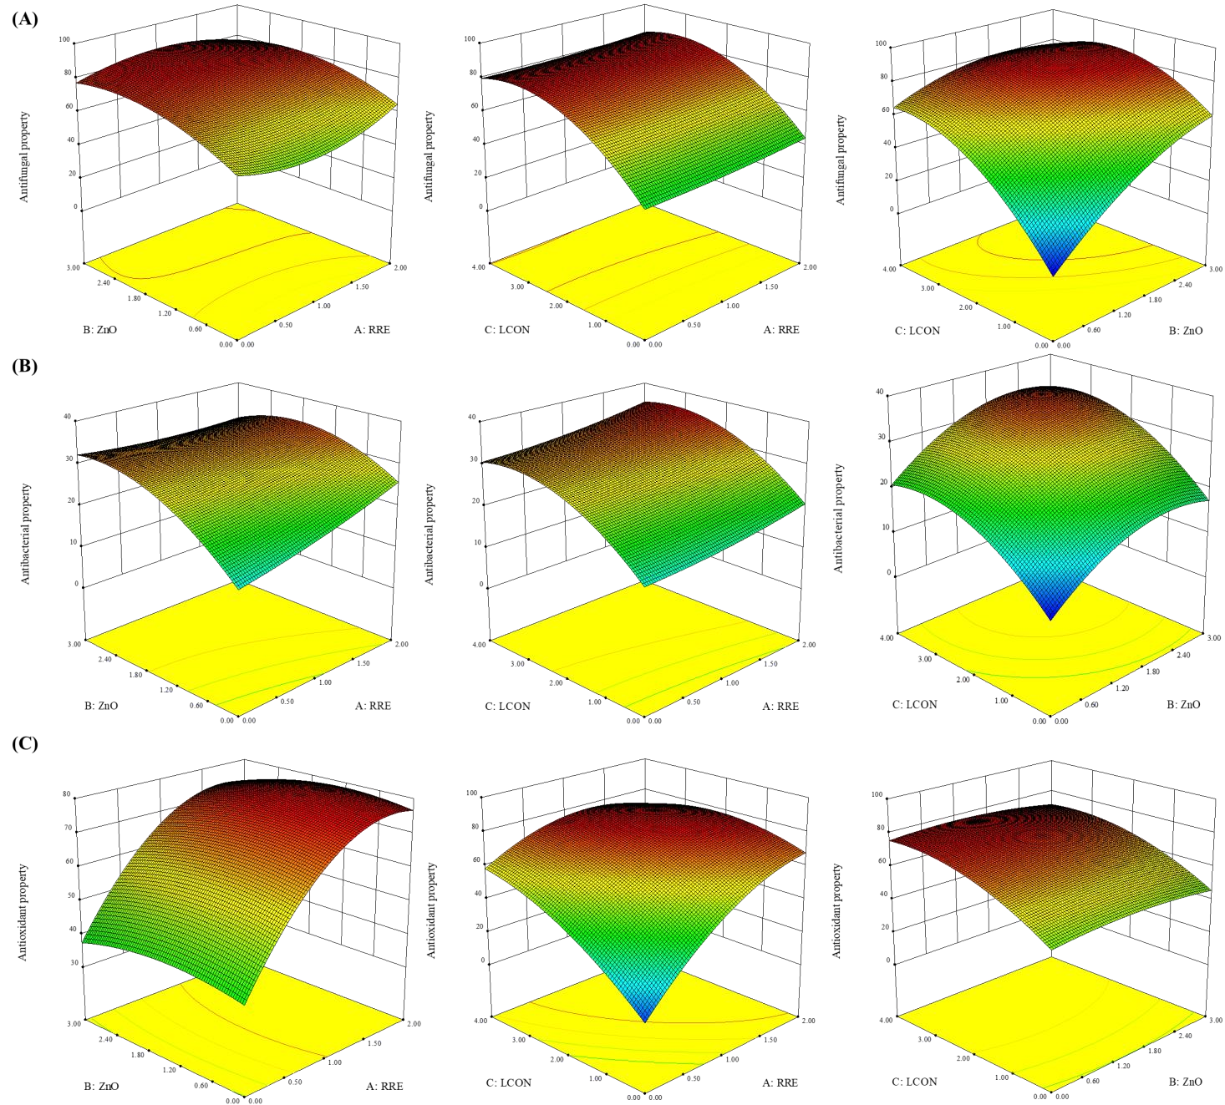

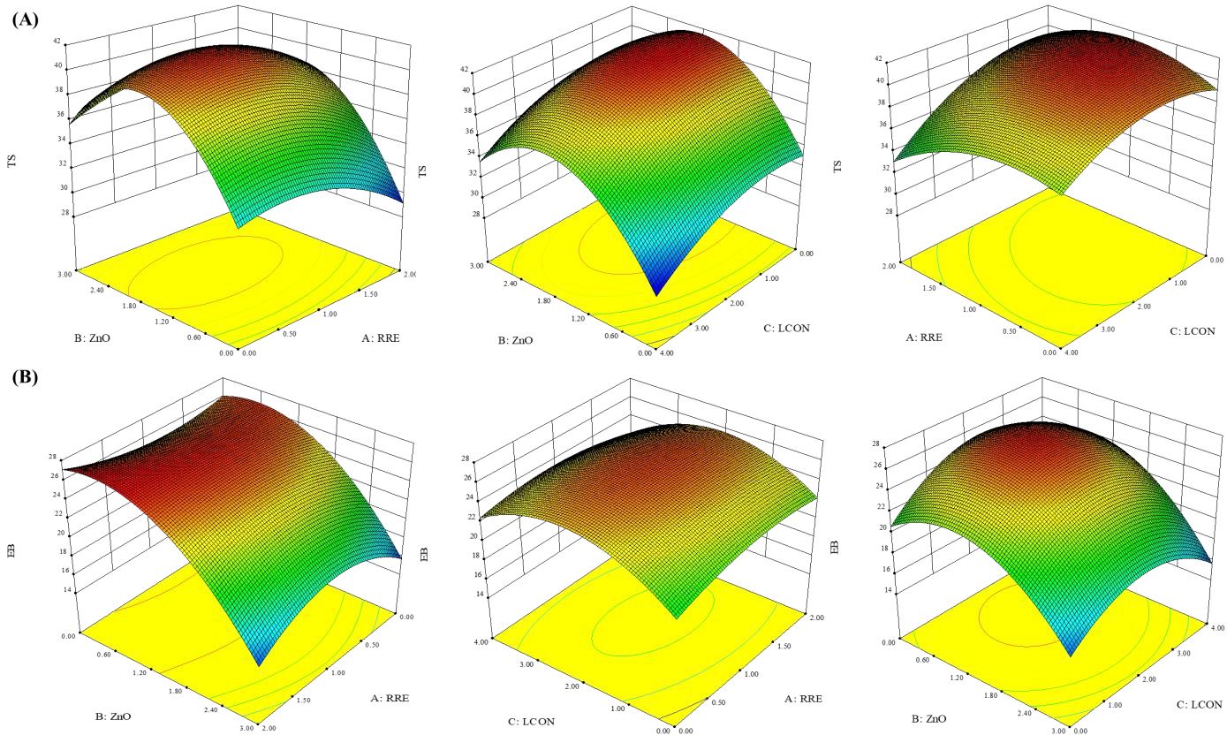

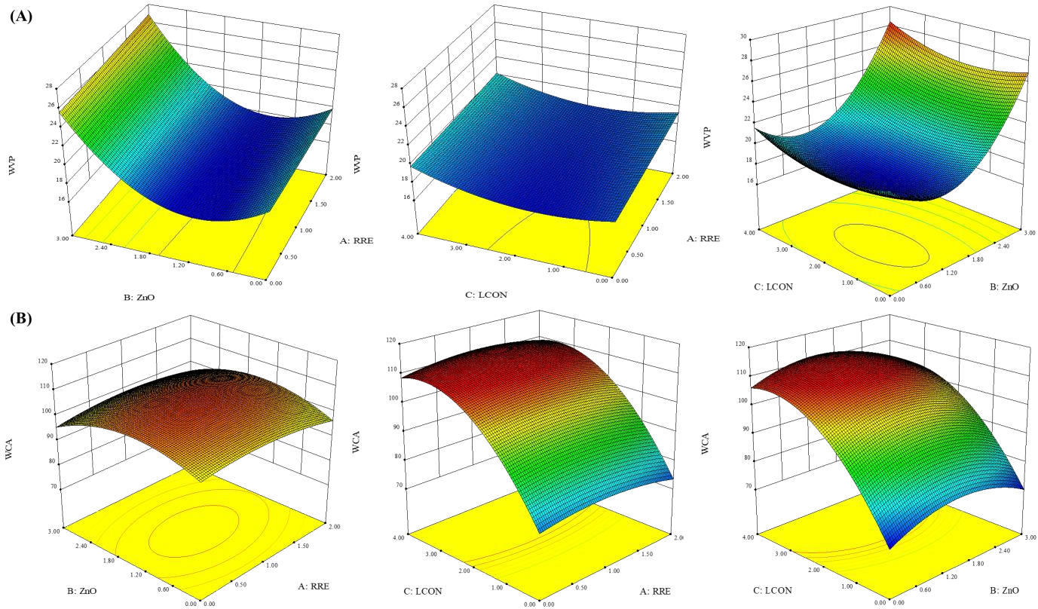

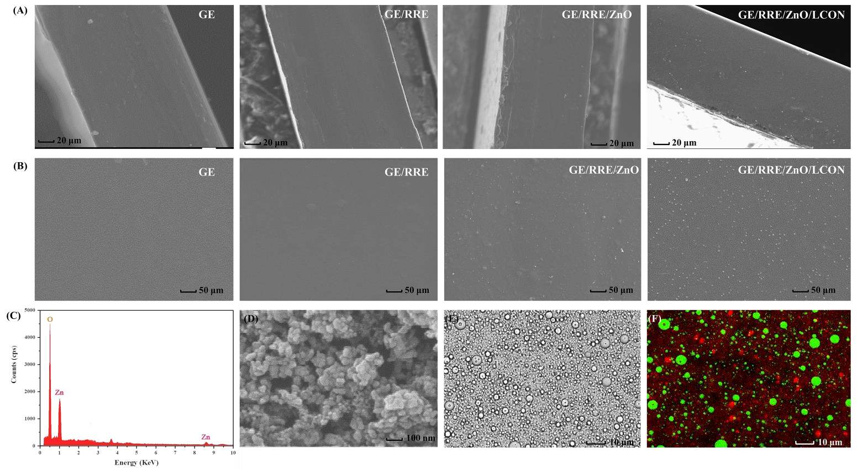

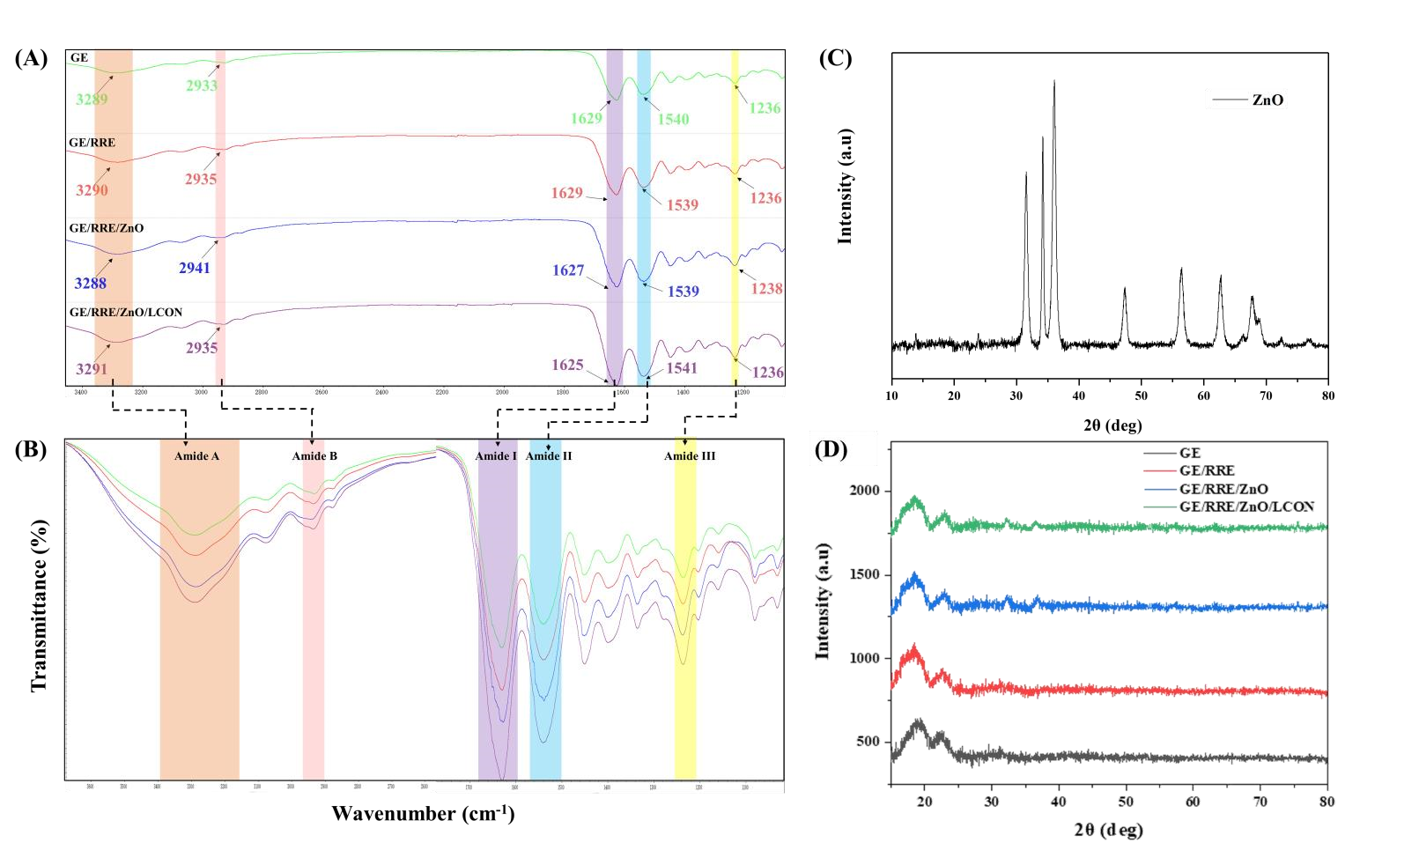

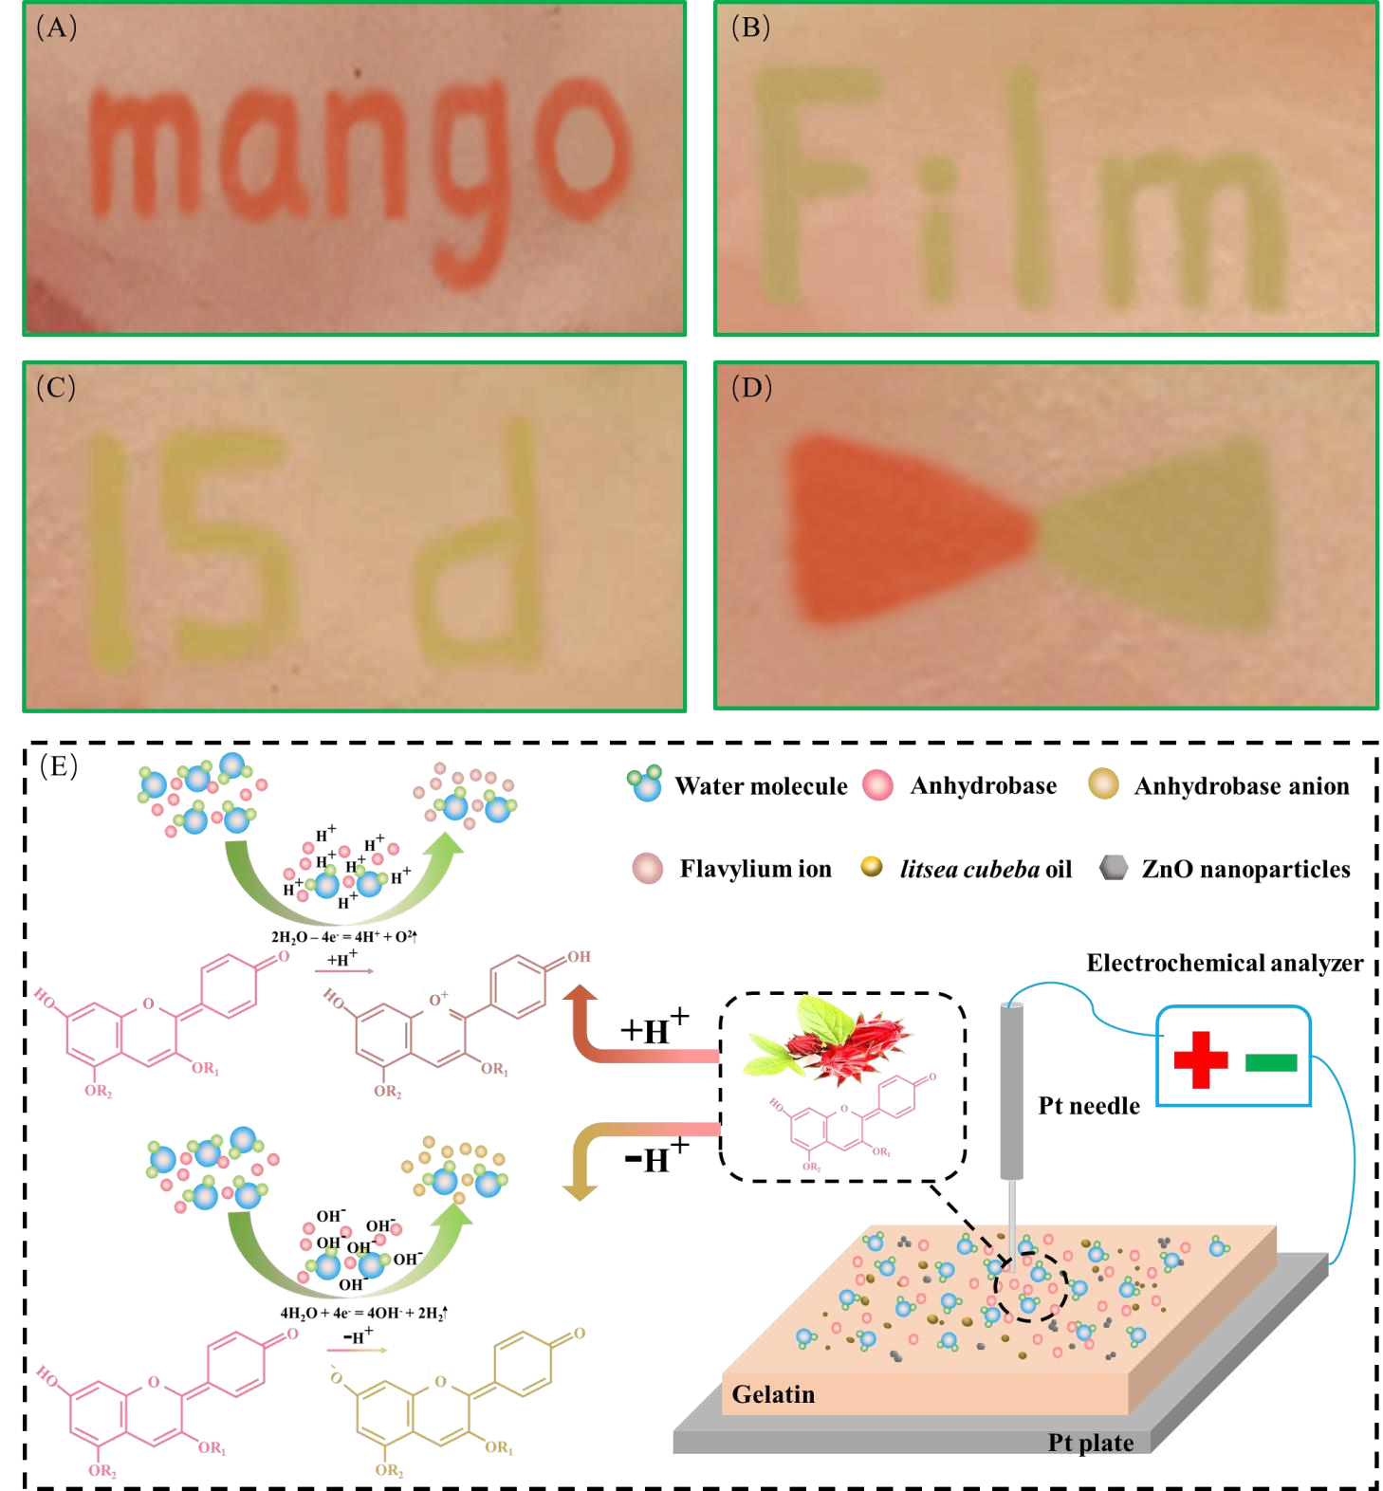

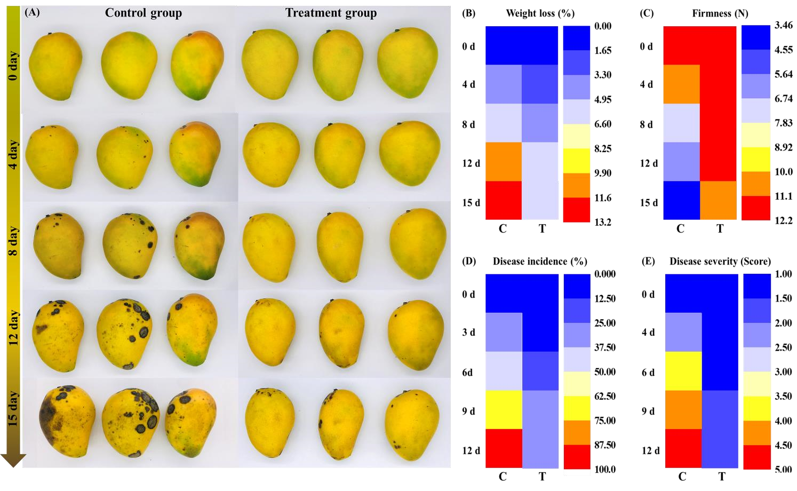

Figure captions Click here to access/download;Figure;Figure captions.doc
Fig. 1. Schematic of the fabrication of Litsea cubeba oil Pickering emulsion (A) and film (B).
Fig. 2. Optical microscope observation (A), confocal laser scanning microscopic (B), droplet size and
Zeta-potential (C) of Litsea cubeba oil Pickering emulsion on day 0 and optical microscope observation
(D), confocal laser scanning microscopic (E), droplet size and Zeta-potential (F) of Litsea cubeba oil Pickering emulsion on day 15.
Fig. 3. The combined effects of the three independent variables on the antifungal (A), antibacterial (B) and antioxidant (C) properties of the tested films.
Fig. 4. The combined effects of the three independent variables on the tensile strength (A) and elongation at break (B) of the tested films.
Fig. 5. The combined effects of the three independent variables on the water vapor permeability (A) and water contact angle (B) of the tested films.
Fig. 6. The cross-section (A) and surface (B) of GE, GE/RRE, GE/RRE/ZnO, and GE/RRE/ZnO/LCON film, EDX (C) and morphology (D) of ZnO nanoparticles, white-light and fluorescence photograph (B) of the GE/RRE/ZnO/LCON film-solution.
Fig. 7. The FTIR spectrum (A), enlarged image of FTIR spectrum (B), X-ray diffraction patterns of ZnO (C) and different films (D).
Fig. 8. The colorful letters ‘Mango’ (A), ‘Film’ (B), ’15 d’ (C), colored triangle (D) and electrochemical writing principle (E) on the film.
Fig. 9. The effect of optimized films on the appearance quality (A), weight loss (B) and firmness (C), , disease incidence (D), and disease severity (E) of mango during the storage period. (C: control group, T:
treatment group)

Table 1. Phytochemical compounds, antioxidant and antimicrobial capability of red roselle (Hibiscus
sabdariffa L.) extracts (Yang, Zou, Li, Huang, & Tahir, 2019)

Samples Vitamin C Total Total Total DPPH FRAP Inhibitory zone (mm)
 | mg/100g | flavonoid content mg/100g | anthocyanin content mg/100g | polyphenol content mg/100g | free radical scavenging  % | mM  Fe(II)/100g | E. coli | S. aureus
Red  roselle extract | 11.0 ± 0.0 | 26.5 ± 0.8 | 33.0 ± 0.4 | 148.2 ± 1.1 | 72.3 ± 1.8 | 139.3 ± 1.34 | 15.7 ± 0.0 | 14.2 ± 0.1
Data are reported as average values and standard deviations obtained from three replicates.

Table 2. Comparison of the effect of various packaging materials on weight loss and firmness of
mango
Packaging materials | Storage conditions | Weight loss (%) | Firmness (N) | Reference
Shellac/tannic acid | 25 ± 1.0 for 15 d | ~11.70 | ~4.62 | [1]
Native starch/cationic starch | 30 °C for 10 d | ~9.0 | N/A | [2]
Amphiphilic chitosan/carboxymethyl gellan gum/mustard essential oil | 26 °C for 20 d | ~17.18 | ~5.66 | [3]
Carboxymethyl chitosan/pullulan/galangal essential oil | 25 ± 1 °C for 15 d | ~8.72 | ~3.82 | [4]
PLA/TiO₂/Ag nanoparticles | 20 ± 1 °C for 15 d | ~4.80 | ~7.50 | [5]
High molecular weight-chitosan | 25 ± 2.0 °C for 16 d | ~13.59 | ~0.68 | [6]
chitosan/polyvinyl alcohol/cinnamon essential oil | 25 °C °C for 15 d | ~9.34 | ~6.18 | [7]
Chitosan | 22 °C for 30 d | ~15.04 | ~14.52 | [8]
Chitosan/quaternary phosphonium salt/ salicylic acid | 25 °C for 20 days | ~12.86 | ~3.68 | [9]
Gelatin/red roselle extract/ZnO/litsea cubeba oil Pickering emulsion | 25 ± 1.0 for 15 d | ~6.18 | ~10.81 | This work

Table 3. Comparison of the effect of various packaging materials on controlling the anthracnose of
mango
Packaging materials | Storage time  (d) | Disease incidence  (%) | Reference
Chitosan/quaternary phosphonium  salt/salicylic acid | 20 | ~52.00 | [1]
Chitosan/lacto-fermented peptides | 9 | ~43.50 | [2]
Polypropylene | 35 | ~78.0 | [3]
Chitosan | 8 | ~87.0 | [4]
Chitosan/nano-TiO₂ | 20 | ~19.73 | [5]
Gelatin/red roselle extract/ZnO/litsea cubeba oil Pickering emulsion | 12 | ~26.50 | This work

Declaration of Interest Statement

Conflict of Interest
Xiaobo Zou declares that he has no conflict of interest. Zhikun Yang declares that he has no conflict of interest. Jiyong Shi declares that he has no conflict of interest. Xiaodong Zhai declares that he has no conflict of interest. Xiaowei Huang declares that she has no conflict of interest. Zhihua Li declares that he has no conflict of interest. Mingrui Li declares that he has no conflict of interest. Jianbo Xiao declares that he has no conflict of interest. Yanxiao Li declares that she has no conflict of interest. Megan Povey declares that she has no conflict of interest. Xin Wang declares that he has no conflict of interest.

Author Statement

Credit author statement
Zou Xiaobo: Conceptualization, Methodology. Yang Zhikun: Data curation, WritingOriginal draft preparation. Zhai Xiaodong: Reviewing and Editing. Shi Jiyong: Conceptualization, Methodology. Li Zhihua: Conceptualization. Methodology. Huang Xiaowei: Reviewing and Editing. Li Mingrui: Reviewing and Editing. Xiao Jianbo: Conceptualization, Methodology. Li Yanxiao: Conceptualization, Methodology. Megan Povey: Conceptualization, Methodology. Wang Xin: Conceptualization, Methodology.

Supplementary Material

Click here to access/download

Supplementary Material
Supporting materials.docx

