**The Effects of Cognitive Reappraisal and Sleep on Emotional Memory Formation**

Brandy S. Martinez1, Dan Denis1, Sara Y. Kim1, Carissa H. DiPietro1, Christopher Stare1, Elizabeth A. Kensinger2, Jessica D. Payne1

1 Department of Psychology, University of Notre Dame

2 Department of Psychology and Neuroscience, Boston College

**Author Note**

Brandy S. Martinezhttps://orcid.org/0000-0003-2441-2002

Dan Denis https://orcid.org/0000-0003-3740-7587

Sara Y. Kimhttps://orcid.org/0000-0003-0105-3772

Carissa DiPietro https://orcid.org/0000-0002-4996-7277

Christopher Stare https://orcid.org/0000-0001-5881-2149

Elizabeth A. Kensinger  https://orcid.org/0000-0003-1940-231X

Jessica D. Payne https://orcid.org/ 0000-0003-3643-0574

Brandy S. Martinez is now at the Veterans Affairs Mid-Atlantic Mental Illness, Research, Education, and Clinical Center, Durham, North Carolina. Dan Denis is now at the Department of Psychology, University of York, UK

We have no known conflict of interest to disclose.

Correspondence concerning this article should be addressed to Brandy S. Martinez, Ph.D, Veterans Affairs Mid-Atlantic Mental Illness, Research, Education, and Clinical Center, Durham, NC, 27705. Email: Brandy.Martinez2@va.gov.

**Abstract**

Emotion regulation (i.e., either up- or down-regulating affective responses to emotional stimuli) has been shown to modulate long-term emotional memory formation. Further, research has demonstrated that the emotional aspects of scenes are preferentially remembered relative to neutral aspects (known as the emotional memory trade-off effect). This trade-off is often enhanced when sleep follows learning, compared to an equivalent period of time spent awake. However, the interactive effects of sleep and emotion regulation on emotional memory are poorly understood. We presented 87 participants with pictures of neutral or negative objects on neutral backgrounds paired with instructions to either increase or decrease their emotional response by altering personal relevance, or to passively view the stimuli. Following a 12 hour period of sleep or wakefulness, participants were tested for their memory of objects and backgrounds separately. Although we replicated the emotional memory trade-off effect, no differences in the magnitude of the trade-off effect were observed between regulation conditions. Sleep improved all aspects of memory, but it did not preferentially benefit memory for emotional components of scenes. Irrespective of a period of sleep or wake following encoding, findings suggest emotion regulation during encoding did not influence memory for emotional items at a 12-hour delay.

**Key words**: Emotion regulation, Cognitive reappraisal, emotional memory trade-off, sleep, sleep spindles, memory

**The Effects of Cognitive Reappraisal and Sleep on Emotional Memory** **Formation**

Research has established that emotional memories are preferentially remembered over emotionally neutral ones. As a real-world example, the “weapon focus effect” describes an individual’s tendency to better remember the details of an assailant’s weapon than their face (Loftus et al., 1987). This weapon focus effect is demonstrative of an emotional memory *trade-off effect*, whichrefers to preferential memory for emotional aspects of a scene at the expense of memory for its neutral components (Kensinger et al., 2007).

Although the trade-off effect is well-documented in the literature (e.g., Kensinger et al., 2007; Steinmetz & Kensinger, 2013), few studies have examined how the initial emotional response to these stimuli may influence how they are consolidated and later remembered. A study by Cunningham et al. (2014) found that individual differences in physiological arousal during encoding was associated with later memory, such that greater arousal while viewing negative scenes predicted better recognition for negative objects. Critically, this relationship emerged only after a consolidation period that included sleep, and not wakefulness, suggesting that one's emotional state during encoding may modulate subsequent sleep-based consolidation and the emotional memory trade-off effect. If so, affecting emotional arousal, for instance through emotion regulation strategies, should have downstream effects on emotional information but not neutral. Thus, the current study sought to examine whether engaging in emotion regulation at the time of encoding influences emotional memory formation over a subsequent night of sleep.

**Emotion Regulation and Memory**

*Emotion regulation* refers to the heterogeneous set of strategies used to influence the timing, type, and intensity of an emotional response. Although a variety of theoretical frameworks have been proposed to characterise the mechanisms underlying affect regulation (e.g., Campos et al., 2011; Gyurak et al., 2011; Koole, 2009), Gross’s Process model of emotion regulation (Gross, 1998a, 1998b) is the primary framework through which the field examines emotion-focused coping strategies. Critically, a central tenet of the Process model proposes that the effects of emotion regulation strategies on affective, cognitive, or social domains differ depending on *when* they are engaged during the emotion-generative process (Gross, 2002). *Antecedent-focused* emotion regulation thus refers to the strategies used to intervene in the emotional response early on whereas *response*-*focused* strategies modify an ongoing emotional experience (Gross, 2001, 2002).

*Cognitive reappraisal* is an antecedent strategy thatrefers to changing one’s perceptions surrounding a situation as a way to modify the emotional experience (Gross, 1998a, 1998b). Engaging in reappraisal can unfold in a variety of ways, such as fostering acceptance or identifying the positive/silver lining (McRae et al., 2012). *Distancing*, which involves cultivating physical or psychological distance from emotionally arousing stimuli by augmenting personal relevance, has been widely utilized in the experimental literature (e.g., Ahn et al., 2015; Kim & Hamann, 2012; Knight & Ponzio, 2013). Studies on cognitive reappraisal have begun to examine how regulating the emotional experience via cognitive reappraisal influences subsequent memory processes (Dolcos et al., 2017). For instance, Steinberger et al. (2011) examined cognitive reappraisal’s modulatory effect on the emotional memory trade-off effect, which refers to enhanced memory for the emotional aspects of a scene but not neutral. In a study by Kensinger et al. (2007), participants were presented with a series of images comprised of either a negative or neutral object superimposed on a neutral background. The images presented in the trade-off task were paired with emotion regulation instructions to either to passively view the stimuli, or utilise cognitive reappraisal to up-regulate (i.e., increase) or down-regulate (i.e., decrease) their emotional response. The findings demonstrated that memory for passively viewed images yielded the greatest trade-off effect, while either up- or down-regulating the emotional experience resulted in decreased trade-off magnitudes, suggesting that cognitive reappraisal may alter memory formation.

Emotion regulation during encoding is particularly relevant for long-term memory formation because the conditions under which memories are encoded influence how they are subsequently shaped over time. For example, Knight and Ponzio (2013) assessed memory following a 48-hour delay using a free recall task. Results revealed poorer memory for items that were downregulated during encoding. Similarly, Ahn et al. (2015) reassessed memory using a free recall task using a 1-week delay. Consistent with what the authors observed at time 1, recall memory for images encoded during the decrease reappraisal trials was worse compared to the increase and watch conditions. Following a long delay, it appears that reappraisal methods used to attenuate the emotional experience impair memory recall for emotionally salient information (e.g., Ahn et al., 2015; Knight & Ponzio, 2013). Research, however, has also demonstrated that recognition memory for emotionally salient stimuli has improved following the use of reappraisal methods used to attenuate or enhance the emotional experience at the time of encoding (Kim & Hamann, 2012), suggesting that the effects of reappraisal on memory may be non-specific.

The interaction between reappraisal and memory thus emerges as unclear. While some research has found impoverished recall memory for emotional stimuli encoded while down-regulating affect following short and long delays (Ahn et al., 2015; Knight & Ponzio, 2013), others have observed improved recognition memory for emotional stimuli encoded while up- or down-regulating the emotional experience (Kim & Hamann, 2012). Given these mixed findings, we endeavored to investigate whether down- versus up-regulating affect at encoding would exert divergent effects on the trade-off effect. We were also especially interested in examining whether a delay that includes a period of sleep influences whether emotion regulation improves or worsens memory for emotional stimuli.

**Emotion Regulation and Sleep**

Research on the interplay between sleep and emotion regulation has largely focused on examining the negative effects of sleep deprivation on emotion regulation ability (Palmer & Alfano, 2017). Indeed, Gruber and Cassoff (2014) have provided a conceptual framework that explicates the associations between sleep deprivation and emotion regulation ability. By contrast, we were interested in examining how sleep interacts with emotion regulation as it concerns the emotional processing of distressing stimuli following cognitive reappraisal. That is, we were interested in examining whether utilizing cognitive reappraisal to alter personal relevance modulates the emotional-memory trade off effect. Further, if reappraisal effectively modulates the emotional tone of distressing stimuli, does a period of sleep further influence how a stimulus is encoded and later recalled? Consistent with the theoretical perspective that sleep may help bolster adaptive emotion regulation via reductions in emotional tone (Vandekerckhove & Wang, 2018; van der Helm & Walker, 2012), we sought to examine sleep as a bio-behavioral mechanism that promotes the adaptive regulation of daily emotional experiences that reduces the emotional tone of distressing experiences.

**Sleep and Emotional Memory**

The magnitude of the emotional memory trade-off effect appears to be enhanced by sleep. For example, Payne et al. (2008), examined how a 12-hour delay containing either sleep or wakefulness impacts the emotional memory trade-off effect. Although the main trade-off effect was found in both groups, negative object memory was greater after a night of sleep compared to a day awake. This suggests that sleep selectively enhances memory for the emotional components of memory. The effect of sleep on the emotional memory trade-off effect has been replicated in a number of subsequent studies (e.g. Alger et al., 2018; Payne & Kensinger, 2011; Payne et al., 2012, 2015), including a recent large-scale study of 280 participants (Denis et al., 2022). Despite these results, recent reviews and meta analyses of the broader sleep and emotional memory literature have failed to find support for sleep preferentially enhancing emotional memory to a larger degree than wakefulness (Davidson et al., 2021; Lipinska et al., 2019; Schäfer et al., 2020). Indeed, not all studies using the trade-off paradigm have found a statistically significant interaction between valence, component (object, background), and sleep (e.g. Bennion et al., 2015, 2017; Cunningham et al., 2014), and the trade-off effect has been shown to remain intact following total sleep deprivation (Vargas et al., 2019).

The sleep correlates of emotional memory formation remain equally unclear. It is often posited that rapid eye movement sleep (REM), and in particular REM *theta oscillations* (4-7Hz), play a role [(Ackermann & Rasch, 2014; Groch et al., 2013; Hutchison & Rathore, 2015; Kim et al., 2019; Nishida et al., 2009; Payne et al., 2012; Schäfer et al., 2020; Sopp et al., 2017)](https://www.zotero.org/google-docs/?ZUpWct) . However, this effect has been found only in a minority of published studies (Davidson et al., 2021). *Beta oscillations* (15-25Hz) are also present during REM sleep (Vijayan et al., 2017), and may be linked to emotion regulation ability (Denis, Bottary, et al., 2021). Conversely, slow wave sleep (SWS) has also been linked to memory consolidation. Mechanistically, this is believed to be achieved via the temporal coupling of the cardinal SWS oscillations, sleep spindles and slow oscillations (Klinzing et al., 2019). While there is some evidence that spindles prioritise the consolidation of certain memories over others (Denis, Mylonas, et al., 2021; Saletin et al., 2011; Studte et al., 2017; Wilhelm et al., 2011), the evidence with regards to emotional memory is mixed (e.g. Davidson et al., 2021; Denis, Kim, et al., 2021; Payne et al., 2015), with no consistent associations being observed.

**Emotion Regulation, Sleep, and The Trade-off Effect**

Does sleep modulate the effects of emotion regulation on the formation of emotional memory? If so, how might the modulatory effects of sleep on the reappraisal–memory interaction vary by sleep stage? We attempted to answer these questions by presenting participants with pictures of neutral or negative objects on neutral backgrounds paired with affect regulatory instructions to either increase or decrease their emotional experience, or passively view the stimuli. Following a 12-hour period of sleep or wakefulness, participant’s memory for objects and backgrounds were tested to characterise the trade-off effect. Based on previous research, we expected that that magnitude of the trade-off effect would be decreased for images encoded while reappraising given that down-regulating the affective response to the images would reduce their emotional intensity (Steinberger et al., 2011). Although previous research indicates that the trade-off effect is enhanced following a 12-hour delay including a night of sleep, particularly for negative object memory (e.g., Payne et al., 2008), we did not expect to observe this effect during decrease-trials given that the use of cognitive reappraisal should have reduced the emotional tone of the stimuli at encoding. We did, however, anticipate that the trade-off effect would be enhanced in up-regulation trials given that the emotional tone of the stimuli at encoding should have increased.

In a subset of participants in the sleep group, we collected overnight polysomnography (PSG) to facilitate exploratory analyses examining whether sleep stages differentially modulate the trade-off effect following affect regulation. Albeit exploratory, we were interested in examining whether REM sleep and neural oscillations during REM would most strongly correlate with memory for stimuli that were up-regulated during encoding, whereas SWS and neural oscillations during SWS would most strongly correlate with memory for items that were down-regulated.

**Method**

**Recruitment**

Participants were recruited from the Chestnut Hill area, the Boston College student body, and the University of Notre Dame student body for financial remuneration (10 USD per hour) or course credit. Prospective participants completed a comprehensive phone screen to exclude for the use of psychoactive drugs or any history of sleep or mood disorders and were instructed to refrain from consuming any caffeine or alcohol for the 24 hours before and throughout the duration of the study. The results presented here included 87 total participants (*Mage* = 19.6, *SDage* = 1.6), with 48 participants in the Sleep group (31 female, 17 male; *Mage* = 19.4, *SDage* = 1.9) and 39 participants in the Wake group (21 female, 18 male; *Mage* = 19.8, *SDage* = 1.2). Results from 12 additional participants were excluded due to unreliable data (e.g., failure to follow task instructions) or missing data (e.g., failure to attend the second study session; trials with missing arousal data). Study procedures were reviewed and approved by the Boston College and University of Notre Dame Institutional Review Boards.

**Stimuli and Apparatus**

Stimuli were selected from The International Affective Picture System (IAPS; Lang, et al., 1997), a standardised set of images rated along dimensions of valence and arousal. The images included in the current study are the same as those reported by Steinberger et al. (2011), and include a total of 160 scenes comprised of 120 negative foreground objects and 40 neutral foreground objects. Further, the 120 scenes including a negative foreground object were subdivided into three sets of 40 images. Each negative image set was assigned to an affect regulation condition (i.e., increase or decrease), or to the control (i.e., view) condition. The 40 neutral scenes, by contrast, were exclusively presented during the view trials.

**Procedures**

All participants completed two study sessions consisting of an encoding task in session 1 followed by a memory recognition task in session 2. Participants in the wake group arrived at the laboratory in the morning (between 8 and 10am) to complete the encoding task and returned approximately 12 hours later to complete the recognition task. Participants in the wake condition were instructed to refrain from taking naps between sessions, yielding a 12-hour delay between encoding and recognition that did not contain a period of sleep. Participants in the sleep group arrived at the laboratory in the evening (between 8 and 10pm) to complete the encoding task. Participants in the sleep group were instructed to obtain at least 6 hours of sleep before returning to the laboratory for session 2 between 8 and 10am, resulting in a 12-hour delay between encoding and recognition containing a night of sleep. A subset of the sleep participants (n = 21) slept overnight in the laboratory, and their sleep was monitored using polysomnography (see below). Both sleep and wake participants completed a questionnaire packet at the start of the session to report whether or not they complied with the instructions associated with their sleep versus wake group assignment (**Figure 1**).

**Encoding Task**

During the encoding task, items were presented in a predetermined sequence (80 neutral scenes followed by 240 negative scenes). For the negative scenes, the assignment of images to the regulation instruction (view, increase, decrease) was counterbalanced between participations, and presented in a randomized order. For every image presented, participants had 3 s to view the image and rate arousal on a 1 (*low arousal*) to 8 (*high arousal*) scale. Participants were then provided with 8 s to follow one of three affect regulation instructions: increase, decrease, or view. When presented with the *increase* instruction, participants were asked to intensify their emotional experience by putting the image in a different contextual framework that enhances personal relevance (e.g., the reaction to the image of a sinking ship may be up-regulated by imagining family members onboard). If presented with the instruction to *decrease*, participants were similarly instructed to attenuate their emotional experience by putting the image in a different contextual framework that reduces personal relevance (e.g., the reaction to the image of a sinking ship may be down-regulated by imagining it as a fictitious scene from a movie). Lastly, when presented with the *view* instruction, participants were asked to “*let yourself respond to each image as you normally would. DO NOT make any efforts to try to alter your feelings toward these images*.” Following affect regulation, participants were given 3 s to provide a second arousal rating on the same 1 to 8 scale. The resulting onscreen duration for every image presented was a total of 14 s.

Prior to encoding, participants completed practice trials to ensure that the affect regulation instructions (i.e., increase, decrease, or view) were understood. Participants were shown 3 images followed by the instruction to increase, decrease or view and were asked to report aloud the strategies used to regulate their affective response. The experimenter offered corrective feedback as needed if non-target regulation strategies (e.g., distraction) were reported.

**Recognition Memory Task**

All participants completed the recognition memory task in session 2, which consisted of the 320 backgrounds and objects presented at encoding in addition to 80 novel images (60 negative, 20 neutral) and 80 novel backgrounds (all neutral). This image list was pseudorandomly arranged (to minimize the likelihood that many stimuli of the same valence or picture type would appear in a row), and then presented in the same order for all participants. Participants were asked to make a rating on their memory of each image by stating if the image was “new,” if they “remembered” it, or if they “knew” it (Hu et al., 2006; Tulving, 1985). If the image had not been presented in the encoding session, participants were asked to make the “new” rating. If the participants vividly remembered the moment they had seen the image before, including some type of context of the event (how they felt about the image, what they were thinking at the time of seeing the image, etc.), they were asked to make a “remember” response. If they knew they had seen the image before, but did not consciously remember the initial viewing event, they were asked to make a “know” response. Each image remained on the screen until the participant made one of these three judgments.

**Polysomnography**

Polysomnography (PSG) was acquired for a full night of sleep in 21 sleep participants. PSG recordings included electrooculography recordings above the right eye and below the left eye, electromyography from two chin electrodes (referenced to each other), and electroencephalography (EEG) recordings from six scalp electrodes (F3, F4, C3, C4, O1, O2), referenced to the contralateral mastoids. Data were collected using a Grass Aura amplifier and TWin software at a sampling rate of 200Hz. EEG data were band-pass filtered between 0.3-35Hz. Following acquisition, data were sleep scored in accordance with the American Academy of Sleep Medicine (2007) guidelines. EEG data were then artefact rejected using automated procedures. For each channel, the root mean square (RMS) and three Hjorth parameters (signal activity, mobility, and complexity) were calculated for each epoch (Hjorth, 1970; Purcell et al., 2017). Epochs where at least one parameter, on at least one channel, was >3 standard deviations above the channel mean were rejected as artefact. This method of artefact rejection was iteratively performed twice and was performed separately for each stage of sleep. All artefact -free epochs were then used for further analysis.

**Power Spectral Density**

The power spectrum was determined for all artifact-free REM sleep data. Power spectral density (PSD) was estimated using Welch’s method with 5s windows and 50% overlap (using the *pwelch* function in MATLAB). To minimise the typical 1/f scaling of the power spectrum, estimates were obtained from the temporal derivative of the EEG time series (Cox et al., 2017). We then normalised the power spectrum by dividing the spectrum by the average power in the 0-25Hz range. Averaged PSD estimates in the theta (4-7Hz) and beta (16-25Hz) ranges were then used for statistical analysis. All analyses were conducted at electrode F3, given prior studies suggesting that REM theta correlations are strongest at frontal electrodes (e.g. Nishida et al., 2009)

**Slow Oscillation-Spindle Coupling**

All analyses were performed at electrode C3, on the basis that spindle activity is strongest at centro-parietal sites (De Gennaro & Ferrara, 2003). Spindles were automatically detected during slow wave sleep using a wavelet-based detector (Denis, Kim, et al., 2021; Mylonas et al., 2019; Wamsley et al., 2012). As a first step, each participant’s spindle peak frequency was identified through visual inspection of the SWS power spectrum (PSD estimated using Welch’s method with 5s windows and 50% overlap, applied to the temporal derivative of the data). The largest, most prominent peak in the 12-15Hz range was considered that participant’s spindle peak frequency, and was used to tune the spindle detector to each individual. We note that we restricted peak detection to 12-15Hz activity, corresponding to primarily “fast” spindle activity. To detect sleep spindles, the raw SWS EEG signal was subjected to time-frequency transformation using complex Morlet wavelets. The wavelet parameters were tuned to each individual’s spindle peak. Specifically, the peak frequency of the wavelet was set at that individual’s spindle peak, with the bandwidth of the wavelet (full-width half-max) being a 1.3Hz range centered on the peak frequency (e.g. if a participant’s spindle peak was 13Hz, the wavelet peak would be set at 13Hz, with a bandwidth of 12.35-13.65Hz; Cox et al., 2017; Denis, Kim, et al., 2021). A spindle was detected whenever the wavelet signal exceeded a threshold of 6 times the median signal amplitude of artefact-free data for a minimum of 400ms (Denis, Kim, et al., 2021; Djonlagic et al., 2021; ).

Slow oscillations during SWS were detected using a second automated detector. First, the artifact-free SWS signal was filtered between 0.5-4Hz and all positive-to-negative zero crossing were identified. All consecutive crossings that fell 0.5-2 s apart were marked as potential slow oscillations. Peak-to-peak amplitude for all potential slow oscillations was calculated, and oscillations in the top quartile (i.e. with the highest amplitudes) were retained as slow oscillations (Denis, Kim, et al., 2021; Helfrich et al., 2018; Staresina et al., 2015).

To determine slow oscillation-spindle coupling, the data were band-pass filtered in the delta (0.5-4Hz) band and in each participant’s spindle band (a 1.3Hz bandpass centered on the participant’s spindle peak frequency). Then, the Hilbert transform was applied to extract the instantaneous phase of the delta-filtered signal and instantaneous amplitude of the spindle-filtered signal. For each detected spindle, the peak amplitude of that spindle was determined. It was then determined whether the spindle peak occurred within the time course (i.e., between the two positive-to-negative crossings) of any detected slow oscillation. If the spindle peak was found to occur during a slow oscillation, it was considered to be coupled to the slow oscillation. Our main metric of focus was the coupled spindle density (i.e., the number of coupled sleep spindles per minute of SWS; Denis, Mylonas, et al., 2021; Mylonas et al., 2020).

**Analytic Strategy**

Data were analysed using the Statistical Package for the Social Sciences (SPSS) V.25 software using an alpha level of .05 for all statistical tests. Pairwise comparisons were adjusted using a Bonferroni correction, and reported using the mean difference (MD) and confidence intervals (CI) where appropriate. Memory performance was defined as corrected recognition scores, defined as hit rate (proportion of old trials assigned as either “remember” or “know”) minus false alarm rate (proportion of new trials incorrectly assigned as “remember” or “know”). Further, “know” responses were also corrected (K/1-R) to account for the interdependence of “remember” and “know” responses. Consequently, results for "remember" and corrected "know" are reported separately in-text where relevant, with full results reported in corresponding tables.

We first examined whether our data replicated the expected memory trade-off effect characterised by superior memory for negative foreground objects at the expense of neutral background images. To achieve this, we used data from all trials (regardless of reappraisal instructions) to perform a 2-between (*Group*: Sleep vs. Wake) x 2-within (*Picture Type*: object vs. background) x 2-within (*Valence*: negative vs. neutral) ANOVA on corrected recognition scores to examine whether the emotional memory trade-off effect was observed in the sleep and wake conditions. A 2-between (*Group*: Sleep vs. Wake) x 2-within (*Picture Type*: object vs. background) x 3-within (*Instruction*: decrease vs. increase vs. view) ANOVA on corrected recognition scores examined whether affect regulation differentially modulated recognition memory for emotional stimuli in the sleep versus wake groups.

Associations between sleep parameters and emotional memory trade-offs were assessed in a subset of the data (n = 21) using robust linear regressions (MATLAB function *lmfit* with *RobustOptions* turned on). For these correlations, the magnitude of the trade-off effect was defined as the difference between memory performance for objects minus backgrounds, by valence (e.g., magnitude of the negative memory trade-off = corrected recognition scores for negative objects – corrected recognition scores for backgrounds that were associated with negative objects at encoding), for each individual. Robust regression procedures were used to minimise the influence of outliers. Although significance was assessed through robust linear regression, correlation coefficients are also reported as a standard measure of association magnitude. Comparisons of correlation magnitude were performed using Meng’s *z* test (Meng et al., 1992; Spaak, 2020).

**Results**

**Arousal Manipulation Check**

We first assessed the efficacy of the reappraisal interventions on self-reported arousal.A mixed ANOVA with between-subjects factor Group (2 levels: Sleep vs. Wake), within-subjects factor Time (2 levels: pre- vs. post-regulation), and within-subjects factor Instruction (3 levels: increase, decrease, view) on negative images. We observed a significant Time-by-Instruction interaction effect (F (2, 79) = 162.595, p < .001, η2partial = .81). As expected, this was driven by a significant increase in self-reported arousal following the increase instruction (Mdifference = -1.22, 95% CI [-1.37, -1.07]) and a significant decrease following the decrease instruction (Mdifference = 1.65, 95% CI [1.43, 1.88]). We note, however, there was a significant difference during view trials such that arousal ratings were higher post-regulation (Mdifference = .181, 95% CI [.094, 0268]). This was only observed in the sleep group (Mdifference = .258, 95% CI [.141, .374]), who reported overall high arousal ratings compared to the wake group (F(1,80) = 10.50, p = .002). Critically, however, the Time-by-Instruction-by-Group (F (2, 79) = .837, p = .437) interaction was not significant. In other words, the reappraisal manipulation was effective in altering post-regulation arousal levels, and this effectiveness was similar in those who would be assigned to the wake-delay versus the sleep-delay groups (see **Table 1**). We note that arousal ratings at encoding did not significantly correlate with memory performance at the recognition test. These correlations were ran separately for item valence (negative, neutral), reappraisal (view, increase, decrease) and group (sleep, wake), indicating there was no association between the subjective arousal rating at encoding with memory for those items at the test.

**Memory Trade-off Effect**

Recognition scores for each group and condition are presented in Table 2. Prior to examining whether affect regulation influences recognition memory, we examined whether our data replicated the expected memory trade-off effect characterised by superior memory for negative foreground objects at the expense of neutral background images (see **Figure 2**). To achieve this, we performed a 2-between (*Group*: Sleep vs. Wake) x 2-within (*Picture Type*: object vs. background) x 2-within (*Valence*: negative vs. neutral) ANOVA restricted to the control (i.e., view) condition. Results of the analyses revealed a significant main effect of Group (*F* (1, 85) = 5.53, *p* = .021, η2partial = .06), with better overall memory in the sleep group compared to the wake group. There were also significant main effects of Valence (*F* (1, 85) = 6.20, *p* = .015, η2partial = .07), with better memory for components of emotional scenes compared to neutral, and Picture type (*F*(1, 85) = 155.10, *p* < .001, η2partial = .65), with superior memory for objects compared to backgrounds. Critically, these effects were qualified by a significantpicture type-by-valence interaction (*F* (1, 85) = 292.13, *p* < .001, η2partial = .78), indicative of the expected trade-off effect. Pairwise comparisons indicated that negative objects were better remembered (*M* = .72, *SD* = .18), compared to their original neutral backgrounds (*M* = .39, *SD* = .18; *t*(86) = 18.50, *p* < 0.001), which was not the case for neutral objects (*M* = .57, *SD* = .16) and their backgrounds (*M* = .59, *SD* = .18; t(86) = .83, *p* = .41). However, the 3-way picture type-by-valence-by-group interaction effect was not significant (*F* (1, 85) = .004, *p* = .95, η2partial < .001), suggesting that the trade-off effect was similar across both wake and sleep conditions during passive viewing. All other main effects and interactions were non-significant (all *p* > .4). When remember and know responses were analysed separately, a similar pattern of results for the effect of valence and the picture type-by-valence interaction were found (**Table 3**). However, the main effect of group was only significant for know responses (*F* (1, 85) = 5.54, *p* = .021, η2partial= .06), and not for remember-only responses (*F* (1, 85) = 1.43, *p* = .24, η2partial = .02).

**Modulatory Effects of Affect Regulation**

We then examined whether emotion regulation would differentially influence the memory trade-off effect in sleep versus wake subjects by conducting a 2-between (*Group*: Sleep vs. Wake) x 2-within (*Picture Type*: object vs. background) x 3-within (*Instruction*: decrease vs. increase vs. view) ANOVA comparing memory for the components of negative scenes (i.e., background vs object) during each of the regulation trials (i.e., decrease, increase, view). Results of the analysis revealed a significant main effect of picture type (*F* (1, 85) = 616.77, *p* < .001, η2partial = .88), such that objects were better remembered overall than their associated backgrounds. Further, results of the ANOVA also indicate a significant main effect of group(*F* (1, 85) = 6.55, *p* = 0.012, η2partial = .07) such that those in the sleep group demonstrated better memory overall (*M*difference = .138, 95% CI [.02, .26]). All other main effects and interactions were not significant (all *p* > .3), suggesting no impact of affect regulation on subsequent memory. When remember and know responses were analyzed separately, a similar pattern of results for the main effect of picture type was found (Table 3). However, the main effect of group was only significant for know responses (*F* (1, 85) = 6.55, *p* = .012, η2partial= .07), and not for remember-only responses (*F* (1, 85) = 1.90, *p* = .17, η2partial = .02). Findings are illustrated in **Figure 3**.

**Exploratory Polysomnography Findings**

Finally, we completed exploratory analyses examining how rapid eye movement (REM) and slow wave (SWS) sleep were associated with the magnitude of the emotional memory trade-off effect for the different reappraisal conditions. We did not look at neutral memory trade-offs, as there was no evidence of such a trade-off existing for neutral objects and their respective backgrounds. We also only focused on know responses, given that is where the behavioural effect of sleep on memory was strongest. For REM sleep, we did not observe any associations between either REM time or REM theta power with the size of the emotional memory trade-off for any of the reappraisal conditions (REM time: all *r* < .27, all *p* > .09; REM theta: all *r* < .10, all *p* > .83). For REM beta power however, there was a significant positive association with trade-off magnitude for items in the increase condition (*r* = .35, *p* = .048), but not the decrease (*r* = .23, *p* = .32) or view conditions (*r* = .20, *p* = .29; **Figure 4**). Although the association was only significant for increase items, we note that the magnitude of the association was not significantly different from either decrease (*z* = 0.48, *p* = .32) or view conditions (*z* = 0.79, *p* = .22).

With regards to SWS, we found a significant positive association between SWS time and the magnitude of the emotional memory trade-off for items in the decrease condition (*r* = .45, *p* = .041), but not the increase (*r* = -.05, *p* = .80) or view (*r* = .03, *p* = .96) conditions (**Figure 5**). The magnitude of the SWS time and trade-off magnitude correlation for decrease items was significantly larger than the association between SWS time and trade-off magnitude for the increase (*z* = 1.93, *p* = .027) or view (*z* = 1.88, *p =* .030) conditions. Furthermore, the density of slow oscillation-coupled sleep spindles during SWS was also uniquely associated with the size of the emotional memory trade-off effect in the decrease condition (*r* = .51, *p* = .026). This was not the case for the increase (*r* = -.13, *p* = .50) or view (*r* = -.10, *p* = .68) conditions (**Figure 5**). The strength of association was significantly stronger in the decrease condition compared to increase (*z* = 2.47, *p* = .007) and view (*z* = 2.70, *p* = .004) conditions. We note that none of the correlations remained significant when controlling for multiple comparisons.

**Discussion**

Research examining the effects of emotion regulation on memory encoding processes is a burgeoning area of research. Although findings in this area are mixed, empirical studies indicate that up-regulating affect via cognitive reappraisal can improve memory for emotional stimuli (Ahn et al., 2015; Dillon et al., 2007; Knight & Ponzio, 2013). We contributed to this area of research by examining whether up- or down-regulating affect via cognitive reappraisal modulates the emotional memory trade-off effect. To further extend the findings originally reported by Steinberger et al. (2011), we included a 12-hour delay comprised of a period of sleep or wakefulness, and performed exploratory analyses on sleep architecture-memory relationships on a subset of participants in the sleep group.

Consistent with the general body of research on emotion regulation and memory, we found that negative objects were better remembered than neutral objects. Studies examining memory following a short delay such as 10 min (e.g., Richards & Gross, 2000, study 2; Sheppes & Meiran, 2008) or 15 min (e.g., Knight & Ponzio, 2013, study 1 and study 2 time 1), for example, suggest cognitive reappraisal has no effect on verbal memory (e.g., Richards & Gross, 2000, study 2; Sheppes & Meiran, 2008; ) or visual memory (Kim & Hamann, 2012, time 1 and 2). As the delay interval between encoding and retrieval is lengthened, however, cognitive reappraisal is associated with impaired memory recall (e.g., Ahn et al., 2015; Knight & Ponzio, 2013) but improved memory recognition for emotionally salient information (e.g., Hayes et al., 2010; Kim & Hamann, 2012). Our findings thus augment the broader literature on emotion regulation and memory by demonstrating that the emotional memory trade-off effect is preserved following a 12-hour delay irrespective of affect regulatory attempts to either enhance or decrease emotional responding at the time of encoding. That is, the magnitude of the trade-off effect was the same regardless of whether participants encoded images while enhancing or decreasing their emotional response or passively viewing them.

Our observation of cognitive reappraisal exerting no effects on the emotional memory trade-off effect differ from Steinberger et al. (2011), who demonstrated that decreasing or increasing the emotional experience reduced the magnitude of the trade-off effect. We attribute our discrepant findings, in part, to potential differences in the operationalisation of cognitive reappraisal. Our claim is motivated by research indicating that variation within the class of cognitive reappraisal strategies exerts divergent effects on affective and physiological processes (McRae et al., 2012). Unlike the Steinberger et al. (2011) study, we narrowly defined cognitive reappraisal as a form of distancing given that participants were instructed to reframe personal relevance (McRae et al., 2012). That is, while Steinberger et al. (2011) also instructed participants to *increase, decrease,* or *view* study stimuli after making an arousal rating; they did not provide further instruction regarding how participants were required to accomplish these changes to their emotional experience. Instead, they defined cognitive reappraisal broadly such that participants independently selected and utilized strategies of their choosing to alter their emotional experience. Our null effects of reappraisal on the emotional memory trade-off may therefore reflect an inability of modulating personal relevance in influencing the trade-off effect as compared to other reappraisal strategies.

Studies utilising a 2-week delay between encoding and retrieval suggest that reappraising affect by modulating personal relevance is associated with improved memory recognition (Hayes et al., 2010). Further, studies examining the effects of cognitive reappraisal on memory retrieval at 48 hours (Knight & Ponzio, 2013 study 2 time 2), 1 week (Ahn et al., 2015 time 2), 2 weeks (Yeh et al., 2020), or 1 year (Erk et al., 2010) post encoding yield similar results. We note, however, a gap in the literature regarding memory assessments at intermediate delays such as 12 hours or 24 hours post-encoding. Our findings thus contribute to the research examining how the effects of cognitive reappraisal on memory unfold overtime by assessing memory recognition following a 12-hour delay. The lack of an effect of affect regulation over a 12-hour delay may suggest that even longer time scales are needed to see the effect of affect regulation on emotional memory.

We found that overall memory performance was better in the sleep group compared to the wake group, replicating the basic finding that sleep benefits memory (Rasch & Born, 2013). However, we did not find that sleep preferentially enhanced the emotional components of scenes to a greater extent than the wake group. While this finding is contradictory to some past work using this paradigm (e.g. Payne & Kensinger, 2011; Payne et al., 2008, 2012, 2015; Alger et al., 2018; Denis et al., 2022), it is not the first study to fail to find a group by valence interaction using this task (Bennion et al., 2015, 2017). While it is unclear what may be driving these mixed results, one speculation could be the number of stimuli presented at encoding has an impact on the magnitude of the sleep effect. The studies by Bennion et al. (2015, 2017), which failed to see a sleep by valence interaction, included more encoding trials (n = 124) than studies which have found a significant interaction (N’s 64 - 100). The present study included 360 encoding trials, which is substantially more than previous studies. Using a paired associates task, other work has shown that the benefit of sleep on memory disappears when the number of encoding items are high (> 300; Feld et al (2016); Kolibius et al. (2021)). Similarly, task length has been shown to be a moderator of sleep effects in other memory domains (Newbury & Monaghan, 2019; Berres & Erdfelder, 2021).

Overall, the mixed findings with respect to the interaction between group (sleep or wake) and valence (negative or neutral) is consistent with recent meta-analytic work that has failed to find evidence for the preferential consolidation of emotional memories during sleep (Lipinska et al., 2019; Schäfer et al., 2020). A major problem in the current literature is low statistical power. Indeed, it is likely that small sample studies have yielded significant effects that likely overestimate the true effect size, meaning that subsequent replication attempts have been underpowered and thus fail to reach statistical significance. A recent study of 280 participants did report a significant interaction between sleep and emotion, although the effect size of the sleep benefit was smaller than that found in laboratory studies (Denis et al., 2022)*.*

It is also likely that boundary conditions exist which must be met in order for the sleep effect to be observed, or that certain experimental factors may best capture sleep’s impact on memory (Cordi & Rasch, 2021). For example, Lipinska et al. (2019) noted in their meta-analysis that the effect of sleep on emotional memory was stronger when using free recall as opposed to recognition measures, or if post-delay outcome measures were controlled for initial learning levels. There are numerous other factors that have been shown to moderate whether a benefit of sleep on memory occurs, including (but not limited to) initial learning level, encoding strategy, elapsed time between learning and sleep and final memory test, and the type of sleep manipulation (e.g. daytime nap vs a full night of sleep). See Berres and Erdfelder (2021) for review.

The differences we observed between sleep and wake were clearest with regards to items that participants responded to as “know”, rather than “remember”. There are a couple of possible reasons for this finding. By one account, when participants say that they “remember” seeing an item before, this indicates the recollection of specific episodic details, whereas saying “know” suggests some familiarity with the item, but specific recollection is lacking (Tulving, 1985). As such, a “remember” judgement is akin to more specific or context-bound memory, whereas “know” judgements reflect a more general or context-free memory. Some work has shown that sleep plays an important role in more general memory processes and appears to reinforce the formation of more gist-based memory representations although the magnitude of the sleep effect depends on factors including type of memory task (recall vs recognition) and task list length (Newbury & Monaghan, 2019). These processes may lead to memory being more flexible, which could be advantageous compared to a veridical reinstatement of the original experience.

Exploratory PSG correlational findings suggested that SWS time and slow-oscillation coupled spindle density during SWS positively correlated with the magnitude of the trade-off effect only for items in the decrease condition. However, these correlations did not survive multiple comparison correction. While intriguing, such findings will need to be replicated in studies with larger sample sizes and *a priori* hypotheses.

We note several relevant strengths of the study that we hope will guide future research on emotion regulation, sleep, and memory. First, we view our inclusion of a 12-hour delay as a strength given the limited amount of research examining memory retrieval over this time period. Future studies incorporating memory probes at 12 or 24 hours would help illuminate the association between reappraisal and memory retrieval by elucidating at which points emotion regulation has no effect on memory, enhances memory, or worsens it during the memory formation process. Longitudinal research would especially inform the temporal unfolding of the emotion regulation and memory interaction by elucidating whether the effects of affect regulation on memory retrieval persist over time. Further, we also encourage that the memory–reappraisal interaction be examined for a variety of memory domains given evidence that divergent effects are present when assessing visual versus semantic memory (Richards & Gross, 2000).

Despite the strengths of this study, limitations should be noted. The sample size, although equivalent to many sleep and memory studies, may have been too small to detect sleep-wake differences with a small effect. Future studies could use online protocols to increase sample sizes given that recent work has shown the promise in online data collection to collect large sample sizes for sleep and memory studies (e.g., Ashton & Cairney, 2021; Morgan et al., 2019).

We also note that for the view trials, the sleep group reported significantly more arousal than the wake group over all. Post-instruction arousal in the sleep group was also significantly higher than arousal reported at pre-instruction. The wake group, by contrast, did not report any significant within-group differences between pre- and post-instruction scores. It is possible that we observed significant differences in arousal ratings during view trials between the wake and sleep group given the unbalanced participant groups. Alternatively, the sleep group may have experienced the images as more arousing which, consequently, would temper the interpretation of our findings.

Additionally, we note that in the present study only subjective, self-reported changes in arousal were used to assess the efficacy of the brief reappraisal intervention. The exclusion of physiological indices such as heart rate variability (HRV), a physiological index of self-regulation (Appleton & Kubzansky, 2014), thus limits our ability to determine whether the effects of the intervention were robust enough to modulate physiological arousal as well. Nevertheless, previous research utilizing similar paradigms indicate that brief interventions similar to that employed by the current study reliably influence autonomic indices such as HRV (e.g., Aldao & Mennin, 2012; Butler et al., 2006; Denson et al., 2011; Ray et al., 2008). Future research examining the emotion regulation, sleep and memory association, however, would benefit from the inclusion of psychophysiological indexes to examine how changes in subjective versus physiological responding following regulation attempts influence memory formation. We also recommend that future research assess arousal ratings at re-rest (i.e., post-encoding) to examine whether sleep further enhances the effects of the emotion regulation intervention on emotional reactivity to distressing stimuli.

We also acknowledge that our PSG findings do not survive multiple comparisons, which further tempers interpretations of our preliminary findings suggesting that emotion regulation during encoding influences how memories are ultimately processed during subsequent sleep. Despite this, our inclusion of PSG offers a novel contribution to the literature that may help elucidate the mechanisms during sleep that facilitate the consolidation of emotional stimuli following affect regulation and may inform future work at this intersection.

**Concluding Remarks**

To conclude, we return to our initial inquiry regarding whether sleep modulates the effects of emotion regulation on the formation of emotional memory. We did not find evidence that sleep preferentially enhanced the emotional aspects of scenes, contrary to prior work, and we did not find that affect regulation affected memory across a 12 hour delay of sleep or wake. Lastly, we also performed exploratory analyses to investigate whether the modulatory effects of sleep on the reappraisal-memory interaction vary by sleep stage. We observed that SWS time and slow-oscillation coupled spindle density during SWS was associated with the trade-off magnitude only for items in the decrease condition, but our findings did not survive correction. Consequently, interpretation of the results from the exploratory PSG analyses are limited and future work in this area would benefit from attempting to replicate our results with a large sample size.

References

[Ackermann, S., & Rasch, B. (2014). Differential effects of non-REM and REM sleep on memory consolidation? *Current Neurology and Neuroscience Reports*, *14*(2), 430. https://doi.org/10.1007/s11910-013-0430-8](https://www.zotero.org/google-docs/?DLBYbw)

Ahn, H. M., Kim, S. A., Hwang, I. J., Jeong, J. W., Kim, H. T., Hamann, S., & Kim, S. H. (2015). The effect of cognitive reappraisal on long‐term emotional experience and emotional memory. *Journal of neuropsychology*, *9*(1), 64-76.

Aldao, A., & Mennin, D. S. (2012). Paradoxical cardiovascular effects of implementing adaptive emotion regulation strategies in generalized anxiety disorder. *Behaviour research and therapy*, *50*(2), 122-130.

Alger, S. E., Kensinger, E. A., & Payne, J. D. (2018). Preferential consolidation of emotionally salient information during a nap is preserved in middle age. Neurobiology of aging, 68, 34–47. https://doi.org/10.1016/j.neurobiolaging.2018.03.030

Appleton, A. A., & Kubzansky, L. D. (2014). Emotion regulation and cardiovascular disease risk.

Ashton, J. E., & Cairney, S. A. (2021). Future-relevant memories are not selectively strengthened during sleep. *PLOS ONE*, *16(11),* e0258110. https://doi.org/ 10.1371/journal.pone.0258110

Bennion, K. A., Mickley Steinmetz, K. R., Kensinger, E. A., & Payne, J. D. (2015). Sleep and cortisol interact to support memory consolidation. *Cerebral Cortex, 25(3)*, 646–657. https://doi.org/10.1093/cercor/bht255

Bennion, K. A., Payne, J. D., & Kensinger, E. A. (2017). Residual effects of emotion are reflected in enhanced visual activity after sleep. *Cognitive, affective & behavioral neuroscience, 17*(2), 290–304. https://doi.org/10.3758/s13415-016-0479-3

Berres, S., & Erdfelder, E. (2021). The sleep benefit in episodic memory: An integrative review and a meta-analysis. *Psychological Bulletin, 147*(12), 1309–1353. https://doi.org/10.1037/bul0000350

Butler, E. A., Wilhelm, F. H., & Gross, J. J. (2006). Respiratory sinus arrhythmia, emotion, and emotion regulation during social interaction. *Psychophysiology*, *43*(6), 612-622

Campos, J. J., Walle, E. A., Dahl, A., & Main, A. (2011). Reconceptualizing emotion regulation. *Emotion Review*, *3*(1), 26-35. https://doi.org/10.1177/1754073910380975

Chambers, A. M., & Payne, J. D. (2014). The Influence of sleep on the consolidation of positive emotional memories: Preliminary evidence. *AIMS Neuroscience, 1*(1): 39-51. https://doi.org/10.3934/Neuroscience.2014.1.39

Cordi, M. J., & Rasch, B. (2021). How robust are sleep-mediated memory benefits?. *Current opinion in neurobiology, 67*, 1–7. https://doi.org/10.1016/j.conb.2020.06.002

Cox, R., Schapiro, A. C., Manoach, D. S., & Stickgold, R. (2017). Individual differences in the frequency and topography of slow and fast spindles. *Frontiers in Human Neuroscience, 11*. 433. https://doi.org/10.3389/fnhum.2017.00433

Cunningham, T. J., Crowell, C. R., Alger, S. E., Kensinger, E. A., Villano, M. A., Mattingly, S. M., & Payne, J. D. (2014). Psychophysiological arousal at encoding leads to reduced reactivity but enhanced emotional memory formation following sleep. *Neurobiology of Learning and Memory, 114,* 155-164. https://doi.org/ 10.1016/j.nlm.2014.06.002

Davidson, P., Jönsson, P., Carlsson, I., & Pace-Schott, E. (2021). Does sleep selectively strengthen certain memories over others? A critical review of the literature. *Nature and Science of Sleep, 13,* 1257-1306. https://doi.org/ 10.2147/NSS.S286701

De Gennaro, L., & Ferrara, M. (2003). Sleep spindles: an overview. *Sleep medicine reviews, 7(5)*, 423–440. https://doi.org/10.1053/smrv.2002.0252

Denis, D., Bottary, R., Cunningham, T. J., Zeng, S., Daffre, C., Oliver, K. L., Moore, K., Gazecki, S., Kram Mendelsohn, A., Martinez, U., Gannon, K., Lasko, N. B., & Pace-Schott, E. F. (2021). Sleep power spectral density and spindle in PTSD and their relationship to symptom severity. *Frontiers in Psychiatry, 12*, 766647. DOI: https://doi.org/ 10.3389/fpsyt.2021.766647

[Denis, D., Kim, S. Y., Kark, S. M., Daley, R. T., Kensinger, E. A., & Payne, J. D. (2021). Slow oscillation-spindle coupling is negatively associated with emotional memory formation following stress. *European Journal of Neuroscience*, 15132. https://doi.org/10.1111/ejn.15132](https://www.zotero.org/google-docs/?DLBYbw)

Denis, D., Mylonas, D., Poskanzer, C., Bursal, V., Payne, J. D., & Stickgold, R. (2021). Sleep spindles preferentially consolidate weakly encoded memories. *The Journal of Neuroscience, 41*(18), 4088-4099. https://doi.org/10.1523/JNEUROSCI.0818-20.2021

Denis, D., Sanders K. E. G., Kensinger E. A., & Payne, J. D. (2022). Sleep preferentially consolidates negative aspects of human memory: Well-powered evidence from two large online experiments. *Proceedings of the National Academy of Sciences, 119* (44). e2202657119. https://doi.org/10.1073/pnas.2202657119

Denson, T. F., Grisham, J. R., & Moulds, M. L. (2011). Cognitive reappraisal increases heart rate variability in response to an anger provocation. *Motivation and Emotion*, *35*(1), 14-22.

Dillon, D. G., Ritchey, M., Johnson, B. D., & LaBar, K. S. (2007). Dissociable effects of conscious emotion regulation strategies on explicit and implicit memory. *Emotion*, *7*(2), 354. https://doi.org/10.1037/1528-3542.7.2.354

Djonlagic, I., Mariani, S., Fitzpatrick, A. L., Van Der Klei, V. M. G. T. H., Johnson, D. A., Wood, A. C., Seeman, T., Hguyen, H. T., Prerau, M. J., Luchsinger, J. A., Dzierzewski, J. M., Rapp, S. R., Tranah, G. J., Yaffe, K., Burdick, K. E., Stone, K. L., Redline, S., & Purcell, S. M. (2021). Macro and micro sleep architecture and cognitive performance in older adults. *Nature Human Behaviour, 5*, 123-145. https://doi.org/10.1038/s41562-020-00964-y

Dolcos, F., Katsumi, Y., Weymar, M., Moore, M., Tsukiura, T., & Dolcos, S. (2017). Emerging directions in emotional episodic memory. *Frontiers in Psychology*, *8*. https://doi.org/10.3389/fpsyg.2017.01867

Erk, S., Von Kalckreuth, A., & Walter, H. (2010). Neural long-term effects of emotion regulation on episodic memory processes. *Neuropsychologia*, *48*(4), 989-996. https://doi.org/10.1016/j.neuropsychologia.2009.11.022

[Groch, S., Wilhelm, I., Diekelmann, S., & Born, J. (2013). The role of REM sleep in the processing of emotional memories: Evidence from behavior and event-related potentials. *Neurobiology of Learning and Memory*, *99*, 1–9. https://doi.org/10.1016/j.nlm.2012.10.006](https://www.zotero.org/google-docs/?DLBYbw)

Gross, J. J. (1998a). The emerging field of emotion regulation: An integrative review. *Review of General Psychology*, *2*(3), 271-299. https://doi.org/10.1037/1089-2680.2.3.271

Gross, J. J. (1998b). Antecedent-and response-focused emotion regulation: divergent consequences for experience, expression, and physiology. *Journal of Personality and Social Psychology*, *74*(1), 224. https://doi.org/10.1037//0022-3514.74.1.224

Gross, J. J. (2001). Emotion regulation in adulthood: Timing is everything. *Current directions in Psychological Science, 10*(6), 214-219. https://doi.org/10.1111%2F1467-8721.00152

Gross, J. J. (2002). Emotion regulation: Affective, cognitive, and social consequences. *Psychophysiology*, *39*(3), 281-291. https://doi.org/10.1017/s0048577201393198

Gruber, R., & Cassoff, J. (2014). The Interplay Between Sleep and Emotion Regulation: Conceptual Framework Empirical Evidence and Future Directions. *Current Psychiatry Reports, 16,* 1-9.

Gyurak, A., Gross, J. J., & Etkin, A. (2011). Explicit and implicit emotion regulation: a dual-process framework. *Cognition and emotion*, *25*(3), 400-412. https://doi.org/10.1080%2F02699931.2010.544160

Hayes, J. P., Morey, R. A., Petty, C. M., Seth, S., Smoski, M. J., McCarthy, G., & LaBar, K. S. (2010). Staying cool when things get hot: Emotion regulation modulates neural mechanisms of memory encoding. *Frontiers in human neuroscience*, *4*, 230. https://doi.org/10.3389/fnhum.2010.00230

[Helfrich, R. F., Mander, B. A., Jagust, W. J., Knight, R. T., & Walker, M. P. (2018). Old brains come uncoupled in sleep: Slow wave-spindle synchrony, brain atrophy, and forgetting. *Neuron*, *97*(1), 221–230. https://doi.org/10.1016/j.neuron.2017.11.020](https://www.zotero.org/google-docs/?DLBYbw)

Hjorth, B. (1970). EEG analysis based on time domain properties. *Electroencephalography and Clinical Neurophysiology, 29*(3), 306-310. https://doi.org/10.1016/0013-4694(70)90143-4

Hu, P., Stylos-Allen, M., & Walker, M.P. (2006). Sleep facilitates consolidation of emotional declarative memory. *Psychological Science*, 17(10), 891-898. https://doi.org/10.1111/j.1467-9280.2006.01799.x

[Hutchison, I. C., & Rathore, S. (2015). The role of REM sleep theta activity in emotional memory. *Frontiers in Psychology*, *6*, 1439. https://doi.org/10.3389/fpsyg.2015.01439](https://www.zotero.org/google-docs/?DLBYbw)

Klinzing, J. G., Niethard, N., & Born, J. (2019). Mechanisms of systems memory consolidation during sleep. *Nature Neuroscience, 22(10)*, 1598-1610. https://doi.org/ 10.1038/s41593-019-0467-3

Kensinger, E. A., Garoff-Eaton R. J., and Schacter, D. L. (2007). Effects of emotion on memory specificity: Memory trade-offs elicited by negative visually arousing stimuli. *Journal of Memory and Language*, 56(4), 575-591. https://doi.org/ 10.1016/j.jml.2006.05.004

Kim, S. H., & Hamann, S. (2012). The effect of cognitive reappraisal on physiological reactivity and emotional memory. *International Journal of Psychophysiology*, *83*(3), 348-356. https://doi.org/10.1016/j.ijpsycho.2011.12.001

[Kim, S. Y., Kark, S. M., Daley, R. T., Alger, S. E., Rebouças, D., Kensinger, E. A., & Payne, J. D. (2019). Interactive effects of stress reactivity and rapid eye movement sleep theta activity on emotional memory formation. *Hippocampus*, 1–13. https://doi.org/10.1002/hipo.23138](https://www.zotero.org/google-docs/?DLBYbw)

Knight, M., & Ponzio, A. (2013). The effects of emotion regulation on explicit memory depend on strategy and testing method. *Emotion*, *13*(6), 1041. https://doi.org/10.1037/a0033533

Kolibius, L. D., Born, J., & Feld, G. B. (2021). Vast amounts of encoded items nullify but do not reverse the effect of sleep on declarative memory. *Frontiers in psychology, 11*, 607070. https://doi.org/10.3389/fpsyg.2020.607070

Koole, S. L. (2009). The psychology of emotion regulation: An integrative review. *Cognition and emotion*, *23*(1), 4-41. https://doi.org/10.1080/02699930802619031

Lang, P. J., Bradley, M. M., & Cuthbert, B. N. (1997). International affective picture system (IAPS): Technical manual and affective ratings. *NIMH Center for the Study of Emotion and Attention*, *1*, 39-58.

Lipinska, G., Stuart, B., Thomas, K. G. F., Baldwin, D. S., & Bolinger, E. (2019). Preferential consolidation of emotional memory during sleep: A Meta-Analysis. *Frontiers in Psychology, 10*, 1014. https://doi.org/10.3389/fpsyg.2019.01014

Loftus, E. F., Loftus, G. R., & Messo, J. (1987). Some facts about "weapon focus." *Law and Human Behavior, 11*(1), 55–62. https://doi.org/10.1007/BF01044839

McRae, K., Ciesielski, B., & Gross, J. J. (2012). Unpacking cognitive reappraisal: goals, tactics, and outcomes. *Emotion*, *12*(2), 250. https://doi.org/10.1037/a0026351

Meng, X., Rosenthal, R., & Rubin, D. B. (1992). Comparing correlated correlation coefficients. *Psychological Bulletin, 111*,172–175. https://doi.org/10.1037/0033-2909.111.1.172

Morgan, D. P., Tamminen, J., Seale-Carlisle, T. M., & Mickes, L. (2019). The impact of sleep on eyewitness identifications. *Royal Society Open Science, 6*(12), 170501. doi:10.1098/rsos.170501

Mylonas, D., Tocci, C., Coon, W. G., Baran, B., Kohnke, E. J., Zhu, L., Vangel, M. G., Stickgold, R., & Manoach, D. S. (2019). Naps reliably estimate nocturnal sleep spindle density in health and schizophrenia. *Journal of Sleep Research*, 29(5), e12968. https://doi.org/ 10.1111/jsr.12968

Mylonas, D., Baran, B., Demanuele, C., Cox, R., Vuper, T. C., Deicol, B. J., Fowler, R. A., Correll, D., Parr, E., Callahan, C. E., Morgan, A., Henderson, D., Vangel, M., Stickgold, R., and Manoach, D. S. (2020). The effects of eszopiclone on sleep spindles and memory consolidation in schizophrenia: a randomized clinical trial. *Neuropsychopharmacology*, 45, 2189-2197. https://doi.org/10.1038/s41386-020-00833-2

Newbury, C. R., & Monaghan, P. (2019). When does sleep affect veridical and false memory consolidation? A meta-analysis. *Psychonomic Bulletin & Review, 26*(2), 387–400. https://doi.org/10.3758/s13423-018-1528-4

[Nishida, M., Pearsall, J., Buckner, R. L., & Walker, M. P. (2009). REM sleep, prefrontal theta, and the consolidation of human emotional memory. *Cerebral Cortex*, *19*(5), 1158–1166.](https://www.zotero.org/google-docs/?DLBYbw) <https://doi.org/10.1093/cercor/bhn155>

Palmer, C. A., & Alfano, C. A. (2017). Sleep and emotion regulation: An organizing, integrative review. *Sleep Medicine Reviews,* *31*, 6-16. https://doi.org/10.1016/j.smrv.2015.12.006

Payne, J. D., & Kensinger, E.A. (2011). Sleep leads to changes in the emotional memory trace: Evidence from fMRI. *Journal of Cognitive Neuroscience, 23(6).* 1285-1297. https://doi.org/10.1162/jocn.2010.21526

[Payne, J. D., Chambers, A. M., & Kensinger, E. A. (2012). Sleep promotes lasting changes in selective memory for emotional scenes. *Frontiers in Integrative Neuroscience*, *6*, 108. https://doi.org/10.3389/fnint.2012.00108](https://www.zotero.org/google-docs/?DLBYbw)

[Payne, J. D., Kensinger, E. A., Wamsley, E. J., Spreng, R. N., Alger, S. E., Gibler, K., Schacter, D. L., & Stickgold, R. (2015). Napping and the selective consolidation of negative aspects of scenes. *Emotion*, *15*(2), 176–186. https://doi.org/10.1037/a0038683](https://www.zotero.org/google-docs/?DLBYbw)

Payne, J. D., Stickgold, R., Swanberg, K., & Kensinger, E. A. (2008). Sleep preferentially enhances memory for emotional components of scenes. *Psychological science*, *19*(8), 781-788.

Purcell, S. M., Manoach, D. S., Demanuele, C., Cade, B. E., Mariani, S., Cox, R., Panagiotaropoulou, G., Saxena, R., Pan, J. Q., Smoller, J. W., Redline, S., & Stickgold, R. (2017). Characterizing sleep spindles in 11,630 individuals from the National Sleep Research Resource. *Nature Communications*, *8*, 15930. https://doi.org/10.1016/ 10.1038/ncomms15930

[Rasch, B., & Born, J. (2013). About sleep’s role in memory. *Physiological Reviews*, *93*(2), 681–766.](https://www.zotero.org/google-docs/?DLBYbw) <https://doi.org/10.1152/physrev.00032.2012>

Ray, R. D., Wilhelm, F. H., & Gross, J. J. (2008). All in the mind's eye? Anger rumination and reappraisal. *Journal of personality and social psychology*, *94*(1), 133.

Richards, J. M., & Gross, J. J. (2000). Emotion regulation and memory: the cognitive costs of keeping one's cool. *Journal of personality and social psychology*, *79*(3), 410.

[Schäfer, S. K., Wirth, B. E., Staginnus, M., Becker, N., Michael, T., & Sopp, M. R. (2020). Sleep’s impact on emotional recognition memory: A meta-analysis of whole-night, nap, and REM sleep effects. *Sleep Medicine Reviews*, *51*, 101280. https://doi.org/10.1016/j.smrv.2020.101280](https://www.zotero.org/google-docs/?DLBYbw)

Sheppes, G., & Meiran, N. (2008). Divergent cognitive costs for online forms of reappraisal and distraction. *Emotion*, *8*(6), 870. https://doi.org/10.1037/a0013711

[Sopp, M. R., Michael, T., Weeß, H.-G., & Mecklinger, A. (2017). Remembering specific features of emotional events across time: The role of REM sleep and prefrontal theta oscillations. *Cognitive, Affective & Behavioral Neuroscience*, *17*(6), 1186–1209. https://doi.org/10.3758/s13415-017-0542-8](https://www.zotero.org/google-docs/?DLBYbw)

Spaak, E. (2020). Meng's Z-test for correlated correlation coefficients (https://www.mathworks.com/matlabcentral/fileexchange/37867-meng-s-z-test-for-correlated-correlation-coefficients), MATLAB Central File Exchange. Retrieved May 5, 2020.

Staresina, B. P., Bergmann, T., Bonnefond, M., van der Meij, R., Jensen, O., Deuker, L., Elger, C.E., Axmacher, N., & Fell, J. (2015). Hierarchical nesting of slow oscillations, spindles and ripples in the human hippocampus during sleep. *Nature Neuroscience,* 18(11), 1679-1686. https://doi.org/10.1038/nn.4119

Steinberger, A., Payne, J. D., & Kensinger, E. A. (2011). The effect of cognitive reappraisal on the emotional memory trade-off. *Cognition & emotion*, *25*(7), 1237-1245. https://doi.org/10.1080/02699931.2010.538373

Steinmetz, K. R., & Kensinger, E. A. (2013). The emotion-induced memory trade-off: More than an effect of overt attention? *Memory & Cognition, 41*, 69–81. https://doi.org/10.3758/s13421-012-0247-8

Studte, S., Bridger, E., & Mecklinger, A. (2017). Sleep spindles during a nap correlate with post sleep memory performance for highly rewarded word-pairs. Brain and language, 167, 28–35. https://doi.org/10.1016/j.bandl.2016.03.003

Tulving, E. (1985). Memory and consciousness. *Canadian Psychology/Psychologie canadienne, 26*(1), 1–12. https://doi.org/10.1037/h0080017

van der Helm, E.; Walker, M. P. (2012). Sleep and affective brain regulation. *Social and Personality Psychology Compass, 6(11)*, 773–791. doi:10.1111/j.1751-9004.2012.00464.x

Vandekerckhove, M., & Wang, Y. L. (2018). Emotion, emotion regulation and sleep: An intimate relationship. *AIMS neuroscience, 5(1),* 1–17. https://doi.org/10.3934/Neuroscience.2018.1.1

Vargas, I., Payne, J. D., Muench, A., Kuhlman, K. R., & Lopez-Duran, N. L. (2019). Acute sleep deprivation and the selective consolidation of emotional memories. Learning & memory (Cold Spring Harbor, N.Y.), 26(6), 176–181. https://doi.org/10.1101/lm.049312.119

Vijayan, S., Lepage, K. Q., Kopell, N. J., & Cash, S. S. (2017). Frontal beta-theta network during REM sleep. *eLife, 6.* e18894. https://doi.org/10.7554/elife.18894

Wamsley, E. J., Tucker, M. A., Shinn, A. K., Ono, K. E., McKinley, S. K., Ely, A. V., Goff, D. C., Stickgold, R., & Manoach, D. S. (2012). Reduced sleep spindles and spindle coherence in schizophrenia: mechanisms of impaired memory consolidation? *Biological Psychiatry, 71(2),* 154-161. https://doi.org/10.1016/j.biopsych.2011.08.008

Wilhelm, I., Diekelmann, S., Molzow, I., Ayoub, A., Mölle, M., & Born, J. (2011). Sleep selectively enhances memory expected to be of future relevance. *Journal of Neuroscience, 31*(5), 1563–1569. https://doi.org/10.1523/JNEUROSCI.3575-10.2011

Yeh, N., Barber, S. J., Suri, G., & Opitz, P. (2020). The role of reappraisal success in emotional and memory outcomes. *Emotion, 20*(6). https://doi.org/10.1037/emo0000575

**Table 1**

*Descriptive Statistics for Pre-instruction and Post-instruction Arousal Ratings*

|  |  |  |  |  |  |  |  |
| --- | --- | --- | --- | --- | --- | --- | --- |
|  |  |  | **Pre-instruction Rating** | |  | **Post-instruction Rating** | |
|  |  |  | Wake Group | Sleep Group |  | Wake Group | Sleep Group |
| Negative Scenes | Increase |  | 4.82 (1.07) | 5.43 (0.98) |  | 6.07 (1.06) | 6.62 (0.77) |
| Decrease |  | 5.02 (0.99) | 5.70 (0.87) |  | 3.58 (0.92) | 3.83 (1.06) |
| View |  | 5.06 (1.10) | 5.82 (0.88) |  | 4.96 (1.02) | 5.56 (0.86) |
| Neutral Scenes | View |  | 2.98 (0.94) | 3.48 (1.07) |  | 3.05 (0.89) | 3.53 (0.93) |

**Table 2**

*Descriptive Statistics for Combined Recognition Scores, "Remember" Responses Only, and "Know" Responses Only*

|  |  |  |  |  |  |  |  |  |  |  |  |
| --- | --- | --- | --- | --- | --- | --- | --- | --- | --- | --- | --- |
|  |  |  |  | **Combined Recognition** | |  | **"Remember" Only** | |  | **"Know" Only** | |
|  |  |  |  | Wake Group | Sleep Group |  | Wake Group | Sleep Group |  | Wake Group | Sleep Group |
| Negative Scenes | Increase | Object |  | 0.66 (0.17) | 0.75 (0.18) |  | 0.62 (0.22) | 0.72 (0.23) |  | 0.47 (0.24) | 0.55 (0.24) |
| Background |  | 0.34 (0.17) | 0.43 (0.18) |  | 0.26 (0.20) | 0.33 (0.20) |  | 0.22 (0.18) | 0.26 (0.15) |
| Decrease | Object |  | 0.70 (0.17) | 0.77 (0.18) |  | 0.66 (0.22) | 0.75 (0.21) |  | 0.54 (0.25) | 0.60 (0.25) |
| Background |  | 0.34 (0.17) | 0.44 (0.19) |  | 0.26 (0.19) | 0.33 (0.21) |  | 0.21 (0.18) | 0.28 (0.18) |
| View | Object |  | 0.68 (0.16) | 0.74 (0.19) |  | 0.64 (0.21) | 0.72 (0.23) |  | 0.51 (0.25) | 0.58 (0.26) |
| Background |  | 0.35 (0.19) | 0.42 (0.19) |  | 0.24 (0.19) | 0.34 (0.20) |  | 0.25 (0.20) | 0.25 (0.18) |
| Neutral Scenes | View | Object |  | 0.53 (0.16) | 0.61 (0.16) |  | 0.42 (0.23) | 0.50 (0.21) |  | 0.37 (0.19) | 0.43 (0.16) |
| Background |  | 0.54 (0.16) | 0.63 (0.18) |  | 0.45 (0.24) | 0.55 (0.23) |  | 0.39 (0.22) | 0.44 (0.21) |

*Note.* Corrected recognition scores are defined as hit rate (proportion of old trials correctly assigned as either "remember" or "know") minus false alarm rate (proportion of old trials incorrectly assigned as "new").

**Table 3**

*ANOVA Results for Combined Recognition Scores, "Remember" Responses Only, and "Know" Responses Only*

|  |  |  |  |  |  |  |  |  |  |  |  |  |  |  |  |  |
| --- | --- | --- | --- | --- | --- | --- | --- | --- | --- | --- | --- | --- | --- | --- | --- | --- |
|  |  |  | **Combined Recognition** | | | |  | **"Remember" Only** | | | |  | **"Know" Only** | | | |
|  |  |  | df | F | p | η2partial |  | df | F | p | η2partial |  | df | F | p | η2partial |
| *Emotional memory trade-off effect* | |  |  |  |  |  |  |  |  |  |  |  |  |  |  |  |
|  | Main effect of Group |  | 1, 85 | 5.53 | .021 | .06 |  | 1, 85 | 1.43 | .24 | .02 |  | 1, 85 | 5.54 | .02 | .06 |
|  | Main effect of Valence |  | 1, 85 | 6.20 | .015 | .07 |  | 1, 85 | .09 | .761 | < .01 |  | 1, 85 | .54 | .465 | < .01 |
|  | Main effect of Picture type |  | 1, 85 | 155.10 | < .001 | .65 |  | 1, 85 | 156.09 | < .001 | .65 |  | 1, 85 | 78.30 | < .001 | .48 |
|  | Group × Valence |  | 1, 85 | .67 | .417 | < .01 |  | 1, 85 | .01 | .941 | < .01 |  | 1, 85 | .55 | .462 | < .01 |
|  | Group × Picture type |  | 1, 85 | .11 | .740 | < .01 |  | 1, 85 | .79 | .376 | < .01 |  | 1, 85 | 1.42 | .236 | .02 |
|  | Valence × Picture type |  | 1, 85 | 292.13 | < .001 | .78 |  | 1, 85 | 340.58 | < .001 | .80 |  | 1, 85 | 122.70 | < .001 | .59 |
|  | Group × Valence × Picture type |  | 1, 85 | .004 | .948 | < .01 |  | 1, 85 | .11 | .743 | < .01 |  | 1, 85 | 1.31 | .255 | .02 |
| *Modulatory effects of affect regulation* | |  |  |  |  |  |  |  |  |  |  |  |  |  |  |  |
|  | Main effect of Group |  | 1, 85 | 6.55 | .012 | .07 |  | 1, 85 | 1.90 | .17 | .02 |  | 1, 85 | 6.55 | .012 | .07 |
|  | Main effect of Picture type |  | 1, 85 | 616.77 | < .001 | .88 |  | 1, 85 | 546.68 | < .001 | .87 |  | 1, 85 | 313.56 | < .001 | .79 |
|  | Main effect of View condition |  | 2, 84 | .77 | .468 | .02 |  | 2, 84 | 1.07 | .347 | .03 |  | 2, 84 | 2.83 | .064 | .06 |
|  | Group × Picture type |  | 1, 85 | .37 | .547 | < .01 |  | 1, 85 | .01 | .920 | < .01 |  | 1, 85 | 1.01 | .317 | .01 |
|  | Group × View condition |  | 2, 84 | .61 | .544 | .01 |  | 2, 84 | .02 | .985 | < .01 |  | 2, 84 | .54 | .585 | .01 |
|  | Picture type × View condition |  | 2, 84 | 1.01 | .370 | .02 |  | 2, 84 | 2.30 | .107 | .05 |  | 2, 84 | 3.43 | .037 | .08 |
|  | Group × Picture type × View condition |  | 2, 84 | .246 | .782 | < .01 |  | 2, 84 | 1.04 | .357 | .02 |  | 2, 84 | 1.56 | .217 | .04 |

**Table 4**

|  |  |  |
| --- | --- | --- |
|  | M | SD |
| Time in bed (min) | 510.24 | 3.23 |
| Total sleep time (min) | 480.40 | 28.48 |
| Sleep onset latency (min) | 6.83 | 5.10 |
| Sleep efficiency (%)1 | 94.16 | 5.70 |
| Wake after sleep onset (min) | 23.45 | 27.52 |
| N1 time (min) | 22.57 | 13.20 |
| N2 time (min) | 255.69 | 27.43 |
| N3 time (min) | 89.57 | 23.00 |
| REM time (min) | 112.57 | 21.26 |
| N1 time (%)2 | 4.81 | 3.12 |
| N2 time (%)2 | 53.21 | 4.54 |
| N3 time (%)2 | 18.64 | 4.56 |
| REM time (%)2 | 23.34 | 3.89 |

*Sleep statistics*

*Note*. M = Mean, SD = Standard deviation.

1 Percentage of time between sleep onset and final awakening spent asleep

2 Percentage of total sleep time

**Appendix**

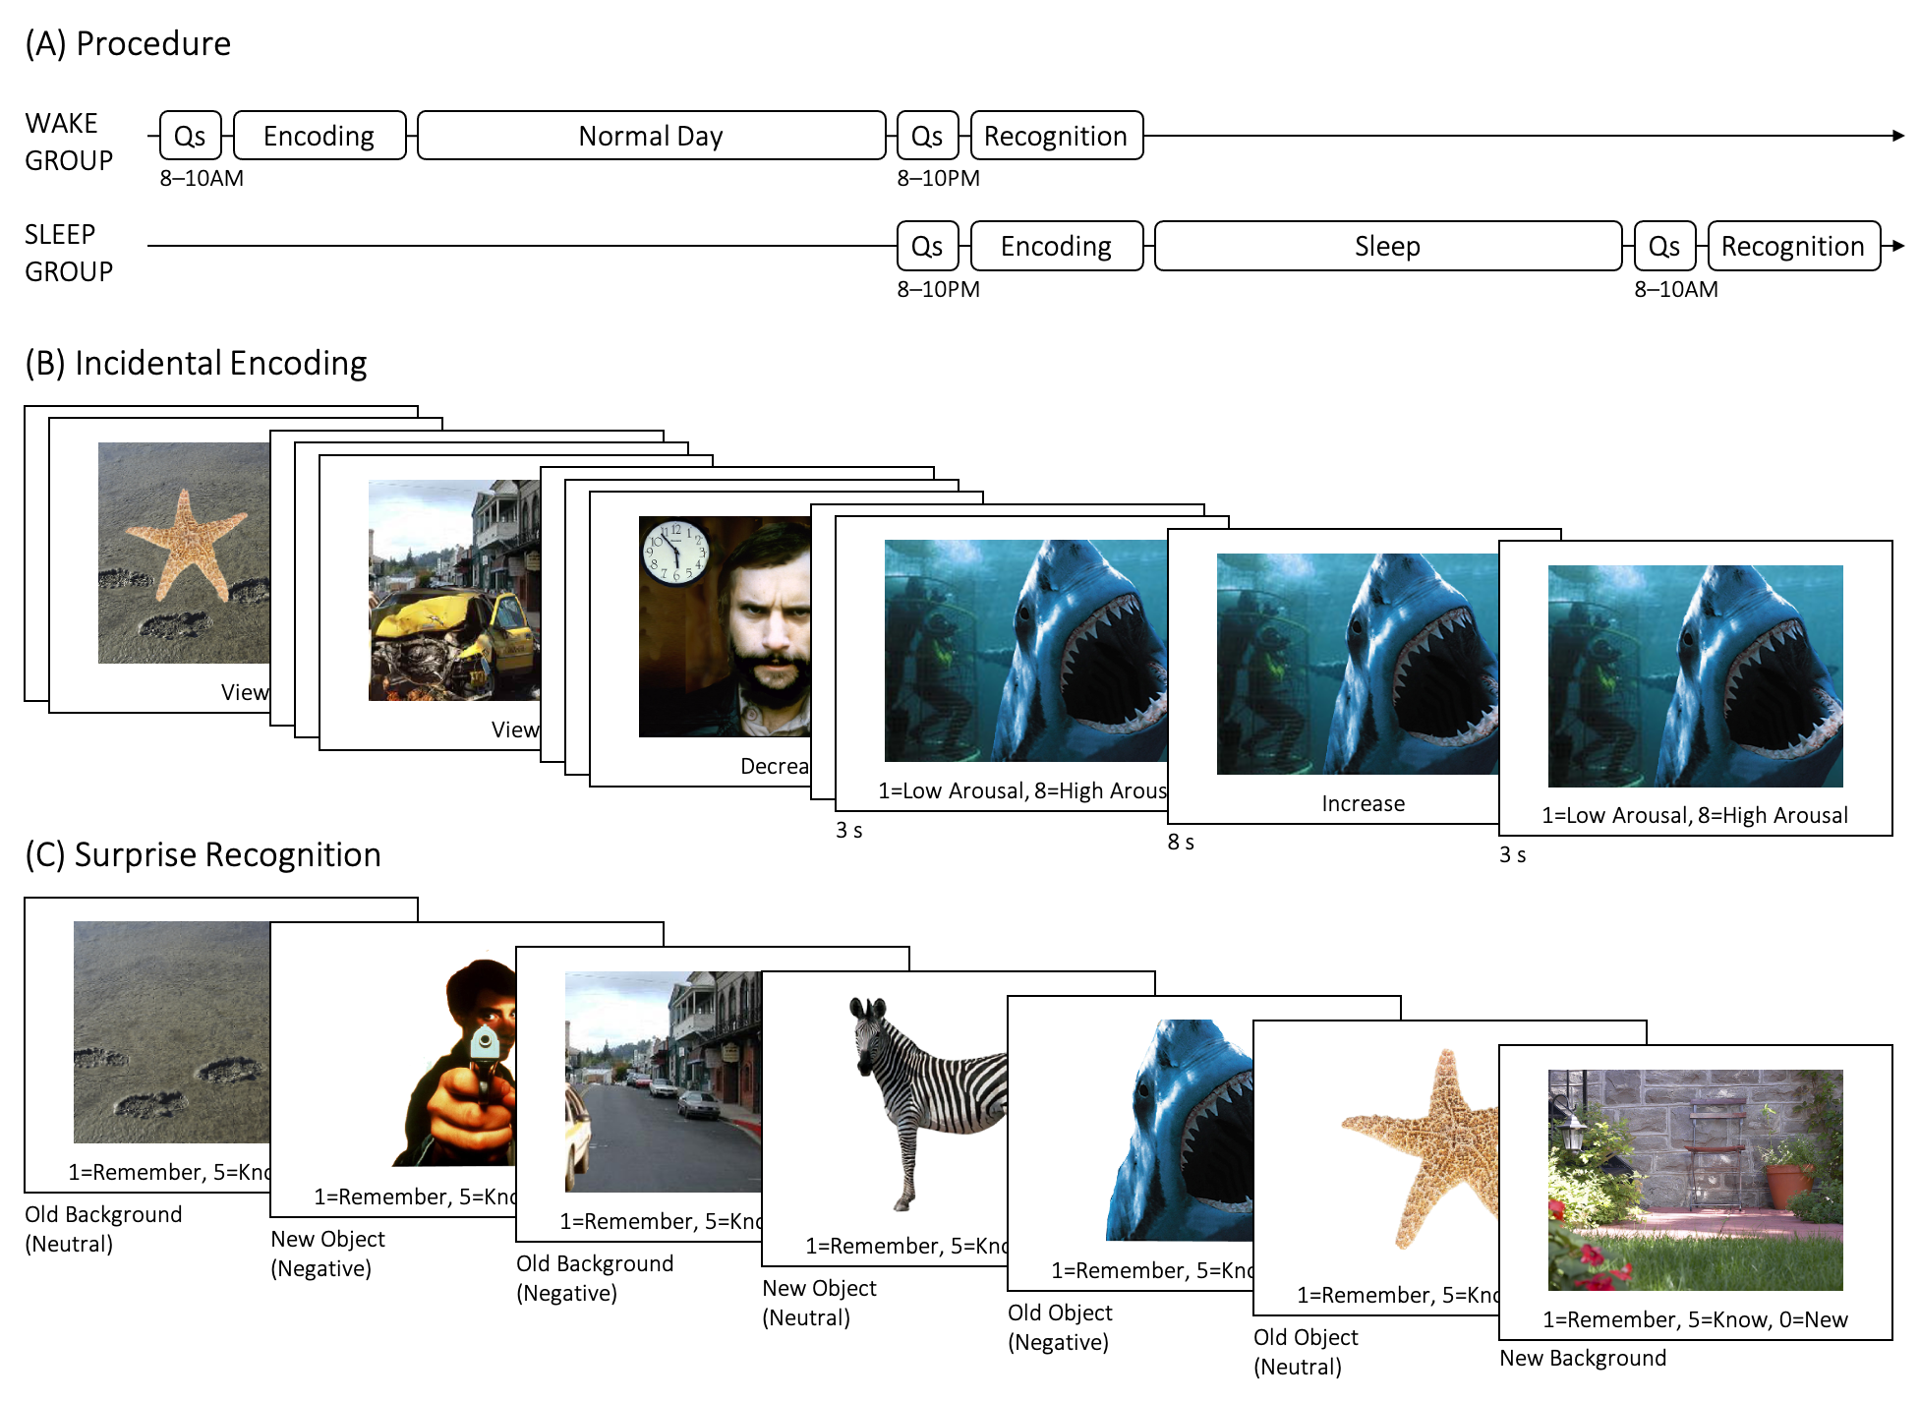

**Figure 1.** (A) Session timeline for the wake and sleep groups. (B) Sample stimuli and procedure for the encoding session of the emotional memory task. Participants were asked to rate the arousal of the scene, regulate their affect according to instruction, then rate the scene again. Neutral scenes were always preceded by the “View” instruction. Negative scenes were preceded by “View, “Decrease”, or “Increase”. (C) Sample stimuli and procedure for the recognition session of the emotional memory task. Objects and backgrounds were presented separately and in random order. Participants were asked to make a self-paced judgment of “remember”, “know”, or “new”. *Note.* Qs = Questionnaires.

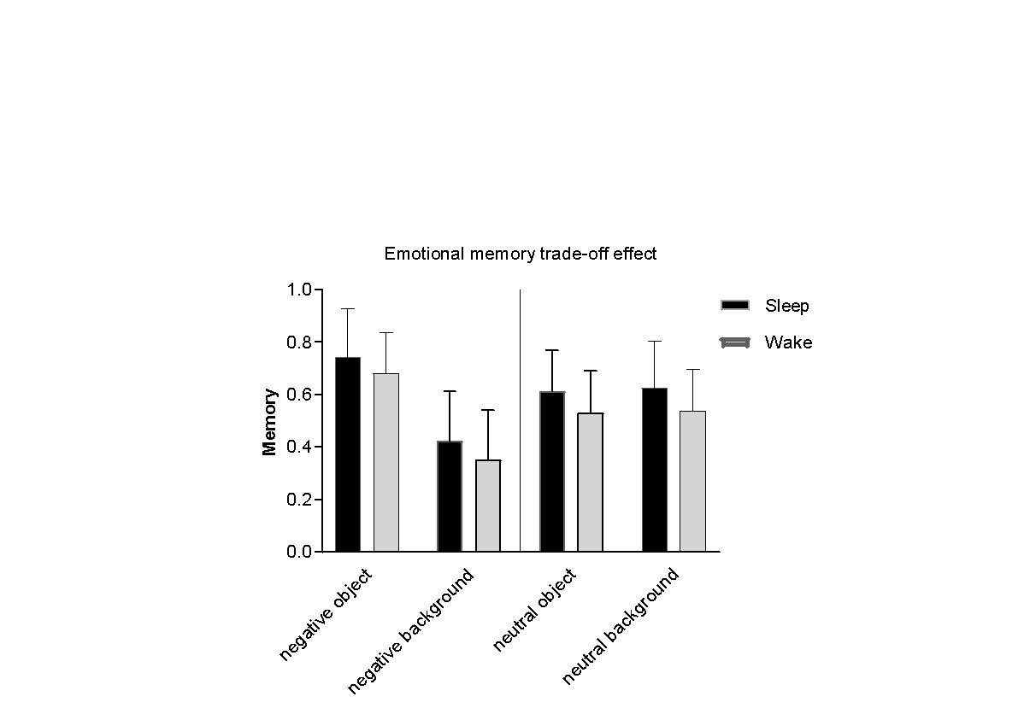

**Figure 2.** Memory trade-off during view trials. When participants were instructed to passively view scenes, negative objects were better remembered but at the expense of accompanying background images. This trade-off effect was similar across the sleep and wake conditions.

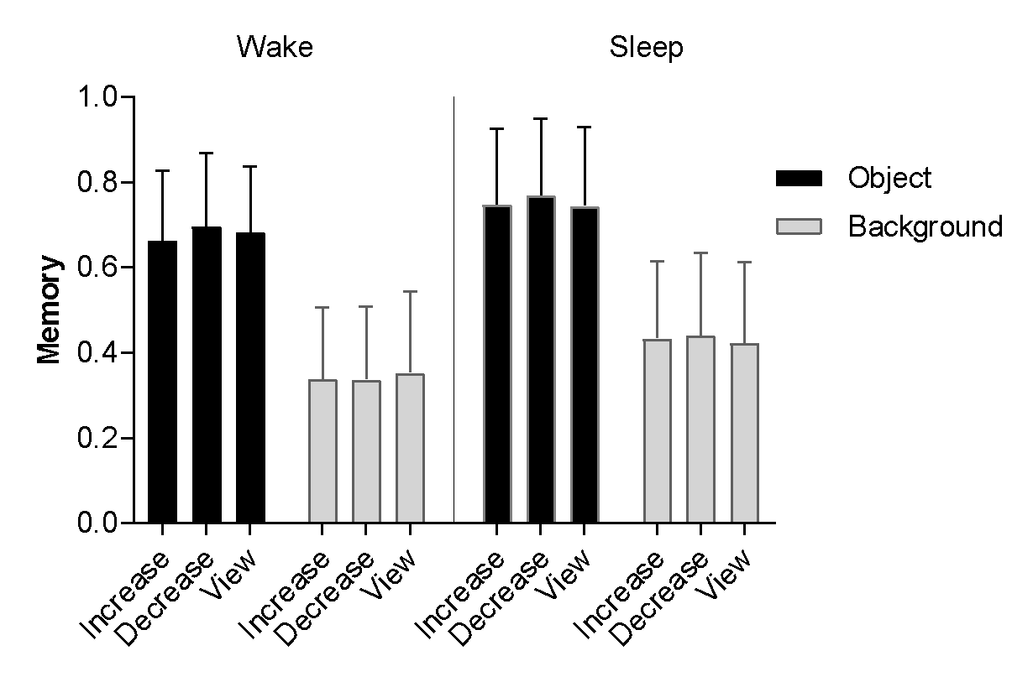

**Figure 3.** Memory for negative scenes following affect regulation in sleep versus wake participants. Objects and backgrounds were better remembered after a night of sleep irrespective of affect modulation (i.e., decreasing or enhancing), or passive viewing. Findings suggest a night of sleep buffered against any negative effects that affect modulation may exert on emotional memory.

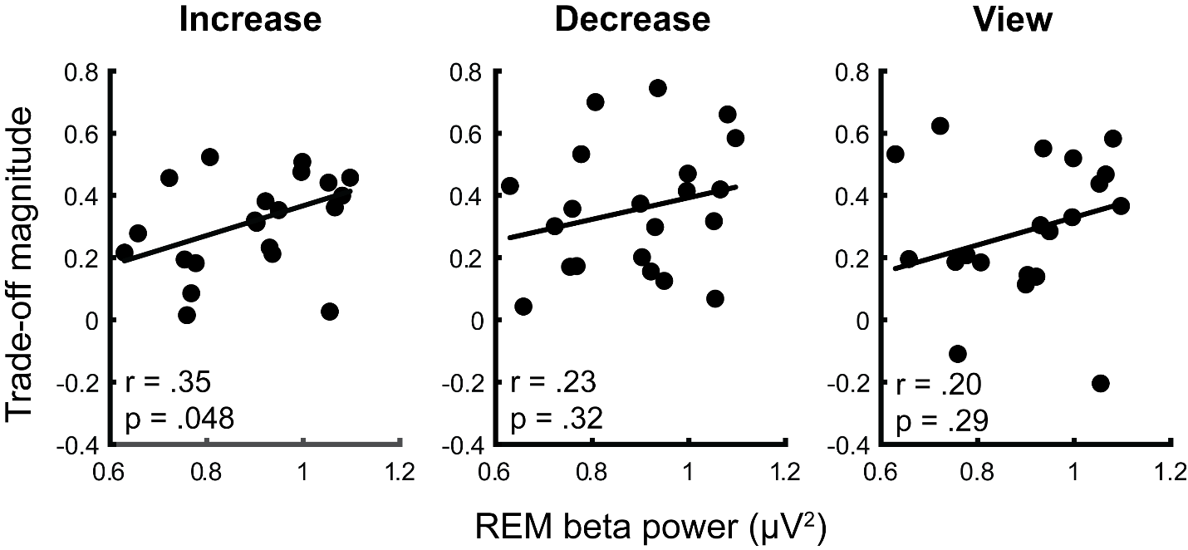

**Figure 4***.* Robust regressions assessing the association between REM beta (16-25Hz) power and the magnitude of the emotional memory trade-off under different reappraisal conditions (left = increase, center = decrease, right = view).

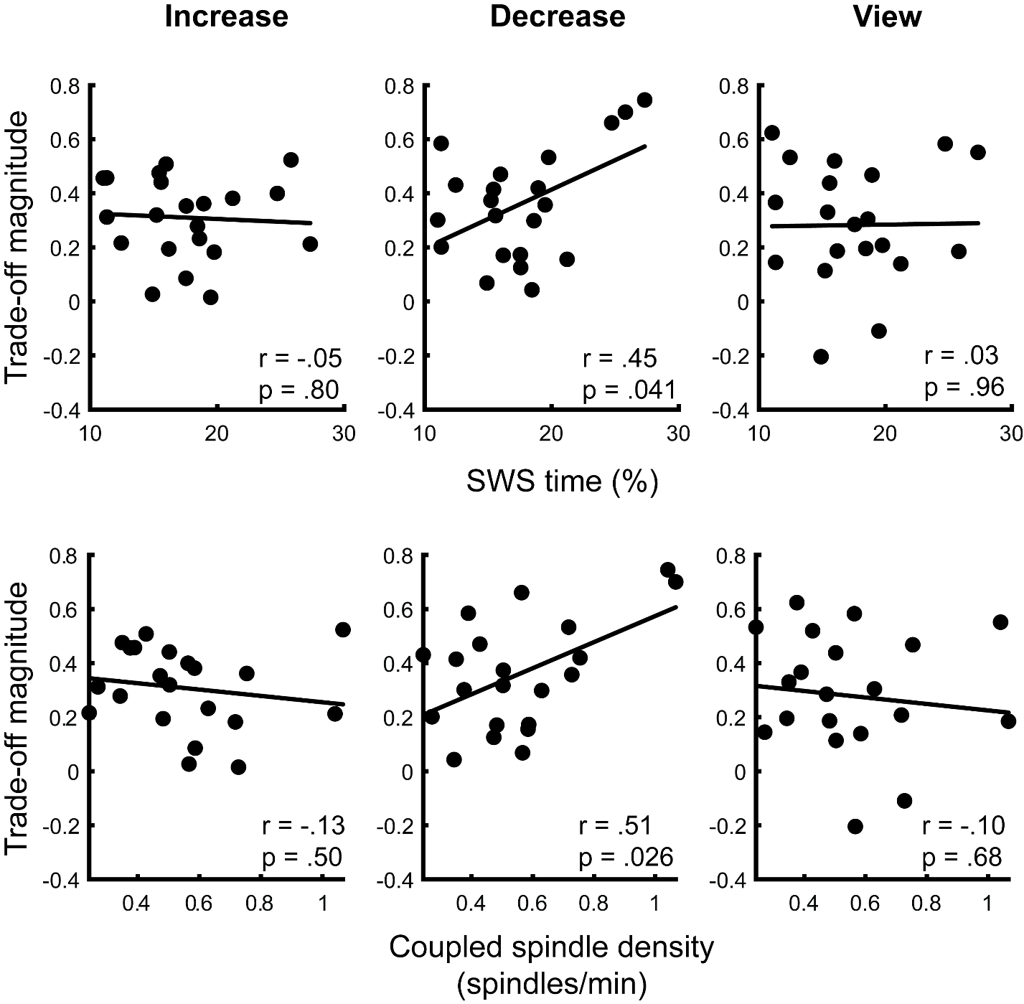

**Figure 5.** Robust regressions assessing the association between slow wave sleep time (top row) and coupled spindle density during slow wave sleep (bottom row) and the magnitude of the emotional memory trade-off under different reappraisal conditions (left = increase, center = decrease, right = view).