# Anti-VEGF drugs compared with laser photocoagulation for the treatment of diabetic retinopathy: a systematic review and meta-analysis

Mark Simmonds

Alexis Llewellyn

Ruth Walker

Helen Fulbright

Matthew Walton

Rob Hodgson

Laura Bojke

Lesley Stewart

Sofia Dias

John Lawrenson

Tunde Peto

David Steel

# Abstract

**Background**

Diabetic retinopathy is a major cause of sight loss in people with diabetes. The most severe form, proliferative diabetic retinopathy (PDR), carries a high risk of vision loss risk, vitreous haemorrhage, macular oedema and other harms. Panretinal photocoagulation (PRP) is the primary treatment for PDR. Anti-vascular endothelial growth factor (anti-VEGF) drugs are used to treat various eye conditions and may be beneficial for people with diabetic retinopathy.

**Objective**

To investigate the efficacy of anti-VEGF therapy for the treatment of diabetic retinopathy when compared to PRP.

**Methods**

A systematic review and network meta-analysis of all published randomised controlled trials comparing anti-VEGF (alone or in combination) to PRP in people with diabetic retinopathy. Trials where the primary focus was treatment of macular oedema or vitreous haemorrhage were excluded.

**Results**

A total of 14 trials were included: 3 of aflibercept, 5 of bevacizumab and 6 of ranibizumab. Two trials were of patients with non-proliferative diabetic retinopathy ); all others were in PDR. Overall anti-VEGF was better than PRP at preventing vison loss, measured as best corrected visual acuity (BCVA), at up to two years follow-up (BCVA mean difference in logMAR -0.064, 95% confidence interval (CI) -0.122 to -0.015). There was no clear evidence of any difference between the anti-VEGFs, but potential for bias and differences in trial complicated the comparison. Anti-VEGF was superior to PRP at preventing macular edema (Relative risk 0.29, 95% CI 0.18 to 0.49) and vitreous haemorrhage (Relative risk 0.77, 95% CI 0.61 to 0.99). There was no evidence that the effectiveness of anti-VEGF varied over time, but one trial found no benefit of anti-VEGF over laser therapy after 5 years.

**Conclusions**

Anti-VEGF injection appears to be superior to using laser photocoagulation, but the benefit in preservation of eyesight appears to be modest. Long-duration observational studies are needed to examine how anti-VEGF may be beneficial in the long term.

# Background

Diabetes is a major cause of poor health, impairing the sight of more than 1,700 people in the UK each year.1 Diabetic retinopathy is a “chronic progressive, potentially sight-threatening disease of the retinal microvasculature”2, 3 and is a major form of sight loss. Prevalence of type 1 diabetes is around 48%, and 28% in type 2 diabetes.3 Older people, men, South Asian groups, and more deprived populations are at higher risk.4 Diabetic retinopathy staging allows for stratification for risk of future visual loss, with the most severe form, proliferative diabetic retinopathy (PDR), placing the patients at a very high risk of vitreous haemorrhage bleeding, retinal detachment, neovascular glaucoma and vision loss.5, 6

Laser photocoagulation is the primary treatment for PDR. Laser is applied to the retina either to prevent proliferation of new blood vessels or encourage fibrosis in those with established new vessels Pan retinal photocoagulation (PRP) is delivered over the entire periphery of the retina, by placing 1,200-1,600 burns per session, usually over two or three treatment sessions. It is known to be effective and long-lasting7 but can have side effects including peripheral visual field loss, impaired night time and colour vision, and blurred vision. There is a small risk of central scotomata if the laser burn is accidently placed in the macula or if there is a laser creep into the macula.8

Anti-vascular endothelial growth factor (anti-VEGF) drugs are used to treat various eye conditions. In the UK, the National Institute for Health and Care Excellence (NICE) has approved ranibizumab and aflibercept for the treatment of diabetic macular edema (DME.9, 10 Anti-VEGF treatments are injected into the eye, under local anaesthetic, at regular intervals. They have rare but potentially serious adverse effects including: ocular hypertension, retinal detachment, endophthalmitis and other intraocular inflammation, and cataracts.11 There are also concerns that effects may not be long-lasting, and patients may have worse outcomes than those who had laser photocoagulation if patients are not carefully followed up.12 13

There is no current NICE guidance for the use of anti-VEGF drugs in diabetic retinopathy in people without macular oedema, including for proliferative retinopathy. International Council of Ophthalmology guidelines on diabetic eye care14 support laser photocoagulation and 'appropriate use of anti-VEGF drugs' for the management of diabetic retinopathy.

There is a growing body of evidence in favour of the various anti-VEGF drugs, so a thorough systematic assessment of the relevant evidence, and network meta-analysis (NMA) is needed to assess the value, effectiveness, and rank of all relevant anti-VEGF interventions. This paper presents a systematic review and NMA of all published randomised controlled trials (RCTs) of the three main anti-VEGFs used to treat diabetic retinopathy: aflibercept, bevacizumab and ranibizumab. The project is funded by the National Institute for Health and Care Research (Project number NIHR132948). Other components of the project included analysis of individual participant data, a wider assessment of anti-VEGF studies, including non-randomised studies, and an economic analysis. The review is registered on PROSPERO [CRD42021272642] and the full protocol is available online from the NIHR [https://fundingawards.nihr.ac.uk/award/NIHR132948].

# Methods

The review was conducted following CRD’s guidance on undertaking systematic reviews15 and reported according to the principles of the overarching PRISMA statement.16

### Inclusion criteria

The wider review in the project included all RCTs that recruited people with diabetic retinopathy (proliferative and non-proliferative); patients with a principal indication for treatment of DME or vitreous haemorrhage were excluded.The technologies of interest were any anti-VEGF therapy, anti-VEGF combined with PRP, PRP alone, and sham injection..

A full list of outcomes of interest are reported in the review protocol. This paper focuses on best corrected visual acuity (BCVA) measured on ETDRS or logMAR scales, as this was the only outcome reported in all trials.

## Review methods

The aim of the literature search was to identify RCTs on anti-vascular endothelial growth factors, angiogenesis inhibitors and other specific drugs used for the treatment of diabetic retinopathy.

An Information Specialist (HF) designed a preliminary search strategy in Ovid MEDLINE in consultation with the research team. The strategy consisted of terms for the condition (diabetic retinopathy), which were combined with terms for the intervention (anti-vascular endothelial growth factor, angiogenesis inhibitors, or specific drugs used for the treatment of diabetic retinopathy) using the Boolean operator AND. Text word searches for terms appearing in the title and abstracts of database records were included in the strategy alongside searches of relevant subject headings. An RCT study filter was applied using the Boolean operator AND. No date or language limits were applied. The final MEDLINE strategy was adapted for use in all resources searched.

The searches were performed on 27th August 2021. The following databases were searched: Ovid MEDLINE(R) ALL, Embase (Ovid), Science Citation Index Expanded (Web of Science), Conference Proceedings Citation Index Science (Web of Science), Cochrane CENTRAL (Wiley), Cochrane Database of Systematic Reviews (Wiley), DARE (CRD), PROSPERO (CRD), and Epistemonikos. The following trial registries were searched: WHO ICTRP, ClinicalTrials.gov, and the EU Clinical Trials Registry.

Search results were imported into EndNote 20 (Clarivate Analytics, US) and deduplicated. All search strategies are presented in full in Appendix [n].

The searches were updated on 13th July 2022 and again on 26th May 2023 using all the databases and strategies as used previously, except for DARE as this database is no longer updated. For each update search, the results of the databases were deduplicated against each other in a separate EndNote 20 Library before being merged with the results of the original EndNote Library and deduplicated for a second time.

Two researchers (RW, AL) independently screened all titles and abstracts retrieved for consideration of the full text. The reviewers then screened all papers to determine inclusion. Disagreements were resolved through discussion or with a third reviewer (MS).

A data extraction form was developed and piloted. Data on interventions used, patient characteristics, outcomes reported, and all outcome data were extracted for all included RCTs from included publications by one reviewer and checked by a second. Risk of bias in all included trials was assessed using the RoB 2 tool, focussing on the BCVA outcome, given limited reporting of other outcomes.17

## Statistical analysis

Effect estimates were pooled across trials using standard DerSimonian-Laird random effect pairwise meta-analyses, according to duration of follow-up. Heterogeneity was assessed in terms of I2 18 and by inspecting the between-study heterogeneity standard deviations (τ), relative to the treatment effect size.

Network meta-analyses were performed using standard Bayesian methods of network meta-analysis in R (version 4.3.1) using the R package multinma (version 0.5.1).19 This extends the standard NMA modelling approach to investigate the potential impact of patient factors (e.g. type of retinopathy) and timing of assessments on the effectiveness of anti-VEGF therapy, and on the ranking of the different treatments.19 Network consistency was checked by comparing the model fit and between-study heterogeneity from the NMA models to an unrelated mean effects model (similar to a model performing direct meta-analysis for each treatment comparison, but with a shared heterogeneity parameter).20

Visual acuity (BCVA) in diabetic retinopathy is commonly measured using the Logarithm of the Minimum Angle of Resolution (logMAR) and Early Treatment Diabetic Retinopathy Study (ETDRS) scales. As both are widely used, network meta-analyses were performed for both scales. Published data was transformed for one scale to the other, as required. This paper presents results on the logMAR scale; with ETDRS results reported in the supplementary material.

## Threshold analysis

The potential impact of unpublished or ongoing trials on the NMAs was investigated using threshold analysis. Threshold analysis investigates where in an NMA results might not be robust to changes in the observed evidence.21

# Results

## General results

Key findings for BCVA, DME, vitrectomy, vitreous haemorrhage and adverse events are presented here. A full presentation of all analyses performed is provided in the two supplementary appendices; one for BCVA data, and one for all other outcomes and adverse events.

Figure 1 shows the PRISMA flow chart for this review. Overall, 14 RCTs were included in the meta-analyses. The searches also identified 21 other RCTs, which were unsuitable for meta-analyses. These included trials reported only as conference abstracts, not in English, published before 2011 (and judged to be out-of-date), that used types of anti-VEGF not in widespread use, or did not include a PRP arm. Those trials therefore could not be reasonably included in the network meta-analysis. These are summarised in Appendix Table XX in the supplementary material.

The included RCTs are summarised in Table 1. Trials varied substantially in sample size from only 40 eyes up to just over 400 persons. There were six trials of ranibizumab, five of bevacizumab, and three trials of aflibercept. Some trials used anti-VEGF as the intervention, but others used anti-VEGF combined with PRP. Twelve trials were of patients with proliferative retinopathy. Two trials recruited patients with non-proliferative retinopathy; both evaluated aflibercept. **22,23** Trials of aflibercept and ranibizumab were conducted in Europe, North America or Brazil, and all trials of bevacizumab were conducted in the Middle East or South Asia. BCVA was the only outcome reported consistently in all trials.



Figure 1 PRISMA flow diagram

Table 1 Summary of the RCTs included in the meta-analyses

|  |  |  |  |  |  |  |  |  |
| --- | --- | --- | --- | --- | --- | --- | --- | --- |
| **Trial** | **Year** | **Anti-VEGF** | **Comparator** | **Location** | **Sample size** | **Follow-up** | **Population** | **Main outcome(s)** |
| **CLARITY22** | 2017 | Aflibercept | PRP | UK | 232 persons | 1 year | PDR | BCVA, DR severity, subsequent treatment, complications |
| **DRCRN**  **Protocol W23** | 2021 | Aflibercept | Sham injection | USA/Canada | 328 persons | 2 years | Severe NPDR (some DME) | Time to PDR or DME |
| **PANORAMA 24** | 2018 | Aflibercept (every 16 weeks vs. 8 weeks) | Sham injection | International | 402 persons | 1 & 2 years | NPDR | DR severity, subsequent treatment, complications |
| **Marashi26** | 2017 | Bevacizumab | PRP | Jordan/Syria | 30 persons | 1 year | PDR | BCVA, DR severity |
| **Ahmad27** | 2012 | Bevacizumab +PRP | PRP | Pakistan | 54 eyes | 3 months | PDR | BCVA |
| **Ali28** | 2018 | Bevacizumab +PRP | PRP | Pakistan | 60 eyes | 1 month | PDR | BCVA |
| **Rebecca29** | 2021 | Bevacizumab +PRP | PRP | Pakistan | 76 eyes | 6 months | PDR | BCVA |
| **Roohipour30** | 2016 | Bevacizumab +PRP | PRP | Iran | 64 eyes | 10 months | PDR | BCVA |
| **DRCRN Protocol S31, 32** | 2018 | Ranibizumab | PRP | USA | 305 persons | 2 & 5 years | PDR | DR severity, functional impact on vision, subsequent treatment, complications |
| **Ferraz33** | 2015 | Ranibizumab +PRP | PRP | Brazil | 60 eyes | 6 months | PDR | BCVA |
| **PRIDE34** | 2019 | Ranibizumab +PRP | PRP | Germany | 106 persons | 1 year | PDR | BCVA, DR severity, subsequent treatment |
| **PROTEUS35** | 2018 | Ranibizumab +PRP | PRP | Europe | 87 persons | 1 year | PDR | BCVA, subsequent treatment, complications |
| **Sao Paulo B36** | 2011 | Ranibizumab +PRP | PRP | Brazil | 40 persons | 1 year | PDR | BCVA, pain |
| **Sao Paulo A37** | 2018 | Ranibizumab +PRP( ETRDS) | Ranibizumab +PRP (PASCAL) | Brazil | 40 eyes | 1 year | PDR | BCVA |

## Risk of bias

The results for the bias assessment of BCVA are shown in Table 2. In general, the larger trials were well reported, with lower risk of bias. Smaller trials, particularly bevacizumab trials, were less well reported and consequently had unclear or high risk of bias in many categories. The main risk of bias concern was in how BCVA and other outcomes were assessed, as in most trials it was not possible to blind patients or outcome assessors to the treatment used.

Table 2 Cochrane Risk of bias assessment of outcome BCVA in the included RCTs

|  |  |  |  |  |  |  |  |  |  |
| --- | --- | --- | --- | --- | --- | --- | --- | --- | --- |
| **Trial** | **D1** | **D2** | **D3** | **D4** | **D5** | **Overall** |  |  |  |
| Ahmad |  |  |  |  |  |  |  |  | Low risk |
| Ali |  |  |  |  |  |  |  |  | Some concerns |
| CLARITY |  |  |  |  |  |  |  |  | High risk |
| Ferraz |  |  |  |  |  |  |  |  |  |
| Marashi |  |  |  |  |  |  |  | D1 | Randomisation process |
| PANORAMA |  |  |  |  |  |  |  | D2 | Deviations from the intended interventions |
| PRIDE |  |  |  |  |  |  |  | D3 | Missing outcome data |
| PROTEUS |  |  |  |  |  |  |  | D4 | Measurement of the outcome |
| PROTOCOL S |  |  |  |  |  |  |  | D5 | Selection of the reported result |
| PROTOCOL W |  |  |  |  |  |  |  |  |  |
| Rebecca |  |  |  |  |  |  |  |  |  |
| Roohipour |  |  |  |  |  |  |  |  |  |
| Sao Paulo A |  |  |  |  |  |  |  |  |  |
| Sao Paulo B |  |  |  |  |  |  |  |  |  |

## Impact on vision (BCVA)

Figure 2 summarises all the data on BCVA for anti-VEGF compared to PRP, as reported across all trials. Results are shown on the logMAR scale; where trials reported ETDRS these results were converted to their logMAR equivalents.

This plot shows several key issues with the available trial data. First, that some trials compare anti-VEGF to PRP directly, while others combine anti-VEGF with PRP. Second, that the time at which BCVA is measured varies enormously across trials, from one month to 5 years. However, we note that despite the differences in intervention and timing, there is comparatively little heterogeneity across studies within each drug class.

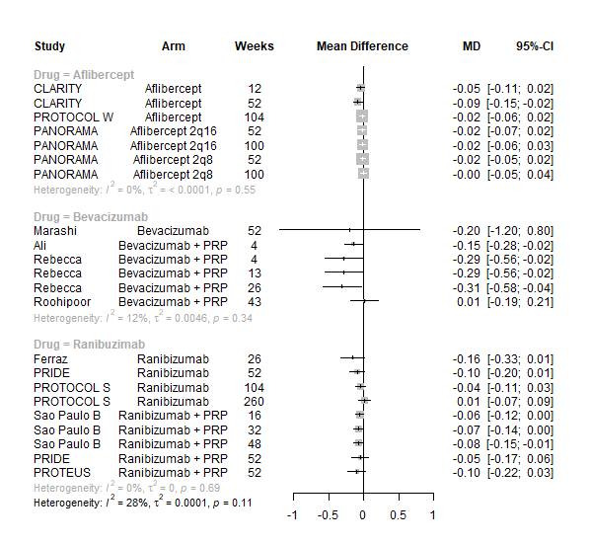

Figure 2 All BCVA data (logMAR scale) from all trials of anti-VEGF

## Network meta-analyses of BCVA in proliferative retinopathy

Given the variations in timing at which BCVA results were reported, for the primary network meta-analyses the data were divided into two groups:

1. Up to and including 1 year of follow-up,

2. 1 to 2 years’ follow up.

Note that trials reporting at exactly 1 year (52 weeks) were included in both analyses. Given the clinical differences between proliferative and non-proliferative disease, the two trials of non-proliferative disease were not included in the network meta-analysis. The network diagrams for both analyses are shown in Figure 3. Note that all of the trials of bevacizumab combined with PRP had follow-up durations of less than one year, so are not included in the analyses at 1 to 2 years. In both networks there is only one trial of aflibercept and one of bevacizumab (without PRP).

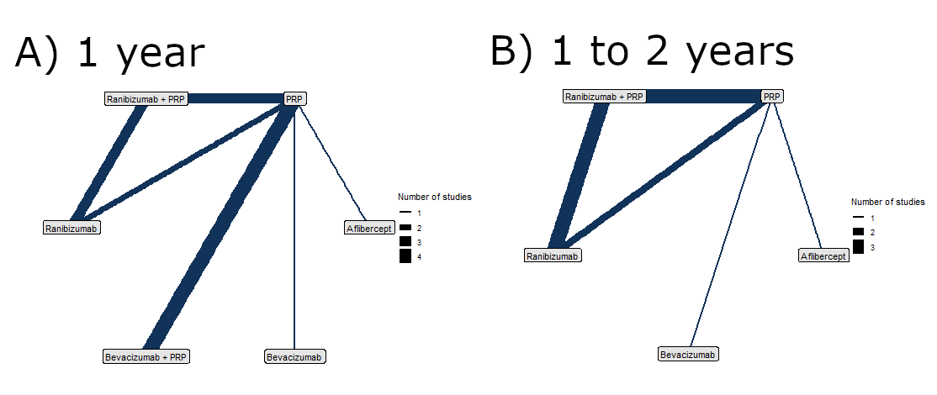

Figure 3 Network diagrams at A) Up to 1 year and B) 1 to 2 years

Figure 4 shows the results of all treatment comparisons from the NMA for data up to 1 year, and Figure 5 for data from 1 to 2 years. For the primary comparisons with PRP all anti-VEGF agents favour anti-VEGF over PRP and reduce logMAR scores (improved BCVA). However, the credible intervals are wide, and include the possibility of no difference between anti-VEGF and PRP for aflibercept at either one or two years, or for ranibizumab at 2 years. Results are broadly similar across anti-VEGF agents and at both 1 year and 2 years. Results for bevacizumab (without PRP) are inconclusive because of the very limited data on this treatment group. For full results see Section 3 of the supplementary appendix.

Given the similarity in magnitude of effect for the various anti-VEGF agents it is not surprising that the indirect comparisons between agents show no conclusive evidence of difference between any of them, suggesting that all three anti-VEGFs have similar efficacy. There appears to be no difference between using ranibizumab alone vs ranibizumab combined with PRP, particularly at 2 years.

Treatment rankings are shown in the supplementary appendix for BCVA (Figures 14 and 17). Given the similarity in effect sizes across the different types of anti-VEGF it is difficult to draw conclusions from the ranking diagrams beyond the fact that PRP alone is likely to be the least effective treatment. The limited data on bevacizumab means its ranking is very uncertain.

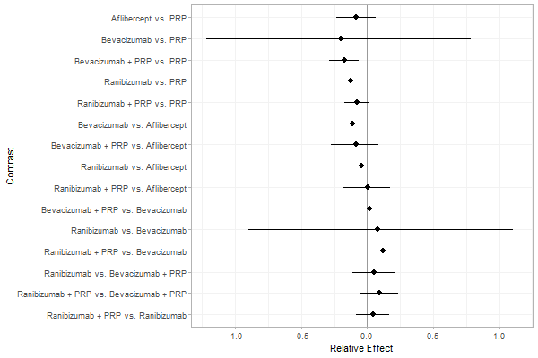

Figure 4 Comparison of interventions from NMA of BCVA up to 1 year

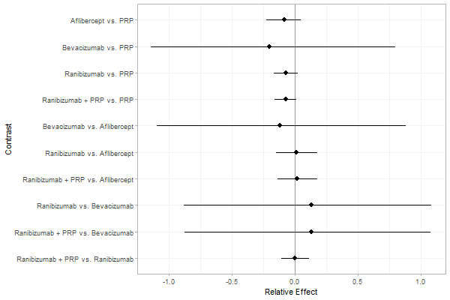

Figure 5 Comparison of interventions from NMA of BCVA from 1 to 2 years

## Impact of time and vision at randomisation

To further examine the impact of time on the effectiveness of anti-VEGFs we fitted a range of models including time as a covariate. This meant that all data could be combined in a single NMA, without excluding data, and whether the effectiveness of anti-VEGFs varied with time could be investigated. Models were also fitted including BCVA at randomisation, as there was some evidence that this might alter the effectiveness of the anti-VEGFs (see Supplementary appendix Section 4).

Overall, results were very similar to the NMAs at 1 and 2 years. As an example, Figure 6 shows the effect estimates for anti-VEGFs compared to PRP alone from a model with a linear time trend and adjustment for BCVA at randomisation. Estimates are presented for 1 year of follow-up and the mean BCVA at baseline across all trials (LogMAR XXX). The pattern of effect sizes is very similar to that seen in Figures 4 and 5.

The various models found no clear evidence that the effectiveness of anti-VEGFs varied with time. However, it should be noted that almost all the data are for follow-up times of 2 years or less. Only one trial followed up patients for 5 years, and that found no evidence of difference between anti-VEGF (ranibizumab) and PRP after 5 years.

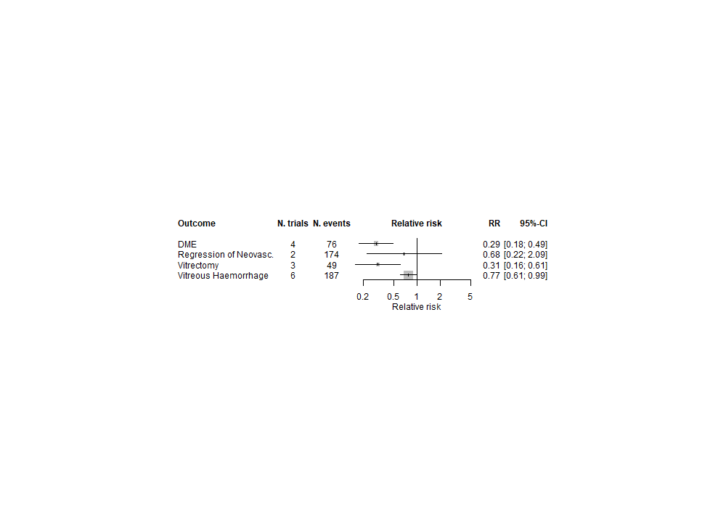

Figure 6 NMA of logMAR with adjustment for follow-up time and BCVA at baseline

## Further network meta-analyses

To further compare the anti-VEGFs to each other, simplified network meta-analyses were performed by combining treatment arms. Two NMAs were performed:

1. Comparing anti-VEGF (of any type), anti-VEGF (any type) combined with PRP, and PRP alone.

2 Comparing aflibercept, ranibizumab (with or without PRP), bevacizumab (with or without PRP), and PRP alone.

Full results for these NMAs are presented in Section 5 of the BCVA supplementary appendix. In summary, there was good evidence that, when all types of anti-VEGF were combined, anti-VEGF in general improved BCVA when compared to PRP (MD -0.064, 95% CI -0.122 to -0.015). When comparing anti-VEGF combined with PRP to PRP alone the evidence was in the direction of favouring combination therapy, but was not statistically significant (MD -0.044, 95% CI -0.115 to 0.021).

When comparing the three anti-VEGFs (with or without concomitant PRP) bevacizumab was superior to ranibizumab (MD -0.121, 95% CI -0.214 to -0.026) and to aflibercept, although the result was not quite statistically significant (MD -0.122, 95% CI -0.246 to 0.003). There was no difference between aflibercept and ranibizumab (MD -0.002, 95% CI -0.083 to 0.079).

## Other outcomes

Results on outcomes other than BCVA were inconsistently reported, with most being reported in no more than three trials. Complete results for these outcomes are presented in the supplementary material, for all outcomes reported in more than one trial. The limited data meant than network meta-analyses were not feasible for these outcomes. A meta-analysis was performed for outcomes reported in two or more trials by assuming that the impact of anti-VEGFs is the same for all types of anti-VEGF, for anti-VEGF alone or in combination with PRP, and at all times up to two years. While these are strong assumptions, they may be reasonable given the results observed for BCVA, and the apparent lack of heterogeneity in the data.

Forest plots of neovascularization of the disc (NVD) and neovascularization elsewhere (NVE) are shown in the supplementary appendix Figures 1 and 2. These suggest that rates of neovascularisation are substantially lowered when using anti-VEGF. The results of meta-analyses for other non-vison outcomes are shown in Figure 7. For full results by trial see Section 1 of the supplementary appendix. Although data are limited, the results suggest that anti-VEGF treatment substantially reduces the rate of macular oedema (DMO) and the need for vitrectomy, and reduces the rates of vitreous haemorrhage. No data on progression of diabetic retinopathy (e.g. from non-proliferative to proliferative, or according to severity of disease) were reported.

Figure 7 Meta-analysis of non-vision outcomes

### Adverse events

As with non-BCVA outcomes, adverse events were not widely reported, with little consistency across trials as to which adverse events were reported. A meta-analysis was performed for adverse event types reported in two or more trials by assuming that the impact of anti-VEGFs is the same for all types of anti-VEGF, for anti-VEGF alone or in combination with PRP, and at all times up to two years.

The meta-analysis results are shown in Figure 8. Due to the small numbers of events, and limited numbers of trials reported each adverse event, most results are inconclusive. Anti-VEGF appears to reduce the incidence of retinal detachment. It appears to increase the rate of ocular pain, but it was unclear whether this was procedure-related or post-intervention pain.

Figure 8 Meta-analyses of adverse event outcomes

## Non-proliferative retinopathy

Two trials compared aflibercept to sham injection in patients with non-proliferative retinopathy with a follow-up of two years. Meta-analysis of their BCVA results found no clear evidence of any benefit of aflibercept over sham injection (Mean difference (logMAR) -0.02, 95% CI -0.05 to 0.01). Progression to macular oedema was the only other outcome reported by both trials, with strong evidence to suggest that aflibercept reduces the risk of macular oedema (Relative risk 0.283, 95% CI: 0.18 to 0.44).

# Discussion

This systematic review included 14 trials of anti-VEGFs used to treat diabetic retinopathy. The network meta-analysis found good, but not conclusive evidence that anti-VEGF therapy is better at maintaining vision than PRP therapy, with a benefit of around 0.064 points on the logMAR scale (95% CI -0.122 to -0.015). This could be as low as 0.026 for aflibercept and as high as 0.146 for bevacizumab. This is broadly equivalent to a benefit of between 1 and 5 points using ETDRS, which is within the region of variation that might be expected between eye tests without any intervention. There was no compelling evidence to suggest that the three anti-VEGFs (aflibercept, ranibizumab and bevacizumab) differ in effectiveness; it is plausible that any observed differences were due to different trial populations and potential for bias. There was no conclusive evidence that combining anti-VEGF injection with PRP therapy is more effective at improving vision than anti-VEGF alone.

Anti-VEGF appears to have no impact on BCVA in people with non-proliferative disease. There was, similarly, some evidence that the benefit of anti-VEGF over PRP is greater in people with poorer eyesight at time of injection. This suggests that the benefits of anti-VEGF may depend on disease severity and eyesight at time of treatment. However, it is not possible to make any firm conclusions on this from data presented in trial publications alone.

A further issue is the impact of time on the effectiveness of anti-VEGF therapy. Our meta-analysis found no evidence that the effectiveness waned over the first two years after initialising therapy. However, the one trial with a longer follow-up (Protocol S) found no benefit of ranibizumab over PRP after five years. The longer-term value of anti-VEGF therapy therefore needs further investigation, particularly regarding how anti-VEGF treatment should be repeated over long time periods.

Data on outcomes other than visual acuity were limited, and not reported consistently across trials. Given the variations in follow-up and interventions used, network meta-analyses were not feasible, and meta-analyses had to make the strong assumption of no difference in effect between the three anti-VEGFs, and no variation over time. Given these limitations, there was some evidence that anti-VEGFs are more effective than PRP at preventing the most serious consequences of diabetic retinopathy. They reduced incidence of macular oedema (RR 0.29, 95% CI 0.21 to 0.41), vitreous haemorrhage (RR 0.78, 95% CI 0.61 to 0.99) and need for vitrectomy (RR 0.31, 95% CI 0.15 to 0.60). This suggests that anti-VEGF may be valuable in preventing progression of diabetic retinopathy, even if its impact on vision itself is more modest.

Evidence on adverse events was limited due to inconsistent reporting, and small numbers of events. There was some evidence that anti-VEGF reduces the risk of retinal detachment (RR 0.45, 95% CI 0.25 to 0.81) but might increase the risk of ocular pain (RR 1.76, 95% CI 0.86 to 3.61). For other types of adverse events anti-VEGF seems to have a similar risk profile as PRP.

# Conclusion

Anti-VEGF injection appears to be plausibly superior to using laser photocoagulation in people with proliferative retinopathy, by better preserving eyesight and reducing the risk of progression to macular oedema and vitreous haemorrhage. However, the benefit in preservation of eyesight appears to be modest. Some concern over bias in the trials remains.

There is some evidence that anti-VEGFs are less effective at maintaining visual acuity in people with less severe retinopathy, but this requires further investigation. Access to original individual-level trial data might aid in resolving this. The benefits of anti-VEGFs appear consistent to at least two years after initiation of treatment, but longer-term benefits are uncertain. Long-duration observational studies are needed to examine how anti-VEGF may be beneficial in the long term.

# References

1. Public Health England. *Public Health Outcomes Framework statistical summary May 2020*. 2020. URL: <https://www.gov.uk/government/publications/public-health-outcomes-framework-may-2020-data-update/public-health-outcomes-framework-statistical-commentary-may-2020> (accessed).

2. Ghanchi F, Diabetic Retinopathy Guidelines Working G. The Royal College of Ophthalmologists' clinical guidelines for diabetic retinopathy: a summary. *Eye (Lond)* 2013;**27**:285-7. <https://doi.org/10.1038/eye.2012.287>

3. Klein R, Knudtson MD, Lee KE, Gangnon R, Klein BE. The Wisconsin Epidemiologic Study of Diabetic Retinopathy: XXII the twenty-five-year progression of retinopathy in persons with type 1 diabetes. *Ophthalmology* 2008;**115**:1859-68. <https://doi.org/10.1016/j.ophtha.2008.08.023>

4. Mathur R, Bhaskaran K, Edwards E, Lee H, Chaturvedi N, Smeeth L*, et al.* Population trends in the 10-year incidence and prevalence of diabetic retinopathy in the UK: a cohort study in the Clinical Practice Research Datalink 2004-2014. *BMJ Open* 2017;**7**:e014444. <https://doi.org/10.1136/bmjopen-2016-014444>

5. Four risk factors for severe visual loss in diabetic retinopathy. The third report from the Diabetic Retinopathy Study. The Diabetic Retinopathy Study Research Group. *Arch Ophthalmol* 1979;**97**:654-5. <https://doi.org/10.1001/archopht.1979.01020010310003>

6. Parikh R, Shah RJ, VanHouten JP, Cherney EF. Ocular findings at initial pan retinal photocoagulation for proliferative diabetic retinopathy predict the need for future pars plana vitrectomy. *Retina* 2014;**34**:1997-2002. <https://doi.org/10.1097/IAE.0000000000000192>

7. Early photocoagulation for diabetic retinopathy. ETDRS report number 9. Early Treatment Diabetic Retinopathy Study Research Group. *Ophthalmology* 1991;**98**:766-85.

8. Royle P, Mistry H, Auguste P, Shyangdan D, Freeman K, Lois N*, et al.* Pan-retinal photocoagulation and other forms of laser treatment and drug therapies for non-proliferative diabetic retinopathy: systematic review and economic evaluation. *Health Technol Assess* 2015;**19**:v-xxviii, 1-247. <https://doi.org/10.3310/hta19510>

9. NICE. *Aflibercept for treating diabetic macular oedema*. URL: <https://www.nice.org.uk/guidance/ta346/resources/aflibercept-for-treating-diabetic-macular-oedema-pdf-82602611201221> (accessed).

10. NICE. *Ranibizumab for treating diabetic macular oedema*. URL: <https://www.nice.org.uk/guidance/ta274/resources/ranibizumab-for-treating-diabetic-macular-oedema-pdf-82600612458181> (accessed).

11. Royal National Institute of Blind People (RNIB). *Anti-VEGF treatment*. URL: <https://www.rnib.org.uk/eye-health/eye-conditions/anti-vegf-treatment> (accessed).

12. Wubben TJ, Johnson MW, Anti VTISG. Anti-Vascular Endothelial Growth Factor Therapy for Diabetic Retinopathy: Consequences of Inadvertent Treatment Interruptions. *Am J Ophthalmol* 2019;**204**:13-8. <https://doi.org/10.1016/j.ajo.2019.03.005>

13. Obeid A, Su D, Patel SN, Uhr JH, Borkar D, Gao X*, et al.* Outcomes of Eyes Lost to Follow-up with Proliferative Diabetic Retinopathy That Received Panretinal Photocoagulation versus Intravitreal Anti-Vascular Endothelial Growth Factor. *Ophthalmology* 2019;**126**:407-13. <https://doi.org/10.1016/j.ophtha.2018.07.027>

14. Wong TY, Sun J, Kawasaki R, Ruamviboonsuk P, Gupta N, Lansingh VC*, et al.* Guidelines on Diabetic Eye Care: The International Council of Ophthalmology Recommendations for Screening, Follow-up, Referral, and Treatment Based on Resource Settings. *Ophthalmology* 2018;**125**:1608-22. <https://doi.org/10.1016/j.ophtha.2018.04.007>

15. Centre for Reviews and Dissemination. *Systematic Reviews: CRD's guidance for undertaking reviews in health care*. URL: <https://www.york.ac.uk/media/crd/Systematic_Reviews.pdf> (accessed 17/09/2020).

16. Moher D, Liberati A, Tetzlaff J, Altman DG, Group P. Preferred reporting items for systematic reviews and meta-analyses: the PRISMA statement. *Ann Intern Med* 2009;**151**:264-9, W64. <https://doi.org/10.7326/0003-4819-151-4-200908180-00135>

17. Sterne JAC, Savovic J, Page MJ, Elbers RG, Blencowe NS, Boutron I*, et al.* RoB 2: a revised tool for assessing risk of bias in randomised trials. *BMJ* 2019;**366**:l4898. <https://doi.org/10.1136/bmj.l4898>

18. Higgins JP, Thompson SG, Deeks JJ, Altman DG. Measuring inconsistency in meta-analyses. *BMJ* 2003;**327**:557-60. <https://doi.org/10.1136/bmj.327.7414.557>

19. Phillippo DM, Dias S, Ades AE, Belger M, Brnabic A, Schacht A*, et al.* Multilevel network meta-regression for population-adjusted treatment comparisons. *J R Stat Soc Ser A Stat Soc* 2020;**183**:1189-210. <https://doi.org/10.1111/rssa.12579>

20. Dias S, Welton NJ, Sutton AJ, Caldwell DM, Lu G, Ades AE. Evidence synthesis for decision making 4: inconsistency in networks of evidence based on randomized controlled trials. *Med Decis Making* 2013;**33**:641-56. <https://doi.org/10.1177/0272989X12455847>

21. Phillippo DM, Dias S, Welton NJ, Caldwell DM, Taske N, Ades AE. Threshold Analysis as an Alternative to GRADE for Assessing Confidence in Guideline Recommendations Based on Network Meta-analyses. *Ann Intern Med* 2019;**170**:538-46. <https://doi.org/10.7326/M18-3542>

22. Sivaprasad S, Prevost AT, Vasconcelos JC, Riddell A, Murphy C, Kelly J*, et al.* Clinical efficacy of intravitreal aflibercept versus panretinal photocoagulation for best corrected visual acuity in patients with proliferative diabetic retinopathy at 52 weeks (CLARITY): a multicentre, single-blinded, randomised, controlled, phase 2b, non-inferiority trial. *Lancet (London, England)* 2017;**389**:2193-203. <https://doi.org/https://dx.doi.org/10.1016/S0140-6736(17)31193-5>

23. Maturi RK, Glassman AR, Josic K, Antoszyk AN, Blodi BA, Jampol LM*, et al.* Effect of Intravitreous Anti-Vascular Endothelial Growth Factor vs Sham Treatment for Prevention of Vision-Threatening Complications of Diabetic Retinopathy: The Protocol W Randomized Clinical Trial. *JAMA Ophthalmology* 2021;**139**:701-12. <https://doi.org/https://dx.doi.org/10.1001/jamaophthalmol.2021.0606>

24. Brown DM, Wykoff CC, Boyer D, Heier JS, Clark WL, Emanuelli A*, et al.* Evaluation of Intravitreal Aflibercept for the Treatment of Severe Nonproliferative Diabetic Retinopathy: Results From the PANORAMA Randomized Clinical Trial. *JAMA Ophthalmology* 2021;**05**:05. <https://doi.org/https://dx.doi.org/10.1001/jamaophthalmol.2021.2809>

25. Wykoff CC, Nittala MG, Zhou B, Fan W, Velaga SB, Lampen SIR*, et al.* Intravitreal Aflibercept for Retinal Nonperfusion in Proliferative Diabetic Retinopathy: Outcomes from the Randomized RECOVERY Trial. *Ophthalmology Retina* 2019;**3**:1076-86. <https://doi.org/https://dx.doi.org/10.1016/j.oret.2019.07.011>

26. Marashi A, Abukhalaf I, Alfaraji R, Shuman Y, A S. Panretinal photocoagulation versus intravitreal bevacizumab for proliferative diabetic retinopathy treatment. *Adv Ophthalmol Vis Syst* 2017;**7**. <https://doi.org/10.15406/aovs.2017.07.00211>

27. Ahmad M, Jan S. Comparison between panretinal photocoagulation and panretinal photocoagulation plus intravitreal bevacizumab in proliferative diabetic retinopathy. *J Ayub Med Coll Abbottabad* 2012;**24**:10-3.

28. Ali W, Abbasi KZ, Raza A. Panretinal Photocoagulation Plus Intravitreal Bevacizumab Versus Panretinal Photocoagulation Alone for Proliferative Diabetic Retinopathy. *J Coll Physicians Surg Pak* 2018;**28**:923-7. <https://doi.org/https://dx.doi.org/10.29271/jcpsp.2018.12.923>

29. Rebecca, Shaikh FF, Jatoi SM. Comparison of efficacy of combination therapy of an Intravitreal injection of bevacizumab and photocoagulation versus Pan Retinal Photocoagulation alone in High risk Proliferative Diabetic Retinopathy. *Pak* 2021;**37**:157-61. <https://doi.org/https://dx.doi.org/10.12669/pjms.37.1.3141>

30. Roohipoor R, Sharifian E, Ghassemi F, Riazi-Esfahani M, Karkhaneh R, Fard MA*, et al.* Choroidal Thickness Changes in Proliferative Diabetic Retinopathy Treated with Panretinal Photocoagulation Versus Panretinal Photocoagulation with Intravitreal Bevacizumab. *Retina* 2016;**36**:1997-2005. <https://doi.org/https://dx.doi.org/10.1097/IAE.0000000000001027>

31. Gross JG, Glassman AR, Jampol LM. Panretinal Photocoagulation vs Intravitreous Ranibizumab for Proliferative Diabetic Retinopathy: A Randomized Clinical Trial (vol ,314 pg 2137, 2015). *JAMA-J Am Med Assoc* 2019;**321**:1008-. <https://doi.org/10.1001/jama.2019.0265>

32. Gross JG, Glassman AR, Liu D. Five-Year Outcomes of Panretinal Photocoagulation vs Intravitreous Ranibizumab for Proliferative Diabetic Retinopathy: A Randomized Clinical Trial (vol 136, pg 1138, 2018). *Jama Ophthalmology* 2015;**137**:467-.

33. Ferraz DA, Vasquez LM, Preti RC, Motta A, Sophie R, Bittencourt MG*, et al.* A randomized controlled trial of panretinal photocoagulation with and without intravitreal ranibizumab in treatment-naive eyes with non-high-risk proliferative diabetic retinopathy. *Retina* 2015;**35**:280-7. <https://doi.org/https://dx.doi.org/10.1097/IAE.0000000000000363>

34. Lang GE, Stahl A, Voegeler J, Quiering C, Lorenz K, Spital G*, et al.* Efficacy and safety of ranibizumab with or without panretinal laser photocoagulation versus laser photocoagulation alone in proliferative diabetic retinopathy - the PRIDE study. *Acta Ophthalmologica* 2020;**98**:e530-e9. <https://doi.org/http://dx.doi.org/10.1111/aos.14312>

35. Figueira J, Fletcher E, Massin P, Silva R, Bandello F, Midena E*, et al.* Ranibizumab Plus Panretinal Photocoagulation versus Panretinal Photocoagulation Alone for High-Risk Proliferative Diabetic Retinopathy (PROTEUS Study). *Ophthalmology* 2018;**125**:691-700. <https://doi.org/10.1016/j.ophtha.2017.12.008>

36. Filho JA, Messias A, Almeida FP, Ribeiro JA, Costa RA, Scott IU*, et al.* Panretinal photocoagulation (PRP) versus PRP plus intravitreal ranibizumab for high-risk proliferative diabetic retinopathy. *Acta Ophthalmol (Oxf)* 2011;**89**:e567-72. <https://doi.org/https://dx.doi.org/10.1111/j.1755-3768.2011.02184.x>

37. Messias K, Barroso RM, Jorge R, Messias A. Retinal function in eyes with proliferative diabetic retinopathy treated with intravitreal ranibizumab and multispot laser panretinal photocoagulation. *Doc Ophthalmol* 2018;**137**:121-9. <https://doi.org/https://dx.doi.org/10.1007/s10633-018-9655-9>