**Experimental and DFT Investigation of structural and optical properties of Lanthanum substituted Bismuth ferrites**

**Ishfaq Ahmed1, Ishrat Naz2, Nicola Morley3, Saqib Shabbir1, Mudassar Maraj4, Ahmad G. Ismail5, Hafeez Anwar1,* and Fayyaz Ahmad2,\***

1Department of Physics, University of Agriculture Faisalabad, 38040, Pakistan

2Department of Physics, Sungkyunkwan University, South Korea

3Department of Material Science and Engineering, The University of Sheffield, S1 3JD, UK

4 Department of Physics, University of Gujrat, Gujrat, 50700, Pakistan

5Institute of Microengineering & Nanoelectronics, The National University of Malaysia

**\***Corresponding authors: [hafeez.anwar@gmail.com](mailto:hafeez.anwar@gmail.com) and [fayyaz.pc@gmail.com](mailto:fayyaz.pc@gmail.com)

**Abstract**

In this work, Bi1-xLaxFeO3 [0≤x≤0.08, step 0.02] was successfully prepared by the co-precipitation method. The as-synthesized samples were investigated by using XRD, SEM, FT-IR, and UV-vis spectroscopy. To get a deep insight into its properties, Density Functional Theory (DFT) was also performed. Calculations have been executed using Wien2k code by employing LDA + U. XRD patterns revealed hexagonal perovskite structure with R3c space group having average crystallite size from 19-39 nm. Rietveld refinement was also performed to identify the different phases presented. SEM results showed a spherical-like morphology. UV-vis spectroscopy results showed that the energy band gap decreased by increasing lanthanum substitution. DFT calculations revealed optical absorption onsets of 2 eV, 2.1 eV, 1.98 eV and 1.86 eV for Bi1-xLaxFeO3 samples for pure and substituted bismuth ferrite were in good agreement with experimental results. Because of these qualities, these materials are excellent candidates for various applications including electromagnetic attenuation, switching and microwave devices.

**Keywords:** BFO; co-precipitation; FP-LAPW; LDA + *U;* Electronic Structure,Optical properties

**1. Introduction**

Bismuth ferrite (BFO) has recently attracted considerable interest due to its significant applications in data storage, sensors, and spintronics [1]. Due to its structural and optical behaviour, including a narrow energy band gap and high light absorption in the visible light range, it is of interest for applications including photocatalysis and photovoltaics [2-5]. The only well-known multiferroic material is BiFeO3 with a rhombohedral distorted perovskite structure at room temperature (RT) [6]. Many techniques, such as the hydrothermal method, pulsed laser deposition (PLD), auto-combustion technique, chemical solution deposition, precipitation method, sol-gel, and magnetron sputtering have been used for the synthesis of BFO to acquire a maximum value of magnetization and remanent polarization (Pr) [7-10].

However, there are still some issues with its possible use such as inhomogeneous magnetic spin structure, significant dielectric loss, the high value of leakage current, and high coercivity. Substitution with other elements in BFO [11, 12] is a successful approach to resolving these shortcomings. In previous research, it was stated that the substitution of Lanthanum can remove the impurity phase in BiFeO3 and help to improve the issue of leakage current and ferroelectric properties [13]. Lanthanum-substituted bismuth ferrite has attracted interest due to the improvement of optical and structural characteristics of this compound due to the distortion of the lattice. Various methods, including the solid-state method, co-precipitation technique, sol-gel, and hydrothermal methods have been developed over the last decade to synthesize and investigate the physical properties of nano-sized BiFeO3. These research works were mainly focused on improving the multiferroic properties of lanthanum-substituted bismuth ferrites [14].

To enhance the opto-structural properties of BFO, different approaches have been proposed. Among the many dopants, lanthanum (La3+) reduces the existence of oxygen vacancies, which stabilizes the oxygen octahedral and hence improves the optical and structural properties [15-16]. The substitution of lanthanum onto the Bi site leads to a continuous variation in the lattice parameters, possibly producing a corresponding structural transformation to a pseudo-cubic structure or an important structural distortion [17]. The control of the particle size and shape are very significant factors as these affect the properties of the nanoparticles [18]. In the above-mentioned approaches, it is very tough to sustain the homogeneity of the final product and control the particle size and shape simultaneously. However, the co-precipitation approach is found to be a useful technique for homogeneity, shape and size control [19].

The optical band gap of BFO varies widely subject to the preparation method [20-24]. The indirect band gap fluctuates from ~1.30 eV (thin films deposition on glassy substrates) [21] to 2.22 eV (polycrystal) [22], and the direct band gap changes from 2.4 eV (polycrystal) [3] to ~ 2.8 eV (single crystal) [24] (thin films by adopting wet-chemical technique) [20]. For -BiFeO3, the indirect and direct band gap of 2.24 eV and 2.02 eV respectively are calculated, which is in good agreement with experimental results [25].

In this research, we report the complete preparation and characterization of Bi1-xLaxFeO3 [x = 0.0, 0.02, 0.04, 0.06 and 0.08] prepared by the co-precipitation method with controlled particle size, shape and homogeneity. The samples that were obtained were characterized by using XRD, SEM, FT-IR, and UV-vis spectroscopy. There is an abundance of experimental work on La-doped BFO ferrites available as mentioned above but the amount of experimental and theoretical combined work on La-doped BFO ferrites is insufficient and quite small. It is also known that the origin of functional response, mechanism, and phase transformation in Bi1−*x*La*x*FeO3 has not been fully resolved and understood yet. Therefore, in this study along with experimental investigation, the ab-initio DFT calculation based on local density approximation plus Hubbard-like U (LDA+U) method is also used to investigate the structural phase transformation and optical properties of Bi1−*x*La*x*FeO3. In addition to this, DFT has the ability to locate the structure of BFO after doping and quickly identify which atoms have been replaced in the original BFO structure. It is worth noting that the theoretical investigation is equally important as that of experimental work as presented in this manuscript.

**2. Experimental work and DFT calculations**

**2.1 Experimental work**

**2.1.1 Chemicals**

La (NO3)3*.*6H2O, Bi (NO3)3*.*5H2O, Fe (NO3)3*.*9H2O, NaOH, HNO3, PVP, and distilled water (DI) were used to prepare Bi1-xLaxFeO3. These were of analytical quality and were not purified further.

**2.1.2 Synthesis**

In this research, Lanthanum substituted BFO (Bi1-xLaxFeO3) nanoparticles with five different substituted ratios [0≤x≤0.08, step 0.02] were synthesized by the co-precipitation method as previously reported elsewhere [26-28]. In brief, Bi(NO3).5H2O and Fe(NO3).9H2O were mixed in distilled water and the solutions were gradually mixed with the measured ratio of lanthanum nitrate while being stirred for 30 minutes. To keep the solution's pH at 12, NaOH was added. Yellow precipitates were obtained. The solution was then mixed for 2 hours. After adding Polyvinylpyrrolidone (PVP), the mixture was consistently stirred for 2 hours. This solution was placed in a water bath at 80 °C for 2 hours for its digestion. After that, the solution was filtered and washed with DI water until the pH reached 7. The solution was dried in an oven at 80 °C overnight and afterward, sintering was done for 2 hours in a furnace at 600 °C. The final sample was attained after grinding in a pestle and mortar. The detail of the synthesis 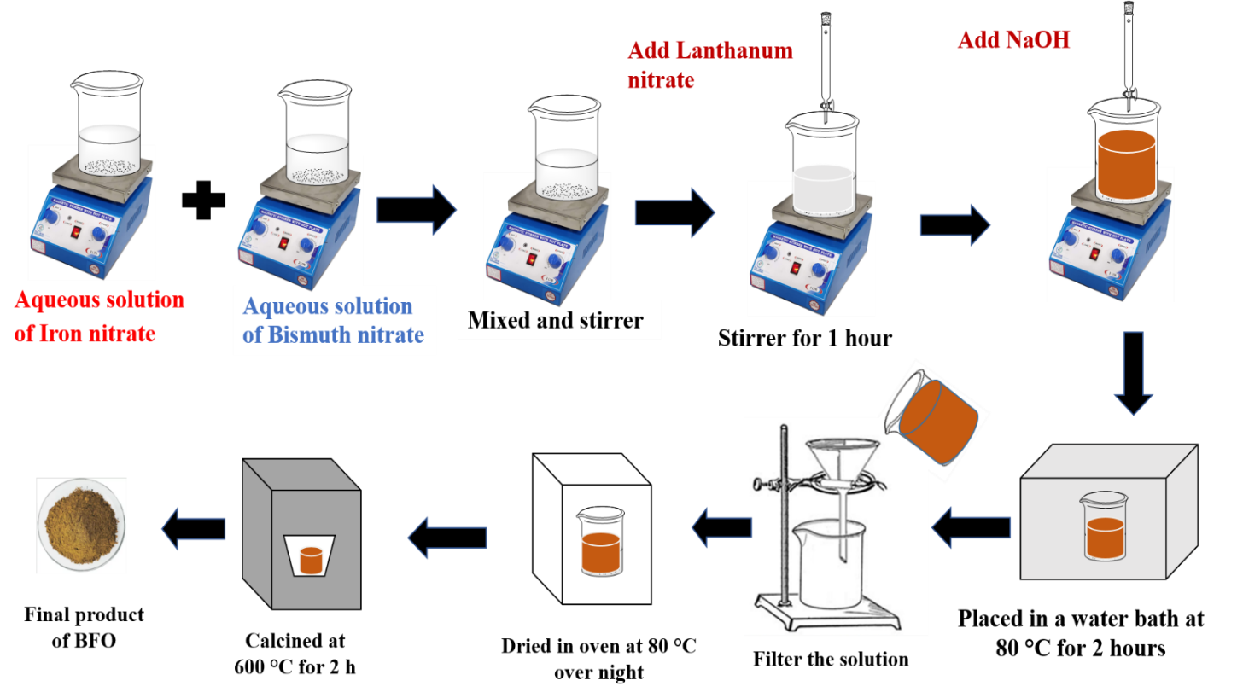is shown in Fig.1.

**Fig. 1.** Preparation of Lanthanum substituted bismuth ferrites

**2.1.3 Characterization**

The X-ray diffractometer was utilized to record the diffraction patterns using D8 Advance, Bruker diffractometer with Cu-K radiation with λ = 0.154 nm and a 2θ range of 20⁰–80⁰ at 20-40 kV and 20 mA. For surface morphology investigation SEM (JSM5910 JEOL) was used. Calculations of FT-IR in the 400–4000 cm-1 region were performed using a Spectrum 2, Perkin Elmer. The absorbance spectrum of the materials was obtained using the UV-Vis spectrometer PG (Model T-80).

**2.2 Calculation Method:**

Theoretical calculations were carried out by adopting the full-potential linearized-augmented-plane-wave (FP-LAPW) technique [29] as employed by the WIEN2K code [30]. The exchange-correlation effects are incorporated within the local-density-approximation (LDA) [31]. The LDA + *U* [32] technique is adopted for strong-correlation systems like *f*-or *d*-orbital. We report the results for U*eff* = 4.5 eV. By decreasing *R*MT*K*MAX, a small basis set can be achieved. It is also noted that this did not affect the accuracy of the final calculated results. The muffin tin sphere radii (*R*MT) used for Bi, Fe and O are 2.7, 2.20 and 1.4 a.u., respectively. *R*MT*K*MAX value of 5.5 was used for proper convergence.

We first performed optimization of the hexagonal structure of BiFeO3. As the primitive unit cell, 2-formula unit crystal cell was adopted. In keeping with the view of different concentrations of dopant, different supercells were constructed. For a primitive unit cell, one La is replaced by one Bi to give BiLaFeO3 structure.

For 2 × 2 × 2 supercell with 16 formula units of bismuth ferrite (80 atoms), the varying concentration of dopant atoms by 0.04, 0.06, and 0.08 give rise to a good response of the calculations. For these concentrations, three supercells were constructed.

**3. Results and Discussion**

**3.1 XRD analysis**

XRD pattern of Bi1-xLaxFeO3 with x = 0.0, 0.04 and 0.08 are presented in Fig. 2. All the diffraction peaks were well investigated, and some low-intensity peaks were also detected. Some secondary phases are also observed as can be seen in Fig. 2. It can be revealed that the structure of Bi1-xLaxFeO3 is a hexagonal perovskite having space group *R*3*c* that contributes to maximum diffraction peaks [33].



**Fig. 2.** XRD patterns of Bi1-xLaxFeO3 **(a)** x = 0.00, **(b)** x = 0.04 and **(c)** x = 0.08

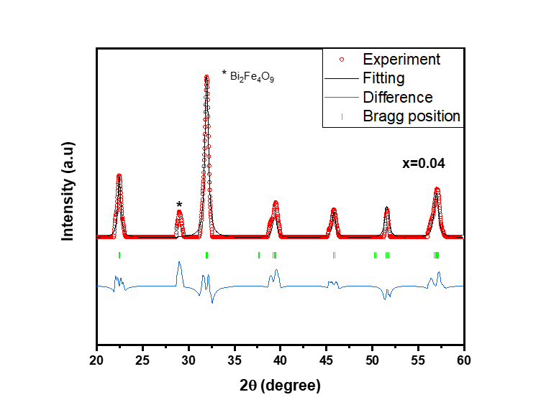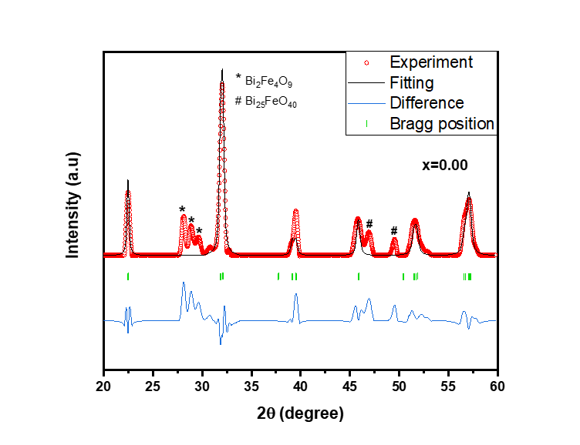To further examine the crystalline nature, Rietveld refinement was done by using FULLPROOF software [34-35]. Rietveld refinement of observed XRD results was done on all samples, as seen in Fig. 3. The polar rhombohedral R3c shape of La substituted BFO sample

**(a)**

**(b)**

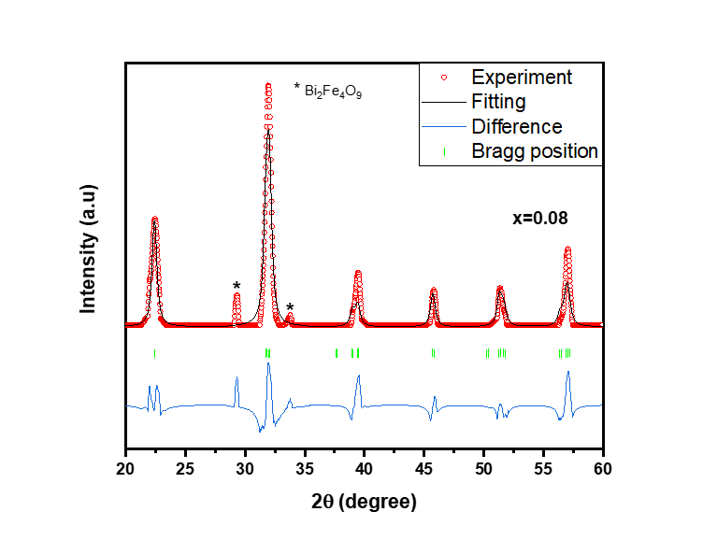

**(c)**

**Fig. 3.** Rietveld refined pattern of the Bi1-xLaxFeO3 **(a)** x = 0.00, **(b)** x = 0.04 and **(c)** x = 0.08

is identical to that of pure bismuth ferrite (BFO). As seen in Figures, the XRD patterns of the BLFO samples were indexed in the rhombohedral (R3c) system having varied lattice parameters with the variation of doping. Previously, a dopant influenced structural variation (R3c to C222) for BLFO compound was observed. The fitting parameters (Rwp, Rexp and χ2) are given in table. 2 [36-38].

La substituting very slightly changes the intensity of the majority peaks because bismuth (Bi3+ =1.03 A°) and lanthanum (Li3+ =1.032 A°) have different ionic radii [39]. The Scherer formula was used to find average crystallite size of BFO [40]. The average crystallite size of BFO powder is 19 nm, 32 nm, and 39 nm for x = 0.0, 0.04, 0.08 samples, respectively as shown in Fig. 4(a). It was demonstrated that the a and c decreased by increasing the substituting concentration, thus cell volume also decreased. The value of X-ray density ρx increased and bulk (ρb) density decreased by increasing the concentration of lanthanum as shown in Fig. 4(b). The calculated values of a, c, Vcell, ρx, and ρb are listed in Table.1. The value of porosity increases, and Specific surface area (S), packing factor (p), strain (ε) and dislocation density (δ) decrease by increasing the Lanthanum concentration as shown in table.1 [43]. The La3+ cation in octahedral coordination has an ionic radius of ~1.03 Å. This is smaller than the ionic radius of the Bi3+ cation ~1.17 Å in the same anionic surrounding. This type of substitution causes a significant change in the unit cell. This change in unit cell ultimately affects the corresponding bond lengths and angles and thus different structural parameters.

**Table 1.** Average crystallite size (Daverage), lattice constant (a, b, c), unit cell volume (Vcell) and X-ray density (ρx) extracted from XRD pattern of Bi1-xLaxFeO3

|  |  |  |  |
| --- | --- | --- | --- |
| **X** | **0.0** | **0.04** | **0.08** |
| **D (nm)** | 19 ± 2 | 32 ± 1 | 39 ± 5 |
| **a = b (Å)** | 5.69 ± 0.04  5.581*[44]  5.54577**[45] | 5.56 ± 0.01 | 5.50 ± 0.03 |
| **c (Å)** | 13.93 ± 0.02  13.88*[44]  13.70408**[45] | 13.67 ± 0.07 | 13.45 ± 0.15 |
| **V (Å)3** | 390.57 ± 5.54  374.14*[34] | 365.97 ± 3.16 | 352.36 ± 7.96 |
| **ρx (g/cm3)** | 7.98 ± 0.12 | 8.44 ± 0.07 | 8.68 ± 0.18 |
| **ρb (g/cm3)** | 4.98 ± 0.03 | 4.52 ± 0.10 | 4.21 ± 0.12 |
| **Porosity (%)** | 37.59 ± 0.88 | 46.45 ± 0.46 | 51.55 ± 1.10 |
| **Dislocation density (*δ)*** | 0.00277 ± 0.00048 | 0.0009 ± 0.0001 | 0.0006 ± 0.0005 |
| **Specific surface area (S)** | 39.57 ± 4.43 | 22.21 ± 0.49 | 17.72 ± 5.88 |
| **Strain (*ε)*** | 14.46 ± 3.25 | 13.25 ± 3.07 | 12.86 ± 3.02 |

*Experimental work from literature, ** theoretical work from literature

**Table 2.** Data collected from Rietveld refinement for La substituted BFO samples

|  |  |  |  |  |
| --- | --- | --- | --- | --- |
| **Concentration** | **Rwp** | **Rexp** | | **χ2** |
| **0.00** | 15.5 | 20.67 | | 1.19 |
| **0.04** | 12.8 | 24.61 | | 0.271 |
| **0.08** | 20.5 | 27.33 | | 0.565 |
| **(a)** | | | **(b)** | | |

**Fig. 4. (a)** Variation of average crystallite size, lattice constants and volume of unit cell **(b)** with different concentration

**3.2 SEM analysis**

Fig. 5 shows the SEM micrographs of Bi1-xLaxFeO3 samples. SEM images of Bi1-xLaxFeO3 samples show the Lanthanum substituting ions affected the morphology of the surface. SEM image of pure bismuth ferrite shows the agglomeration and spherical shape of the particles as shown in Fig. 5. The average grain sizes of representative samples were determined by using ImageJ software (Pictograph). The unsubstituted BiFeO3 particles were spherical with an average grain size of 0.16 μm. When the concentration of Lanthanum increased to *x* = 0.04 and 0.08, particles retained a spherical shape and the surface appeared smooth as compared to the unsubstituted sample. The average particle size increased from 0.18 μm to 0.22 μm as lanthanum concentration increased to *x* = 0.04 to 0.08.

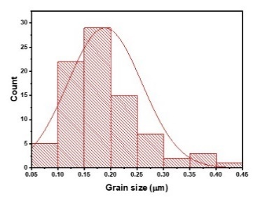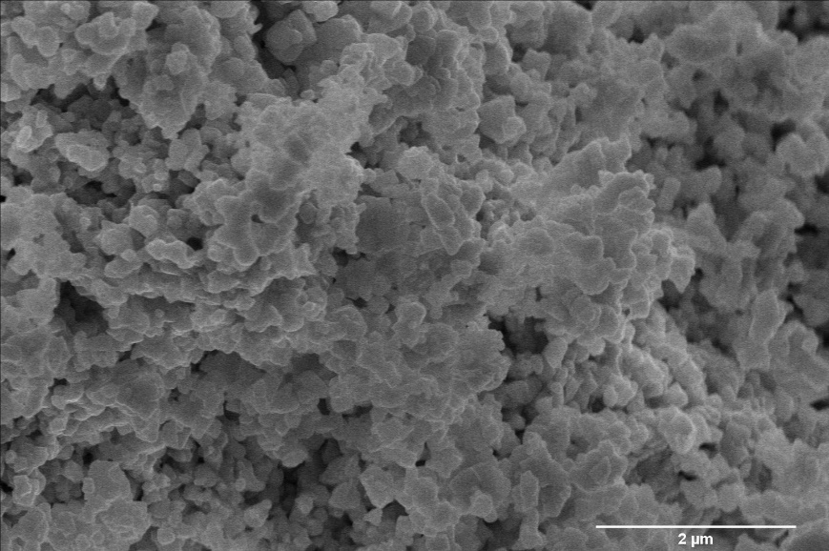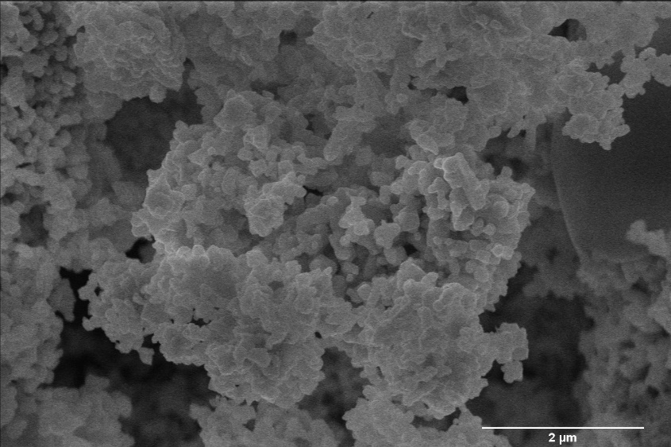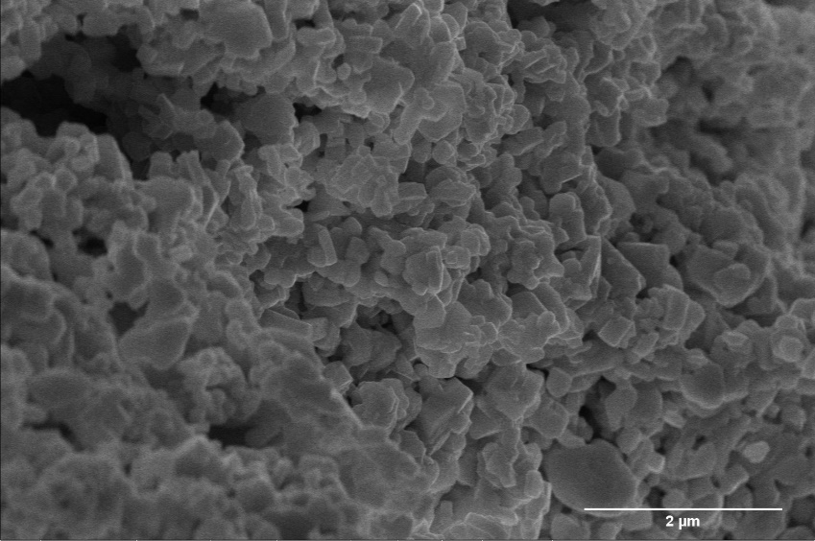

**(c)**

**(a)**

**(b)**

**Fig. 5.** SEM images of Bi1-xLaxFeO3 **(a)** x=0 **(b)** x=0.04 and **(c)** x=0.08

**3.3 FTIR analysis**

Fig. 6 indicates the FTIR spectra of both pure and substituted BFO analysed in region

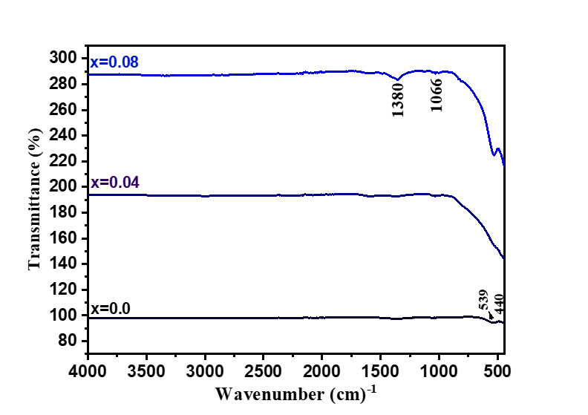

**Fig. 6.** FTIR spectra of Bi1-xLaxFeO3 [x = 0.00, 0.04 and 0.08]

of 4000-400 cm-1. The M-O bond is associated with a band in the range of 400–600 cm-1, which confirmed the perovskite structure. The bending of the Fe-O bond was ascribed to the peak position at 450 cm-1, whereas the stretching of the O-Fe-O bonds that was presence in octahedral FeO6 group was attributed to the band 550 cm-1. The Bi-O bond was attributed to the band value of around 1066 cm-1 [46]. The presence of trapped nitrates resulted in a broad band at approximately 1380 cm-1. A broad band of 1380 cm-1 was due to the presence of the trapped nitrates. There is no O-H group observed in the range of 3000- 3600 cm-1 because the prepared samples are purely dried [47].

**3.4 UV-Vis analysis**

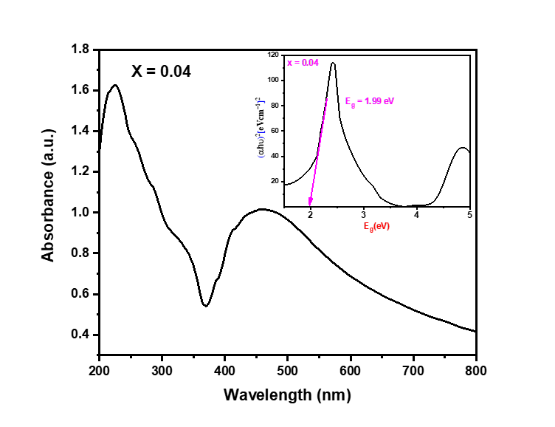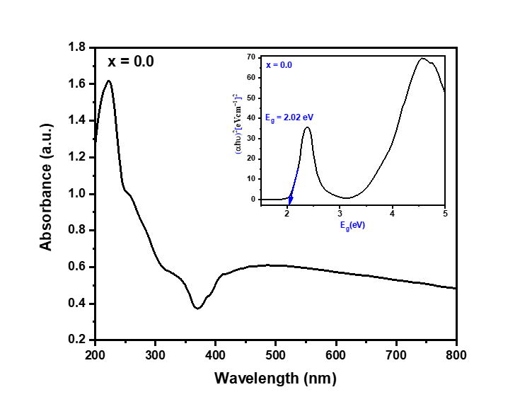The absorption spectra of bismuth ferrite nanoparticles prepared by the co-precipitation technique for different lanthanum substitutions are shown in Fig. 7. The absorption spectra

**(b)**

**(a)**

**(c)**

**Fig. 7.** UV-vis spectra of Bi1-xLaxFeO3 **(a)** x=0.0, **(b)** x = 0.04 and **(c)** x = 0.08

reveal that BFO can absorb a significant amount of visible light. The maximum absorption peak was observed at 367 nm. According to [40], the optical band gap in ferrites depends on various factors, such as the concentration of dopants used, structural parameters used, the size of the particles used, lattice stresses, and contaminants. The value of the (α) absorption coefficient can be determined by using the Kubelka-Munk function reflectance relation [39].The optical band gap (Eg) value of prepared samples was calculated by using the Tauc plot [40-42].The results revealed that the band gap value decreased by increasing the lanthanum substitution.

**3.5 DFT investigation**

For the calculations, same experimental lattice parameters were used in a unit cell of BFO. Furthermore, insubstituted cells, it was noted that the slight changes in atomic sites did not disturb the insulating states obtained after configurations of these structures during structural optimization. Theoretically, it was evident that the R3c (hexagonal) structure was the correct ground state more than the triclinic (*P*1) and monoclinic (*Cc*) structures of BiFeO3 [48]. Moreover, a study on comprehensive optical properties of aforementioned space-groups is also studied [49]. Furthermore, to predict the correct band gap, particularly for Fe-*d* and transition metal oxide systems (TMO), the LDA + *U* scheme was a better choice than that of a modified Becke-Johnson (mBJ) exchange potential [25]. For all 0.04, 0.06 and 0.08 concentrations, three supercells were built. The separations between the dopant atoms differed for each of them. After different site configurations, optimized supercells for the dopant of said concentrations were chosen as shown in Fig. 8.

Kramers–Kronig transformation is adopted to calculate the real part of dielectric-function $ε_{1}(ω)$ whereas the iimaginary part of the dielectric function $ε_{2}(ω)$ are calculated by the many-electron wave function [50]. The dielectric function is mainly concerned with the electronic response. The momentum matrix components between the occupied and unoccupied wave functions are used to compute the imaginary portion $ε_{2}\left(ω\right)$ of the dielectric-function and the results are as follows:

$$ε_{2}\left(ω\right)= \frac{ve^{2}}{2πℏm^{2}w^{2}}\int{d^{3}k\sum_{m,n^{ˊ}}{B_{m, n^{ˊ}}{\left|\left\langle kn\left|p\right|kn^{ˊ}\right\rangle \right|}^{2}×f(}}kn)\left(1-f\left(kn^{ˊ} \right)\right)δ\left(E_{kn}-E_{kn^{ˊ}}-ℏω\right) Eq. (2)$$

In contrast, where denotes the incident phonon's energy, $p$ denotes the momentum operator, $〈kn|$ denotes the crystal wave function, and $f(kn)$ denotes the Fermi function. The Kramer-Kronig transformation is used to assess the real component $ε_{2}\left(ω\right)$ of the dielectric- function from its imaginary part $ε_{2}\left(ω\right)$ [51]. In the first irreducible Brillion zone, intra-band and inter-band transitions are represented by the imaginary-part of the dielectric function. The optical characteristics for Bi1-xLaxFeO3 samples with x = 0.0, 0.04, 0.06 and 0.08 are also calculated.

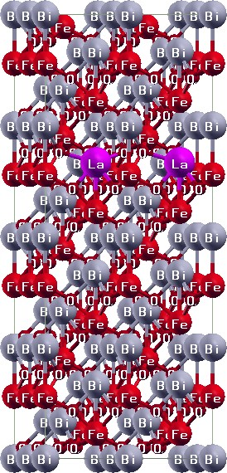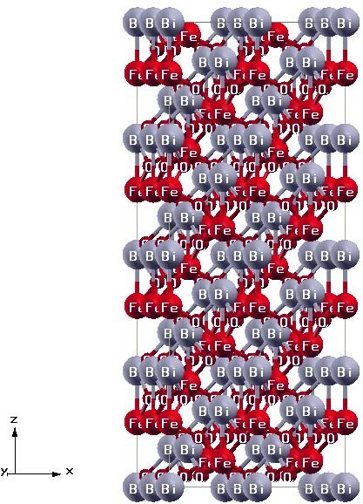

**(b)**

**(a)**

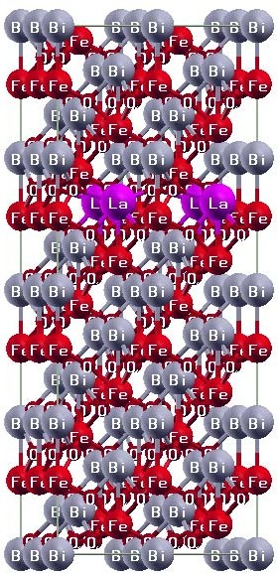

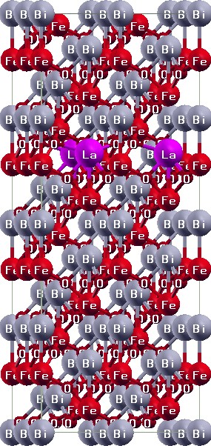

**(d)**

**(c)**

**Fig. 8.** Optimized structural models of three distinct configurations of Bi1-xLaxFeO3**(a)** x=0.00, **(b)** x = 0.04 **(c)** x = 0.06 and **(d)** x = 0.08

The material response to an electric field is related to the dielectric function. The spectrum of wavelengths for the real part $ε_{1}\left(ω\right)$ of dielectric function was kept from 200 to 1000 nm. The dielectric-functions of Bi1-xLaxFeO3 are calculated as shown in Figs. 9 and 10 by the employing LDA + U method. In BiFeO3 substituted compound the $ε_{1}\left(ω\right)$ leads the broadcasting behaviour of the electromagnetic field. The $ε_{1}\left(ω\right)$ showed a negative value. The real part's negative value is the indication of total reflection of the incident electromagnetic wave is totally reflected above 700 nm as depicted in Fig. 9. The maximum peak of absorption was observed in the vicinity from 320 to 450 nm which is in good agreement with our experiment.

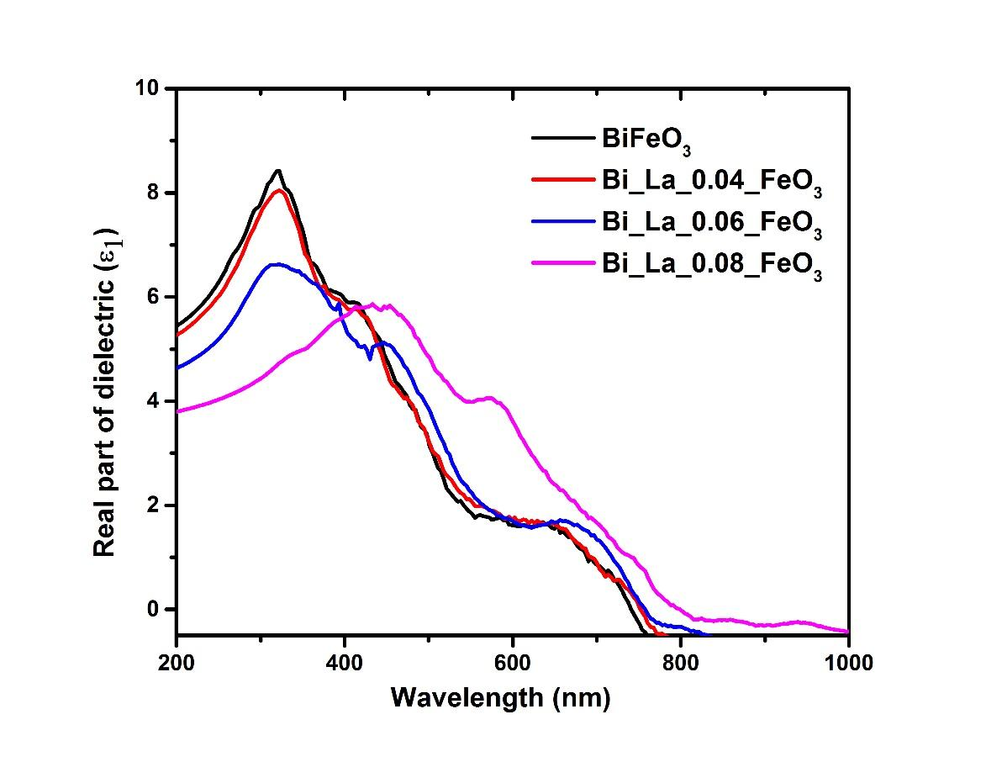

**Fig. 9.** Real part of dielectric functions $ε_{1}\left(ω\right)$ with Lorentz broadening (1.5 eV) **(a)** x=0, **(b)** x= 0.04, **(c)** x= 0.06 and **(d)** x=0.08

From Fig. 10, in all cases, the on-set absorption starts around 2 eV, which is consistent with our experimental findings of UV-visible spectra for pure and substituted bismuth ferrites. The optical gap for x = 0.02 (not shown), is found to be overestimated compared to our experimental results. The band structure's energy is connected to the imaginary-part $ε_{2}(ω)$. In electronic structure calculations (not shown), the indirect band gaps around 1.6 eV, 1.8 eV and 1.6 eV were observed for pure, 0.04 and 0.08 substituted structure of Bi1-xLaxFeO3 respectively. Whereas, direct band gaps 2 eV, 2.1 eV, 1.98 eV, and 1.86 eV were computed for Bi1-xLaxFeO3 samples with x = 0.0, 0.04, 0.06 and 0.08, respectively. The same as a direct band gap, an indirect band gap between the topmost of the O-2*p* valence-band (VB) and the bottommost of the Fe 3*d* conduction-band (CB) for 0.06 substituted structure of Bi1-xLaxFeO3 was also observed. However, dielectric function of $ε_{2}(ω)$ for pure and Bi1-xLaxFeO3 increases rapidly around 2 eV which corresponds to the direct band gaps. The $ε_{2}\left(ω\right)$ describes inter-transitions from O-p occupied to unoccupied Fe-*d* states and also including O-*p* electron to other *p*-states of high-energy occupied states. The more pronounced peaks around 4 eV (Fig. 10a, c and d) and 5 eV (Fig. 10b) correspond mainly with the transition from the occupied O-2*p* to Fe-3*d* states and from O-2*p* VB to Fe-3*d* or Bi-6*p* or La-5*p* high energy CB.

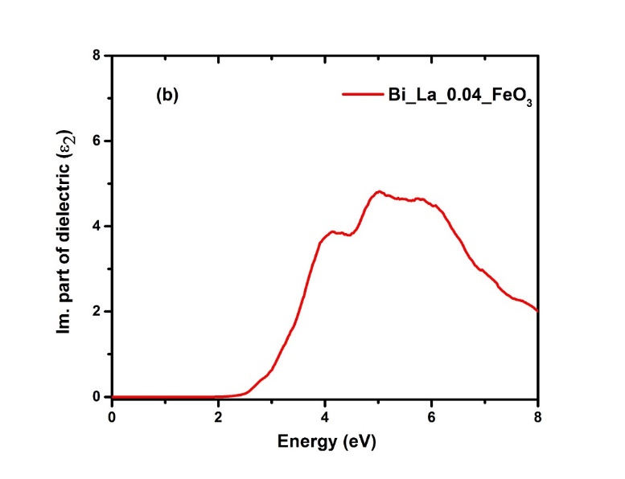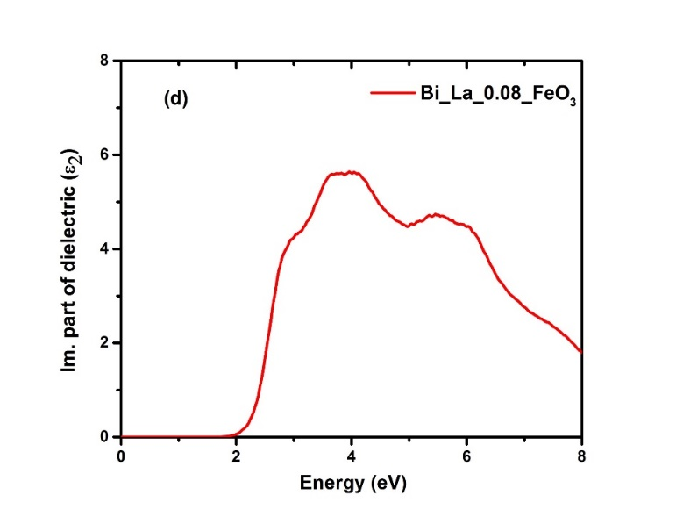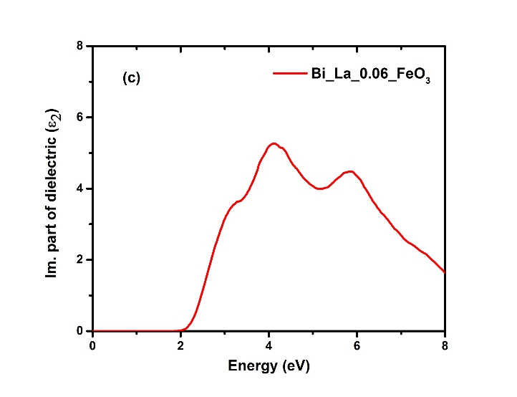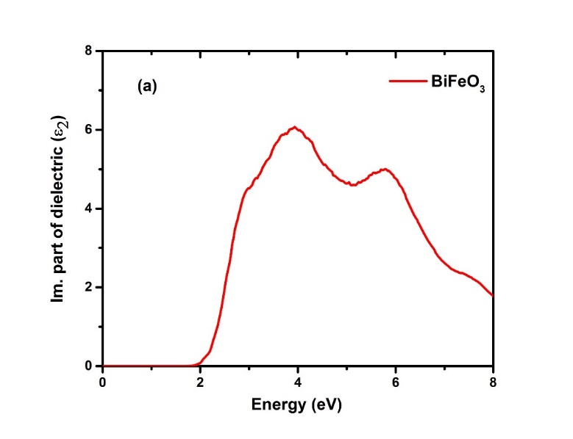

**Fig. 10.** Imaginary part of dielectric functions $ε_{2}\left(ω\right)$ with Lorentz broadening (1.5 eV) **(a)** x=0, **(b)** x= 0.04, **(c)** x= 0.06 and **(d)** x=0.08

**4. Conclusion**

Lanthanum-substituted bismuth ferrites were successfully prepared by using the co-precipitation rout for different concentrations of lanthanum. The XRD pattern revealed the hexagonal perovskite structure of space group *R*3*c* which is also confirmed by Rietveld refinement. The average crystallite size was estimated to be in the range of 19 to 35 nm. SEM image showed a crystal-like shape of bismuth ferrite nanoparticles. UV-visible spectroscopy disclosed that with increase in lanthanum substitution, band gap decreased. Furthermore, the on-set absorption of the calculated optical and experimental band gaps of pure and substituted bismuth ferrites, Bi1-xLaxFeO3, were 2 eV (2.02 eV), 1.98 eV (1.99 eV) and 1.86 eV (1.85 eV) particularly at x= 0, 0.04 and 0.08, respectively, which were in good agreement experimentally. These results would provide a theoretical reference for fundamental science and technological application of Bi1-xLaxFeO3. The present results may provide new insight into the role of La (III) modified multiferroic BiFeO3 and its potential for applications.

**Acknowledgement:**

The authors acknowledge the funding from Kementerian Pendidikan Malaysia Grant FRGS/1/2018/TK04/UKM/02/11.

**References:**

[1] Y. Du, Z.X. Cheng, M. Shahbazi, E.W. Collings, S.X. Dou, X.L. Wang, Enhancement of ferromagnetic and dielectric properties in lanthanum doped BiFeO3 by hydrothermal synthesis, J. Alloys Compd. 490 (2010) 637–641. <https://doi.org/10.1016/j.jallcom.2009.10.124>.

[2] H. Maleki, Photocatalytic activity, optical and ferroelectric properties of Bi0.8Nd0.2FeO3 nanoparticles synthesized by sol-gel and hydrothermal methods, ArXiv. (2018). <https://doi.org/10.1016/j.jmmm.2018.03.043>.

[3] H. Maleki, M. Kazemeini, A.S. Larimi, F. Khorasheh, Transesterification of canola oil and methanol by lithium impregnated CaO–La2O3 mixed oxide for biodiesel synthesis, J. Ind. Eng. Chem. 47 (2017) 399–404. <https://doi.org/10.1016/j.jiec.2016.12.011>.

[4] N.D.M. Ridzuan, N.H.M. Kaus, M.A.S. Md Lazim, T. Kobayashi, R. Adnan, M.Z. Othman, M.H.M. Kassim, Photocatalytic heterostructures-based BiFeO3 embedded liquid natural rubber (LNR) for highly removal of cationic dye under direct sunlight, J. Environ. Chem. Eng. 8 (2020). <https://doi.org/10.1016/j.jece.2020.104152>.

[5] H. Baqiah, Z.A. Talib, A.H. Shaari, N. Tamchek, N.B. Ibrahim, Synthesis, optical and magnetic behavior of (BiFeO3)1−x(α-Fe2O3)x nanocomposites, Mater. Sci. Eng. B Solid-State Mater. Adv. Technol. 231 (2018) 5–10. <https://doi.org/10.1016/j.mseb.2018.03.002>.

[6] N.B. Delfard, H. Maleki, A.M. Badizi, M. Taraz, Enhanced Structural, Optical, and Multiferroic Properties of Rod-Like Bismuth Iron Oxide Nanoceramics by Dopant Lanthanum, J. Supercond. Nov. Magn. 33 (2020) 1207–1214. <https://doi.org/10.1007/s10948-019-05294-3>.

[7] H. Maleki, M. Zakeri, R. Fathi, Experimental study of the effect of yttrium on the structural, thermal, and magnetic properties of BiFeO3, Appl. Phys. A Mater. Sci. Process. 124 (2018) 1–23. <https://doi.org/10.1007/s00339-018-2154-8>.

[8] X. Qi, X. Zhang, X. Wang, H. Sun, J. Qi, Preparation and characterization of BiFeO3 film via sol-gel spin-coating process, Key Eng. Mater. 492 (2012) 202–205. <https://doi.org/10.4028/www.scientific.net/KEM.492.202>.

[9] Z. Quan, W. Liu, H. Hu, S. Xu, B. Sebo, G. Fang, M. Li, X. Zhao, Microstructure, electrical and magnetic properties of Ce-doped BiFeO3 thin films, J. Appl. Phys. 104 (2008) 0–10. <https://doi.org/10.1063/1.3000478>.

[10] H. Baqiah, Z. A. Talib, A. H. Shaari, M. M. Kechik, J. Y. C. Liew and N. B. Ibrahim. "Effects of Aging Time on Microstructure, Hydrophobic and Optical Properties of BiFeO3 Thin Films Synthesized via Sol-Gel Method." J. Ceram. Sci. Technol.9, no. 4 (2018): 419-425. <https://doi.org/10.1016/j.rinp.2022.105446>.

[11] H. Liu, X. Wang, Study on the Ce substitution effects of BiFeO3 films prepared by a sol-gel process, Solid State Commun. 148 (2008) 203–205. <https://doi.org/10.1016/j.ssc.2008.08.018>.

[12] D. Lee, M.G. Kim, S. Ryu, H.M. Jang, S.G. Lee, Epitaxially grown La-modified BiFeO3 magnetoferroelectric thin films, Appl. Phys. Lett. 86 (2005) 1–3. <https://doi.org/10.1063/1.1941474>.

[13] X. Zhang, X. Qi, J. Qi, X. Wang, Preparation and properties of multiferroic La-doped BiFeO3 thin film, Adv. Mater. Res. 486 (2012) 417–421. <https://doi.org/10.4028/www.scientific.net/AMR.486.417>.

[14] Q.Q. Wang, C.C. Wang, N. Zhang, H. Wang, Y.D. Li, Q.J. Li, S.G. Huang, Y. Yu, Y.M. Guo, Z.Q. Lin, Dielectric relaxations in pure, La-doped, and (La, Co)-codoped BiFeO3: Post-sintering annealing studies, J. Alloys Compd. 745 (2018) 401–408. <https://doi.org/10.1016/j.jallcom.2018.02.014>.

[15] A.J Preethi, M. Ragam. Effect of doping in multiferroic BFO: A review. Journal of Advanced Dielectrics. 2021;11(6):2130001. <https://doi.org/10.1142/S2010135X21300012>

[16] H. Anwar, Y. Jamil, G. Mustafa, M.U. Islam, A. Shakoor, M.I. Arshad, H. Akhtar, M.R.S. Aleem, Effect of Co-substitution of (Bi,Mn) ions on structural, magnetic and dielectric properties of (DyFeO3) dysprosium orthoferrite, J. Ovonic Res. 13 (2017) 241–248.

[17] J. Basu, R. Katoch, A. Garg, C.B. Carter, Microstructure and Interfacial Chemistry of Pure and La-doped BiFeO3 Thin Films, 1309 (2013) 1304–1309. <https://doi.org/10.1002/jemt.22302>.

[18] Q. Tang, Z. Liu, S. Li, S. Zhang, X. Liu, Y. Qian, Synthesis of yttrium hydroxide and oxide nanotubes, J. Cryst. Growth. 259 (2003) 208–214. <https://doi.org/10.1016/S0022-0248(03)01590-2>.

[19] R. Srinivasan, R. Yogamalar, A. Vinu, K. Ariga, A.C. Bose, Structural and optical characterization of samarium doped yttrium oxide nanoparticles, J. Nanosci. Nanotechnol. 9 (2009) 6747–6752. <https://doi.org/10.1166/jnn.2009.1467>.

[20] V. Fruth, E. Tenea, M. Gartner, M. Anastasescu, D. Berger, R. Ramer, M. Zaharescu, Preparation of BiFeO3 films by wet chemical method and their characterization, J. Eur. Ceram. Soc. 27 (2007) 937–940. <https://doi.org/10.1016/j.jeurceramsoc.2006.04.135>.

[21] T.P. Gujar, V.R. Shinde, C.D. Lokhande, Nanocrystalline and highly resistive bismuth ferric oxide thin films by a simple chemical method, Mater. Chem. Phys. 103 (2007) 142–146. <https://doi.org/10.1016/j.matchemphys.2007.02.003>.

[22] S. Mohammad, K. Davinder, V.S. Chandel, M.A. Siddiqui, Investigation on multiferroic properties of BiFeO3 ceramics, Mater. Sci. Pol. 31 (2013) 471–475. <https://doi.org/10.2478/s13536-013-0128-2>.

[23] J.F. Ihlefeld, N.J. Podraza, Z.K. Liu, R.C. Rai, X. Xu, T. Heeg, Y.B. Chen, J. Li, R.W. Collins, J.L. Musfeldt, X.Q. Pan, J. Schubert, R. Ramesh, D.G. Schlom, Optical band gap of BiFeO3 grown by molecular-beam epitaxy, Appl. Phys. Lett. 92 (2008). <https://doi.org/10.1063/1.2901160>.

[24] M.O. Ramirez, A. Kumar, S.A. Denev, Y.H. Chu, J. Seidel, L.W. Martin, S.Y. Yang, R.C. Rai, X.S. Xue, J.F. Ihlefeld, N.J. Podraza, E. Saiz, S. Lee, J. Klug, S.W. Cheong, M.J. Bedzyk, O. Auciello, D.G. Schlom, J. Orenstein, R. Ramesh, J.L. Musfeldt, A.P. Litvinchuk, V. Gopalan, Spin-charge-lattice coupling through resonant multimagnon excitations in multiferroic BiFeO3, Appl. Phys. Lett. 94 (2009) 1–11. <https://doi.org/10.1063/1.3118576>.

[25] I. Naz, F. Ahmad, J. Jang, J.Y. Rhee, Ab-initio investigation of electronic structures of α-BiFeO3 with different exchange-correlation functionals, AIP Adv. 8 (2018). <https://doi.org/10.1063/1.5064645>.

[26] Ahmed, I., Mustafa, G., Umair Subhani, M., Hussain, G., Ismail, A. G., & Anwar, H. (2022). A detailed investigation of lanthanum substituted bismuth ferrite for enhanced structural, optical, dielectric, magnetic and ferroelectric properties. Results in Physics, 38(May), 105584. https://doi.org/10.1016/j.rinp.2022.105584.

[27] Ghosh, M. Prasad, S. Kinra, D. Dagur, R. K. Choubey, and S. Mukherjee. "Evidence of large exchange bias effect in single-phase spinel ferrite nanoparticles." *Physica Scripta* 95, no. 9 (2020): 095812. <https://iopscience.iop.org/article/10.1088/1402-4896/abaf90/meta>.

[28] Kumar, Sunil, A. Jain, S. Panwar, I. Sharma, H. C. Jeon, T. W. Kang, and R. K. Choubey. "Effect of silica on the ZnS nanoparticles for stable and sustainable antibacterial application." *International Journal of Applied Ceramic Technology* 16, no. 2 (2019): 531-540.  <https://doi.org/10.1111/ijac.13145>.

[29] P. Blaha, WIEN2k, 2021. [https://doi.org/10.1107/S1574870720003171](https://dx.doi.org/openurl?url_ver=Z39.88-2003&rfr_id=ori:rid:iucr.org&rft_id=doi:10.1107/S1574870720003171&rfr_dat=cr%5FsetVer%3D01%26cr%5Fpub%3D10%2E1107%26cr%5Fwork%3D%3Cspan%20class%3D%22it%22%3E%3Ci%3EWIEN%3C%2Fi%3E%3C%2Fspan%3E2%3Cspan%20class%3D%22it%22%3E%3Ci%3Ek%3C%2Fi%3E%3C%2Fspan%3E%2C%20an%20augmented%20plane%20wave%20plus%20local%20orbital%20package%20for%20the%20electronic%20structure%20of%20solids%26cr%5Fsrc%3D10%2E1107%26cr%5FsrvTyp%3Dhtml).

[30] K. Schwarz, P. Blaha, Solid state calculations using WIEN2k, Comput. Mater. Sci. 28 (2003) 259–273. <https://doi.org/10.1016/S0927-0256(03)00112-5>.

[31] J.P. Perdew, Y. Wang, M. Carlo, r’), (2), 46 (1992) 947–954. <https://doi.org/10.1103/PhysRevB.46.12947>.

[32] V.I. Anisimov, M.A. Korotin, J. Zaanen, O.K. Andersen, Spin bags, polarons, and impurity potentials in La2-xSrxCuO4 from first principles, Phys. Rev. Lett. 68 (1992) 345–348. <https://doi.org/10.1103/PhysRevLett.68.345>.

[33] K. Sen, K. Singh, A. Gautam, M. Singh, Dispersion studies of la substitution on dielectric and ferroelectric properties of multiferroic BiFeO3 ceramic, Ceram. Int. 38 (2012) 243–249. <https://doi.org/10.1016/j.ceramint.2011.06.059>.

[34] Choubey, Ravikant, D. Das, and S. Mukherjee. "Effect of doping of manganese ions on the structural and magnetic properties of nickel ferrite." *Journal of Alloys and Compounds* 668 (2016): 33-39. <https://doi.org/10.1016/j.jallcom.2016.01.198>.

[35] T. Kamar, L. K. Sharma, R. K. Singh, R. K. Choubey, and S. Mukherjee. "Evidence of exchange-coupled behavior in chromium-cobalt ferrite nanoparticles." *J. of Magnetism and Magnetic Materials* 456 (2018):118-123. <https://doi.org/10.1016/j.jmmm.2018.02.019>.

[36] Z. Zhang, H. Liu, Y. Lin, Y. Wei, C. Nan, X. Deng, Influence of La Doping on Magnetic and Optical Properties of Bismuth Ferrite Nanofibers, 2012 (2012). <https://doi.org/10.1155/2012/238605>.

[37] A. Kumar, P. Sharma, and D. Varshney, Structural and Ferroic Properties of La, Nd, and Dy Doped BiFeO3 Ceramics, J. Ceram. 2015 (2015). <https://doi.org/10.1155/2015/869071>.

[38] G. Catalan and J. F. Scott, Physics and applications of bismuth ferrite, Advanced Materials, 21 (2009) 2463-2485. <https://doi.org/10.1002/adma.200802849>.

[39] M. K. Singh, H. M. Jang, S. Ryu, and M. H. Jo, Polarized Raman scattering of multiferroic BiFeO3 epitaxial films with rhombohedral R3c symmetry, Applied Physics Letters, 88 (2006). <https://doi.org/10.1063/1.2168038>.

[40] M.K. Sharif, M.A. Khan, M.F. Warsi, M. Ramzan, A. Hussain, Structural and ferroelectric properties of hafnium substituted BiFeO3 multiferroics synthesized via auto combustion technique, Ceram. Int. 44 (2018) 20648–20655. <https://doi.org/10.1016/j.ceramint.2018.08.057>.

[41] Kumar, Sunil, H. C. Jeon, T. W. Kang, R. Seth, S. Panwar, S. K. Shinde, D. P. Waghmode, R. G. Saratale, and R. K. Choubey. "Variation in chemical bath pH and the corresponding precursor concentration for optimizing the optical, structural and morphological properties of ZnO thin films." Journal of Materials Science: Materials in Electronics 30(2019):17747-17758. <https://link.springer.com/article/10.1007/s10854-019-02125-y>.

[42] Kumar, Arun, M. Kumar, V. Bhatt, S. Mukherjee, S. Kumar, H. Sharma, M. K. Yadav, S. Tomar, J. Yun, and R. K. Choubey. "Highly responsive and low-cost ultraviolet sensor based on ZnS/p-Si heterojunction grown by chemical bath deposition." *Sensors and Actuators A: Physical* 331 (2021): 112988. <https://doi.org/10.1016/j.sna.2021.112988>.

[43] I. Ali, M.U. Islam, M.S. Awan, M. Ahmad. Effects of heat-treatment time on the structural, dielectric, electrical, and magnetic properties of bam hexaferrite. J. Mater. Eng. Perform. 22 (2013) 2104–2114. <https://doi.org/10.1007/s11665-013-0484-4>.

[44] M.N. Abdillah, D. Triyono, Structural properties of bismuth ferrite synthesized by sol-gel method with variation of calcination temperature, J. Phys. Conf. Ser. 1245 (2019). <https://doi.org/10.1088/1742-6596/1245/1/012087>.

[45] M.K. Yaakob, M.F.M. Taib, M.S.M. Deni, M.Z.A. Yahya, Ab initio studies on the structural and electronic properties of bismuth ferrite based on ferroelectric hexagonal phase and paraelectric orthorhombic phase, Integr. Ferroelectr. 155 (2014) 134–142. <https://doi.org/10.1080/10584587.2014.905306>.

[46] M. Cebela, B. Jankovic, R. Hercigonja, M.J. Lukic, Z. Dohcevic-Mitrovic, D. Milivojevic, B. Matovic, Comprehensive characterization of BiFeO3 powder synthesized by the hydrothermal procedure, Process. Appl. Ceram. 10 (2016) 201–208. <https://doi.org/10.2298/PAC1604201C>.

[47] K. Karthikeyan, A. Thirumoorthi, Synthesis , Characterization and Photoluminescence Behaviour of Bismuth Ferrites, 2 (2017) 51–56.

[48] F. Ahmad, I. Naz, J.K. Jang, J.Y. Rhee, Stability of the crystal structure of α-BiFeO3, J. Korean Phys. Soc. 70 (2017) 394–400. <https://doi.org/10.3938/jkps.70.394>.

[49] I. Naz, F. Ahmad, B.U. Haq, H. Anwar, I.B. Khadka, M.M. Alsardia, S.H. Kim. First-principles calculations to investigate the Electronic and Optical Properties of Hexagonal, Triclinic, and Monoclinic Structures of α-BiFeO3. Materials Science and Engineering: B. 2022 Oct 1; 284:115838. <https://doi.org/10.1016/j.mseb.2022.115838>.

[50] R. Zhang, G. Wang, S. Qin, X. Zhang, J. Zhang, W. Ma, Z. Zhu, Chang S. Photocurrent imaging of CdS/Al interfaces based on microscopic analysis. Applied Optics. 2013 Jul 20;52(21):5230-4. <https://doi.org/10.1364/AO.52.005230>.

[51] R.M. Martin. Electronic structure: basic theory and practical methods. Cambridge university press; 2020 Aug 27. <https://doi.org/10.1080/00107514.2010.509989>.