**Supporting Information for**

**Impact of NiCo2O4/SrTiO3 p-n Heterojunction on the Interface of Photoelectrochemical Water Oxidation**

Hongxia Wang1, Yan Wang1, Yumei Lin1, Xiaochun Huang1, Miguel García-Tecedor,2 Víctor A. de la Peña O’Shea,2 Connor Murrill3, Vlado K. Lazarov3,4, Freddy E. Oropeza2*, Kelvin H. L. Zhang1*

1State Key Laboratory of Physical Chemistry of Solid Surfaces, College of Chemistry and Chemical Engineering, Xiamen University, Xiamen 361005, P. R. China.

2Photoactivated Processes Unit, IMDEA Energy Institute, Avda. Ramón de la Sagra 3, 28935 Móstoles, Madrid, Spain.

3Physics, Engineering and Technology School, University of York, Heslington, York, YO10 5DD, UK

4The York JEOL Nanocentre, York Science Park, Heslington, YO10 5BR, York, UK

*Email: freddy.oropeza@imdea.org; kelvinzhang@xmu.edu.cn

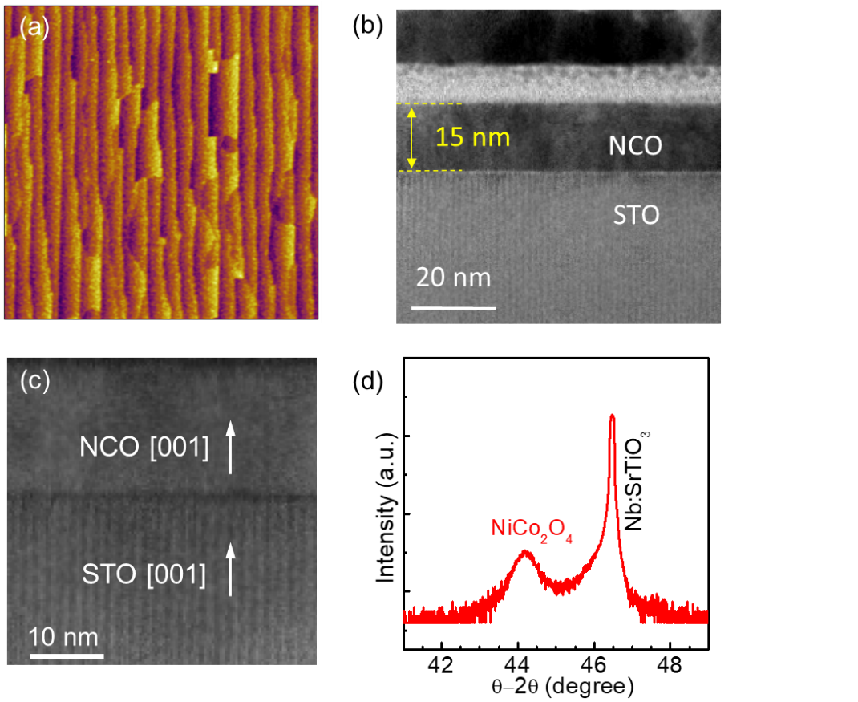

**Figure S1.** (a) AFM image of SrTiO3 (001) substrate with TiO2 termination. (b) and (c) Low-magnification HAADF-STEM image of a NiCo2O4/SrTiO3 heterojunction. (d) *θ-2θ* XRD out-of-plane scans of the 15 nm NiCo2O4 film grown on SrTiO3 substrate.

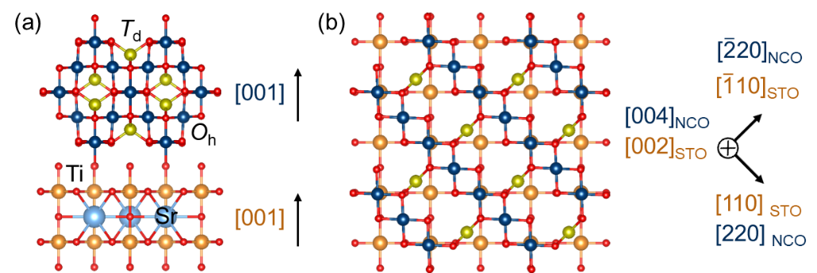

**Figure S2**. (a) Side-view and (b) top-view schematic model of NiCo2O4 on SrTiO3. From the top-view (Fig. S2b) atomic arrangement model, four unit cells of perovskite fit well with one unit cell in NiCo2O4, where two-third of the *Oh* site cations is registered with the oxygen anions in TiO2 termination with orientation relationships of [220]NCO||[110]STO and []NCO||[]STO.

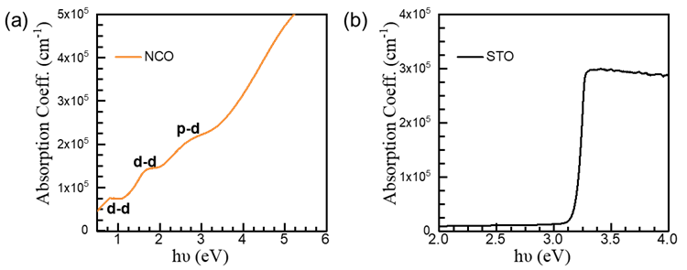

**Figure S3**. Optical absorption coefficients of (a) the NiCo2O4 and (b) the SrTiO3 as a function of photon energy.

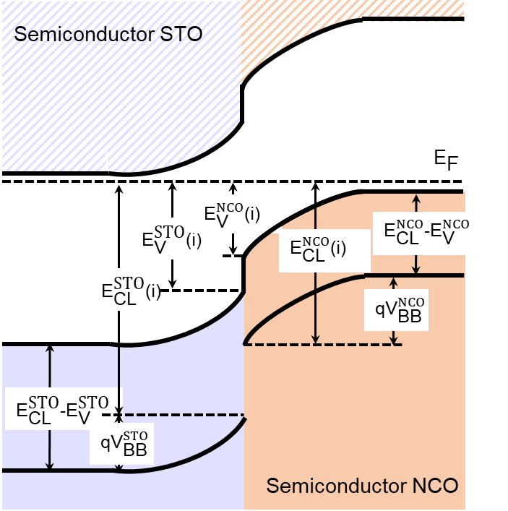

**Figure S4.** Schematic diagram for the calculation of band bending potential and the built-in potential.

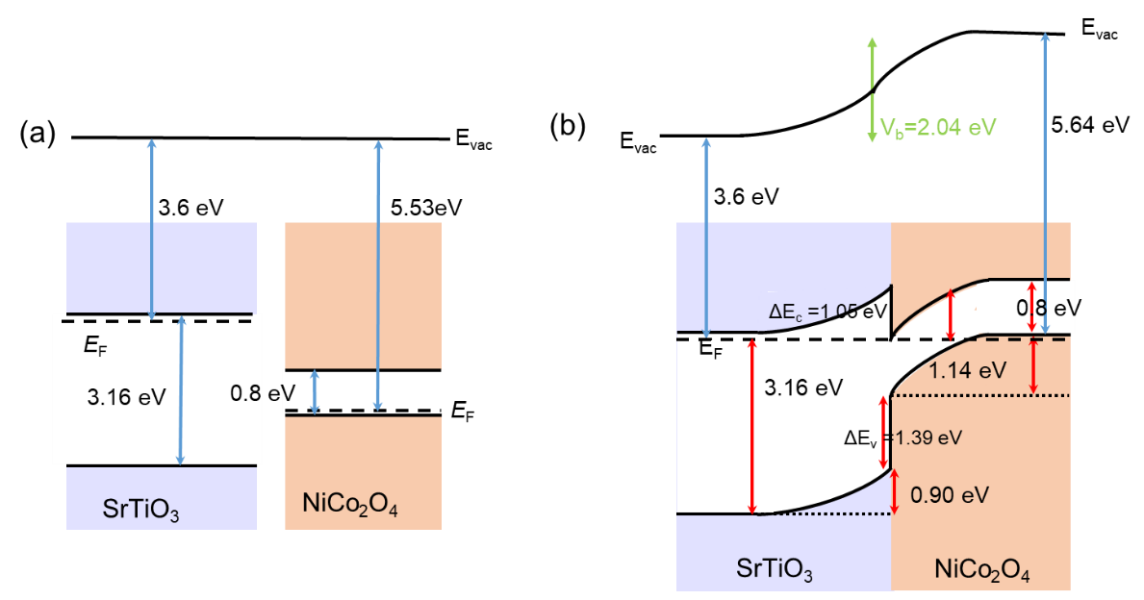

**Figure S5**. (a) Energy diagram of the NiCo2O4 and SrTiO3 before contact, which is obtained based on the band gaps of NiCo2O4 and SrTiO3, and the work function of SrTiO3 (3.6 eV)1, 2 and NiCo2O4 (5.53 eV)3. (b) Energy diagram of 15 nm thick NCO/STO heterojunction. $\text{Δ}{\text{E}}_{\text{V}}$ and $\text{Δ}{\text{E}}_{\text{C}}$ are the valence band offset and conduction band offset, respectively. $E_{g}^{NCO}$ and $E_{g}^{STO}$ are the bandgaps of NiCo2O4 (0.8 eV) and SrTiO3 (3.16 eV), respectively.

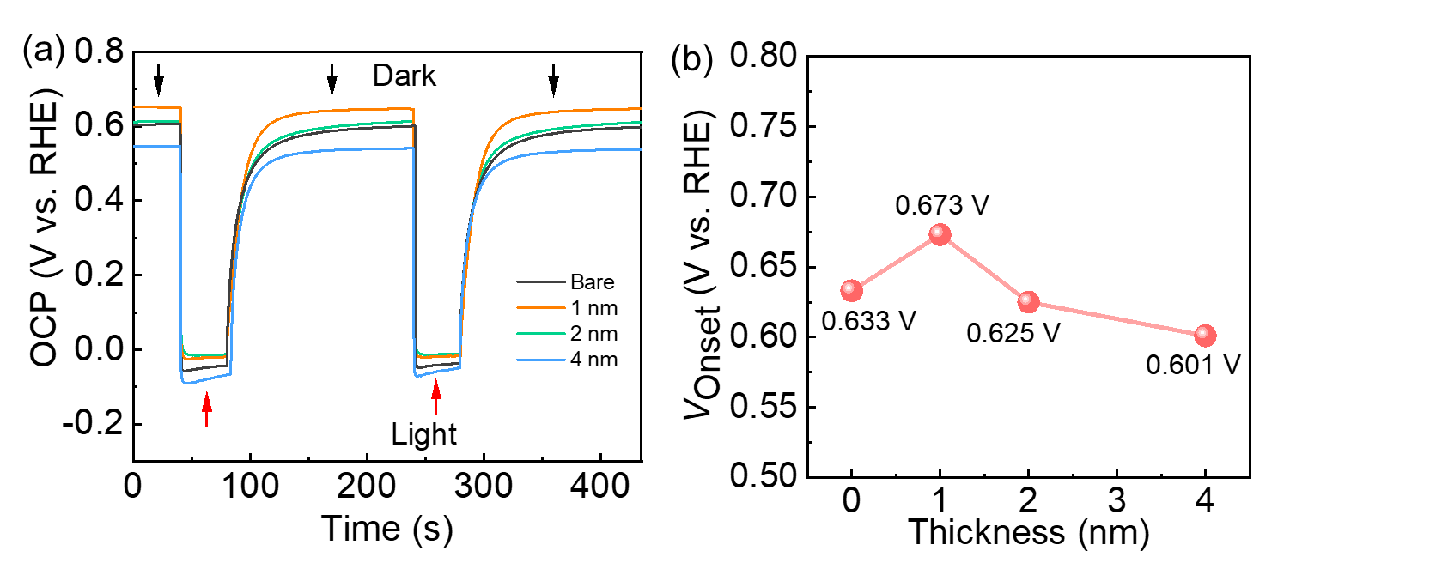

**Figure S6**. (a) Open-circuit potential measurement in 0.1 M KOH measured in the dark and under illumination. The change in OCP between the dark and illuminated conditions indicates the photovoltage of the photoanode. (b) The photovoltage values of NiCo2O4 thin films with different thickness on SrTiO3 and bare SrTiO3.

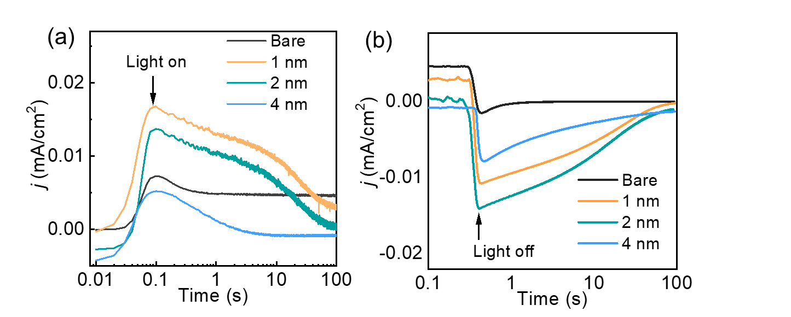

**Figure S7.** Transient light illumination curves at a constant applied potential of 0.2 V vs. RHE (a) when light on and (b) when light off.

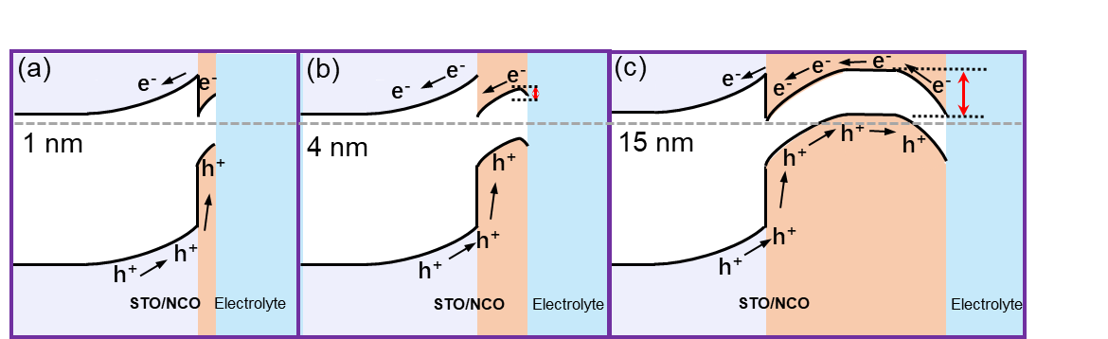

**Figure S8.** Energy and charge transfer diagrams at the interface of (a) 1 nm, (b) 4 nm and (c) 15 nm NiCo2O4/SrTiO3 heterojunctions.

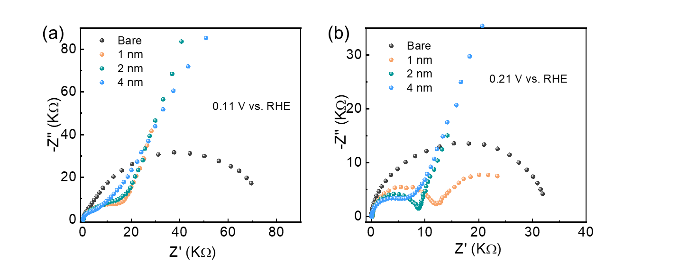

**Figure S9.** Nyquist plots acquired under three-electrode configuration on the fabricated photoanodes at (a) 0.11, and (b) 0.21 V vs RHE.

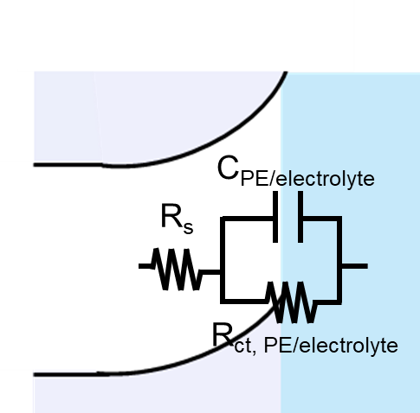

**Figure S10.** Employed equivalent circuits to fit the EIS data acquired in the bare SrTiO3. The proposed Randles’ circuit takes into account contacts and wiring through the series resistance (*R*s), and the STO/Electrolyte through the charge transfer resistance (*R*ct, PE/Electrolyte) and capacitance (*C*PE/Electrolyte) associated with this interface.

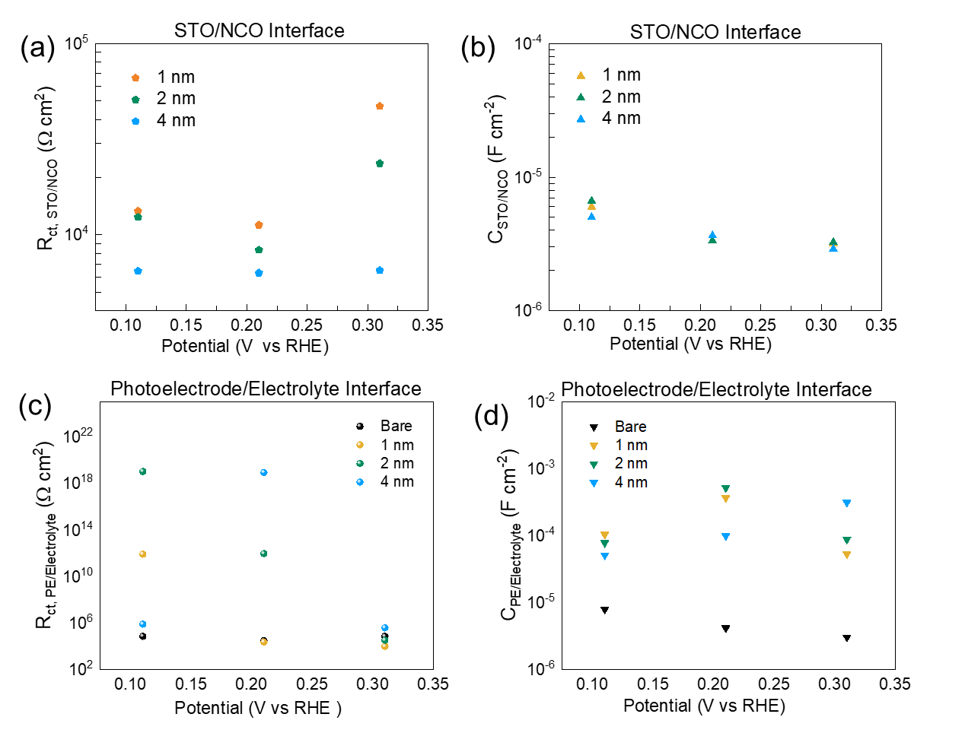

**Figure S11.** Extracted charge transfer resistances (a) and capacitances (b) associated with the STO/NCO under different potentials. Extracted charge transfer resistances (c) and capacitances (d) associated with the STO/NCO and bare SrTiO3 under different potentials.

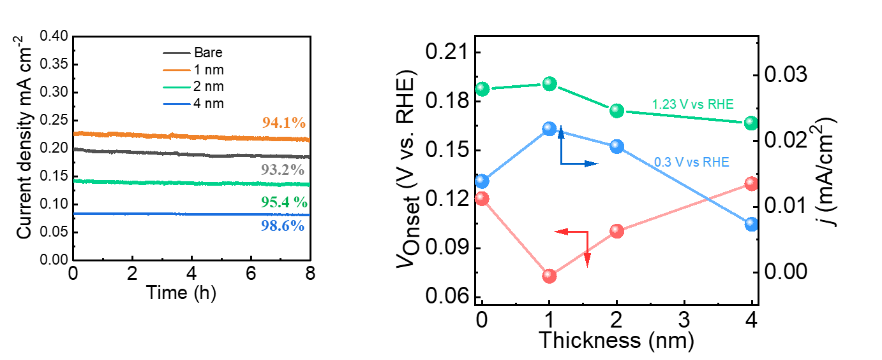

**Figure S12**. Chronoamperometry curves of NCO/STO with different thickness and bare SrTiO3 measured at a constant potential of 0.3 V vs RHE in 0.1 M KOH.

**Table S1**. Flat potential and band bending width of all samples.

|  |  |  |
| --- | --- | --- |
| Sample | *E*fb (V vs. RHE) | *W*SC (nm) |
| Bare | -0.08 | 8.81 |
| 0.5 nm | -0.14 | 8.93 |
| 1 nm | -0.10 | 9.37 |
| 2 nm | -0.12 | 9.40 |
| 4 nm | -0.29 | 9.92 |
| 15 nm | -0.92 | 10.78 |

**Table S2.** Extracted parameters from EIS measurements at 0.11 V vs. RHE.

|  |  |  |  |  |  |
| --- | --- | --- | --- | --- | --- |
| Parameters  Thickness | *R*s | *R*ct, STO/NCO | *C*STO/NCO | *R*ct, electrolyte | *C*electrolyte |
| Bare | 43.26 | - | - | 73268 | 7.9378E-6 |
| 1 nm | 233 | 13309 | 5.9989E-6 | 8.1277E11 | 1.0418E-4 |
| 2 nm | 162.9 | 12350 | 6.6373E-6 | 1.0218E19 | 7.8001E-5 |
| 4 nm | 75.53 | 6458 | 5.0176E-6 | 804000 | 5.1091E-5 |

**Table S2 continued.** Extracted parameters from EIS measurements at 0.21 V vs. RHE.

|  |  |  |  |  |  |
| --- | --- | --- | --- | --- | --- |
| Parameters  Thickness | *R*s | *R*ct,STO/NCO | *C*STO/NCO | *R*ct, electrolyte | *C*electrolyte |
| Bare | 48.22 | - | - | 31014 | 4.1675E-6 |
| 1 nm | 246.6 | 11252 | 3.3392E-6 | 23142 | 3.6578E-4 |
| 2 nm | 178.4 | 8329 | 3.3492E-6 | 9.1537E11 | 5.1774E-4 |
| 4 nm | 78.21 | 6314 | 3.66E-6 | 8.4165E18 | 9.9128E-5 |

**Table S2 continued.** Extracted parameters from EIS measurements at 0.31 V vs. RHE.

|  |  |  |  |  |  |
| --- | --- | --- | --- | --- | --- |
| Parameters | *R*s | *R*ct(STO/NCO) | *C*STO/NCO | *R*ct, electrolyte | *C*electrolyte |
| Bare  Thickness | 48.95 | - | - | 72307 | 3.0417E-6 |
| 1 nm | 243.7 | 46946 | 3.1651E-6 | 10009 | 5.3124E-5 |
| 2 nm | 165.6 | 23620 | 3.26E-6 | 33455 | 8.79E-5 |
| 4 nm | 83.57 | 6509 | 2.8964E-6 | 387670 | 3.1231E-4 |

**Methods for calculating the band-bending potential.**

Kraut et al. proposed a method to measure semiconductor interface potentials combining X-ray photoelectron spectroscopy.4, 5 According to this method, the band-bending potential (*qV*BB) of STO and NCO can be derived by the equation below:

$$qV_{BB}^{STO} \text{=} \left(E_{CL}^{STO}\text{-}E_{VBM}^{XSTO}\right)\text{ + }\text{STO} \text{-}{ E}_{CL}^{STO}(i)$$

$$qV_{BB}^{NCO} \text{=} { E}_{CL}^{NCO}\left(i\right)-( \left(E_{CL}^{NCO}\text{-}E_{VBM}^{NCO}\right)\text{ + }\text{NCO} \text{)}$$

Where δ is the position of the Fermi level (*E*F) in the bulk relative to the valence-band edge, $\left(E_{CL}^{STO}\text{-}E_{VBM}^{STO}\right)$ and $\left(E_{CL}^{NCO}\text{-}E_{VBM}^{NCO}\right)$ are the energy difference between core level and valence-band maximum form STO and NCO semiconductors, as shown in Fig. S3. The value of $\left(E_{CL}^{STO}\text{-}E_{VBM}^{STO}\right)\text{ + }\text{STO}$ equals to the position of the core level in bare STO measured by XPS. ${ E}_{CL}^{STO}(i)$ is the position of the core level at the interface. Therefore, the band-bending potential of STO can also be described as:

$qV_{BB}^{STO}=q(ETi2p, bare - ETi2p, x$), (x=1, 2, 4, 15 nm)

Where ETi 2p, bare and ETi 2p, x represent the binding energy of Ti 2p in the bulk and at the interface measured by XPS, respectively.

However, an approximate treatment is needed to calculate $qV_{BB}^{NCO}$. We need to epitaxially grow a NCO layer that thin enough to obtain $E_{CL}^{NCO}$ (thin) under the maximum bending potential but still thick enough to allow XPS examination.6, 7 Here, we grow a thin NCO layer with the thickness of 0.5 nm as a reference. Thus, the band-bending potential of NCO can be calculated by the equation below:

$qV_{BB}^{NCO}=q(ENi3p, x - ENi3p, 0.5)$, (x=1, 2, 4, 15 nm)

Where ENi 3p, x represents the binding energy of Ni 3p at the interface measured by XPS.

The valencen band offset $(\text{Δ}{\text{E}}_{\text{V}})$ can be calculated by the equation below:

$$\text{Δ}{\text{E}}_{\text{V}} \text{=} \left(E_{Ni3p}^{NCO}\text{-} E_{VBM}^{NCO}\right) \text{-} \left(E_{Ti2p}^{STO} \text{-}{ E}_{VBM}^{STO}\right) \text{-} \left(ENi3p, 0.5 \text{-} ETi2p\right)$$

The conductiob band offset $(\text{Δ}{\text{E}}_{\text{C}})$ can be calculated by the equation below:

$$\text{Δ}{\text{E}}_{\text{C}} \text{=} \text{Δ}{\text{E}}_{\text{V}}+\left(E_{g}^{NCO}\text{-} E_{g}^{STO}\right)$$

$E_{g}^{NCO}$ and $E_{g}^{STO}$ are the bandgaps of NCO and STO, respectively.

According to the band gap and work function values of SrTiO3 (3.6 eV)1, 2 and NiCo2O4 (5.53 eV)3, we can obtain the relative position of the conduction band and valence band of NiCo2O4 and SrTiO3 before contact, as is shown in Figure S5a. After NiCo2O4 contacting with SrTiO3, according to the binding energy shift values calculated in Table 1, we can obtain the precise band energy alignment. We take the band energy alignment of 15 nm thick NCO/STO as example. When NiCo2O4 contacts with SrTiO3, the Fermi level of NiCo2O4 will be aligned with the Fermi level of SrTiO3, and accompanied with the bending of vacuum level, as is shown in Figure S5b. We can obtain the interfacial band structure and the built-in potential (*V*b) value of the NCO/STO heterojunction from high-resolution XPS measurements. Our calculated work function value of NiCo2O4 (5.64 eV) is close to the value (5.53 eV) in the literature. Based on the calculation mentioned above, we can obtain the relative position of *E*f vs *E*vac.

**Reference**

1. Ma, T.; Jacobs, R.; Booske, J.; Morgan, D., Understanding the interplay of surface structure and work function in oxides: A case study on SrTiO3. *APL Materials* **2020,** *8* (7), 071110.

2. Du, Y.; Peng, H. Y.; Mao, H.; Jin, K. X.; Wang, H.; Li, F.; Gao, X. Y.; Chen, W.; Wu, T., Evolution of the SrTiO3–MoO3 Interface Electronic Structure: An in Situ Photoelectron Spectroscopy Study. *ACS applied materials & interfaces* **2015,** *7* (21), 11309-11314.

3. Naik, K. K.; Khare, R. T.; Gelamo, R. V.; More, M. A.; Thapa, R.; Late, D. J.; Rout, C. S., Enhanced electron field emission from NiCo2O4 nanosheet arrays. *Materials Research Express* **2015,** *2* (9), 095011.

4. Kraut, E. A.; Grant, R. W.; Waldrop, J. R.; Kowalczyk, S. P., Precise Determination of the Valence-Band Edge in X-Ray Photoemission Spectra: Application to Measurement of Semiconductor Interface Potentials. *Physical review letters* **1980,** *44* (24), 1620-1623.

5. Kraut, E. A.; Grant, R. W.; Waldrop, J. R.; Kowalczyk, S. P., Semiconductor core-level to valence-band maximum binding-energy differences: Precise determination by x-ray photoelectron spectroscopy. *Physical Review B* **1983,** *28* (4), 1965-1977.

6. Zhang, K. H. L.; Wu, R.; Tang, F.; Li, W.; Oropeza, F. E.; Qiao, L.; Lazarov, V. K.; Du, Y.; Payne, D. J.; MacManus-Driscoll, J. L.; Blamire, M. G., Electronic Structure and Band Alignment at the NiO and SrTiO3 p-n Heterojunctions. *ACS applied materials & interfaces* **2017,** *9* (31), 26549-26555.

7. Zhang, J.; Han, S.; Cui, M.; Xu, X.; Li, W.; Xu, H.; Jin, C.; Gu, M.; Chen, L.; Zhang, K. H. L., Fabrication and Interfacial Electronic Structure of Wide Bandgap NiO and Ga2O3 p–n Heterojunction. *ACS Applied Electronic Materials* **2020,** *2* (2), 456-463.