**Impact of NiCo2O4/SrTiO3 p-n Heterojunction on the Interface of Photoelectrochemical Water Oxidation**

Hongxia Wang1, Yan Wang1, Yumei Lin1, Xiaochun Huang1, Miguel García-Tecedor,2 Víctor A. de la Peña O’Shea,2 Connor Murrill3, Vlado K. Lazarov3,4, Freddy E. Oropeza2*, Kelvin H. L. Zhang1*

1State Key Laboratory of Physical Chemistry of Solid Surfaces, College of Chemistry and Chemical Engineering, Xiamen University, Xiamen 361005, P. R. China.

2Photoactivated Processes Unit, IMDEA Energy Institute, Avda. Ramón de la Sagra

328935 Móstoles, Madrid, Spain.3 Physics, Engineering and Technology School, University of York, Heslington, York, YO10 5DD, UK

4The York JEOL Nanocentre, York Science Park, Heslington, YO10 5BR, York, UK

*Email: freddy.oropeza@imdea.org; kelvinzhang@xmu.edu.cn

**Abstract:**

Forming semiconductor heterojunctions is a promising strategy to boost the efficiency of solar-driven photoelectrochemical water splitting by accelerating the separation and transport of photo-generated charge carriers via interfacial electric field. However, there is limited research considering the influence of electrolyte on the band alignment of the heterojunction under photoelectrochemical conditions. In this work, we use single crystal NiCo2O4/SrTiO3 (NCO/STO) heterojunction with atomic- precision controlled thickness as a model photoelectrode to study the band structure modulations upon getting in contact with the electrolyte and the correlation with the photoelectrochemical activity. It is found that the band alignment can be tuned by the control of p-n heterojunction film thickness and regulated by the water redox potential (*E*redox). When the Fermi level (*E*F) of heterojunction is higher/lower than the *E*redox, the band bending at the NCO/STO-electrolyte interface will increase/decrease after contacting with the electrolyte. However, when the band bending width of NiCo2O4 layer is thinner than its thickness, the electrolyte will not influence the band alignment at the NCO/STO interface. In addition, PEC characterization results show that 1 nm NCO/STO heterojunction photoanode exhibits the superior water-splitting performance, owing to the optimum band structure of p-n heterojunction and the shorter charge transfer distance.

**Keywords:** photoelectrochemical water oxidation; NiCo2O4/SrTiO3 heterojunction; interfacial band structure; thickness effect; thin films; pulsed laser deposition

**1. Introduction:**

Photoelectrochemical (PEC) water splitting offers a promising approach to harvest solar energy and convert it to chemical energy for convenient storage, transport, and use in the form of hydrogen and other so called solar fuels.1, 2 Many semiconductors, such as TiO2,3, 4 Fe2O3,5, 6 WO37 and BiVO4,8 have been explored as photoelectrode materials. Nevertheless, the intrinsic PEC activity of these materials do not reach the required level for industrial applications, mainly due to high charge carrier recombination and sluggish water oxidation kinetics, as well as, in some cases improper bandgaps for harvesting visible light.9 As a consequence, diverse modification strategies have been widely applied to improve the PEC efficiency, including nanostructure engineering,10 doping,11, 12 heterojunction construction,13 and surface modifications14, 15. Among them, the construction of heterojunctions with suitable matched band energy positions is regarded as one of the most efficient methods for improving the PEC performance as it modifies surface or interface charge transfer/separation.16, 17 Various heterojunctions, such as CuO2/TiO2,18, 19 WO3/Fe2O3,20 BiVO4/Co3O4,21 TiO2/SrTiO3,22 and CuInS2/ZnIn2S423, have been reported to exhibit enhanced PEC activity, with the improvement ascribed to broad/complementary light adsorption, efficient carrier separation and surface charge transfer. For instance, Li et al. prepared an efficient Bi2WO6/BiOBr heterostructure photoelectrode, which showed better photoelectrochemical performance than Bi2WO6 owing to the accelerated spatial separation of photogenerated charges by constructing a heterojunction.24

In the case of heterojunction-based photoelectrodes, the charge transfer processes heavily depend on the band alignment and the built-in interfacial electric field, which is induced by difference in band positions and Fermi levels between a metal and a semiconductor or between two type of semiconductors. The additional driving force offered by this field can accelerate the diffusion of charge carriers, resulting in more efficient carrier separation, within the so-called space charge region. Thus, the band alignments in the heterojunction have great influence on the carrier separation efficiency and PEC performance and can be tuned by changing the thickness of two semiconductors. For instance, Chung *et al.* modified the interfacial band alignments of 2D layered PtSe2/p-Si heterojunctions by systematically controlling the number of atomic layers of PtSe2 films.25 They found that the PtSe2/p-Si photocathode composed of PtSe2 film with thickness of 3 atomic layers shows the optimized band alignment and delivers the best PEC performance with a photocurrent density of -32.4 mA cm−2 at 0 V vs. RHE. May et al. reported that the LaFeO3 films on Nb:SrTiO3 showed a strong thickness-dependent PEC activity for the oxygen evolution reaction (OER), which was ascribed to differences in band offsets caused by film thickness, which modulates the carrier transport and photoresponse behavior.26 Although these works studied how the thickness of the outer layer semiconductor affects the band energy alignment in the heterojunction, it is not understood how such alignment changes in real PEC conditions. It is worth noting that the Fermi level (*E*F) of the heterojunction will be in equilibrium with the redox potential of electrolyte (*E*redox) in the PEC conditions. Since the thickness of the outer layer semiconductor is usually only a few or tens of nanometers, the band energy levels of the outer layer will be substantially modified upon reaching equilibrium with the redox potential of the electrolyte. Therefore, the band energy alignment of the heterojunctions in the PEC conditions will be most likely different from the band alignment based on heterojunctions in vacuum. Thus, a clear understanding of the three-phase interfacial energy band energy structure is significant for the better design of heterojunction photoelectrodes.

In this work, we quantify the thickness and *E*redox effects on the band alignment of single crystalline p-type NiCo2O4/n-type SrTiO3 heterojunctions, as well as the influence of band alignment on the charge transport and transfer process for PEC water oxidation. Samples were prepared by well-controlled NiCo2O4 film deposition on SrTiO3 substrates using pulsed-laser deposition (PLD) with thickness of 0.5, 1, 2, 4 and 15 nm. We choose n-type SrTiO3, because it is a widely-studied and effective photocatalytic material with good flat band potential, photovoltage and stability.27, 28 Constructing heterojunction of SrTiO3 with a p-type NiCo2O4 can accelerates the diffusion of charge carriers and further improve the PEC performance. In addition, NiCo2O4 shows good catalytic activity toward oxygen evolution reaction and lattice-matched growth on the substrate. Its spinel cubic structure can be epitaxially grown on perovskite cubic SrTiO3 with well-defined surface and interface structure, forming an ideal model system that we exploit in this work. We found that the band alignment can be tuned by the control of p-n heterojunction film thickness and regulated by the water redox potential (*E*redox). In addition, the PEC activity of NiCo2O4/SrTiO3 (NCO/STO) heterojunction highly relies on the thickness of NiCo2O4 layer. The 1 nm NCO/STO heterojunction photoanode exhibits the superior water-splitting performance, owing to the optimum band structure of p-n heterojunction and the shorter charge transfer distance.

**2. Experiment:**

**2.1. Preparation of photoanodes**

NiCo2O4 films were epitaxially grown on TiO2‐terminated Nb doped SrTiO3 (001) substrates (0.5 wt. % Nb doped) using PLD. Laser ablation was performed at a repetition rate of 10 Hz and an energy density of 1.2 J/cm2 with a 248 nm KrF excimer. NiCo2O4 films were grown in 50 mTorr oxygen at a substrate temperature of 325 °C, and cooled to room temperature in the same oxygen partial pressure. Different thickness of the films was controlled by the sputtering time. The NiCo2O4 films with different thickness are grown by 30 seconds, 1 minutes, 2 minutes, 4 minutes, and 15 minutes.

**2.2. Characterizations**

The crystal structure and epitaxial relationship were determined by high-resolution XRD using a PANalytical four-circle diffractometer in *θ*-2*θ* scans. The surface morphologies were characterized by atomic force microscopy (AFM) (Asylum Research MFP-3D-SA) in tapping mode. Scanning transmission electron microscopy (STEM) was done by aberration corrected JEOL 2200FS. Cross-sectional (S) TEM specimens were prepared with an FEI Helios dual-beam focused ion beam/scanning electron microscope (FIB/SEM) using a standard lift-out approach. Optical absorption measurements were performed at room temperature using a Cary 5000 spectrophotometer in the photon energy range of 0.45-5.0 eV. The electronic structure, band offsets, and bending were measured by high-resolution X-ray photoemission spectroscopy (XPS) using monochromatic Al Kα1 x-ray (*hγ*= 1486.6 eV) with a SPECS PHOIBOS 150 electron energy analyzer. The total energy resolution was 0.50 eV. The binding energy (BE) was calibrated using a polycrystalline Au foil placed in electrical contact with the film surfaces after deposition.

**2.3.** **Photoelectrochemical measurements**

The PEC measurements were carried out in a PEC cell with three-electrode configuration using CH Instruments 660E and Autolab potentiostat. The three electrodes included an Ag/AgCl reference electrode, a platinum counter electrode, and NiCo2O4/SrTiO3 thin film as working electrode. Besides, 0.1 M KOH aqueous solution was treated with nitrogen to exclude oxygen and employed as electrolyte. And all potentials were converted to reversible hydrogen electrode (RHE) scale. Linear sweep voltammetry (LSV) was performed at 100 mW cm-2 (AM 1.5G) simulated illumination, with an applied potential from -0.9 V to +0.8 V vs. Ag/AgCl. Mott-Schottky analysis was performed to determine the flat band potential (*E*fb) using 50 Hz frequencies at bias potentials from 0 V to +1.2 V vs. RHE.

**3. Results and discussion**

**3.1 Morphology and Structure Characterizations**

NiCo2O4 thin films were deposited on (001)-oriented SrTiO3 substrates as p-type layers to construct a p-n heterojunction (as shown in Fig. 1a). AFM images (Fig. 1b and Fig. S1a) reveal that the NiCo2O4 film exhibit atomic step morphology, which is characteristic of high-quality atomically flat films.29 The large-scale cross-sectional TEM image shown in Fig. S1b and c provides evidence for the formation of a well-defined and sharp interface between NiCo2O4 and SrTiO3 substrate. As is shown in Figure S1b, the thickness of NiCo2O4 layer is 15 nm. The sputtering time of 15 nm thick NCO/STO is 15 min. The thickness is proportional to the sputtering time. Then the thickness of NiCo2O4 grown by 30s, 1 min, 2 min, 4 min are 0.5, 1, 2, 4 nm, respectively. Fig. 1c displays the zoom-in image of the NiCo2O4/SrTiO3 interface, in which the observed *d* spacing of ~4.6 Å and ~3.9 Å are consistent with the lattice spacing of NiCo2O4 (111) planes and SrTiO3 (001) planes, respectively. The out-of-plane *θ-2θ* XRD scan displayed in Fig. S1d shows the (004) reflection from the NiCo2O4 film near the (002) reflection from SrTiO3 substrate, indicative of the out-plane epitaxial relationship of NiCo2O4/SrTiO3 [004]NCO||[002]STO (Fig. 1d).The in-plane epitaxial relationship of NiCo2O4/SrTiO3 is [220]NCO||[110]STO, as displayed in Fig. S2. Figure S3 shows the optical absorption spectra of NiCo2O4 and SrTiO3, indicating a band gap of 0.8 eV and 3.16 eV for NiCo2O4 and SrTiO3, respectively.

**3.2 Energy Band Alignment at the NiCo2O4/SrTiO3 Heterojunctions**

Fig. 2a shows the high-resolution XPS valence band (VB) spectra of bare SrTiO3 and NCO/STO heterojunctions with different thickness of NiCo2O4. All the spectra are referenced the Fermi level (*E*F) as zero energy. As shown in Fig. 2a, the valence band maximum (VBM) of bare SrTiO3 is located at 3 eV below the EF, which indicate a pinning of the EF close to the conduction band minimum (CBM), as expected for an n-type semiconductors. With increase of NiCo2O4 thickness, clear spectral contributions from occupied Ni *3d* and Co *3d* emerge. The position of these contributions, close to 0 eV, indicates a pining of the EF close to the VBM, confirming the p-type character of NiCo2O4. Provided the sampling depth of Al Kα XPS is up to 3-4 nm, spectra of samples with NiCo2O4 film thickness from 0.5 nm to 4 nm probe the interface built-in potential. Fig. 2b shows the Ti *2p* and Ni *3p* core level spectra as a function of NiCo2O4 thickness. Both Ti *2p* and Ni *3p* shift towards lower binding energy (BE) as increase of NiCo2O4 thickness. The shifts of BE as the increase of NiCo2O4 thickness suggest the existence of upward band bending across the interface from buried SrTiO3 to the surface of NiCo2O4.

According to the method proposed by Kraut et al,30, 31 we used the XPS results to quantitatively determine the band bending potential and the built-in potential (*Vb*) at the NCO/STO heterojunction interface. The calculated method is shown in the supporting information. The *V*b estimated from the BE shifts of Ti *2p* and Ni *3p* core-level spectra is summarized in Table 1 and the energy diagrams of the 15 nm thick NCO/STO heterojunction determined by XPS are shown in Figure S5. Comparing with bare SrTiO3, the *Vb* increases with the film thickness, i.e. 1.26, 1.34, 1.80, and 2.04 eV for 1, 2, 4, and 15 nm thick films, respectively.

However, when the p-n heterojunction is in contact with electrolyte, the interfacial energy band structure will reconstruct through equilibrium of the *E*F and water redox potential (*E*redox). To measure the energy band structure in electrolyte, we carried out Mott-Schottky (M-S) measurements in dark. The M-S relation is given by:

$$\frac{1}{{C_{sc}}^{2}}=\frac{2}{e{A^{2}ε}_{r}ε_{0}N_{D}}(E-E_{fb}-\frac{kT}{e})$$

where *C*sc is the space-charge depletion layer (SCL) capacitance, *e* is the electronic charge, *A* is the surface area of the electrode, *ε*0 is the permittivity of vacuum, *ε*r is relative permittivity, *N*D is the majority charge carrier density, *E* is the applied potential, *E*fb is the flat-band potential, *k* is the Boltzmann’s constant and *T* is temperature. From the M-S plots in Fig. S6, the sign of the slope is positive, indicating that the majority carrier is n-type, because the signal mainly results from SrTiO3. Table S1 summarizes the values of the *E*fb of the heterojunctions. The *E*fb is -0.08 V vs. RHE for bare SrTiO3, and decreases with the increase of thickness of NiCo2O4, e.g., -0.29 V vs. RHE for 4 nm thick NiCo2O4 and -0.92 V vs. RHE for 15 nm thick NiCo2O4. Therefore, after the *E*F of the heterojunction is aligned with *E*redox of the electrolyte, the built-in potential at the heterojunction interface in the electrolyte (referenced as $V_{b}^{'}$) further increases. Table 2 summarizes the values of *V*b and $V_{b}^{'}$. Notwithstanding, compared with the *V*b in vacuum, the $V_{b}^{'}$ in the electrolyte of the 1 nm thick NiCo2O4 increases, but decreases for 4 nm thick NiCo2O4, and remains almost unchanged for the 2 nm NiCo2O4/SrTiO3 heterojunction. The slight difference of Vb and $V_{b}^{'}$ for 15 nm p-n heterojunction is 0.11 eV, likely due to underestimated $V_{b}^{'}$ by using the value of ETi2p, 4 nm to fit the maximum bending potential. This observation suggests that the *V*b of the p-n heterojunction can be regulated by the *E*redox when the heterojunction is in contact with electrolyte.

Therefore, it is of importance to describe the relationship between the *E*F, of heterojunction and the *E*redox for the sake of its effect on the band bending (from *V*b in vacuum to $V_{b}^{' }$ in electrolyte) of the NCO/STO heterojunctions. We can use the modified empirical equation *E*vac = - (4.44 + *E*NHE) to describe the relation between the potential vs. normal hydrogen electrode (*E*NHE) and the potential vs. the vacuum level (*E*vac).32, 33 The *E*F relative to the *E*redox is shown in Fig. 3, where the black short solid line indicates the *E*F and the blue short solid line is the position of *E*redox. In accordance with the band diagrams of p-n heterojunction with NiCo2O4 thickness less than 2 nm, the depletion region for NiCo2O4 extends across the entire film. As demonstrated in Fig. 3b, the *E*F with thickness of 1 nm is higher than the *E*redox. Therefore, the built-in potential will increase when the *E*F is aligned to the *E*redox. On the contrary, when the NiCo2O4 thickness is increased to 4 nm, the *E*F is below the *E*redox, and therefore the built-in potential decreases after contacting with the electrolyte. The *E*F of 2 nm thick NiCo2O4 film is very close to the *E*redox, so that the *V*b value is similar to $V_{b}^{'}$. Fig. 4a shows the band energy diagrams of the heterojucntions with different NiCo2O4 thickness before (upper panel) and after (lower panel) contacting with electrolyte. However, for the 15 nm thick NiCo2O4 p-n heterojunction, the $V_{b}^{'}$ also keeps almost similar with *V*b, although the *E*F is far below the *E*redox as shown in Fig. 3b. This is mainly caused by the downward band bending in thick p-type NiCo2O4. These results show that *V*b is ultimately constrained by the difference of *E*F and *E*redox. We can adjust *V*b by controlling the thickness of p-n junction, unless it is far away from the interface. It is interesting to evaluate the depletion region width at the solid-liquid interface, and further predict the minimum thickness that the *V*b of the p-n junction is beyond the affected area. Using equation *W*sc = [2*ε*0*ε*r(*E*-*E*fb)/(*qN*D)]1/2, we can estimate that band bending width (*W*sc) at applied bias of 1.23 V vs. RHE is 10.78 nm for 15 nm NiCo2O4 film, as shown in Table 2.

**3.3 Photoelectrochemical activity**

The PEC measurements of the NCO/STO heterojunction were carried out in 0.1 M KOH under simulated AM 1.5G at 100 mW cm-2 illumination. Fig. 5a shows linear sweep voltammetry (LSV) plots under chopped illumination for bare SrTiO3 and NCO/STO heterojunctions with 0.5 nm 1 nm, 2 nm and 4 nm thick NiCo2O4. The NCO/STO heterojunction with 1 nm thick NiCo2O4 exhibits the highest saturation photocurrent density, followed by a constant decrease of the PEC performance. Such trend is also observed in the LSV under constant illumination shown in Fig. 5b, from which we can also determine the photocurrent onset potentials for all samples. As shown in Figure 5c (red trace) and Figure S6, the 1 nm NCO/STO shows the lowest *V*onset of 0.07 V vs. RHE and the highest photovoltage (*V*ph) of 0.673 V, compared to the *V*onset of 0.12 V and the *V*ph of 0.633 V for bare STO as well as the *V*onset of 0.13 V and the *V*ph of 0.601 V for 4 nm thick NCO/STO. Figure 5c also shows the inverse correlation between photocurrent onset potential and the photocurrent at applied biases of +0.3 V (blue trace) vs. RHE and 1.23 V (green trace) vs. RHE, with the NCO/STO heterojunction exhibiting the best overall performance.

Many researches have demonstrated that the built-in potential at the p-n heterojunctions can inhibit the recombination of photo-generated carriers by promoting the charge transport across the interfaces.34, 35 Spikes in the in the profile of the plots of LSV under chopped illumination indicates that the PEC process is limited by charge transference processes. As shown in the transient j-t curves shown in Fig. S7, the magnitude of the spikes decreases for the NCO/STO heterojunction, indicating that the magnitude of the charge that passes through the p-n junctions significantly improves, compared with bare STO sample. It indicates that the hole transport and separation process are greatly promoted by the $V_{b}^{'}$ of a suitable p-n-liquid junction.

Electrochemical impedance spectroscopy (EIS) was used to in order to gain more quantitative information about the charge transfer processes during the PEC water oxidation. Figure 5d shows EIS results for the OER under simulated AM 1.5G illumination at 0.31 V vs RHE, represented in a Nyquist plot. See Fig. S9 for EIS results at applied potentials 0.11 V vs. RHE and 0.21 V vs. RHE. Firstly, it is important to notice that a single arc is observed in the Nyquist plots for the bare SrTiO3 sample, whereas two arcs are observed for the photoelectrodes formed by the SrTiO3/NiCo2O4 p-n heterojunction. In order to fit the experimental EIS data, a single Randles’ circuit was employed for bare SrTiO3 photoanode (see Fig. S10), while two RC couples in series (see inset in Figure 5d) were employed as equivalent circuit to fit the p-n junction photoanodes, due to the highly dense nature of this samples and the presence of two separate interfaces. In the case of bare SrTiO3 sample, the proposed Randles’ circuit takes into account contacts and wiring through the series resistance (*R*s), and the STO/Electrolyte interface through the charge transfer resistance (*R*ct, PE/Electrolyte) and capacitance (*C*PE/Electrolyte) associated with this interface. On the other hand, in the case of the p-n junction photoanodes, the employed circuit includes one RC couple associated with the STO/NCO interface, while the other RC is related to the NCO/Electrolyte interface. Note that in the case of the p-n junction photoanodes, there are two charge transfer processes taking place: i) the one between STO/NCO (which corresponds with the high frequency arc observed in the Nyquist plots, taking place at 10-100 Hz, i.e 0.01-0.1 s timescale) and ii) the transfer of the photogenerated holes to the electrolyte to drive the OER (which corresponds with the low frequency arc in the Nyquist plots, happening at 1-0.1 Hz, i.e 1-10 s timescale), in good agreement with the water oxidation timescales.36-38

Figure S11 shows the extracted resistances and capacitances from the fitting of the raw experimental EIS data at applied potentials 0.11, 0.21 and 0.31 V vs RHE (see table S2 for numerical values). The charge transfer resistance associated with the STO/NCO interface (*R*ct, STO/NCO) clearly decreases as the NCO layer thickness increases for all analysed potentials, which can be directly correlated with the increasing interface built-in potential (see details in section 3.2) that promotes charge mobility and transfer across the interface. On the other hand, the charge transfer resistance associated with the photoanode/electrolyte interface (*R*ct, PE/Electrolyte) decreases with the increase of the applied potential for all the samples, as expected in a photoanode, due to the favourable band bending39. Interestingly, *R*ct, PE/Electrolyte decreases for 1 nm thick NCO/STO photoelectrodes, but this value sharply increases as the NCO film thickness further increases. This observation correlates with the unfavourable band bending of the STO/NCO/electrolyte system schematically shown in Figure 4 and Figure S8, which acts as a trap for the photogenerated holes when the NCO film thickness goes beyond a critical value. The band bending profile in layered photoelectrodes has been shown to play an important role in the performance.40

The capacitance associated with the STO/NCO interface (*C*STO/NCO) mainly shows a flat behaviour with the applied potential and slightly decreases with the increasing of the thickness of the NCO layer. On the other hand, in the capacitance associated with the photoelectrode/electrolyte interface several behaviours can be distinguished between bare SrTiO3 sample and the p-n junction photoanodes. In both cases, a decrease in the capacitance is observed with the applied potential, due to a lower accumulation of photogenerated holes at the photoanode/electrolyte interface as a consequence of an enhanced extraction.41, 42 It is also clear than the p-n junction photoanodes shows a higher capacitance than bare SrTiO3 at all applied potentials, due to a higher accumulation of these carriers, directly increasing with the thickness of the NiCo2O4 layer due to the hole-trapping process.

For 1 nm thick NCO/STO, the hole transport and separation process are not only enhanced by the formation of p-n junction but also by the increased band bending width after contact with the electrolyte. For 2 nm thick NCO/STO, the unchanged band bending after contacting with the electrolyte does not influence its hole transport and separation process. However, when the NiCo2O4 layer becomes thicker, the energy barrier height in the NiCo2O4/electrolyte interface may become larger and blocks electrons transfer to SrTiO3 (as shown in Figure S8). And the longer charge transfer distance may also cause more serious charge recombination, thus decreasing the PEC performance. While for 4 nm thick NCO/STO, the decreased band bending width after contacting with the electrolyte have negative impact on its hole transport and separation process as well as PEC performance. In addition, a higher energy barrier of 4 nm thick NCO/STO in the NiCo2O4/electrolyte interface and a longer charge transfer distance also lead to a worse PEC performance than that of 1 nm and 2 nm thick NCO/STO.

Additionally, the stability of samples was also measured by the chronoamperometry curves in 0.1 M KOH at 0.3 V vs RHE. As displayed in Figure S12, the current densities of NCO/STO with different thickness and bare SrTiO3 only decrease slightly during the continuous reaction for 8 hours. And the stability of NCO/STO heterojunctions is better than that of SrTiO3.

**4. Conclusion:**

In conclusion, we use single crystal NCO/STO heterojunction with atomic precision thickness as a model catalyst to study the energy band alignment and the PEC activity. It is found that the built-in potential can be tuned by the control of p-n heterojunction film thickness and regulated by the *E*redox. When the *E*F of sample is higher/lower than the *E*redox, the $V_{b}^{'}$ will increase/decrease compared with the *Vb* value after contacting with the electrolyte. However, when the band bending width thinner than the film thickness, the electrolyte will not influence the $V_{b}^{'}$. This leads to the formation of an unfavourable band bending of the STO/NCO/electrolyte system, which acts as a trap for the photogenerated holes when the NCO film thickness goes beyond 1 nm. PEC characterization results show that 1 nm NiCo2O4/SrTiO3 heterojunction photoanode exhibits the superior water-splitting performance, owing to the optimum enlarged band bending of p-n heterojunction and the shorter charge transfer distance. However, thicker NiCo2O4 overlayers detrimentally affect the charge transfer to the electrolyte, generating large resistance when the NiCo2O4 thickness is beyond 4 nm. Provided the construction of photoanodes for water oxidation usually involves the combination of an n-type semiconductor absorber (such as TiO2, SrTiO3 WO3 and BiVO4) and an OER co-catalysts usually with p-type semiconducting behavior (such as NiCo2O4, NiO, Co3O4 and LaCoO3), impact of the p-n heterojunction on the interface energetics of the PEC water oxidation is a crucial factor to address. Therefore, we believe that our results will provide a new perspective for the design and construction of p-n heterojunction in the application of PEC water splitting.

**Acknowledgements**

This work was financially supported by the funding support by the National Natural Science Foundation of China (Grant No. 22021001). K.H.L Zhang acknowledge the Mobility Program of the Sino-German Center for Research Promotion (Grant No. M-0377). This work has received funding from the European Union’s Horizon 2020 research and innovation programme under the Marie Skłodowska-Curie grant agreement No 101030782. F.E.O thanks to MINECO and European NextGenerationEU/PRTR Fund for the Ramón y Cajal contract (RyC2021-034254-I). M.G.T. and V.P.O. would like to thank the project TED2021-129999A-C33 funded by MCIN/AEI/10.13039/501100011033 and the European Union NextGenerationEU/PRTR

**Reference**

1. Segev, G.; Beeman, J. W.; Greenblatt, J. B.; Sharp, I. D., Hybrid photoelectrochemical and photovoltaic cells for simultaneous production of chemical fuels and electrical power. *Nature Materials* **2018,** *17* (12), 1115-1121.

2. Lv, J.; Xie, J.; Mohamed, A. G. A.; Zhang, X.; Wang, Y., Photoelectrochemical energy storage materials: design principles and functional devices towards direct solar to electrochemical energy storage. *Chemical Society Reviews* **2022,** *51* (4), 1511-1528.

3. Cao, S.; Kang, Z.; Yu, Y.; Du, J.; German, L.; Li, J.; Yan, X.; Wang, X.; Zhang, Y., Tailored TiO2 Protection Layer Enabled Efficient and Stable Microdome Structured p-GaAs Photoelectrochemical Cathodes. *Advanced Energy Materials* **2020,** *10* (9), 1902985.

4. Gao, B.; Sun, M.; Ding, W.; Ding, Z.; Liu, W., Decoration of γ-graphyne on TiO2 nanotube arrays: Improved photoelectrochemical and photoelectrocatalytic properties. *Applied Catalysis B: Environmental* **2021,** *281*, 119492.

5. Tang, P.; Xie, H.; Ros, C.; Han, L.; Biset-Peiró, M.; He, Y.; Kramer, W.; Rodríguez, A. P.; Saucedo, E.; Galán-Mascarós, J. R.; Andreu, T.; Morante, J. R.; Arbiol, J., Enhanced photoelectrochemical water splitting of hematite multilayer nanowire photoanodes by tuning the surface state via bottom-up interfacial engineering. *Energy & Environmental Science* **2017,** *10* (10), 2124-2136.

6. Zhao, Y.; Deng, C.; Tang, D.; Ding, L.; Zhang, Y.; Sheng, H.; Ji, H.; Song, W.; Ma, W.; Chen, C.; Zhao, J., α-Fe2O3 as a versatile and efficient oxygen atom transfer catalyst in combination with H2O as the oxygen source. *Nature Catalysis* **2021,** *4* (8), 684-691.

7. Kalanur, S. S.; Yoo, I.-H.; Eom, K.; Seo, H., Enhancement of photoelectrochemical water splitting response of WO3 by Means of Bi doping. *Journal of Catalysis* **2018,** *357*, 127-137.

8. Beetz, M.; Häringer, S.; Elsässer, P.; Kampmann, J.; Sauerland, L.; Wolf, F.; Günther, M.; Fischer, A.; Bein, T., Ultra-Thin Protective Coatings for Sustained Photoelectrochemical Water Oxidation with Mo:BiVO4. *Advanced Functional Materials* **2021,** *31* (45), 2011210.

9. Sun, H.; Dong, C.; Liu, Q.; Yuan, Y.; Zhang, T.; Zhang, J.; Hou, Y.; Zhang, D.; Feng, X., Conjugated Acetylenic Polymers Grafted Cuprous Oxide as an Efficient Z-Scheme Heterojunction for Photoelectrochemical Water Reduction. *Advanced Materials* **2020,** *32* (39), 2002486.

10. Warren, S. C.; Voïtchovsky, K.; Dotan, H.; Leroy, C. M.; Cornuz, M.; Stellacci, F.; Hébert, C.; Rothschild, A.; Grätzel, M., Identifying champion nanostructures for solar water-splitting. *Nature Materials* **2013,** *12* (9), 842-849.

11. Urbanová, V.; Antonatos, N.; Plutnar, J.; Lazar, P.; Michalička, J.; Otyepka, M.; Sofer, Z.; Pumera, M., Rhenium Doping of Layered Transition-Metal Diselenides Triggers Enhancement of Photoelectrochemical Activity. *ACS Nano* **2021,** *15* (2), 2374-2385.

12. Tian, C. M.; Li, W. W.; Lin, Y. M.; Yang, Z. Z.; Wang, L.; Du, Y. G.; Xiao, H. Y.; Qiao, L.; Zhang, J. Y.; Chen, L.; Qi, D.-C.; MacManus-Driscoll, J. L.; Zhang, K. H. L., Electronic Structure, Optical Properties, and Photoelectrochemical Activity of Sn-Doped Fe2O3 Thin Films. *The Journal of Physical Chemistry C* **2020,** *124* (23), 12548-12558.

13. Park, J.; Lee, T. H.; Kim, C.; Lee, S. A.; Choi, M.-J.; Kim, H.; Yang, J. W.; Lim, J.; Jang, H. W., Hydrothermally obtained type-Ⅱ heterojunction nanostructures of In2S3 / TiO2 for remarkably enhanced photoelectrochemical water splitting. *Applied Catalysis B: Environmental* **2021,** *295*, 120276.

14. Zhong, D. K.; Sun, J.; Inumaru, H.; Gamelin, D. R., Solar Water Oxidation by Composite Catalyst/α-Fe2O3 Photoanodes. *Journal of the American Chemical Society* **2009,** *131* (17), 6086-6087.

15. Li, M.; Liu, T.; Yang, Y.; Qiu, W.; Liang, C.; Tong, Y.; Li, Y., Zipping Up NiFe(OH)x-Encapsulated Hematite To Achieve an Ultralow Turn-On Potential for Water Oxidation. *ACS Energy Letters* **2019,** *4* (8), 1983-1990.

16. Wang, P.; Liu, Z.; Han, C.; Ma, X.; Tong, Z.; Tan, B., Cu2O/CuO heterojunction formed by thermal oxidation and decorated with Pt co-catalyst as an efficient photocathode for photoelectrochemical water splitting. *Journal of Nanoparticle Research* **2021,** *23* (12), 268.

17. Zhao, Q.; Liu, Z.; Li, J.; Yan, W.; Ya, J.; Wu, X., Piezoelectric polarization assisted WO3/CdS photoanode improved carrier separation efficiency via CdS phase regulation. *International Journal of Hydrogen Energy* **2021,** *46* (73), 36113-36123.

18. Yu, D.; Yu, D.; Dai, J.; Zhang, Y.; Wang, F., Growth of Cu2O/TiO2 heterojunction and its photoelectrochemical properties. *Materials Letters* **2020,** *263*, 127225.

19. Zhang, S.; Liu, Z.; Yan, W.; Guo, Z.; Ruan, M., Decorating non-noble metal plasmonic Al on a TiO2/Cu2O photoanode to boost performance in photoelectrochemical water splitting. *Chinese Journal of Catalysis* **2020,** *41* (12), 1884-1893.

20. Sun, J.; Li, L.; Ge, S.; Zhao, P.; Zhu, P.; Wang, M.; Yu, J., Dual-Mode Aptasensor Assembled by a WO3/Fe2O3 Heterojunction for Paper-Based Colorimetric Prediction/Photoelectrochemical Multicomponent Analysis. *ACS Applied Materials & Interfaces* **2021,** *13* (3), 3645-3652.

21. Wang, J.; Osterloh, F. E., Limiting factors for photochemical charge separation in BiVO4/Co3O4, a highly active photocatalyst for water oxidation in sunlight. *Journal of Materials Chemistry A* **2014,** *2* (24), 9405-9411.

22. Wu, F.; Yu, Y.; Yang, H.; German, L. N.; Li, Z.; Chen, J.; Yang, W.; Huang, L.; Shi, W.; Wang, L.; Wang, X., Simultaneous Enhancement of Charge Separation and Hole Transportation in a TiO2–SrTiO3 Core–Shell Nanowire Photoelectrochemical System. *Advanced Materials* **2017,** *29* (28), 1701432.

23. Qian, H.; Liu, Z.; Guo, Z.; Ruan, M.; Yan, W., A promising ternary sulfide bidirectional p–n heterojunction for unassisted tandem photoelectrochemical cells. *Chemical communications* **2021,** *57* (40), 4910-4913.

24. You, J.; Liu, Z.; Guo, Z.; Meng, Y.; Li, J., Manipulating the charge separation via piezoelectric field and heterojunction to enhance the photoelectrochemical water splitting ability of Bi2WO6/BiOBr photoanode. *International Journal of Hydrogen Energy* **2022,** *47* (91), 38609-38621.

25. Chung, C.-C.; Yeh, H.; Wu, P.-H.; Lin, C.-C.; Li, C.-S.; Yeh, T.-T.; Chou, Y.; Wei, C.-Y.; Wen, C.-Y.; Chou, Y.-C.; Luo, C.-W.; Wu, C.-I.; Li, M.-Y.; Li, L.-J.; Chang, W.-H.; Chen, C.-W., Atomic-Layer Controlled Interfacial Band Engineering at Two-Dimensional Layered PtSe2/Si Heterojunctions for Efficient Photoelectrochemical Hydrogen Production. *ACS Nano* **2021,** *15* (3), 4627-4635.

26. May, K. J.; Fenning, D. P.; Ming, T.; Hong, W. T.; Lee, D.; Stoerzinger, K. A.; Biegalski, M. D.; Kolpak, A. M.; Shao-Horn, Y., Thickness-Dependent Photoelectrochemical Water Splitting on Ultrathin LaFeO3 Films Grown on Nb:SrTiO3. *The Journal of Physical Chemistry Letters* **2015,** *6* (6), 977-985.

27. Sharma, D.; Upadhyay, S.; Satsangi, V. R.; Shrivastav, R.; Waghmare, U. V.; Dass, S., Improved Photoelectrochemical Water Splitting Performance of Cu2O/SrTiO3 Heterojunction Photoelectrode. *The Journal of Physical Chemistry C* **2014,** *118* (44), 25320-25329.

28. Shi, L.; Zhou, W.; Li, Z.; Koul, S.; Kushima, A.; Yang, Y., Periodically Ordered Nanoporous Perovskite Photoelectrode for Efficient Photoelectrochemical Water Splitting. *ACS Nano* **2018,** *12* (6), 6335-6342.

29. Huang, X. C.; Li, W. W.; Zhang, S.; Oropeza, F. E.; Gorni, G.; de la Peña-O’Shea, V. A.; Lee, T. L.; Wu, M.; Wang, L. S.; Qi, D. C.; Qiao, L.; Cheng, J.; Zhang, K. H. L., ${\mathrm{Ni}}^{3+}$-induced semiconductor-to-metal transition in spinel nickel cobaltite thin films. *Physical Review B* **2021,** *104* (12), 125136.

30. Kraut, E. A.; Grant, R. W.; Waldrop, J. R.; Kowalczyk, S. P., Semiconductor core-level to valence-band maximum binding-energy differences: Precise determination by x-ray photoelectron spectroscopy. *Physical Review B* **1983,** *28* (4), 1965-1977.

31. Kraut, E. A.; Grant, R. W.; Waldrop, J. R.; Kowalczyk, S. P., Precise Determination of the Valence-Band Edge in X-Ray Photoemission Spectra: Application to Measurement of Semiconductor Interface Potentials. *Physical review letters* **1980,** *44* (24), 1620-1623.

32. Kuznetsov, D. A.; Han, B.; Yu, Y.; Rao, R. R.; Hwang, J.; Román-Leshkov, Y.; Shao-Horn, Y., Tuning Redox Transitions via Inductive Effect in Metal Oxides and Complexes, and Implications in Oxygen Electrocatalysis. *Joule* **2018,** *2* (2), 225-244.

33. Trasatti, S., The Absolute Electrode Potential: an Explanatory Note (Recommendations 1986). *Pure & AppL Chem.* **1986,** *58* (7), 955.

34. Lim, W. Y.; Wu, H.; Lim, Y.-F.; Ho, G. W., Facilitating the charge transfer of ZnMoS4/CuS p–n heterojunctions through ZnO intercalation for efficient photocatalytic hydrogen generation. *Journal of Materials Chemistry A* **2018,** *6* (24), 11416-11423.

35. Wang, C.-H.; Qin, D.-D.; Shan, D.-L.; Gu, J.; Yan, Y.; Chen, J.; Wang, Q.-H.; He, C.-H.; Li, Y.; Quan, J.-J.; Lu, X.-Q., Assembly of g-C3N4-based type II and Z-scheme heterojunction anodes with improved charge separation for photoelectrojunction water oxidation. *Physical Chemistry Chemical Physics* **2017,** *19* (6), 4507-4515.

36. Lopes, T.; Andrade, L.; Ribeiro, H. A.; Mendes, A., Characterization of photoelectrochemical cells for water splitting by electrochemical impedance spectroscopy. *International Journal of Hydrogen Energy* **2010,** *35* (20), 11601.

37. Bicer, Y.; Dincer, I., Electrochemical impedance spectroscopic assessment and analysis of a newly developed photoelectrochemical cell. *Chemical Engineering and Processing: Process Intensification* **2017,** *117*, 141.

38. Selim, S.; Pastor, E.; García-Tecedor, M.; Morris, M. R.; Francàs, L.; Sachs, M.; Moss, B.; Corby, S.; Mesa, C. A.; Gimenez, S.; Kafizas, A.; Bakulin, A. A.; Durrant, J. R., Impact of Oxygen Vacancy Occupancy on Charge Carrier Dynamics in BiVO4 Photoanodes. *Journal of the American Chemical Society* **2019,** *141* (47), 18791-18798.

39. Cardenas-Morcoso, D.; Ifraemov, R.; García-Tecedor, M.; Liberman, I.; Gimenez, S.; Hod, I., A metal–organic framework converted catalyst that boosts photo-electrochemical water splitting. *Journal of Materials Chemistry A* **2019,** *7* (18), 11143-11149.

40. García-Tecedor, M.; Cardenas-Morcoso, D.; Fernández-Climent, R.; Giménez, S., The Role of Underlayers and Overlayers in Thin Film BiVO4 Photoanodes for Solar Water Splitting. *Advanced Materials Interfaces* **2019,** *6* (15), 1900299.

41. Barawi, M.; Gomez-Mendoza, M.; Oropeza, F. E.; Gorni, G.; Villar-Garcia, I. J.; Giménez, S.; de la Peña O’Shea, V. A.; García-Tecedor, M., Laser-Reduced BiVO4 for Enhanced Photoelectrochemical Water Splitting. *ACS applied materials & interfaces* **2022,** *14* (29), 33200-33210.

42. Arcas, R.; Cardenas-Morcoso, D.; Spadaro, M. C.; García-Tecedor, M.; Mesa, C. A.; Arbiol, J.; Fabregat-Santiago, F.; Giménez, S.; Mas-Marzá, E., Direct Observation of the Chemical Transformations in BiVO4 Photoanodes upon Prolonged Light-Aging Treatments. *Solar RRL* **2022,** *6* (7), 2200132.

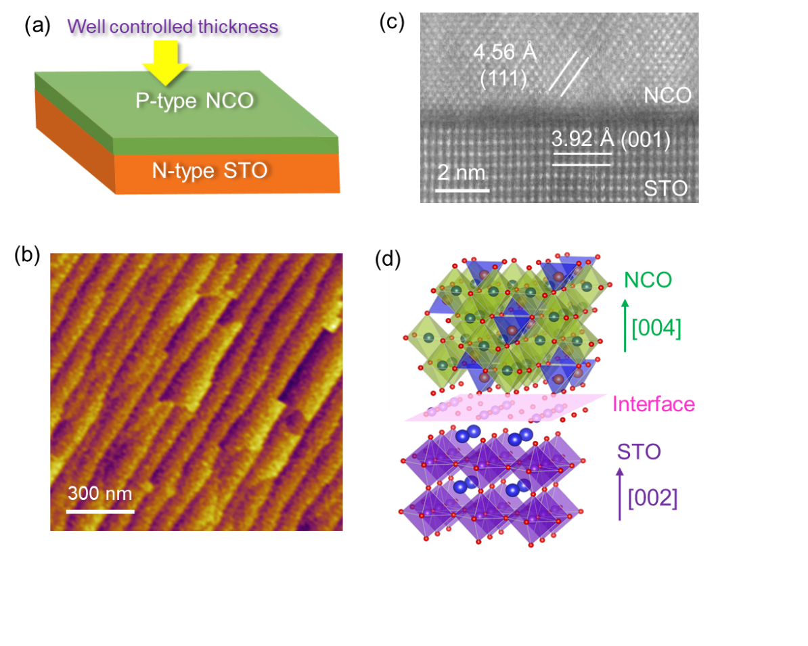

**Figure 1.** (a) Schematic illustration of NiCo2O4/SrTiO3 heterostructure. (b) AFM image of 1 nm NiCo2O4 film on TiO2-terminated SrTiO3 (001) substrate. (c) High-magnification HAADF-STEM image of a NiCo2O4/SrTiO3 heterojunction. (d) Crystal structure of NiCo2O4/SrTiO3 heterostructure.

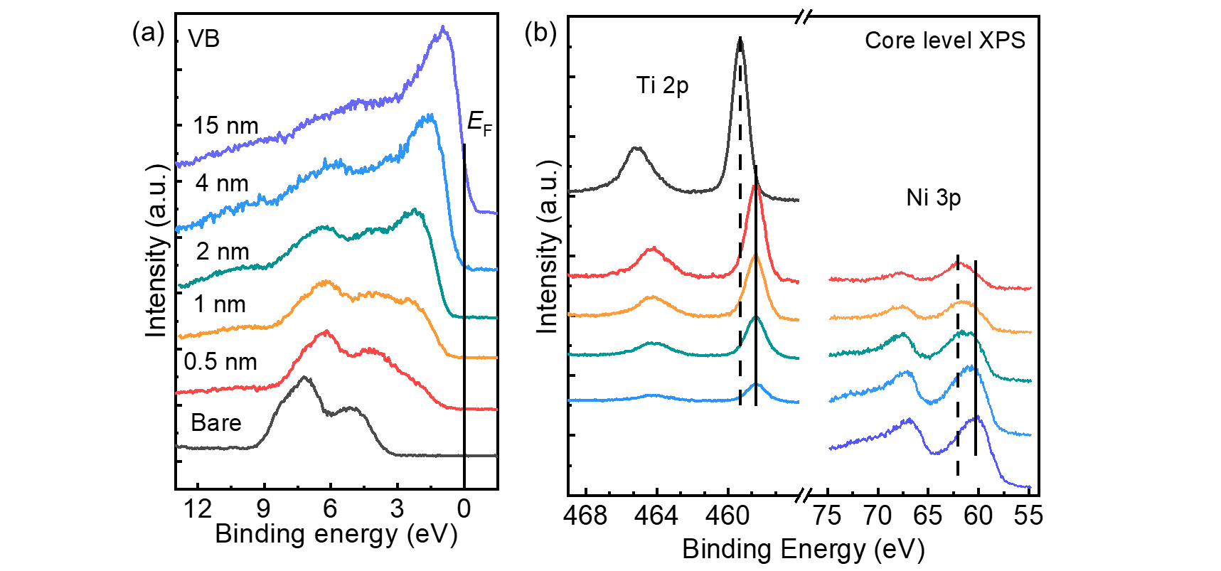

**Figure 2.** (a) XPS valence band (VB) and (b) Ti *2p*, Ni *3p* core level spectra of NiCo2O4 films with different thicknesses on SrTiO3.

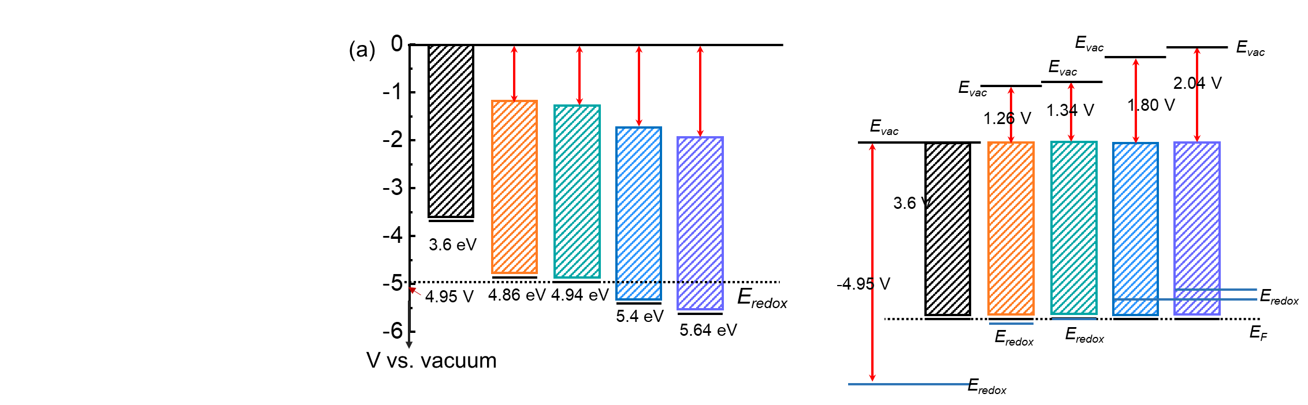

**Figure 3.** Schematical diagram of the *E*F relative to the *E*redox based on the *E*vac, where the black short solid line indicates the *E*F, and the blue short solid line is the position of *E*redox at pH of 13.

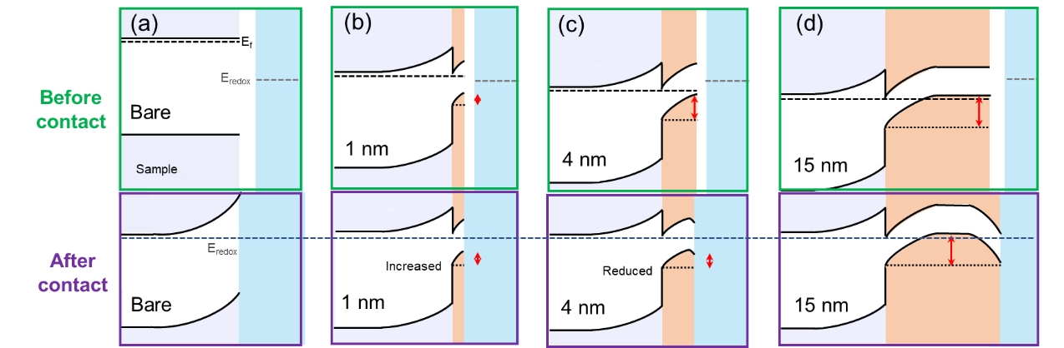

**Figure 4.** Band diagrams of (a) bare SrTiO3, (b) 1 nm thick NiCo2O4 on SrTiO3, (c) 4 nm thick NiCo2O4 on SrTiO3and (d) 15 nm thick NiCo2O4 on SrTiO3 in before (upper panel) and after (lower panel) contacting with electrolyte in the dark.

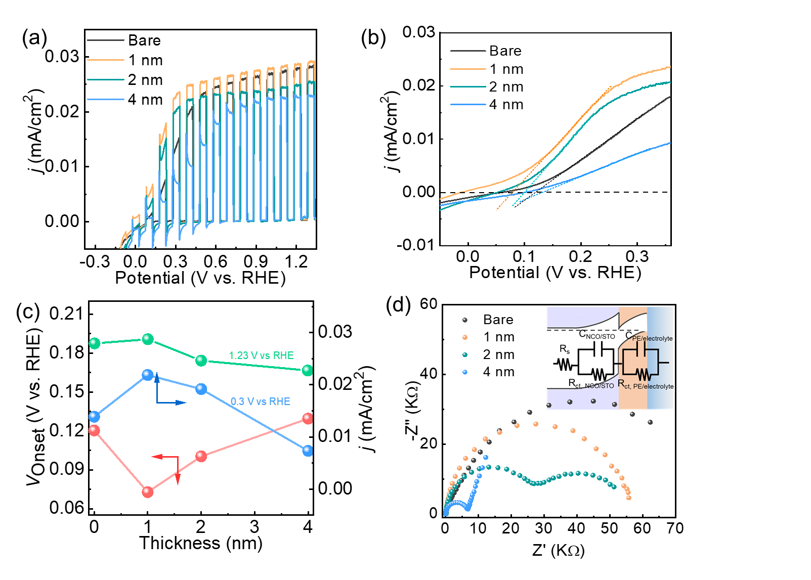

**Figure 5.** (a) Chopped light linear sweep voltammetry (LSV) plots and (b) light linear sweep voltammetry plots of NCO/STO with different thickness and bare SrTiO3 in 0.1 M KOH electrolyte. (c) The onset potential (*V*onset) and photocurrent density of NCO/STO with different thickness and bare SrTiO3 under +0.3 V vs. RHE and +1.23 V vs. RHE. (d) Nyquist plots of both bare and p-n junction electrodes with the simulated AM 1.5G illumination at 0.31 V vs. RHE, and the physical equivalent circuit model shown in the inset. The simulated equivalent circuit includes contacts and wiring through the series resistance (*R*s), and the NCO/STO through the charge transfer resistance (*R*ct, NCO/STO) and the corresponding capacitance (*C*NCO/STO), as well as the NCO/Electrolyte through the charge transfer resistance (*R*ct, PE/Electrolyte) and capacitance (*C*PE/Electrolyte) associated with this interface.

**Table 1**. Relative binding energy (BE) and band offsets for NiCo2O4 films with different thickness.

|  |  |  |  |  |  |  |  |
| --- | --- | --- | --- | --- | --- | --- | --- |
| Film thickness | EVBM | | BE of Ti 2p  (eV) | BE of Ni 3p  (eV) | ΔENCO  (eV) | ΔESTO  (eV) | Vb  (V) |
| Bare | 3.1 | | 459.52 | - | - | - | - |
| 0.5 nm | 1.11 | | 458.67 | 62.04 | - | 0.85 | - |
| 1 nm | 0.98 | | 458.67 | 61.63 | 0.41 | 0.85 | 1.26 |
| 2 nm | 0.93 | | 458.63 | 61.59 | 0.45 | 0.89 | 1.34 |
| 4 nm | 0.54 | | 458.62 | 61.14 | 0.9 | 0.9 | 1.8 |
| 15 nm | | -0.07 | - | 60.9 | 1.14 | 0.9 | 2.04 |

ΔENCO = ENi 3p,0.5 - ENi3p, x, (x=1, 2, 4, 15 nm)

ΔESTO = ETi 2p, bare - ETi 2p, x, (x=1, 2, 4, 15 nm)

Vb =q(ΔENCO+ΔESTO)

**Table 2**. Built-in potential of p-n heterojunction before and after contacting with electrolyte.

|  |  |  |  |  |  |
| --- | --- | --- | --- | --- | --- |
| Sample | Bare | 1 nm | 2 nm | 4 nm | 15 nm |
| q*V*b (V) | 0 | 1.26 | 1.34 | 1.80 | 2.04 |
| Efb vs. RHE (V) | -0.08 | -0.10 | -0.12 | -0.29 | -0.92 |
| $V_{b}^{'}$ (V) | 1.31 | 1.33 | 1.35 | 1.52 | 2.15 |

*V*b: built-in potential of p-n heterojunction before contacting with electrolyte

$V_{b}^{'}$: built-in potential of p-n heterojunction after contacting with electrolyte

$V_{b}^{'}$ = *E*redox(1.23 V) - *E*fb

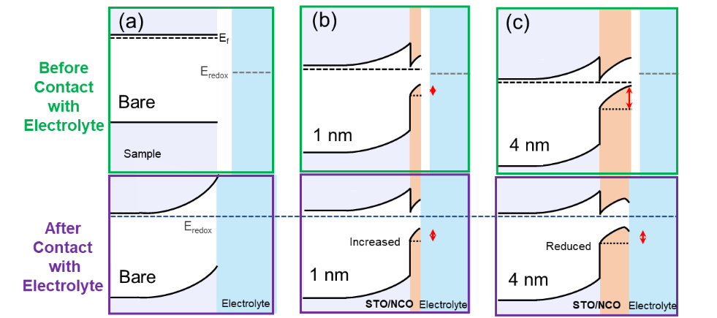

Graphical abstract picture.