Title

The Erosion of selected tungsten coatings by ion beam and plasma sources compared to calculated predictions.

Authors,

Mike Jackson*(1), Patrick Bunting (1), Vivian Lee (1), Vladimir Vishnyakov (2), James W Bradley (3), Zeyad Ali (3), Sarah Thornley (4), James Dutson (4), David Cox (5), Yuri Zhuk (6), Erik Wagenaars (7)

(*corresponding author)

Affiliations,

1. Tokamak Energy, 173 Brook Drive, Milton Park, Oxon, OX14 4SD, United Kingdom
2. Centre for Engineering Materials, University of Huddersfield, Queensgate, Huddersfield, HD1 3DH, UK
3. Department of Electrical Engineering and Electronics, University of Liverpool, Liverpool, L69 3GJ
4. Plasma Quest Ltd, Unit 1B Rose Estate, Osborn Way, Hook, RG27 9UT, UK
5. Advanced Technology Institute, University of Surrey, Guildford, Surrey, GU2 7XH
6. Hardide Coatings Ltd, Unit 9 Longlands Road, Bicester, Oxon OX26 5AH
7. Department of Physics, University of York, Heslington, York, YO10 5DD, UK

Highlights,

* Erosion of tungsten samples was measured in ion beams and low temperature plasmas.
* Sputter yield code was written and compared to experiment.
* Developed code results give reasonable results and are quick calculations.
* Erosion rate of several tungsten coatings were compared to each other.

Abstract,

Tungsten is proposed as a tokamak divertor armour due to its good erosion resistance. Combining tungsten coatings with copper as a base material can overcome problems with machinability, lower the weight and reduce the component cost. The erosion rate must be known to estimate the lifetime of plasma facing components.

This work aims to compare selected tungsten coatings to check if the erosion rate remains as good. It also compares the experimental data to a developed code based on previous work that aims to be quick and simple while giving reasonable results.

In this study a set of erosion experiments were undertaken to measure the sputter yield in different conditions at partner organisations; Helium ion beam erosion at Huddersfield University, Helium plasma erosion at the University of Liverpool, Argon plasma erosion at Plasma Quest Ltd and Xenon Focussed Ion Beam (FIB) erosion at University of Surrey

This work compares sputter yields different tungsten samples: sheet material, Chemical Vapour Deposition tungsten coating, Additive Manufacture deposited tungsten and tungsten coatings laid down by Thermal Plasma Spray. These coatings are available commercially so are ready to deploy today.

The experimental sputter yields were compared to theoretical predictions, based on previously published work. While the experimental results agreed well with the models in trend and angular dependence the quantitative agreement was only well predicted to within a factor of four.

It was found that the coatings have similar, and sometimes slightly lower sputter yields, and therefore, on occasion, slightly better erosion performance than the stock tungsten sheet samples.

Keywords,

Plasma Surface Interaction

Divertor Erosion

Sputter Yield

Tokamak

Chemical Vapour Deposition

Additive manufacture

Main text,

# Introduction

Tokamak fusion reactors show the promise of long-term low-carbon energy and are a well-researched fusion energy scheme. Well characterised erosion of plasma facing walls is critical to obtaining reliable plasma confinement. Tungsten (W) is a promising material to use as plasma facing components because of its high melting point, high work function, good erosion resistance, good thermal conductivity and low tritium retention [1]. This will be particularly important in the divertor region where plasma impact will be greatest. Running a fusion device 24/7 requires that the divertor does not erode significantly, otherwise down-time for divertor replacement will make fusion uneconomic.

The downside of tungsten is that it is expensive, brittle and hard to machine. These problems might be overcome if a material, such as copper which is cheap and easy to machine, is used and then coated with tungsten. In addition, copper has a much higher thermal conductivity than tungsten so is envisaged for use as a heatsink material in the divertor with tungsten armour on top [2]. Although copper is expected to show effects when exposed to neutrons such as hardening, creep and changes in tensile strength these are partially recovered by in-situ heating [3]. Activation can also be an issue. Swelling can also be a problem but is found to be less in copper alloys which are to be used in the ITER divertor design. Coatings of tungsten on copper are therefore of interest.

Some erosion by melting of tungsten has been seen on other tokamaks in the past and melting of tungsten is predicted in ITER conditions if there are uncontrolled ELMs (Edge Localised Modes), vertical displacement events, unmitigated disruptions or proud leading edges due to tile misalignment [4], [5]. Melting or evaporation of tungsten test tiles has been seen but this was said to have a plasma pressure an order of magnitude higher than expected on ITER [6]. Also, in the ASDEX tokamak W evaporation was seen by arcing during giant ELMs under ITER like conditions [7].

The main erosion process for tungsten plasma facing surfaces is physical sputtering [7]–[9]. This is where, under ion bombardment, atoms from the tungsten surface are removed. Incoming ions provide sufficient energy to the lattice for one of the atoms to overcome the binding energy so sputtering tends to occur before knock on displacement [7] and “gross” erosion occurs. Under certain conditions some of the sputtered material is re-deposited (“prompt redeposition”) and giving a lower overall “net” erosion.

Erosion has been studied on tungsten surfaces before. For example ion beam sputtering experiments and calculations [10], [11], [12], erosion experiments in tokamaks [7], [13]–[15] and code predictions [16]. Usually only one sample type has been studied at a time. In this work samples were exposed side by side in the same apparatus so they can be directly compared under the same experimental conditions.

The aim of the work is to see if tungsten coatings can provide the same low erosion rates as sheet tungsten. If so this gives the benefits of low cost and easy machinability of copper as well as good joining of tungsten armour to a copper heatsink.

In this paper sheet tungsten samples are compared with selected tungsten coated samples to see if there is a difference in erosion rate or sputter yield when exposed to the same conditions. These samples and coatings are available commercially and thus are relatively easy to use for building tokamak components. Tungsten samples, produced by different technologies, are investigated by being eroded by different ion beams and plasma sources. These are all relatively small-scale machines, and it is cheaper to do experiments in these than in tokamaks or linear plasma devices. Erosion of tungsten by He, Ar and Xe ions was investigated.

In order to last a reasonable lifetime divertor armour will need to be of the order of 5 mm thick. The coating thickness in this study varies from 76 µm to ~300 µm, depending on the technique. The coating thickness was dictated by a thickness that the suppliers was confident with, to test the coatings. If these first samples perform well then further development would be needed to increase coating thickness up to ~ 5 mm.

Previous codes to calculate sputtering yield include a physical sputtering code called DSPUT [17], the WBC code [18] and the Bohdansky formula [19] used by Eckstein [11] with the Yamamura formula for different angular dependence [20]. More recent work used Monte Carlo methods [21] and was used in calculations by Abrams [22] and compared to experiment by Sugiyama [23]. Currently the ERO erosion code has also been used to study impurity transport, erosion and wall interactions [24], prompt redeposition and self-sputtering [25], [26], and erosion by seeding gasses [16].

In this work we aim to produce code predictions that are sufficiently accurate to base engineering decisions on and are delivered in a quick time to enable rapid prototyping.

Erosion calculations that produce sputter yields are described. This is done using a simple code based on the Bohdansky equations. This code is not as comprehensive or accurate as the “state-of-the-art” ERO code for example, but it is quick. It can be run on a desktop PC in a few seconds as opposed to ERO that takes a few months or BCA (Binary Collision Approximation) code that takes a few hours. The calculated yield is compared to the experimental results.

# Method

## Sample Preparation and Coatings

Tungsten sheet samples were obtained from Plansee SE. They were hot rolled and pickled and >99.97% pure W.

Two sets of W coated samples were prepared by atmospheric Thermal Plasma Spray (TPS) by Engineered Performance Coatings Ltd. (Cardiff UK). One set was coated on a copper substrate and one set on a tungsten substrate with a coating thickness of 220-230 µm.

Although the aim of this work was the study of tungsten coatings on copper substrates some coatings on tungsten substrates were also used. This was to check for issues such as potential melting and mixing of the copper substrate from the high temperatures of TPS or additive manufacture deposition.

A set of W coated samples were prepared by CVD (Chemical Vapour Deposition) by Hardide Coatings Ltd (Bicester, UK). The Hardide® CVD coating was on a copper substrate and the tungsten coating thickness was measured to be around 76 µm. Unlike other coatings tested in this study the CVD coating has columnar structure, which is visible in the left image of Figure 7. Each column is a single tungsten monocrystal, which results in maximum binding energy for tungsten atoms. The CVD coating is produced in a vacuum chamber with oxygen-free precursor gases, as a result the bulk of the coating is practically free from oxygen and tungsten oxides. The CVD coating is crystallised from the gas media atom-by-atom, which results in very dense pore-free structure and enables uniform coating of complex shape components. This coating has high thermal conductivity and combined with tungsten’s very low thermal expansion coefficient this can be beneficial for managing high heat flux on the plasma-facing components of tokamaks.

A final set if samples were made by L-DED (Laser Direct Energy Deposition) AM (Additive Manufacture) by Laser Additive Solutions ltd (Doncaster, UK). This technique uses an automated laser deposition system with integrated software and a Sulzer Metco powder feed unit. The system uses a Continuous Wave TRUMPF laser source (TruDisk 2002), a TRUMPF BEO D70 process head and a coaxial welding nozzle to deliver the laser beam and inert shielding gas to the weld pool. The thickness of this coating was around 300 µm W.

All the samples were 20mm x 20mm x 3mm. Selected samples were profiled using an optical confocal surface profilometer. The plain tungsten sample had surface roughness (Sa) = 2.0 µm, the CVD coated sample shows a similar surface roughness at (Sa) = 2.3 µm. The thermal spray tungsten coatings were much rougher with Sa ~7.3 µm. This is because thermal spray produces splats or platelets of material, which mechanically bind to the surface.

The Scanning Electron Microscope (SEM) at Huddersfield University was used to image the AM samples and compare them to tungsten sheet. The images are shown in Figure 1 and show a much greater surface roughness. On the right SEM image in Figure 1 some un-melted spherical tungsten particles approximately 50 microns across are seen, which will define the micro-structure of this AM material.

Energy Dispersive X-Ray (EDX) spectroscopy was also used at Huddersfield University to compare the near surface composition of the additive manufacture samples and the tungsten sheet samples as manufactured. The quantification results should be analysed with caution due to excessive (for EDX analysis) surface roughness and uneven in-depth elemental composition. Nevertheless, the analysis showed much higher oxygen concentration in the AM samples (71 at%) compared with the tungsten sheet samples (18 at%). This indicates almost fully developed stoichiometric surface tungsten oxides in the AM sample.

|  |  |
| --- | --- |
| A picture containing text, outdoor, crater  Description automatically generated  SEM image of the Tungsten Sheet sample (as received from Plansee). | A picture containing outdoor, dirt, hillside  Description automatically generated  SEM image of the Additive Manufacture sample. Surface is rougher and ~50µm spherical features are seen. |

Figure 1: SEM images of a plain tungsten sample (left) and a sample coated with tungsten using the laser additive manufacture (AM) technique.

## He ion beam erosion experiments details

Erosion experiments were carried out at the University of Huddersfield using a 4” Kaufman ion source system [27]. Helium ions were accelerated in the range 500 – 1250 eV. Samples were mounted on a plate that could be tilted to different angles. The ion flux was measured by using a Faraday cup. The ion flux was of the order of 1 x 1015 ions/cm2s. Approximately three days exposure (each about 8 hours per day) was applied to each sample to get sufficient fluence.

Different coated samples were exposed in the same conditions, three at a time for comparison. Erosion was measured by weight loss and also by masking the samples with tantalum wire and measuring the surface height drop using an optical confocal profilometer. These were then used to calculate the sputter yield.

Measurement uncertainty was calculated by taking repeat measurements of both the flux and the mass loss measurement and calculating the standard deviation.

## He plasma erosion experiments details

A magnetron sputtering system was used at the University of Liverpool to investigate sheet tungsten samples erosion. This consisted of a vacuum chamber pumped to a base pressure of 2 x 10-6 torr. He gas was introduced using a mass flow controller to the DC magnetron sputter source. Samples were vertically positioned in front of the magnetic trap and biased with a high voltage power supply to sputter at different He ion energies. The magnetic field at the sample position was measured to be 5 mT. Some more details of the system can be found in previous publications [28], [29].

Samples were biased to provide bombarding energies of 200, 400, 600 and 1000 eV. The ion flux density was calculated from current on the sample plate and was of the order of 1 x 1016 ions/cm2s. Samples were exposed for approximately 14 hours. Sputter yield was calculated based on mass loss.

## Ar plasma erosion experiments details

Erosion in a magnetised argon plasma was investigated using a HiTUS (High Target Utilisation Sputtering) remote plasma system at PlasmaQuest Ltd (Hook, UK). An argon plasma was generated in a side chamber using a RF power of 1.2 kW and guided and constrained on the target to impact at normal incidence. The target current density is measured to give a flux in the order of 1 x 1017 ions/cm2s. Some more information on the system used can be found in reference [30], [31]. Samples were exposed for 20 – 120 mins. The magnetic field strength at the target in these experiments was measured to be ~0.02 T. The targets were biased with a DC supply to get an ion energy of 100, 300 and 1000 eV. Different coated samples were exposed in the same conditions, four at a time for comparison. Sputter yield was calculated based on mass loss.

## Xe ion beam erosion experiments details

Experiments were undertaken at The University of Surrey IBC using a xenon (Xe) FIB system. This was a Tescan Fera PFIB with the ion column fixed at 55° and the sample tilted to 10° so that the irradiation took place at 45°. The samples were irradiated with a 30keV Xe ion beam over a square of 300µm side near the centre of the sample.

The experiment took 90 minutes for each exposure run and the ion dose was around 2.2 x 1019 ions/cm2. The erosion depth was measured using a SEM and an optical profilometer.

# Theory of Sputtering Calculations

Several papers exist on calculation of sputtering yield for ions impacting a surface. In the present work the Bohdansky formula [19] is used as in Eckstein’s calculations [11]. This is an empirical formula fit to experimental data. Their sputter yield is given by equation 1:

|  |  |
| --- | --- |
| $$Y\left(E\right)=Q S_{n}^{KrC}\left(ε\right)\left[1-{\left(\frac{E_{th}}{E}\right)}^{2/3}\right]×{\left[1-\left(\frac{E_{th}}{E}\right)\right]}^{2}$$ | (1) |

Where Y is the yield, E is the particle energy, Sn is the nuclear stopping cross section (using the Kr-C potential). The parameters Q and Eth (the threshold energy) are fit parameters whose values are taken from Eckstein’s paper [11]. The parameter ϵ is the reduced energy and depends on the mass and atomic number of the target and impinging ion.

Angular dependence is given by the Yamamura formula [11], [12], [20], equation 2:

|  |  |  |
| --- | --- | --- |
| $$\frac{Y(θ)}{Y(0)}= {\left(\frac{1}{cos⁡(θ)}\right)}^{f}\exp\left[f\left(1-\frac{1}{cos⁡(θ)}\right)cos⁡(θ_{opt})\right]$$ |  | (2) |

Here f and ϴopt are fit parameters and ϴ is angle of incidence from surface normal. This is also an empirical formula found to give good agreement with angular yield data.

During the present work a Python code has been written to calculate sputter yield using these equations. This approach is straightforward and has the advantage of running in a few seconds on a desktop PC. More details of the developed code can be found in reference [32]. This developed code was run for various ion and target combinations and compared to published results with good agreement.

# Results and Discussion

## He ion beam erosion results agree with theory but show higher magnitude.

The sputter yield at different ion energies for samples exposed to He ion beam at the University of Huddersfield are shown below in Figure 2 as symbols. Data for tungsten sheet samples are shown as well as CVD coated samples and TPS coated samples. Note in Figure 2 one point at 1000eV has a very high sputter yield of over 0.18. This is assumed to be an outlying result, perhaps from some error that was unaccounted for.

The sputter yield calculated by the weight method and the profile method is similar for each sample and serves to validate the accuracy of the results. Both results are combined in Figure 2. The measurement uncertainty is shown by the error bars.

Results from the developed code calculations in this paper for sputter yield of He on a W target at 45° angle of incidence are also shown in Figure 2 (solid black line). Results from previous theory calculations for the yield of He on a W target at 45° angle of incidence are also shown in Figure 2 (dotted blue line), which were using the TRIM code based on the BCA calculations by Eckstein in reference [21].

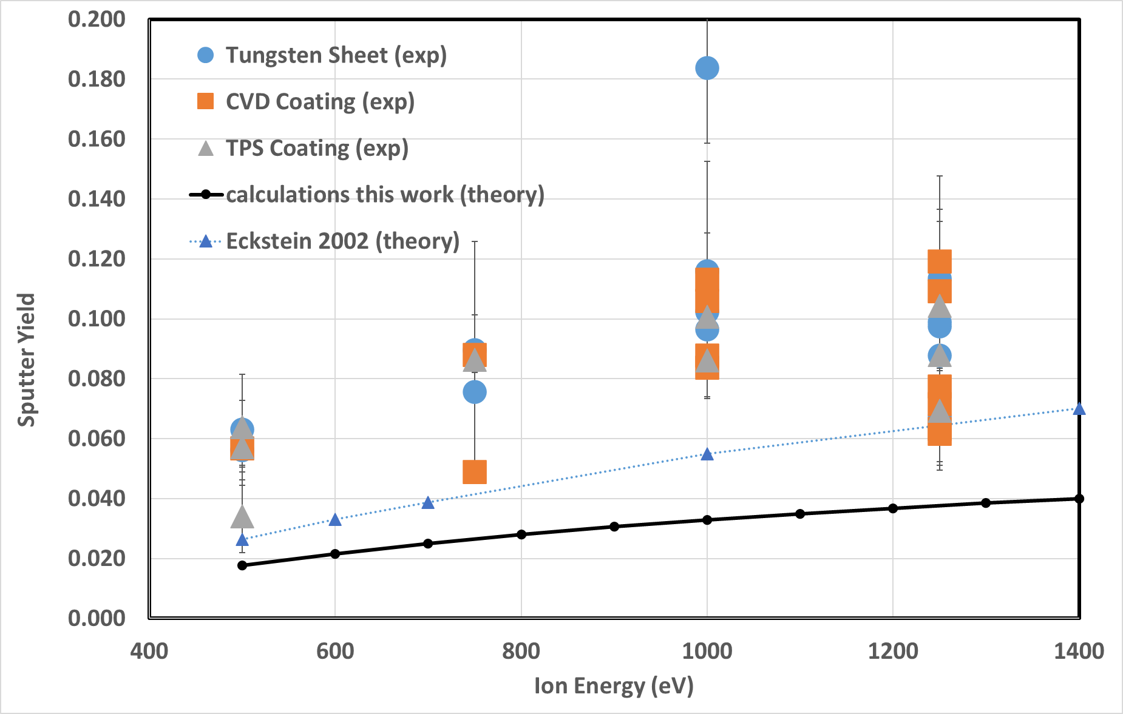

Figure 2: Sputter yield at different ion energies for selected tungsten and tungsten coated samples in helium ion beam erosion experiment. All data was taken at 45° angle of incidence. Black line is the developed code calculated (theory) sputter yield from this work for He on W target at 45° angle of incidence. Blue dotted line is the calculated (theory) yield from a 2002 paper by Eckstein using BCA calcuations [21].

By taking the average sputter yield of the samples at the same energy conditions we can compare the relative erosion of the coatings. We find that the CVD coating samples have a sputter yield on average 85 ± 28% that of the tungsten sheet and the TPS coating samples have a sputter yield on average 91 ± 20% that of the tungsten sheet. So, the sputter yield, and hence the erosion rate, of the coated samples looks to be less than tungsten sheet but the experimental uncertainty is too large to say for sure.

The sputter yield at different angles of incidence is shown below in Figure 3. Results for the tungsten sheet samples are shown as well as CVD coated, TPS plasma spray coated and AM coated samples.

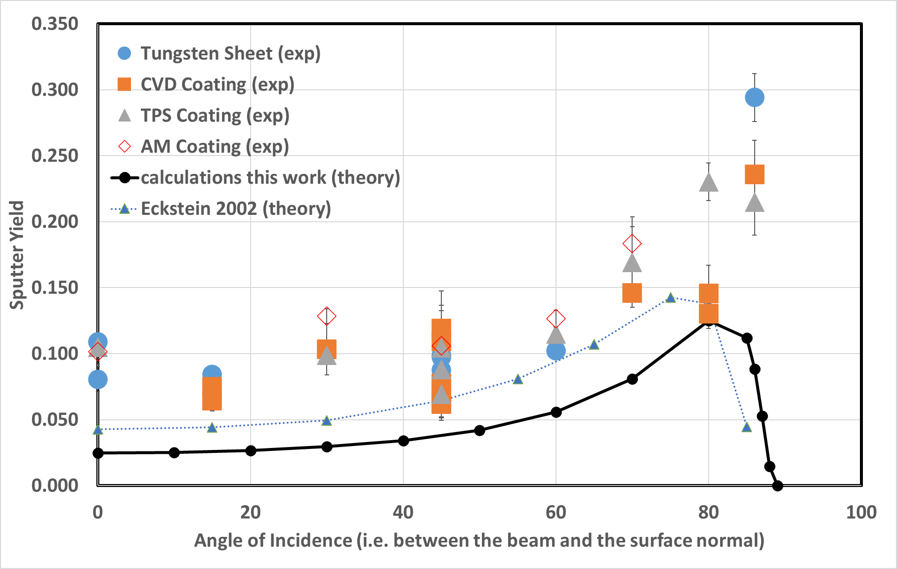

Figure 3: Sputter yield at different angles of incidence for selected tungsten and tungsten coated samples in helium ion beam erosion experiment. All data was taken at an ion energy of 1250eV. Black solid line is the developed code calculated (theory) sputter yield from this work for He on W target at 45° angle of incidence. Blue dotted line is the calculated (theory) yield extrapolated to 1250eV from a 2002 paper by Eckstein using BCA calcuations [21].

By taking the average sputter yield of the samples at the same angle conditions we can compare the relative erosion of the coatings. We find that the CVD coating samples have a sputter yield on average 93 ± 35% that of the tungsten sheet, the TPS coating samples have a sputter yield on average 92 ± 20% that of the tungsten sheet and the AM coating samples have a sputter yield on average 109 ± 22% that of the tungsten sheet. So, the sputter yield, and hence the erosion rate of the CVD and TPS coated samples looks lower than tungsten sheet, and the AM coating looks higher, but the experimental uncertainty is too large to say if this is significant.

In both Figure 2 and Figure 3 we can see that the experimental data follows the trend of the developed code sputter yield calculated in this work. However, the magnitude of sputter yield is larger than the calculated value by up to a factor of four times. Possible explanations for this discrepancy in magnitude may be:

* It is possible that the ions flux was not measured very accurately as the system used was a modified ion sputtering system and was not designed for dedicated erosion experiments.
* Small levels of impurities in the ion beam are always present when it has not been mass filtered. Even a small quantity of high mass ions would increase the sputter yield dramatically. The vacuum system was always well pumped down to a base pressure around 2x10-6 Torr and the gas lines were purged and evacuated to reduce this effect, but low-level impurities cannot be eliminated.
* Surface roughness: Sputtering models assume ideally flat surfaces but if the surface is rough a significant portion of the ions actually hit at a much higher angle than we think and at higher angle a larger sputter yield is expected.

The developed code calculated yield shown in Figure 2 and Figure 3 by Eckstein from reference [21] using TRIM code show a higher sputter yield. This is closer to the experimental data we have recorded except for the angular data over 75°. However, the code developed in the present work based on the Bohdansky model runs in a few seconds on a desktop PC whereas BCA codes like TRIM take several hours to complete.

## He plasma erosion results agree with theory but agree better with BCA calculations.

The sputter yield results from the magnetron sputtering experiments at Liverpool University are shown below in Figure 4.

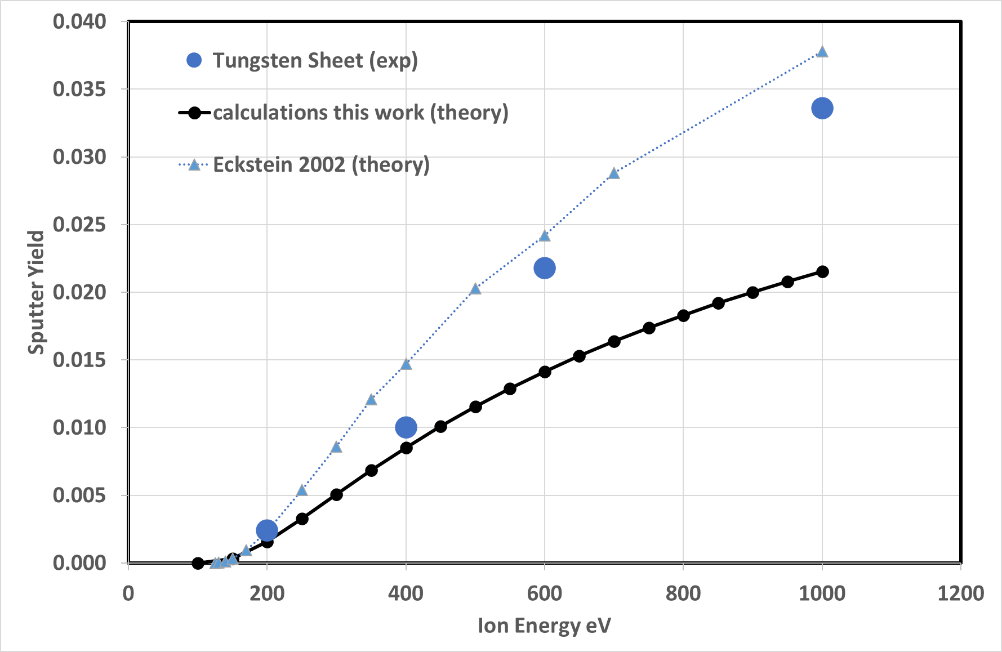

Figure 4: Sputter yield at different ion energy for tungsten sheet samples in helium plasma erosion experiment. All samples were effectively at normal incidence. The solid black line with small circles is the developed code calculated sputter yield for He on W target based on the calculations in the present work. The blue dotted lines with small triangles is data from TRIM calculations from reference [21].

The large blue dots in Figure 4 show the data from the sputter magnetron experiment, which agree reasonably well with the solid line plotted from the developed code. The data shows erosion yield of the same order of magnitude. The sputter yield is slightly higher in practice than predicted by the current model by up to a factor of x2. The difference between experiment and theory is most at higher energy. Data from Eckstein’s TRIM code paper from 2002 [21] is also shown in Figure 4 this gives a higher yield which agrees better with the experimental results at higher energy.

In comparison with the He ion beam results shown in Figure 2 these results show a lower sputter yield in the He plasma, even when accounting for the change in angle of incidence. This may be because this is a plasma and not an ion beam. Therefore, there are magnetic effects and the magnetic field that the samples were exposed to in these experiments was measured to be 5mT. It is possible that prompt redeposition occurred at this level of magnetic field and that has reduced the sputter yield. Therefore, it is possible that the actual sputter yield is x4 the predicted yield (like the values found using the Huddersfield helium ion beam) but the magnetic field reduced the yield by prompt redeposition.

## Ar plasma erosion results agree with theory but show lower magnitude.

The erosion results from the Argon plasma erosion experiments at Plasma Quest are shown below in Figure 5.

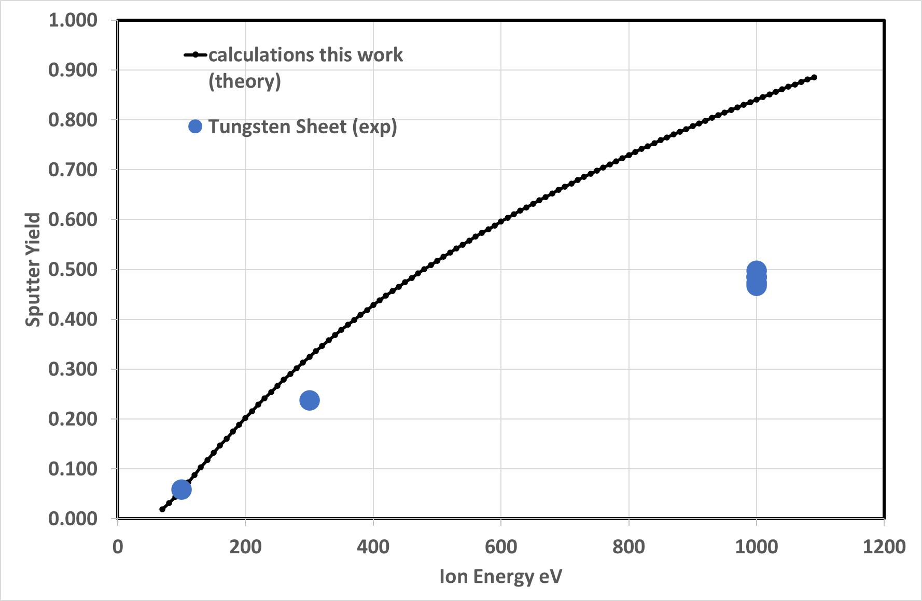

Figure 5: Sputter yield at different ion energy for tungsten sheet samples in argon plasma erosion experiment (blue dots). Plasma is bent onto the sample to it hits at normal incidence. Black line is the developed code calculated sputter yield for Ar on W target.

Figure 5 above shows the graph of the measured erosion yield for the plain tungsten (W) samples at different energies. The data at 1000eV was repeated several times to check for reproducibility and we can see that it gives consistent results. These results were compared to results from the current theoretical model for Ar sputtering W (shown as a black line).

The experimental sputter yield seen in Figure 5 follows the trend of the developed code prediction. It is approximately as predicted for 100eV, however the experimental sputter yield at higher energy was found to be lower than yields predicted by the model. This may be because these samples were in a magnetic field, albeit small, where prompt redeposition could have occurred, or because surface roughness plays less of a role here because the plasma is not in a “beam” hitting the surface.

The sputter yield for different coatings samples was calculated and compared to the corresponding sputter yield of the tungsten sheet samples at the same energy. This comparison gives the result shown in Figure 6. On only one occasion, at 300 eV, the CVD coated sample sputtered more than the tungsten sheet sample. However, this is only a 4% rise, which is within the experimental errors (which are in the range 2% to 13%) so that is not statistically significant. Since these experiments have not been repeated it is not clear if this is a real effect, a one off or merely statistical variation.

However, this indicates that in most cases the coated samples erode slightly less than the plain tungsten sheet samples in these argon plasma experiments and so are slightly more robust (by approximately 20%).

|  |  |  |  |  |  |  |  |
| --- | --- | --- | --- | --- | --- | --- | --- |
|  | |  | |  | |  | |
| Energy | Plasma Thermal Spray on Copper | | Plasma Thermal Spray on Tungsten | | CVD tungsten coating | | Additive Manufacture tungsten coating |
| 100eV | 77% | | 84% | | 88% | | 88% |
| 300eV | 86% | | 89% | | 104% | | 88% |
| 1000eV | 72% | | 70% | | 82% | | 83% |

Figure 6: Sputter yield of the different coated samples at the three energies investigated for the argon erosion Plasma Quest results. Yields are normalised to the plain tungsten yield so that yield of W sheet=100%.

## Xe ion beam erosion results agree with theory predictions.

Experiment results from The University of Surrey Xe FIB are shown below in Figure 7.

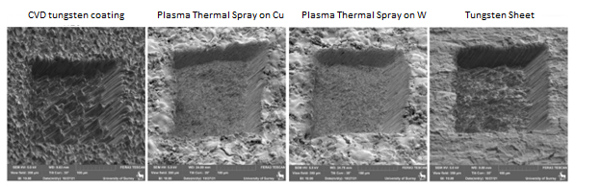

Figure 7: SEM images of the four samples after exposure to Xe FIB at the University of Surrey.

The erosion depth to the bottom of each pit was measured using SEM and profilometer and compared to the estimate from the calculation code for Xe impacting a W target. The parameters from Eckstein’s paper [11] were used, however there is no angular data in this paper for Xe hitting a W target so angular data parameters for W on a W target were used as this was the most similar mass ion. These results are shown in Figure 8. The report from University of Surrey stated a change in flux of ± 3% over the course of a single sample run. A ± 3% error on these sputter depth measurements of 30-50 µm is about 1 µm.

|  |  |  |  |
| --- | --- | --- | --- |
| Sample | Approx. sputtered depth from SEM | Approx. sputtered depth from profile | Estimate from the developed code |
| CVD tungsten coating | 43µm | 34µm | 31.8µm |
| Plasma Thermal Spray on copper substrate | 37µm | 39µm | 32.4µm |
| Plasma Thermal Spray on tungsten substrate | 45µm | 30µm | 33.1µm |
| Tungsten Sheet | 51µm | 40µm | 34.0µm |

Figure 8: Table of erosion depth measured by the two methods compared with the erosion depth predicted from the developed erosion code for Xe on W target.

The experimentally measured erosion is again higher than the theoretical erosion predicted from the developed code, but only by a little. The calculated estimate from the prediction code was reasonably close to the results presented above. Certainly, at the correct order of magnitude and within around 20% off the measured value. The code generally estimates a lower erosion than the measured erosion.

Although erosion by Xe is not a particularly fusion-relevant gas this is still valuable to check as we can see that the developed code still works well for higher mass ion species so gives confidence that it will be applicable to other high mass ions. This might include seeding or puffing gases or high-z material sputtered off the tokamak wall that then goes on to cause secondary sputtering.

Erosion on the different coatings can be compared. It seems that in both sets of measurements the erosion of the tungsten sheet was slightly higher than the coated samples. Each coated sample had slightly lower erosion than the tungsten sheet sample but no one sample was consistently better in both measurement techniques. This result is significant even though the total ion dose on the tungsten sheet sample was higher, which led to the slightly higher estimates from the code.

The reduced erosion in the coated samples is unlikely to be due to surface roughness because the TPS samples were measured to be rougher than the tungsten sheet and CVD samples.

The images in Figure 7 show a different texture in the pit on the different samples. The plasma thermal spray coatings and the tungsten sheet sample have a similar surface roughness at the base of the pit. This contrasts with the profilometer measurements of the original surfaces, where tungsten sheet samples were found to have a lower surface roughness (of around 2 µm) while the plasma thermal spray samples are rougher (around 7 µm). This indicates that ion beam exposure results in a surface roughness that depends more on the time of exposure and statistics of particle sputtering, rather than the original surface roughness.

However, the CVD tungsten coating has a very jagged appearance with a higher surface roughness in the pit. The roughness of the CVD sample will be due to the columnar crystalline structure of the CVD coating material.

# Conclusion

This work has shown that accurate erosion measurements by experiment using both ion beams and plasma can be done but is quite challenging. A modelling code has been written and developed, based on previous literature, to predict erosion by physical sputtering. This has been compared to a series of erosion experiments.

The experimental results follow the trend of the developed code predictions in general but in most cases the magnitude does not match the predictions accurately.

* In the He ion beam experiment the experimental erosion rate was higher than predicted by the present code
* In the He plasma experiments the experimental erosion rate was close to the prediction.
* In the Ar plasma experiments the experimental erosion rate was lower than predicted.

The discrepancy is likely to be due to redeposition due to magnetic field effects in the plasma exposure. However, the erosion magnitude was successfully predicted to within a factor of four.

In many cases the experimental data is better matched by previously published code using TRIM BCA calculations. However, the developed code runs in a few seconds whilst BCA codes take a few hours to complete.

The erosion for the different tungsten coatings were compared to tungsten sheet samples. The coatings generally behaved well, certainly having a sputter yield that was similar to that of tungsten and not like that of copper. There is no measurable difference between the samples with the copper bases and the tungsten bases. In most cases the CVD and thermal spray coated samples showed a lower sputter yield (erosion rate) than tungsten sheet samples, although measurement uncertainties were often too high to say for certain. This suggest that their lifetime in service may be slightly longer than tungsten sheet parts. The additive manufacture coating had a slightly higher sputter yield in some experiments and lower in other, but again experimental uncertainties make it hard to say if this is significant. An increase may be due to surface oxide, which will have a lower binding energy than sheet tungsten. The AM coating sputter yield was still very similar to sheet tungsten in these experiments, which suggests it may be suitable for use in fusion applications.

It is quite surprising that the thermal spray coatings seem to have lower sputter yield because the coating is applied in air and therefore is expected to also contain oxide.

It is possible that erosion in the coated samples was lower because the coatings have a different microstructure compared to sheet tungsten. It must be noted that this effect is only minor given the experimental errors.

The surface roughness of the CVD coated samples was similar to the tungsten sheet samples. In both the Huddersfield University (helium ion beam) and Surrey University (focussed xenon ion beam) experiments the CVD coated sample seemed to develop a larger surface roughness after erosion, most likely due to the coating columnar microstructure. As noted earlier, CVD coatings are formed when a single atom affixes to the surface. A grain is grown on this first atom so grows as a small single crystal until it touches the next crystal. The grains then grow upwards in a column keeping the same crystal orientation. This means that the surface is made up of a set of vertical single crystals. The CVD coating method allows control of the coating composition, hardness and to some degree its microstructure.

Future studies are suggested to test the effect of these coating characteristics on their resistance to the plasma erosion, heat flux and other factors affecting the components in a fusion environment.

# References

[1] M. Rieth, R. Doerner, A. Hasegawa, Y. Ueda, and M. Wirtz, “Behavior of tungsten under irradiation and plasma interaction,” *Journal of Nuclear Materials*, vol. 519. Elsevier B.V., pp. 334–368, Jun. 01, 2019. doi: 10.1016/j.jnucmat.2019.03.035.

[2] J. Linke *et al.*, “Challenges for plasma-facing components in nuclear fusion,” *Matter and Radiation at Extremes*, vol. 4, no. 5, Sep. 2019, doi: 10.1063/1.5090100.

[3] J. H. You, “A review on two previous divertor target concepts for DEMO: Mutual impact between structural design requirements and materials performance,” *Nuclear Fusion*, vol. 55, no. 11. Institute of Physics Publishing, Oct. 05, 2015. doi: 10.1088/0029-5515/55/11/113026.

[4] V. Philipps, “Tungsten as material for plasma-facing components in fusion devices,” in *Journal of Nuclear Materials*, Elsevier B.V., Aug. 2011, p. S2. doi: 10.1016/j.jnucmat.2011.01.110.

[5] J. W. Coenen *et al.*, “Transient induced tungsten melting at the Joint European Torus (JET),” in *Physica Scripta*, Institute of Physics Publishing, Dec. 2017. doi: 10.1088/1402-4896/aa8789.

[6] B. Bazylev *et al.*, “Experimental validation of 3D simulations of tungsten melt erosion under ITER-like transient loads,” *Journal of Nuclear Materials*, vol. 390–391, no. 1, pp. 810–813, Jun. 2009, doi: 10.1016/j.jnucmat.2009.01.214.

[7] D. Naujoks *et al.*, “Tungsten as a target material in fusion devices,” *Nucl. Fusion*, vol. 36, p. 671, 1996.

[8] D. B. Williams and C. Carter, *Transmission Electron Microscopy Basics 1*. Springer, 1996.

[9] O. Auciello and R. Kelly, *Ion bombardment modification of surfaces*. Amsterdam, Oxford, New York, Tokyo: Elsevier, 1984.

[10] Roth J, Bohdansky J, and Ottenberger W, “Roth yield graphs 1979 IPP_9_26,” *IPP 9/26*, 1979.

[11] Eckstein W, Garcia-Rosales C, Roth J, and Ottenberger W, “Eckstein Sputtering Data IPP_9_82,” *IPP 9/82*, 1993.

[12] Y. Yamamura, H. Tawara, Y. Yamamura, and H. Tawara, “ENERGY DEPENDENCE OF ION-INDUCED SPUTTERING YIELDS FROM MONATOMIC SOLIDS AT NORMAL INCIDENCE,” 1996.

[13] D. G. Whyte, “Plasma-surface interaction studies on DIII-D and their implications for next-step fusion experiments,” *Fusion Science and Technology*, vol. 48, no. 2, pp. 1096–1116, 2005, doi: 10.13182/FST05-A1063.

[14] A. Thoma *et al.*, “Spectroscopic measurements of tungsten erosion in the ASDEX Upgrade divertor,” *Plasma Phys Control. Fusion*, vol. 39, p. 1487, 1997.

[15] R. Dux *et al.*, “Plasma-wall interaction and plasma behaviour in the non-boronised all tungsten ASDEX Upgrade,” *Journal of Nuclear Materials*, vol. 390–391, no. 1, pp. 858–863, Jun. 2009, doi: 10.1016/j.jnucmat.2009.01.225.

[16] M. Beckers, W. Biel, M. Tokar, and U. Samm, “Investigations of the first-wall erosion of DEMO with the CELLSOR code,” *Nuclear Materials and Energy*, vol. 12, pp. 1163–1170, Aug. 2017, doi: 10.1016/j.nme.2017.01.006.

[17] D. L. Smith, J. N. Brooks, and D. E. Post, “A PHYSICAL SPUTTERING CODE FOR FUSION APPLICATIONS,” in *9th Symposium of Engineering Problems of Fusion Research*, Chicago, Illinois, Oct. 1981.

[18] J. N. Brooks, “Near-surface sputtered particle transport for an oblique incidence magnetic field plasma,” *Physics of Fluids B*, vol. 2, no. 8, pp. 1858–1863, 1990, doi: 10.1063/1.859457.

[19] J. Bohdansky, “A UNIVERSAL RELATION FOR THE SPUTTERING YIELD OF MONATOMIC SOLIDS AT NORMAL ION INCIDENCE,” 1984.

[20] Yamamura Y, Itikawa Y, and Itoh N, “Yamamura angular IPPJ-AM-26,” *IPPJ-AM-26*, 1983.

[21] Eckstein W, “Calculated Sputtering, Reflection and Range Values. IPP 9/132.,” Jun. 2002.

[22] T. Abrams *et al.*, “Experimental validation of a model for particle recycling and tungsten erosion during ELMs in the DIII-D divertor,” *Nuclear Materials and Energy*, vol. 17, pp. 164–173, Dec. 2018, doi: 10.1016/j.nme.2018.10.011.

[23] K. Sugiyama, K. Schmid, and W. Jacob, “Sputtering of iron, chromium and tungsten by energetic deuterium ion bombardment,” *Nuclear Materials and Energy*, vol. 8, pp. 1–7, Aug. 2016, doi: 10.1016/j.nme.2016.05.016.

[24] A. Kirschner *et al.*, “Modelling of plasma-wall interaction and impurity transport in fusion devices and prompt deposition of tungsten as application,” *Plasma Phys Control Fusion*, vol. 60, no. 1, Jan. 2018, doi: 10.1088/1361-6587/aa8dce.

[25] J. Guterl, I. Bykov, R. Ding, and P. Snyder, “On the prediction and monitoring of tungsten prompt redeposition in tokamak divertors,” *Nuclear Materials and Energy*, vol. 27, Jun. 2021, doi: 10.1016/j.nme.2021.100948.

[26] G. et. al. Fussman, “HIGH-Z ELEMENTS AS TARGET MATERIALS IN FUSION DEVICES,” in *Plasma Physics and Controlled Nuclear Fusion Research Fifteenth Conference Proceedings. Vol 2*, Seville, 1994, p. 143.

[27] H. R. Kaufman and R. S. Robinson, “Ion source design for industrial applications,” *AIAA Journal*, vol. 20, no. 6, pp. 745–760, 1982, doi: 10.2514/3.51131.

[28] J. W. Bradley, A. Mishra, and P. J. Kelly, “The effect of changing the magnetic field strength on HiPIMS deposition rates,” *J Phys D Appl Phys*, vol. 48, no. 21, Jun. 2015, doi: 10.1088/0022-3727/48/21/215202.

[29] T. J. Petty and J. W. Bradley, “Tungsten nanostructure formation in a magnetron sputtering device,” *Journal of Nuclear Materials*, vol. 453, no. 1–3. Elsevier B.V., pp. 320–322, 2014. doi: 10.1016/j.jnucmat.2014.07.023.

[30] H. L. Brown, S. A. Thornley, S. J. Wakeham, M. J. Thwaites, R. J. Curry, and M. A. Baker, “The impact of substrate bias on a remote plasma sputter coating process for conformal coverage of trenches and 3D structures,” *J Phys D Appl Phys*, vol. 48, no. 33, Aug. 2015, doi: 10.1088/0022-3727/48/33/335303.

[31] B. C. Bussell *et al.*, “The effect of RF plasma power on remote plasma sputtered AZO thin films,” *Surf Coat Technol*, vol. 442, Jul. 2022, doi: 10.1016/j.surfcoat.2022.128402.

[32] M. Jackson and E. Wagenaars, “Calculation of Tungsten and Molybdenum Erosion of Plasma Facing Walls in Tokamak Energy’s ST-40 compared to experiment,” MSC Thesis, University of York, York Plasma Institute, 2021.

Acknowledgements,

The authors would like to thank Peter Brown at LAS Ltd and Rafal Tomaszek at EPC Ltd for providing the samples. University of York YPI (York Plasma Institute) in the department of physics is also acknowledged for support in developing the code. This work was supported through the UK Government’s Department for Business, Energy and Industrial Strategy (BEIS) Advanced Modular Reactor (AMR) Feasibility and Development Phase 2 Programme.