Effects of grazing and enclosure management on soil physical to chemical properties vary with aridity in China’s drylands

Wenxin Zhou1,2, Changjia Li1,2*, Shuai Wang1,2, Zhuobing Ren1,2, Lindsay C. Stringer3

1. State Key Laboratory of Earth Surface Processes and Resource Ecology, Faculty of Geographical Science, Beijing Normal University, Beijing, China

2. Institute of Land Surface System and Sustainable Development, Faculty of Geographical Science, Beijing Normal University, Beijing, China.

3. Department of Environment and Geography, University of York, York, UK.

*Correspondence: changjia.li@bnu.edu.cn

# Abstract

Dryland soils are nutrient-poor and prone to degradation due to aridity, grazing and enclosure. It is essential to examine the effects of grazing and enclosure on aridity-induced soil degradation in dryland ecosystems to optimize land management practices in response to climate change. However, quantitative evaluation on this topic is scarce due to a lack of long-term field monitoring data. This study evaluated the combined effects of aridity and grazing/enclosure using data from three research stations providing long-term (2005-2015) data on soil physical and chemical properties in the typical steppe and desert steppe across the semi-arid and hyper-arid areas of China’s drylands. Results showed that soil organic matter (OM) content was higher for enclosures (20.50 g/kg) than for grazing (19.06 g/kg). In the semi-arid steppe, those aged 30-33 years had the highest soil total nitrogen (TN) contents (1.21 g/kg). Longer enclosures aged 34-36 years decreased soil TN content (0.88 g/kg). In the desert steppe, the enclosure aged 5-8 years exhibited the highest soil OM (2.44 g/kg) and TN (0.21 g/kg) contents. Grazing enhanced the decrease of OM content (from 4.57 to 2.39 g/kg) with increasing aridity (1 - aridity index) from 0.35 to 1. These findings indicate that enclosures can improve soil fertility, but prolonged enclosures may have negative effects. Grazing had a synergistic effect on the decrease of OM with aridity. Results can be used to formulate sustainable land management strategies in response to climate changes, such as reducing the enclosure period in wetter and restored areas, and diminishing the grazing intensity in areas with higher aridity.

**Keywords:** Soil characteristic, rangeland, fence off, land use, semi-arid steppe, desert steppe

# 1. Introduction

Drylands cover about 41% of the global land areas (Cherlet et al., 2018) and comprise >38% of the human population (Reynolds et al., 2007). Drylands are characterized by limited and highly variable rainfall, high evaporation, nutrient-poor soils, and sparse vegetation (Maestre et al., 2021). Drylands tend to expand under the interactive effects of global climate change and human activities (Huang et al., 2016; Reed and Stringer, 2016; Li et al., 2021). As global climate change continues to impact dryland regions, sustainable management practices are needed to reduce the vulnerability of dryland ecosystems (Lal, 2012). Soil physical and chemical properties, which are essential for ecosystem functioning and productivity, are modulated by climate, vegetation, land management practices and their interactions (Zhou et al., 2023). By exploring these interactions, we can gain a better understanding of the underlying processes and develop evidence-based ecological management strategies of drylands.

Livestock grazing is the most common land use in drylands (Maestre et al., 2016), yet it modifies plant cover, biomass and richness (Eldridge et al., 2016), alongside multiple soil physical and chemical properties (Eldridge and Delgado-Baquerizo, 2017). Grazing promoted the cycling of nitrogen by stimulating net nitrogen mineralization through the release of nitrogen-rich waste products such as dung and urine to pastures, which increased the availability of nitrogen (Zarekia et al., 2012). However, high-intensity and long-term grazing slowed nitrogen cycling by reducing the abundance of nitrogen-rich and palatable species and increasing nitrogen-poor species (Shan et al., 2011). Xie and Wittig (2004) also observed that the increase in grazing intensity in the steppes of northern China reduced soil organic matter and nitrogen content. In order to control the grassland degradation caused by grazing, grazing exclusion was implemented and proved to promote plant productivity, species richness, and soil fertility (He et al., 2009; Angassa et al., 2012; Sun et al., 2020). Notably, the effects of enclosure vary with the age of the enclosure. Sun et al. (2020) reported that 4-8 years of enclosure significantly increased the soil nutrient content, but reduced the aboveground biomass, plant diversity and soil fertility in semi-arid alpine meadows on the Qinghai-Tibet Plateau (Sun et al., 2021b; Wu et al., 2021). Steffens et al. (2008) observed that the soil physical and chemical properties did not change after five years of the enclosure, but improved after 25 years of enclosure in the semi-arid steppes of Mongolia. Because of these disputes, the effects of enclosure and grazing on soil physical and chemical properties and the effects of enclosure years need to be further verified.

Grazing might have synergistic effects on ecosystems with aridity, including enhancing land degradation and desertification under a warmer and drier climate (Maestre et al., 2022a; Maestre et al., 2022b). On the other hand, an increase in aridity caused nonlinear and abrupt changes in soil properties (Delgado-Baquerizo et al., 2013; Berdugo et al., 2020). Therefore, soil physical and chemical properties are affected by the interactions of management practices (i.e., grazing or enclosure), age of enclosure, and local aridity conditions (Mallen-Cooper et al., 2018). It is necessary to evaluate the combined effects of grazing pressure and aridity in dryland ecosystems for comprehending the condition of dryland ecosystems in the face of climate change and growing human activities.

China's drylands, which cover approximately 67% of the land areas (6.6 million km2), and provide a wide range of ecological services, such as food, energy, carbon sequestration, habitat and biodiversity, supports approximately 580 million people (Li et al., 2021). Grasslands and deserts are the two largest natural ecosystems, accounting for 34.2% and 21.1% of China’s dryland area, respectively. Degradation of the nutrient-poor soil, caused by processing including water and wind erosion, and salinization, is a major land degradation process (Prăvălie, 2021). China’s drylands are characterized by increasing aridity and are at risk of expansion due to climate change (Huang et al., 2016; Huang et al., 2017; Prăvălie et al., 2019). The grazing of sheep and goats is the major form of livestock production, and has a long history of hundreds of years in China’s arid and semi-arid grasslands (Yan et al., 2013). Overgrazing in some regions has caused rapid grassland degradation, ultimately reducing livestock production (Akiyama and Kawamura, 2007). Since the 1980s, the Chinese government has implemented several grassland restoration measures, such as vegetation planting and livestock exclusion using fences (Wang et al., 2018). Studies reported contradicting results on the effect of grazing and enclosure management on soil physical and chemical properties (Chen et al., 2015; Hao and He, 2019). For instance, a previous study reported that long-term overgrazing reduces vegetation cover, biodiversity and soil fertility, ultimately causing grassland degradation and desertification in drylands (Hao and He, 2019). However, Chen et al. (2015) reported that grazing could improve soil fertility and promote the cycling of carbon, nitrogen and phosphorus. In addition, the combined effects of aridity and grazing/enclosure management on soil physical and chemical properties in typical dryland ecosystems in China have not been fully elucidated. To obtain a comprehensive understanding of the effects of the interaction between aridity and grazing/enclosure, it is essential to analyze data obtained through regular and systematic monitoring of dryland ecosystem structural and functional attributes through comparative experiments under the enclosure and grazing treatments, such as the on-site retention of soil nutrients and plant productivity.

The hypotheses of this study are as follows: i) enclosures of medium ages (30-33 years in the semi-arid steppe and 5-8 years in the desert steppe) promote the accumulation of soil carbon and nitrogen compared with the younger (26-29 years in the semi-arid steppe and 1-4 years in the desert steppe) and older enclosures (34-36 years in the semi-arid steppe and 9-11 years in the desert steppe); and ii) grazing has a synergistic effect on the decrease of soil organic matter content with increasing aridity. These hypotheses were tested through the analysis of 10 years of field monitoring of soil properties. The specific objectives of this study were: i) to assess the interactive effects of grazing/enclosure management and local aridity conditions on soil physical and chemical properties; and ii) to investigate the effects of the age of livestock exclusion on soil physical and chemical properties. The findings of this study provide valuable new insights into the formulation of strategies for the integrated management and sustainable utilization of natural resources.

# 2. Materials and methods

## 2.1 Study sites

This study was conducted across the drylands of China, which cover approximately 6.6 million km2 accounting for 66% of China’s terrestrial areas (Fig. 1a). Precipitation in the region is low, with a mean annual rainfall of 305.3 mm reported between 2005 and 2015 (Li et al., 2021). China’s drylands are mainly characterized by grasslands (2.3 million km2, 34%), deserts (1.4 million km2, 21%), and croplands (1.1 million km2, 16%). The natural landscape comprises typical steppes, desert steppes and deserts from east to west along the aridity gradient. Typical steppes are mainly distributed in areas with a temperate and semi-arid climate, with approximately 350 mm mean annual precipitation (Bai et al., 2004). *Stipa grandis* and *Leymus chinensis* steppes are common in typical grassland areas, and Haplic Calcisols are the main soil types as reported by the FAO/UNESCO taxonomy (Wu et al., 2009). Desert ecosystems have an annual average precipitation of <200 mm and > 700 mm evapotranspiration. The deserts have low coverage of aboveground vegetation (<5%), and the main soil type is Arenosols which is highly vulnerable to wind erosion (Jin et al., 2007; Chang et al., 2015).

The Chinese Ecosystem Research Network (CERN) is a national network comprising 40 ecosystem research stations that provide long-term, comprehensive monitoring of major ecosystems in China (Fu et al., 2010; Zhao et al., 2021). The CERN network has one grassland ecosystem research station and two desert ecosystem research stations to study the effects of enclosure and grazing across China’s drylands. These stations include the Inner Mongolia Grassland Ecosystem Research Station (NMG), Ordos Desert Ecological Research Station (ESD), and Cele Desert Ecosystem Research Station (CLD) (Fig. 1 and Table 1). The 3 sites crossed from semi-arid grassland (NMG) to semi-arid desert (ESD) and to hyper-arid desert ecosystems (CLD) (Liu et al., 2020) (latitudinal range from 37°00′N to 43°55′N, longitudinal range from 80°43′E to 120°42′E). The region had a mean annual land surface temperature ranging from 2.0 to 13.4°C (from 2005 to 2015), and a mean annual precipitation ranging from 43.8 to 386,7 mm (from 2005 to 2015) (Table 1). Control-impact paired experiments were set across the fences between the enclosure and grazing management areas for the three ecosystem research stations (Fig. 2). Table 1 summarized the key characteristics in the region of each research station.

## 2.2 Soil sampling and analysis

Soil sampling sites for 10-year monitoring were set up for the enclosure and grazing treatments, with a rectangular sampling plot (100 m $×$ 100 m) in the northwest of each site (Fig. 2). Sites were set up approximately 20-30 m away from the fence border between the enclosure and grazing lands to avoid the edge effect. The selected paired sites had similar soil types, vegetation types and landscape positions (Table 1). Collections of soil samples were carried out in the enclosure and adjacent grazing sites during the annual growing season over the period from 2005 to 2015 (Table 1). To ensure representative sampling, the sampling area was divided into 16 small subplots. Soil samples were collected from 6 pre-defined subplots out of 16 sampling subplots each year (Fig. 2). The subplots of sampling were changed annually, with the first-year samples collected from subplots marked A and the second-year samples collected from subplots marked B. The order was changed annually (Fig. 2). At least 10 soil samples were collected in an S-shaped pattern from each selected plot, and were then fully mixed to obtain a single composite sample for subsequent analysis.

The soil sampling process followed a set of established procedures as defined by the CERN. These protocols required soil samples to be collected at five different depths (0-10 cm, 10-20 cm, 20-40 cm, 40-60 cm, 60-100 cm) using a soil sampler with a diameter of 4.0 cm at each site. Soil physical and chemical properties, including bulk density (g/cm3), the ratio of silt and clay (Silt+clay) (%), pH, organic matter (OM) content (g/kg), total nitrogen (TN) content (g/kg), total phosphorus (TP) content (g/kg) and total potassium (TK) content (g/kg) were evaluated in this study. A 1.0-m long, 0.7-m wide, and 1.0-m deep pit was dug in each sampling plot to determine soil bulk density using a stainless steel cutting ring (5.0-cm diameter by 5.0-cm height, 100 cm3 volume). Samples were manually mixed, and gravel and major live plant material (such as visible root residues) were removed prior to analysis. All samples were air-dried, crushed and sieved through a 2 mm mesh. The samples were portioned into subsamples and 50 g subsamples were ground using a mortar and sieved with a 0.25 mm mesh to determine the OM, TN, TP and TK content. N:P stoichiometric ratio is the ratio of total nitrogen to total phosphorus. The ratio of silt+clay was determined by the pipette method (Miller and Miller, 1987). Soil pH was evaluated by potentiometric method with 1:2.5 soil-to-water suspension (Pansu and Gautheyrou, 2006). Soil OM content was evaluated by the potassium dichromate oxidation method. A digestion mixture of potassium dichromate with sulfuric acid was added to the soil samples and subjected to external heating using an electric plate at 100 ºC for 30 minutes under reflux (Kalembasa and Jenkinson, 1973). Soil TN content was determined using the Kjeldahl method (Bremner, 1960). Soil TP content was measured using the antimony anti-colorimetric method after treatment of the samples with sulfuric acid, perchloric acid and molybdenum. Phosphorus compounded in the soil reacts with sulfuric acid and perchloric acid under high-temperature conditions, completely transforming into orthophosphate salt which is dissolved in the solution. Anti-colorimetry is then used to determine the soil TP content (Sommers and Nelson, 1972). Soil TK content was evaluated by the sodium carbonate melting method. Sodium carbonate (Na2CO3) was used as an alkali solvent which melted with the soil samples at a high temperature (920°C). Then the potassium dissolved in the solution (Knudsen et al., 1983). Soil samples were transported to the laboratory for analyzing physical and chemical properties. The laboratory analyses were conducted at each research station using established methods and protocols.

## 2.3 Statistical analysis

Annual mean precipitation and potential evapotranspiration data from 2005-2015 were retrieved from the TerraClimate dataset (https://www.climatologylab.org/terraclimate.html). This dataset provides monthly climate and climatic water balance data with a 4 km spatial resolution for global terrestrial areas (Abatzoglou et al., 2018). Datasets of soil properties under different treatments (enclosure vs. grazing), ages of enclosure (three categories including younger (26-29 years in the semi-arid steppe and 1-4 years in the desert steppe), medium (30-33 years in the semi-arid steppe and 5-8 years in the desert steppe) and older ages(34-36 years in the semi-arid steppe and 9-11 years in the desert steppe)) at each soil depth were tested for normality using the Shapiro–Wilk test, and for homogeneity of variance using Levene’s test (p>0.05). One-way and two-way analysis of variance (*ANOVA*) with Fisher's least significant difference (*LSD*) test with Bonferroni correction was conducted to determine a statistically significant difference at the *p*=0.05 level for the means of the variables. The value for the enclosure treatment was subtracted from the value for the adjacent grazing treatment to obtain the difference between enclosure and grazing. If the result > 0, it indicated that the enclosure treatment had a higher value than the grazing treatment. Conversely, if the result < 0, it indicated that the enclosure had a lower value than grazing.

Max-min normalization was used to normalize the values of soil physical and chemical properties to avoid dimensional differences. For the time series of the difference in values of soil properties between enclosure and grazing (enclosure–grazing) and aridity (1-AI, aridity index, the ratio of mean annual precipitation to mean annual evapotranspiration) from 2005 to 2015, linear regression analysis was conducted to evaluate the variation of soil properties along the aridity gradient. Ordinary least-squares regression analysis was performed to estimate the linear trends, and the slope coefficient of the fitted regression line was computed. The significance of the linear regression equation was tested using the F-test. Pair differences in soil properties between the enclosure and grazing treatments, among different enclosure ages, and among different soil depths were tested using the student’s T-test with statistical significance determined at *p*=0.05. Data analysis was conducted using SPSS 26.0 software.

# 3. Results

## 3.1 Effects of enclosure and grazing management

Soil physical and chemical properties varied with soil depth. In the semi-arid steppe, the soil pH on the topsoil at 0-10 and 10-20 cm depths were significantly lower (p<0.05) than those at 20-40 and 40-60 cm soil depths for both the enclosure and grazing treatments (Fig. 3a). The OM, TN and TP contents, the ratio of silt and clay, and N:P ratio decreased with increasing soil depth for the enclosure and grazing treatments. However, the differences between the two treatments were not significant (p>0.05) in the deeper 40-100 cm soil (Fig. 3c, d, e, g and h). Soil OM and TN contents in the desert steppe significantly decreased (p<0.05) from the topsoil (0-10 cm) to the deeper soil for the enclosure and grazing treatments, but the differences in the lower 10-100 cm soil were not significant (p>0.05) between the two treatments (Fig. 4c and d). The TP content in the 0-10 cm topsoil for the enclosure treatment (0.41±0.05 g/kg) was significantly higher than that for the deeper 60-100 cm soil (0.35±0.01 g/kg) (Fig. 4e). The pH, bulk density, TK content, ratio of silt and clay, and N:P were not significantly different (p>0.05) across the studied soil depths for both the enclosure and grazing treatments (Fig. 4a, b, f, g and h).

Soil pH for the enclosure treatment in the semi-arid steppe was lower than that of the grazing treatment in the 0-60 cm soil of the Inner Mongolia grassland (Table 2). The OM contents for the enclosure treatment were higher compared with the grazing treatment (Table 2). However, soil pH, bulk density, OM, TN and TP contents in the 0-100 cm soil were not significantly different (p>0.05) between the enclosure and grazing treatments (Table 2). The TK content for the enclosure treatment (25.64±1.52 g/kg) set-up for 30-33 years was significantly higher (p<0.05) for the 60-100 cm soil compared with the grazing treatment (23.53±0.53 g/kg) (Table 2). The ratios of silt+clay of the 20-40, 40-60 and 60-100 cm soil were significantly lower (p<0.05) for the enclosure treatment set up for 34-36 years than the grazing treatments (Table 2). The N:P ratio of the topsoil at 0-10 and 10-20 cm was lower for the enclosure treatment than for the grazing treatment (Table 2). However, the N:P ratio for the deeper 40-100 cm soil for the enclosure treatment set-up for 30-33 years was significantly higher (p<0.05) than the grazing treatment (Table 2). The pH, bulk density, OM, TN, TP, TK, silt+clay content and N:P ratio for the desert steppe were not significantly different between the enclosure and grazing treatments for the 0-100 cm soil (Table 2).

## 3.2 Effects of enclosure ages

Soil pH in the 20-40 cm soil for the younger enclosure of 26-29 years was 7.29±0.24, which was significantly lower (p<0.05) than that of 7.37±0.17 for the medium-aged enclosure of 30-33 years in the semi-arid steppe (Fig. 5a). The TP content for the 10-20 cm soil for the younger 26-29 years aged enclosure (0.23±0.04 g/kg) was significantly lower (p<0.05) than that of the older-age enclosure of 34-36 years (0.30±0.03 g/kg) (Fig. 5e). The silt+clay ratio in 0-10, 10-20, 20-40, and 40-60 cm soil for the 30-33 years medium-aged enclosure were significantly lower (p<0.05) than the value for the 34-36 years older-aged enclosure (Fig. 5g). The medium-aged enclosure (30-33 years) had significantly higher (p<0.05) TN content in the 10-20 cm soil and TK content in the 0-100 cm soil compared with the younger-aged enclosure (26-29 years) and older aged enclosure (34-36 years) (Fig. 5d and 5f). However, the results showed that the values for the studied soil properties in the semi-arid steppe and the desert steppe were not significantly different between the enclosure and grazing treatments (enclosure-grazing), and showed no significant differences (p>0.05) were observed with differences in age of the enclosure (Fig. 5 and 6).

Soil bulk density of the 0-20 cm topsoil in the desert steppe was 1.59 g/cm3 in the 1-4 years younger-aged enclosure, and then increased to 1.71 g/cm3 in the 5-8 years aged enclosure (Table 3, Fig. 6b). Differences in soil OM, TN, and TP contents and the silt+clay ratio between the enclosure and grazing treatments (enclosure-grazing) in the younger 1-4 years aged enclosure increased in the medium 5-8 years aged enclosure, and then decreased in the older 9-11 years aged enclosure in the desert steppe (Fig. 6c, d, e and g). Differences in OM contents in the 0-60 cm soil and TN content in the 0-10 cm soil were negative for the enclosure treatment with 1-4 enclosure years, implying that values for the enclosure treatment were lower than values for the grazing treatment. Notably, differences significantly increased (p<0.05) to positive values (values>0) for the treatments with 5-8 enclosure years, and then significantly decreased (p<0.05) to negative values (values<0) for the treatments with 9-11 enclosure years (Fig. 6c and d). The difference in TK content between the enclosure and grazing treatments decreased from positive values during the 1-4 and 5-8 enclosure years to negative values during the 9-11 enclosure years (Fig. 6f). Differences in TK content and N:P ratio in the 0-60 cm soil were not significant (p>0.05) among the three enclosure ages (Fig. 6f and h). Analysis of the linear regression showed a significant decrease (p<0.05) in values of enclosure-grazing from 1 to 11 enclosure years, with a slope of -0.039 (p<0.05, R2=0.660) and -0.041 (p<0.05, R2=0.472), respectively.

## 3.3 Combined effects of land management and aridity

The soil properties data for the enclosure and grazing treatments were obtained from 2009 to 2015 for the semi-arid steppe of Inner Mongolia Grassland (NMG). The aridity of the semi-arid steppe significantly decreased from 0.74 in 2005 to 0.58 in 2015 with a slope of -0.132 (R2=0.383, p<0.05), showing that the climate changed to a wet climate with time. Soil TP content showed a significant increase with time with a slope of 0.36 (p<0.001), whereas the TK content and silt+clay ratio significantly decreased (p<0.05) from 2005 to 2015 for enclosure and grazing treatments (Table 4). The aridity of the desert steppe decreased from 2005 to 2015 with a slope of -0.011 (p>0.05) from 2005 to 2015. Soil bulk density, TP content and the silt+clay ratio showed a significant increase (p<0.05) from 2005 to 2015 for both enclosure and grazing treatments (Table 4). On the contrary, the TK content significantly decreased from 2005 to 2015 with a slope of -0.077 (p<0.001, R2=0.934) and -0.035 (p<0.05, R2=0.289) for the enclosure treatment and grazing treatment, respectively (Table 4).

Soil OM and TK contents and N:P ratio for the desert steppe of Ordos Desert (ESD, aridity=0.73) and Cele Desert (CLD, aridity=0.98) significantly decreased (slope>0, p<0.05) with increased aridity (Fig. 7a, b, e, f, g and h). On the contrary, the TP content significantly increased (slope<0, p<0.001) as the aridity increased (Fig. 7c and d). A comparison of the trends for the enclosure and grazing treatments showed that the slopes of OM and TK contents were positive, and the slopes for the grazing treatment were higher than the slopes for the enclosure treatment (Fig. 7a, b, e and f). The slope of the TP content was negative, and the absolute value for the grazing treatment (0.84) was lower than that of the enclosure treatment (0.91) (Fig. 7c and d). The enclosure treatment exhibited a higher decrease in the N:P ratio (slope = -1.46) than the grazing treatment (slope = -1.34) (Fig. 7g and h).

# 4. Discussion

## 4.1 Effects of enclosure and grazing management

Soils for the semi-arid typical steppe and desert steppe are moderately alkaline with pH values ranging from 7.0 to 8.2. Soil pH for the enclosure treatment was slightly lower than that of the grazing treatment. Similarly, Tessema et al. (2011) observed a slightly higher pH value in lightly grazed areas than in enclosure areas in a semi-arid savanna in Ethiopia. The possible reasons for this observation include: i) grazing may induce changes in the composition of plant species, leading to a lower proportion of annual and perennial grasses and legumes favored by herbivores that may increase soil pH (Semmartin et al., 2010); ii) accumulation of livestock waste in the area can increase soil pH; and iii) grazing exclusion management practices may lead to higher root biomass and root microbial metabolism, which promote accumulation and metabolism of organic acids, resulting in lower soil pH (Mofidi et al., 2013).

The grazing area exhibited a slightly higher soil bulk density than the enclosure areas due to the effect of trampling by large herbivores on soil compaction (Feyisa et al., 2017). Soil bulk density in the desert steppe increased along the age chrono sequence of enclosures, which is consistent with findings from a study conducted by Feyisa et al. (2017) in the East African rangelands.

The enclosure treatment exhibited relatively higher soil nutrients (including soil OM and TK) than the grazing treatment, indicating that the enclosure enhanced soil nutrient accumulation. These results are consistent with findings on typical drylands (He et al., 2009; Angassa et al., 2012; Mekuria and Veldkamp, 2012). Higher levels of soil nutrients for enclosure compared with grazing area were attributed to the higher accumulation of herbaceous biomass, litter cover from grasses and woody plants, and plant root residues, which are the primary sources of soil organic matter (Angassa et al., 2012; Mekuria and Veldkamp, 2012). The grazing treatment had a higher ratio of soil silt+clay associated with stabilized soil organic carbon indicating a higher carbon sequestration potential of the soils (Conant et al., 2003; He et al., 2009). The enclosure treatment had a lower N:P ratio in the topsoil but a significantly higher N:P ratio in deeper soil compared with the grazing treatment. The TP content in the topsoil was significantly higher than that in the deeper soil for the enclosure treatment. However, the TP content was not significantly different between topsoil and deeper soil for the grazing treatment. The main reason is that grazing and animal activities increase the distribution of the carbon that plants absorb to their root exudates, thus promoting the development of underground parts and accelerating litter decomposition (Bardgett and Wardle, 2003). This increases the content of soil nutrients, especially in the deeper soil.

OM and TN in the semi-arid steppe and desert steppe regions were concentrated on the topsoil, and their contents decreased with an increase in soil depth with an equilibrium observed for the 40-100 cm soil. These findings are consistent with findings reported by Wang et al. (2001), who suggested that nutrients on the topsoil are easily lost through water and wind erosion (Feyisa et al., 2017). The vertical distribution of soil nutrients in the semi-arid steppe and desert steppe can be ascribed to the vegetation with the root-shoot allocations along the soil profile (Jobbágy and Jackson, 2000). The relatively stable soil OM and TN in the desert profile could be attributed to the low precipitation, leading to weak soil leaching, and slow infiltration and diffusion of soil elements (Lu et al., 2023).

## 4.2 Effects of enclosure ages

Soil TN, TP, TK, silt and clay contents of the semi-arid steppe with the enclosure age ranging from 26 to 36 years increased between enclosures of 26-29 years to 30-33 years, but decreased from those of 30-33 years to 34-36 years of the enclosure. The medium age (5-8 years) of the enclosure had higher soil OM, TN, TP, silt and clay contents compared with the younger (1-4 years) and older (9-11 years) enclosures for the desert steppe. Differences in the soil nutrients between the enclosure and grazing treatment changed from positive to negative when the enclosure age increased from 5-8 years to 9-11 years. These results indicated that managing enclosures of different ages is important and can help to improve soil fertility (Wang et al., 2011; Feyisa et al., 2017), but that prolonged enclosure can have negative effects on soil fertility. Sun et al. (2020) reported that the effect of enclosure on promoting vegetation growth was only observed in the first few years of the enclosure, probably because continued enclosure results in a decline in plant diversity leading to a decline in vegetation growth (Sun et al., 2020). In the absence of livestock, which might graze on the tall grasses and keep them at a shorter height, the tall grasses could grow taller and increase their aboveground biomass (Onoda et al., 2014). This increase in biomass could further enhance their competitive advantage for light, as they were able to shade out shorter species and capture more sunlight for photosynthesis, which limited the growth and reproduction of shorter species, and further declined the biodiversity (Wu et al., 2021). Plant species losses could reduce the uptake of atmospheric carbon and nitrogen into the soil (Zhang et al., 2018). In addition, the less-compacted soil under enclosure treatment has more soil aeration and a higher water infiltration capacity, which accelerates the degradation of soil organic carbon (Shi et al., 2013). This implies that prolonged livestock exclusion might not be sustainable if soil fertility improvements are desired.

## 4.3 Combined effects of land management and aridity

Temporal variations in soil properties result from the combined effects of climate change and land management practices (grazing/enclosure). The climate in China’s northwest drylands became wetter from 2005 to 2015 (Groisman et al., 2018). An increase in TP content and a decrease in TK content were observed for the enclosure and grazing treatments in the semi-arid typical steppe and desert steppe. The increase in TP could be attributed to reduced soil erosion on the topsoil containing soil phosphorus (Belnap, 2011). A decrease in TK was associated with an increase in soil enzyme and microbe activity, which increased the capacity of soil potassium release and absorption by plants (Sardans and PeÑUelas, 2007).

A positive relationship was observed between the TP content and aridity, whereas the OM and TK contents, N:P ratio, and aridity exhibited a negative relationship in the desert steppe. Similar results were reported in previous studies along an aridity transect (Delgado-Baquerizo et al., 2013; Jiao et al., 2016; Wang et al., 2020). The contents of soil carbon and nitrogen are mainly controlled by biological processes, such as photosynthesis, atmospheric N fixation, and soil enzyme and microbe activity (Jiao et al., 2016), while soil phosphorus content is primarily derived from physical processes, such as mechanical weathering, and is regulated by biological and geochemical processes (Finzi et al., 2011; Delgado-Baquerizo et al., 2013). Decreased vegetation production with an increase in aridity lowered the input of soil organic matter (Berdugo et al., 2020). However, higher wind erosion and lower plant absorption promote the accumulation of soil TP in a more arid region (Delgado-Baquerizo et al., 2013). This implies that an increase in aridity promoted the decoupling of soil TN and TP, leading to a decrease in the N:P stoichiometric ratio (Delgado-Baquerizo et al., 2013; Jiao et al., 2016).

Grazing enhanced the negative relationships between OM, TK and aridity, and it might be more pronounced in drier environments (Maestre et al., 2022b). Similar findings from previous studies also indicated that the decrease in soil nutrients with the increase in aridity was more profound under the grazing treatment (Eldridge et al., 2016), because the grazing management reduced the vegetation and litter cover, and species richness, resulting in ecosystem characteristics being more like that of a slightly more arid climate (Hamilton et al., 2022). These results indicate that aridity and grazing have synergistic effects on the structure and function of ecosystems (Gaitán et al., 2018). Notably, grazing weakened the increase in TP with increased aridity compared with the enclosure treatment. Moderate grazing was found to be beneficial for optimizing the plant species composition (Hanke et al., 2014). For example, the allelopathy of the *genus Artemisia* promotes their growth and suppresses the growth of other species (Hierro and Callaway, 2021). In desert steppes where the *genus Artemisia* is the dominant species, grazing inhibits the growth of *Artemisia* and reduces its allelopathy effect on other plants, contributing to increasing the diversity and biomass of herbaceous plants (Hierro and Callaway, 2021). Moreover, livestock dung might improve the availability of phosphorous (Vandandorj et al., 2017). These effects promote the uptake of soil TP by plants in grazing lands (Vandandorj et al., 2017; Yan et al., 2020), thus weakening the increase in TP caused by increasing aridity.

## 4.4 Implications

The findings indicated that enclosure reduced soil pH and increased soil nutrients, implying that enclosure management plays an important role in regulating ecosystem services in the arid typical steppe and desert steppe by promoting soil nutrient accumulation. Improving the level of soil nutrients in degraded pasture lands has direct environmental, economic, and social benefits for the local people (Robert, 2001). Successful local actions of enclosure management should be encouraged and supported as they can have a global impact. Notably, the positive effects of grazing exclusion decreased with an increase in the age of the enclosure. Results in this study indicated that long-term enclosures in arid and semi-arid grassland ecosystems might not improve the accumulation of soil nutrients. The removal of fences and moderate grazing could improve soil fertility, and promote diversity and productivity (Zhan et al., 2020; Sun et al., 2021a). Additionally, a monitoring and assessment system combined with remote sensing, field surveys and a long-term fencing database should be used to track the real-time status of grassland restoration and determine the appropriate time to stop the enclosure (Sun et al., 2021b).

Grazing management can enhance the decreasing trend of some soil nutrients (such as soil OM and TK), but weaken the increasing trend of others (such as TP) with increasing aridity. Grazing could be promoted as a strategy to improve soil quality in drylands where the climate is more humid. However, grazing could promote soil degradation in areas with high aridity levels. Therefore, the formulation of grazing management strategies should be conducted based on the cumulative effect of grazing and aridity (Eldridge et al., 2017). Grazing management needs to adapt to climate change, and implement measures to increase species richness and pasture coverage under changing aridity (Cowie et al., 2011). Government authorities should advocate for light grazing treatment over heavy grazing. In addition, high grazing intensities should be prohibited under extreme aridity conditions. Moreover, low-aridity areas cannot be considered as having the capacity to support any grazing intensity (Velasco Ayuso et al., 2020). Studies should be conducted to further understand the relationship among grazing strategies, soil properties, and climate (Byrnes et al., 2018), identifying the key drivers of ecosystem function and structure can be identified (Li et al., 2021). Moreover, it is important to reduce the undesirable effects of climate change on dryland ecosystem function and structure. To address this, long-term monitoring and comprehensive assessment should be conducted to evaluate the effect of grazing on dryland ecosystem function and structure, which can help to determine the most effective management strategies for maintaining or improving the quality and productivity of dryland ecosystems.

# 5. Conclusion

Soil physical and chemical properties in China’s drylands are modulated by the combined influences of aridity and land management. Soil nutrients such as OM and TN were concentrated in topsoil, and decreased with an increase in soil depth and stabilize in the 40-100 cm soil. The enclosure treatment in the semi-arid steppe was associated with a lower soil pH, N:P ratio, and ratio of silt+clay, but higher soil OM and TK contents compared with the grazing treatment. Soil physical and chemical properties were not significantly different between enclosure and grazing treatments in the desert steppe. The enclosure treatment of 30-33 years in the semi-arid steppe had higher soil TN and TK contents than the younger (26-29 years) or older (34-36 years) aged enclosures. The older enclosure of 34-36 years exhibited higher soil TP, and silt+clay contents compared with the medium or younger enclosures. The medium-aged enclosure of 5-8 years in the desert steppe had higher soil OM, TN, TP, silt and clay contents relative to the younger (1-4 years) or older (9-11 years) enclosures. The hypothesis that enclosures of medium ages promote the accumulation of soil carbon and nitrogen compared with the younger and older enclosure can be accepted.

The study period experienced a wetter climate from 2005 to 2015, which was associated with an increasing trend in TP content but a decreasing trend in soil OM and TK contents and N:P ratio with the increased aridity. Grazing enhanced the decrease in OM and TK, by which the hypothesis that grazing has a synergistic effect on the decrease of soil organic matter content with increasing aridity can be accepted. However, grazing weakened the increase in TP with increased aridity, which indicated that the enclosure strategy was a useful practice to alleviate land degradation in grassland, with medium enclosures of 30-33 years and 5-8 years being best for the accumulation of soil nutrients in the semi-arid steppe and desert steppe, respectively. Findings from this study provided information on the combined effect of land management (enclosure and grazing) and aridity on soil nutrient accumulation, and suggested that the enclosure period in wetter and restored areas should be shortened, as well as the grazing intensity in areas with higher aridity should be reduced.

# Acknowledgements

This research is jointly funded by the National Natural Science Foundation of China Project (grants 41991235, 42007052), and the Fundamental Research Funds for the Central Universities.

# References

Abatzoglou, J.T., Dobrowski, S.Z.P., Sean A. , Hegewisch, K.C., 2018. TerraClimate, a high-resolution global dataset of monthly climate and climatic water balance from 1958–2015. Scientific Data. 5(1), 170191. https://doi.org/10.1038/sdata.2017.191.

Akiyama, T., Kawamura, K., 2007. Grassland degradation in China: Methods of monitoring, management and restoration. Grassland Science. 53(1), 1-17. https://doi.org/10.1111/j.1744-697X.2007.00073.x.

Angassa, A., Sheleme, B., Oba, G., Treydte, A.C., Linstädter, A., Sauerborn, J., 2012. Savanna land use and its effect on soil characteristics in southern Ethiopia. Journal of Arid Environments. 81, 67-76. https://doi.org/10.1016/j.jaridenv.2012.01.006.

Bai, Y., Han, X., Wu, J., Chen, Z., Li, L., 2004. Ecosystem stability and compensatory effects in the Inner Mongolia grassland. Nature. 431(7005), 181-184. https://doi.org/10.1038/nature02850.

Bardgett, R.D., Wardle, D.A., 2003. Herbivore‐mediated linkages between aboveground and belowground communities. Ecology. 84(9), 2258-2268. https://doi.org/10.1890/02-0274.

Belnap, J., 2011. Biological Phosphorus Cycling in Dryland Regions. In: E. Bünemann, A. Oberson, E. Frossard (Eds.), Phosphorus in Action: Biological Processes in Soil Phosphorus Cycling. Springer Berlin Heidelberg, Berlin, Heidelberg, pp. 371-406. https://doi.org/10.1007/978-3-642-15271-9_15.

Berdugo, M., Delgado-Baquerizo, M., Soliveres, S., Hernández-Clemente, R., Zhao, Y., Gaitán, J.J., Gross, N., Saiz, H., Maire, V., Lehman, A., 2020. Global ecosystem thresholds driven by aridity. Science. 367(6479), 787-790. https://doi.org/10.1126/science.aay5958.

Bremner, J.M., 1960. Determination of nitrogen in soil by the Kjeldahl method. The Journal of Agricultural Science. 55(1), 11-33. https://doi.org/10.1017/S0021859600021572.

Byrnes, R.C., Eastburn, D.J., Tate, K.W., Roche, L.M., 2018. A Global Meta-Analysis of Grazing Impacts on Soil Health Indicators. Journal of Environmental Quality. 47(4), 758-765. https://doi.org/10.2134/jeq2017.08.0313.

Chang, X., Zhao, W., Zeng, F., 2015. Crop evapotranspiration-based irrigation management during the growing season in the arid region of northwestern China. Environmental Monitoring and Assessment. 187(11), 699. https://doi.org/10.1007/s10661-015-4920-9.

Chen, W., Huang, D., Liu, N., Zhang, Y., Badgery, W.B., Wang, X., Shen, Y., 2015. Improved grazing management may increase soil carbon sequestration in temperate steppe. Scientific Reports. 5(1), 10892. https://doi.org/10.1038/srep10892.

Cherlet, M., Hill, J., Sommer, S., Reynolds, J., Von Maltitz, G., Hutchinson, C., 2018. World atlas of desertification : rethinking land degradation and sustainable land management. European Commission Joint Research Centre. https://doi.org/doi/10.2760/06292.

Conant, R.T., Six, J., Paustian, K., 2003. Land use effects on soil carbon fractions in the southeastern United States. I. Management-intensive versus extensive grazing. Biology and Fertility of Soils. 38(6), 386-392. https://doi.org/10.1007/s00374-003-0652-z.

Cowie, A.L., Penman, T.D., Gorissen, L., Winslow, M.D., Lehmann, J., Tyrrell, T.D., Twomlow, S., Wilkes, A., Lal, R., Jones, J.W., Paulsch, A., Kellner, K., Akhtar-Schuster, M., 2011. Towards sustainable land management in the drylands: Scientific connections in monitoring and assessing dryland degradation, climate change and biodiversity. Land Degradation & Development. 22(2), 248-260. https://doi.org/10.1002/ldr.1086.

Delgado-Baquerizo, M., Maestre, F.T., Gallardo, A., Bowker, M.A., Wallenstein, M.D., Quero, J.L., Ochoa, V., Gozalo, B., García-Gómez, M., Soliveres, S., García-Palacios, P., Berdugo, M., Valencia, E., Escolar, C., Arredondo, T., Barraza-Zepeda, C., Bran, D., Carreira, J.A., Chaieb, M., Conceição, A.A., Derak, M., Eldridge, D.J., Escudero, A., Espinosa, C.I., Gaitán, J., Gatica, M.G., Gómez-González, S., Guzman, E., Gutiérrez, J.R., Florentino, A., Hepper, E., Hernández, R.M., Huber-Sannwald, E., Jankju, M., Liu, J., Mau, R.L., Miriti, M., Monerris, J., Naseri, K., Noumi, Z., Polo, V., Prina, A., Pucheta, E., Ramírez, E., Ramírez-Collantes, D.A., Romão, R., Tighe, M., Torres, D., Torres-Díaz, C., Ungar, E.D., Val, J., Wamiti, W., Wang, D., Zaady, E., 2013. Decoupling of soil nutrient cycles as a function of aridity in global drylands. Nature. 502(7473), 672-676. https://doi.org/10.1038/nature12670.

Eldridge, D.J., Delgado-Baquerizo, M., 2017. Continental-scale Impacts of Livestock Grazing on Ecosystem Supporting and Regulating Services. Land Degradation & Development. 28(4), 1473-1481. https://doi.org/10.1002/ldr.2668.

Eldridge, D.J., Delgado-Baquerizo, M., Travers, S.K., Val, J., Oliver, I., 2017. Do grazing intensity and herbivore type affect soil health? Insights from a semi-arid productivity gradient. Journal of Applied Ecology. 54(3), 976-985. https://doi.org/10.1111/1365-2664.12834.

Eldridge, D.J., Poore, A.G.B., Ruiz-Colmenero, M., Letnic, M., Soliveres, S., 2016. Ecosystem structure, function, and composition in rangelands are negatively affected by livestock grazing. Ecological Applications. 26(4), 1273-1283. https://doi.org/10.1890/15-1234.

Feyisa, K., Beyene, S., Angassa, A., Said, M.Y., de Leeuw, J., Abebe, A., Megersa, B., 2017. Effects of enclosure management on carbon sequestration, soil properties and vegetation attributes in East African rangelands. CATENA. 159, 9-19. https://doi.org/10.1016/j.catena.2017.08.002.

Finzi, A.C., Austin, A.T., Cleland, E.E., Frey, S.D., Houlton, B.Z., Wallenstein, M.D., 2011. Responses and feedbacks of coupled biogeochemical cycles to climate change: examples from terrestrial ecosystems. Frontiers in Ecology and the Environment. 9(1), 61-67. https://doi.org/10.1890/100001.

Fu, B., Li, S., Yu, X., Yang, P., Yu, G., Feng, R., Zhuang, X., 2010. Chinese ecosystem research network: Progress and perspectives. Ecological Complexity. 7(2), 225-233. https://doi.org/10.1016/j.ecocom.2010.02.007.

Gaitán, J.J., Bran, D.E., Oliva, G.E., Aguiar, M.R., Buono, G.G., Ferrante, D., Nakamatsu, V., Ciari, G., Salomone, J.M., Massara, V., Martínez, G.G., Maestre, F.T., 2018. Aridity and Overgrazing Have Convergent Effects on Ecosystem Structure and Functioning in Patagonian Rangelands. Land Degradation & Development. 29(2), 210-218. https://doi.org/10.1002/ldr.2694.

Groisman, P., Bulygina, O., Henebry, G., Speranskaya, N., Shiklomanov, A., Chen, Y., Tchebakova, N., Parfenova, E., Tilinina, N., Zolina, O., Dufour, A., Chen, J., John, R., Fan, P., Mátyás, C., Yesserkepova, I., Kaipov, I., 2018. Dryland belt of Northern Eurasia: contemporary environmental changes and their consequences. Environmental Research Letters. 13(11), 115008. https://doi.org/10.1088/1748-9326/aae43c.

Hamilton, N.P., Sanborn, P.T., Burton, P.J., 2022. Effects of grazing on plant communities and successional processes vary along an aridity gradient at a northern temperate grassland. Plant Ecology. 223(2), 151-170. https://doi.org/10.1007/s11258-021-01196-4.

Hanke, W., Böhner, J., Dreber, N., Jürgens, N., Schmiedel, U., Wesuls, D., Dengler, J., 2014. The impact of livestock grazing on plant diversity: an analysis across dryland ecosystems and scales in southern Africa. Ecological Applications. 24(5), 1188-1203. https://doi.org/10.1890/13-0377.1.

Hao, Y., He, Z., 2019. Effects of grazing patterns on grassland biomass and soil environments in China: A meta-analysis. PloS one. 14(4), e0215223. https://doi.org/10.1371/journal.pone.0215223.

He, N., Wu, L., Wang, Y., Han, X., 2009. Changes in carbon and nitrogen in soil particle-size fractions along a grassland restoration chronosequence in northern China. Geoderma. 150(3), 302-308. https://doi.org/10.1016/j.geoderma.2009.02.004.

Hierro, J.L., Callaway, R.M., 2021. The Ecological Importance of Allelopathy. 52(1), 25-45. https://doi.org/10.1146/annurev-ecolsys-051120-030619.

Huang, J., Yu, H., Dai, A., Wei, Y., Kang, L., 2017. Drylands face potential threat under 2 C global warming target. Nature Climate Change. 7(6), 417-422. https://doi.org/10.1038/nclimate3275.

Huang, J., Yu, H., Guan, X., Wang, G., Guo, R., 2016. Accelerated dryland expansion under climate change. Nature Climate Change. 6(2), 166-171. https://doi.org/10.1038/nclimate2837.

Jiao, F., Shi, X.-R., Han, F.-P., Yuan, Z.-Y., 2016. Increasing aridity, temperature and soil pH induce soil C-N-P imbalance in grasslands. Scientific Reports. 6(1), 19601. https://doi.org/10.1038/srep19601.

Jin, Z., Qi, Y.-c., Dong, Y.-s., 2007. Storage of biomass and net primary productivity in desert shrubland of Artemisia ordosica on Ordos Plateau of Inner Mongolia, China. Journal of Forestry Research. 18(4), 298-300. https://doi.org/10.1007/s11676-007-0059-z.

Jobbágy, E.G., Jackson, R.B., 2000. THE VERTICAL DISTRIBUTION OF SOIL ORGANIC CARBON AND ITS RELATION TO CLIMATE AND VEGETATION. Ecological Applications. 10(2), 423-436. https://doi.org/10.1890/1051-0761(2000)010[0423:TVDOSO]2.0.CO;2.

Kalembasa, S.J., Jenkinson, D.S., 1973. A comparative study of titrimetric and gravimetric methods for the determination of organic carbon in soil. Journal of the Science of Food and Agriculture. 24(9), 1085-1090. https://doi.org/10.1002/jsfa.2740240910.

Knudsen, D., Peterson, G.A., Pratt, P.F., 1983. Lithium, Sodium, and Potassium. In Methods of Soil Analysis. https://doi.org/10.2134/agronmonogr9.2.2ed.c13.

Lal, R., 2012. Climate Change and Soil Degradation Mitigation by Sustainable Management of Soils and Other Natural Resources. Agricultural Research. 1(3), 199-212. https://doi.org/10.1007/s40003-012-0031-9.

Li, C., Fu, B., Wang, S., Stringer, L.C., Wang, Y., Li, Z., Liu, Y., Zhou, W., 2021. Drivers and impacts of changes in China’s drylands. Nature Reviews Earth & Environment. 2(12), 858-873. https://doi.org/10.1038/s43017-021-00226-z.

Liu, J., Xu, A., Wang, C., Guo, Z., Wu, S., Pan, K., Zhang, F., Pan, X., 2020. Soil microbiotic homogenization occurred after long-term agricultural development in desert areas across northern China. Land Degradation & Development. 31(8), 1014-1025. https://doi.org/10.1002/ldr.3521.

Lu, J., Feng, S., Wang, S., Zhang, B., Ning, Z., Wang, R., Chen, X., Yu, L., Zhao, H., Lan, D., Zhao, X., 2023. Patterns and driving mechanism of soil organic carbon, nitrogen, and phosphorus stoichiometry across northern China’s desert-grassland transition zone. CATENA. 220, 106695. https://doi.org/10.1016/j.catena.2022.106695.

Maestre, F.T., Benito, B.M., Berdugo, M., Concostrina-Zubiri, L., Delgado-Baquerizo, M., Eldridge, D.J., Guirado, E., Gross, N., Kéfi, S., Le Bagousse-Pinguet, Y., Ochoa-Hueso, R., Soliveres, S., 2021. Biogeography of global drylands. New Phytologist. 231(2), 540-558. https://doi.org/10.1111/nph.17395.

Maestre, F.T., Eldridge, D.J., Gross, N., Le Bagousse-Pinguet, Y., Saiz, H., Gozalo, B., Ochoa, V., Gaitán, J.J., 2022a. The BIODESERT survey: assessing the impacts of grazing on the structure and functioning of global drylands. Web Ecol. 22(2), 75-96. https://doi.org/10.5194/we-22-75-2022.

Maestre, F.T., Eldridge, D.J., Soliveres, S., Kéfi, S., Delgado-Baquerizo, M., Bowker, M.A., García-Palacios, P., Gaitán, J., Gallardo, A., Lázaro, R., 2016. Structure and functioning of dryland ecosystems in a changing world. Annual Review of Ecology, Evolution, Systematics. 47, 215-237. https://doi.org/10.1146/annurev-ecolsys-121415-032311.

Maestre, F.T., Le Bagousse-Pinguet, Y., Delgado-Baquerizo, M., Eldridge, D.J., Saiz, H., Berdugo, M., Gozalo, B., Ochoa, V., Guirado, E., García-Gómez, M., Valencia, E., Gaitán, J.J., Asensio, S., Mendoza, B.J., Plaza, C., Díaz-Martínez, P., Rey, A., Hu, H.-W., He, J.-Z., Wang, J.-T., Lehmann, A., Rillig, M.C., Cesarz, S., Eisenhauer, N., Martínez-Valderrama, J., Moreno-Jiménez, E., Sala, O., Abedi, M., Ahmadian, N., Alados, C.L., Aramayo, V., Amghar, F., Arredondo, T., Ahumada, R.J., Bahalkeh, K., Ben Salem, F., Blaum, N., Boldgiv, B., Bowker, M.A., Bran, D., Bu, C., Canessa, R., Castillo-Monroy, A.P., Castro, H., Castro, I., Castro-Quezada, P., Chibani, R., Conceição, A.A., Currier, C.M., Darrouzet-Nardi, A., Deák, B., Donoso, D.A., Dougill, A.J., Durán, J., Erdenetsetseg, B., Espinosa, C.I., Fajardo, A., Farzam, M., Ferrante, D., Frank, A.S.K., Fraser, L.H., Gherardi, L.A., Greenville, A.C., Guerra, C.A., Gusmán-Montalvan, E., Hernández-Hernández, R.M., Hölzel, N., Huber-Sannwald, E., Hughes, F.M., Jadán-Maza, O., Jeltsch, F., Jentsch, A., Kaseke, K.F., Köbel, M., Koopman, J.E., Leder, C.V., Linstädter, A., le Roux, P.C., Li, X., Liancourt, P., Liu, J., Louw, M.A., Maggs-Kölling, G., Makhalanyane, T.P., Issa, O.M., Manzaneda, A.J., Marais, E., Mora, J.P., Moreno, G., Munson, S.M., Nunes, A., Oliva, G., Oñatibia, G.R., Peter, G., Pivari, M.O.D., Pueyo, Y., Quiroga, R.E., Rahmanian, S., Reed, S.C., Rey, P.J., Richard, B., Rodríguez, A., Rolo, V., Rubalcaba, J.G., Ruppert, J.C., Salah, A., Schuchardt, M.A., Spann, S., Stavi, I., Stephens, C.R.A., Swemmer, A.M., Teixido, A.L., Thomas, A.D., Throop, H.L., Tielbörger, K., Travers, S., Val, J., Valkó, O., van den Brink, L., Ayuso, S.V., Velbert, F., Wamiti, W., Wang, D., Wang, L., Wardle, G.M., Yahdjian, L., Zaady, E., Zhang, Y., Zhou, X., Singh, B.K., Gross, N., 2022b. Grazing and ecosystem service delivery in global drylands. 378(6622), 915-920. https://doi.org/10.1126/science.abq4062.

Mallen-Cooper, M., Eldridge, D.J., Delgado-Baquerizo, M., 2018. Livestock grazing and aridity reduce the functional diversity of biocrusts. Plant and Soil. 429(1), 175-185. https://doi.org/10.1007/s11104-017-3388-5.

Mekuria, W., Veldkamp, E., 2012. Restoration of native vegetation following exclosure establishment on communal grazing lands in Tigray, Ethiopia. Applied Vegetation Science. 15(1), 71-83. https://doi.org/10.1111/j.1654-109X.2011.01145.x.

Miller, W.P., Miller, D.M., 1987. A micro‐pipette method for soil mechanical analysis. Communications in Soil Science and Plant Analysis. 18(1), 1-15. https://doi.org/10.1080/00103628709367799.

Mofidi, M., Jafari, M., Tavili, A., Rashtbari, M., Alijanpour, A., 2013. Grazing Exclusion Effect on Soil and Vegetation Properties in Imam Kandi Rangelands, Iran. Arid Land Research and Management. 27(1), 32-40. https://doi.org/10.1080/15324982.2012.719575.

Onoda, Y., Saluñga, J.B., Akutsu, K., Aiba, S.-i., Yahara, T., Anten, N.P.R., 2014. Trade-off between light interception efficiency and light use efficiency: implications for species coexistence in one-sided light competition. Journal of Ecology. 102(1), 167-175. https://doi.org/10.1111/1365-2745.12184.

Pansu, M., Gautheyrou, J., 2006. pH measurement. Springer. https://doi.org/10.1007/978-3-540-31211-6_15.

Prăvălie, R., 2021. Exploring the multiple land degradation pathways across the planet. Earth-Science Reviews. 220, 103689. https://doi.org/10.1016/j.earscirev.2021.103689.

Prăvălie, R., Bandoc, G., Patriche, C., Sternberg, T., 2019. Recent changes in global drylands: Evidences from two major aridity databases. Catena. 178, 209-231. https://doi.org/10.1016/j.catena.2019.03.016.

Reed, M., Stringer, L., 2016. Land Degradation, Desertification and Climate Change: Anticipating, assessing and adapting to future change. 1st Edition ed., London. https://doi.org/10.4324/9780203071151.

Reynolds, J.F., Smith, D.M.S., Lambin, E.F., Turner, B.L., Mortimore, M., Batterbury, S.P.J., Downing, T.E., Dowlatabadi, H., Fernández, R.J., Herrick, J.E., Huber-Sannwald, E., Jiang, H., Leemans, R., Lynam, T., Maestre, F.T., Ayarza, M., Walker, B., 2007. Global Desertification: Building a Science for Dryland Development. Science. 316(5826), 847-851. https://doi.org/10.1126/science.1131634.

Robert, M., 2001. Soil carbon sequestration for improved land management. FAO.

Sardans, J., PeÑUelas, J., 2007. Drought changes phosphorus and potassium accumulation patterns in an evergreen Mediterranean forest. Functional Ecology. 21(2), 191-201. https://doi.org/10.1111/j.1365-2435.2007.01247.x.

Semmartin, M., Di Bella, C., de Salamone, I.G., 2010. Grazing-induced changes in plant species composition affect plant and soil properties of grassland mesocosms. Plant and Soil. 328(1), 471-481. https://doi.org/10.1007/s11104-009-0126-7.

Shan, Y., Chen, D., Guan, X., Zheng, S., Chen, H., Wang, M., Bai, Y., 2011. Seasonally dependent impacts of grazing on soil nitrogen mineralization and linkages to ecosystem functioning in Inner Mongolia grassland. Soil Biology and Biochemistry. 43(9), 1943-1954. https://doi.org/10.1016/j.soilbio.2011.06.002.

Shi, X.-M., Li, X.G., Li, C.T., Zhao, Y., Shang, Z.H., Ma, Q., 2013. Grazing exclusion decreases soil organic C storage at an alpine grassland of the Qinghai–Tibetan Plateau. Ecological Engineering. 57, 183-187. https://doi.org/10.1016/j.ecoleng.2013.04.032.

Sommers, L.E., Nelson, D.W., 1972. Determination of Total Phosphorus in Soils: A Rapid Perchloric Acid Digestion Procedure. Soil Science Society of America Journal. 36(6), 902-904. https://doi.org/10.2136/sssaj1972.03615995003600060020x.

Steffens, M., Kölbl, A., Totsche, K.U., Kögel-Knabner, I., 2008. Grazing effects on soil chemical and physical properties in a semiarid steppe of Inner Mongolia (P.R. China). Geoderma. 143(1), 63-72. https://doi.org/10.1016/j.geoderma.2007.09.004.

Sun, J., Fu, B., Zhao, W., Liu, S., Liu, G., Zhou, H., Shao, X., Chen, Y., Zhang, Y., Deng, Y., 2021a. Optimizing grazing exclusion practices to achieve Goal 15 of the sustainable development goals in the Tibetan Plateau. Science Bulletin. 66(15), 1493-1496. https://doi.org/10.1016/j.scib.2021.03.014.

Sun, J., Liang, E., Barrio, I.C., Chen, J., Wang, J., Fu, B., 2021b. Fences undermine biodiversity targets. Science. 374(6565), 269-269. https://doi.org/10.1126/science.abm3642.

Sun, J., Liu, M., Fu, B., Kemp, D., Zhao, W., Liu, G., Han, G., Wilkes, A., Lu, X., Chen, Y., Cheng, G., Zhou, T., Hou, G., Zhan, T., Peng, F., Shang, H., Xu, M., Shi, P., He, Y., Li, M., Wang, J., Tsunekawa, A., Zhou, H., Liu, Y., Li, Y., Liu, S., 2020. Reconsidering the efficiency of grazing exclusion using fences on the Tibetan Plateau. Science Bulletin. 65(16), 1405-1414. https://doi.org/10.1016/j.scib.2020.04.035.

Tessema, Z.K., de Boer, W.F., Baars, R.M.T., Prins, H.H.T., 2011. Changes in soil nutrients, vegetation structure and herbaceous biomass in response to grazing in a semi-arid savanna of Ethiopia. Journal of Arid Environments. 75(7), 662-670. https://doi.org/10.1016/j.jaridenv.2011.02.004.

Vandandorj, S., Eldridge, D.J., Travers, S.K., Delgado-Baquerizo, M., 2017. Contrasting Effects of Aridity and Grazing Intensity on Multiple Ecosystem Functions and Services in Australian Woodlands. Land Degradation & Development. 28(7), 2098-2108. https://doi.org/10.1002/ldr.2736.

Velasco Ayuso, S., Oñatibia, G.R., Maestre, F.T., Yahdjian, L., 2020. Grazing pressure interacts with aridity to determine the development and diversity of biological soil crusts in Patagonian rangelands. Land Degradation & Development. 31(4), 488-499. https://doi.org/10.1002/ldr.3465.

Wang, D., Wang, L., Liu, J., Zhu, H., Zhong, Z., 2018. Grassland ecology in China: perspectives and challenges. Frontiers of Agricultural Science and Engineering. 5(1), 24-43. https://doi.org/10.15302/j-fase-2018205.

Wang, J., Fu, B., Qiu, Y., Chen, L., 2001. Soil nutrients in relation to land use and landscape position in the semi-arid small catchment on the loess plateau in China. Journal of Arid Environments. 48(4), 537-550. https://doi.org/10.1006/jare.2000.0763.

Wang, S., Wilkes, A., Zhang, Z., Chang, X., Lang, R., Wang, Y., Niu, H., 2011. Management and land use change effects on soil carbon in northern China's grasslands: a synthesis. Agriculture, Ecosystems & Environment. 142(3), 329-340. https://doi.org/10.1016/j.agee.2011.06.002.

Wang, X.-G., Lü, X.-T., Zhang, H.-Y., Dijkstra, F.A., Jiang, Y.-G., Wang, X.-B., Lu, J.-Y., Wuyunna, Wang, Z.-W., Han, X.-G., 2020. Changes in soil C:N:P stoichiometry along an aridity gradient in drylands of northern China. Geoderma. 361, 114087. https://doi.org/10.1016/j.geoderma.2019.114087.

Wu, H., Guo, Z., Gao, Q., Peng, C., 2009. Distribution of soil inorganic carbon storage and its changes due to agricultural land use activity in China. Agriculture, Ecosystems & Environment. 129(4), 413-421. https://doi.org/10.1016/j.agee.2008.10.020.

Wu, X., Wang, Y., Sun, S., 2021. Long-term fencing decreases plant diversity and soil organic carbon concentration of the Zoige alpine meadows on the eastern Tibetan plateau. Plant and Soil. 458(1), 191-200. https://doi.org/10.1007/s11104-019-04373-7.

Xie, Y., Wittig, R., 2004. The impact of grazing intensity on soil characteristics of Stipa grandis and Stipa bungeana steppe in northern China (autonomous region of Ningxia). Acta Oecologica. 25(3), 197-204. https://doi.org/10.1016/j.actao.2004.01.004.

Yan, L., Zhou, G., Zhang, F.J.P.o., 2013. Effects of different grazing intensities on grassland production in China: a meta-analysis. 8(12), e81466. https://doi.org/10.1371/journal.pone.0081466.

Yan, Y., Zhang, Q., Buyantuev, A., Liu, Q., Niu, J., 2020. Plant functional β diversity is an important mediator of effects of aridity on soil multifunctionality. Science of The Total Environment. 726, 138529. https://doi.org/10.1016/j.scitotenv.2020.138529.

Zarekia, S., Jafari, M., Arzani, H., Javadi, S.A., Jafari, A.A., 2012. Grazing effects on some of the physical and chemical properties of soil. World Applied Sciences Journal. 20, 205-212. https://doi.org/10.5829/idosi.wasj.2012.20.02.1624.

Zhan, T., Zhang, Z., Sun, J., Liu, M., Zhang, X., Peng, F., Tsunekawa, A., Zhou, H., Gou, X., Fu, S., 2020. Meta-analysis demonstrating that moderate grazing can improve the soil quality across China's grassland ecosystems. Applied Soil Ecology. 147, 103438. https://doi.org/10.1016/j.apsoil.2019.103438.

Zhang, C., Liu, G., Song, Z., Wang, J., Guo, L., 2018. Interactions of soil bacteria and fungi with plants during long-term grazing exclusion in semiarid grasslands. Soil Biology and Biochemistry. 124, 47-58. https://doi.org/10.1016/j.soilbio.2018.05.026.

Zhao, W., Yu, X., Xu, C., 2021. Social-ecological system management in drylands: experiences from Chinese Ecosystem Research Network. Current Opinion in Environmental Sustainability. 48, 93-102. https://doi.org/10.1016/j.cosust.2020.11.006.

Zhou, W., Li, C., Zhao, W., Stringer, L.C., Fu, B., 2023. Spatial distributions of soil nutrients affected by land use, topography and their interactions, in the Loess Plateau of China. International Soil and Water Conservation Research. https://doi.org/10.1016/j.iswcr.2023.02.005.

# Figures

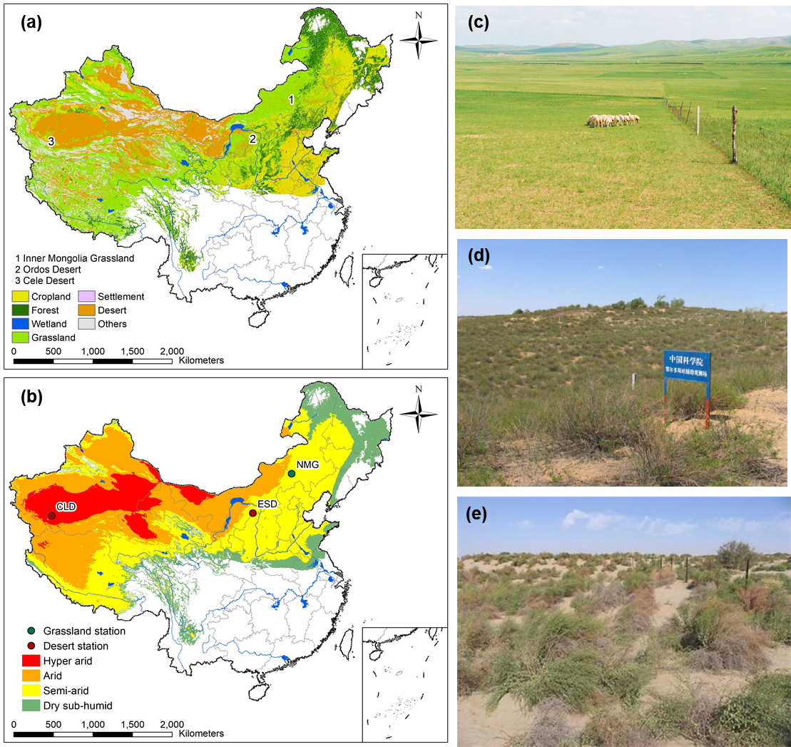

**Fig. 1.** (a) Distributions of major ecosystems in China’s drylands. (b) Spatial distributions of (c) Inner Mongolia Grassland (NMG), (d) Ordos Desert (ESD) and (e) Cele Desert (CLD) of the Chinese Ecosystem Research Network (CERN) in China’s drylands (Figure adapted from http://www.cern.ac.cn).

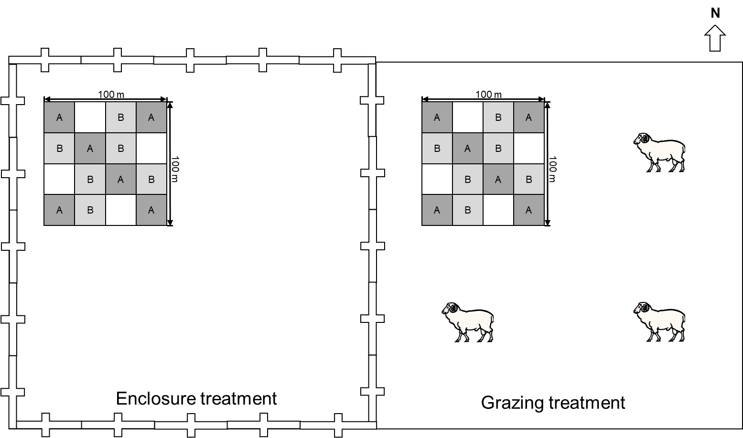

**Fig. 2.** The sub-plot layout strategy used in soil sampling. The enclosure and grazing lands are not drawn to scale. Symbol sources: Illustration of Ovis aries (Sheep), from Tim Carruthers, Integration and Application Network (ian.umces.edu/media-library).

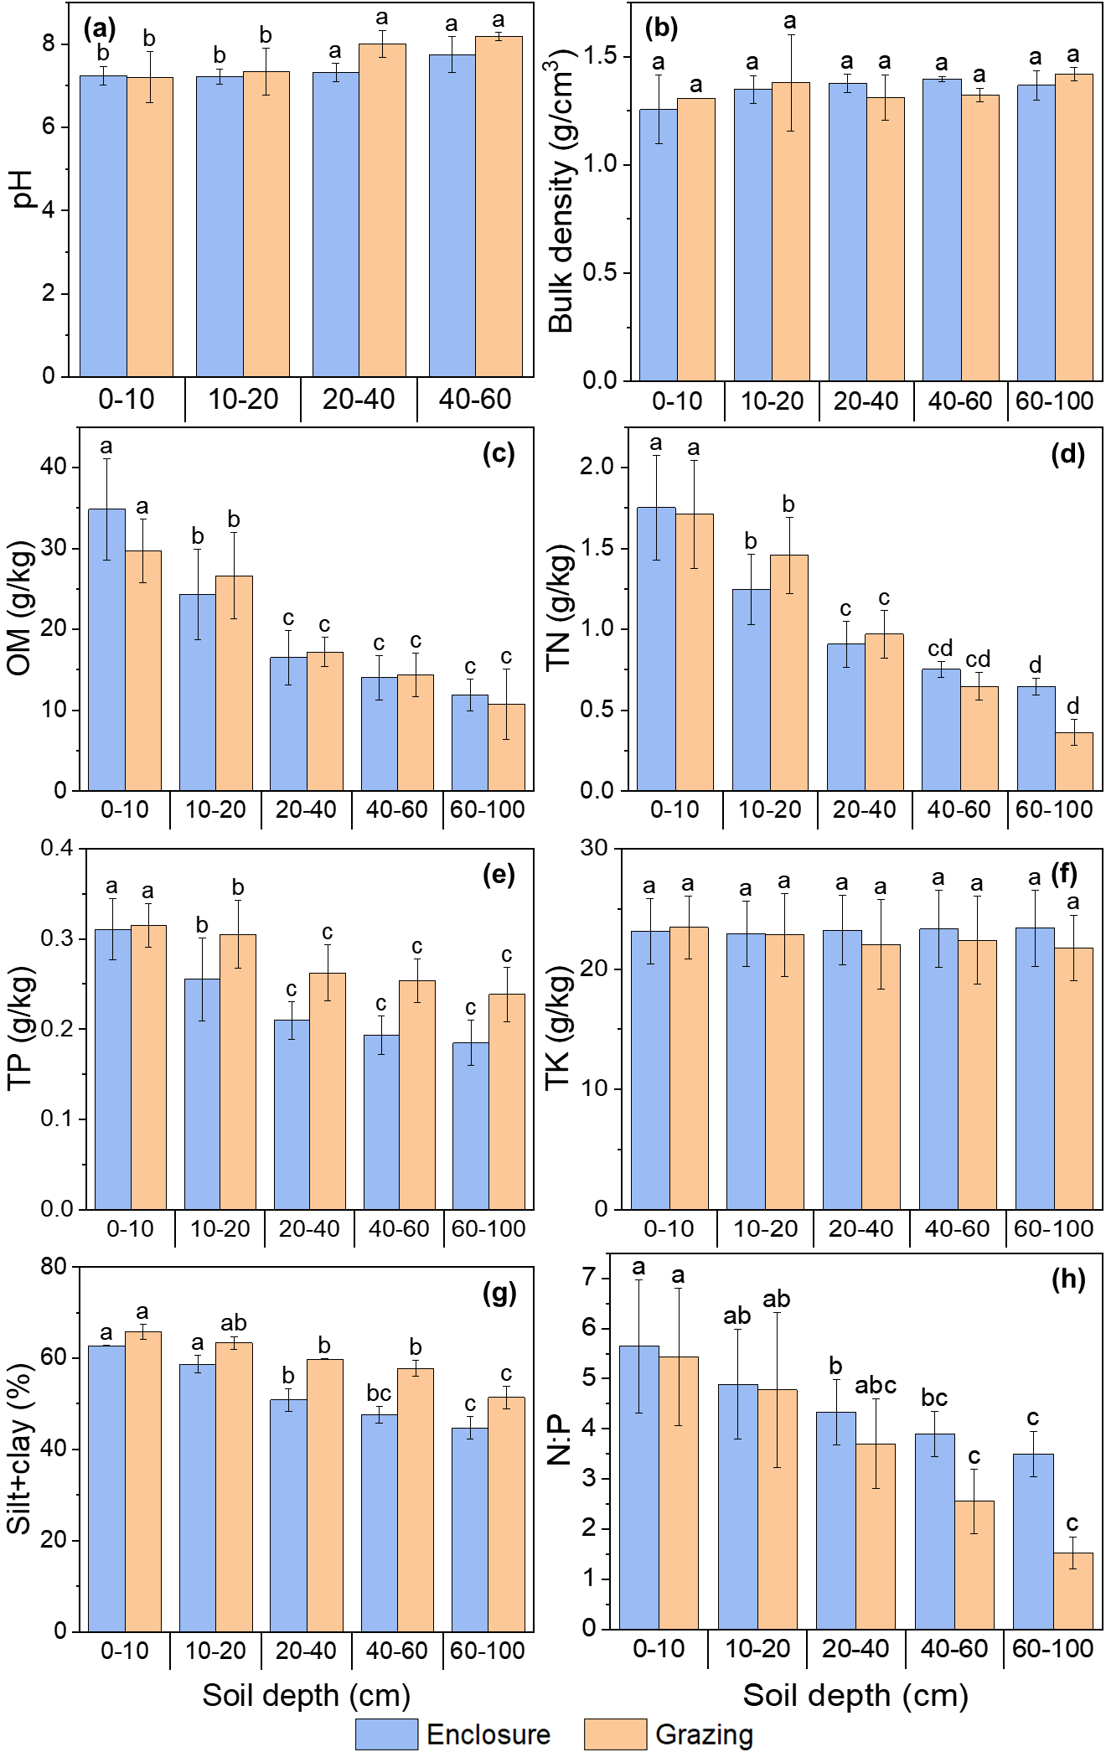

**Fig. 3.** Soil properties for enclosure and grazing across different soil depths in the semi-arid steppe (NMG): (a) pH, (b) bulk density, (c) organic matter (OM), (d) total nitrogen (TN), (e) total phosphorus (TP), (f) total potassium (TK) contents, (g) the ratio of silt and clay (Silt +clay), (h) the stoichiometric ratio of nitrogen: phosphorus (N:P). Error bars indicate standard errors of means. Means with standard error bars followed by the same letter for the same soil depth indicate insignificant differences (p < 0.05). Means without standard error indicate that the number of samples is 1 (N=1), and N>3 for others.

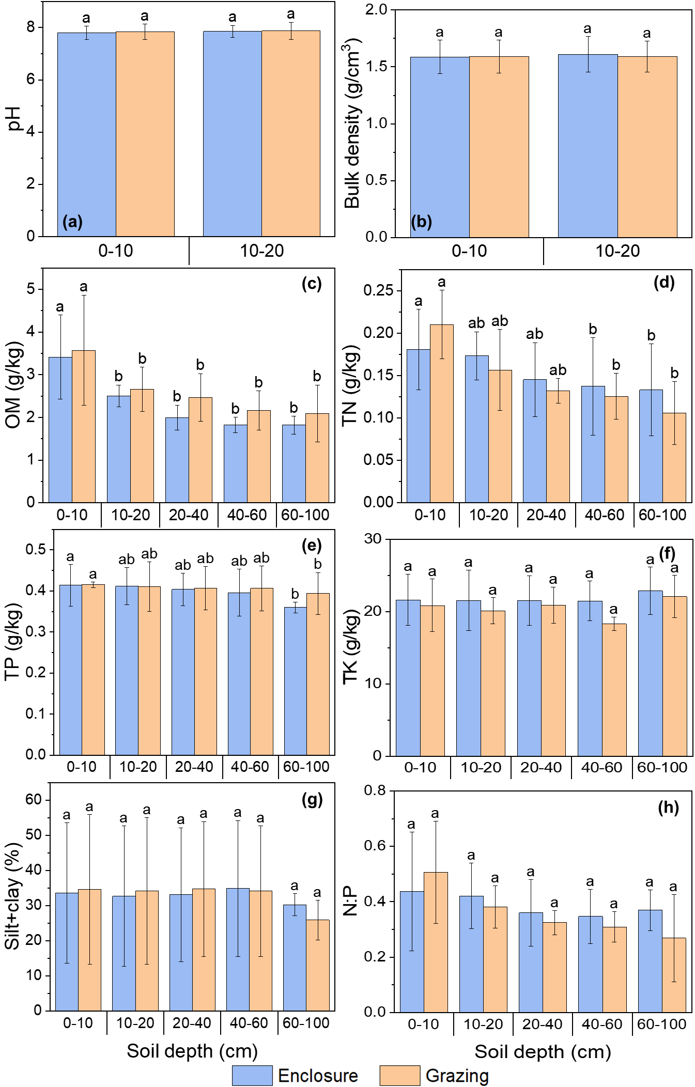

**Fig. 4.** Soil properties for enclosure and grazing across different soil depths in the desert steppe (ESD and CLD): (a) pH, (b) bulk density, (c) OM, (d) TN, (e) TP, (f) TK contents, (g) the silt +clay ratio, (h) the N:P ratio. Error bars indicate standard errors of means. Means with standard error bars followed by the same letter for the same soil depth indicate insignificant differences (p < 0.05). Means without standard error indicate that the number of samples is 1 (N=1), and N>3 for others.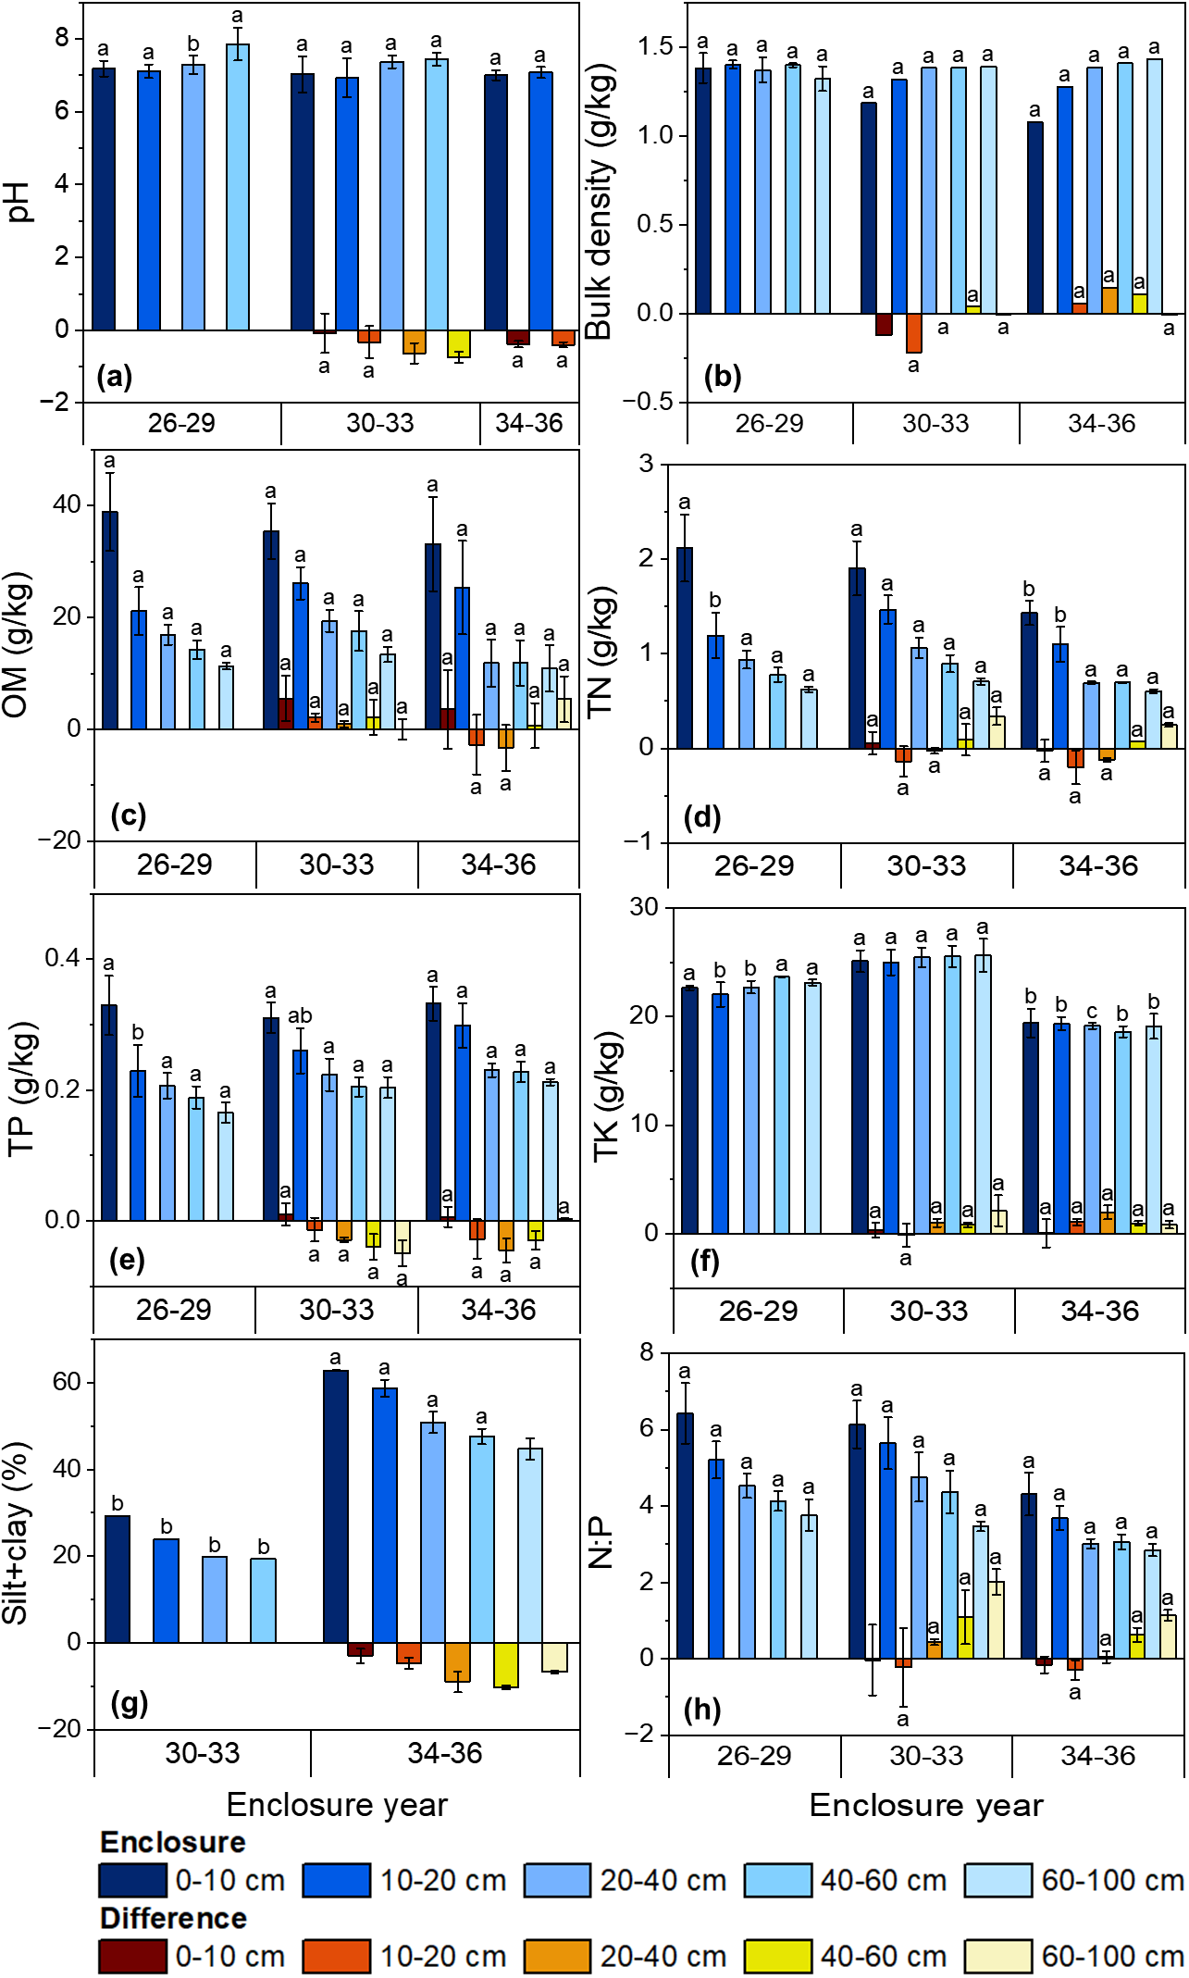

**Fig. 5.** Soil properties for enclosure and differences between enclosure and grazing (enclosure–grazing) across different soil depths along the enclosure age sequence in the semi-arid steppe (NMG): (a) pH, (b) bulk density, (c) OM, (d) TN, (e) TP, (f) TK contents, (g) the silt +clay ratio, (h) the N:P ratio. Error bars indicate standard errors of means. Means with standard error bars followed by the same letter for the same enclosure age category indicate insignificant differences (p < 0.05). Means without standard error indicate that the number of samples is 1 (N=1), and N>3 for others.

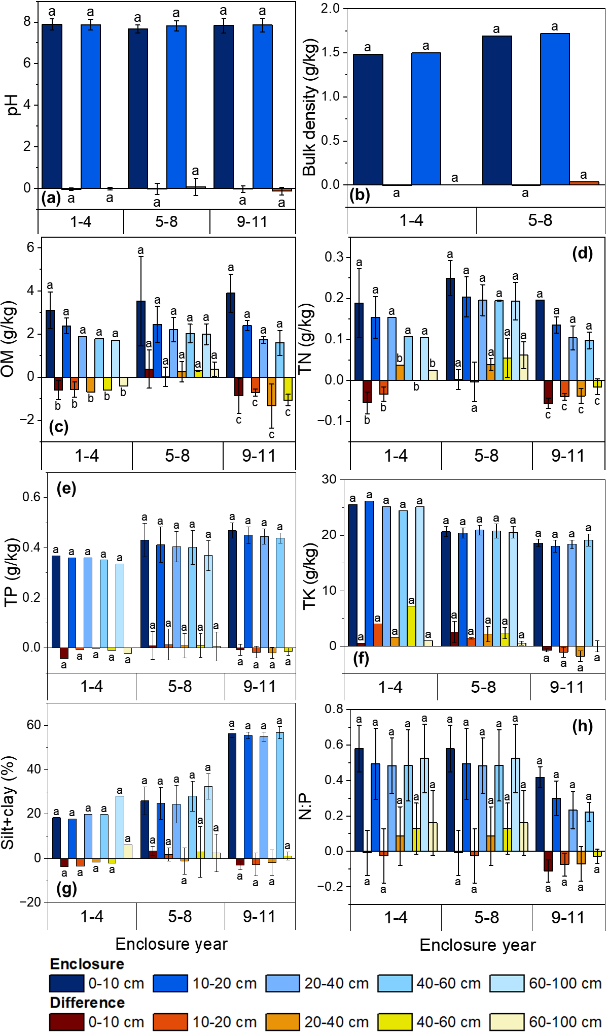

**Fig. 6.** Soil properties for enclosure and differences between enclosure and grazing lands (enclosure–grazing) across different soil depths along the enclosure age sequence in the desert steppe (ESD and CLD): (a) pH, (b) bulk density, (c) OM, (d) TN, (e) TP, (f) TK contents, (g) the silt +clay ratio, (h) the N:P ratio. Error bars indicate standard errors of means. Means with standard error bars followed by the same letter for the same enclosure age category indicate insignificant differences (p < 0.05). Means without standard error indicate that the number of samples is 1 (N=1), and N>3 for others.

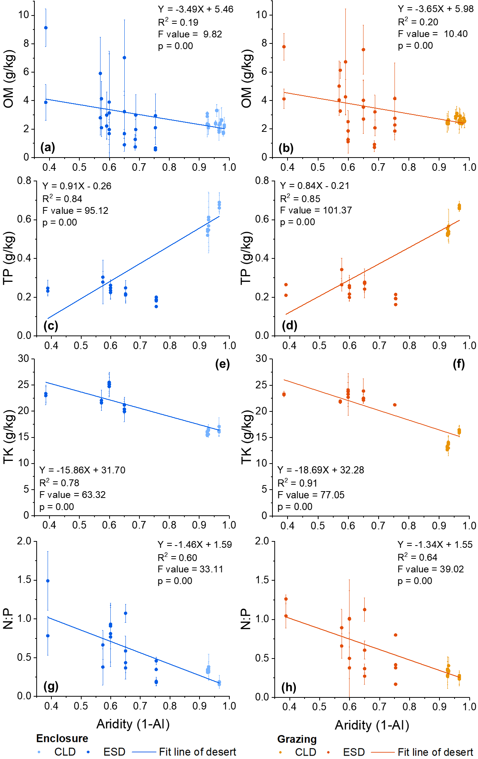

**Fig. 7.** Variation of soil properties for enclosure and grazing in the desert steppe (ESD and CLD) along the aridity gradients as determined by linear fit: (a), (b) OM, (c), (d) TP, (e), (f) TK contents, (g), (h) the N:P ratio. Slope>0 indicates that the content of the soil property increases along the aridity gradient. Slope<0 indicates that the content of the soil property decreases along the aridity gradient.

# Tables

**Table 1.** Site information about the CERN grassland research station (NMG) and two CERN desert research stations (ESD and CLD).

| Abbreviation | NMG | ESD | CLD |
| --- | --- | --- | --- |
| Ecosystem Research Station | Inner Mongolia Grassland Ecosystem Research Station | Ordos Desert Ecological Research Station | Cele Desert Ecosystem Research Station |
| Location | Inner Mongolia Plateau | Mu Us Desert | Taklimakan Desert |
| Latitude and longitude | 116°42′E, 43°38′N | 110°11′E, 39°29′N | 80°43′E, 37°00′N |
| Elevation (m) | 1100 | 1300 | 1310 |
| Topography | Platform | Sand dunes | Sand dunes |
| Dryland subtypes | Semi-arid | Semi-arid | Hyper-arid |
| AI | 0.26 | 0.27 | 0.02 |
| Climate type | Semi-arid temperate monsoon climate | Semi-arid continental climate | Hyper arid warm temperate climate |
| Annual mean temperature (℃) | 2.0 | 8.1 | 13.4 |
| Annual precipitation (mm) | 266.7 | 386.7 | 43.8 |
| Ecosystem | Grassland | Desert | Desert |
| Vegetation type | Temperate typical steppe | Shrubland | Desert vegetation |
| Dominant species | *Stipa grandis, Leymus chinensis* | *Artemisia ordosica* | *Alhagi sparsifolia, Karelinia capsica, Tamarix chinensis* |
| Soil type | Haplic Calcisols | Arenosols | Arenosols |
| Soil properties and sampling years | Bulk density, TK: 2005, 2010, 2015; Silt+clay: 2005, 2015; pH, OM, TN, TP: 2005-2007, 2009-2010, 2015 | Bulk density: 2005, 2010, 2015; Silt+clay: 2005-2006, 2010, 2012, 2015; pH, OM: 2005-2010, 2012-2013, 2015; TN: 2005-2007, 2010, 2012-2013, 2015; TP, TK: 2005, 2010, 2012-2013, 2015 | Bulk density, Silt+clay, TP, TK: 2005, 2010, 2015; pH, OM, TN, TP: 2005-2010, 2013-2015 |
| Grazing intensity | Moderate grazing | Light grazing | Light grazing |
| Starting year of enclosure | 1979 | 2004 | 2004 |
| Area of experiment field | Enclosure: 250,000 m2; Grazing: 23,000 m2 | Enclosure: 12,100 m2; Grazing: 2,500 m2 | Enclosure: 21,750 m2; Grazing: 10,000 m2 |

Note: Detailed descriptions are available in Bai et al. (2004) for NMG, Jin et al. (2007) for ESD, and Chang et al. (2015) for CLD. Soil properties: soil pH, organic matter (OM), total nitrogen (TN), total phosphorus (TP), total potassium (TK) contents, bulk density, and the ratio of silt and clay (Silt+clay).

**Table 2.** Comparisons of selected soil properties (mean ± standard error) in the enclosure and adjacent grazing lands across different soil depths in the semi-arid steppe of Inner Mongolia Grassland (NMG).

| Soil Property | Depth  (cm) | Land management across enclosure age sequence | | | | |
| --- | --- | --- | --- | --- | --- | --- |
| 26-29 years | 30-33 years | | 34-36 years | |
| Enclosure | Enclosure | Grazing | Enclosure | Grazing |
| pH | 0-10 | 7.19±0.21 | 7.03±0.49 a | 7.11±0.74 a | 7.01±0.14 a | 7.39±0.10 a |
| 10-20 | 7.11±0.19 | 6.94±0.53 a | 7.26±0.69 a | 7.08±0.15 a | 7.48±0.13 a |
| 20-40 | 7.29±0.24 | 7.37±0.17 a | 8.00±0.33 a | - | - |
| 40-60 | 7.86±0.45 | 7.44±0.17 a | 8.18±0.10 a |  | - |
| Bulk density  (g/cm3) | 0-10 | 1.38±0.08 | 1.18 a | 1.31 a | 1.08 | - |
| 10-20 | 1.40±0.02 | 1.32 a | 1.54 a | 1.28 a | 1.22 a |
| 20-40 | 1.37±0.07 | 1.38 a | 1.39 a | 1.38 a | 1.24 a |
| 40-60 | 1.04±0.01 | 1.38 a | 1.35 a | 1.41 a | 1.30 a |
| 60-100 | 1.32±0.07 | 1.39 a | 1.40 a | 1.43 a | 1.44 a |
| OM (g/kg) | 0-10 | 38.88±7.01 | 35.41±4.95 a | 29.88±2.86 a | 33.11±8.39 a | 29.54±4.62 a |
| 10-20 | 21.13±4.30 | 26.11±2.89 a | 24.00±2.99 a | 25.34±8.35 a | 28.07±6.46 a |
| 20-40 | 16.91±1.81 | 19.38±1.97 a | 18.44±2.05 a | 11.82±4.16 a | 15.17±0.57 a |
| 40-60 | 14.24±1.63 | 17.57±3.55 a | 15.41±1.60 a | 11.90±4.05 a | 11.23±0.31 a |
| 60-100 | 11.30±0.61 | 13.38±1.37 a | 13.35±2.31 a | 10.88±4.15 a | 5.51±0.60 a |
| TN (g/kg) | 0-10 | 2.12±0.35 | 1.91±0.29 a | 1.85±0.31 a | 1.43±0.13 a | 1.46±0.17 a |
| 10-20 | 1.19±0.24 | 1.47±0.15 a | 1.61±0.22 a | 1.10±0.18 a | 1.30±0.04 a |
| 20-40 | 0.94±0.10 | 1.06±0.11 a | 1.09±0.10 a | 0.69±0.01 a | 0.82±0.02 a |
| 40-60 | 0.78±0.07 | 0.90±0.09 a | 0.80±0.19 a | 0.70 a | 0.63 a |
| 60-100 | 0.62±0.03 | 0.71±0.03 a | 0.37±0.10 a | 0.60±0.02 a | 0.36±0.01 a |
| TP (g/kg) | 0-10 | 0.33±0.05 | 0.31±0.02 a | 0.30±0.02 a | 0.33±0.03 a | 0.33±0.02 a |
| 10-20 | 0.23±0.04 | 0.26±0.03 a | 0.27±0.03 a | 0.30±0.03 a | 0.33±0.02 a |
| 20-40 | 0.21±0.02 | 0.22±0.02 a | 0.25±0.02 a | 0.23±0.01 a | 0.28±0.02 a |
| 40-60 | 0.19±0.02 | 0.20±0.01 a | 0.24±0.02 a | 0.23±0.02 a | 0.26±0.01 a |
| 60-100 | 0.17±0.02 | 0.20±0.02 a | 0.25±0.03 a | 0.21±0.01 a | 0.21±0.01 a |
| TK (g/kg) | 0-10 | 22.66±0.21 | 25.12±1.00 a | 24.81±0.73 a | 19.41±1.31 a | 19.36±0.14 a |
| 10-20 | 22.05±1.12 | 25.00±1.19 a | 25.12±0.54 a | 19.37±0.60 a | 18.30±0.68 a |
| 20-40 | 22.71±0.57 | 25.46±0.91 a | 24.46±0.81 a | 19.14±0.28 a | 17.18±0.70 a |
| 40-60 | 23.68±0.03 | 25.56±0.99 a | 24.75±1.01 a | 18.61±0.52 a | 17.65±0.56 a |
| 60-100 | 23.14±0.28 | 25.64±1.52 a | 23.53±0.53 b | 19.10±1.16 a | 18.26±1.10 a |
| Silt+clay (%) | 0-10 | - | 29.27 | - | 62.77±0.13 a | 65.73±1.66 a |
| 10-20 | - | 23.91 | - | 58.69±1.94 a | 63.37±1.40 a |
| 20-40 | - | 19.8 | - | 50.85±2.42 b | 59.80±0.14 a |
| 40-60 | - | 19.37 | - | 47.58±1.78 b | 57.74±1.73 a |
| 60-100 | - | - | - | 44.72±2.46 b | 51.39±2.44 a |
| N:P | 0-10 | 6.43±0.79 | 6.14±0.62 a | 6.17±1.11 a | 4.31±0.56 a | 4.48±0.60 a |
| 10-20 | 5.21±0.48 | 5.65±0.68 a | 5.88±1.24 a | 3.69±0.32 a | 3.99±0.19 a |
| 20-40 | 4.53±0.32 | 4.76±0.64 a | 4.33±0.64 a | 3.01±0.13 a | 2.97±0.20 a |
| 40-60 | 4.13±0.26 | 4.37±0.56 a | 3.28±0.90 b | 3.06±0.19 a | 2.43±0.07 a |
| 60-100 | 3.76±0.41 | 3.47±0.13 a | 1.45±0.36 b | 2.85±0.16 a | 1.70±0.09 a |

Notes: Soil physical and chemical properties included bulk density, pH, organic matter (OM), total nitrogen (TN), total phosphorus (TP), and total potassium (TK) contents, the ratio of silt and clay (Silt+clay), and the ratio of nitrogen: phosphorus (N:P). Means (± standard error) followed by the same letters indicate an insignificant difference between the enclosure and the adjacent grazing lands at p>0.05. Means without standard error indicate that the number of samples is 1 (N=1), and N>3 for the other means.

**Table 3.** Comparisons of selected soil properties (mean ± standard error) in the enclosure and adjacent grazing lands across different soil depths in the desert steppe of Ordos Desert (ESD) and Cele Desert (CLD).

| Soil Property | Depth  (cm) | Land management across enclosure age sequence | | | | | |
| --- | --- | --- | --- | --- | --- | --- | --- |
| 1-4 years | | 5-8 years | | 9-11 years | |
| Enclosure | Grazing | Enclosure | Grazing | Enclosure | Grazing |
| pH | 0-10 | 7.89±0.27 a | 7.93±0.28 a | 7.67±0.19 a | 7.71±0.33 a | 7.83±0.36 a | 7.87±0.40 a |
| 10-20 | 7.88±0.25 a | 7.89±0.26 a | 7.83±0.25 a | 7.77±0.49 a | 7.86±0.33 a | 8.00±0.38 a |
| Bulk density (g/cm3) | 0-10 | 1.48 a | 1.49 a | 1.69 a | 1.69 a | - | - |
| 10-20 | 1.50 a | 1.50 a | 1.72 a | 1.69 a | - | - |
| OM  (g/kg) | 0-10 | 3.11±0.84 a | 3.71±0.72 a | 3.52±2.07 a | 3.14±1.87 a | 3.90±0.88 a | 4.76±0.33 a |
| 10-20 | 2.38±0.35 a | 2.96±0.50 a | 2.45±0.84 a | 2.44±0.95 a | 2.39±0.24 a | 3.10±0.17 a |
| 20-40 | 1.88 a | 2.57 a | 2.20±0.56 a | 1.95±0.31 a | 1.73±0.15 a | 3.06±1.03 a |
| 40-60 | 1.79 a | 2.39 a | 2.03±0.43 a | 1.73±0.43 a | 1.59±0.58 a | 2.64±0.52 a |
| 60-100 | 1.72 a | 2.12 a | 1.99±0.48 a | 1.62±0.35 a | - | - |
| TN  (g/kg) | 0-10 | 0.19±0.08 a | 0.24±0.07 a | 0.25±0.04 a | 0.25±0.03 a | 0.20±0.00 a | 0.25±0.01 a |
| 10-20 | 0.15±0.05 a | 0.19±0.07 a | 0.20±0.04 a | 0.21±0.01 a | 0.13±0.02 a | 0.17±0.02 a |
| 20-40 | 0.15 a | 0.12 a | 0.20±0.05 a | 0.14±0.05 a | 0.10±0.03 a | 0.14±0.02 a |
| 40-60 | 0.11 a | 0.11 a | 0.19±0.00 a | 0.16±0.04 a | 0.10±0.02 a | 0.11±0.03 a |
| 60-100 | 0.10 a | 0.08 a | 0.19±0.05 a | 0.13±0.03 a | - | - |
| TP  (g/kg) | 0-10 | 0.37 a | 0.41 a | 0.40±0.06 a | 0.42±0.04 a | 0.47±0.03 a | 0.48±0.02 a |
| 10-20 | 0.36 a | 0.37 a | 0.43±0.07 a | 0.40±0.03 a | 0.44±0.03 a | 0.47±0.02 a |
| 20-40 | 0.36 a | 0.36 a | 0.41±0.07 a | 0.39±0.05 a | 0.44±0.02 a | 0.46±0.04 a |
| 40-60 | 0.35 a | 0.36 a | 0.40±0.07 a | 0.39±0.04 a | 0.45±0.03 a | 0.45±0.01 a |
| 60-100 | 0.34 a | 0.36 a | 0.37±0.06 a | 0.36±0.02 a | - | - |
| TK  (g/kg) | 0-10 | 25.55 a | 24.98 a | 20.66±0.91 a | 18.14±2.14 a | 18.61±0.69 a | 19.38±0.63 a |
| 10-20 | 26.18 a | 22.18 a | 20.41±0.93 a | 18.97±0.94 a | 18.03±1.08 a | 19.12±0.54 a |
| 20-40 | 25.17 a | 23.64 a | 20.93±0.89 a | 18.74±1.66 a | 18.38±0.76 a | 20.18±1.22 a |
| 40-60 | 24.47 a | 17.28 a | 20.77±1.27 a | 18.39±0.79 a | 19.15±1.11 a | 19.16±0.48 a |
| 60-100 | 25.15 a | 24.12 a | 20.53±1.08 a | 19.99±1.13 a | - | - |
| Silt+clay  (%) | 0-10 | 18.43 a | 22.04 a | 25.99±6.33 a | 22.50±6.65 a | 56.26±1.82 a | 59.28±2.67 a |
| 10-20 | 17.80 a | 21.27 a | 24.83±7.31 a | 23.08±7.90 a | 55.49±1.43 a | 58.24±5.35 a |
| 20-40 | 19.98 a | 21.72 a | 24.47±8.51 a | 25.65±10.34 a | 54.96±2.06 a | 56.80±6.17 a |
| 40-60 | 19.78 a | 21.75 a | 28.06±6.80 a | 25.14±13.34 a | 56.71±2.68 a | 55.51±1.96 a |
| 60-100 | 28.04 a | 21.90 a | 32.48±5.69 a | 29.91±10.20 a | - | - |
| N:P | 0-10 | 0.51 a | 0.59 a | 0.58±0.13 a | 0.59±0.18 a | 0.42±0.06 a | 0.53±0.09 a |
| 10-20 | 0.43 a | 0.51 a | 0.49±0.20 a | 0.52±0.25 a | 0.30±0.10 a | 0.37±0.07 a |
| 20-40 | 0.43 a | 0.32 a | 0.48±0.16 a | 0.40±0.23 a | 0.23±0.11 a | 0.31±0.04 a |
| 40-60 | 0.30 a | 0.30 a | 0.48±0.20 a | 0.36±0.14 a | 0.22±0.05 a | 0.25±0.07 a |
| 60-100 | 0.31 a | 0.22 a | 0.52±0.19 a | 0.36±0.06 a | - | - |

Note: Soil physical and chemical properties included bulk density, pH, organic matter (OM), total nitrogen (TN), total phosphorus (TP), and total potassium (TK) contents, the ratio of silt and clay (Silt+clay), and the ratio of nitrogen: phosphorus (N:P). Means (± standard error) followed by the same letters indicate an insignificant difference (p>0.05) between the enclosure and the adjacent grazing lands. Means without standard error indicate that the number of samples is 1 (N=1), and N>3 for the other means.

**Table 4.** Variation of soil properties for the enclosure and grazing management in grassland and desert ecosystems along the time series as determined by a linear fit.

|  |  |  |  |  |  |  |  |  |
| --- | --- | --- | --- | --- | --- | --- | --- | --- |
| Ecosystem | Land management | Year | Soil Property | Depth (cm) | Slope | R2 | F value | p |
| Semi-arid steppe | Enclosure | 2009-2015 | pH | 0-20 | -0.003 | 0.002 | 0.060 | 0.808 |
| Bulk density | 0-60 | -0.013 | 0.020 | 0.122 | 0.739 |
| OM | 0.002 | 0.000 | 0.025 | 0.875 |
| TN | -0.018* | 0.060 | 4.502 | 0.037 |
| TP | 0.036*** | 0.155 | 12.840 | 0.001 |
| TK | -0.119*** | 0.914 | 362.269 | 0.000 |
| N:P | -0.033*** | 0.359 | 47.357 | 0.000 |
| Grazing | pH | 0-20 | 0.006 | 0.004 | 0.138 | 0.712 |
| Bulk density | 0-60 | -0.061 | 0.502 | 5.046 | 0.075 |
| OM | 0.013 | 0.035 | 0.350 | 0.556 |
| TN | -0.011 | 0.019 | 2.929 | 0.092 |
| TP | 0.036* | 0.293 | 4.436 | 0.040 |
| TK | -0.131*** | 0.938 | 502.312 | 0.000 |
| N:P | -0.024** | 0.089 | 7.359 | 0.009 |
| Desert steppe | Enclosure | 2005-2015 | pH | 0-20 | -0.003 | 0.159 | 0.028 | 0.869 |
| Bulk density | 0.171** | 0.999 | 159.695 | 0.006 |
| OM | 0-60 | 0.015 | 0.050 | 1.159 | 0.293 |
| TN | 0.003 | 0.003 | 0.036 | 0.852 |
| TP | 0.068*** | 0.869 | 100.363 | 0.000 |
| TK | -0.077*** | 0.934 | 142.069 | 0.000 |
| Silt+clay | 0.082*** | 0.836 | 73.199 | 0.000 |
| N:P | -0.021 | 0.110 | 1.232 | 0.293 |
| Grazing | pH | 0-20 | 0.001 | 0.001 | 0.001 | 0.974 |
| Bulk density | 0.179*** | 0.989 | 1339.480 | 0.001 |
| OM | 0-60 | 0.021 | 0.093 | 2.255 | 0.147 |
| TN | 0.007 | 0.010 | 0.182 | 0.675 |
| TP | 0.066*** | 0.763 | 73.266 | 0.000 |
| TK | -0.035* | 0.289 | 2.743 | 0.013 |
| Silt+clay | 0.083*** | 0.792 | 39.064 | 0.000 |
| N:P | -0.01 | 0.035 | 0.364 | 0.560 |

Note: Soil physical and chemical properties included bulk density, pH, organic matter (OM), total nitrogen (TN), total phosphorus (TP), and total potassium (TK) contents, the ratio of silt and clay (Silt+clay), and the ratio of nitrogen: phosphorus (N:P). Slope>0 indicates that the content of the soil property increases along the time series. Slope<0 indicates that the content of the soil property decreases along the time series. *, ** and *** indicate that the variation trend is significant at p=0.05, 0.01 and 0.001 levels, respectively