Claire Carswell, Peter A Coventry, Jennifer V E Brown, Sarah Alderson, Keith Double, Simon Gilbody, Richard Holt, Rowena Jacobs, Jennie Lister, David Osborn, David Shiers, Najma Siddiqi, Jo Taylor, Ian Kellar, DIAMONDS Research Group

## Original Paper

## A theory and evidence-based co-design approach to develop a supported self-management intervention for people with severe mental illness and type 2 diabetes

## Abstract

**Background**

Type 2 diabetes is 2-3 times more common among people with severe mental illness (SMI). Self-management is crucial, with additional challenges faced by people with SMI. Therefore, it is essential that any diabetes self-management programme for people with SMI addresses the unique needs of people living with both conditions, and the inequalities they experience within healthcare services.

**Objectives**

We combined theory, empirical evidence, and co-design approaches to develop a type 2 diabetes self-management intervention for people with SMI.

**Methods**

The development process encompassed four steps: Step 1 involved prioritising the Mechanisms of Action (MoAs) and Behaviour Change Techniques (BCTs) for the intervention. Using findings from primary qualitative research and systematic reviews we selected candidate MoAs to target in the intervention, and candidate BCTs to use. Expert stakeholders then ranked these MoAs and BCTs in a two-phase survey. Average scores were used to generate a prioritised list of MoAs and BCTs. During step 2 we presented the survey results to an expert consensus workshop to agree the definitive list of MoAs and BCTs for the intervention and identify potential modes of delivery. Step 3 involved developing trigger films using evidence from step 1 and step 2. We employed animations to present the experiences of people with SMI managing diabetes. These films were used in step 4, where we used a stakeholder co-design approach. This involved a series of structured workshops where the co-design activities were informed by theory and evidence.

**Results**

On completion of the four-step process, we had developed the DIAMONDS intervention. It is a tailored self-management intervention based on the synthesis of the outputs from the co-design process.

The intervention incorporates a digital app, a paper-based workbook and one-to-one coaching designed to meet the needs of people with SMI and co-existing type 2 diabetes.

**Conclusions**

The intervention development work was underpinned by the MoA theoretical framework, and incorporated systematic reviews, primary qualitative research, expert stakeholder surveys and evidence generated during co-design workshops. The intervention will now be tested for feasibility before undergoing a definitive evaluation in a pragmatic randomised controlled trial.

**Keywords:** severe mental illness, diabetes, intervention development, co-design, mental health, co-morbidity

## Introduction

Long-term physical conditions (LTCs), also referred to as chronic diseases, develop earlier and are two to three times more common in people with severe mental illness (SMI; e.g., schizophrenia, schizoaffective disorder, psychosis, and bipolar disorder), than in the general population [1-3]. Life expectancy is significantly reduced by 15 to 20 years among people with SMI [4, 5].

Rates of obesity [6], poor diet and nutrition [7], and smoking [8, 9] are higher and physical activity levels [10] lower among people with SMI, likely contributing to the higher prevalence of LTCs and premature mortality in this population. Type 2 diabetes is twice as prevalent in people with SMI and those with SMI are more likely to experience poorer clinical outcomes compared with people who have type 2 diabetes alone [11-13]. Reducing the risk of poor clinical outcomes for people with type 2 diabetes is contingent on effective self-management [14-16]. Self-management for type 2 diabetes includes activities such as healthy eating, smoking cessation, managing stress, physical activity, monitoring blood glucose, and taking medication as prescribed [17]. In England, structured diabetes self-management education programmes are recommended for those who are recently diagnosed with type 2 diabetes, and they provide people with an opportunity to develop their knowledge and skills for self-management [14, 16, 18]. They are effective at improving self-management behaviours, clinical outcomes, and associated healthcare costs [19-21].

However, people with SMI and type 2 diabetes rarely receive support for self-management [22]. The experience of SMI itself can make it difficult to engage in self-management, for example, due to symptoms such as avolition, social withdrawal, or hallucinations, as well as side effects from psychiatric medication such as fatigue and excessive hunger [23]. Furthermore, it is unclear whether existing diabetes self-management education programmes are effective for people with SMI, as they are typically excluded from research on these programmes [24].

There is a growing emphasis within healthcare services on the use of digital technologies, including within services to support self-management of LTCs, such as diabetes [25]. Digital exclusion will likely further exacerbate health inequality amongst people with SMI [26]. While digital exclusion for those with SMI is declining in the UK [27], the proportion of people with SMI who use the internet or computers remains a minority [28] Reasons for non-engagement with digital technology include lack of access to devices or wifi, sociodemographic factors, lack of independence, lack of skills and the symptoms of SMI [28]. The COVID-19 pandemic further compounded this inequality as health services responded to national restrictions by providing services remotely using digital technologies [29]. Those without access to these technologies, including those without the knowledge or skills to use them, and those with symptoms that hinder the use of digital technology, faced difficulties accessing healthcare services [30]. This shift to digital provision of healthcare services is likely to persist [30], meaning digital exclusion needs to be addressed to ensure interventions can have widespread use, and prevent further widening of inequality.

Therefore, it is essential that any diabetes self-management programme for people with SMI addresses the unique needs of people living with both conditions, and the inequalities they experience within healthcare services. We aimed to co-design a self-management intervention for people with SMI and co-existing type 2 diabetes, living in the community, incorporating digital technology and paper-based options, and addressing the specific barriers that people living with co-existing SMI and type 2 diabetes experience when managing these conditions together.

## Methods

We used an approach that integrated behavioural theory and empirical evidence with co-design methods to ensure that the intervention we developed would be effective for improving diabetes self-management in people with SMI, as well as being feasible to deliver and acceptable to both service users and those delivering the intervention. The approach to co-design was modelled on Experience Based Co-Design (EBCD), which is primarily a service improvement methodology increasingly used to develop complex interventions and starts with understanding users’ experiences, needs and preferences, and involves working in partnership with users to design or improve services based on these understandings [31].

An overview of the intervention development process is shown in Figure 1. This paper reports the development process for the intervention (stages 2-4), separate papers report the findings of the systematic reviews [32, 33] and qualitative research [23] that formed the basis of stage 1.

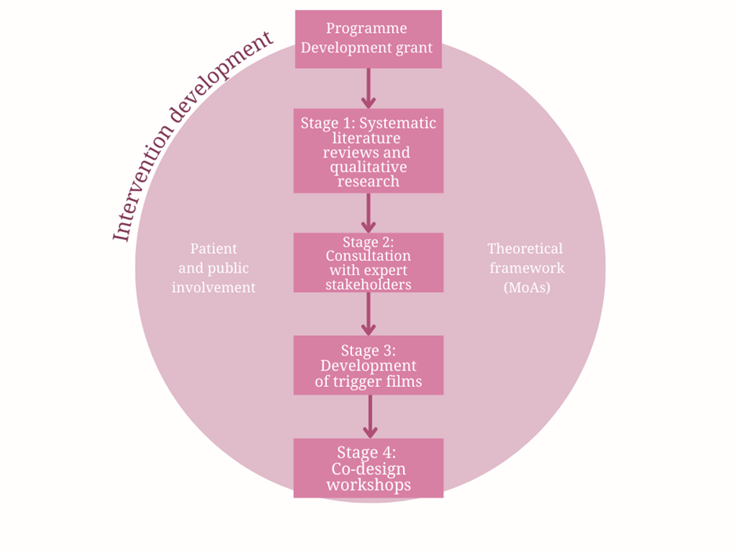

*Figure 1. Overview of the intervention development process*

### Theoretical Framework

The intervention development process was structured around understanding the mechanisms of action (MoAs) for self-management behaviours for people with SMI and co-existing LTCs [34]. MoAs are theoretical constructs that are thought to explain the process through which specific Behaviour Change Techniques (BCTs) affect self-management [35].

### Patient and Public Involvement (PPI)

DIAMONDS Voice is a service user and carer group which has contributed to the DIAMONDS Programme since 2015. At the time of this study, DIAMONDS Voice consisted of eight people with SMI and one family member. DIAMONDS Voice contributed to the development of the study protocol, attended DIAMONDS research team meetings, and provided continued support throughout the co-design study, through input on expert consensus surveys, participation at workshops, involvement in synthesis sessions, and design of the intervention materials.

### Programme Development Grant

#### Preparatory research and underlying principles

The DIAMONDS programme is underpinned by previous work conducted as part of an NIHR Programme Development Grant (RP-DG-1214-10002). During this 12-month development period, we conducted a scoping review of existing diabetes self-management and education programmes for people with type 2 diabetes, combined with a series of multi-disciplinary workshops to explore how to adapt diabetes self-management for people with SMI, and conducted five PPI panels to build PPI capacity.

The scoping review identified more than 150 unique interventions to support self-management of diabetes. While differing in format, duration and delivery, the interventions were broadly similar in content and there was no leading candidate approach for adaptation for people with SMI. Many of the interventions from the scoping review were included in a previous systematic review of diabetes self-management interventions by Chrvala et al. [36]. This review identified 118 interventions that included goal setting in at least one area of self-management and concluded that interventions that combined group and individual sessions, and those with a mean contact time of more than 10 hours were more effective than those without these features. We used two intervention planning workshops alongside consultation with our PPI panel to provide feedback on the suitability of different intervention types (e.g. group / individual / combined) and to identify how self-management interventions may need to be adapted to meet the needs of people with SMI. The workshops were attended by the DIAMONDS research team and clinical professionals from primary care, diabetes services and psychiatric services. A total of 19 people attended the first workshop, and 21 people attended the second workshop.

In these workshops we explored specific barriers and facilitators for self-management in people with SMI with experts in the field. Discussions around educational content of programmes concluded that any intervention should cover the seven main areas of self-management included in the American Association of Diabetes Educators (AADE) 7 Self-care behaviours (Healthy coping, healthy eating, being active, taking medication, monitoring, problem solving, reducing risks) [17]. The workshops also specified a need for additional one-to-one support that was not often provided in existing diabetes self-management and education programmes. There were mixed opinions about the extent to which we should use digital technologies, and the potential acceptability and feasibility of this approach for people with SMI. Attendees of the workshops also discussed opportunities to train people working in mental health services to deliver a tailored intervention. Diabetes and mental health clinicians agreed that this approach was feasible, although pointed out that while people working in mental health services have the skills to support people with SMI, they may know little about diabetes and would need specific training for this.

PPI panel meetings confirmed that there were mixed opinions in relation to using digital technologies to support health. The panel agreed that applications could form part of an intervention but should not be used to the exclusion of other platforms and intervention content. PPI meetings also identified that in-person support would be an essential aspect of any intervention to help reduce anxiety and address low motivation. There was consensus that both group and individual intervention sessions would be needed to support people with SMI and diabetes. There was agreement that group sessions need not be compulsory but optional and stand-alone so that people could attend if able to.

#### Key learning underpinning co-design process

Our preparatory research informed our decision to develop a bespoke self-management intervention for people who have type 2 diabetes and SMI. The intervention would need to include both group and one-to-one support to ensure accessibility and engagement for people with SMI. The intervention should also incorporate a digital application, but there would be options available for participants who do not have access to digital technology or who struggle with using it, such as a participant workbook. Additionally, the barriers to self-management experienced by people with SMI meant that the intervention would need to be adapted to individual needs. These design principles were taken forward and served as a foundation for a phased approach to intervention development using co-design methodology.

### Intervention development process

#### Stage one: primary and secondary analysis of qualitative and quantitative evidence about determinants of self-management behaviours in SMI and LTCs

### Stage one identified MoAs that mapped against the determinants of self-management. This stage combined secondary analysis of published qualitative and quantitative evidence about enablers, barriers and determinants (mapped against MoAs) of self-management for adults living in the community SMI and LTCs [32, 33], with analysis of in-depth qualitative interviews with staff, informal caregivers, and service users in England, about the lived experience of self-management of LTCs and SMI[23]. Evidential links between all MoAs and determinants of self-management behaviour were cross-tabulated. An example of this cross-tabulation mapping the MoA ‘Attitude towards the behaviour’ with determinants identified from primary qualitative research [23] can be seen in Table 1.

Table 1. Example of cross-tabulation mapping MoAs to determinants in primary qualitative research

|  |  |
| --- | --- |
| **Mechanism of Action: Attitude towards the behaviour** | |
| **Statement** | **Illustrative quote** |
|  | |
| I take medication for my mental health by injection which I don’t like because it hurts but it keeps me well | *I have an injection every fortnight and that keeps me stable. I don’t like it, it hurts, it’s horrible but it keeps me well. My husband would tell you, it’s the best thing that’s happened to me.* [Patient participant] |
| I get fed up with taking my medications because they cause side effects | *And the Diabetes, I do get fed up with needles every day. Twice a day. In my thigh, twice a day, morning and night. I get fed up with that. And tablets as well, I take a load of tablets every day and I get fed up with that as well. They cause side effects, you see.* [Patient participant] |
| I enjoy doing some types of exercise but not others | *P* [Patient participant]*: I used to go the gym.*  *I*[Interviewer]*: And how did you find that?*  *P: I liked the walking machine and the rowing machine but I didn’t fancy the weights.*  *I: Is that something you’d like to carry on doing?*  *P: No, not really.*  *I: No? Why not?*  *P: No, no. I don’t really-- I didn’t really enjoy it that much.* |
| I drink alcoholic drinks because I enjoy it | *Oh I drink about 5 or 6 cans [of alcoholic drinks] a night yeah. To have a good time because I enjoy it, I enjoy it yeah.* [Patient participant] |
| I don’t always monitor my blood glucose levels because it seems like too much hard work | *Well, I could do it at tea time I suppose but I don’t because it seems like too much messing about. You’ve got to fiddle about putting this needle thing in here. Put the strip on the machine and then test your blood. Sometimes, when you press the button and no blood comes out, you’ve got to do it again. Stuff like that.* [Patient participant] |
| I have a great counsellor that I see every week to help me cope with my conditions | *I go to counselling every week. I’ve got a great counsellor. So, that’s a big part of my self-management.* [Patient participant] |
| I used to take part in relaxation sessions which were really good | *I used to do relaxation [at the day centre], you know when they put the lights out and listen to music and you relax and they tell you you're walking through a forest or whatever? That's really good.* [Patient participant] |
| I take part in leisure activities and I like doing them | *There are things I can do, I like to walk as well and there’s some really nice walks around here. Leisure activities, yeah, I can walk the dog and do the garden, I like to paint.* [Patient participant] |

#### Stage two: Consensus and prioritisation exercise with stakeholders

Stage two involved a two-phase survey and consultation with expert stakeholders to prioritise and select candidate BCTs based on established theoretical and empirical evidence about behaviour change interventions. Expert stakeholders were first tasked with ranking (on a 4-point Likert scale) the MoAs identified in stage one in terms of perceived strength of association with self-management of diabetes and modifiability. 21 people responded to the electronic survey, the stakeholders included healthcare professionals working in primary care (n=1), diabetes (n=5), chronic obstructive pulmonary disease (COPD) (n=4) and mental health (n=2), clinical academics (n=3), carers (n=1), service users (n=4), and healthcare managers (n=1).

The DIAMONDS research team then mapped average expert-rated rankings for MoA-BCT associations with the cross-tabulation mapping from stage 1 to generate a list of candidate MoAs and BCT links. The second phase of the survey was administered again to the expert stakeholders approximately two months following the completion of the first survey, to judge each MoA and BCT link according to whether it was acceptable and practical, using the APEASE criteria (Affordability, Practicability, Effectiveness, Acceptability, Safety and Equity). The BCTs and MoAs that reached consensus were carried forward to inform potential content in the co-design process.

For each MoA, between four and eleven BCT links were identified. Following the prioritisation process the DIAMONDS research team selected BCTs that offered the most promise in terms of potential efficacy, acceptability, and deliverability, using the results of both surveys, the preparatory work, expert consultation, and PPI. The 22 BCTs that were included in the intervention are shown in Table 2.

Table 2. Included BCTs and linked MoAs

|  |  |
| --- | --- |
| **Behaviour Change Techniques** | **Linked Mechanism of Actions** |
|  | |
| Goal setting (behaviour) | Intentions; Goals; Memory, attention, and decision processes. |
| Problem solving | Knowledge; Skills; Beliefs about capabilities; Memory, attention, and decision processes; Behavioural regulation |
| Action planning | Memory, attention, and decision processes; Behavioural regulation; Behavioural cueing |
| Graded tasks | Skills; Beliefs about capabilities; Memory, attention, and decision processes |
| Review behaviour goals | Beliefs about capabilities; Reinforcement; Intentions; Goals; Feedback processes |
| Feedback on behaviour | Reinforcement; Motivation; Feedback processes |
| Focus on past success | Beliefs about capabilities |
| Prompts/cues | Memory, attention, and decision processes; Environmental context and resources; Behavioural regulation; Behavioural cueing |
| Habit formation | Memory, attention, and decision processes; Behavioural regulation; Behavioural cueing |
| Information about health consequences | Knowledge; Beliefs about consequences; Intentions; Attitude towards behaviour |
| Information on how to perform the behaviour | Knowledge; Skills; Beliefs about capabilities |
| Demonstration of the behaviour | Knowledge; Skills; Beliefs about capabilities |
| Body changes | Beliefs about capabilities |
| Verbal persuasion about capability | Beliefs about capabilities |
| Self-monitoring of behaviour | Behavioural regulation; Feedback processes; Behavioural cueing |
| Feedback on behaviour | Reinforcement; Motivation; Feedback processes |
| Reduce negative emotions | Skills; Emotion; Behavioural regulation |
| Self-monitoring the outcome of behaviour | Goals |
| Monitoring of emotional consequences | Beliefs about consequences; Emotion |
| Information about emotional consequences | Knowledge, Beliefs about consequences; Emotion |
| Social support (unspecified) | Environmental context and resources |
| Social support (practical) | Environmental context and resources |

#### Stage three: development of trigger films

Stage three happened in parallel to the first two stages, and involved the creation of animated trigger films. Trigger films, also known as catalyst films, are films designed to generate discussion on a specific topic [31]. The films were based on key themes and illustrative points from our qualitative study [23] and qualitative evidence synthesis [33] about the experiences of people with co-existing SMI and LTCs, their informal caregivers and healthcare professionals. These themes included the impact of SMI on self-management behaviours, the interaction between SMI and LTCs, and the barriers and facilitators to self-management. During stage 3, we worked with an external collaborator, digital design agency HMA [37]. We used animations within the trigger films to integrate and illustrate various themes and points rapidly. Subsequently, we used these trigger films, and the personas we developed in stage four, as part of the co-design process. We developed two trigger films, one consisting of an overview of three characters who had SMI and LTCs, and one providing different self-management scenarios for each of the three characters to highlight the difficulties people with SMI experience when trying to manage their health.

#### Stage four: co-design workshops with staff, service users, and carers

Stage 4 included an initial discovery day workshop that lasted 5 ½ hours, followed by five co-design workshops with staff and service users over eight months. The five co-design workshops took place face-to-face and lasted approximately fifteen hours in total. The co-design workshops were facilitated by mHabitat (currently Thrive by Design [38]) and were attended by our digital design partners HMA [37]. During the workshops the DIAMONDS research team, digital design partners, service users and healthcare professionals worked closely together to inform the development of the intervention.

#### Co-design participants

Workshop participants were recruited from three groups: i) service users (i.e., individuals with SMI and LTCs); ii) informal caregivers; and iii) healthcare professionals involved in the care of people with SMI and/or LTCs.

We recruited participants from existing DIAMONDS research cohorts (i.e., people who had taken part in the programme development work, or related research, and had given consent to be contacted again), DIAMONDS Voice, and three NHS mental health Trusts in Yorkshire, UK. The eligibility criteria for workshop participants are described in Table 3.

Table 3. Eligibility criteria for workshop participants

|  |  |  |
| --- | --- | --- |
| Eligibility criteria | | |
| Service users | Informal caregivers | Healthcare professionals |
| People who have co-existing SMI and type 2 diabetes. People were excluded if they were in an acute psychiatric ward during the study recruitment period, if they lacked capacity to participate, or if they had experienced a recent relapse of their SMI. People with a diagnosis of gestational diabetes only were also excluded. | People who provided informal support to people with co-existing SMI and type 2 diabetes, including family members and friends. | People who had professional experience supporting people with either SMI or type 2 diabetes. |

All potential participants received an invitation pack about the study in the post, including an invitation letter, participant information sheet, and an expression of interest form which included consent-to-contact. The DIAMONDS research team contacted individuals who expressed an interest and explained the study. All participants signed a consent form at the start of the first discovery day for the duration of the co-design workshops. Twenty-four people were recruited for stage 4 of the study. Eight people were recruited and provided consent but were unable to attend any of the workshops, seven of these participants were healthcare professionals, one was a service user. One healthcare professional attended the first discovery day workshop and then withdrew from the study. Numbers of attendees by group for each workshop are shown in Table 4.

Table 4. Overview of workshop participants

|  |  |
| --- | --- |
| **Workshop** | **Participants (n attending)** |
|  | |
| Discovery day | Service users (n=3)  Informal caregivers (n=2)  Healthcare professionals (n=4)  Total: 9 |
| Workshop 1 | Service users (n=3)  Informal caregivers (n=3*)  Healthcare professionals (n=0)  Total: 6 |
| Workshop 2 | Service users (n=4*)  Informal caregivers (n=2)  Healthcare professionals (n=2)  Total: 8 |
| Workshop 3 | Service users (n=5*)  Informal caregivers (n=3*)  Healthcare professionals (n=2)  Total: 10 |
| Workshop 4 | Service users (n=4*)  Informal caregivers (n=3*)  Healthcare professionals (n=2)  Total: 9 |
| Workshop 5 | Service users (n=3)  Informal caregivers (n=2)  Healthcare professionals (n=0)  Total: 5 |
| *Including a member of DIAMONDS Voice | |

#### Discovery day workshop

The discovery day workshop was split between separate morning sessions for staff and service users, and a joint afternoon session. To address barriers to using a digital application to support self-management, participants were asked to write down their frustrations surrounding digital technology on post-it notes and place these on a ‘wall of frustration’, which included a poster illustrating participant quotes about experiences of digital technology from our qualitative research [23]. Following this initial exercise, trigger films were then shown separately to each group.

The service user group was asked to complete a journey mapping activity, mapping how a typical day in their life compared with, and related to, the characters in the trigger films. Following the journey mapping, the service users identified problems they experienced during their typical day when trying to manage their health. During this activity service user participants expressed that their ability to engage in self-management behaviours was heavily compromised by mental health symptoms. Furthermore, as people with SMI, service users described how they often feel intimidated by going to public places, such as gyms, and that this acted as a barrier to physical activity. Service users also identified that deciding where to do food shopping, as well as their ability to cook, were important considerations that underpinned their ability to manage their physical health.

The staff group were asked to draw up a care pathway for service users with type 2 diabetes and to determine if there were any points along this pathway where digital technology could be incorporated. Following these separate discovery sessions, service users and healthcare professionals were brought together for a joint discovery exercise. The healthcare professional group presented the pathway they had designed, while the service user group presented an outline of ‘a day in the life of’ to highlight self-management activities they engaged in each day. Service users highlighted challenges they often experienced, such as access to healthcare services and acceptability of the services provided. Optimal pathways described by healthcare professionals included structured education for people with type 2 diabetes. Figure 2 captures the perspectives of workshop participants about the challenges of living with SMI and LTCs.

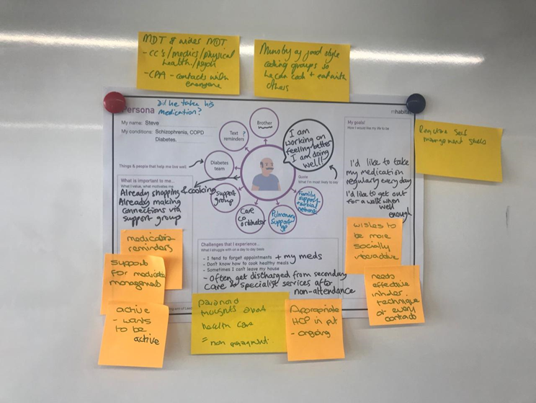

*Figure 2. Outputs from the discovery day workshop persona activity*

In the joint final session of the discovery day, the two groups reviewed the outputs from the earlier sessions. Variable sleep patterns, taking medication, and eating were highlighted as issues that contributed to a person’s ability to engage with self-management. Mental health was identified as having a much greater impact on quality of life and health, and therefore was typically prioritised over self-management of type 2 diabetes.

***Discovery day synthesis***

Following the discovery day, an in-person synthesis session was held to develop paper prototype components of a self-management intervention that could be delivered within an app or workbook, with prioritised functions and placeholder content. This prototype was based on a synthesis of the information gained during the discovery day and the MoAs and BCTs identified in stages 1 and 2. The prototype was used as a framework for the following co-design workshops.

During the synthesis session, the research team, DIAMONDS Voice, and staff from HMA and mHabitat categorised notes from the discovery day as follows: (i) content (e.g. smoking cessation); (ii) functionality (e.g. any interaction with the intervention); (iii), insights (into behaviour of people with SMI); and (iv) risk (e.g. clinical or data risk).

Next, the group collaboratively prioritised content in the following order:

1. Motivation/daily routine (including sleep)
2. Healthy eating
3. Physical activity/ Exercise
4. Stress management/emotion/mood
5. Taking medication

For each of the prioritised functions workshop participants explored how that function could be delivered. For example, development of a daily routine could be supported by self-monitoring consisting of prompts within an app.

***Co-design workshops***

Five co-design workshops followed on from the discovery day and discovery day synthesis session. At least one member of the DIAMONDS research team attended each workshop to observe, take notes and provide information around existing evidence. Workshop content was developed iteratively based on a priori objectives, preceding synthesis sessions, and input from the wider DIAMONDS team. Photographs of the workshop outputs were used as a basis for the synthesis sessions during which the DIAMONDS team and DIAMONDS Voice iteratively tested and refined intervention prototypes.

##### Workshop 1 – testing of a wireframe of the prototype, and prioritisation of target health behaviours

Bringing together discussions and learning from the previous steps, a paper prototype of an app entitled ‘Change One Thing’ was presented to participants. The prototype focused on supporting small lifestyle changes, hence the name “Change One Thing”, and was presented using a series of questions (e.g. do you sleep well’?), designed to offer daily prompts for a chosen activity, (e.g. to go to sleep at a regular time).

Participants were divided into two groups, a mix of service users and informal caregivers. One group was asked to provide feedback on the prototype, while the other group was asked to rank by priority five self-management behaviours that had been identified from stage 1 to 4, with number 1 being the highest priority and number 5 being the lowest priority. Medication and managing sleep were the top priority self-management behaviours for most of the participants.

Participants felt the app would help them remember to take their medication, and the inclusion of videos and the ability to track progress could provide motivation to engage in self-management. The participants also discussed the use of one-to-one and group sessions to deliver the intervention. Participants agreed that one-to-one sessions would be necessary for engagement and help people work towards specific goals related to healthy eating, exercise, and sleep, while group sessions were considered to add social support.

##### Workshop 2 – Ideation and prototype sense checking

Participants were shown ideas for the “look and feel” for the intervention materials (app and workbook), the initial set-up process for the app, and the process for goal setting and action planning. Discussion about the appearance, set-up, and utility of the app was facilitated in relation to exemplar content about stress management and physical activity.

Participants reviewed five potential options for the look and feel of the ‘Change One Thing’ app and workbook and identified preferred questions to support goal setting and action planning. Using the key priorities identified in workshop 1, suggested goals were provided for medication and sleep, with options for how these goals could be phrased and monitored. Additional content for the workbook and app was suggested for how people could add personalised changes to physical activity, (e.g. walking to the post-box) and how to seek social support to manage stress. The participants placed an emphasis on person-centred content that considered personal ability and interests, with an intervention facilitator asking questions rather than making suggestions.

##### Workshop 3 – Refined prototype sense checking

Proposed components included 16 weekly one-to-one meetings, a digital app or a workbook entitled ‘Change One Thing’, and monthly group sessions. These components were informed by the preparatory research that was conducted during the programme development grant, alongside the information and preferences provided during the discovery day and first two workshops, and input from Diamonds Voice members.

The workshop participants were split into two groups, one group of healthcare professionals and one group of service users and informal caregivers. The healthcare professional group focused on the training and support needs of intervention facilitators. Proposed support included supervision and training about diabetes and mental health, and goal setting and personalisation of care. Healthcare professionals also identified the need for processes to be set up around referrals and reporting for participants who may be at risk, or who become unwell while taking part in the intervention.

The service user group reviewed the specificity and emotional valence of the language and wording proposed for the initial goal setting and action planning activity which would be completed either in the ‘Change One Thing’ app or workbook. Participants suggested alternative goal statements that were not appropriate as they could not be framed within action plans, or contradicted the evidence base (e.g. sleeping in on the weekend instead of having a regular sleep schedule). The service user group and healthcare professional groups then reconvened and provided feedback on their activities.

##### Workshop 4 – User acceptance testing and evaluation

This workshop focused on clinical safety of the intervention. Topics of concern addressed problems associated with using the ‘Change One Thing’ app and workbook, the one-to-one sessions, and the end of the intervention. Problems associated with using the app included concerns about security of personal data, malfunction of the app, and phone charging. These could be best solved by ensuring that the workbook delivers the same content and function as the app. Participants also identified that after the final intervention sessions people will need to be sign-posted to relevant support services. A photograph of this evaluative process, outlining concerns and potential solutions associated with the first sessions, daily use of an app, and weekly one-to-one sessions, is shown in Figure 3.

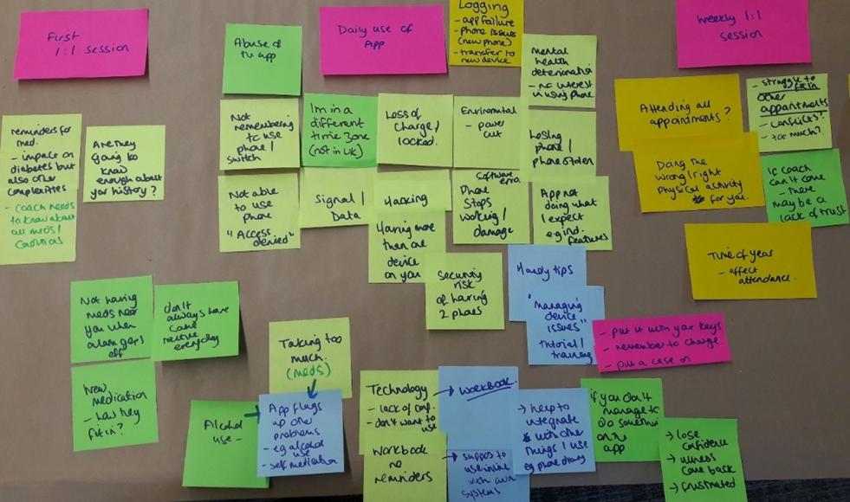

*Figure 3. Solution focused evaluation of intervention components.*

##### Workshop 5 – Further user acceptance testing and evaluation to inform refinement of the intervention

User testing and evaluation in workshop 4 was truncated because of a fire alarm and we therefore repurposed Workshop 5 to complete this process. Participants watched a series of educational animations that had been created for inclusion in the ‘Change One Thing’ app and workbook (presented in the workbook as comic strips), and were asked to provide feedback about the acceptability, utility, and relevance of each video. The videos focused on sleep, medication taking, fluid intake, and physical activity, and were based on the personas previously shown in the trigger films during the discovery day. Following viewing of the video’s participants were asked a series of questions to review their understanding of the educational content. Participants demonstrated a good understanding of what the videos were trying to communicate and provided suggestions on how they could be improved.

Digital app user testing sessions were facilitated by the research team and ran in parallel to the review of the educational animations. Participants were asked to use the app and provide feedback on functionality and content. Despite being smartphone users, several participants found it difficult to use the app. Problems that were encountered included repeated crashing or locking of the screen and difficulties using some of the features, such as setting the time or using sliders within the app. It was therefore recommended that service users should be supported by the intervention facilitators to set up the app and to enable accessibility options during the onboarding process.

#### Design of the intervention materials

The main outputs from the co-design process were the Change One Thing app and workbook, and the DIAMONDS coach manual and training handbook. We hosted several collaborative meetings with NiftyFox Creative [39] and DIAMONDS Voice to ensure that the layout, language, design and organisation of the workbook was accessible, engaging, fit for purpose and matched the content of the app. We worked with Leicester Diabetes Centre [40] to design the Coach Manual and training handbook. The Change One Thing app was designed and developed during the co-design process by our digital design partners HMA [37], and finalised by app developers Pipe and Piper [41].

## Results

### Intervention overview and structure

The DIAMONDS intervention aims to support the self-management of type 2 diabetes for people who have co-existing SMI, by improving diabetes self-management knowledge and skills, and through enhancing the specific capabilities, opportunities and motivations that influence diabetes self-management in this population. In particular, the intervention provides tailored and person-centred support for setting behavioural goals, action planning, problem solving and increasing physical activity, and by providing and facilitating peer support. The logic model for the DIAMONDS Intervention can be seen in Appendix 1.

The DIAMONDS intervention will be delivered by a trained facilitator, called a ‘DIAMONDS Coach’. Participants will be offered weekly sessions either face-to-face, over the phone or over video call with their DIAMONDS Coach for up to 16 weeks, in combination with daily use of the DIAMONDS workbook or the DIAMONDS app called ‘Change One Thing’. They can also engage in in-person monthly group sessions, facilitated by two DIAMONDS Coaches, with other participants receiving the intervention if they choose to do so. We will establish the feasibility and acceptability of the intervention before evaluating clinical and cost effectiveness in a randomised controlled trial [42]. An overview of the core intervention components is shown in Figure 4.

*Figure 4. The DIAMONDS Intervention*

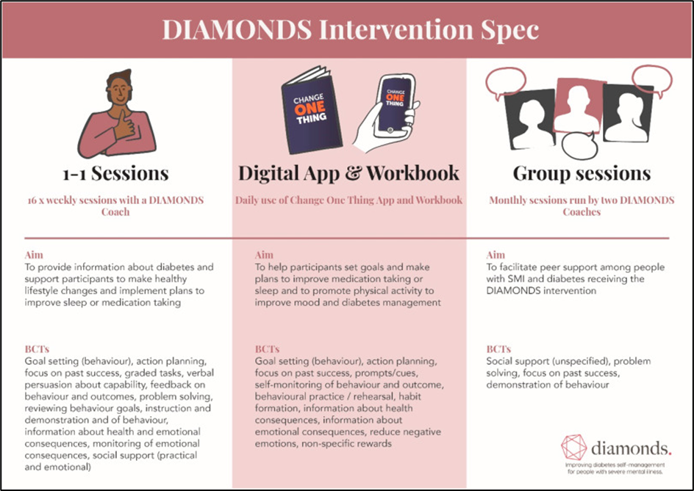

### Delivering the BCTs: Goal setting

As outlined in Figure 8 and in the logic model provided in Appendix 1, the intervention aims to deliver several BCTs to help support people to make lifestyle changes that will support their physical health. To demonstrate how these BCTs will be delivered using the Change One Thing app and/or the workbook, we will outline the BCT goal setting within the DIAMONDS Intervention. In each one-to-one session the DIAMONDS Coach will follow the subsequent steps to support the participant to set a goal.

Using the app or workbook, the DIAMONDS Coach will ask the participant what they would like to focus on during the following week. The app and the workbook have been designed to focus on goals relating to sleep and taking medication, as these were identified during the development process as being the main priorities for service users. However, the participant may want to focus on a different problem, and therefore can identify their own goal if preferred. An example of these choices in the app and workbook are shown in Figure 5 and Figure 6.

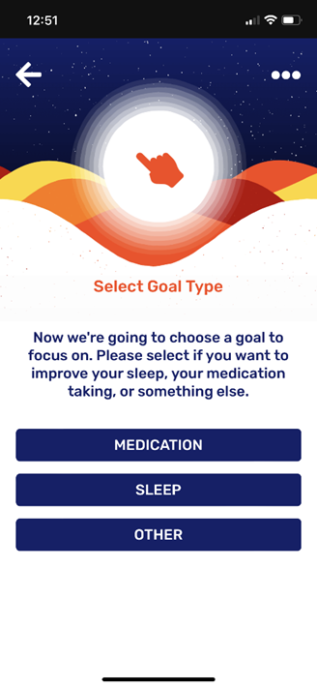

Figure 5. Goal types within the Change One Thing app.

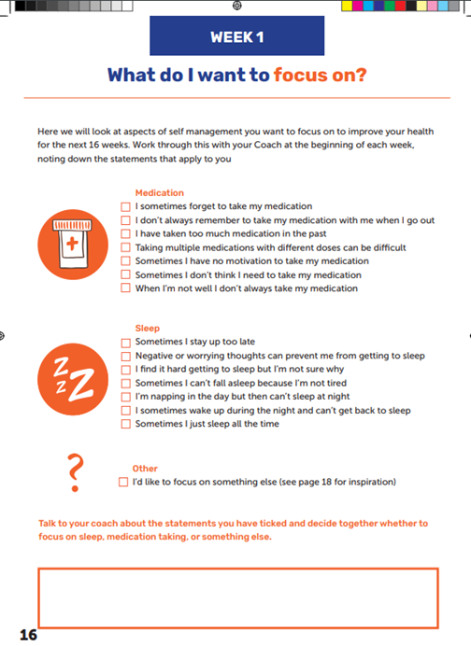

Figure 6. Goal types within the workbook

Once the participant has identified what they want to focus on, the DIAMONDS Coach will support them to develop a goal. If the participant is using the Change One Thing app and chose to focus on medication or sleep, the goal statement will be automatically generated. If the participant is using the participant workbook, they can choose from a list of goal statements identical to those generated in the app, related to that behaviour if they want to focus on medication or sleep. If the participant has not identified medication or sleep, the DIAMONDS Coach will support them to generate a goal statement related to the other behaviour they have identified (for example, healthy eating), ensuring the goal is realistic and achievable.

The goal will automatically be recorded in the app once it has been generated by the participant. If the participant is using the workbook, then the participant or DIAMONDS Coach will record the goal in the goal setting section of the workbook.

## Discussion

This paper describes how we integrated an evidence-based intervention development approach and co-design methodology to develop a complex intervention to support people with SMI and type 2 diabetes to self-manage their health. Drawing on the philosophy that intervention development is best served by integrating theory, evidence, and person-centred approaches [43], we set out to combine behavioural theory with empirical evidence about determinants of self-management behaviours with user-centred design. A consistent thread in our development work has been the use of the MoA framework to underpin our research about self-management behaviours in people with SMI and LTCs, combined with the use of the BCT taxonomy as a means of linking determinants to intervention components. This theoretical lens has offered the means to interpret systematic review evidence about determinants of self-management behaviours in people with SMI and diabetes [32]. Our understanding about the drivers and lived experience of managing LTCs in the context of SMI was extended further by primary qualitative exploration and qualitative evidence synthesis [33]. In this sense we were able to ensure that the first phases of the co-design process were founded on a firm theoretical and evidential basis, leading to more targeted and person-centred co-design workshops.

Person-centred approaches revolved around thinking about how end-users would interact with and use the intervention. End-users of the DIAMONDS intervention are service users with SMI and diabetes (and their informal caregivers), but also health professionals tasked with intervention delivery. The consistent involvement of end users throughout the co-design process was critical to managing tensions between developing an intervention that could be feasibly delivered for a clinical trial (with a primary goal of reducing glycated haemoglobin (HbA1c)) and developing an intervention that met the priorities of service users. For example, service users highlighted their desire to focus on mental health, whilst healthcare professionals felt it was important to incorporate physical activity as a means of reducing HbA1c. Previous research has highlighted the priority for people with SMI is frequently the management of mental health, over the self-management of LTCs [23]. Trials of other bespoke self-management interventions for people with SMI have failed to demonstrate an effect on clinical biomarkers, despite improving other measures that may be of a higher priority to people with SMI, such as hospitalisations [44]. By co-designing an intervention that accommodates goals about both physical and mental health, for example, by framing physical activity as a method of improving mood, we have potentially offered a solution to overcome the disconnect between the priorities of service users and clinical imperatives to reduce HbA1c.

Additionally, our person-centred approach was key to decision making about including a digital component in the final intervention specification. People with SMI are less likely to have access to digital technology [27], and face more barriers to its use when they do have physical access (for example, lacking necessary skills) [45], but there is evidence that digital health technologies can feasibly support people with SMI [46], and that access to the internet and smartphones are increasing in this population, particularly in younger age groups [47]. To minimise digital exclusion we therefore developed the ‘Change One Thing’ app, but built in user flexibility by ensuring that the same components are provided in the workbook.

### Conclusions

We adopted an inclusive and participatory approach to co-designing a flexible and user-focused intervention to support self-management of physical and mental health in people with SMI and diabetes. We integrated behavioural science theory, empirical evidence, and co-design to structure the intervention development process, informed by our linked work to model and evidence the barriers and facilitators to self-management behaviours in this population. This approach shows the value of combining behavioural theory with critical insights from primary and secondary research to maximise the utility and success of co-design with diverse groups of stakeholders.

## References

1. Ruggeri M, Leese M, Thornicroft G, Bisoffi G, Tansella M. Definition and prevalence of severe and persistent mental illness. The British journal of psychiatry : the journal of mental science; 2000, 177:149-155. Doi: DOI: 10.1192/bjp.177.2.149

2. De Hert M, Dekker JM, Wood D, Kahl KG, Holt RI, Moller HJ. Cardiovascular disease and diabetes in people with severe mental illness position statement from the European Psychiatric Association (EPA), supported by the European Association for the Study of Diabetes (EASD) and the European Society of Cardiology (ESC). European psychiatry : the journal of the Association of European Psychiatrists; 2009, 24(6):412-424. Doi: 10.1016/j.eurpsy.2009.01.005

3. Reilly S, Olier I, Planner C, Doran T, Reeves D, Ashcroft DM, et al. Inequalities in physical comorbidity: a longitudinal comparative cohort study of people with severe mental illness in the UK. BMJ Open; 2015, 5(12):e009010. Doi: 10.1136/bmjopen-2015-009010

4. Brown S, Kim M, Mitchell C, Inskip H. Twenty-five year mortality of a community cohort with schizophrenia. The British journal of psychiatry : the journal of mental science; 2010, 196(2):116-121. Doi: 10.1192/bjp.bp.109.067512

5. Osborn DPJ, Levy G, Nazareth I, Petersen I, Islam A, King MB. Relative Risk of Cardiovascular and Cancer Mortality in People With Severe Mental Illness From the United Kingdom's General Practice Research Database. Archives of General Psychiatry; 2007, 64(2):242-249. Doi: 10.1001/archpsyc.64.2.242

6. Afzal M, Siddiqi N, Ahmad B, Afsheen N, Aslam F, Ali A, et al. Prevalence of Overweight and Obesity in People With Severe Mental Illness: Systematic Review and Meta-Analysis. Frontiers in Endocrinology; 2021, 12. Doi: 10.3389/fendo.2021.769309

7. Dipasquale S, Pariante CM, Dazzan P, Aguglia E, McGuire P, Mondelli V. The dietary pattern of patients with schizophrenia: a systematic review. J Psychiatr Res; 2013, 47(2):197-207. Doi: 10.1016/j.jpsychires.2012.10.005

8. Gilbody S, Peckham E, Bailey D, Arundel C, Heron P, Crosland S, et al. Smoking cessation for people with severe mental illness (SCIMITAR+): a pragmatic randomised controlled trial. The Lancet Psychiatry; 2019, 6(5):379-390. Doi: 10.1016/S2215-0366(19)30047-1

9. Szatkowski L, McNeill A. Diverging trends in smoking behaviors according to mental health status. Nicotine Tob Res; 2015, 17(3):356-360. Doi: 10.1093/ntr/ntu173

10. Stubbs B, Firth J, Berry A, Schuch FB, Rosenbaum S, Gaughran F, et al. How much physical activity do people with schizophrenia engage in? A systematic review, comparative meta-analysis and meta-regression. Schizophr Res 2016, 176(2-3):431-440. Doi: 10.1016/j.schres.2016.05.017

11. Vinogradova Y, Coupland C, Hippisley-Cox J, Whyte S, Penny C. Effects of severe mental illness on survival of people with diabetes. The British journal of psychiatry : the journal of mental science; 2010, 197(4):272-277. Doi: 10.1192/bjp.bp.109.074674

12. Schoepf D, Potluri R, Uppal H, Natalwala A, Narendran P, Heun R. Type-2 diabetes mellitus in schizophrenia: increased prevalence and major risk factor of excess mortality in a naturalistic 7-year follow-up. European psychiatry : the journal of the Association of European Psychiatrists; 2012, 27(1):33-42. Doi: 10.1016/j.eurpsy.2011.02.009

13. Wu CS, Lai MS, Gau SS. Complications and mortality in patients with schizophrenia and diabetes: population-based cohort study. The British journal of psychiatry : the journal of mental science; 2015, 207(5):450-457. Doi: 10.1192/bjp.bp.113.143925

14. NICE. 2022. Type 2 diabetes in adults: management. NICE guideline [NG28]. https://www.nice.org.uk/guidance/ng28

15. Diabetes UK. 2009. Improving supported self-management for people with diabetes. http://www.diabetes.org.uk/Documents/Reports/Supported_self-management.pdf

16. NHS England. 2014. Action for Diabetes. http://www.england.nhs.uk/wp-content/uploads/2014/01/act-for-diabetes.pdf

17. Educators AAoD. An Effective Model of Diabetes Care and Education: Revising the AADE7 Self-Care Behaviors(®). Diabetes Educ; 2020, 46(2):139-160. Doi: 10.1177/0145721719894903

18. All-Party Parliamentary Group for Diabetes. 2015. Taking Control: Supporting people to self-manage their diabetes. https://jdrf.org.uk/wp-content/uploads/2015/10/APPG-Diabetes-Report-Education-Final-Report.pdf

19. Newman S, Steed L, Mulligan K. Self-management interventions for chronic illness. Lancet; 2004, 364(9444):1523-1537. Doi: 10.1016/S0140-6736(04)17277-2

20. Nobis S, Lehr D, Ebert DD, Baumeister H, Snoek F, Riper H, et al. Efficacy of a web-based intervention with mobile phone support in treating depressive symptoms in adults with type 1 and type 2 diabetes: a randomized controlled trial. Diabetes care; 2015, 38(5):776-783. Doi: 10.2337/dc14-1728

21. Norris SL, Engelgau MM, Narayan KM. Effectiveness of self-management training in type 2 diabetes: a systematic review of randomized controlled trials. Diabetes care; 2001, 24(3):561-587. Doi: 10.2337/diacare.24.3.561

22. Smith R, Han L, Ali S, Prady SL, Taylor J, Hughes T, et al. Glucose, cholesterol and blood pressure in type II diabetes: A longitudinal observational study comparing patients with and without severe mental illness. J Psychiatr Ment Health Nurs; 2019, 26(9-10):347-357. Doi: 10.1111/jpm.12546

23. Carswell C, Brown JVE, Lister J, Ajjan RA, Alderson SL, Balogun-Katung A, et al. The lived experience of severe mental illness and long-term conditions: a qualitative exploration of service user, carer, and healthcare professional perspectives on self-managing co-existing mental and physical conditions. BMC Psychiatry; 2022, 22(1):479. Doi: 10.1186/s12888-022-04117-5

24. Roberts SH, Bailey JE. An ethnographic study of the incentives and barriers to lifestyle interventions for people with severe mental illness. Journal of advanced nursing; 2013, 69(11):2514-2524. Doi: 10.1111/jan.12136

25. Hadjiconstantinou M, Schreder S, Brough C, Northern A, Stribling B, Khunti K, et al. Using intervention mapping to develop a digital self-management program for people with type 2 diabetes: tutorial on MyDESMOND. Journal of medical Internet research; 2020, 22(5):e17316. Doi: 10.2196/17316

26. Spanakis P, Peckham E, Mathers A, Shiers D, Gilbody S. The digital divide: amplifying health inequalities for people with severe mental illness in the time of COVID-19. The British journal of psychiatry : the journal of mental science; 2021, 219(4):529-531. Doi: 10.1192/bjp.2021.56

27. Robotham D, Satkunanathan S, Doughty L, Wykes T. Do We Still Have a Digital Divide in Mental Health? A Five-Year Survey Follow-up. J Med Internet Res; 2016, 18(11):e309. Doi: 10.2196/jmir.6511

28. Tobitt S, Percival R. Switched on or switched off? A survey of mobile, computer and Internet use in a community mental health rehabilitation sample. J Ment Health; 2019, 28(1):4-10. Doi: 10.1080/09638237.2017.1340623

29. The Lancet Digital Health: Digital tools for mental health in a crisis. The Lancet Digital Health; 2021, 3(4):e204. Doi: 10.1016/S2589-7500(21)00045-5

30. Litchfield I, Shukla D, Greenfield S. Impact of COVID-19 on the digital divide: a rapid review. BMJ Open; 2021, 11(10):e053440. Doi: 10.1136/bmjopen-2021-053440

31. Donetto S, Tsianakas V, Robert . Using Experience-based Co-design (EBCD) to improve the quality of healthcare: mapping where we are now and establishing future directions; London, Kings College London; 2014.

32. Coventry PA, Young B, Balogun-Katang A, Taylor J, Brown JVE, Kitchen C. Determinants of Physical Health Self-Management Behaviours in Adults With Serious Mental Illness: A Systematic Review. Frontiers in Psychiatry; 2021, 12. Doi: 10.3389/fpsyt.2021.723962

33. Balogun-Katung A, Carswell C, Brown JVE, Coventry P, Ajjan R, Alderson S, et al. Exploring the facilitators, barriers, and strategies for self-management in adults living with severe mental illness, with and without long-term conditions: A qualitative evidence synthesis. PLoS One; 2021, 16(10):e0258937. Doi: 10.1371/journal.pone.0258937

34. Michie S, Carey RN, Johnston M, Rothman AJ, de Bruin M, Kelly MP, et al. From Theory-Inspired to Theory-Based Interventions: A Protocol for Developing and Testing a Methodology for Linking Behaviour Change Techniques to Theoretical Mechanisms of Action. Ann Behav Med; 2018, 52(6):501-512. Doi: 10.1007/s12160-016-9816-6

35. Michie S, Richardson M, Johnston M, Abraham C, Francis J, Hardeman W, et al. The behavior change technique taxonomy (v1) of 93 hierarchically clustered techniques: building an international consensus for the reporting of behavior change interventions. Ann Behav Med; 2013, 46(1):81-95. Doi: 10.1007/s12160-013-9486-6

36. Chrvala CA, Sherr D, Lipman RD. Diabetes self-management education for adults with type 2 diabetes mellitus: A systematic review of the effect on glycemic control. Patient education and counseling; 2016, 99(6):926-943. Doi: 10.1016/j.pec.2015.11.003

37. HMA. 2022. hma.co.uk. https://www.hma.co.uk/

38. Thrive By Design. 2022. Thrive By Design. https://www.thrivebydesign.org.uk/

39. Nifty Fox Creative. 2022. Nifty Fox Creative. https://www.niftyfoxcreative.com/

40. Leicester Diabetes Centre. 2022. Leicester Diabetes Centre https://www.leicesterdiabetescentre.org.uk/

41. Pipe & Piper. 2022. Pipe & Piper https://pipeandpiper.co.uk/

42. Brown JVE, Ajjan R, Alderson S, Böhnke JR, Carswell C, Doherty P, et al. The DIAMONDS intervention to support self-management of type 2 diabetes in people with severe mental illness: Study protocol for a single-group feasibility study. SSM - Mental Health; 2022, 2:100086. Doi: 10.1016/j.ssmmh.2022.100086

43. Band R, Bradbury K, Morton K, May C, Michie S, Mair FS, et al. Intervention planning for a digital intervention for self-management of hypertension: a theory-, evidence- and person-based approach. Implementation Science; 2017, 12(1):25. Doi: 10.1186/s13012-017-0553-4

44. Osborn D, Burton A, Hunter R, Marston L, Atkins L, Barnes T, et al. Clinical and cost-effectiveness of an intervention for reducing cholesterol and cardiovascular risk for people with severe mental illness in English primary care: a cluster randomised controlled trial. The Lancet Psychiatry; 2018, 5(2):145-154. Doi: 10.1016/S2215-0366(18)30007-5

45. Spanakis P, Wadman R, Walker L, Heron P, Mathers A, Baker J, et al. Measuring the digital divide among people with severe mental ill health using the essential digital skills framework. Perspect Public Health; 2022:17579139221106399. Doi: 10.1177/17579139221106399

46. Batra S, Baker RA, Wang T, Forma F, DiBiasi F, Peters-Strickland T. Digital health technology for use in patients with serious mental illness: a systematic review of the literature. Med Devices (Auckl); 2017, 10:237-251. Doi: 10.2147/MDER.S144158

47. Ennis L, Rose D, Denis M, Pandit N, Wykes T. Can't surf, won't surf: The digital divide in mental health. Journal of Mental Health; 2012, 21(4):395-403. Doi: 10.3109/09638237.2012.689437

### Acknowledgements

This paper reports work undertaken as part of the DIAMONDS programme, which is funded by the National Institute for Health Research under its Programme Grants for Applied Research (project number RP-PG-1016-20003). PC and SG are part funded by the UK Research and Innovation Closing the Gap Network+ [ES/S004459/1] and the NIHR Applied Research Collaboration Yorkshire and Humber.

DS is an expert advisor to the NICE Centre for Guidelines; the views expressed are the authors’ and not those of NICE. RIGH has received honoraria for speaker engagement, conference attendance or advisory boards from: Abbott, AstraZeneca, Boehringer-Ingelheim, European Association for the Study of Diabetes, Eli Lilly, Encore, Janssen, Menarini, NAPP, Novo Nordisk and Omniamed, Roche and Sanofi.

We would like to acknowledge the work and contribution of the wider DIAMONDS Research team, including members of our PPI panel DIAMONDS Voice.

### Conflicts of Interest

None declared

### Abbreviations

BCT – Behaviour Change Technique

HbA1c – glycated haemoglobin

LTCs – Long-term conditions

MoA – Mechanism of Action

SMI – Severe mental illness

**Appendix 1: Logic model**

| Resources | *Activities*  BCTs from BCTTv1 | Outputs | Outcomes | | | Impact |
| --- | --- | --- | --- | --- | --- | --- |
| Short- term (MoAs) | Medium-term (Behaviours) | Long-term (Health changes) |
| Session 1 (onboarding) – facilitated by Change One Thing *app* and *workbook* | ***Information Giving***  4.2 Information about antecedents  ***Select goal and action plan***  1.1 Goal setting behaviour  1.4 Action plan  7.1 Prompts & cues  ***Physical activity planning***  5.6 Information about emotional consequences  15.3 Focus on past success  ***Planning for good days and bad days***  1.2 Problem solving  11.2 Reducing negative emotion  ***Specify contacts***  3.1 Social support unspecified  3.2 Social support practical  3.3 Social support emotional | Evidence of fidelity of delivery by Coach (intervention fidelity checklist)    App downloaded by participant  Workbook set up | Behavioural regulation  Goals  Behavioural cueing  Memory, attention, and decision processes  Social influence  Beliefs about consequences  Beliefs about capabilities | Engagement with/adherence to a personalised self-management action plan with the aim to make sustainable lifestyle changes (e.g., sleep, medication taking, physical activity) | Primary outcome:Glycaemic control (HbA1c)  Secondary outcomes:  Physical activity  Psychological health  Cholesterol  Haemoglobin  BMI  Blood pressure  Diabetes complications  Health resource use  Smoking status | Mental health  Wellbeing  Diabetic complications  Healthcare costs/use  QoL  Service delivery |
| Maintenance sessions – facilitated by Change One Thing *app* and *workbook* | ***Review progress of previous week***  1.2 Problem solving  1.5 Review behavioural goals  2.2 Feedback on behaviour  2.7 Feedback on outcomes of behaviour  15.3 Focus on past success  ***Goal setting and action planning***  1.1 Goal setting behaviour  1.4 Action plan  7.1 Prompts & cues  8.7 Graded tasks  ***Physical activity planning***  5.6 Information about emotional consequences  8.7 Graded tasks  15.3 Focus on past success  ***Planning for good days and bad days***  1.2 Problem solving  11.2 Reducing negative emotion  ***Diabetes education***  4.1 Instructions on how to perform a behaviour  4.2 Information about antecedents  5.1 Information about health consequences  5.6 Information about emotional consequences  8.3 Habit formation  9.1 Credible source | Evidence of fidelity of delivery by Coach (intervention fidelity checklist)  Workbook completion  App use | Behavioural regulation  Feedback processes  Beliefs about capabilities  Goals  Behavioural cueing  Memory, attention, and decision processes  Beliefs about consequences |
| Step-down session – facilitated by Change One Thing *app* and *workbook* | ***Review progress of previous week(s)***  1.2 Problem solving  1.5 Review behavioural goals  2.2 Feedback on behaviour  2.7 Feedback on outcomes of behaviour  15.3 Focus on past success  ***Review understanding of diabetes***  4.2 Information about antecedents  5.6 Information about emotional consequences  5.1 Information about health consequences  4.1 Instructions on how to perform a behaviour  9.1 Credible source  8.3 Habit formation  ***Identify existing support structures***  3.1 Social support unspecified  3.2 Social support practical  3.3 Social support emotional | Evidence of fidelity of delivery by Coach (IF checklist)    App use  Workbook completion | Motivation  Feedback processes  Knowledge  Behavioural regulation  Beliefs about consequences |
| Workbook (used between sessions) | ***Progress tracking***  2.3 Self-monitoring of behaviour  2.4 Self-monitoring of outcomes of behaviour | Workbook completion | Behavioural regulation |
| App  (used between sessions) | ***Progress tracking***  2.3 Self-monitoring of behaviour  2.4 Self-monitoring of outcomes of behaviour | App use | Behavioural regulation |