Co-design of a behaviour change intervention to equip geriatricians and pharmacists to proactively deprescribe medicines that are no longer needed or are risky to continue in hospital

Abstract

Background
Trials of hospital deprescribing interventions have demonstrated limited changes in practitioner behaviour. Our previous research characterised four barriers and one enabler to geriatricians and pharmacists deprescribing in hospital that require addressing by a behaviour change intervention. Six behaviour change techniques (BCTs) have also been selected by the target audience using the hospital Deprescribing Implementation Framework (hDIF). This research aimed to co-design and operationalise the content, mode of delivery and duration/intensity of the six selected BCTs to develop the CompreHensive geriAtRician-led MEdication Review (CHARMER) deprescribing intervention.
Methods
We established co-design panels at three hospitals representing contextual factors likely to influence CHARMER implementation. Panels comprised geriatricians, pharmacists and other hospital staff likely to be involved in implementation. We convened two rounds of co-design workshops with each hospital to design a prototype for each BCT, which went for feedback at a final workshop attended by all three hospital panels.
Results
The six BCTs were co-designed into an intervention comprising:
(1 & 2) Pharmacists’ workshop with pros and cons of deprescribing activities, and videos of salient patient cases
(3) Regular geriatrician and pharmacist deprescribing briefings
(4) Videos of geriatricians navigating challenging deprescribing consultations
(5) Hospital deprescribing action plan
(6) Dashboard to benchmark deprescribing activities
Automated prompts to flag high-risk patients for deprescribing and a primary and secondary care deprescribing forum were proposed as additional BCTs by stakeholders. These were later excluded as they were not fidelitous to the theoretical determinants of geriatricians’ and pharmacists’ deprescribing behaviours.
Conclusions
This study illustrates the integration of theory and co-design methodology with the target audience and staff likely to be involved in implementation of a hospital deprescribing behaviour change intervention. The development of an intervention that remains faithful to the underpinning mechanisms of action of behaviour change is a strength of this approach.
Key words
Behaviour change, fidelity, theory, inappropriate medication, deprescriptions, secondary care, older people

Contributions to the literature

- Deprescribing (stopping) unnecessary or harmful medicines prescribed to older adults is a World Health Organisation priority.
- This study co-designed a multi-component hospital deprescribing intervention to equip geriatricians and pharmacists to work with older adults to stop medicines before they cause harm (proactively deprescribe).
- The intervention is underpinned by behaviour change theory and evidence about what factors help and hinder geriatricians and pharmacists to proactively deprescribe medicines.
- By combining evidence, theory and co-design methods, we have developed an intervention deemed feasible by the target audience and ensured all components are faithful to the underpinning mechanisms of action of deprescribing behaviour change.

Introduction
Over 50% of older people are prescribed a medicine with more risk than benefit leading to avoidable morbidity, hospitalisation and mortality (1). The World Health Organisation has recognised this problem in its recent Global Patient Safety Challenge: Medication Without Harm(2). Deprescribing is the process of stopping inappropriate medicines with the aim of managing polypharmacy and improving patient outcomes (3), which may be reactive (in response to an adverse clinical trigger) or proactive (initiated before potential harm has occurred) (4). Whilst the principle of deprescribing has always been an expectation of good prescribing practice, it is yet to become routine(5,6). There is an expectation from older people and carers that prescribed medicines are reviewed for appropriateness and any inappropriate medicines stopped; however, fewer than 1% of medicines are deprescribed during a hospital admission and most medicines are only stopped after they have caused harm, i.e. reactive deprescribing.
The CompreHensive geriAtRician-led MEdication Review (CHARMER) study is a UK National Institute for Health and Care Research (NIHR) programme of research aiming to address the barriers and enablers (determinants) of proactive deprescribing by designing and testing an intervention targeting geriatricians’ and pharmacists’ behaviour. The CHARMER intervention has been developed in line with the Medical Research Council guidance for developing and evaluating complex interventions(7) using the hospital Deprescribing Implementation Framework (hDIF)(6), which is underpinned by behaviour change theory and characterises four prioritised barriers and one enabler to geriatricians’ and pharmacists’ deprescribing that require addressing in the hospital context. The hDIF provides a range of 44 behaviour change techniques (BCTs) to address these five determinants permitting BCTs to be selected based on the individual context of healthcare systems. Behaviour change techniques are the active ingredients that make up interventions and define the principle by which intervention components aim to change behaviour (8).
Figure 1 shows the deprescribing determinants, their behavioural mechanisms of action from the hDIF and provides the six BCTs selected by geriatricians and pharmacists from hospitals in England for the CHARMER intervention(9). This approach to developing a deprescribing intervention is a significant departure from previously reported approaches which have focussed on providing knowledge and prompts and cues(10). In contrast, focus groups with geriatricians and pharmacists confirm that they have the capability to deprescribe but lack motivation and opportunity(6).
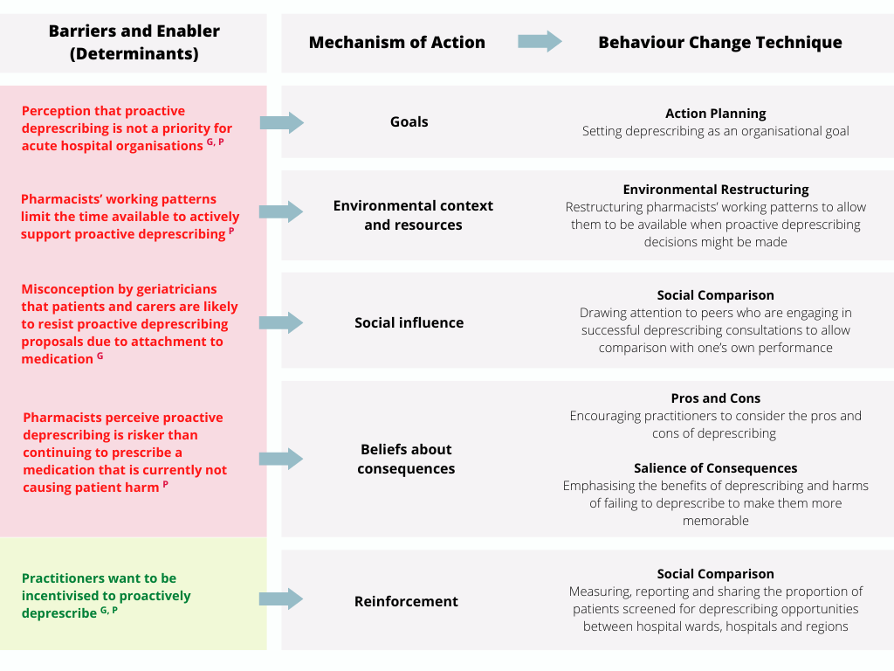Figure 1. Six BCTs selected from the hDIF to address the determinants to pharmacist and geriatrician proactive deprescribing behaviour in hospitals in England
^{G}Geriatrician determinant of deprescribing ^{P}Pharmacist determinant of deprescribing

To enable interventions to be effectively implemented and evaluated, BCTs require characterising in terms of their content (what is delivered), mode of delivery (how it is delivered) and duration/intensity (how much of it is delivered) (11). Interventions should also be designed to accommodate effective implementation across the diversity of complex systems and contexts to facilitate equity when scaling-up (12–14). Co-design facilitates incorporation of the required contextual insight through a partnership between the target audience who are the experts in the context, and researchers who are experts in designing theory-based interventions (15). Input from other stakeholders who are impacted by a change in target audience behaviour and who may have a local role in implementation supports development of an intervention that is more likely to be acceptable and implementable (12–15).
Fidelity is the extent to which an intervention is delivered as intended(16). Higher fidelity is associated with an increase in the likelihood of an intervention successfully changing behaviour (17). However, fidelity should be balanced against permitting a degree of flexibility to accommodate differences in contexts, such as available resources, configuration of staff and cultural norms (17–19).
This paper describes the process of co-designing and operationalising the content, mode of delivery and duration/intensity of the six BCTs to develop the CHARMER intervention(9).

Methods
We used a co-design approach with stakeholder panels from three National Health Service (NHS) acute hospitals in England to develop the CHARMER intervention. Geriatricians and pharmacists (the intervention target audience) and other relevant hospital staff who were likely to be involved in implementing the intervention, collaborated with the research team to design a prototype intervention. This process involved characterising the content, mode of delivery and duration/intensity of six BCTs selected by geriatricians and pharmacists from our previous study(9) to formulate a coherent and implementable intervention package. The study was undertaken between June and December 2021.
The Reporting Design Research (REDR) guidelines(20) have supported our reporting of the study (Appendix 1).
Patient and public involvement
While older people prescribed medicines and carers of such people are not the target audience of the CHARMER intervention, changes in geriatrician and pharmacist behaviour will have a direct impact on the care they receive. To facilitate development and evaluation of intervention content that is acceptable to the recipients of geriatrician and pharmacist care, five patient and public involvement (PPI) members work within the CHARMER research team. We used the Guidance for Reporting Involvement of Patients and the Public 2 short form (GRIPP 2-SF) to guide involvement and reporting of PPI input(21). A summary of PPI involvement is reported in Table 1.

[TABLE 1 HERE]

Recruitment of co-design panels
We employed a maximum variation approach (22) to purposively sample three hospitals from a sample of 27 hospitals that had expressed an interest in the CHARMER research programme. These hospitals represent contextual factors likely to influence implementation of the intervention: diversity in the patient population served, geographical location, maturity of IT infrastructure, and include a combination of larger teaching and smaller district general hospitals(23). This ensured equity in the intervention’s implementability across contextual variations arising from differing resources, patient and staff profiles, infrastructures, policies and practice.
We asked each hospital to establish a co-design panel with representation from pharmacists (n=3-4), geriatricians (n=3-4) and any other staff (n=3-4) who they felt were likely to be involved in implementation of the intervention e.g. IT staff and senior managers.
A gatekeeper at each hospital identified eligible staff and invited them to join the co-design panel via email. The email contained an information sheet detailing the study aims and a link to complete an online consent form which also requested their gender, age range and role. We worked with gatekeepers to monitor attrition during the study and they recruited new members to the panels where necessary to preserve representation of all stakeholders.
Hospitals were remunerated for participants’ time commitment to the research.
Co-design process
In designing the CHARMER intervention, we followed the five iterative steps of design thinking: empathise, define, ideate, prototype, and test (24). Our previous research reports the empathise (25) and define (9) phases and this manuscript reports the processes to ideate and prototype the intervention. Progress of the subsequent testing phase can be followed at [link omitted for anonymised review].
Figure 2 provides an overview of the co-design process undertaken between May and November 2021. Due to the Covid-19 restrictions, all workshops (n=7) took place virtually using Microsoft® Teams and Zoom®.

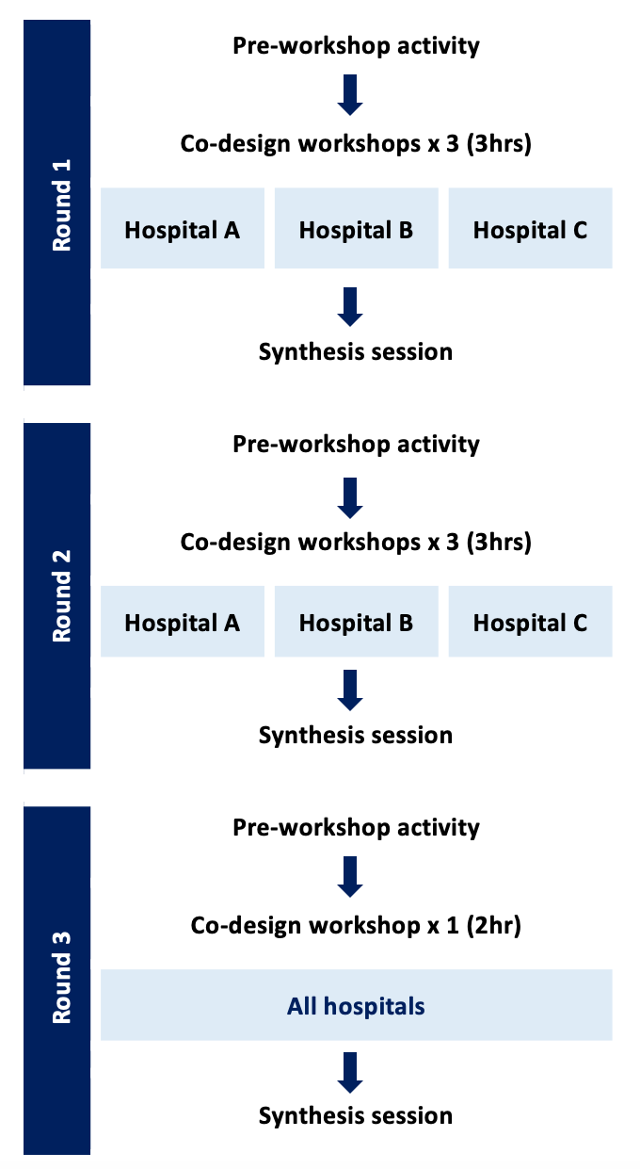
Figure 2. Co-design process

We piloted the co-design activities with geriatrician and pharmacist collaborators unfamiliar with the CHARMER research programme. This was in order to identify any difficulties with understanding and interpreting concepts and content. This also provided an opportunity to evaluate whether the data generated would address the aims of the study.
We undertook three rounds of (three-hour and two-hour) workshops facilitated by [omitted for anonymised review]. Additional members of the research team audio-recorded the workshops and took note of participants’ ideas.
Round 1
The first round aimed to generate ideas for the six BCTs. We worked with each hospital co-design panel independently to ensure we could identify and address issues affecting acceptability and feasibility of the intervention specific to that hospital.
Round 1 pre-workshop activity
We embedded a trigger film (26) introducing the barriers and enabler to deprescribing (25) and the six BCTs (6) into an online survey. Ahead of Round 1 workshops, we asked panel members to view the video and to record their initial ideas about how the BCTs could be operationalised at their hospital.
Round 1 workshops
To help guide the ideation process, we introduced geriatrician and pharmacist personas to present experiences expressed in a previous focus group study relating to the barriers and enabler(25) to deprescribing that the CHARMER intervention seeks to address (Supplementary file 1)(26). We then asked panel members to discuss how the barriers and enabler influence deprescribing practice through a journey mapping exercise, followed by brainstorming ideas for how the relevant BCT(s) to address them could be operationalised, emphasising free flow of ideas regardless of acceptability and feasibility at this stage. We then presented a summary of the pre-workshop activity ideas to generate further discussion. The discussion then focussed on evaluating the feasibility and acceptability of each idea.
Round 1 synthesis session
The research team which includes patient representatives, behavioural scientists, geriatricians and pharmacists, synthesised the BCT operationalisation ideas from the three hospitals into a matrix which presented the operationalisation idea, the content, duration/intensity and mode of delivery to populate for each BCT.
Round 2
The aim of the second round was to reach a consensus about which of the Round 1 BCT operationalisation ideas were most promising, and then refine their content, mode of delivery and duration/intensity.
Round 2 pre-workshop activity
We presented each BCT operationalisation idea from Round 1 to panel members in an online survey and asked them to rate each one according to their acceptability (to patients, carers and practitioners), deliverability (in terms of the cost and effort to implement the strategy in their hospital) and effectiveness (at addressing the barrier or enabler to deprescribing).
We collated the responses from the three hospitals and organised the BCT operationalisation ideas into the following categories: green = ≥70% ‘Yes’ vote across acceptability, deliverability and effectiveness, amber = ≥60%, and the remainder red (see Table 3 for results). We retained the results from each hospital site to allow for comparison against the overall ratings; in the event that a hospital’s rating differed to the collated results, panel members were given the opportunity to express any disagreements.
Round 2 workshops
We presented the categorised BCT operationalisation ideas and how these were rated during the pre-workshop activity to panel members and asked for their initial thoughts. This provided each hospital panel with an opportunity to express any disagreements about whether they felt any operationalisations could/could not be implemented in their hospital. We then asked them to select a maximum of two best candidate operationalisations for each of the six BCTs, which could be from the green, amber or red categories.
In order to maximise intervention efficiency, the second half of the workshop invited panel members to consider whether any overlap between BCT operationalisation ideas would lend to co-delivering several BCTs within one operationalisation.
To enable us to develop prototypes for best candidate BCT operationalisations, we asked panel members to expand on key design elements. This was guided by the Template for Intervention Description and Replication (TIDieR) (27) and covered the following: how the BCT operationalisations will be delivered, where they will occur, who will provide them, their duration and intensity, and what resources are required.
Round 2 synthesis session
We identified BCT operationalisations that were selected as the best candidates by all three hospital panels. We used them to populate the matrix with the key design elements and identified commonalities across panels for incorporation into BCT prototypes.
Members of the research team with relevant expertise and contextual insight developed BCT prototypes based on the matrix descriptions. For example, BCTs targeting geriatrician behaviour were assigned to geriatrician, patient representative and behavioural scientist members of the research team.
Round 3
The aim of the third round was to review and refine prototypes for each operationalised BCT at a joint workshop attended by all three co-design panels. This was to ensure that the intervention was refined and ratified in view of the diversity and contextual factors represented by the three hospitals(28).
Round 3 pre-workshop activity
We emailed panel members a link to access the operationalised BCT prototypes relevant to them and asked them to review them ahead of the workshop. For example, we asked geriatricians to watch the videos of geriatricians sharing their experiences of deprescribing, and asked pharmacists to review the ‘pros and cons workbook’ and watch the patient videos.
Round 3 workshop
We invited the panels to provide feedback and explored any remaining uncertainties relating to the potential efficacy, acceptability or feasibility of combining the six operationalised BCTs into the CHARMER intervention package.
Round 3 synthesis sessions
We refined the matrix based on the workshop feedback. Any outstanding uncertainties about the BCT operationalisations were explored with the wider CHARMER team with constant cross-referencing to the data generated at each round in the study.
A detailed specification for the CHARMER intervention and the fully operationalised BCTs were produced.

Results
Thirty-three co-design panel members participated across the three hospitals (17 geriatricians, 12 pharmacists and 4 other hospital staff). The median age range was 25-34 years and 23 (69%) were women. Table 2 provides the composition of the co-design panels across the workshops.
[TABLE 2 HERE]
Initial brainstorming at Round 1 led to 29 potential operationalisations for the six BCTs, which were rated in the pre-workshop survey for Round 2 (Table 3). This was refined to 17 during the Round 2 workshop, wherein each panel selected the best candidate operationalisations for their hospital. For each BCT, one operationalisation idea was selected as a best candidate by all three hospitals and these were therefore included in the CHARMER intervention. Figure 3 provides an overview of the final five-component CHARMER intervention. The evidence underpinning the development of these components is provided below.

[TABLE 3 HERE]

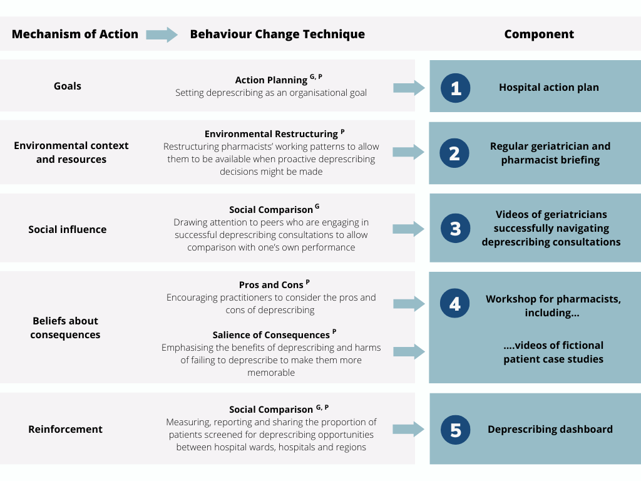Figure 3. Overview of the BCT operationalisations that comprise the five-component CHARMER intervention
^{G}Geriatrician Behaviour Change Technique ^{P}Pharmacist Behaviour Change Technique

Action Planning > Hospital action plan
There was agreement across the three hospitals that an action plan for proactive deprescribing initiated by the organisation’s senior leadership team was most likely to be effective in setting deprescribing as a high priority for the organisation. However, panel members were not confident that securing senior leadership’s engagement was feasible as deprescribing was perceived not to be a priority for acute hospitals. Whilst less impactful, they felt it would be more feasible to set an action plan at their department level (e.g. Pharmacy and Older People’s Medicine departments) because this was something that was already within their remit as senior members of these departments. It was agreed that as a minimum, the action plan should be at the department level with flexibility to permit this to be at the hospital organisation level if possible.
Pros and Cons and Salience of consequences > Workshop for pharmacists, including videos of fictional patient case studies
For pros and cons, there was agreement from the outset that addressing pharmacists’ concerns about the potential adverse consequences of deprescribing should be operationalised through either asynchronous e-Learning or synchronous training. However, as pharmacists already have to complete several e-Learning packages, panel members felt that this operationalisation could become another “tick box” exercise. It was therefore agreed that any training would be more effective if delivered via a synchronous workshop, either online or face-to-face. One of the workshop activities was structured around a patient case study, which enabled it to be delivered as a joint component with salience of consequences (below).
Panel members suggested that salient information about the consequences of deprescribing for patients should be delivered through automated computer pop-ups (for example, flagging high-risk medicines) or videos of fictional patient case studies. However, while information that might be contained in pop-ups derived from lists of potentially inappropriate medicines such as STOPP (29) and Beer’s (30) could provide just-in-time salient information, panel members were concerned that they would be disruptive in practice and ultimately ignored. Videos of fictional patient case studies were appealing because they could foster reflection on the longer-term benefits of deprescribing for patients that hospital pharmacists do not usually see within the limitations of a short admission. There was also a desire for a facilitated discussion between peers following watching the videos and so, as the two BCTs intended to address the same barrier, this operationalisation was incorporated into the pros and cons workshop.
Salience of consequences was also operationalised as a joint primary and secondary care meeting wherein geriatricians and pharmacists could hear from primary care colleagues of the positive outcomes arising from deprescribing in hospital. Panel members, however, discussed this joint meeting more as an approach to addressing issues of poor communication at transition of care. This operationalisation was therefore dropped at Round 3, as it was established during review by the research team that it was operating mainly via the mechanism of restructuring the environment rather than salience of consequences.
Social Comparison > Videos of geriatricians navigating deprescribing consultations
Two ideas were proposed around sharing of practice to operationalise social comparison to address the misconception that patients are resistant to deprescribing. These were a deprescribing ‘champion’ regularly presenting successful case studies or videos showing positive (fictional) deprescribing encounters between a geriatrician and a patient or relative. There were concerns that the champion could lead to demotivation if people perceived they were being benchmarked against an unrealistic standard. The fictional videos were therefore taken forward as the chosen operationalisation. In their feedback on the prototype videos, panel members asked for the scenarios to explicitly include tips on how to navigate challenging deprescribing consultations, which were incorporated into the final component.
Environmental Restructuring > Regular geriatrician and pharmacist briefing
Ideas for operationalising environmental restructuring converged around strategies to enable a face-to-face interaction between pharmacists and geriatricians to discuss potential deprescribing opportunities. Initially, pharmacists attending existing multidisciplinary team ward rounds was proposed. However, as deprescribing decisions would only constitute a small part of ward round activities, the panels felt that mandating this was inefficient for hospitals where this was not already routine practice. It could also lead to inequity resulting from variation in pharmacist capacity in different hospitals. Additionally, some pharmacists said that they would need training before joining multidisciplinary team ward rounds to feel confident to contribute. A weekly protected time slot for pharmacists to brief geriatricians on potential deprescribing opportunities was therefore the final operationalisation for this BCT, with optional additional protected time for pharmacists to prepare before the briefing if needed.
Social Comparison > Deprescribing dashboard
There was agreement from the outset that operationalising social comparison to incentivise deprescribing would comprise a national dashboard reporting a range of metrics to enable hospitals to monitor their own performance and benchmark against other hospitals. Exactly what metrics would be reported dominated the remaining discussions for this BCT. All three hospitals coalesced around three categories of metric to provide an overall picture of performance: 1) a process measure that captures an indication of the work undertaken to deprescribe, 2) a performance measure and 3) a measure of the quality of deprescribing. For the process measure, it was important that this captured work undertaken even if it is determined that continuing to prescribe a medicine is the most appropriate course of action. The number of deprescribing discussions with patients and/or relatives logged by prescribers was therefore the agreed measure. For the performance measure, the number of medicines stopped was the chosen measure. The number of medicines that required re-prescribing within 30 days of a patient being discharged was the selected quality measure. This is because deprescribing in hospital that subsequently requires medicines to be re-prescribed by primary care was agreed to constitute poor quality care.

Discussion
Through integrating evidence and behaviour change theory into the co-design process, we have developed an intervention package deemed implementable by the target audience and the hospital team members required to support implementation. The six BCTs have been operationalised into a five-component intervention to address determinants related to opportunity and motivation for geriatricians and pharmacists to proactively deprescribe.
To prepare geriatricians and pharmacists to proactively deprescribe, the CHARMER intervention comprises: an organisational action plan to prioritise proactive deprescribing; a workshop including patient case studies for pharmacists to address negative beliefs about the consequences of proactive deprescribing; a video for geriatricians to address a misconception that patients and families are resistant to proactive deprescribing proposals; regular briefings to provide protected time for pharmacists to discuss proactive deprescribing opportunities with geriatricians; and a national deprescribing dashboard to provide an incentive by reporting salient metrics to geriatricians and pharmacists on their proactive deprescribing activities.
Using evidence regarding the determinants of the behaviour that require addressing (25), coupled with behaviour change theory (31) to underpin the co-design process, is a key strength of this study. This approach has not only translated existing knowledge into a fully operationalised intervention (i.e. leading to practical deprescribing efforts)(32) but has ensured that the CHARMER intervention components are faithful to the underpinning mechanisms of action of behaviour change. This was demonstrated by the two potential operationalisations that were not retained due to deviating from the intended mechanism of action for the CHARMER intervention (25). The initially proposed operationalisation of automated deprescribing pop-ups was selected to address negative beliefs about the consequences of deprescribing (9) and thus the intended BCT mechanism of action was salience of consequences. However, automatic pop-ups target the memory, attention and decision processes mechanism (31). There is a wealth of literature demonstrating that interventions that are designed to prompt a behaviour about which people have ingrained reservations are ineffective, including in large deprescribing trials (33,34). The proposal to operationalise Salience of consequences as a forum between primary and secondary care was also dropped as it did not operate via the intended mechanism (16).
The workshop discussions did however highlight the potential and important role of primary care in CHARMER; namely, how any increase in hospital proactive deprescribing due to the CHARMER intervention will have an impact on primary care. In response to the workshop feedback, and in order to understand the effects of CHARMER on primary care, we established a Primary Care Advisory Group consisting of chief and senior clinical pharmacists, medical directors and senior general practitioners. The group will meet twice yearly at key time points in the CHARMER project. The focus of the first meetings are to ensure that any increase in hospital proactive deprescribing activity is effectively communicated with primary care.
It is widely recognised that implementation in a complex system such as a hospital organisation requires participation and action from people other than the intervention target audience (35). Co-designing the CHARMER intervention with geriatricians and pharmacists ensures acceptability to the target audience (36). Permitting hospitals to invite other key stakeholders at their discretion to co-design the intervention also enabled identification of who else needs to be involved and what work they would need to do to support CHARMER intervention implementation (37). Together with representatives from the target audience, these other key stakeholders constitute a local implementation team, whose responsibility is to agree local adaptations and oversee implementation (38).
The workshop for pharmacists, video for geriatricians, and the dashboard have been co-designed as components of the CHARMER intervention that have limited flexibility for implementation. However, there is flexibility in how the regular briefings and hospital action plan can be operationalised by hospitals in recognition of the diversity of resource available (17). The regular briefing can be fulfilled by pharmacists attending multidisciplinary ward rounds if this is already standard practice. Where it is not, a regular protected time slot between a pharmacist and geriatrician is also permitted. The latter also circumvents the barrier that some pharmacists do not feel confident to contribute to a multidisciplinary ward round without prior training. Similarly, the hospital action plan can either be established at the organisational level, which may be more effective, or at the departmental level, which is likely to be more feasible. This scope for some adaptation is necessary when developing scalable interventions because it permits local contexts to implement according to what is achievable with the resources available (39). Moreover, by permitting local ownership of the intervention, adaptation increases the likelihood that the implementation is sustained (40).
Contextual factors may present barriers and enablers to implementation of an intervention (41,42). Purposively sampling for hospital contextual factors permitted representation of the ‘extremes’ of factors likely to impact CHARMER implementation and thus an intervention to accommodate for these. While it is possible that this method may result in an intervention that is not fully optimised for some hospitals (i.e. those that do not fall within these ‘extremes’), incorporating an understanding of how a range of factors are likely to influence intervention implementation is essential to achieving equity and scalability. Co-designing the CHARMER intervention with three diverse hospitals fulfils this requirement. This key strength was made possible owing to the virtual nature of the workshops, which permitted convening a geographically diverse group of stakeholders. Establishing separate co-design panels at the three hospitals to work independently in phases one and two was a key requirement to ensure that no initial ideas critical to implementability were masked by virtue of a single panel (43).
While panel members were able to review and refine the BCT prototypes, they did not have the opportunity to comment on the final iterations of the BCTs developed after the final workshop. This may impact on the potential efficacy, acceptability or feasibility of the BCTs, however, the next phase in the CHARMER programme of research is to feasibility test the intervention and trial processes to inform any necessary refinements (7). This process will similarly be undertaken across diverse contexts to test the CHARMER intervention’s theoretical implementability (44).

Conclusions

This study illustrates the importance of integrating evidence, behaviour change theory and co-design methodology into the design of hospital deprescribing intervention. In doing so, we have developed the CHARMER intervention components to be faithful to the underpinning mechanisms of action of deprescribing behaviour change and developed an intervention deemed feasible by the target audience of geriatricians and pharmacists, and hospital staff likely to be involved in supporting implementation. This approach departs from existing deprescribing interventions in that it increases the likelihood that deprescribing activity resulting from the intervention is sustained beyond the trial period.

References

1. Gallagher P, Lang PO, Cherubini A, Topinková E, Cruz-Jentoft A, Montero Errasquín B, et al. Prevalence of potentially inappropriate prescribing in an acutely ill population of older patients admitted to six European hospitals. European Journal of Clinical Pharmacology. 2011;67(11):1175–88.
2. Medication Without Harm [Internet]. World Health Organisation; 2017 [cited 2022 Jan 21]. Available from: https://www.who.int/publications/i/item/WHO-HIS-SDS-2017.6
3. ScottIA HS, Reeve E, Potter K, Le Couteur D, Rigby D. Reducing Inappropriate Polypharmacy. JAMA Intern Med. 2015;175:827.
4. Scott S, Clark A, Farrow C, May H, Patel M, Twigg MJ, et al. Deprescribing admission medication at a UK teaching hospital; a report on quantity and nature of activity. International journal of clinical pharmacy. 2018;40(5):991–6.
5. Anderson K, Stowasser D, Freeman C, Scott I. Prescriber barriers and enablers to minimising potentially inappropriate medications in adults: a systematic review and thematic synthesis. BMJ open. 2014;4(12):e006544.
6. Scott S, Twigg MJ, Clark A, Farrow C, May H, Patel M, et al. Development of a hospital deprescribing implementation framework: A focus group study with geriatricians and pharmacists. Age and ageing. 2020;49(1):102–10.
7. Skivington K, Matthews L, Simpson SA, Craig P, Baird J, Blazeby JM, et al. A new framework for developing and evaluating complex interventions: update of Medical Research Council guidance. bmj. 2021;374.
8. Michie S, Wood CE, Johnston M, Abraham C, Francis J, Hardeman W. Behaviour change techniques: the development and evaluation of a taxonomic method for reporting and describing behaviour change interventions (a suite of five studies involving consensus methods, randomised controlled trials and analysis of qualitative data). Health technology assessment. 2015;19(99).
9. Scott S, May H, Patel M, Wright DJ, Bhattacharya D. A practitioner behaviour change intervention for deprescribing in the hospital setting. Age and ageing. 2021;50(2):581–6.
10. Thillainadesan J, Gnjidic D, Green S, Hilmer SN. Impact of deprescribing interventions in older hospitalised patients on prescribing and clinical outcomes: a systematic review of randomised trials. Drugs & aging. 2018;35(4):303–19.
11. van Achterberg T, Huisman-de Waal GGJ, Ketelaar NABM, Oostendorp RA, Jacobs JE, Wollersheim HCH. How to promote healthy behaviours in patients? An overview of evidence for behaviour change techniques. Health Promot Int. 2011 Jun;26(2):148–62.
12. Power J, Gilmore B, Vallières F, Toomey E, Mannan H, McAuliffe E. Adapting health interventions for local fit when scaling-up: a realist review protocol. BMJ open. 2019;9(1):e022084.
13. Simmons R, Fajans P, Ghiron L. Scaling Up Health Service Delivery: From Pilot Innovations to Policies and Programmes. World Health Organization; 2007. 206 p.
14. Barker PM, Reid A, Schall MW. A framework for scaling up health interventions: lessons from large-scale improvement initiatives in Africa. Implementation Science. 2016 Jan 29;11(1):12.
15. Donetto S, Pierri P, Tsianakas V, Robert G. Experience-based Co-design and Healthcare Improvement: Realizing Participatory Design in the Public Sector. The Design Journal. 2015 Jun 1;18(2):227–48.
16. Gearing RE, El-Bassel N, Ghesquiere A, Baldwin S, Gillies J, Ngeow E. Major ingredients of fidelity: A review and scientific guide to improving quality of intervention research implementation. Clinical Psychology Review. 2011 Feb 1;31(1):79–88.
17. Borrelli B. The assessment, monitoring, and enhancement of treatment fidelity in public health clinical trials. Journal of Public Health Dentistry. 2011;71(s1):S52–63.
18. Resnick B, Bellg AJ, Borrelli B, De Francesco C, Breger R, Hecht J, et al. Examples of implementation and evaluation of treatment fidelity in the BCC studies: where we are and where we need to go. Annals of Behavioral Medicine. 2005;29(2):46–54.
19. Prestwich A, Sniehotta FF, Whittington C, Dombrowski SU, Rogers L, Michie S. Does theory influence the effectiveness of health behavior interventions? Meta-analysis. Health psychology. 2014;33(5):465.
20. Bazzano AN, Yan SD, Martin J, Mulhern E, Brown E, LaFond A, et al. Improving the reporting of health research involving design: a proposed guideline. BMJ Global Health. 2020;5(2):e002248.
21. Staniszewska S, Brett J, Simera I, Seers K, Mockford C, Goodlad S, et al. GRIPP2 reporting checklists: tools to improve reporting of patient and public involvement in research. bmj. 2017;358.
22. Palinkas LA, Horwitz SM, Green CA, Wisdom JP, Duan N, Hoagwood K. Purposeful sampling for qualitative data collection and analysis in mixed method implementation research. Administration and policy in mental health and mental health services research. 2015;42(5):533–44.
23. Durlak JA, DuPre EP. Implementation matters: A review of research on the influence of implementation on program outcomes and the factors affecting implementation. American journal of community psychology. 2008;41(3):327–50.
24. Plattner H, Meinel C, Leifer L. Design thinking: understand–improve–apply. Springer Science & Business Media; 2010.
25. Scott S, Twigg MJ, Clark A, Farrow C, May H, Patel M, et al. Development of a hospital deprescribing implementation framework: a focus group study with geriatricians and pharmacists. Age and ageing. 2020;49(1):102–10.
26. Grindell C, Coates E, Croot L, O’Cathain A. The use of co-production, co-design and co-creation to mobilise knowledge in the management of health conditions: a systematic review. BMC Health Services Research. 2022 Jul 7;22(1):877.
27. Hoffmann TC, Glasziou PP, Boutron I, Milne R, Perera R, Moher D, et al. Better reporting of interventions: template for intervention description and replication (TIDieR) checklist and guide. Bmj. 2014;348.
28. Law RJ, Williams L, Langley J, Burton C, Hall B, Hiscock J, et al. ‘Function First—Be Active, Stay Independent’—promoting physical activity and physical function in people with long-term conditions by primary care: a protocol for a realist synthesis with embedded co-production and co-design. BMJ open. 2020;10(2):e035686.
29. O’Mahony D, O’Sullivan D, Byrne S, O’Connor MN, Ryan C, Gallagher P. STOPP/START criteria for potentially inappropriate prescribing in older people: version 2. Age and ageing. 2014;44(2):213–8.
30. Fick DM, Cooper JW, Wade WE, Waller JL, Maclean JR, Beers MH. Updating the Beers Criteria for Potentially Inappropriate Medication Use in Older Adults: Results of a US Consensus Panel of Experts. Archives of Internal Medicine. 2003 Dec 8;163(22):2716–24.
31. Atkins L, Francis J, Islam R, O’Connor D, Patey A, Ivers N, et al. A guide to using the Theoretical Domains Framework of behaviour change to investigate implementation problems. Implementation Science. 2017;12(1):1–18.
32. Thompson W, Reeve E. Deprescribing: Moving beyond barriers and facilitators. Research in Social and Administrative Pharmacy. 2022 Mar 1;18(3):2547–9.
33. Dalton K, O’Mahony D, Cullinan S, Byrne S. Factors affecting prescriber implementation of computer-generated medication recommendations in the SENATOR trial: a qualitative study. Drugs & Aging. 2020;37(9):703–13.
34. O’Mahony D, Gudmundsson A, Soiza RL, Petrovic M, Cruz-Jentoft AJ, Cherubini A, et al. Prevention of adverse drug reactions in hospitalized older patients with multi-morbidity and polypharmacy: the SENATOR* randomized controlled clinical trial. Age and Ageing. 2020;49(4):605–14.
35. May CR, Mair F, Finch T, MacFarlane A, Dowrick C, Treweek S, et al. Development of a theory of implementation and integration: Normalization Process Theory. Implementation Science. 2009 May 21;4(1):29.
36. Donetto S, Pierri P, Tsianakas V, Robert G. Experience-based co-design and healthcare improvement: realizing participatory design in the public sector. The Design Journal. 2015;18(2):227–48.
37. Murray E, Treweek S, Pope C, MacFarlane A, Ballini L, Dowrick C, et al. Normalisation process theory: a framework for developing, evaluating and implementing complex interventions. BMC Med. 2010 Oct 20;8(1):63.
38. Rycroft-Malone J. The PARIHS framework—a framework for guiding the implementation of evidence-based practice. Journal of nursing care quality. 2004;19(4):297–304.
39. Cutbush S, Gibbs D, Krieger K, Clinton-Sherrod M, Miller S. Implementers’ Perspectives on Fidelity of Implementation: “Teach Every Single Part” or “Be Right With the Curriculum”? Health promotion practice. 2017;18(2):275–82.
40. Hailemariam M, Bustos T, Montgomery B, Barajas R, Evans LB, Drahota A. Evidence-based intervention sustainability strategies: a systematic review. Implementation Science. 2019;14(1):1–12.
41. May CR, Johnson M, Finch T. Implementation, context and complexity. Implementation Science. 2016 Oct 19;11(1):141.
42. Alharthi M, Wright D, Scott S, Birt L. Barriers and enablers to deprescribing for older people in care homes: The theory-based perspectives of pharmacist independent prescribers. Research in Social and Administrative Pharmacy [Internet]. 2023 Jan 31 [cited 2023 Feb 7]; Available from: https://www.sciencedirect.com/science/article/pii/S1551741123000335
43. Klaic M, Kapp S, Hudson P, Chapman W, Denehy L, Story D, et al. Implementability of healthcare interventions: an overview of reviews and development of a conceptual framework. Implementation Science. 2022 Jan 27;17(1):10.
44. Geerligs L, Shepherd HL, Rankin NM, Masya L, Shaw JM, Price MA, et al. The value of real-world testing: a qualitative feasibility study to explore staff and organisational barriers and strategies to support implementation of a clinical pathway for the management of anxiety and depression in adult cancer patients. Pilot and Feasibility Studies. 2020 Jul 29;6(1):109.

Declarations

Ethics approval and consent to participate
[Omitted for anonymised review]

Consent for publication
Not applicable.

Availability of data and materials
All relevant materials with the exception of the matrix are available within the manuscript and its supplementary files. The matrix, which includes confidential details regarding the design elements (the content, duration/intensity and mode of delivery for each Behaviour Change Technique operationalisation) will be available on the CHARMER website once the definitive trial has been completed. This is to preserve the intervention’s innovation.

Competing interests
The authors declare that they have no competing interests.

Funding
[Omitted for anonymised review]

Authors' contributions
[Omitted for anonymised review]

Acknowledgements
The authors would like to thank all workshop participants. We thank all participating sites and the principle investigators at these sites for identifying participants for the study, in particularly difficult times. We also thank the NIHR Clinical Research Network for supporting recruitment.

Table 1. PPI involvement in co-designing the CHARMER intervention reported using GRIPP 2-SF
Section and topic | Item
1. Aim/s | To collaboratively involve older people prescribed medicines and cares of such people in the development of the CHARMER intervention.  To ensure the CHARMER intervention is acceptable to the recipients of a change in care delivered by geriatricians and pharmacists exposed to the CHARMER intervention.
2. Methods | Two PPI of the five CHARMER PPI members joined the sub-research team for this study and were involved in all stages of its development, from research design to data collection through to data analysis. The PPI team members contributed to the design of the co-design workshops in terms of structure and content, attended and supported the facilitation of all workshops (n=7) and attended all synthesis sessions. Attendance at the workshops meant that PPI team members also took part in the selection and design of the BCTs alongside the other stakeholders. PPI team members attended synthesis sessions in between workshops, assisting in the collation and interpretation of the workshop data.  The three other CHARMER PPI members also provided input at programme management meetings along with other members of the wider research team.
3. Results | PPI team members contributed to the development of the CHARMER intervention in several ways. These include:  - Highlighting the importance of PPI team members attending all co-design workshops (rather than the final two rounds of workshops, as originally planned). This ensured that the impact of the CHARMER intervention on patients and carers was fully considered from the outset.  - Identifying 'patient touchpoints' in the deprescribing process prior to the first round of co-design workshops. This ensured the researchers were familiar with the patient perspective prior to the workshop and that these touchpoints were considered by the other stakeholders when designing the BCTs.  - Contributing to the development of the patient and carer case studies (intervention component four) in terms of script development and production (such as set design and acting directions). This ensured the case studies represented the patient voice.  - Contributing to all synthesis sessions and analysis of the pre-workshop and workshop data (see Methods and Results).  - Contributing to the edits of the manuscript.
4. Discussion | The success and effectiveness of PPI in this study is attributable to a number of factors; firstly, the PPI team members were already embedded in the wider CHARMER programme of research, meaning they were familiar with its aims and context and available to contribute to (and shape) this research from the outset. In addition, the research team held weekly meetings which provided an opportunity for PPI team members to have regular input and ask questions. The researchers also provided training and support where necessary (e.g. on how PPI team members could contribute to and support facilitation of the co-design workshops). These factors established a collaborative environment and ensured that PPI were fully embedded into the research team throughout the study.  An advantage of PPI team members being present in all co-design workshops was that they were part of process from the outset; however, as a practitioner behaviour change intervention, their presence may have inhibited free and open sharing of concerns and working practices among other stakeholders. Furthermore, the first round of workshops was amenable to PPI contribution as it involved co-design panels brainstorming ideas for the BCTs. The second and third rounds of workshops involved stakeholders refining the BCTs according to their acceptability, deliverability and effectiveness in their specific hospital settings, thus PPI contribution at this stage was more difficult.
5. Reflections | The PPI team members in this study successfully contributed to the co-design of the CHARMER intervention. A key challenge was ensuring that PPI team members were able to contribute to the workshop activities and provide input on the design of the BCTs where these were focused on establishing their acceptability, deliverability and effectiveness in hospital and from a practitioner perspective. However, PPI attendance at the synthesis sessions (data analysis stage) and their role as co-facilitators of the workshops went some way in remedying this limitation.

Table 2: Overview of co-design panel member composition across workshops
 | Role | Hospital A  Representing a large hospital with mature IT infrastructure | Hospital B  Representing a smaller district general hospital | Hospital C  Representing diversity in patient population
Workshop 1 | Geriatricians | 3 | 4 | 3
 | Pharmacists | 4 | 3 | 4
 | Other stakeholders | 2 | 2* | 1
Total participants at Round 1 |  | 9 | 7 | 8
Workshop 2 | Geriatricians | 5 | 4 | 3
 | Pharmacists | 3 | 4 | 3
 | Other stakeholders | 1 | 2* | 2
Total participants at Round 2 |  | 9 | 8 | 8
Workshop 3 | Geriatricians | 5 | 2 | 1
 | Pharmacists | 4 | 3 | 2
 | Other stakeholders | 1 | 1* | 1
Total participants at Round 3 |  | 10 | 5 | 4
Total participants per hospital |  | 14 | 8 | 11

‘Other stakeholders’ included Improvement and Transformation Managers, an Advanced Nurse Practitioner and an IT Business Change Manager. *Dual role, two geriatricians also acting as Improvement and Transformation Managers.

Table 3. Operationalisations, ratings and selection of the BCTs at Round 1 and Round 2
Behaviour Change Technique operationalisations | Round 1 selections |  |  | Round 2 selections
 | Hospital: |  |  | Hospital:
Pros and Cons & Salience of Consequences | A | B | C | A | B | C
Real-life patient cases from own trust of harms arising from missed deprescribing opportunities | ✓ | ✓ |  |  | ✓
Training including evidence about the efficacy and harms of medicines |  |  | ✓
Primary:secondary care forum to share experiences of the outcomes of deprescribing | ✓ |  |  | ✓ | ✓ | ✓
Training including patient case studies | ✓ | ✓ | ✓ | ✓ | ✓ | ✓
Incorporate harms and benefits of prescribing into existing guidelines/checklists |  |  | ✓
Incorporate automated prompts into electronic systems to flag high risk patients for review | ✓ | ✓ | ✓ |  |  | ✓
Convene Schwartz Rounds to talk about the emotional aspects of deprescribing | ✓ | ✓
Pop ups highlighting the pros and cons of continuing to prescribe in real time |  |  | ✓
Mandatory to record indications and patient perceptions of all medicines |  |  | ✓
Training including information about carbon footprint of medicines |  |  | ✓
Environmental Restructuring
Earlier starts and pharmacists attending ward round once weekly | ✓ | ✓ | ✓ | ✓ | ✓ | ✓
Earlier starts and pharmacists attending board round once weekly |  | ✓
Include proactive deprescribing into pharmacist job descriptions
Greater/different use of pharmacy technicians to liberate pharmacist time | ✓ |  | ✓ | ✓ |  | ✓
Include proactive deprescribing into ward/board rounds |  | ✓ |  |  | ✓
Agree a process for prioritising patients for review to identify proactive deprescribing opportunities |  |  | ✓ |  | ✓
Regular activity for pharmacists and ward teams to discuss proactive deprescribing opportunities |  | ✓
Social Comparison
Select geriatricians who are successfully initiating deprescribing discussions to share their experiences | ✓ |  |  | ✓
Provide real-life patient case studies of successful deprescribing discussions | ✓ | ✓ | ✓ | ✓ | ✓ | ✓
Geriatrician buddy system enabling comparison with peers |  |  | ✓
Action Planning
Normalising deprescribing as part of the patient journey, e.g. like checking weight on admission | ✓ | ✓ | ✓ | ✓
Raise the profile of deprescribing through posters in the hospital targeting patients |  |  | ✓ |  | ✓
Formulate an action plan specifying who is responsible for deprescribing and incorporate deprescribing into relevant policies | ✓ | ✓ | ✓ | ✓ | ✓ | ✓
Restructure staff daily tasks/job descriptions to specifically include deprescribing |  | ✓ | ✓ | ✓
Nominate a trust deprescribing lead, e.g. someone on the hospital board | ✓ |  |  | ✓
Social Comparison
National, regional, local level deprescribing activity data available for benchmarking | ✓ | ✓ | ✓ | ✓ | ✓ | ✓
Presentation of deprescribing success stories at risk and audit meetings |  |  | ✓ |  | ✓
Share excellence in deprescribing practice nationally, regionally and locally | ✓
Patient deprescribing feedback questionnaires X weeks after admission reported back to practitioner | ✓ |  | ✓

Green = ≥70% ‘Yes’ vote across acceptability, deliverability and effectiveness, amber = ≥60%, and the remainder red at Round 2 pre-workshop survey across all three hospitals.
Hospital A represented a large hospital with mature IT infrastructure; Hospital B represented a smaller district general hospital; Hospital C represented diversity in patient population.

