Half-Metallic Bandgap Measurement Using Circularly-Polarised Infrared Light
Tariq F. Alhuwaymel,^{1),a)} Takahide Kubota,^{2),3).b)} Jun-young Kim,^{4),c)} Koki Takanashi ^{2),3),5)} and Atsufumi Hirohata ¹⁾
¹⁾ Department of Electronic Engineering, University of York, York YO10 5DD, United Kingdom
²⁾ Institute for Materials Research, Tohoku University, Sendai 980-8577, Japan
³⁾ Center for Spintronics Research Network, Tohoku University, Sendai 980-8577, Japan
⁴⁾ Department of Physics, University of York, York YO10 5DD, United Kingdom
⁵⁾ Center for Science and Innovation in Spintronics, Core Research Cluster, Tohoku University, Sendai 980-8577, Japan
^{a)} Present address: National Center for Nanotechnology and Semiconductors, King Abdulaziz City for Science and Technology (KACST), Riyadh 11442, Saudi Arabia
^{b)} Present address: Advanced Spintronics Medical Engineering (ASPIME), Graduate School of Engineering, Tohoku University, Sendai 980-0845, Japan
^{c)} Present address: Institute of Materials Research and Engineering (IMRE), Agency for Science, Technology and Research, 138632, Singapore

Abstract
One avenue towards next generation spintronic devices is to develop half-metallic ferromagnets with 100% spin polarisation and Curie temperature above room temperature. Half-metallic ferromagnets have unique density of states, where the majority spins are metallic but the minority spins are semiconducting with the Fermi level lying within an energy gap. To date, the half-metallic bandgap has been predominantly estimated using Jullière’s formula in a magnetic tunnel junction or measured by the Andreev reflection at low temperature, both of which are very sensitive to the surface/interface spin polarisation. Alternative optical methods such as photoemission have also been employed but with a complicated and expensive set-up. In this study, we developed and optimised a new technique to directly measure the half-metallic bandgap by introducing circularly-polarised infrared light to excite minority spins. The absorption of the light represents the bandgap under a magnetic field to saturate the magnetisation of a sample. This technique can be used to provide simple evaluation of a half-metallic film.

1. Introduction
Spintronics is an emerging field that aims to realise high-performance electronic devices by utilising electron spins which used to be ignored in the conventional electronics ‎[1]. Recently, tunnelling magnetoresistance (TMR) has been implemented in a read head of hard disk drives and a cell of magnetic random access memories for example ‎[2]. These spintronic devices are relied on a resistance change between their parallel and antiparallel configurations of the TMR junctions consisting of ferromagnet 1/tunnel barrier/ferromagnet 2. The change is defined as the TMR ratio = 2P₁P₂ / (1 – P₁P₂), where P₁ and P₂ are the spin polarisation of the ferromagnetic layers 1 and 2, respectively. P is defined as the difference between the number of up- and down-spin electrons at the Fermi level E_{F} as follows:
$P =\frac{N_{↑} \left(E_{F}\right)- N_{↓ }(E_{F})}{N_{↑} \left(E_{F}\right)+ N_{↓ }(E_{F})} ,$ (1)
where N↑ and N↓ are the densities of the majority and minority electrons at E_{F}, respectively.
In order to achieve a magnetic switch, typically > 1,000% TMR ratios, to replace the conventional transistor, band matching in a TMR junction with a MgO barrier ‎[3],‎[4],‎[5],‎[6],[7] and the development of 100% spin-polarised materials ‎[8],[9] have been intensively investigated. For the latter approach, the presence of a bandgap only in one spin band at E_{F} holds the key to exhibit 100% spin polarisation. Until recently P has been estimated using Julliere’s formula in a magnetic tunnel junction ‎[10] or measured by the Andreev reflection ‎[11], both of which are very sensitive to surface/interface spin polarisation. Several other methods, such as a tunnel contact with a superconductor ‎[12], spin-resolved photoemission ‎[13] and optical pump-probe ‎[14] techniques have been reported. However, these techniques require either low temperature or complicated setups. It is therefore critical to develop a new simple technique to measure the half-metallic bandgaps.
In this study, we develop a new technique to directly measure the bandgap at room temperature. In our measurement, circularly-polarised infrared (IR) light excites the valence-band electrons to the conduction band across the bandgap. Due to both viability and simplicity, a reflection mode has been selected to measure the changes in the reflected signals from the sample surface and these signals are measured to evaluate the presence of a bandgap. This developed set-up can also be used to measure the bandgap electrically by detecting the change in the four-point-probe signals induced by the optical absorption at elevating temperature.

2. Bandgap Measurement Setup
We have recently developed a new experimental setup to measure the bandgap of half-metallic ferromagnets at elevating temperature using a cryostat with optical windows. The setup was based on spectroscopic measurement techniques with a range of photon energy that has been widely used to measure semiconductor bandgaps. According to the optical selection rule, right (left) circularly-polarised light can excite up- (down-) spin electrons from the valence band to the conduction band in a semiconducting bandgap ‎[15]. We adopt this rule to a half-metallic ferromagnet in this study, exciting spin-polarised electrons in the minority bandgap. This setup can utilise two measurement configurations; reflection and transmission modes. The reflection mode was preferred and used due to its simplicity as compared to the transmission method ‎[16]. Our technique offers a non-contact and non-destructive spectroscopic technique to investigate the electronic structure of materials as similar to cathode luminescence (CL) and photoluminescence (PL). However, unlike typical CL and PL measurements, our technique can be operated at relatively low photon energy due to the optimum conditions used as detailed below.

(A) Wavelength and Optics
Heusler alloy films [17], one of major half-metallic ferromagnets [17],‎[18], possess their bandgaps only for one of their spin density of states as theoretically calculated and experimentally measured. The bandgaps of the most Heusler alloy films were found to be in the range of ~ 0.062 and 0.62 eV (corresponding wavelength in the range of 2 ~ 20 µm) ‎[18]. In order to cover this wavelength range, an IR lamp (LOT-Oriel, LSB150) was selected due to its wide wavelength coverage (between 1 and 24 µm) and its high emissivity (> 60%). This wavelength range corresponds to the photon energy between 1.24 and 0.052 eV, which covers the aforementioned bandgaps. This lamp consists of a coil made of an oxidation-resistant wire to emit IR light at high temperature. It features a 10 W power and a very constant emissivity profile ‎[19].
The lamp was used in conjunction with a reflector mirror to intensify and to precisely adjust the light direction. The mirror was positioned so that the monochromator (Horiba Scientific, iHR320) could receive the maximum amount of reflection as depicted in Fig. 1. With the aperture of < 1 nm, the monochromator achieved great controllability of ± 0.20 nm in wavelength. In order to cover the wavelength range between 3 and 20 µm with reasonable efficiency between ~ 40 and 80%, two diffraction gratings (Horiba Scientific, 51031 and 51038) were used ‎[20],‎[21]. The wavelength at which these gratings were switched was 9.5 µm.
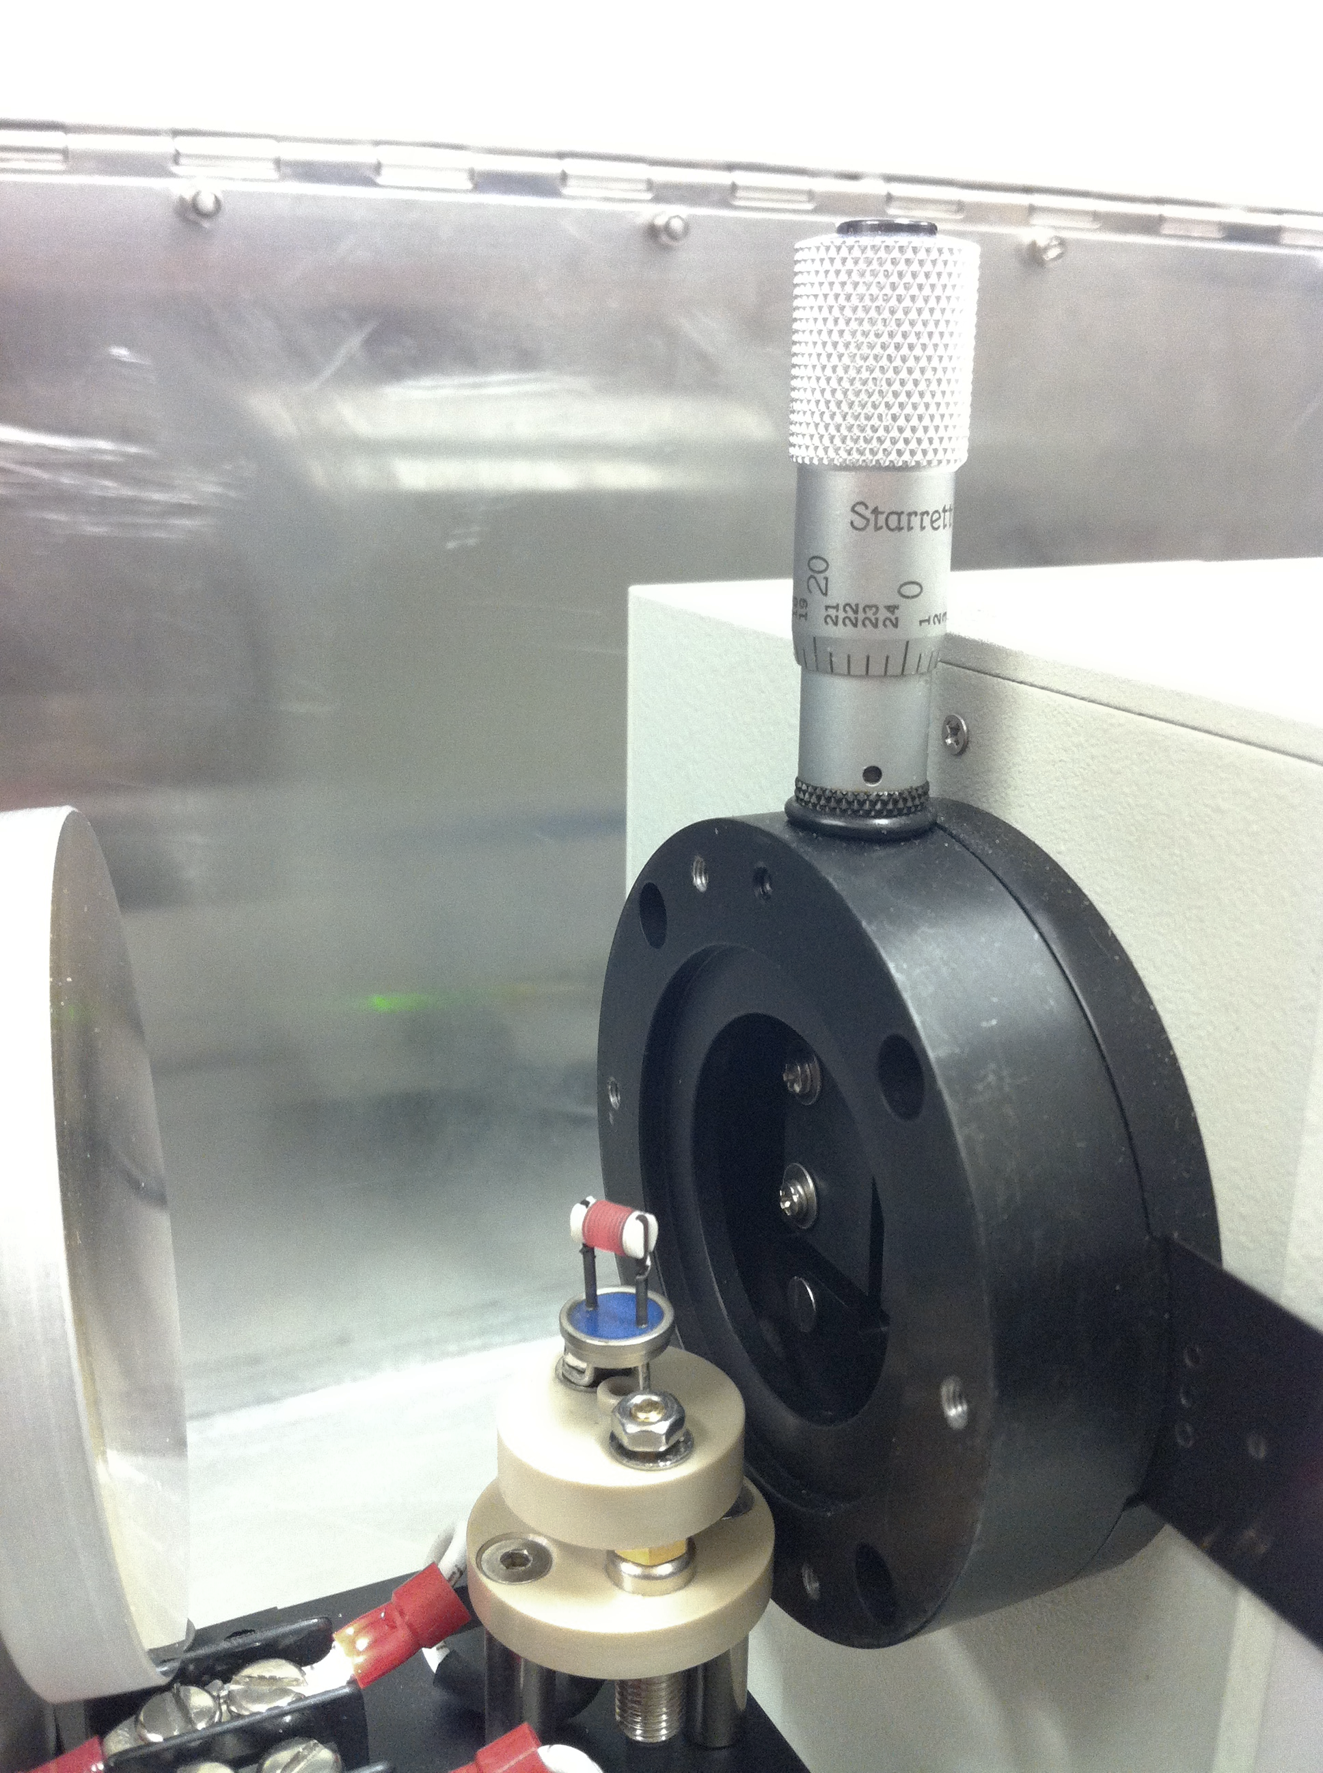
Fig. 1: Configuration of the IR lamp, the reflector mirror and the monochromator ‎[22]. The IR source is placed on the holder at the centre. IR light propagating to the left is reflected by the mirror placed to maximise the inputs to the monochrometer on the right. The distance between the mirror and the monochrometer apature is set as 5 cm.

(B) Lock-In Detection
In order to generate pulsed IR light, an optical chopper (Signal Recovery, 197) was used. The chopper covered the frequency range between 15 and 3000 Hz. For ideal lock-in detection, the higher frequencies (> 1.0 kHz) provided a well-defined square pulse form (Signal Recovery, 7265) [see Fig. 2(a)]. However, the higher frequencies exhibited poor signal-to-noise ratios (SNR) of approximately 26 ~ 20 due to the high noise level (around 20 ~ 30 mV). In contrast, as can be shown in Fig. 2(b), the lower frequencies (< 100 Hz) exhibited better SNRs. Accordingly, all bandgap measurements were conducted at the frequency of 17 Hz in this due to the optimum stability (± 0.1 Hz).
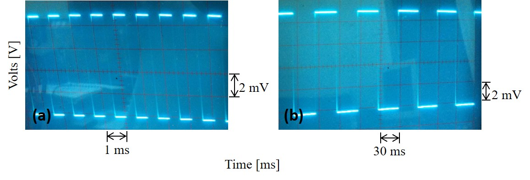
Fig. 2: Signals of the optical chopper operated at (a) 1 kHz and (b) 17 Hz ‎[22].
The reflected light was used as a main signal and the chopper signal used as a reference with nearly 0º phase shift between the two signals. To minimise the noise level in this study, time constant, sensitivity and settling time were selected to be 200 s, 20 mV and 200 s, respectively.

(C) Circular Polarisation
Circularly-polarised IR light needed to be generated in order to achieve the photoexcitation in the half-metallic bandgap. Thus, a linear polariser (Edmund Optics, KRS-5 62774) was used to polarise the IR light linearly with efficient transmission over 70% in a wide wavelength range of 3 ~ 20 µm ‎[23],‎[24]. The linear polarisation was obtained at an angle of 45º tilt from the vertical optical axis and was then introduced to a quarter-wave plate (II-VI, FRZ-2-14-0.75-90-RM) to convert it into circular polarisation, which covers the wavelength range between 2 and 14 µm ‎[25].
IR intensity is known to be reduced almost exponentially with respect to the travelling distance ‎[26],‎[27]. These optical paths have been minimised by aligning the positions of the components in an optimised manner. This eventually provided typical intensity of ~ 25 mV in this study.

(D) Photodetector
The key component to achieve the bandgap measurement is a photodetector that can cover the abovementioned wavelength range. Different types of detectors holding their advantages and disadvantages, can be chosen depending on the requirements. In this study, the choice was a pyroelectric due to its high detectivity of ~ 1.13 × 10⁸ cm·Hz^{1/2}/W and low noise of ~ 291 µV/Hz^{1/2}. The pyroelectric is basically a thermal sensor which converts the incoming light into an electric signal to be measured. A pyroelectric detector (ELTEC, Pyroelectric IR detector model 441) was selected. It uses a single-element lithium tantalite (LiTaO₃). This pyroelectric detector has several additional advantages, such as reasonably wide spectral range (~ 6 < λ < 16 µm), high sensitivity of ~ 88 kV/W, high transmittance average above 75% (as can be seen in Fig. 3), ambient operation temperature (– 40º to + 70º C) and large active area of 2.5 × 2.5 mm².
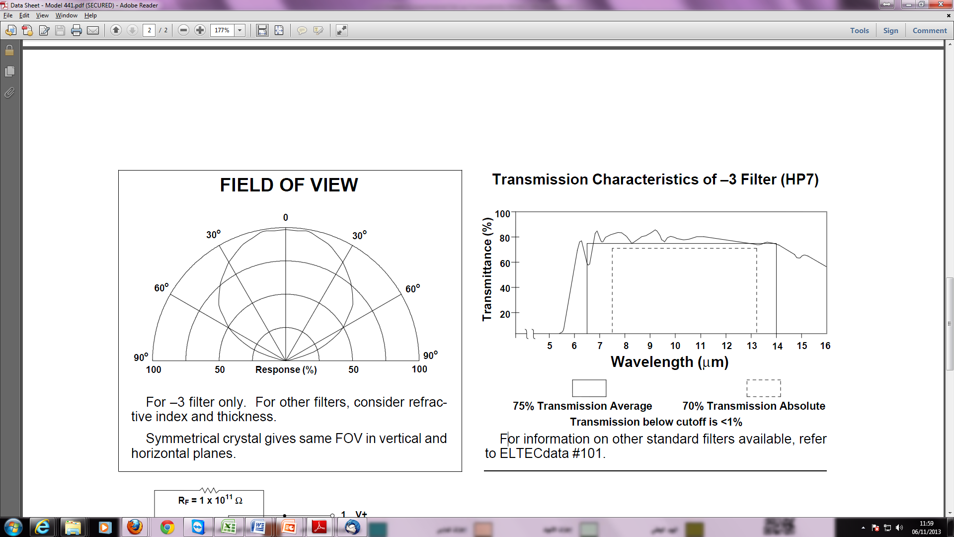
Fig. 3: Transmission characteristics of the IR photodetector used in this study ‎[28].
The photodetector is unable to measure low signals efficiently if the noise level is higher than 35 mV. Accordingly, an additional electronic circuit with a feedback resistor of 1 × 10¹¹ Ω was designed to reduce the noise level (see Appendix). The photodetector and its associated electronic circuit were enclosed in a small aluminium box for better protection from the electromagnetic noise.

(E) Sample Holder
The sample holder was designed to have two adjacent grooves, one for the sample and the other for a permanent magnet. The permanent magnet used had larger diameter (~ 11 mm) than the films (5 × 5 mm²) to ensure that the magnetic field travelling through the film was exactly perpendicular and not to be diverged at the edges of the magnet or the film. The magnet was used to apply a magnetic field perpendicular to the sample, which was ~ 4 kOe sufficient to saturate a Heusler-alloy film. The sample position was adjusted with an accuracy of 240 arcsecond to introduce the circularly-polarised IR light beam spot onto the centre of the sample. Additionally, the height of the sample could be adjusted through the post. The incidence angle of the IR light was set to be at 45º from the film normal, so that the reflection was measured by the photodetector. This configuration was chosen to provide the largest signals from the photodetector.

(F) Alignment
These components were assembled as shown in Fig. 4. The alignment was achieved in several steps to ensure the maximum beam intensity to pass through all of the components. The IR lamp was held on a post and post holder and was coupled to the incident slit of the monochromator within ~ 16 mm.
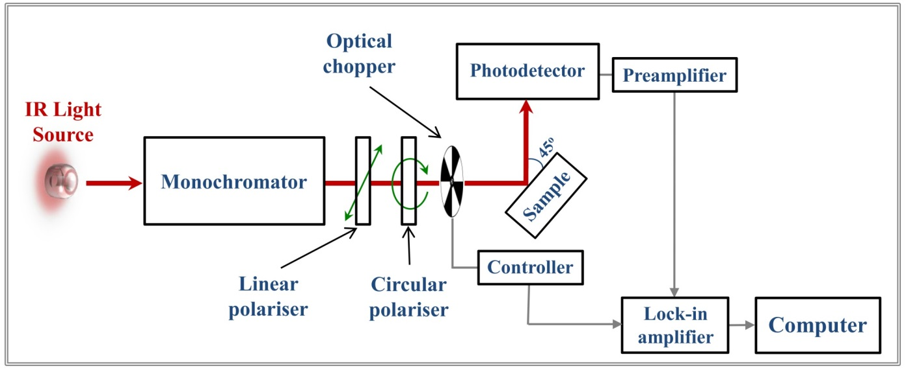
Fig. 4: Schematic diagram of the experimental setup ‎[22].
The IR lamp was turned on and left for about 30 minutes to stabilise its radiation. The monochromator was set at a specific wavelength (i.e., 3 µm) to begin with. The photodetector was used to measure the output intensity to compare it with the corresponding dual-peak intensity provided by the IR source supplier ‎[19]. This process was repeated at different wavelengths by tuning the grating at 20 nm steps as shown in Fig. 5.
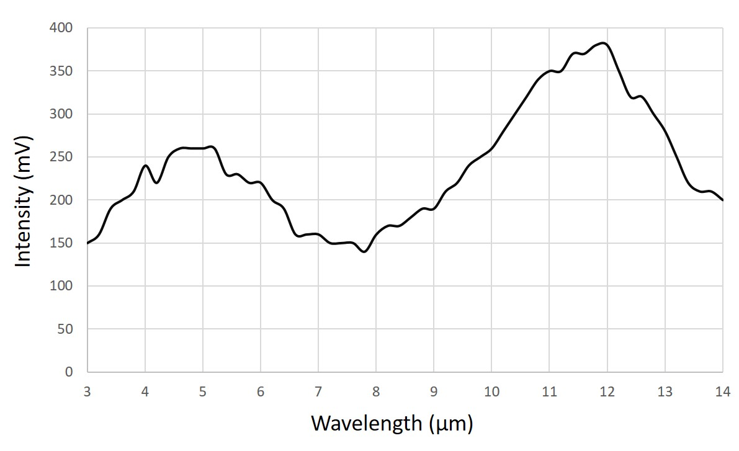
Fig. 5: Measured intensity distribution of the IR light source at 20 nm steps ‎[22].
In order to maximise the intensity, the IR lamp was moved by ± 15 mm in three axes around the centre of the incident slit. The position of the IR source was then fixed. Thereafter the concave mirror was adjusting to maximise the light coupling into the monochromator. The concave mirror could increase the intensity by up to ~ 67% as seen in Fig. 6. Once the largest signal was obtained for the dual peaks within the measured range, the concave mirror and the monochromator were fixed at their positions.
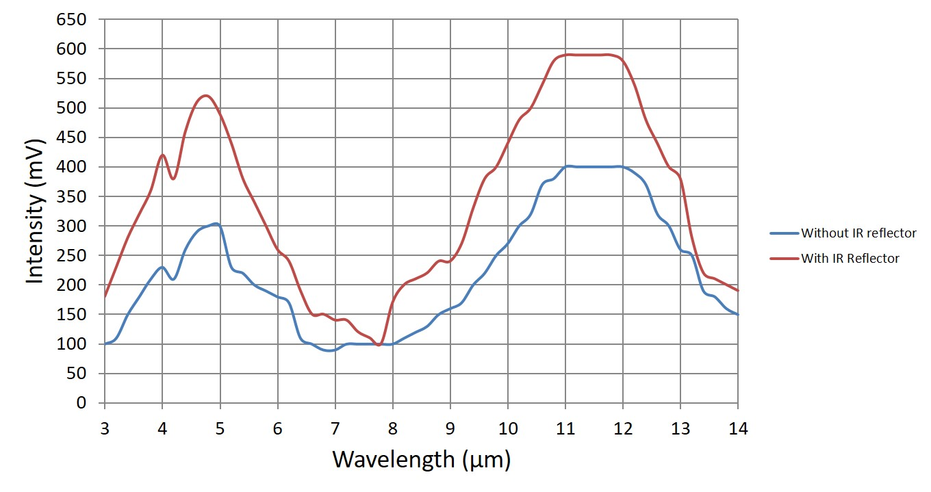
Fig. 6: Measured IR light intensity with (red line) and without (blue line) reflector ‎[22].

(G) Bandgap Measurement
The bandgap measurements were carried out after completing the optical alignment ‎[22]. The monochromator was initialised by fully opening the entrance and exit slits (i.e., 2 mm) and setting the wavelength to 3 µm, which tuned up to 16 µm. The frequency of the optical chopper was set to 17 Hz. A sample (i.e., Co₂FeSi ‎[29], Co₂FeAl_{0.5}Si_{0.5} ‎[30] and NiMnSb ‎[22]) was then placed on the sample holder at the right position (i.e., at 45º from the light entrance and at 45º to the photodetector). Last step was to set the parameters of the lock-in amplifier as follows: the time constant of 200 s, sensitivity of 20 mV, settling time of 200 s and phase shift of ~ 0º. Here, the time constant should be long enough to minimise the output noise below 20 mV. Sensitivity was set according to the changes in the signal level with 1 µV resolution. Settling time was adequate for preventing the influence of quick changes in the signal values in ~ 500 ms.
The measurement used a set of three separate measurements for one sample with maintaining the same IR circular polarisation. The first measurement was made without applying a magnetic field where the intensity of the reflected light from the sample surface was measured over the entire wavelength range. The second measurement was made with applying a perpendicular magnetic field by attaching a magnet on the back of the sample with the S-pole facing to the sample. The third measurement was similar to the second one except the orientation of the magnetic field which was reversed (N-pole facing to the sample). The bandgap was determined by subtracting the second signal from the third signal measured.
For further reduction of the noise level, a shielding box was fabricated using non-magnetic materials. All the optical components were enclosed inside this box, while both the lock-in amplifier and the power supply of the IR light source stayed outside the box.

3. Results and Discussion
We applied our bandgap measurements on quaternary Heusler alloy films, Co₂(Fe,Mn)Si (CFMS) and Co₂(Fe,Mn)Al (CFMA). Sample growth was carried out using an ultrahigh vacuum magnetron sputtering system. Off-stoichiometric alloy targets were used for the film fabrication, which resulted in nearly stoichiometric film compositions of Co_{1.9}Fe_{0.5}Mn_{0.6}Si_{1.0} and Co_{1.8}Fe_{0.5}Mn_{0.6}Al_{1.1} for the CFMS film and the CFMA film, respectively. The film samples were grown onto MgO(001) single crystal substrates, and the deposition temperature was 500°C. The layer thickness was 50 nm. After depositing the Heusler layer, the substrate temperature was cool down to a room temperature, and a 2 nm-thick Au layer was deposited on the top as a protection layer. Crystal structures were examined by using reflection high-energy electron diffraction and X-ray diffraction confirming the epitaxial growth and the full-Heusler structure for the samples. The details for the crystal structure, magnetic properties, and electrical transport properties were reported in a previous paper ‎[31]
Measured IR light spectra are shown in Figs. 7(a) and 7(b) for CFMS and CFMA, respectively. The wavelength ranges from 10 to 16 µm corresponding to the photon energies in the range of 77 and 120 meV. Three subtracted spectra are plotted in each panel, i.e., (i) subtractions of the spectrum without applying a magnetic field (nomagnet) from that with a magnetic field with the north (N)-pole facing to the sample (N - nonmagnet), (ii) subtractions of that with a magnetic field with the south (S)-pole facing to the sample from that with the N-pole facing to the sample (N - S), and (iii) subtractions of that without a field from that with the S-pole facing to the sample (S - nonmagnet). A drift component from the background caused by the intensity distribution of the IR light source was removed by the subtraction procedure. Within the present wavelength range of the measurements, no peak/dip observed, suggesting absence of the half-metallic band gap in the present samples at room temperature. One possible reason for the no half-metallic result is the temperature dependence of half-metallicity in the cobalt-based Heusler alloys: relatively large temperature dependence of the spin polarisation was reported in the current perpendicular-to-plane type giant magnetoresistance junctions ‎[32],‎[33]. According to theoretical studies, thermal excitation of magnons smear the half-metallic energy gap ‎[34],‎[35]. Such a temperature effect causes the minority density of states that may result in the disappearance of absorption in the IR light measurements.
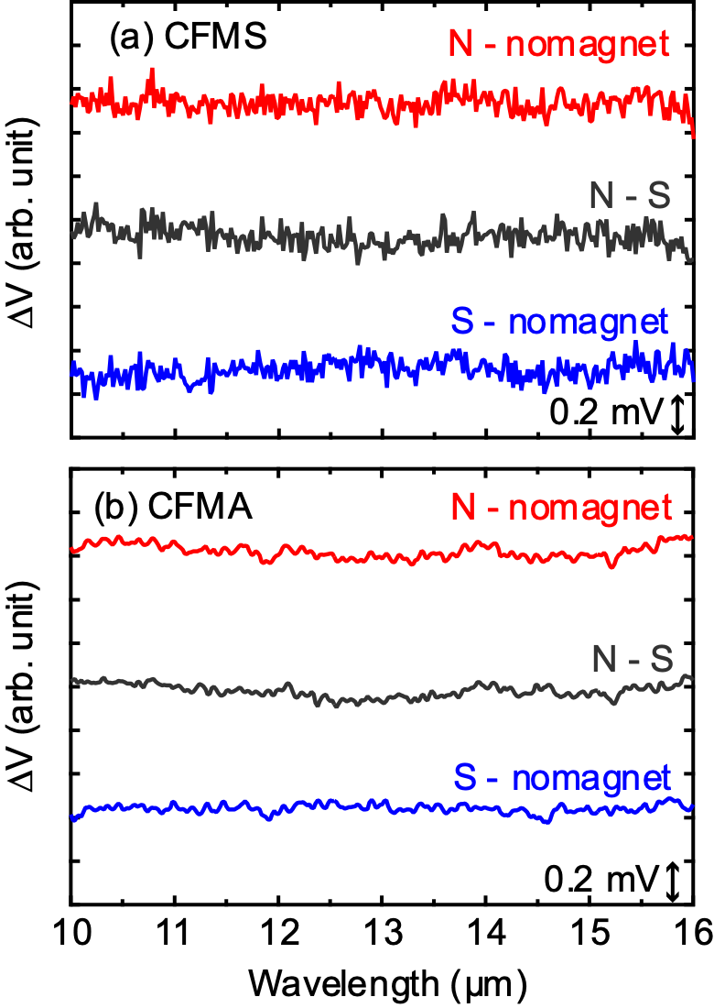

Fig. 7 IR spectra for (a) Co₂(Fe,Mn)Si (CFMS) and (b) Co2(Fe,Mn)Al (CFMA) epitaxially grown film samples measured at room temperature. Subtracted results are shown in both panels using spectra measured using a magnet with the north (N) and south (S) poles facing the sample, and without a permanent magnet (nomagnet).
4. Conclusion
We successfully developed and optimised a new technique to measure a half-metallic bandgap using circularly-polarised infrared light. We measured epitaxially grown full-Heusler alloy films, CFMS and CFMA, and the results suggested that the half-metallic energy gap disappears at room temperature. Our technique has several advantages; (i) flexible design at various incidence angles, (ii) high sensitivity in the order of few µV, (iii) applicability for both thin films and bulk materials and (iv) possible temperature-dependent measurements. This technique can therefore be ideal for the evaluation of the half-metallicity in a simple manner and can provide feedback to their growth and preparation process for their optimisation.
Acknowledgement
This work was partially supported by EPSRC (EP/V007211/1 and EP/V047779/1), Royal Society International Exchange Programme and JST CREST (JPMJCR17J5).

Appendix: Electronic Circuit
An electric circuit was designed to reduce the noise level of the photodetector and accordingly to enhance the output signals. It contains a series of resistors and different types of capacitors with different capacitance values as shown in Fig. A1. It was found to reduce the noise from > 35 mV to ~ 20 mV.
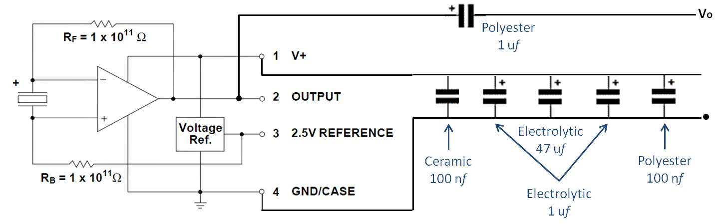
Fig. A1: Final electronic circuit, which has been developed in this study.

References
- A. Hirohata, K. Yamada, Y. Nakatani, L. Prejbeanu, B. Diény, P. Pirro and B. Hillebrands, "Review on spintronics: Principles and device applications," J. Magn. Magn. Mater. 509, 166711 (2020); https://doi.org/10.1016/j.jmmm.2020.166711.
- B. Dieny, I. L. Prejbeanu, K. Garello, P. Gambardella, P. Freitas, R. Lehndorff, W. Raberg, U. Ebels, S. O. Demokritov, J. Akerman, A. Deac, P. Pirro, C. Adelmann, A. Anane, A. V. Chumak, A. Hirohata, S.Mangin, M.Cengiz Onbasli, M.d'Aquino, G.Prenat, G. Finocchio, L. Lopez Diaz, R. Chantrell, O. Chubykalo-Fesenko and P. Bortolotti, "Opportunities and challenges for spintronics in the microelectronic industry," Nat. Electron. 3, 446 (2020); https://doi.org/10.1038/s41928-020-0461-5.
- W. H. Butler, X.-G. Zhang, T. C. Schulthess and J. M. MacLaren, “Spin-dependent tunneling conductance of Fe|MgO|Fe sandwiches,” Phys. Rev B 63, 054416 (2001); https://doi.org/10.1103/PhysRevB.63.054416.
- J. Mathon and A. Umerski, “Theory of tunneling magnetoresistance of an epitaxial Fe/MgO/Fe(001) junction,” Phys. Rev. B 63, 220403(R) (2001); https://doi.org/10.1103/PhysRevB.63.220403.
- S. S. P. Parkin, C. Kaiser, A. Panchkula, P. M. Rice, B. Hughes, M. Samant and S.-H. Yang, “Giant tunnelling magnetoresistance at room temperature with MgO(100) tunnel barriers,” Nat. Mater. 3, 862 (2004); https://doi.org/10.1038/nmat1256.
- S. Yuasa, T. Nagahama, A. Fukushima, Y. Suzuki and K. Ando, “Giant room-temperature magnetoresistance in single-crystal Fe/MgO/Fe magnetic tunnel junctions,” Nat. Mater. 3, 868 (2004); https://doi.org/10.1038/nmat1257.
- A. Hirohata, J. Sagar, L. R. Fleet and H. Endo, "Polycrystalline Co-based full-Heusler alloy films for spintronic devices," Spin 04, 1440021 (2014); https://doi.org/10.1142/S2010324714400219.
- I. Galanakis and P. H. Dederichs (Eds.), Half-metallic Alloys (Springer, Berlin, Germany, 2005); ISBN: 3-540-27719-6.
- R. Y. Umetsu, A. Okubo, M. Nagasako, M. Ohtsuka, R. Kainuma and K. Ishida, "Phase Stability of L2₁ Phase in Co-Based Heusler Alloys," Spin 04, 1440018 (2014); https://doi.org/10.1142/S2010324714400189.
- M. Jullière, “Tunneling between ferromagnetic films,” Phys. Lett. A 54, 225 (1975); https://doi.org/10.1016/0375-9601(75)90174-7.
- R.J. Soulen Jr., J. M. Byers, M. S. Osofsky, B. Nadgorny, T. Ambrose, S. F. Cheng, P. R. Broussard, C. T. Tanaka, J. Nowak, J. S. Moodera, A. Barry and J. M. D. Coey, “Measuring the spin polarization of a metal with a superconducting point contact,” Science 282, 85 (1998); https://doi.org/10.1126/science.282.5386.85.
- R. Meservey and P. M. Tedrow, “Spin-polarized electron tunnelling,” Phys. Rep., 238, 173 (1994); https://doi.org/10.1016/0370-1573(94)90105-8.
- Y. S. Dedkov, M. Fonine, C. König, U. Rüdiger, and G. Güntherodt, “Electrical switching effect of a single-unit-cell CrO₂ layer on rutile TiO₂ surface,” Appl. Phys. Lett. 80, 4181 (2006); https://doi.org/10.1063/1.4869852.
- G. M. Müller, J. Walowski, M. Djordjevic, G.-X Miao, A. Gupta, A. V. Ramos, K. Gehrke, V. Moshnyaga, K. Samwer, J. Schmalhorst, A. Thomas, A. Hütten, G. Reiss, J. S. Moodera and M. Münzenberg, “Spin polarization in half-metals probed by femtosecond spin excitation,” Nat. Mater. 8, 56 (2009); https://doi.org/10.1038/NMAT2341.
- A. Hirohata, Y. B. Xu, C. M. Guertler, J. A. C. Bland, and S. N. Holmes, “Spin-polarized electron transport in ferromagnet/semiconductor hybrid structures induced by photon excitation,” Phys. Rev. B 63, 104425 (2001); https://doi.org/10.1103/PhysRevB.63.104425.
- V. Kumara, S. K. Sharmaa, T. P. Sharmaa and V. Singh, “Band gap determination in thick films from reflectance measurements,” Opt. Mater. 12, 115 (1999); https://doi.org/10.1016/S0925-3467(98)00052-4.
- K. Elphick, W. Frost, M. Samiepour, T. Kubota, K. Takanashi, H. Sukegawa, S. Mitani and A. Hirohata, "Heusler alloys for spintronic devices: Review on recent development and future perspectives," Sci. Technol. Adv. Mater. 22, 235 (2020); https://doi.org/10.1080/14686996.2020.1812364.
- A. Hirohata, M. Kikuchi, N. Tezuka, K. Inomata, J. S. Claydon, Y. B. Xu, G. van der Laan, "Heusler alloy/semiconductor hybrid structures," Curr. Opin. Solid State Mater. Sci. 10, 93 (2006); https://doi.org/10.1016/j.cossms.2006.11.006.
- LOT-Oriel website: http://www.lot-oriel.com/files/downloads/lightsources/eu/LQ_10_30_W_IR-sources_eu.pdf
- Horiba website: www.horiba.com/fileadmin/uploads/Scientific/Documents/Mono/iHR.pdf
- II-VI Infrared, http://www.iiviinfrared.com/CO2-Laser-Optics/prisms-rhombs.html
- T. F. Alhuwaymel, “New band-gap measurement technique for a half-metallic ferromagnet,” PhD thesis (University of York, UK, 2015); https://etheses.whiterose.ac.uk/10668/.
- Edmund Optics, http://www.edmundoptics.com/optics/polarizers/wire-grid-polarizers/infrared-ir-wire-grid-polarizers/62-774
- Edmund Optics, data sheet attached with the polariser.
- II-VI Infrared, data sheet attached with the λ/4-wave plate.
- S. Tavernier, Experimental Techniques in Nuclear and Particle Physics (Springer, Berlin, Germany, 2010) pp 23-53.
- http://spiff.rit.edu/classes/phys440/lectures/optd/optd.html
- ELTEC Instruments, Inc., http://www.eltecinstruments.com/PDF/Ds/Data%20Sheet%20-%20Model%20441.pdf
- T. F. Alhuwaymel, R. M. Abdullah, O. Whear, T. Huminiuc, R. Carpenter, M. El-Gomati and A. Hirohata, “New bandgap measurement technique for a half-metallic ferromagnet”, IEEE Trans. Magn. 50, 2600504 (2014); https://doi.org/10.1109/TMAG.2014.2322912.
- T. F. Alhuwaymel, R. Carpenter, C. N. T. Yu, B. Kuerbanjiang, R. M. Abdullah, V. K. Lazarov, M. El-Gomati and A. Hirohata, “Direct band-gap measurement on epitaxial Co₂FeAl_{0.5}Si_{0.5} Heusler-alloy films”, J. Appl. Phys. 117, 17D131 (2015); https://doi.org/10.1063/1.4916817.
- H. Yako, T. Kubota, and K. Takanashi, “Anisotropic Magnetoresistance Effect in Co₂(Fe–Mn)(Al–Si) Heusler Alloy Thin Film”, IEEE Trans. Magn. 51, 2600403 (2015); https://doi.org/10.1109/TMAG.2015.2439284
- Y. Sakuraba, M. Ueda, Y. Miura, K. Sato, S. Bosu, K. Saito, M. Shirai, T.J. Konno, and K. Takanashi, “Extensive study of giant magnetoresistance properties in half-metallic Co₂(Fe,Mn)Si-based devices”, Appl. Phys. Lett. 101, 252408 (2012); http://dx.doi.org/10.1063/1.4772546
- T. Kubota, Y. Ina, Z. Wen, and K. Takanashi, J. Magn. Magn. Mater. 474, 365 (2019); https://doi.org/10.1016/j.jmmm.2018.11.051
- L. Chioncel, E. Arrigoni, M. I. Katsnelson, and A. I. Lichtenstein, “Electron correlations and the minority-spin band gap in half-metallic Heusler alloys,” Phys. Rev. Lett. 96, 137203 (2006); https://doi.org/10.1103/PhysRevLett.96.137203.
- L. Chioncel, Y. Sakuraba, E. Arrigoni, M. I. Katsnelson, M. Oogane, Y. Ando, T. Miyazaki, E. Burzo, and A. I. Lichtenstein, “Nonquasiparticle States in Co₂MnSi Evidenced through Magnetic Tunnel Junction Spectroscopy Measurements”, Phys. Rev. Lett. 100, 086402 (2008); http://dx.doi.org/10.1103/PhysRevLett.100.086402

