Management and Outcomes of Femoral Hip Periprosthetic Fractures: Data from the Characteristics, Outcomes and Management of PeriprOsthetic Fracture Service Evaluation (COMPOSE) cohort study

**Abstract**

**Aims**

To describe the management and associated outcomes of patients sustaining a femoral hip periprosthetic fracture (PPF) in the United Kingdom population.

**Methods**

Multicentre retrospective cohort study including adult patients presenting to hospital with a new PPF between 01/01/2018 and 31/12/2018. Data collected included: management strategy (operative and non-operative), length of stay, discharge destination, and details of post-treatment outcomes (reoperation, readmission, 30-day and 12-month mortality). Descriptive analysis by fracture type was performed and predictors of PPF management and outcomes were assessed using mixed-effects logistic regression.

**Results**

539 femoral hip PPFs from 27 NHS sites were included. 417 (77%) cases were managed operatively and 122 (23%) conservatively. The median time to surgery was 4 days (IQR:2 to 7). Of those undergoing surgery, 246 (59%) underwent revision+/-fixation and 169 (41%) fixation alone. The surgical strategy used differed by UCPF type with the highest rate of revision in B2/B3 fractures (both 77%) and the highest rate of fixation alone in B1 (71%) and C-type (75%) fractures. Cemented stem fixation (OR=2.66; 95%CI:1.42 to 4.99; p<0.01) and B2/B3 fracture type (OR=7.56; 95%CI:4.14 to 13.78; p<0.01) were predictors of operative management.

The median LOS was 15 days (IQR:9 to 23), 12-month reoperation rate was 5.6% (n=30), and 30-day readmission rate was 8.4% (n=45). 30-day and 12-month mortality rates were 5.2% and 21.0%. Non-operative treatment, older age, male gender, admission from residential or nursing care and sustaining the PPF around a revision prosthesis were significant predictors of an increased 12-month mortality.

**Conclusions**

Femoral hip PPFs have mortality, re-operation and readmission rates comparable to hip fracture patients. However, they have a longer wait for surgery and surgical treatment is more complex. There is a need to create a national framework for data collection for this heterogeneous group of patients to understand the outcomes of different approaches to treatment.

**Introduction**

The management of femoral PPFs associated with a hip replacement presents a challenge due to the presence of an implant, reduced bone stock and the presence of osteoporosis. These cases are complex, requiring high levels of surgical planning and skill, and are associated with increased procedural costs, morbidity and risk of mortality. (1) The incidence of these complex injuries is forecast to increase over the next decade, placing a burden on modern healthcare systems, as well as the patients who sustain these injuries and the surgeons treating them.(2) Improved understanding of their management and the associated outcomes is essential to direct clinical decision making.

There is currently a lack of high-quality evidence in the literature to guide the management of femoral hip PPFs. Recent systematic reviews are inconclusive; lacking a controlled comparator and are largely insufficiently powered. (3) Femoral hip PPFs are a highly heterogeneous group of fractures with multiple subtypes described within both the Vancouver classification system and Unified Classification system for Periprosthetic Fractures (UCPF).(4,5) This makes it difficult to report outcomes and gather sufficient numbers to draw robust conclusions. In practice a range of factors dictate treatment, including patients’ co-morbidities, functional status, surgical expertise, and fracture morphology.

The COMPOSE (Characteristics, Outcomes and Management of PeriprOsthetic fractures: Service Evaluation) study was undertaken with the aim of providing information about the population of patients who sustain PPFs in the United Kingdom (UK). The analysis presented in this paper focuses on the management of a subset of femoral hip PPFs and their associated outcomes. It supplements our associated paper, which reports the epidemiology, patient and fracture characteristics, and predictors of fracture type of a broader cohort of all femoral PPFs collected as part of the COMPOSE study.

**Methods**

COMPOSE was a multicentre retrospective cohort study that followed a prospective study protocol and analysis plan. Data were collected from a consecutive series of patients that presented to participating hospitals in the UK with a new PPF, between 1st Jan 2018 and 31st December 2018. Further details on the sampling strategy, study inclusions/exclusions, method of data collection, ethics and study regulations can be found in our associated paper reporting the epidemiology and characteristics of femoral PPFs within the COMPOSE cohort.

Overall, data on 720 femoral PPFs (539 hip; 151 knee; 30 dividing type) were collected as part of the broader COMPOSE study. This paper presents a focussed analysis of the management and outcomes of the 539 femoral fractures related to a hip replacement. The COMPOSE study flowchart describing overall patient distribution and the available data for analysis is presented in Figure 1.

**Data collection**

Data collected relating to the management and outcomes of femoral hip PPFs included: management strategy (operative versus non-operative), details of non-operative management, details of operative management (revision+/-fixation versus fixation alone) including surgical strategy employed, length of stay (LOS), discharge destination, and details of post-treatment outcomes (reoperation, readmission, 30-day and 12-month mortality). All fractures were classified via the UCPF classification system for PPFs.(4) A full list of data fields collected can be found in the Appendix. Participant flowchart is presented in Figure 1.

**Analysis**

***Descriptive summaries***

Management and outcome data were summarised descriptively using counts and percentages for categorical data and mean, SD, median, interquartile range, minimum and maximum values for continuous data.

***Candidate predictors of management strategy***

The femoral hip PPFs were grouped into two categories based on whether the underlying joint replacement remained fixed to the bone or was loose. Category 1 comprised type A, B1 and C fractures (implant fixed to bone following PPF and therefore potentially suitable for fixation), while category 2 comprised B2 and B3 fractures (implant not fixed to bone following PPF and therefore likely to require revision). Candidate predictors of fracture management in femoral hip PPFs were summarised descriptively by whether the fracture was A/B1/C or B2/B3. A mixed-effects logistic regression model with fracture type as the dependent variable was implemented, controlling for the candidate predictors as fixed effects and site as a random effect. The candidate predictors were age, gender, residence type (own home, supported living, residential care, nursing care), whether the fracture was around a primary or revision implant, implant fixation (cemented or uncemented) and time between joint replacement and periprosthetic fracture (<1 year, 1-10 years or >10 years). Candidate predictors of management strategy were chosen using prior clinical knowledge. The impact of sparse data bias on the model estimates for binary outcomes was assessed using Firth logistic regression.

***Candidate predictors of outcomes***

The impact of patient and fracture characteristics on each of the collected outcomes was assessed. Binary outcomes were analysed using a mixed-effects logistic regression model including type of surgery (fixation alone, revision ± fixation), age, gender, residence type (own home, supported living, residential care, nursing care), whether the fracture was around a primary or revision implant and time between joint replacement and periprosthetic fracture (<1 year, 1-10 years or >10 years) as fixed effects, and site as a random effect. Length of stay was analysed using a mixed-effects Poisson regression model using the same fixed and random effects. Candidate predictors of outcomes were chosen using prior clinical knowledge.

***Site variation in periprosthetic fracture management***

The number of femoral hip PPFs at each of the 27 study sites were summarised dependent upon the management approach (operative versus non-operative) using counts and percentages. For the most complex B2/B3 fracture group the patient’s outcomes for those undergoing surgery were also reported based on surgical volume (low volume: =< one B2/B3 hip femoral PPF operation/month; high volume: > one B2/B3 hip femoral PPF operation/month).

**Results**

***Periprosthetic fracture management***

**Descriptive summary**

Of the 539 femoral hip PPFs analysed, 417 (77.4%) were managed operatively with 122 (22.6%) managed non-operatively. The proportion of patients treated non-operatively was similar in patients with <2 co-morbidities (33 of 163 patients (20.1%) treated non-operatively) compared to those with ≥ 2 comorbidities (89 of 375 patients (23.7%) treated non-operatively.

In the non-operative group 20 (17.5%) patients were instructed to be ‘non weight bearing’, 31 (27.2%) were ‘restricted weight bearing’ and 51 (44.7%) were ‘unrestricted weight bearing’. The remaining 10 cases (8.1%) were treated palliatively and restricted to bed. The use of adjunctive immobilisation with casts or splints was rarely seen (n=2, 1.6%).

A detailed analysis of the operative management of hip femoral PPFs dependent upon the UCPF fracture type is presented in Table 1. The median time between admission and surgery for the 417 patients treated operatively was 4 days (IQR: 2 to 7 days) and varied between 3 and 4.5 days dependent upon the fracture type.

Overall, 246 (59.1%) of the surgical cases involved component revision+/-additional fixation and 169 (40.6%) involved fixation alone, with 1 (0.2%) patient undergoing amputation. Most surgical cases (244; 58.6%) used multiple surgical strategies (Table 1). The proportion of patients undergoing a revision procedure varied by fracture type (Table 1). Revision occurred in only 25 and 30% of C and B1 type fractures but was more frequently observed B2/B3 fractures (77%). For B1 fractures, single plate fixation (n=48, 61.5%) and cerclage cables (n=58, 74.4%) were the most used surgical strategies. For B2 fractures, cerclage cables (n=131, 57.5%), uncemented revision (n=104, 45.6%) and cemented revision (n=72, 31.6%) were the most used surgical strategies. For B3 fractures, cerclage cables (n=13, 41.9%), uncemented revision (n=12, 38.7%) and cemented revision (n=11, 35.5%) were the most used surgical strategies. For C fractures, single plate fixation (n=48, 73.8%) and cerclage cables (n=33, 50.8%) were the most used surgical strategies (Table 1). Augments to fixation such as strut graft (n=2, 0.5%), bone graft/biocomposite augmentation (n=6, 1.4%) and cement augmentation (n=7, 1.7%) were rarely employed. Where a hip prosthesis was revised, revision of the reciprocal (acetabular) component was reported in 99 patients (40.7%) (Table 1).

Operative time reflected operative complexity with B3 fractures requiring the longest time in theatre (Median 167 minutes, IQR:141 to 246.5 minutes) (Table 1). While rates of intraoperative complications were low (n=7, 1.6%) a significant proportion of patients required HDU/ITU admission in the post-operative phase (n=62, 15.2%). Complexity was also reflected in rates of HDU/ITU admission with the highest rates again seen in the most complex B3 fractures (n=8, 26.7%) (Table 1).

**Site variation in periprosthetic fracture management**

Data for the number of femoral hip PPFs treated at each of the 27 study sites is presented in the Appendix (Table A), which also provides details of the management strategy used at each site (non-operative; operative revision+/-fixation; operative fixation alone). There was wide variation in the use of non-operative management (range 0-64% of cases) and the surgical techniques employed (revision+/-fixation range 0-94% of cases; fixation alone range 0-100% of cases) across the study sites.

**Predictors of management strategy**

Complete data was available for 475 (88.5%) PPFs which were included in the models for candidate predictors of management strategy (Appendix: Table B). Patients whose PPF was type B2/B3 (OR 7.56; 95%CI:4.14 to 13.78; p<0.01) and whose original implant was cemented (OR 2.66; 95%CI:1.42 to 4.99; p<0.01) were more likely to have their PPF managed operatively (Figure 2). There was a trend towards patients living in supported living (OR 0.33; 95%CI:0.09 to 1.16; p=0.08) or being in residential care (OR 0.38; 95%CI:0.13 to 1.07; p=0.07) being more likely to have their PPF managed non-operatively, although this was not significant.

***Periprosthetic fracture outcomes***

**Descriptive summary**

The rates of complications, length of stay, 30-day and-12-month reoperation rates, 30-day readmission rate, and 30-day and-12 month mortality rates following hip, knee and dividing femoral PPFs are presented in table 2. The median length of stay was 15 days (IQR:9 to 23).

The overall 30-day and 12-month re-operation rates were 2.8% (n=15) and 8.0% (n=43) respectively. For the subset that were managed operatively (n=417) the 30-day and 12-month re-operation rates were 2.4% (n=10) and 8.7% (n=36) with a higher 12-month re-operation rates observed in patients treated with revision+/-fixation (n=25, 10.2%) compared to fixation alone (n=11, 6.5%) (Table 3).

The 30-day readmission rate was 8.4% (n=45). The overall 12-month mortality rate was 21.0% (n=113). 30-day and 12-month mortality rates varied by UCPF fracture type with B3 hip PPFs having the highest 12-month mortality (38.5%) (Table 2).

**Predictors of outcome**

Complete data was available for 465 (Length of stay), 473 (30-day readmission) and 473 (12-month mortality) PPFs which were included in the models for candidate predictors of management strategy (Appendix: Table C). Formal analyses could not be carried out for 30-day mortality due to sparse data. For the remaining outcomes, results are displayed graphically in figures 3-5.

In the model examining length of stay, non-operative treatment was associated with a shorter length of stay when compared to patients operated on using fixation alone (IRR 0.75; 95%CI:0.70 to 0.81; p<0.01). In contrast undergoing a revision procedure was associated with a longer length of stay when compared to patients operated on using fixation alone (IRR 1.09; 95%CI:1.03 to 1.16; p<0.01). Additional factors found to be associated with a longer length of stay included older age (IRR 1.03; 95%CI:1.02 to 1.04; p<0.01), being admitted from supported living (IRR 1.17; 95%CI:1.05 to 1.31; p<0.01) or a residential accommodation (IRR 1.31; 95%CI:1.20 to 1.44; p<0.01), sustaining a B2/B3 fracture (IRR 1.07; 95%CI:1.01 to 1.13; p=0.01) and sustaining the PPF >10 years after initial implantation (IRR 1.10; 95%CI:1.03 to 1.18; p<0.01) and (Figure 3).

No variables were found to be associated with the likelihood of being readmitted to hospital within 30 days, although the fracture being B2/B3 was of borderline significance (OR 0.44; 95%CI:0.19 to 1.01; p=0.05) (Figure 4).

Patients treated non-operatively were more likely to die within 12 months compared to those treated operatively using fixation alone (OR 2.64; 95%CI:1.34 to 5.19; p<0.01). However, there was no observed difference between patients operated using a ‘fixation alone’ approach and those undergoing a revision procedure. Additional factors found to be associated with an increased likelihood of dying within 12 months of injury included older age (OR 1.38; 95%CI:1.18 to 1.60; p<0.01), being in residential care (OR 2.91; 95%CI:1.20 to 7.04; p=0.02) or nursing care (OR 3.22; 95%CI:1.49 to 6.98; p<0.01), and sustaining the PPF around a revision rather than a primary prosthesis (OR 2.28; 95%CI:1.15 to 4.51; p=0.02) (Figure 5). Being female was found to be associated with a decreased likelihood of dying within 12 months of injury (OR 0.50; 95%CI:0.30 to 0.83; p<0.01)

**Outcomes for B2/3 fractures**

In total, there were 289 B2/B3 fractures, of which 200 (69.2%) were managed using revision±fixation, 58 (20.1%) were managed using fixation alone and one was managed using amputation. Outcomes dependent upon the surgical management are presented in Table 4. Other than observing a higher 12-month reoperation rate in the revision+/- fixation group (10.1% versus 3.5% in the fixation alone group) the outcomes for these two groups were similar (Table 4)

Of the 258 B2/B3 PPFs managed operatively, 117 (45.3) were managed at low-volume sites (less than or equal to one B2/B3 operation per month) and 141 (54.7%) were managed at high-volume sites (more than one B2/B3 operation per month) (Table 5). There was a tendency for longer length of stay (median 18 days versus 14 days), a higher 12-month re-operation rate (16 cases (13.9%) versus 6 cases (4.3%)), and a higher 12-month mortality rate (26 cases (22.4%) versus 20 cases (14.2%) in the low volume centres based on the unadjusted descriptive data (Table 5).

**Discharge destination**

Information on the patients place of residence pre- and post-fracture dependent upon the fracture location is presented in table 6. Of the 431 femoral hip PPFs admitted from their own home, only 264 (61.3%) were discharged back to their own home post discharge respectively.

**Discussion**

COMPOSE provides a cross-sectional review of the current management of femoral hip periprosthetic fractures and 12-month outcomes from 27 study sites across the UK.

It demonstrates variation in fracture management both within and between UCPF fracture types and also dependent upon the treating site. Multiple operative and non-operative strategies were reported reflecting the heterogeneity in the fractures that present to hospital and the complexity of management. Surgical waiting times were typically >4 days and the overall 12-month mortality rates were >20%.

The study was designed to be a descriptive analysis of the characteristics, management of outcomes of PPFs. We have therefore been careful not to over interpret unadjusted data and draw strong inferences upon observed difference except in the instances that we have performed adjusted statistical comparisons. However, despite this caveat there are a number of interesting observations that merit further investigation and should be the focus of future research. Firstly, there was wide variation in the management approaches used across the 27 study sites. This is possibly due to the availability of surgeons, their training background and their surgical skillsets as differences in the management of distal femoral PPFs have been reported dependant on whether the surgeon come from a trauma or arthroplasty background (6). Secondly, we observed differences in outcomes after between high and low volume centres for the most complex B2/3 fractures. The impact of surgical volume is increasingly recognised in orthopaedic surgery (7) and this finding provides further evidence to support the cohorting of these cases in high volume centres. Thirdly, we observed higher re-operation rates in cases undergoing revision+/-fixation compared to fixation alone, both for all surgically treated fractures and for the B2/B3 subset. While these differences were small, and we have been careful not to ascribe statistical significance to them due to a lack of adjustment, comparison of different strategies to management could be an area for future research. Finally, in our adjusted models the non-operative patients had the highest mortality but the shortest LOS. Possible explanations for this finding are that a proportion of the non-operative patients died early after fracture or that having made the decision to treat non-operatively patients were discharged back to care facilities or intermediate care beds to reduce the pressure on acute trauma services.

The majority of patients in our study underwent operative intervention (77%), similar to the 73% reported by Bottle et al. in their analysis of UK HES data. (2) Other series reporting on specific subsets of hip PPFs have reported higher operative rates of 84 to 94%. (8,9) In their analysis Bottle et al. reported that both males and females over the age of 84 were less likely to undergo surgery in comparison to younger patients, as well as those with increasing socioeconomic deprivation, COPD, or a pre-existing neurological disorder.(2) COMPOSE observed similar rates on non-operative treatment in patients with co-morbidities compared to those without co-morbidities. It also found that the method of stem fixation and fracture type were predictors of the decision to treat operatively. These variables would not have been available from HES and this represents new information about the decision making process utilised by surgeons to treat femoral hip PPFs.

In COMPOSE, the most common strategies used in patients sustaining femoral hip B1 PPFs were single plate fixation and cerclage cables. The proportions undergoing fixation (71%) were similar to the findings of an Italian single site study which reported that 77% of patients underwent fixation. (10) There continues to be a lack of consensus in how to manage B2/3 fractures, however, COMPOSE found that 77% of femoral hip B2/B3 PPFs underwent revision and that sustaining this fracture type around a cemented implant in was positively correlated with the patient undergoing surgical intervention. For B2 and B3 fractures the proportions of patients undergoing revision (B2 77%; B3 77%) were lower than the 87% (B2) and 96% (B3) reported in the Cochrane review by Khan et al. (11)The difference in the proportion of patients undergoing revision for B1 and B2/B3 PPFs may to be due to the contemporary utilization of taper-slip cemented femoral stem designs. (12) The taper-slip stem design requires controlled subsidence within an intact cement mantle and therefore, when the cement-implant interface is broken, the implant is by definition loose and may require revision. In uncemented, proximally well-fixed implants; a fixation alone may be appropriate. (8,12).

National standards for the treatment of hip fragility fractures stipulate that these injuries should be operated on within 36 hours of admissions (13). COMPOSE data demonstrated that for all fractures the median time between admission and surgery across 27 NHS sites was 4 days. The longest waits were observed in hip B2/3 type PPFs in which the majority of patients underwent revision. A recent systematic review by Farrow et al. reported a mean time to surgery of 2.7 days and observed that delays in surgery were associated with higher mortality and poorer clinical outcomes including: greater risk of medical complications, longer length of stay, higher transfusion risk and increased rates of reoperation.(14) Griffiths et al. reported that a delay to surgery of greater than 72 hours led to increased risk of post-operative complications.(9) whereas Bliemel et al. observed that early surgery had no effect on mortality and patient outcomes at 120 days but did find that the risk of reoperation was significantly higher in patient whose surgery was delayed.(15) Other studies have failed to find an association between the timing of surgery and hospital length of stay or mortality at 1 year. (16,17) While timely surgery is likely to reduce the risks to patients it is important to recognise these are complex injuries that often require significant planning, surgical experience and appropriate theatre resources to ensure an optimal surgical result.

A significant proportion (39%) of patients who lived in their own homes prior to their PPF did not return to their own home post-operatively. This is higher than the 25% reported in a large observational study using HES data including all PPFs (2) but lower than 65% observed in B type femoral hip PPFs from Sweden. (18). The reported 30-day and 12-month reoperation rate (2.8% and 5.6%) were much lower than the reoperation rate of 13.3% reported by Khan et al. (11) although a timescale for re-operation was not provided within their review making direct comparison difficult. They observed that B2/B3 fractures treated without revision of the stem were associated with a higher rate of re-operation. (11) Re-operation rates in our cohort may continue to rise beyond 12 months due to late fixation failures.

We observed that the mortality rate for all femoral hip PPFs increased from 5.2% at 30 days to 21.0% at 12 months. This is similar to the 12-month rates previously reported in the literature for people experiencing hip (21%) PPFs. (2,9,16,17). However, we observed variation in mortality outcomes dependent upon fracture type, method of surgical reconstruction and, for B2/3 fracture, the hospital surgical volume. Older age and being in supported/residential care prior to injury predicted the greatest risk of death within 12 months. Our 30-day mortality rate was also similar to the rates for hip fracture reported by the National Hip Fracture Database but our cohort had higher rates of failing to return to their own home and longer waits between admission and surgery. (19) The median length of stay (LOS) (15 days) observed was similar to the 17 days reported by Bottle et al. (2). Their findings of a longer LOS in older patients and those managed operatively concurred with our data demonstrating a longer LOS in older patients, those requiring a revision, those from residential care or supported living and those who sustained a PPF >10 years after their original surgery. (2) Approximately a quarter of our cohort had a complication prior to discharge. Griffiths et al. found that on average, patients who had complications during their treatment, had a delayed discharge and stayed 4.5 days longer. (9)

This study is limited by its retrospective study design. Data collection was dependent on individual, independent investigators at each site and required adequate clinical coding in the participating hospitals to retrospectively identify patients undergoing both operative and non-operative treatment. Patients who were managed non-operatively may not have been coded correctly or have been assigned a different diagnosis and therefore may not have appeared in the hospital records used to identify patients for this study. This may have resulted in an underestimation of the number of non-operative patients, particularly if they were managed in an outpatient setting. The sites were also responsible for classifying the fracture type, albeit based on a variety of available data sources including operation notes, clinical notes and x-rays. Inter-reporter variability in the recording of the UCPF type is a known issue with this classification system, particularly with differentiating between B1 and B2 fractures. However, our results have good face validity which offsets concerns that this may have impacted on the findings. Furthermore, we did not collect data about the reasons for delays to surgery which may have provided valuable information about how care is delivered to this group of patients.

**Conclusion**

Although patients sustaining femoral hip PPFs are broadly similar to those with hip fractures COMPOSE suggests they have a more complicated treatment course and wait longer for surgery. There is a need to create a national framework for data collection for this heterogeneous group of patients to help build an evidence base to support clinical decision making and management based on patient and fracture characteristics and study their long-term outcomes. Further work should focus on developing strategies to improve the timing and delivery of care, identifying risks factors associated with poor outcomes and defining a core outcome set to allow standardised reporting within clinical studies.

**References**

1. Capone A, Congia S, Civinini R, Marongiu G. Periprosthetic fractures: epidemiology and current treatment. Clin Cases Miner Bone Metab. 2017;14(2):189-96.

2. Bottle A, Griffiths R, White S, Wynn-Jones H, Aylin P, Moppett I, et al. Periprosthetic fractures: the next fragility fracture epidemic? A national observational study. BMJ Open. 2020;10(12):e042371.

3. Stoffel K, Sommer C, Kalampoki V, Blumenthal A, Joeris A. The influence of the operation technique and implant used in the treatment of periprosthetic hip and interprosthetic femur fractures: a systematic literature review of 1571 cases. Arch Orthop Trauma Surg. 2016;136(4):553-61.

4. Duncan CP, Haddad FS. The Unified Classification System (UCS): improving our understanding of periprosthetic fractures. Bone Joint J. 2014;96-B(6):713-6.

5. Brady OH, Garbuz DS, Masri BA, Duncan CP. Classification of the hip. Orthop Clin North Am. 1999;30(2):215-20.

6. Van Rysselberghe NL, Campbell ST, Goodnough LH, Amanatullah DF, Gardner MJ, Bishop JA. To Fix or Revise: Differences in Periprosthetic Distal Femur Fracture Management Between Trauma and Arthroplasty Surgeons. J Am Acad Orthop Surg 2022;30(1):e17-e24

7. Critchley R, Baker PN, Deehan DJ. Does surgical volume affect outcome after primary and revision knee arthroplasty? A systematic review of the literature. Knee 2012;19(5):513-8.

8. Jain S, Lamb J, Townsend O, Scott CEH, Kendrick B, Middleton R, et al. Risk factors influencing fracture characteristics in postoperative periprosthetic femoral fractures around cemented stems in total hip arthroplasty : a multicentre observational cohort study on 584 fractures. Bone Jt Open. 2021;2(7):466-75.

9. Griffiths EJ, Cash DJ, Kalra S, Hopgood PJ. Time to surgery and 30-day morbidity and mortality of periprosthetic hip fractures. Injury. 2013;44(12):1949-52.

10. Giaretta S, Momoli A, Porcelli G, Micheloni GM. Diagnosis and management of periprosthetic femoral fractures after hip arthroplasty. Injury. 2019;50 Suppl 2:S29-S33.

11. Khan T, Grindlay D, Ollivere BJ, Scammell BE, Manktelow AR, Pearson RG. A systematic review of Vancouver B2 and B3 periprosthetic femoral fractures. Bone Joint J. 2017;99-B(4 Supple B):17-25.

12. Jain S, Mohrir G, Townsend O, Lamb JN, Palan J, Aderinto J, et al. Reliability and validity of the Unified Classification System for postoperative periprosthetic femoral fractures around cemented polished taper-slip stems. Bone Joint J. 2021;103-B(8):1339-44.

13. British Orthopaedic Association, BOAST 1 Version 2 - Patients sustaining a Fragility Hip Fracture (2012). https://www.boa.ac.uk/uploads/assets/6750e0bf-4aa3-4680-b1612265704512db/patients%20sustaining%20a%20fragility%20hip%20fracture.pdf

14. Farrow L, Ablett AD, Sargeant HW, Smith TO, Johnston AT. Does early surgery improve outcomes for periprosthetic fractures of the hip and knee? A systematic review and meta-analysis. Arch Orthop Trauma Surg. 2021;141(8):1393-400.

15. Bliemel C, Rascher K, Knauf T, Hack J, Eschbach DA, Aigner R, et al. Early Surgery Does Not Improve Outcomes for Patients with Periprosthetic Femoral Fractures-Results from the Registry for Geriatric Trauma of the German Trauma Society. Medicina (Kaunas). 2021;57(6).

16. Sellan ME, Lanting BA, Schemitsch EH, MacDonald SJ, Vasarhelyi EM, Howard JL. Does Time to Surgery Affect Outcomes for Periprosthetic Femur Fractures? J Arthroplasty. 2018;33(3):878-81.

17. Johnson-Lynn S, Ngu A, Holland J, Carluke I, Fearon P. The effect of delay to surgery on morbidity, mortality and length of stay following periprosthetic fracture around the hip. Injury. 2016;47(3):725-7.

18. Chatziagorou G, Lindahl H, Kärrholm J. Surgical treatment of Vancouver type B periprosthetic femoral fractures: patient characteristics and outcomes of 1381 fractures treated in Sweden between 2001 and 2011. Bone Joint J. 2019;101-B(11):1447-58.

19. *National Hip Fracture Database (NHFD) Annual report 2019*. <https://www.nhfd.co.uk/files/2019ReportFiles/NHFD_2019_Annual_Report_v101.pdf>; 2021.

**Tables and Figures**

**Table 1:** Operative treatment by hip femoral PPF fracture type using the UCPF classification (percentages calculated based on number of patients with non-missing data). Data on the 1 F type fracture managed operatively is not presented as a separate column

|  | **A**  **(n=14)** | **B1**  **(n=78)** | **B2**  **(n=228)** | **B3**  **(n=31)** | **C**  **(n=65)** | **Overall**  **(n=417)** |
| --- | --- | --- | --- | --- | --- | --- |
| **Time between periprosthetic fracture and surgery (days), n (%)**  n (%)  Mean (SD)  Median (IQR)  Min, Max | 11 (78.6)  3.8 (3.3)  3 (2, 5)  1, 10 | 77 (98.7)  5.5 (5.3)  4 (3, 6)  0, 28 | 213 (93.4)  6.0 (6.1)  4 (3, 7)  0, 37 | 28 (90.3)  6.4 (5.0)  4.5 (2.5, 10)  0, 19 | 60 (92.3)  4.0 (4.5)  3 (1, 5)  0, 22 | 389 (93.3)  5.6 (5.6)  4 (2, 7)  0, 37 |
| **Overall surgical strategy, n (%)**  Revision +/- fixation  Fixation alone  Amputation | 6 (46.2)  7 (53.8)  0 (0) | 23 (29.5)  55 (70.5)  0 (0) | 176 (77.2)  51 (22.4)  1 (0.4) | 24 (77.4)  7 (22.6)  0 (0) | 16 (24.6)  49 (75.4)  0 (0) | 246 (59.1)  169 (40.6)  1 (0.2) |
| **Surgical strategy**  **(multiple strategies possible), n (%)**  Fixation with single plate  Fixation with 2 or more  plates  Cerclage cables  Strut graft  Bone graft/bone  biocomposite augmentation  Cement augmentation  Cement revision of  component related to  fractured bone  Uncemented revision of  component related to the  fractured bone  Nail  Endoprosthetic replacement  Excision arthroplasty | 5 (35.7)  0 (0)  8 (57.1)  0 (0)  0 (0)  1 (7.1)  3 (21.4)  3 (21.4)  0 (0)  0 (0)  0 (0) | 48 (61.5)  1 (1.3)  58 (74.4)  1 (1.3)  0 (0)  1 (1.3)  12 (15.4)  9 (11.5)  0 (0)  0 (0)  0 (0) | 71 (31.1)  7 (3.1)  131 (57.5)  0 (0)  3 (1.3)  3 (1.3)  72 (31.6)  104 (45.6)  0 (0)  1 (0.4)  1 (0.4) | 6 (19.4)  1 (3.2)  13 (41.9)  0 (0)  3 (9.7)  0 (0)  11 (35.5)  12 (38.7)  0 (0)  1 (3.2)  0 (0) | 48 (73.8)  0 (0)  33 (50.8)  1 (1.5)  0 (0)  2 (3.1)  9 (13.8)  4 (6.2)  1 (1.5)  2 (3.1)  0 (0) | 178 (42.7)  9 (2.2)  243 (58.3)  2 (0.5)  6 (1.4)  7 (1.7)  108 (25.9)  132 (31.7)  1 (0.2)  4 (1.0)  1 (0.2) |
| **Number of surgical strategies used, n (%)**  1  2  3 | 7 (53.8)  5 (38.9)  1 (7.7) | 28 (35.9)  46 (59.0)  4 (5.1) | 86 (37.7)  118 (51.8)  24 (10.5) | 19 (61.3)  8 (25.8)  4 (12.9) | 31 (47.7)  32 (49.2)  2 (3.1) | 172 (41.3)  209 (50.2)  35 (8.4) |
| **Reciprocal component also revised, n ((% of those who underwent revision ± fixation)**  Yes  No | 2 (33.3)  4 (66.7) | 11 (50.0)  11 (50.0) | 61 (34.7)  115 (65.3) | 14 (60.9)  9 (39.1) | 11 (68.8)  5 (31.2) | 99 (40.7)  144 (59.3) |
| **Duration of operation, minutes**  n (%)  Mean (SD)  Median (IQR)  Min, Max | 6 (42.9)  106.2 (42.3)  97.5 (90, 143)  45, 164 | 34 (43.6)  132.8 (33.6)  126 (113, 150)  84, 242 | 98 (43.0)  167.4 (62.2)  150 (120, 189)  62, 360 | 12 (38.7)  196.8 (100.1)  167 (141, 246.5)  39, 388 | 20 (30.8)  150.8 (44.7)  129.5 (120, 186)  70, 238 | 170 (40.8)  158.4 (61.3)  150 (120, 180)  39, 388 |
| **Intraoperative complications**  Intraoperative fracture  Nerve injury  Blood vessel injury  Other | 0 (0)  0 (0)  0 (0)  0 (0) | 1 (0.8)  0 (0)  0 (0)  0 (0) | 1 (0.4)  1 (0.4)  0 (0)  1 (0.4) | 0 (0)  0 (0)  0 (0)  1 (2.6) | 1 (1.4)  0 (0)  1 (1.4)  0 (0) | 3 (0.7)  1 (0.2)  1 (0.2)  2 (0.5) |
| **Admission to HTU/ITU post-operatively**  Yes  No | 1 (7.1)  13 (92.9) | 9 (11.8)  67 (88.2) | 38 (16.9)  187 (83.1) | 8 (26.7)  22 (73.3) | 6 (9.7)  56 (90.3) | 62 (15.2)  346 (84.8) |

**Table 2:** Outcomes in patients with femoral hip periprosthetic fractures summarised by fracture classification (two fractures classified as F *not presented as a separate column*).

|  | **Hips (n=537)** | | | | |  |
| --- | --- | --- | --- | --- | --- | --- |
|  | **A (n=61)** | **B1 (n=118)** | **B2 (n=250)** | **B3 (n=39)** | **C (n=69)** | **Overall (n=537)** |
| **Length of Hospital Stay, days**  n (%)  Mean (SD)  Median (IQR)  Min, Max | 58 (95.0)  13.4 (11.8)  10 (5, 18)  1, 64 | 117 (97.5)  18.6 (15.5)  14 (8, 23)  1, 90 | 249 (99.2)  20.2 (17.6)  15 (10, 24)  1, 120 | 38 (97.4)  19.5 (12.7)  15 (11, 24)  3, 65 | 69 (100)  21.1 (19.3)  16 (10, 23)  2, 137 | 533 (98.3)  19.1 (16.6)  15 (9, 23)  1, 137 |
| **Readmitted Within 30 days, n (%)**  Yes  No  Information  unavailable | 7 (11.5)  54 (88.5)  0 (0) | 7 (5.9)  111 (94.1)  0 (0) | 19 (7.6)  230 (92.0)  1 (0.4) | 1 (2.6)  38 (97.4)  0 (0) | 11 (15.9)  58 (84.1)  0 (0) | 45 (8.4)  491 (91.4)  1 (0) |
| **30 Day Mortality, n (%)**  Yes  No  Information  unavailable | 1 (1.6)  60 (98.4)  0 (0) | 5 (4.2)  113 (95.8)  0 (0) | 15 (6.0)  235 (94.0)  0 (0) | 7 (17.9)  32 (82.1)  0 (0) | 0 (0)  69 (100)  0 (0) | 28 (5.2)  511 (94.8)  0 (0) |
| **12 Month Mortality, n (%)**  Yes  No  Information  unavailable | 17 (27.9)  44 (72.1)  0 (0) | 23 (19.5)  95 (80.5)  0 (0) | 48 (19.2)  201 (80.4)  1 (0.4) | 15 (38.5)  24 (61.5)  0 (0) | 10 (14.5)  59 (85.5)  0 (0) | 113 (21.0)  425 (79.0)  1 (0) |

**Table 3:** Reoperation rates for those with periprosthetic hip fractures managed using either revision±fixation or fixation alone.

|  | **Revision±fixation**  **(n=246)** | **Fixation alone**  **(n=169)** | **Overall**  **(n=415)** |
| --- | --- | --- | --- |
| **Had operation post-discharge within 30 days, n (%)**  Yes  No | 7 (2.8)  239 (97.2) | 3 (1.8)  165 (98.2) | 10 (2.4)  404 (97.6) |
| **Had operation post-discharge within 12 months, n (%)**  Yes  No | 25 (10.2)  220 (89.8) | 11 (6.5)  157 (93.5) | 36 (8.7)  377 (91.3) |

**Table 4:** Outcomes for those with B2/B3 periprosthetic hip fractures managed using either revision±fixation or fixation alone.

|  | **Revision ± fixation**  **(n=200)** | **Fixation alone**  **(n=58)** | **Overall**  **(n=258)** |
| --- | --- | --- | --- |
| **Complications prior to discharge, n (%)**  Yes  No | 46 (23.2)  152 (76.8) | 16 (28.1)  41 (71.9) | 62 (24.3)  193 (75.7) |
| **Length of Hospital Stay, days**  n (%)  Mean (SD)  Median (IQR)  Min, Max | 200 (100)  20.7 (16.6)  16 (10, 24)  3, 119 | 57 (98.3)  17.6 (14.6)  13 (10, 22)  4, 105 | 257 (99.6)  20.0 (16.2)  15 (10, 24)  3, 119 |
| **Had operation post-discharge within 30 days, n (%)**  Yes  No | 7 (3.5)  193 (96.5) | 0 (0)  57 (100) | 7 (2.7)  250 (97.3) |
| **Had operation post-discharge within 12 months, n (%)**  Yes  No | 20 (10.1)  179 (89.9) | 2 (3.5)  55 (96.5) | 22 (8.6)  234 (91.4) |
| **Readmitted Within 30 days, n (%)**  Yes  No | 15 (7.5)  185 (92.5) | 4 (7.0)  53 (93.0) | 19 (7.4)  238 (92.6) |
| **30 Day Mortality, n (%)**  Yes  No | 11 (5.5)  189 (94.5) | 2 (3.4)  56 (96.6) | 13 (5.0)  245 (95.0) |
| **12 Month Mortality, n (%)**  Yes  No | 34 (17.0)  166 (83.0) | 12 (21.1)  45 (78.9) | 46 (19.9)  211 (82.1) |

**Table 5:** Outcomes for those with B2/B3 periprosthetic hip fractures managed using either revision±fixation or fixation alone, presented by whether the study site was low-volume (less than or equal to one operation per month on average) or high volume (more than one operation per month on average).

|  | **Operated on at low-volume site**  **(n=117)** | **Operated on at high-volume site**  **(n=141)** | **Overall**  **(n=258)** |
| --- | --- | --- | --- |
| **Complications prior to discharge, n (%)**  Yes  No | 29 (25.2)  86 (74.8) | 33 (23.6)  107 (76.4) | 62 (24.3)  193 (75.7) |
| **Length of Hospital Stay, days**  n (%)  Mean (SD)  Median (IQR)  Min, Max | 116 (100)  23.2 (18.9)  18 (11, 28.5)  3, 119 | 141 (100)  17.3 (13.1)  14 (10, 21)  3, 95 | 257 (100)  20.0 (16.2)  15 (10, 24)  3, 119 |
| **Had operation post-discharge within 30 days, n (%)**  Yes  No | 5 (4.3)  111 (95.7) | 2 (1.4)  139 (98.6) | 7 (2.7)  250 (97.3) |
| **Had operation post-discharge within 12 months, n (%)**  Yes  No | 16 (13.9)  99 (86.1) | 6 (4.3)  135 (95.7) | 22 (8.6)  234 (91.4) |
| **Readmitted Within 30 days, n (%)**  Yes  No | 14 (12.1)  102 (87.9) | 5 (3.5)  136 (96.5) | 19 (7.4)  238 (92.6) |
| **30 Day Mortality, n (%)**  Yes  No | 6 (5.1)  111 (94.9) | 7 (5.0)  134 (95.0) | 13 (5.0)  245 (95.0) |
| **12 Month Mortality, n (%)**  Yes  No | 26 (22.4)  90 (77.6) | 20 (14.2)  121 (85.8) | 46 (17.9)  211 (82.1) |

**Table 6:** Information on residence type pre-fracture and post-fracture, presented by fracture location.

|  | **Hip**  **(n=539)** |
| --- | --- |
| **Residence type pre-periprosthetic fracture**  Own home  Supported living  Residential care  Nursing care  Information unavailable | 431 (80.0)  20 (3.7)  30 (5.6)  56 (10.4)  2 (0.4) |
| **Discharge destination, n (%)**  Own home  Supported living  Respite care  Residential care  Nursing care  Another hospital  Passed away  Information unavailable | 270 (50.1)  18 (3.4)  0 (0)  44 (8.2)  103 (19.1)  72 (13.4)  23 (4.3)  9 (1.7) |

**Figure 1:** Flowchart of participants within the COMPOSE study analysis

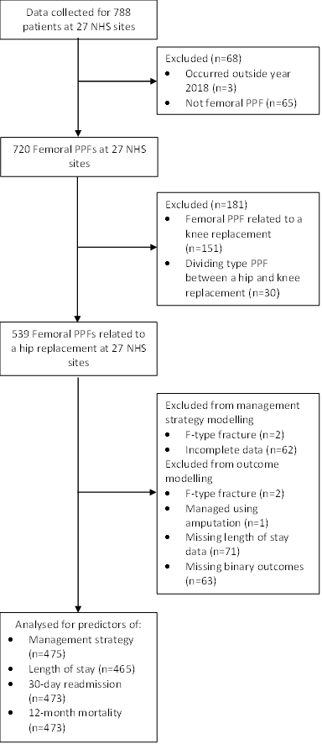

**Figure 2**: Association of patient characteristics with whether the femoral periprosthetic hip fracture was managed operatively or non-operatively. 1Reference category males; 2Reference category living in own home; 3Reference category A/B1/C; 4Reference category PPF around primary implant; 5Reference category original implant uncemented; 6Reference category early PPF. Descriptive comparison of candidate predictors for the operative and non-operative PPFs groups are presented in Table B in the appendix.

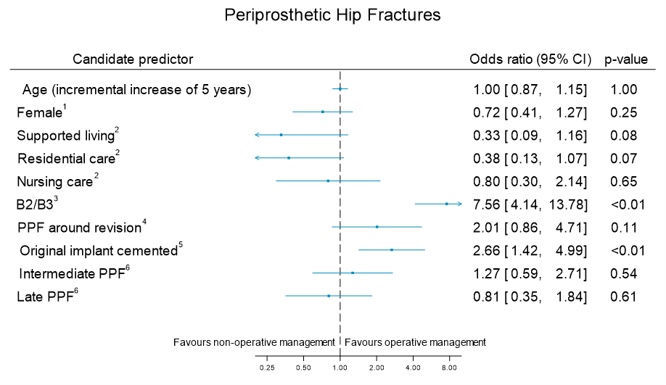

**Figure 3:** Forest plot displaying predictors of length of stay for patients with femoral periprosthetic hip fracture. 1Reference category fixation; 2Reference category male; 3Reference category living in own home; 4Reference category A/B1/C; 5Reference category PPF around primary; 6Reference category early PPF. Descriptive comparison of candidate predictor variables based on the median Length of stay (15 days) is presented in Table C in the appendix.

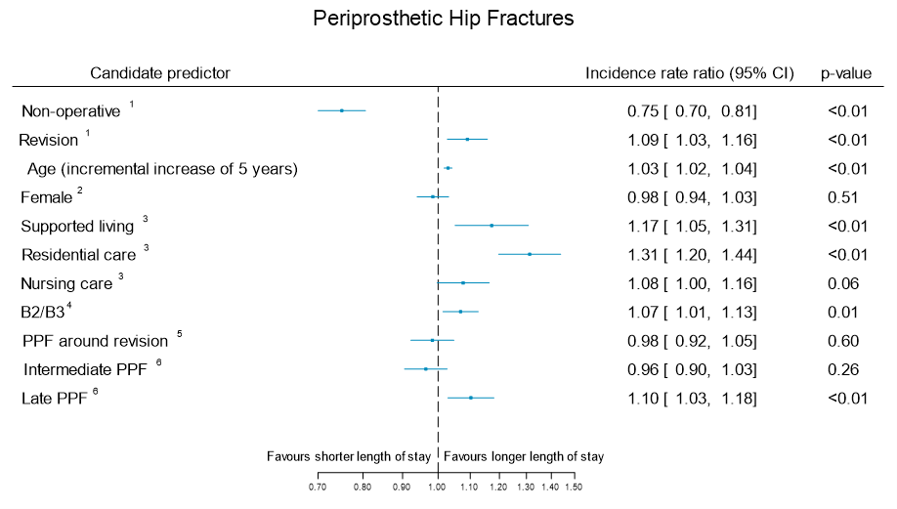

**Figure 4:** Forest plot displaying predictors of hospital readmission within 30 days of discharge for patients with femoral periprosthetic hip fracture. 1Reference category fixation; 2Reference category male; 3Reference category living in own home; 4Reference category A/B1/C; 5Reference category PPF around primary; 6Reference category early PPF. Descriptive comparison of candidate predictor variables based on readmission (Yes/No) is presented in Table C in the appendix.

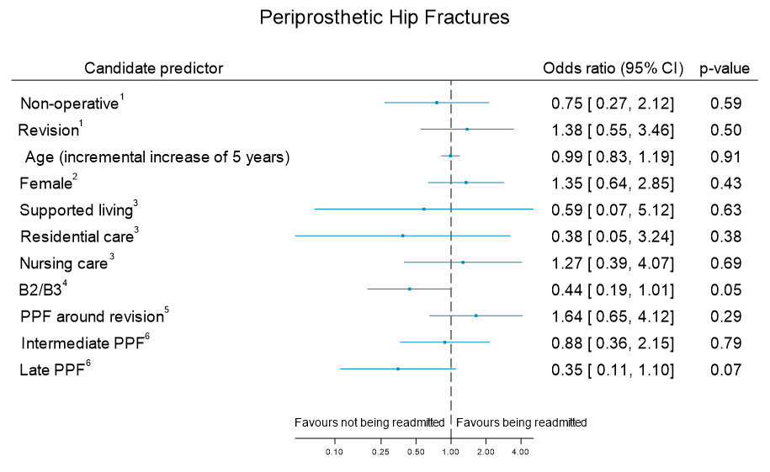

**Figure 5:** Forest plot displaying predictors of 12-month mortality for patients with femoral periprosthetic hip fracture. 1Reference category fixation; 2Reference category male; 3Reference category living in own home; 4Reference category A/B1/C; 5Reference category PPF around primary; 6Reference category early PPF. Descriptive comparison of candidate predictor variables based on 12-month mortality (Yes/No) is presented in Table C in the appendix.

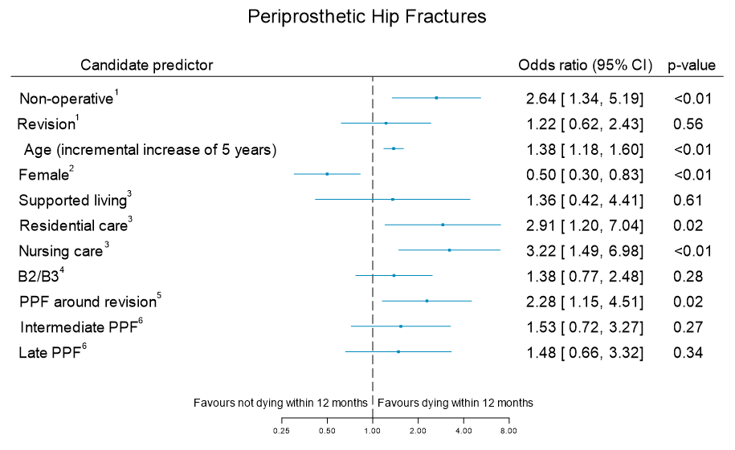

**Appendices**

Appendix 1

**Table A:** Information on site variation in management of femoral periprosthetic hip fractures.

|  | **Hip1**  **(n=537)** | | | |
| --- | --- | --- | --- | --- |
|  | **Number of fractures** | **Managed non-operatively**  **(% of fractures)** | **Managed with revision ± fixation**  **(% of fractures)** | **Managed with fixation alone**  **(% of fractures)** |
| **Site, n (%)**  A  B  C  D  E  F  G  H  I  J  K  L  M  N  O  P  Q  R  S  T  U  V  W  X  Y  Z  AA  **Total** | 11  16  25  43  6  7  27  5  11  25  10  24  8  32  82  15  35  11  18  20  13  15  18  20  4  28  8  **537** | 2 (18.2)  4 (25.0)  8 (32.0)  8 (18.6)  0 (0)  0 (0)  8 (29.6)  0 (0)  7 (63.6)  7 (28.0)  5 (50.0)  10 (41.7)  0 (0)  0 (0)  29 (35.4)  4 (26.7)  8 (22.9)  3 (27.3)  0 (0)  9 (45.0)  0 (0)  0 (0)  0 (0)  4 (20.0)  0 (0)  3 (10.7)  3 (37.5)  **122 (22.7)** | 6 (54.5)  10 (62.5)  12 (48.0)  11 (25.6)  6 (100)  0 (0)  4 (14.8)  1 (20.0)  0 (0)  8 (32.0)  3 (30.0)  11 (45.8)  7 (87.5)  30 (93.7)  33 (40.2)  4 (26.7)  12 (34.3)  3 (27.3)  14 (77.8)  3 (15.0)  10 (76.9)  4 (26.7)  14 (77.8)  12 (60.0)  2 (50.0)  22 (78.6)  4 (50.0)  **246 (45.8)** | 3 (27.3)  2 (12.5)  5 (20.0)  24 (55.8)  0 (0)  7 (100)  15 (55.6)  4 (80.0)  4 (36.4)  10 (40.0)  2 (20.0)  3 (12.5)  1 (12.5)  2 (6.3)  20 (24.4)  7 (46.7)  15 (42.9)  5 (45.5)  4 (22.2)  8 (40.0)  3 (23.1)  11 (73.3)  4 (22.2)  4 (20.0)  2 (50.0)  3 (10.7)  1 (12.5)  **169 (31.5)** |
| 1One patient excluded due to missing information on whether the fracture was managed using revision ± fixation or fixation alone, while another was excluded as was managed using amputation. | | | | | |

**Table B:** Patient characteristics presented by whether the femoral periprosthetic hip fracture was managed operatively or non-operatively.

|  | **Hips (n=475)** | |
| --- | --- | --- |
|  | **Managed operatively**  **(n=370)** | **Managed non-operatively**  **(n=105)** |
| **Age, years**  n (%)  Mean (SD)  Median (IQR)  Min, Max | 370 (100)  78.9 (10.6)  81 (73, 86)  19, 102 | 105 (100)  79.5 (11.3)  81 (71, 88)  43, 102 |
| **Gender, n (%)**  Female  Male | 205 (55.4)  165 (44.6) | 68 (64.8)  37 (35.2) |
| **Residence type pre-periprosthetic fracture, n (%)**  Own home  Supported living  Residential care  Nursing care | 310 (83.8)  12 (3.2)  17 (4.6)  31 (8.4) | 78 (74.3)  6 (5.7)  11 (10.5)  10 (9.5) |
| **Fracture type, n (%)**  A/B1/C  B2/B3 | 135 (36.5)  235 (63.5) | 81 (77.1)  24 (22.9) |
| **Fracture around primary or revision joint**  **replacement, n (%)**  Primary  Revision | 318 (85.9)  52 (14.1) | 94 (89.5)  11 (10.5) |
| **Method of implant fixation around which periprosthetic fracture occurred, n (%)**  Cemented  Uncemented | 284 (76.8)  86 (23.2) | 61 (58.1)  44 (41.9) |
| **Time between joint replacement and periprosthetic fracture, years, n (%)**  Early (≤1 year)  Intermediate (1-10 yrs)  Late (>10 yrs) | 61 (16.5)  198 (53.5)  111 (30.0) | 21 (20.0)  43 (41.0)  41 (39.0) |

**Table C:** Descriptive analysis of the candidate predictors of outcomes presented by the location of the femoral periprosthetic fracture and the value of the outcome (split by the median value for length of stay and yes/no for binary outcomes).

|  |  |  |
| --- | --- | --- |
|  | **Hip femoral PPFs** | |
| **Length of Hospital Stay1** | **Length of Stay < 15 days**  **(n=234)** | **Length of Stay >= 15 days**  **(n=231)** |
| **Management strategy, n (%)**  Non-operative  Revision ± fixation  Fixation alone | 63 (26.9)  99 (42.3)  72 (30.8) | 34 (14.7)  123 (53.2)  74 (32.0) |
| **Age, years**  n (%)  Mean (SD)  Median (IQR)  Min, Max | 234 (100)  77.5 (11.5)  80 (71, 86)  19, 99 | 231 (100)  80.9 (9.5)  82 (76, 87)  36, 102 |
| **Gender, n (%)**  Female  Male | 134 (57.3)  100 (42.7) | 133 (57.6)  98 (42.4) |
| **Residence type pre-PPF fracture, n (%)**  Own home  Supported living  Residential care  Nursing care | 190 (81.2)  7 (3.0)  16 (6.8)  21 (9.0) | 192 (83.1)  9 (3.9)  11 (4.8)  19 (8.2) |
| **Fracture type, n (%)**  A/B1/C  B2/B3 | 108 (46.2)  126 (53.8) | 101 (43.7)  130 (56.3) |
| **Fracture around primary or revision joint**  **replacement, n (%)**  Primary  Revision | 201 (85.9)  33 (14.1) | 201 (87.0)  30 (13.0) |
| **Time between joint replacement and periprosthetic fracture, years, n (%)**  Early (≤1 year)  Intermediate (1-10 yrs)  Late (>10 yrs) | 46 (19.7)  123 (52.6)  65 (27.8) | 35 (15.2)  113 (48.9)  83 (35.9) |
| **Readmitted Within 30 days** | **Yes**  **(n=39)** | **No**  **(n=434)** |
| **Management strategy, n (%)**  Non-operative  Revision ± fixation  Fixation alone | 7 (17.9)  19 (48.7)  13 (33.3) | 98 (22.6)  203 (46.8)  133 (30.6) |
| **Age, years**  n (%)  Mean (SD)  Median (IQR)  Min, Max | 39 (100)  77.8 (10.2)  79 (74, 86)  43, 91 | 434 (100)  79.2 (10.8)  81 (73, 87)  19, 102 |
| **Gender, n (%)**  Female  Male | 25 (64.1)  14 (35.9) | 246 (56.7)  188 (43.3) |
| **Residence type pre-PPF fracture, n (%)**  Own home  Supported living  Residential care  Nursing care | 32 (82.1)  1 (2.6)  1 (2.6)  5 (12.8) | 355 (81.8)  17 (3.9)  27 (6.2)  35 (8.1) |
| **Fracture type, n (%)**  A/B1/C  B2/B3 | 23 (59.0)  16 (41.0) | 192 (44.2)  242 (55.8) |
| **Fracture around primary or revision joint**  **replacement, n (%)**  Primary  Revision | 31 (79.5)  8 (20.5) | 379 (87.3)  55 (12.7) |
| **Time between joint replacement and periprosthetic fracture, years, n (%)**  Early (≤1 year)  Intermediate (1-10 yrs)  Late (>10 yrs) | 11 (28.2)  22 (56.4)  6 (15.4) | 71 (16.4)  219 (50.5)  14 (33.2) |
| **12 Month Mortality** | **Yes**  **(n=98)** | **No**  **(n=375)** |
| **Management strategy, n (%)**  Non-operative  Revision ± fixation  Fixation alone | 32 (32.7)  41 (41.8)  25 (25.5) | 73 (19.5)  181 (48.3)  121 (32.3) |
| **Age, years**  n (%)  Mean (SD)  Median (IQR)  Min, Max | 98 (100)  83.9 (10.4)  86 (80, 90)  43, 102 | 375 (100)  77.8 (10.5)  79 (72, 85)  19, 99 |
| **Gender, n (%)**  Female  Male | 48 (45.0)  50 (51.0) | 223 (59.5)  152 (40.5) |
| **Residence type pre-PPF, n (%)**  Own home  Supported living  Residential care  Nursing care | 63 (64.3)  5 (5.1)  12 (12.2)  18 (18.4) | 324 (86.4)  13 (3.5)  16 (4.3)  22 (5.9) |
| **Fracture type, n (%)**  A/B1/C  B2/B3 | 43 (43.9)  55 (56.1) | 172 (45.9)  203 (54.1) |
| **Fracture around primary or revision joint**  **replacement, n (%)**  Primary  Revision | 80 (81.6)  18 (18.4) | 330 (88.0)  45 (12.0) |
| **Time between joint replacement and periprosthetic fracture, years, n (%)**  Early (≤1 year)  Intermediate (1-10 yrs)  Late (>10 yrs) | 14 (14.3)  49 (50.0)  35 (35.7) | 68 (18.1)  192 (51.2)  115 (30.7) |

1Length of hospital stay summarised categorically using the median as the cut point for the purposes of this descriptive table, however as an outcome length of stay was analysed as count data.