Epidemiology and Characteristics of Femoral Periprosthetic Fractures: Data from the Characteristics, Outcomes and Management of PeriprOsthetic Fracture Service Evaluation (COMPOSE) cohort study

# Abstract

**Aims**

To describe the demographics of patients that sustain a femoral periprosthetic fracture (PPF), the epidemiology of PPFs, PPF characteristics and the predictors of PPF types in the United Kingdom population.

**Methods**

Multicentre retrospective cohort study including adult patients presenting to hospital with a new PPF between 01/01/2018 and 31/12/2018. Data collected included: patient demographics, co-morbidities, anti-coagulant use, social circumstances, level of mobility, fracture characteristics, UCFP type, and details of the original implant. Descriptive analysis by fracture location was performed and predictors of PPF type were assessed using mixed-effects logistic regression models.

**Results**

720 femoral PPFs from 27 NHS sites were included. PPF patients were typically elderly (mean 79.9 years, SD 10.6 years), female (n=455, 63.2%), had at least one comorbidity (n=670, 93.1%), and were reliant on walking aids or bed/chair bound prior to admission (n=419, 61.7%). The study population included 539 (74.9%) hip PPFs, 151 (21.0%) knee PPFs and 30 (4.2%) dividing type PPFs. For hip (n=407, 75.5%) and knee (n=88, 58.3%) arthroplasty UCPF B type fractures were most common. Overall, 556 (86.2%) were treated in the presenting hospital and 89 (13.8%) required transfer for treatment. Female gender was the only significant predictor of fracture type (A/B1/C type versus B2/B3) for femoral hip PPFs (OR 0.61; 95% CI: 0.41 to 0.91; p=0.01). Gender, residence type, primary versus revision implant PPF, implant fixation and time between joint replacement and PPF were not found to predict fracture type for hip PPFs.

**Conclusions**

This multicentre analysis describes patient and injury factors for patients presenting with femoral PPFs to centres across the UK. These patients are generally elderly and frail, comparable to those sustaining a hip fracture. This data can be useful in planning future services and clinical trials.

# Introduction

The demand for arthroplasty is increasing, with over 200,000 primary arthroplasties being performed in the UK in 2020. (1,2) Due to improvements in implant design and surgical technique the longevity of the joints implanted has increased significantly over the last 20 years. (3,4) This observation, alongside increases in life expectancy and the incidence of comorbidities such as osteoporosis, has led to an increased incidence offemoral periprosthetic fractures (PPFs).(5) This trend is expected to continue, with the prevalence of femoral PPFs predicted to increase by 13.8% over the next 30 years.(6,7) Data from the National Joint Registry (NJR) also demonstrates that the prevalence of revision surgery for PPFs is increasing, rising from 9.5% in 2015 to 11.5% in 2020.(1)

Despite the significant burden posed by femoral PPFs, there is a paucity of existing evidence examining the demographics of this patient group and the types of injuries they sustain. The current literature is dominated by single centre studies reporting on a narrow spectrum of treatment modalities (8–12), and studies that rely on data from registries. (13,14) Whilst registries and national datasets provide valuable information these resources have significant limitations as they do not adequately classify fractures and may under estimate the true burden of PPFs as subsets of the PPF patient population are omitted. (15) For example, the NJR reports only on PPFs resulting in revision and Hospital Episode Statistics (HES) reports only on inpatient episodes. This makes it difficult to truly understand the disease burden posed by PPFs, which is essential to planning regional and national management strategies, and informing future clinical trials in this poorly studied field.

The COMPOSE (Characteristics, Outcomes and Management of PeriprOsthetic fractures: Service Evaluation) study was undertaken with the aim of providing information about the population of patients who sustain PPFs in the United Kingdom (UK). The analysis presented in this paper describes the demographic characteristics of the population of patients that sustain a femoral PPF, the epidemiology of PPF occurrence, PPF characteristics and the predictors of PPF types. It supplements our associated paper reporting the management and outcomes of this patient cohort.

# Methods

COMPOSE was a multicentre retrospective cohort study that followed a prospective study protocol and analysis plan. Data were collected from a consecutive series of patients that presented to participating hospitals in the UK with a new PPF between 1st January 2018 and 31st December 2018. Data collection ran from 1st July 2020 to 31st January 2021. From the entire PPF cohort (n=788) a subset of eligible patients sustaining a femoral PPF (n=720) were selected for inclusion in this analysis (Figure 1, Table 1)

All patients, aged 18 or over, presenting to the participating site with a new PPF were eligible for inclusion irrespective of the joint involved, fracture type or method of treatment (non-operative, fixation, revision). Patients were excluded if they had sustained a concurrent injury to another body part e.g. polytrauma patients, presented to hospital more than 4 weeks from injury or had sustained a previousPPF of the same bone or joint*.*

We aimed to involve as many hospitals treating PPFs as possible to enable broad geographical spread and ensure that the data collected was representative of current UK practice and included the management of PPFs around different implant types (e.g., cemented and uncemented femoral stems). Site recruitment was coordinated through the trainee-led Collaborative Orthopaedic Research NETwork (CORNET) and the project was managed by South Tees Hospitals NHS Foundation Trust. The study was delivered by regional trainee research groups, with oversight at each site by a consultant supervisor.

## Data collection

Anonymised data were collected from multiple data sources at each site including patient or theatre records, operation notes, discharge letters and electronic routine data collection systems. A pragmatic approach to data collection was taken, with the optimal strategy at each site determined by the site leads. Data were collated centrally using the REDCap data entry system. The REDCap system was housed on secure servers at the South Tees Hospitals NHS Foundation Trust. No patient identifiable data were collected. Local service evaluation approval was obtained from all participating sites along with signed REDCap user registration and data sharing agreements before sites were provided access to the REDCap system.

Data collected relating to the epidemiology and characteristics of people with PPFs included: patient demographics, co-morbidities, anti-coagulant use, social circumstances, level of mobility, hospital presentation, fracture characteristics, and details of the implant around which the PPF occurred. All fractures were classified via the Unified Classification System (UCFP) classification system for PPFs. (16) Fracture classification was based on local records such as clinical notes, letters and/or operation notes. Where not specified the classification was determined by interpretation of the available imagining by the local trainee and consultant site lead. Additionally, management and outcome data on all patients were collected and this is presented in an associated paper. A full list of data fields collected can be found in the Appendix.

## Ethics and study regulation

The COMPOSE study was performed as a service evaluation as it was collecting retrospective, anonymised information about care that had previously been delivered. All patients received standard care as per their treating centre and their surgeon’s usual practice. There was no requirement for ethical approval or patient consent as checked against the Health Research Authority criteria. (17) The study was registered locally at each site as a service evaluation prior to data collection.

## Analysis

### *Descriptive summaries*

Patient demographics, fracture characteristics and treatment were summarised descriptively by whether the femoral PPF was located around a hip replacement, knee replacement or was a dividing (D type) fracture between a hip and knee replacement. The monthly incidence of femoral PPFs was summarised graphically by location of the fracture.

### *Candidate predictors of periprosthetic fracture type*

Femoral PPFs were grouped into two categories based on whether the underlying joint replacement remained fixed to the bone or not. Category 1 comprised type A, B1 and C fractures (implant fixed to bone following PPF and therefore potentially suitable for fixation), while Category 2 comprised B2 and B3 fractures (implant not fixed to bone following PPF and therefore likely to require revision). Candidate predictors of fracture type in hip femoral PPFs were summarised descriptively by whether the fracture was A/B1/C or B2/B3. A mixed-effects logistic regression model with fracture type as the dependent variable was implemented, controlling for the candidate predictors as fixed effects and site as a random effect. The candidate predictors were age, gender, residence type (own home, supported living, residential care, nursing care), whether the fracture was around a primary or revision implant, implant fixation (cemented or uncemented) and time between joint replacement and PPF (Early ≤1 year; Intermediate 1-10 years; Late >10 years). Candidate predictors were chosen using prior clinical knowledge. The impact of sparse data bias on the model estimates for binary outcomes was assessed using Firth logistic regression. The analysis was repeated for femoral PPFs related to knee replacements.

# Results

In total, 720 eligible patients from 27 NHS sites across England and Scotland, that had sustained a femoral PPFs (around a hip replacement, knee replacement or dividing between both) were included in this analysis.

## Patient demographics

In total, there were 539 femoral PPFs around a hip replacement, 151 femoral PPFs around a knee replacement and 30 dividing femoral PPFs (Figure 1). Table 2 presents information on patient demographics for each of these fracture types. While the majority of patients lived in their own home (n=570, 79.4%), they were typically elderly (mean age 79.9 years, SD 10.6 years) and frail with at least one comorbidity (n=670, 93.1%) and reliant on walking aids or bed/chair bound (n=419, 61.7%). Only 395 (58.3%) were mobile outside of the house prior to their PPF and 196 (37.0%) had an abbreviated mental test score (AMTS) of <10. The knee group had a greater proportion of females (n=127, 84.1%) compared to the hip group (n=310, 57.5%). Compared to the knee group, the hip group had a greater proportion of patients that were independent for all ADLs (Hip 294 (71.0%); Knee 66 (61.7%)), a greater proportion of patients that were independently mobile outside of the home (Hip 315 (61.3%); Knee 67 (49.3%)) and a greater proportion of patients with an AMTS of 10 (Hip 266 (64.4%); Knee 59 (59.0%)), suggesting the hip group were less dependent and frail than the knee group.

## Periprosthetic fracture occurrence

There was no observed seasonal variation in the number of femoral PPFs across 2018, but we observed that the highest numbers presented in January and the lowest in September (Figure 2).

## Periprosthetic fracture characteristics

The characteristics for each of the femoral PPFs, dependent on the anatomical site, are presented in Table 3. Overall, 556 (86.2%) were treated in the presenting hospital and 89 (13.8%) had to be transferred to a different site to receive treatment. For the hip group, B type fractures were predominant (A type: 61 (11.3%); B type: 407 (75.5%); C type: 69 (12.8%)) and the same was seen for the knee group (A type: 10 (6.6%); B type: 88 (58.3%); C type: 53 (35.1%)). The knee group had the greatest proportion of C type fractures. The majority of femoral PPFs occurred around cemented implants with knee PPFs almost exclusively related to cemented implants. Only 96 (15.6%) femoral PPFs occurred within the first year after surgery and the overall median time from implantation to PPF occurrence was 6.75 years (IQR:2.41 to 11.33).

## Predictors of periprosthetic fracture type

Complete data was available for 475 (88.5%) hip and 111 (73.5%) knee femoral PPFs which were included in the models for candidate predictors of PPF type. Descriptive information on the candidate predictors for patients with sufficient data to be included in the models, presented by where the fracture was located and whether the fracture was classified as A/B1/C ‘implant fixed’ or B2/B3 ‘implant loose’ is presented in table 4. A greater proportion of A/B1/C fractures was observed in the knee group (n=78, 70.3%) when compared to the hip group (n=216, 45.5%). The age of patients was similar between the groups for both hip and knee PPFs, however, in both the hip and knee group the proportion of female patients was higher in the A/B1/C group compared to the B2/B3 group.

Due to sparse data for some candidate predictors, implausibly large odds ratios were found for patients with knee femoral PPFs, and this issue could not be rectified using a Firth logistic regression model. Therefore, the model was only run for patients with femoral hip PPFs. Figure 3 presents the forest plot of odds ratios resulting from the model to assess candidate predictors of fracture type in patients with femoral hip PPFs. Female gender was the only significant predictor of fracture type for femoral hip PPFs (OR=0.61; 95% CI:0.41 to 0.91; p=0.01). While there was a trend toward cemented implants being more likely to sustain a B2/B3 type PPFs in which the implant is defined as loose compared to the cementless implants this association did not reach significance (OR=1.53; 95% CI:0.97 to 2.41; p=0.07).

# Discussion

COMPOSE is the largest multicentre evaluation of femoral PPFs and provides a comprehensive description of the patient and fracture characteristics for this patient group from 27 sites covering England and Scotland. It captured data on all femoral PPFs fractures irrespective of management strategy (non-operative or operative). It found that these fractures occur in people who are older, frail and have comorbidities.

Previous UK Hospital Episode Statistics (HES) analyses have attempted to quantify the burden of PPFs presenting to health services. (18) These data demonstrate that most PPFs occur in female patients over the age of 65. The median age of our cohort was 79.5 years for hip femoral PPFs and 81.1 years for knee femoral PPFs, and overall the lower age quartile was 74 years. This suggests that while there is a wide age range of patients sustaining these injuries the majority of patients are elderly, similar to patients sustaining a neck of femur fracture (median age 82 years). (19) We also observed a variation in gender distribution dependent upon fracture type which was similar to other studies. (20,21) The NJR reports that 60% (THR) and 56% (TKR) of primary arthroplasties are performed in females. This contrasts with a female proportion of 58% and 84% for hip and knee femoral PPFs respectively suggesting that gender is variably associated with the risk of a femoral PPFs dependent upon the joint involved. Similar to our cohort, data from Sweden demonstrates that PPF patients are typically elderly and frail with high levels of social dependence and sustain fractures resulting from low energy mechanisms, such as a fall from standing height. (13,14)

COMPOSE found that patients sustaining femoral PPFs are more likely to live in their own home pre-injury (75-80%) when compared to those sustaining a neck of femur fracture (63-73%). (30) However, despite this they remain a frail group that are similarly dependant on walking aids and carers, and they have similar levels of cognitive impairment as those sustaining a hip fracture. (19) Seasonal variation in the presentation of hip fractures has previously been reported with 8% more patients presenting in the winter months compared to the summer and an associated 30% higher mortality. (22) The COMPOSE data identified January as the busiest month but we did not identify any seasonal trends which is important for planning future service requirements.

The Unified Classification System for Periprosthetic Fractures (UCPF) was introduced in 2014 and aimed to act as a means to discuss the management of the different PPF subtypes. (16) The classification has been subsequently validated (23) although its validity and reliability in differentiating loose from fixed cemented polished taper stem has been questioned. (24) The COMPOSE femoral PPF cohort was predominantly UCPF Type B, 76% hip and 58% knee, in-keeping with previous published series of PPFs around hip arthroplasty where the reported incidence of B type fractures ranged from 70 to 78% (25,26) and Swedish registry data (86%). (14) Type A fractures are often under-reported or excluded from cohort studies examining PPFs as they may be treated non-operatively and/or be managed in an outpatient setting. (27) The Swedish registry reported the incidence of type A fractures as 4%, between 1979 and 2000. (14) In the same study, Type C fractures were identified in only 10% of cases. In COMPOSE, the incidence of hip femoral Type A and C fractures was higher for both of these fracture types (11% and 13% respectively) and, due to the nature of the data collection, may represent a more accurate picture of the true incidence of these fractures.

Cement is currently used for femoral fixation in 56% of primary hip replacements in the United Kingdom. (1) COMPOSE found weak evidence that the femoral hip implant was more likely to be classified as ‘loose’ (UCPF B2/3) when the implant was cemented when compared to it being uncemented, although this result was not statistically significant. Unfortunately we do not have further information on the overall incidence and rates of PPFs for cemented and uncemented implants. However, this finding does suggest a potentially different mode and pattern of failure dependent upon the method of primary fixation. Berend et al, reported a higher incidence (6.4%) of fractures in uncemented THRs when compared to cemented THRs, although the specific fracture type was not identified. (28) In contrast, the observational study by Jain et al, reported that 85.1% of the PPFs in their series occurred around cemented polished taper stems. (21) Other series have reported that fractures around uncemented implants mainly occur intra-operatively (29) and Miettinen et al. suggested cementless fixation was an independent risk factor for PPF. (30) The observed differences between these studies is probably a function of the different populations studied and merits further investigation to help surgeons understand the modes of failure with differing implants designs and fixation methods.

COMPOSE captured data on the transfer of patients for management between units. Transfer rates for the hip and knee cohorts were 13.5% and 9.3%, respectively. The requirement for transfer may be linked to the availability of surgeons and their skillset. A survey of Orthopaedic Trauma Association members revealed that the training background the surgeon had undertaken affected their surgical plan, with trauma surgeons favouring fixation over revision compared to arthroplasty colleagues. (31) Variation in surgical capability and capacity may be driving patient flow alongside the changes in trauma provision due to the advent of major trauma centres and trauma networks.

We found the majority (93.1%) of patients had at least one comorbidity (Table 2), and overall, comorbidity rates were comparable to other patient groups, such as hip fracture patients, where multi-disciplinary care pathways are well established (19). In 2020, the NHFD announced that their database would expand to include all femoral fractures from April 2020 and that in the future, the Best Practice Tariff (BPT) will include femoral PPFs. (32) The introduction of BPT has improved 30-day and 1-year mortality in hip fracture patients (33,34). Given the similar age and comorbidity profile, patients sustaining femoral PPF’s may benefit from similar multi-disciplinary care, as encouraged by the expansion of BPT. However, as shown by the wide range of ages observed in this study not all PPF patients are elderly, and some younger are likely to have different rehabilitation requirements. This potentially has implications when considering the approach to management.

Our study was limited by its retrospective nature and use of multiple data sources at individual sites to access patient data which may have potentially introduced bias. For example, our approach to fracture classification using the UCPF based on clinical records and/or interpretation of imaging may have impacted the reproducibility and reliability of classification. However, sites were encouraged to use all available information including operative notes when classifying fractures in conjunction with local arthroplasty consultant leads. In addition, we were able to capture 95% of the data fields intended from our prospective study protocol and the data collection was gathered from 27 Trusts across England and Scotland, improving the generalisability of our results to other UK NHS Trusts. In addition, whilst extensive data were captured on comorbidities, it was not possible to calculate the Charlson Comorbidity Index, which may have further aided population comparisons (35). COMPOSE was delivered and co-ordinated by the CORNET trainee research collaborative. The design of the study and its electronic data collection system meant that the study could be rapidly implemented and adopted by trainees at multiple sites simultaneously helping to harness trainee engagement and maximise data capture. This success of COMPOSE highlights the value of this type of trainee-led collaborative approach to delivering impactful projects effectively.

# Conclusion

This multicentre analysis is the largest of its kind to describe patient and injury factors for patients presenting with femoral PPF to centres across England and Scotland. PPF patients are generally elderly and frail, comparable to those sustaining a hip fracture. The data from this study can be useful in planning future services and helps to define the population of patients that should be included in any future clinic trials examining the management of PPFs.

# References

1. National Joint Registry. 17th Annual Report 2019-2020. Available from: https://reports.njrcentre.org.uk/Portals/0/PDFdownloads/NJR 17th Annual Report 2020.pdf

2. Scottish Arthroplasty Project. Annual Report 2020. 2020; Available from: https://readymag.com/PHIDigital/SAP-Annual-Report-2020/

3. Fevang B-TS, Lie SA, Havelin LI, Engesæter LB, Furnes O. Improved results of primary total hip replacement. Acta Orthop. 2010 Dec 26;81(6):649–59.

4. Herberts P, Malchau H. Long-term registration has improved the quality of hip replacement: A review of the Swedish THR Register comparing 160,000 cases. Acta Orthop Scand. 2000;71(2):111–21.

5. Johnston AT, Tsiridis E, Eyres KS, Toms AD. Periprosthetic fractures in the distal femur following total knee replacement: A review and guide to management. Knee. 2012;19(3):156–62.

6. Pivec R, Issa K, Kapadia BH, Cherian JJ, Maheshwari AJ, Bonutti PM, et al. Incidence and Future Projections of Periprosthetic Femoral Fracture Following Primary Total Hip Arthroplasty: An Analysis of International Registry Data. J Long Term Eff Med Implants. 2015;25(4):269–75.

7. Della Rocca GJ, Leung KS, Pape H-C. Periprosthetic Fractures: Epidemiology and Future Projections. J Orthop Trauma. 2011;25(Suppl 2):S66–70.

8. Fink B, Oremek D. Hip revision arthroplasty for failed osteosynthesis in periprosthetic Vancouver type B1 fractures using a cementless, modular, tapered revision stem. Bone Joint J. 2017;99-B(4):11–6.

9. Khan T, Grindlay D, Ollivere BJ, Scammell BE, Manktelow ARJ, Pearson RG. A systematic review of Vancouver B2 and B3 periprosthetic femoral fractures. Bone Joint J. 2017 Apr;99(4):17–25.

10. Hou Z, Bowen TR, Irgit K, Strohecker K, Matzko ME, Widmaier J, et al. Locked Plating of Periprosthetic Femur Fractures Above Total Knee Arthroplasty. J Orthop Trauma. 2012 Jul;26(7):427–32.

11. Gavaskar AS, Tummala NC, Subramanian M. The Outcome and Complications of the Locked Plating Management for the Periprosthetic Distal Femur Fractures after a Total Knee Arthroplasty. Clin Orthop Surg. 2013 Jun;5(2):124.

12. Shin Y-S, Han S-B. Periprosthetic fracture around a stable femoral stem treated with locking plate osteosynthesis: distal femoral locking plate alone versus with cerclage cable. Eur J Orthop Surg Traumatol. 2017 Jul 16;27(5):623–30.

13. Kärrholm J. The Swedish Hip Arthroplasty Register (www.shpr.se). Acta Orthop. 2010 Feb 22;81(1):3–4.

14. Lindahl H, Malchau H, Herberts P, Garellick G. Periprosthetic Femoral Fractures: Classification and Demographics of 1049 Periprosthetic Femoral Fractures from the Swedish National Hip Arthroplasty Register. J Arthroplasty. 2005 Oct 1;20(7):857–65.

15. Konow T, Baetz J, Melsheimer O, Grimberg A, Morlock M. Factors influencing periprosthetic femoral fracture risk. Bone Joint J. 2021;103-B(4):650–8.

16. Duncan CP, Haddad FS. The Unified Classification System (UCS): improving our understanding of periprosthetic fractures. Bone Joint J. 2014 Jun 1;96-B(6):713–6.

17. NHS Health Research Authority. Research decision tool [Internet]. 2020. Available from: http://www.hra-decisiontools.org.uk/research/

18. Bottle A, Griffiths R, White S, Wynn-Jones H, Aylin P, Moppett I, et al. Periprosthetic fractures: the next fragility fracture epidemic? A national observational study. BMJ Open. 2020 Dec 10;10(12):e042371.

19. Baker PN, Salar O, Ollivere BJ, Forward DP, Weerasuriya N, Moppett IK, et al. Evolution of the hip fracture population: time to consider the future? A retrospective observational analysis. BMJ Open. 2014 Apr;4(4):e004405.

20. Powell-Bowns MFR, Oag E, Martin D, Clement ND, Scott CEH. Vancouver B and C periprosthetic fractures around the cemented Exeter Stem: sex is associate with fracture pattern. Arch Orthop Trauma Surg. 2021 Aug 14;

21. Jain S, Lamb J, Townsend O, Scott CEH, Kendrick B, Middleton R, et al. Risk factors influencing fracture characteristics in postoperative periprosthetic femoral fractures around cemented stems in total hip arthroplasty. Bone Jt Open. 2021 Jul 1;2(7):466–75.

22. Johansen A, Grose C, Havelock W. Hip fractures in the winter – Using the National Hip Fracture Database to examine seasonal variation in incidence and mortality. Injury. 2020 Apr;51(4):1011–4.

23. Van der Merwe JM, Haddad FS, Duncan CP. Field testing the Unified Classification System for periprosthetic fractures of the femur, tibia and patella in association with knee replacement. Bone Joint J. 2014 Dec;96-B(12):1669–73.

24. Jain S, Mohrir G, Townsend O, Lamb JN, Palan J, Aderinto J, et al. Reliability and validity of the Unified Classification System for postoperative periprosthetic femoral fractures around cemented polished taper-slip stems. Bone Joint J. 2021 Aug 1;103-B(8):1339–44.

25. Pavelka T, Salášek M, Weisová D. Periprosthetic Femoral Fractures after Total Hip Replacement: Our Results and Treatment Complications. Acta Chir Orthop Traumatol Cech. 2017;84(1):52–8.

26. Concina C, Crucil M, Gherlinzoni F. Factors influencing results and complications in proximal periprosthetic femoral fractures: a retrospective study at 1- to 8-year follow-up. Acta Biomed. 2021 Jul;92(S3):e2021022.

27. Pritchett JW. Fracture of the Greater Trochanter After Hip Replacement. Clin Orthop Relat Res. 2001 Sep;390(390):221–6.

28. Berend ME, Smith A, Meding JB, Ritter MA, Lynch T, Davis K. Long-Term Outcome and Risk Factors of Proximal Femoral Fracture in Uncemented and Cemented Total Hip Arthroplasty in 2551 Hips. J Arthroplasty. 2006 Sep;21(6):53–9.

29. Berry DJ. Epidemiology: Hip and Knee. Orthop Clin North Am. 1999 Apr;30(2):183–90.

30. Miettinen SSA, Törmä S V, Lappalainen JM, Sund R, Kröger H. Retrospective Population-Based Cohort Study of Incidence, Complications, and Survival of 202 Operatively Treated Periprosthetic Femoral Fractures. J Arthroplasty. 2021 Jul 1;36(7):2591–6.

31. Van Rysselberghe NL, Campbell ST, Goodnough LH, Amanatullah DF, Gardner MJ, Bishop JA. To Fix or Revise: Differences in Periprosthetic Distal Femur Fracture Management Between Trauma and Arthroplasty Surgeons. J Am Acad Orthop Surg. 2021 Jul 20;Publish Ah.

32. Royal College of Physicians. The challenge of the next decade: are hip fracture services ready? A review of data from the National Hip Fracture Database (January–December 2019). 2021.

33. Oakley B, Nightingale J, Moran C, Moppett I. Does achieving the best practice tariff improve outcomes in hip fracture patients? An observational cohort study. BMJ Open. 2017 Feb 6;7(2):e014190.

34. Whitaker SR, Nisar S, Scally AJ, Radcliffe GS. Does achieving the ‘Best Practice Tariff’ criteria for fractured neck of femur patients improve one year outcomes? Injury. 2019 Jul;50(7):1358–63.

35. Charlson M, Szatrowski TP, Peterson J, Gold J. Validation of a combined comorbidity index. J Clin Epidemiol. 1994;47(11):1245–51.

**Tables and figures**

**Table 1:** Location of periprosthetic fractures from the entire COMPOSE cohort (n=785) during the year 2018 (3 patients excluded as not during the year 2018)

|  |  |
| --- | --- |
|  | **Periprosthetic fractures (n=785)** |
| **Hip, n (%)** | **562 (71.6)** |
| Femur  Pelvis  Acetabulum  Acetabulum and femur | 539 (95.9)  2 (0.4)  20 (3.6)  1 (0.2) |
| **Knee, n (%)** | **162 (20.6)** |
| Femur  Patella  Tibia | 151 (93.2)  1 (0.6)  10 (6.2) |
| **Hip and knee (dividing), n (%)** | **30 (3.8)** |
| Femur | 30 (100) |
| **Other, n (%)** | **31 (4.0%)** |
| Ankle  Shoulder  Elbow  Wrist | 4 (0.5)  16 (2.1)  7 (0.9)  4 (0.5) |

**Table 2:** Patient demographics presented by femoral fracture type (percentages calculated based on those with non-missing data).

|  | **Hip**  **(n=539)** | **Knee**  **(n=151)** | **Dividing (n=30)** | **Overall**  **(n=720)** |
| --- | --- | --- | --- | --- |
| **Age, years**  Mean (SD)  Median (IQR)  Min, Max | 79.5 (10.6)  81 (73, 87)  19, 102 | 81.1 (10.3)  84 (75, 89)  49, 99 | 82.2 (10.3)  83 (77, 89)  52, 98 | 79.9 (10.6)  82 (74, 87)  19, 102 |
| **Gender, n (%)**  Female  Male | 310 (57.5)  229 (42.5) | 127 (84.1)  24 (15.9) | 18 (60.0)  12 (40.0) | 455 (63.2)  265 (36.8) |
| **Residence type pre-periprosthetic fracture, n (%)**  Own home  Supported living  Residential care  Nursing care | 431 (80.3)  20 (3.7)  30 (30)  56 (10.4) | 114 (75.5)  9 (6.0)  14 (9.3)  14 (9.3) | 25 (83.3)  1 (3.3)  2 (6.7)  2 (6.7) | 570 (79.4)  30 (4.2)  46 (6.4)  72 (10.0) |
| **Level of social support pre-injury, n (% of those who live in own home)**  Independent for all ADLs  Assistance of family for care needs  1-2 carer visits per day  3-4 carer visits per day | 294 (71.0)  86 (20.8)  23 (5.6)  11 (2.7) | 66 (61.7)  22 (20.6)  12 (11.2)  7 (6.5) | 8 (36.4)  8 (36.4)  3 (13.6)  3 (13.6) | 368 (67.8)  116 (21.4)  38 (7.0)  21 (3.9) |
| **Use of walking aids pre-injury, n (%)**  Independent/unaided  One stick  Two sticks  Frame  Bed/chair bound | 201 (39.2)  138 (26.9)  27 (5.3)  134 (26.1)  13 (2.5) | 52 (37.4)  35 (25.2)  6 (4.3)  38 (27.3)  8 (5.8) | 7 (25.9)  5 (18.5)  3 (11.1)  10 (37.0)  2 (7.4) | 260 (38.3)  178 (26.2)  36 (5.3)  182 (26.8)  23 (3.4) |
| **Uses a walking aid or bed/chair bound, n (%)**  Yes  No | 312 (60.8)  201 (39.2) | 87 (62.6)  52 (37.4) | 20 (74.1)  7 (25.9) | 419 (61.7)  260 (38.3) |
| **Independently mobile outside of the home pre-injury, n (%)**  Yes  No | 315 (61.3)  199 (38.7) | 67 (49.3)  69 (50.7) | 13 (48.1)  14 (51.9) | 395 (58.3)  282 (41.7) |
| **At least one comorbidity, n (%)**  Yes  No | 499 (92.6)  40 (7.4) | 142 (94.0)  9 (6.0) | 29 (96.7)  1 (3.3) | 670 (93.1)  50 (6.9) |
| **Comorbidities, n (%)**  COPD/asthma  Ischaemic heart disease  Hypertension  Previous MI  AF/arrhythmia  CVA/stroke  Diabetes  Kidney disease  Liver disease  Cancer diagnosis  Alcohol excess (>16 units per week)  Dementia  Rheumatoid arthritis  Hypothyroidism  Other | 65 (12.1)  107 (19.9)  247 (45.8)  41 (7.6)  103 (19.1)  64 (11.9)  78 (14.5)  47 (8.7)  4 (0.7)  68 (12.6)  13 (2.4)  95 (17.6)  21 (3.9)  27 (5.0)  224 (41.6) | 18 (11.9)  24 (15.9)  70 (46.4)  6 (4.0)  23 (15.2)  19 (12.6)  24 (15.9)  16 (10.6)  2 (1.3)  15 (9.9)  5 (3.3)  30 (19.9)  17 (11.3)  9 (6.0)  59 (39.1) | 7 (23.3)  8 (26.7)  19 (63.3)  1 (3.3)  6 (20.0)  7 (23.3)  4 (13.3)  3 (10.0)  0 (0)  4 (13.3)  0 (0)  7 (23.3)  5 (16.7)  1 (3.3)  9 (30.0) | 90 (12.5)  139 (19.3)  336 (46.7)  48 (6.7)  132 (18.3)  90 (12.5)  106 (14.7)  66 (9.2)  6 (0.8)  87 (12.1)  18 (2.5)  132 (18.3)  43 (6.0)  37 (5.1)  292 (40.6) |
| **On anticoagulant admission on admission, n (%)**  Yes  No | 130 (24.5)  400 (75.5) | 33 (22.4)  114 (77.6) | 8 (27.6)  21 (72.4) | 171 (24.2)  535 (75.8) |
| **AMTS, n (%)**  Full capacity (10)  Reduced capacity (7-9)  Lacking capacity (0-6) | 266 (64.4)  70 (16.9)  77 (18.6) | 59 (59.0)  18 (18.0)  23 (23.0) | 9 (52.9)  4 (23.5)  4 (23.5) | 334 (63.0)  92 (17.4)  104 (19.6) |

**Table 3:** Femoral periprosthetic fracture details by location (percentages calculated based on those with non-missing data).

|  | **Hip**  **(n=539)** | **Knee**  **(n=151)** | **Dividing**  **(n=30)** | **Overall**  **(n=720)** |
| --- | --- | --- | --- | --- |
| **Hospital patient first presented with fracture at, n (%)**  Same hospital  Other hospital | 410 (84.9)  73 (15.1) | 120 (89.6)  14 (10.4) | 26 (92.9)  2 (7.1) | 556 (86.2)  89 (13.8) |
| **Side of fracture, n (%)**  Left  Right | 227 (42.1)  312 (57.9) | 82 (54.3)  69 (45.7) | 15 (50.0)  15 (50.0) | 324 (45.0)  396 (55.0) |
| **Energy of fracture, n (%)**  Low energy  High energy | 507 (94.8)  28 (5.2) | 142 (94.0)  9 (6.0) | 28 (93.3)  2 (6.7) | 677 (94.6)  39 (5.4) |
| **Fracture open or**  **closed, n (%)**  Open  Closed | 8 (1.5)  531 (98.5) | 2 (1.3)  149 (98.7) | 0 (0)  30 (100) | 10 (1.4)  710 (98.6) |
| **Type of fracture, n (%)**  A1  A2  B1  B2  B3  C  D  E  F | 37 (6.9)  24 (4.5)  118 (21.9)  250 (46.4)  39 (7.2)  69 (12.8)  NA  0 (0)  2 (0.4) | 6 (4.0)  4 (2.6)  44 (29.1)  28 (18.5)  16 (10.6)  53 (35.1)  NA  0 (0)  0 (0) | NA  NA  NA  NA  NA  NA  30 (100)  NA  NA | NA  NA  NA  NA  NA  NA  NA  NA  NA |
| **Fracture around primary or revision joint replacement, n (%)**  Primary  Revision | 468 (86.8)  71 (13.2) | 145 (96.7)  5 (3.3) | 26 (86.7)  4 (13.3) | 639 (88.9)  80 (11.1) |
| **Method of implant fixation around which periprosthetic fracture occurred, n (%)**  Cemented  Uncemented | 387 (71.8)  152 (28.2) | 141 (94.0)  9 (6.0) | 26 (86.7)  4 (13.3) | 554 (77.1)  165 (22.9) |
| **Time between joint replacement and periprosthetic fracture, years, n (%)**  Early (≤1 year)  Intermediate (1-10 years)  Late (>10 years) | 82 (17.2)  243 (50.8)  153 (32.0) | 14 (12.6)  55 (49.5)  42 (37.8) | 0 (0)  19 (76.0)  6 (24.0) | 96 (15.6)  317 (51.6)  201 (32.7) |
| **Time between joint replacement and periprosthetic fracture, years**  n (%)  Mean (SD)  Median (IQR)  Min, Max | 478 (88.7)  7.60 (6.44)  6.60 (2.05, 11.33)  0, 28.09 | 111 (73.5)  8.22 (5.82)  7.48 (3.76, 11.96)  0, 25.10 | 25 (83.3)  6.47 (3.54)  6.35 (3.86, 9.26)  1.16, 13.50 | 614 (85.3)  7.67 (6.24)  6.75 (2.41, 11.33)  0, 29.09 |

**Table 4:** Patient characteristics presented by fracture location and whether periprosthetic fracture was classified as A/B1/C ‘implant fixed’ or B2/B3 ‘implant loose’.

|  | **Hip**  **(n=475)** | | **Knee**  **(n=111)** | |
| --- | --- | --- | --- | --- |
|  | **A/B1/C**  **(n=216)** | **B2/B3**  **(n=259)** | **A/B1/C**  **(n=78)** | **B2/B3**  **(n=33)** |
| **Age, years**  n (%)  Mean (SD) | 216 (100)  79.5 (10.1) | 259 (100)  78.7 (11.3) | 78 (100)  80.3 (11.0) | 33 (100)  83.8 (8.6) |
| **Gender, n (%)**  Female  Male | 139 (64.4)  77 (35.6) | 134 (51.7)  125 (48.3) | 65 (83.3)  13 (16.7) | 24 (72.7)  9 (27.3) |
| **Residence type pre-periprosthetic fracture, n (%)**  Own home  Supported living  Residential care  Nursing care | 171 (79.2)  9 (4.2)  17 (7.9)  19 (8.8) | 217 (83.8)  9 (3.5)  11 (4.2)  22 (8.5) | 61 (78.2)  5 (6.4)  7 (9.0)  5 (6.4) | 25 (75.8)  2 (6.1)  1 (3.0)  5 (15.2) |
| **Fracture around primary or revision joint**  **replacement, n (%)**  Primary  Revision | 185 (85.6)  31 (14.4) | 227 (87.6)  32 (12.4) | 76 (97.4)  2 (2.6) | 30 (90.9)  3 (9.1) |
| **Method of implant fixation around which periprosthetic fracture occurred, n (%)**  Cemented  Uncemented | 147 (68.1)  69 (31.9) | 198 (76.4)  61 (23.6) | 70 (89.7)  8 (10.3) | 33 (100)  0 (0) |
| **Time between joint replacement and periprosthetic fracture, years, n (%)**  Early (≤1 year)  Intermediate (1-10 years)  Late (>10 years) | 44 (20.4)  102 (47.2)  70 (32.4) | 38 (14.7)  139 (53.7)  82 (31.778) | 11 (14.1)  36 (46.2)  31 (39.7) | 3 (9.1)  19 (57.6)  11 (33.3) |

**Figure 1:** Flowchart of participants within the COMPOSE study analysis

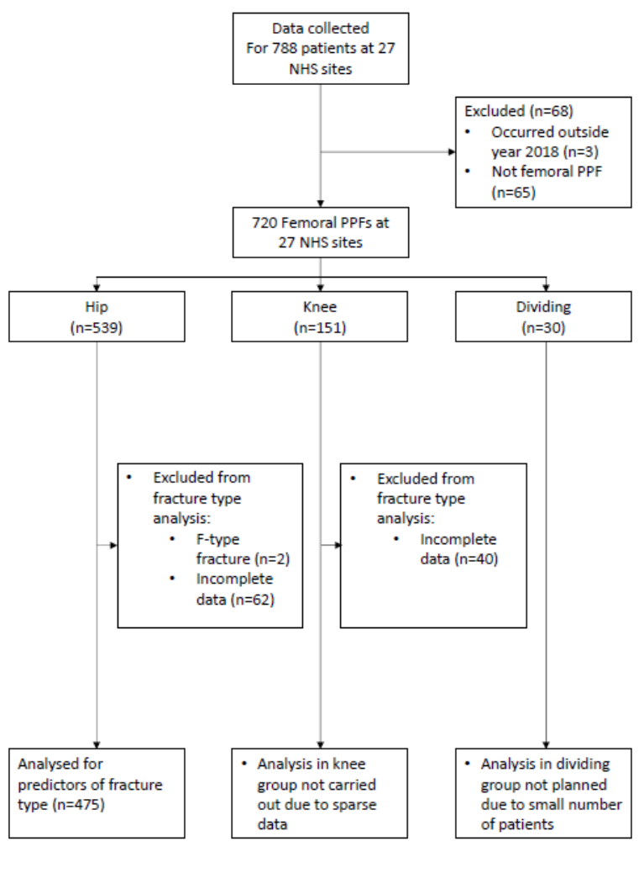

**Figure 2:** Occurrence of femoral periprosthetic hip, knee and dividing fractures throughout the year 2018.

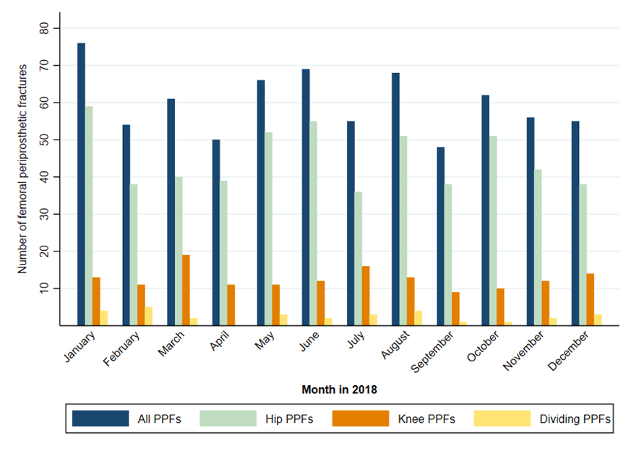

**Figure 3:** Predictors of fracture type in patients with a femoral hip periprosthetic fracture; 1Reference category males; 2Reference category living in own home; 3Reference category PPF around primary implant; 4Reference category original implant uncemented; 5Reference category early PPF.

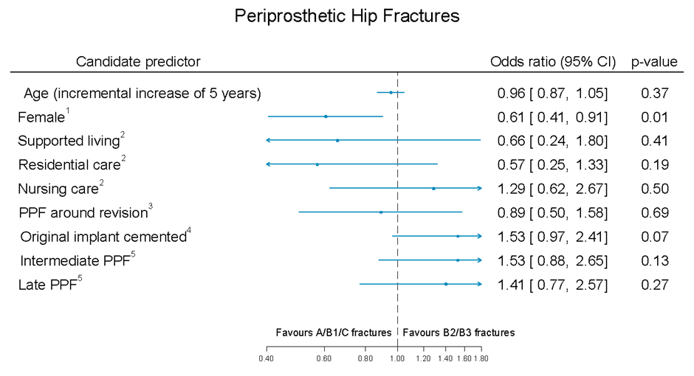

**Appendices**

Appendix A

**Pre-operative data collection**

* BASELINE DEMOGRAPHICS
  + Local patient record number
  + Age
  + Gender
  + Place of residence pre-injury
  + Use of walking aids pre-injury
  + Social support pre-injury
  + Exercise tolerance / Walking distance pre-injury
  + Co-morbidities
  + Anti-coagulant medication
  + Smoking
  + Alcohol consumption
  + AMTS
* FRACTURE CHARACTERISTICS
  + Date of fracture
  + Mechanism of fracture
  + Hip, Knee, Ankle, Shoulder, Elbow or Wrist replacement
  + Primary or Revision joint replacement
  + Fracture classification (AO Universal classification)
  + Type of implant around which the periprosthetic fracture occurred (e.g. cemented / uncemented)
  + Open or Closed Injury
* SURGICAL CHARACTERISTICS
  + Date of Surgery
  + Grade of lead surgeon
  + Grade of second surgeon
  + Surgical approach
  + Surgical strategy (e.g. fix / replace or both)
  + Operative duration
  + Requirement for HDU/ITU admission
  + DVT prophylaxis
  + Operative findings and information

**Post-operative data collection**

* Length of stay (primary and subsequent admissions)
* Discharge destination - home versus elsewhere
* Post-operative complications before discharge (VTE, infection, pressure sores)
* Re-admission to hospital
* Re-operation on operated limb
* Mortality