Low soil nitrogen and moisture limit the expansion of the invasive grass, Megathyrsus maximus (Guinea grass)​ in semi-arid soils
E Penelope Hollandª, Vanessa Thomas^{b}, Pushpa Soti^{b}
ªDepartment of Biology, University of York, York, YO10 5DD, UK
^{b}Department of Biology, University of Texas Rio Grande Valley, Edinburg, TX, 78539, USA

Highlights
- Megathyrsus maximus (Guinea grass)​, an African forage grass species, is emerging as a major invasive species in arid and semi-arid subtropics.

- Soil moisture and nitrogen are the two key factors in determining M. maximus presence and future range expansion.

- Under wetter conditions, M. maximus can further invade rangelands and natural areas.

- Irrigation and nitrogen fertilization management are important to reduce invasion by M. maximus in agricultural fields.

Abstract
The goal of this study was to predict the range expansion potential of an invasive forage grass, Guinea grass (Megathyrsus maximus). We collected rhizosphere soil samples of M. maximus and coexisting species from 150 different locations and analysed them for soil properties. We estimated the probability of M. maximus presence as a function of soil moisture, organic matter, pH, salinity, total N, and CN ratio using logistic regression. Presence of M. maximus was associated with higher soil moisture, higher organic matter, pH, and nitrogen, but lower salinity and CN ratio. Soil nitrogen and moisture were key factors for predicting the presence of M. maximus. Our results show that while M. Maximus prefers high nitrogen soils, coexisting plants are better adapted to soils with low nitrogen availability. Wetter soil with high nitrogen concentrations gives M. maximus a strong competitive advantage over other species as more nitrogen reduces the effect of otherwise adverse environmental conditions and allows M. maximus to capitalize on moisture. We expect that a regional climate shift towards a wetter rainfall regime in semi-arid regions would facilitate a range expansion by M. maximus further into the rangelands, countering efforts to protect and restore native plant communities.

Keywords: soil nitrogen, soil moisture, range expansion, invasive grasses, habitat management

1. Introduction
Invasive plants are widely accepted as drivers of ecological change causing an impact on a range of biotic and abiotic conditions in the recipient habitats (Didham et al. 2005; Vila et al. 2011). High profile examples include Japanese knotweed (Fallopia japonica var. Japonica) across Europe and North America (Barney 2006), kudzu vine (Pueraria montana) in the United States (Forseth and Innis 2004), garlic mustard (Alliaria petiolata (M. Bieb.) Cavara & Grande) in the United States and Canada (Welk et al. 2002). Invasive plants are known to cause a significant change in the functioning of the invaded ecosystem (Weidenhamer and Callaway 2010) by changing the litter turnover rates (Allison and Vitousek 2004), influencing the fire regime (Vitousek 1990; D’Antonio 2000), impacting hydrological processes (Le Maitre 2004; Le Maitre et al. 2016), changing thermal regimes (Carter et al. 2014), and shifting the soil microbial communities (Wolfe 2008). These changes in the soil biotic and abiotic environment not only change the structure and functioning of the ecosystem in the short term, but also complicate the management of the invader and restoration of native species in the long term.

Early detection and rapid response are generally regarded as a key tenet of invasive species management (Reaser et al. 2020). Additionally, understanding the causes of invasion is essential in determining the invasion potential of an introduced species. However, a major problem with invasive plant introductions is that without early detection and rapid response, eradication or minimizing the impacts is unlikely (Reaser et al. 2020). In most instances, by the time public awareness begins and the invasion is recognized, the plant may already be well established and/or widespread. In this case, local control and management are more feasible, often at a high cost economically and ecologically (Huenneke 1996).
In their native habitats, the outcome of plant interactions is influenced by environmental conditions, including temperature, precipitation, soil moisture, pH, nutrients, salinity, and biotic interactions (Van Kleunen et al. 2011; Wisz et al. 2013; Soti et al. 2020a). Habitat soil characteristics therefore play an important role in determining the distribution of invasive plant species. Invasive plants are generally reported to grow in high resource environments (Huenneke et al. 1990). However, with their superior ability to exploit resources (such as effective nitrogen fixation or rapid litter turnover rates) invasive plants can outcompete the coexisting natives and invade low resource environments (Vitousek and Walker 1989; Tilman 2004). Comparative studies on invasive and non-invasive performance have shown that invasive species are more successful in maintaining fitness in stressful environments through the high phenotypic plasticity of physiological and morphological traits (Davidson et al. 2011; Fenollosa et al. 2017). Thus, after the initial establishment, an understanding of the microhabitat and traits of an invasive species can provide insight into the necessary conditions for spread to predict new sites that the species can potentially invade. However, studies on the interactions of invasive forage grasses and native plants regarding soil abiotic factors, especially soil moisture and nitrogen, depending on climatic variables is limited, particularly in semi-arid subtropics where changes in the climatic variables have a drastic impact. Environmental gradients such as temperature and precipitation are likely to shift with climate change, with a warmer and drier regime, especially in the arid and semi-arid regions (Archer and Predick 2008). Anticipating how these changes may interact with soil characteristics to help or hinder invasive spread is crucial for local management of invasive species and habitat restoration.

The goal of this study was to better understand the microhabitat preference of an invasive grass species, Megathyrsus maximus [Jacq.] B.K. Simon & S.W.L. Jacobs (Poaceae), previously Panicum maximum and Urochloa maxima [Jacq.] (Guinea grass). M. maximus is one of several African forage grass species grown widely in tropics, subtropics, and warm temperate regions worldwide. In south Texas, M. maximus and other African grasses were introduced in the mid-twentieth century for soil conservation and enhancement of rangeland forage and livestock production when overgrazing and drought degraded the rangelands (Wied et al. 2020). However, several of these introduced grasses, including M. maximus, have become widespread invasive species in the region (Wied et al. 2020), causing a significant impact on native vegetation (Lonard and Judd 2006). Currently, it is found predominantly along roads, farm edges, and natural areas and potentially poses a threat to irrigated and fertilised summer crops in the region, such as corn, cotton, and sugarcane. M. maximus is also reported to invade previously restored forests and shrublands despite control efforts (Best 2006; Albrecht et al. 2021) and its range expansion further into the Tamaulipan thornscrub could counter current efforts to restore native plant communities in the South Texas Plains ecoregion.

To fully understand the potential impact of M. maximus in the agricultural, natural, and urban areas, it is important to characterize its fundamental habitat requirements. Our study questions were: (1) What are soil characteristics associated with M. maximus and are they different from those under native plants? and (2) What are the soil factors that might influence the habitat expansion of M. maximus? To answer these questions, we collected soil samples and environmental variables from locations in southwestern Texas where this plant has escaped from cultivated rangelands and invaded disturbed sites, roadsides, untended areas, and grazing pastures at alarming rates and has become impossible to remove (Lonard and Judd 2006; Soti and Thomas 2021).

2. Methods
2.1 Study area
This study was conducted in southwestern Texas, the South Texas Plains, in March 2020 (Fig. 1). This region encompasses five sub-ecoregions: Tamaulipan Thornscrub, Southern Subhumid Gulf Coast Prairies, Coastal Sand Plain, Lower Rio Grande Valley, and Lower Rio Grande Valley Alluvial Floodplain (Griffith et al. 2007). The South Texas Plains ecoregion has a semi-arid subtropical climate characterized by 50 to 81 cm of average annual rainfall. Droughts are common and often severe in this region, particularly in the Tamaulipan Thornscrub (Griffith et al. 2007). Much of the vegetation is drought tolerant and primarily consists of thorny brush such as mesquite (Prosopis glandulosa), a woody legume which invades the rangelands, acacia (Acacia farnesiana), a woody legume, and prickly pear (Opuntia engelmannii var. lindheimeri), a native flowering plant in the cactus family, mixed with grasses. In addition, plant species such as Ebenopsis ebano (Texas ebony; Fabaceae) and Sabal mexicana (Rio Grande palmetto; Arecaceae) are endemic to this region (Luera 2021). Vegetation composition here is highly influenced by the environmental variables including topography, soil depth, nitrogen concentration, texture, moisture, and climate (Reid et al. 1990, Ewing and Best 2004). The dense brush community is found in the alluvial soils, grasses dominate the sandy loam uplands, while spiney shrubs and stunted trees dominate the drier upland areas (Vora 1992; Best 2006). These communities provide forage and nesting sites for a diverse species of animals including 514 resident native vertebrate species including 40 amphibians, 109 reptiles, 283 birds, and 82 mammals (Holt et al. 2000). Due to increasing human population growth in the region, a significant portion of the historic Tamaulipan thornforest (more than 95%) has been lost to agriculture and urbanization (Jahrsdoerfer and Leslie 1988; Pierre et al. 2018). The restoration effort to conserve the high biodiversity of this region started in 1958, in abandoned pastures and agricultural fields, has faced several setbacks including seedling mortality, herbivore damage, extreme drought conditions, and invasive species (Alexander et al. 2016).

2.2 Sample collection and analysis
Soil samples were collected from the rhizosphere of 150 randomly selected plant stands along roads and farm edges where the plant is reported to grow at an alarming rate threatening the native vegetation and increasing weed management costs for farmers (P. Soti V. Thomas personal communication/observation). Since M. maximus is reported to grow well under 25-50% shade (Malaviya et al. 2020), our samples were only collected from farm margins, roadsides, and under open canopy in natural areas. Two phenotypes (small and giant) occur in South Texas (Soti et al. 2020b). Soil samples were only collected from the small phenotype, which is reported to be widespread and invasive in the region.
At each soil/plant sample location, plant species were recorded as M. maximus and other coexisting native species, predominantly S. elaeagnifolium (silverleaf nightshade) and 3 soil sample cores were collected from 0-12cm depth and mixed to make a composite sample under both M. maximums and others. Soil samples were then placed in airtight containers and transported to the lab in a cooler with ice. In the lab, soil samples were analysed following the modified NRCS (2004) method. Soil samples were thoroughly mixed and passed through a 2 mm sieve to remove gravel and larger plant residues. Soil samples were then analysed for moisture, pH, organic matter, salinity, and total C and N.

Soil moisture was assessed by the gravimetric method (Reynolds 1970). Organic matter was assessed by the combustion method (450°C for five hours). Total carbon (C), nitrogen (N) were determined by the dry combustion method using a CN analyser (Leco Corporation, MI, USA). Salinity and pH were assessed with a probe in 1:2 soil: DI water solution.
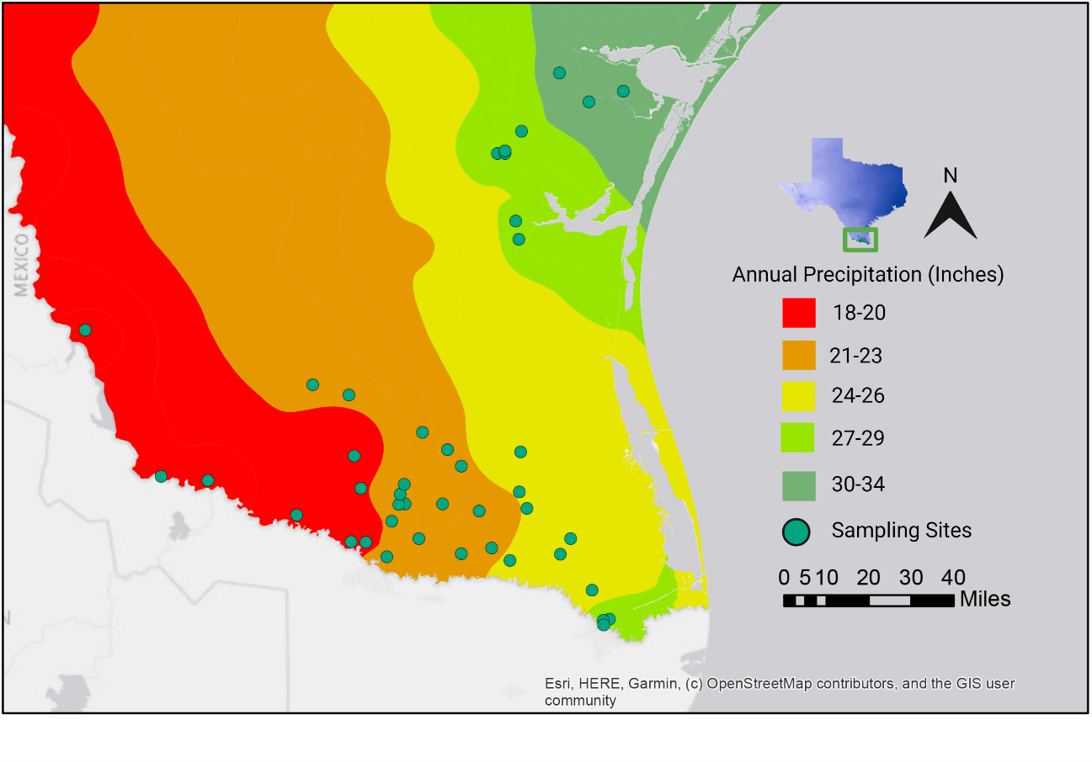
Fig. 1. Study area showing the 150 sampling sites along the total annual precipitation in southwest Texas, the South Texas Plains.

2.2 Data analysis

2.2.1 Data transformations and preliminary analysis
The CN ratio was calculated as total carbon divided by total nitrogen for each individual plant, and total carbon and nitrogen calculated as the sum of total C and total N. We calculated Pearson’s correlation between all pairs of environmental variables (Wei and Simko 2017) and used the Wilcoxon rank sum test to explore differences between each environmental variable by plant species (M. maximus or other).

2.2.2 Modelling M. maximus
We used logistic regression to model the probability that a plant would be M. maximus or not (P (M. maximus)), with soil moisture, organic matter, pH, salinity, CN ratio and total N as independent variables. We used forwards and backwards stepwise model selection using stepAIC in the MASS package (Venables and Ripley 2002) of R 4.0.3 (R Core Team 2020) to find the best model with which to describe the current dataset. We then graphed P (M. maximus) as a function of the key environmental variables soil moisture, organic matter, and total N, and summarised the projected change in P (M. maximus) if soil moisture and total N were to be manipulated via the application or withholding of irrigation and fertilizer.

3. Results
3.1 Soil characteristics
Our results show a significant difference in the measured soil parameters between M. maximus invaded and uninvaded sites (Fig 2). While M. maximus presence was strongly associated with higher soil moisture (P < 0.001), organic matter (P < 0.01), soil pH (P < 0.01), and total N (P <0.001), the other coexisting natives were strongly associated higher soil salinity (P=0.045). Similarly, soil C:N was significantly lower in M. maximus compared to others (P<0.001). Though not statistically significant, M. maximus soils had higher total C (P=0.06) compared to the coexisting vegetation.

Correlation analysis between the environmental variables had mixed results. As expected, there were positive correlations between soil organic matter and total C (r = 0.583, P < 0.001), total N (r = 0.581, P < 0.001), and soil moisture (r = 0.193, P = 0.012). In contrast, there was a negative correlation between soil organic matter and salinity (r = -0.261, P < 0.001) and soil pH (r = -0.226, P = 0.003). There was a negative correlation between soil pH and total C (r = -0.209, P = 0.006) and total N (r = -0.237, P = 0.002). Total C and total N were positively correlated with each other (r = 0.654, P < 0.001) and with soil organic matter. While there was a negative correlation between organic matter and both pH and soil salinity, there was no correlation between pH or soil salinity with CN ratio.

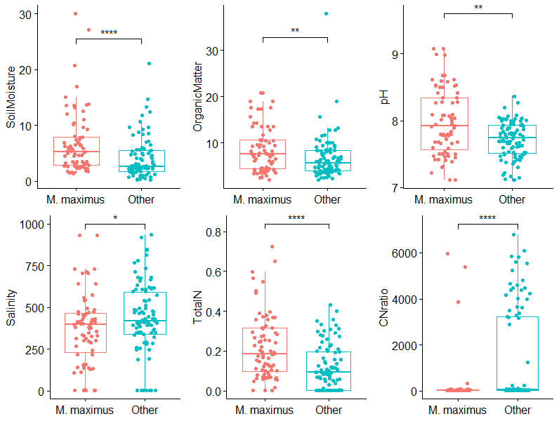

Fig. 2. Difference in the soil properties under M. maximus and other coexisting plants. Results of Wilcoxon rank sum test are shown for each comparison where significance is highlighted by  (P < 0.001), ** (P < 0.01), * (P < 0.05). M. maximus presence was strongly associated with higher soil moisture, organic matter, soil pH and total nitrogen, and lower CN ratio and soil salinity.

3.2 Modelling M. maximus
The best model describing the probability of the focal plant being M. maximus (as opposed to another) as a function of environmental and soil variables had AIC = 152.6. This was a considerable improvement on the original model (AIC = 167.0, see Appendix A). The best model includes several key interactions:
P (M. maximus) ~ Organic Matter + pH + Soil Moisture + Salinity + Total N+
CN ratio + Organic Matter: CN ratio + Salinity: Total N

The two variables with the most significant effect are pH (P < 0.001) and total N (P < 0.001), with increases in either variable increasing the probability of finding M. maximus compared to another plant (Table 1, Fig. 3). Increasing soil moisture also significantly increases the probability of finding M. maximus compared to other plants (P < 0.01, Table 1), while a lower CN ratio decreases that probability (P = 0.086, Table 1). There is also a significant negative interaction between salinity and total N (P =0.012), implying that when salinity is low, a unit increase in total N will raise the probability of finding M. maximus more than the same increase in total N in high salinity soils.
Table 1. Summary of model parameter estimates and p-values for predicting the presence of M. maximus from environmental and soil data. Positive estimates for variables indicate an increasing probability of finding M. maximus with an increase in that variable and vice versa. Positive interactions between variables (e.g., A: B) indicate a disproportionate increase in the probability of finding M. maximus with an increase in either A or B. Negative interactions indicate a decreasing effect of an increase (e.g. if A:C is negative, increasing A will reduce the effect of C on M. maximus presence). Significance is highlighted by *** (P < 0.001), ** (P < 0.01), * (P < 0.05) and (P < 0.1).

Variable | Estimate | Std. Error | z value | Pr (>|z|)
(Intercept) | -33.5100 | 6.9030 | -4.854 | 0.0000 | ***
Organic Matter | -0.0533 | 0.0634 | -0.842 | 0.4000
pH | 3.8570 | 0.8373 | 4.606 | 0.0000 | ***
Soil Moisture | 0.1834 | 0.0606 | 3.026 | 0.0025 | **
Salinity | 0.0031 | 0.0022 | 1.388 | 0.1651
Total N | 20.5200 | 5.6430 | 3.637 | 0.0003 | ***
CN ratio | -0.0024 | 0.0014 | -1.717 | 0.0859 | .
Organic Matter: CN ratio | 0.0003 | 0.0002 | 1.63 | 0.1031
Salinity: Total N | -0.0275 | 0.0110 | -2.501 | 0.0124 | *

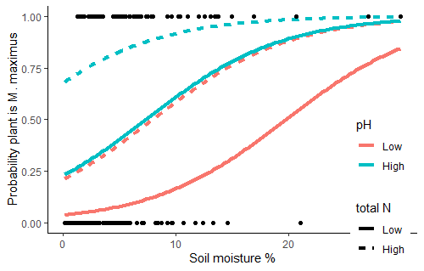

Fig. 3. The probability of a plant being M. maximus (1 on the y axis) rather than another species (0 on the y axis) increases with increasing soil moisture (x axis), increasing soil pH (the interquartile range, IQR, of pH is shown from low (7.52%) in red to high (8.03%) in blue) and increasing total N (with IQR from low (0.06%, solid line) to high (0.254%, dashed line). In this graph, all other model variables are held at the mean values from the data set (pH = 7.8, salinity= 408.3, and CN ratio = 832.7:1).

4. Discussion

With a rapid increase in population, the Lower Rio Grande Valley in southwestern Texas has seen a significant change in land use over the past several years. Converting brushland to pastureland and eventually to cropland or urban and residential developments has been a common practice, particularly in Hidalgo and Cameron County (Huang et al. 2011). This change in land use, along with the landscape alteration by oil and gas infrastructure development (Pierre et al. 2018), poses several challenges for wildlife conservation and habitat management in the region (Wied et al. 2020). In addition, habitat fragmentation and change in land cover can change abiotic conditions facilitating the spread and establishment of invasive species.

The aim of this study was to analyse the soil characteristics in the rhizosphere of an invasive grass species, M. maximus, and predict the factors that promote its establishment and spread in South Texas. Our results provide strong evidence that there is a significant difference in the rhizosphere abiotic conditions between M. maximus and other plant species. Changes in the soil conditions increase the probability of M. maximus presence, although the limitations of this study with respect to the number of samples and sampling design means that the extent to which this pattern results from establishment success in differing conditions or changes in local microhabitats after establishment remains to be verified.

African forage grasses were introduced worldwide because of their tolerance to a wide range of environmental stresses. The traits which make these grasses preferred forage species also promote their invasiveness if grown outside confinement. M. maximus, like other forage grasses, is reported to be tolerant of environmental stress including, drought, soil conditions (Holm et al. 1977), shade (Malaviya et al. 2020), and heavy grazing (Benabderrahim and Elfalleh 2021). Invasive grasses are reported to outcompete natives through rapid exploitation of soil moisture in semi-arid regions (Melgoza et al. 1990) as well as mesic temperate forests (Warren et al. 2013). Our results show that M. maximus is tolerant to a wide range of soil moisture, nutrient, salinity, and pH, supporting its success as an invader across the region. However, they also indicate that it is more likely to be found in habitats with higher nitrogen and moisture and lower CN ratio. This contrasts with the other, primarily native, species that were found in drier, low nutrient soils, and associated with a much higher CN ratio.

In nitrogen-limited systems, changes in soil nitrogen concentration determine the competitive advantage of invading species (Laungani 2009). Semi-arid subtropical soils are typically low in both nitrogen and soil moisture, and they are the most limiting factors in plant growth. In addition, drought and soil salinity occur simultaneously in these regions. Our results show that low soil nitrogen and moisture in combination with high salinity can act as barriers in the establishment, reproduction and spread of invasive species after introduction. In addition, nitrogen limited systems can be high in biodiversity (Bobbink et al. 2010) and have higher resistance to invasion. Our results show that increasing soil nitrogen levels and moisture increase the probability of M. maximus presence. Thus, managing nitrogen availability to M. maximus can potentially aid in reducing or preventing its further spread.

High soil salinity is one of the major limiting factors for plant growth and biomass accumulation (Bui 2013). We found a negative interaction between total N and salinity. Our results show that when soil N is high, salinity is less restrictive in plant growth. Under low and moderate salinity levels, proper use of N is reported to promote plant growth and alleviate salinity stress (Chen et al. 2010). Thus, in N fertilized cropping systems, and in abandoned agricultural fields with higher N availability, soil salinity is a less restrictive factor for M. maximus growth.

Our results also show that soil nitrogen, pH, and moisture are very important factors in M. maximus growth. While soil microbial community analysis was beyond the scope of our study, soil pH and moisture can potentially influence soil microbes such as ammonia-oxidizing archaea (AOA) and ammonia-oxidizing bacteria (AOB) abundances and nitrification rates which are sensitive to changes to environmental factors (Erguder et al. 2009), resulting in increased nitrogen availability to M. maximus. Thus, the microbial community in the rhizosphere of M. maximus warrants further research.

5. Conclusions
M. maximus was introduced to Texas as a forage grass and as a soil conservation tool to prevent soil erosion. However, with the shift in the rangelands use from cattle grazing to wildlife conservation, the public perception of this forage grass species has also changed as it has a significant impact on the native vegetation and wildlife (Moore 2010; Larson et al. 2012). The ongoing restoration efforts in the Tamulipan thornscrub include establishing native vegetation in abandoned farmlands and creating a dense and diverse brush that provides habitat for many plant and wildlife species. However, high nitrogen status in abandoned farmlands could make them susceptible to invasion by introduced grasses giving them a competitive advantage over the natives which have adapted to low nitrogen environments.

Finally, our results indicate that within the Texas Plains ecoregion, a semi-arid subtropical climate zone, M. maximus prefers wetter soils with high nitrogen concentration. Currently, M. maximus is mostly found along roads and farm edges. As it expands its range, M. maximus can pose a serious threat to irrigated summer crops in the region, such as corn, cotton, and sugarcane. Because of its preference for wetter soils, we also expect that if the conditions become wetter, M. maximus will become more competitive and further expand its range in natural areas. Additional research is needed to determine the influence of environmental variables on the germination and growth rate of M. maximus, which is a major weed in different agricultural systems worldwide. To prevent further spread, land managers and farmers should consider nutrient and irrigation management and include habitat management as a M. maximus management strategy. Since M. maximus is an invasive species in the introduced range, these results are significant for M. maximus management not only in Texas, but in the arid and semi-arid regions worldwide.

Acknowledgements
We thank Kristine Lowe, PhD (UTRGV Biology Chair) for her support in this project. We thank Jesus Chavana and Stephanie Kasper for their support in the field sample collection. We also thank the Texas Parks and Wildlife staff for their assistance in the field sample collection and site identification. This research was funded by the University of Texas Rio Grande Valley College of Science Start-up Funds to P. Soti and USDA-AFRI Grant (2017-67012-26128) to P. Soti.

Author Contributions
PS planned the project; VT collected and analysed the samples with PS assistance; EPH developed the model and analysed the data. All three authors contributed to the writing of the manuscript.

Data availability statement
The data that supports the findings of this study are available in the supplementary material of this article.

References
Albrecht, C., Contreras, Z., Wahl‐Villareal, K., Sternberg, M., & Christoffersen, B. (2021). Winners and losers in dryland reforestation: Species survival, growth, and recruitment along a 33‐year planting chronosequence. Restoration Ecology, e13559.

Alexander, H. D., Moczygemba, J., & Dick, K. (2016). Growth and survival of thornscrub forest seedlings in response to restoration strategies aimed at alleviating abiotic and biotic stressors. Journal of Arid environments, 124, 180-188.

Allison, S. D., & Vitousek, P. M. (2004). Rapid nutrient cycling in leaf litter from invasive plants in Hawai’i. Oecologia, 141(4), 612-619.

Archer, S. R., & Predick, K. I. (2008). Climate change and ecosystems of the southwestern United States. Rangelands, 30(3), 23-28.

Barney, J. N. (2006). North American history of two invasive plant species: phytogeographic distribution, dispersal vectors, and multiple introductions. Biological Invasions, 8(4), 703-717.

Benabderrahim, M. A., & Elfalleh, W. (2021). Forage Potential of Non-Native Guinea Grass in North African Agroecosystems: Genetic, Agronomic, and Adaptive Traits. Agronomy, 11(6), 1071.

Best, C. (2006, May). Fighting weeds with weeds: Battling invasive grasses in the Rio Grande Delta of Texas. In Proceedings of the Weeds across Borders Conference. Tucson: Arizona-Sonora Desert Museum (pp. 307-318).

Bobbink, R., Hicks, K., Galloway, J., Spranger, T., Alkemade, R., Ashmore, M., ... & De Vries, W. (2010). Global assessment of nitrogen deposition effects on terrestrial plant diversity: a synthesis. Ecological applications, 20(1), 30-59.

Bui, E. N. (2013). Soil salinity: a neglected factor in plant ecology and biogeography. Journal of arid environments, 92, 14-25.

Carter, E. T., Eads, B. C., Ravesi, M. J., & Kingsbury, B. A. (2015). Exotic invasive plants alter thermal regimes: implications for management using a case study of a native ectotherm. Functional Ecology, 29(5), 683-693.

Chen, W., Hou, Z., Wu, L., Liang, Y., & Wei, C. (2010). Effects of salinity and nitrogen on cotton growth in arid environment. Plant and soil, 326(1), 61-73.

D’Antonio, C. M. (2000). Fire, plant invasions, and global changes. Invasive species in a changing world, 65-93.

Davidson, A. M., Jennions, M., & Nicotra, A. B. (2011). Do invasive species show higher phenotypic plasticity than native species and, if so, is it adaptive? A meta‐analysis. Ecology letters, 14(4), 419-431.

Didham, R. K., Tylianakis, J. M., Hutchison, M. A., Ewers, R. M., & Gemmell, N. J. (2005). Are invasive species the drivers of ecological change? Trends in ecology & evolution, 20(9), 470-474.

Erguder, T. H., Boon, N., Wittebolle, L., Marzorati, M., & Verstraete, W. (2009). Environmental factors shaping the ecological niches of ammonia-oxidizing archaea. FEMS microbiology reviews, 33(5), 855-869.

Ewing, K., & Best, C. (2004). South Texas Tamaulipan Thornscrub restoration experiment measures growth of planted woody vegetation. Ecological Restoration, 22(1), 11-17.

Fenollosa, E., Munné‐Bosch, S., & Pintó‐Marijuan, M. (2017). Contrasting phenotypic plasticity in the photoprotective strategies of the invasive species Carpobrotus edulis and the coexisting native species Crithmum maritimum. Physiologia plantarum, 160(2), 185-200.

Forseth, I. N., & Innis, A. F. (2004). Kudzu (Pueraria montana): history, physiology, and ecology combine to make a major ecosystem threat. Critical reviews in plant sciences, 23(5), 401-413.

Griffith, G. E., Bryce, S. A., Omernik, J. M., & Rogers, A. (2007). Ecoregions of Texas. Austin: Texas Commission on Environmental Quality. Report., 125-p.

Holm, L. G., Plucknett, D. L., Pancho, J. V., & Herberger, J. P. (1977). The world's worst weeds. Distribution and biology. University press of Hawaii.

Holt, E. A., Allen, K. E., Parker, N. C., & Baker, R. J. (2000). Ecotourism and conservation: richness of terrestrial vertebrates across Texas. Museum of Texas Tech University.

Huang, Y., Fipps, G., Lacey, R. E., & Thomson, S. J. (2011). Landsat satellite multi-spectral image classification of land cover and land use changes for GIS-based urbanization analysis in irrigation districts of Lower Rio Grande Valley of Texas. Appl Remote Sens J, 2(1), 27-36.

Huenneke, L. F., Hamburg, S. P., Koide, R., Mooney, H. A., & Vitousek, P. M. (1990). Effects of soil resources on plant invasion and community structure in Californian serpentine grassland. Ecology, 71(2), 478-491.

Huenneke, L. F. (1996). Ecological impacts of invasive plants in natural resource areas. In Western Society of Weed Science (USA).

Jahrsdoerfer, S. E., & Leslie, D. M. (1988). Tamaulipan brushland of the Lower Rio Grande Valley of south Texas: description, human impacts, and management options. US Department of the Interior, Fish and Wildlife Service.

Larson, J. A. (2008). Preference and nutrition of grass seeds and common supplemental feeds eaten by northern bobwhites. Texas A&M University-Kingsville.

Laungani, R., & Knops, J. M. (2009). Species-driven changes in nitrogen cycling can provide a mechanism for plant invasions. Proceedings of the National Academy of Sciences, 106(30), 12400-12405.

Le Maitre, D. C. (2004). Predicting invasive species impacts on hydrological processes: the consequences of plant physiology for landscape processes. Weed Technology, 1408-1410.

Le Maitre, D. C., Forsyth, G. G., Dzikiti, S., & Gush, M. B. (2016). Estimates of the impacts of invasive alien plants on water flows in South Africa. Water Sa, 42(4), 659-672.

Lonard, R. I., & Judd, F. W. (2006). Notes on invasive plants in the Rio Grande delta of Cameron County, Texas. The Texas Journal of Science, 58(3), 271-278.

Luera, P., Wahl-Villarreal, K., Christoffersen, B. O., Treviño, A., Soti, P., & Gabler, C. A. (2021). Effects of Scarification, Phytohormones, Soil Type, and Warming on the Germination and/or Seedling Performance of Three Tamaulipan Thornscrub Forest Species. Plants, 10(8), 1489.

Malaviya, D.R., Baig, M.J., Kumar, B., & Kaushal, P. (2020) Effects of shade on guinea grass genotypes Megathyrsus maximus (Poales: Poaceae). Revista De Biología Tropical, 68(2), 563–572. https://doi.org/10.15517/ rbt. v68i2.38362

Melgoza, G., Nowak, R. S., & Tausch, R. J. (1990). Soil water exploitation after fire: competition between Bromus tectorum (cheatgrass) and two native species. Oecologia, 83(1), 7-13.

Moore, S. F. (2010). Effects of guineagrass on northern bobwhite habitat use. Texas A&M University-Kingsville.

NRCS, U. (2004). Soil survey laboratory methods manual, Burt, R.(ed.). Soil Survey Laboratory Lincoln, Nebraska (No. 42). Soil survey investigation report.

Pierre, J. P., Wolaver, B. D., Labay, B. J., LaDuc, T. J., Duran, C. M., Ryberg, W. A., ... & Andrews, J. R. (2018). Comparison of recent oil and gas, wind energy, and other anthropogenic landscape alteration factors in Texas through 2014. Environmental management, 61(5), 805-818.

R Core Team (2020). R: A language and environment for statistical computing. R Foundation for Statistical Computing, Vienna, Austria. URL https://www.R-project.org/.

Reaser, J. K., Burgiel, S. W., Kirkey, J., Brantley, K. A., Veatch, S. D., & Burgos-Rodríguez, J. (2020). The early detection of and rapid response (EDRR) to invasive species: a conceptual framework and federal capacities assessment. Biological Invasions, 22(1), 1-19.

Reid, N., Stafford, S. D., Beyer‐Miinzel, P., & Marroquín, J. (1990). Floristic and structural variation in the Tamaulipan thornscrub, northeastern Mexico. Journal of Vegetation Science, 1(4), 529-538.

Reynolds, S. G. (1970). The gravimetric method of soil moisture determination Part II Typical required sample sizes and methods of reducing variability. Journal of Hydrology, 11(3), 274-287.

Soti, P., & Thomas, V. (2022). Review of the invasive forage Grass, Guinea grass (Megathyrsus maximus): Ecology and potential impacts in arid and semi‐arid regions. Weed Research, 62(1), 68-74.

Soti, P. G., Purcell, M., & Jayachandran, K. (2020a). Soil biotic and abiotic conditions negate invasive species performance in native habitat. Ecological Processes, 9, 1-9.

Soti, P., Goolsby, J. A., & Racelis, A. (2020b). Agricultural and environmental weeds of south Texas and their management. Subtropical Agriculture and Environments, 71.

Tilman, D. (2004). Niche tradeoffs, neutrality, and community structure: a stochastic theory of resource competition, invasion, and community assembly. Proceedings of the National Academy of Sciences, 101(30), 10854-10861.

van Kleunen, M., Schlaepfer, D. R., Glaettli, M., & Fischer, M. (2011). Preadapted for invasiveness: do species traits or their plastic response to shading differ between invasive and non‐invasive plant species in their native range?. Journal of Biogeography, 38(7), 1294-1304.

Venables, W. N. & Ripley, B. D. (2002) Modern Applied Statistics with S. Fourth Edition. Springer, New York. ISBN 0-387-95457-0.

Vilà, M., Espinar, J. L., Hejda, M., Hulme, P. E., Jarošík, V., Maron, J. L., ... & Pyšek, P. (2011). Ecological impacts of invasive alien plants: a meta‐analysis of their effects on species, communities and ecosystems. Ecology letters, 14(7), 702-708.

Vitousek, P. M., & Walker, L. R. (1989). Biological invasion by Myrica faya in Hawai'i: plant demography, nitrogen fixation, ecosystem effects. Ecological monographs, 59(3), 247-265.

Vitousek, P. M. (1990). Biological invasions and ecosystem processes: towards an integration of population biology and ecosystem studies. In Ecosystem management (pp. 183-191). Springer, New York, NY.

Vora, R.S. (1992). Restoration of Native Vegetation in the Lower Rio Grande Valley, 1984-87. Restoration & Management Notes, 10, 150 - 157.

Warren, R. J., Bahn, V., & Bradford, M. A. (2013). Decoupling litter barrier and soil moisture influences on the establishment of an invasive grass. Plant and Soil, 367(1), 339-346.

Wied, J. P., Perotto-Baldivieso, H. L., Conkey, A. A., Brennan, L. A., & Mata, J. M. (2020). Invasive grasses in South Texas rangelands: historical perspectives and future directions. Invasive Plant Science and Management, 13(2), 41-58.

Weidenhamer, J. D., & Callaway, R. M. (2010). Direct and indirect effects of invasive plants on soil chemistry and ecosystem function. Journal of chemical ecology, 36(1), 59-69.

Welk, E., Schubert, K., & Hoffmann, M. H. (2002). Present and potential distribution of invasive garlic mustard (Alliaria petiolata) in North America. Diversity and Distributions, 8(4), 219-233.

Wisz, M. S., Pottier, J., Kissling, W. D., Pellissier, L., Lenoir, J., Damgaard, C. F., ... & Svenning, J. C. (2013). The role of biotic interactions in shaping distributions and realised assemblages of species: implications for species distribution modelling. Biological reviews, 88(1), 15-30.

Wolfe, B. E., Rodgers, V. L., Stinson, K. A., & Pringle, A. (2008). The invasive plant Alliaria petiolata (garlic mustard) inhibits ectomycorrhizal fungi in its introduced range. Journal of Ecology, 96(4), 777-783.

