Surface Structure of Alkyl / Fluoroalkylimidazolium Ionic-Liquid Mixtures

Simon M. Purcell,† Paul D. Lane,† Lucía D’Andrea, § Naomi S. Elstone, § Duncan W. Bruce, § iD John M. Slattery, §,* iD Eric J. Smoll, Jr., ‡ Stuart J. Greaves, † iD Matthew L. Costen,† iD Timothy K. Minton, ⁑,* iD and Kenneth G. McKendrick†,* iD

†Institute of Chemical Sciences, School of Engineering and Physical Sciences, Heriot-Watt University, Edinburgh, EH14 4AS, United Kingdom.

‡Department of Chemistry and Biochemistry, Montana State University, Bozeman, Montana 59717, United States.

⁑Ann and H.J. Smead Department of Aerospace Engineering Sciences, University of Colorado Boulder, Boulder, CO 80303, USA

§Department of Chemistry, University of York, Heslington, York YO10 5DD, United Kingdom.

Received Date:

KEYWORDS: Ionic liquids, ionic-liquid mixtures, reactive-atom scattering, [C*n*mim][Tf2N], imidazolium, fluoroalkyl, surface structure, liquid-vacuum interface.

AbstractReactive-atom scattering (RAS), surface tension measurements and molecular dynamics (MD) simulations were used to study the vacuum interface of mixtures of partially fluorinated and normal alkyl ionic liquids (ILs). The series of ILs 1-alkyl-3-methylimidazolium bis(trifluoromethylsulfonyl)imide ([C*n*mim][Tf2N]) with *n* = 4 – 12 were mixed with a fixed-length, semiperfluorinated analogue (1*H*,1*H*,2*H*,2*H*-perfluorooctyl)-3-methylimidazolium bis(trifluoromethylsulfonyl)imide ([C8mimF13][Tf2N]), forming [C*n*mim](1-*x*)[C8mimF13]*x*[Tf2N] mixtures, where *x* is the bulk mole fraction of the fluorinated component. The RAS-LIF method combined O-atom projectiles with laser-induced fluorescence (LIF) detection of the product OH as a measure of surface exposure of the alkyl chains. For [C8mim](1-*x*)[C8mimF13]*x*[Tf2N] mixtures, RAS-LIF OH yields are below those expected from stoichiometry. There are quantitatively consistent negative deviations from linearity of the surface tension. Both results imply that the lower-surface-tension fluoroalkyl material dominates the surface. A similar deficit is found for alkyl chain lengths *n* = 4, 6, 8 and 12 and for all (non-zero) *x* investigated by RAS-LIF. Accessible-surface-area (ASA) analyses of the MD simulations for [C*n*mim](1-*x*)[C8mimF13]*x*[Tf2N] mixtures qualitatively reproduce the same primary effect of fluoro-chain predominance of the surface over most of the range of *n*. However, there are significant quantitative discrepancies between MD ASA predictions and experiment relating to the strength of any *n-*dependence of the relative alkyl coverage at fixed *x*, and on the *x*-dependence at fixed *n*. These discrepancies are discussed in the context of detailed examinations of the surface structures predicted in the MD simulations. Potential explanations, beyond experimental artefacts, include inadequacies in the classical force fields used in the MD simulations or the inability of simple ASA algorithms to capture dynamical factors that influence RAS-LIF yields.

# Introduction

Ionic liquids (ILs) are regarded as salts that are liquid below 100 °C. They are typically composed of large organic cations paired with a wide variety of anions, with the absence of molecular symmetry helping to disrupt efficient packing and delocalized charges minimizing the strength of Coulomb interactions. ILs have attracted a very large amount of interest in recent decades due to their prospects as alternative reaction media, with diverse potential applications spanning e.g. catalysis,1-10 carbon-capture and storage (CCS),11-12 biomass processing,13-14 electrolytes in batteries,15-20 supercapacitors21-22 and dye-sensitized solar cells.23

It is now well established that the bulk structures of many ILs exhibit microheterogeneity, with nanoseparation into polar and nonpolar domains.24-27 This behavior is promoted by pendant alkyl chains on either the cation or anion, which occupy the non-polar domains, interpenetrated by polar domains consisting mainly of cation headgroups with attendant anions. The incorporation of alkyl chains is a very common motif in ILs used in practical applications, with variations in the chain length being used to fine-tune other desired physical properties, for example liquid crystallinity.28

A promising, but as yet relatively underexplored, strategy to avoid the rapidly diverging combinatorial possibilities arising from trial-and-error testing of all conceivable binary combinations of cations and anions, is to generate mixtures of a pair (or other small number as a basis set) of ILs in different proportions.29-32 The progression in bulk properties and interesting variations in underlying nanostructure has been demonstrated, for example, in mixtures of short and long-chain versions of a common cation combined with a common anion.26

An obvious alternative to combinations of different chain lengths is mixtures of distinct chemical functionality. A class of pure ILs generating interest in their own right is those containing fluorinated chains on either the cation or the anion.33 The well-known differences in molecular-level properties (volume, stiffness, polarity, polarizability) induced by fluorination can be expected to lead to corresponding changes in the physical properties (density, viscosity, hydrophobicity, surface tension, etc.) relative to their alkyl analogues. Both types of chain can be present in the same material; this can be achieved either in a single-component IL, for example by attaching different chain types to the cation and anion, respectively, or by attaching both types of chain to the cation.34 Variations in properties can then be investigated by synthesizing different materials with different combinations of chain type and length. Alternatively, two distinct ILs, one containing alkyl chains and the other fluoroalkyl chains, can be mixed in different proportions.35 It is this latter approach that is of particular interest here; all the materials investigated are based on the widely studied 1-alkyl-3-methylimidazolium cation (labelled [C*n*mim]+, where *n* is the length of the alkyl side chain), combined with the common anion bis(trifluoromethylsulfonyl)imide ([Tf2N]–).

Recent work has begun to unravel in more detail the structure and properties of fluorinated ILs and their mixtures.33-45 The existence of fluorinated domains in various fluorinated IL systems has been predicted through molecular dynamics (MD) modelling and confirmed experimentally through neutron and X-ray scattering. In particular, MD simulations of mixtures of alkyl- and fluoroalkylimidazolium ILs by Holloczki *et al.* revealed *bulk* ‘triphilic’ behavior.35, 46 They identified three distinct domains in mixtures with essentially equal (C8) alkyl and fluoroalkyl cationic chain lengths combined with a common anion (bromide); i.e. polar (cation headgroups and anions), nonpolar alkyl, and nonpolar fluorous domains. They speculated that these unusual characteristics might allow ‘smart’ liquids to be developed whose properties could be switched in predictable ways through changes in composition or other stimuli such as temperature.

The focus of the current work is the even more sparsely investigated field of the *surfaces* of mixed alkyl/fluoroalkyl IL systems. Surface properties of ILs in general have been recognized to be of substantial interest because they are expected to play a crucial role in a number of very important applications; these include gas separation, sequestration, and forms of multiphase catalysis (e.g. supported ionic-liquid phase catalysis (SILP)47-52). Information on the specific competition for surface sites between alkyl and fluoroalkyl chains has been derived from surface tension measurements in ILs consisting of alkylimidazolium cations and perfluorobutyl sulfonate anions, and correlated with MD simulations of the corresponding structural changes.53 The semiperfluorinated butyl chain of the anion appears to dominate the surface for cationic alkyl chains shorter than C4, with increasing penetration by longer alkyl chains. The surface tension is minimized for C8, when the combined overall surface density of alkyl and fluoroalkyl chains is maximized. It increases again for longer alkyl chains, which become dominant at the surface. Most recently, Heller *et al.* have investigated the surfaces of mixtures of varying mole fractions of butyl and 3,3,4,4,4-pentafluorobutylimidazolium cations combined with a common [PF6]– anion using angle-resolved X-ray photoelectron spectroscopy (ARXPS) and through surface tension and surface light-scattering measurements.54-55 The topmost layers were found to be enriched in pentafluorofluorobutyl chains, with the deviation from stoichiometry largest for the most dilute mixture examined (10% pentaflurobutylimidazolium). The enrichment was enhanced at lower temperatures while the system remained liquid. The surface preference for fluorinated chains has been shown to extend to competition with methoxy functionalized ILs.56

Our own contribution to the field of IL surface analysis has been the development of the reactive-atom scattering (RAS) method, in which reactive atomic projectiles are directed at a liquid surface and gas-phase products are detected which are characteristic of reaction with a specific functional group exposed at the liquid surface.26, 57-66 In one variant, as will be used here, the products are detected by laser-induced fluorescence (hence RAS-LIF).26, 57-58, 60, 62-65 An alternative, developed independently in the Minton group, is to use mass-spectrometric detection (RAS-MS).59-61, 64, 66 These RAS methods complement the array of other physical techniques that have been applied to the surfaces of ILs, including e.g. ARXPS (as already noted), low-energy ion scattering (LEIS), Rutherford back scattering (RBS), metastable-atom electron spectroscopy (MAES), secondary-ion mass spectrometry (SIMS), neutron reflectivity (NR), X-ray reflectivity (XR), sum-frequency generation (SFG) and second-harmonic generation (SHG).67-78 These methods all have strengths and weaknesses. They vary in their chemical specificity and penetration depth, i.e. ultimately, what constitutes ‘the surface’ of the liquid, but together can give complementary information that leads to a fuller understanding of the systems studied.

We have demonstrated the power of the RAS-LIF and RAS-MS methods to analyze the extreme outer surfaces of a number of IL systems, including homologous series of imidazolium- and pyrrolidinium based liquids, the coupled effects of variation of the anion, and even liquid-crystalline materials.57-63 The majority of this work has used ground-state oxygen, O(3P), atoms as the projectile, with detection of OH (RAS-LIF) or inelastically scattered O, OH and H2O (RAS-MS). Recently, we have also shown that RAS-MS can be extended to F(2P) projectiles, combined with detection of HF, or DF for isotopically labelled samples, giving detailed site-specific information on the occupancy and orientation of cations at the surface.66

Most closely related to the current work, we have shown that RAS-LIF can be used successfully to investigate the competition for surface sites in mixtures of ILs. We have applied this approach most systematically to combinations of short and long chains in [C2mim]1−x[C12mim]x [Tf2N] mixtures.26 We found a clear non-stoichiometric preference for the longer chains to occupy the surface over most of the mole-fraction range. There were corresponding changes to the nanoscopic domain structure in the bulk, as determined experimentally by neutron and X-ray scattering, and complemented by extensive molecular dynamics (MD) simulations. We have examined the applicability of fitting functions based on established physical models for the deviation from stoichiometric surface coverage and discussed how our RAS-LIF observations relate to other independent observations for sparser sets of related mixtures using ARXPS, RBS and SIMS.65, 69, 79-80

As a relatively minor part of this previous work,65 intended to illustrate the universality of the functional form of the deviations from stoichiometry in different types of IL mixtures, we presented some preliminary RAS-LIF data for one of the fluoro/alkyl mixtures that we now explore in more detail here. Thus, [C8mim][Tf2N] was mixed with its semiperfluorinated analogue (1*H*,1*H*,2*H*,2*H*-perfluorooctyl)-3-methylimidazolium bis(trifluoromethylsulfonyl) amide (which we label [C8mimF13][Tf2N]). The measured *deficit* of OH and hence of exposed alkyl chains relative to the expectations from stoichiometry implied, indirectly, that there must be a corresponding *excess* of fluoroalkyl chains at the surface. We present here a more extended, systematic investigation of mixed alkyl/fluoroalkyl IL systems, based on the same fluorinated cation ([C8mimF13]+) mixed with alkylated cations of varying chain lengths ([C*n*mim]+ with *n* = 4 – 12). We address the question of whether the apparent higher intrinsic surface preference for fluorinated over alkyl chains of the same length might be counterbalanced by the also known increase in surface activity of alkyl chains with increasing chain length.60 We examine the extent to which the RAS-LIF observations are reproduced by large-scale MD simulations and what additional insight they provide into the molecular-level organization of the surfaces of these interesting materials.

Methods

**Materials**

The molecular structures of the liquids used in this study are shown in Figure 1. Note the inclusion, for practical synthetic reasons, of a –CH2CH2– linker next to the ring in [C8mimF13][Tf2N]. [C8mimF13][Tf2N] was mixed with [C*n*mim][Tf2N], where *n* = 4, 6, 8 or 12 – these mixtures are written here as [C*n*mim](1-*x*)[C8mimF13]*x*[Tf2N], where *x* is the bulk mole fraction of the [C8mimF13][Tf2N] component. For *n* = 8, and 12, a full range of *x* was studied, whereas for *n* = 4 or 6, a fixed mole fraction of *x* = 0.25 was used.

The syntheses of [C8mim][NTf2] and [C8mimF13][NTf2] have been described previously,65 as have those for [C4mim][Tf2N] and [C12mim][Tf2N]. 26, 66 [C6mim][NTf2] was prepared in a directly analogous manner from freshly distilled 1-methylimidazole and 1-bromohexane. Commercial samples of [C8mim][Tf2N] (99%) and [C12mim][Tf2N] (99.9%), used for confirmatory RAS-LIF measurements at *x* = 0, were supplied by IoLiTec. Water (prior to additional degassing, below) and halide content for these liquids are given in the **Supporting Information 1.1**. The branched hydrocarbon squalane was purchased from Sigma Aldrich (99%), and was used as a reference liquid in the RAS-LIF experiments. All liquids were degassed overnight under vacuum (<10–6 mbar) to remove volatile components, prior to measurements being taken.



**Figure 1.** Molecular structures of the components of the fluoroalkyl ionic-liquid mixtures, along with the reference liquid, squalane. *x* indicates bulk mole fraction of the partially fluorinated [C8mimF13][Tf2N] component.

**Surface Tension**

The surface tension of the [C8mim](1-*x*)[C8mimF13]*x*[Tf2N] mixtures were recorded using a Krüss DSA100 tensiometer using the pendant drop method. The instrument has a resolution of 0.01 mN m–1 and an accuracy of 0.3 mN m–1. For all compositions, eight or more measurements were recorded and averaged.

**RAS-LIF**

The RAS-LIF apparatus is shown in outline in Figure 2. A brief overview is given here as detailed descriptions have been presented previously.57-58, 60, 62-65 The liquid surface was created by rotating a partially immersed wheel (diameter 5 cm, speed 30 rpm) in a bath of liquid. This dragged a liquid film onto the wheel and created a continually refreshed liquid surface. A carousel, which housed four such wheels, allowed accurate relative measurements to be made by being able to switch between wheels (by rotating the carousel 90° successively about its central axis) without breaking the vacuum. Passing parallel to one of the wheels (distance to the center of the beam 6.7 mm), a pulsed photolysis laser beam (355 nm, 80 mJ, ~6 ns fwhm) dissociated a low pressure (1 mTorr) of NO2 precursor gas above the liquid surface. O(3P) atoms were generated with a distribution of translational energies (mean 16 kJ mol-1, fwhm 26 kJ mol-1).81

Some of the O-atoms incident at the liquid surface reacted to form OH via abstraction. For energetic reasons, as discussed further below, the OH products are expected to be derived almost exclusively from secondary aliphatic C-H bonds and therefore the amount of OH detected is correlated directly with the surface exposure of -CH2- groups in the alkyl chains. OH in the gas phase was detected via LIF excited on the A-X (1,0) band by a pulsed probe laser beam (~283 nm, 250 µJ, ~5 ns fwhm) that counter-propagated the photolysis beam. The OH fluorescence was collected by a liquid light guide and, after optical filtering to isolate the A-X(1,1) band, directed onto a photomultiplier tube (PMT) to provide a signal which is proportional to the number density of OH molecules in the probe volume. For most measurements of relative number densities, OH was probed on the most intense, Q1(1), line. A small background contribution to the OH density resulting from direct photolysis of a contaminant in the NO2 precursor, thought to be HONO, was subtracted for all liquids studied, as described previously.60, 82

During RAS-LIF measurements, all liquids were temperature controlled to 47 ± 2 ºC, chosen to lower the viscosity of the fluorinated ILs. This resulted in a better-quality, uniform liquid film on the surface of each of the carousel wheels.

C:\Users\Maria\Dropbox\Work\Simon\Articles\Fluoro\Figures\Figure2.tif

**Figure 2:** Schematic diagram of the RAS-LIF apparatus. The central, 4-wheel carousel could be rotated about its central axis, which allowed each of the liquid wheels to be presented to the laser beams for study.

**Molecular Dynamics**

MD simulations of the ionic liquids were performed in GROMACS 5.1.2 using the CL&P extensions83-89 to the OPLS-AA force field.90-97 Additional parameters describing the intramolecular interactions around the CH2-CH2 linker unit in [C8mimF13]+ were used,83, 89 along with the perfluoroalkyl parameters developed by Watkins and Jorgenson.97 Simulations were performed for multiple compositions in the C8 system and at *x* = 0 and *x* = 0.25 for the C4, C6 and C12 systems. The majority of the simulations used 800 ion pairs; an additional two liquids, pure [C8mimF13][Tf2N] and a [C8mim]0.5[C8mimF13] 0.5[Tf2N] mixture, were simulated using 1600 ion pairs, to establish if the simulated interface was affected by the finite system size. A detailed description of the procedure for each simulation is given in the **Supporting Information 2.1**, and is summarized briefly here.

The first step was the simulation of the bulk liquid. Ions, in a single conformation of each type, were randomly packed into a cubic box with length 7-9 nm. Following a steepest-descent energy minimization, each liquid was simulated under NPT conditions for typically ~0.5 ns using a Berendsen barostat (1 bar) and velocity-rescaling thermostat at 500 K. Subsequently, the system was typically propagated for 4 ns, using a Parrinello-Rahman barostat (1 bar) and a velocity-rescaling thermostat at 320 K, the temperature of the RAS-LIF experiments in this work. The simulated densities are given in **Supporting Information 2.1**; they systematically overestimated the measured bulk density of the liquids by < 6 %, which is not unexpected for the force field used.89

The final frame from the bulk runs was extended in the *z*-dimension by a factor of 3. This allowed for simulation of a slab, typically 8 -10 nm thick, with two vacuum interfaces, whilst still using 3D periodic boundary conditions. Under NVT conditions, repeated cycles of 5 ns at 320 K followed by 5 ns at 500 K were used to equilibrate the slab out to ~80 ns, when a final 10 ns at 320 K was run. Typically, MD trajectories were therefore run for 90 ns overall, with results generally being reported here, for reasons described below, from averages over the final ~45 ns excluding the 500 K annealing cycles.

A solvent-accessible surface-area (ASA) algorithm,98 which is implemented as part of GROMACS, was used to determine the areas of each atom type exposed at the liquid surface (at both interfaces). Extensive characterizations were carried out for different unique atom types, including different positions along the side chains. Of particular interest were the secondary H atoms because they are known to be the principal source of OH in the RAS-LIF experiments, as discussed further below.60 Thorough exploratory analyses confirmed that a probe particle radius of 0.15 nm, close to the accepted van der Waals radius for O atoms,99 was sufficient to prevent any significant unwanted contributions from voids within the bulk liquid. Counting of atoms whose exposed area exceeded a selected threshold level was also explored as explained in the **Supporting Information 2.2**. It was used in some preliminary tests of equilibration and convergence, but was found to be prone to artefacts for quantitative comparison of different atom types. The principal results reported here are therefore the summed exposed areas of atoms of a given type, normalized as appropriate to the total exposed surface area for a given liquid as explained below.

The ASA analysis was carried out for selected frames in the relevant MD trajectory. To account for the (artificially, on account of the classical force fields)100 slow MD dynamics of the IL surface relative to the simulation time step, a block analysis101 (see **Supporting Information 2.3**) was used to determine the effective relaxation time of the surface. For several of the simulated liquids, the average surface relaxation time of the secondary H-atom count was found to be ~0.4 ns. Therefore, the trajectories were sampled every 0.4 ns, to produce broadly uncorrelated frames, with the average and standard error calculated in the conventional way. This resulted in a minimum of 17 ns of simulation time (42 frames) for each liquid from which the average surface-accessible area of selected atom types was calculated. System size effects were investigated by comparing the 1600 and 800 ion-pair system for [C8mim]*x*[C8mimF13](1-*x*)[NTf2] with *x* = 0 and *x* = 0.5 . The general structure of the interfaces was very similar, other than some weak density oscillations which reached the middle of the slab for the 800 ion-pair systems but not for those with 1600 ion pairs (see **Supporting Information 2.4**).

The results for the areal density of surface hydrogen atoms for different system sizes also agreed within their respective errors (see **Supporting Information 2.5**). The surface-hydrogen density for each liquid was monitored as the simulation progressed; this was the basis for selecting only the final ~45 ns of each trajectory for further analysis, since by this time results for a wide range of liquids no longer varied within a small tolerance (see **Supporting Information 2.5**).

# Results

**Surface Tension**

The surface tensions of the pure components of the [C8mim](1-*x*)[C8mimF13]*x*[Tf2N] system have been reported previously;65, 102 for the mixtures, the new measurements here are shown in Figure 3a. (Values are tabulated in the **Supporting Information 3.1**.) As *x* increases, it is clear that the surface tension decreases to a greater extent than would be expected for a linear-mixing model based on the bulk mole fractions (Equation 1):

$$σ_{x} ={(1-x)σ}_{1}+xσ_{2} (1)$$

where *σ*1, and *σ*2, are the surface tensions of the pure components (1 refers to alkyl and 2 to fluoroalkyl) and σ*x* is the measured surface tension of the mixture. This relationship is indicated by the dashed line in Figure 3a.

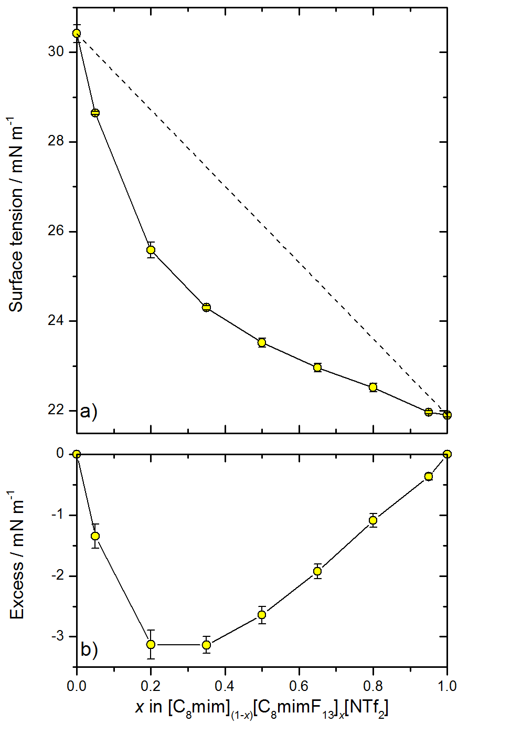

**Figure 3:** a) Surface tension data for [C8mim](1-*x*)[C8mimF13]*x*[Tf2N] mixtures. The dashed line illustrates a linear-mixing model (Equation 1). b) Excess surface tension, the difference between ideal and observed behavior, which is negative here. All errors are 95% CL; derived from the repeatability of the measurements and not the accuracy of the instrument.

Figure 3b illustrates the deviation from the linear-mixing model by plotting the excess surface tension (difference between the surface tension of the mixture and that predicted from linear mixing) for each composition. The largest deviation in the surface excess, which is negative here, occurs in the composition range between *x* = 0.2 and 0.4.

For the purposes of comparison with the RAS-LIF data and MD simulation to follow, we can invert the logic of Equation 1 to assert that the observed surface tension is a linear combination of the surface tensions of the pure liquids weighted by the *surface* mole fractions of the fluoro (denoted *x*s) and alkyl (1- *x*s) components, respectively, i.e.

$$σ_{x} ={(1-x_{\text{s}})σ}_{1}+{x_{\text{s}} σ}_{2} (2a)$$

Note that this is an implicit equation for the unknown surface mole fractions in terms of the measured surface tension at a known bulk composition, *x*, and is equivalent to:

$$x_{\text{s}}= \frac{σ_{1}-σ_{x}}{σ_{1}-σ_{2}} (2b)$$

A similar model (other than being expressed in terms of volume rather than mole fractions, which will be similar here) gives a reasonable fit to measured surface tension data for mixtures of long- and short-chain alkyl ionic liquids.65 As discussed in this previous work, the best-fit value of an adjustable weighting parameter allowing for higher-order cross terms was close to zero.

The resulting values of (1- *x*s) (i.e. the implied fraction of the alkyl component at the surface) from Equation (2) are included as a function of the bulk composition, *x*, in Figure 4. They show the expected strong negative deviation from the linearity that would have been predicted by Equation (1) (dashed line). (The other data with which they are compared are introduced below.)

# 

Figure 4: Comparable relative measures of surface exposure of the alkyl component in [C*n*mim](1-*x*)[C8mimF13]*x*[Tf2N] mixtures. Surface tension (ST) = alkyl surface mole fraction (1- *x*s) as defined through Equation (2) for C8 mixtures only (green circles). RAS-LIF = normalized reactivity to produce OH as defined in Equation (3) (red circles C12 mixtures; black squares C8 mixtures; blue triangles C6 mixtures; magenta triangles C4 mixtures). MD-ASA = relative fraction of the surface area consisting of reactive secondary-hydrogen atoms for C8 mixtures only (yellow diamonds). The dashed line is the prediction for linear mixing in all cases. All experimental error bars 95% CL. A representative *x*-error bar, reflecting the precision of preparing the mixtures, is shown for *x* = 0.82. The confidence limits for the MD ASA analyses correspond to different assumptions about the alkyl chain positions which contribute, as described in the text, which makes only marginal differences here.

**RAS-LIF**

Figure 5 shows, as a representative example, the detected OH density from the [C12mim](1-*x*)[C8mimF13]*x*[Tf2N] system of mixtures as a function of delay between the photolysis and probe laser pulses. [Similar data for [C8mim](1-*x*)[C8mimF13]*x*[Tf2N] mixtures have been reported previously65 and those for the C4 and C6 mixtures are given in the **Supporting Information 4.1**. These OH appearance profiles are normalized to the peak of the corresponding profile from squalane. The squalane reference data were recorded immediately after those from each mixture of interest. Typically, ten such individual relative measurements were made for each mixture and averaged. This approach reduced the effect of unavoidable minor variations in the experimental conditions that affect the magnitude of the LIF signal, providing a precise, consistent measurement relative to the reference liquid. An additional profile was measured for a commercial sample of pure [C12mim][Tf2N] (i.e. *x* = 0). This gave essentially identical results to the sample synthesized in-house, used to make the mixtures for other values of *x*.

The OH rotational distribution was also determined for *x* = 0 and 0.5, by taking the LIF excitation spectrum (LIF intensity as a function of probe laser wavelength) with the photolysis-probe delay fixed at the peak of the OH appearance profile. It was found not to change significantly with *x* (see **Supporting Information 5.1-5.2**). This simplifies the interpretation of figure 5 in that variations in OH signal are related directly to an increase in total OH density, and by inference the surface alkyl chain exposure of the methylene units, and not due to a redistribution of OH rotational populations. This assumption has been verified previously.60 The same assumption was made for the C4 and C6 chain length mixtures, where rotational distributions were not recorded due to the lower signal levels.



Figure 5: OH appearance profiles (OH density as a function of photolysis-probe delay) from [C12mim](1-*x*)[C8mimF13]*x*[Tf2N] for varying *x*, as shown. Signals are normalized to those from the squalane reference liquid. a Measurement of commercial sample, confirming reproducibility of data. Error bars are 95% CL.

The appearance profiles in figure 5 all have essentially the same peak arrival time, implying that the most-probable scattered OH velocity is the same for all liquid mixtures. Therefore, a density-to-flux transformation was not required and the OH densities in figure 5 can straightforwardly be integrated between fixed limits to yield a single value representative of the OH yield from each mixture (see **Supporting Information 6.1-6.4**); we term these integrated values the *relative reactivity* with respect to squalane.

Figure 6 summarizes the RAS-LIF relative reactivities, normalized to squalane, for all chain lengths and compositions studied. Some observations and trends are immediately clear.

First, for *x* = 1, the reactivity is effectively zero; i.e. no measurable OH is detected. This implies that, in addition to the well-established absence of reactivity of the imidazolium-ring H atoms,26, 57-58, 60, 63 the ‑CH2CH2‑ linker in [C8mimF13][Tf2N] is not amenable to H-abstraction by O(3P). We return to the relative contributions of different C-H bond types below.

Second, for all mixtures, as *x* increases there is a decrease in reactivity larger than that expected from stoichiometry for linear mixing, which is indicated by the dashed lines for C12 (red) and C8 (black) in Figure 6(a). This implies that [C*n*mim]+ ions are statistically underrepresented relative to their bulk composition at the surface for all *n*. The corresponding (negative) excesses in relative reactivity are shown in Figure 6(b).



Figure 6: a) RAS-LIF reactivity relative to squalane for the neat liquids and for [C*n*mim](1-*x*)[C8mimF13]*x*[Tf2N] mixtures, with chain lengths *n* as shown. The dashed lines show the behavior expected from a linear mixing law for C8 (black dashed line) and C12 (red dashed line). b) Excess reactivity, which is the difference (not renormalized) between the reactivity of a mixture and the linear mixing prediction. All errors bars are 95% CL. A representative *x*-error bar, reflecting the precision of preparing the mixtures, is shown for *x* = 0.82.

Third, by comparing the reactivities of the C8 and C12 mixtures, there is a larger *absolute* deviation from linear mixing for C12 than for C8; i.e. as the alkyl chain length increases, a larger number of reactive sites are displaced from the surface by a given mole fraction of semiperfluorinated chains. However, the absolute OH yield for the pure C12 liquid is already known to be larger than that for the pure C8 (as confirmed by the behavior at *x* = 0 in Figure 6(a)).60 This can be taken into account by normalizing the reactivity of each mixture to the reactivity of the corresponding pure liquid at *x* = 0 *via* equation (3):

$$\text{Normalized reactivity} = \frac{\text{ Reactivity of mixture (0< }x≤\text{1)}}{\text{Reactivity of neat alkyl liquid (}x\text{ = 0)}} \left(3\right).$$

Note that this produces a relative measure of the fraction of the alkyl component at the surface formally equivalent to equation (2b), but directly in terms of the measured OH yield from the alkyl component for which no further assumption of linearity is required (because the OH yield from the fluoro component is effectively zero).

The normalized reactivities are included in Figure 4 as a function of *x* for different chain lengths. Interestingly, the reactivities for C8 and C12 are nearly identical across the whole range in *x* when expressed in this relative form. The more restricted RAS-LIF measurements for C6 and C4 at a mixing ratio of *x* = 0.25 also suggest essentially the same relative reduction in reactivity as a *proportion of that in the pure liquid* on introduction of [C8mimF13]+ ions. Moreover, the agreement with the surface composition based on the surface tension data as derived via equation (2) for C8 mixtures is rather good. We return to this in the Discussion below.

The variations with *n* for the pure liquids (*x* = 0) and the *x* = 0.25 mixtures are presented in an alternative form in Figure 7. For the purposes of further comparison with the MD simulations (see below), the RAS-LIF reactivities have been renormalized in Figure 7(a) to the result for pure [C12mim] [Tf2N] (i.e. *x =* 0 for *n* = 12). All the other RAS-LIF measurements retain their correct relative values directly from experiment. For the pure alkyl liquids, the strong increase in alkyl chain exposure with increasing *n*, already well known from previous work,58, 60 is reproduced here. Since the point at which any of the MD simulations is normalized to the RAS-LIF measurements is arbitrary, we show a second choice in Figure 7(b) in which this is done for the *x* = 0.25 mixture for *n* = 12, to which we will return below.

The significant absolute reductions in alkyl-chain exposure between *x* = 0 and *x* = 0.25 for all *n* are apparent in Figure 7(a). The *proportional* decreases between *x* = 0 and *x* = 0.25 are independent of any choice of normalization in either the measurements or the simulations. They are plotted in Figure 7(c), where it is obvious that the RAS-LIF reactivities for the *x* = 0.25 mixtures are essentially a *constant proportion*, of around ~35%, of those for the pure alkyl liquids.



Figure 7 (a) Relative reactivities from either RAS-LIF (OH signals, blue) or MD ASA (proportion of the exposed surface covered by secondary hydrogen, black) for pure alkyl liquids (*x* = 0, squares, solid lines) or [C8mim]0.75 [C8mimF13]0.25[Tf2N] mixtures (*x =* 0.25, circles, dashed lines), as a function of alkyl chain length, *n*. Both RAS-LIF and MD ASA results have been normalized to those for pure C12 (i.e. *x* = 0, *n* = 12). (b) RAS-LIF and MD ASA results (symbols and lines as in (a)) for the same *x* = 0.25 mixtures renormalized at *x* = 0.25, *n* = 12. (c) Ratio of reactivity for *x* = 0.25 to *x* = 0 for RAS-LIF (blue) and ASA-MD (black). All experimental errors are 95% CL. The confidence limits for the ASA-MD analyses correspond to different assumptions about the alkyl chain positions which contribute, as described in the text. Note that these largely cancel in (c) because the effects of this assumption on *x* = 0.25 and *x* = 0 are correlated.

**MD simulations**

We present first some selected snaphots at fixed points along MD trajectories to give a qualitative visual sense of the results of the MD simulations. These are generally the final frames of a given simulation run, but are representative of typical, fully equilibrated samples, as established in the Methods section above and demonstrated in detail in **Supporting Information 2.4-2.5**). A common color coding is used throughout, selected to highlight the distinction between the polar regions made up of cationic headgroups and [Tf2N]– anions (both shown in red) and the two potentially distinct nonpolar regions consisting of regular alkyl chains (grey) or fluoroalkyl chains (cyan), as also illustrated in Figure 8. For reasons introduced above and developed below, the first two members of all the alkyl chains and the -CH2CH2- linker in [C8mimF13]+ are color-coded as part of their respective headgroups.

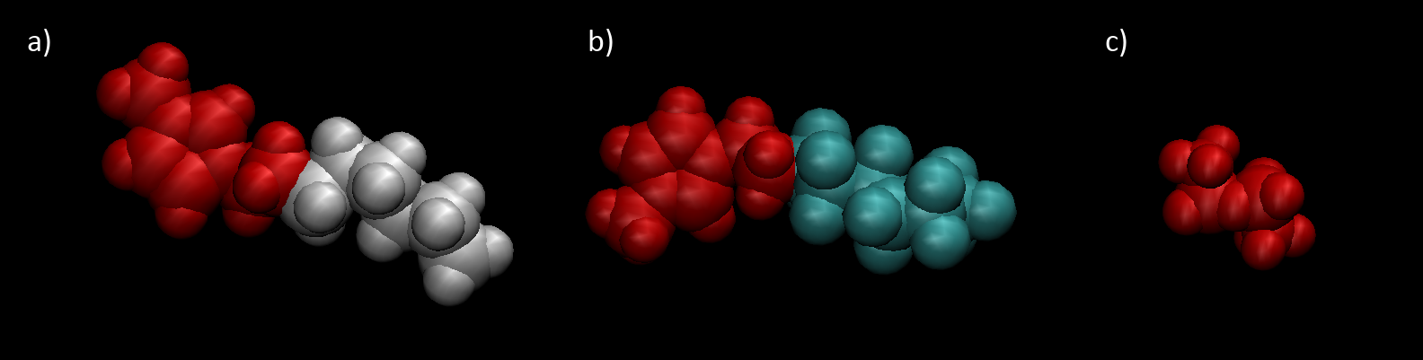

Figure 8: Color scheme used for the MD snaphots in Figures 9 – 12. The polar headgroups and the CH2-CH2 linker unit of both (a) [C*n*mim]+ (in this case *n* = 8) and (b) [C8mimF13]+ are colored red; their non-polar alkyl and fluoroalkyl chains are grey and cyan, respectively. The polar anion (c) [Tf2N]– is also red.

The variation in appearance with mole fraction, *x*, in [C8mim](1-*x*)[C8mimF13]*x*[Tf2N] mixtures is shown in Figures 9 (top-down view) and 10 (side view). For this alkyl chain length, the surface is heavily populated by nonpolar cation chains throughout the full range of *x*, with a clear sublayer (Figure 10) composed almost entirely of polar headgroups and anions. Fluoroalkyl chains progressively displace alkyl chains from the surface layer as *x* increases. It is obvious even by qualitative inspection that the fluoroalkyl chains have a higher surface preference than the alkyl chains, with e.g. considerably more than half of the exposed chains being fluoroalkyl in the *x* = 0.5 frame.

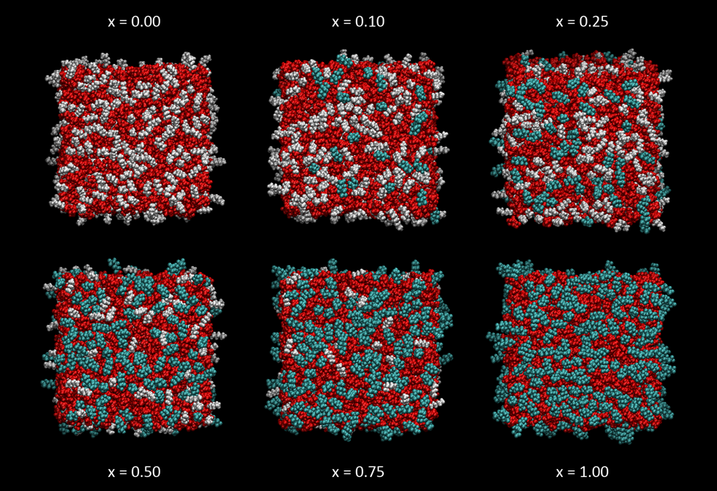

Figure 9. Top-down view of representative single MD snapshots of [C8mim](1-*x*) [C8mimF13]*x* [Tf2N] mixtures; *x* as indicated. Color scheme as in Figure 8.

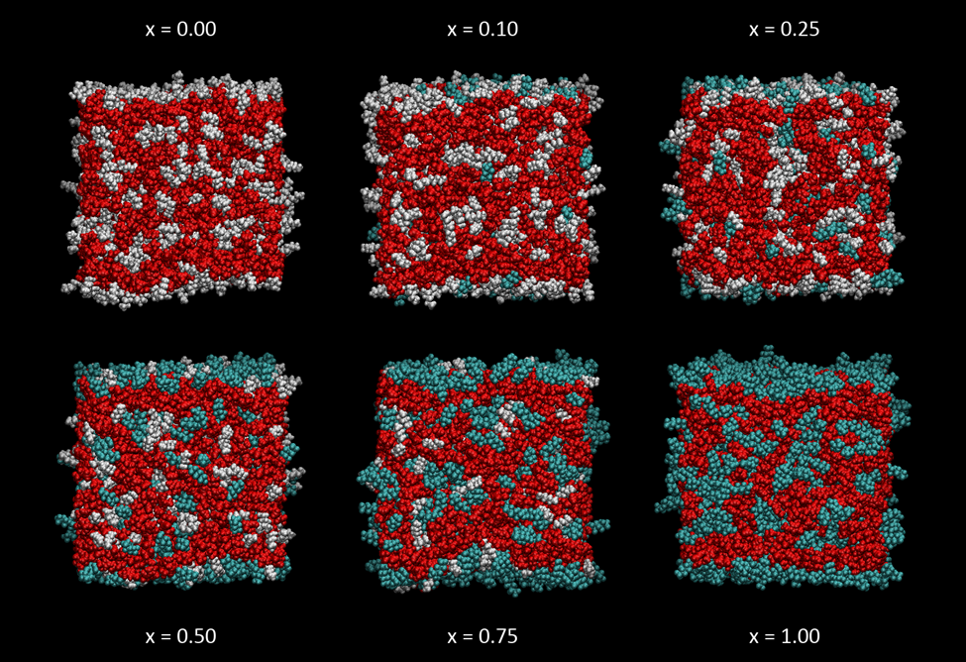

Figure 10. Side view of representative single MD snapshots of [C8mim](1-*x*) [C8mimF13]*x* [Tf2N] mixtures; *x* as indicated. Color scheme as in Figure 8.

The corresponding trends with chain length in the [C*n*mim] cation are shown in Figures 11 (top-down view) and 12 (side view). In each case the pure [C*n*mim][Tf2N] material (i.e. *x* = 0, upper rows) is compared with the [C*n*mim]0.75[C8mimF13]0.25[Tf2N] mixture (lower rows). As expected from previous work on the pure alkyl liquids, the development of the alkyl-dominated surface layer increases significantly with *n*.26, 60 On the introduction of [C8mimF13]at a mole fraction of 0.25, an overlayer is formed for all *n*; fluoroalkyl chains are its dominant component for *n* £ 8 but a visibly larger area is covered by alkyl chains for *n* = 12.

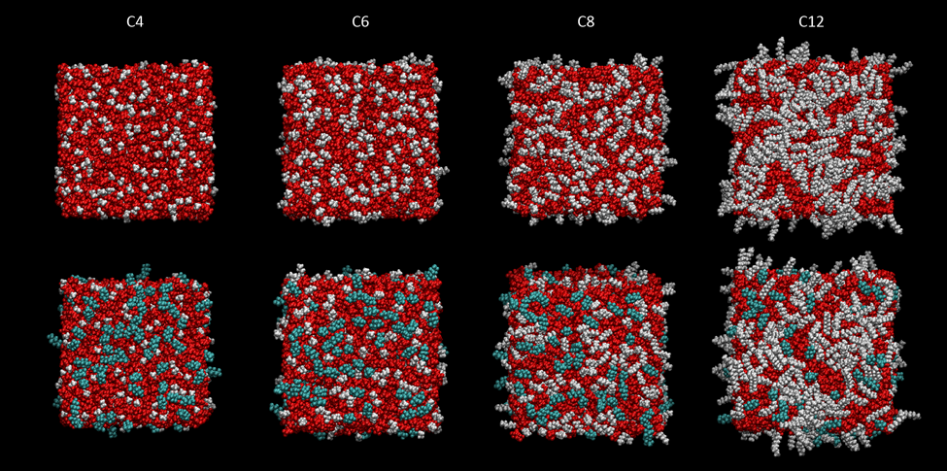

Figure 11. Top-down view of representative single MD snapshots of pure [C*n*mim][Tf2N] (upper row) and [C8mim]0.75 [C8mimF13]0.25[Tf2N] mixtures (lower row), for *n* = 4, 6, 8, 12. Color scheme as in Figure 8.

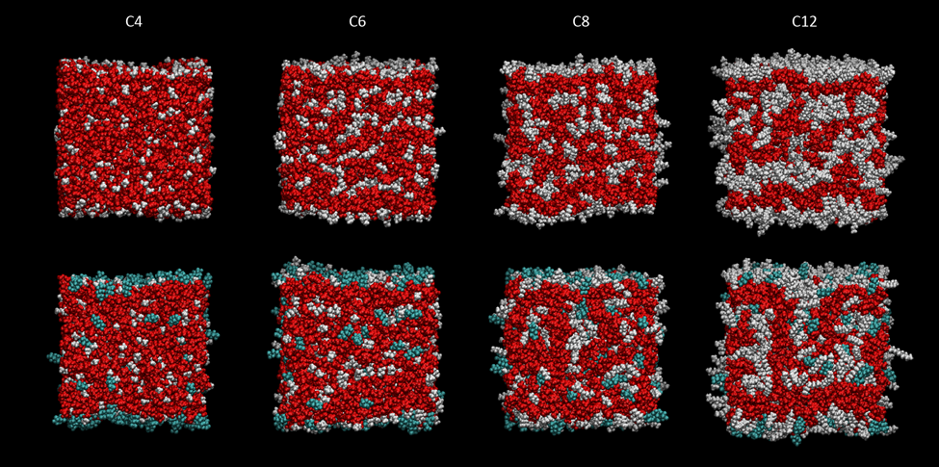

Figure 12. Side view of representative single MD snapshots of pure [C*n*mim][Tf2N] (upper row) and [C8mim]0.75 [C8mimF13]0.25[Tf2N] mixtures (lower row), for *n* = 4, 6, 8, 12. Color scheme as in Figure 8.

At a more quantitative level, the ASA analysis can be used to assess the degree of abstractable hydrogen-atom exposure on different surfaces. The results, expressed as fractions (see below), are included in Figures 4 (for C8 only) and 7 (all *n*), where they are compared with the corresponding measures from the RAS-LIF and (more limited) surface tension data. To carry out this analysis, a choice was necessary about which H-atom types to designate as abstractable. As noted above, we have concluded previously that, due to the only modestly superthermal O-atom translational energy distribution from NO2 photolysis,81 the H-abstraction is effectively highly selective towards the methylene units on the alkyl chain of the imidazolium cation.58, 60 On the basis of relative reactivities of related small molecules in the gas phase, confirmed in experiments on related isotopically labelled self-assembled monolayer (SAM) surfaces,103-104 the terminal methyl group is thought to show almost negligibly reactivity, despite its undoubtedly higher exposure, consistent with its significantly higher C-H bond energy.82, 105 There is a further important technical uncertainty about the intrinsic reactivities (independent of exposure) of different methylene positions along the alkyl chain in these ionic liquids. We return to this question in the Discussion below, but for the moment use the error bars in Figs. 4 and 7 to indicate the range of results obtained by assuming that the H atoms on either the first two, one, or none of the C atoms nearest the ring in the alkyl chain are excluded from the calculation of accessible reactive secondary hydrogen.

The MD-derived quantities in Figures 4 and 7 represent fractions of the total area of a given surface covered by the accessible reactive secondary-hydrogen atoms and are hence comparable to the other quantities plotted there. (This is the appropriate measure because the total probability of those probe O atoms that are directed towards the surface suffering a collision remains at unity, regardless of changes in the surface morphology.) The predicted absolute surface area of all atom types per unit geometric area of the slab were found to depend on the liquid. They increased slightly with increasing fluoro content in the [C8mim](1-*x*) [C8mimF13]*x* [Tf2N] mixtures (around 10% from *x* = 0 to 1), somewhat more significantly with alkyl chain length in the pure alkyl liquids (around 19% from *n*  = 4 to 12), but only more modestly with chain length in the *x* = 0.25 mixtures (around 4%). Full details are given in the **Supporting Information 2.6**.

Figure 4 shows the MD results for [C8mim](1-*x*) [C8mimF13]*x* [Tf2N] mixtures, normalized (as in eqn (3)) to pure [C8mim][Tf2N]. They show the same qualitative behavior as the RAS-LIF and surface-tension data, with negative deviations of the secondary-hydrogen exposure from linearity ideality. However, they tend to underestimate either of the experimentally observed deviations for low-*x* mixtures. There is closer correspondence when *x* ³ 0.5.

The variations in secondary-hydrogen exposure with *n* for *x* = 0 and the *x* = 0.25 mixtures are shown in Figure 7. As noted above, there is an (unknown) overall scaling factor relative to the RAS-LIF measurements, so, for the purposes of the comparison in Figure 7(a), the MD results have also been normalized to that for pure [C12mim][Tf2N]. Once again, there is qualitative agreement with the RAS-LIF results that for all chain lengths the introduction of 25% [C8mimF13]+ ions leads to a substantial reduction in the alkyl-chain exposure. However, there is quantitative disagreement about the extent of this reduction and its variation with *n*. This depends on, but is not outweighed by, the assumption of which positions in the alkyl chain are included in the ASA analysis. The apparent agreement between RAS-LIF and MD is somewhat better if the *x* = 0.25 results are considered alone, and the renormalization to experiment is carried out for the *n* = 12 mixture, as in Figure 7(b). The qualitatively different degrees of dependence of the ratio of *x* = 0.25 to *x* = 0 on *n*, which we emphasize do not depend on any choice of normalization, are highlighted in Figure 7(c); as noted above, in the RAS-LIF measurements this ratio is essentially independent of *n* at around 35%, whereas from the MD ASA analysis, it is in approximate agreement with this for *n* = 4, but increases roughly linearly with *n*. By *n* =12, the ratio is close to 0.75, which is the stoichiometric result for a mixture containing 25% fluoroalkyl and 75% alkyl chains. Note that an alternative way of expressing this is that the MD results for different *n* would not fall on a single curve in the construction of Figure 4, unlike the RAS-LIF data. (We have only shown the *n* = 8 MD data there to avoid clutter.)

# Discussion

The surface tension measurements, RAS-LIF observations and MD simulations are all in qualitative agreement that fluoroalkyl chains occupy the surface preferentially in mixtures of [C8mimF13] [Tf2N] and [C*n*mim][Tf2N], at least for *n* £ 8. This conclusion follows naturally from the observations that: (i) the negative deviations from linearity in the surface tensions (Figures 3 and 4), given that [C8mimF13] [Tf2N] has a lower surface tension than [C8mim][Tf2N]; (ii) the deficits in alkyl-chain exposure relative to linearity observed by RAS-LIF for mixtures of all alkyl chain lengths (Figs. 4 and 5), most straightforwardly interpreted as a complementary implicit preference for fluoroalkyl chains and (iii) the corresponding deficits in the fractions of the surface covered by abstractable secondary hydrogen atoms predicted in the MD simulations (Figs. 4 and 7) for chain lengths for *n* £ 8.

At this qualitative level, our results reinforce previous observations of a generally stronger surface preference for fluoroalkyl chains over alkyl chains.53-56 The conformity to the ‘universal’ functional form of the deviation from ideality for other types of IL mixtures noted previously for [C*n*mim](1-*x*) [C8mimF13]*x* [Tf2N] mixtures with *n*  = 8 is also now shown here to extend at least to *n* = 12.65

However, there are significant quantitative discrepancies between the ASA analyses of the MD simulations and either our RAS-LIF or surface-tension results, which appear in good agreement with one another where we have data for both (*n*  = 8). There are three main aspects:

(A) MD ASA predicts a weaker dependence on chain length, *n*, than RAS-LIF for the pure alkyl liquids (Figure 7(a)).

(B) MD ASA does not reproduce quantitatively how the ratio of abstractable hydrogen exposure varies with *n* in *x* = 0.25 mixtures (Figure 7(c)) according to RAS-LIF.

(C) MD ASA also does not reproduce quantitatively the effects of introducing [C8mimF13][Tf2N] at different ratios in [C8mim](1-*x*)[C8mimF13]*x*[Tf2N] mixtures (Figure 4), found either by RAS-LIF (spanning *n*) or surface tension (*n* = 8).

Discrepancy (A) has been noted previously.60 Discrepancies (B) and (C) are connected and are among the principal additional new observations here. MD ASA appears to support the proposition that longer alkyl chains should compete better with fluorinated chains for surface sites. However, although this may be expected intuitively based on the intrinsically higher surface presence for longer chains in the pure alkyl ILs, it is not borne out in the RAS-LIF experiments here.

The source of discrepancies (A)-(C) could lie within one, or a combination, of three possibilities:

(1) There is some undetected artefact in the RAS-LIF experiments.

(2) The MD simulations do not give a physically accurate description of the liquid surfaces.

(3) The results of the ASA analysis are not directly comparable with what is measured in the RAS-LIF or surface-tension experiments.

We have no good reason to suspect explanation (1). Note that the discrepancies are obvious even in the raw data; e.g. for discrepancy (B), the *x* = 0.25 curve in Figure 5 would have to be more than a factor of two larger for it to agree with the MD ASA prediction for the *x* = 0.25 / *x* = 0 ratio. Similar raw data illustrating the other discrepancies are given in the **Supporting Information 4.1** or in previous publications.60, 65 None of the discrepancies can, therefore, be a consequence of the way the data are processed to produce relative reactivities, and are far beyond the level of statistical uncertainty in the RAS-LIF measurements.

Surface-active contaminants have been found to be a potentially significant issue in related surface-specific experiments on ILs.106-110 However, we see no evidence of irreproducibility or irregular trends in the RAS-LIF results; the variations with mixing ratio and with alkyl chain length are all regular and monotonic. The surface-tension data also support the RAS-LIF results for *n* = 8 mixtures. We have, of course, used only one source of fluoro-labeled [C8mimF13] [Tf2N], which could conceivably be the source of discrepancies (B) and (C). However, note that (A) only concerns the *n*-dependence of the RAS-LIF OH yield from the pure alkyl liquids, for which effectively indistinguishable results are obtained here and previously using independent sources of [C*n*mim] [Tf2N].58, 60

There is also nothing obvious within the MD simulations themselves to suggest (A)-(C) can be explained by (2). As described in the **Supporting Information 2.3-2.5**, we are confident that the MD trajectories are fully equilibrated and that the sampling interval is long enough that the snapshots analyzed are uncorrelated. Doubling the number of ion pairs to make slabs which are twice as thick has only minor, predictable effects (see **Supporting Information 2.4-2.5**). Statistical errors based on the variation of ASA results between snapshots are small, even for individual positions on alkyl chains, and much smaller (typically only a few percent) when summed over all secondary hydrogen atoms.

As further reassurance, the representative snapshots in Figs. 11 and 12 (and see also **Supporting Information 2.4**) for selected 1600-ion-pair systems) show the expected development of interpenetrating alkyl and polar domains in the bulk and increased alkyl coverage of the surface with increasing chain length that have already been well-characterized for the parent, non-fluorinated ionic liquids.26 For the [C8mim](1-*x*)[C8mimF13]*x*[Tf2N] mixtures in Figs, 9 and 10, the structures are similar except for the visual appearance of two distinct polar domains (alkyl and fluoroalkyl) for intermediate *x*.

The disproportionate occupancy of the surface by semiperfluorinated chains is also qualitatively obvious. The nature of these surface layers can be examined more quantitatively by constructing *z*-density profiles (i.e. number density of different atom types in the direction normal to the surface, suitably averaged over both faces of the slab for sufficient length of a trajectory). As an illustrative example of some of the key features, Figure 13 shows the profiles for the terminal methyl carbons (atom-types CT or CT-F, respectively, for alkyl or fluoroalkyl chains) and ring N-atom (atom-types N and N-F, respectively) to which the chains were attached, for *x* = 0 and *x* = 0.5 of [C8mim](1-*x*)[C8mimF13]*x*[Tf2N]. The larger, 1600-ion-pair system is illustrated, because it is not subject to minor, undamped oscillations that remain perceptible in the middle of the thinner slabs with 800 ion pairs (see **Supporting Information 2.4**). The corresponding representative snapshots (final frames of the production runs) are also included for completeness in the **Supporting Information 2.4**.

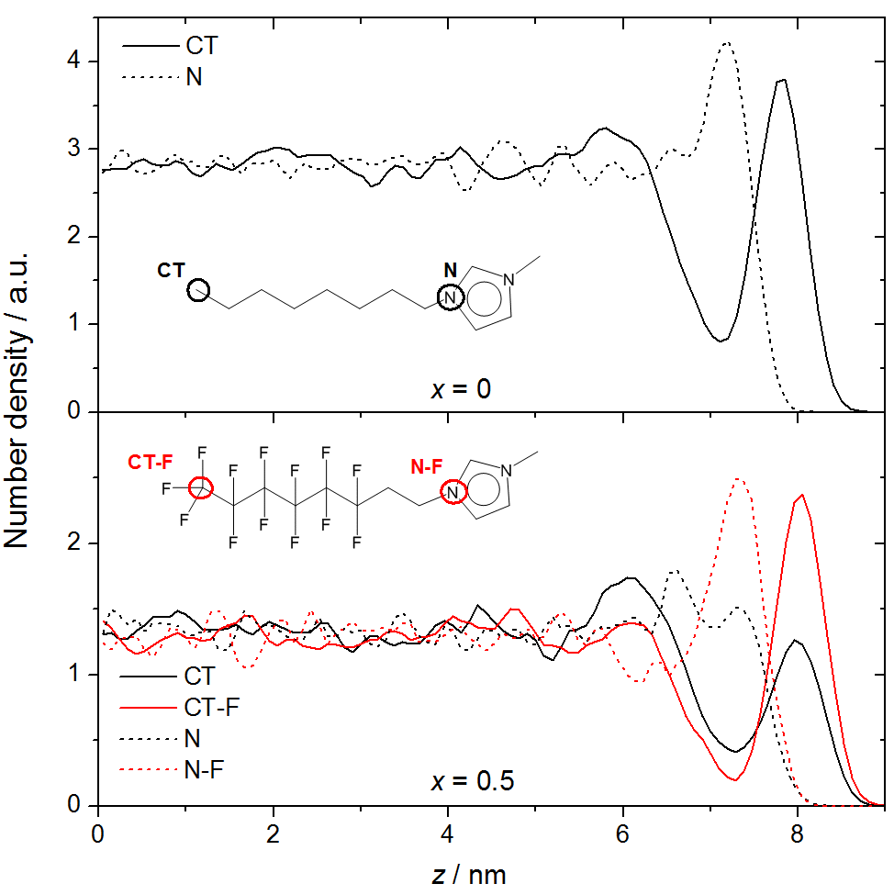

Figure 13: Number density as a function of *z* for the 1600-ion-pair system with *x* = 0 and *x* = 0.5 in the [C8mim](1-*x*)[C8mimF13]*x*[Tf2N] mixture system at 320 K. The densities of the same atom types for the [C8mim]+ and [C8mimF13]+ cations are plotted: CT (or CT-F), the terminal carbon atom on the alkyl (or fluoroalkyl) chain and N (or N-F), the ring nitrogen to which the alkyl (or fluoroalkyl) chain is attached. The *z* = 0 position was defined by the center of mass of the slab. Bin widths were ~0.09 nm, corresponding to 500 slices along the *z*-axis. Averaging is over the equilibrated periods of the MD trajectory, beginning 1 ns (to allow the surface to relax from the previous 500 K heating cycle) into each of the 320-K simulation blocks from 30 ns to 95 ns.

For *x* = 0, the outer edge of the interface is enriched with CT atoms. The N-atoms occupy a distinct, polar underlayer depleted in alkyl chains, consistent with previous simulations and experimental studies.26, 60, 65, 111 There is also the suggestion of a weak, second nonpolar layer around *z* ~ 6 nm; the depth at which this layer forms, combined with the weak inner shoulder on the N-atom profile, suggest that these are alkyl chains which tend to point inwards toward the center of the slab from headgroups in the polar layer. This is confirmed by visual inspection of individual snapshots (see e.g. the relevant panels of Figs. 10 or 12). Such multilayer ordering is consistent with independent MD simulations, confirmed by X-ray scattering and SFG measurements, on related systems.112-115

For *x* = 0.5, there is a clear enrichment of [C8mimF13]+ ions at the expense of [C8mim]+ ions in the outermost layer, as indicated by the corresponding CT-F and CT number densities. The fluoro chains are enriched by a factor of ~2 relative to their bulk density, whereas the alkyl chains, although still a very clear local maximum, are slightly under-represented relative to the bulk. The immediate polar underlayer is dominated by N-F over N atoms in roughly the same proportions (as required by molecular connectivity). Interestingly, there is a weaker but still obvious secondary polar layer, which is dominated by N over N-F atoms (which are depleted in this region relative to bulk). Correspondingly, the secondary polar layer at *z* ~ 6 nm, which is more pronounced than for *x* = 0, contains an excess of CT over CT-F atoms. The breadth of this secondary CT peak suggests that although predominantly inward-pointing, the alkyl chains adopt a wide range of orientations. This is also plausible based on simulations of related systems.115

In this absence of any obvious anomalies and barring any undetected errors in the way the MD simulations have been carried out, one remaining possibility within explanation (2) is that the non-polarizable OPLS-AA / CL&P force fields do not give an accurate representation of the surfaces of these mixed alkyl/fluoro systems. The developers of the OPLS-AA/CL&P framework have recently described its extension to include explicit polarizability, using an approach based on Drude dipoles (also known as a ‘core-shell’ model); they have demonstrated its application to the bulk structures of selected ionic liquids.100, 116 The most significant effects, however, are on ion mobility, producing viscosities and diffusion coefficients in much better agreement with experiment than classical MD; effects on structure are more modest. Application to IL surface structures has been very limited so far and is confined to our own treatment of the surface of [C4mim] [Tf2N].66 As such, it is not possible to say whether it would significantly alter the surface structures in the more complex alkyl / fluoroalkyl systems here. We simply note, however, that we found very good agreement between RAS-LIF measurements and classical, non-polarisable MD systems for the surface occupancy of short and long chains in [C2mim]1-*x*[C12mim]*x*[Tf2N] mixtures.26

Our final alternative, explanation (3), concerns the relationship between the results of the ASA analysis of the (now assumed to be physically correct) MD simulations and OH yields in RAS-LIF experiments (now assumed to be free from systematic errors). These two measures are obviously designed to be related, but *a priori* they are certainly notidentical. Hence, in that sense, differences between RAS-LIF and ASA are not necessarily surprising. However, that is not to say that those differences which can be identified necessarily provide a self-consistent explanation for the observed discrepancies in the results. We consider here two principal aspects: (3)(a) that the OH yield will depend on energetic factors (differential reactivity of different C-H bond types) absent from MD ASA; and (3)(b) that OH yields will separately depend on stereodynamical factors, including impact factors and angles of approach, clearly neglected in a simple ASA analysis.

Considering the energetic factors (3)(a) first, we have been assuming, as explained above, that the observed OH yield has a negligible contribution from the CH3 terminus of the alkyl chains. Although we know this to be a reasonable approximation, based on our previous related work,60, 82, 103-105 it might not be completely reliable. The situation is exacerbated by the relatively large contribution that the terminal CH3 group makes to the surface coverage, at least as predicted by MD ASA. This is illustrated in Figure 14(a), which shows the fraction of the total surface area occupied by the H atoms at each site in the alkyl chain for the pure [C*n*mim] [Tf2N] liquids for *n* = 4 -12. Interestingly, when presented in this form, the fraction of the surface covered by terminal methyl groups is almost independent of chain length. However, as noted above, the total area also increases by ~19% from *n* = 4 to 12 (see **Supporting Information 2.6** for full details), despite a significant absolute reduction in anion exposure, reflecting the increased roughness of the surface as it is dominated by longer alkyl chains. If the CH3 groups were to be making a non-negligible contribution to the observed OH yield and should therefore be included to some extent in the MD ASA analysis, note that this would result in an *even less steep* variation with *n* for the MD ASA results than is currently shown in Figure 7(a). The level of this agreement between MD and RAS-LIF would therefore be *even poorer*. We conclude that any potential CH3 reactivity *does not* in itself provide a resolution of discrepancy (A). As we have noted previously, it does help to rationalize the very significant differences in the *n*-dependence of OH yields from pure alkyl liquids between RAS-LIF using relatively low-energy O(3P) atoms from an NO2 photolytic source, as here, versus those in related RAS-MS measurements using hyperthermal O(3P) atoms.60

The issue of differential intrinsic reactivity due to electronic effects is not necessarily confined to differences between primary and secondary H atoms. It is well known from e.g. ARXPS spectroscopy that the electronic environment of the alkyl C atoms is significantly affected by the charge on the imidazolium ring.109 The C atoms connected directly to the ring (i.e. the methyl group on N(3) and the first position on the alkyl chain attached to N(1)) were nominally assigned by Lovelock *et al.* as part of the ‘ring’ (or ‘Chetero’) atoms on the basis of their contribution to the corresponding peak in the XPS spectrum. The remaining members of the alkyl chain form a distinct ‘Calkyl’ peak, but the average splitting from the Chetero peak is only fully converged for *n*  ³ 8.

These differences in electronic environment may also be reflected in higher C-H bond strengths, and correlated higher activation energies for H abstraction, for the methylene positions closer to the ring. This is the source of the ambiguity we alluded to above (Results) about whether all the secondary H atoms should be included for comparison with RAS-LIF experiments, or whether some positions closest to the ring should be excluded. However, in practice this choice makes relatively little difference, as indicated by the error bars in Figure 7(a). The reason for this is now obvious from Figure 14(a), which shows that the exposure of the -CH2- units declines strongly in the direction from the methyl terminus towards the ring. For most chain lengths, it therefore makes little arithmetic difference whether one or both of the first two positions nearest the ring are excluded from the ASA. Naturally, the sensitivity to this choice is largest for *n* = 4. The agreement with the RAS-LIF results in Figure 7(a) is best, but still systematically poor, when both of the first two positions are excluded.



Figure 14. (a) Fraction of the total surface area (sum of all atom types) occupied by the H atoms attached to each C atom in the alkyl chain for pure [C*n*mim] [Tf2N] liquids for *n* = 4 -12, as indicated. Chain positions are numbered from the imidazolium ring. Note that the last member of each chain is a methyl group. (b) Corresponding MD ASA fractional areas for the same atom types in [C*n*mim]0.75 [C8mimF13]0.25[Tf2N] mixtures. (c) Ratio of the fractional areas of the same atom types in the mixtures, (b), to those in the pure liquids, (a).

This may lend some weight to the proposal that electronic effects suppress the reactivity of the -CH2- units closest to the ring. We note that in previous work we saw essentially no measurable OH signal from [C2mim] ionic liquids, consistent with electronically suppressed reactivity of its sole -CH2- unit.26, 58, 60 If so, the other -CH3 group attached to the ring at N(3) would have its reactivity doubly suppressed below that of a remote terminal -CH3 group. A conceivable resolution of discrepancy (A) might be that the electronic suppression effect propagates further along the chain than the first two positions. This would obviously have most effect for the shorter chains for which the relative discrepancy with the longest C12 chain is largest. It would be amplified if it extended to the terminus for the shorter chains *and* that these terminal -CH3 groups make a non-negligible contribution to OH yield for the longer chains. There would still have to be some suppression as far as *n* = 8, because as Figure 7(a) shows the C8/C12 ratio is currently over-predicted. This explanation admittedly remains very speculative, but would in principle be testable through further experiments and supporting *ab initio* calculations.

A similar electronic effect due to adjacency to the ring, potentially further enhanced by the electron-withdrawing character of the remainder of the fluorinated chain, would also suppress the reactivity of both methylene groups in the -CH2CH2-linker in [C8mimF13][Tf2N]. However, it is not necessary to invoke this to explain the effective absence of OH yield from pure [C8mimF13][Tf2N] (see Figure 3), because the ASA analysis (see **Supporting Information 2.6**) implies that these positions are substantially less accessible (by a factor of ~3.5) than the already minimally exposed equivalent positions in [C8mim][Tf2N] in Figure 13(a). This is consistent with established principles of increased volume and stiffness of fluoro chains relative to their alkyl analogues.

To assess whether discrepancy (B) could be explained by differential energetic effects, i.e. 3(a), the fractional ASAs for each chain position in the *x* = 0.25 mixtures are plotted in Figure 14(b) for comparison with those for the pure alkyl liquids in Figure 14(a). Since they must be consistent with Figure 7(c), the fractional areas occupied by the alkyl chains in the mixtures necessarily increase with *n* in Figure 14(b). What is also apparent, though, from closer inspection of Figs. 14(a) and (b) is that other than the overall scaling factors, the variations with chain position are of very similar shape for a given *n*. This is confirmed explicitly in Figure 14(c), which shows the *x* = 0.25 / *x* = 0 ratio for the exposures of each chain position for each *n*. For all chain lengths, the variation with position along the chain is very modest (although interestingly with a clearly systematic odd-even alternation for *n* = 12) and quite tightly distributed around the corresponding overall ratios shown in Figure 7(c). This is true also of the terminal methyl groups (which recall do not contribute in Figure 7(c)). An important conclusion is that although differential reactivities may well be substantial it is *not possible* that they could explain discrepancy (B). Even changing the weighting of different chain positions substantially in the ASA analysis would not significantly alter the *x* = 0.25 / *x* = 0 ratios. No amount of selective inclusion of only specific positions for *n* = 6, 8 or 12 would deliver the constant ratio of ~0.35 seen for all chain lengths in the RAS-LIF measurements (Figure 7(c)), which can only be matched via MD ASA for *n* = 4.

A similar analysis (see **Supporting Information 2.6**) shows that the ratios of surface exposure for different mixing ratios in [C8mim](1-*x*)[C8mimF13]*x*[Tf2N] mixtures is also only weakly dependent on position along the C8 alkyl chain. Although the *x*-dependence of the deviations from RAS-LIF experiments in Figure 4 are more subtle than those for the *n*-dependence in Figure 7(c), we conclude that it is also unlikely that differential reactivities, 3(a), could explain discrepancy (C).

This leaves (3)(b), stereodynamical factors, as a possible explanation of discrepancies (A)-(C). The ASA algorithm includes all secondary hydrogen atoms which can be contacted by the probe particle, regardless of impact parameter or direction of approach.98 We had already suggested that such effects might explain discrepancy (A), when it was first noted in previous work.58, 60 Note carefully, however, that consistent with the discussion above of energetic effects, these will only be satisfactory explanations if the stereodynamical effects vary strongly with alkyl chain length in pure liquids (to explain (A)) *and* significantly with composition when mixed with fluoroalkyl chains (to explain (B) and (C)), over and above how the exposures assessed by ASA already depend on these variables.

This does not, however, necessarily rule them out. It is believable from inspection of MD snapshots such as those in Figs. 9-12, as supported by the limited analyses of chain orientation for different chain lengths that has been carried out,59, 65 that the outer ends of longer chains tend to lie more parallel to the surface (and perpendicular to the surface normal) than shorter chains. This will increase the probability of O(3P) atom approach close to parallel to the H-C bond axis, which is known to strongly preferred geometry from experiments and *ab initio* potentials for gas-phase reactions of related smaller alkanes.82, 117 It will also reduce overshadowing of the reactive -CH2- positions by the unreactive terminal methyl groups. These effects together might explain discrepancy (A). If either or both effects depend in the correct way on the mixing ratio with fluoroalkyl chains, which would perhaps be at least qualitatively consistent with enhanced overshadowing of alkyl chains by bulky neighboring fluoroalkyl groups, then they might also explain discrepancies (B) and (C). In principle, it would be possible to assess partially whether the implied structural changes are present in the MD simulations by further analysis of MD snapshots. However, this could never be quantitative in the absence of an accurate description of how the reactivity depends on the stereodynamics. Ultimately, this would require a full dynamical scattering calculation. Some progress has been made in this direction using QM/MM methods for reactions of projectiles, including O(3P), with liquid surfaces, including model ionic liquids.118 However, it is very far from routine, and currently highly questionable whether the relatively low-accuracy level of *ab initio* theory necessary to constrain the computational cost would capture the subtle dynamical factors correctly.

Consequently, in the immediate future, it would be more realistic and extremely interesting to compare the current RAS-LIF results for the mixed alkyl/fluoroalkyl systems with alternative experimental measurements of surface composition to establish to what extent the quantitative observations might be method-dependent.

# Conclusion

Reactive-atom scattering - laser-induced fluorescence (RAS-LIF) measurements on mixtures of variable alkyl chain length 1-alkyl-3-methyl imidazolium-based ionic liquids (([C*n*mim][Tf2N], *n*= 4, 6, 8, 12) with a fixed semiperfluorinated C8 chain analogue ([C8mimF13]*x*[Tf2N]) imply that the fluorinated chains have a higher surface preference for alkyl chain lengths *n* = 4 - 12. This is corroborated for *n =* 8 by surface tension measurements, which agree quantitatively on the under-representation of the alkyl component at the surface.

Molecular dynamics (MD) simulations using classical force fields broadly reproduce this effect. However, accessible surface area (ASA) analyses do not agree quantitatively with the RAS-LIF measurements, or the more-limited surface tension data, in a number of respects. In particular, the chain-length dependence of neither the RAS-LIF OH yield in the pure alkyl liquids nor its ratio to the yield in a fixed-composition (*x* = 0.25) mixture with [C8mimF13] [Tf2N] is predicted correctly by ASA-MD.

An unexpectedly large contribution to the OH yield in RAS-LIF measurements from the terminal methyl groups would not in itself resolve these disagreements and is in any case not supported by independent experimental observations. Potential differential reactivities of methylene groups as a function of their proximity to the imidazolium ring are also not able to explain all the discrepancies. The remaining possibility, within the assumption that the MD simulations are physically correct, is that subtle stereochemical effects affect the OH yield in a way that depends both on alkyl chain length and on the influence of fluorinated chains in the mixtures.

Alternatively, the classical force-fields used in the MD simulations may not be able to capture the structure of the liquid surface correctly. It would be interesting to test this using more sophisticated polarizable force fields, and also to examine these intriguing materials through alternative surface-sensitive experimental methods.

# Author Information

Corresponding authors: *Email: [tminton@colorado.edu](mailto:tminton@colorado.edu), [john.slattery@york.ac.uk](mailto:john.slattery@york.ac.uk) and [K.G.McKendrick@hw.ac.uk](mailto:K.G.McKendrick@hw.ac.uk)

iD ORCID ids:

Duncan W. Bruce 0000-0002-1365-2222

John M. Slattery 0000-0001-6491-8302

Stuart J. Greaves 0000-0002-5238-7150

Matthew L. Costen 0000-0002-6491-9812

Timothy K. Minton 0000-0003-4577-7879

Kenneth G. McKendrick 0000-0001-8979-2195

# Acknowledgements

This work was funded jointly by the UK Engineering and Physical Sciences Research Council (EP/K032062/1, EP/T021675/1, EP/T03114X/1, EP/T031174/1) and the U.S. National Science Foundation (NSF-CHE-1266032).

# Supporting Information

Commercial ionic liquid characteristics; Molecular dynamics simulations; Surface tension measurements; RAS-LIF OH appearance profiles; RAS-LIF rotational distributions; Integrated RAS-LIF OH number densities.

# References

1. Welton, T., Room-temperature ionic liquids. Solvents for synthesis and catalysis. *Chem. Rev.* **1999,** *99* (8), 2071-2083.

2. Zhao, D. B.; Wu, M.; Kou, Y.; Min, E., Ionic liquids: applications in catalysis. *Catal. Today* **2002,** *74* (1-2), 157-189.

3. Sheldon, R. A.; Lau, R. M.; Sorgedrager, M. J.; van Rantwijk, F.; Seddon, K. R., Biocatalysis in ionic liquids. *Green Chemistry* **2002,** *4* (2), 147-151.

4. Welton, T., Ionic liquids in catalysis. *Coord. Chem. Rev.* **2004,** *248* (21-24), 2459-2477.

5. Giernoth, R., Homogeneous catalysis in ionic liquids. In *In Situ Nmr Methods in Catalysis*, Bargon, J.; Kuhn, L. T., Eds. 2007; Vol. 276, pp 1-23.

6. Parvulescu, V. I.; Hardacre, C., Catalysis in ionic liquids. *Chem. Rev.* **2007,** *107* (6), 2615-2665.

7. Wasserscheid, P.; Welton, T., *Ionic Liquids in Synthesis*. 2nd ed.; Wiley-VCH: Weinheim, 2008.

8. Betz, D.; Altmann, P.; Cokoja, M.; Herrmann, W. A.; Kuehn, F. E., Recent advances in oxidation catalysis using ionic liquids as solvents. *Coord. Chem. Rev.* **2011,** *255* (13-14), 1518-1540.

9. Zhang, Q.; Zhang, S.; Deng, Y., Recent advances in ionic liquid catalysis. *Green Chemistry* **2011,** *13* (10), 2619-2637.

10. Hallett, J. P.; Welton, T., Room-Temperature Ionic Liquids: Solvents for Synthesis and Catalysis. 2. *Chem. Rev.* **2011,** *111* (5), 3508-3576.

11. Ramdin, M.; de Loos, T. W.; Vlugt, T. J. H., State-of-the-Art of CO2 Capture with Ionic Liquids. *Ind Eng Chem Res* **2012,** *51* (24), 8149-8177.

12. Wang, C. M.; Luo, X. Y.; Zhu, X.; Cui, G. K.; Jiang, D. E.; Deng, D. S.; Li, H. R.; Dai, S., The strategies for improving carbon dioxide chemisorption by functionalized ionic liquids. *Rsc Adv* **2013,** *3* (36), 15518-15527.

13. Brandt, A.; Grasvik, J.; Hallett, J. P.; Welton, T., Deconstruction of lignocellulosic biomass with ionic liquids. *Green Chemistry* **2013,** *15* (3), 550-583.

14. Luska, K. L.; Migowski, P.; Leitner, W., Ionic liquid-stabilized nanoparticles as catalysts for the conversion of biomass. *Green Chemistry* **2015,** *17* (6), 3195-3206.

15. Watanabe, M.; Thomas, M. L.; Zhang, S. G.; Ueno, K.; Yasuda, T.; Dokko, K., Application of Ionic Liquids to Energy Storage and Conversion Materials and Devices. *Chem. Rev.* **2017,** *117* (10), 7190-7239.

16. Yang, Q. W.; Zhang, Z. Q.; Sun, X. G.; Hu, Y. S.; Xing, H. B.; Dai, S., Ionic liquids and derived materials for lithium and sodium batteries. *Chem Soc Rev* **2018,** *47* (6), 2020-2064.

17. Forsyth, M.; Porcarelli, L.; Wang, X. E.; Goujon, N.; Mecerreyes, D., Innovative Electrolytes Based on Ionic Liquids and Polymers for Next-Generation Solid -State Batteries. *Acc. Chem. Res.* **2019,** *52* (3), 686-694.

18. Liu, H.; Yu, H. J., Ionic liquids for electrochemical energy storage devices applications. *Journal of Materials Science & Technology* **2019,** *35* (4), 674-686.

19. Ohno, H.; Yoshizawa-Fujita, M.; Kohno, Y., Functional Design of Ionic Liquids: Unprecedented Liquids that Contribute to Energy Technology, Bioscience, and Materials Sciences. *Bull. Chem. Soc. Jpn.* **2019,** *92* (4), 852-868.

20. Jonsson, E., Ionic liquids as electrolytes for energy storage applications - A modelling perspective. *Energy Storage Mater* **2020,** *25*, 827-835.

21. Zhong, C.; Deng, Y. D.; Hu, W. B.; Qiao, J. L.; Zhang, L.; Zhang, J. J., A review of electrolyte materials and compositions for electrochemical supercapacitors. *Chem Soc Rev* **2015,** *44* (21), 7484-7539.

22. Yu, L. P.; Chen, G. Z., Ionic Liquid-Based Electrolytes for Supercapacitor and Supercapattery. *Front Chem* **2019,** *7*.

23. Wu, J. H.; Lan, Z.; Lin, J. M.; Huang, M. L.; Huang, Y. F.; Fan, L. Q.; Luo, G. G., Electrolytes in Dye-Sensitized Solar Cells. *Chem. Rev.* **2015,** *115* (5), 2136-2173.

24. Hayes, R.; Warr, G. G.; Atkin, R., Structure and Nanostructure in Ionic Liquids. *Chem. Rev.* **2015,** *115* (13), 6357-6426.

25. Elfgen, R.; Holloczki, O.; Kirchner, B., A Molecular Level Understanding of Template Effects in Ionic Liquids. *Acc. Chem. Res.* **2017,** *50* (12), 2949-2957.

26. Bruce, D. W.; Cabry, C. P.; Lopes, J. N. C.; Costen, M. L.; D'Andrea, L.; Grillo, I.; Marshall, B. C.; McKendrick, K. G.; Minton, T. K.; Purcell, S. M.; Rogers, S.; Slattery, J. M.; Shimizu, K.; Smoll, E.; Tesa-Serrate, M. A., Nanosegregation and Structuring in the Bulk and at the Surface of Ionic-Liquid Mixtures. *J Phys Chem B* **2017,** *121* (24), 6002-6020.

27. Jiang, H. J.; Atkin, R.; Warr, G. G., Nanostructured ionic liquids and their solutions: Recent advances and emerging challenges. *Curr Opin Green Sust* **2018,** *12*, 27-32.

28. Goossens, K.; Lava, K.; Bielawski, C. W.; Binnemans, K., Ionic Liquid Crystals: Versatile Materials. *Chem. Rev.* **2016,** *116* (8), 4643-4807.

29. Lui, M. Y.; Crowhurst, L.; Hallett, J. P.; Hunt, P. A.; Niedermeyer, H.; Welton, T., Salts dissolved in salts: ionic liquid mixtures. *Chem Sci* **2011,** *2* (8), 1491-1496.

30. Niedermeyer, H.; Hallett, J. P.; Villar-Garcia, I. J.; Hunt, P. A.; Welton, T., Mixtures of ionic liquids. *Chemical Society Reviews* **2012,** *41* (23), 7780-7802.

31. Chatel, G.; Pereira, J. F. B.; Debbeti, V.; Wang, H.; Rogers, R. D., Mixing ionic liquids - "simple mixtures" or "double salts"? *Green Chemistry* **2014,** *16* (4), 2051-2083.

32. Clough, M. T.; Crick, C. R.; Grasvik, J.; Hunt, P. A.; Niedermeyer, H.; Welton, T.; Whitaker, O. P., A physicochemical investigation of ionic liquid mixtures. *Chem Sci* **2015,** *6* (2), 1101-1114.

33. Lo Celso, F.; Yoshida, Y.; Castiglione, F.; Ferro, M.; Mele, A.; Jafta, C. J.; Triolo, A.; Russina, O., Direct experimental observation of mesoscopic fluorous domains in fluorinated room temperature ionic liquids. *Phys Chem Chem Phys* **2017,** *19* (20), 13101-13110.

34. Russina, O.; Lo Celso, F.; Di Michiel, M.; Passerini, S.; Appetecchi, G. B.; Castiglione, F.; Mele, A.; Caminiti, R.; Triolo, A., Mesoscopic structural organization in triphilic room temperature ionic liquids. *Faraday Discuss* **2013,** *167*, 499-513.

35. Holloczki, O.; Macchiagodena, M.; Weber, H.; Thomas, M.; Brehm, M.; Stark, A.; Russina, O.; Triolo, A.; Kirchner, B., Triphilic Ionic-Liquid Mixtures: Fluorinated and Non-fluorinated Aprotic Ionic-Liquid Mixtures. *Chemphyschem* **2015,** *16* (15), 3325-33.

36. Lo Celso, F.; Appetecchi, G. B.; Jafta, C. J.; Gontrani, L.; Canongia Lopes, J. N.; Triolo, A.; Russina, O., Nanoscale organization in the fluorinated room temperature ionic liquid: Tetraethyl ammonium (trifluoromethanesulfonyl)(nonafluorobutylsulfonyl)imide. *J Chem Phys* **2018,** *148* (19), 193816.

37. Ferreira, M. L.; Araujo, J. M. M.; Pereiro, A. B.; Vega, L. F., Insights into the influence of the molecular structures of fluorinated ionic liquids on their thermophysical properties. A soft-SAFT based approach. *Phys Chem Chem Phys* **2019,** *21* (12), 6362-6380.

38. Vieira, N. S. M.; Reis, P. M.; Shimizu, K.; Cortes, O. A.; Marrucho, I. M.; Araujo, J. M. M.; Esperanca, J. M. S. S.; Lopes, J. N. C.; Pereiro, A. B.; Rebelo, L. P. N., A thermophysical and structural characterization of ionic liquids with alkyl and perfluoroalkyl side chains. *Rsc Adv* **2015,** *5* (80), 65337-65350.

39. Ferreira, M. L.; Pastoriza-Gallego, M. J.; Araujo, J. M. M.; Lopes, J. N. C.; Rebelo, L. P. N.; Pineiro, M. M.; Shimizu, K.; Pereiro, A. B., Influence of Nanosegregation on the Phase Behavior of Fluorinated Ionic Liquids. *J Phys Chem C* **2017,** *121* (9), 5415-5427.

40. Rauber, D.; Heib, F.; Schmitt, M.; Hempelmann, R., Trioctylphosphonium room temperature ionic liquids with perfluorinated groups - Physical properties and surface behavior in comparison with the nonfluorinated analogues. *Colloid Surface A* **2018,** *537*, 116-125.

41. Lo Celso, F.; Yoshida, Y.; Lombardo, R.; Jafta, C.; Gontrani, L.; Triolo, A.; Russina, O., Mesoscopic structural organization in fluorinated room temperature ionic liquids. *Cr Chim* **2018,** *21* (8), 757-770.

42. Lo Celso, F.; Appetecchi, G. B.; Simonetti, E.; Zhao, M.; Castner, E. W.; Keiderling, U.; Gontrani, L.; Triolo, A.; Russina, O., Microscopic Structural and Dynamic Features in Triphilic Room Temperature Ionic Liquids. *Front Chem* **2019,** *7*.

43. Lepre, L. F.; Pison, L.; Otero, I.; Gautier, A.; Devemy, J.; Husson, P.; Padua, A. A. H.; Gomes, M. C., Using hydrogenated and perfluorinated gases to probe the interactions and structure of fluorinated ionic liquids. *Phys Chem Chem Phys* **2019,** *21* (17), 8865-8873.

44. Rodrigues, A. S. M. C.; Fernandes, A. M.; Devemy, J.; Gomes, M. C.; Santos, L. M. N. B. F., Fluorination effect in the volatility of imidazolium-based ionic liquids. *J Mol Liq* **2019,** *282*, 385-391.

45. Lo Celso, F.; Appetecchi, G. B.; Simonetti, E.; Keiderling, U.; Gontrani, L.; Triolo, A.; Russina, O., Mesoscopic structural organization in fluorinated pyrrolidinium-based room temperature ionic liquids. *J Mol Liq* **2019,** *289*.

46. Brehm, M.; Weber, H.; Thomas, M.; Holloczki, O.; Kirchner, B., Domain Analysis in Nanostructured Liquids: A Post-Molecular Dynamics Study at the Example of Ionic Liquids. *Chemphyschem* **2015,** *16* (15), 3271-3277.

47. Riisager, A.; Fehrmann, R.; Haumann, M.; Wasserscheid, P., Supported Ionic Liquid Phase (SILP) catalysis: An innovative concept for homogeneous catalysis in continuous fixed-bed reactors. *Eur. J. Inorg. Chem.* **2006,** (4), 695-706.

48. Shylesh, S.; Hanna, D.; Werner, S.; Bell, A. T., Factors Influencing the Activity, Selectivity, and Stability of Rh-Based Supported Ionic Liquid Phase (SILP) Catalysts for Hydroformylation of Propene. *Acs Catal* **2012,** *2* (4), 487-493.

49. Weiss, A.; Munoz, M.; Haas, A.; Rietzler, F.; Steinruck, H. P.; Haumann, M.; Wasserscheid, P.; Etzold, B. J. M., Boosting the Activity in Supported Ionic Liquid-Phase-Catalyzed Hydroformylation via Surface Functionalization of the Carbon Support. *Acs Catal* **2016,** *6* (4), 2280-2286.

50. Walter, S.; Spohr, H.; Franke, R.; Hieringer, W.; Wasserscheid, P.; Haumann, M., Detailed Investigation of the Mechanism of Rh-Diphosphite Supported Ionic Liquid Phase (SILP)-Catalyzed 1-Butene Hydroformylation in the Gas Phase via Combined Kinetic and Density Functional Theory (DFT) Modeling Studies. *Acs Catal* **2017,** *7* (2), 1035-1044.

51. Brunig, J.; Csendes, Z.; Weber, S.; Gorgas, N.; Bittner, R. W.; Limbeck, A.; Bica, K.; Hoffmann, H.; Kirchner, K., Chemoselective Supported Ionic-Liquid-Phase (SILP) Aldehyde Hydrogenation Catalyzed by an Fe(II) PNP Pincer Complex. *Acs Catal* **2018,** *8* (2), 1048-1051.

52. Marinkovic, J. M.; Riisager, A.; Franke, R.; Wasserscheid, P.; Haumann, M., Fifteen Years of Supported Ionic Liquid Phase-Catalyzed Hydroformylation: Material and Process Developments. *Ind Eng Chem Res* **2019,** *58* (7), 2409-2420.

53. Luis, A.; Shimizu, K.; Araujo, J. M. M.; Carvalho, P. J.; Lopes-da-Silva, J. A.; Lopes, J. N. C.; Rebelo, L. P. N.; Coutinho, J. A. P.; Freire, M. G.; Pereiro, A. B., Influence of Nanosegregation on the Surface Tension of Fluorinated Ionic Liquids. *Langmuir* **2016,** *32* (24), 6130-6139.

54. Heller, B. S. J.; Lexow, M.; Greco, F.; Shin, S.; Partl, G.; Maier, F.; Steinruck, H. P., Temperature-Dependent Surface Enrichment Effects in Binary Mixtures of Fluorinated and Non-Fluorinated Ionic Liquids. *Chem. Eur. J.* **2020,** *26* (5), 1117-1126.

55. Koller, T. M.; Lenahan, F. D.; Schmidt, P. S.; Klein, T.; Mehler, J.; Maier, F.; Rausch, M. H.; Wasserscheid, P.; Steinruck, H. P.; Froba, A. P., Surface Tension and Viscosity of Binary Mixtures of the Fluorinated and Non-fluorinated Ionic Liquids [PFBMIm][PF6] and [C(4)C(1)Im][PF6] by the Pendant Drop Method and Surface Light Scattering. *Int. J. Thermophys.* **2020,** *41* (10).

56. Heller, B. S. J.; Paap, U.; Maier, F.; Steinruck, H. P., Pronounced surface enrichment of fluorinated ionic liquids in binary mixtures with methoxy-functionalized ionic liquids. *J Mol Liq* **2020,** *305*.

57. Waring, C.; Bagot, P. A. J.; Slattery, J. M.; Costen, M. L.; McKendrick, K. G., O(P-3) Atoms as a Probe of Surface Ordering in 1-Alkyl-3-methylimidazolium-Based Ionic Liquids. *J Phys Chem Lett* **2010,** *1* (1), 429-433.

58. Waring, C.; Bagot, P. A. J.; Slattery, J. M.; Costen, M. L.; McKendrick, K. G., O(P-3) Atoms as a Chemical Probe of Surface Ordering in Ionic Liquids. *Journal of Physical Chemistry A* **2010,** *114* (14), 4896-4904.

59. Wu, B. H.; Zhang, J. M.; Minton, T. K.; McKendrick, K. G.; Slattery, J. M.; Yockel, S.; Schatz, G. C., Scattering Dynamics of Hyperthermal Oxygen Atoms on Ionic Liquid Surfaces: [emim][NTf2] and [C(12)mim][NTf2]. *J Phys Chem C* **2010,** *114* (9), 4015-4027.

60. Tesa-Serrate, M. A.; Marshall, B. C.; Smoll, E. J.; Purcell, S. M.; Costen, M. L.; Slattery, J. M.; Minton, T. K.; McKendrick, K. G., Ionic Liquid-Vacuum Interfaces Probed by Reactive Atom Scattering: Influence of Alkyl Chain Length and Anion Volume. *J Phys Chem C* **2015,** *119* (10), 5491-5505.

61. Marshall, B. C.; Smoll, E. J.; Purcell, S. M.; Costen, M. L.; McKendrick, K. G.; Minton, T. K., Scattering Dynamics of Oxygen Atoms on Imidazolium Tetrafluoroborate Ionic Liquid Surfaces: Dependence on Alkyl Chain Length. *J Phys Chem C* **2016,** *120* (23), 12472-12483.

62. Purcell, S. M.; Tesa-Serrate, M. A.; Marshall, B. C.; Bruce, D. W.; D'Andrea, L.; Costen, M. L.; Slattery, J. M.; Smoll, E. J.; Minton, T. K.; McKendrick, K. G., Reactive-Atom Scattering from Liquid Crystals at the Liquid-Vacuum Interface: [C(12)mim][BF4] and 4-Cyano-4 '-Octylbiphenyl (8CB). *Langmuir* **2016,** *32* (39), 9938-9949.

63. Tesa-Serrate, M. A.; Smoll, E. J.; D’Andrea, L.; Purcell, S. M.; Costen, M. L.; Bruce, D. W.; Slattery, J. M.; Minton, T. K.; McKendrick, K. G., Hiding the Headgroup? Remarkable Similarity in Alkyl Coverage of the Surfaces of Pyrrolidinium- and Imidazolium-Based Ionic Liquids. *The Journal of Physical Chemistry C* **2016,** *120* (48), 27369-27379.

64. Tesa-Serrate, M. A.; Smoll, E. J.; Minton, T. K.; McKendrick, K. G., Atomic and Molecular Collisions at Liquid Surfaces. *Annu Rev Phys Chem* **2016,** *67*, 515-540.

65. Smoll, E. J.; Tesa-Serrate, M. A.; Purcell, S. M.; D'Andrea, L.; Bruce, D. W.; Slattery, J. M.; Costen, M. L.; Minton, T. K.; McKendrick, K. G., Determining the composition of the vacuum-liquid interface in ionic-liquid mixtures. *Faraday Discussions* **2018,** *206*, 497-522.

66. Smoll, E. J.; Purcell, S. M.; D'Andrea, L.; Slattery, J. M.; Bruce, D. W.; Costen, M. L.; McKendrick, K. G.; Minton, T. K., Probing Conformational Heterogeneity at the Ionic Liquid-Vacuum Interface by Reactive-Atom Scattering. *J Phys Chem Lett* **2019,** *10* (2), 156-163.

67. Maier, F.; Cremer, T.; Kolbeck, C.; Lovelock, K. R. J.; Paape, N.; Schulz, P. S.; Wasserscheidc, P.; Steinruck, H. P., Insights into the surface composition and enrichment effects of ionic liquids and ionic liquid mixtures. *Physical Chemistry Chemical Physics* **2010,** *12* (8), 1905-1915.

68. Villar-Garcia, I. J.; Fearn, S.; De Gregorio, G. F.; Ismail, N. L.; Gschwend, F. J. V.; McIntosh, A. J. S.; Lovelock, K. R. J., The ionic liquid-vacuum outer atomic surface: a low-energy ion scattering study. *Chem Sci* **2014,** *5* (11), 4404-4418.

69. Nakajima, K.; Miyashita, M.; Suzuki, M.; Kimura, K., Surface structures of binary mixtures of imidazolium-based ionic liquids using high-resolution Rutherford backscattering spectroscopy and time of flight secondary ion mass spectroscopy. *Journal of Chemical Physics* **2013,** *139* (22), 224701.

70. Nakajima, K.; Oshima, S.; Suzuki, M.; Kimura, K., Surface structures of equimolar mixtures of imidazolium-based ionic liquids using high-resolution Rutherford backscattering spectroscopy. *Surface Science* **2012,** *606* (21-22), 1693-1699.

71. Iwahashi, T.; Nishi, T.; Yamane, H.; Miyamae, T.; Kanai, K.; Seki, K.; Kim, D.; Ouchi, Y., Surface Structural Study on Ionic Liquids Using Metastable Atom Electron Spectroscopy. *J Phys Chem C* **2009,** *113* (44), 19237-19243.

72. Santos, C. S.; Baldelli, S., Alkyl Chain Interaction at the Surface of Room Temperature Ionic Liquids: Systematic Variation of Alkyl Chain Length (R = C1−C4, C8) in both Cation and Anion of [RMIM][R−OSO3] by Sum Frequency Generation and Surface Tension. *Journal of Physical Chemistry B* **2009,** *113* (4), 923-933.

73. Martinez, I. S.; Baldelli, S., On the Arrangement of Ions in Imidazolium-Based Room Temperature Ionic Liquids at the Gas-Liquid Interface, Using Sum Frequency Generation, Surface Potential, and Surface Tension Measurements. *J Phys Chem C* **2010,** *114* (26), 11564-11575.

74. Grenoble, Z.; Baldelli, S., Ionic Liquids at the Gas–Liquid and Solid–Liquid Interface – Characterization and Properties. In *Supported Ionic Liquids*, Wiley-VCH Verlag GmbH & Co. KGaA: 2014; pp 145-176.

75. Lovelock, K. R. J., Influence of the ionic liquid/gas surface on ionic liquid chemistry. *Physical Chemistry Chemical Physics* **2012,** *14* (15), 5071-5089.

76. Bowers, J.; Vergara-Gutierrez, M. C.; Webster, J. R. P., Surface ordering of amphiphilic ionic liquids. *Langmuir* **2004,** *20* (2), 309-312.

77. Sloutskin, E.; Lynden-Bell, R. M.; Balasubramanian, S.; Deutsch, M., The surface structure of ionic liquids: comparing simulations with x-ray measurements. *J Chem Phys* **2006,** *125* (17), 174715.

78. Iimori, T.; Iwahashi, T.; Ishii, H.; Seki, K.; Ouchi, Y.; Ozawa, R.; Hamaguchi, H.; Kim, D., Orientational ordering of alkyl chain at the air/liquid interface of ionic liquids studied by sum frequency vibrational spectroscopy. *Chem Phys Lett* **2004,** *389* (4-6), 321-326.

79. Nakajima, K.; Nakanishi, S.; Chval, Z.; Lisal, M.; Kimura, K., Surface segregation in a binary mixture of ionic liquids: Comparison between high-resolution RBS measurements and molecular dynamics simulations. *Journal of Chemical Physics* **2016,** *145* (18), 184704.

80. Nakajima, K.; Nakanishi, S.; Lisal, M.; Kimura, K., Surface structures of binary mixture of ionic liquids. *Journal of Molecular Liquids* **2017,** *230*, 542-549.

81. Baker, R. P.; Costen, M. L.; Hancock, G.; Ritchie, G. A. D.; Summerdeld, D., Vector correlations in the 355 nm photolysis of thermal NO2. *Physical Chemistry Chemical Physics* **2000,** *2* (4), 661-664.

82. Ausfelder, F.; McKendrick, K. G., The dynamics of reactions of O(3P) atoms with saturated hydrocarbons and related compounds. *Progress in Reaction Kinetics and Mechanism* **2000,** *25* (4), 299-370.

83. Pádua, A. A. H., Torsion Energy Profiles and Force Fields Derived from Ab Initio Calculations for Simulations of Hydrocarbon−Fluorocarbon Diblocks and Perfluoroalkylbromides. *The Journal of Physical Chemistry A* **2002,** *106* (43), 10116-10123.

84. Lopes, J. N. A. C.; Padua, A. A. H.; Deschamps, J., Modeling ionic liquids using an extended OPLS-AA force field. *Abstr Pap Am Chem S* **2003,** *226*, U618-U618.

85. Lopes, J. N. C.; Deschamps, J.; Padua, A. A. H., Modeling ionic liquids using a systematic all-atom force field. *J. Phys. Chem. B.* **2004,** *108* (6), 2038-2047.

86. Lopes, J. N. C.; Padua, A. A. H., Molecular force field for ionic liquids composed of triflate or bistriflylimide anions. *Journal of Physical Chemistry B* **2004,** *108* (43), 16893-16898.

87. Lopes, J. N. C.; Padua, A. A. H., Molecular force field for ionic liquids III: Imidazolium, pyridinium, and phosphonium cations; Chloride, bromide, and dicyanamide anions. *Journal of Physical Chemistry B* **2006,** *110* (39), 19586-19592.

88. Lopes, J. N. C.; Padua, A. A. H.; Shimizu, K., Molecular force field for ionic liquids IV: Trialkylimidazolium and alkoxycarbonyl-imidazolium cations; alkylsulfonate and alkylsulfate anions. *Journal of Physical Chemistry B* **2008,** *112* (16), 5039-5046.

89. Shimizu, K.; Almantariotis, D.; Gomes, M. F. C.; Padua, A. A. H.; Lopes, J. N. C., Molecular Force Field for Ionic Liquids V: Hydroxyethylimidazolium, Dimethoxy-2-Methylimidazolium, and Fluoroalkylimidazolium Cations and Bis(Fluorosulfonyl)Amide, Perfluoroalkanesulfonylamide, and Fluoroalkylfluorophosphate Anions. *Journal of Physical Chemistry B* **2010,** *114* (10), 3592-3600.

90. Jorgensen, W. L.; Maxwell, D. S.; Tirado-Rives, J., Development and Testing of the OPLS All-Atom Force Field on Conformational Energetics and Properties of Organic Liquids. *Journal of the American Chemical Society* **1996,** *118* (45), 11225-11236.

91. Kaminski, G.; Jorgensen, W. L., Performance of the AMBER94, MMFF94, and OPLS-AA Force Fields for Modeling Organic Liquids. *The Journal of Physical Chemistry* **1996,** *100* (46), 18010-18013.

92. Jorgensen, W. L.; McDonald, N. A., Development of an all-atom force field for heterocycles. Properties of liquid pyridine and diazenes. *Journal of Molecular Structure: THEOCHEM* **1998,** *424* (1), 145-155.

93. McDonald, N. A.; Jorgensen, W. L., Development of an All-Atom Force Field for Heterocycles. Properties of Liquid Pyrrole, Furan, Diazoles, and Oxazoles. *The Journal of Physical Chemistry B* **1998,** *102* (41), 8049-8059.

94. Rizzo, R. C.; Jorgensen, W. L., OPLS All-Atom Model for Amines:  Resolution of the Amine Hydration Problem. *Journal of the American Chemical Society* **1999,** *121* (20), 4827-4836.

95. Kaminski, G. A.; Friesner, R. A.; Tirado-Rives, J.; Jorgensen, W. L., Evaluation and Reparametrization of the OPLS-AA Force Field for Proteins via Comparison with Accurate Quantum Chemical Calculations on Peptides. *The Journal of Physical Chemistry B* **2001,** *105* (28), 6474-6487.

96. Price, M. L. P.; Ostrovsky, D.; Jorgensen, W. L., Gas-phase and liquid-state properties of esters, nitriles, and nitro compounds with the OPLS-AA force field. *J. Comput. Chem.* **2001,** *22* (13), 1340-1352.

97. Watkins, E. K.; Jorgensen, W. L., Perfluoroalkanes:  Conformational Analysis and Liquid-State Properties from ab Initio and Monte Carlo Calculations. *The Journal of Physical Chemistry A* **2001,** *105* (16), 4118-4125.

98. Eisenhaber, F.; Lijnzaad, P.; Argos, P.; Sander, C.; Scharf, M., The Double Cubic Lattice Method - Efficient Approaches to Numerical-Integration of Surface-Area and Volume and to Dot Surface Ccontouring of Molecular Assemblies. *J. Comput. Chem.* **1995,** *16* (3), 273-284.

99. Bondi, A., Van Der Waals Volumes + Radii. *J. Phys. Chem.* **1964,** *68* (3), 441-+.

100. Bernardes, C. E. S.; Shimizu, K.; Lopes, J. N. C.; Marquetand, P.; Heid, E.; Steinhauser, O.; Schroder, C., Additive polarizabilities in ionic liquids. *Phys Chem Chem Phys* **2016,** *18* (3), 1665-1670.

101. Leach, A. R., *Molecular Modelling, Principles and Applications*. 2nd ed.; Prentice Hall: Harlow, England, 2001.

102. Kolbeck, C.; Lehmann, J.; Lovelock, K. R. J.; Cremer, T.; Paape, N.; Wasserscheid, P.; Froba, A. P.; Maier, F.; Steinruck, H. P., Density and Surface Tension of Ionic Liquids. *Journal of Physical Chemistry B* **2010,** *114* (51), 17025-17036.

103. Waring, C.; Bagot, P. A. J.; Raisanen, M. T.; Costen, M. L.; McKendrick, K. G., Dynamics of the Reaction of O(P-3) Atoms with Alkylthiol Self-assembled Monolayers. *Journal of Physical Chemistry A* **2009,** *113* (16), 4320-4329.

104. Waring, C.; Bagot, P. A. J.; Bebbington, M. W. P.; Raisanen, M. T.; Buck, M.; Costen, M. L.; McKendrick, K. G., How Penetrable Are Thioalkyl Self-Assembled Monolayers? *J Phys Chem Lett* **2010,** *1* (13), 1917-1921.

105. Allan, M.; Bagot, P. A. J.; Westacott, R. E.; Costen, M. L.; McKendrick, K. G., Influence of molecular and supramolecular structure on the gas-liquid interfacial reactivity of hydrocarbon liquids with O(3P) atoms. *J Phys Chem C* **2008,** *112* (5), 1524-1532.

106. Gottfried, J. M.; Maier, F.; Rossa, J.; Gerhard, D.; Schulz, P. S.; Wasserscheid, P.; Steinruck, H. P., Surface studies on the ionic liquid 1-ethyl-3-methylimidazolium ethylsulfate using X-ray photoelectron spectroscopy (XPS). *Zeitschrift Fur Physikalische Chemie-International Journal of Research in Physical Chemistry & Chemical Physics* **2006,** *220* (10-11), 1439-1453.

107. Smith, E. F.; Rutten, F. J. M.; Villar-Garcia, I. J.; Briggs, D.; Licence, P., Ionic liquids in vacuo: Analysis of liquid surfaces using ultra-high-vacuum techniques. *Langmuir* **2006,** *22* (22), 9386-9392.

108. Lovelock, K. R. J.; Smith, E. F.; Deyko, A.; Villar-Garcia, I. J.; Licence, P.; Jones, R. G., Water adsorption on a liquid surface. *Chem Commun* **2007,** (46), 4866-4868.

109. Lovelock, K. R. J.; Kolbeck, C.; Cremer, T.; Paape, N.; Schulz, P. S.; Wasserscheid, P.; Maier, F.; Steinruck, H. P., Influence of Different Substituents on the Surface Composition of Ionic Liquids Studied Using ARXPS. *J Phys Chem B* **2009,** *113* (9), 2854-2864.

110. Men, S.; Hurisso, B. B.; Lovelock, K. R. J.; Licence, P., Does the influence of substituents impact upon the surface composition of pyrrolidinium-based ionic liquids? An angle resolved XPS study. *Phys Chem Chem Phys* **2012,** *14* (15), 5229-5238.

111. Bhargava, B. L.; Balasubramanian, S., Layering at an ionic liquid-vapor interface: A molecular dynamics simulation study of [bmim][PF6]. *Journal of the American Chemical Society* **2006,** *128* (31), 10073-10078.

112. Jiang, W.; Wang, Y. T.; Yan, T. Y.; Voth, G. A., A multiscale coarse-graining study of the liquid/vacuum interface of room-temperature ionic liquids with alkyl substituents of different lengths. *J Phys Chem C* **2008,** *112* (4), 1132-1139.

113. Lisal, M.; Posel, Z.; Izak, P., Air-liquid interfaces of imidazolium-based [TF2N-] ionic liquids: insight from molecular dynamics simulations. *Phys Chem Chem Phys* **2012,** *14* (15), 5164-5177.

114. Haddad, J.; Pontoni, D.; Murphy, B. M.; Festersen, S.; Runge, B.; Magnussen, O. M.; Steinruck, H. G.; Reichert, H.; Ocko, B. M.; Deutsch, M., Surface structure evolution in a homologous series of ionic liquids. *P Natl Acad Sci USA* **2018,** *115* (6), E1100-E1107.

115. Iwahashi, T.; Ishiyama, T.; Sakai, Y.; Morita, A.; Kim, D.; Ouchi, Y., Bi-layering at ionic liquid surfaces: a sum-frequency generation vibrational spectroscopy- and molecular dynamics simulation-based study. *Phys Chem Chem Phys* **2020,** *22* (22), 12565-12576.

116. Padua, A. A. H., Resolving dispersion and induction components for polarisable molecular simulations of ionic liquids. *J Chem Phys* **2017,** *146* (20), 204501.

117. Martinez, R.; Enriquez, P. A.; Puyuelo, M. P.; Gonzalez, M., Exploring the stereodynamics and microscopic mechanism of the O(P-3) + CH4, CD4 -> OH + CH3, OD + CD3 combustion reactions. *Chem. Phys.* **2015,** *461*, 98-105.

118. Yockel, S.; Schatz, G. C., Modeling O(3P) and Ar Scattering from the Ionic Liquid [emim][NO3] at 5 eV with Hybrid QM/MM Molecular Dynamics. *Journal of Physical Chemistry B* **2010,** *114* (45), 14241-14248.

# TOC Graphic

