**Introduction**

Venous leg ulcers (VLU) are common, recurring open wounds on the lower leg resulting from venous insufficiency. Wound care is mainly delivered in community-based clinics, patient homes or out-patient settings. Delivering effective treatments remains important to maximise ulcer free days and improve the health-related quality of life of people with VLU. Evidence suggests full (high) compression treatment, aiming to deliver around 40mmHg compression at the ankle, is effective in reducing ulcer healing time and is cost effective (1). More recently, Early venous Reflux Ablation (EVRA) trial has reported early provision of endovenous ablation surgery to further reduce time to healing and to be cost effective (2, 3). Due to the long waiting times for referral for surgery however such treatment may be delayed resulting in people receiving compression therapies in the interim. Furthermore, some people with VLU might not be eligible for this surgery and so would require compression therapy as their primary treatment. Understanding the most clinically and cost effective compression treatment for VLU remains an important aim in wound care.

The main full compression treatments currently in use in the UK NHS are: 1) two-layer hosiery or the four-layer bandage (termed here as evidence based compression EBC), 2) the two-layer bandage and 3) compression wraps. The effectiveness of EBC therapies was assessed previously with the four layer bandage shown to be more clinically and cost effective than the short stretch bandage (4). A subsequent trial with 457 participants showed little difference in healing times between the four-layer bandage and two-layer hosiery (5, 6). Two layer hosiery was also found to be a cost effective treatment compared with the four layer bandage, although this treatment is not suitable for all patients.

There is more limited evidence for other compression therapies. Three trials involving a total of 299 participants have compared two-layer bandage with four-layer bandage, with uncertainty around the relative effects of the two treatment options (7-9). For compression wraps, only one small trial has been reported (24 participants), with a relatively short follow-up period of 12 weeks. Time to healing or complete wound healing was not reported (10). Whilst relative effectiveness evidence is limited two-layer bandages and increasingly compression wraps are widely used as treatment for venous leg ulcers. Generation of further robust evidence through a sufficiently powered RCT to evaluate which is the best full compression treatment for reducing time to healing for venous leg ulcer can inform future decision making in this area.

Given the varying evidence for different compression systems, the VenUS 6 study has been designed to undertake the following comparisons for time to healing of VLUs and so to address the uncertainties identified above in a way which is most relevant to decision makers. The key objectives are therefore:

* To compare compression wraps with EBC in terms of the time to healing of venous leg ulcer.
* To determine whether two-layer bandages are non-inferior to EBC for time to healing of venous leg ulcer,
* To determine which is the cost effective, full compression treatment for venous leg ulcer

**Methods**

**Trial design:** VenUS 6 is a multicentre, three–arm, parallel group, pragmatic randomised controlled trial evaluating the clinical and cost effectiveness of EBC, two-layer bandage and compression wraps. The trial has 32-month recruitment period including an initial 6-month internal pilot. Follow up will be variable with participants followed for minimum of 4 months and a maximum of 12 months following randomisation. This is a pragmatic trial and so following randomisation and application of the allocated treatment; the participant will receive treatment as per routine clinical practice. The trial is registered with ISRCTN (reference: 67321719), and approved by the Research Ethics Committee (reference: 20/WS/0121), Health Research Authority and Health and Care Research Wales (HCRW). It is funded by the National Institute Health and Research Health Technology Assessment programme (NIHR128625) and sponsored by Manchester University NHS Foundation trust.

**Study Setting**

The study will enlist up to 35 sites including secondary care NHS Trusts, community NHS Trusts and Primary care centres.

**Participants:** We will recruit adult (≥18yrs) participants with at least one venous leg ulcer. Patients will be eligible for inclusion if they have least one venous leg ulcer wholly or partially within gaiter region of leg, have an ankle brachial pressure index of ≥0.8 taken within last 3 months or any locally approved alternate assessment to rule out peripheral arterial disease, and if they are able to tolerate full compression. Participants will be excluded if they: have a VLU which has non-venous aetiology and is confined to the foot only, is an active participant in another study evaluating treatments for VLU or is has already been a VenUS 6 participant or has planned treatment to remove/close superficial veins within 28 days. Figure 1 shows the VenUS 6 study design.

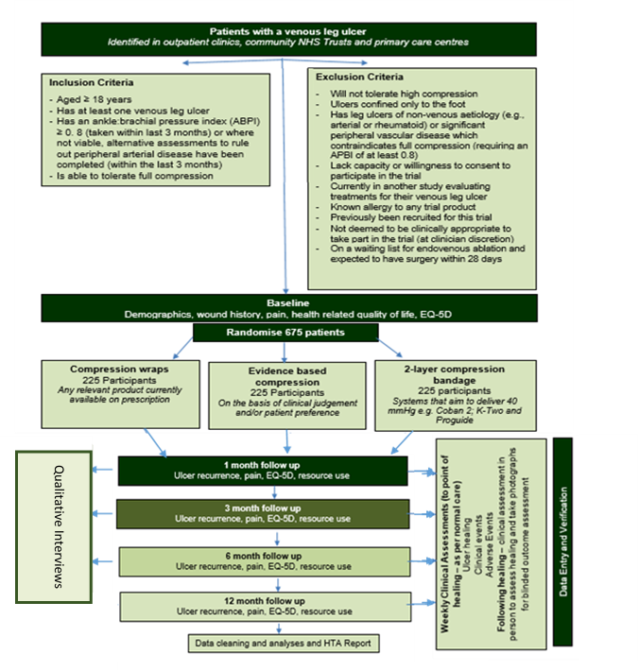

Figure 1. VenUS 6 design/participant pathway throughout the study

**Randomisation and allocation**: Six hundred and seventy-five eligible participants will be equally randomised and allocate to one of the three compression therapies. A secure, centralised, online randomisation service, hosted by the University of York Trials Unit, will be used to randomise eligible participants. Randomisation will be stratified by ulcer duration (≤6 months or ˃6 months) and ulcer area (≤5cm2 or ˃5cm2) using permuted blocks.

**Interventions:** Two hundred and twenty-five participants will be received one of the following three intervention arms:

1. **Evidence based compression:** This is choice arm of applying with four-layer bandage or two-layer compression hosiery system based on clinical discretion or participant preference. Any recognised brand of four-layer bandage can be used if it aims to deliver ≥40mmHg compression at ankle. Compression hosiery consists of two layers of compression aiming to deliver graduate sustained compression of ≥40mmHg at the ankle. The first layer is understocking or liner over which a second layer/overstocking is applied.
2. **Two-layer bandage:** This contains an initial bandage layer covered with top cohesive layer bandage to apply ≥40mmHg compression at the ankle. Any recognised two-layer system listed under the British National Formulary under ‘multilayer compression bandaging/two-layer system’ can be used (11).
3. **Compression wrap:** compression wraps are defined using hook and loop systems (such as Velcro) to secure the compression sleeve around the foot and leg. Wraps can be used in VenUS 6 if they are designed to be worn on lower leg and foot, aim to deliver ≥40mmHg compression at ankle, and are CE marked and available on FP-10. These can be used with compressive or non-compressive liner.

**Outcomes:** The primary outcome of the trial is time to healing of reference ulcer defined as complete epithelial cover in the absence of scab (eschar) with no dressing required. We will undertake blinded outcome assessment by assessing images of VLU taken at baseline and once a week for four weeks following healing. Secondary outcome measures are ulcer recurrence, adverse events, health-related quality of life, resource use, wound related pain, treatment adherence and ease of use collected through study specific case report forms. Data on treatment use, clinical events including healing of VLU and adverse events will be collected during nurse assessments until the participants leg is ulcer free and via monthly telephone contact following healing until the end of the participants follow up period. During the trial, participants will also be asked to complete postal questionnaires sent at months 1, 3, 6 and 12 following randomisation to collect information around quality of life, pain, treatment adherence and resource use in relation to VLU. We will integrate VenUS 6 into a wider economic model to explore the relative cost effectiveness of alternative compression treatments.

**VenUS 6 progress update:**

**Sites update:**  To date eighteen sites have been opened and are actively recruiting participants to VenUS 6. This includes: twelve secondary care trust, four community trusts and two GP practices. In addition, there are twelve sites currently in the process of being set up for the study. Full support is provided to sites during the set-up process and to help in delivering VenUS 6 study activities locally. There is also per participant fee of £469 available to sites to support study activity**.** For trial related progress update information please visit

**Recruitment update:** Recruitment to VenUS 6 commenced on 03/02/2021 and is anticipated to be completed by 30th March 2023. As of 31st January 2022, 155 participant (23% of 675) have been recruited. For information related to VenUS 6 progress update please visit VenUS 6 webpage at:

https://www.york.ac.uk/healthsciences/research/trials/research/trials/venus6/#tab-3

VenUS 6 is still open to new recruiting sites. For more information and to express interest in participating please contact: [venus6-trial-group@york.ac.uk](mailto:venus6-trial-group@york.ac.uk)

**Declarations**

Competing interests

All authors declare that they have no competing interests.

Acknowledgements

The research team would like to thank the study participants who have kindly agreed to take part in this study and our patient and public involvement representatives whose input has been indispensable in developing study documentation.

Funding

This project was funded by the National Institute for Health Research (NIHR) Health Technology Assessment Programme (Project Reference: 128625).

The views expressed are those of the author(s) and not necessarily those of the NIHR or the Department of Health and Social Care.

Availability of data and materials

Datasets and statistical code used in this study will be available from the corresponding author on reasonable request following completion of the trial.

Ethics approval and consent to participate

Ethical approval for this trial has been granted by the West of Scotland Research Ethics Committee 4 – reference 20/WS/0121 (Approval dated: 15.09.2020). Participants are required to provide informed consent prior to participation.

Consent for publication

Not applicable.

References

1. O'Meara S, Cullum N, Nelson EA, Dumville JC. Compression for venous leg ulcers. Cochrane Database Syst Rev. 2012;11:CD000265.

2. Gohel MS, Heatley F, Liu X, Bradbury A, Bulbulia R, Cullum N, et al. A Randomized Trial of Early Endovenous Ablation in Venous Ulceration. N Engl J Med. 2018;378(22):2105-14.

3. Epstein DM, Gohel MS, Heatley F, Liu X, Bradbury A, Bulbulia R, et al. Cost-effectiveness analysis of a randomized clinical trial of early versus deferred endovenous ablation of superficial venous reflux in patients with venous ulceration. Br J Surg. 2019;106(5):555-62.

4. Iglesias C, Nelson EA, Cullum NA, Torgerson DJ, Team V. VenUS I: a randomised controlled trial of two types of bandage for treating venous leg ulcers. Health Technol Assess. 2004;8(29):iii, 1-105.

5. Ashby R GR, Ali S, Adderley U, Bland JB, Cullum N, Dumville J et al. Compression hosiery versus compression bandages in treatment of venous leg ulcers (Venous leg Ulcer Study IV, VenUS IV): a randomised controlled trial. . L*ancet* 2014;383:871-9.

6. Ashby R GR, Ali S, Saramago P, Chuang L-H, Adderley U, Bland JM, Cullum NA, Dumville JC, Iglesias CP, Kang’ombe AR, Soares MO, Stubbs NC, Torgerson DJ. Compression hosiery versus compression bandaging in the treatment of venous leg ulcers: a randomised controlled trial, mixed treatment comparison and decision analytic model. . 2014;18:1-293.

7. Lazareth I, Moffatt C, Dissemond J, Lesne Padieu AS, Truchetet F, Beissert S, et al. Efficacy of two compression systems in the management of VLUs: results of a European RCT. J Wound Care. 2012;21(11):553-4, 6, 8 passim.

8. Moffatt CJ, Edwards L, Collier M, Treadwell T, Miller M, Shafer L, et al. A randomised controlled 8-week crossover clinical evaluation of the 3M Coban 2 Layer Compression System versus Profore to evaluate the product performance in patients with venous leg ulcers. Int Wound J. 2008;5(2):267-79.

9. Szewczyk MT, Jawień A, Cierzniakowska K, Cwajda-Białasik J, Mościcka P. Comparison of the effectiveness of compression stockings and layer compression systems in venous ulceration treatment. Arch Med Sci. 2010;6(5):793-9.

10. Blecken SR, Villavicencio JL, Kao TC. Comparison of elastic versus nonelastic compression in bilateral venous ulcers: a randomized trial. J Vasc Surg. 2005;42(6):1150-5.

11. BNF. Two layer systems: National Institute for Health and Care Excellence; [Available from: <https://bnf.nice.org.uk/wound-management/two-layer-systems.html>.