**Thermokinetics synergistic effects on co-pyrolysis of coal and rice husk blends for bioenergy production**

Maham Tauseef 1, Abeera Ayaz Ansari1, Asif Hussain Khoja1*, Salman Raza Naqvi2, Rabia Liaquat1, William Nimmo3,Syed Sheraz Daood 4,5,*

*1U.S.-Pakistan Centre for Advanced Studies in Energy (USPCAS-E), National University of Sciences & Technology (NUST), Sector H-12 Islamabad (44000), Pakistan*

*2School of Chemical and Materials Engineering (SCME), National University of Sciences & Technology (NUST), Sector H-12 Islamabad (44000), Pakistan.*

*3Energy Engineering Group, Energy 2050, Department of Mechanical Engineering, University of Sheffield, Sheffield, S3 7RD, United Kingdom*

*4Institute of Energy and Environmental Engineering, Faculty of Electrical, Energy and Environmental Engineering, University of the Punjab, Lahore 54590, Pakistan.*

*5Energy Engineering Research and Development Centre, Faculty of Electrical, Energy and Environmental Engineering, University of the Punjab, Lahore 54590, Pakistan.*

*Corresponding authors: [asif@uspcase.nust.edu.pk](mailto:asif@uspcase.nust.edu.pk), [sdaood.icet@pu.edu.pk](mailto:sdaood.icet@pu.edu.pk),

# Abstract

In-depth thermodynamic and kinetic synergistic effects of the coal and rice husk blends on co-pyrolysis have been investigated for bioenergy production. The thermokinetic rate parameters were determined for chemical, one-dimensional diffusional, and phase interfacial reaction models especially when fitted to the Coats-Redfern method. The fitted models exhibited thermokinetic rate parameters. The thermogravimetric analysis in view of the thermodynamic parameters including enthalpy, Gibbs free energy, and entropy imparted the prominent degradation temperature ranges (Stage A: 200 °C-400°C, Stage B: 410 °C-560°C) for co-pyrolysis reactions of blends. The proportional increase of rise husk into coal for Stage A caused an increase in the apparent values of activation energy, enthalpy specifically for one-dimensional diffusional, and phase interfacial reaction models. In case of Stage B, the increasing share of rice husk into coal proved to be beneficial in decreasing values of activation energy and enthalpy. Positive synergies for 80:20 and 60:40 coal-rice husk blends were calculated. In addition to characterisation analysis of all samples; co-pyrolysis and co-gasification experiments were completed in a tubular fixed bed reactor at Stage B and onwards temperatures for synergised blends. The resultant co-pyrolysis biochar samples revealed honeycomb structure useful in adsorption applications. The gas chromatography-mass spectrometry analysis of the bio-oil yields 23% phenols, 11% acids, and methoxy phenols for the 60:40 coal-rice husk blend. The product gas composition of 2% H2, 14% CH4, and 4% CO2 for the 80:20 coal-rice husk blend increased to 3% H2, 12% CH4, and 5% CO2 for the 60:40 blend. The co-gasification process substantially increased the production of H2 up to 14%-17% when compared to co-pyrolysis results. The approach used in this study can be utilized to capitalize on synergy to enhance co-pyrolysis of appropriate blends and their products can be used in further future applications upon upgradation.

**Keywords:** Co-pyrolysis; Co-gasification; coal-biomass blends; Thermokinetic; Bio-oil; Biochar;

**Highlights:**

* Kinetic study to investigate mechanistic behaviour of rice husk and coal blends
* Chemical, one-dimensional diffusional, and phase interfacial reaction models exhibited thermokinetic rate parameters for 200 °C-400 °C and 410 °C-560 °C temperature ranges
* Synergistic effects were observed in 80:20 and 60:40 coal-rice husk blends with positive deviation
* 15-20% bio-oil yield with characterised bio-char
* Thermodynamics of selected blends were investigated for further uptake in co-gasification
* Application of co-gasification method to produce 14-17% H2 for bioenergy production

# Nomenclature

|  |  |  |
| --- | --- | --- |
| β | Heating rate | °C/min |
| Ea | Activation energy | kJ/mol |
| A | Pre-exponential factor | min-1 |
| R | Universal gas constant | J/mol/K |
| ΔH | Enthalpy | kJ/mol |
| ΔG | Gibbs Free energy | kJ/mol |
| ΔS | Entropy | kJ/mol.K |
| Kb | Boltzmann Constant | kgs-2 K-1 |
| H | Plank’s Constant | m2 kgs-1 |
| Tp | Peak temperature | °C |
| Tb | Burnout temperature | °C |

# List of abbreviations

|  |  |
| --- | --- |
| C | Coal |
| RH | Rice Husk |
| TGA | Thermogravimetric analysis |
| DTG | Derived thermogravimetric analysis |
| FTIR | Fourier Transform Infrared spectroscopy |
| SEM | Scanning electron microscope |
| EDX | Energy dispersive X-ray spectroscopy |
| GC-MS | Gas chromatography–mass spectrometry |
| WL | Weight loss |
| PB | Pine butter |

# 1 Introduction

Growing population, rapid increase in industrialization concurrently complying to restrict the global warming to 1.5oC raise potential challenges to sustainability and also increase the energy demand [1]. The detrimental impacts of fossil fuels as primary energy resources on the environment is scientifically well documented, however, the economic growth rates for developing as well developed nations necessitates their continuing consumption. The premise of ongoing research and development in the energy and environment sector is to curb the increase of CO2 whilst offsetting the consumption of fossil fuels without creating energy crises to meet energy and emission targets for the 21st century [2]. Coal still dominates the global primary energy consumption by resource; nevertheless, this conventional energy resource is producing greenhouse gases (GHGs) at an accelerated rate causing a serious threat to global energy and environmental sustainability. Consequently, there is a vital need of global integration of conventional and renewable energy via clean utilisation of coal and other fossil fuels [2].

The deployment of renewable resources especially biomass has established prominence in the field of energy production due to incentives such as supply reliance, emissions mitigation [3], cheap and carbon neutral resource [4], diversified potential for biofuel production [5]. The thermochemical conversions routes such as combustion, pyrolysis, gasification, and liquefaction [6] of a single type of conventional fuel have limited application when compared to the approach adopted for co-utilisation of the same with biomass. Co-use of fuels mitigate the limitations of sole fuel such as high moisture content, low calorific value, variation in the compositions, flexible operation, cleaner and better conversion yield. In addition a considerable interest also lies in advancement of effective techniques to recover materials and energy from wastes [7].

In case of energy generation, co-pyrolysis of biomass is considered as a favourable technology to obtain different bio-products, such as bio-oil, biochar and mixture of gaseous products [8]. It is a low energy intensive process with resulting fuels (solid, liquid and gas) ideal for various applications [9]. Co-pyrolysis include devolatilization of biomass to form char, tar, gases, resulting in solid-gases and gases-tar reactions. Coal-biomass co-pyrolysis apart from paving the way to greater efficiency with better utilization of biomass, volume reduction of waste can also improve the quality of pyrolytic oils produced form coal only [10]. In some studies co-pyrolysis of bituminous coal and woody biomass exhibited no synergy, whereas, in other bituminous and lignite coal blends with cellulose, lignin, and pine sawdust presented synergistic effect in batch pyrolysis reactor [11]. Generally, thermogravimetric analysis (TGA) is widely used for an in-depth investigation of co-pyrolysis process [12, 13]. The synergistic effect may activate due to availability of enough hydrogen (H2) donors, free radicals and volatiles as biomass has greater H/C ratio than coal [14]. It was observed that co-pyrolysis of coal slime and coffee residue showed synergistic effect at blending ratio of 70% coffee residue and 30% coal [15]. Corn straw and lignite co-pyrolysis suggested the presence of synergistic effect however when oxidative environment was enabled it inhibited the production of volatile matter indicating the absence of synergy [16]. Co-pyrolysis of coal gangue and coffee residue showed that increasing the proportion of coffee residue exponentially decreased the co-pyrolysis index. Blending ratio of 30% coffee residue and 70% coal gangue was considered the ideal blend for co-pyrolysis [17]. Coal tar asphaltene and biomass co-pyrolysis revealed the presence of synergistic effect [18]. Co-pyrolysis of coal and polyethylene revealed that synergistic effect reduces the activation energy of co-pyrolysis. It also reported the distributions of H and OH radicals contributing to the interaction mechanisms [19]. Thus, the thermokinetic behaviour of the coal-biomass blends reveals the mechanistic insights of the pyrolysis process and assists in the decision-making path for suitable coal-biomass ratio.

Various kinetic models have been used to study the mechanistic behaviour of blends and to assess the reactivity of these fuels with changing blending ratios, heating rates as well as type of coal and biomass [20]. Coats-Redfern one of a model-fitting method has been practised to predict behaviour of coal-biomass blends, possible reaction mechanisms and to calculate the apparent values of activation energy (Ea), pre-exponential factor (A), and linear regression co-efficient (R2) for each stage of co-pyrolysis [21, 22]. Coats-Redfern method assess the validity of various models and provides the most appropriate model for decomposition of coal-biomass blends [23]. Kinetic analysis of coal and sawdust blends by Coats-Redfern method suggested that results were in agreement with behaviour of both feedstocks [24]. So, this method can be used to assess the mechanistic behaviour of blends. Various kinds of biomasses are available with different physical and chemical characteristics, amongst that rice husk (RH) as a feedstock has a great potential for co-pyrolysis due to its low cost and availability specially in agriculture based countries. RH usually discarded as waste material has an effective burning efficiency. The thermochemical conversion of RH is known to produce solid residue to synthesize silica based materials for a number of applications [25]. RH is also used for biochar and ethanol production [26].

The in-depth thermokinetics synergistic effect on co-pyrolysis for biofuel production followed by co-gasification (targeted for H2 rich gas production) of appropriate ratio of coal-RH blends has been systematically reported for the first time. The aim of this study is to investigate the thermal, kinetic and thermodynamic behaviour of various coal-RH blends during co-pyrolysis at a constant heating rate of 20°C/min and determine the understanding of blend profiles, rate parameters for chemical (F1, F1.5), one-dimensional diffusional (D1), and phase interfacial (S1) reaction models especially when fitted to the Coats-Redfern method. The blends are also characterised using ultimate analysis (CHN-S), gross calorific value (GCV), Fourier transform infrared analysis (FTIR), thermogravimetric analysis (TGA) and derived thermogravimetric analysis (DTG). Moreover, this study also attempts to carry out detailed characterization and analysis of co-pyrolysis biochar, bio-oil and product gases to understand the interactions of coal-RH blends.

# 2 Materials and methods

## 2.1 Sample collection and blend preparation

Punjab and Sindh provinces have vast cultivation areas dedicated for rice harvesting. Similarly, Punjab (eastern, central and western Salt Range, Makerwal coalfields) and Balochistan (Sor-range-degari and Chamalang coalfields) has bituminous quality of coal. Consequently, locally sourced Rice husk (RH) and bituminous coal (C) is used for this study. The schematic of coal-RH samples (Fig. 1) entailed drying in an oven at 110°Cfor 24 h to remove the moisture content, followed by crushing-grinding in Hardgrove Grindability Index Tester (USA) to produce particle sizes of 0.2 mm through sieving (RX-29–10, WS Tyler). All the blends of coal-RH were prepared on weight percent basis by mixing coal with rice husk to make a 100% wt. of blend besides the pure samples. C80-RH20 represents that 80% wt. of coal was mixed with 20% wt. of rice husk, similarly, C60-RH40, C40-RH60 and C20-RH80 blends were prepared accordingly. Pure sample of coal and RH were referred as pure coal (C100) and pure rice husk (RH100) respectively.

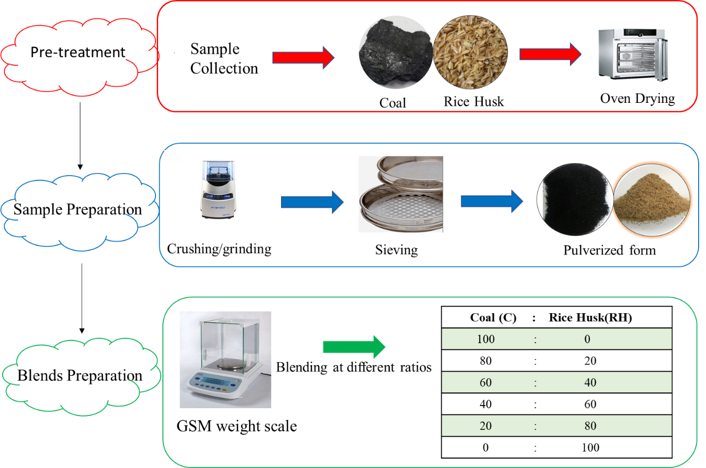

Fig 1. Schematic for coal-RH blend preparation.

**Table 1**. Sample code and percentage weight composition of the blends

|  |  |  |  |  |  |  |  |
| --- | --- | --- | --- | --- | --- | --- | --- |
|  | Weight (%) composition of pure samples | | | Weight (%) composition of blends | | | |
| Sample code | | C100 RH100 | | C80-RH20 | C60-RH40 | C40-RH60 | C20-RH80 |
| Coal | | 100 | 0 | 80 | 60 | 40 | 20 |
| Rice Husk | | 0 | 100 | 20 | 40 | 60 | 80 |

## 2.2 Characterisation of Coal-biomass blends

The 5ECHN2200 model of CKIC series Carbon, Hydrogen Nitrogen analyser with oxygen, helium, and nitrogen-standardised gases determined the ultimate analysis of 80 mg of each of the pure samples and blends in duplicates. 80 mg of each sample was placed in aluminium foil cup and foil was then placed on sample cup holder. Foil cup was then weighed and twisted to seal. The sealed foil cup was placed in the analyser for analysis. The sulphur analyser 5E-IRS II model of CKIC make determined composition of sulphur. 300 mg of each sample was taken and the same procedure adopted for CHN analysis was followed. The calorific values of all samples were determined in the PAR-6200 bomb calorimeter following standard method of ASTM D5865-13. 0.5 g of each sample was placed into a crucible, crucible was then placed inside a vessel, vessel was filled with oxygen and the sample was then ignited. The sample burned and calorific value was calculated upon comparing it with the calibrant. The functional groups and chemical bonds present in the samples was determined through attenuated total reflection (ATR) module of the Fourier transform infrared (FTIR) spectroscopy allowing the direct measurement of wavelengths of 650-4500 cm-1 (Cary 630 model by Agilent Technologies, USA). Sample was placed in FTIR spectrometer and infrared radiation was directed towards the sample. Some of the radiation was absorbed by the sample while some was reflected. The absorbed radiation was converted into vibrational energy of molecules and the resulting signal was presented as a spectrum. Every chemical structure was distinguished upon producing a specific fingerprint. The TGA and DTG testing of the 10 mg of samples (in duplicates) from ambient to a 900 °C temperature at the 20 °C min-1 heating rate was completed with the 5500-0304 TGA (thermogravimetric analyser). 8 mg of sample was placed in the pan and the pan was then placed on the sample tray. Nitrogen flow rate was set at 35 mL min-1 and the weight loss of blends and pure samples were recorded as a function of time and temperature under standard conditions.

## 2.3 Kinetic study

Coats-Redfern method has been frequently used for mechanistic analysis [27]. The coal-RH blends were analysed for chemical (F1, F1.5), one-dimensional diffusional (D1), and phase interfacial (S1) reaction models to determine apparent activation energy (Ea), and collision frequency factor (A, pre-exponential factor) both for pyrolysis and co-pyrolysis techniques. In general, 200 °C to 600 °C is the temperature range where weight loss is attributed to moisture removal and devolatilization for the most of the blends [28]. The reaction equations for non-isothermal kinetics according to reaction kinetic theory adopted from [29] are written as follows

The decomposition rate of solid to volatile state assuming Arrhenius model that the oxidation rate for mass loss is dependent only on the rate constant; mass of the sample remaining, and temperature is represented in Eq. 1.

$\frac{dα}{dt}=kTf(α)$ (1)

Where, $\frac{dα}{dt}$ is the rate of conversion, k(T) is the rate constant and f(α) is the reaction model. The α is defined in Eq. 2.

α = $\frac{Wi-Wt}{Wi-Wf}$ (2)

where, wi is the initial mass of sample, wt is the mass at any time(t), wf is the final mass when degradation ends. Rate constant in Eq. 1 is expressed in Eq. 3 according to the Arrhenius equation.

k(T) = $A\exp\left(\frac{-E}{RT}\right)f(α)$ (3)

where, Ea is the activation energy (kJ/mol), T is the temperature (K), R is universal gas constant (0.008314kJ/mol K). By substituting Eq. 3 in Eq. 1, the new form is represented in Eq. 4.

$\frac{dα}{dt}=A\exp\left(\frac{-E}{RT}\right)f(α)$ (4)

For TGA experiments having constant heating rate β = $\frac{dT}{dt}$, so equation can be expressed by the chain rule as presented in Eq. 5.

$\frac{dα}{dt}$ = $\frac{A}{β}$ $\exp\left(\frac{-E}{RT}\right)f(α)$ (5)

On applying integration to Eq. 5**,** the new equation form is shown in Eq. 6.

g(α) = $\int_{0}^{α}{\frac{dα}{fα}}$ = $\frac{A}{β}$ $\int{exp}$ $\left(\frac{-E}{RT}\right)$ dT (6)

While is the integral form of the reaction model. An exact analytical solution of the right-hand side of Eq. 6 is not possible so different method could be used to simplify this part of the equation. In case of the Coats-Redfern method the determination of three parameters including the apparent activation energy (Ea), order of reaction and Coats-Redfern constant [30] is required. This method has significance as the exact mechanism of reaction is not required in this model [31]. In this study, it was assumed that the order of reaction is equal to unity, hence the final form is expressed in Eq. 7:

ln [$\frac{g(α)}{T^{2}}$] = ln [($\frac{AR}{βE})]$ ×($\frac{1-2RT}{E})]$- $\frac{E}{RT}$ (7)

where, β is the heating rate, T is the temperature, A is the pre-exponential factor, R is universal gas constant. The value of Ea can be obtained from the slope of ln [$\frac{g(α)}{T^{2}}$] and  which gives a straight line [23]. The value of A can be obtained from the intercept of this graph. The reaction models implemented on all the blends and pure samples are illustrated in Table 2and were adopted from [32], [33].

**Table 2.** Reaction mechanisms and model names

|  |  |  |
| --- | --- | --- |
| **Mechanism of reaction** | **Model name** |  |
| Chemical reaction order | Chemical reaction order 1 (F1) | -ln(1-α) |
|  | Chemical reaction order 1.5 (F1.5) | 2[(1-α)-0.5-1] |
| One dimensional diffusion | Parabolic law (D1) | α2 |
| Phase interfacial reaction | Shrinkage geometrical column (S1) | 1-(1-α)1.5 |

The synergistic effect was determined by comparing the calculated values of blends with experimental values. The calculated values using Eq. 8 were obtained by the additive model which assumed that no interactions occurred between the coal and biomass during co-pyrolysis [14].

Ycalculated **=** X **coal** Y**coal +**X**biomass** Y**biomass**  (8)

Where Ycoal and Ybiomass are the experimental values of coal and rice husk, while Xcoal and Xbiomass are the mass fractions of coal and rice husk in the blends, respectively.

Deviation (Eq. 9) between experimental and calculated values of weight loss rates was determined to identify the presence of synergistic effect in blends [34, 35].

Deviation = $\frac{{Exp}_{value }-{Cal}_{value}}{{Exp}_{value}}$ × 100 (9)

where Expvalue is the value which is obtained from TGA curve and Calvalue is the value obtained from sum of TGA curves of individual samples as indicated in Eq. 8.

## 2.4 Thermodynamic study

Thermogravimetric analysis is also useful in determination of various thermodynamic parameters such as enthalpy (H), Gibbs free energy (G) and entropy (S) [36]. Kinetic data is used for calculation of thermodynamic parameters by using Eq. (10-12). The equations used for calculation of thermodynamic parameters were adopted from [37-39]

ΔH = Ea -RT (10)

ΔG = Ea -RTm ln[$\frac{K_{b T}}{hA}$] (11)

ΔS = $\frac{ΔH-ΔG}{T_{m}}$ (12)

Where ΔH is the change in enthalpy, ΔG is Gibbs free energy and ΔS represents change in entropy. Kb is the Boltzmann constant equal to 1.381×10-23 m2 kgs-2 K-1. Tm corresponds to the maximum decomposition temperature. h is Plank’s constant having value of 6.626×10-34 m2 kgs-1 and R is the universal gas constant.

## 2.5 Experimental setup for co-pyrolysis and co-gasification

The schematic of co-pyrolysis set up is presented in Fig. 2**.** The reactor consisted of a stainless-steel tube having 14 mm outer and 12 mm inner diameter. The selected coal-RH blend was placed in the middle section of the reactor tube sandwiched by quartz wool. Heating was provided via an electric heater coupled with a temperature controller. Mass flow controller (MFC) (MF4603-n1-1-bv-a, Servoﬂo Corporation, USA) was used to regulate gas flow. Heating rate was kept constant at 20 °C/min. Post pyrolysis reactor gases were collected after the condenser, whereas, liquid product was collected in a separate vessel. Feed gas and product gas were analysed using Gas Chromatograph (GC-2010 Pro, SHIMADZU, Japan equipped with TCD column (RT-MS5A, 30 m × 0.32 mm ID, 30 μm) to detect hydrogen gas (H2), carbon dioxide (CO2) and methane (CH4). After 2 h the distilled water was introduced using HPLC pump to the pre-heater to generate steam. The temperature of the reactor was elevated to 750 °C and then fixed for 2 h to analyse the co-gasification products.

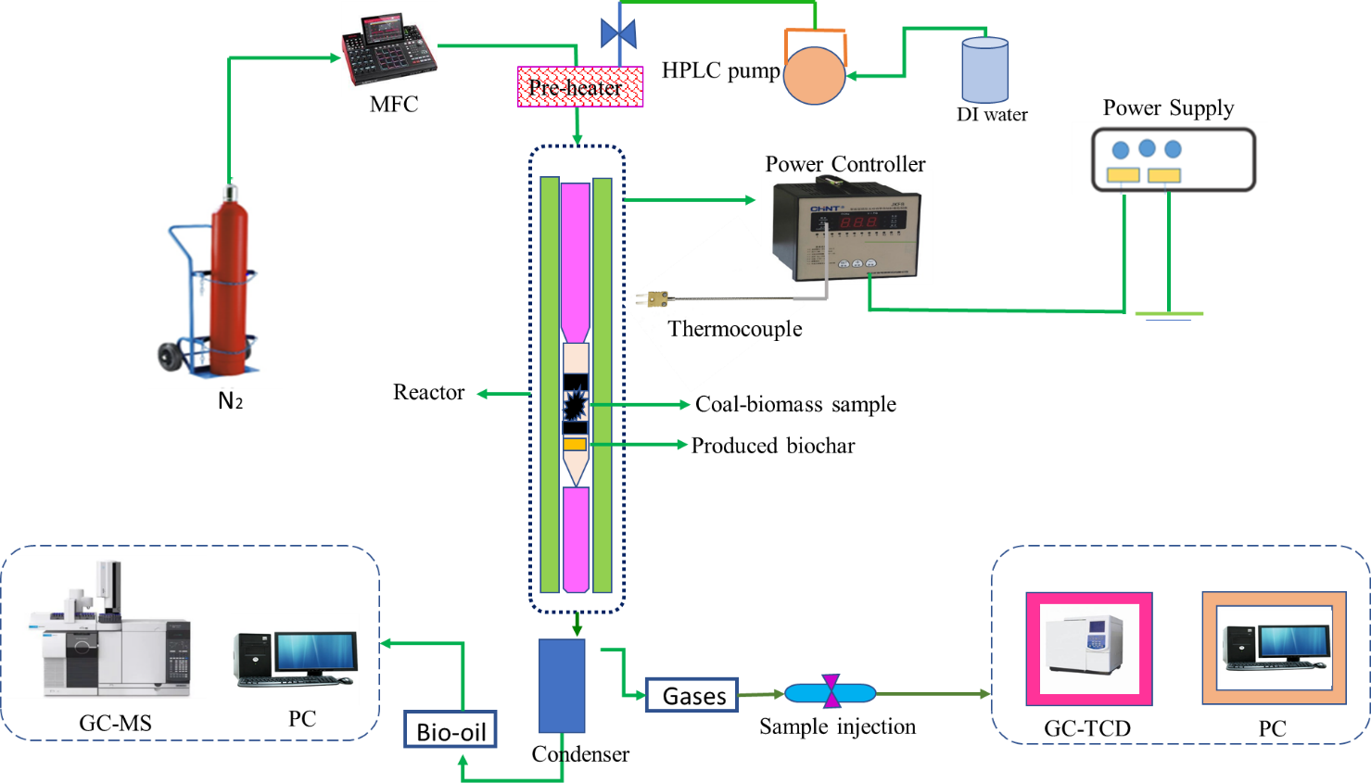

Fig. 2 Schematic diagram representing the setup for co-pyrolysis/co-gasification

# 2.6 Characterization of pyrolysis products

## 2.6.1 Characterization of biochar

The characterisation of biochar received after the pyrolysis was completed in SEM-EDS, TGA and FTIR to check its suitability for various catalysis and environmental applications. The morphology of biochar investigated at 20kV exposure of 3nm resolution extended to 10-20,000X, exhibited the desired micrographs through scanning electron microscopy (SEM) using (TESCAN VEGA 3, Czech Republic). The SEM images taken at different field magnifications produced better morphological structure insights. Elemental composition of biochar was examined through EDX detector (Oxford Instruments, model: 51-AD0007) [40], concurrently, the TGA and FTIR analysis as per cited conditions was also completed. The overall yield of biochar and bio-oil was calculated using Eq. 13.

Product yield (wt.%) = $\frac{W_{p}}{W_{f}}$ × 100 (13)

Where, Wp is the weight of product (g), Wf is the total weight of feedstock (g)

## 2.6.2 Characterization of bio-oil and product gases

The chemical composition of produced bio-oil was analysed using GC-MS (Shimadzu P2020 NX, Japan). The sample dissolved in n-hexane solvent was loaded in the autosampler GC vial and then 1.0 µL, at a split ratio of 1:20 injected into GC-MS for analysis with helium used as a carrier gas. The initial temperature ramp for column oven was set at 5°C/min from 50 °C to 150 °C and then at rate of 10°C/min from 150°C to 290 °C. The temperature of injector and detector was set at 290 °C. Electron impact potential of 70 eV with scan range of 35-500 amu was set. The comparison of mass spectra of blends with National Institute of standards and technology (NIST) library data helped to determine the organic compounds. The product gases were analyzed in GC-TCD (Shimadzu Japan) with already reported [41] details of the used column.

# 3 Results and discussion

## 3.1 Physicochemical properties of coal-biomass blends

Ultimate analysis of blends exhibit significant differences in the carbon, hydrogen, nitrogen, and sulphur contents of the samples (Fig. 3). C100 has 67.2% carbon, almost 80% more than the 37.4% carbon of RH100 (Fig. 3(a)). Coal contains additional amount of carbon and less volatile content when compared to the biomass that usually has high moisture, oxygen and hydrogen contents with less carbon [42]. In the case of blends, increase in the weight percentage of coal contributes to the rise in the carbon content of the blends up to a maximum amount of 63.4% carbon for C80-RH20. On the other hand, the reduction of weight percentage of coal in the blends decreased the overall percentage of carbon present in the prepared samples. The resultant percentages of carbon detected in C60-RH40, C40-RH60, and C20-RH80 blends are 53.4%, 48.2%, and 43.6%, respectively. A 4.7% hydrogen in R100 compared to 3.5% hydrogen of C100 was determined (Fig 3(b)) and correspondingly C20-RH80 exhibited the maximum hydrogen content (i.e. 4.5%) among the blends because of the increased ratio of biomass present. The lowest percentage of hydrogen (i.e. 3.7%) because of the higher weight ratio of coal was present in the C80-RH20 blend. While C60-RH40 and C40-RH60 blends contained 4.1% and 4.31% hydrogen, respectively. Nitrogen content of C100 (0.5 %) slightly higher than that of RH100 (0.2%) is usually present in the aromatic structures. The content of nitrogen in the blends (Fig 3(c)) being within the range of the pure fuels decreased with reducing share of coal. The percentage of sulphur (Fig 3(d)) of C100 (0.6%) and RH100 (0.3%), altered to 0.57%, 0.43%, 0.43%, and 0.41% for C80-RH20, C60-RH40, C40-RH60, and C20-RH80 blends, respectively.

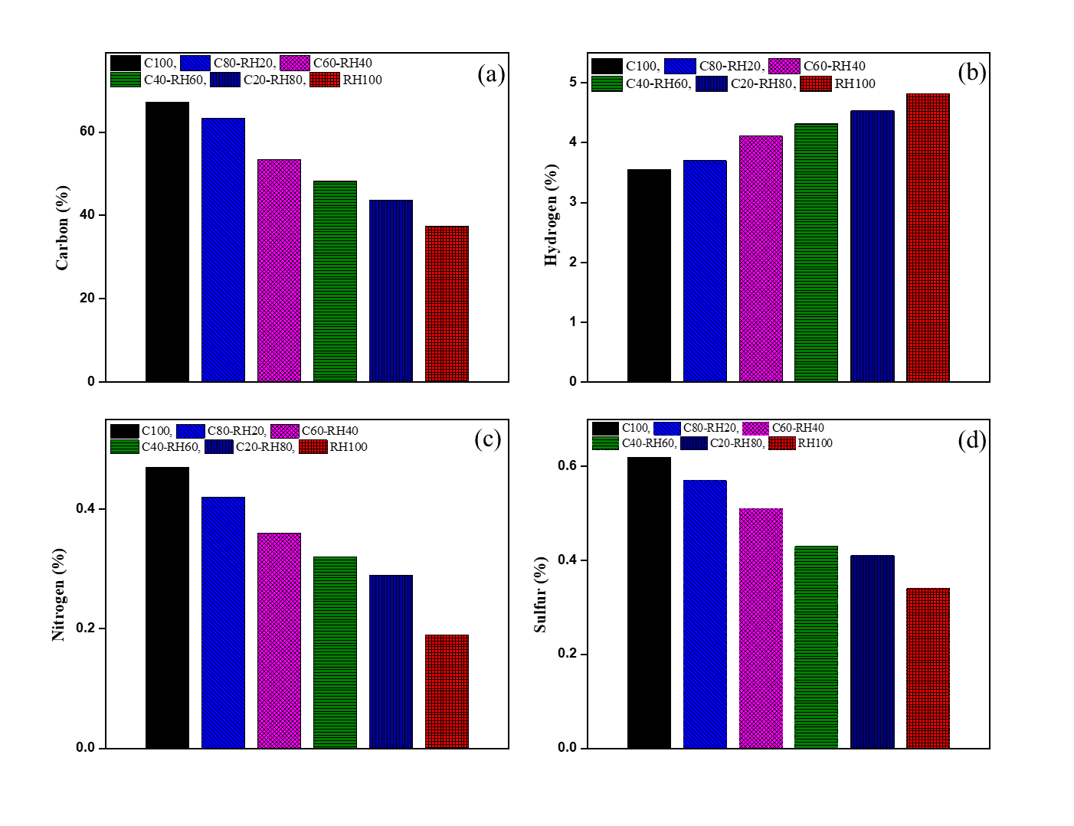

Fig. 3 Ultimate analysis of fuel blends; (a) Carbon (b) Hydrogen (c) Nitrogen (d) Sulphur

The selection criteria for a sustainable conversion process depend on the net heat release potential i.e. gross calorific value (GCV) of fuel[43]. Coal and RH having significantly different amounts of carbon, moisture and volatiles exhibited corresponding GCV of 29 MJ/kg and 17 MJ/kg (Fig. 4). C80-RH20 blend has the highest GCV of 28 MJ/kg almost comparable with C100, whilst, C60-RH40, C40-RH60, and C20-RH80 blends have 26MJ/kg, 23MJ/kg, and 21MJ/kg values, congruently. C80-RH20, C60-RH40 blends have the potential for energy production purposes. The sensible ratios of biomass (20% and 40%) in the blends impart improvement in the overall reactivity and ignition characteristics [44].

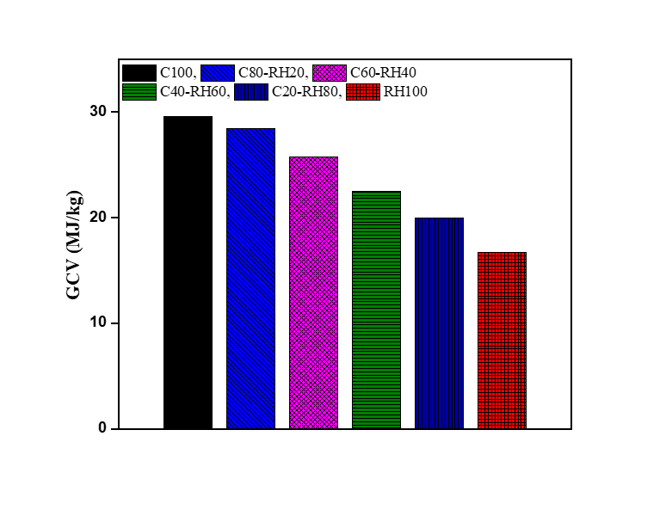

Fig. 4 Gross Calorific value (GCV) analysis of Coal-RH blends

FTIR spectra (Fig. 5) represents the chemical structural (functional group) differences [45] of coal, RH and blends corresponding to specific wavelengths. The oxygen-containing hydroxyl and carboxyl functional groups are present in RH, compared to the aromatic rings with some aliphatic side chains/bonds for coal. A few aromatic and aliphatic groups though present but O-H, C-O, C-H groups are abundantly detected. The most prominent peaks are obtained between the range of 1000-1700cm-1. Coal shows a peak at a wavenumber of 2800-3000 indicating aliphatic C-H stretching. Significant peak is observed between 1580-1650 cm-1 which shows aromatic C=C stretching. From 1300-1500 cm-1 coal shows aliphatic C-H deformation along with aromatic C=C stretching. This shows that the macro molecular structure of coal is composed of large number of aliphatic chains and bridge bonds [46]. Peaks with weak strength seemed over the wavenumber of 1100-1300 cm-1 indicating C-O stretching attributed to the deficiency of oxygen containing functional groups in coal.

However, RH100 shows peak indicating O-H stretching between 3200-3400 cm-1 [47]. These spectra signifies the presence of hydroxyl groups and a large number of hydrogen bonds due to inherently detected hydrogen as identified by CHN analysis discussed above. Pure RH shows a well-defined peak at 930-1200 cm-1 representing C-O bond stretching [48]. This reveals the molecular structure of rice husk that contains ether bonds, alcoholic and phenolic hydroxyl groups. Aliphatic C-H stretching and deformation is observed between 3000-2600 cm-1. Weaker peak between 1600-1400 indicates presence of aromatic C=C stretching. These major differences define their pyrolysis and combustion characteristics. RH100 comprises of cellulose, hemicellulose and lignin. Cellulose comprises of polyhydroxy aldehyde and the hydrogen atom on hydroxyl groups attract electrons on oxygen atom to form hydrogen bond. Hemicellulose on the other hand has uneven structure and excessive branched chains. Hence, functional groups of both cellulose and hemicellulose consisting of aldehyde, alcohol and hydroxyl groups contribute the detected absorption peaks. Lignin contains side chains with irregularity between recurring units and contains phenolic and alcoholic hydroxyl groups, benzene, methoxy groups etc. [46].

The impact of biomass in the blends especially with increasing the mass ratio of RH100 results in abundance of hydroxyl and oxygen containing functional groups in C20-RH80. Similarly, C80-RH20 shows abundant aromatic rings and side chains (aliphatic) whereas lesser oxygen and hydroxyl groups. These differences develop due to the differences in the base of structural units and the type of connection between these units.

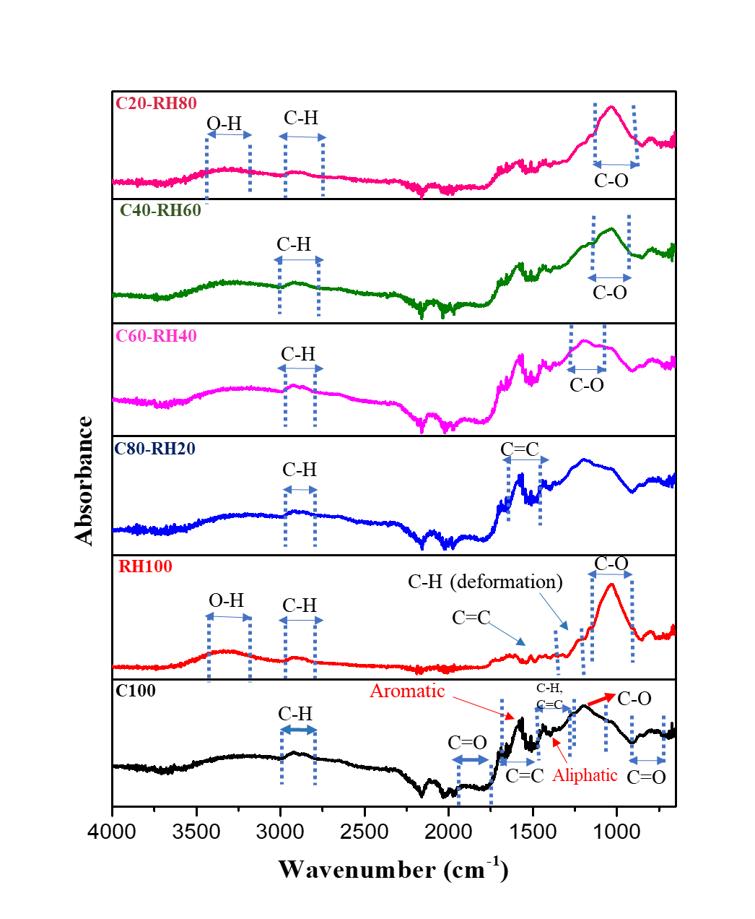

Fig. 5 FTIR spectra of Coal-RH blends

The TGA profiles of the studied samples in nitrogen environment at heating rate of 20 °C min-1 represents the changes in sample composition (Fig. 6(a)) and redox reactions accompanied with weight loss. It has been observed that the volatiles emitted by biomass may interact with the coal char especially when the biomass and coal are within their respective major pyrolysis section regions [46]. The interaction occurs due to transfer and interactions within volatiles and char, hydrogen, alkali and alkaline earth metal and free radicals from biomass. The TGA curves indicate that weight loss of blends can be divided into three stages [49]. Three-zone specific weight losses i.e. stage-I, stage-II, stage-III can be identified in Fig. 6(b). Stage-I is attributed to the moisture loss from the fibrous structure and breakdown of low molecular weight components within 50°C to 200°C. In case of biomass, the thermal degradation (Stage-II) includes the decomposition of cellulose, hemicellulose, and lignin [49]. At temperature range of 250°C-450°C, organic matter undergoes oxidation due to the presence of oxygen containing species and –OH functional groups [49]. In stage-I, moisture removal is associated with minimal weight loss. This moisture removal in stage-I degrades the thermal bonds in structure and creates stronger bonds in their place [50]. TGA and DTG profiles show that degradation of RH started earlier than coal. The reason attributed to this behaviour is that cellulose, hemicellulose and lignin present in RH are linked together with weak ether bonds (R-O-R) having bond energy of 380-420 kJ/mol [51] that degrade at lower temperature. However structure of coal is composed of polycyclic aromatic hydrocarbons linked together by single or double bonds having high stability and high resistance towards thermal decomposition because of the bond energy of 1000 kJ/mol [52]. It is the possible reason that in (stage-II) RH started decomposing at 200 °C while degradation of coal started in stage -III at 366 °C. TGA curves reveal that bonding strength of stage-II is comparatively higher than stage-I. In the case of blends, faster degradation at higher biomass-blending ratio is exhibited compared to those with smaller blending ratios. With the increase in temperature the oxygen containing by-products reach to their burnout temperatures and this released heat, consequently breaks down the remaining organic components [53]. Aromatic hydrocarbons are much stable than ether bond, hence, biomass degrades much rapidly than coal [54].

Comparative analysis of the TGA results exhibit increase in weight loss with increasing content of biomass of the tested blends. The weight loss attributed to the Stage-II vary from 20% to a maximum of 53% in case of pure RH. The differences in the devolatilization temperatures of RH and coal are due to different structural properties attributed to the chemical and elemental composition of the parent fuels [42]. At temperature above 600 °C, complex and thermally stable components mostly inorganic start to degrade. Table 3 lists the pyrolysis characteristics of each blend representing diverse temperature zones with corresponding peak temperatures.

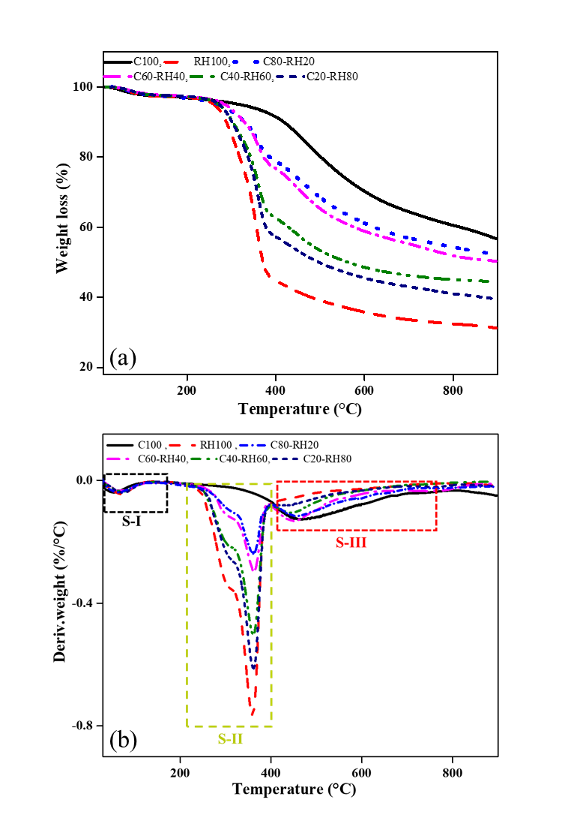

Fig. 6 TGA (a) and DTG (b) curves of coal-rice husk blends in pyrolytic atmosphere

The DTG peaks basically indicate the points of inflection of TGA profiles and demonstrate extreme weight loss rates [55]. These curves show temperature ranges where maximum degradation takes place. Fig. 6(b) shows that reactivity of coal and RH blends is directly proportional to the DTG peaks and decreases with the increases in temperature. The peaks from raw coal combustion are broader as compared to the blends profile. Coal profile reveals its low reactivity and its corresponding DTG curve does not show a significant marked peak. It is observed that reactivity increases linearly with the increase in biomass proportion. At the end of the peak after 600 °C, the slow breakdown of the components over a wide temperature range produces residue that reaches to a constant ratio, usually referred as a long tailing section [53]. The DTG profile evaluation shows that in case of blends, the peaks shifted to lower temperatures with increase of RH blending [56]. It is evident from Fig. 6(b) that for pure RH the degradation was largest with increasing rate and was maximum at temperature of 358 °C. However, from 410 °C the degradation decreased to a very low value till 900 °C. Coal depicted a very less devolatilization rate achieving maximum degradation at 460 °C.

The detailed pyrolysis characteristics of each sample are illustrated in Table 3. The ignition temperatures (Ti) of blends for stage II decreased as the RH blending ratio increases. The earlier ignition temperatures are pivotal to the operations of thermochemical conversion units. Temperature in stage-II where maximum degradation took place is 358 °C for RH, 363 °C for C80-RH20, 361°C for C60-RH40, 360 °C for C40-RH60, 359 °C for C20-RH80. There is an opulent difference of 166 °C noted between pure samples (C100 = 366 °C; RH100 = 200 °C). A change of about 122 °C, 149 °C, 154 °C, and 160 °C in the ignition temperature was reported for 20 wt. %, 40 wt. %, 60 wt. %, and 80 wt. % of added biomass when compared to pure coal. This indicated that RH degrades faster and more rapidly than coal, similarly, the peak temperature (Tp) for blends decreases as the RH blending ratio increases. However, weight loss increases when ratio of RH in the blends increases i.e. C80-RH20 exhibits a total weight loss (stage II and III) of 36%, C60-RH40 reveals 45%, C40-RH60 shows 52% and C20-RH80 demonstrates a mass loss of 56%. C100 and RH100 show weight loss of 35.2% and 86% respectively. Higher residue of coal is due to its high ash content and higher carbon content [57]. So, it is rational that with increase of RH in the blend more volatiles will release, and more weight loss will be observed. The percentage of residue left and burnout temperatures at the end of pyrolysis decreases with increasing biomass-blending ratio (Table 3).

**Table 3**  Pyrolysis parameters of blends

|  |  |  |  |  |  |  |
| --- | --- | --- | --- | --- | --- | --- |
|  | C100 | RH100 | C80-RH20 | C60-RH40 | C40-RH60 | C20-RH80 |
| Stage II (°C) | - | 200-421 | 224-387 | 217-393 | 212-402 | 206-400 |
| Tp (°C) | - | 358 | 363 | 361 | 360 | 359 |
| Weight loss (%) | - | 53.3 | 16.59 | 19.48 | 20.30 | 39.69 |
| Residue left | - | 43.28 | 80.39 | 77.57 | 77.08 | 57.36 |
| DTG (%/°C) | - | -0.06 | -0.05 | -0.076 | -0.084 | -0.076 |
| Stage III (°C) | 368-895 | 421-741 | 387-863 | 393-853 | 402-821 | 400-819 |
| Tp (°C) | 460 | 430 | 454 | 449 | 446 | 445 |
| Tb (°C) | 895 | 744 | 863 | 853 | 821 | 819 |
| Weight loss | 35.28 | 10.23 | 28.12 | 26 | 32.02 | 16.58 |
| Residue left | 58.13 | 33.05 | 52.27 | 51.57 | 45.06 | 40.75 |
| DTG (%/°C) | -0.05 | 0.01 | -0.008 | -0.01 | -0.008 | -0.014 |

## 3.2 Kinetic analysis

Ea is the energy required to initiate the reaction and very important parameter in coal-RH blending analysis [58]. The temperature where maximum weight loss occurred varied according to the composition of the blends indicative of volatilization and depolymerization reactions at dissimilar temperatures for each blend. The selection of suitable temperature ranges for each blend can have a significant impact in analysing the kinetic parameters [59]. The best fitted model can be selected based on linear fitting of the solid-state reaction kinetic models as well as the regression coefficient of every model. Model having regression coefficient nearly equal to 0.99 can be considered as the most appropriate model for co-pyrolysis. A is the pre-exponential factor that describes the material structure [60]. Higher values of pre-exponential factors represent a complex reaction whereas the lower values represent surface reaction [34]. In the case of co-pyrolysis, the blends are divided into two stages (Stage A and Stage B) of temperature for calculation of Ea depending upon their reactivity and the region where maximum decomposition occurred as illustrated in Table 4. The initial moisture loss stage has not been included in the kinetics calculation. Fig. 7 represents the graph between 1/T and [$\frac{ln⁡g(α)}{T^{2}}$] expected to form a straight line with -E/R slope to determine the Ea for each sample as depicted in Table 4. This straight line also gives intercept to determine pre-exponential factor A (min-1). Fig. 7(a-d) represent the plot for model F1, F1.5, D1, and S1 respectively. It depicts the linear regression (R2) for the extraction of various kinetic parameters for the blends at different reaction models. For stage A, model F1 depicted higher correlation coefficient for the blends and pure samples ranging from 0.984-0.991 shown in Fig.7 (a). While F1.5 provided values ranging from 0.981-0.988 as depicted in Fig. 7(b). For D1 the values of correlation coefficient ranged from 0.980-0.990 in Fig. 7(c) and for S1 the values ranged from 0.982-0.987 in Fig. 7(d) for stage A. However, for stage B, the correlation coefficient values ranged from 0.986-0.996 for F1 in Fig. 7(a), Stage B. Whereas F1.5 depicted values from 0.988-0.999 in Fig. 7(b), Stage B. D1 for stage B showed values from 0.956-0.975 as can be observed from in Fig. 7(c) which can be considered a good fit, however for C40-RH60 and C20-RH80 the values were 0.889 and 0.546 respectively. S1 showed values ranging from 0.974-0.977 except for C40-RH60 and C20-RH80 showing 0.797 and 0.896 respectively in Fig. 7(d), Stage B. For all the models, the higher apparent Ea value of RH100 is due to the presence of pore structures and usually such samples require higher temperatures [23].

All models showed linear regression in the range of 0.95-0.99 except for one-dimensional diffusional reaction model (D1) that exhibited smaller interdependence between variables (i.e. R2 = 0.5) for C20-RH80 blend in the stage B temperature range. In chemical reaction models, lower Ea values were determined in case of F1 than F1.5. In the case of C100, model F1 related apparent value of 25.28 kJ/mol for Ea with linear regression of 0.986, and 30.64 kJ/mol for model F1.5 with linear regression of 0.988 were attained. On the other hand, RH100 fuel based F1 modelyields Ea of 59.15 kJ/mol with best-fitted regression of 0.991 while F1.5 furnishes a higher Ea of 67 kJ/mol with comparatively lower regression of 0.988.

In stage A, F1 model exhibits overall better linear regression with lower Ea as compared to F1.5 that yields lesser regression coefficients with higher Ea. On the other hand, in stage B, model F1.5 results in better regression coefficients with higher Ea as compared to F1. In case of D1,stage A exhibits higher Ea as compared to stage B however, the linear regression of stage A is lower as compared to both F1 and F1.5. Model F1 shows higher values of pre-exponential factors than F1.5 and D1. For C100, F1 gives the value of A which is 2.9896 min-1 while F1.5 gives 10.123 min-1and D1 gives 34.46 min-1. On the other hand, in the case of RH100, F1.5 shows higher value of 1.8×105min-1 as compared to other models. Model D1 exhibits much higher Ea in stage A, while phase interfacial reaction mechanism (S1)shows the least Ea for stage A. Fig. 8 illustrates that in stage B model D1 shows higher Ea for C80-RH20 and C60-RH40 which decreases with decreasing the coal ratio in the blends. A similar trend can be observed for F1.5 which shows higher Ea for C80-RH20 and C60-RH40 and comparatively lower Ea for C40-RH60 and C20-RH80 in stage B. This shows that these two models give higher activation values with blends having increased coal content in stage B. However, for all the models in stage A, blends having higher proportion of coal in the mix show lower Ea.

In other words, the proportional increase of RH into C for Stage A caused an increase in the apparent values of activation energy (Ea). Hence, more energy will be required in the co-pyrolysis process of blends based when operated from 200 oC to 400 oC. Nevertheless, the increasing share of RH into C for Stage B proved to be beneficial due to the decreasing values of Ea. It is also indicative that pyrolysis reactions easily initiate in case of higher blending ratios of RH especially for Stage B temperature range (410 oC-560 oC). Furthermore, in each model (Table 4) with temperature ranges changing from stage A to stage B, apparent values of Ea decreased indicative of faster reaction rates in the pyrolysis process. This might be due to the additional volatile matter content of RH than Coal. Comparative analysis of the reaction models revealed similar order; D1 > F1 > F1.5 > S1 despite dissimilar values of Ea for C, RH, and their blends. In addition to the studied best-fitted models, other models describing the complex scheme of reactions for co-pyrolysis process of coal and RH blends can equally be used.

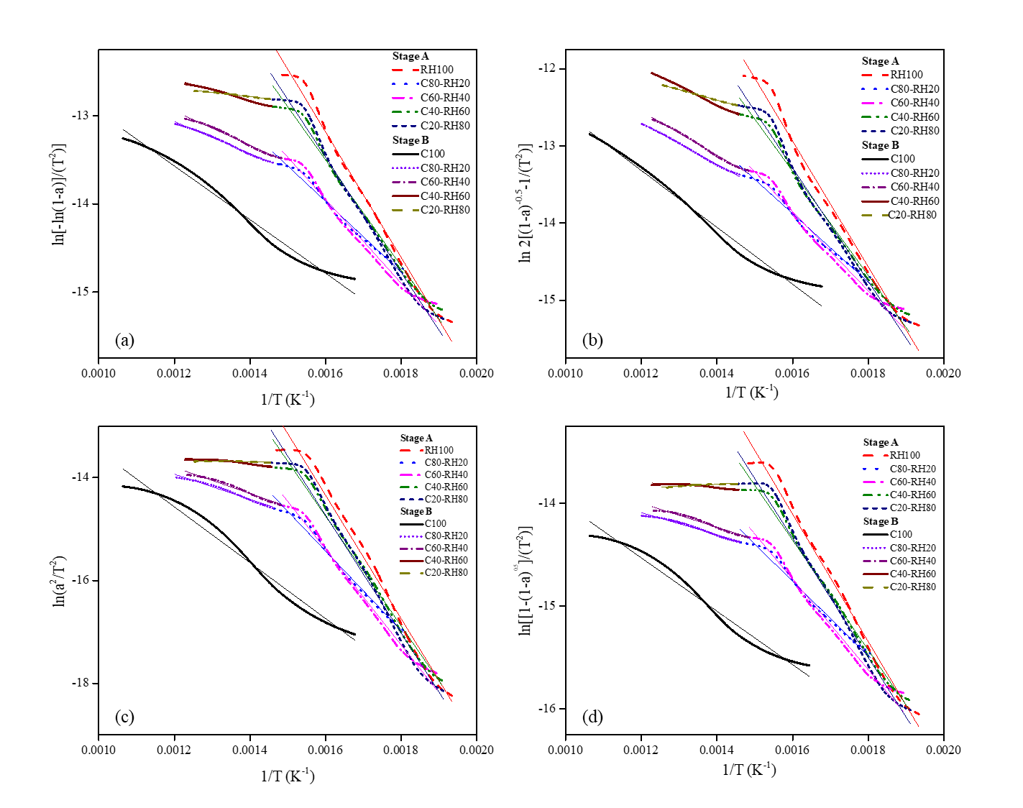  
Fig. 7. Coats Redfern plots representing models (a) F1, (b) F1.5, (c) D1, (d) S1

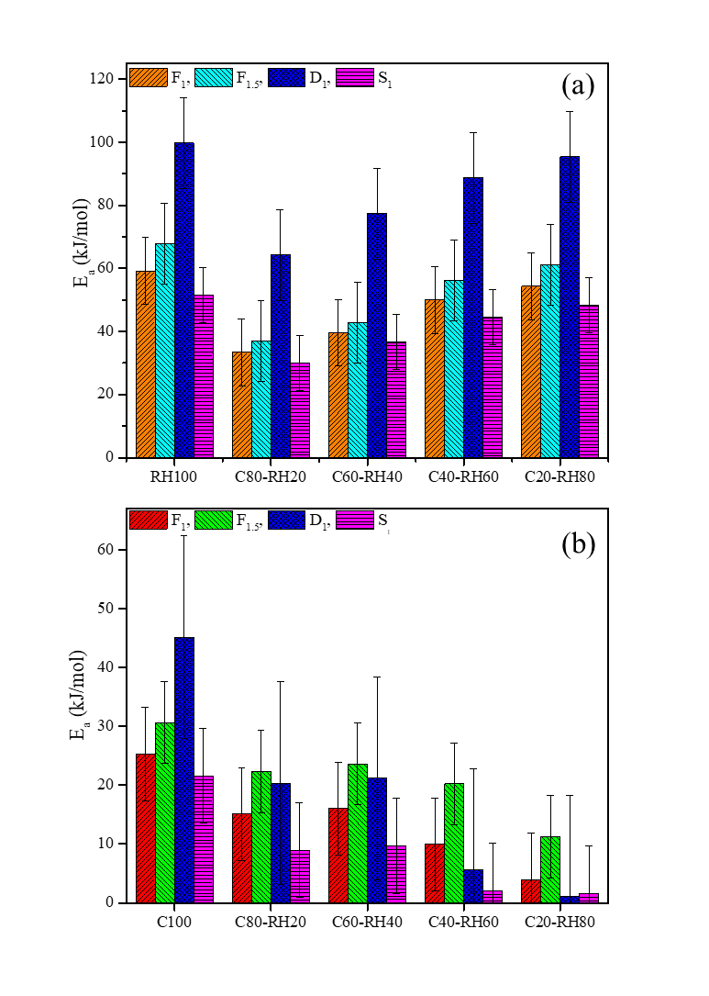

Fig. 8 Activation energy of blends representing various models and their stages (a) stage A and (b) stage B

**Table 4** Activation energy values of blends using different models

|  |  |  |  |  |  |  |  |  |  |
| --- | --- | --- | --- | --- | --- | --- | --- | --- | --- |
|  | STAGE A (main decomposition region) | | | | | STAGE B (main decomposition region) | | | |
|  | | **Temperature range (°C)** | **E (kJ/mol)** | **R2** | **A (min-1)** | **Temperature range (°C)** | **E (kJ/mol)** | **R2** | **A (min-1)** |
| F1 | |  | | | | | | | |
|  | C100 | - | - | - | - | 323-667 | 25.28 | 0.986 | 2.9896 |  |
|  | RH100 | 244-407 | 59.15 | 0.991 | 2.3×104 | - | - | - | - |
|  | C80RH20 | 282-412 | 33.39 | 0.984 | 42.47 | 413-561 | 15.08 | 0.996 | 10.89 |
|  | C60RH40 | 255-400 | 39.6 | 0.984 | 170.18 | 401-541 | 16.05 | 0.992 | 0.9316 |
|  | C40RH60 | 251-412 | 50.03 | 0.989 | 2.5×103 | 413-541 | 9.93 | 0.993 | 0.03413 |
|  | C20RH80 | 250-414 | 54.3 | 0.986 | 6.4×103 | 415-525 | 3.97 | 0.991 | 0.0524 |
| F1.5 | |  | | | | | | | |
|  | C100 | - | - | - | - | 323-667 | 30.64 | 0.988 | 10.123 |
|  | RH100 | 244-407 | 67.8 | 0.988 | 1.8×105 | - | - | - | - |
|  | C80-RH20 | 282-412 | 36.90 | 0.984 | 1×102 | 413-561 | 22.34 | 0.998 | 4.128 |
|  | C60-RH40 | 255-400 | 42.78 | 0.981 | 3.7×102 | 401-541 | 23.63 | 0.996 | 6.110 |
|  | C40-RH60 | 251-412 | 56.17 | 0.988 | 1×104 | 413-541 | 20.21 | 0.998 | 5.63 |
|  | C20-RH80 | 250-414 | 76.77 | 0.986 | 3.2×104 | 415-525 | 11.26 | 0.999 | 0.7391 |
| D1 | |  | | | | | | | |
|  | C100 | - | - | - | - | 323-667 | 45.12 | 0.975 | 34.46 |
|  | RH100 | 244-407 | 99.72 | 0.982 | 3×107 | - | - | - | - |
|  | C80-RH20 | 282-412 | 64.22 | 0.986 | 7.1×103 | 413-561 | 20.30 | 0.981 | 0.813 |
|  | C60-RH40 | 255-400 | 77.37 | 0.990 | 1.1×105 | 401-541 | 21.15 | 0.978 | 1.095 |
|  | C40-RH60 | 251-412 | 88.74 | 0.984 | 2.1×106 | 413-541 | 5.605 | 0.889 | 0.0376 |
|  | C20-RH80 | 250-414 | 95.33 | 0.980 | 8.5×106 | 415-525 | 1.079 | 0.546 | 3.5×10-3 |
| S1 | |  | | | | | | | |
|  | C100 | - | - | - | - | 323-667 | 21.58 | 0.977 | 0.572 |
|  | RH100 | 244-407 | 51.54 | 0.987 | 1.8×103 | - | - | - | - |
|  | C80-RH20 | 282-412 | 30.09 | 0.982 | 9.245 | 413-561 | 8.936 | 0.979 | 0.059 |
|  | C60-RH40 | 255-400 | 36.58 | 0.986 | 39.97 | 401-541 | 9.664 | 0.974 | 0.077 |
|  | C40-RH60 | 251-412 | 44.44 | 0.986 | 3.2×102 | 413-541 | 2.11 | 0.797 | 7.048 |
|  | C20-RH80 | 250-414 | 48.2 | 0.983 | 7.3×102 | 415-525 | 1.61 | 0.896 | 2.9×10-3 |

## 3.3 Synergistic effect

The synergistic effect in the blends during pyrolysis is reflected by any positive deviation in calculated and experimental values obtained from TGA of individual fuels [61]. So, to identify the synergistic effect the theoretical data was calculated based on the assumption that all interactions between parent fuels in the blends are an additive function. Synergistic effect is explained in terms of TGA weight loss values (WL) of the blends. The comparison between experimental and calculated values of weight loss (WL) is represented in Table 5. Calculated values were obtained using Eq. 8. The deviation between experimental and calculated values is obtained using Eq. 9. The results exhibit noticeable differences between actual and calculated data and these deviations give rise to synergistic effect [62]. C80-RH20 and C60-RH40 show positive deviation representing positive synergistic effect, while C40-RH60 and C20-RH80 show slightly negative deviation representing negative synergistic effect though the difference between experimental and calculated data is very less as shown in Table 5. For C80-RH20 and C60-RH40, the experimental weight loss value is greater than calculated weight loss value which is a major indication of presence of synergistic effect [63, 64]. As experimental WL of C8-RH20 is 48% while calculated WL is 46.7%. Similarly, experimental WL for C60-RH40 is 49.5% while calculated weight loss is around 47%. So, the synergistic effect can be explained in terms of comparison of weight loss values of the blends which corresponds to release of more volatiles. In other studies [63, 65-68] synergistic effect arises due to the transfer of hydrogen radicals or due to existence of alkali and alkaline earth metals (AAEM) depending on type of biomass and its composition. This can be associated with the catalytic or non-catalytic interactions within the fuel blends. The catalytic effect arises due to the presence of various alkali and alkaline earth metals and other inorganic species while the non-catalytic effect arises due to the presence of free radicals and transfer of hydrogen from biomass [69]. The interaction between volatiles and char components as well as the interference of alkali and alkaline earth metals present in RH give rise to a synergistic effect. Moreover, the heat transfer reactions and hydrogen transfer reactions with catalytic effects of metal transfer also impacts the synergistic properties [70]. Additionally, the porous structure of char formed after devolatilization in co-pyrolysis may also lead to synergistic effect by increasing the volatile emissions and consequently increasing the weight loss [71]. In this study, the negative synergistic effect is observed for blending at higher biomass blending ratios of C40-RH60 and C20-RH80 though the deviation is very small. This may arise due to the reason that at higher biomass blending the particles of RH and C do not completely fill into each other’s interspaces [14, 72]. Various other studies have also reported negative synergistic effect at higher biomass blending ratios [72-74].

**Table 5** Deviation in experimental and calculated weight loss (WL) of blends

|  |  |  |  |
| --- | --- | --- | --- |
| Sample | Experimental | Calculated | Deviation |
|  | **WL (%)** | **WL (%)** | **WL (%)** |
| C80-RH20 | 48 | 46.7 | 0.027 |
| C60-RH40 | 49.51 | 47.4 | 0.041 |
| C40-RH60 | 56 | 57.0 | -0.017 |
| C20-RH80 | 60 | 61.1 | -0.018 |

## 3.4 Thermodynamic analysis

The calculated thermodynamic parameters ΔH, ΔG and ΔS are illustrated in Table 6. The enthalpy change represents the heat absorbed or released while keeping the pressure constant [75]. Gibbs free energy exhibits the increase in energy in the development of activated complex [76]. It can be observed from Table 6 that all of the models depicted positive ΔH values except in some cases for the stage B. The positive values of ΔH show that an external energy source is required to provide energy for molecules at a higher energy level to their state of transition [77]. Increased value of ΔH shows that a longer time is also required for the conversion, so high values of ΔH may change the primary reaction mechanism in co-pyrolysis [78]. In stage A and stage B of all the models, ΔH increased as the activation energy increased. Among all models, ΔG values in stage B are slightly higher than in stage A, this can be interpreted to establish the disorder and changes in heat flow [36]. In all the models, ΔS exhibited negative values in both stages as shown in Table 6. This trend clearly shows that the disorder which occurred in the products due to bond breakage was lower as compared to the primary reactants [60]. These negative values depict the presence of a very organised structure of breakdown in the active state and the reactions taking place in the active state followed a very mild pattern [79].

**Table 6** Thermodynamic parameters of Coal-RH blends at various reaction models

|  |  |  |  |  |  |  |  |  |  |  |  |  |  |
| --- | --- | --- | --- | --- | --- | --- | --- | --- | --- | --- | --- | --- | --- |
|  | STAGE A (main decomposition region) | | | | | | | STAGE B (main decomposition region) | | | | | |
|  | | | **Temperature range (°C)** | **ΔH**  **(kJ/mol)** | **ΔG**  **(kJ/mol)** | **ΔS**  **(kJ/mol.K)** | **Temperature range (°C)** | | | **ΔH**  **(kJ/mol)** | | **ΔG**  **(kJ/mol)** | **ΔS**  **(kJ/mol.K)** | |
| F1 | | |  | | | | | | | | | | | |
|  | | C100 | - | - | - | - | | | 323-667 | | 19.20147 | 527.9 | -0.695 | | |  |
|  | | RH100 | 244-407 | 53.89 | 445.7 | -0.620 | | | - | | - | - | - | | |
|  | | C80-RH20 | 282-412 | 28.10 | 455.47 | -0.672 | | | 413-561 | | 9.06 | 521.41 | -0.708 | | |
|  | | C60-RH40 | 255-400 | 34.32 | 453.5 | -0.661 | | | 401-541 | | 10.04 | 519.2 | -0.705 | | |
|  | | C40-RH60 | 251-412 | 44.76 | 499.19 | -0.638 | | | 413-541 | | 3.93 | 523 | -0.732 | | |
|  | | C20-RH80 | 250-414 | 49.02 | 460.4 | -0.648 | | | 415-525 | | -1.963 | 518.3 | -0.820 | | |
| F1.5 | | |  | | | | | | | | | | | |
|  | | C100 | - | - | - | - | | | 323-667 | | 24.56 | 525.9 | -0.685 | | |
|  | | RH100 | 244-407 | 62.54 | 443.5 | -0.603 | | | - | | - | - | - | | |
|  | | C80-RH20 | 282-412 | 31.61 | 454.3 | -0.665 | | | 413-561 | | 16.32 | 517.78 | -0.693 | | |
|  | | C60-RH40 | 255-400 | 37.5 | 452.6 | -0.654 | | | 401-541 | | 17.62 | 515.58 | -0.689 | | |
|  | | C40-RH60 | 251-412 | 50.90 | 448 | -0.627 | | | 413-541 | | 14.21 | 512.18 | -0.690 | | |
|  | | C20-RH80 | 250-414 | 71.49 | 462.9 | -0.617 | | | 415-525 | | 5.32 | 510.09 | -0.796 | | |
| D1 | | |  | | | | | | | | | | | |
|  | | C100 | - | - | - | - | | | 323-667 | | 39.04 | 532.94 | -0.675 | | |
|  | | RH100 | 244-407 | 94.46 | 448.6 | -0.560 | | | - | | - | - | - | | |
|  | | C80-RH20 | 282-412 | 58.93 | 459.19 | -0.629 | | | 413-561 | | 14.28 | 525.5 | -0.706 | | |
|  | | C60-RH40 | 255-400 | 72.09 | 457.2 | -0.607 | | | 401-541 | | 15.14 | 523.4 | -0.704 | | |
|  | | C40-RH60 | 251-412 | 83.47 | 452.4 | -0.582 | | | 413-541 | | -0.390 | 527.6 | -0.732 | | |
|  | | C20-RH80 | 250-414 | 90.059 | 452.1 | -0.571 | | | 415-525 | | -4.854 | 531.6 | -0.846 | | |
| S1 | | |  | | | | | | | | | | | |
|  | | C100 | - | - | - | - | | | 323-667 | | 15.5 | 512.7 | -0.709 | | |
|  | | RH100 | 244-407 | 46.28 | 451.5 | -0.641 | | | - | | - | - | - | | |
|  | | C80-RH20 | 282-412 | 24.81 | 460.2 | -0.685 | | | 413-561 | | 2.92 | 529.9 | -0.728 | | |
|  | | C60-RH40 | 255-400 | 31.30 | 458.21 | -0.673 | | | 401-541 | | 3.66 | 527.8 | -0.726 | | |
|  | | C40-RH60 | 251-412 | 39.17 | 454.4 | -0.655 | | | 413-541 | | -3.88 | 492.7 | -0.688 | | |
|  | | C20-RH80 | 250-414 | 42.92 | 454.3 | -0.648 | | | 415-525 | | -4.32 | 499.2 | -0.794 | | |

## 3.5 Product analysis of co-pyrolysis

C80-RH20 and C60-RH40 were selected for co-pyrolysis in a fixed bed reactor due to the presence of a positive synergistic effect. Moreover, these two blends showed comparatively lower activation energies and higher calorific values as discussed above. The pyrolytic reactions controlled at a temperature of 500 **°**C produced biochar yields of 60% and 55% for C80-RH20 and C60-RH40 blends. The increase in the share of biomass decreased the char yield of the blends. These SEM micrographs (Fig. 9(a-d)) exhibited honeycomb-like porous structure for C80-RH20 blend, whereas, flake structure were detected in the biochar of C60-RH40 blend. SEM analyses indicate that the evaporation of volatile compounds increases the porosity and appearance of voids in the structure as expected with increasing surface area, pore volume and micropore ratio. Coal structure consists of aromatic hydrocarbons which are relatively dense having bond energies of 1000 kJ/mol. In C80-RH20 the synergy may occur due to various depolymerization and decomposition reactions especially transfer of H2 from RH to coal as discussed above. Heat transfer and chemical reactions also play a vital role in synergistic effects [80] especially when diverse magnitudes of holes have been observed. The pore structure facilitates the reaction and diffusion of various products and also serves as the major adsorption surface for various chemical reactions [81]. Characteristics and growth of pore structure is affected by blending ratio, pyrolysis temperature and feedstock used. Many studies have shown that a synergistic effect was observed in co-pyrolysis char due to the presence of alkali and alkaline earth metal (AAEM) species, mainly K and Ca [82]. Moreover, SEM analysis of C80-RH20 biochar confirms honey-comb shaped morphology with number of pores which shows the rapid release of volatiles from RH. SEM of C60-RH40 also shows the presence of pores which correspond to volatile release. A clear porous structure is observed which is in accordance to releasing volatiles and thus synergistic effect is confirmed [63].

EDS analysis of C80-RH20 in Fig.10(a) shows that biochar comprises of carbon (C), oxygen (O), silicon (Si), and potassium (K). It is observed that on increasing the biomass blending ratio, alkali and alkaline earth metals increase. Potassium is transferred from biomass to coal char so this indicates that mixing of coal and RH is beneficial and co-pyrolysis facilitates the activation of K [83]. C60-RH40 blend based biochar (Fig.10(b)) comprising of elements of carbon (C), oxygen(O), silicon (Si), potassium (K), calcium (Ca), magnesium (Mg) depicts an increase in the catalytically active AAEM species in co-pyrolysis char [84]. The blending of coal with RH is advantageous for the release of catalytic species including K, Mg, Ca, and Si. These specific biochar exhibit additional favourable results in terms of catalytic species and suitability in future applications as well. The SEM-EDS analysis shows that the produced co-pyrolysis biochar has potential for several applications where it can be applied as an adsorbent, storage medium for carbon and hydrogen, catalyst for biodiesel production, to improve soil quality, as a habitat for microorganisms and can also work as a semiconductor [85].

TGA analysis of co-pyrolysis chars, was also performed as shown in Fig 10(c). Biochar after co-pyrolysis shows less weight loss than their actual blends and hence show stability. The comparative analysis of the chemical structure of biochars exhibited a decrease in the amorphous carbon structure with an increase of coal mass fraction in C80-RH20 blend [83]. The most dominant peak at a wavenumber of 3542 cm-1 signifies the O-H bond stretching. Peak observed at a wavenumber of 1614 cm-1 indicates C=C stretching, whereas, 1170-1130 cm-1 wavelength range represent ester based C-O stretching. FTIR spectra of biochar from C60-RH40 shows that increased content of biomass increased amorphous structure [86]. The observed two peaks represent O-H bond stretching for 3500-3300 cm-1 and C-O bond stretching for 1200-1000 cm-1. Co-pyrolysis char from C60RH40 includes less significant aromatic ring structures as compared to C80RH20 [87].

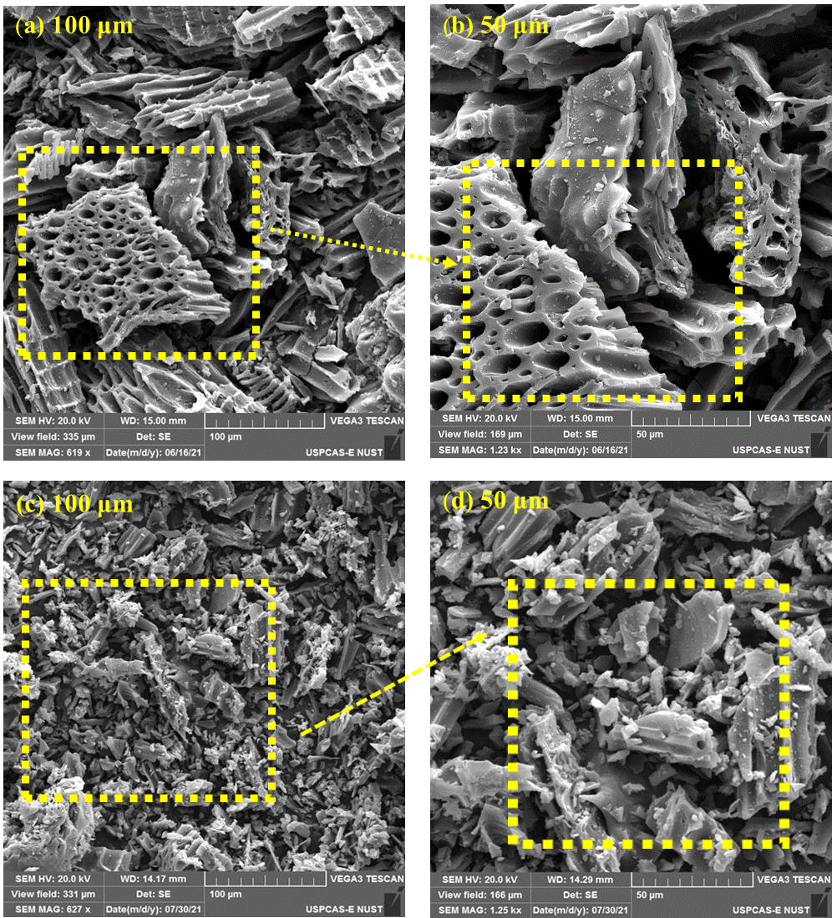

**Fig .9.** SEM images of biochar from C80-RH20 (a-b) and C60-RH40 (c-d)

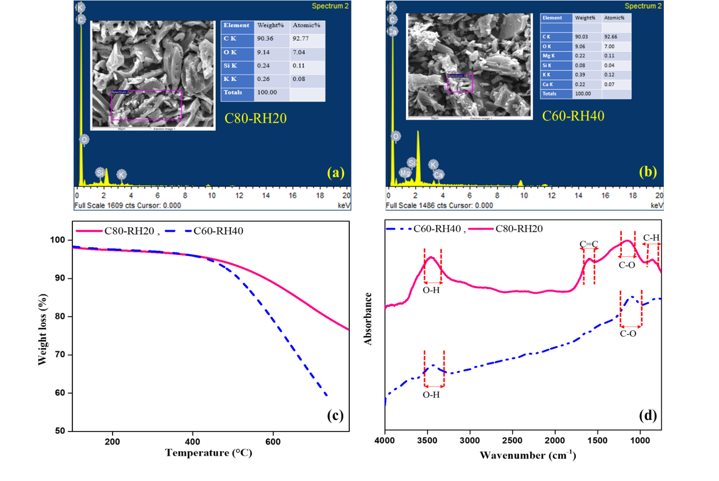

**Fig. 10** Characteristics of biochar produced from C80-RH20 and C60-RH40 (i) (a-b) EDS analysis (c) TGA (d) FTIR

The chemical composition of the liquid product obtained at 500 °C for both C80-RH20 and C60-RH40 was analysed by GC-MS. The peaks presented by chromatogram were interpreted using NIST search software. The analysis conducted determines that bio-oil is composed of acids, phenols, alcohols, furans, amines and esters. The composition of both samples of bio-oil was different because of the blending ratios as shown in Fig. 11. In the case of C80-RH20 blend, 15% bio-oil whereas, 20% from C80-RH20 blend was obtained. Major compounds identified in bio-oil obtained from C80-RH20 were phenols (22%) and acids (11%), similarly, phenols (23%) and acids (11%) were also present in the bio-oil from C60-RH40 blend. Other compounds identified in C80-RH20 were esters (3.1%), furans (0.14%) and amines (1%). While, in C60-RH40 the bio-oil also consisted of esters (3%), furans (0.3%), amines (0.5%) and alcohols (0.33%). The analysis shows that different types and amounts of fatty acids and esters were formed by the interaction of coal and RH. RH contains oxygenated compounds that mainly comprise phenols, furans and acids having more than two oxygen-containing functional groups [88]. It has been reported that liquid products majorly from pyrolysis of RH consisted of phenols, organic acids and ketones [89]. Another report revealed that compounds detected by GC-MS from pyrolysis of rice husk were classified into ketones, aldehydes, phenols, alcohols, esters, furans and acids [88]. C60-RH40 exhibited higher amounts of phenols, alcohols and furans than C80-RH20 because C60-RH40 has higher share of RH in it as compared to C80-RH20, and biomass pyrolysis oils have higher concentration of phenols, acids, alcohols as compared to coal pyrolysis oil evident from other studies [90, 91]. RH100 also has higher hydrogen (4.7%) than coal (3.5%) as discussed above in CHN analysis and FTIR analysis where hydroxyl (-OH) groups in RH are abundant as compared to coal. This is also a reason of higher concentration of phenols in biomass pyrolysis as compared to coal pyrolysis and consequently the blend having higher biomass share will depict higher concentrations of phenols and acids.

Fig. 12 shows the retention time with respect to intensity of various chemical compounds identified through GC-MS**.** Fig. 12(a-b) represent spectra of C80-RH20 and C60-RH40 respectively. The major absorption peaks are represented in the spectra with their chemical structures. Table 7 lists the compounds present in bio-oils according to the relative peak number.

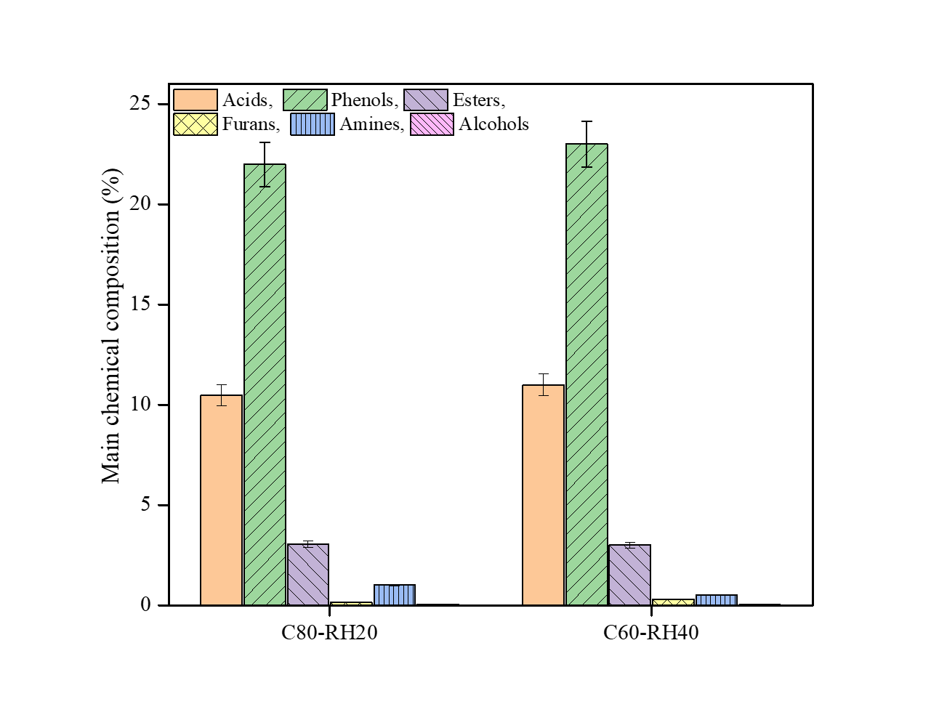

**Fig. 11** Composition analysis of bio-oils from C80-RH20 and C60-RH40

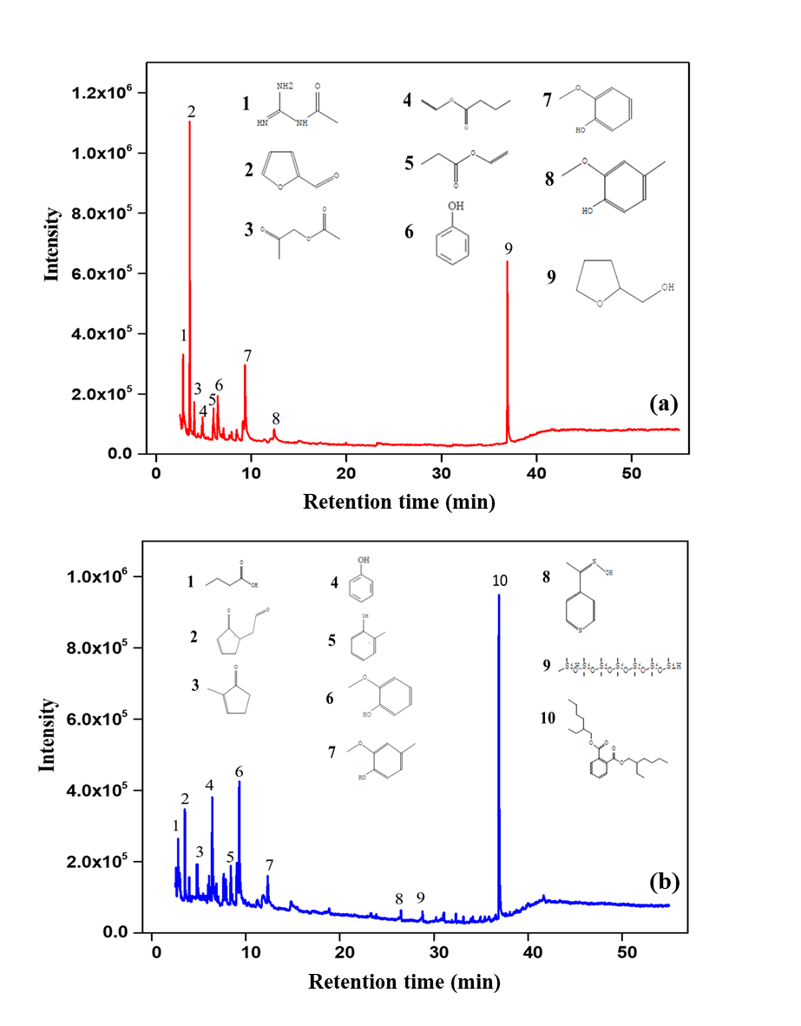

**Fig. 12** GC-MS chromatograms of (a) C80-RH20 bio-oil (b) C60-RH40 bio-oil

**Table 7** Chemical compounds identified at various peaks in C80-RH20 bio-oil and C60-RH40 bio-oil

|  |  |  |  |
| --- | --- | --- | --- |
| Peak Number | Compounds identified in C80-RH20 bio-oil | | Compounds identified in C60RH40 bio-oil |
| 1 | Acetamide, N-(aminoiminomethyl) | Butanoic acid | |
| 2 | Furfural | 3-Cyclopentene-1-acetaldehyde, 2-oxo | |
| 3 | 2-Propanone, 1-(acetyloxy) | 2-Cyclopenten-1-one,2 methyl | |
| 4 | Vinyl butyrate | Phenol | |
| 5 | Propanoic acid, ethenyl ester | Phenol, 2-methyl- | |
| 6 | Phenol | Phenol, 2-methoxy- | |
| 7 | Phenol, 2-methoxy- | Creosol | |
| 8 | Creosol | Ethanone,1-(4-pyridinyl)-, oxime | |
| 9 | 2-Furanmethanol, tetrahydro- | Heptasiloxane,1,1,3,3,5,5,7,7,9,9,11,11,13,13-tetradecamethyl | |
| 10 | - | Bis(2-ethylhexyl) phthalate | |

The gaseous product analysis of C80-RH20 and C60-RH40 was carried out using a GC-TCD analyser. The temperature of the fixed bed reactor was kept at 500 °C (Stage B range) in an inert atmosphere for pyrolysis for Cycle 1 (2 h) with product analysis presented in Fig. 13(a). After 2 h, co-gasification was enabled, referred to as Cycle 2. It can be observed that produced gases were composed of H2, CO2, CH4. Major constituents of gaseous fraction were H2, CO2 andCH4. These experimental results depict that production of gases is greatly influenced by the mixing ratio of blend. The release of CO2 during initial pyrolysis mainly occurred due to decarboxylation reactions of hemicellulose and other components like fats, lignin, phenols and other inorganics present in biomass [92].

In the case of C80-RH20, Cycle 1 exhibited CH4 as the major gas with 13% production and H2 as the minor gas with 1% production. In addition to cited measurements 5% production of CO2 and 6-7% production of CO was also achieved during co-pyrolysis. However, when co-gasification is enabled in Cycle 2, methane production drastically decreased (from 13% to 4%) and hydrogen production significantly increased to 15%. Production of CO2 decreased from 4% to 1% whereas CO production increased to 11%. The products yield also get influenced by the content of ash, depending upon the mineral composition of each blend [93]. However, when co-gasification is enabled in Cycle 2, CH4 production drastically decreased (from 12% to 5%) and H2 production increased to 15%. Production of CO2 also reduced from 5% to 1%, whereas, CO yield increased indicative of the progression of reverse water gas shift reaction.

According to studies presented in literature it was observed that during co-pyrolysis of peat (PT) and pine branch (PB) the blends having less biomass share (3PT:1PB) reported 9% CO and that having higher biomass ratio (1PT:3PB) depicted considerably less amount of CO (7%). CO2 was reported to be 40% in 3PT:1PB and 36% in 1PT:3PB. Similarly for 3PT:1PB, 19% CH4 was observed and for 1PT:3PB 22% CH4 was observed [94]. This shows that increasing biomass share in blend decreased the amount of CO and CO2 while increased CH4. The results presented in this study are also in accordance with the fact that in blend having higher biomass ratio (C60-RH40), the production of CO and CO2 decreased as compared to blend having lesser biomass ratio (C80-RH20). The gaseous production of H2 also increased in C60-RH40 as compared to C80-RH20 due to greater concentration of hydrogen in RH evident from CHN and FTIR analysis.

In case of C60-RH40, Fig. 13(b), Cycle 1 represented CH4 yield of 11% with H2 yield noted at 2%. CO2 and CO yields were around 4% and 6% respectively. The Cycle 2 exhibited higher amount of H2 (17%) while CH4 yield significantly decreased. It is also observed that production of CO2 (2%) decreased in co-gasification as compared to co-pyrolysis while CO increased to 9%. On comparing C80-RH20 and C60-RH40, C60-RH40 blend resulted in higher amount of H2 (17%) produced due to larger share of biomass in the blend, as RH has greater hydrogen content. These results indicated that H2 yield increases as CH4 production decreases and blending also helps in the reduction of CO2 emissions. The H2/CO >1 for both blends is encouraging as higher H2 is beneficial for downstream conversion to various chemicals. It is imperative that further future research is carried out to fully exploit these by-products for other commercial-level applications. Table 8 shows a brief discussion some of the previous research conducted on co-pyrolysis of coal and biomass blends

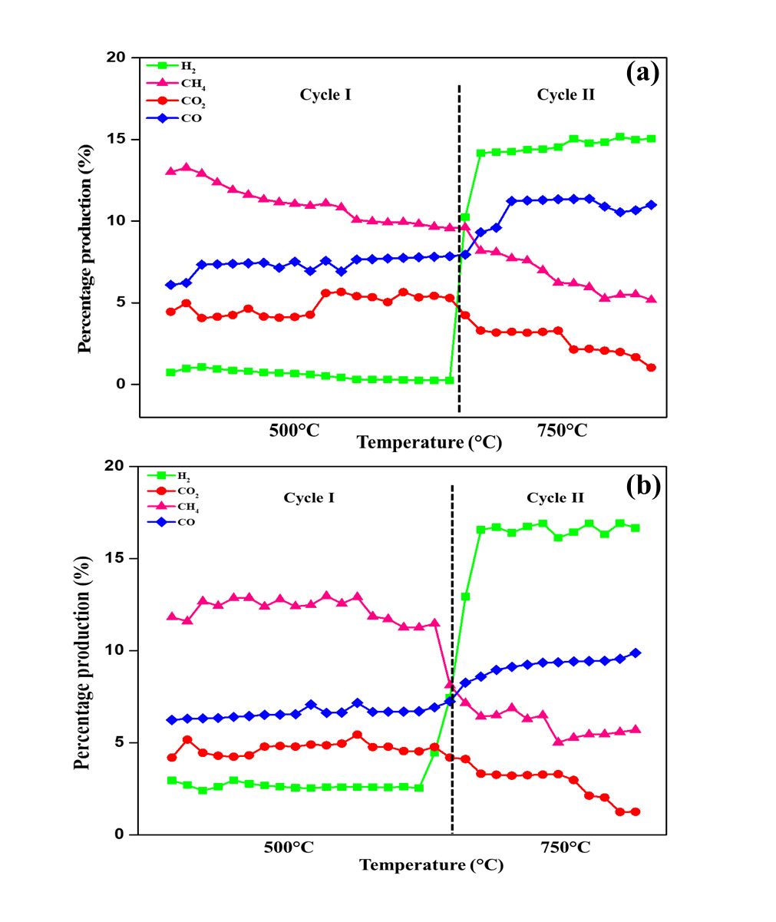

**Fig. 13**  Product analysis from (a) C80-RH20 and (b) C60-RH40. (Cycle I: co-pyrolysis, Cycle II: co-gasification)

**Table 8** Summary of some literature on co-pyrolysis of coal and biomass blends

|  |  |  |  |  |
| --- | --- | --- | --- | --- |
| Coal/biomass type | Blending ratios (Coal: biomass) | Heating rate | Remarks | Ref |
| Lignite/rice husk | 95:5  90:10  85:15  80:20  70:30 | 5°C/min | Gas and water yields were higher because of combination of hydrogen free radicals. RH produced more hydrogen and thus more methane was produced from RH as compared to coal. AAEM species in RH promoted transfer of hydrogen and also increased secondary tar cracking. | [95] |
| Lignite/rice husk | 1:1 | 10°C/min | Fixed bed reactor was employed to pyrolyze rice husk, coal and their blend. Results depicted significant synergy during co-pyrolysis. Addition of RH increased gas yield and facilitated gasification of char. | [96] |
| Indonesian(sub-bituminous) coal/rice straw (RS) | 1:0  3:1  1:1  1:3  0:1 | 33°C/s for steam gasification | Synergy was observed in the blending ratio of 1:1. It was due to transfer of H and OH radicals and presence of AAEM (specially potassium) from rice straw (RS). Steam gasification produced highly reactive char. | [74] |
| Shenfu bituminous coal/ rice straw (RS) | 1:4  1:1  4:1  *(by mass ratios) | N/A | Synergy was observed at blending ratio of (RS/SB= 1:4) indicating higher volatile yield. It was also observed that increase in ration of RS in the blend decreased the synergy as well as reduced gasification rates. | [72] |
| Shenfu bituminous coal/ rice straw (RS) | 100:0  25:75  50:50  75:25  0:100 | N/A | Rice straw was torrefied which increased its C/H and C/O ratio. Very slight synergistic effect was observed in the blends. The secondary pyrolysis of coal after 700°C was prevented on addition of biomass | [97] |
| Peat (PT) /pine branch (PB) | 1:3  3:1  1:1 | 5, 10, 20, 40, 80 °C/min | A slightly weal interaction was observed between both feedstocks in terms of volatile release. Activation energies were considerably higher with higher linear correlation | [94] |
| Sub-bituminous coal (SB) /pine saw dust (SD) | 50:50 | 25°C/min | TGA weight loss behaviours of coal and biomass show three stages of devolatilization in TGA. Coats-Redfern method was used for determination of kinetic and thermodynamic parameters of blends | [22] |

# 4 Conclusions

The mixing of biomass (RH) into coal exhibited an interactive impact on co-pyrolysis as well as co-gasification processes, especially for the most appropriate blending ratio. The optimum temperature range of about 410 °C-560 °C was identified for co-pyrolysis reactions on the basis of four different reaction mechanisms, applied to calculate apparent energy of activation from the non-isothermal TGA data. The thermokinetic analysis exhibited convergence of all four reaction mechanisms with the TGA data except the diffusional reaction mechanism in the case of the C20-RH80 fuel blend. The average apparent values of Ea increased with an increasing ratio of RH for 250 °C-400 °C but later the energy barrier decreased with further increase in temperature, hence 500 °C and above was selected for fixed bed reactor tests. Comparative analysis of the reaction models revealed similar order; D1 > F1 > F1.5 > S1 despite dissimilar values of Ea for C, RH, and their blends. The experimental weight loss value is greater than calculated weight loss value for C80-RH20 and C60-RH40, which is a major indication of presence of synergistic effect.

Co-pyrolysis proved to be effective in the transfer of catalytically active species from RH to coal and thus the produced biochar has a honeycomb structure useful in adsorption and various applications. Bio-oil consisted of phenols, acids, methoxy phenols, creosols, ethenone, cyclopentene, and acetaldehydes. The product gas fraction consisted of CH4, H2, and CO2. The early evolution of CH4 and H2 is evidence of the interaction between coal and RH through the transfer of hydrogen radicals. Co-gasification configuration produced a significant increase in H2 production, however, further future research is required to utilize these by-products with little up-gradation for other commercial-level applications.

# Acknowledgement

The authors Acknowledge the USPCAS-E NUST for lab Facilities.

# Declaration of competing interest

The authors declare no conflict of interest that could have influenced the work reported in this paper.

# References

[1] G. Bensidhom, A. Ben Hassen Trabelsi, M.A. mahmood, S. Ceylan, Insights into pyrolytic feedstock potential of date palm industry wastes: Kinetic study and product characterization, Fuel, 285 (2021) 119096.

[2] F. Sher, M.A. Pans, D.T. Afilaka, C. Sun, H. Liu, Experimental investigation of woody and non-woody biomass combustion in a bubbling fluidised bed combustor focusing on gaseous emissions and temperature profiles, Energy, 141 (2017) 2069-2080.

[3] P. McNamee, L.I. Darvell, J.M. Jones, A. Williams, The combustion characteristics of high-heating-rate chars from untreated and torrefied biomass fuels, Biomass and Bioenergy, 82 (2015) 63-72.

[4] A.A. Bhuiyan, A.S. Blicblau, A.K.M.S. Islam, J. Naser, A review on thermo-chemical characteristics of coal/biomass co-firing in industrial furnace, Journal of the Energy Institute, 91 (2018) 1-18.

[5] M.A. Munawar, A.H. Khoja, S.R. Naqvi, M.T. Mehran, M. Hassan, R. Liaquat, U.F. Dawood, Challenges and opportunities in biomass ash management and its utilization in novel applications, Renew Sust Energ Rev, 150 (2021) 111451.

[6] H.C. Ong, W.-H. Chen, A. Farooq, Y.Y. Gan, K.T. Lee, V. Ashokkumar, Catalytic thermochemical conversion of biomass for biofuel production: A comprehensive review, Renewable and Sustainable Energy Reviews, 113 (2019) 109266.

[7] I. Ali, S.R. Naqvi, A. Bahadar, Kinetic analysis of Botryococcus braunii pyrolysis using model-free and model fitting methods, Fuel, 214 (2018) 369-380.

[8] X. Hu, M. Gholizadeh, Biomass pyrolysis: A review of the process development and challenges from initial researches up to the commercialisation stage, Journal of Energy Chemistry, 39 (2019) 109-143.

[9] J. Jin, Y. Li, J. Zhang, S. Wu, Y. Cao, P. Liang, J. Zhang, M.H. Wong, M. Wang, S. Shan, P. Christie, Influence of pyrolysis temperature on properties and environmental safety of heavy metals in biochars derived from municipal sewage sludge, Journal of Hazardous Materials, 320 (2016) 417-426.

[10] L. Shi, Q. Liu, X. Guo, W. Wu, Z. Liu, Pyrolysis behavior and bonding information of coal — A TGA study, Fuel Processing Technology, 108 (2013) 125-132.

[11] J.M. Jones, M. Kubacki, K. Kubica, A.B. Ross, A. Williams, Devolatilisation characteristics of coal and biomass blends, Journal of Analytical and Applied Pyrolysis, 74 (2005) 502-511.

[12] G. Liu, H. Song, J. Wu, Thermogravimetric study and kinetic analysis of dried industrial sludge pyrolysis, Waste Management, 41 (2015) 128-133.

[13] Y. Zhai, W. Peng, G. Zeng, Z. Fu, Y. Lan, H. Chen, C. Wang, X. Fan, Pyrolysis characteristics and kinetics of sewage sludge for different sizes and heating rates, Journal of Thermal Analysis and Calorimetry, 107 (2012) 1015-1022.

[14] D.K. Park, S.D. Kim, S.H. Lee, J.G. Lee, Co-pyrolysis characteristics of sawdust and coal blend in TGA and a fixed bed reactor, Bioresource Technology, 101 (2010) 6151-6156.

[15] Z. Ni, H. Bi, C. Jiang, C. Wang, J. Tian, W. Zhou, H. Sun, Q. Lin, Investigation of the co-pyrolysis of coal slime and coffee industry residue based on machine learning methods and TG-FTIR: Synergistic effect, kinetics and thermodynamic, Fuel, 305 (2021) 121527.

[16] Y. Li, L. Li, Y. Liu, X. Ren, J. Chen, Y.A. Levendis, Sulfur and Nitrogen release from co-pyrolysis of coal and biomass under oxidative and non-oxidative conditions, Journal of Energy Resources Technology, 143 (2021) 061304.

[17] Z. Ni, H. Bi, C. Jiang, J. Tian, H. Sun, W. Zhou, Q. Lin, Research on the co-pyrolysis of coal gangue and coffee industry residue based on machine language: Interaction, kinetics, and thermodynamics, Science of The Total Environment, 804 (2022) 150217.

[18] R. Zhou, R. Cao, Y. Liu, D. Ma, Q. Yao, J. Wang, M. Sun, X. Ma, Study on the characteristics and mechanism of fast co-pyrolysis of coal tar asphaltene and biomass, Journal of Analytical and Applied Pyrolysis, 161 (2022) 105409.

[19] D. Hong, P. Li, T. Si, X. Guo, ReaxFF simulations of the synergistic effect mechanisms during co-pyrolysis of coal and polyethylene/polystyrene, Energy, 218 (2021) 119553.

[20] Y. Ding, O.A. Ezekoye, S. Lu, C. Wang, R. Zhou, Comparative pyrolysis behaviors and reaction mechanisms of hardwood and softwood, Energy conversion and management, 132 (2017) 102-109.

[21] K. Jayaraman, M.V. Kok, I. Gokalp, Thermogravimetric and mass spectrometric (TG-MS) analysis and kinetics of coal-biomass blends, Renewable Energy, 101 (2017) 293-300.

[22] M.S. Masnadi, R. Habibi, J. Kopyscinski, J.M. Hill, X. Bi, C.J. Lim, N. Ellis, J.R. Grace, Fuel characterization and co-pyrolysis kinetics of biomass and fossil fuels, Fuel, 117 (2014) 1204-1214.

[23] I. Mian, X. Li, Y. Jian, O.D. Dacres, M. Zhong, J. Liu, F. Ma, N. Rahman, Kinetic study of biomass pellet pyrolysis by using distributed activation energy model and Coats Redfern methods and their comparison, Bioresource Technology, 294 (2019) 122099.

[24] M.G. Montiano, E. Díaz-Faes, C. Barriocanal, Kinetics of co-pyrolysis of sawdust, coal and tar, Bioresource Technology, 205 (2016) 222-229.

[25] S.R. Naqvi, Y. Uemura, N. Osman, S. Yusup, Production and evaluation of physicochemical characteristics of paddy husk bio-char for its C sequestration applications, BioEnergy Research, 8 (2015) 1800-1809.

[26] Y. Sudiyani, Muryanto,“The potential of biomass waste feedstock for bioethanol production,” Proceeding of the International Conference on Sustainable Energy Engineering and Application Inna Garuda Hotel, 2012.

[27] M. Mureddu, F. Dessì, A. Orsini, F. Ferrara, A. Pettinau, Air- and oxygen-blown characterization of coal and biomass by thermogravimetric analysis, Fuel, 212 (2018) 626-637.

[28] A. Dhaundiyal, S.B. Singh, M.M. Hanon, R. Rawat, Determination of kinetic parameters for the thermal decomposition of parthenium hysterophorus, Environmental and Climate Technologies, 22 (2018) 5-21.

[29] (!!! INVALID CITATION !!! [29, 30]).

[30] A.W. Coats, J. Redfern, Kinetic parameters from thermogravimetric data, Nature, 201 (1964) 68-69.

[31] Z. Hameed, Z. Aman, S.R. Naqvi, R. Tariq, I. Ali, A.A. Makki, Kinetic and thermodynamic analyses of sugar cane bagasse and sewage sludge co-pyrolysis process, Energy & Fuels, 32 (2018) 9551-9558.

[32] V. Balasundram, N. Ibrahim, R.M. Kasmani, M.K.A. Hamid, R. Isha, H. Hasbullah, R.R. Ali, Thermogravimetric catalytic pyrolysis and kinetic studies of coconut copra and rice husk for possible maximum production of pyrolysis oil, Journal of Cleaner Production, 167 (2017) 218-228.

[33] S.R. Naqvi, Z. Hameed, R. Tariq, S.A. Taqvi, I. Ali, M.B.K. Niazi, T. Noor, A. Hussain, N. Iqbal, M. Shahbaz, Synergistic effect on co-pyrolysis of rice husk and sewage sludge by thermal behavior, kinetics, thermodynamic parameters and artificial neural network, Waste Management, 85 (2019) 131-140.

[34] H. Merdun, Z.B. Laougé, Kinetic and thermodynamic analyses during co-pyrolysis of greenhouse wastes and coal by TGA, Renewable Energy, 163 (2021) 453-464.

[35] Z. He, Z. Xia, J. Hu, L. Ma, Y. Li, Thermal decomposition and kinetics of electrically controlled solid propellant through thermogravimetric analysis, Journal of Thermal Analysis and Calorimetry, 139 (2020) 2187-2195.

[36] Y.S. Kim, Y.S. Kim, S.H. Kim, Investigation of thermodynamic parameters in the thermal decomposition of plastic waste− waste lube oil compounds, Environmental science & technology, 44 (2010) 5313-5317.

[37] A.K. Varma, N. Lal, A.K. Rathore, R. Katiyar, L.S. Thakur, R. Shankar, P. Mondal, Thermal, kinetic and thermodynamic study for co-pyrolysis of pine needles and styrofoam using thermogravimetric analysis, Energy, 218 (2021) 119404.

[38] Y. Xu, B. Chen, Investigation of thermodynamic parameters in the pyrolysis conversion of biomass and manure to biochars using thermogravimetric analysis, Bioresource Technology, 146 (2013) 485-493.

[39] K. Konwar, H.P. Nath, N. Bhuyan, B.K. Saikia, R.C. Borah, A.C. Kalita, N. Saikia, Effect of biomass addition on the devolatilization kinetics, mechanisms and thermodynamics of a northeast Indian low rank sub-bituminous coal, Fuel, 256 (2019) 115926.

[40] U. Jamil, A. Husain Khoja, R. Liaquat, S. Raza Naqvi, W. Nor Nadyaini Wan Omar, N. Aishah Saidina Amin, Copper and calcium-based metal organic framework (MOF) catalyst for biodiesel production from waste cooking oil: A process optimization study, Energy Conversion and Management, 215 (2020) 112934.

[41] J. Raza, A.H. Khoja, S.R. Naqvi, M.T. Mehran, S. Shakir, R. Liaquat, M. Tahir, G. Ali, Methane decomposition for hydrogen production over biomass fly ash-based CeO2 nanowires promoted cobalt catalyst, Journal of Environmental Chemical Engineering, 9 (2021) 105816.

[42] S.V. Vassilev, D. Baxter, L.K. Andersen, C.G. Vassileva, An overview of the chemical composition of biomass, Fuel, 89 (2010) 913-933.

[43] S.U. Patel, B. Jeevan Kumar, Y.P. Badhe, B.K. Sharma, S. Saha, S. Biswas, A. Chaudhury, S.S. Tambe, B.D. Kulkarni, Estimation of gross calorific value of coals using artificial neural networks, Fuel, 86 (2007) 334-344.

[44] G. Wang, J. Zhang, J. Shao, Z. Liu, G. Zhang, T. Xu, J. Guo, H. Wang, R. Xu, H. Lin, Thermal behavior and kinetic analysis of co-combustion of waste biomass/low rank coal blends, Energy Conversion and Management, 124 (2016) 414-426.

[45] R.K. Mishra, K. Mohanty, Characterization of non-edible lignocellulosic biomass in terms of their candidacy towards alternative renewable fuels, Biomass Conversion and Biorefinery, 8 (2018) 799-812.

[46] X. Chen, L. Liu, L. Zhang, Y. Zhao, P. Qiu, Pyrolysis Characteristics and Kinetics of Coal–Biomass Blends during Co-Pyrolysis, Energy & Fuels, 33 (2019) 1267-1278.

[47] D. Chen, J. Zhou, Q. Zhang, Effects of torrefaction on the pyrolysis behavior and bio-oil properties of rice husk by using TG-FTIR and Py-GC/MS, Energy & Fuels, 28 (2014) 5857-5863.

[48] S.B. Daffalla, H. Mukhtar, M.S. Shaharun, Preparation and characterization of rice husk adsorbents for phenol removal from aqueous systems, PloS one, 15 (2020) e0243540.

[49] W.-H. Chen, J.-S. Wu, An evaluation on rice husks and pulverized coal blends using a drop tube furnace and a thermogravimetric analyzer for application to a blast furnace, Energy, 34 (2009) 1458-1466.

[50] D. Vamvuka, E. Kakaras, E. Kastanaki, P. Grammelis, Pyrolysis characteristics and kinetics of biomass residuals mixtures with lignite☆, Fuel, 82 (2003) 1949-1960.

[51] A. Blazej, M. Kosik, Phytomass, England: Ellis Horwood, (1993).

[52] K.L. Smith, L.D. Smoot, T.H. Fletcher, R.J. Pugmire, The structure and reaction processes of coal, Springer Science & Business Media1994.

[53] S. Munir, S.S. Daood, W. Nimmo, A.M. Cunliffe, B.M. Gibbs, Thermal analysis and devolatilization kinetics of cotton stalk, sugar cane bagasse and shea meal under nitrogen and air atmospheres, Bioresource Technology, 100 (2009) 1413-1418.

[54] X. Chen, L. Liu, L. Zhang, Y. Zhao, Z. Zhang, X. Xie, P. Qiu, G. Chen, J. Pei, Thermogravimetric analysis and kinetics of the co-pyrolysis of coal blends with corn stalks, Thermochimica Acta, 659 (2018) 59-65.

[55] G. Zheng, J.A. Koziński, Thermal events occurring during the combustion of biomass residue, Fuel, 79 (2000) 181-192.

[56] Y. Hu, S. Naito, N. Kobayashi, M. Hasatani, CO2, NOx and SO2 emissions from the combustion of coal with high oxygen concentration gases, Fuel, 79 (2000) 1925-1932.

[57] A.K. Sadhukhan, P. Gupta, T. Goyal, R.K. Saha, Modelling of pyrolysis of coal–biomass blends using thermogravimetric analysis, Bioresource Technology, 99 (2008) 8022-8026.

[58] Z.B. Laougé, H. Merdun, Investigation of thermal behavior of pine sawdust and coal during co-pyrolysis and co-combustion, Energy, 231 (2021) 120895.

[59] A. Saddawi, J. Jones, A. Williams, M. Wojtowicz, Kinetics of the thermal decomposition of biomass, Energy & fuels, 24 (2010) 1274-1282.

[60] A.A.D. Maia, L.C. de Morais, Kinetic parameters of red pepper waste as biomass to solid biofuel, Bioresource Technology, 204 (2016) 157-163.

[61] T. Wu, M. Gong, E. Lester, P. Hall, Characteristics and synergistic effects of co-firing of coal and carbonaceous wastes, Fuel, 104 (2013) 194-200.

[62] J. Oladejo, S. Adegbite, X. Gao, H. Liu, T. Wu, Catalytic and non-catalytic synergistic effects and their individual contributions to improved combustion performance of coal/biomass blends, Applied Energy, 211 (2018) 334-345.

[63] Z. Wu, S. Wang, J. Zhao, L. Chen, H. Meng, Thermochemical behavior and char morphology analysis of blended bituminous coal and lignocellulosic biomass model compound co-pyrolysis: Effects of cellulose and carboxymethylcellulose sodium, Fuel, 171 (2016) 65-73.

[64] K.-M. Lu, W.-J. Lee, W.-H. Chen, T.-C. Lin, Thermogravimetric analysis and kinetics of co-pyrolysis of raw/torrefied wood and coal blends, Applied Energy, 105 (2013) 57-65.

[65] R.M. Soncini, N.C. Means, N.T. Weiland, Co-pyrolysis of low rank coals and biomass: Product distributions, Fuel, 112 (2013) 74-82.

[66] H.M. Jeong, M.W. Seo, S.M. Jeong, B.K. Na, S.J. Yoon, J.G. Lee, W.J. Lee, Pyrolysis kinetics of coking coal mixed with biomass under non-isothermal and isothermal conditions, Bioresource Technology, 155 (2014) 442-445.

[67] N. Ellis, M.S. Masnadi, D.G. Roberts, M.A. Kochanek, A.Y. Ilyushechkin, Mineral matter interactions during co-pyrolysis of coal and biomass and their impact on intrinsic char co-gasification reactivity, Chemical Engineering Journal, 279 (2015) 402-408.

[68] S. Li, X. Chen, A. Liu, L. Wang, G. Yu, Co-pyrolysis characteristic of biomass and bituminous coal, Bioresource Technology, 179 (2015) 414-420.

[69] A.H. Tchapda, S.V. Pisupati, A review of thermal co-conversion of coal and biomass/waste, Energies, 7 (2014) 1098-1148.

[70] X. Chen, L. Liu, L. Zhang, Y. Zhao, P. Qiu, R. Ruan, A review on the properties of copyrolysis char from coal blended with biomass, Energy & Fuels, 34 (2020) 3996-4005.

[71] T. Abbas, P. Costen, N.H. Kandamby, F.C. Lockwood, J.J. Ou, The influence of burner injection mode on pulverized coal and biomass co-fired flames, Combustion and Flame, 99 (1994) 617-625.

[72] S. Yuan, Z.-h. Dai, Z.-j. Zhou, X.-l. Chen, G.-s. Yu, F.-c. Wang, Rapid co-pyrolysis of rice straw and a bituminous coal in a high-frequency furnace and gasification of the residual char, Bioresource Technology, 109 (2012) 188-197.

[73] N. Howaniec, A. Smoliński, K. Stańczyk, M. Pichlak, Steam co-gasification of coal and biomass derived chars with synergy effect as an innovative way of hydrogen-rich gas production, International journal of hydrogen energy, 36 (2011) 14455-14463.

[74] S. Krerkkaiwan, C. Fushimi, A. Tsutsumi, P. Kuchonthara, Synergetic effect during co-pyrolysis/gasification of biomass and sub-bituminous coal, Fuel Processing Technology, 115 (2013) 11-18.

[75] H. Li, S.-l. Niu, C.-m. Lu, S.-q. Cheng, Comparative evaluation of thermal degradation for biodiesels derived from various feedstocks through transesterification, Energy Conversion and Management, 98 (2015) 81-88.

[76] S.C. Turmanova, S. Genieva, A. Dimitrova, L. Vlaev, Non-isothermal degradation kinetics of filled with rise husk ash polypropene composites, Express Polymer Letters, 2 (2008) 133-146.

[77] L. Huang, J. Liu, Y. He, S. Sun, J. Chen, J. Sun, K. Chang, J. Kuo, X.a. Ning, Thermodynamics and kinetics parameters of co-combustion between sewage sludge and water hyacinth in CO2/O2 atmosphere as biomass to solid biofuel, Bioresource Technology, 218 (2016) 631-642.

[78] B.V. Babu, A.S. Chaurasia, Parametric study of thermal and thermodynamic properties on pyrolysis of biomass in thermally thick regime, Energy Conversion and Management, 45 (2004) 53-72.

[79] S.R. Naqvi, R. Tariq, Z. Hameed, I. Ali, M. Naqvi, W.-H. Chen, S. Ceylan, H. Rashid, J. Ahmad, S.A. Taqvi, Pyrolysis of high ash sewage sludge: Kinetics and thermodynamic analysis using Coats-Redfern method, Renewable energy, 131 (2019) 854-860.

[80] T. Sonobe, N. Worasuwannarak, S. Pipatmanomai, Synergies in co-pyrolysis of Thai lignite and corncob, Fuel Processing Technology, 89 (2008) 1371-1378.

[81] Z. Wu, W. Yang, L. Chen, H. Meng, J. Zhao, S. Wang, Morphology and microstructure of co-pyrolysis char from bituminous coal blended with lignocellulosic biomass: Effects of cellulose, hemicellulose and lignin, Applied Thermal Engineering, 116 (2017) 24-32.

[82] J. Wei, Y. Gong, Q. Guo, X. Chen, L. Ding, G. Yu, A mechanism investigation of synergy behaviour variations during blended char co-gasification of biomass and different rank coals, Renewable energy, 131 (2019) 597-605.

[83] J. Wei, Y. Gong, Q. Guo, L. Ding, F. Wang, G. Yu, Physicochemical evolution during rice straw and coal co-pyrolysis and its effect on co-gasification reactivity, Bioresource technology, 227 (2017) 345-352.

[84] Y. Zhang, Y. Zheng, M. Yang, Y. Song, Effect of fuel origin on synergy during co-gasification of biomass and coal in CO2, Bioresource technology, 200 (2016) 789-794.

[85] J. Wang, S. Wang, Preparation, modification and environmental application of biochar: a review, Journal of Cleaner Production, 227 (2019) 1002-1022.

[86] X. Chen, L. Liu, L. Zhang, Y. Zhao, R. Ruan, P. Qiu, Physicochemical properties and AAEM retention of copyrolysis char from coal blended with corn stalks, Energy & Fuels, 33 (2019) 11082-11091.

[87] M. Wang, J. Tian, D.G. Roberts, L. Chang, K. Xie, Interactions between corncob and lignite during temperature-programmed co-pyrolysis, Fuel, 142 (2015) 102-108.

[88] Q. Lu, X.-l. Yang, X.-f. Zhu, Analysis on chemical and physical properties of bio-oil pyrolyzed from rice husk, Journal of Analytical and Applied Pyrolysis, 82 (2008) 191-198.

[89] M.S. Abu Bakar, J.O. Titiloye, Catalytic pyrolysis of rice husk for bio-oil production, Journal of Analytical and Applied Pyrolysis, 103 (2013) 362-368.

[90] N.T. Weiland, N.C. Means, B.D. Morreale, Product distributions from isothermal co-pyrolysis of coal and biomass, Fuel, 94 (2012) 563-570.

[91] J. Wang, Q. Yan, J. Zhao, Z. Wang, J. Huang, S. Gao, S. Song, Y. Fang, Fast co-pyrolysis of coal and biomass in a fluidized-bed reactor, Journal of Thermal Analysis and Calorimetry, 118 (2014) 1663-1673.

[92] Y. Qian, J. Zhang, J. Wang, Pressurized pyrolysis of rice husk in an inert gas sweeping fixed-bed reactor with a focus on bio-oil deoxygenation, Bioresource technology, 174 (2014) 95-102.

[93] G. Bensidhom, A. Ben Hassen-Trabelsi, K. Alper, M. Sghairoun, K. Zaafouri, I. Trabelsi, Pyrolysis of Date palm waste in a fixed-bed reactor: Characterization of pyrolytic products, Bioresource Technology, 247 (2018) 363-369.

[94] Y. Li, H. Zhao, X. Sui, X. Wang, H. Ji, Studies on individual pyrolysis and co-pyrolysis of peat–biomass blends: Thermal decomposition behavior, possible synergism, product characteristic evaluations and kinetics, Fuel, 310 (2022) 122280.

[95] Y. Li, S. Huang, Q. Wang, H. Li, Q. Zhang, H. Wang, Y. Wu, S. Wu, J. Gao, Hydrogen transfer route and interaction mechanism during co-pyrolysis of Xilinhot lignite and rice husk, Fuel Processing Technology, 192 (2019) 13-20.

[96] X. Yang, C. Yuan, J. Xu, W. Zhang, Co-pyrolysis of Chinese lignite and biomass in a vacuum reactor, Bioresource Technology, 173 (2014) 1-5.

[97] Q. He, Q. Guo, L. Ding, Y. Gong, J. Wei, G. Yu, Co-pyrolysis behavior and char structure evolution of raw/torrefied rice straw and coal blends, Energy & Fuels, 32 (2018) 12469-12476.