**Development of a variable frequency, low current, low volume hysteresis loop tracer**

D. M. Clarke, and G. Vallejo-Fernandez,*

Department of Physics, University of York, York, YO10 5DD, UK.

*Corresponding author. Tel. +44 1904322265

Email address: [gonzalo.vallejofernandez@york.ac.uk](mailto:gonzalo.vallejofernandez@york.ac.uk) (G. Vallejo-Fernandez)

**Abstract:** a variable frequency, low current, low cost, high sensitivity magnetometer has been developed. The system uses three MnZn ferrite rods to enhance the maximum field achievable by up to a factor 6 compared to the case where no ferrites are used. The system was tested using a suspension of magnetite nanoparticles in water. The magnetic response of the particles was investigated as a function of the maximum applied field and the frequency of operation. Volumes as low as (7.0±0.1) µL are required to obtain a signal to noise ratio of 8(47 kHz)/3(111 kHz) for a fluid with a saturation magnetisation of 1.07 emu/cm3. Fields as high as 420 Oe can be applied by passing a current as low as 2.5 A through the primary coil at all operating frequencies.

Keywords: AC magnetometer; magnetite nanoparticles; magnetic measurements; magnetic hyperthermia.

1. **Introduction**

Over the years, several systems have been designed to measure the high frequency hysteretic behaviour of fine particle systems. One of the earlier designs for measuring magnetic hysteresis in high frequency fields was that of Slade et al. [[1]]. The system was in effect a high sensitivity AC susceptometer and high frequency B-H looper. The primary coil was an ~80 turn, single layer, 165 mm long solenoid driven at 150 A producing a maximum field of 3 kOe at frequencies up to 2 kHz. In 2010 Bekovic and Hamler [[2]] used a 70 turn, one layer coil to achieve a field of 44 Oe at frequencies up to 400 kHz. The sample was separated from the primary coil by a vacuum tube to prevent heating. The system also included a temperature sensor on the fluid sample holder so as to compare the measured hysteretic data to the real heating. Unfortunately, the current requirement for the set-up was not stated. More recently, Garaio et al. [[3]] developed a system capable of working at frequencies as high as 958 kHz with a field amplitude of 138 Oe. The primary coil consisted of a 9 turn solenoid driven at 200 A. Hysteresis loops became distorted due to higher order harmonics from the power amplifier at frequencies over 250 kHz.

A similar design for a resonant type circuit was presented by Connord et al. [[4],[5]]. For their set-up they used a 100 mm long, 120 turn single layer Litz wire coil. This resulted in 40 mm depth of field uniformity at the centre of the coil. Two secondary search coils, 5 mm in length and 20 mm apart, were used for field and magnetic moment sensing, respectively. The use of Litz wire allows the system to be air cooled through the use of a vacuum cleaner, unlike every other system mentioned which are water cooled. The system was shown to reach a field strength of 750 Oe at lower frequencies of up to 55 kHz. However, at the maximum frequency of 95 kHz the field amplitude dropped to 450 Oe. The system required a current of 40 A and 25 A, respectively, to reach the required field at those frequencies. The final system is somewhat different. It uses a non-standard design, as it has two full layers and a third broken layer [[6]]. The full layers consist of 14 turns of Litz wire each with the final layer consisting of an additional 4 windings at both ends of the coil to increase the field uniformity. The total 36 windings were driven at 290 A achieving a field maximum of 1600 Oe at a frequency of 46 kHz.

All the above systems tend to be based on a similar resonant design with a high current primary coil producing the high frequency AC field and a pair of sensing coils into which the sample is inserted. As mentioned earlier, all these designs necessitate cooling. In this work we present a low current, high field and low cost alternative using soft ferrites to amplify the field in the sample space. In addition, unlike other setups, our system minimises the effect of the demagnetising field and only requires volumes as low as 7μL to obtain a SNR of up to 8. Although a fan is used to cool the outer layer of the primary coil during operation, the system can be used without external cooling unlike other systems as most of the heating arises from losses within three MnZn ferrites located inside the primary coil.

Magnetic hyperthermia is a cancer therapy with the aim of causing tumour death through the application of targeted heating via magnetic nanoparticles. This is completed in high frequency (50 - 200 kHz) alternating magnetic fields [[7]] and the rate of this heating defines the treatment time. Three mechanisms cause the heating: susceptibility loss, hysteretic heating and viscous heating [[8]]. Of these, susceptibility loss provides a negligible proportion, whereas viscous and hysteretic heating account for approximately half each. The hysteretic heating per cycle is equal to the area within the hysteresis loop of the particles, and so measuring this can provide insight as to the heat rate of the system as a whole. As the shape of the loop is defined by the frequency and the maximum applied field of the measurement, any measurements must be completed at the frequencies and fields intended for clinical use. The system presented here is a versatile tool for the measurement of such properties.

1. **Experimental**

The set-up is based on the common basis for previous designs. A resonant circuit is used to create an alternating current at a series of defined frequencies. A sinusoidal reference waveform (<2.5 V) is fed into a Dr. Hubert A1110-16-E power amplifier (gain of 7) to generate the high frequency magnetic field. The primary coil is 140 mm long, inner diameter of 10 mm, and 280 turns over three layers built on a PEEK former. Litz wire (200 strands, 0.071 mm width/strand) is used to reduce the effective impedance and negate the skin-depth effect. The DC resistance of the coil and its inductance were measured to be 0.6 Ω and 83 μH, respectively. The coil is cooled using a 300 cfm Sanyo Denki 9GV1412P1G001 fan capable of stabilising the temperature below 40°C at DC currents of up to 7-8 A.

The field amplitude as a function of DC current as well as the field uniformity along the axial direction of the primary coil are shown in Figures 1(a) and (b), respectively. These were measured using a Hirst GM07AP gaussmeter with an axial Hall probe. By itself, the primary coil generates a field of (27.5±0.1) Oe/A with a field uniformity better than 2% over a 120 mm region. The solid line in Figure 1(b) is the calculated field profile using FEMMLAB [[9]] with the input calculation parameters being determined by the actual properties of the primary coil.

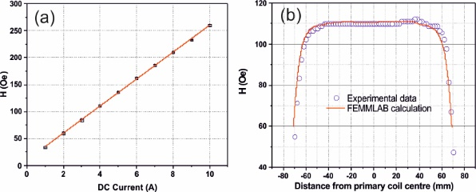

Figure 1. (a) Magnetic field as a function of DC current with no ferrites inserted and (b) Measured and calculated field uniformity at 4A.

Two secondary coils wound in opposition were used to measure the sample signal as well as the field amplitude, as in similar designs. Each coil consists of 18 turns of 0.2 mm copper wire. Due to Faraday’s law of induction, an emf, Vac, is generated in each coil which is equal to the negative of the time rate of change of the magnetic flux enclosed by the coils. The amplitude of this emf is given by

$V_{ac}=-Nε\frac{dϕ}{dt}$ (1)

where N is the number of turns in the coil, φ is the magnetic flux and t is the time. In Eq. (1) ε is a dimensionless parameter and represents the geometrical dependence on the area of the coil and needs to be determined to ensure an accurate calibration. The high field, low current requirement is achieved through the use of three 40 mm long, 6 mm wide MnZn ferrite rods (Fair Rite, Material 78) [[10]]. This material provides a flux density of 4800 G at 5 Oe and 25°C measured at 10 kHz. The effect of the ferrite cores on the primary coil is an increase in inductance from 83 to 660 µH. A schematic diagram of the sensing coils, the primary coil and the ferrites is shown in Figure 2 as well as an actual image of the primary coil and PEEK former.

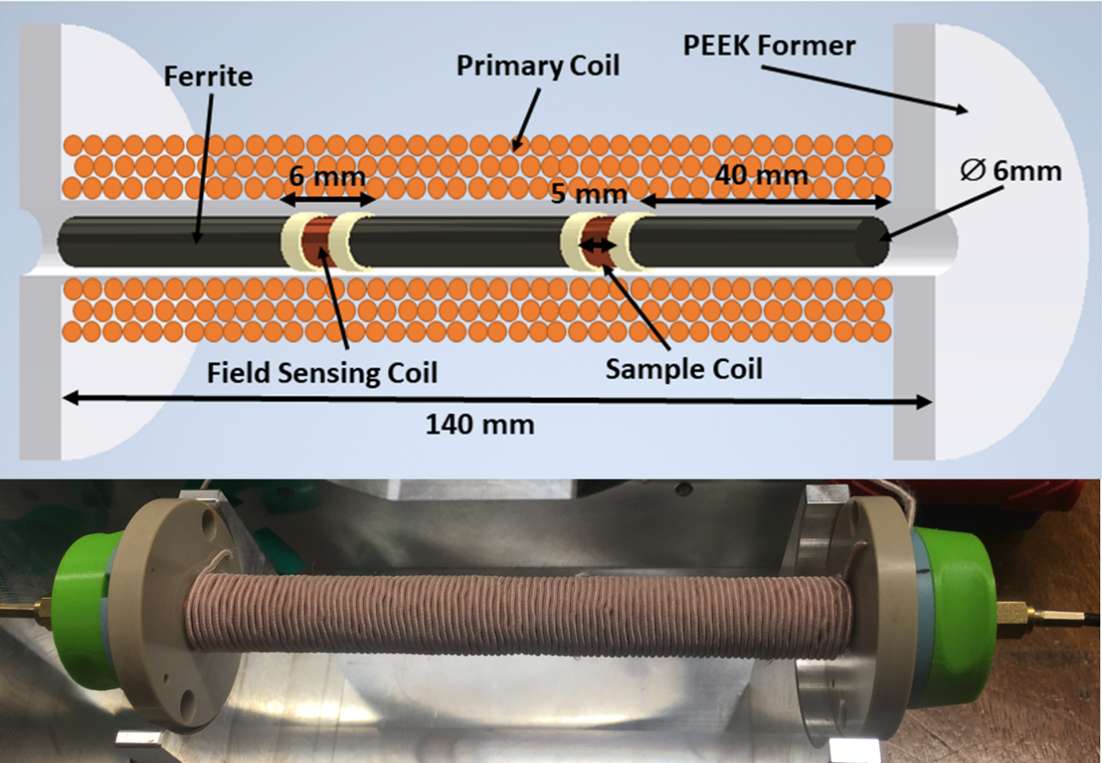

Figure 2. Schematic diagram of the sensing set-up (top) and actual image of the primary coil (bottom).

Figure 3 shows an actual image of the mount for one of the ferrites and the sensing coil where the sample is inserted. The inset in the top left corner of Figure 3 shows the top view of the mount while the inset in the top right corner shows an image of a typical sample. This mount was designed to provide good reproducibility in terms of positioning when removing/inserting the sample. The wires from the coil are glued at several places along the ferrite to ensure that their position is fixed, minimising the chances of them breaking when inserting/removing the mount.

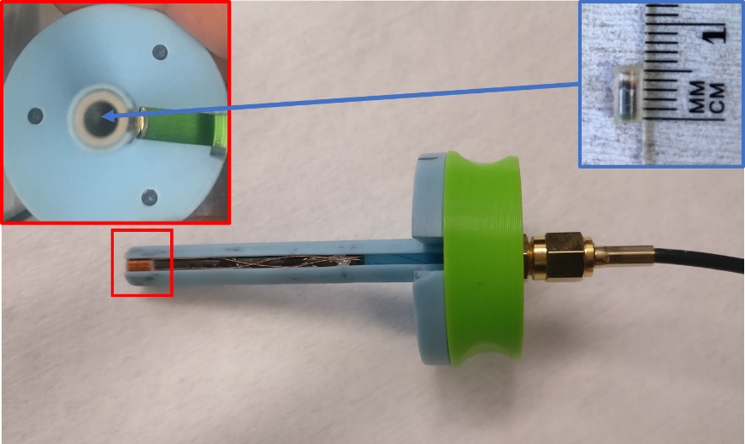

Figure 3. Mount containing the moment sensing coil and one of the 40 mm ferrites.

While the primary coil provides the inductive and resistive terms for the circuit, the capacitive term is given by a series of capacitor banks with capacitance values in the range ~3-18 nF. Even though the current through the circuit is not very high, ≤2.5 A, and the capacitance value does not affect the driving voltage of the circuit at resonance, if a single capacitor were to be used, voltage drops of the order of 1 kV would occur in some cases at a rate given by the driving frequency of the circuit. This would result in a steady shift of the resonance frequency due to the change in capacitance as the capacitor warms up. For this reason, several banks of capacitors, one for each operating frequency, were designed and built. For instance, an equivalent measured capacitance of 10.98 nF was achieved by combining 36 polypropylene 10 nF capacitors and allowed for the voltage drop across each capacitor to be reduced by a factor 6 compared to the single capacitor case. Table 1 shows a summary of the different resonant frequencies achievable with the available range of capacitor banks. Note that this could be easily extended by tuning the capacitive term of the circuit.

Table 1. Resonant properties of the circuit as a function of capacitor used.

|  |  |
| --- | --- |
| Measured Capacitance (nF) | Frequency of Operation (kHz) |
| 17.6 | 47 |
| 11.0 | 62 |
| 7.0 | 74 |
| 4.9 | 89 |
| 3.1 | 111 |

An image of the full setup is shown in Figure 4. The metal box containing the primary coil and the fan is kept closed during operation due to the presence of the fan. The voltage output selector allows for the measurement of the voltage drop across both search coils connected in series or the attenuated voltage from the one of the search coils. The capacitor bank can also be placed inside the box although cooling is not required.

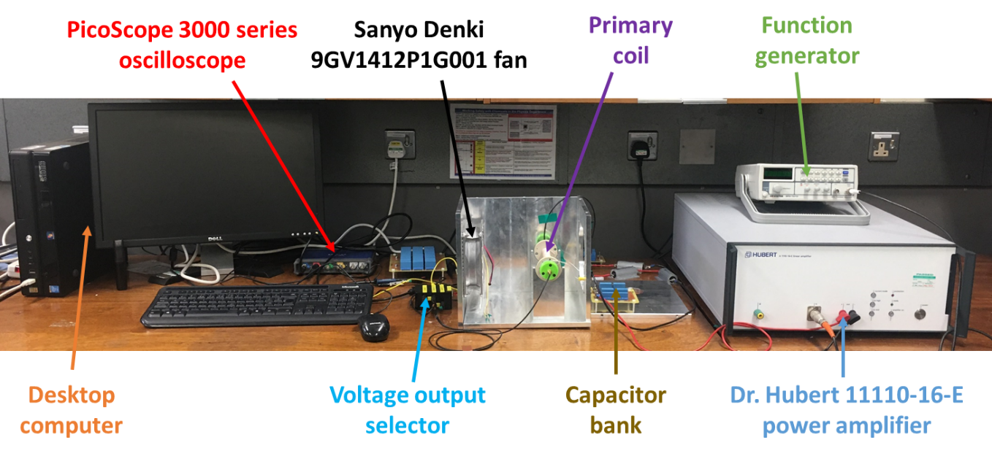

Figure 4. Full experimental setup used in this study.

In order to determine the amplitude of the applied magnetic field with the ferrites inserted, a different search coil consisting on 155 turns of 0.2 mm wide Cu wire was wound using an identical former to those used for the two pick-up coils shown schematically in Figure 2. A high turn coil was used to maximise the emf generated at low, 70 Hz, frequency. This coil was only used for field calibration purposes. The form factor of the coil was calculated by comparing the emf generated at 70 Hz to the field measured using a Hall probe. This calibration had to be done without the ferrites inserted as it is not possible to measure the field using a Hall probe otherwise. From Eq. (1) it follows that the amplitude of the field, in Oe, as a function of time, H(t), is given by

$H\left(t\right)=\frac{{10}^{8}\int{V_{F}\left(t\right)dt}}{NεS}$ (2)

where VF(t) is the emf generated and S is the cross section area of the coil in cm2. The factor 108 arises from the relationship between the unit of electromotive force in the cgs and SI systems of units and the fact that the emf is measured in Volts. By comparing the maximum value of the field obtained using Eq. (2) to the field measured using the Hall probe, it is possible to calculate ε. This experiment was repeated four times passing different currents through the primary coil resulting in a value of ε of (0.70±0.05). In order to test the calibration when the ferrites were in place, the measured field value using Eq. (2) once the form factor had been calibrated was compared to calculated values using FEMMLAB. Passing a 4 A current through the primary coil, again at 70 Hz, resulted in a measured value of 643 Oe. Based on FEMMLAB, the average field value across the spacing between the ferrites, 6 mm, was 638 Oe with a standard deviation of 29 Oe (4.5%). As will be discussed later, the magnetic samples are 4 mm long, 2 mm either side of the centre of the field coil. Based on the FEMMLAB calculations again, this reduces the amplitude of the applied field seen by the sample to 619 Oe with a standard deviation of 13 Oe resulting in a field uniformity in the sample space of ~2%. Taking all these factors into account, the calibration factor obtained for the field sensing coil is (3.2±0.2)x10-8 V/(Hz⋅Oe). Once the calibration of the search coil was complete, the field amplitude as a function of the current passing through the circuit could be measured as shown in Figure 5. In this particular case, the frequency used was 62 kHz. Note that at this frequency, a calibrated attenuation probe had to be used as the induced voltage (>200 V) was higher than the operating range of our oscilloscope. By introducing the ferrites, the field amplitude increased by a factor 6, from 27.5 Oe/A with no ferrites inserted as shown in Figure 1(a) to 165 Oe/A as shown in Figure 5. Note that for currents >2.5 A, the slope of the curve changes due to the ferrites approaching saturation. By monitoring the current passing through the primary coil, the field amplitude can be calculated easily.



Figure 5. Applied field as a function of current through the primary coil when the ferrites are inserted.

As it is not possible to wind two perfectly identical coils, the output from both search coils shown schematically in Figure 2 without a sample inserted needs to be balanced. This is done by copying the unbalanced signal digitally and subtracting it from the original waveform using a PicoScope 3000 series oscilloscope. An example of the resulting signal, A, is shown in Figure 6. The reason why two search coils rather than one are needed is that at high frequencies the voltage induced in the search coils is greater than the maximum voltage that can be measured using our oscilloscope. By winding them in opposition, the voltage drop across both coils is <0.9 V at 2.5 A even at frequencies as high as 111 kHz. An attenuation probe could be used to reduce the overall voltage. However, this would also attenuate the signal coming from the sample itself rendering it unmeasurable. In order to perform a measurement, one of the ferrites needs to be removed so that the sample can be inserted. Since it is not possible to place the mount shown in Figure 3 in exactly the same position every time, the perfectly balanced signal marked as A in Figure 6 varies slightly from measurement to measurement. This is shown as signal B in the same figure with a typical signal after the sample has been reinserted marked as C. This measurement procedure was repeated at least five times for each measurement and the average calculated. The signal from the sample is taken as the average (C-B) waveform. By integrating the average (C-B) waveform, the un-calibrated moment of a given sample as a function of time, m(t), is obtained. The hysteresis loop obtained using the signals shown in Figure 6(a) is shown in Figure 6(b). A signal to noise ratio (SNR) of 8 is obtained at this operating frequency. As the frequency of operation is increased the SNR decreases. At the highest frequency of operation, 111 kHz, a SNR of 3 was obtained. For clarity purposes, the measurement steps are summarised below:

1. A frequency and current of operation are chosen.
2. After turning the system on, the waveform from the two search coils connected in series is copied digitally and subtracted (signal A).
3. The mount containing one of the ferrites and the sample coil is removed and reinserted.
4. The output of the two coils in series is recorded (signal B).
5. The mount containing one of the ferrites and the sample coil is removed.
6. The sample is inserted and the mount placed back inside the primary coil.
7. The signal from the sample (signal C) as well as the field sensing coil are recorded.
8. Steps 2-7 are repeated at least 5 times.
9. The average (C-B) as well as the field sensing coil signals are integrated.
10. By plotting one as a function of the other a hysteresis loop is obtained. The field axis is calibrated using the data shown in Figure 5.

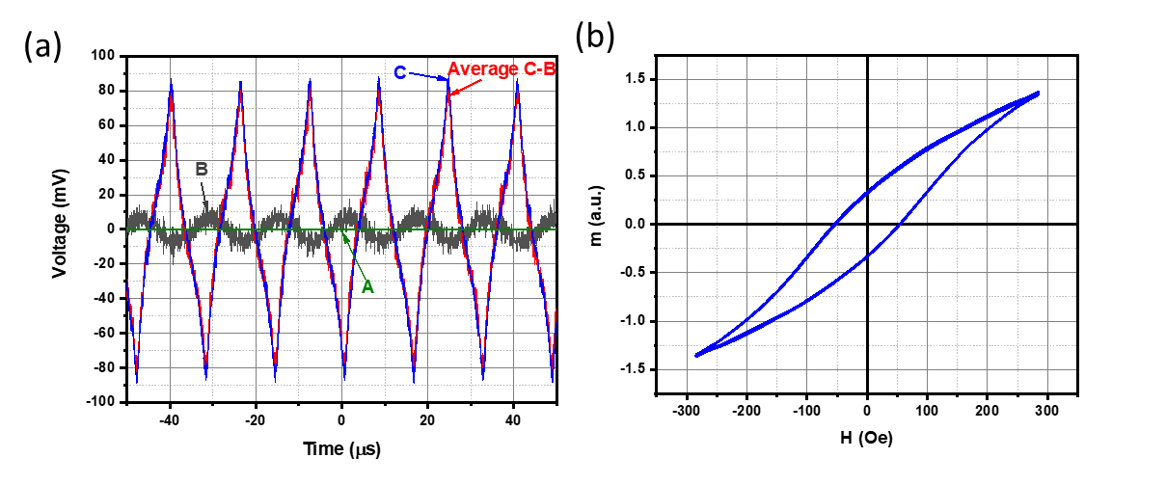

Figure 6. (a) Typical signals measured and (b) Hysteresis loop obtained from the signals in (a).

Careful consideration has been given to the size and shape of the sample holder. In order to maximise the field in the sample space, the ferrites in Figure 2 were designed to be placed as close as possible to each other. However, reducing the spacing between the ferrites has two undesirable effects: it limits 1) the sample volume which will affect the SNR and 2) the aspect ratio of the sample which will affect the demagnetising field. Hence, a compromise needed to be found. In our case we have opted for a 6 mm gap between the ferrites as shown in Figure 2. The search coils themselves are 5 mm long. The samples are made out of rubber tubing with glue at either end used to seal the container. This results in a maximum sample length of about 4 mm. The container was filled using a Fisherbrand Elite adjustable volume pipette (2-20 μL, ±0.1μL with 0.02 μL increments). The sample that was used to test the apparatus was a suspension of magnetite nanoparticles dispersed in water with a saturation magnetisation of 400 emu/cm3 and a concentration of 10mgFe/mL of solution. Overall, this results in a fluid with a magnetisation (4πMs, where Ms is the magnetisation of the material in emu/cc) of 13.4 G.

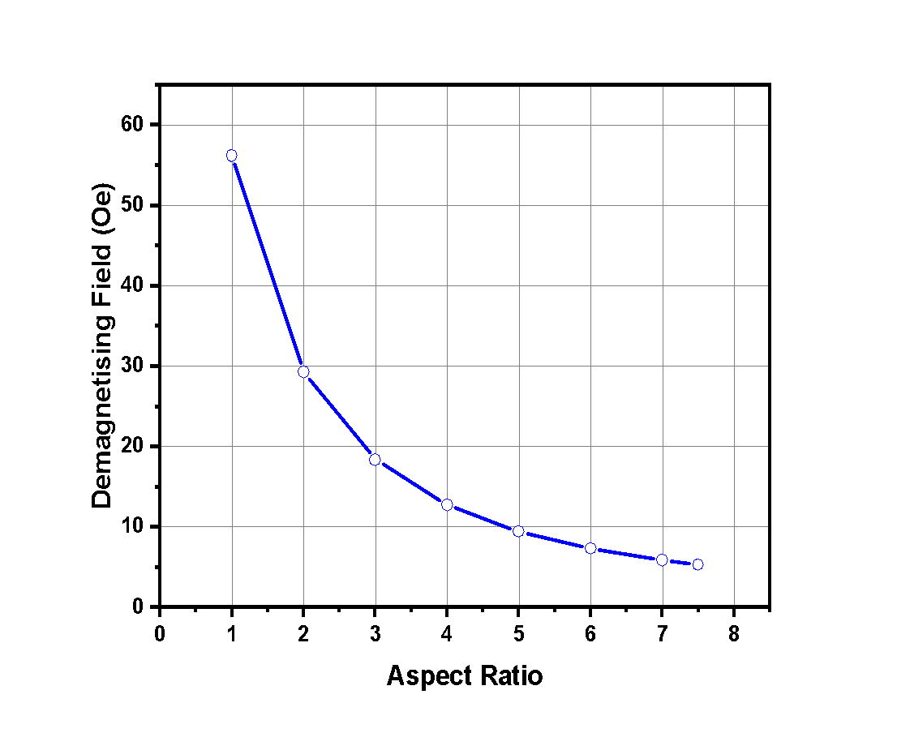

Figure 7. Demagnetising field as a function of the aspect ratio of the sample holder for the fluid used in this study.

Figure 7 shows the variation of the demagnetising field at saturation as a function of the aspect ratio for such fluid. Considering that the maximum applied field that can be achieved using a 6 mm gap between the ferrites is 420 Oe, using a sample holder with an aspect ratio of 3:1 (4 mm long by 1.3 mm wide) results in a demagnetising field of 4% of the maximum applied field and a sample volume of ~7 $μ$ L. An aspect ratio of 4:1 (4 mm long by 1 mm wide) reduces the demagnetising field to 3% but the sample volume is also reduced to ~3 $μ$ L. The most sensitive point in a hysteresis loop for randomly oriented single domain particles is at the remanence. In our case, the value of the demagnetising field at remanence is ~3 Oe. Of course, at the coercivity the demagnetising field is zero. Hence, an aspect ratio of 3:1 was deemed most advantageous.

Finally, the physical properties of the sample were investigated using a JEOL 2011 transmission electron microscope (TEM) available at the York JEOL Nanocentre.

1. **Results and Discussion**

In order to test the performance of our system a sample of magnetic nanoparticles was measured using the set-up described above. The samples were made by a variation of the well-known co-precipitation process [[11]] in which salts of Fe2+ and Fe3+ are treated with an alkali, resulting in the precipitation of magnetite. This process generally produces a wide distribution of particle sizes, but careful control of the growth conditions allows for a narrow distribution of particle sizes to be obtained. The material was prepared by Liquids Research Limited using this process, which is known as the controlled growth process (CGP), with the products being designated CGP particles with the brand name HyperMAG® C [[12]]. A typical TEM image for the HyperMAG® sample is shown in Figure 8(a) with a higher magnification image shown in Figure 8(b). Because of the nature of the CGP process, the particles are all well separated by the dispersant with little evidence of primary aggregation.

Figure 8. (a) Typical and (b) high magnification TEM image of the sample studied in this work.

By tuning the current passing through the circuit, any field in the range 0-420 Oe can be obtained at all frequencies. Figure 9(a) shows the coercivity as a function of the maximum applied field measured at 47 kHz while Figure 9(b) shows examples of the obtained hysteresis loops. Only a few hysteresis loops are shown for clarity purposes. Both the coercivity and the remanence increase with the maximum applied field as the fraction of particles that is saturated by the applied field increases. It is clear that the area under the hysteresis loop increases with increasing field amplitude. This will in turn affect the amount of heat generated by the particles via hysteresis losses. While no losses occur at 0.25A (41 Oe), heating values of ~25 W/gFe would be expected at 1.75A (280 Oe) based on the hysteresis loops shown in Figure 9(b) and the properties of the particles studied in this work.

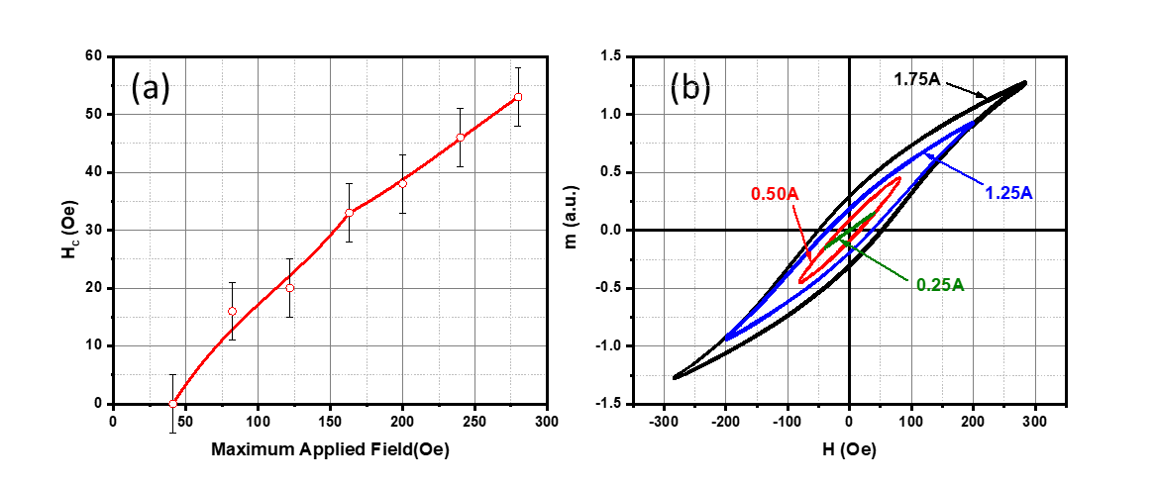

Figure 9. (a) Coercivity as a function of applied field and (b) Hysterisis loops used to obtain the values displayed in (a) measured at 47 kHz.

Although the use of ferrites increases the achievable field by up to a factor 6, ferrites do suffer losses at high frequencies/currents. These losses result in the ferrites warming up if the system is left on for a few minutes and the appearance of harmonics which distort the signal. The overheating issue leads to a reduction in the flux density and hence field available. This can be avoided by allowing the ferrites to cool down between measurements. The system only remains on for a few seconds during a measurement so it is not an issue in practice. Regarding the harmonics, Figure 10 shows a typical FFT of the sample signal for a measurement at 111 kHz and 2 A. As can be seen, clear harmonic peaks are present at odd integers of the frequency of operation. The signal can be cleaned by averaging over a number of measurements at low frequencies or simply by averaging and filtering out the harmonics.

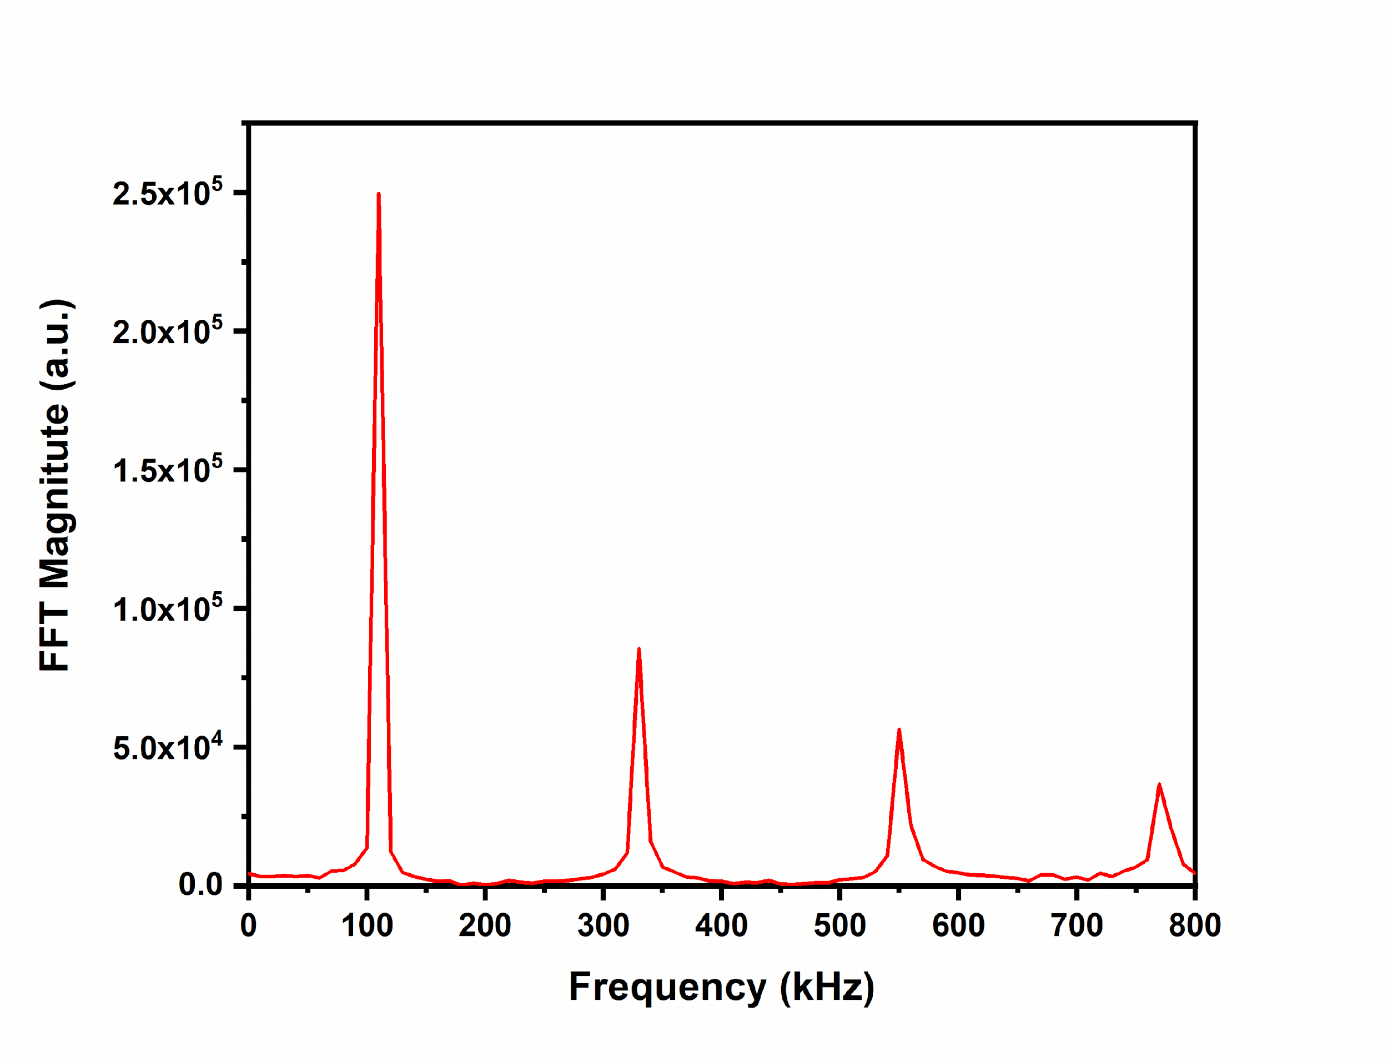

Figure 10. Typical Fourier transform of the sample signal measured at 111 kHz and 2 A.

Figure 11 shows the signal from a single measurement, signal A, measured using a current of 2 A at 47 and 111 kHz. Both waveforms appear distorted with the level of distortion increasing with frequency. The figure also includes the averaged signal over 5 measurements, signal B, as well as the averaged signal once the balanced signal without the sample has been subtracted, signal C. Signal C for the 111 kHz measurement was filtered while the data taken at 47 kHz required no manipulation. 5 measurements were deemed appropriate to ensure good reproducibility.

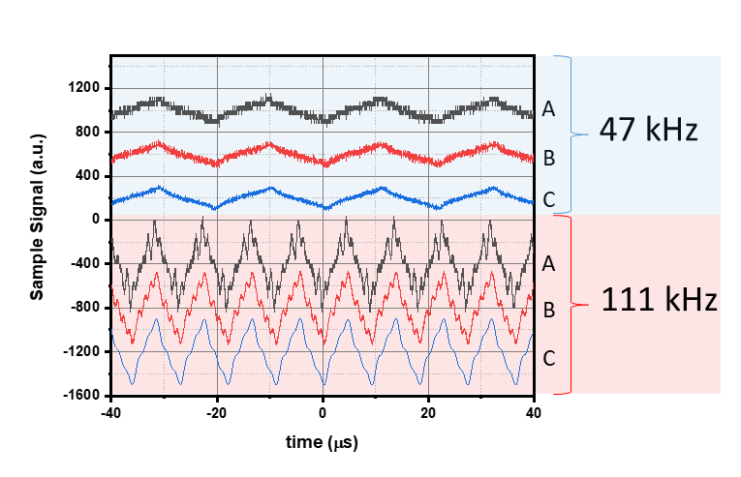

Figure 11 (a). Single shot and averaged sample signals measured at 47 and 111 kHz and 2.5A.

We have also investigated the magnetic properties of the sample as a function of the frequency of operation. Figure 12 shows the hysteresis loops obtained at 2 A at each available frequency. The loops have been normalised so that they can be compared in a more meaningful way. At higher frequencies (≥89 kHz) the waveforms were filtered as described above resulting in a slight reduction in signal amplitude (<5%) compared to the unfiltered waveform. There is no big variation in the value of the coercivity with the frequency of measurement. De Witte et al. [[13]] used a Stoner-Wohlfarth model developed by el-Hilo et al. [[14]] to explain the sweep rate dependence of the coercivity in particulate recording media. In our case, the sweep rate is controlled by the frequency of operation as the maximum applied field is the same for all measurements. Based on that model, variations in the coercivity <2%, i.e. <1 Oe, were expected for measurements in the range 47-111 kHz.

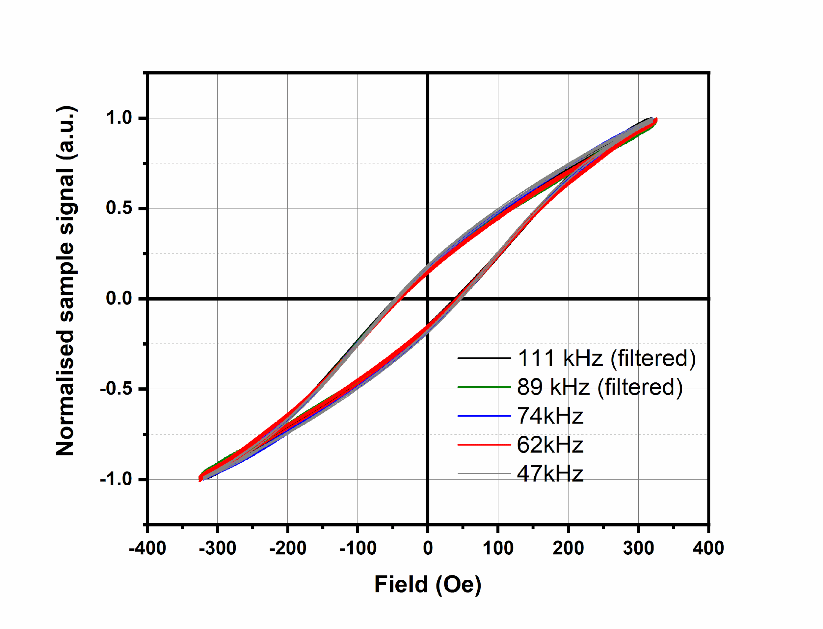

Figure 12. Hysteresis loops measured at 2 A for the different frequencies of operation.

In order to perform a calibrated measurement, a calibration sample of known moment would be needed. This calibration sample would then need to be measured at the selected frequency and current and the data analysed with the same filtering conditions used for the actual measurement. This is to account for the slight reduction in signal amplitude when cleaning the harmonic noise.

1. **Conclusions**

In conclusion, we have developed a low current, highly sensitive, varying frequency magnetometer for the measurement of the magnetic properties of assemblies of magnetic nanoparticles. The system uses three MnZn rods to increase the maximum applied field by up to a factor 6 compared with a system with no ferrites. A sample volume of only 7 μL is needed to obtain a SNR of up to 8 (~9 dB) for a 13.4 G (1.07 emu/cm3) fluid. The system was tested by measuring the properties of a suspension of magnetite nanoparticles with the brand name HyperMAG®C at different fields and frequencies. The results are consistent with previous published data for the same particles [4].

**Acknowledgements**

The authors acknowledge fruitful discussions with Prof. Kevin O’Grady from the Department of Physics at the University of York and Liquids Research Ltd. They would also like to thank T. Ayers and J. Emery from the Electronics Workshop in the Department of Physics at York for their help and advice. Generous financial support from Liquids Research Ltd. is also greatly appreciated. Funding is also acknowledged from EPSRC via their Impact Acceleration Account (EP/R51181X/1).

**References**

1. [] S. B. Slade, G. Kassabian, and A. E. Berkowitz, Rev. Sci. Instrum. **67**, 2871 (1996).
2. [] M. Bekovic, and A. Hamler, IEEE Trans. Magn. **46**, 552 (2010).
3. [] E Garaio, J M Collantes, F Plazaola, J A Garcia, I Castellanos-Rubio, Meas. Sci. Technol. **25**, 115702 (2014).
4. [] V Connord, B Mehdaoui, R P Tan, J Carrey, M Respaud, Rev. Sci. Instrum. **85**, 093904 (2014).
5. [] L. M. Lacroix, J. Carrey, and M. Respaud, Rev. Sci. Instrum. **79**, 093909 (2008).
6. [] P Lenox, L K Plummer, P Paul, J E Hutchison, A Jander, P Dhagat, IEEE. Mag. Lett. **9**, 6500405 (2018).
7. [] M. Johannsen, U. Gneveckow, L. Eckelt, A. Feussner, N. Waldöfner, R. Scholz, S. Deger, P. Wust, S.A. Loening, A. Jordan, Int. J. Hyperthermia **21**, 637 (2005).
8. [] G. Vallejo-Fernandez, O. Whear, A. G. Roca, S. Hussain, J. Timmis, V. Patel, and K. O’Grady, J. Phys. D: Appl. Phys. **46**, 312001 (2013).
9. [] https://www.femm.info/wiki/HomePage
10. [] http://www.fair-rite.com/78-material-data-sheet/
11. []S. E. Khalafalla, and G. W. Reimens, IEEE Trans. Magn. **16**, 178 (1980).
12. [] www.liquidsresearch.com
13. [] A. M. de Witte, M. El-Hilo, K. O’Grady, and R. W. Chantrell, J. Magn. Magn. Mater. **120**, 184 (1993).
14. [] M. El-Hilo, A. M. de Witte, K. O’Grady, and R. W. Chantrell, J. Magn. Magn. Mater. **117**, L307 (1992).