Downsizing by Design – investigating acceptance, choice and willingness to pay for portion control design concepts.

Tang Tang1, Liam R Chawner2 Ruiqi Chu1, Chandani Nekitsing2,3, Marion M Hetherington2*

1 School of Design, University of Leeds, LS2 9JT.

2 School of Psychology, University of Leeds, LS2 9JT.

3 Department of Health Science, University of York, York Y010 5DD.

* corresponding author: [m.hetherington@leeds.ac.uk](mailto:m.hetherington@leeds.ac.uk)

**Abstract**

Nudge theory predicts that consumers will select smaller portions of high energy density (HED) foods and drinks when packaging presents physical or other limits. To test the feasibility and acceptability of packaging concepts designed to limit portion sizes for children, two mixed methods studies were conducted. Packaging with functional serving size reminders, visual narrative, and metaphor were developed using 3-D prototypes. In each study, packaging prototypes were assessed, either in person (Study 1, n = 50) or via an online survey (Study 2, n = 297). In Study 1, parents visiting a Science museum poured servings for their children of HED foods/drinks and provided feedback on prototypes designed to limit portions of these items. Responses were recorded via questionnaire and interview. In Study 1, parents significantly adjusted amount poured for children based on age and in alignment with recommended portion sizes; they reported that the packaging prototypes would facilitate portion control through education, convenience and autonomy but raised concerns about costs and recyclable/reusable materials. In Study 2 parents responded to the same prototypes online providing measures of willingness to pay (WTP), forced choice and open-ended feedback for each concept. Parents were WTP more for downsizing packaging concepts, choosing them over their regular brand in most cases and confirming a generally positive view of the designs. However, WTP magnitude depended on consumer segmentation (price concerns, health motives). Innovative design concepts can be used to nudge towards smaller portions, but this depends on parental motivation.

**Keywords:** portion control, food intake, packaging design, children, functionality, narrative

**Introduction**

The portion size effect (PSE), where more is eaten when large portions of foods or drinks are offered, is a robust and reliable phenomenon (Fisher, Rolls, & Birch, 2003; Hetherington et al., 2018; Hetherington & Blundell‐Birtill, 2018; Rolls, Morris, & Roe, 2002). The PSE has been observed across different age groups and is generally stronger for high energy density (HED) foods (Kling, Roe, Keller, & Rolls, 2016). Habitual consumption of large portions of highly liked, HED foods and drinks has been linked to overeating and overweight (Albar, Alwan, Evans, & Cade, 2014). One possible solution to the PSE, is to nudge parents towards offering smaller portions of palatable, HED items. In preschool children, a randomised control trial offering smaller portion sizes or swapping out HED items for fruits and vegetables demonstrated that this strategy was well accepted and produced significant benefits to the diets of children (Reale et al., 2018). However, for older children (8- 11 yr) offering smaller sized apple sauce and brownies was less acceptable than large portions (Schwartz et al. (2020). Unlike adults (Cornil & Chandon, 2016) children appear to appreciate quantity over quality and shifting that focus is likely to be challenging.

**Establishing social norms among children for downsizing**

Instead of persuading children that “less is more” in relation to highly palatable, HED items, shifting social norms towards a smaller, “right size” portion may be more achievable. Sharps and Robinson (2016) reported increased intake of fruit and vegetables in children aged 6- 11yr following health focussed and descriptive social norm-based messages. Therefore, if large portions of fruits and vegetables, and small portions of HED items are presented as the social norm for children, this could facilitate intake of nutrient dense foods and downsize energy dense foods.

Social norms for children are set by parents, caregivers and peers, including typically presented portion sizes. In a study of four evening meals, the amount that mothers served themselves for dinner was strongly correlated to the portion size they served to their preschool children; and in turn this amount was generally eaten in full (Johnson, Goodell, Williams, Power, & Hughes, 2015; Johnson et al., 2014). Therefore, it is assumed that habitual exposure to large portions sets an expected norm. Using an online survey with images of varying portion sizes of low and high energy density foods, Reale et al. (2018) found that 16% of caregivers selected *smaller* than recommended amounts of fruits and vegetables for their preschool child, whilst 28% selected *larger* than recommended sizes of HED items such as cookies and potato chips. This study also confirmed the findings by Johnson et al. (2014), that portions selected by caregivers related to portions served themselves (Johnson et al., 2014; Reale et al., 2018).

Governments also set social norms, for example in the UK, Public Health England (PHE) suggest strategies to reduce intake of sugar and to limit snacks for children to 100 kcal and no more than two per day (Public Health England, 2018). However, it is not clear whether parents adhere to this guidance in selecting snacks for their children.

**Packaging and portion balance for children**

Parents report a variety of ways to limit snacks for children, since snacks are considered less nutritious than meals (Fisher et al., 2015). Parents of pre-school children, report the use of measuring cups, scales and hand measures to adjust for their child’s size (Blake et al., 2015). Parents describe these methods as inconvenient, often relying on pre-packaged items to determine the appropriate amount to serve children (Curtis, Atkins, & Brown, 2017). As packages for HED snacks are generally developed with adults in mind, and family sizes are better value for some HED items, portions may need to be adjusted to match the age and stage of the child. Packaging can be designed with recommended amounts displayed front-of-pack (McGale, Smits, Halford, Harrold, & Boyland, 2020) or with functional compartments to limit portion size (Argo & White, 2012; Bui, Tangari, & Haws, 2017; Holden & Zlatevska, 2015) and these have been shown to assist with reducing measured food intake(Chu, Tang, & Hetherington, 2021).

Packaging manipulations influence intake via physical, functional and cognitive means (Chu et al., 2021). For example, smaller serving sizes displayed front-of-pack may “nudge” reduced intake not only for cereals (McGale, Smits, Halford, Harrold, & Boyland, 2020) but for HED snacks.

To assist downsizing for children, packaging can be designed with cognitive (suggested portion size), physical (small package size), and functional (clear calibrated serving volume/amount) solutions. Packaging design can nudge smaller portions of HED items through establishing a social norm with pack size, partitioning and visual display of suggested portion size.

Steering directs food intake through embedded behavioural affordances and scripts (Jelsma & Knot, 2002; Norman, 2013). Narratives (Grimaldi, Fokkinga, & Ocnarescu, 2013) can be used in the packaging design involving an adventure or challenging story. Children can be engaged through visual images and structural forms that introduce a character with a story reinforcing the message of a small, child size portion. A metaphor can be physically applied in design by transferring source cues to the target (Hekkert & Cila, 2015) where packaging (e.g., form, graphics) may be metaphorical and associated with the process or consequences of having unhealthy or healthy diets. However, while these ideas appear compelling in theory, they have yet to be tested for portion balance in terms of acceptability to parents, their willingness to pay (more) for innovative packaging design and whether they can be applied to familiar, highly liked, habitually consumed foods and drinks.

**Study rationale**

The aim of the present study was to explore new packaging concepts designed to encourage downsizing of high energy density foods and drinks. The research objective was to investigate the feasibility and acceptability of these new concepts for parents as a solution to limiting portion sizes of highly palatable, but energy dense foods and drinks for their children. This objective was framed within both nudge theory and social norms then further developed using narrative and functional concepts for the packaging design. Typically served portion sizes (family norm) were recorded to compare against the recommended amount for the HED items. Then a series of prototype packaging concepts were developed with packaging features known to influence food intake (Chu et al., 2021) which were adapted for children. These were then presented to parents and their responses recorded. Since parents were likely to vary in how acceptable and applicable each of the packaging concepts were to their family norms, food choice motivations of the parents were measured.

To achieve the research objective, the following hypotheses were tested:

H1: portions poured by parents for their child will be “downsized” for child age and adjusted to match PHE 100 kcal guidance**.** It was important to identify the typical portion served to children so that the relevance of any packaging to encourage portion balance could be placed in context.

H2: parents would respond positively to packaging concepts which are interactive, playful and designed to help them limit portions sizes of palatable, HED items (**H2a**). Furthermore, parents would be willing to pay (WTP) more for this type of packaging compared to their regular brand (**H2b**) and would select the packaging concept over their regular brand in a forced choice scenario (**H2c**). These predictions were based on the observation that parents seek out packaging which helps with convenient portion control (Tang et al., 2020). Finally, it was predicted that parents motivated by health would be WTP more for the packaging concepts than parents motivated by cost (**H2d**).

To examine whether packaging design could be used to encourage downsizing of HED foods and drinks, we developed a set of design concepts which were appealing, playful and child-friendly. These were based on narrative, metaphor or functional concepts to downsize portions. We then tested these concepts in person (3D prototypes) or as images presented onscreen.

**Study 1**

Study 1 was field-based at the EUREKA! Children’s Science Museum in Halifax where children and families who could see, hold and explore the prototype packaging and engage in a short pouring task. Study 1a tested the prediction that amounts poured for children would be age appropriate and match closely the PHE advice on 100 kcal snacks. Study 1b was developed to test acceptability and feasibility of the new package concepts for these same foods and drinks in the pouring task. Some participants did the pouring task first, some did the interview tasks first, others did only one of the tasks.

To test H1 we designed a pouring task and invited parents to pour into a plate or cup their typical portion size for themselves or their child (counterbalanced). The items were three sweet snacks (cookies, chocolate buttons, candy), one sweet cereal and one fruit juice (orange juice) all typically consumed by children in the UK.

For Study 1b we developed a number of packaging design concept prototypes (**See Figure 1**) (details in <https://mfr.osf.io/render?url=https://osf.io/gtzse/?direct%26mode=render%26action=download%26mode=render>). This preliminary study encouraged parents to pick up and explore prototypes of the child-friendly packaging design concepts and their responses to these were recorded via interview and rating scales.

**Figure 1**- Experimental packaging (regular brand packaging and new packaging prototypes)

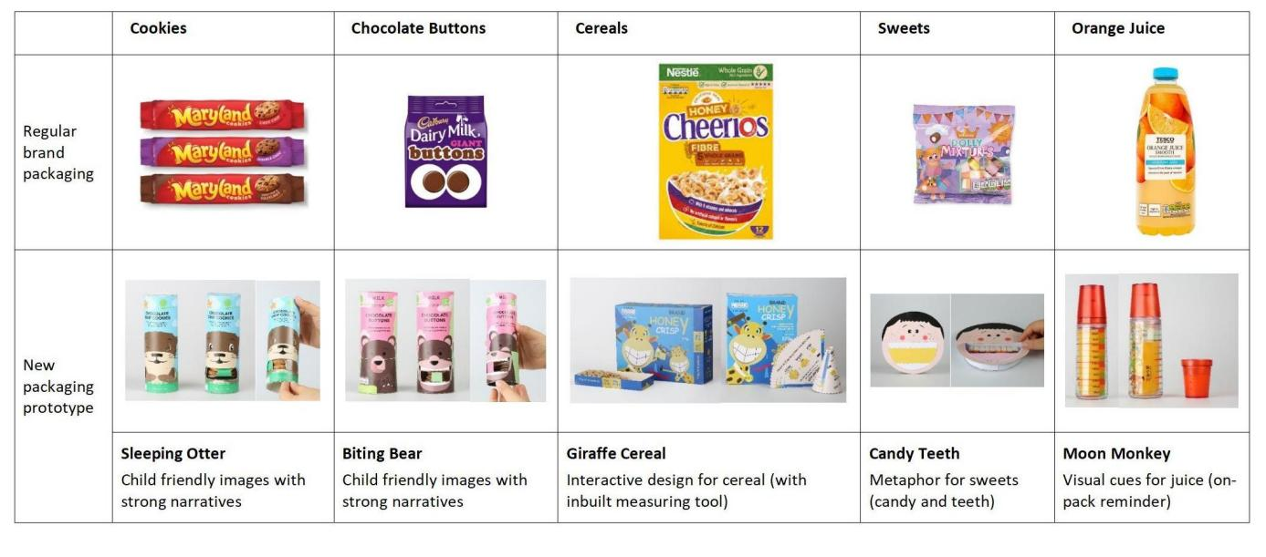

**Study 1a Participants and Procedure**

Parents were asked to identify one of the children (2-13yr) they had brought with them to the museum and to answer questions on behalf of that child (**Table 1**). Parents were asked to “imagine your child has had lunch at 12 noon and dinner will be served at 5pm. It is mid-afternoon and you are offering them a snack. How much would you pour of each of these foods/drinks for your child, if they had only one of them?”. Parents were then asked to estimate the energy content (kcal) of each snack once they had completed the pouring task. Finally, parents were asked to report how often their children ate/drank these items on a Likert scale from 0 (never), 1 (rarely-once per month), 2 (sometimes – twice per month), 3 (often – at least once per week), to 4 (every day). BMI is not reported for this study since so few parents reported their height and weight.

**Table 1-** Demographic characteristics of families recruited to Study 1a, including frequency of snacking per day and intake of target foods per month.

|  |  |  |
| --- | --- | --- |
| **Caregivers** | **Mean ± SD (mode: %)** | **Range** |
| Age (yr); Females (n = 33) | 37.0 ± 8 yr (35: 18%) | 27 - 62 |
| Age (yr); Males (n = 17) | 38.8 ± 6 yr (37: 18%) | 28 - 48 |
| Education - High School | N = 5 (10%) |  |
| Education - College | N = 9 (28%) |  |
| Education - University | N = 36 (72%) |  |
| **Children** | **Mean ± SD (mode: %)** | **Range** |
| Age (yr) Females (n = 29) | 5.6 ± 2.5 (5: 38%) | 2 - 9 |
| Age (yr) Males (n = 21) | 5.6 ± 2.7 (6: 17%) | 2- 13 |
| General snacking (per day) | 2.5 ± 1.5 (2: 36%) | 1 - 8.5 |
| Cookies * | 2.4 ± 1.0 (3: 42%) | 0 - 4 |
| Buttons * | 2.2 ± 1.0 (3: 42%) | 0 - 4 |
| Cereal * | 2.7 ± 1.4 (4: 34%) | 0 - 4 |
| Sweets * | 1.7 ± 1.4 (3: 32%) | 0 - 4 |
| Orange juice * | 2.0 ± 1.4 (3: 32%) | 0 - 4 |

* Likert scale from 0 to 4, where 0 = never, 1 = once per month, 2 = twice per month, 3 = weekly, 4 = every day

**Study 1b Procedure**

Parents of children aged between 2 and 13 years of age were invited to participate when they arrived at the stand. Written, informed consent was obtained to record the interviews and then parents were presented with the 5 prototypes of the packaging concepts (3-D) which they could see and handle. For each packaging concept parents were asked about how much they would normally pay for their regular branded product (cookies, chocolate, candy, cereal and orange juice see **Table 2** for nutritional information), then how much they would pay for the same product in the new design; then which they would select from the regular, new or neither product and why; then which their child would select and why; then parents were asked to think about the new design concept and whether they thought this would encourage their child to eat more, less or the same as usual and why. After each concept was considered, and parents were free to handle the packages, they were asked some open-ended questions for example their views on the designs if made from recyclable, reusable materials (see <https://osf.io/c3uwf/?view_only=8a5f3f82938e47dd96428d32d51d335b>

**Table 2** - Packaged products with energy content, serving size and nutritional composition with indicative price.

|  |  |  |  |  |  |  |
| --- | --- | --- | --- | --- | --- | --- |
| **Item (Brand)** | **Serving size** | **Energy density**  (kcal/g or ml) | **Fat**  (g/100g or ml) | **CHO**  (g/100g or ml) | **Sugars**  (g/100g or ml) | **Protein**  (g/100g or ml) |
| **Maryland Chocolate Chip Cookies (230g bag: £1.30)** | 2 cookies  (105 kcal) | 4.92 | 22.1 | 65.4 | 34.4 | 5.8 |
| **Cadbury Chocolate Buttons (240g bag: £2.00)** | 25 g  (134 kcal) | 5.35 | 30.0 | 57.0 | 56.0 | 7.3 |
| **Nestlé Honey Cheerio (375g box: £2.60)** | 30 g  (113 kcal) | 3.78 | 3.6 | 74.0 | 22.0 | 8.7 |
| **Tesco Dolly Mixtures (85g: 40p)** | 21 g  (80 kcal) | 3.82 | 1.1 | 91.4 | 81.7 | 1.5 |
| **Tesco Orange Juice (1 litre: £1.20)** | 150 ml  (64 kcal) | 0.43 | 0 | 10.0 | 10.0 | 0.6 |

**Data analysis**

For Study 1a weight (g) poured was recorded then converted into energy (kcal). Correlations were conducted between age of the child and amount poured, and t-tests used to compare parental estimates of energy content with actual energy content using t-tests. Study 1b involved interviews which were audio recorded and then transcribed by one of the authors (CN). Quantitative analyses of the Likert scale questions were conducted using chi-square and for qualitative analyses a modified thematic analysis (Braun & Clarke, 2006) was applied.

**Results**

Weights poured are shown in Figure 2 for each target food (regular brand). Correlations between age and amount indicated that parents adjusted by age of child with older children having larger servings poured. Significant correlations between child age and serving size was found for all foods (cookies: r(49) = 0.4, p = 0.005; buttons: r(45) = 0.4, p = 0.006; cereal r(39) = 0.5, p = 0.001; sweets: r(40) = 0.32, p =0.045; orange juice: r(44) = 0.52, p < 0.001).

Significant correlations between parental estimates and actual energy content of items poured were found for all except sweets (cookies: r(45) = 0.595, p < 0.001; buttons: r(42) = 0.668, p < 0.001; cereal r(39) 0.623, p < 0.001; sweets: r(38) = 0.15, p =0.38; orange juice: r(36) = 0.33, p = 0.046). The magnitude of difference between actual and estimated energy content was small indicating accuracy of parental estimates. However, there was a small, significant difference between estimated and actual energy content for cookies (parents poured 1-2 cookies, with an actual content of 90 kcal, estimated as 108 kcal; t (45) = -2.46, p = 0.018) and for orange juice (parents poured 156 ml, with an actual content of 70 kcal estimated as 98 kcal; t (36) = -2.44, p = 0.02). In both cases, parents overestimated energy content of the amount they poured for cookies and orange juice, but were accurate for the other items (not significantly different) with estimates close to 100 kcal (**Figure 2**).

**Figure 2 -** Amount poured (g), actual energy content and estimated energy content (mean ± SEM)

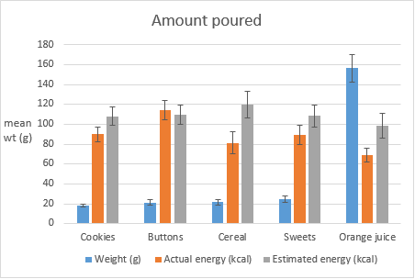

Parents tended to select the same packaging (regular or concept) for themselves as for their child (Figure 3). Most selected the new packaging concept over the regular brand. The chi-square confirmed this for all five items (Cookies：χ2 (2) = 37.87, p < .001; Chocolate buttons: χ2 (2) = 19.09, p < .001; Cereal: χ2 (2) = 28.13, p < .001; Candy: χ2 (2) = 14.40, p < .001; Orange juice: χ2 (2) = 34.77, p < .001).

**Figure 3** – Mean number of participants selecting regular brand, concept or neither option.

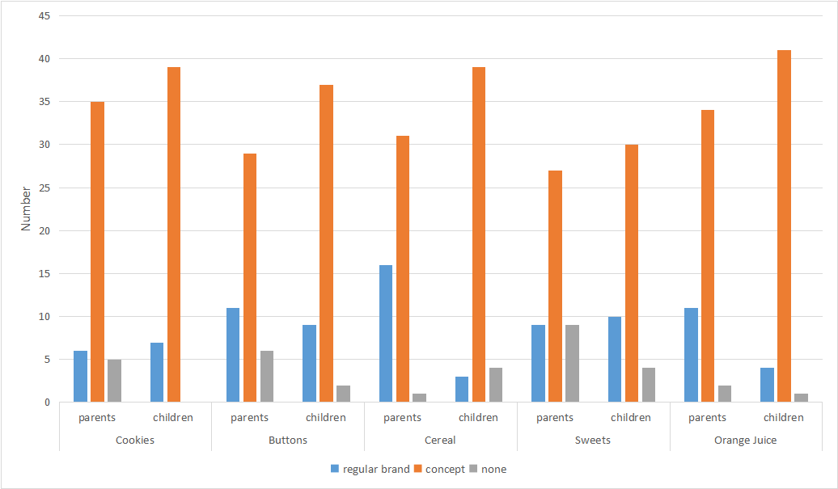

Overall, parents reported that the packaging concept would reduce and not increase intake **(Figure 4)**. The chi-square results confirmed this for all foods (Cookies：χ2 (2) = 16.53, p < .001; Chocolate Buttons: χ2 (2) = 19.70, p < .001; Cereal: χ2 (2) = 21.73, p < .001; Candy: χ2 (2) = 19.00, p < .001), but not orange juice (χ2 (2) = 5.78, p =.056).

**Figure 4 -** Number of parents reporting the effect of the packaging concepts on their child eating more, eating less or the same as usual.

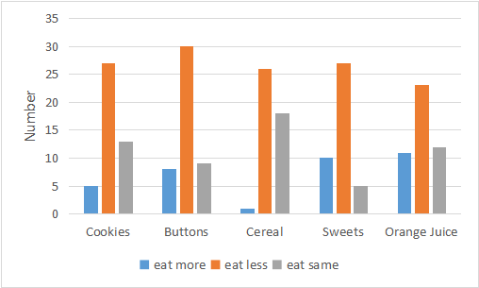

Paired samples t-tests showed that on average, consumers were WTP more for the new packaging concepts compared with the regular brand (**Figure 5**). Specifically, WTP was 54.7 +/- 10.7 pence (51%) more for the “Sleeping Otter” than the regular brand of chocolate cookies (t(47) = -5.1, p <.0001). Similarly, WTP 55.6 +/- 10.4 pence (47%) more for the “Biting Bear” product than the regular chocolate buttons (t(46) = -5.3, p <.0001); about 49.2 +/- 12.9 pence (87%) more for the “Candy Teeth” than regular (t(36) = -3.8, p = 0.001); and 202.9 +/- 25.4 pence (151%) more for the “Moon Monkey” product than a regular bottle of orange juice (t(37) = -8.0, p <.0001). However, caution must be applied to this difference in WTP since the design concept for orange juice was presented in a reusable, solid bottle with matching dispensing cup.

As for the cereal, on average, there is a statistical price difference but not a meaningful difference, as participants would pay 22.2 +/- 9.5 pence (11%) more for the “Giraffe Cereal” product than the regular brand (t(46) = -2.4, p = 0.023).

**Figure 5 -** Study 1b estimates of WTP(mean ± SEM) (pence) for regular brand compared to the new packaging concepts.

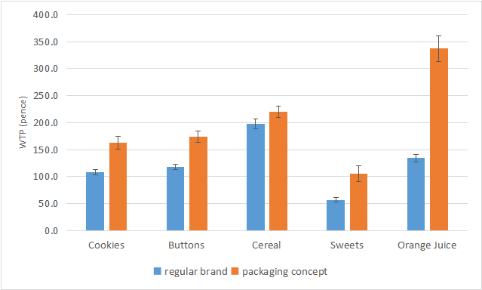

**Study 1 Qualitative feedback**

Packaging prototypes were considered as: an aid to portion control, having an educational function, a means to promote autonomy so that children could serve themselves and were praised as reusable. In contrast, some parents reported that as gatekeepers of their child’s nutrition, they were in control of servings and so the packaging was considered neither helpful nor unhelpful. Other parents were very sensitive to the price point for packaging and their response was dependent on how much the prototype would cost. Parents also expressed concern about additional packaging and potential plastic waste.

(1) Portion control as an asset

Some parents recognised that the packaging could assist with limiting treats, but they maintained that this could only be done with adult supervision.

e.g., *it’s good for kids because you can just get one portion out, whereas when you open that packet (*pointing to branded package) *they want more* (2020CK19; Sleeping Otter)

(2) Packaging as educational

The potential educational aspect was recognised by parents: …a *good idea because I'm always telling them that too many sweets is bad for the teeth and they could see it physically there* (2020KM21; Candy Teeth)

(3) Parents as gatekeepers

Other parents were more sceptical about any potential benefits of packaging, since they acted as the gatekeepers to treats and did not rely on packaging for portion sizes:

*I would get it from the cupboard and put it in the plate for them so that I controlled the portion.* (2020AEN108; Sleeping Otter)

*I would only give them 6 or 7 of these anyway, definitely wouldn't give them that many* (2020LT: Candy Teeth)

**Discussion Study 1**

The preliminary findings from Study 1a showed that parents downsized according to the age of their child in the pouring task and the amounts poured were close to PHE recommendations. Study 1b showed that parents were mostly positive about design prototypes to limit portion sizes. However, these results may be limited to the population who visit a Science Museum. These parents tend to be well educated (70% had a university education), interested in science and potentially more invested in health outcomes than the general population. Therefore, Study 2 opened out the investigation to a wider demographic of parents to test predictions on acceptability, feasibility, cost and consumer segmentation. Also, using an online platform encouraged anonymised responses to the design concepts without the potential for social desirability bias of in-person interviews.

**Study 2**

Study 2 was developed to replicate the findings of Study 1b in a wider demographic context and was conducted online. When the products are introduced to participants, they were randomised. Study 2 examined feasibility and acceptability of the prototypes using WTP, forced choice, and the parental motives which predicted WTP and switch point from the familiar brands.

Based on the findings from Study 1, it was predicted that parents would respond positively to downsizing packaging concepts, would be WTP more and be more likely to select them over the regular brand. Parents with a higher health motive and lower cost motive would be WTP more for the new packaging than parents who are more cost conscious.

**Participants**

Participants were recruited via Prolific Academic (n = 297). The recruitment call was sent to potential participants who were parents of children between 2 and 10 years. The call invited parents to participate in a short survey (up to 20 minutes) to provide feedback about some new packaging concepts. Participants were paid GBP2.50 for their time.

**Procedure**

Informed consent was requested before the survey began. General demographic questions were asked – parental age, gender, height, weight, education, occupation and income and child age, gender, height, weight, and snacking habits were recorded. For example, how many snacks were typically eaten in a day and how often each of the featured items were eaten in a month. This question permitted a measure of snacking habits and familiarity with the items used in the study.

Next, participants were directed to a series of specific questions about each of the foods/drinks in turn to record approximate portions served (units, grams or ml), and how much parents typically paid for existing brands of the featured items (chocolate chip cookies, chocolate buttons, cereal, candy, and orange juice). Then participants were presented with each new design concept and they were asked how much they would be willing to pay (WTP) for this version of the item. This was collected before and then after the design concept was explained. This tested whether WTP for each item would increase once the purpose of the narrative was explained.

Next a forced choice scenario was presented in which the regular brand was presented against the new concept at the same, or incrementally greater price points (0, 25%, 50%, 75%, 100% more than the regular price). This was done to find out the “switch point” where WTP would not be more for the new design concept. The Food Choice Questionnaire (FCQ: Steptoe, Pollard, & Wardle, 1995) was completed then parents were thanked for their feedback and paid via Prolific.

**Data analysis**

To examine participant’s WTP for each concept product packaging compared with the regular product packaging, data were analysed using two multi-level models. The first model examined WTP (in pence, GBP) for each product after learning of the product portion control narrative. The second model examined which product would be chosen in a forced choice task where the regular packaging was pitted against the concept packaging at price increases of 25%, up to double the price.

To determine how much (in pence) participants were WTP for each product after learning about the portion control narrative, a linear multi-level model was conducted with the participant as a random factor. Predictor variables including food type, frequency that each food is eaten, WTP for regular packaged product, WTP for concept packaged product (pre-narrative), Price and Weight control subscale scores on the FCQ, beliefs about how much the concept packaging would encourage children to eat and which packaging parents thought their child would prefer, were included in the model.

To determine the switch point from choosing the concept packaging to choosing the regular packaging, a multi-level ordinal regression was conducted (cumulative link mixed model using the logit method) with the participant as the random factor. The outcome (switch point) was defined as the percentage price increase at which participants no longer chose the concept packaging over the regular packaging. Switch point included six levels: Switching at the same price (participants never chose the concept packaging), switching at +25%, +50%, +75% and +100% price increases and lastly no switch point (participants were WTP double and always chose the concept packaging). Predictor variables of food type, Price and Weight control subscale scores on the FCQ, beliefs about how much the concept packaging would encourage children to eat and which packaging parents thought their child would prefer were included in the model.

To check that participants from different countries did not affect any outcomes (e.g. in amount WTP or product choices) due to familiarity with brands used, analyses were also conducted using only UK participants. However, no differences were found and all results reported therefore used the entire sample.

Data analyses of WTP were conducted using RStudio 1.1.383, with R (version 3.5.2, Eggshell Igloo), tidyverse 1.3.0, qualtRics 3.1.2, lme4 1.1-21 and ordinal 2019.12-10. To understand packaging choice and their perceived portion effect of each packaging concept, chi-square analyses were conducted. Answers to open-ended questions were coded and analyzed using NVivo software (version 12). To generate an overall map of parental response to the packaging concepts, a word frequency derived from the open-ended question was recorded and a qualitative analysis conducted.

**Results**

Participant characteristics

There were 297 participants (**Table 3**) taking part in the online survey, but 20 participants were excluded due to incomplete submissions. Of the 277 participants who completed the survey most were women, within a healthy weight range, from the UK and were educated to University level. Mean age of children was 7 years and gender split was 52% girls and 48% boys.

**Table 3 -** Study 2 Participant characteristics and frequency of consuming the snack foods used in the questionnaire

|  |  |  |
| --- | --- | --- |
| **Caregivers** | **Mean ± SD (mode: %)** | **Range** |
| Age (yr) Females (n = 199) | 36.3 ± 5.6 yr (38: 9%) | 25 - 50 |
| Age (yr) Males (n = 71) | 39 ± 5.5 yr (39/44: 10% each) | 26 - 57 |
| BMI wt(kg)/ht(m)2 (n = 218) | 27.1 ± 5.7 kg/m2 | 17.2 - 42.0 |
| Education - High School | N = 44 (16%) |  |
| Education - College | N = 94 (34%) |  |
| Education - University | N = 139 (50%) |  |
| Country - UK | N = 176 (64%) |  |
| Country - USA | N = 88 (32%) |  |
| Country - Others | N = 13 (5%) |  |
| **Children** |  |  |
| Age (yr) Females (n = 142) | 7.1 ± 2.5 (10: 29%) | 2 - 10 |
| Age (yr) Males (n = 131) | 6.7 ± 2.7 (10: 21%) | 2 - 10 |
| BMI (n= 104) | 17.4 ± 3.5 | 13.1 - 30.9 |
| General snacking times (per day) | 2.4 ± 0.6 (2: 62%) | 1 - 4 |
| Cookies * | 2.9 ± 0.9 (2: 34%) | 1 - 5 |
| Buttons * | 2.2 ± 1.0 (2: 31%) | 1 - 5 |
| Cereal * | 4.1 ± 1.0 (4: 42%) | 1 - 5 |
| Sweets * | 3.2 ± 0.9 (4: 44%) | 1 - 5 |
| Orange juice * | 2.9 ± 1.3 (4: 26%) | 1 - 5 |

* Likert scale from 1 to 5, where 1 = never, 2 = once per month, 3 = twice per month, 4 = weekly, 5 = every day Quantitative measures: Willingness to pay (in pence)

WTP for branded products and concept products before and after the narrative is presented in **Figure 6.** For all conditions, the entire range of the price scale was used by participants (£0.00-£5.00) for each product. Very few people were willing to pay £0.00 for each regular packaging product (Cookies = 1, Buttons = 4, Cereal = 3, Orange juice = 3 and Sweets = 5), and for each concept packaging product (Cookies = 0, Buttons = 4, Cereal = 5, Orange juice = 6 and Sweets = 12). If they did use zero this may indicate that they did not wish their child to have this product.

**Figure 6 -** Study 2 WTP (mean ± SEM) regular brand, concept packaging (before and after narrative/functionality explained).

Linear multi-level model analyses revealed that participants were WTP more for the concept packaging post-narrative. Those scoring higher on concerns about weight control on the FCQ were further WTP more for the concept packaging after the narrative. However, those scoring higher on the concerns about price subscale of the FCQ were WTP less for the concept packaging. Participant beliefs further added to the model. Participants that thought the packaging would encourage their child to eat less than the regular packaging were WTP more for the concept packaging, whereas participants that thought the packaging would encourage their children to consume more of the snack were WTP less. Similarly, if parents thought their child would prefer the concept packaging, parents reported higher WTP. Holding everything else constant, participants were WTP more after the narrative for orange juice, cookies and chocolate buttons than for the sweets packaging. Frequency for eating each type of snack food and drink was not a significant predictor of WTP and was therefore not included in the final model. Overall, the model explains 72.8% of the variance. 50% of variance explained by the model was due to between person variation, suggesting that WTP varies not only between individuals, but also within individuals due to the different foods and packaging being presented (see **Table 4)**.

**Table 4 -** Results of analysis of variance by Satterthwaite’s method, and parameters from multilevel modelling for predicting Post narrative willingness to pay (WTP) for the concept packaging product.

|  |  |  |  |  |  |  |  |  |
| --- | --- | --- | --- | --- | --- | --- | --- | --- |
|  | |  | | **Post-Narrative WTP for the Concept Product (pence)** | | | | |
| *Predictors* | | *F-Test, p-value* | | *Estimates* | *std. Error* | *CI* | *Statistic* | *p-value* |
| (Intercept) | |  | | 64.51 | 20.90 | 23.54 – 105.48 | 3.09 | **0.002** |
| Food Type | *(Reference category:* Sweets) | F(4, 1103) = 14.78, ***p*<0.001** | |  |  |  |  |  |
| Cookies | |  | | 13.27 | 4.61 | 4.23 – 22.30 | 2.88 | **0.004** |
| Chocolate Buttons | |  | | 9.02 | 4.52 | 0.17 – 17.87 | 2.00 | **0.046** |
| Orange Juice | |  | | 31.63 | 4.76 | 22.30 – 40.97 | 6.64 | **<0.001** |
| Cereal | |  | | 4.76 | 5.28 | -5.59 – 15.10 | 0.90 | 0.368 |
| WTP Regular product | | F(1, 1355) = 103.41, ***p*<0.001** | | 0.26 | 0.03 | 0.21 – 0.31 | 10.17 | **<0.001** |
| WTP Concept Product (Pre narrative) | | F(1, 1296) = 342.41, ***p*<0.001** | | 0.44 | 0.02 | 0.39 – 0.48 | 18.50 | **<0.001** |
| FCQ Price Score | | F(1, 232) = 3.35, *p*=0.068 | | -3.55 | 1.94 | -7.35 – 0.25 | -1.83 | 0.067 |
| FCQ Weight Control Score | | F(1, 231) = 4.72, ***p*=0.031** | | 3.39 | 1.56 | 0.33 – 6.44 | 2.17 | **0.030** |
| How much would the product encourage children to eat? | *(Reference category: Same as usual)* | F(2, 1279) = 5.16, ***p*=0.006** | |  |  |  |  |  |
| Less than usual | |  | | 9.81 | 3.85 | 2.26 – 17.36 | 2.55 | **0.011** |
| More than usual | |  | | -5.59 | 5.76 | -16.87 – 5.69 | -0.97 | 0.331 |
| Which product would your child prefer? | *(Reference category: Regular Product)* | F(2, 1248) = 14.77, ***p*<0.001** | |  |  |  |  |  |
| Neither Product | |  | | 9.36 | 5.55 | -1.51 – 20.23 | 1.69 | 0.091 |
| Concept Product | |  | | 22.17 | 4.11 | 14.12 – 30.22 | 5.40 | **<0.001** |
|  | | | **Random Effects** | | | | | |
| σ2 | |  | | 2563.22 | | | | |
| τ00 ID | |  | | 2577.85 | | | | |
| ICC | |  | | 0.50 | | | | |
| N ID | |  | | 273 | | | | |
| Observations | |  | | 1365 | | | | |
| Marginal R2 / Conditional R2 | |  | | 0.455 / 0.728 | | | | |
|  | |  | |  | | | | |

Quantitative measures: Forced choice task

In the forced choice task, we observed a bimodal distribution in responses, with most participants either not willing to switch from the branded products or participants willing to pay double the price for the concept products, with fewer participants switching their choice between these two categories. **Table 5** reports the raw number of participants for each product that switched their choice at each price point.

**Table 5 -**Number of participants that switched their choice at each price point for each product.

|  |  |  |  |  |  |  |
| --- | --- | --- | --- | --- | --- | --- |
|  | **Switch Point** | | | | | |
| **Food** | **Same Price** | **+25%** | **+50%** | **+75%** | **+100%** | **No Switch Point\*** |
| Chocolate Buttons | 74 | 51 | 35 | 20 | 23 | 74 |
| Cookies | 53 | 40 | 42 | 39 | 22 | 81 |
| Cereal | 91 | 73 | 59 | 17 | 9 | 28 |
| Orange Juice | 88 | 52 | 35 | 19 | 30 | 53 |
| Sweets | 94 | 34 | 19 | 46 | 6 | 78 |

*No switch point = participants were WTP double for the concept packaging.

**Table 6** reports the likelihood of switching from choosing the concept packaging to choosing the regular packaging at price increases of 25%. As the outcome variable (switch point) is ordinal, a cumulative link mixed effects model using the logit method was conducted with participants as the random factor. The model shows that the packaging presented affects the likelihood of switching, with the cereal packaging much less likely to have a higher switch point and cookies more likely to have a higher switch point (although estimate NS) when compared with the sweets packaging.

**Table 6 -** Results of analysis of deviance with Type II Wald chi-square tests method, and parameters from multi-level modelling using cumulative logit method for determining the point at which people switch their purchase choice from the concept packaging to the regular packaging.

|  |  |  |  |  |  |  |  |  |
| --- | --- | --- | --- | --- | --- | --- | --- | --- |
|  | |  | | **Switch Point** | | | | |
| *Predictors* | | χ2 – Tests, p-value | | *Odds Ratios* | *std. Error* | *CI* | *Statistic* | *p-value* |
| Same Price | 25% | |  | | 0.32 | 0.81 | 0.07 – 1.57 | -1.40 | 0.161 |
| 25% | 50% | |  | | 1.44 | 0.81 | 0.29 – 6.99 | 0.45 | 0.655 |
| 50% | 75% | |  | | 4.37 | 0.81 | 0.90 – 21.32 | 1.83 | 0.068 |
| 75% | 100% | |  | | 10.62 | 0.81 | 2.18 – 51.79 | 2.92 | **0.003** |
| 100% | No Switch Point | |  | | 20.18 | 0.81 | 4.14 – 98.45 | 3.72 | **<0.001** |
| Food Type | *(Reference category: Sweets)* | χ2(4) = 51.83,***p<0.001*** | |  |  |  |  |  |
| Cookies | |  | | 1.30 | 0.18 | 0.92 – 1.85 | 1.49 | 0.135 |
| Chocolate Buttons | |  | | 0.92 | 0.18 | 0.65 – 1.31 | -0.45 | 0.651 |
| Orange Juice | |  | | 0.78 | 0.18 | 0.55 – 1.10 | -1.42 | 0.155 |
| Cereal | |  | | 0.39 | 0.18 | 0.27 – 0.55 | -5.20 | **<0.001** |
| FCQ Price Score | | χ2(1) = 7.64,***p<0.006*** | | 0.81 | 0.08 | 0.70 – 0.94 | -2.77 | **0.006** |
| FCQ Weight Control Score | | χ2(1) = 8.91,***p<0.003*** | | 1.20 | 0.06 | 1.06 – 1.35 | 2.98 | **0.003** |
| How much would the product encourage children to eat? | *(Reference category: Same as usual)* | χ2(2) = 8.85,***p<0.012*** | |  |  |  |  |  |
| Less than usual | |  | | 1.53 | 0.15 | 1.14 – 2.06 | 2.84 | **0.004** |
| More than usual | |  | | 1.03 | 0.23 | 0.66 – 1.61 | 0.13 | 0.899 |
| Which product would your child prefer? | *(Reference category: Regular Product)* | χ2(2) = 147.47,***p<0.001*** | |  |  |  |  |  |
| Neither Product | |  | | 2.70 | 0.23 | 1.72 – 4.24 | 4.31 | **<0.001** |
| Concept Product | |  | | 7.67 | 0.17 | 5.48 – 10.73 | 11.87 | **<0.001** |
|  | | | **Random Effects** | | | | | |
| σ2 | |  | | 3.29 | | | | |
| τ00 ID | |  | | 3.78 | | | | |
| ICC | |  | | 0.53 | | | | |
| N ID | |  | | 273 | | | | |
| Observations | |  | | 1365 | | | | |
| Marginal R2 / Conditional R2 | |  | | 0.180 / 0.618 | | | | |

It was found that participant’s scores on FCQ price and weight control subscales were good predictors of switch points. For each unit increase that parents scored on the FCQ price concern subscale, participants were 1.25x less likely to have a higher switch point (**Figure 7. A**), whereas for each unit increase scored on the FCQ weight control subscale participants were 1.2x more likely to have a higher switch point for each food packaging (**Figure 7. B**). **Figure 7.** Illustrates the predicted probabilities of each switch point for each food based on FCQ Price (**A**) and Weight Control (**B**) scores. This shows that the probability of switching at the same price is higher with a higher FCQ price score and lower with a lower FCQ Price score. In contrast, the probability of having no switch point was higher for those with higher FCQ Weight Control scores and lower for those with lower FCQ Weight Control scores. However, the probability of switching in the middle of these two switch points decreases with each 25% increase in price of the concept packaging.

Furthermore, participants who thought the concepts encouraged children to consume less of the snack than usual were also more likely to have a higher switch point, whereas switch point was not affected by beliefs that the packaging would encourage increased intake by children. Lastly, those that believed their child would prefer the concept packaging to the regular packaging were also more likely to have a higher switch point than those that thought their child would prefer the regular packaging. Overall, the model explains 61.8% of the variance. 53% of the variance explained by the model was due to between person variation, meaning that switch points changed between individuals, but also within individuals due to the foods and packaging presented.

**Figure 7 - A.** Plot of predicted probabilities for each food packaging and switch point based on FCQ Price score. **B.** Plot of predicted probabilities for each food and switch point based on FCQ Weight Control score.

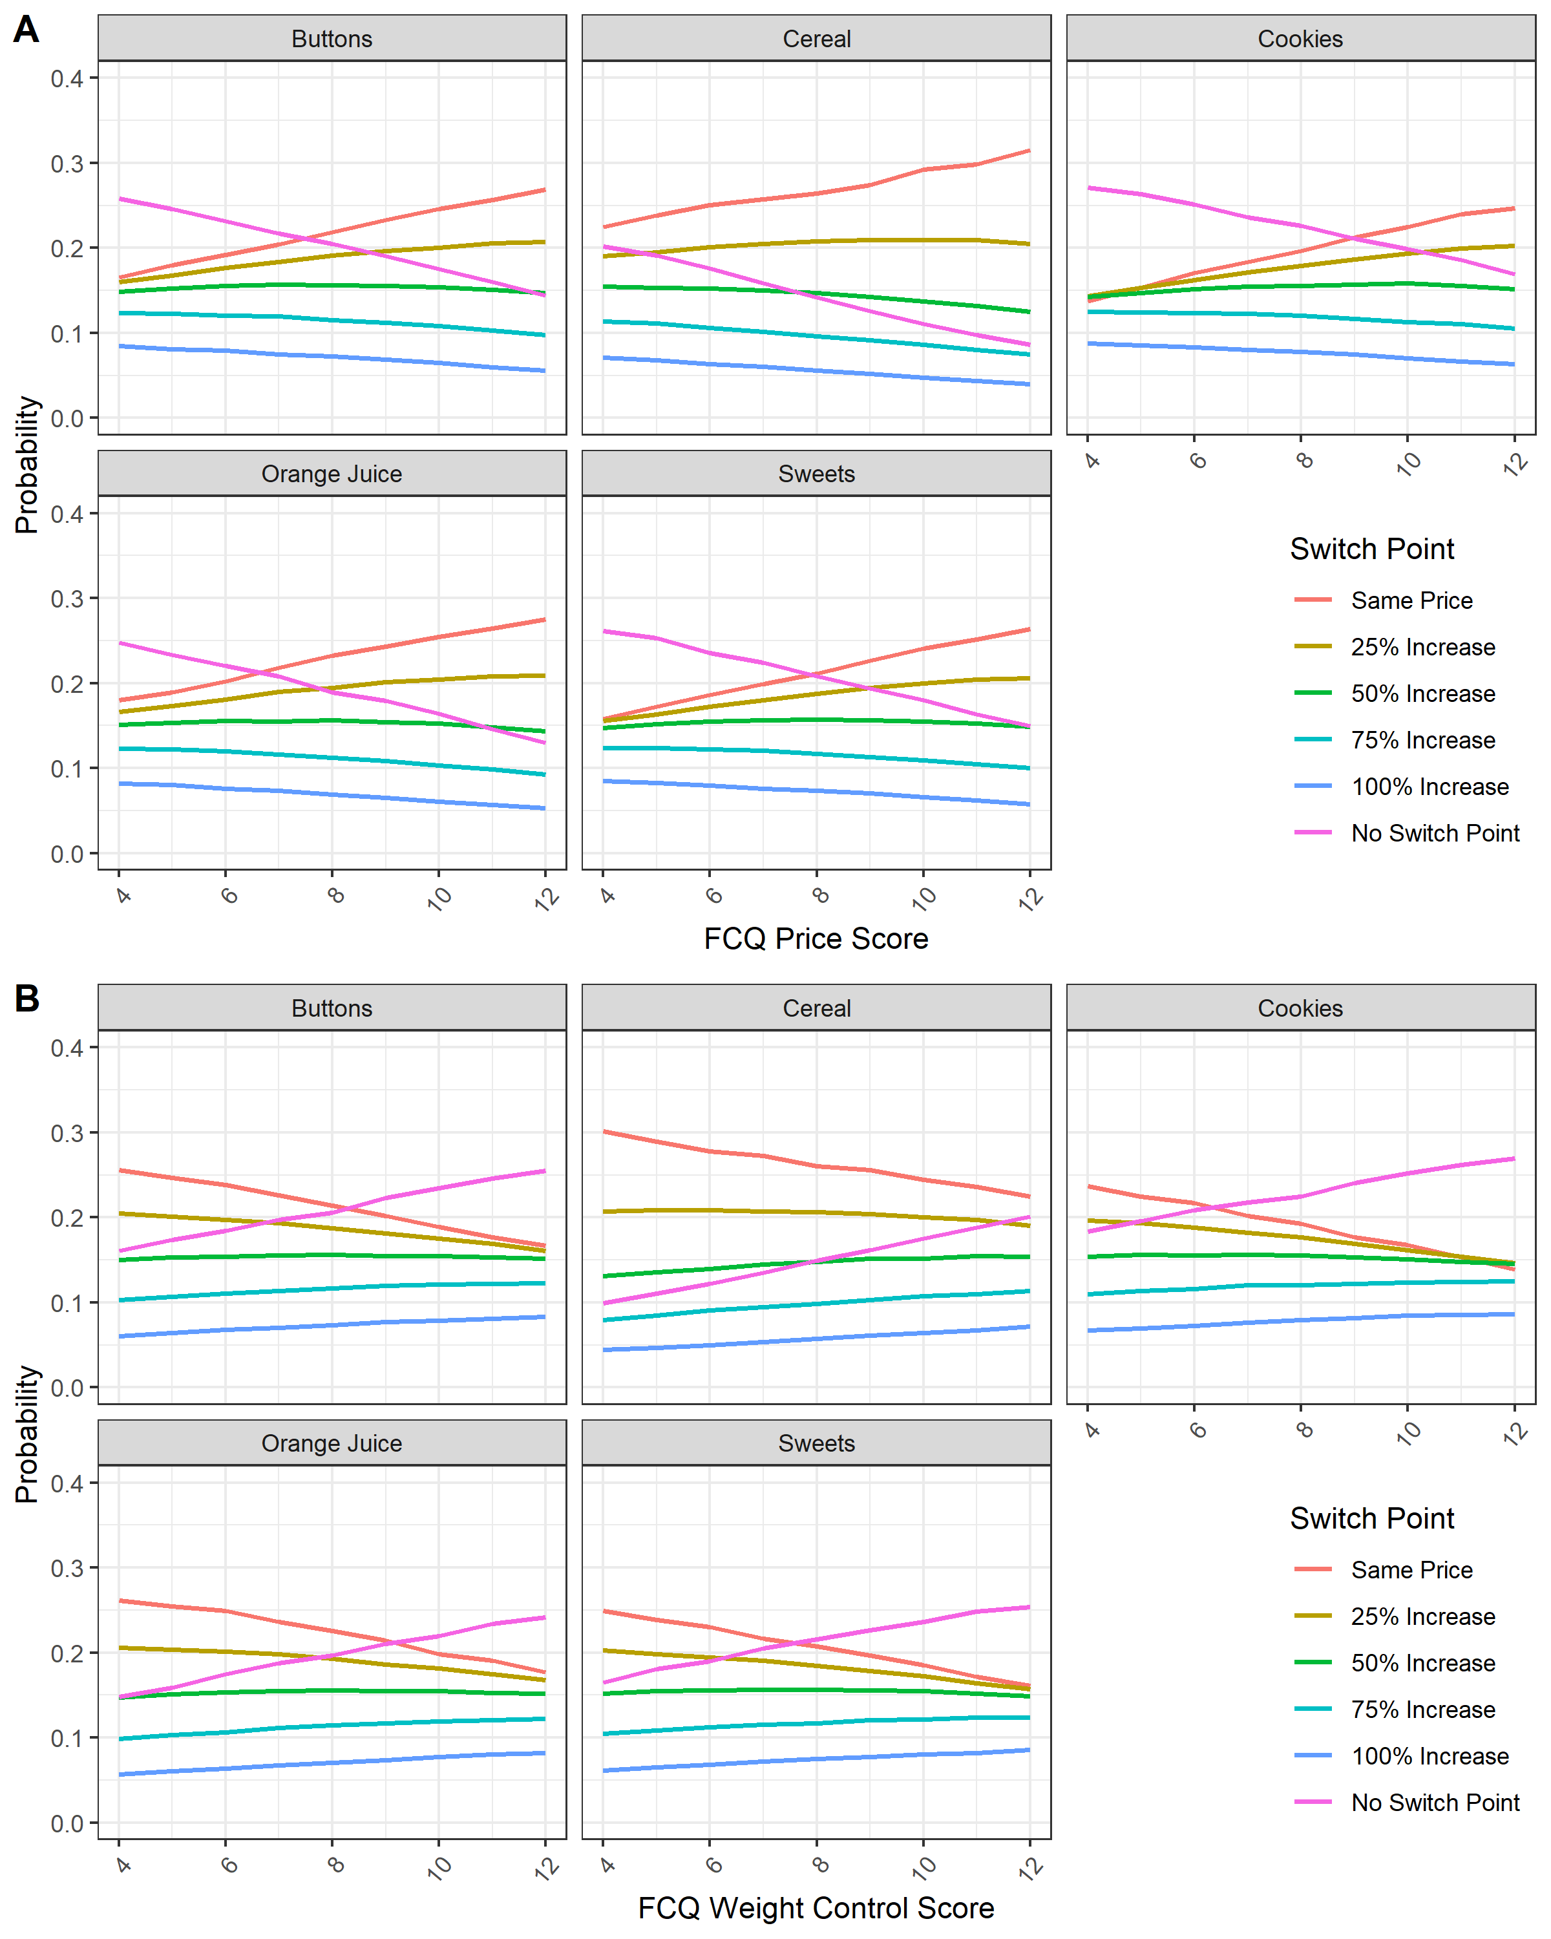

Both WTP analyses indicate that the FCQ scores and beliefs about the functionality of packaging influenced WTP judgements for each product. On average, participants were WTP more for each product after learning the product narrative about downsizing snacks and portion control.

For packaging choice (parent preference) there was a significant relationship between the packaging preference and the perceived portion effect of packaging (**Table 7.**). When parents believed the new packaging would help limit intake, they selected the concept packaging over the regular brand. For example, for cookies, 79% of parents who identified the downsizing function of the packaging concept to decrease intake chose this over their regular brand. However, for cereal and orange juice, the association between functional portioning effect of the packaging and choice was weak. Interestingly, nearly half of parents (44.7%) who perceived the new cereal packaging would decrease the intake still chose the regular brand.

**Table 7 -** Packaging concepts (narrative, functional and metaphor), preference for new over regular brand and perceived portion effect

|  |  |  |  |  |  |  |  |  |  |  |
| --- | --- | --- | --- | --- | --- | --- | --- | --- | --- | --- |
| Packaging Choice | Sleeping Otter  (narrative) | | Biting Bear  (narrative) | | Giraffe Cereal  (functional) | | Candy Teeth  (metaphor) | | Moon Monkey  (functional) | |
|  | Parent | Child | Parent | Child | Parent | Child | Parent | Child | Parent | Child |
| New packaging | 174 | 209 | 140 | 169 | 114 | 145 | 102 | 138 | 116 | 138 |
| Regular brand | 86 | 60 | 97 | 69 | 153 | 122 | 104 | 77 | 117 | 86 |
| Neither | 17 | 8 | 40 | 38 | 9 | 8 | 70 | 60 | 43 | 51 |
| Effect | Sleeping Otter | | Biting Bear | | Giraffe Cereal | | Candy Teeth | | Moon Monkey | |
| Eat Less/ percent | 147 | 53.1% | 144 | 52.6% | 123 | 44.7% | 124 | 45.8% | 8 | 31.7% |
| Eat More/ percent | 39 | 14.1% | 49 | 17.9% | 16 | 5.8% | 30 | 11.1% | 27 | 9.9% |
| No effect/ percent | 91 | 32.8% | 81 | 29.6% | 136 | 48.5% | 117 | 43.2% | 158 | 58.3% |
| Chi-square test between the packaging choice (parent preference) and the effect choice | | | | | | | | | | |
| Test result | χ2 (4) = 38.59,  p < .001 | | χ2 (4) = 49.15,  p < .001 | | χ2 (4) = 23.81,  p < .001 | | χ2 (4) = 38.34,  p < .001 | | χ2 (4) = 16.59,  p < .001 | |

* Fisher’s exact test was used for all χ2 tests due to violation of minimum cell counts.

**Qualitative analysis**

Although parents were relatively positive about the design concepts, they favoured the narrative packaging over the functional packaging. They preferred the Sleeping Otter and Biting Bear over the Candy Teeth (metaphor). Parental responses were categorised according to the main themes which emerged from the online open-ended questions (data is fully available here https://osf.io/95fgw/?view_only=6dc34337a1f240c781a55c992abbe20c ). Brief consideration of these is given below under each theme.

#### Educational for both parent and child

Design concepts were described as “educational” for both for parent and child. For example, functional aspects such as indicating an appropriate portion for children and narratives to remind parents that some foods should be offered in small amounts. Parents identified the lack of child-sizes portion recommendations on pack and suggested that these design concepts filled this gap.

#### Convenience

Time saving, reducing waste and offering a means to serve portions were mentioned as benefits. Physical constraints were recognised as useful (e.g., partitioned packaging for one portion; inbuilt measuring tool; obvious calibrated measures for juice). However, parents also mentioned the inconvenience of cutting out measuring tools in the cereal box since they were time constrained (see the parents positive, negative and neutral comments in detail here <https://osf.io/87yu9/?view_only=d7bdc70aa99240ba982cf1a38dd35a17>)

#### Child autonomy and novelty

Some of the design concepts were considered useful to encourage greater autonomy so that children could serve themselves. Also, parents noted the novelty of the packaging concepts as attractive to both parent and child reinforcing the messaging around portion control.

#### Price concern and Individual brand loyalty

Parents reported concerns that new concepts would be expensive and others mentioned that brand loyalty was important since they thought the taste and quality of the items in the new designs would be compromised. Similarly, some parents mentioned that their child would prefer the packaging and contents of familiar brands, in part due to fussy eating.

#### Providing easy portion control methods

Parents appreciated the downsizing packaging designs to prevent overeating, since the messaging was functional and fun. But others were more circumspect, some thought the fun element might encourage intake and others reckoned that they were the ultimate gatekeepers of their child’s nutrition so packaging innovations would go unnoticed or were not considered relevant.

**Discussion Study 2**

In general, parents were positive about the concepts, to help with portion control and were willing to pay more for this kind of packaging. Parents liked the visual format to guide portions, especially providing narratives, functional guides and limits to encourage healthy eating. Furthermore, the dual elements of pre-portioning and fun in packaging were regarded as helpful but some parents worried that the playful aspects would encourage more intake. Some parents wanted reassurance about environmental-friendly packaging and others felt that the packaging did not add much to what they already did as gatekeepers of their own child’s intake.

**General Discussion**

Findings from Studies 1 confirmed the hypothesis that parents downsize portions for their child (H1) and from Studies 1 and 2 confirmed the prediction (H2a) that parents would be generally receptive to packaging designed to assist with portion control (**see Figure 8**). However, some parents expressed less favourable responses depending on the concept (narrative was favoured over metaphor) or on their personal circumstances (brand loyalty, recyclable materials). Predictions (H2b and H2c) that parents would be WTP more and would select concepts designed to support portion control (see Figure 8) were supported both in interviews (Study 1) and via the online experiment (Study 2). Finally, parents with strong health motives (H2d) were WTP for the new design concepts than parents with cost concerns (Study 2, Figure 8).

Interviews in person (Study 1) and in response to online, open-ended questions (Study 2) were generally supportive of the portion control functionality of the packaging. However, some parents were sceptical of the direct application to their family, since they acted as gatekeepers of their child’s nutrition and so packaging would make little difference to them. Nonetheless, for those parents who liked the design concepts they recognised the educational purpose both for them and for their child; with some identifying the benefit that children could be “trusted” to serve themselves an appropriate portion size, facilitating autonomy.

Study 2 built on these findings by assessing acceptability through self-report, WTP and forced choice. Here, it was found that WTP was determined by parental food choice motivations and by the credibility of the narrative. Similar findings have demonstrated that storytelling or informing consumers of the purpose of the narrative increases WTP and even liking for a product (Lundqvist, Liljander, Gummerus, & Van Riel, 2013). However, this depends on the credibility of the portion control narrative (Roosen et al., 2015). For parents with weight control motives higher WTP may be attributable to greater trust in the functionality of the product (Plasek & Temesi, 2019) to reduce portion sizes of snacks. Previous findings in the WTP literature also suggest that health benefit messaging can increase WTP (Hellyer, Fraser, & Haddock-Fraser, 2012). Although the current packaging concepts focused on downsizing to limit portions of a single item with no direct health benefit, parents in the present study may be WTP more for these concept designs with the potential indirect benefit of prevention (Annunziata & Vecchio, 2013).

**Figure 8** - How the hypotheses (H2a-d) relate to findings regarding WTP

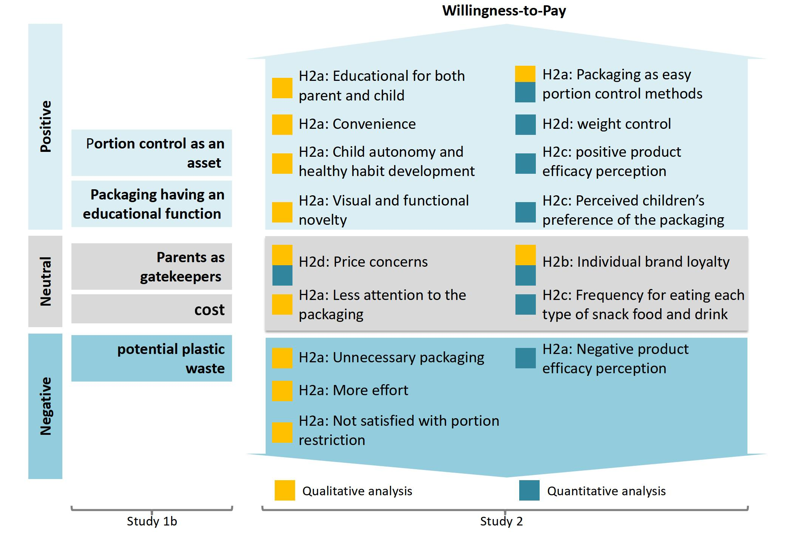

Footnote: H2a: Parents will respond positively to packaging concepts which assist them in offering their child a downsized portion of a food/beverage high in sugar.

H2b: Parents will be willing to pay more for this type of packaging concept compared to their regular brand.

H2c: Parents will select the packaging concept more often in a choice scenario.

H2d: Parents motivated by health will be willing to pay more for the packaging concepts than parents motivated by cost.

Design implications

Recommendations to parents to provide children with 100 kcal snacks no more than twice per day to reduce sugar intake (Public Health England, 2018) is an important message. Parents generally offered amounts in Study 1 close to 100 kcal. However, public health campaigns often use printed materials (e.g., leaflet), video and media coverage, which then requires parents to make the link between the information, their own and their child’s behaviour. This more distal relationship may be improved by the immediacy of design-led solutions on packaging, either through functional portion control, narratives or front-of-pack suggested serving size (Chu et al., 2020).

Understanding user diversity might predict who will use nudges and design-led portion size solutions e.g. Coskun and Erbug (2017) identified nine user types and proposed design techniques to promote eco-friendly driving for each user type. Our findings showed that the WTP of these new design concepts were affected by individual differences in parental motivations (e.g., acting as gatekeepers, price awareness or weight control). Firstly, this reaffirms that variables used for creating user groups can vary depending on the type of target behaviour and its context (Coskun & Erbug, 2017). In the present study WTP magnitude depended on parental food choice motivations, therefore, interventions could be tested to target a particular user segment who may share common characteristics such as beliefs, attitudes, experiences, needs (Tang, 2010; Zachrisson & Boks, 2012), goals (Tang & Won, 2018) or stages in the Transtheoretical Model of Health Behaviour Change (Ludden & Offringa, 2015). As the users' beliefs, attitudes and intentions are aligned with the desired behaviour (Triandis, 1977) and a goal intention must already be in place and achieved (Gollwitzer, 1999) to create new healthy behaviour or habits, in the present study, health conscious parents were WTP more for greater user control over portions. User segmentation might offer a systematic means of designing strategies for further downsizing solutions.

Future research on the packaging of HED food and drink items could focus on narratives and functionality to convey portion size information to caregivers and children through educational, fun and environmentally friendly packaging. Based on the results presented here, we propose some attributes which could increase WTP for innovative design concepts promoting downsizing. The downsizing packaging could:

* Convey more clearly the purpose of the design intervention to parents, i.e. to limit intake/control portion size
* Give clear guidance about the age-appropriate portion sizes through visual, functional and cognitive features of the product;
* Be coupled with a teachable, playful and fun moment for portion control using storytelling and metaphor that can encourage children’s understanding about why small amounts are appropriate;
* Not conflict with, but support the context of use and accommodate parents’ demand for convenience;
* Respond to growing users’ awareness of packaging waste.

This study created and examined five packaging design concepts which were acceptable solutions but WTP and effectiveness depended on context and motivation. It is notable that the effectiveness of intervention tools might vary by age of the child (Darnton, Battye, Scott, & Krelle, 2013). Therefore, age could be a critical dimension for future research. ‘Behaviour-changing’ nudges and packaging devices need to be prototyped and user-tested to evaluate their effectiveness with parents and children in different age groups in a home environment.

There are several limitations to these studies. First, we have relied on self-report and therefore interviews will be influenced by impression management and by social desirability bias. However, in the open-ended questions of the online survey answers are given entirely anonymously and so it may be argued that participants could be as honest and critical without fear of judgement. In this way, our findings were sufficiently similar across studies to reassure us that parents were open and direct about the concepts. Secondly, the prototypes were not final products and so participants might have responded to the perceived quality of the packaging rather than the innovative design. However, Study 2 used an online presentation of the prototypes thereby drawing more attention to the visual imagery, functionality and narratives than the in-person quality of the packaging materials. Thirdly, we did not ask about willingness to purchase. This is a limitation since the assumption made is that the participants would be willing to purchase the product, and this may not be the case. However, participants were always free to select 0 for WTP and this rarely occurred. In the forced choice part of the study, there should not be over-estimation of WTP for the concept packaging, because if the participant would not be willing to pay an increasing amount for the concept packaging, they would have selected the regular brand. It is likely only that there would have been an overestimation of people who would choose the regular brand product over no product. Another limitation is the representativeness of the samples. While a community-based sample was recruited from the science museum, those who attend these museums are generally better educated and more affluent than the average citizen.

In conclusion, packaging design for downsizing appears to be acceptable to parents. Moreover, WTP was greater for new, functional and narrative designs than for regular, branded products. However, WTP for an attractive downsizing design depended on consumer attributes such as health motives compared to cost concerns. It is unrealistic to expect children to limit intake of foods which they find highly desirable. Thus, packaging which is designed to guide parents and children towards an amount which is “me-sized” and age appropriate to assist with downsizing is acceptable to parents and worth translating to real world solutions. More studies are needed in the long term, with parents using these designs at home to investigate any portion control effects and their sustainability.

### **References**

Albar, S. A., Alwan, N. A., Evans, C. E., & Cade, J. E. (2014). Is there an association between food portion size and BMI among British adolescents? *British Journal of Nutrition, 112*(5), 841-851.

Annunziata, A., & Vecchio, R. (2013). Consumer perception of functional foods: A conjoint analysis with probiotics. *Food Quality and Preference, 28*(1), 348-355.

Argo, J. J., & White, K. (2012). When do consumers eat more? The role of appearance self-esteem and food packaging cues. *Journal of Marketing, 76*(2), 67-80.

Blake, C. E., Fisher, J. O., Ganter, C., Younginer, N., Orloski, A., Blaine, R. E., . . . Davison, K. K. (2015). A qualitative study of parents' perceptions and use of portion size strategies for preschool children's snacks. *Appetite, 88*, 17-23.

Braun, V., & Clarke, V. (2006). Using thematic analysis in psychology. *Qualitative Research in Psychology, 3*(2), 77-101.

Bui, M. M., Tangari, A. H., & Haws, K. L. (2017). Can health “halos” extend to food packaging? An investigation into food healthfulness perceptions and serving sizes on consumption decisions. *Journal of Business Research, 75*, 221-228.

Chu, R., Tang, T., & Hetherington, M. M. (2021). The impact of food packaging on measured food intake: A systematic review of experimental, field and naturalistic studies. *Appetite*, 105579.

Cornil, Y., & Chandon, P. (2016). Pleasure as a substitute for size: How multisensory imagery can make people happier with smaller food portions. *Journal of Marketing Research, 53*(5), 847-864.

Coskun, A., & Erbug, C. (2017). User orientation maps: an approach to address user diversity in design for sustainable behaviour. *The Design Journal, 20*(1), 131-152.

Curtis, K., Atkins, L., & Brown, K. (2017). Big hearts, small hands: a focus group study exploring parental food portion behaviours. *BMC Public Health, 17*(1), 1-14.

Darnton, A., Battye, F., Scott, D., & Krelle, H. (2013). Physical Activity and Healthy Eating Interventions Review-Final Report. *AD Research Analysis Ltd ICF GHK Ltd for Public Health England*

Fisher, J., Rolls, B. J., & Birch, L. L. (2003). Children's bite size and intake of an entree are greater with large portions than with age-appropriate or self-selected portions. *The American Journal of Clinical Nutrition, 77*(5), 1164-1170.

Fisher, J., Wright, G., Herman, A., Malhotra, K., Serrano, E., Foster, G., & Whitaker, R. (2015). “Snacks are not food”. Low-income, urban mothers' perceptions of feeding snacks to their preschool-aged children. *Appetite, 84*, 61-67.

Gollwitzer, P. M. (1999). Implementation intentions: strong effects of simple plans. *American Psychologist, 54*(7), 493.

Grimaldi, S., Fokkinga, S., & Ocnarescu, I. (2013). *Narratives in design: a study of the types, applications and functions of narratives in design practice.* Paper presented at the Proceedings of the 6th International Conference on Designing Pleasurable Products and Interfaces.

Hekkert, P., & Cila, N. (2015). Handle with care! Why and how designers make use of product metaphors. *Design Studies, 40*, 196-217.

Hellyer, N. E., Fraser, I., & Haddock-Fraser, J. (2012). Food choice, health information and functional ingredients: An experimental auction employing bread. *Food Policy, 37*(3), 232-245.

Hetherington, M., Blundell-Birtill, P., Caton, S. J., Cecil, J. E., Evans, C. E., Rolls, B. J., & Tang, T. (2018). Understanding the science of portion control and the art of downsizing. *Proceedings of the Nutrition Society, 77*(3), 347-355.

Hetherington, M., & Blundell‐Birtill, P. (2018). The portion size effect and overconsumption–towards downsizing solutions for children and adolescents. In: Wiley Online Library.

Holden, S. S., & Zlatevska, N. (2015). The partitioning paradox: The big bite around small packages. *International Journal of Research in Marketing, 32*(2), 230-233.

Jelsma, J., & Knot, M. (2002). Designing environmentally efficient services; a ‘script’approach. *The Journal of Sustainable Product Design, 2*(3-4), 119-130.

Johnson, S. L., Goodell, L. S., Williams, K., Power, T. G., & Hughes, S. O. (2015). Getting my child to eat the right amount. Mothers' considerations when deciding how much food to offer their child at a meal. *Appetite, 88*, 24-32.

Johnson, S. L., Hughes, S. O., Cui, X., Li, X., Allison, D. B., Liu, Y., . . . Vollrath, K. (2014). Portion sizes for children are predicted by parental characteristics and the amounts parents serve themselves. *The American Journal of Clinical Nutrition, 99*(4), 763-770.

Kling, S. M., Roe, L. S., Keller, K. L., & Rolls, B. J. (2016). Double trouble: Portion size and energy density combine to increase preschool children's lunch intake. *Physiology & Behavior, 162*, 18-26.

Ludden, G. D. S., & Offringa, M. (2015). *Triggers in the environment. Increasing reach of Behavior Change Support Systems by connecting to the offline world.* Paper presented at the Third International Workshop on Behavior Change Support Systems, BCSS 2015.

Lundqvist, A., Liljander, V., Gummerus, J., & Van Riel, A. (2013). The impact of storytelling on the consumer brand experience: The case of a firm-originated story. *Journal of Brand Management, 20*(4), 283-297.

McGale, L. S., Smits, T., Halford, J. C. G., Harrold, J. A., & Boyland, E. J. (2020). The influence of front‐of‐pack portion size images on children's serving and intake of cereal. *Pediatric Obesity, 15*(2), e12583.

Norman, D. (2013). *The design of everyday things: Revised and expanded edition*: Basic books.

Plasek, B., & Temesi, Á. (2019). The credibility of the effects of functional food products and consumers’ willingness to purchase/willingness to pay–review. *Appetite, 143*, 104398.

Public Health England. (2018). PHE launches Change4Life campaign around children’s snacking. [*https://www.gov.uk/government/news/phe-launches-change4life-campaign-around-childrens-snacking*](https://www.gov.uk/government/news/phe-launches-change4life-campaign-around-childrens-snacking) *(accessed 22.01.21)*.

Reale, S., Kearney, C. M., Hetherington, M. M., Croden, F., Cecil, J. E., Carstairs, S. A., . . . Caton, S. J. (2018). The feasibility and acceptability of two methods of snack portion control in United Kingdom (UK) preschool children: Reduction and replacement. *Nutrients, 10*(10), 1493.

Rolls, B. J., Morris, E. L., & Roe, L. S. (2002). Portion size of food affects energy intake in normal-weight and overweight men and women. *The American Journal of Clinical Nutrition, 76*(6), 1207-1213.

Roosen, J., Bieberstein, A., Blanchemanche, S., Goddard, E., Marette, S., & Vandermoere, F. (2015). Trust and willingness to pay for nanotechnology food. *Food Policy, 52*, 75-83.

Schwartz, C., Lange, C., Hachefa, C., Cornil, Y., Nicklaus, S., & Chandon, P. (2020). Effects of snack portion size on anticipated and experienced hunger, eating enjoyment, and perceived healthiness among children. *International Journal of Behavioral Nutrition and Physical Activity, 17*(1), 1-14.

Sharps, M., & Robinson, E. (2016). Encouraging children to eat more fruit and vegetables: Health vs. descriptive social norm-based messages. *Appetite, 100*, 18-25.

Steptoe, A., Pollard, T. M., & Wardle, J. (1995). Development of a measure of the motives underlying the selection of food: the food choice questionnaire. *Appetite, 25*(3), 267-284.

Tang, T. (2010). *Towards sustainable use: design behaviour intervention to reduce household environment impact.* Loughborough University,

Tang, T., & Won, S. (2018). How Design Influences Habits. In *In: Egenhoefer RB (eds.) Routledge Handbook of Sustainable Design.* : Routledge International Handbooks.

Triandis, H. J. D. f. S. B. t. C. C. B. (1977). ‘Interpersonal Behavior’. Monterey, CA: Brooks/Cole. In (Vol. 14, pp. 427-445).

Zachrisson, J., & Boks, C. (2012). Exploring behavioural psychology to support design for sustainable behaviour research. *Journal of Design Research 14, 10*(1-2), 50-66.