**Global nutrient equity for people and the planet**

Helena Kahiluotoa,b,c*, Kate E Pickettd, Will Steffene,f

aLUT University, Sustainability Science, Finland

bUniversity of Helsinki, Agroecology, Finland

cStrategic Research Council at the Academy of Finland

dUniversity of York, Health Sciences, and Leverhulme Centre for Anthropocene Biodiversity, Heslington, York, YO10 5DD, UK

eThe Australian National University, Canberra, Australia

fStockholm Resilience Centre, Sweden

*\*Corresponding author, Tel. +358405118335, E-mail:* [*helena.kahiluoto@lut.fi*](mailto:helena.kahiluoto@lut.fi)

***[ok? please present all affiliation addresses at the city, state and country levels]***

**The industrial world has converted inert soil and atmospheric nutrients into reactive fertiliser flows that endanger water quality, biodiversity and climate. Simultaneously, poor nations starve because of the shortage of these nutrients in agricultural soils. Here, we propose redistribution of accumulated nutrients to enhance food security while counteracting the current degradation of critical Earth System processes. Residue and sediment nutrients could be processed and transported to food insecure regions through the opposite logistics used to ship phosphate rock across the globe. Financing through trading accumulated rights could trigger the required innovations in processing, logistics and thinking. Such a socially just ‘One Earth Currency’ could leverage a transformation towards resilience, equity and dignity, across the critical Earth System processes.**

Overloading the stern will sink a boat; distributing the load equally will save all – a metaphor that applies to the global distribution of nutrients ***[ok? would suggest rewording the metaphor to be more concise; a further idea here would be using the metaphor of loading on a container ship?]***. Rights to operate ***[ok? could you specify what is meant by ‘operate’ here as it relates to nutrient distribution or food systems – this phrase needs a little more specificity]*** are not fairly distributed within humanity, and the global economy does not operate within the carrying capacity of the planet. The nutrients nitrogen and phosphorus are a primary resource for food production, the cornerstone of human security, and use of these nutrients has been extremely uneven in different parts of the world1,2. Far more nitrogen and phosphorus has been converted from inert sources to reactive forms for food production3 than allowed to maintain a well-functioning Earth System4. The accumulated nutrient surplus causes expanding anoxic dead zones in open oceans, coastal zones and estuaries5 contributing to the sixth mass extinction of biodiversity that we are witnessing and profound impact on the climate6. Simultaneously, the nutrient depletion in agricultural land of poor countries leaves a legacy of hunger7 and social unrest8. ***[ok? the edits here are suggested to improve flow and specificity for our international readership]***

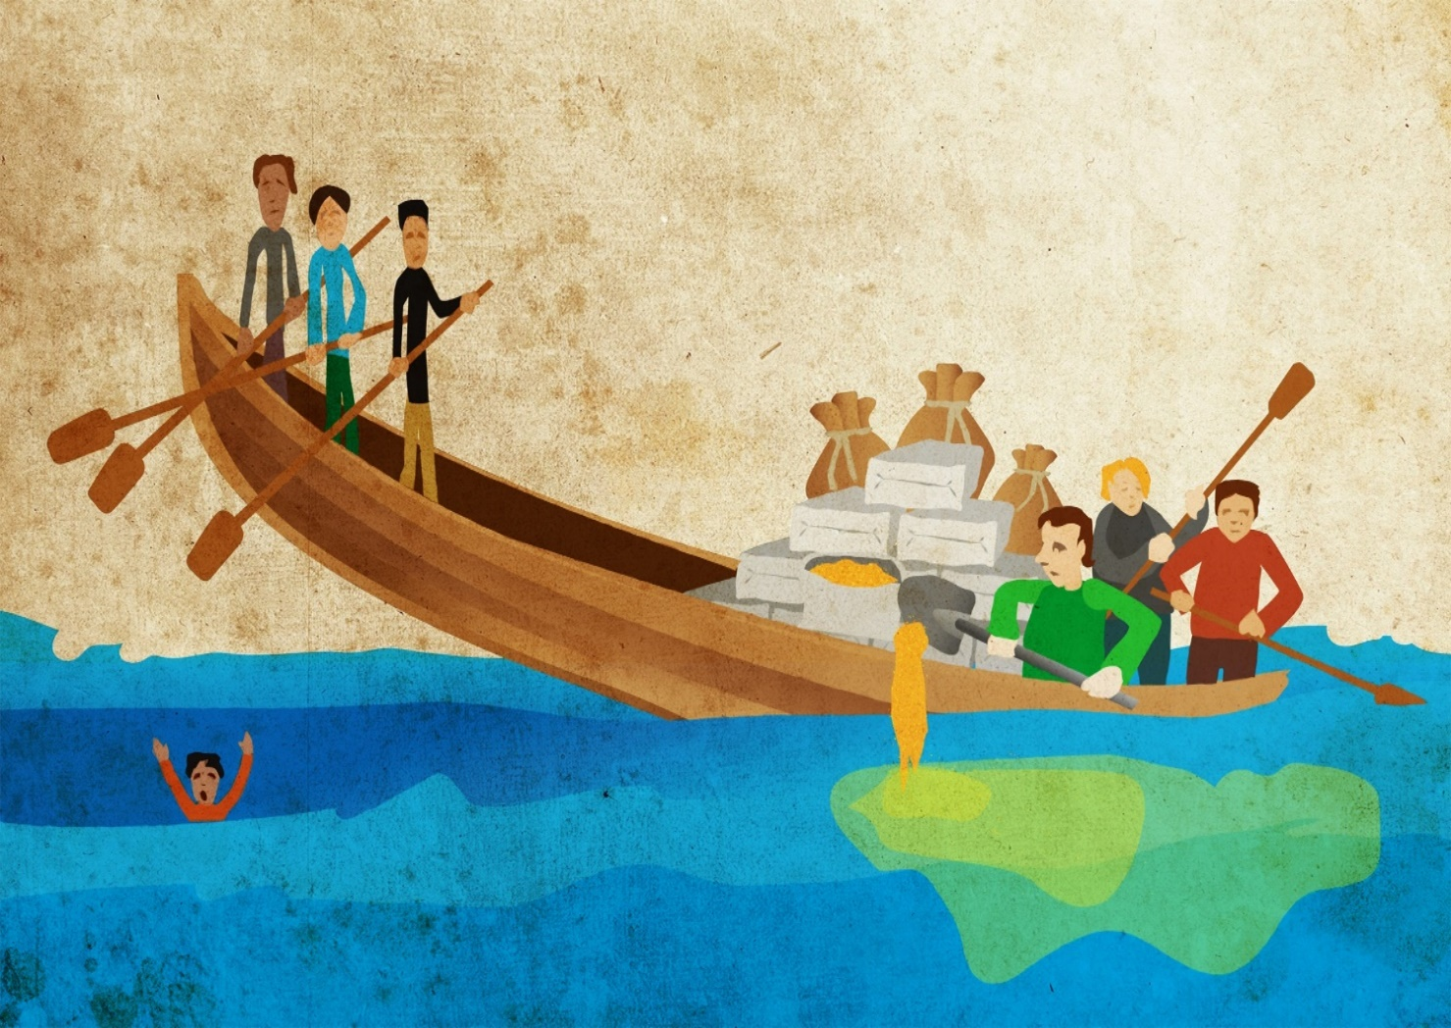

**Fig. 1 | Inequity creates wastage and instability.** Redistributing the unequally accumulated nutrients would reduce food insecurity while enhancing recovery of aquatic ecosystems and climate.

Consequently, nutrient use must be redistributed ***[ok? ‘must’ by itself denotes a value system of equity…I wonder if this could be framed as either a question (eg: Is it possible to redistribute nutrient use?) or a statement of your view point (eg: Consequently, we posit that nutrient use must be redistributed). My preference is the latter, a statement of your determination]***. Since access to nutrients is related to wealth9, economic instruments are required. A global circular nutrient economy and redistributive incentives have, however, been absent in the scientific debate. Here, we propose a transformative initiative to incentivise and finance global redistribution of nutrient use. The synergetic purpose is to restore nutrient-depleted soils in poor countries to enhance food and nutrition security while safeguarding Earth System functioning. The window of opportunities opened up10 by the current global crises could enable such redistribution serving as a pilot testing of a ‘One Earth Currency’, which could then be potentially extended to all the quantified planetary boundaries4 as a foundation for a sustainable, fair and planet-bound economy.

**Current and past nutrient use**

More than half of all globally applied fertilisers and 85% of manure nitrogen are allocated to 10% of global agricultural land, whereas 80% of African countries suffer from nitrogen scarcity11,12. Similarly, 45% of phosphorus surpluses relative to crop uptake appear on 10% of the global cropland area while 65% of the phosphorus deficits are spatially as concentrated on another 10% of the global cropland13. Eliminating nutrient overuse would still allow as much as a 30% increase in production of main cereals; large gains in cereal production could be achieved especially in areas such as sub-Saharan Africa and Eastern Europe by redistributing nutrients14.

**Accumulated disparity.** Reactive surplus nutrients have accumulated in the wealthy parts of the globe via the industrialization of agriculture and trade of nutrients, food and fodder. In developed countries since 1960s, nitrogen excesses of 2000 kg ha-1 relative to nitrogen harvested were estimated over 300 million hectares over 30 years15, with annual accumulation of 25-70 kg ha-1 measured for 50 years in croplands across watersheds16, and the imbalances continue17. In European field soils, fertiliser phosphorus of 700 to 800 kg ha-1 has accumulated18, and in North America, 230 to 1,400 kg ha-1 since 190019. Simultaneously in Africa, a depletion of 1100 kg ha-1 nitrogen and 125 kg ha-1 phosphorus has accumulated by 2015. In developing countries, the depletion amounts to an average of 930 kg ha-1 nitrogen and 250 kg ha-1 phosphorus for 200 to 300 Mha of arable land, if the depletion rates for the 30 years before15 and for 200020 represent the average for the 50-year period to 2015.

**Critical thresholds.** Because critical boundaries in Earth System functioning have been transgressed by large amounts, very few new inert nutrients can be converted to reactive forms4. In an increasing number of freshwater and coastal ecosystems and estuaries in the industrialized world, greater nutrient loading from bottom sediments compared to loading from cultivated soils21,22 have led to persistent, widespread eutrophication. For example, in the Baltic Sea, even with a return to pre-industrial nutrient flows from the watershed, recovery would require more than a century23, and in freshwaters even a thousand years24. Therefore, the accumulated reserves need to be mined so that aquatic ecosystems can recover22. In poor parts of the world, nutrient depletion triggers a vicious cycle of soil carbon depletion, exponentially decreasing yields2,25. Chronic undernourishment is globally on the rise since 2014 and affects one in five people in Africa26, where the population is projected to grow from 1.5 billion in 2020 to 4 billion in 210027. Worldwide, more than one in five children are stunted which is related to poverty26, hampering the next generations’ capabilities in the Global South and creating a legacy of inequality.

**Specific drivers.** Although 70% of the currently known global P-rock reserves are located in Morocco and the western Sahara28, they have been mainly transported to wealthy markets elsewhere. Biological nitrogen fixation is phosphorus-dependent, and the Haber-Bosch process for the conversion of atmospheric nitrogen to reactive forms has a high energy requirement. Consequently, wealth has also determined access to nitrogen9. The use of fertiliser in food production by smallholders in low- and middle-income countries is seldom profitable because the fertiliser price is often multiplied due to poor infrastructure and other domestic transaction costs29, the local food price is low relative to that of cash crops, and there is a significant risk of losing the crop15. For example, in sub-Saharan Africa, the lack of other energy sourcesleadsto the combustion of residues for cooking, thereby reducing the amount recycled30. Also, nutrient import in food to Africa is a recent development31, unlike export of cash crops, and the imports serve urban areas with no distribution of the residue nutrients to agricultural soils.

**Transformative measures required**. Current attempts in wealthy countries towards less nutrient use or loading are focused on dietary changes and reducing waste3, decoupling food production from land use32, local recycling33,34 and precision agriculture35. Also, nutrient flow from soils to waters can be prevented and consequences of nutrients in water systems mitigated through geoengineering approaches, but with ecological risks36. Importantly, none of these endeavours is aimed at reversing the disparity in access to nutrients and food between the Global North and South, thus missing the opportunity to build a synergetic outcome. Increased nutrient use in depleted soils is environmentally superior to land expansion37 but synthetic fertilisers worsen the global transgression of the safe space for nitrogen and phosphorus loading. Because nutrient reserves and depletion are spatially separated by historical, persistent global inequities in access to nutrients1,2, global redistribution of these resources needs to be triggered.

**Towards equity in nutrient use**

While equity across generations is intrinsic to sustainability, the health and psycho-social well-being of all citizens, even the wealthiest, is greater with greater distributional equality38. Equity and well-being within planetary boundaries were conceptualized as the ‘safe and just space for humanity’ by Raworth39. Redistributing excess nutrients to regions with deficits in food14 and nutrition security1,2 not only builds the ‘social foundation’39 for global wellbeing through increasing equity but also respects critical planetary boundaries by reducing wastage (Fig. 2) thus building synergy between these fundamental dimensions of sustainability (Fig. 3).

**Equity for dignity and peace.** Inequity in access to food is a threat to peace as demonstrated by food riots8. For distributional equity, whether based on equality, capability or fundamental needs40, procedural equity is required41. Disparities in wealth and power prevent the consensus needed to reallocate scarce resources42 whereas procedures that exemplify ‘justice as fairness’ as proposed by Rawls43 compensate for naturally (or historically) occurring inequalities such as those in wealth, power and nutrients. Consequently, fair procedures decrease threats of conflict world-wide. Procedural justice again is enabled by norms and values42. Hunger and poverty reflect and convey the values of societies; these are important also because fear of being considered less worthy triggers violence38. The notion that everyone is equal in dignity and rights represents the deepest form of equity and is the foundation of human rights44. Rights to nutrients imply secure access to nutrients for all the world’s nations, farmers and citizens, thus building food sovereignty and

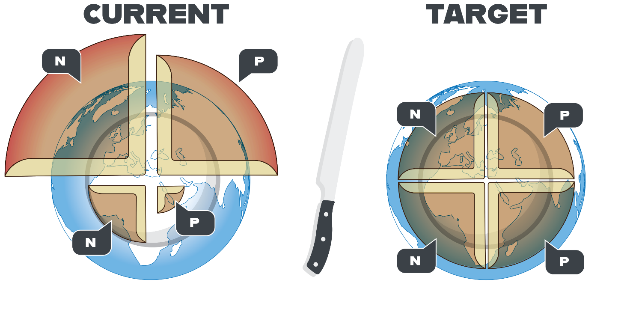

**Fig. 2 | Redistribution of nutrients for food security and resilience.** Redistribution of nutrients accumulated in wealthy countries of the Global North would counteract the transgression of the planetary boundaries while securing food (‘daily bread’ on the plate) also in the Global South. N=nitrogen, P=phosphorus.

security. Equal rights of access to nutrients45 can thus exemplify a global society that promotes dignity and peace8,38 (Fig. 3).

**A safe and just space for nutrients?** *[ok? subheadings need to be quite short]*

**Nutrients to redistribute.** The extent of nutrient redistribution needed depends on how much is required to return to the critical nutrient limits in the regions of surplus and to replenish degraded soils for food security in regions of deficit. For example, in Finland the current annual excess flow of reactive nitrogen (40 kg cap-1 a-1) is almost double the global average, and the long-term rate of accumulation (65 kg cap-1 a-1 on average since 1900) is almost triple the global average of 24 kg cap-1 a-1. In contrast, in Ethiopia, there is still space to convert inert nitrogen2 to reactive forms. If Finland paid its ‘nitrogen debt’ within as many years as it was accumulated2, it could replenish half of the annual depletion of arable land in Ethiopia12. Half of the debt could be removed by the manure and other agrifood residues produced in Finland46. Alternatively, 4% of the nitrogen accumulated in the sediments of the Baltic Sea would be required21,23 for the annual debt. Only one-third of the phosphorus in annually produced agrifood residues in Finland33 would cover the Finnish annual accumulated debt and replenish one-third to one-half of the annual deficit in the Ivory Coast11, one of the most severely phosphorus-depleted areas13.

Two-thirds of the nitrogen11 and phosphorus33 contained in manure produced annually in the EU might be sufficient to restore the world’s depleted soils within a few decades. The phosphorus13, 17,18 and nitrogen16-17 accumulated in the soils of wealthy areas is frequently sufficient for local food production for decades, and a considerable amount of nitrogen and most phosphorus present in agrifood residues could be exported to nutrient-depleted areas. Based on the estimated depletion and accumulation15-20,46, the nutrient amount to be transported from regions with surplus to restore the nutrient-depleted soils within 30 years in in the range of 6 400 to 7 300 Gg a-1 for nitrogen and 830 to 2500 Gg a-1 for phosphorus.

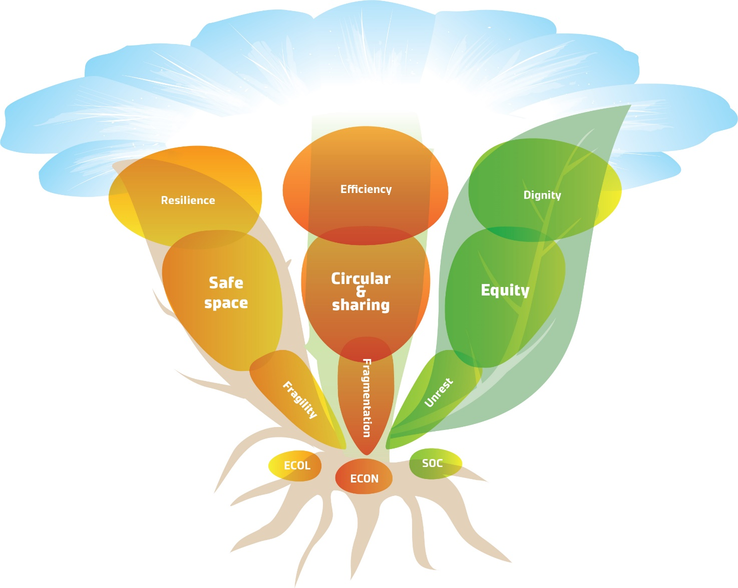

**Fig. 3 |** **Synergetic sustainability in use of nutrients as global commons**. A global circular nutrient economy exemplifies synergy growing among resilience, equity and reduced wastage, similar to that among roots, stems and leaves that are all vital for a plant to flourish.

**Technologies and logistics.** The residue nutrients accumulated in the Global North can be captured in manure, and in sediments through aquatic vegetation or near-bottom nutrient-rich water, for safe use in depleted areas in the Global South. Technologies for recovery from waste-water and industrial gases are rapidly developing. Cropping systems, root zones and residues can be managed and crops improved to enhance the recovery of nutrients from soil reserves and residues. The challenges of transportation can be facilitated by volume-reducing and stabilising technologies and by using standard containers or 0.5 m3 sacks. Separation of residues into liquid and solid phases, combined with production of bioenergy and a nutrient-rich by-product biochar47 may provide options together with many other processes under development. Building logistics for nutrient transfers to developing countries, reversing the decades- or centuries-long import of rock phosphate and other raw materials to industrial countries, would create the methodologies for local and global circular nutrient flows. The nutrient quantities that would need to be redistributed roughly correspond to the annual import of rock phosphate by the EU48, and the unprocessed dry matter of manure represents two to three per cent of the seaborne trade of developing countries. Creating bioenergy and biochar for the carbon market could generate income which reduces net-costs.

Based on the price range of fertiliser nutrients in sub-Saharan Africa in recent years29, the annual global cost of the redistribution of nutrients would be between €10 billion and €34 billion. Consequently, the annual cost would be a minor part of the cost of nitrogen pollution to societies, estimated to be €70–€320 billion in the EU49 and $81–$441 billion USD in USA50. These costs could be totally or at least partly avoided through global nutrient redistribution. The economic feasibility of residue processing and transportation may, however, be challenging at current African fertiliser prices, and use of nutrients is not profitable for smallholders even at the current price.

**One Earth Currency**

A global circular and sharing economy could redistribute nutrient use and accumulated nutrients to benefit human security, water systems and climate, but how can the transformation be incentivized and financed? Since the unequal nutrient use is related to disparities in wealth9, trading accumulated rights to nutrients could provide the trigger (Fig. 4). Nations with excessive use of nutrients relative to fair rights would need to pay their accumulated ‘debt’ in nutrients to nations with deficits, coordinated by a global fund but perhaps initiated as a voluntary scheme. Farmers and firms capturing nutrients could sell them to brokers serving nations. Consumers would pay the current level for rights to nutrients as reflected in food prices, thus creating an incentive to reduce use while no new inert phosphorus and little new nitrogen would be allowed. In the market, power is distributed according to wealth but a currency of fair historical rights, jointly enabled by nations, could provide procedural justice41 and build dignity for those with little power due to past inequities. Governance for dignity43-45 benefits from an exchange among equal actors rather than from aid on terms of the donor. Global rights to use nutrients allocated among nations equally, accounting for historical use, and among citizens through deliberative democratic procedures43

**Fig. 4 |** **Trading fair nutrient rights.** The unused rights to nutrients could be paid with the nutrients (or partly with money) by the nations which exceeded their rights. The rights could also be saved for later use or exchange, and thus enable investments in global recycling.

according to perceived fairness, would therefore finance the redistribution of nutrients in a way

that fosters dignity.

**Trading rights.** The ecological and social ‘externalities’ of nutrient use can be internalized within the economic system through regulations and taxes, baseline and credits system, and trading rights, i.e., permissions to use or emit. Among these approaches, only well-designed cap-and-trade systems51 provide a high degree of environmental certainty with the cap defined by planetary boundaries. Cap-and-trade systems allow redistribution of rights52 to use nutrients among actors and regions through democratic decision-making. When rights were exceeded by a nation, farmer or consumer household, they could be purchased, if surplus rights were available. When demand would exceed supply, price would increase and make selling, rather than using, attractive. Stepwise lowering the cap keeps the price high enough to incentivise reduction in use. The market-led mechanism causes lower administrative costs after start-up than environmental regulations or taxes, robustness, and few rent-seeking benefits52,53.

Cap-and-trade systems tend to mainstream environmental management in firms as a core business activity and are flexible enough to incentivise learning and innovations in capturing, processing and redistributing nutrients, and in trading nutrient rights. Local trading systems have been organized or proposed for air quality, fisheries, water access, wetland management, carbon emissions and nutrients54. Up to the present, nutrient right trading systems have only aimed at increasing economic efficiency in reducing nutrient emissions to local water systems. Global trade of nutrient rights that accounts for national historical use per capita2 with a stepwise declining cap, and price floor, coupled with a penalty for the activation of new inert nutrients51,53, could redistribute nutrient reserves for mutual global benefit.

**Allocation of rights.** The quantity of nutrients converted to reactive forms in residues and sediments can be shared according to the unused rights. The national caps or rights to the annual reuse can be weighted according to differences in the accumulated excess or gap relative to the local critical upper limits, or downscaled planetary boundaries, of reactive nutrient flows2. Rights to use nutrients in agriculture would be allocated among nations according to cultivation area, and rights to use products with a nutrient footprint (virtual nutrients) according to population. Nation-states can provide the surplus nutrients to countries with a gap and allocate the national cap or rights to farmers. Nitrogen losses are partly gaseous and thus not recyclable, but carbon-sequestering nutrient carriers such as biochar could be considered because they neutralize the warming impact of N2O6 while improving nutrient retention of degraded soils.

Fair rights to use nutrients could be nationally determined based on needs through deliberative democratic consultations or surveys among farmers. Virtual nutrients could be allocated to households through similar processes, for example, among clients of a retailer participating in a voluntary scheme that accounts for number of children and dietary requirements. Trading rights by consumers would incentivise all food value chain actors upstream through demand. Allowing any agent to purchase and sell rights enables a high, positive social and environmental impact.

**Monitoring use.** Verifying impacts on nutrient flows could be practice-based relying on a scientific, accumulating database. A recycling- and context-sensitive global nutrient-foot-printing could rely on ratios of nutrient purchases and sales in fertilisers and residues, feed and food by farmers, and footprints of products purchased by manufacturers, retailers and consumers. Accumulation, use and exchange of rights would be digitally recorded and transparently marketed using blockchain technologies. Consumers’ food purchases would be recorded at check-out where a new balance would be routinely calculated. Mobile applications, intelligent packages and artificial intelligence facilitate choice by consumers.

**The fund.** The nutrients would be paid for by the accumulated unused rights of nations or saved for future. The fair planet-bound currency would represent an important part of the price of all products and services. A global fund could govern the exchange of the fair One Earth Currency under the mandate of, for example, the United Nations Development Program (UNDP) (Fig**.** 4). The fund could set standards for the procedures in trading rights among nations, actors and citizens while learning from diverse emerging practices42. Equal access to information and control over the procedure is a key to perceived procedural equity and trust.

**Winners and losers.** Citizens in areas of nutrient surplus in the Global North would benefit from better water quality and citizens across the world would benefit from mitigation of climate change and reduction in nature loss as well as from empowerment as equal actors in the global economy. Farmers in the Global North and businesses everywhere would benefit from the new economic activity that the scheme would generate. Poor farmers and consumers in nutrient-depleted regions of the Global South would benefit from restored soils and nutrition security. The fertiliser industry has the opportunity to pivot towards the emerging demand, perhaps in coalitions55 with proactive food chain actors, nations or cities, United Nations organizations, other global governance platforms and civil society organizations, spurred by agile start-ups56, activists and scientists. For rich countries that exceeded their equal rights to nutrients in the past, the immediate cost would represent an investment in long-term ecological and social security, providing a model applicable in many other fields as well.

**Stepping stones**. Current global crises could enable10 a disruptive social innovation56 of equal trading rights to nutrients, initiated by proactive coalitions as voluntary schemes42 that would incentivise research and experimentation towards a sustainable digital currency. Science-based local critical limits of nutrient application will need to be determined2. Fair allocation of rights to nutrients would involve users and other actors across scales. Current and past use will need to be explored and the data base for nutrient footprints established. Capturing residue nutrients would be advanced and logistics reverse to rock phosphate export and to within-country flows of agricultural commodities coordinated. Transparent trading of nutrients and rights would be digitalized. Finally, collective learning through action could transform thinking towards global equity, as necessary to create the commitment to maintain planet Earth as a safe and just space for the humanity.

**Conclusions**

Trading democratically allocated nutrient rights which respect the functioning of the planet would act as an initiative towards a ‘One Earth Currency’ which could be applicable across all planetary boundaries. Such an initiative exemplifies restoring eroded planetary functioning, equity and institutions57. A global treaty to set a cap, underpinned by polycentric institutions initiated as self-organized voluntary schemes, would provide legitimacy across scales and invaluable experiments for learning42. Coalitions of public, private and civil society actors55 that recognize this new-market-based, disruptive business opportunity56 could generate the required sustainability transformation as a broader role model.

The fates of humanity and the planet have become intertwined by the current global crises, increasing pressure on regimes which once served well for different needs and goals. Momentum is building to transform10 the ‘rules of the game’ of the human society. Fairly allocated rights synergetic with Earth System functioning could provide the new economy needed to underpin sustainability. Making the market fair for those with little voice could trigger a paradigm shift towards dignity driven by action, allowing both people and the planet to flourish.

**Acknowledgments**

We thank Antti Törmälä for elaborating the figures. ***[ok? could you provide some information on whether the display items were originally created for the manuscripts. If they are adapted or have been previously published please provide that detail. If they are original, I would suggest the word ‘creating the artwork’ is used rather than ‘elaborating the figures’]***

**Author contributions**

All authors contributed to the conceptualisation and the writing of this paper.

**Competing interests statement**

The authors declare no competing interests.

**References**

1. Steffen, W. & Stafford Smith, M. Planetary boundaries, equity and global sustainability: why wealthy countries could benefit from more equity. *Curr. Opin. Environ. Sustain.* S403-S408 (2013).
2. Kahiluoto, H., Kuisma, M., Kuokkanen, A., Mikkilä, M. & Linnanen, L. Local and social facets of planetary boundaries: right to nutrients. *Environ. Res. Lett.***10**, 104013 (2015).
3. Kahiluoto, H., Kuisma, M., Kuokkanen, A., Mikkilä, M. & Linnanen, L. Taking planetary nutrient boundaries seriously: Can we feed the people? *Glob. Food Sec.* **3**,16-21 (2014).
4. Steffen, W. et al. Planetary boundaries: Guiding human development on a changing planet. 15 March *Science Express* (2015).
5. Breitburg, D. et al. Declining oxygen in the global ocean and coastal waters. *Science* 05 Jan **359** (2018).
6. Thompson, R. L. et al. Acceleration of global N2O emissions seen from two decades of atmospheric inversion. *Nat. Clim. Chang.* **9**, 993-998 (2019).
7. Sanchez, P. A. & Swaminathan, M. S. Hunger in Africa: the link between unhealthy people and unhealthy soils. *Lancet* **365**, 442-444 (2005).
8. Lagi, M., Bertrand, K. Z. & Bar-Yam, Y. In *Conflict and complexity. Understanding complex systems* (eds. Fellman, P. V., Bar-Yam, Y. & Minai, A.) 249-259 (Springer, 2015).
9. Zhang, X. et al. Managing nitrogen for sustainable development. *Nature* Dec 3 (2015).
10. Geels, F. W. Technological transitions as evolutionary reconfiguration processes: a multi-level perspective and a case-study. *Res. Policy* **31**, 1257–1274 (2002).
11. Potter, P., Ramankutty, N., Bennett, E. M. & Donner, S. D. Characterizing the spatial patterns of global fertilizer application and manure production. *Earth Interact.* **14**, 1-22. (2010).
12. Liu, J. et al. A high-resolution assessment on nitrogen flows in cropland. Proc. Natl Acad. Sci. USA **107**, 8035-8040 (2010).
13. MacDonald, G. K., Bennett, E. M., Potter, P. A. & Ramankutty, N. Agronomic phosphorus imbalances across the world’s croplands. Proc. Natl Acad. Sci. USA **108**, 3086-3091 (2011).
14. Mueller, N. D. et al. Closing yield gaps through nutrient and water management. *Nature* **490**, 254-257 (2012).
15. Sanchez, P. A. et al. In *Replenishing soil fertility in Africa.* (Eds. Buresh, R. J., Sanchez, P. A. & Calhoun, F.) 1-46 (SSSA Special Publ 1997).
16. Van Meter, K. J., Basu, N. B., Veenstra, J. J. & Burras, C. L. The nitrogen legacy: emerging evidence of nitrogen accumulation in anthropogenic landscapes. *Environ. Res. Lett.* **11**, 035014 (2016).
17. Bouwman, A. F. et al. Lessons from temporal and spatial patterns in global use of N and P fertilizer on cropland. *Sci. Rep.* **7**, 40366 (2017).
18. Sattari, S. Z., Bouwman, A. F., Giller, K. E. & van Ittersum, M. K. Residual soil phosphorus as the missing piece in the global phosphorus crisis puzzle. Proc. Natl Acad. Sci. USA **109**, 6348-6353 (2012).
19. MacDonald, G. K. & Bennett, E. M. Phosphorus accumulation in Saint Lawrence River Watershed Soils: A century-long perspective. *Ecosystems* **12**, 621-635 (2010).
20. Tan, Z. X., Lal, R. & Wiebe, K. D. Global Soil Nutrient Depletion and Yield Reduction. *J. Sust. Agric.* **26**, 123-146 (2005).
21. Meier, H. E. et al. Impact of climate change on ecological quality indicators and biogeochemical fluxes in the Baltic sea: a multi-model ensemble study. *Ambio* **41**, 558-573 (2012).
22. Ekholm, P. & Mitikka, S. Agricultural lakes in Finland: Current water quality and trends. *Environ. Monit. Assess.* **116**, 111-135 (2006).
23. **Savchuk, O. P. & W**ulff, F. Long-term modeling of large-scale nutrient cycles in the entire Baltic Sea. *Hydrobiologia* **629**, 209-224 (2009).
24. Carpenter, S. R. Eutrophication of aquatic ecosystems: Bistability and soil phosphorus. Proc. Natl Acad. Sci. USA **102**, 10002-10005 (2005).
25. Stocking, M. A. Tropical soils and food security: the next fifty years. *Science*

**302**, 1356-1359 (2003).

1. *The State of Food Security and Nutrition in the World 2020*. *Building Climate Resilience for Food Security and Nutrition* (FAO, IFAD, UNICEF, WFP and WHO, 2020).
2. *World Population Prospects 2019 Highlights*. (UN Dep. Economic and Social Affairs, New York, 2019).
3. Jasinski, S.M. *Mineral Commodity Summaries: Phosphate Rock.* U.S. Geol. Surv. (2021).
4. Agbahey, J.U.I., Luckmann, J., Grethe, H. & Alemub, B.A. How do domestic policies affect the integration of Ethiopian fertiliser markets with world markets? *J. Agric. Rural Dev. Trop. Subtrop.* **116**, 213-226 (2015).
5. Rimhanen, K. & Kahiluoto, H. Management of harvested carbon in smallholder mixed farming in Ethiopia. *Agric. Syst.* **130**, 13-22 (2014).
6. Lassaletta, L. et al. Food and feed trade as a driver in the global nitrogen cycle: 50-year trends. *Biogeochemistry* **118**, 225-241 (2014).
7. Sillman, J. et al. A life cycle environmental sustainability analysis of microbial protein

production via power-to-food approaches. *Int. J. Life Cycle Assess.* **25**, 2190-2203 (2020).

1. Van Dijk, K. C., Lesschen, J. P. & Oenema, O. Phosphorus flows and balances of the European Union Member States. *Sci. Total Environ.* **542**, 1078-1093 (2016).
2. Kahiluoto, H. et al. Potential of agrifood wastes in mitigation of climate change and

eutrophication – two case regions. *Biomass Bioenergy* **35**, 1983-1994 (2011).

1. Hedley, C.The role of precision agriculture for improved nutrient management on farms**.** *J. Sci. Food Agric.* **95,** 12-19 (2015).
2. Conley, D. J. et al. Tackling hypoxia in the Baltic Sea: Is engineering a solution? Save the Baltic Sea. *Env. Sci. Tech.* **43**, 3407–3411 (2009).
3. Van Loon, M. P. et al. (2019) Impacts of intensifying or expanding cereal cropping in sub-Saharan Africa in coming decades on greenhouse gas emissions and food security. *Glob. Chang. Biol.* **25,** 3720-3730.
4. Wilkinson, R. G. & Pickett, K. E. Income inequality and social dysfunction. *Annu. Rev. Sociol.* **35,** 493-511 (2009).
5. Raworth, K. *Oxfam Discussion Paper*. (Oxford, UK: Oxfam, 2012).
6. van den Berg, N. J. et al. Implications of various effort-sharing approaches for national carbon budgets and emission pathways. *Clim. Change* 1-18 (2019).
7. McDermott, M., Mahanty, S. & Schreckenberg, K. Examining equity: a multidimensional framework for assessing equity in payments for ecosystem services. *Environ. Sci. Policy* **33**, 416-427 (2013).
8. Ostrom, E. Polycentric systems for coping with collective action and global environmental change. *Glob. Environ. Change* **20**, 550–557 (2010).
9. Rawls, J. *A Theory of Justice* (Cambridge, Mass., Belknap Press, 1971).
10. McCrudden, C. Human dignity and judicial interpretation of human rights. *Eur. J. Int. Law* **19**, 655-724 (2008).
11. Ayala, A. & Meier, B. M. A human rights approach to the health implications of food and nutrition security. *Public Health Rev.* **38**, 10 (2017).
12. Erisman, J. W. et al. In *The European Nitrogen Assessment Ch 2 (*Eds. Sutton, M. A. et al.) 9-31 (Cambridge University Press, Cambridge, 2011).
13. Abiven, S., Schmidt, M.W.I. & Lehmann, J. Biochar by design. *Nat. Geosci.* **7**, 324-327 (2014).
14. Ridder, M., de Jong, S., Polchar, J. & Lingemann, S. *Risks and opportunities in the global phosphate rock market. Robust strategies in times of uncertainty.* The Hague Centre for Strategic Studies (HCSS). Den Haag (2013)
15. Sutton, M. A. et al. Too much of a good thing. *Nature* **472**, 159-161 (2016).
16. Sobota, D. J., Compton, J. E., McCrackin, M. L. & Singh, S. Cost of reactive nitrogen release from human activities to the environment in the United States. *Environ. Res. Lett.* 10:025006 (2015).
17. Goulder, L. H. & Schein, L. R. Carbon taxes versus cap and trade: a critical review. *Clim. Chang. Econ.* **4**, 1350010 (2013).
18. OECD. *Tradeable Permits: Policy Evaluation, Design and Reform.* (Paris, OECD, 2004).
19. Chen, Y., Wang, C., Nie, P. & Chen, Z. A clean innovation comparison between carbon tax and cap-and-trade system. *Energy Strategy Rev.* **29,** 100483 (2020).
20. Green Stream. *Framework for a Nutrient Quota and Credits´ Trading System for the*

*Contracting Parties of HELCOM in order to reduce Eutrophication of the Baltic Sea*.

(Green Stream Network, Helsinki 2008).

55. Moberg, E. et al. Combined innovations in public policy, the private sector and culture

can drive sustainability transitions in food systems. *Nat. Food* **2**, 1-9 (2021).

56. Christensen, C. M., McDonald, R., Altman, E. J. & Palmer, J. E. Disruptive innovation: An

intellectual history and directions for future research.*﻿ J. Managem. Studies* **55**, 7 (2018).

57. Henderson, R. *Reimagining Capitalism in a World on Fire*. (Public Affairs, New York

2020).