PLEASE READ ALL ‘COMMENT’ TEXT BEFORE PREPARING YOUR ARTICLE. If you do not see the Comments, select View > Print Layout. Please delete them before submitting (Review > Delete All Comments in Document) so that peer reviewers see a clean copy of the manuscript.
Remember that you are writing for an interdisciplinary audience. Please be sure to discuss interdisciplinary themes, issues, debates, etc. where appropriate. Note that the WIREs are forums for review articles, rather than primary literature describing the results of original research.
If you have any questions, contact your editorial office.


Article Title: Computational mechanistic study in organometallic catalysis – why prediction is still a challenge

Article Category:

Authors:
First author name
Natalie Fey,* https://orcid.org/0000-0003-0609-475X, School of Chemistry, University of Bristol, Cantock’s Close, Bristol, BS8 1TS, UK, email: Natalie.Fey@Bristol.ac.uk
Second author name
Jason M. Lynam,* https://orcid.org/0000-0003-0103-9479, Department of Chemistry, University of York, Heslington, York YO10 5DD, UK, email: Jason.Lynam@York.ac.uk

Abstract
Although computational contributions to the understanding of organometallic homogeneous catalysts have become fairly routine, a step-change in the application of computational methods would be to achieve efficient, robust and reliable prediction of the outcome of catalytic transformations. While we concur that there have been a number of recent promising advances in the interactions between computational and experimental mechanistic studies, the mapping of reactivity space remains incomplete and large-scale studies have to make limiting assumptions which restrict their transferability. Close synergies between characterisation and analysis techniques which are integrated with computational data, along with data capture, curation and exploitation about all aspects of the catalytic pathways (including activation and deactivation) and the continual refinement of mechanistic understanding, challenged by testing predictions experimentally, and we review recent examples to formulate a protocol for such interactions.

Graphical/Visual Abstract and Caption
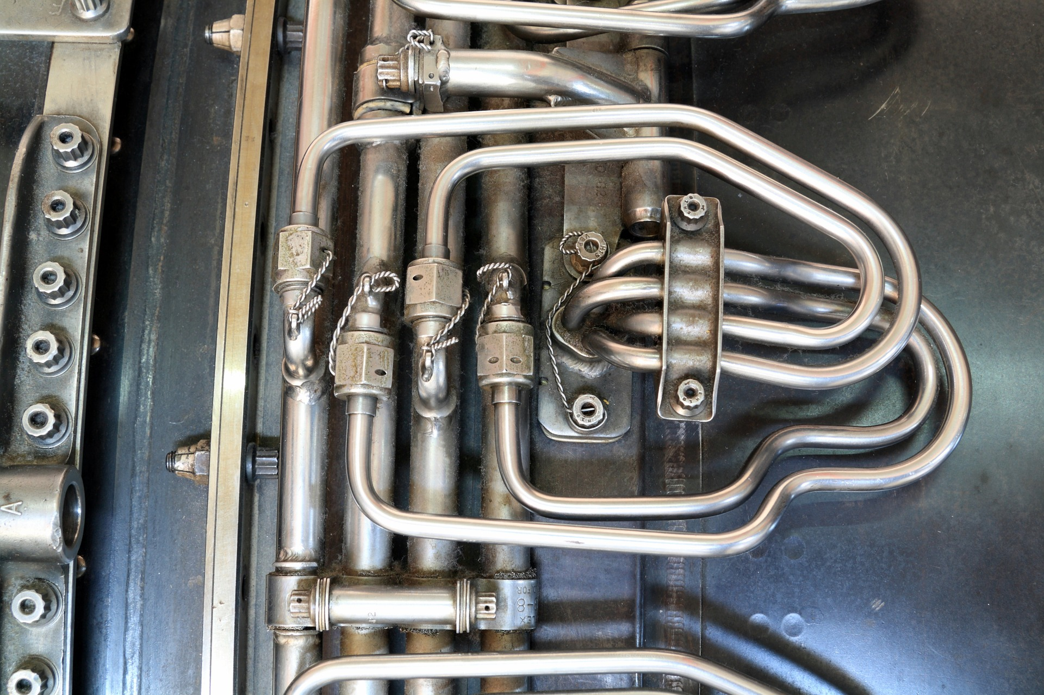
Caption: Like this engine manifold, most catalytic reaction pathways need to be explored with care, combining a variety of experimental and computational approaches to map out and test the different pathways. With such complexity, prediction remains a challenge. (Image by 2427999 from Pixabay).

1. Introduction
Computational chemistry has matured considerably, and calculated results, particularly those obtained with Density Functional Theory (DFT), are frequently used to support the interpretation of experimental data with structural insights, calculated spectroscopic data and testing of mechanistic hypotheses, increasingly presented in integrated studies. Alongside these, improvements to computational methodology, benchmarking studies and extensive computational mechanistic studies are also frequently described in stand-alone reports, highlighting ongoing research developments in computational chemistry and showing how practitioners are addressing challenges and seeking to improve the accuracy of calculations. While there are known issues around selecting a suitable computational methodology, arising mainly from the lack of systematic improvability for density functionals, a recent perspective review (1) has identified further contributions affecting the accuracy of computational mechanistic studies, namely the treatment of entropic, thermal and solvation effects, the representation of the system in a computational study, in particular small molecules, ion pairs, aggregates and the formation of salt byproducts, the exploration of conformational space and concentration effects and the consideration of selectivity, producing a roadmap for the design of mechanistic studies to support catalysis. Overall, though, computational contributions to homogeneous catalysis are now a routine part of the toolbox used by practitioners and, as a result of these advances, publications are rife with computational mechanistic studies and their contribution to the design and optimisation of catalysts has been extensive (2).
Many of these studies are focussed on rationalising the reaction mechanism(s) underpinning the catalytic reaction under study. However, a step-change in the application of computational methods would be to achieve the effective, robust, reliable and user-friendly prediction of the outcome of catalytic transformations. While there are promising developments in this direction, the desirable goal of using computational insights to select a suitable catalyst based on the desired synthetic transformation, (3), or, perhaps (slightly) less ambitiously, to achieve reliable prediction of catalyst performance for given substrates based on computational data alone, remains elusive. Achieving this goal continues to motivate the application of new approaches in the field of catalyst design (4), most recently the coupling of machine-learning and related, data-led approaches to mechanistic insights (5-13). Such interactions will be necessary to achieve predictions on timescales which are useful to chemical synthesis (14).
While data-led approaches are often described as attractive because mechanistic insights are not necessarily required from the outset (13), the experimental data used to train models is likely to be incomplete or remains focussed on local chemical space, potentially limiting the scope for prediction, and it is important to be clear about such limitations. Some recent efforts follow on from previous applications of evolutionary algorithms to homogeneous organometallic catalysis (6) and seek to apply machine-learning approaches with mechanistic insights to identify improved catalysts (9-12); such approaches imply that the mechanism is robust to the chemical changes sampled, which may be, at times, a limiting assumption for the models developed, especially as consideration of wider catalyst space is attempted, as we will explore in section 4.
In contrast, the “gold-standard” of a complete, experimentally validated, potential energy surface for the catalytic reaction coordinate, with concomitant identification of catalyst (de)activation processes, is an attractive goal for physical organometallic chemists, which would enable reaction prediction. However, (2, 15) (16) the most common experimental observation is that what looks like a minor change to substrate or ligand leads to a reduction in reactivity and yield, a change of selectivity or indeed unwanted side products, necessitating extensive screening (15-16). Indeed, while the effects of different substitution patterns on specific states may be readily calculated, there is also the potential to access new, unanticipated, reaction pathways. Rather than dealing with a single, robust catalytic cycle, data so far suggest that the mechanistic manifold of many successful catalysts is complex (2, 15), meaning that small changes to the variables involved can alter the outcomes significantly (16), usually to the detriment of catalyst performance. Nevertheless, the benefits of achieving a fundamental understanding of the factors controlling reactivity and selectivity across chemical space continues to be a key academic focus and benefits from linking experimental and computational studies to best effect.
While we continue to strive to fulfil the promise of computational predictions of reactivity for synthetic chemistry, it is timely to reflect on the assumptions made and the limitations of such studies and models, both in general terms and specific to organometallic catalysis, and so to clarify what inputs will likely be needed and how those might be obtained. By highlighting recent promising advances in the interactions between computational and experimental studies and exploring their extensions to the mapping of synthetically-accessible chemical space, we begin to suggest a protocol for interactions focussed on catalyst characterisation and the capture and curation of data, along with proposing an alternative prioritisation when allocating computational resources.

2. Computational Methodology
Access to computational resources has improved for most users, especially those in academic research, allowing the consideration of relatively large complexes along the catalytic cycle (2, 17), and the need for consideration of multiple conformers and isomers is becoming increasingly recognised; it is of particular importance where selectivity is of interest (8, 18-21). Going forward, new semi-empirical/tight-binding approaches are likely to improve this aspect of exploring the relevant potential and free energy surfaces further, with improved agreement with DFT calculations potentially streamlining the evaluation of multiple options (21-25).
As we will show below, reliable comparison of competing reaction pathways remains challenging even with good-quality DFT (26), with different functionals at times leading to conflicting predictions,(27) but experimental insights and/or calibration against calculations at higher levels of theory may serve to tension the data where DFT accuracy alone is uncertain or insufficient. Furthermore, as recently highlighted by Brakestad et al. (28) calculations of this type have an error associated with the basis set. This basis set error results from two factors. Firstly, all basis sets are finite, as well as mathematically convenient functions, and thus do not constitute a complete basis set, and secondly, basis set superposition error (BSSE) arises from the sharing of basis functions between atoms in a molecule which may artificially improve the description of the system, whereas this is not feasible for smaller molecules, such as ligands and solvents considered separately when binding energies are calculated. Brakestad et al. demonstrate how an alternative multiwavelet approach may circumvent the basis set error, however, this option is not yet available in most available software for electronic structure calculations and the use of standard basis sets in DFT approaches means that basis set errors are present in most calculations.
Furthermore, the treatment of solvent and salt effects, traditionally left out of models for computational simplicity (1), continues to be explored and improved as well (1, 29-34), with some examples considered below. Some workflows and corrections are becoming accepted for routine cases, i.e. catalytic cycles where the solvent is not directly involved (1, 17), and a growing body of knowledge is being developed about what to do for exceptions, such as solvation changing the reaction pathway (32-33) and solvent-mediated/outer sphere pathways (35) where the use of molecular dynamics is of growing importance (30-31, 36-38). As the system considered becomes more complex, we would also encourage a degree of pragmatism: data that are consistent/deviate systematically may be “good enough” for a problem in hand (1, 34), whereas a full evaluation may be computationally costly and not add further chemical insights. Key to such decisions is often a validation against available experimental data, which, as we discuss below, can be difficult to obtain.
One additional aspect, which is explored in some mechanistic studies reported, but rarely discussed in its own right, is the value of sampling chemical space in computational mechanistic studies, changing key variables such as catalyst (37), ligands (5, 39) and reagents (39-40), especially where experimental screening and substrate scopes have been reported and provide validation, and seeking to explore the effect of such variations on the mechanistic manifold. As we have alluded to above and will highlight further in sections 3 and 4 below, many familiar catalytic routes involve a range of competing pathways, making it more appropriate to consider a manifold than a single cycle, and introducing such variations to the computational evaluation of mechanistic hypotheses can help to determine their robustness. In the extreme, all variations could be explored for all variables (albeit at considerable computational cost), but more commonly this can be used to identify where additional experimental insights would be most valuable as a limit for calculations is reached.
Finally, we propose that a single pass of computational study, usually to confirm a mechanistic hypothesis, is insufficient if we want to move towards computational prediction. Instead, where calculations suggest that a mechanistic hypothesis is viable, additional calculations, e.g. on key variables, could be used to make a new computational prediction which can then be tested and challenged experimentally. With such results in hand, the calculations can then be refined to take account of such variable effects on the reaction outcomes, moving towards a more comprehensive exploration of mechanism, backed up by experimental insights. Such feedback loops, and the curation of the resulting data, will ultimately facilitate the development of more general models in this area.

3. Experimental Approaches Particularly useful to computational studies
Arguably the most common interaction between experiment and calculation in mechanistic organometallic studies is through the evaluation of a mechanistic hypothesis relatively late in the development of a catalytic route (41), usually shown as a proposed catalytic cycle, by DFT calculations (2), with the occasional exploration of a small subset of variables (ligands, reagents, substrates) if those are synthetically interesting once the mechanism has been established. While this approach can confirm that a mechanistic hypothesis is energetically accessible if Transition State Theory and the Eyring equation (see sidebar 1) hold, i.e. barriers are low enough to give viable rates under the reaction conditions, this does not necessarily mean that the mechanism holds true in practice.

Sidebar 1: Transition State Theory and the Eyring equation (adapted from (42-43)
Drawing on statistical thermodynamics, Transition State Theory seeks to relate the rate constant to a model of a chemical reaction. It assumes that an activated complex is in equilibrium with the reactants; the rate at which this activated complex rearranges to products depends on the rate with which it reaches the transition state, i.e. the arrangement of atoms that will lead to products. The standard Gibbs free energy difference between the reactants and the transition state for the reaction (free energy of activation, ΔG‡) can be used to estimate the rate constant, expressed as the (simplified) Eyring equation (also sometimes referred to as the Eyring-Polyani equation):

where k_{B} – Boltzmann’s constant, T – temperature, h – Planck’s constant, c_{std} – standard concentration, Δn is change in number of molecules between reactants and products (1/c term makes unit consistent, often left out).
This allows the conversion between reaction rates and (calculated) barriers at reaction temperatures and is often at the heart of discussions about mechanistic hypotheses. The exponential function in this equation amplifies computational errors substantially, such that predicted rate constants can be wrong by several orders of magnitude, and conversion is often avoided. Even in these cases, computational studies of mechanism can provide important structural and energetic insights and often allow comparison with related systems.

Scheme 1: Reaction pathways and intermediates for the oxidative addition of ArX by a palladium catalyst [PdL_{n}]. (Reproduced from reference (39) with permission from the Royal Society of Chemistry.)

The reactions shown in Scheme 1 highlight an example of where the choice of computational method make an important outcome on the predicted reaction profile (44). In the case of the oxidative addition step, which most palladium-catalysed cross-coupling reactions are thought to have in common, DFT calculations without dispersion corrections predict a clear preference for a dissociative pathway (path A, Scheme 1), while a more balanced treatment of dispersion, solvation and entropic contributions is required to approach agreement with experimental kinetic measurements which suggest that an associative displacement (path B) is more likely (39-40). While the ligand effects on the oxidative addition were captured well, even though there was considerable variation even within a subset of large, electron-rich ligands considered privileged for cross-coupling reactions (PtBu₃, PCy₃, PPh₃, SPhos), the effects of the arylhalide on the favoured oxidation addition pathway were not fully captured by the calculations (39). In that study, we relied strongly on kinetic data reported for different ligands (see references (39-40) for full details and citations), as well as using crystal structure databases in conjunction with conformational searches to ensure that low energy conformers and isomers were considered. New experimental insights about catalyst speciation and precursors continue to emerge for this family of palladium-catalysed reactions as well, see, for example, references (45) and (46), suggesting that our understanding remains incomplete.
While calculations can make vital contributions and lead to new developments (2, 47-49), stable precursors, catalyst speciation, intermediates and resting states involving the catalytically-active metal can at times be difficult to assess from calculations alone and would ideally be monitored further experimentally to ensure that computational mechanistic studies are aligned well. We regard these observations as the cornerstones of any mechanistic hypothesis and the characterisation of such compounds provides very useful inputs to DFT, tensioning structural data and favoured isomers, helping to identify the metal coordination sphere and challenging energetic data.
With this in mind, it is worth briefly reviewing the nature of experimental information which may be obtained and how it can relate to the results from calculations. In nearly all synthetic chemistry, the two principal measures of success of a given reaction that are normally reported are yield and selectivity. Isolated yield is an excellent measure of the effectiveness of the reaction in delivering the desired material. From a mechanistic perspective, conversion to product(s) is probably a more useful metric as it is not subject to any artefacts introduced during the purification process. Both yield and conversion give insight into the efficacy of the catalyst and thus indirectly, the prevalence of catalyst deactivation pathways. Further characterisation of the reaction mixture to identify side products can provide additional insights about competing pathways.

Sidebar 2: Formalising computational data analysis with the Energetic Span Approach (adapted from reference (50))
For many catalytic cycles, the overall kinetic information requires consideration of more than one reaction step or transition state, especially when assessment in terms of turnover frequency (TOF) determines the efficiency of a catalytic cycle. While this can be assessed by careful consideration of the entire reaction pathway, the analysis has been formalised several times (50-52), building for example on reports by Christiansen and others (53-54). Perhaps the most prolifically used example of such a formalism in organometallic catalysis (55) has been the energetic span model described by Kozuch and Shaik (50) which defines TOF-determining transition states (TDTS), TOF-determining intermediates (TDI) and the reaction energy, ΔG_{r}, leading to a modified version of the Eying equation where the energetic span, δE, of a cycle is used:
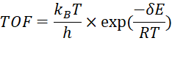
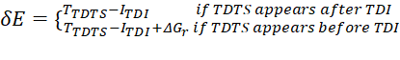
where T and I are the standard state Gibbs energies of the intermediate or TS, and ΔG_{r} is the energy of the reaction.
Key to this approach is the recognition that TDI and TDTS are not necessarily the highest and lowest energy species, and they also do not have to be adjacent to each other on the potential energy surface; sometimes a second cycle needs to be considered to identify these states. Further conclusions about which species affect the reaction rate can be drawn, as discussed in detail in references (50) and (51).

The selectivity of the reaction (which is again better measured either in operando or on crude reaction mixtures) provides insight into the differences in energetic spans (sidebar 2) of competing reaction pathways (presuming that the reaction is solely under kinetic control). Such insight can then be related to the predicted potential or Gibbs free energy surface, however, the logarithmic relationship between rate constants and free energy changes as expressed in the Eyring equation (see sidebar 1) means that small errors in the calculated barriers of key reaction steps (and so the energetic span) will significantly alter predicted selectivity.
As noted above, studies of the catalyst activation process and analysis of spent catalytic reactions can also provide important information about entry and exit from the catalytic cycle, informing catalyst design (45, 56-57) and enable the identification of otherwise unexpected mechanistic pathways (58). These may be further complemented through in operando methods which can enable the identification of intermediates (59). An important caveat is that species observed in this manner are, at best, resting states and may be off-cycle.
With a postulated catalytic cycle, anchored by such observations, in hand, detailed kinetic study, ideally across a range of catalysts and substrates, becomes key and has arguably driven many of the developments in blockbuster applications of catalysis, such as for palladium-catalysed cross-coupling (60). Experimentally determined rate laws can help to identify key species and steps along the catalytic cycle, and their combination with microkinetic modelling (61) for the analysis of computational data provides a fertile testing ground for calculations (34, 56), reviewed further below (section 4). However, determining elemental rate constants for individual mechanistic steps is challenging. In most in operando measurements, the measured rate constants are composite quantities, covering multiple steps. When considering the computational potential energy surface it may be possible to relate an observed rate constant to the rate-determining states within the rubric of the Energetic Span model (sidebar) (55). However, it is not possible then to evaluate the accuracy or validity of the calculated states which are non-rate determining but may play an important role in controlling the selectivity of a reaction (62).

Scheme 2 Experimentally observed states and KIE values for intramolecular proton transfer within the coordination sphere of manganese. Adapted with permission from reference (63). Copyright 2021 American Chemical Society.

In recent studies, time-resolved spectroscopy has been used to overcome these issues and highlights the pitfalls of measuring composite rate constants. For example, time-resolved infra-red spectroscopy has been used to measure the rates of proton transfer from a coordinated acetic acid which results in Mn–C bond cleavage (Scheme 2); this process is the microscopic reverse of the Concerted Metalation Deprotonation reaction mechanism (63). Photolysis of Mn(CO)₄(ppy) (ppy = metalated 2-phenylpyrinine) results in loss of a CO-ligand in < 1 ps and coordination of the solvent to the metal (64). If the solvent is acetic acid then, following an initial unselective coordination and rearrangement to an O-bound isomer, proton transfer from to the organic ligand can be observed in ca. 100 ns. A KIE of 5.8 ± 0.1 was observed for this step. Performing the same experiment in a toluene solution of acetic acid results in the formation of the same product, however, initial binding of toluene to the metal occurs as this is a kinetically controlled event and the solvent is in large excess. The intermediate states for acetic acid coordination and proton transfer cannot be observed because they occur much faster than the rate of substitution of the solvent. Indeed, in toluene solution, the formation of the final product had a KIE of 1.41 ± 0.19, illustrating this point. Therefore, by performing such reactions in neat substrate, it is possible to observe catalytically-relevant elementary reaction steps which are obscured in ensemble measurements performed in operando (65). This enables direct correlation and validation of the computational predictions made about non-rate controlling processes. These observations are further illustrated in a recent study of C–H bond activation by a half-sandwich cobalt complex (66). An experimental KIE of between 1.4 and 2.0 was measured. The authors then used the DFT-calculated harmonic vibrational frequencies to calculate the KIE for each step in the C–H bond activation processes via the simplified Bigeleisen equation. This revealed that the KIE for the actual bond cleavage was predicted to be 7.1.

Such insights are still relatively rare, such that many mechanistic postulates lack experimental foundations; in such situations, energetically accessible barriers are clearly not sufficient to fully validate a mechanistic hypothesis, because there may be another pathway of lower energy which has not been considered, such that insight into individual steps remains opaque. Advances in experimental methodology, such as the application of time-resolved spectroscopy, offer the opportunity to meet these challenges and provide the required mechanistic insight.

In terms of analytical technique, the experimental toolbox is potentially extensive, but often only used when problems become apparent. While isotopic labelling and the determination of kinetic isotope effects are not new tools for mechanistic studies in organometallic chemistry (67-68), recent examples continue to highlight the insights gained from such experimental approaches and how these can be used to develop mechanistic postulates.

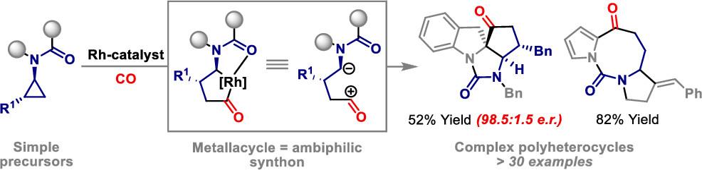
Scheme 3: Graphical abstract. Reprinted with permission from reference (69). Copyright 2020 American Chemical Society.

In an extensive experimental and computational study of rhodium-catalysed formation of polycycles (Scheme 3), deuterium incorporation at different sites suggested a reversible C-H activation process, guiding a computational mechanistic study which in turn inspired further experiments that led to the proposed reactivity platform for complex and diverse polyheterocycles otherwise inaccessible (69). The computational study, while hampered by a lack of structural insights into the coordination environment of the rhodium catalyst, has been related to the available experimental data with considerable care, allowing a critical examination of competing mechanistic postulates which helped to inform further experiments.

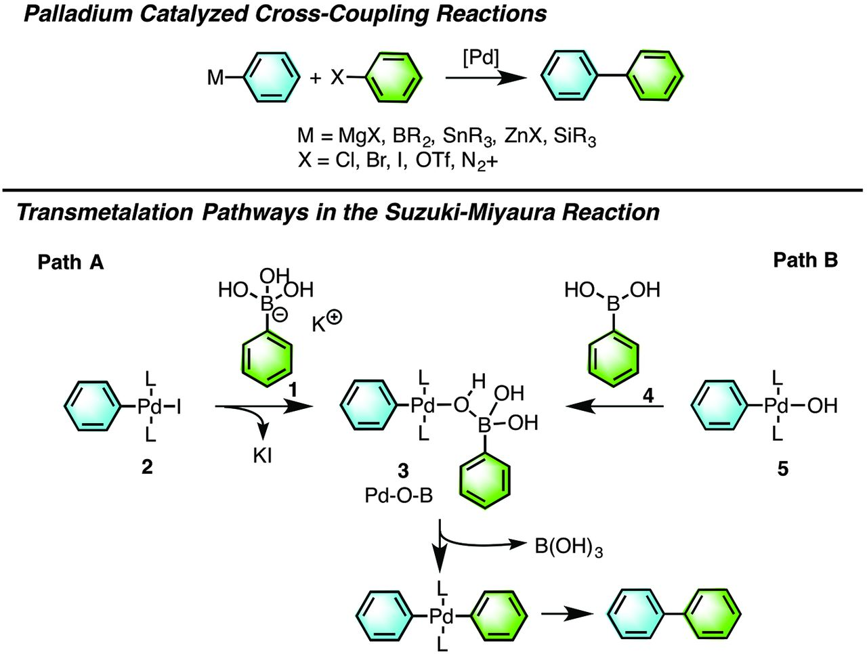
Scheme 4: Summary of possible transmetalation pathways in Suzuki-Miyaura reactions. From reference (70). Reprinted with permission from AAAS.

NMR studies focussed on nuclei other than ¹H and ¹³C can also provide important insights on stable intermediates, especially when using low-temperature rapid-injection NMR techniques to provide kinetic data and structural insights for key intermediates as described by the Denmark group for the transmetalation step of Suzuki-Miyaura reactions (Scheme 4) (70-71). Their studies used a combination of ¹¹B, ¹⁹F and ³¹P NMR results obtained on stoichiometric mixtures to characterise a range of complexes containing the postulated Pd-O-B bonds and monitor their reactivity in situ. The kinetic data obtained were related to calculated free energy profiles (71) and further explored in a computational study by Yaman and Harvey (reviewed in section 4 below, (34)).
More generally, in situ and in operando modelling of reactions can be achieved with a range of analytical techniques and recent examples have also demonstrated how ESI-MS measurements can inform mechanistic studies (72-73). For example, further insights about the fate of the metal catalyst in Suzuki-Miyaura coupling have been obtained by ESI-MS study using a palladium-ligand combination with moderate catalytic activity to facilitate direct monitoring of the reaction mixture (74). These observations provide rich data on stable intermediates and support kinetic analysis (Scheme 5).
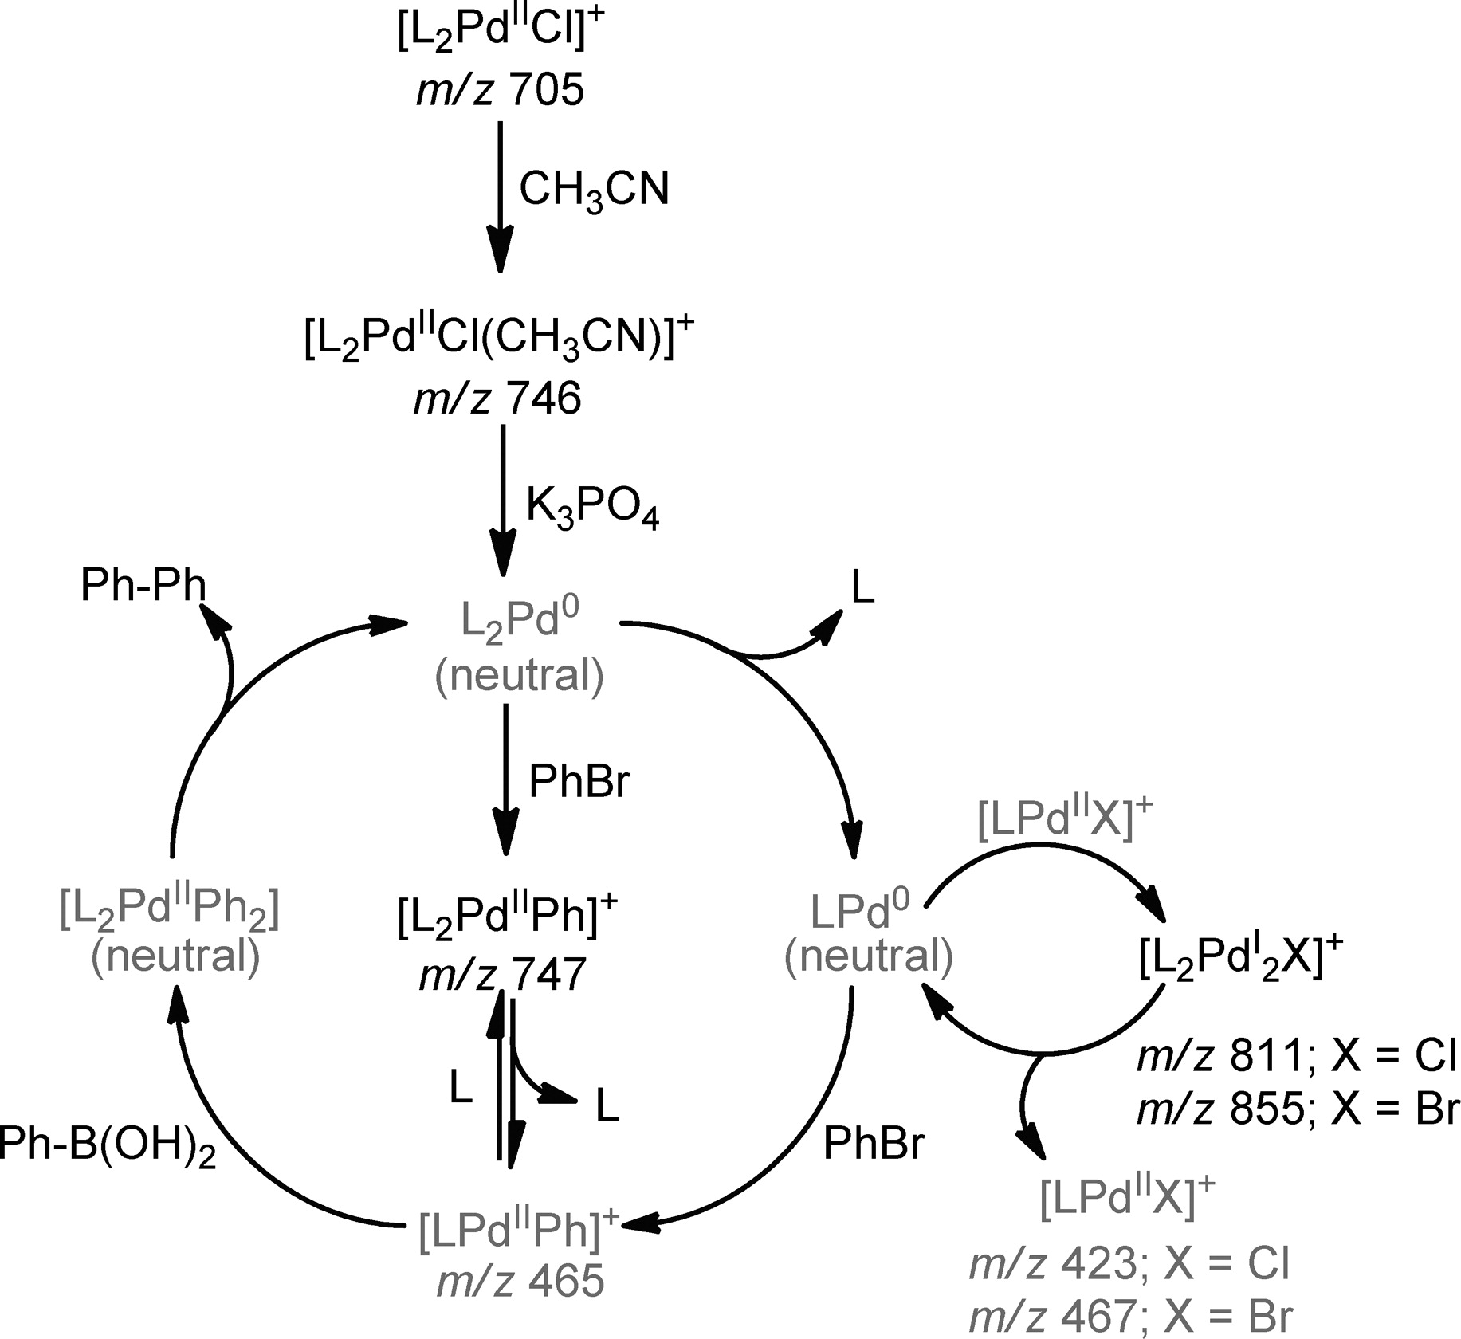
Scheme 5: Proposed Mechanistic Pathway for Suzuki–Miyaura Cross-Coupling by a Dichloro-bis(aminophosphine) Complex. (The species not observed during ESI-MS analysis (including the corresponding neutral intermediates) are depicted in grey.) Reprinted with permission from reference (74). Copyright 2011 American Chemical Society.

Scheme 6: (i) Toluene 16 hrs, r.t., (ii) CH₂Cl₂, 16 hrs, r.t. - [Au(PPh₃)₂]SbF₆. Reproduced from reference (27).with permission from the Royal Society of Chemistry.

In an attempt to synthesise stable gold vinylidene complexes rooted in computational prediction (27, 75), we found that CNC pincer ligands were able to stabilise unusual trinuclear gold complexes as shown in Scheme 6 (27). While intra- and intermolecular π-stacking interactions from the pincer ligands facilitated the isolation of these complexes, likely making them a thermodynamic sink, calculations predicted that related PPh₃-ligated gold complexes might also be energetically accessible, even though the dinuclear σ-π complexes ([5]SbF₆ in Scheme 5) were predicted to be more favourable (albeit only by 6-8 kJ mol⁻¹). We used ESI-MS and ¹³C-enriched NMR spectroscopy to detect a trinuclear gold alkynyl complex with PPh₃ ligands in situ, highlighting how such techniques can be used to tension calculated data against experimental reality. ESI-MS and ¹⁹F NMR data also supported the development of a gold-mediated Negishi coupling reaction (76), suggesting that the fascinating chemistry of gold complexes can be studied well by mass spectrometry, not in the least because few other compounds occur at the exceptionally high masses involved..
Catalysis by first row transition metals is mechanistically challenging (17), as a broader range of spin states and coordination isomers could potentially be accessed over the course of the reaction, or several pathways might be in competition. In this field, techniques such as Mössbauer, EPR and related inorganic spectroscopic approaches can also contribute useful experimental insights, although we note that such equipment is less common in research laboratories than NMR, IR and ESI-MS while the interpretation of measurements is more involved, often requiring computational input. In consequence, computational data are often crucial in this field, and integrated closely with other experimental techniques (77-78).

Scheme 7: a) 1 reacts with borane to generate 1_{A}, which can then undergo further stabilization with alkene; b) proposed Fe(I/III) catalytic cycle for the isomerization of allylbenzene. Reproduced from reference (79).

When exploring double bond isomerisation catalysis by an iron(II) β-diketiminate complex (Scheme 7, (79)), we found that we needed to bring a full spectrum of synthetic, computational and spectroscopic insights to bear to develop and assess a mechanistic proposal, as these catalysts can access different spin states along the reaction coordinate. With minimum energy crossing points (MECPs) difficult to determine, experimental data were at times easier to obtain than reliable computational predictions, although we note that in such cases the whole can be very much greater than the sum of its parts, showing the benefits of a close integration of experimental and computational insights about the mechanism of organometallic catalysis. Similar synergies in the study of iron complexes have been demonstrated in a collaboration between the groups of Bedford, Harvey, Murphy and Neidig (80), and the interplay between different approaches in more recent work from Bedford et al. e.g. described in reference (81).
As noted, data curation is also important in this context – one challenge at the moment is that reactions are individually optimised (which makes eminent sense when seeking to achieve synthetic goals, but provides fewer gains towards in silico prediction), such that it becomes difficult to compare experiments and isolate variable effects without experimental design. This limits the opportunities for developing predictive models across wider chemical space, especially those trained on experimental figures-of-merit. Where screening data have been reported for a standard set of conditions and considered a consistent subset of catalysts/ligands, data can be calibrated, improving the sampling of chemical space. This can help to identify mechanistic change along with improving the conditions for data-led optimisation and prediction (82-85). If those screening results were further enhanced by repeated sampling during each reaction, allowing at least rudimentary kinetic analyses, e.g. from initial rates, the conditions for data-led predictions could be improved substantially, especially with more open access to such data and appropriate curation. Such information-rich screening data has been reported in some cases, see reference (86) for an example.
As noted, experimental insights are often crucial to tension computational mechanistic studies, and while here we have focussed on the contribution and value of experimental data, in the next section we will look at studies where computational results have been used to complement experiments, with a clear understanding of their strengths and weaknesses in a synergic relationship.

4. Validation of Mechanistic Proposals
The alkene hydroformylation catalytic cycle for unmodified cobalt complexes arising from [HCo(CO)₄] has been explored by the Harvey group and collaborators (Scheme 8, (56, 87)), to identify which factors determine rate and selectivity. DFT calculations were refined with CCSD(T)-F12 single point energies, and the predicted kinetic behaviour was then analysed in detail, allowing the authors to compare experimental and theoretical rates. These were found to be in good agreement, allowing the identification of the turnover-limiting step as alkene coordination (87). Later work (56) explored regioselectivity further and expanded the catalytic manifold to consider competing hydrogenation reactions, as well as exploring an alternative, dinuclear cobalt complex involved in aldehyde formation (Scheme 8). Kinetic profiles have again been simulated and compared to experimental data, achieving reasonably good agreement based on ab initio free energies alone, leading the authors to explore the sensitivity of kinetic predictions to the calculated data and so pinpointing where the model has weaknesses. These results allowed the identification of alkene addition and reductive elimination steps as competing, turnover-limiting pathways and support the introduction of the dinuclear route to the catalytic manifold as well. Key to the success of this work is that this hydroformylation reaction has been studied extensively, allowing close comparison with the experimental data.
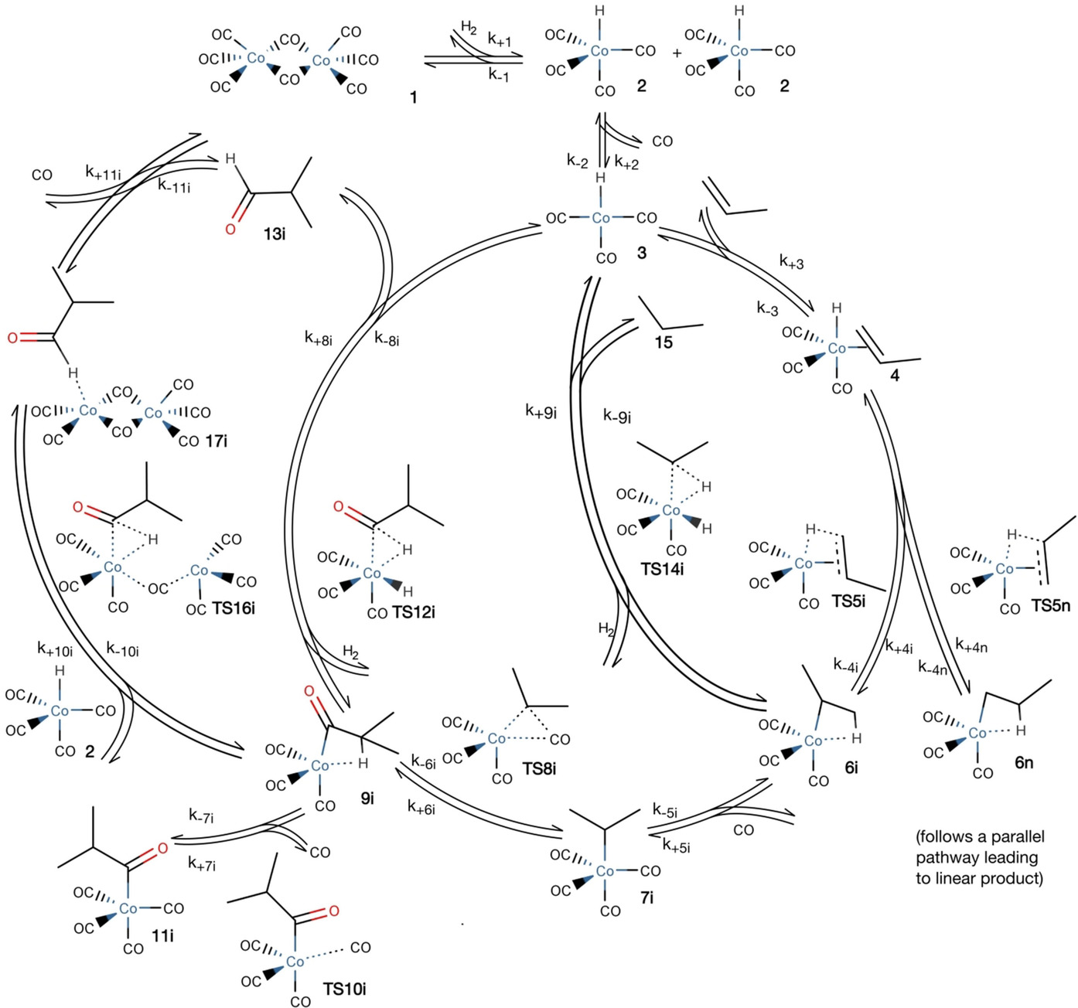Scheme 8: Reaction steps considered in hydroformylation and hydrogenation of propene by unmodified cobalt carbonyl catalyst. Reproduced with permission from reference (56). Copyright John Wiley & Sons 2018.

A similar approach, albeit based on DFT-D3BJ data alone, has been applied by the same group to Suzuki-Miyaura coupling (34), prompted by the publication of the rapid-injection NMR results on complexes with Pd-O-B linkages reported by Thomas, Denmark and co-workers as described earlier (Scheme 3, (70-71)). The speciation of boronic acid and the role of solid base in calculations were assessed with considerable care in this work (34), and the authors then expanded their study to consider the entire catalytic cycle, achieving what they describe as “fair agreement” with experiment, albeit not quantitative. In contrast to other studies, their treatment highlights that several steps have similar energy requirements , suggesting that catalyst optimisation likely needs to look beyond the oxidative addition. They also raise concern that further computational and experimental studies will be needed to improve quantitative agreement.

With the growing interest in the use of Earth-abundant transition metal catalysts, mechanistic studies combining computational and experimental insights are increasingly being reported. In a study of copper-catalysed Ullmann coupling of aromatic alcohols with aryl halides (88), the Hartwig group and collaborators report structural and kinetic analyses using a broad range of techniques, along with a DFT study of the parts of the catalytic cycle which could not be assessed experimentally (Scheme 9).
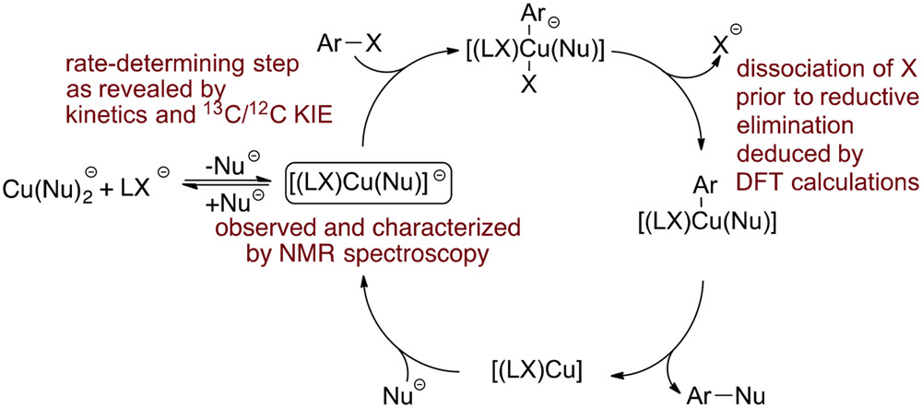
Scheme 9: Graphical abstract for reference (88), summarising the synergy of experimental and calculated approaches used. Reprinted (adapted) with permission from reference (88). Copyright 2018 American Chemical Society.

The work was motivated by four mechanistic proposals reported in the literature which were based on DFT calculations, lacking experimental data to distinguish between different options. In contrast, in this work (88) key intermediates were synthesised, characterised and their catalytic competence evaluated with different supporting ligands that are anionic, including a 1,3-diketone in common use, using a range of spectroscopic techniques (¹H and ¹⁹F NMR, UV-vis, ESI-MS), to confirm that three-coordinate, mononuclear copper complexes are stable. Radical clock reactions confirmed that free aryl radical intermediates are unlikely, and kinetic studies on stoichiometric reactions were then used to show that an anionic pathway is likely, while kinetic isotope effects demonstrated that the oxidative addition step is likely to be turnover limiting. Finally, a Hammett plot was used to further confirm that an anionic pathway is indeed more likely. Computational mechanistic studies on a simplified model complex without dispersion corrections alone were not able to distinguish between neutral and anionic pathways but helped to settle the most likely reductive elimination route as occurring after iodide dissociation. Again, only the combination of experimental and computational insights allowed the authors to draw such conclusions and the skilful combination of approaches to compensate for weaknesses of techniques used in isolation is noteworthy.

The mechanistic challenges and diversity posed by copper catalysts is also highlighted in a study by Gribble, Liu and Buchwald (89), which investigated the direct asymmetric dearomatisation of pyridine catalysed by bis(phosphine) copper hydride complexes. They brought a range of NMR data and kinetics to bear to investigate and control the selectivity of the reaction, and use such insights to revise their earlier mechanistic proposal involving two CuL₂ units in the reaction (90) (Scheme 10). Their experimental mechanistic studies were then supplemented by testing each possible postulate with dispersion-corrected DFT, as well as supplementing this with additional computational descriptors of aromaticity. They then predicted the likely rate law for a different heterocycle and related this to further experimental study, obtaining good qualitative agreement. In addition, their revised mechanistic model allowed prediction of stereo- and regiochemistry. Key to their work was the close integration of experiment and calculation, showing how different techniques were used in a dialogue of insights to develop their understanding of the likely reaction pathway.
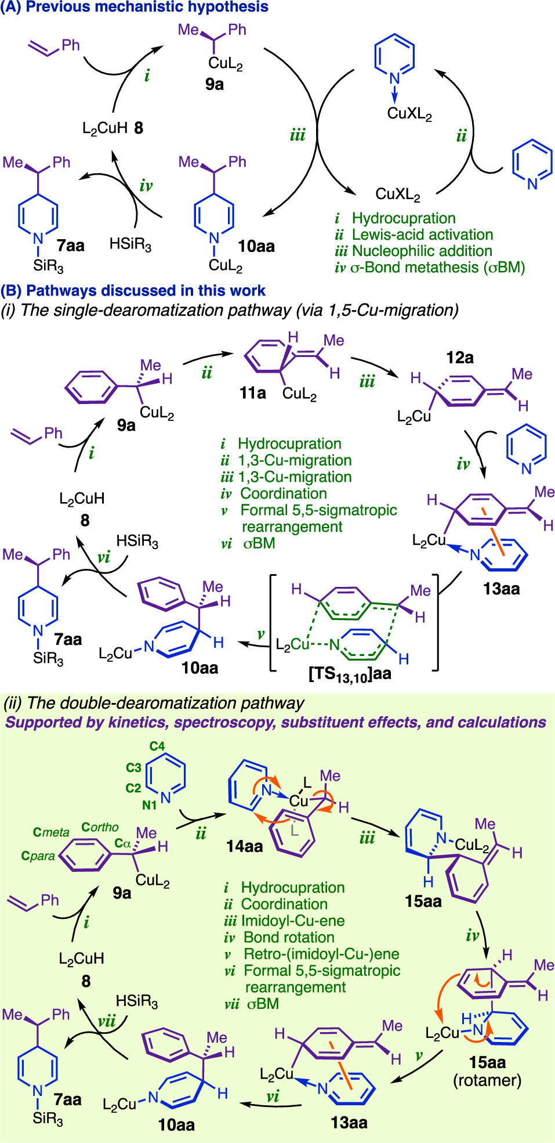
Scheme 10: Graphical summary of the Cu(I)-catalysed direct dearomatisation pathways considered in reference (89). Reprinted with permission from reference (89). Copyright 2020 American Chemical Society.

The last few years have seen other mechanistic studies of organometallic catalysis which use a similar combination of approaches to move beyond confirming mechanism and tension it against experimental data, as well as attempting predictions. Our (non-exhaustive) list of examples includes studies involving the groups of Houk (91), Paton (8, 18, 92), Hopmann (35) and Jensen (93-94), all showing close interaction with the available experimental data and careful hypothesis testing, often across chemical space. These studies show close integration of data from a variety of sources (experimental and computational) can be achieved and helps to elucidate mechanism. These studies also highlight why prediction remains a challenge – subtle changes to the catalyst, ligands, substrates or reaction conditions open up mechanistic alternatives, necessitating further detailed study.
This does not mean that prediction cannot be achieved, just that it will take time and effort to develop the underpinning mechanistic insights and map out not just chemical space, but also what one might term reactivity space, to fully understand the impact of variables involved. A combination with Design of Experiments (DoE) approaches here may prove powerful, but we must concede that the reliability of prediction will only improve as more of the reactivity space becomes understood. This means that currently the time which needs to be invested in understanding mechanism and reactivity is considerable (all studies considered in this study have been extensive and many involved multiple teams), hampering reliable prediction on timescales which are useful to synthetic chemists trying to achieve a transformation in industry and academia. Approaches which seek to remedy this range from automating workflows for setting up calculations (25, 95), development of faster computational approaches (22) and/or taking advantage of new hardware architectures (such as ARM and GPUs), to the application of machine learning and artificial intelligence for catalyst selection.

5. Can we link Machine Learning to Mechanism?
Many applications of data-led approaches to prediction in organometallic catalysis, including our own efforts in this area (3, 75, 96), are based on establishing structure-property relationships between a catalyst figure-of-merit, e.g. yield or selectivity, and suitable steric and electronic parameters. There is a link with the reaction pathway, but it usually remains indirect. As noted above, such relationships also assume that altering the input variables considered does not substantially change the reaction pathway or outcome, allowing chemical similarity to be exploited; as shown in section 3, this does not necessarily hold even for privileged ligands in the oxidative addition step of cross-coupling reactions (39). Such relationships tend to fail as models extrapolate to variables outside of an initial training set. When the energetic balance between key steps along the reaction coordinate is subtle, also observed for other well-established reactions such as hydroformylation (97), small changes can lead to different outcomes and large-scale prediction cannot be achieved. However, if the mechanism is either very robust or mapped out well, large-scale predictions can be attempted, and a few examples have been reported in this area.
Occhipinti, Jensen and collaborators have demonstrated that the catalytic productivity of ruthenium-catalysed metathesis reactions can be assessed by calculating the enthalpy difference of an active complex compared to two key intermediates, as shown in Figure 1 (98). They drew on extensive mechanistic studies to demonstrated that the stability of the metallacyclobutane intermediate correlates with barrier height. Initially, they developed a quantitative structure-activity relationship (QSAR) using this measure to evaluate ligand effects, achieving good agreement with experimental data (98).
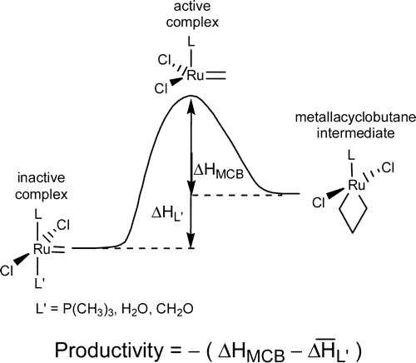
Figure 1: Definition of “productivity” as used as the response variable in the QSAR model building described in reference (98). Reprinted with permission from reference (98). Copyright 2006 American Chemical Society.
In a follow-on study (6), in collaboration with Alsberg and collaborators, they combined this model for the prediction of DFT-based productivity with an evolutionary algorithm to construct new molecular structures from different substituents connected to different scaffolds, including three-coordinate phosphorus and an unsaturated imidazol-2-ylidene. The evolutionary approach mirrored the experimental transition from first to second generation supporting ligands, i.e. phosphines to N-heterocyclic carbenes, along with picking up differences in each ligand class. Predicted productivities for new generations of catalysts were then tested by computing them for the most promising structures with DFT, selecting for likely synthetic accessibility and exploring the impact of various modifications. In their discussion, they highlighted the importance of finding a suitable fitness function, along with extensive information about the mechanism. The computational cost of such evaluations was also noted, emphasising the need for QSAR models and reliable molecular mechanics calculations to achieve catalyst evaluation on faster timescales than DFT and semi-empirical evaluations of fitness.

One strategy to circumvent the direct evaluation of a target property of catalysts in virtual screening, which follows on from this idea, is to use machine learning, trained on DFT or other quantum mechanical approaches.
Work by the groups of von Lilienfeld and Corminboeuf initially relied on a simplified thermodynamic picture of cross-coupling reactions, focussing on the electronic energy of the oxidative addition step to identify catalysts for C-C coupling following a Suzuki-Miyaura reaction mechanism (12). They used a set of 7054 candidates for which full DFT calculations were performed to train their models and then made predictions for more than eighteen thousand ligands, streamlining the approach to rely on rough coordinate estimates, rather than accurate geometries. They tested a range of machine learning models, training set sizes and molecular representations and used their best model, based on a Bag-of-Bonds representation, to identify catalysts that fell on the target region of their volcano plot (Figure 2), which relate the oxidative addition step to the relative free energies of other intermediates and transition states, highlighting the most difficult reaction step as a function of the reaction energy for oxidative addition. (See reference (99) for a more detailed discussion of the process.) These are predominantly based on the group 10 metals (Ni, Pd, Pt) and the authors were able to discern differences in ligand effects for the different metals. These predictions were further evaluated based on estimated catalyst costs, leading to the suggestion of 37 promising targets for palladium and copper.
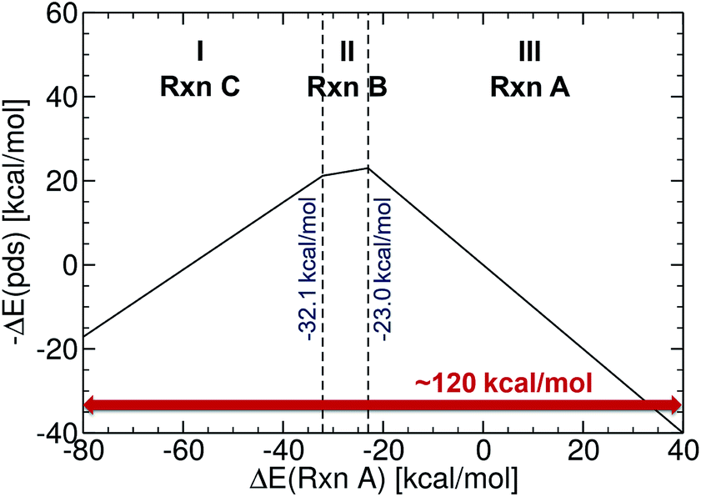
Figure 2: Reference volcano plot for the Suzuki cross-coupling reaction. Region (I) corresponds to reductive elimination, (II) to transmetallation, and (III) to oxidative addition. Acceptable catalysts should fall into the mid region (in between −32.1 and −23.0 kcal mol⁻¹). Reproduced from reference (12) with permission from the Royal Society of Chemistry.

The Corminboeuf group have since tackled a range of different problems with a similar approach, i.e. assessing the entire catalytic cycle through linear free energy scaling relationships shown as a volcano plot, including the hydrogenation of carbon dioxide by pincer-ligand supported metal complexes (100), hydroformylation by group 9 metals (99, 101), a wider range of cross-coupling reactions (102) and to explore catalyst substrate scope (103). However, most of these studies are of medium scale, rather than using machine learning approaches.

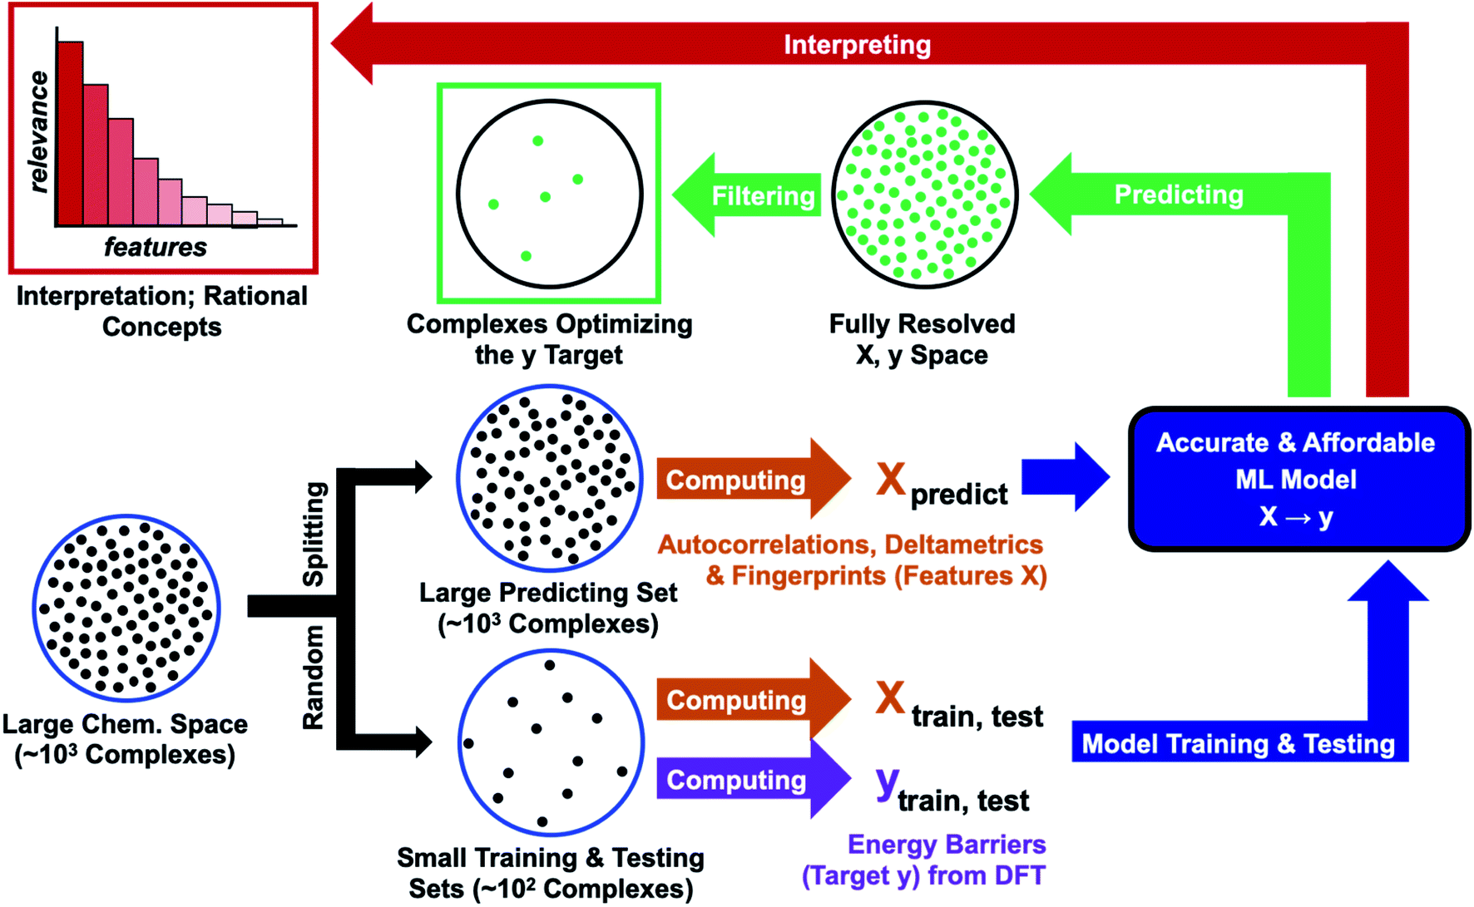
Figure 3: Computational protocol combining DFT calculations with ML methods. Reproduced from reference (9) with permission from the Royal Society of Chemistry.

The groups of Aspuru-Guzik and Balcells (9) have reported a large scale study of the activation of dihydrogen using iridium complexes related to [Ir(PPh₃)₂(CO)(Cl)] as a case study. They explored combinations of ligands to generate unique square-planar trans iridium(I) complexes from three different ligand sets and evaluated the transition state for H₂ activation for each combination, as shown in Figure 3 These results were then used as a response in machine-learning models based on feature sets derived from atomic properties aggregated for each complex (autocorrelations and deltametrics, illustrated in Figure 3), which have very low computational costs. A range of machine-learning approaches were considered, and the authors found Gaussian processes to give particularly good performance. A model was also trained to predict the H-H distance at the transition state, generating improved guess structures for optimisation. The authors also explored whether their models could be interpreted in terms of familiar steric and electronic effects and found that most results were in good agreement with the known design criteria of electron-rich metal centres promoting the oxidative addition of dihydrogen. The authors provide extensive guidelines for deploying this approach, including a clear-eyed evaluation of the limitations, i.e. the limited transferability to other experimental and computational approaches and the focus on a single energy barrier, where other steps along the catalytic cycle may take over in determining reactivity overall. As with other examples, the importance of detailed mechanistic study, along with the sensitivity of organometallic catalysts to small changes which may limit the predictive power of models is noted again; synthetic accessibility of complexes may also be a consideration.

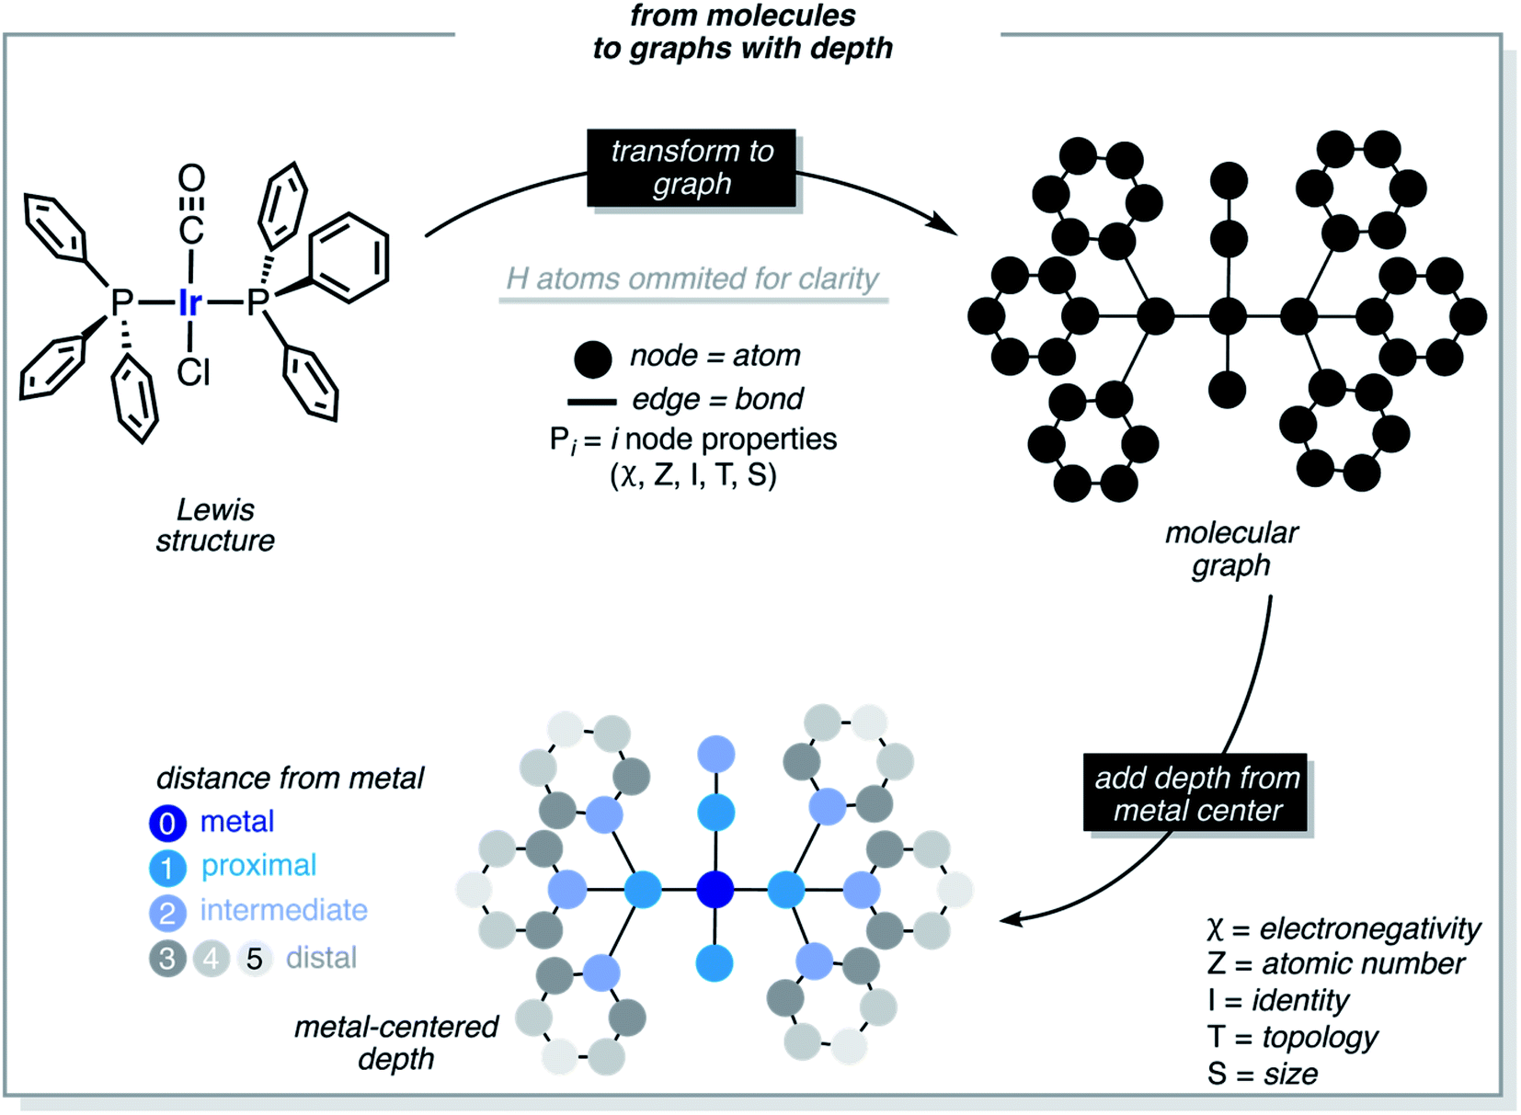
Figure 4: Molecular graph and depth concepts used in the calculation of the autocorrelation and deltametric functions. Reproduced from reference (9) with permission from the Royal Society of Chemistry.

The groups of Bischof and Ess have combined their previous work on chromium catalysts used to control the balance between ethylene trimerization and tetramerization (104) with a machine learning approach (11), with a view to accelerating catalyst design (Figure 5).

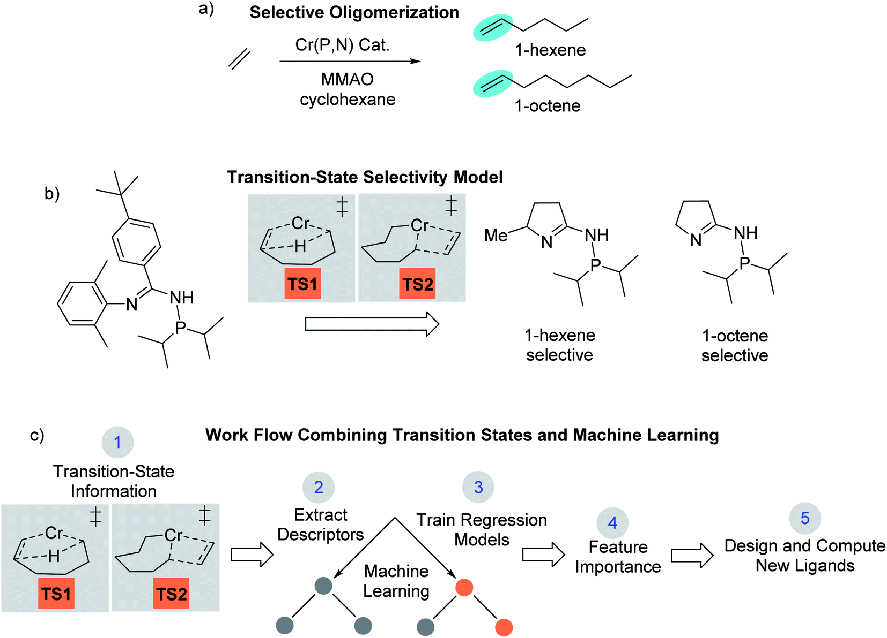
Figure 5: a) Outline of Cr catalyzed selective ethylene oligomerization reaction conditions with targets of 1-hexene and 1-octene. The catalyst involves a Cr metal center with phosphine and imine ligand coordination. MMAO is typically used to activate the pre-catalyst complex. (b) Outline of using TS1 and TS2 as a selectivity model to design new monocyclic imine Cr(P,N) catalysts that are 1-hexene and 1-octene selective. (c) The work presented in reference (11) involves using the 1-hexene/1-octene transition-state selectivity model combined with machine learning models to reveal selectivity controlling features that are then used for virtual design of new catalyst ligands. Adapted from reference (11) with permission from the Royal Society of Chemistry.

The authors generated transition state data for a training set of 105 P,N ligands using DFT calculations and harvested a range of structural and electronic parameters from these geometries. They then tested a range of different models to optimise the prediction error when relating the parameters to transition state energy differences, finding random forest models to give the smallest error; in further analysis, they establish the selectivity ranges for which their model performs best, as the data were not distributed evenly. While the DFT model performed well, the machine learned random forest model did not reliably reproduce experimental selectivities. That notwithstanding, the model highlighted which parameters are most important in enhancing the desirable 1-octene selectivity. Their final step (Fig. 6c, 5) appears to rely on chemical intuition to propose new ligand geometries that support the key structural change (Cr-distance out of pocket), all predicted to have high selectivity. This has been verified for one of the ligands considered by literature searches.

Perhaps the most comprehensive attempt at coupling mechanistic insights to machine learning approaches has recently been reported by a team from AstraZeneca and their collaborators (10). While their study focusses on aromatic nucleophilic substitution reactions, i.e. falls outside of the scope of this review, their insights about sample size are noteworthy (Figure 76), highlighting that small datasets are unlikely to be suitable for machine learning models, whereas quantitative structure-reactivity relationships (QSRR) become viable above 150 datapoints and models based on structures alone become useful with more than 300 examples. In the intermediate regime (50-150 results), a hybrid model combining computational mechanistic study with QSRR as described by them, performed well, and the authors anticipate further developments as the prediction of transition state geometries becomes easier, using transfer learning to pre-train models on DFT-calculated barriers which are then re-trained on experimental data of high quality.

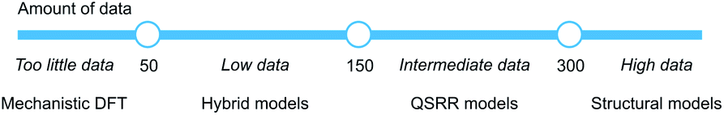
Figure 6: Models for quantitative rate prediction for different data regimes based on the S_{N}Ar dataset
Reproduced from reference (10) with permission from the Royal Society of Chemistry.

While these machine learning/data-led studies hint at a viable strategy for expanding mechanistic insights to wider chemical space and so a large number of catalysts, limiting assumptions about mechanistic robustness must be taken into account when attempting predictions, with organometallic catalysis posing particular challenges as the mechanism is often complicated, with fine energy balances between key steps which can be changed by modifications to the catalyst, substrate and reaction conditions. Capturing this reliably is challenging not just for DFT calculations but also for the generation of experimental data, suggesting perhaps that machine learning approaches must be used with caution and only where extensive data are available. Only a handful of examples seeking to link machine learning to mechanism/reactivity have been reported to date and this field is still very much in its infancy, making it premature and difficult to give clear guidance on which algorithms are suitable. Key to such decisions is what data are available for training and a critical evaluation of the domain of applicability of the models derived, along with a sound appreciation of the statistical assumptions underpinning such models. In addition, while machine learning relies on large and varied data, not all cases may be synthetically accessible, frustrating attempts at model validation as well as requiring further user intervention.

6. Conclusions
Organometallic catalysis is a challenging target for predictions because there are potentially multiple competing reaction pathways which can be accessed by small changes to reaction variables. That notwithstanding, efficient and reliable prediction holds considerable promise for the acceleration and optimisation of this field and we should continue to pursue it. While computational study alone can be used to test mechanistic hypotheses, accessible energetic spans do not automatically mean that the mechanism is correct and we advocate in favour of a close integration of experimental and computational approaches to the elucidation of mechanism, along with the exploration of variable effects and the validation of predictions. A range of experimental techniques are suited well to provide inputs and validation for computational mechanistic study and we have highlighted studies, both collaborative and consecutive, where computational insights have been demonstrated and contextualised, providing a snapshot of the opportunities and limitations for calculations in organometallic catalysis. We have also explored some recent attempts at increasing the scale of studies by data-led and machine learned models which are based on mechanism; while these will undoubtedly help to increase the chemical space which can be explored, this has to be done with care and in full recognition of the limiting assumptions, most commonly that the mechanism of reaction remains robust to changes in reaction inputs. Indications so far are that this may not be the case across the board, requiring detailed mechanistic insights before models can be built. The evaluation of synthetic accessibility is also a key component of large-scale data analysis, and we welcome the growing interest in chemical interpretability of models noted by key contributors (6, 9-12), which will enhance the overall understanding of mechanism. It seems sensible to build a data-rich environment for organometallic catalysis, drawing together full characterisation of reaction mixtures, appropriate spectroscopies and kinetic studies in curated and searchable databases, with which computational mechanistic studies can be fully integrated. All the indications are that, within such a framework, we can move towards more frequent and increasingly reliable predictions, and indeed we would encourage computational chemists to attempt predictions based on mechanism for future testing; again, capturing such data will be one of the communities challenges on going forward.
Following on from the discussion of models for different data regimes in reference (10) and summarised in Figure 7, it is timely to formulate how we might prioritise the use of computational resources. While small-scale testing of the chosen computational approach should be routine, although perhaps refocussed from trying to find a “best” method (unless detailed kinetic data for comparison are available) towards demonstrating that accessible changes in computational approach will not significantly alter the results and predictions made, an extension of mechanistic studies to consider common variations (such as ligands and substrates) is likely to be accessible for many groups. Where results emerge that are at odds with experimental observations (assuming that these are robust to variations in the computational approach), the mechanistic considerations may need to be broadened to consider competing pathways, or additional experiments could be of interest. If a significantly larger computing budget can be accessed, improved accuracy by generating energies at higher levels of theory, or a more complete model of the catalyst, including e.g. explicit consideration of the solvent, likely requiring ab initio molecular dynamics, would be worthwhile avenues to explore. For even bigger budgets, these variations could be combined, investigating method and catalyst robustness. However, in all of these cases, with the current level of knowledge, we suggest that the interaction between calculations, models and experiments remains key, allowing predictions to be tensioned and observations to be challenged.

Acknowledgments
We have been fortunate to work with many talented students, collaborators and mentors, and their contributions to our understanding of this area are gratefully acknowledged. While no specific research project is reported here, the authors’ collaboration has been supported by funding from the UK’s Engineering and Physical Sciences Research Council, the Dial-a-Molecule Network, the University of York’s Pump-Priming Fund and the generous availability of computing resources through Bristol’s Centre for Computational Chemistry. These opportunities are gratefully acknowledged.
In addition, we would like to express our gratitude for the forbearance of the WIREs team during the rocky preparation of this article, heavily impacted by the ongoing COVID-19 pandemic.

References

Which we consider as DFT geometry optimisations with a hybrid functional or better on the Jacob’s ladder, including dispersion, double zeta quality basis set with polarisation (DZP) and effective core potentials on metals, thermochemical corrections, and energy corrections with a larger basis set. Such calculations generally show good agreement with higher levels of theory, although problems with using the ab initio DLPNO-CCSD(T) approach to achieve high accuracy have been noted. 26. Feldt M, Martín-Fernández C, Harvey JN. Energetics of non-heme iron reactivity: can ab initio calculations provide the right answer? PCCP. 2020;22(41):23908-19. doi: 10.1039/D0CP04401F.
We note that this is a bigger concern for binding energies and related calculations than for the comparison of complexes of similar size. In the latter cases, although the absolute accuracy will be incorrect, the relative precision of the calculated energy of individual states will be high.
It seems opportune to clarify that by chemical space we mean molecules whereas reactivity space refers to how such molecules can be made, i.e. establishing, evaluating and predicting the relationship between molecular structures and the kinetic and thermodynamic factors affecting their successful synthesis.

