**Influence of Transverse Reinforcement on the Cracking Behaviour of Reinforced Concrete Panels subjected to Uniaxial Tension**

**Abstract**

Theories for predicting the cracking behaviour of reinforced concrete elements subjected to in-plane or direct tension are primarily based on axially reinforced prisms. Formulas derived from those studies have been assumed to be true for any other tension zones by relating the effective area of concrete surrounding the steel bar to the cross section of the reinforced prisms. The situation is quite different and more complex in members reinforced in both longitudinal and transverse directions such as walls and slabs. Although such members are designed for applied flexural loading, a considerable risk of self-induced cracking due to restrained volume changes also exists. Volume change of concrete in reinforced concrete walls and slabs can be restrained externally by the adjoining members at their ends, edges or a combination of both, resulting in the generation of tensile stresses. Existing guidance on the subject of restraint hinges upon the end restraint theory, which also evolved from investigations on axially reinforced prisms.

In order to ascertain the significance of the transverse reinforcement, an experimental study comprising tests on six reinforced concrete panels (600x600x100) mm has been undertaken. Four of these panels were reinforced in both directions while the remaining two were reinforced only in the direction of the applied loading. The members were subjected to direct tension by applying an axial tension to the steel reinforcement bars. The results indicate that when transverse reinforcement was present the cracking load for the tested specimens decreased by 25 – 30 %, whereas the crack widths and number of cracks increased. Finite element analysis / analytical techniques have also been employed to develop a further understanding of the subject.

**Introduction**

The cracking mechanism of reinforced concrete members has been studied for many years. However, although a number of analytical and experimental investigations have been carried out, a consensus on predicting the cracking behaviour still does not exist. Most of the theories and experimental investigations on the subject have been based on concrete prisms reinforced axially with a steel bar and subjected to direct tension. The findings of these investigations have then been applied to all types of members by relating the tension zone around the steel reinforcement to the concrete in the studied prisms. Beeby [1] carried out a comparison of the crack width prediction based on different codes available internationally and found significant variation among them. His observation is still valid despite a considerable amount of research undertaken since then on the subject. Cracking occurs when the tensile stress developed in the concrete exceeds its tensile capacity. Under direct tension, normally the entire section of the member cracks at once reducing the concrete stress at the crack location to zero and at this point the entire load is transferred to the steel reinforcement. The force required to cause a crack can be computed from the cross sectional area and tensile strength of concrete. Away from the crack, the transfer of applied stress from the steel to the concrete occurs through bond and at some distance from the crack location the concrete stress becomes unaffected by the crack. This distance on both sides of the crack is instrumental in defining the minimum and maximum crack spacing in a member. Maximum crack width can then be calculated as a product of the maximum crack spacing and the difference of the average strain in the steel and concrete. The theory is the basis of the cracking phenomenon in end restrained members and has been used for predicting their response [2, 3].

The force required to cause a crack in a member subjected to uniaxial tension can be predicted according to ACI Committee 224.2R [4] and Model Code 2010 [5]. Both approaches are based on the theory defining the total force as the sum of forces in the steel and concrete, and therefore predict almost similar values for the cracking load. The ACI and Model code expressions are given below in Equation 1 and 2, respectively:

$P_{cr}=(1-ρ+α_{e}ρ)A_{g}f_{t}^{'}$ 1

$P_{cr}=A_{c}f_{ctm}\left(1+α_{e}ρ_{s,eff}\right)$ 2

However, although, the maximum crack width in members subjected to direct tension can be calculated using the expressions available in the above two codes as well as EC2, the appraoches are based on different cracking theories and they thus predict quite different values. Expressions available in ACI Committee 224.2R [4], Model Code 2010 [5] and BS EN 1992-1-1 [6] are given as Equation 3, 4 and 5, respectively:

$w_{max}=0.10f_{s}\sqrt[3]{d_{c}A}*{10}^{-3}$ 3

$w_{max}=\frac{f_{ctm}ϕ_{s}}{2τ_{bm}ρ_{s}}(ε_{sm}-ε_{cm})$ 4

$w_{max}={(k}_{3}c+k_{1}k_{2}k_{4}\frac{ϕ}{ρ_{s,eff}})\left(ε_{sm}-ε_{cm}\right)$ 5

In members like reinforced concrete walls and slabs, steel bars in two perpendicular directions are provided. Therefore, the suitability of the theory and expressions developed on the basis of axially reinforced prisms needs to be investigated, particularly in terms of the influence of the reinforcement perpendicular to the direction of applied load. Previously, Desayi and Kulkarni [7] emphasized the importance of considering the transverse reinforcement and developed analytical expressions for the determination of maximum crack width in two way reinforced concrete slabs which incorporated the influence of the transverse steel. Rizkalla and Hwang [8], [9] conducted an experimental investigation into members subjected to uniaxial tension and, subsequently, analysed the role of transverse reinforcement. They found that the crack spacing was influenced by the transverse reinforcement. Beeby [1] stated that the transverse reinforcement present in members can act as a ‘crack former’ and in certain circumstances can significantly influence the spacing and width of the cracks. Both Leonhardt [10] and Beeby [1] proposed expressions for estimating the average surface strain in the concrete near the crack location. Rizkalla and Hwang [9] analysed these proposed expressions and suggested a modification to the equations proposed by Beeby [1]. Finally, Dawood and Marzouk [11] performed tests on thick reinforced concrete panels subjected to biaxial tension and developed an analytical model for predicting the crack spacing in such members.

This paper aims to confirm that the influence of transverse steel reinforcement needs to be considered in the prediction of the cracking behaviour in general, and the cracking load in particular, for reinforced concrete walls and slabs.

**Experimental Program**

*Introduction*

In order to investigate the influence of transverse steel reinforcement, tests on six reinforced concrete panels were carried out at the University of Leeds. Four of the tested specimens were reinforced in both directions while the remaining two were reinforced only in the direction of the applied load. The uniaxial tensile load was applied to the specimens using the universal testing machine (UTM) and the cracking behaviour of the specimens was observed.

*Test Specimens*

The space available between the two ends of the UTM was a limiting factor on the physical size of the specimens. Therefore, the test specimens were 600 mm x 600 mm square concrete panels having a thickness of 100 mm. Details of specimen size, reinforcement and concrete cover are given in Figure 1. The specimens were cast from two different batches of concrete; one specimen without and two specimens with transverse reinforcement were cast from each batch. Specimens were allocated a code for identification purposes comprising three parts. The first part of the code is a number depicting concrete batch one or two; the second part comprises the letter ‘S’ or ‘D’ and denotes the absence or presence of transverse reinforcement, respectively; and the third part is a number describing the specimen number in each category. The ends of the reinforcement bars in the direction of loading protruded out of the concrete panels and were threaded to accommodate the loading assembly. The moulds for the specimens were prepared using timber and 19 mm thick plywood sheets. After casting, the specimens were cured in the formwork for a day; the formwork was then removed and the specimens were cured by being covered with wet hessian cloth, for 14 days in the laboratory.

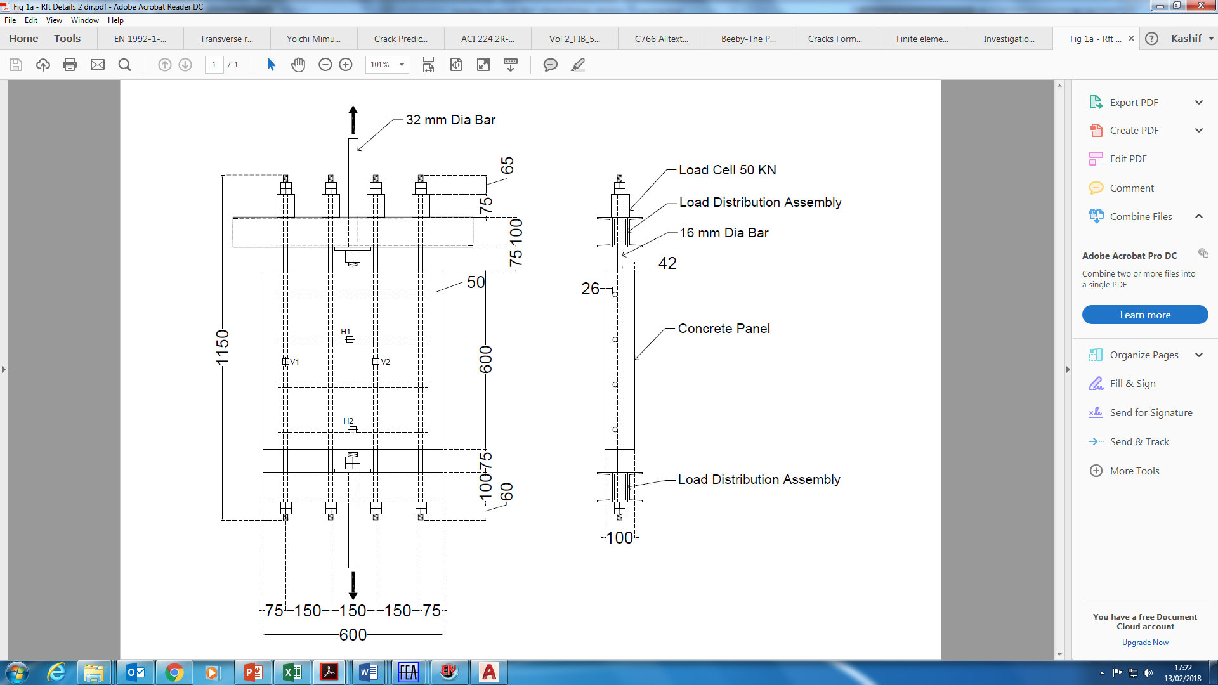

(a)

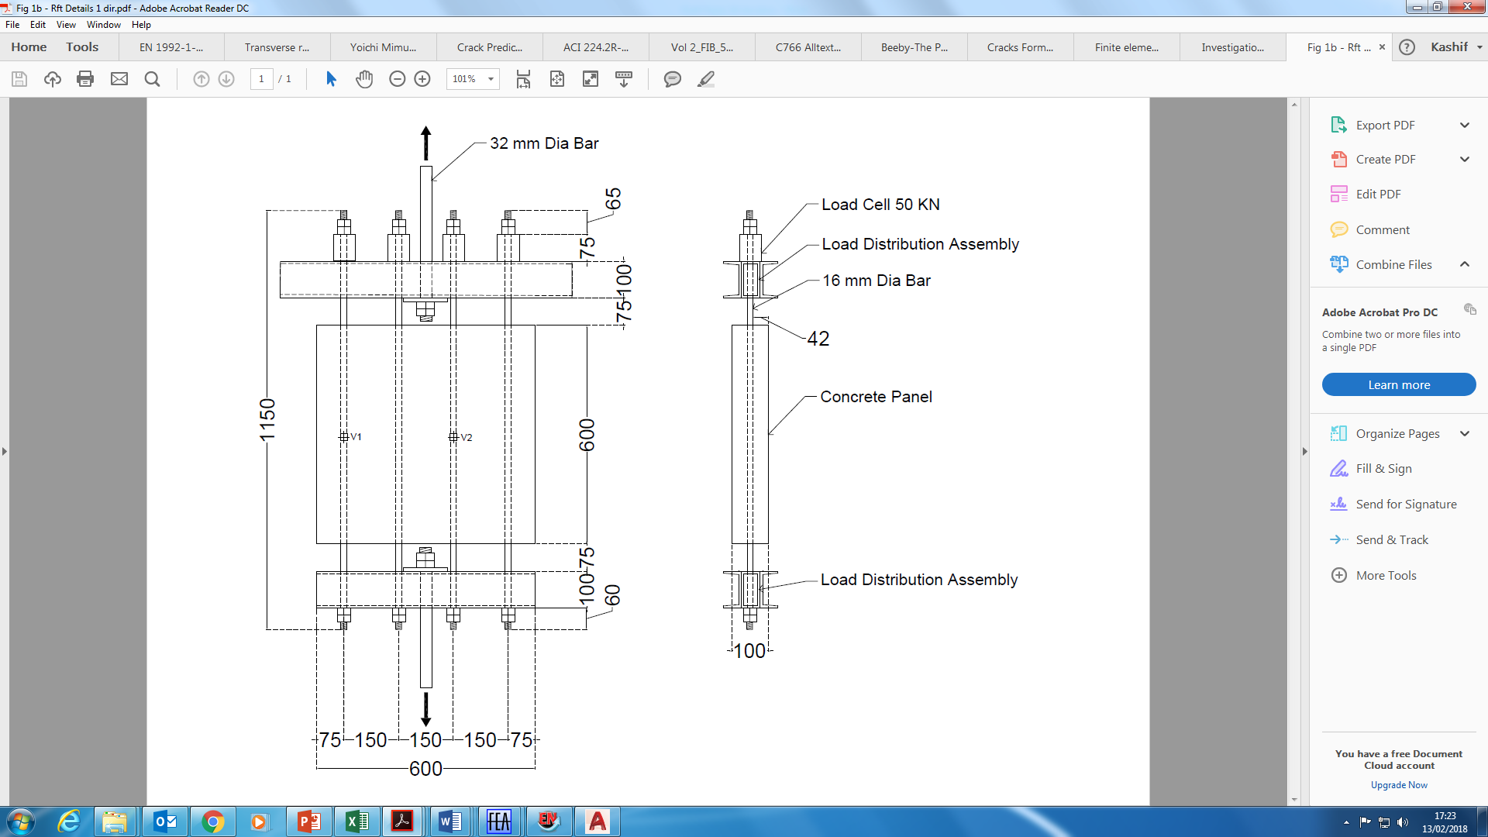

(b)

Figure 1. The test specimens: (a) Specimen reinforced in both directions; (b) Specimen reinforced in only one direction.

*Test Set Up*

The uniaxial load from the 1000kN capacity UTM was transmitted to the 16 mm steel reinforcement bars of the specimens using a specially designed load distribution assembly. The test set up is shown in Figure 2. The assemblies were sufficiently stiff to apply the load equally to all 16 mm bars. Load cells were attached to each reinforcement bar for adjustment so that the load variation remained within +1 kN. The applied load was limited to 200 kN, in order to avoid the yielding of the steel bars. The load was transferred from the steel bars to the concrete via the bond between the two elements of the rc composite.

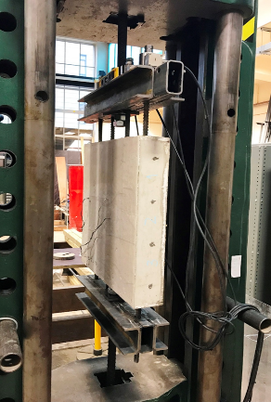 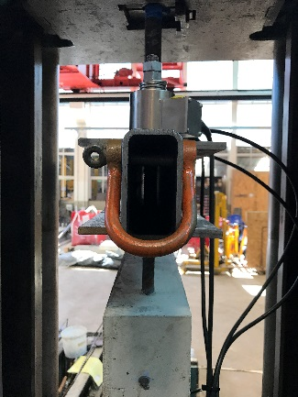 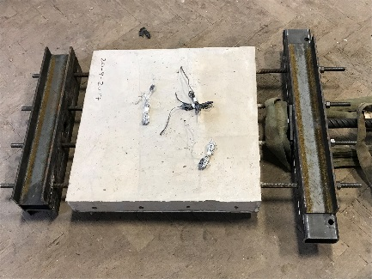

Figure 2. Test set up

*Material Properties and Instrumentation*

Specimens were cast from two different batches of concrete which had the same mix composition (see Table 1), but were prepared at different times. The compressive strength, splitting tensile strength and the modulus of elasticity of each batch of concrete were determined in the laboratory by testing 150 x 300 mm cylinders at the age of 28 days. All the specimens were moist cured inside a curing room (99% relative humidity). Batch 1 concrete had a compressive strength of 40 MPa and a splitting tensile strength of 2.7 MPa, while the batch 2 concrete had a compressive strength of 46.4 MPa and a splitting tensile strength of 3.2 MPa. As each batch was used to cast a comparative set of panels, the difference in physical strengths between the two batches did not affect the analysis of the panel results; rather, as it was the cracking pattern being investigated these differences provided further evidence for this review (see Section x.x). In order to monitor the strain in the steel reinforcement bars, electrical resistance strain (ERS) gauges were installed on two bars in each direction. DEMEC studs were installed on the concrete surface and strains in the concrete were recorded during the test using the DEMEC gauge.

Table 1. Composition of the concrete mix

|  |  |
| --- | --- |
| Ingredients | Quantity (kg/m3) |
| Cement (CEM I) | 385 |
| Water | 175 |
| Fine Aggregate | 730 |
| Coarse Aggregate | 1364 |
| Admixture | VS1000 |

*Test Procedure*

The load distribution assembly was attached to the test specimen prior to putting the specimen in the UTM. The load was gradually applied to the specimens at an approximate rate of 0.5 kN per second in increments of 20 kN. An equal load on all bars, within a variation of +1 kN, was ensured. After each increment of 20kN, the DEMEC gauge readings were recorded and the appearance of any cracks was observed. On the occurrence of a crack, the cracking load was noted, the alignment of each crack was marked and the crack widths were measured using a portable microscope with a magnification power of x40 and a precision of ±0.02 mm. Application of the load was continued until a total load of 200 kN was achieved. The specimen was then unloaded and removed from the rig.

**Experimental Results**

*Cracking Load*

Due to the composite behaviour of reinforced concrete, the bond stresses between the steel bars and the concrete enable a proportion of the tensile load applied to the bars to be transferred to the concrete. When the stress in the concrete exceeded its tensile strength capacity, cracks were formed. The cracking load for the specimens was calculated using Equation 1 and 2; these are compared with the experimental load at which cracks were developed in the specimens - see Table 2.

Table 2: Comparison of the theoretically predicted and experimentally obtained cracking loads

|  |  |  |  |  |  |
| --- | --- | --- | --- | --- | --- |
| Cracking Load (kN) | | | | | |
| Specimen | ACI | Model Code | 1st Crack | 2nd Crack | 3rd Crack |
| 1S1 | 154 | 156 | 142 |  |  |
| 1D1 | 90 | 110 |  |
| 1D2 | 106 | 118 |  |
| 2S1 | 186 | 189 | 161 |  |  |
| 2D1 | 136 | 180 | 192 |
| 2D2 | 120 | 151 |  |

From Table 2 it can be seen that all of the specimens cracked at a lower load than those predicted by the codes. The specimens having transverse reinforcement cracked at an even lower load compared to the specimens reinforced in only one direction. The tensile strength of the second batch of concrete was higher than that of the first batch; although this led to higher cracking loads for the batch 2 specimens, the pattern of crack development due to presence of transverse reinforcement remained the same and was therefore independent of the concrete tensile strength. On average the cracking load was reduced by 25 – 30% in the specimens containing transverse steel. The cracking patterns obtained in the tested specimens are given in Figure 3. Specimens 1S1 and 2S1 developed only one crack during the test; this occurred near the mid-span. Specimens 1D1, 1D2 and 2D2 each developed two cracks; specimen 2D1 had three cracks. It was noticed that in the case of the D- series tests, the cracks occurred almost at the location of the transverse reinforcement. This observation is in line with the observation made by Beeby [1], i.e., that transverse reinforcement can act as a ‘crack former’. Similar observations were also made by Rizkalla and Hwang [8], [9] during their tests. A possible explanation for this is that when the concrete is subjected to tensile stresses, the transverse reinforcement bears against the surrounding concrete and augments the tensile force generated in the concrete through its bond with the steel bars. This bearing force is proportional to the applied tensile stress in the concrete and the size of the transverse reinforcement bars. It is this additional tensile force which causes the concrete section to crack prematurely and at a lower load than that of the specimens without the transverse reinforcement. The additional tensile force due to the transverse reinforcement is maximum at the location of the reinforcement and reduces away from the bar. The location of the cracks, which is almost at the same position as the transverse bars further supports this observation. The cracks occurred across the entire section of the specimen and were brittle in nature; there was a slight reduction in the load immediately upon cracking. A few of the cracked specimens are shown in Figure 4. Based on the above results, it is concluded that the cracking load in members having transverse reinforcement and subjected to uniaxial tension should not, therefore, be predicted using the existing expressions.

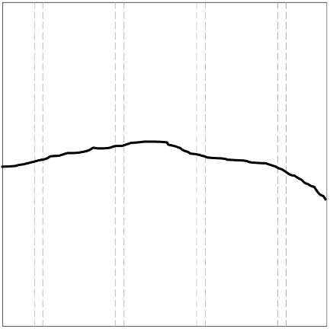 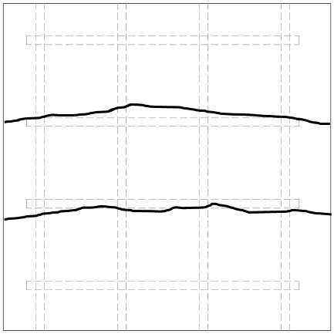 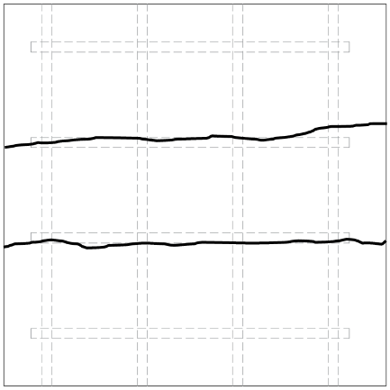

(a) (b) (c)

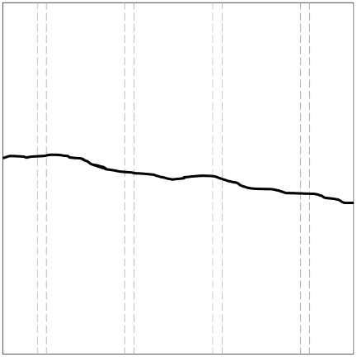 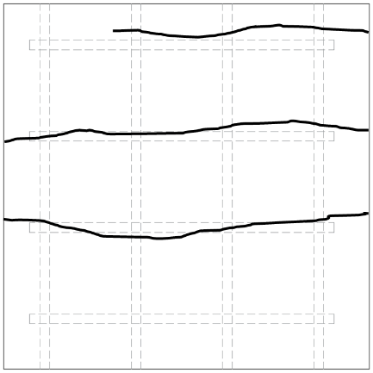 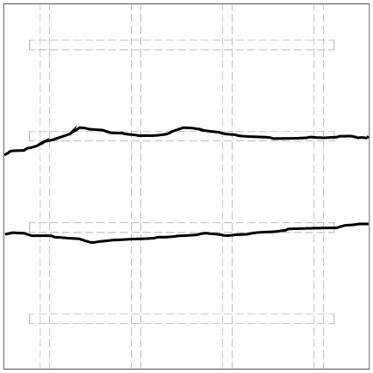

(d) (e) (f)

Figure 3. Cracking Patterns: (a) 1S1; (b) 1D1; (b) 1D2; (b) 2S1; (b) 2D1; (b) 2D2.

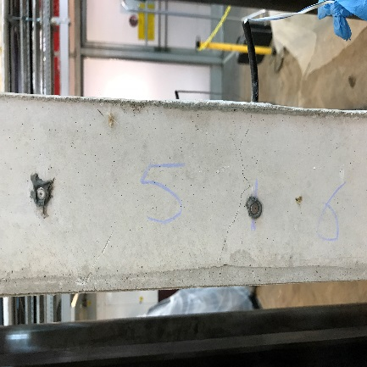 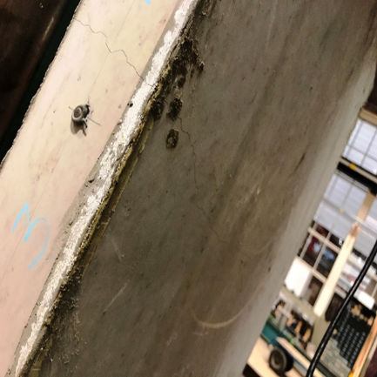 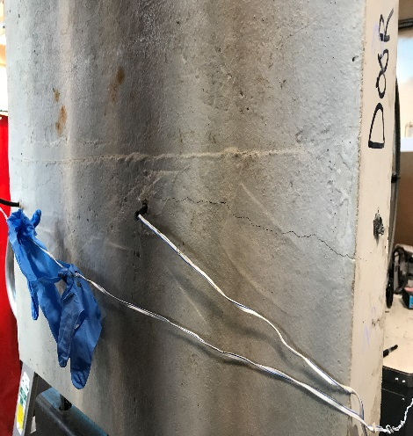

Figure 4. Cracked Specimens

*Crack Spacing and Width*

Once the cracks had formed, the crack widths were measured at each load step; the width of the cracks increased with an increase in the load. The strains measured in the steel reinforcement perpendicular to the direction of the crack increased significantly when each crack formed. This confirms that the load is transferred from the concrete to the steel reinforcement when a crack is formed. For each crack, readings at 6 different points were taken to find out the maximum crack width; these are given in Table 3 for each specimen. The crack widths were also calculated according to Equations 3, 4 and 5; these are also given in Table 3. The predicted values are different for each of the design codes, however, it is obvious that the crack width increases with an increase in the concrete tensile strength. From Table 3 it can be seen that the specimens with transverse reinforcement exhibited wider cracks compared to those without transverse steel. Moreover, the measured crack widths were more than those predicted in almost all cases. Since the size of the specimens was limited due to the available space in the UTM rig, it is difficult to comment on the crack spacing in specimens without transverse reinforcement, however, it is evident that the crack spacing where transverse reinforcement is present is significantly influenced by the location, size and spacing of the transverse bars.

Table 3: Comparison of predicted and measured crack widths

|  |  |  |  |  |  |  |
| --- | --- | --- | --- | --- | --- | --- |
| Crack Widths (mm) | | | | | | |
| Specimen | ACI | Model Code | EC2 | 1st Crack | 2nd Crack | 3rd Crack |
| 1S1 | 0.19 | 0.13 | 0.21 | 0.28 |  |  |
| 1D1 | 0.3 | 0.36 |  |
| 1D2 | 0.25 | 0.3 |  |
| 2S1 | 0.23 | 0.16 | 0.26 | 0.22 |  |  |
| 2D1 | 0.26 | 0.18 | 0.06 |
| 2D2 | 0.28 | 0.2 |  |

*Concrete Surface Strain*

Surface strains on both sides of tested specimens (as indicated in Figure 4) were recorded after every load increment using the DEMEC gauges. The average gross strain at the surface due to the applied loads, including the concrete contribution within the transfer length, was then computed from the measured values. Predicted values of the surface strain were also calculated according to the expressions proposed by Leonhardt [10], Beeby [1] and Rizkalla and Hwang [9]. A comparison of the predicted and experimentally obtained surface strains is shown in Figure 5, where it can be seen that the predictions appear to be close to the experimentally obtained values in the case of specimens without transverse reinforcement. However, where there exists the presence of transverse reinforcement the surface strains are quite a lot higher than those predicted.

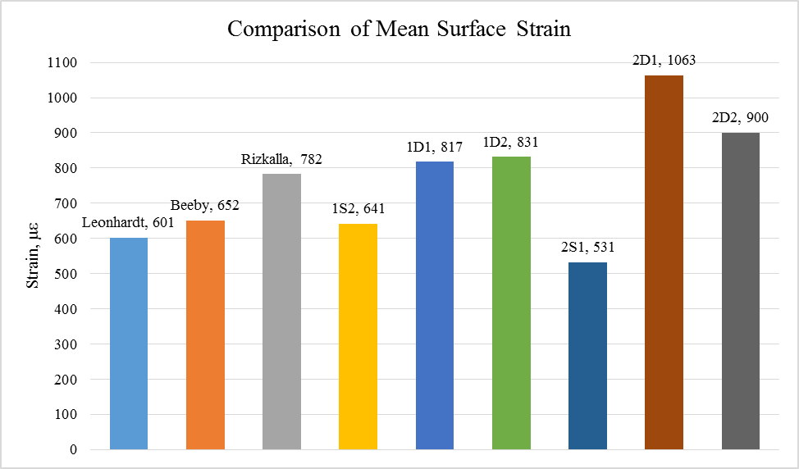

Figure 5. Comparison of the mean surface strains in concrete after cracking

**Finite Element Analysis and Results**

The tested specimens were also modelled using MIDAS FEA in order to simulate the behaviour under experimental conditions. The concrete was modelled using 20 noded three dimensional hexahedron solid elements. In order to model the concrete, a total strain based cracking model involving a rotating crack model was used. The tensile behaviour of the concrete was modelled using the nonlinear function proposed by Hordijk [12], which provides a nonlinear softening curve for predicting the post cracking tensile behaviour of concrete assuming that the stress gradually reduces to zero at an ultimate strain, $ε_{ult}=5.136{(G_{f}^{I}}/{f_{ct}h_{e}})$, where *GIf* is the mode I fracture energy of concrete, *he* is the element size and *fct* is the concrete tensile strength. The fracture energy of the concrete was calculated according to the Model Code 2010 [5]. The reinforcement bars were modelled using solid elements, and the concrete – steel reinforcement bond was modelled through the interface elements. Material properties obtained from the experimental tests were used as input data in the models. The load was applied to one end of the exposed steel bars while the ends on the opposite edge were fixed. The Newton Raphson iteration scheme was employed for obtaining the nonlinear solution in which the energy and displacement norms for a convergence tolerance of 0.00001 were satisfied. The FE mesh used and the cracking pattern for both types of specimen obtained from the FE analysis are given in Figure 6. From Figure 6 it can be seen that the cracking behaviour of the members obtained from the FE analysis displayed a close resemblance to that witnessed during the experimental investigation. An analysis of the stress generated in the concrete at the location of the transverse reinforcement reveals that the concrete stress in the model with transverse steel bars was approximately 20% more than that without the transverse bars (and is in-line with the measured reduction in cracking load observed during the tests). Although this analysis confirms the introduction of additional tensile force in the concrete due to presence of the transverse steels bars, further work is required to more accurately quantify the influence of the transverse steel reinforcement on the cracking load.

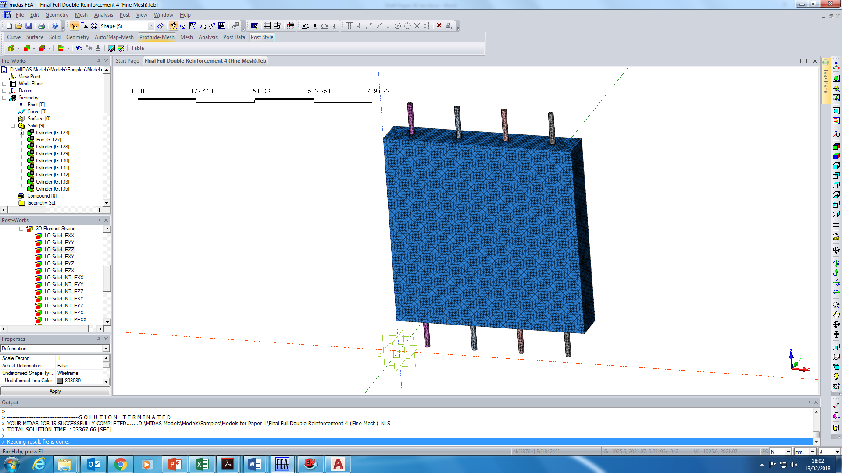 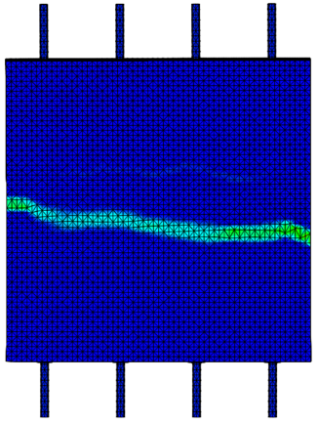 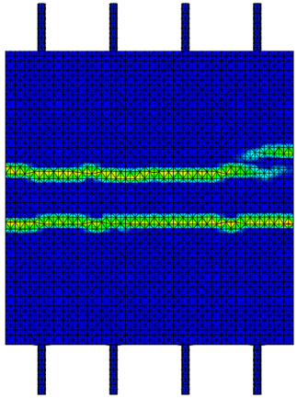

(a) (b) (c)

Figure 6. FE Analysis: (a) FE mesh; (b) Cracking pattern of model without transverse reinforcement; (c) Cracking pattern of model with transverse reinforcement.

**Conclusions**

The work presented here confirms the significance of the transverse reinforcement and the influence it has on the cracking behaviour of reinforced concrete walls and slabs. Further work is still required to more accurately ascertain this influence.

**List of Notations**

Pcr cracking load

Ag gross area of the section

Ac area of concrete section

*ρs* steel reinforcement ratio

αe modular ratio

fctm mean tensile strength of concrete

ft’ tensile strength of concrete

*ρs,eff* effective steel reinforcement ratio

wmax  maximum crack width

fs steel stress

dc distance from centre of bar to extreme tension fibre

εsm mean strain in steel

εcm mean strain in concrete

τbm mean bond strength between reinforcing bar and concrete

ϕs diameter of steel bar

k1 coefficient which takes account of bond properties

k2 coefficient which takes account of distribution of strain

k3, k4 coefficients found in National Annex; values are 3.4 and 0.425 respectively

**References**

[1] Beeby A. Prediction of Crack Widths in Hardened Concrete. STRUCTURAL ENGINEER-PART A. 1979;57:9-17.

[2] Gilbert RI. Shrinkage cracking in fully restrained concrete members. ACI Structural Journal. 1992;89.

[3] Nejadi S, Gilbert I. Shrinkage cracking and crack control in restrained reinforced concrete members. Structural Journal. 2004;101:840-5.

[4] ACI Committee 224.2R. Cracking of Concrete Members in Direct Tension. Journal Proceedings. 1997;83.

[5] Model Code 2010 CF. Fib model code for concrete structures 2010. Document Competence Center Siegmar Kästl eK, Germany2010.

[6] BS EN 1992-1-1. Eurocode 2: Design of Concrete Structures: Part 1-1: General Rules and Rules for Buildings: British Standards Institution; 2004.

[7] Desayi P, Kulkarni A. DETERMINATION OF MAXIMUM CRACK WIDTH IN TWO-WAY REINFORCED CONCRETE SLABS. Proceedings of the Institution of Civil Engineers. 1976;61:343-9.

[8] Rizkalla S, Hwang L. Effective tensile stress-strain characteristics for reinforced concrete. Proceedings of the Canadian Society of Civil Engineering. 1983:129-47.

[9] Rizkalla, Hwang. Crack Prediction for Members in Uniaxial Tension. Journal Proceedings. 1983;81.

[10] Leonhardt F. Crack control in concrete structures. International Association for Bridge and Structural Engineering; 1977.

[11] Dawood N, Marzouk H. An analytical model for crack spacing of thick reinforced concrete plates. Engineering structures. 2010;32:472-82.

[12] Hordijk DA. Local approach to fatigue of concrete: TU Delft, Delft University of Technology; 1991.