Are child welfare intervention rates higher or lower in areas targeted for enhanced early years services?

Abstract
Flying Start is an enhanced early years programme in Wales which is targeted at areas where a high proportion of households with children are recipients of income-related benefits or tax credits. Child protection interventions are known to be concentrated in more deprived areas. Flying Start could have the effect of reducing risk to children or conversely it could result in more children coming to the attention of social services. Administrative data were used to identify children in public care and on child protection registers in Wales on 31 March 2015 and also to identify lower super output areas covered by Flying Start services. Child welfare intervention rates were examined and comparison made between areas within deprivation quintiles where Flying Start was operating and areas where it was not. In areas where Flying Start services are provided, child welfare intervention rates are higher than in areas where they are not, after controlling for multiple deprivation. Further work is needed to establish why child welfare intervention rates are higher in Flying Start areas and what effect there might be longer term.

Key Messages
- In Wales there is a ‘social gradient’ in the rates at which local authorities intervene by placing children in statutory care or making them subject to child protection procedures. For each step increase in relative deprivation there is a corresponding increase in intervention rates.
- In areas where Flying Start enhanced early years services are provided, child welfare intervention rates are higher than in areas where they are not, after controlling for area-level deprivation.
- The link between poverty and risk to children needs to be more clearly acknowledged in the child protection process.

Introduction
Enhanced early years programmes, such as Head Start in the United States, Sure Start in England and Flying Start in Wales aim to reduce inequalities in child development and parenting skills. As well as having a long-term economic impact (Garces, Thomas and Currie, 2002; Heckman and Raut, 2016), which is their main aim, these changes in parents and children would be expected to pay off in terms of preventing harm to children, leading to a reduced need for intervention from child protection agencies (Green et al., 2014). However, it is also possible that enhanced child and family services could mean more vulnerable children being identified and referred to social services and therefore higher levels of intervention to protect children. This article explores this issue in Wales, with reference to Flying Start, on a cross-sectional basis. The study takes deprivation into account because Flying Start is targeted on more deprived areas. International evidence shows a strong relationship between deprivation and child maltreatment (Bywaters et al., 2016) and studies in the four nations of the UK have found much higher levels of child welfare intervention in more deprived areas (Bywaters et al., 2020).
Flying Start is a Welsh early-years programme, aiming to improve life opportunities and outcomes for children in the most deprived areas of Wales (Welsh Government, 2016). It is comprised of four key elements: free high quality, part-time childcare for 2-3-year-olds; enhanced health visiting services, with one health visitor per 110 children; access to parenting support; and support for children’s speech, language and communication skills. Flying Start’s long-term goal is to tackle income inequality by reducing the size of the population with low skills, although the programme does not attempt to tackle all areas of child poverty. The aim of longer-term reduction in ‘low skills’ encompasses language ability, social skills such as the ability to function in groups and educational performance such as in reading and maths (Welsh Government, 2014a). International evidence would suggest the economic benefits of enhanced early years provision can be felt longer-term and even inter-generationally (Heckman and Raut, 2016).
This programme in its current form has been in place since 2006/7. The Government’s aim up to the 2016 election was to increase the number of children benefitting from the scheme over time. Flying Start has been very successful in exceeding its targets for increased numbers, with 23,579 children benefitting from the scheme in 2012/13 and 37,260 in 2014/15 (Welsh Government, 2014b; 2016). Originally, local authorities were allocated grants based on the catchment areas of schools within the most deprived areas. However, due to Flying Start’s expansion from 2011 onwards, this criterion changed. Instead, local authorities’ allocation of funding is calculated based on the approximate number of children under the age of 4 years old within a lower super output area who are living in a household in receipt of income related benefits or tax credits. A lower super output area (LSOA) is a spatial unit with minimum population of 1000 and mean of 1500. This expansion of Flying Start from 2011 onwards also encompassed an outreach component, meaning that children residing outside of defined Flying Start areas, and who are in need of support, can access some or all Flying Start Services available in their Local Authority.
The Flying Start programme has been evaluated by the Welsh Government (e.g. 2010; 2013; 2017; 2018; 2019a). These reports have assessed the effectiveness of the programme’s ability in creating the conditions required for later improvements in life chances whilst also giving an evaluation of the impacts, outcomes and recommendations. The 2010 report focuses mainly on the effectiveness in addressing the children most in need, considering the ways in which support is delivered, barriers to effectiveness and value for money. The report found that the programme had been effective with this group in several respects, including: increased and higher levels of take up; engagement with families who are difficult to reach or have limited involvement with services; successfully engaging parents in the lives of their children; and earlier identification of problems. A further report found that educational outcomes had been improving at a faster rate in Flying Start areas than in non-Flying Start areas, although this difference could not confidently be attributed to the presence of Flying Start (Welsh Government, 2017). The most recent evidence on Flying Start outcomes is the most robust to date, albeit based on only one local authority, as it includes analysis of individual-level linked administrative data over several years, taking into account actual receipt of Flying Start services (Welsh Government, 2014, 2019a). Although there are methodological caveats, the analysis suggests a possible protective effect of Flying Start on low birth weight, hospital admissions, the birth rate in teenage mothers and primary school absences.
The specific issue explored in this paper is what rates of child welfare intervention are found in Flying Start areas, compared with those areas without Flying Start but within the same quintile of multiple deprivation. The term ‘child welfare intervention’ is used here to mean statutory intervention in family life, namely children being on the child protection register or looked after by the local authority (i.e. in care). This question arises from the recent UK evidence that at both local authority and lower super output area level there is a strong association between multiple deprivation and rates of child welfare intervention (Bywaters, 2015; Bywaters et al., 2020), which reinforces what is known from international evidence (Doidge et al, 2017; Slack et al. 2017; Kim and Drake, 2018). There is a complex relationship between child maltreatment and deprivation. A ‘contributory causal’ relationship has been claimed by Bywaters et al. (2016, p.4) on the basis of an evidence review. The two identified mechanisms are direct effects, resulting from insufficient resources for good enough child health and development, and indirect effects via parental stress, interconnected with factors that can contribute to difficult and damaged childhoods, such as parental mental illness, domestic violence and substance misuse. Neighbourhood factors, such as supportive social networks and/or physical environments, can also be protective against child harm and may be less evident in deprived communities (Maguire-Jack and Font, 2017).
In examining child welfare interventions in Flying Start areas, the presence of enhanced early years services could feasibly help reduce stress in families and perhaps improve parents’ and children’s resilience. This could result in reductions in state child protection activity, as Green et al. (2014) found to be the case for Early Head Start services in the US. However, it is also quite possible that the increased contact with early years professionals in those communities targeted for enhanced services could result in higher rates of child protection referral, because more children in vulnerable situations are identified (see Beecham and Sinclair, 2007). Given the evidence summarised above about higher levels of child protection intervention in more deprived areas, it is important to take deprivation into account when comparing areas with and without Flying Start services.
Prevention of child welfare intervention – child protection involvement and children becoming looked after - is not claimed by the Welsh Government to be one of the aims of Flying Start, and therefore not addressed in its evaluations of the programme to date. However, the programme is referenced as relevant to the Government’s aim of reducing the need for children to be in care, insofar as it can help prevent difficult experiences in childhood (Welsh Government, 2019b).

Methods
The data used within this study originate from three sources. Firstly, a list of which LSOAs were covered by Flying Start in 2014-15 was supplied by the Welsh Government. The list is of areas where families were eligible for Flying Start services and does not reflect actual family engagement levels. Local Flying Start services have some discretion in practice, with some departing slightly from the Welsh Government list of LSOAs and using local intelligence about areas of need. Secondly, an anonymised individual-level dataset of children ‘looked-after’ in Wales on the census date of 31st March 2015 was provided, also by the Welsh Government. This was from the routinely-collected SSDA903 dataset on children looked after by local authorities (see McGrath-Lone et al., 2016 for a profile of the very similar English version). The children looked after in Wales on 31 March 2015 include 11% who are placed at home with parents, so not all are in out-of-home care, although the large majority are. Thirdly, the 22 local authorities in Wales supplied anonymised individual-level data on children on the child protection register on 31st March 2015, derived from the routinely-collected Children in Need census (now re-named Children Receiving Care and Support Census).
The data used in the article for child protection registration and children looked-after combined come from just 20 Welsh local authorities. This is because there was a substantial amount of missing LSOA data on children looked after from two local authorities, Ceredigion and Vale of Glamorgan. Consequently, the analysis represents a sample of 1784 out of a Welsh total of 1909 LSOAs (93%). Two of the LSOAs with Flying Start operating could not be matched by LSOA code to the child welfare intervention data, thus were removed, meaning that the analysis uses 467 LSOAs with Flying Start operating, rather than all 469.
As noted earlier, the spatial unit used in the analysis was the lower super output area (LSOA). In order to compare the rates of child welfare between Flying Start and non-Flying-Start LSOAs it was important to control for deprivation, since Flying Start is targeted on the most deprived areas and these are also the communities where we would expect there to be higher rates of child welfare intervention. As already noted, Flying Start services are allocated using a single measure of deprivation, namely the number of households on income related benefits and tax credits in an LSOA. To control for deprivation in the analysis of child welfare rates, we used the most commonly used measurement of area-level multiple deprivation in Wales for policy, practice and research, namely the Welsh Index of Multiple Deprivation (WIMD). This is the Welsh Government’s official measurement of relative deprivation within smaller areas of Wales (Welsh Government, 2014c). An LSOA’s WIMD rank is created from a weighted sum score for each of eight domains, weighted on importance. The eight domains and their weightings are as follows: income 23.5%, employment 23.5%, health 14.0%, education 14.0%, access to services 10.0%, community safety 5.0%, physical environment 5.0% and housing 5.0%. As well as being used by some researchers (e.g. Dunstan, Fone, Glickman and Palmer, 2013), the WIMD is heavily used for service planning, for example in the allocation of funding to local authorities and planning of neighbourhood police resourcing (see Welsh Government 2014c for more information on the WIMD).
LSOAs were banded into quintiles of multiple deprivation, with each quintile representing approximately 20% of the population within Wales. The analysis focused on the difference in rates of ‘looked after’ children and child protection registrations by Flying Start operation and multiple deprivation quintile. Child welfare intervention rates were calculated as number of children in care or on child protection registers (i.e. these two numbers combined) per 10,000 child population. Rates were calculated for children aged 0-3, because Flying Start is an early-years programme. The estimated mid-year populations from 2014 were used, as the nearest estimation to the 31 March 2015 census point.
In order to test the statistical significance of the results three multilevel negative binomial regression models were created, predicting intervention rates by deprivation quintile, Flying Start service, and the interaction between deprivation and Flying Start service. This allowed for the analysis to control for the clustering effects of local authority membership with the inclusion of random effects (Robson & Pevalin, 2015). Analysis was conducted with R software. The Generalized Linear Mixed Models using Template Model Builder package glmmTMB (Brooks, et al. 2017) was used to fit multilevel regression models. Data tidying and plotting made use of multiple tidyverse packages (Wickham, et al. 2019). Alkaike Information Criterion (AIC) estimators were used to identify improvements in the models (Burnham & Anderson, 2004) and marginal effects were extracted and plotted using the ggeffects (Lüdecke, 2018) and ggplot (Wickham, et al. 2019) packages to identify which LSOAs had significantly different average intervention rates conditional on their Flying Start services and level of deprivation.

Results
The mean rate by lower super output area for children aged 0-3 on the child protection register on 31 March 2015 was 65 per 10,000 children, but there is considerable variation between LSOAs, with the standard deviation being 128, and many areas have no children on the child protection register at all, as indicated by the inter-quartile range being 108. A similar distribution was found for rates of children looked after aged 0-3 on 31 March 2015 (mean 59; SD 122; IQR 95). Figure 1 represents rates per 10,000 for both children looked after and those on the child protection register, aged 0-3, by multiple deprivation quintile. The graph clearly shows a social gradient. For child protection registrations, there is a 16-fold increase in rates between the least deprived quintile and the most. The rates for all children looked after are 10.6 times higher in the 20% most deprived neighbourhoods than in the 20% least deprived. Similar gradients were observed for all-age children (see Authors, 2017). Figure 1 clearly illustrates the relationship between living in a poor neighbourhood and the likelihood of being the subject of local authority intervention.
Figure 2 shows the percentage of the lower super output areas (LSOAs) within each multiple deprivation quintile that have Flying Start operating. As would be expected, the more deprived the LSOA quintile, the more LSOAs there are with Flying Start operating within them. There is a social gradient, albeit not a linear one. Less than 1% of the 20% least deprived LSOAs in Wales have Flying Start provision.
[Insert Figure 1 about here]

[Insert Figure 2 about here]
Table 1 shows the combined head count and rates per 10,000 for children aged 0-3 on the child protection register or looked after by the local authority, for areas with and without Flying Start, by deprivation quintile. The table and figure 3 show that areas with Flying Start had higher intervention rates than those without, apart from quintile 1 where the number of children aged 0-3 living in Flying Start areas is too small (n=125) for this to be a meaningful result. The same pattern was found when children looked after and children on the child protection register were considered separately.
[Insert Table 1 and Figure 3 about here]
A multilevel regression analysis of the data confirms that the difference in average neighbourhood rates of child welfare interventions in Flying Start and non-Flying Start was statistically significant in all but the most deprived 20 per cent of LSOAs. Table two shows three regression models that estimate the rate of child welfare interventions in a neighbourhood by their deprivation quintile (model 1), whether the neighbourhood has Flying Start services (model 2), and the interaction between deprivation quintile and Flying Start services (model 3). The addition of Flying Start to the model resulted in a reduction of around 21 in the model AIC, indicating a strong improvement in model fit. The addition of an interaction effect in model 3 resulted in a decrease of 3.6 in the AIC value, indicating a weak improvement in model fit (Burnham & Anderson, 2004). Deprivation quintile, Flying Start services, and the interaction between deprivation quintile and Flying Start service all had statistically significant associations with neighbourhood intervention rates.
The models suggest that a Flying Start service was associated with a 43 per cent increase in interventions in a neighbourhood’s expected intervention rate after controlling for deprivation (exp^{0.358}). In less deprived neighbourhoods the increase associated with Flying Start services was higher, a 133 per cent increase in the second least deprived quintile compared to non-Flying Start LSOAs in the same quintile. In more deprived neighbourhoods the increase was smaller and, in the case of the most deprived quintile, not statistically significant. In the most deprived 20 per cent of neighbourhoods the non-significant increase in child welfare interventions associated with Flying Start was 29 per cent. Figure 4 illustrates the relationship between deprivation and Flying Start services with standard error ribbons at the 95 percent level of confidence. Overlapping standard error ribbons indicate a non-significant difference.
[Insert Table 2 and Figure 4 about here]
An alternative but equally valid interpretation of this result is that the presence of Flying Start centres is associated with a significant decrease in the socioeconomic gradient of child welfare interventions because of greater levels of intervention in less deprived neighbourhoods. While interventions overall increase, the socioeconomic disparities in intervention rates between neighbourhoods decrease. This is indicated by the ‘flatter’ line across deprivation quintiles in figure 4 for Flying Start areas. In non-Flying Start LSOAs, there was around a 60 per cent increase in interventions for each increase in deprivation quintile. By contrast, in Flying Start LSOAs this increase was only 30 per cent per deprivation quintile.

Discussion
The analysis of administrative data shows that there is a clear social gradient for child welfare intervention in Wales, as has been found elsewhere in the UK (Bywaters et al., 2020). When the enhanced early years programme Flying Start is considered, we see higher levels of child welfare intervention in areas where Flying Start operates than in areas where it does not, after controlling for area-level multiple deprivation. In less deprived neighbourhoods the increase associated with Flying Start services was higher. It needs to be remembered that this analysis is cross-sectional only and there is no comparison of intervention rates in these areas before and after the establishment of Flying Start.
There are a few plausible explanations for the finding. Firstly, it is possible that the measure of deprivation used for Flying Start, namely the numbers of households receiving income-related benefits, is a better predictor of high need in families and risk to children than the Welsh Index of Multiple Deprivation; i.e. economic resources, rather than other markers of deprivation, are the most important driver of socioeconomic inequalities in child welfare. Analysis by Endicott (2019) compared the ability of each of the separate WIMD deprivation domains and overall multiple deprivation to predict child protection registration rates. This analysis showed that income was indeed the strongest predictor of all the domains, but there was very little difference between income deprivation and overall multiple deprivation (R²=0.28 compared with R²=0.27).
Another possible explanation is that the additional professional contact with children in Flying Start areas could be resulting in more referrals to Children’s Services about potential harm and these increased referrals follow through to more intervention. In other words, increased surveillance of families leads to increased protective intervention and this in turn could have a negative impact on families’ voluntary help-seeking and engagement with services. The fact that the increase associated with Flying Start services was higher in less deprived neighbourhoods where there would generally be less surveillance from children’s services might support this interpretation.
It should also be noted that the kinds of provision Flying Start currently employs (child care for 2-3-year-olds, health visiting and parenting support) are not meant to directly address – at least in the short term - the material deprivation that is the basis for these areas being selected for help. This is because Flying Start’s focus is child development and its impact is meant to be on the next generation of adults, by reducing the chances they will grow up with low skills, via help with their development in the early years.
Another important point to note is that although families involved in child protection processes can receive services such as parenting support and child care through Flying Start, the programme is not designed to directly address the key issues for child maltreatment of parental mental ill health, domestic abuse and substance misuse.
Yet another issue is that in some areas there could possibly be a lag effect, if Flying Start has not been operational for long. There is some strong evidence that the strongest impacts of enhanced early years initiatives are felt longer term (Garces et al., 2002; Heckman and Raut, 2016: Institute for Fiscal Studies, 2019). It is possible, therefore, that although Flying Start might bring important societal benefits, both in the shorter term in terms of health and child development, and potentially the longer term in terms of health and social mobility, as similar programmes have achieved in other countries, it may not be best suited to helping the families who are at risk of child protection interventions.
There are certainly limitations to this analysis. Most importantly, we have not considered intervention rates before and after Flying Start was initiated, to assess change over time. What we know from publicly available aggregate data (e.g. Elliott, 2018; Thomas, 2018) is that the rate of children coming into care in Wales, as elsewhere in the UK, has been increasing year on year in the last two decades. It is therefore unlikely that Flying Start areas will have seen a decrease in state intervention over time. However, it is possible they may have seen a less marked increase than similar areas without Flying Start provision, because services have proved to be preventative. Other limitations are that the list of LSOAs is not exact, with discretion over area eligibility being used in some local authorities, and the list does not reflect levels of actual family engagement with Flying Start. Also, because of the outreach agenda since 2011, some children in non-Flying Start areas could have received Flying Start services. The analysis has also not considered the impact of earlier support in the early years on older children’s child protection or looked after rates.
In future research, it would important to explore practices of referral to social services in detail, both by looking at quantitative administrative data at LSOA level and also by conducting qualitative research in Flying Start and other relevant services. Most importantly, future research needs to consider change over time since the introduction of Flying Start through longitudinal studies. The linkage of individual-level administrative data, including social services routine data, should have potential in this regard.
The analysis presented in the paper emphasises again the strong association between child welfare interventions and deprivation (Bywaters et al 2020) and highlights the need for policy and practice to address the connection between poverty reduction and the prevention of child maltreatment.
Acknowledgements
We are grateful to the Nuffield Foundation for funding project …… and the …. University scheme ….. for funding the additional work on Flying Start (details removed for anonymity). We are also grateful to Welsh Government officials for their help, in supplying data on Flying Start coverage and commenting on the article. Both Welsh Government and individual local authorities also helpfully supplied routine data on child welfare interventions.

References
Authors (2017) Report on child welfare inequalities in Wales
Beecham, Jennifer and Sinclair, Ian (2007) Costs and Outcomes in Children's Social Care: Messages from Research. Jessica Kingsley Publishing, London.
Burnham, K. P. & Anderson, D. R. (2004). Multimodel Inference: Understanding AIC and BIC in Model Selection. Sociological Research & Methods, 33(2), 261-304. https://doi.org/10.1177/0049124104268644
Brooks, M. E., Kristensen, K., van Benthem, K. J., Magnusson, A., Berg, C. W., Nielsen, A., Skaug, H. J., Maechler, M. & Bolker, B. M. (2017). glmmTMB Balances Speed and Flexibility Among Packages for Zero-inflated Generalized Linear Mixed Modeling. The R Journal, 9(2), 378-400. https://journal.r-project.org/archive/2017/RJ-2017-066/index.html
Bywaters, P. (2015) Inequalities in child welfare: Towards a new policy, research and action agenda. British Journal of Social Work 45, 1: 6-23.
Bywaters, P., Scourfield, J., Jones, C., Elliott, E., Hooper, J., McCartan, C., Shapira, M., Bunting, L., Daniel, B. (2020) Child welfare inequalities in the four nations of the UK, Journal of Social Work 20(2), 193–215.
Bywaters, P., Bunting, L., Davidson, G., Hanratty, J., Mason, W., McCartan, C. and Steils, N. (2016). The Relationship Between Poverty, Child Abuse and Neglect: An Evidence Review, York; Joseph Rowntree Foundation.
Doidge, J. C., Higgins, D. J., Delfabbro, P., & Segal, L. (2017). Risk factors for child maltreatment in an Australian population-based birth cohort. Child Abuse & Neglect, 64, 47–60. http://doi.org/10.1016/j.chiabu.2016.12.002
Dunstan F, Fone DL, Glickman M, Palmer S (2013) Objectively measured residential environment and self-reported health: A multilevel analysis of UK census data. PLoS ONE 8(7): e69045. https://doi.org/10.1371/journal.pone.0069045
Elliott, M. (2018). Looked-after children in Wales: An analysis of the backgrounds of children entering public care. PhD Thesis, Cardiff University.
Endicott, A. (2019) Exploring rates of child protection registration in wales using the Welsh Index of Multiple Deprivation. MSc dissertation, Cardiff University, Cardiff.
Garces, E., Thomas, D. & Currie, J. (2002). Longer-Term effects of Head Start. The American Economic Review. 92 :999–1012
Green, B.L., Ayoub, C., Dym Bartlett, J., Von Ende, A., Furrer, C., Chazan-Cohen, R., Vallotton, C. & Klevens, J. (2014). The effect of Early Head Start on child welfare system involvement: A first look at longitudinal child maltreatment outcomes. Children and Youth Services Review, 42: 127-135.
Heckman, J.J. and Raut, L.K. (2016) Intergenerational long-term effects of preschool-structural estimates from a discrete dynamic programming model. Journal of Econometrics 191, 1: 164-175. https://doi.org/10.1016/j.jeconom.2015.10.001
Institute for Fiscal Studies (2019) The Health Effects of Sure Start, https://www.ifs.org.uk/publications/14139 [accessed 20/02/20]
Kim, H., & Drake, B. (2018). Child maltreatment risk as a function of poverty and race / ethnicity in the USA, International Journal of Epidemiology Online advance access http://doi.org/10.1093/ije/dyx280
Lüdecke, D. (2018). “ggeffects: Tidy Data Frames of Marginal Effects from Regression Models.” Journal of Open Source Software, 3(26), 772. https://doi.org/10.21105/joss.00772
Maguire-Jack, K., & Font, S. A. (2017). Community and Individual Risk Factors for Physical Child Abuse and Child Neglect: Variations by Poverty Status. Child Maltreatment, 107755951771180. http://doi.org/10.1177/1077559517711806
McGrath-Lone, L., Harron, K., Dearden, L., Nasim, B. and Gilbert, R. (2016) Data resource profile: Children ‘looked after’ return. International Journal of Epidemiology 45, 3: 716-717.
Robson, K., & Pevalin, D. (2015). Multilevel Modeling in Plain Language. London: Sage.
Slack, K.S., Berger, L.M. and Noyes, J.L. (2017) Introduction to the special issue on the economic causes and consequences of child maltreatment, Children and Youth Services Review 72: 1-4.
Thomas, C. (2018) The Care Crisis Review: Factors contributing to national increases in numbers of looked after children and applications for care orders. London: Family Rights Group.
Welsh Government (2010) Interim Evaluation of Flying Start. National Assembly for Wales. http://www.sqw.co.uk/files/4813/8523/6885/CYP_1_Interim.pdf
Welsh Government (2013) National Evaluation of Flying Start: Impact Report. National Assembly for Wales. http://cdn.basw.co.uk/upload/basw_94549-7.pdf
Welsh Government (2014a) Flying Start –Annex. Quality Childcare Guidance. https://gov.wales/sites/default/files/publications/2019-07/flying-start-childcare-guidance.pdf [Accessed 29.02.20]
Welsh Government (2014b) Research Note – Flying Start. National Assem bly for Wales. http://www.assembly.wales/Research%20Documents/Flying%20Start%20-%20Research%20note-03032014-254185/rn14-005-English.pdf [Accessed 29/02/20]
Welsh Government (2014c) Welsh Index of Multiple Deprivation (WIMD). National Assembly for Wales. http://gov.wales/statistics-and-research/welsh-index-multiple-deprivation/?lang=en [accessed 05/03/18]
Welsh Government (2016) Flying Start. National Assembly for Wales. http://gov.wales/topics/people-and-communities/people/children-and-young-people/parenting-support-guidance/help/flyingstart/?lang=en [Accessed 26/06/17]
Welsh Government (2017) Flying Start Evaluation: Educational Outcomes https://gov.wales/docs/caecd/research/2017/170208-flying-start-educational-outcomes-en.pdf [Accessed 11/03/19]
Welsh Government (2018) National Evaluation of Flying Start Wave 3 https://gov.wales/national-evaluation-flying-start-wave-3
Welsh Government (2019a) Analysis of Flying Start outcomes using linked data: emerging findings. https://gov.wales/analysis-flying-start-outcomes-using-linked-data-emerging-findings-html.
Welsh Government (2019b) Improving Young Lives: Our Programme for Change https://gov.wales/sites/default/files/publications/2019-10/improving-outcomes-for-children-2-year-plan.pdf [accessed 29/02/20]
Wickham et al., (2019). Welcome to the tidyverse. Journal of Open Source Software, 4(43), 1686 https://doi.org/10.21105/joss.01686

Figure 1: Child protection and looked-after children rates for ages 0-3 in 2015, by multiple deprivation quintile (for 20 local authorities)
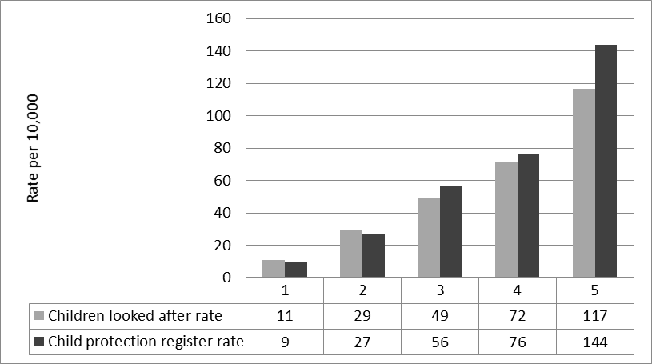

Figure 2: Lower super output areas with Flying Start operating in 2014-15 by multiple deprivation quintile

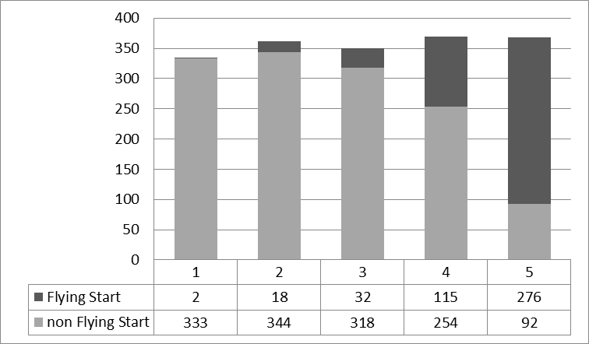
Figure 3: Child welfare intervention rates (aged 0-3) in Flying Start and non-Flying Start areas, by multiple deprivation quintile

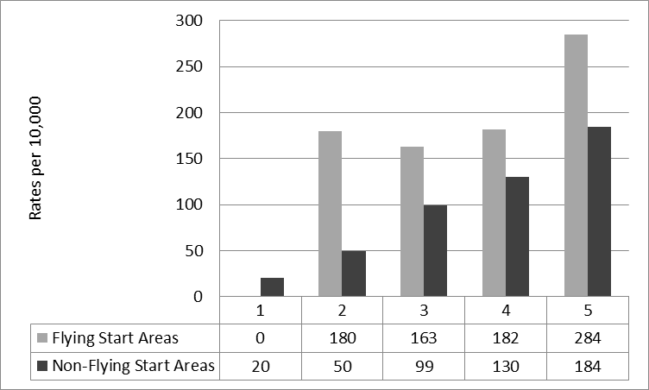

Figure 4: Predicted rate of child welfare interventions per 10,000 for different combinations of deprivation and Flying Start services. Shaded areas represent 95 per cent confidence intervals.

Table 1: Child welfare intervention rates (aged 0-3) in Flying Start and non-Flying Start areas, by multiple deprivation quintile

 |  | Multiple deprivation quintiles (5=most deprived)
 |  |  | 1 | 2 | 3 | 4 | 5
Children looked after or on the child protection register | Flying Start | N on child protection register or looked after | 0 | 20 | 41 | 178 | 748
 |  | 0-3 population | 125 | 1111 | 2521 | 9804 | 26296
 |  | Rate per 10,000 | 0 | 180 | 163 | 182 | 284
 | No Flying Start | N on child protection register or looked after | 41 | 110 | 230 | 251 | 151
 |  | 0-3 population | 20257 | 22206 | 23253 | 19244 | 8200
 |  | Rate per 10,000 | 20 | 50 | 99 | 130 | 184

Table 2: Multilevel negative binomial regression models predicting child welfare intervention rates by quintile of deprivation and Flying Start service

 | Model 1 |  |  |  |  | Model 2 |  |  | Model 3
 | B | exp(B) | p |  | B |  | exp(B) | p | B | exp(b) | p
Deprivation Quintile | 0.527 | 1.694 | *** |  | 0.433 |  | 1.542 | *** | 0.469 | 1.598 | ***
Flying Start |  |  |  |  | 0.358 |  | 1.430 | *** | 1.045 | 2.843 | ***
WIMD x Flying Start |  |  |  |  |  |  |  |  | -0.197 | 0.821 | **
Intercept | 4.434 | 84.267 |  |  | 3.530 |  | 34.124 |  | 3.437 | 31.093
AIC | 4155.5 |  |  |  | 4133.8 |  |  |  | 4129.2
* = p < 0.05; ** = p < 0.01, *** = p < 0.001

