**Cost-effectiveness of gestational diabetes screening including prevention of type 2 diabetes: application of the GeDiForCE model in Australia**

Hannah Beilby1, Fan Yang2, Brenda Gannon1, Harold David McIntyre3

1Centre for the Business and Economics of Health, The University of Queensland, Australia

2Centre for Health Economics, University of York, UK

3Mater Research, The University of Queensland, Australia

**Aims**

Gestational diabetes mellitus (GDM) is associated with an increased risk of perinatal complications and of developing type 2 diabetes mellitus (T2DM). A strategy including universal screening following new evidence-based thresholds recommended by the International Association of Diabetes and Pregnancy Study Groups (IADPSG) combined with antenatal care and postpartum lifestyle management could reduce these risks. This new strategy has been endorsed by the Australasian Diabetes in Pregnancy Society (ADIPS) following evidence that showed previous diagnostic thresholds were too high to prevent perinatal adverse events (PAEs) and subsequent T2DM. This study therefore aimed to assess the cost-effectiveness of the new ADIPS GDM strategy in Australia.

**Methods**

A decision tree model (GeDiForCE) was applied in this study. Our analysis modifies the model and optimises resource use and cost parameters, to reflect real costs within the Australian context. Data on Australian GDM and T2DM epidemiology, intervention costs and literature were used to estimate model parameters. Costs (in AUD $), averted disability-adjusted life years (DALYs) and net cost per DALY averted during life-time horizon were calculated. Sensitivity analyses were also conducted, by testing the impact of variations in key input variables.

**Results**

Compared to the previous criteria, the new ADIPS strategy costs AUD $20,671 (USD $15,839) per DALY averted in the base case, however sensitivity analyses reveal it is dominant in over half of cases and has a 86% chance of being dominant and/or cost-effective according to WTP threshold of $151,200 international dollars ($I) or $AUD 217,576 per DALY averted (equal to three times per capita GDP). Compared with no screening or treatment, the new ADIPS strategy saves AUD $25,509 (USD $19,547) per DALY averted.

**Conclusions**

Using local data and literature estimates, this study shows that use of the new ADIPS GDM strategy would lead to cost saving care for pregnant women in Australia when compared to a no screening scenario and is likely to be cost effective when compared to previously used criteria.

# **Acronyms**

# ADIPS: Australasian Diabetes in Pregnancy Society

DPP: Diabetes Prevention Program

DALY: Disability-adjusted Life Years

HAPO: Hyperglycaemia and Adverse Pregnancy Outcome (HAPO) study

# IADPSG: International Association of Diabetes and Pregnancy Study Group

# GDM+: Gestational Diabetes Mellitus

# GeDiForCE: Gestational Diabetes Formulas For Cost-Effectiveness Model

PAE: Perinatal Adverse Event

# T2DM: Type 2 Diabetes Mellitus

WHO: World Health Organisation

# **Introduction**

In this study, we assessed the cost-effectiveness of the current Australasian Diabetes in Pregnancy Society (ADIPS) Gestational Diabetes Mellitus (GDM) strategy in Australia in terms of morbidity and DALYs avoided using the previously developed GeDiForCE decision tree model (Marseille et al., 2013). We compare this strategy with the previously used criteria and a hypothetical no screening or treatment scenario. GDM is associated with an increased risk of perinatal complications including obstetric and neonatal complications (morbidity and mortality) and higher risk of developing type 2 diabetes mellitus (T2DM). Screening and effective intervention for all women, regardless of pre-existing diabetes risk factors (i.e. universal screening) could reduce these risks.

Much debate exists as to the appropriate method and criteria for determining the diagnosis of GDM. In an effort to define evidence-based thresholds, the recent Hyperglycaemia and Adverse Pregnancy Outcome (HAPO) study observed a cohort of 25,505 pregnant women in a multisite prospective controlled trial. This trial demonstrated a link between high maternal glucose levels at 24‐32 week’s gestation and a range of adverse maternal and foetal outcomes (HAPO Study Cooperative Research Group, 2008). Crucially, this was found to be true for hyperglycaemia at levels below the diagnostic thresholds for ‘overt’ diabetes, with no obvious thresholds at which risks were markedly increased. Their report and other relevant work was subsequently reviewed by the International Association of Diabetes and Pregnancy Study Group (IADPSG) Consensus Panel which included Australasian Diabetes in Pregnancy Society (ADIPS) representation. This resulted in the formation of new guidelines for the testing and diagnosis of GDM (IADPSG Consensus Panel, 2010) based upon odds ratios for adverse neonatal outcomes of at least 1.75 compared to mean values for normoglycaemic women (see Box 1). These guidelines were endorsed by the World Health Organisation (WHO) in 2014 (World Health Organization, 2014). Subsequently ADIPS released their “Consensus Guidelines for the Testing and Diagnosis of Hyperglycaemia in Pregnancy in Australia and New Zealand” which stated their adoption of the IADPSG thresholds. These new criteria are significantly lower than those recommended by ADIPS previously (Hoffman, Nolan, Wilson, Oats, & Simmons, 1998) (see Box 1) and have come with considerable controversy as preventing perinatal complications is weighed against concerns for cost and of unnecessary treatment.

The new consensus guidelines call for further research into the cost-effectiveness of the new criteria with a longer follow up time than in the existing health economics literature, so as to assess disease prevention in later life. An Australian paper assessed the impact of the new IADPSG criteria and found it identified a group of women at previously unrecognised increased risk of adverse perinatal outcomes and that improvements in perinatal morbidity, in addition to potential long-term benefits, may justify the increase in healthcare workload (Laafira, White, Griffin, & Graham, 2016). To date there has been no assessment of cost-effectiveness of the newly developed ADIPS strategy, from the Australian health care system perspective compared to previous criteria or a no screening scenario. Our paper now aims to fill this gap in the literature.

**Box 1: Comparison of current and previous ADIPS recommended criteria**

**IADPSG criteria** (adopted by ADIPS in 2011 in ‘new ADIPS strategy’) – one step

The diagnosis of GDM at any time during pregnancy* should be based on any one of the following a fasting 75g OGTT:

(a) fasting plasma glucose ≥ 5.1 mmol/;

(b) 1-h plasma glucose ≥ 10.0 mmol/l**;

(c) 2-h plasma glucose ≥ 8.5–11.0 mmol/l .

*recommended at first prenatal visit and at 24-28 weeks gestation

**note there are no established criteria for the diagnosis of diabetes mellitus in pregnancy based on the 1-h post-load value

**ADIPS 1998 criteria** – two step

Recommended morning non-fasting test (GCT) for GDM is performed at 26-28 weeks and positive results are:

(a) 1-h post 50 g oral glucose load ≥ 7.8 mmol/l*; or

(b) 1-h post 75 g oral glucose load ≥ 8.0 mmol/l .

After a positive screening test, confirmation of diagnosis at 26-30 weeks gestation is based on any one of the following a fasting 75g OGTT:

(a) fasting plasma glucose ≥ 5.5 mmol/l; and/or

(b) 2-h plasma glucose ≥ 8.0 mmol/l .

We combine data related to the prevalence of GDM using IADPSG screening criteria with recommended antenatal care and postpartum lifestyle management to form our overall intervention (hereafter referred to as ‘the new ADIPS strategy’) for the purposes of this analysis. Antenatal care consisted of routine clinical visit including screening tests, dietary advice and pharmacological therapy (metformin and insulin). Post-partum care was based on the Diabetes Prevention Program (DPP), a lifestyle modification program which prescribes one home-based individual session and five group (2-hour, up to 15 women per group) sessions delivered by specially trained healthcare professionals, with two additional follow-up maintenance telephone calls for each individual (O’Reilly et al., 2016). The ADIPS GDM strategy is compared to the previously used criteria recommended by ADIPS (hereafter referred to as ‘ADIPS 1998’ - see (Hoffman et al., 1998)). We aim to show whether the new ADIPS strategy represents cost-effective care for pregnant women in Australia using local

data, expert opinion and literature estimates. Outcomes are assessed in terms of long-term morbidity (T2DM) for both mothers and children, averted disability-adjusted life years (DALYs) and net cost per DALY averted during life-time horizon. Additionally, we compare the new criteria to a hypothetical no screening or treatment scenario in the base case and against other commonly used criteria featured in the original GeDiForCE model.

# **Methods**

**Model design**

A decision tree model (GeDiForCE) was used in this study. The structure is shown in **Figure 1.** The open-source tool is implemented in Microsoft Excel and its design and many underlying assumptions are described elsewhere (Marseille et al., 2013). Using a decision tree as the chosen type of decision analytical model is appropriate given the binary nature of diagnosis following screening, presence or absence of Perinatal Adverse Events (PAEs) and choice whether or not to intervene, and is the simplest framework for the purposes of achieving our objectives. Costs are expressed in Australian (AUD) and US Dollars (USD) at a conversion rate of $1 USD = $1.31 AUD and long-term costs and effects are discounted at 5% to 2018 as per PBAC official guidelines (Pharmaceutical Benefits Advisory Committee, 2016). We focus on IADPSG criteria as they are currently recommended by ADIPS, and compare cost-effectiveness in the base case for no screening and against other screening strategies (ADIPS 1998, World Health Organisation (WHO) 1999 and American Diabetes Association (ADA)). See **Table 1** for a comparison of past and present commonly used criteria. We take an in depth look at the how these new criteria compare to the previously recommended ADIPS 1998 criteria (Hoffman et al., 1998), and perform probabilistic sensitivity analysis to identify underlying uncertainty in the model parameters. Each intervention strategy is defined by a one or two step testing strategy with unique thresholds beyond which GDM either confirmed or suspected and further testing is indicated. The model computes the cost of each strategy; the expected incidence and cost of perinatal complications and T2DM; and the cost per averted DALY compared with no intervention.

**Model inputs**

The inputs used in this analysis are summarised in **Table 2**. Inputs are inflated according to the Australian Institute of Health and Welfare (AIHW) health deflator using 2017-18 as the reference year (Australian Institute of Health and Welfare, 2019).

*Epidemiological*

We compare outcomes for a hypothetical cohort of 301,116 pregnant women according to the annual live birth rate (total confinements) from Australia Bureau of Statistics (Australian Bureau of Statistics, 2015) under the ADIPS GDM strategy versus no screening or care. The expected prevalence of GDM of 13% was taken from a prospective Australian observational trial using the IADPSG criteria against the previously estimated 9.6% using the 1998 criteria (Moses, Morris, Petocz, San Gil, & Gard, 2011). Similarly, the incidence of T2DM was derived from a cumulative risk of 25.8% amongst GDM+ mothers as estimated in the literature at 15 years post diagnosis (Lee, Hiscock, Wein, Walker, & Permezel, 2007). We assumed this incidence of T2DM is halved amongst the children of GDM+ mothers. The initial age of mothers was taken to be 31 years as per the median age of all mothers for births registered in 2015 (Australian Bureau of Statistics, 2015). The age and sex adjusted annual total direct cost to a normal weight diabetic is estimated as $2,353 per person according to the latest Australian Diabetes, Obesity and Lifestyle study (Ying Lee et al., 2018).

*Intervention*

All costs were converted to Australian dollars adjusted to 2018 prices. Cost of an Oral Glucose Tolerance Test (OGTT), glucose challenge test (GCT), antenatal clinical visits (assumed eight sessions) and post-natal care was obtained from theMedicare Benefits Schedule online database (Australian Government, 2019). The postnatal costs are obtained from a 2016 randomised controlled trial of the Mothers after Gestational Diabetes in Australia (MAGDA) Diabetes Prevention Program (DPP) specifically designed to address barriers to participation (O’Reilly et al., 2016). These costs are assumed to last for 10 years and inflated by 20% to account for manpower and other costs. As previously assumed (Marseille et al., 2013) the proportion of women diagnosed with GDM who adopt the postnatal care programs offered is estimated at 80%. We average over two American studies (Knowler et al., 2002; Ratner et al., 2008) and one Indian study (Ramachandran et al., 2006) to estimate an effect size of 45% reduced lifetime T2DM maternal risk for those completing the DPP compared to those who have not been exposed to the program. We do not confer any risk reduction of T2DM incidence for children of GDM+ mothers who partake in DPP as done in the original model, due to a lack of evidence.

Sensitivity Analysis

A probabilistic sensitivity analysis (PSA) was conducted by sampling from the appropriate distributions for each input used in our model to understand the uncertainty in the baseline results. The choice of distribution depends on the underlying characteristics of parameters. For example, since the cost data are generally positively skewed and constrained in the range from zero to positive infinity, the gamma distribution is appropriate to represent the uncertainty of this type of parameter. We conducted Monte Carlo analysis, where one simulation represents a woman undergoing routine GDM screening with probabilities and costs randomly sampled from the appropriate distribution. This simulation is repeated with a different set of randomly chosen values, with the aggregate representing a theoretical cohort of 1000 women displayed on a Cost-Effectiveness Plane (CE Plane). To analyse results we fit a willingness to pay (WTP) threshold based on GDP per capita in 2018 International dollars ($I) as per the WHO Choosing Interventions that are Cost–Effective (WHO-CHOICE) project (Marseille, Larson, Kazi, Kahn, & Rosen, 2015). This project dictates an intervention that, per DALY avoided, costs less than three times the national annual GDP per capita is considered cost–effective, whereas one that costs less than once the national annual GDP per capita is considered highly cost–effective. We convert these thresholds back to AUD using the exchange rate of AUD $1.43= I $1 (International Monetary Fund, 2019). We also perform one-way sensitivity analysis to complement PSA. All key variables are varied by 50-150% of their base value, except for the proportion of GDM+ women who initiate postpartum care (80%) which is varied ± 20 percentage points, summary details are provided in Table 1.

# **Results**

**Base case**

The lifetime cost of the new ADIPS strategy is AUD $19,148 (USD $14,673) per patient while the previous ADIPS 1998 criteria cost AUD $17,853 (USD $13,680) per patient, resulting in an additional cost of AUD $1,295 (USD $993) under the new screening program. Initial screening, antenatal interventions and post-partum interventions constituted 0.15%, 7% and 92% of these costs, respectively. Average DALYs incurred per patient are 0.33 for the new strategy and 0.39 using the previous criteria, resulting in 0.06 DALYs averted using the strategy. The majority of the burden avoided is due to averted cases of T2DM (99%), with the remainder due to averted PAEs. The baseline incremental cost effectiveness ratio (ICER) of the intervention is AUD $20,671 (USD $15,839) per DALY averted. Compared with no screening, the new ADIPS strategy conversely saves AUD $28,137 (USD $21,561) per DALY averted. Compared to no screening, the new strategy using IADPSG criteria appears to be the most effective but most costly compared to all other screening options in the base case scenario as shown in **Figure 2.**

**Sensitivity analyses**

The results of the Monte Carlo simulations for the new ADIPS GDM strategy compared to ADIPS 1998 criteria is presented in the Cost-Effectiveness plane shown in Figure 3. Of 1000 simulations, 52% were in the southeast quadrant which indicates that IADPSG is likely to be the dominant screening criteria. We analyse the remainder of simulations in the northeast quadrant and find there is an additional 15% and 20% chance of the intervention being cost-effective and highly cost-effective, respectively. Therefore, there is only a 14% chance of the intervention failing to meet these WTP thresholds. These results indicate that there are more DALYs averted using IADPSG threshold screening, antenatal and postpartum care and these are likely to come at an acceptable cost compared to the previous method of GDM screening.

The one-way sensitivity tornado graph is shown in Figure 4, where each horizontal bar represents the range in net cost per DALY averted across the range of the base case value specified in Table 1 for each of eight key inputs.The input with the greatest influence on cost-effectiveness is the discount rate; at 50–150% of the 5% base case value, the ICER ranges from $4,027 to $104,633 saved per DALY averted. The next most influential variables on cost-effectiveness are the incidence of T2DM as a result of GDM and the initial GDM prevalence in the Australian population. If we simultaneously alter the top three influential variables to the right-hand side of the tornado graph (in which costs are higher) we find that the new ADIPS strategy is still cost-effective ($AUD 54,843 per DALY averted) compared to a cost effectiveness threshold of $I 50,400/$AUD 72,576 per DALY averted.

# **Conclusions**

This study shows universal screening and treatment of gestational diabetes, accounting for adverse perinatal events and future incidence of type 2 diabetes, would lead to cost saving care for pregnant women in Australia. The intervention has an incremental cost-effectiveness ratio of AUD $20,671 (USD $15,839) per DALY averted compared to previous criteria. Probabilistic sensitivity analysis predicts a 54% chance of the new ADIPS strategy being effective and cost saving. Multiple studies report increased prevalence of GDM using IADPSG criteria (Avalos, Owens, & Dunn, 2013; Moses et al., 2011) which raises concerns about the medicalization of pregnancy, and related rising health care costs (Long & Cundy, 2013). However, we find consistent results with a Spanish study to suggest despite this increased prevalence cost savings are still realised compared to alternative screening criteria (Duran et al., 2014). Another major difference is that the shift from two-step to one-step testing – a recent systematic review and meta-analysis of randomised trials comparing these two methods found the one step approach was associated with better maternal and perinatal outcomes with no significant implications for the incidence of GDM (Saccone et al., 2019). This suggests the one-step approach has clinical as well as operational advantages over the two-step approach.

Cost-effectiveness was sensitive to the cost of post-partum care over the treatment period, the initial incidence of GDM and the long-term incidence of T2DM due to GDM. Effective postpartum care may require 5–10 years of follow-up (assumed 10 years in this study) and is thus it is the most costly portion of our intervention representing 92% of these costs, and there is an onus on program administrators to contain these costs. An important limitation of our study is that the model can only test the percentage of women who initiate post-partum interventions rather than continue with care. Compliance to post-partum care needs to be considered, as it is well recognised that many barriers exist to mothers engaging in behaviour change during the early infancy period (Nielsen, Kapur, Damm, de Courten, & Bygbjerg, 2014). An Australian trial of post-partum care specifically designed to address these barriers still found significant challenges in maintaining engagement with the program, and concluded the intervention would therefore not be sustainable in routine health services (O’Reilly et al., 2016). Alongside this is the need to more accurately estimate the effect of GDM and postpartum care in avoiding T2DM given large effect of variations in the discount rate to long-term outcomes. The GeDiForCE model is unique in its ability to investigate T2DM incidence and potential of antenatal and postpartum intervention to reduce the intergenerational transmission of diabetes. This paper reinforces the importance of early detection of GDM as an opportunity for early prevention of diabetes and other disease over the lifespan of mother and child and its associated costs.

**References**

Australian Bureau of Statistics. (2015). 3301.0 - Births, Australia, 2015. Retrieved from https://www.abs.gov.au/AUSSTATS/abs@.nsf/Previousproducts/3301.0Main%20Features32015?opendocument&tabname=Summary&prodno=3301.0&issue=2015&num=&view=

Australian Government. (2019). Medicare Benefits Schedule Book Retrieved from h  
ttps://www.health.gov.au/internet/mbsonline/publishing.nsf/Content/Downloads-201904

Australian Institute of Health and Welfare. (2019). *Health expenditure Australia 2017–18*. Retrieved from Canberra: h  
ttps://www.aihw.gov.au/reports/health-welfare-expenditure/health-expenditure-australia-2017-18

Avalos, G. E. M. S. C., Owens, L. A. M. D., & Dunn, F. M. D. P. H. D. (2013). Applying Current Screening Tools for Gestational Diabetes Mellitus to a European Population: Is It Time for Change? *Diabetes Care, 36*(10), 3040. doi:h  
ttp://dx.doi.org/10.2337/dc12-2669

Duran, A., Sáenz, S., Torrejón, M. J., Bordiú, E., del Valle, L., & Galindo, M. (2014). Introduction of IADPSG Criteria for the Screening and Diagnosis of Gestational Diabetes Mellitus Results in Improved Pregnancy Outcomes at a Lower Cost in a Large Cohort of Pregnant Women: The St. Carlos Gestational Diabetes Study. *Diabetes Care, 37*, 2442-2450. doi:10.2337/dc14-0179

HAPO Study Cooperative Research Group. (2008). Hyperglycemia and Adverse Pregnancy Outcomes. *The New England Journal of Medicine, 358*(19), 1991-2002.

HAPO Study Cooperative Research Group. (2008). Hyperglycemia and Adverse Pregnancy Outcomes. *The New England Journal of Medicine, 358*(19), 1991-2002.

International Monetary Fund. (2019). IMF DataMapper: Implied PPP conversion rate. Retrieved from <https://www.imf.org/external/datamapper/PPPEX@WEO/OEMDC/ADVEC/WEOWORLD/DA/IND/AUS>

Pharmaceutical Benefits Advisory Committee. (2016). *Guidelines for preparing submissions to the Pharmaceutical Benefits Advisory Committee (version 5.0) Canberra: Australian Government Department of Health and Ageing*. Retrieved from <https://pbac.pbs.gov.au/>

Hoffman, L., Nolan, C., Wilson, J. D., Oats, J. J. N., & Simmons, D. (1998). Gestational diabetes mellitus ‐ management guidelines: The Australasian Diabetes in Pregnancy Society. *Medical Journal of Australia, 169*(2), 93-97. doi:10.5694/j.1326-5377.1998.tb140192.x

IADPSG Consensus Panel. (2010). International Association of Diabetes and Pregnancy Study Groups Recommendations of the Diagnosis and Classification of Hyperglycemia in Pregnancy *Diabetes Care, 33*(3), 676-682.

International Monetary Fund. IMF DataMapper: Implied PPP conversion rate. Retrieved from <https://www.imf.org/external/datamapper/PPPEX@WEO/OEMDC/ADVEC/WEOWORLD/DA/IND/AUS>

Knowler, W. C., Barrett-Connor, E., Fowler, S. E., Hamman, R. F., Lachin, J. M., Walker, E. A., & Nathan, D. M. (2002). Reduction in the Incidence of Type 2 Diabetes with Lifestyle Intervention or Metformin. *The New England Journal of Medicine, 346*(6), 393-403. doi:10.1056/NEJMoa012512

Laafira, A., White, S. W., Griffin, C. J., & Graham, D. (2016). Impact of the new IADPSG gestational diabetes diagnostic criteria on pregnancy outcomes in Western Australia. *The Australian & New Zealand journal of obstetrics & gynaecology, 56*(1), 36. doi:10.1111/ajo.12394

Lee, A. J., Hiscock, R. J., Wein, P., Walker, S. P., & Permezel, M. (2007). Gestational Diabetes Mellitus: Clinical Predictors and Long-Term Risk of Developing Type 2 Diabetes *Diabetes Care, 30*(4), 878.

Long, H., & Cundy, T. (2013). Establishing Consensus in the Diagnosis of Gestational Diabetes Following HAPO: Where Do We Stand? *Current Diabetes Reports, 13*(1), 43-50. doi:10.1007/s11892-012-0330-3

Marseille, E., Larson, B., Kazi, D. S., Kahn, J. G., & Rosen, S. (2015). Thresholds for the cost–effectiveness of interventions: alternative approaches. *Bulletin of the World Health Organization, 93*(2), 118-124. doi:10.2471/BLT.14.138206

Marseille, E., Lohse, N., Jiwani, A., Hod, M., Seshiah, V., Yajnik, C. S., . . . Kahn, J. G. (2013). The cost-effectiveness of gestational diabetes screening including prevention of type 2 diabetes: application of a new model in India and Israel. *The Journal of Maternal-Fetal & Neonatal Medicine, 26*(8), 802-810. doi:10.3109/14767058.2013.765845

Moses, R. G., Morris, G. J., Petocz, P., San Gil, F., & Gard, D. (2011). The impact of potential new diagnostic criteria on the prevalence of gestational diabetes mellitus in Australia *MJA, 194*(7), 338-340.

Nielsen, K. K., Kapur, A., Damm, P., de Courten, M., & Bygbjerg, I. C. (2014). From screening to postpartum follow-up - the determinants and barriers for gestational diabetes mellitus (GDM) services, a systematic review. *BMC Pregnancy Childbirth, 14*, 41. doi:10.1186/1471-2393-14-41

O’Reilly, S. L., Dunbar, J. A., Versace, V., Janus, E., Best, J. D., Carter, R., . . . Wildey, C. (2016). Mothers after Gestational Diabetes in Australia (MAGDA): A Randomised Controlled Trial of a Postnatal Diabetes Prevention Program. *PLOS Medicine, 13*(7). doi:10.1371/journal.pmed.1002092

Pharmaceutical Benefits Advisory Committee. (2016). *Guidelines for preparing submissions to the Pharmaceutical Benefits Advisory Committee (version 5.0) Canberra: Australian Government Department of Health and Ageing*. Retrieved from <https://pbac.pbs.gov.au/>.

Ramachandran, A., Snehalatha, C., Mary, S., Mukesh, B., Bhaskar, A., & Vijay, V. (2006). The Indian Diabetes Prevention Programme shows that lifestyle modification and metformin prevent type 2 diabetes in Asian Indian subjects with impaired glucose tolerance (IDPP-1). *Clinical and Experimental Diabetes and Metabolism, 49*(2), 289-297. doi:10.1007/s00125-005-0097-z

Ratner, R. E., Christophi, C. A., Metzger, B. E., Dabelea, D., Bennett, P. H., Pi-Sunyer, X., . . . Kahn, S. E. (2008). Prevention of Diabetes in Women with a History of Gestational Diabetes: Effects of Metformin and Lifestyle Interventions. *The Journal of Clinical Endocrinology & Metabolism, 93*(12), 4774-4779. doi:10.1210/jc.2008-0772

Saccone, G., Caissutti, C., Khalifeh, A., Meltzer, S., Scifres, C., Simhan, H. N., . . . Berghella, V. (2019). One step versus two step approach for gestational diabetes screening: systematic review and meta-analysis of the randomized trials. *The Journal of Maternal-Fetal & Neonatal Medicine, 32*(9), 1547-1555. doi:10.1080/14767058.2017.1408068

World Health Organization. (2014). Diagnostic criteria and classification of hyperglycaemia first detected in pregnancy: A World Health Organization Guideline. *Diabetes Research and Clinical Practice, 103*(3), 341-363. doi:10.1016/j.diabres.2013.10.012

Ying Lee, C. M., Goode, B., Nørtoft, E., Shaw, J. E., Magliano, D. J., & Colagiuri, S. (2018). The cost of diabetes and obesity in Australia. *Journal of Medical Economics, 21*(10), 1001-1005. doi:10.1080/13696998.2018.1497641

**Table 1.** Most commonly used guidelines for the diagnosis of GDM. *Table adapted from WHO 2014 statement (World Health Organization, 2014).*

|  |  |  |  |  |  |
| --- | --- | --- | --- | --- | --- |
| **Organisation** | **Fasting Plasma glucose** | **Glucose Challenge** | **1-h plasma glucose** | **2-h plasma glucose** | **3-h plasma glucose** |
| *WHO 1999\** | *≥ 7.0* | *75g OGTT* | *Not required* | *≥ 7.8* | *Not required* |
| Canadian Diabetes Association** | ≥5.3 | 75g OGTT | ≥10.6 | ≥8.9 | Not required |
| **IADPSG 2010\***  **=WHO 2013**  **= ADIPS 2010** | **≥5.1** | **75g OGTT** | **≥10.0** | **≥8.5** | **Not required** |
| ADA/ACOG/CC**  (two step for most – diagnostic (2nd step) thresholds) | ≥5.3 | Initial 50g (1hr ≥ 7.8 ) then 100g 2nd step | ≥10.0 | ≥8.6 | ≥ 7.8 |
| pre-IADPSG ADIPS 1998 (Hoffman et al) | ≥5.5 | 75g OGTT | Not required | ≥8.0 | Not required |
| NICE 2015 (UK) | ≥5.6 | 75g OGTT | Not required | ≥7.8 | Not required |

*one value is sufficient for diagnosis

** two or more values are required for diagnosis

**Table 2 Model inputs: base-case values, ranges for one way sensitivity analyses and sources.**

|  |  |  |  |
| --- | --- | --- | --- |
| **Input** | **Estimate** | **Sensitivity analyses range** | **Source** |
| **Epidemic** |  |  |  |
| Prevalence of GDM in screened women | 13% | +/-50% | Moses et al., 2011 |
| Incidence of T2DM for GDM+ mother | 25.8% | +/-50% | Lee et al., 2007 |
| Incidence of T2DM for GDM+ child | 12.9% | +/-50% | Assumption (halved) |
| Relative risk reduction for T2DM given DPP for GDM+ mother | 0.45 | +/-50% | Multiple sources |
| Average age T2DM onset in GDM+ mother | 45 years | -- | Lee et al., 2007 |
| Average age T2DM onset in GDM+ child | 30 years | -- | Assumption |
| Estimated life expectancy from GDM intervention: Mother | 43 years | -- | OECD Health Stats |
| Estimated life expectancy from GDM intervention: Child | 44 years | -- | OECD Health Stats |
| Proportion of GDM+ women who initiate post-partum care | 80% | +/-20 % points (60-100%) | Assumption |
| **Intervention Cost ($AUD 2018 prices)** | |  |  |
| Initial screen (IADPSG – one step) | $ 16.11 | -- | MBS item 66542 (85% benefit) |
| Initial screen (ADIPS 1998 – two step) | $29.54 | -- | MBS item 66545 + 66542 (85% benefit) |
| Antenatal care per GDM+ mother | $ 828 | -- | Multiple sources |
| Post-partum care (10 years) | $ 10,228 | +/-50% | Multiple sources |
| **Cost of illness ($AUD 2018 prices)** | |  |  |
| Cost of perinatal adverse events among GDM+ women:  with/  without intervention  Lifetime cost of T2DM in mother (assume 30 years) | $13,631  $19,163  $73,378 | +/-50% | GeDiForCE model  Ying Lee et al., 2018 |
| **Other**  Discount rate | 5% | +/-50% | (Pharmaceutical Benefits Advisory Committee, 2016) |

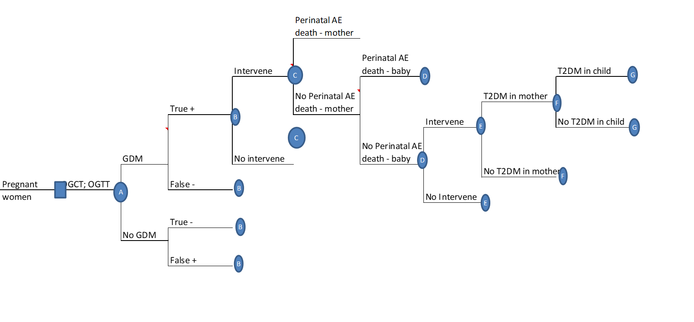

**Figure 1: GeDiForCE model developed and described by Marseille et al (Marseille et al., 2013)**

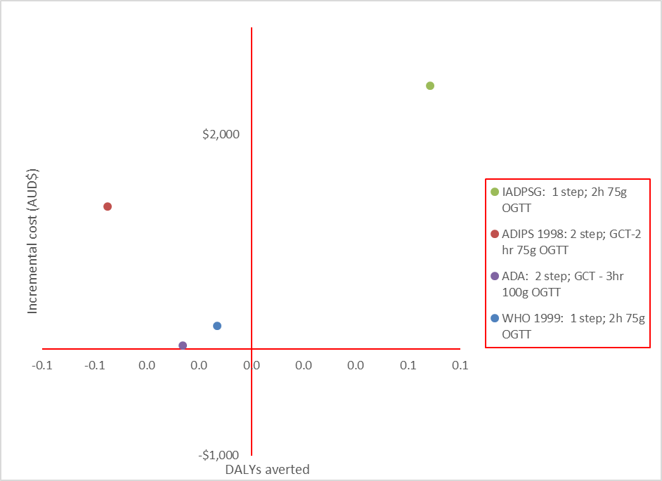

**Figure 2: Base case Cost-Effectiveness Plane for all screening criteria**

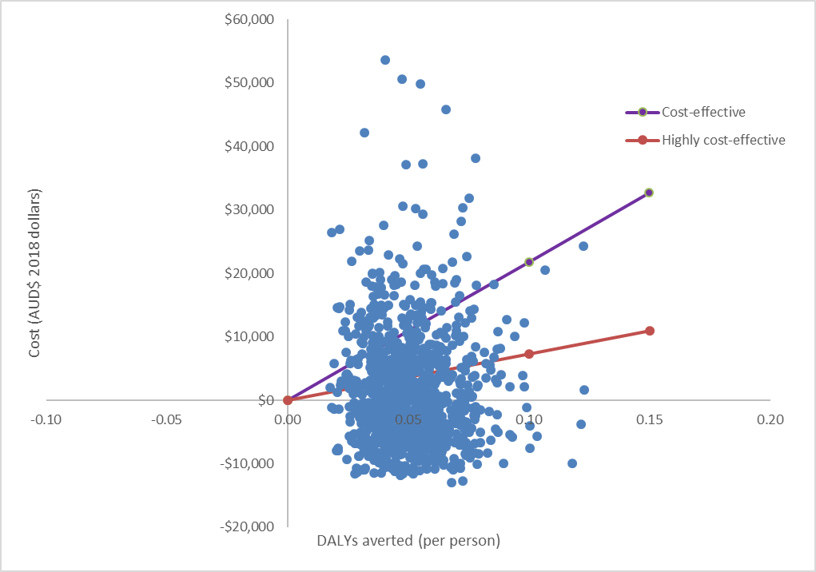

**Figure 3: Cost-effectiveness Plane of new ADIPS GDM strategy vs ADIPS 1998 criteria using 1000 Monte Carlo Simulations with cost effective (purple) and highly cost-effective (red) thresholds (equal to $I 151,200 and $I 50,400 respectively).**

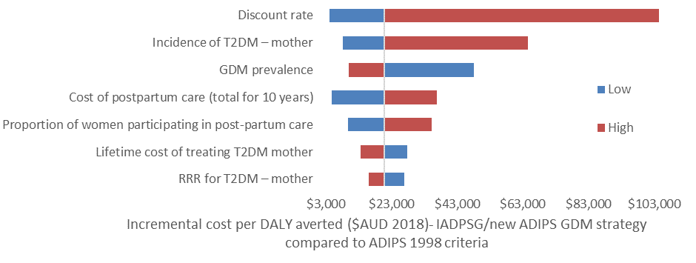

**Figure 4 – One-way sensitivity analysis –** refer to Table 2 for sensitivity range for each variable.