Fault Detection Algorithm for Grid-Connected Photovoltaic Plants

Mahmoud Dhimish, Violeta Holmes

Department of Computing and Engineering

University of Huddersfield, Huddersfield, United Kingdom

[Mahmoud.dhimish2@hud.ac.uk](mailto:Mahmoud.dhimish2@hud.ac.uk) , [V.holmes@hud.ac.uk](mailto:V.holmes@hud.ac.uk)

***Abstract***

This paper presents detailed procedure for automatic fault detection and diagnosis of possible faults occurring in a grid-connected photovoltaic (GCPV) plant using statistical methods. The approach has been validated using an experimental data of climate and electrical parameters based on a 1.98 kWp plant installed at the University of Huddersfield, United Kingdom. There are few instances of statistical tools being deployed in the analysis of PV measured data. The main focus of this paper is, therefore, to create a system capable of simulating the theoretical performances of PV systems and to enable statistical analysis of PV measured data. The fault detection algorithm compares the measured and theoretical output power using statistical t-test. In order to determine the location of the fault, the ratio between the measured and theoretical DC power and voltage is monitored. The obtained results indicate that the fault detection algorithm can detect and locate accurately different types of faults. Some of the typical faults are fault in a photovoltaic module, photovoltaic string and faulty maximum power point tracker (MPPT) unit. A virtual instrumentation (VI) LabVIEW software was used in the system development and implementation. This system was used successfully for fault detection on the GCPV plant.

***Keywords:*** Grid-Connected photovoltaic plant; Fault Detection algorithm; statistical analysis; LabVIEW.

***1. INTRODUCTION***

The cumulative global photovoltaic (PV) capacity has been growing exponentially around the world, especially due to the installation of grid connected photovoltaic (GCPV) plants (Bube, 2012). This growth indicates that the PV energy production will have a very important role in the generation of electricity for the future. But still important efforts remain to be done in terms of cost, performance and reliability of GCPV system. Different factors can be responsible for the production losses of a PV system, such as maximum power point tracking error (Reisi et al., 2013; Tey et al., 2014); wiring losses and ageing (Potnuru et al, 2015), shading effect (Ishaque and Salam, 2013), dust or snow accumulation on the surface of the solar panels (Marion, 2013), and faulty dc-ac inverters (Petruska et al., 2015; Perpiñán et al., 2013).

There are existing techniques which were developed for possible fault detection in grid-connected PV systems. Some of these techniques use meteorological and satellite data for predicting the faults in the GCPV plants (Tadi et al., 2014). However, some of the PV fault detecting algorithms do not require any climate data (Solar irradiance and module temperature) such as the earth capacitance measurements established by Taka-Shima (Takashima et al., 2009).

Other fault detecting techniques are based on a diagnosis signal which indicates possible faults occurring in the GCPV plant (Solorzano et al., 2013). In addition, Chine, W and Platon, R (Chin et al., 2013; Platon el at., 2015) proposed a reliable fault detection method for gird-connected photovoltaic plants. The system depends on the real-time climate data (Solar Irradiance and module temperature) and some PV parameters such as DC input/output ratio, AC input/output ration and reference yield measurements. A number of fault diagnosis algorithms for photovoltaic systems are based on artificial intelligence techniques such as the neural network presented by (Chine et al., 2016) and fuzzy logic developed by (Suganthi et al., 2015). Faults such as module failure, partial shading, shadow effect with faulty bypass diode and shadow effect with connection fault can be monitored using different monitoring platforms such as virtual instrumentation (VI) LabVIEW (Chouder et al., 2013) and MATLAB (Liu et al., 2013). However, to the best of our knowledge none of the reviewed articles have used statistical approach other than the normal standard deviation limits (± 1 SD or ± 3 SD) algorithm.

In this work, we present the development of a fault detecting algorithm which allows the detecting of faults occurring in the DC side of GCPV plant. The algorithm is using the theoretical and the measured power from the GCPV plant. Initially, the measured output power is compared with the theoretical power. Subsequently, statistical t-test is used to check the location of the fault which occurred in the system. Two parameters are calculated and used in order to determine the type of fault: the power ratio between the simulated and measured power (PR) and the ratio between the simulated and measured DC voltage (VR).

This algorithm was developed and validated using online and historical field measurements from a 1.98 kWp PV plant located in Huddersfield, United Kingdom. The fault detection algorithm was validated with data that include measurements taken during the faulty operation of the GCPV plant. Table I shows the eight different faults which can be identified by the proposed detecting algorithm. A software tool is designed using VI LabVIEW to automatically display and monitor the possible faults occurring in the GCPV plant. Also, the VI is used to log the measured data of the power, voltage and the current of the entire GCPV system.

The main contribution of this work is the development and implementation of a simple, fast and reliable fault diagnosis algorithm for GCPV plants. Statistical t-test is used to determine the location of the fault in the PV system, therefore, there is no need to compare the measured data with a specific simulation threshold as described in (Platon et al., 2015; Chine et al., 2016; Silvestre et al., 2013 ). In addition, the detection error is approximately zero which means that the algorithm can detect various types of faults reliably.

This paper is organized as follows: Section 2 presents the data acquisition in the GCPV plant. Section 3 describes the methodology used, Fault detection algorithm and Diagnosis rule is presented, while section 4 lists the results and discussion of the work. Finally, section 5 describes the conclusion and future work.

TABLE I

Different type of faults occurring in a pv array

|  |  |
| --- | --- |
| Type of fault | Symbol |
| Connection Failure, LabVIEW Failure or Logging data Failure | F1 |
| Partial shading in a string | F2 |
| Faulty PV module in a string | F3 |
| Faulty PV module and Partial shading in a string | F4 |
| Two Faulty PV modules in a string | F5 |
| Two Faulty PV modules and Partial shading in a string | F6 |
| Faulty string | F7 |
| Faulty MPPT | F8 |

***2. GCPV PLANT AND DATA ACQUISITION***

The PV system used in this work consists of a grid-connected PV plant which contains 9 polycrystalline silicon PV modules with a nominal power of 220 Wp. The photovoltaic modules are organized in 3 strings and each string is made of 3 series-connected PV modules. Each photovoltaic string is connected to a maximum power point tracker (MPPT) that has output efficiency not less than 98.5% (Outback power, 2014). The DC current and voltage are measured using the internal sensors which are part of the Flexmax MPPT unit. Battery bank is used to store the energy that is produced by the PV pant. The battery bank is connected to DC/AC inverter which is manufactured by Victron Energy (Victron Energy, 2016). Vantage Pro monitoring unit is used to receive the Global solar irradiance measured by Davis weather station which includes pyranometer. Hub 4 communication manager is used to facilitate acquisition of modules temperature using Davis external temperature sensor, and the electrical data for each photovoltaic strings. LabVIEW software is used to implement data logging and monitoring functions of the GCPV system. Fig. 1 illustrates the overall system architecture of the GCPV plant.

The SMT6 (60) P solar module manufactured by Romag (Romag, 2016), has been used in this work. The electrical characteristics of the solar module are shown in Table II. The standard test condition (STC) for these solar panels are: Solar Irradiance= 1000 W/m2; Module Temperature = 25 °C.

TABLE II

Electrical Characteristics of SMT6 (60) P PV Module

|  |  |
| --- | --- |
| Solar Panel Electrical Characteristics | Value |
| Peak Power | 220 W |
| Voltage at maximum power point (Vmp) | 28.7 V |
| Current at maximum power point (Imp) | 7.67 A |
| Open Circuit Voltage (VOC) | 36.74 V |
| Short Circuit Current (Isc) | 8.24 A |
| Number of cells connected in series | 60 |
| Number of cells connected in parallel | 1 |

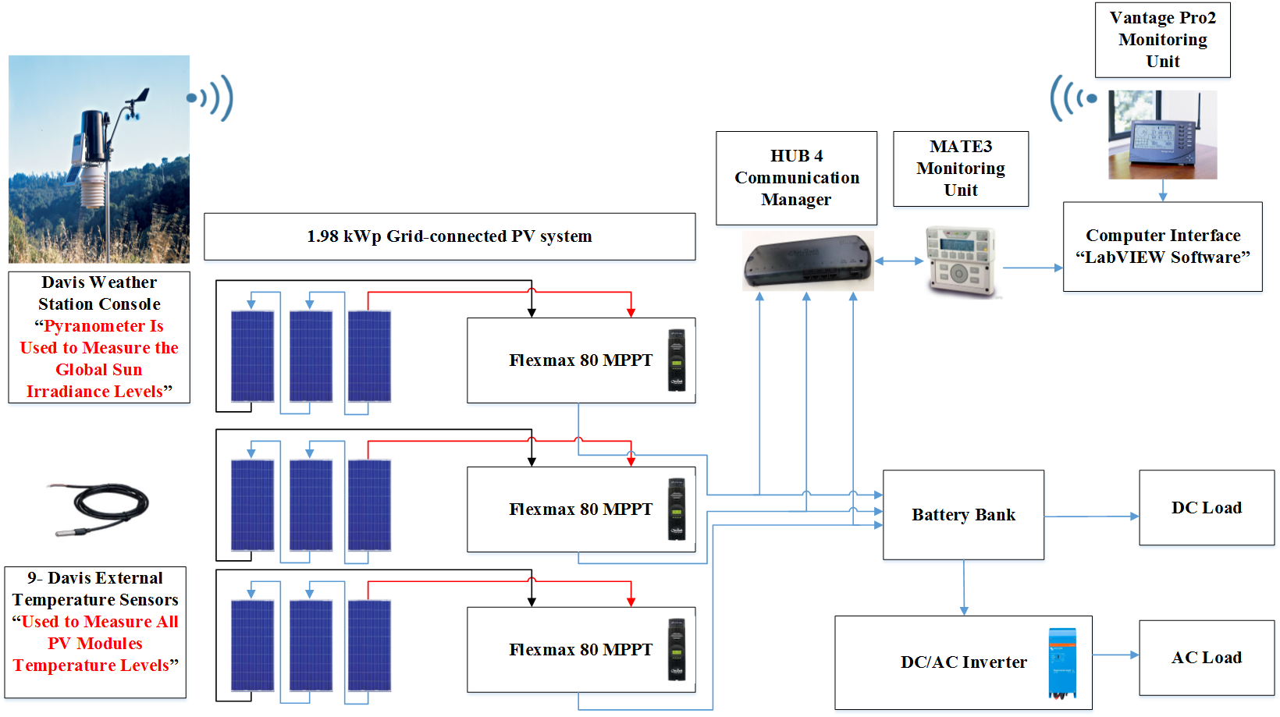

Fig. 1. The GCPV Plant Installed at the Huddersfield University, United Kingdom

The real-time measurements are taken from averaging 60 samples, each sample is taken at 1 second interval. Therefore, the obtained results of the power, voltage and current are calculated at one minute interval for each sample. These measurements are used for further statistical analysis.

***3. METHODOLOGY***

In this section, the modelling of the DC power, the fault detection algorithm, the fault diagnosis rule and faulty region identification for the GCPV system are presented.

***3.1. DC Output Modelling***

The DC side of the GCPV system is modelled using 5-parameters model. The voltage and current characteristics of the PV module can be obtained using the single diode model (McEvoy et al., 2012) as the following:

$I= I_{ph}- I_{o}\left(e^{\frac{V+IR_{s}}{nsV_{t}}} -1\right)-(\frac{V+IR_{s}}{R_{sh}})$ (1)

Where $I_{ph}$ is the photo-generated current at STC , $I_{o}$ is the dark saturation current at STC, $R_{s}$ is the module series resistance, $R_{sh}$ is the panel parallel resistance, $ns$ is the number of series cells in the PV module and $V_{t}$ is the thermal voltage and it can be defined based on:

$V_{t}= \frac{A K T}{q}$ (2)

Where $A$ the diode ideality factor, $k$ is Boltzmann’s constant and $q$ is the charge of the electron.

The five parameters model are determined by solving the transcendental equation (1) using Newton-Raphson algorithm (Sera et al., 2007) based only on the datasheet of the available parameters shown previously in Table II. The power produced by PV module in watts can be easily calculated along with the current (I) and voltage (V) that is generated by equation (1), therefore, Ptheoretical = IV.

***3.2. Fault Detection Algorithm Approach***

The main objective of the fault detecting system is to detect and determine when and where a fault has occurred in the considered GCPV plant.

The fault diagnostic algorithm is based on the analysis of the standard deviation between the measured and theoretical data of the power. Fig. 3(a) presents the general algorithm for detecting errors in the GCPV system. This algorithm has been used and validated by (Platon et al., 2015), nevertheless, when the measured power (Pm) is lower or higher than the threshold $μ ±3SD$ the statistical fault detecting (SFD) technique will be activated. From the VI graphical user interface (GUI), the user can monitor the status of the GCPV plant using the generated output graphs that present the output power and the theoretical power for the entire system.

SFD technique which is presented in Fig. 3(b), is used to identify when and where the fault occurred in the GCPV plant. The technique is based on t-test statistical analysis between the theoretical power and the measured power in each PV string separately. T-test can be evaluated using (3) where $\overline{x}$ is the mean of the samples, $μ$ is the population mean, n is the sample size and SD is the standard deviation of the entire data. The confidence interval can be selected based on the total number of samples (degrees of freedom) which is selected using LabVIEW software. In this work we have used 99% as a confidence interval for all our measured data, the confidence interval values for statistical t-test can be determined using table III (Miller, N and Miller, C, 2005).

After gathering the data from each string, two possible outputs can be determined:

1. **No fault detected.** This output indicates that the system has one of the following errors: error in data logging, error in the network used, or error in the VI LabVIEW tool.
2. **Fault detected in PV string**. This output indicates a fault detected in a specific PV string. The error might occur in one or multiple photovoltaic strings.

$t= \frac{\left(\overline{x}- μ\right)\sqrt{n}}{SD}$ (3)

TABLE III

Statistical T-Test Confidence Interval

|  |  |  |  |
| --- | --- | --- | --- |
| Value of t for Confidence Interval of Critical Value |t| for P Values of Number of Degrees of Freedom | 90 %  (P=0.1) | 95%  (P=0.05) | 99%  (P=0.01) |
| 1 | 6.31 | 12.71 | 63.66 |
| 20 | 1.72 | 2.09 | 2.85 |
| 50 | 1.68 | 2.01 | 2.68 |
| ∞ | 1.64 | 1.96 | 2.58 |

***3.3. Fault Diagnosis Rules***

In order to determine the type of a fault occurred in our GCPV plant, two ratios have been identified. Power ratio (PR) and voltage ratio (VR) have been used to categorise the region of the fault because both ratios have the following features:

1. Both ratios are changeable during faulty conditions in the GCPV system.
2. When the power ratio is equal to zero, the voltage ratio can still have a value regarding the voltage open circuit of the PV modules.
3. The power ratio is used to facilitate the region location (described in Fig. 4). However, the voltage ratio is used to facilitate the type of the fault occurred in the GCPV system (described in Figs. 5 and 6).

The power and voltage ratios are given by the following expressions:

$PR= \frac{P_{theoretical}}{P_{measured}}$ (4)

$VR= \frac{V_{theoretical}}{V_{measured}}$ (5)

Where $P_{theoretical}$ is the theoretical output power generated by the GCPV system, $P_{measured}$ is the measured output power from PV string, $V_{theoretical}$ is the theoretical output voltage generated by the GCPV system and $V_{measured}$ is the measured output DC voltage from PV string.

The analysis of the PR for the GCPV system can be used to create a fault diagnosis rules which are described in Fig. 4. In order to facilitate a system capable to detect faults in GCPV systems correctly, all power ratios are calculated at exactly 98.5% of the theoretical power that represents the maximum error conditions for the estimated theoretical power. The values are calculated according to the set of conditions shown in Fig. 2.

Expectedly, the fault detection algorithm can be used on GCPV plants. By applying (4) for the power ratio calculations and (5) for the voltage ratio calculations it is possible to generate a fault detection rule.

Number of modules in each photovoltaic string plays a major role in implementing the fault detection rule. As shown in Fig. 2, the power ratio calculations depend on the total number of modules in each PV string. In this work each PV string contains three PV modules. In order to apply this fault detection rule to other GCPV plants the ratios should be calculated based on the PV system architecture (Number of PV strings and Modules per string).

The estimation for the maximum percentage of error varies from one GCPV plants to another. We have used 98.5% as a maximum percentage of error because the MPPT generates a measured power greater than 98.5% of the theoretical simulated power. In order to make this rule applicable to other GCPV plants, it is necessary to use the percentage of MPPT error for that particular plant.

Fig. 2 shows that there is a very small gap between the lower and upper limit for the set of rules that are applied in this work. The internal sensors of the MPPT device are used to measure the voltage and current values. Hence, the maximum measured error tolerance for the voltage ratio and power ratio can be evaluated accurately up to 1.5% due to the high quality of the instrumentation within the MPPT device used in our GCPV system.

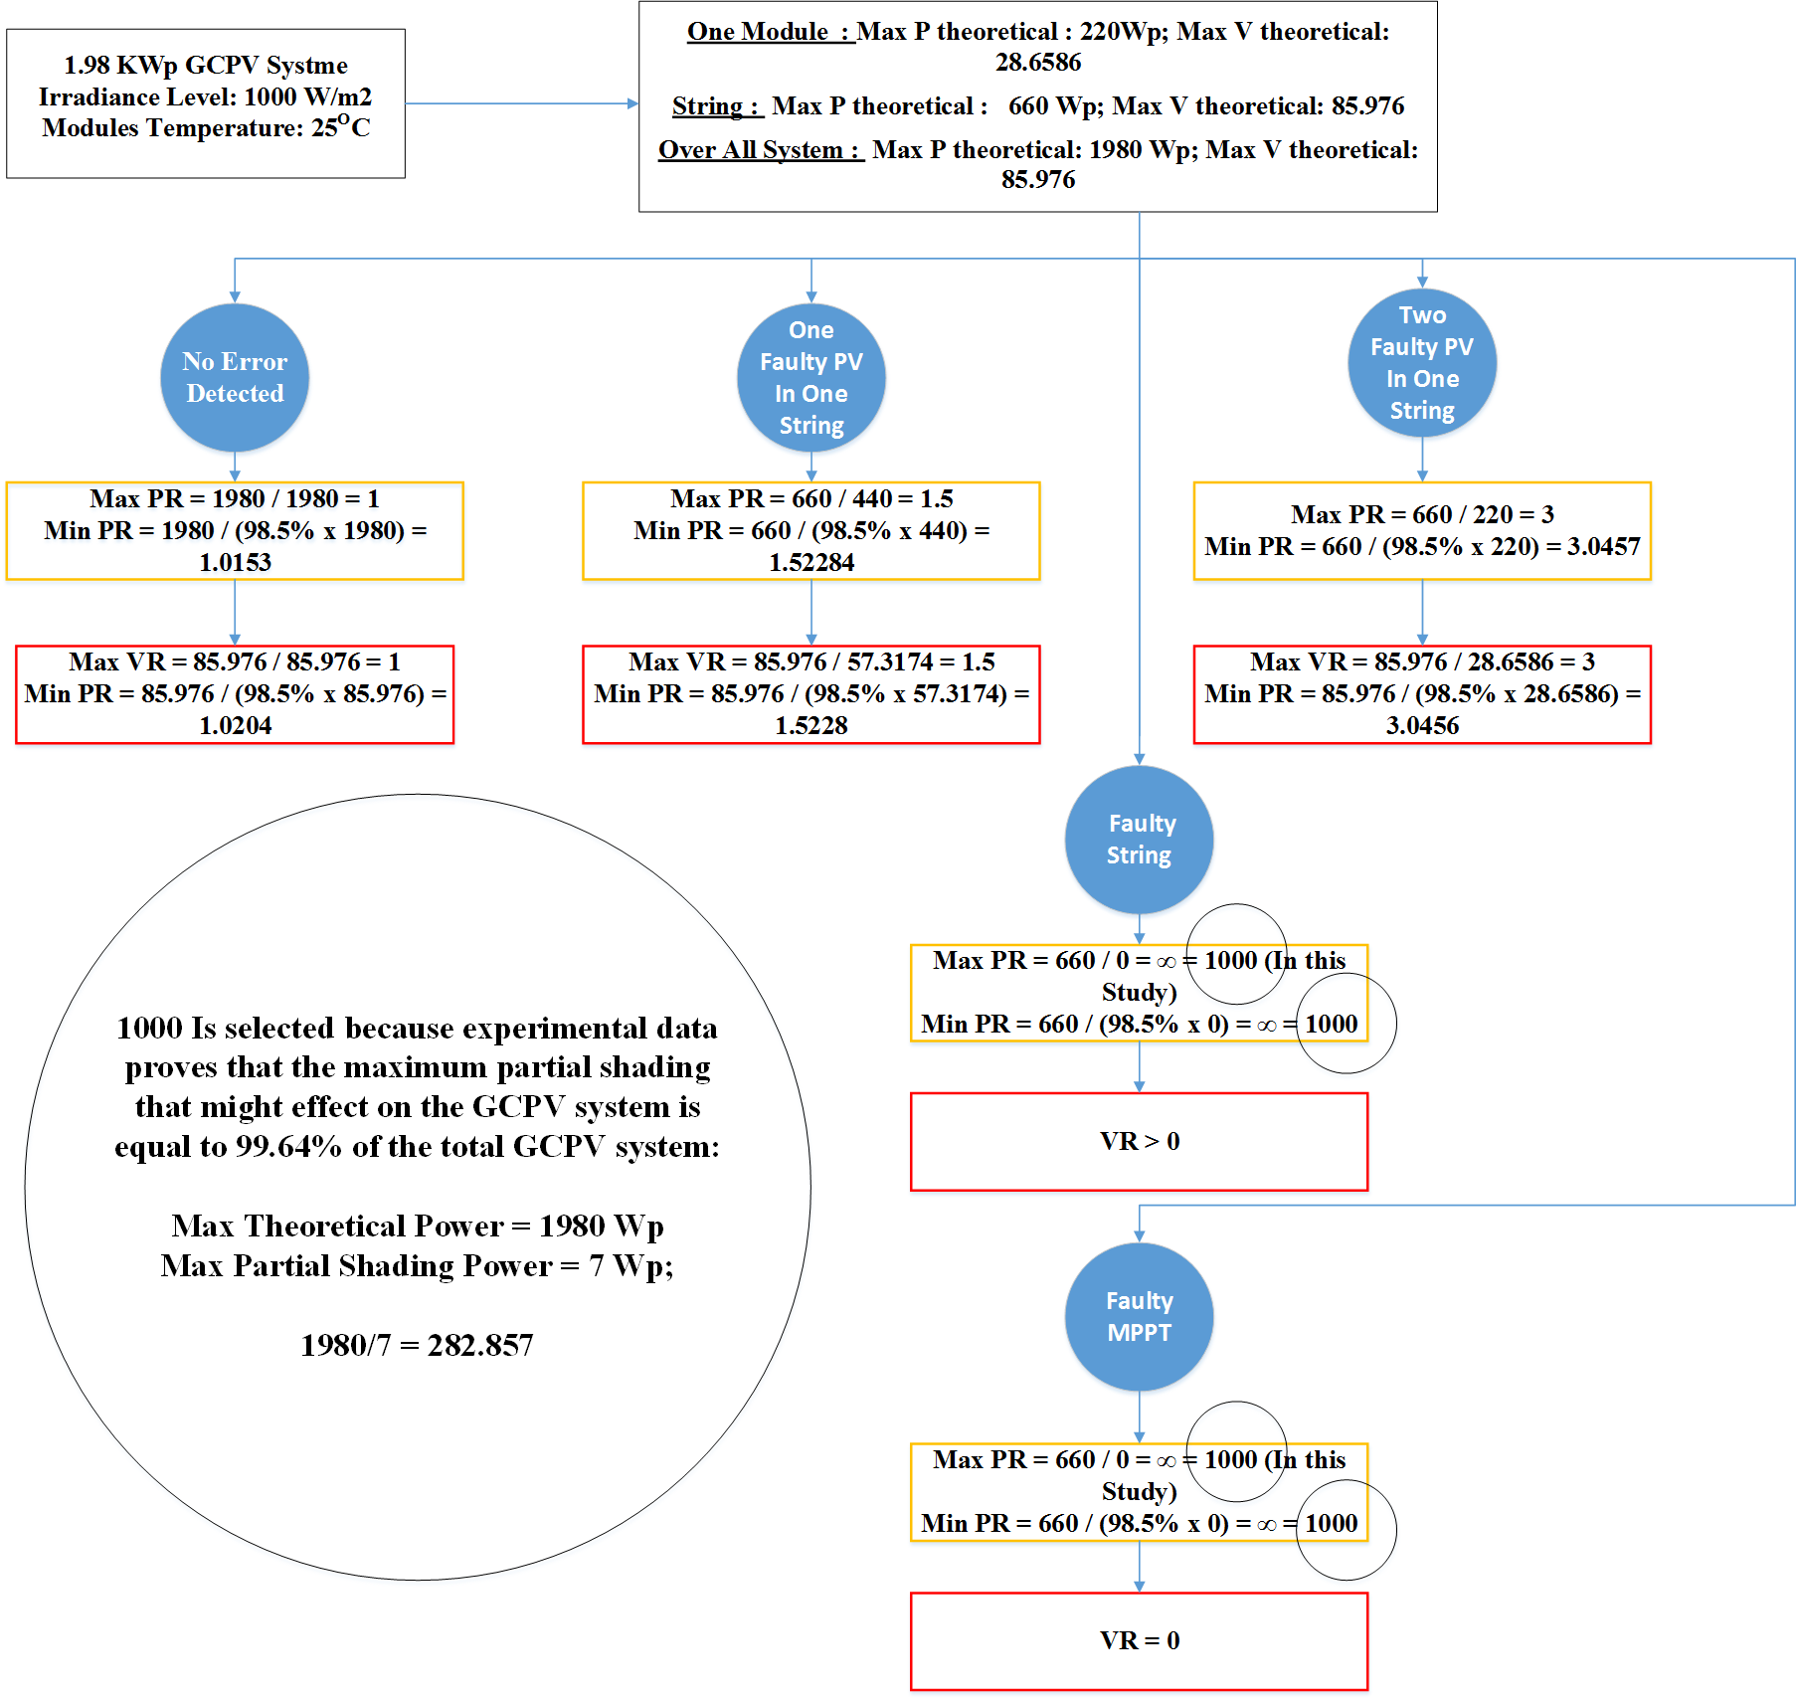

Fig. 2. The Calculations of Power and Voltage Ratios for Different Faults Types Based on Equations (4) and (5)

***3.4. Fault Identification Regions in the GCPV plant***

There are various regions found in the fault diagnosis rule. The normal operation (NO) mode is used for faultless conditions. However, the partial shading (PS) condition can be detected though all rule set regions. The first faulty region is between the power ratio 1.5 and 3, in this region three different faults can be identified: Faulty PV module in a string, faulty PV module and PS in a string or PS effect.

The next region, where the power ratio is between 3 and 1000 can determine multiple faults: two faulty modules in a string, PS effect or a faulty PV module and PS in a string which can be detected in between 3 - 3.0457 power ratio. The last region (Third region), where the power ratio equals to 1000 the algorithm can identify two possible faults: Faulty string or Faulty MPPT.

Voltage ratios are used to identify the fault type. Fig. 5 and 6 explain the last step of the detecting algorithm. These flowcharts are used to determine the fault type of the system. The faults can be detected according to the following conditions:

1. If 1.52284 ≥ PR ≥ 1.5: it means that the fault occurred in the first region, in this case we can identify two categories of faults: if 2.47445 ≥ VR ≥ 1.5: It indicates that there is a faulty PV module in the string, otherwise, a PS effect occurred in the string.
2. If 3 > PR > 1.52284: it means that the fault occurred in the first region, in this case if the voltage ratio is between 2.47445 and 1.5, a faulty PV module and PS effect on the PV string have arisen. However, if the voltage ratio is out of the region 2.47445 - 1.5, only PS effects the PV string.
3. If 1000 > PR ≥ 3: it means that the fault occurred in the second region. This case can determine various faults such as: Faulty PV module with PS effect on the PV string, PS effect on the PV string, two faulty modules in the PV string, two faulty modules in the PV string and PS effect.
4. If PR = 1000: it means that the fault occurred in the third region, where the GCPV plant has a failure in a PV string or a failure in a MPPT unit.
5. Sleep mode will start during the night when PR=0.

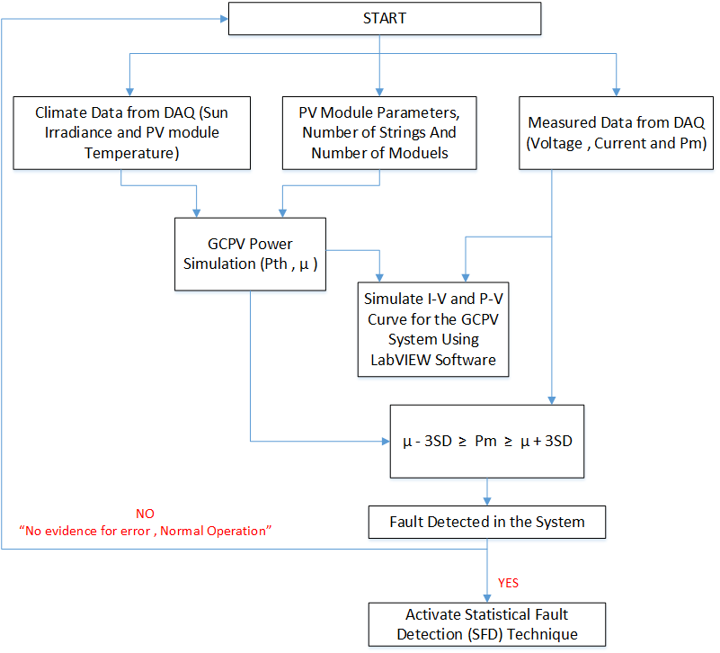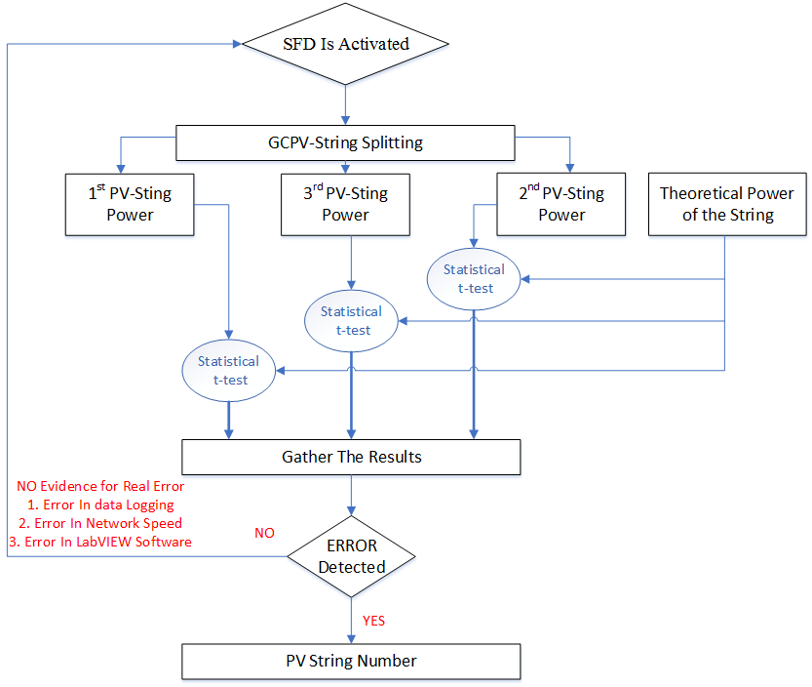

(a) (b)

Fig. 3. Error detecting in the GCPV system. (a) General Algorithm Using Standard Deviation Statistical Technique, (b) T-test Statistical Analysis Fault Detecting Technique

Fig. 1. Magnetization as a function of applied field. Note that “Fig.” is abbreviated. There is a period after the figure number, followed by two spaces. It is good practice to explain the significance of the figure in the caption.

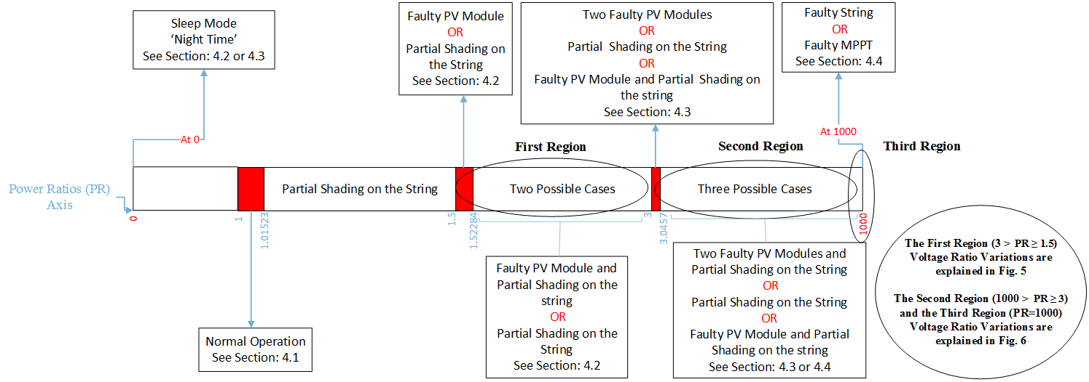

Fig. 4. The fault Diagnosis Power Ratio Rule for All Possible Fault Conditions

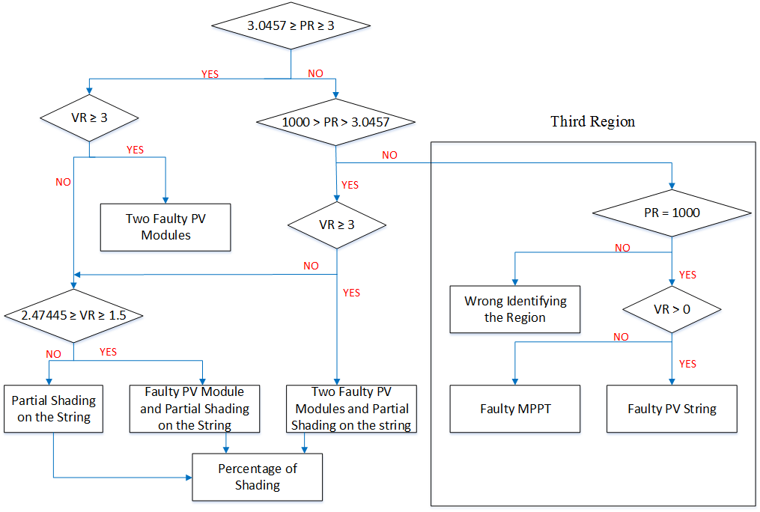

Fig. 6. Diagnosis the Error in the Second and Third Regions: Two Faulty PV Modules, Two Faulty PV Modules with Partial Shading Effect, Faulty MPPT and Faulty PV String

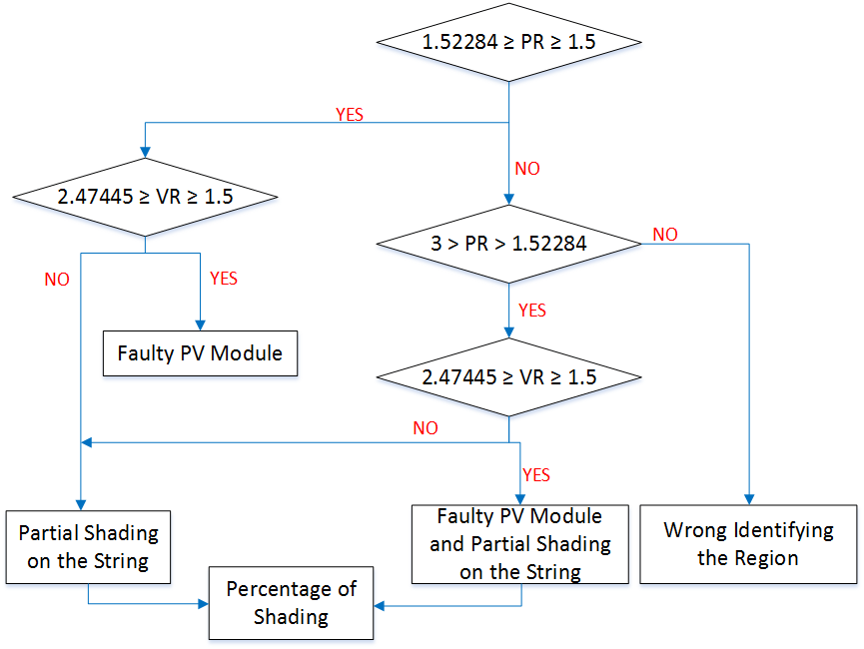

Fig. 5. Diagnosis the Error in the First Region: Faulty PV Module, Faulty PV Module with Partial Shading Effect and Partial Shading Effect on a PV string

***4. RESULTS AND DISCUSSION***

In this section, the performance of the developed diagnostic algorithm is verified. For this purpose, the acquired data for various days have been considered. All error types and the normal operation mode have been examined. The time zone for all measurements is GMT.

***4.1. Normal Operation***

As shown in Fig. 7, the measured DC power is very close to the theoretical power during a period of a full day, starting from 6am ending at 20:24pm. According to the achieved result of this test, the DC-DC converter used in this work has a high efficiency rate which is approximate to 98.8%. Fig. 7 indicates that the system is stable for all variation of the sun irradiance.

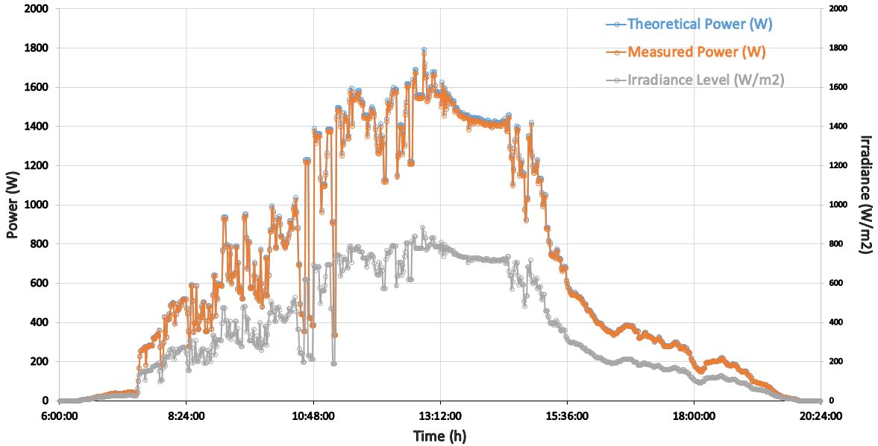

Fig. 7. PV Array Theoretical and Measured Output Power in a Normal Operation Mode

***4.2. Diagnosis the Fault in the First Region***

In order to test the ability of the method to detect the faults in the first error region, described previously is section 3.4, a number of experiments were conducted. Firstly, a PS of 25% has been applied on the first PV string from 12:30pm – 13:00pm, the maximum power and voltage ratios of the test is equal to 1.39 and 1.05 respectively. All obtained results can be seen in Fig. 8, where the variation of the power and voltage is presented using the blue color.

By disconnecting one PV module and applying a 25% PS (Opaque paper object) to the same PV string as shown in Fig. 8(d). As a consequence, the power ratio of the string is higher than 1.5, exactly equal to 2.07. The voltage ratio for the test will remain above 1.5.

This Partial shading Test occurred when the 25% PS on the PV string is removed, but still one faulty photovoltaic module in the same PV string exists. The results for this partial shading test can be seen in Fig. 8(b) and Fig. 8(c) between the time 15pm and 17pm. The power ratio for all the period of time always less than or equal to 1.52284 and more than or equal to 1.5. However, the voltage ratio remains in the threshold value between 2.47445 ≥ VP ≥ 1.5.

During the time 18:00pm until 20:24pm no faults occurred in the GCPV system. Where the sleep mode of the system starts when the power ratio and voltage ratio is equal to zero at 19:24pm.

All obtained results for the various test conditions indicate that the fault detecting algorithm has a high degree of detecting rate: there is no evidence of any errors in the detecting algorithm during the time of conducting faulty PV and partial shading tests.

***4.3. Diagnosis of the Faults in the Second Region***

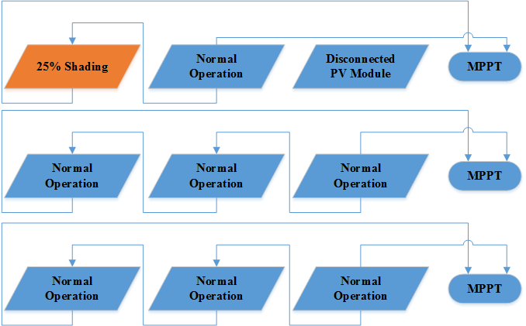

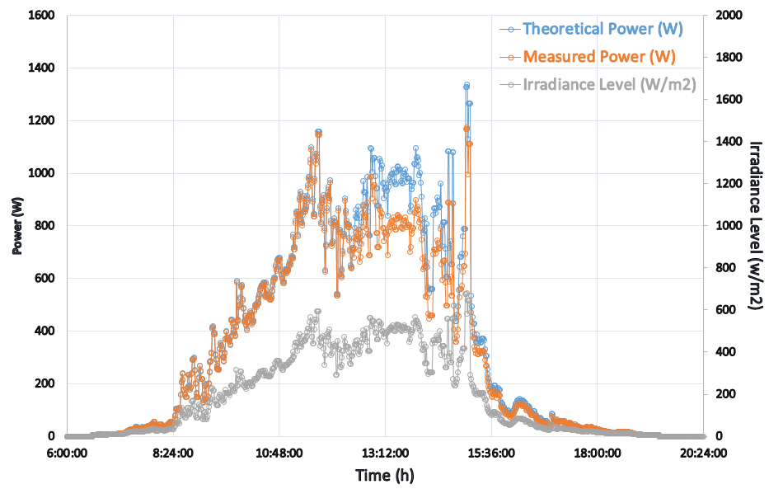 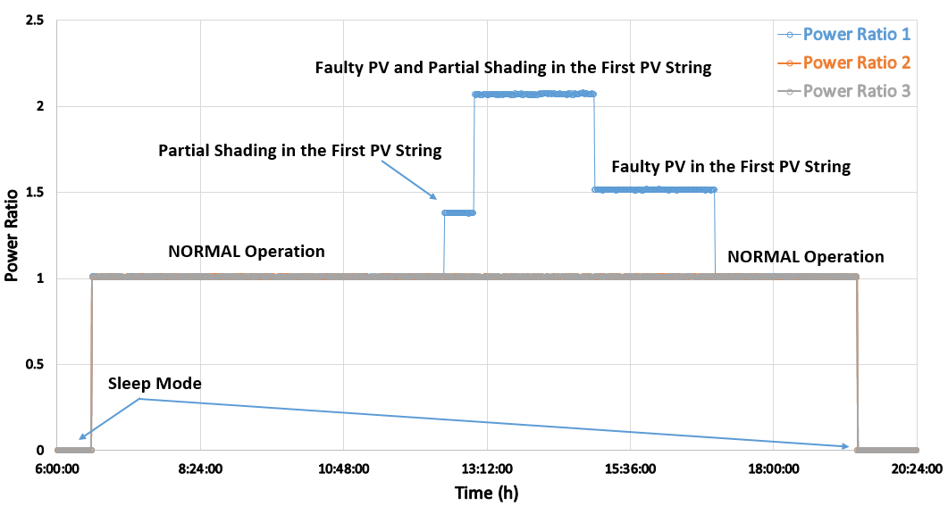

(a) (b)

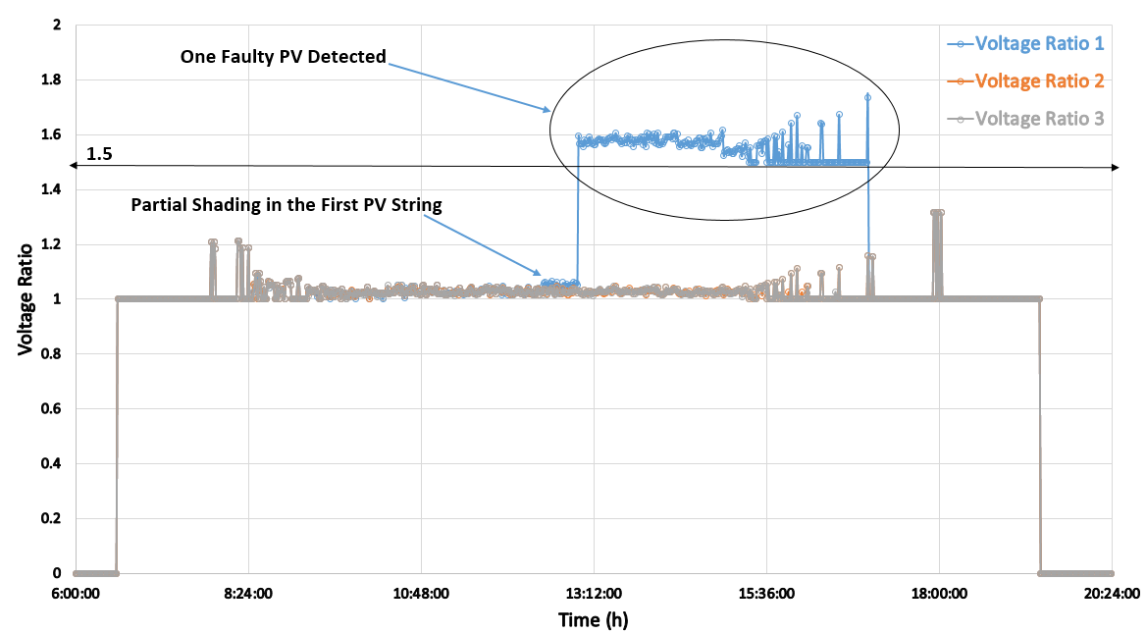 (c) (d)

Fig. 8. Diagnosis the Fault in the First Region. (a) Theoretical Output Power vs. Measured Output Power, (b) Power Ratio for All PV Strings, (c) Voltage Ratio for All PV strings, (d) 25% Partial Shading and PV Module disconnection in the First PV String

In this case, the fault detecting algorithm will detect various faults that occurred in the second region where the power ratio is between 1000 > PR ≥ 3. According to Fig. 9, between 6am – 6:15:15am the GCPV plant is in the sleep mode, where the voltage and power ratios is equal to zero. Next, the normal operation mode started at 6:15:15am across all PV modules in the GVPC plant.

As shown in Fig. 9(b), a 25% partial shading has been detected by the fault detecting algorithm between 10:00am – 12:00pm. The power and the voltage ratios for this particular test are described in Fig. 9(b) and Fig. 9(c) respectively. Afterwards, two faulty photovoltaic modules and 25% PS have been detected in the third PV string, the GCPV system architecture for this scenario is shown in Fig. 9(d). It can be observed that the power ratio during this test is between 8.2 and 8.5, and the voltage ratio is between 3 and 3.5. This test can be seen during the time 12:01pm – 13:33pm.

Two Faulty PV test has been conducted between 13:34pm – 16:14pm. In this scenario two faulty photovoltaic modules has been detected in the GCPV plant. For instance, the power ratio for the test is between 3 and 3.04. In addition, the voltage ratio is always greater than or equal to 3.

The location and the time for each fault that is detected using the proposed detection algorithm were accurate. The power and voltage ratios for each test scenario indicates that the algorithm is well designed and structured. Furthermore, the detecting algorithm can achieve a high accuracy rate for diagnosis the fault in the GCPV system not only in stable irradiance levels as shown in Fig. 8(a) but also in a rapid irradiance level fluctuation as described in Fig. 9(a).

***4.4. Diagnosis of the Faults in the Third Region and Multiple Faults in Various PV Strings***

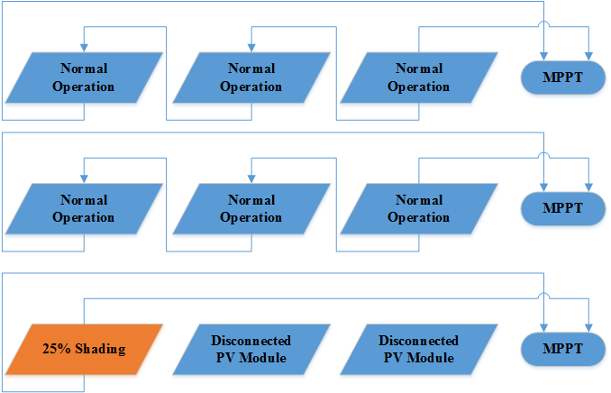

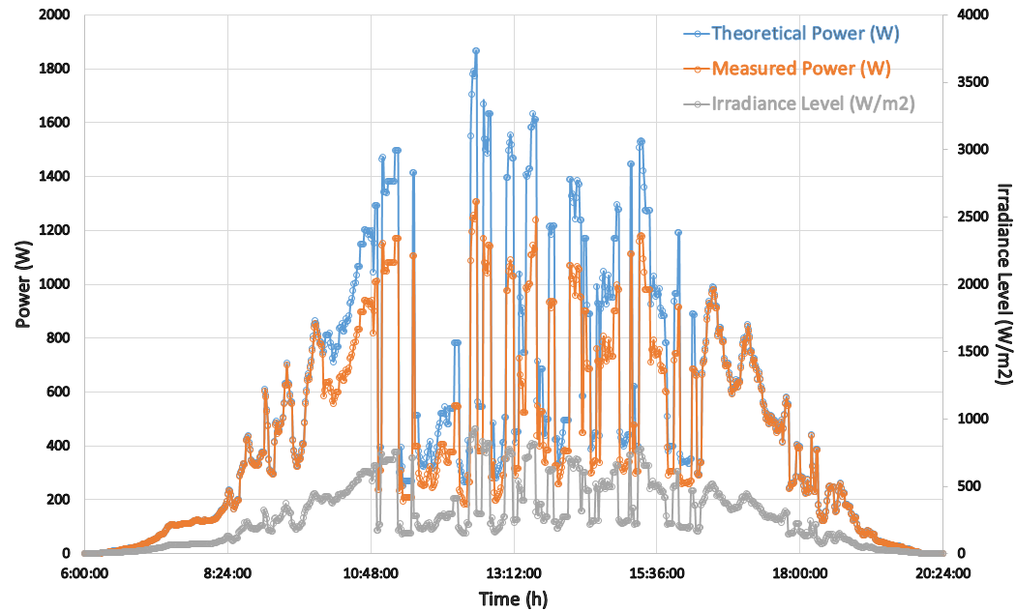 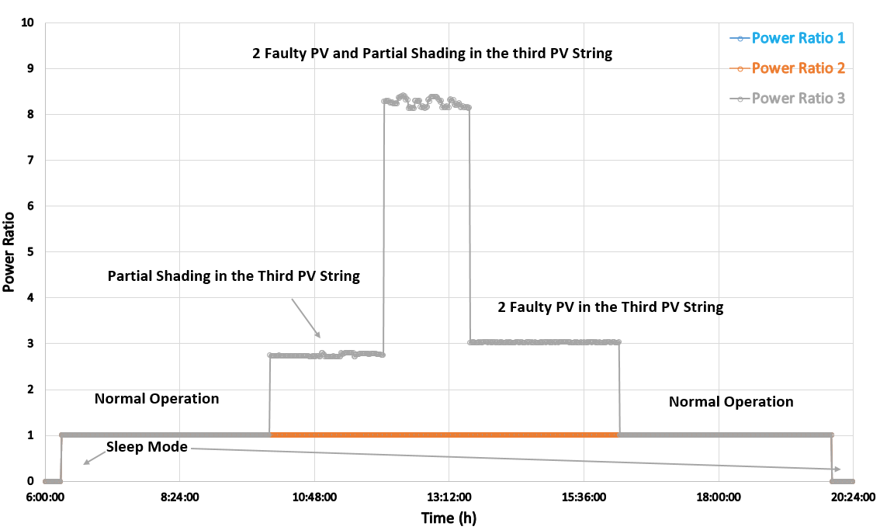

(a) (b)

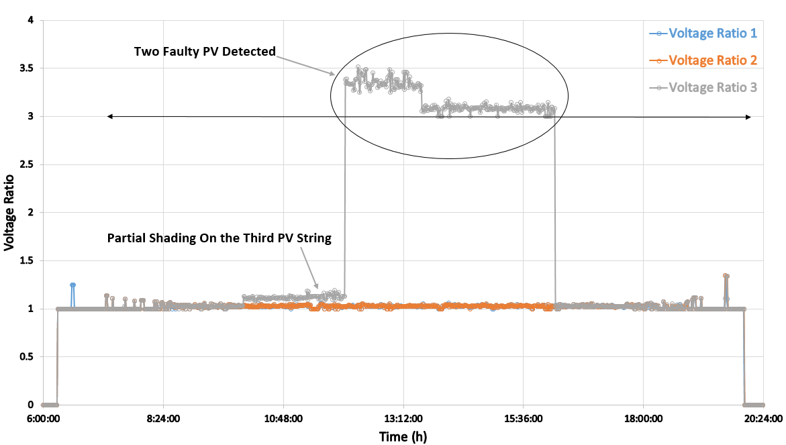 (c) (d)

Fig. 9. Diagnosis the Fault in the Second Region. (a) Theoretical Output Power vs. Measured Output Power, (b) Power ratio for All PV Strings, (c) Voltage Ratio for All PV Strings (d) 25% Partial Shading and Two PV Modules disconnection in the Third PV String

This test is created to confirm the ability of the fault detection algorithm to detect multiple faults occurring at the same time in multiple PV strings at various locations in the GCPV plant.

Table V describes the starting and ending time for each mode occurring in the strings of the GCPV plant. Eight different time periods were examined, starting and ending at 4:48am – 21:36pm respectively.

Fig. 10(a) shows the theoretical vs. measured output power for the GCPV system whilst Figs. 10(b), (c) and (d) describe the resulted power and voltage ratios for each PV string separately.

There is a rapid change in the irradiance level during the test time period, and this can be shown in Fig. 10(a). Starting from 4:48am, all PV strings were in sleep mode, VR and PR is equal to zero. At 5:39:19am the GCPV strings started working in normal operation mode. One faulty PV module has been detected in the third PV string at 9:58:18am. After 1.5 Hour, two faulty PV modules are detected in the Third PV string and 40% partial shading occurred in the first PV String. Both tests can be seen in Fig. 10(d) during the power ratio region 1 and Fig. 10(b) respectively.

Starting at 13:06:17pm, one faulty PV module is detected in the second PV string as shown in Fig. 10(c), power ratio region 1. At the same time period, PS and NO are determined by the detection algorithm in the first PV string and third PV string respectively. Furthermore, faulty PV string is detected at 13:06:17pm in the second PV string. The voltage ratio for the test is between 1 and 1.04. However, the power ratio is equal to 1000 as shown in Fig. 10(c), power ratio region 2.

Faulty MPPT is detected in the third PV string at 15:51:18pm. According to Fig. 10(d), power ratio region 2, the voltage ratio and power ratio is equal to 1000. At the same period of time, faulty PV module and 40% partial shading is detected in the first PV string. The voltage ratio is between 1.5 and 2. However, the power ratio is always greater than 2.5. During the time 17:25:18pm – 19:35:18pm, the fault detection algorithm indicates that the GCPV plant is working probably without any faults. The entire system is back to sleep mode at 19:35:18, where VR = PR = 0.

TABLE V

Diagnosis Multiple Faults in Multiple Strings Locations at the Same Time

|  |  |  |  |  |
| --- | --- | --- | --- | --- |
| Start Time | End Time | First PV String | Second PV String | Third PV String |
| 4:48:00 am | 5:39:18 am | Sleep Mode | Sleep Mode | Sleep Mode |
| 5:39:18 am | 9:59:18 am | Normal Operation | Normal Operation | Normal Operation |
| 9:59:18 am | 11:29:18 am | Normal Operation | 60% Partial Shading | One Faulty PV |
| 11:29:18 am | 13:06:18 pm | 40% Partial Shading | Normal Operation | Two Faulty PV |
| 13:06:18 pm | 15:51:18 pm | 40% Partial Shading | Faulty PV String | Normal Operation |
| 15:51:18 pm | 17:25:18 pm | One Faulty PV and 40% Partial Shading | Normal Operation | Faulty MPPT |
| 17:25:18 pm | 19:35:19 pm | Normal Operation | Normal Operation | Normal Operation |
| 19:35:19 pm | 21:36:00 pm | Sleep Mode | Sleep Mode | Sleep Mode |

In this test, the fault detection algorithm shows a significant success for the detection of many possible failure that may occur in the GCPV plant. The time and the location of the fault can be recognized by the algorithm, as well as the type of the fault. It was also demonstrated that the detection algorithm can achieve a high accuracy rate in detection failure under a rapid change in the irradiance level.

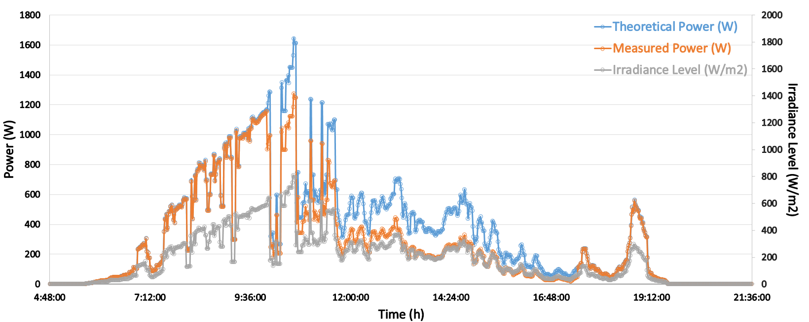 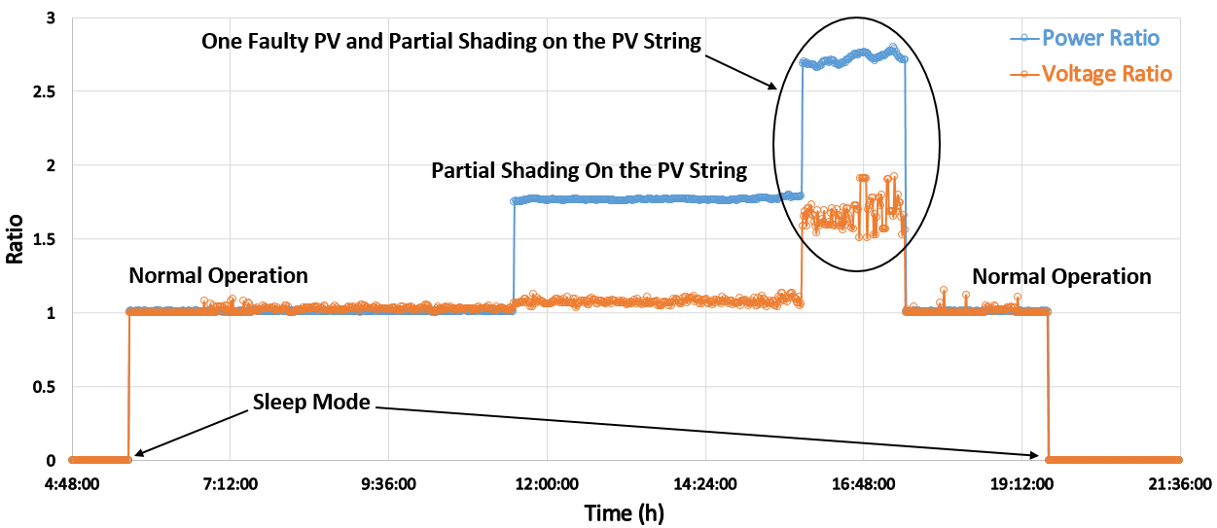

(a) (b)

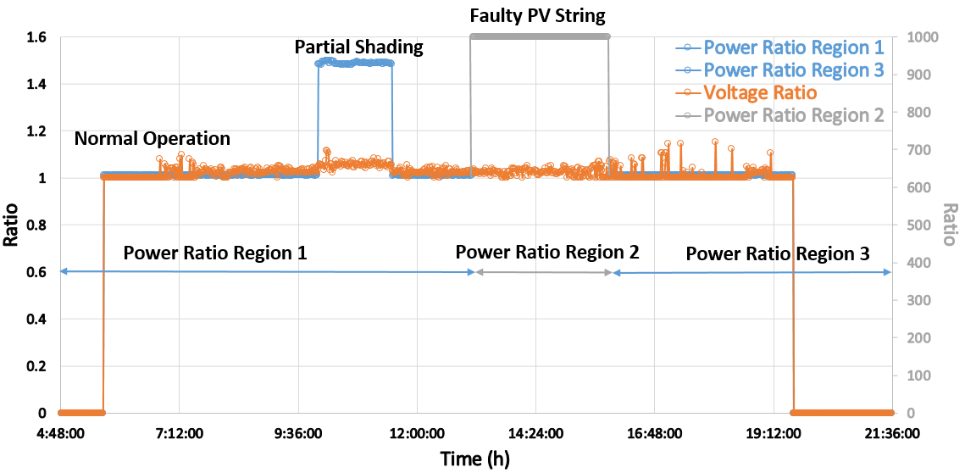 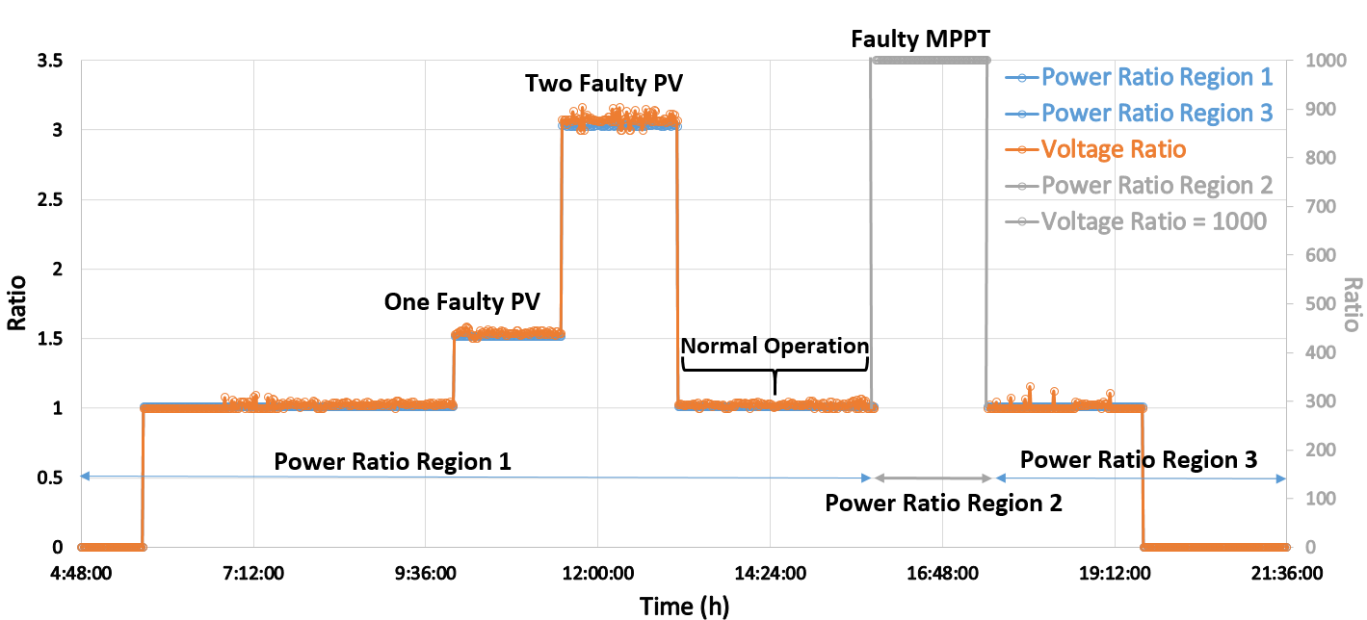

(c) (d)

Fig. 10. Multiple Faults Occurred in the GCPV Plant Output Results. (a) PV Array Theoretical and Measured Output Power, (b) First PV String PR and VR, (c) Second PV string PR and VR, (d) Third PV string PR and VR

***4.5. Advantages and Disadvantages of the Proposed Algorithm***

In this paper, we presents a fault detection algorithm for gird-connected PV systems. The algorithm has some major advantages and disadvantages such as:

Advantages:

* The algorithm is easy to implement, since it depends only on the voltage and the power of the photovoltaic system which are capable to be measured in most GCPV systems.
* The algorithm use simple statistical analysis technique (T-test), which can be acknowledged by equation (3). The statistical T-test technique depends on a simple statistical calculations such as the standard deviation and number of samples for the measured data.
* The proposed algorithm use two main equations to create the set of rules for detection possible faults. Both equations use the voltage and the power measurements, therefore, it is simple to recreate and adapt both equations in GCPV systems. The equations are illustrated previously in (4) and (5).
* Multiple faults can be detected using the proposed algorithm, which grants that the algorithm is realistic and reliable to be used in GCPV system. All faults that can be detected using the proposed algorithm are shown in Table I.

Disadvantages:

* The fault detection algorithm cannot detect any fault arise in the DC/AC inverters that are used in the GCPV systems.
* The algorithm is not capable to detect the faults occurred by the bypass diodes, which are nowadays commonly used in GCPV systems.
* The algorithm depends on the voltage and the power ratios of the GCPV systems. Therefore, the accuracy of the algorithm depends on the instrumentation used in the PV plants.

***5. CONCLUSION***

A fault detection for grid-connected photovoltaic (GCPV) plant based on the comparison between the theoretical and measured data using t-test statistical technique is proposed and verified experimentally. The detection algorithm can detect many types of faults occurring in a GCPV plant such as faulty maximum power point tracking, faulty PV string and Faulty modules in a PV string.

In order to identify the failure in the GCPV system, we have defined two indicators named power ratio (PR) and voltage ratio (VR). By using both ratios it is possible to determine the fault type, time and the location where this fault occurred in the system. This algorithm has been tested using a 1.98 KWp GCPV plant. The graphical user interface (GUI) was used to monitor the status of the existing system is a virtual instrumentation (VI) LabVIEW software.

Novel contribution of this research is that the fault detection algorithm can detect the faults in the GCPV plant using statistical analysis of real-time long-term measured data and theoretical thresholds.

In future, it is intended to implement the developed fault detection algorithm into low cost microcontroller-based systems. The system’s fault diagnostic capabilities will be enhanced further by using artificial intelligence machine learning techniques.

***6. ACKNOWLEDGEMENT***

The authors would like to acknowledge the financial assistant to the University of Huddersfield, engineering and computing department.

***REFRENCES***

Bube, R. (2012). Fundamentals of solar cells: photovoltaic solar energy conversion. Elsevier.

Reisi, A. R., Moradi, M. H., & Jamasb, S. (2013). Classification and comparison of maximum power point tracking techniques for photovoltaic system: A review. *Renewable and Sustainable Energy Reviews*, *19*, 433-443.

Tey, K. S., & Mekhilef, S. (2014). Modified incremental conductance MPPT algorithm to mitigate inaccurate responses under fast-changing solar irradiation level. Solar Energy, 101, 333-342.

Potnuru, S. R., Pattabiraman, D., Ganesan, S. I., & Chilakapati, N. (2015). Positioning of PV panels for reduction in line losses and mismatch losses in PV array. *Renewable Energy*, *78*, 264-275.

Ishaque, K., & Salam, Z. (2013). A review of maximum power point tracking techniques of PV system for uniform insolation and partial shading condition.Renewable and Sustainable Energy Reviews, 19, 475-488.

Marion, B., Schaefer, R., Caine, H., & Sanchez, G. (2013). Measured and modeled photovoltaic system energy losses from snow for Colorado and Wisconsin locations. Solar Energy, 97, 112-121.

Petruska, D. C., Stewart, D. K., Wegner, M. L., & Eberhardt, G. M. (2015).*U.S. Patent No. 8,931,457*. Washington, DC: U.S. Patent and Trademark Office.

Perpiñán, O., Marcos, J., & Lorenzo, E. (2013). Electrical power fluctuations in a network of DC/AC inverters in a large PV plant: Relationship between correlation, distance and time scale. *Solar Energy*, *88*, 227-241.

Tadj, M., Benmouiza, K., Cheknane, A., & Silvestre, S. (2014). Improving the performance of PV systems by faults detection using GISTEL approach.Energy conversion and management, 80, 298-304.

Takashima, T., Yamaguchi, J., Otani, K., Oozeki, T., Kato, K., & Ishida, M. (2009). Experimental studies of fault location in PV module strings. Solar Energy Materials and Solar Cells, 93(6), 1079-1082.

Solórzano, J., & Egido, M. A. (2013). Automatic fault diagnosis in PV systems with distributed MPPT. Energy Conversion and Management, 76, 925-934.

Chine, W., Mellit, A., Pavan, A. M., & Kalogirou, S. A. (2014). Fault detection method for grid-connected photovoltaic plants. Renewable Energy,66, 99-110.

Platon, R., Martel, J., Woodruff, N., & Chau, T. Y. (2015). Online Fault Detection in PV Systems. Sustainable Energy, IEEE Transactions on, 6(4), 1200-1207.

Chine, W., Mellit, A., Lughi, V., Malek, A., Sulligoi, G., & Pavan, A. M. (2016). A novel fault diagnosis technique for photovoltaic systems based on artificial neural networks. Renewable Energy, 90, 501-512.

Suganthi, L., Iniyan, S., & Samuel, A. A. (2015). Applications of fuzzy logic in renewable energy systems–a review. *Renewable and Sustainable Energy Reviews*, *48*, 585-607.

Chouder, A., Silvestre, S., Taghezouit, B., & Karatepe, E. (2013). Monitoring, modelling and simulation of PV systems using LabVIEW. Solar Energy, 91, 337-349.

Liu, Y. H., Liu, C. L., Huang, J. W., & Chen, J. H. (2013). Neural-network-based maximum power point tracking methods for photovoltaic systems operating under fast changing environments. Solar Energy, 89, 42-53.

Silvestre, S., Chouder, A., & Karatepe, E. (2013). Automatic fault detection in grid connected PV systems. Solar Energy, 94, 119-127.

Outback Power. (2014). FLEXpower Systems. Retrieved from http://www.outbackpower.com/outback-products/make-the-power/flexpower-integrated-systems.

Victron Energy. (2014). Inverters. Retrieved from https://www.victronenergy.com/inverters.

Romag. (2016). Roof-Integrated Solar Panels. Retrieved from http://www.romag.co.uk/solar/roof-integrated-pv/.

McEvoy, A., Castaner, L., & Markvart, T. (2012). Solar cells: materials, manufacture and operation. Academic Press.

Sera, D., Teodorescu, R., & Rodriguez, P. (2007). PV panel model based on datasheet values. Paper presented at the 2392-2396. doi:10.1109/ISIE.2007.4374981

Miller, J. N., & Miller, J. C. (2005). Statistics and chemometrics for analytical chemistry. Pearson Education.